Revising the National Minimum Standards (NMS) for Adoption, Children’s Homes and Fostering

Government Response to Consultation


Introduction
National Minimum Standards (NMS) have been in place for Fostering Services and Children’s Homes since 2002 and for Adoption and Adoption Support Agencies since 2003 and 2005 respectively. The NMS are underpinned by regulations and are taken into account by Ofsted when assessing whether a provider is complying with regulations and providing an acceptable level of service.

The revised NMS aimed to make the current standards:
- more streamlined, including by merging the two current sets of adoption NMS;
- more consistent across the three NMS, where appropriate;
- more child-focused, by including new child-centred standards;
- more outcome-focused, by starting each standard with the outcome that the service is expected to achieve followed by the type of evidence that may indicate that the service is meeting that outcome;
- clearer about the values services should be operating by, by including values at the start of the NMS;
- consistent with changes in legislation, policy and practice.

A formal 12 week consultation took place between 24 September 2010 and 17 December 2010 to obtain views on proposed amendments to the NMS.

The consultation was carried through the following channels:
- A number of consultation events;
- Formal responses received via the DCSF e-consultation website;
- Stakeholder workshops.
The consultation received 159 responses. Of the 159 responses many organisation included feedback from consultation events they had held with their members. This report contains a summary of the consultation responses and a break down of responses to the consultation questions posed. The post consultation revision of the NMS encapsulates the Government’s response to the consultation.

Next steps
Revised NMS for adoption, fostering and children’s homes are due to come into force in April 2011 alongside revised Fostering Services and Children’s Homes Regulations and Statutory Guidance. A consultation on the revised Regulations and Guidance ends on 19 November 2010. As the NMS are linked to both the regulations and guidance this version of the NMS may be subject to minor changes. We intend to publish a final version of the NMS taking into account any changes resulting from the consultation on the regulations and guidance in January 2011.
Q1. Do you think that the layout of the NMS is helpful?

 | Yes | No | Not sure | 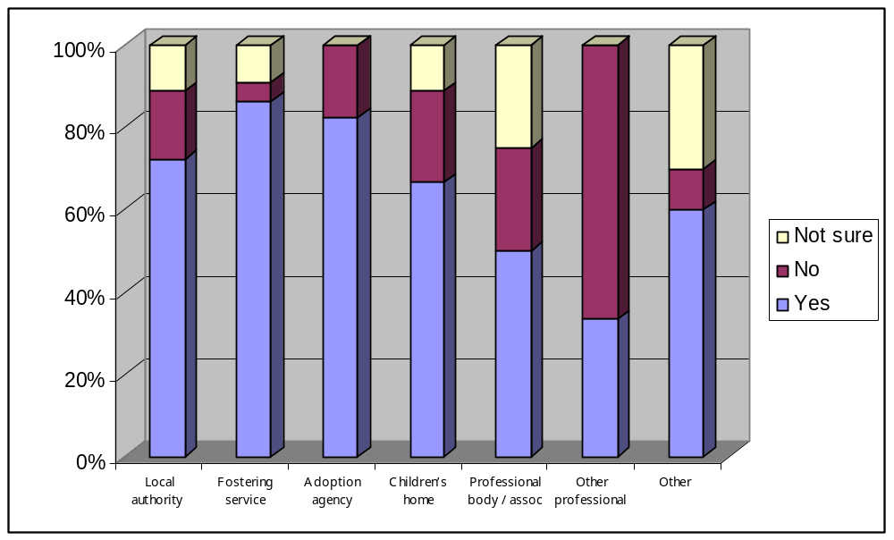
Local authority | 26 | 6 | 4
Fostering service | 19 | 1 | 2
Adoption agency | 14 | 3 | 0
Children’s home | 6 | 2 | 1
Professional body / assoc | 4 | 2 | 2
Other professional | 1 | 2 | 0
Other | 12 | 2 | 6
TOTAL | 82 (71%) | 18 (16%) | 15 (13%)

Most respondents to the consultation felt that the layout of the NMS is clear, understandable and helpful. Respondents also liked having child-focused standards at the beginning of the document and than having the standards around the running of the service. Comments included that that the layout is more child-friendly and child-focused, that it is helpful to have the outcome, standards and regulations together and that the amalgamation of the two current sets of adoption NMS is helpful.

Some respondents commented that the standards are too long and detailed and that there is inappropriate duplication between the sets of NMS. However, bringing the layout of the adoption standards in line with those for fostering and children’s homes was also suggested. The post consultation revision of the standards takes into account comments about the standards being too detailed and in some areas, for example restraint, inappropriately applying the same standards across children’s homes and fostering.

Q2. Do you think that the values stated in the General Introduction capture the important principles for the service?

 | Yes | No | Not sure | 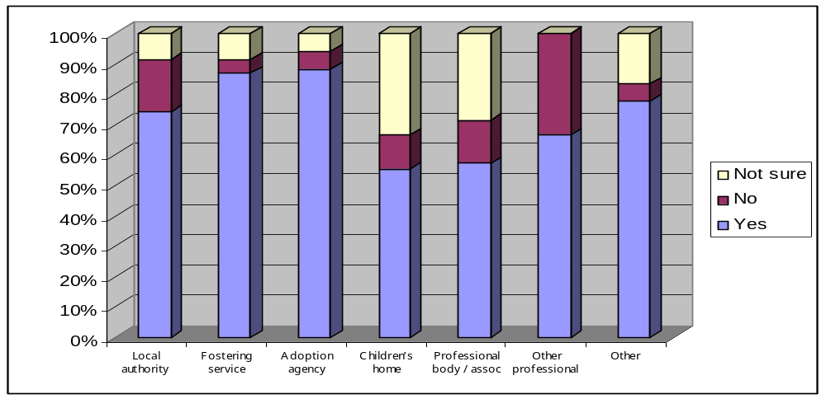
Local authority | 26 | 6 | 3
Fostering service | 20 | 1 | 2
Adoption agency | 15 | 1 | 1
Children’s home | 5 | 1 | 3
Professional body / assoc | 4 | 1 | 2
Other professional | 2 | 1 | 0
Other | 14 | 1 | 3
TOTAL | 86 (77%) | 12 (11%) | 14 (13%)

The majority of respondents felt that the values capture the important principles for the service and are child focused. Some respondents suggested additional values; however, others commented that there are too many values. Concerns were raised that the values contain a mix of values, principles and actions. Given comments, the values remain largely as consulted on.

Q3. Are you content with the statement in the General Introduction about how the standards fit with the five Every Child Matters outcomes?

 | Yes | No | Not sure | 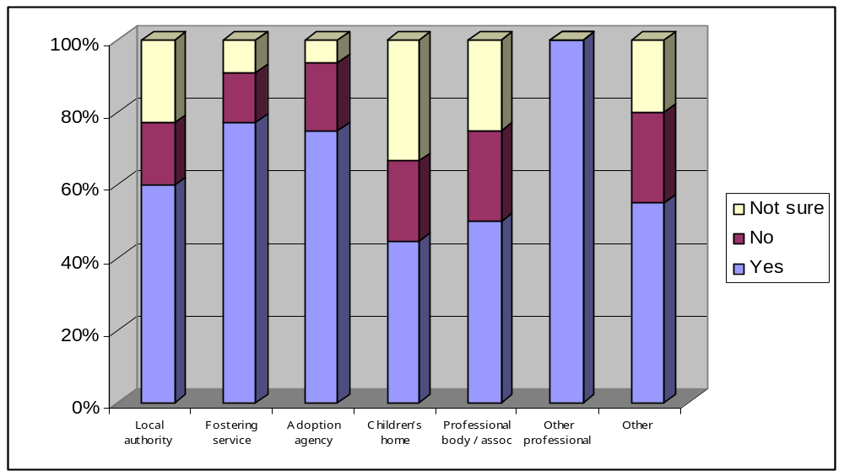
Local authority | 21 | 6 | 8
Fostering service | 17 | 3 | 2
Adoption agency | 12 | 3 | 1
Children’s home | 4 | 2 | 3
Professional body / assoc | 4 | 2 | 2
Other professional | 3 | 0 | 0
Other | 11 | 5 | 4
TOTAL | 72 (64%) | 21 (19%) | 20 (18%)

Most respondents were content with the statement concerning how the standards fit with the Every Child Matters (ECM) outcomes but there was concern in particular around how the standards fit with the inspection framework. We have avoided corralling each standard into an every child matters outcome as in many standards there is an overlap between outcomes. Ofsted are currently consulting on a new framework for children’s homes inspection with new inspection frameworks for fostering and adoption to follow. Ofsted will be making clear in their guidance how the standards fit against their inspection framework.

Q4. Do you think that the standards represent the minimum standard we should expect for the agency/service/setting and if not why?
 | Yes | No | Not sure | 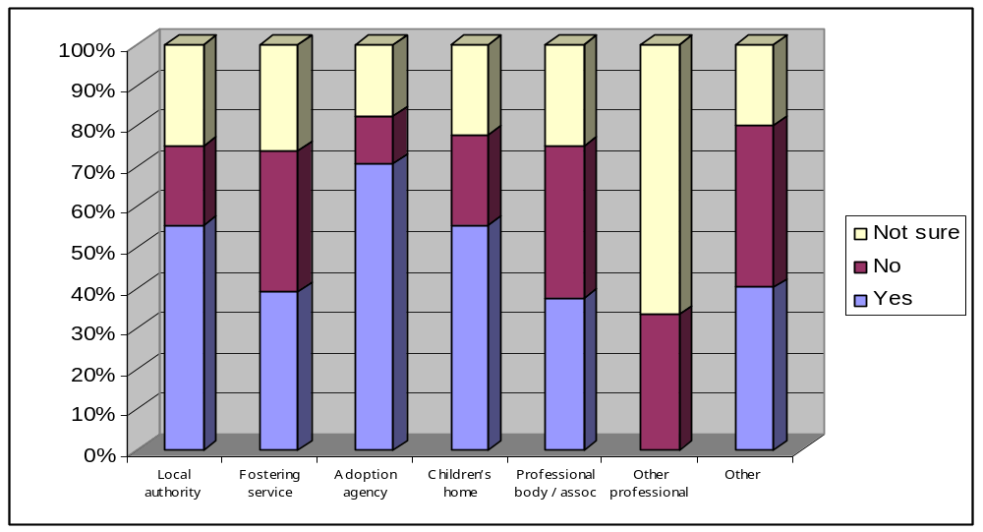
Local authority | 20 | 7 | 9
Fostering service | 9 | 8 | 6
Adoption agency | 12 | 2 | 3
Children’s home | 5 | 2 | 2
Professional body / assoc | 3 | 3 | 2
Other professional | 0 | 1 | 2
Other | 8 | 8 | 4
TOTAL | 57 (49%) | 31 (27%) | 28 (24%)

There was a mixed response to this question, with just slightly less than half of respondents agreeing that the standards represent the minimum standard we should expect from the setting. However, while some respondents felt that the standards are too aspirational, others felt that they are not aspirational enough.

Some respondents felt that there are too many standards and that they are too long and detailed. It was commented that the standards are too prescriptive; although there was also concern that the standards lack clarity, leaving them open to subjective interpretation at inspection. Some respondents were concerned that the standards should be outcome focused, rather than input or process orientated. Respondents mentioned the advantage of consistency between the different sets of NMS, reinforcing the connections between the settings and contributing to joined up thinking, but concern was also expressed that the NMS do not adequately express the differences between the sectors. The post consultation revision of the NMS aim to address these concerns by achieving a more proportionate outcome focused approach and better balance of consistency where appropriate but recognition of the difference between services.

Q.5 Do you think any of the standards are not needed or would fit better elsewhere, for example within revised statutory guidance or regulations? Please explain which standards you are referring to.
 | Yes | No | Not sure | 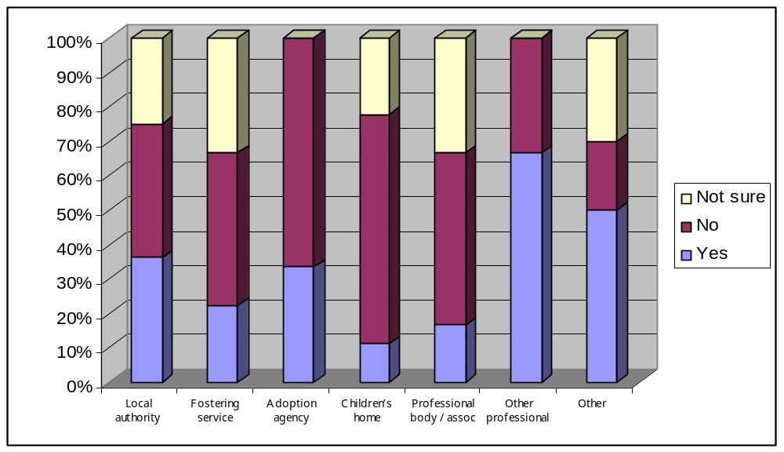
Local authority | 13 | 14 | 9
Fostering service | 4 | 8 | 6
Adoption agency | 5 | 10 | 0
Children’s home | 1 | 6 | 2
Professional body / assoc | 1 | 3 | 2
Other professional | 2 | 1 | 0
Other | 10 | 4 | 6
TOTAL | 36 (34%) | 46 (43%) | 25 (23%)

Just under half of the respondents felt that all the standards are needed. Those who said the standards were not needed were concerned with the detail within the standard rather than the actual number of headline standards. A number of respondents expressed concern about the length and repetitiveness of the standards, requesting that the detail be placed in guidance and that there be a clear distinction made between requirements, practice and aspirations, as well as who the NMS apply to. This was particularly mentioned in relation to fostering where there was concern about the clarity between the fostering service’s duties and those of the child’s responsible authority. We have worked to clarify accountability in the revised NMS and remove repetition and unnecessary detail.
The importance was highlighted of ensuring that the standards are aligned with statutory guidance and regulations and that duplication is avoided as much as possible. Some respondents suggested providing links within the NMS to a broader range of legislation. We have made links with the broader legislation in the draft statutory guidance that we are currently consulting on until 19 November 2010. The consultation version of the regulations and statutory guidance for children’s homes and fostering takes into account and references this post consultation version of the NMS.
It was commented, again, that in some cases, standards have been replicated across settings that are appropriate to one setting but not another. The post consultation versions of the NMS aim to address these matters.

Q6. Are there any additional standards you think should be included and if so what should they be?
 | Yes | No | Not sure | 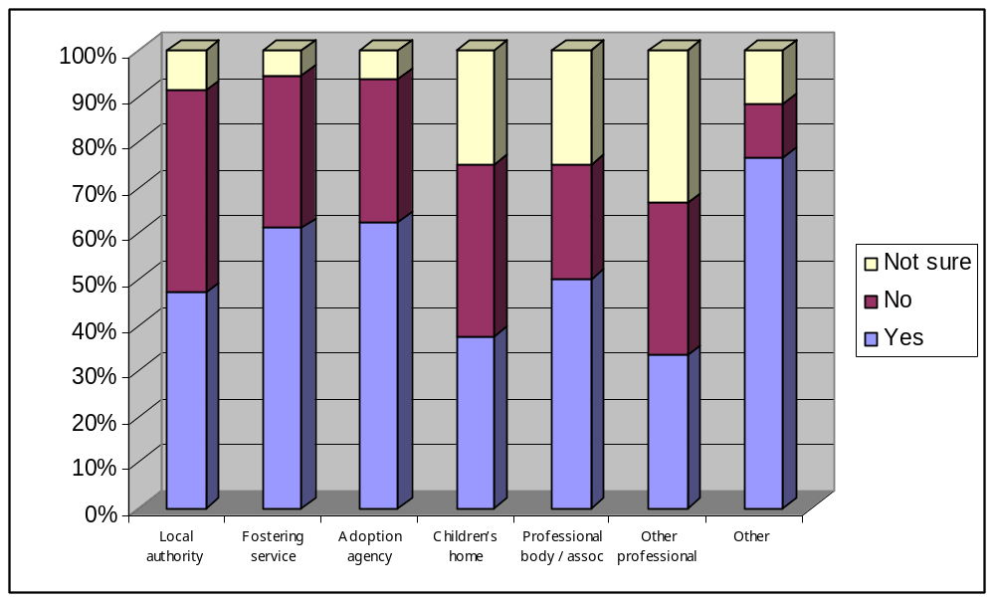
Local authority | 16 | 15 | 3
Fostering service | 11 | 6 | 1
Adoption agency | 10 | 5 | 1
Children’s home | 3 | 3 | 2
Professional body / assoc | 4 | 2 | 2
Other professional | 1 | 1 | 1
Other | 13 | 2 | 2
TOTAL | 58 (56%) | 34 (33%) | 12 (12%)

56% of respondents said that they felt additional standards should be included. The suggestions covered a broad range of matters and covered new themes as well as additions to existing standards. Several respondents suggested that there should be standards around internet safety, parent and child placements and the review of foster carers. In some cases new standards have not been incorporated because the issues are better suited to guidance and in other areas because they do not fall within the Fostering Service Regulations so would not have a statutory underpinning if put into the NMS.

Q7. Do you think that the stated outcome for each standard is appropriate? If you do not think the outcome appropriate please explain which standard and outcome you are referring to.

 | Yes | No | Not sure | 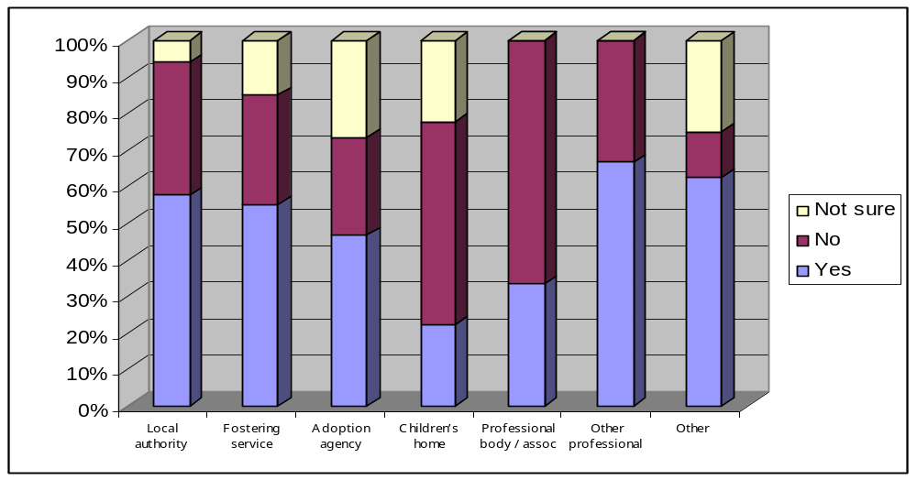
Local authority | 19 | 12 | 2
Fostering service | 11 | 6 | 3
Adoption agency | 7 | 4 | 4
Children’s home | 2 | 5 | 2
Professional body / assoc | 2 | 4 | 0
Other professional | 2 | 1 | 0
Other | 10 | 2 | 4
TOTAL | 53 (52%) | 34 (33%) | 15 (15%)

The majority of respondents felt that the outcome for each standard is appropriate. In commenting about the outcomes, respondents reiterated concerns about clarity, linking to the inspection framework and acknowledging the differences between settings. Some respondents asked that the standards be made accessible to children. These issues have been discussed above and reflected in the NMS. We will be working with the Children’s Rights Director on making the NMS accessible for children.

Q8. Do you think that the standards address the needs of all children or are there any particular groups that are not served well by the standards?

 | Yes | No | Not sure | 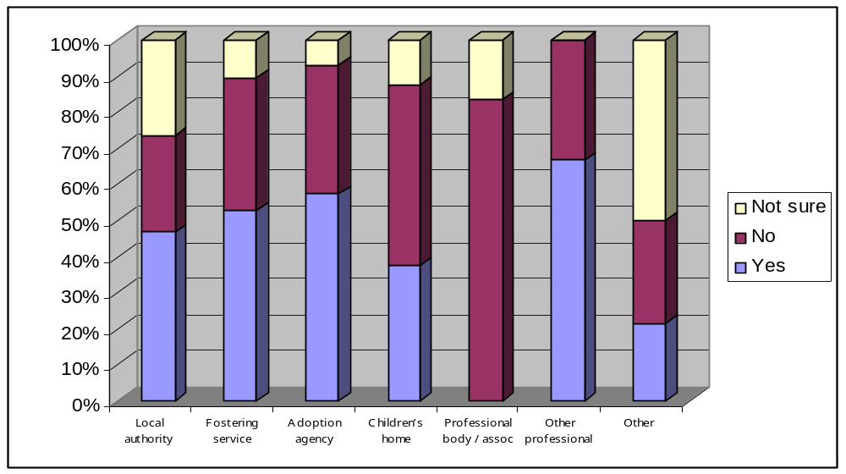
Local authority | 14 | 8 | 8
Fostering service | 10 | 7 | 2
Adoption agency | 8 | 5 | 1
Children’s home | 3 | 4 | 1
Professional body / assoc | 0 | 5 | 1
Other professional | 2 | 1 | 0
Other | 3 | 4 | 7
TOTAL | 40 (43%) | 34 (36%) | 20 (21%)

Opinion of whether the standards addressed the needs of all children was divided. 43% of respondents agreed, 36% disagreed and 21% were not sure. A number of groups were listed including, children with disabilities (including learning disabilities) and complex health needs, unaccompanied asylum seeking children, babies and young runaways. Respondents were generally not very specific about why particular groups are not served well or how they could be served better. In other cases people felt that listing particular groups within the standards was repetitive.

In revising the post consultation NMS we have taken the approach that in the majority of cases it is appropriate for the NMS to be generic, for example ‘all children are supported to communicate their views’ this would include children whose first language is not English and children with learning difficulties, disabilities, or communication difficulties. The NMS describe minimum standards which define what all children regardless of differences can expect in terms of basic standards of care. It will be for inspectors taking into account the provision and statement of purpose to reflect whether any specific needs are met to minimum standards. On balance it was felt to be overly cumbersome to list in each point how it applied to different groups and there was also the danger that if a point did not list a particular group it would be read as not applying to them.

9a) Do you agree that the transitional period which allowed individuals without certain qualifications/experience to be appointed to the post of manager is no longer required?

 | Yes | No | Not sure | 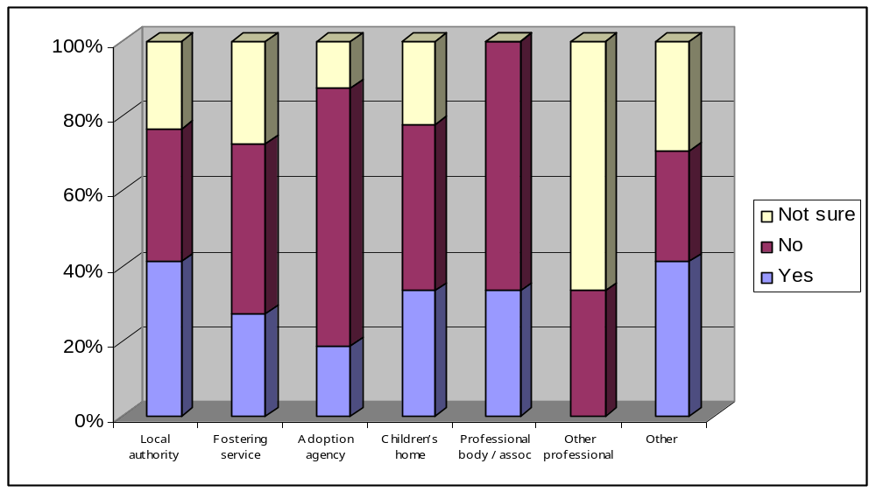
Local authority | 14 | 12 | 8
Fostering service | 6 | 10 | 6
Adoption agency | 3 | 11 | 2
Children’s home | 3 | 4 | 2
Professional body / assoc | 2 | 4 | 0
Other professional | 0 | 1 | 2
Other | 7 | 5 | 5
TOTAL | 35 (33%) | 47 (44%) | 25 (23%)

The current sets of NMS have standards that allow individuals to be appointed to the post of manager where they do not hold the appropriate qualifications. The transitional periods have lasted for a number of years and were included in the NMS to allow, for example, those individuals who were already the manager and who did not have the management qualification, to obtain it without having to give up their post.

In light of above, we consulted to ask whether people agreed that the transitional period was no longer required and could be removed. About a third of respondents agreed the transitional period could be removed stating ‘Yes, it has been several years since the requirement was made and this has been sufficient time for staff intending to have a career in managing a children’s home to train for the position.’ and ‘The sector has had ample time to address this matter and to recruit suitably qualified and experienced individuals’.

However, 44% of respondents felt the transitional period was still needed. Comments included ‘Given the difficult recruitment situation we need to ensure that agencies can appoint people with the necessary adoption experience and potential for growth into management. There should be a standard for the agency which gives a timescale between appointment and commencing a training course leading to a recognised and appropriate management position’ and ‘The challenge may be that potential new managers will not have the necessary management qualification when a vacancy arises. So unless some grace is given for otherwise suitable candidates to obtain their Mgt Qualification, this could seriously affect succession planning’ and ‘A standard about required qualifications is helpful. There needs to be a transitional period post recruitment, for example any one appointed to the role of manager must commence appropriate training within 12 months of recruitment. If you do not allow this flexibility you will cause recruitment problems’

Given the comments received, the NMS now states.

‘Appointees to the role of registered manager who do not have the management qualification (above) must enrol on a management training course within six months, and obtain a relevant management qualification within three years, of their appointment’

9b Do you agree that the qualifications and experience for managers and branch managers, provided for in the standards are appropriate?

 | Yes | No | Not sure | 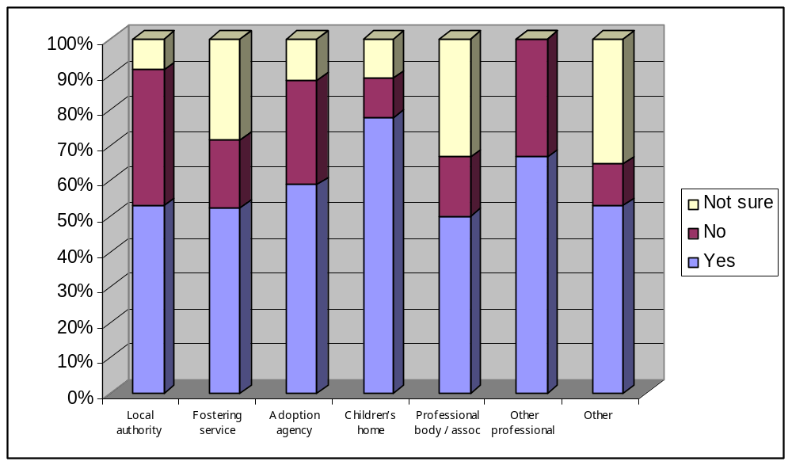
Local authority | 18 | 13 | 3
Fostering service | 11 | 4 | 6
Adoption agency | 10 | 5 | 2
Children’s home | 7 | 1 | 1
Professional body / assoc | 3 | 1 | 2
Other professional | 2 | 1 | 0
Other | 9 | 2 | 6
TOTAL | 60 (56%) | 27 (25%) | 20 19%)

The majority of respondents (56%) agreed that the qualification and experience requirements are appropriate. Comments included ‘it is essential to regard the qualifications and experience as the absolute minimum, to ensure that the complexity of the service can be managed by people with extensive skills and a history of good quality training’ and ‘It is very useful to set out the operational responsibilities of the registered manager with this level of detail’.

A number of people asked for clarity on specific points for example, what we meant by ‘at least one years experience in working at a senior level’. This has been clarified in the post consultations standards as ‘at least one years experience supervising and managing professional staff’. A number of other amendments have been made to the post consultation NMS to improve clarity.

9c Do you agree that the qualifications and training requirements provided for in the standards for staff, adoption panel members, foster carers and others working for an agency are appropriate?

 | Yes | No | Not sure | 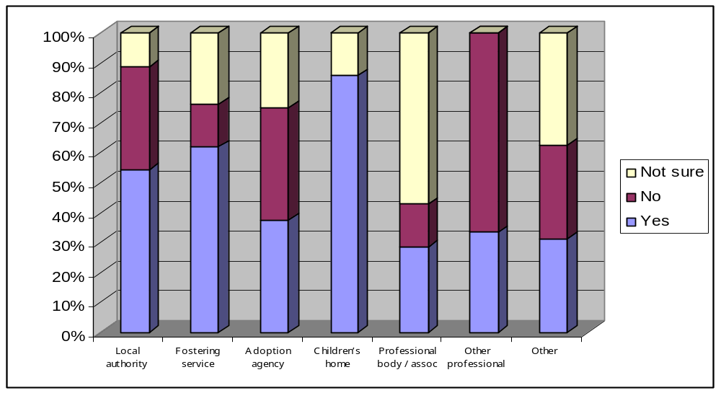
Local authority | 19 | 12 | 4
Fostering service | 13 | 3 | 5
Adoption agency | 6 | 6 | 4
Children’s home | 6 | 0 | 1
Professional body / assoc | 2 | 1 | 4
Other professional | 1 | 2 | 0
Other | 5 | 5 | 6
TOTAL | 52 (50%) | 29 (28%) | 24 (23%)

Even though 50% of respondents agreed that the qualification and training requirements provided for in the standards were appropriate, the other 50% were fairly evenly split between disagreeing and not sure.
As with comments on the managerial transitional period (Q9a above), respondents thought that 3 months to have staff in children’s homes enrolled on a course to gain NVQ/Level 3 was unrealistic and that a more attainable timeframe would be 6 months. The post consultation standards for children’s homes have been amended to reflect this. Some respondents were of the view that our use of the term social worker was confusing as it did not acknowledge that this is a protected title. We have improved clarity of wording in this area and others in the post consultation standards.

Question 10: Do you agree that the amalgamation of the current two sets of adoption NMS will make them simple to use and understand?
 | Yes | No | Not sure | 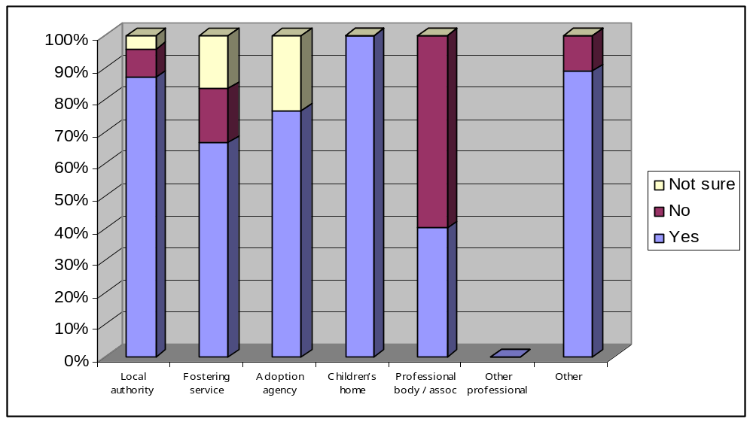
Local authority | 20 | 2 | 1
Fostering service | 4 | 1 | 1
Adoption agency | 13 | 0 | 4
Children’s home | 1 | 0 | 0
Professional body / assoc | 2 | 3 | 0
Other professional | 0 | 0 | 0
Other | 8 | 1 | 0
TOTAL | 48 (79%) | 7 (11%) | 6 (10%)

The majority of respondents agreed that the amalgamation of the current adoption agencies and adoption support agencies NMS will make them simpler to use and understand (79%). However, 10% of the respondents did not agree that the amalgamation would be as helpful to adoption support agencies as to local authorities and voluntary adoption agencies because their work is primarily with adults rather than children.
- As the majority of respondents welcomed the amalgamation and because some adoption support agencies (ASAs) provide a service to both children and adults, we propose to retain the amalgamated set of NMS. To help adoption agencies and adoption support agencies, the top of each standard identifies the type of agency the standard applies to. This information has been gathered into a table which sits in the introduction to the standards.

Where it is stated that a standard applies to adoption agencies and/or adoption support agencies, it will be for the individual agency to decide, based on the terms of their conditions of registration with Ofsted, if the standard applies to them.

Question 11 a) Are the two children specific standards: comprehensive?

 | Yes | No | Not sure | 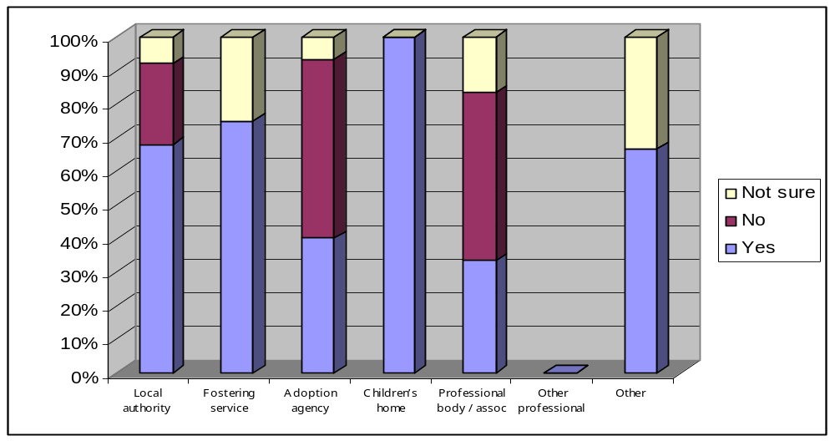
Local authority | 17 | 6 | 2
Fostering service | 3 | 0 | 1
Adoption agency | 6 | 8 | 1
Children’s home | 1 | 0 | 0
Professional body / assoc | 2 | 3 | 1
Other professional | 0 | 0 | 0
Other | 4 | 0 | 2
TOTAL | 33 (58%) | 17 (30%) | 7 (12%)

More than half of respondents considered that the two children specific standards are comprehensive (58%) while nearly a third disagreed (30%). Suggestions were put forward as to how to make the two children specific standards more comprehensive, for timescales; having separate standards for children who are brought into England; sharing of information between agencies when considering a match between a child and prospective adopters. The revised NMS include comprehensive standards around children.

11 b) Are the two children specific standards: adequate to meet the requirements of both domestic and intercountry adoptions, in respect of looked after children and children who are being brought into the British Islands by prospective adopters who have been assessed and approved by an English adoption agency/Welsh voluntary adoption agency?
 | Yes | No | Not sure | 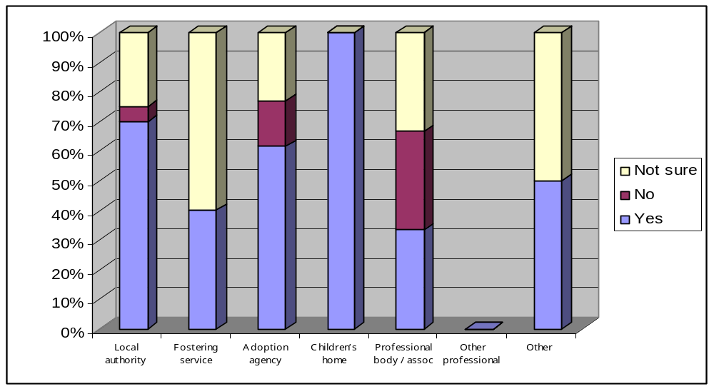
Local authority | 14 | 1 | 5
Fostering service | 2 | 0 | 3
Adoption agency | 8 | 2 | 3
Children’s home | 1 | 0 | 0
Professional body / assoc | 2 | 2 | 2
Other professional | 0 | 0 | 0
Other | 3 | 0 | 3
TOTAL | 30 (59%) | 5 (10%) | 16 (31%)

More than half of the respondents considered the standards for children were adequate to meet the requirements for domestic and intercountry adoptions. These standards have been, however, expanded and strengthened.

Question 12 a): Do you agree that disclosure of adoption information counselling should be undertaken by social workers?
 | Yes | No | Not sure | 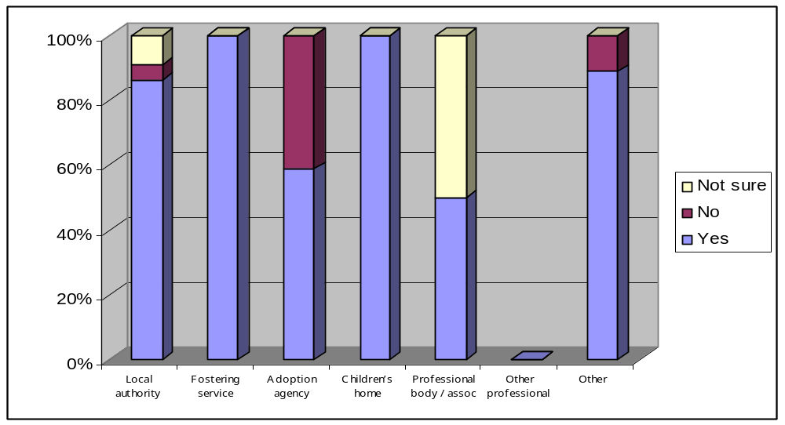
Local authority | 19 | 1 | 2
Fostering service | 5 | 0 | 0
Adoption agency | 10 | 7 | 0
Children’s home | 1 | 0 | 0
Professional body / assoc | 3 | 0 | 3
Other professional | 0 | 0 | 0
Other | 8 | 1 | 0
TOTAL | 46 (77%) | 9 (15%) | 5 (8%)

The majority of respondents agreed that social workers should undertake disclosure of adoption information counselling (77%) with some respondents confirming that only social workers provide this type of counselling within their agency. However, 15% of the respondents did not agree with the proposal.

These respondents believed that support workers and counsellors were able to undertake this work. They were concerned that some Adoption Support Agencies (ASAs) would have to close either because they would find it difficult to replace non-social worker staff and counsellors with qualified social workers or because the registered providers were individual counsellors.
The original proposal has been revised and now includes social workers and counsellors. In addition, any individual who provides disclosure of adoption information counselling who is not a social worker or counsellor, must work under the direct supervision of a social worker or counsellor experienced in that work and who takes responsibility for the counselling.

Question 12 b): Is the transitional time period long enough?

 | Yes | No | Not sure | 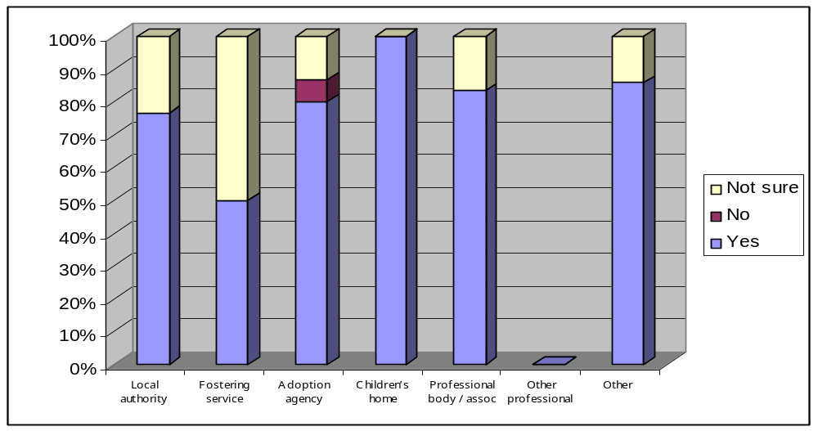
Local authority | 13 | 0 | 4
Fostering service | 2 | 0 | 2
Adoption agency | 12 | 1 | 2
Children’s home | 1 | 0 | 0
Professional body / assoc | 5 | 0 | 1
Other professional | 0 | 0 | 0
Other | 6 | 0 | 1
TOTAL | 39 (78%) | 1 (2%) | 10 (20%)

The majority of respondents agreed that the transitional time period was long enough (78%) but many thought a transitional period was unnecessary because they considered that only social workers should provide the counselling. Two per cent of the respondents considered the transitional period too long.
The transitional period has been removed in response to the concerns expressed by Adoption Support Agencies to the original proposal – see response to question 12(a) above.
Question 13 a): We would like to extend eligibility for enhanced disclosure CRB checks to fostering and adoption panel members. Currently while, for example, a social worker or medical professional sitting on a panel would be eligible for an enhanced disclosure CRB check because of their profession this is not the case for all panel members.
Do you agree that enhanced disclosure CRB checks should be sought for those adoption and fostering panel members who do not already have one by virtue of their profession and work with children?
 | Yes | No | Not sure | 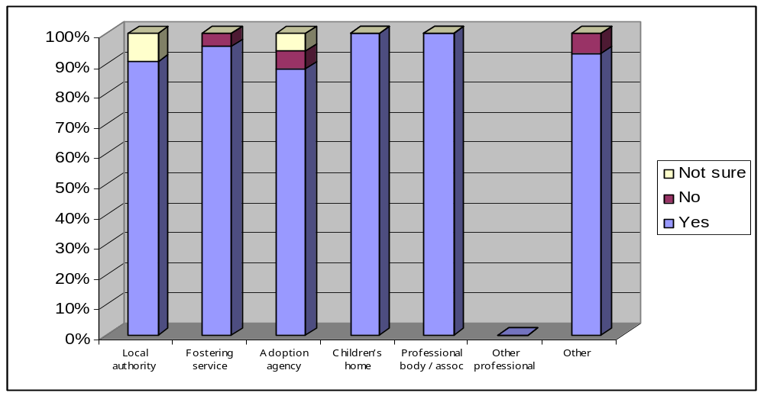
Local authority | 29 | 0 | 3
Fostering service | 22 | 1 | 0
Adoption agency | 15 | 1 | 1
Children’s home | 1 | 0 | 0
Professional body / assoc | 7 | 0 | 0
Other professional | 0 | 0 | 0
Other | 14 | 1 | 0
TOTAL | 88 (93%) | 3 (3%) | 4 (4%)

There was an overwhelming agreement to this proposal (93%) with just 3% of respondents disagreeing. Respondents confirmed that adoption and fostering panel members have regular access to sensitive and identifying information about vulnerable children and their families and in some agencies, meet children and birth family members at agency events. Similarly fostering panels may have direct access to children in addition to sensitive information. The Safeguarding Vulnerable Groups Act 2006 (Regulated Activity, Devolution and Miscellaneous Provisions) Order 2010 provides that adoption and fostering panel members are office holders and part of that means eligibility for CRB checks. Please note that the Government is currently reviewing the criminal records system.
Question 13 b): We would like to make fostering and adoption panel members ‘regulated activity' under the Safeguarding Vulnerable Groups Act 2006 and require panel members to have their Independent Safeguarding Authority (ISA) registration verified by the agency advisor and CRB checks sought on those who do not already have them by virtue of their professional position. Do you agree with this ambition?

 | Yes | No | Not sure | 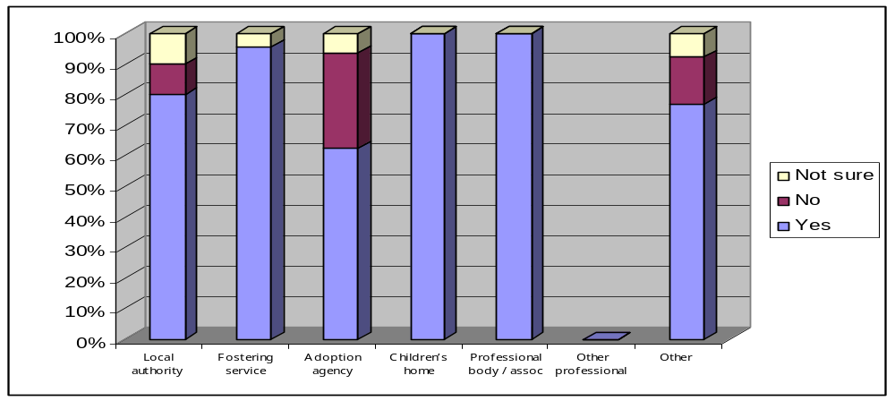
Local authority | 24 | 3 | 3
Fostering service | 22 | 0 | 1
Adoption agency | 10 | 5 | 1
Children’s home | 1 | 0 | 0
Professional body / assoc | 7 | 0 | 0
Other professional | 0 | 0 | 0
Other | 10 | 2 | 1
TOTAL | 74 (82%) | 10 (11%) | 6 (7%)
The vast majority of respondents agreed with this proposal (82%) for those reasons given above in response to question 13(a). Respondents who did not agree with the proposal (11%) considered it would affect the ability of adoption agencies and fostering providers to recruit and retain panel members. The minority who disagreed felt the proposal is disproportionate to the role carried out by adoption and fostering panel members. As above The Safeguarding Vulnerable Groups Act 2006 (Regulated Activity, Devolution and Miscellaneous Provisions) Order 2010 provides that adoption and fostering panel members are office holders and therefore are ‘regulated activity’ and can have their registration status verified. The Government is currently reviewing the vetting and barring scheme set up under the Safeguarding Vulnerable Groups Act 2006.
Question 14 a): Do you agree with the standards requiring the agency decision-maker in local authorities, voluntary adoption agency and independent fostering providers to have specific qualifications and experience?
 | Yes | No | Not sure | 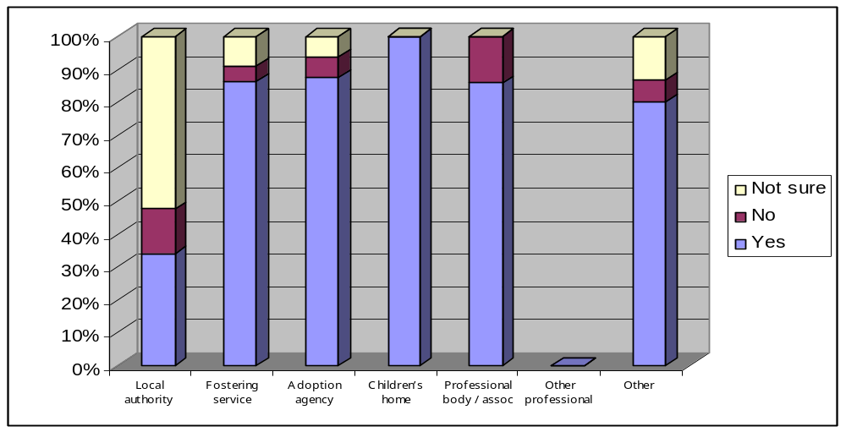
Local authority | 20 | 8 | 31
Fostering service | 19 | 1 | 2
Adoption agency | 14 | 1 | 1
Children’s home | 1 | 0 | 0
Professional body / assoc | 6 | 1 | 0
Other professional | 0 | 0 | 0
Other | 12 | 1 | 2
TOTAL | 72 (80%) | 12 (13%) | 6 (7%)
This standard was welcomed as a positive step in terms of improving the quality of decision-making for adoption work. While the vast majority of respondents agreed with the proposal (80%) there was concern that the standard was too restrictive and that those agencies whose decision-makers are not social workers, would find it difficult to replace them.
We propose to keep the requirement but remove the need for the decision maker to have direct experience of the recruitment, preparation, assessment and support of prospective adopters. This new requirement has been included in the fostering NMS, as requested by many respondents.

Question 14 b): Are those standards appropriate and comprehensive?
 | Yes | No | Not sure | 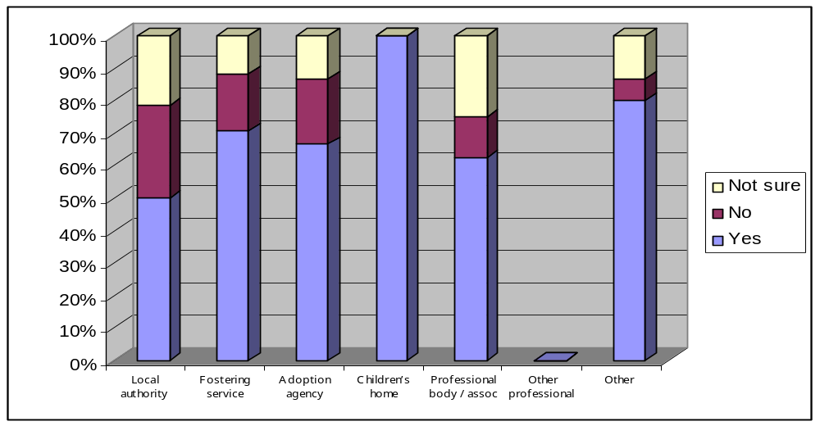
Local authority | 14 | 8 | 6
Fostering service | 12 | 3 | 2
Adoption agency | 10 | 3 | 2
Children’s home | 1 | 0 | 0
Professional body / assoc | 5 | 1 | 2
Other professional | 0 | 0 | 0
Other | 7 | 3 | 2
TOTAL | 49 (61%) | 17 (21%) | 14 (18%)
Over half of the respondents agreed that the standards were appropriate and comprehensive (61%) but 21% disagreed. Similar concerns were expressed as set out above. Clarification was sought of who could be the decision-maker; whether the decision-maker could have a deputy.
The standard has been revised to remove the requirement for the decision-maker to have direct experience of the recruitment, preparation, assessment and support of prospective adopters. A similar standard has been included in the NMS on fostering

Q15 a): Do you agree that the standards adequately address issues relating to short-break care?
 | Yes | No | Not sure | 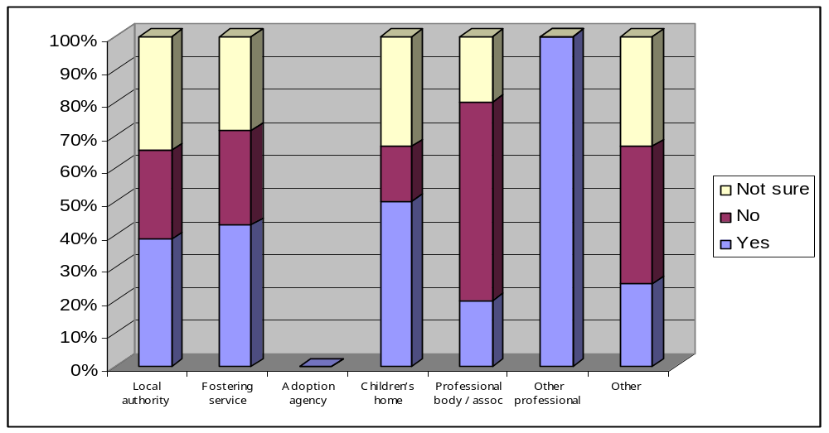
Local authority | 10 | 7 | 9
Fostering service | 9 | 6 | 6
Adoption agency | 0 | 0 | 0
Children’s home | 3 | 1 | 2
Professional body / assoc | 1 | 3 | 1
Other professional | 1 | 0 | 0
Other | 3 | 5 | 4
TOTAL | 27 (38%) | 22 (31%) | 22 (31%)
Just over a third (38%) felt that the standards adequately addressed short break care. Where people said that the did not or they were not sure if the standards adequately addressed short break care they were still welcoming of the recognition that many children in short break care are not looked after children and that the standards recognised in some cases that the standards need to be exempted or applied flexibly for short break care. Some people proposed that separate set of standards and regulations and others felt that it would be helpful to have a summary of the standards which do not apply to short break care to save people reading through the document. People were also concerned that there should be greater consistency between children’s homes and fostering for the treatment of short break care in the standards. The Post consultation NMS summarise which standards do not apply to short break care and give greater consistency in application across children’s homes and fostering.
Q15 b) Do you agree with the proposals within the NMS to disapply specific standards for providers of short break care?
 | Yes | No | Not sure | 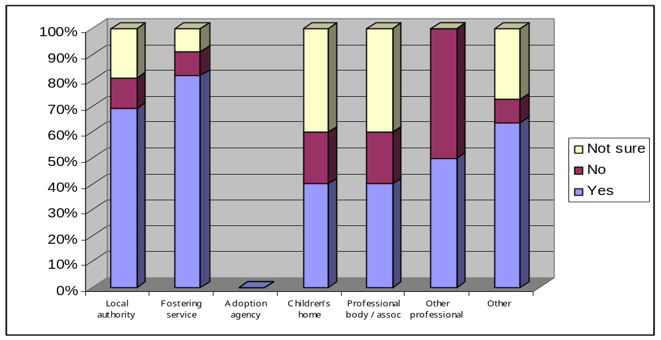
Local authority | 18 | 3 | 5
Fostering service | 18 | 2 | 2
Adoption agency | 0 | 0 | 0
Children’s home | 2 | 1 | 2
Professional body / assoc | 2 | 1 | 2
Other professional | 1 | 1 | 0
Other | 7 | 1 | 3
TOTAL | 48 (68%) | 9 (13%) | 14 (20%)

A majority of respondents (68%) agreed with the proposals to dissaply certain standards in relation to short break. A comment included that it appears a more proportionate response that properly respects the role of the parent in such placements. Some providers said that it has been difficult as a provider of short breaks to meet some of the standards and we they now feel there is a common sense approach to short breaks. above comments were made around the importance of clarifying exactly what applies and what does not apply to short break care.

Q15 c): Do you agree with the proposals within the NMS to allow flexibility in relation to specific standards for providers of short break care?
 | Yes | No | Not sure | 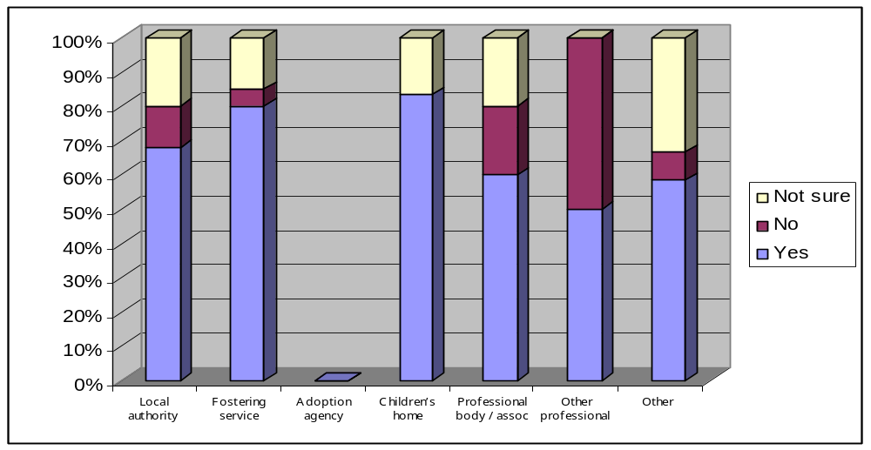
Local authority | 17 | 3 | 5
Fostering service | 16 | 1 | 3
Adoption agency | 0 | 0 | 0
Children’s home | 5 | 0 | 1
Professional body / assoc | 3 | 1 | 1
Other professional | 1 | 1 | 0
Other | 7 | 1 | 4
TOTAL | 49 (70%) | 7 (10%) | 14 (20%)

A majority of respondents (70%) agreed with the proposals. A number of respondents stressed the importance of consistency of inspection against the standards and again of clarity of approach in relation to particular standards. We have aimed to address these concerns in the revised NMS and a decrease in the amount of detail should also make it clearer how standards apply to short break care. In parallel, the consultation on the fostering services regulations and children’s homes regulations that finishes 19 November 2010 seeks views on exemption from certain regulations in relation to short break care and clarifies what we mean by short break care.

Q16 : This question asked for views on whether it should be made easier for foster carers to transfer from one fostering service to another. This would require a greater standardisation of the assessment process and further clarity in standards and regulations in terms of what is expected. We would be grateful for you views on what information should be provided for in regulations and in standards.
 | Yes | No | Not sure | 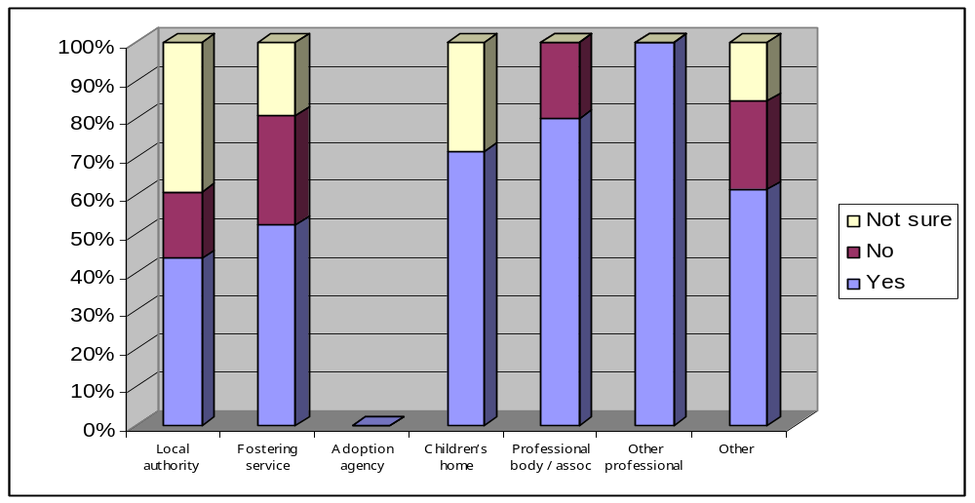
Local authority | 10 | 4 | 9
Fostering service | 11 | 6 | 4
Adoption agency | 0 | 0 | 0
Children’s home | 5 | 0 | 2
Professional body / assoc | 4 | 1 | 0
Other professional | 2 | 0 | 0
Other | 8 | 3 | 2
TOTAL | 35 (53%) | 14 (21%) | 17 (26%)

Just over half of all respondents and just over half of fostering services respondents thought that it should be made easier to transfer from one fostering service to another. The main purpose of this questions was to seek views on this as barriers to foster carers easily moving from one service to another could not be entirely solved by amending the NMS and would need changes in regulations. Respondents also expressed concern that it is important that the agency importing the foster carer carries out a proper assessment. The post consultation revision of the standards does include in standard 24 that when a foster carer seeks to move to a new provider, the new provider seeks information from the previous provider about the prospective foster carer, and the previous provider complies with such a request within 28 days of receipt of the written request. We are currently consulting on the Fostering Services Regulations until 19 November 2010. The draft regulations state that a fostering provider must make their records about the foster carer available for inspection by another agency within a month. The actual assessment process set out in regulations for approving a foster carer is streamlined and providers can choose to go beyond this by completing a fuller assessment. However, this is not a regulatory requirement. The draft regulations also set out a process for approval of a foster carer where an agency closes.

Q17 Currently, a foster carer (approved by the service) or member of the foster carers household cannot work in a management or social work position for the fostering service. They may work in a professional position for the fostering service as long as the work undertaken is on an occasional basis, as a volunteer, or for no more than 5 hours in any week.

Do you agree this provision is needed to avoid conflict of interest where a foster carer may both work for and be assessed by the agency?
We would find it helpful to get views about how we could avoid conflict of interest where a person may inappropriately be able to sway decision making, but allow foster carers to work for the service, for example, by attending recruitment events or helping with training.

 | Yes | No | Not sure | 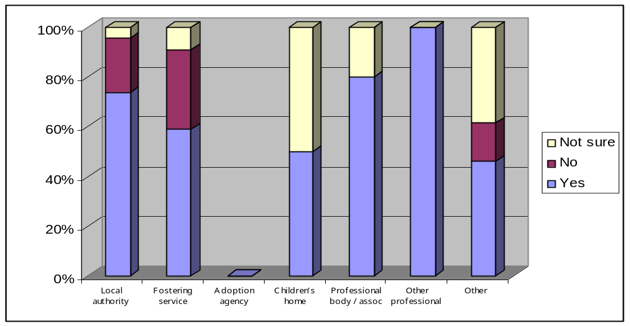
Local authority | 17 | 5 | 1
Fostering service | 13 | 7 | 2
Adoption agency | 0 | 0 | 0
Children’s home | 1 | 0 | 1
Professional body / assoc | 4 | 0 | 1
Other professional | 1 | 0 | 0
Other | 6 | 2 | 5
TOTAL | 42 (64%) | 14 (21%) | 10 (15%)

A majority of people felt strongly that there was still a need for stipulating rules around what foster carers can do for their provider. A foster carer responded that she would not work for her agency and a number of independent providers and local authorities commented that it is justified and as there may be conflicts of interest and it is better for foster carers not to be employed within an agency. Within the comments section respondents said that positions such as ‘buddy’, mentor, involvement in recruitment and in a support role such as foster carer preparation training were seen as functions which do not cause a conflict of interest. People commented that ‘the existing standard is helpful as foster carers have a lot to offer at recruitment events, training sessions, and consultation exercises. However, we do not believe it is appropriate for a foster carer to work as a member of staff for the agency.’ Fostering Network’s Young People Project mentioned the positive experience of foster carers being involved in training and events alongside sons and daughters of foster carers and young people who have been in foster care and said that therefore this should not be stopped or made difficult in the standards.

We are currently consulting on the draft Fostering Services regulations until 19 November 2010. Given responses to the consultation question in the NMS we have retained the provision that foster carers and members of the household can only work for no more than 5 hours a week in a position which is not management or social. However, we have included that foster carers or members of the household can also be employed to train or mentor foster parents approved by the fostering agency, including for more than 5 hours a week. This reflects that these were the areas were people thought foster carers and their family could add most value and where they thought it would be helpful to have flexibility to use foster carers creatively and for more than 5 hours a week. We have also specified this in the draft regulations as people felt it was unclear at the moment that foster carers and their households could undertake mentoring and training etc. Comments included ‘Five hours per week is very limited. Many foster carers have the time and skills to assist with support groups, planning meetings, training etc. We feel foster carers have much to offer and can undertake work for the fostering service which does not present a conflict of interest. We feel that 5 hours is too restrictive’.

Q18 Do you think that it should be compulsory for the systems of restraint used in children's homes to be subject to some form of accreditation to evaluate the safety of the restraint techniques?

 | Yes | No | Not sure | 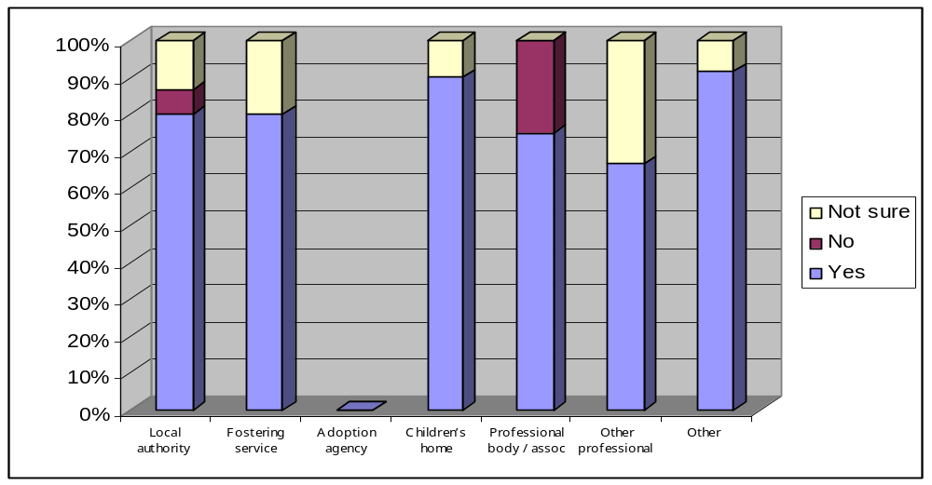
Local authority | 12 | 1 | 2
Fostering service | 4 | 0 | 1
Adoption agency | 0 | 0 | 0
Children’s home | 9 | 0 | 1
Professional body / assoc | 3 | 1 | 0
Other professional | 2 | 0 | 1
Other | 11 | 0 | 1
TOTAL | 41 (85%) | 2 (4%) | 5 (10%)

The majority of respondents overall and the majority of children’s homes agreed that systems of restraint used should be accredited. Comments included ‘Whilst restraint should only be used in very specific circumstances, an accreditation system is essential in ensuring even further that the restraint techniques are safe. Harm has come to children through the use of restraint, and lack of staffing means that it can sometimes not be used properly. Restraint can also result in emotional harm to children and may re-traumatise them in relation to their early experiences. In addition, methods should be consistent across services in line with currently agreed best practice.’ and ‘Yes, systems for physical intervention should be formally accredited for use in children’s settings and only those methods that have been formally ‘approved’ should be permitted. Whilst no method of physical intervention can be fully risk free, research indicates that some approaches are safer than others and homes should be given clear guidance about which approaches are permissible and which are not. All permitted methods of restrictive physical intervention should only be used by staff who have been assessed as competent through an accredited training course, with regular refreshers’. A minority of comments expressed concerns over possible cost implications and that accreditation by itself does not ensure that a restraint method will always be applied safely to individual children . One person responded they were concerned about which restraint providers would get accredited.

We are currently consulting on the draft Children’s Homes Regulations until 19 November 2010. The regulations include a regulation on when restraint can be used and we would welcome your views. Government accepted the recommendations of the independent Review of the Use of Restraint in Juvenile Secure Settings by Peter Smallridge and Andrew Williamson that only accredited methods of restraint should be used in juvenile secure settings, which will include Secure Children’s Homes.
Work to establish an authoritative panel to accredit restraint techniques that may used in the secure estate is being lead by the Ministry of Justice and information about this will be shared with secure children’s homes providers as soon as this is available.
Q19 : Do the standards allow sufficient flexibility to deal with children who have very challenging behaviour, while sufficiently safeguarding those children (in particular, with regard to behaviour management and restricting movement)?

 | Yes | No | Not sure | 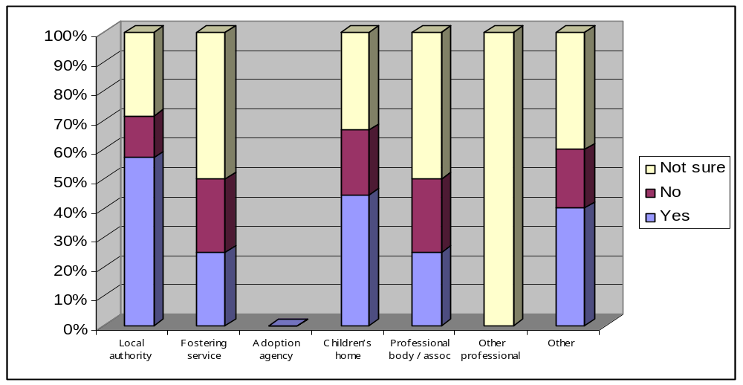
Local authority | 8 | 2 | 4
Fostering service | 1 | 1 | 2
Adoption agency | 0 | 0 | 0
Children’s home | 4 | 2 | 3
Professional body / assoc | 1 | 1 | 2
Other professional | 0 | 0 | 3
Other | 4 | 2 | 4
TOTAL | 18 (41%) | 8 (18%) | 18 (41%)

Some concern was expressed that the standard did not allow for more flexibility in restricting liberty, perhaps by locking doors, in order to protect groups of children who were thought to be especially vulnerable – mention was made of children with severely challenging behaviour and children with a very limited understanding of safety. The revised standards recognise that there may be exceptional circumstances that would permit restricting a child’s liberty

Just under half (41%) of respondents felt that the standards allowed sufficient flexibility to deal with children who have very challenging behaviour while sufficiently safeguarding those children, in particular, with regard to behaviour management and restricting movement.

Respondents made a number of suggestions for improvement, for example, some fostering organisations felt there was too much emphasis on restraint in the fostering standards and this has been rebalanced in the post consultation draft. A number of respondents also pointed out how important it is not to criminalise young people where possible, again the revised draft of the standards attempts to do this.

Several respondents made the point that supporting children to develop, positive patterns of behaviour is dependent on good quality care planning and providers following consistent models of intervention, so that the need to respond to incidents of challenging behaviour is “planned out” of a provision’s routines. Good practice might involve actively consulting children to develop a provision’s behaviour support plan.

A significant, minority of respondents considered that there was a delicate balance between restriction of liberty and safeguarding, this was particulate in the context of behaviour management in children’s homes, for this reason they thought that further guidance would be helpful. We are currently consulting on the draft Children’s Homes statutory guidance until 19 November and would welcome your views.

Q20: Currently Children's Homes which have different buildings on the same site or adjacent sites are operated as a single home, but establishments on different, non-adjacent sites must be registered and operated as separate children's homes. We would welcome views about how regulations could be improved to both safeguard children and avoid duplication of information as part of the registration process?

As this was not a ‘yes/no/not sure’ question, we do not have a breakdown on responses in the same way as the questions above.
We received very few comments in relation to this question. However, the vast majority of these comments supported separate registration for children’s homes located on different sites. Therefore, we have decided to keep the existing requirements the same. Comments included that ‘The current arrangements should remain in place, as interrelated factors such as leadership, management, supervision, service levels, staff skills and expertise, accommodation, catering, access to local services, ethos, current population needs, etc, may differ very significantly in non-adjacent sites .’ (School head) ‘Would feel that young people are best safeguarded by maintaining separate registration.’ (Local authority). ‘NASS would be content to see current practice continue. For schools with several residential buildings on site, we would not welcome any move to make each building register separately’ (National Association of Independent Schools and Non-maintained Special Schools). Another respondent felt that the practice should continue but application to register should be streamlined. The revised registration regulations that came into force October 2010 aim to streamline the process where an applicant is already known to Ofsted (see Regulation 3 (5)). The regulations can be found at http://www.legislation.gov.uk/uksi/2010/2130/contents/made

