Higher Education Funding Council for England

Ref 99/19

March 1999

National Institute for Adult Continuing Education

Non Award-Bearing Continuing Education
An Evaluation of the HEFCE programme 1995-1998

by
Stephen McNair
with
Sue Cara
Veronica McGivney
Fiona Raybould
Jim Soulsby
Alastair Thomson
Mike Vaughan.

Preface
This is a report on the Non Award-Bearing Continuing Education programme (NABCE), funded by the Higher Education Funding Council for England (HEFCE) between 1995 and 1998. It is a product of the evaluation of the programme which the Council commissioned from the National Institute of Adult Continuing Education (NIACE), and focuses particularly on the policy implications of the work.
Widening participation, and liberal adult education have a long and complex history in British higher education, with distinctive traditions and funding mechanisms in the universities and polytechnics. Following the merging of the two into a single higher education sector in 1992, the HEFCE sought to develop a coherent funding approach which treated all institutions equitably. It did so by encouraging the old universities to “mainstream” work which had previously been funded separately, bringing it into the administrative, quality assurance and funding frames used for other higher education activity.
However, concern was expressed in many quarters that valuable work might be inadvertently damaged by this, especially in two areas of non award-bearing work: Liberal Adult Education (LAE) and widening participation. The former was traditionally not accredited, and delivered in distinctive ways and locations which made the mainstream systems difficult to apply. The latter often called for special strategies, with different time scales, funding requirements, curricular and organisational needs. In response, the Council agreed in 1995 to create a competitive fund to which institutions could bid for resources for work in both these fields, and commissioned NIACE to evaluate the programme.
Since then, the context has changed significantly. The Dearing Committee gave positive support to a continued widening of participation, and highlighted the fact that expansion of numbers had not meant a significant widening of recruitment. The Government’s consultative paper on lifelong learning, The Learning Age, changed the emphasis of Government policy, paying greater attention to the role of education in overcoming social exclusion, and in community development. The Government’s interest in the development of regional structures added greater weight to initiatives which strengthen links between higher education institutions (HEIs) and their local and regional communities, and most recently Ministers have expressed concern about the place and survival of some forms of LAE.
The issues addressed in the NABCE programme have thus become more central to the national policy agenda. Although the projects were not set up to explore policy issues, their experience, and the debates around them, can help to shape our understanding of the way forward. This report is a contribution to that understanding.

Contents
1. Preface
2. Contents
3. Executive summary
4. The context
5. Widening provision
5.1 Targeting
5.2 Participation in what?
5.3 Liberal adult education and widening participation
5.4 Six approaches to widening participation
6. Liberal adult education
6.1 The historical context
6.2 The projects
6.3 What was “Liberal adult education”?
7. Two Kinds of higher education?
8. Conclusions
9. Policy implications
9.1 The case for special funding
9.2 Concentration or diffusion?
9.3 The project/mainstream balance
9.4 Criteria for funding
9.5 Making development work
11. Appendices
11.1 The interim report
11.2 Evaluation methodology
11.3 The widening participation questionnaire
11.4 The liberal adult education questionnaire
11.5 The project steering group
12. References
13. Index

Executive summary
Higher education institutions have always done more than carry out formal research and teach students on degree programmes. This report is concerned with two other activities: “liberal adult education”, which traditionally offered educational programmes and activities to a range of learners who do not seek formal accreditation, and “widening provision”, which sought to encourage those who would not normally expect to participate in higher education to do so, by offering preparatory programmes or by other activities.
Prior to the creation of a unified higher education system in 1992, this work had been differently funded in different sectors and institutions, and funding was often not directly related to student numbers on accredited courses. It therefore presented a particular challenge to the new Funding Council as it sought to create a unified and equitable funding methodology. Most of the pre-1992 universities had received separate funding for liberal adult work, while the polytechnics had resourced it from their mainstream funding. The HEFCE encouraged the pre-1992 universities to bring their LAE work into their mainstream funding and quality assurance processes (“mainstreaming”), and all did so for the majority of the activity. However, a residue remained, and doubt was expressed in the institutions about whether the new approach could adequately support all the valuable work previously undertaken.
At the same time, concern had been growing that the expansion of student numbers in the late 1980s and early 1990s had not widened access to non-participant groups. Such widening was believed to call for special initiatives, which might not be course based, to promote higher education and to prepare individuals for entry.
In response to these concerns, the HEFCE created the Non Award-Bearing Continuing Education programme (NABCE), and invited institutions to bid for funding to carry out work on widening provision (WP) and/or liberal adult education (LAE). It provided £4.6 million pounds a year over 4 years; and bidding was open to all HE institutions, whether or not they had previously received specific funding for liberal adult education. After a competitive bidding process 46 WP and 20 LAE projects were funded.
This report is the result of the evaluation of the programme, which the HEFCE commissioned from the National Institute of Adult Continuing Education (NIACE). Over three years, five NIACE staff undertook a series of visits to 20 sample projects, and read project documentation. In addition there were three surveys of projects, four national seminars, and two national conferences.

The context
The rationale for widening participation is both economic (that the public interest requires the maximisation of human resources) and ethical (that it is unjust for people who could benefit from higher education to be excluded from its evident social and economic benefits by the accidents of class, ethnicity, gender, disability or location).
The rationale for liberal adult education is more complex and contested. Its elements include the role of the higher education institution (HEI) in sharing knowledge, in promoting citizenship and overcoming exclusion, and in developing the capacity of its local and regional communities.
Since 1995, when the programme was launched, there has been a substantial change in the policy priority given to these issues. Government and others are now much more concerned with the role of HEIs in overcoming social exclusion, and in the social and economic development of their regional and local communities. Since all the WP projects, and most of the LAE ones, had these issues as a major focus, their outcomes and lessons became of interest to a growing policy community. However, the programme was not constructed for this purpose, and the tension between the local objectives of individual projects and the broader policy agenda was a feature of the evaluation.

General Issues
The WP and LAE projects were funded differently, the former on an “activity” basis and the latter on student numbers. However, there was considerable overlap in activities and objectives.
The diversity of institutions and projects makes it difficult to identify simple transferable lessons, or to generalise about success. Significant innovation for one project might be established practice for another, and a successful strategy for one was impossible for another. The projects varied in size (with funding ranging from £20,000 to £190,000 a year), in target groups, objectives and methodology. The institutions varied in mission, structure, previous experience of continuing education, extent and strength of established partnerships, and experience of project management.

Widening provision
Many of the WP projects sought to create and maintain infrastructure to support widening participation, rather than to provide courses. Much of the activity had long-term objectives, and did not expect to produce substantial changes in student numbers in that institution during the life of the project (although some did achieve this).
The principal target groups addressed by the 46 projects were (many projects targeted several groups):
- ethnic minorities (21 projects)
- women (15)
- rural communities (9)
- people with disabilities (6)
- learners in the “third age” (4).

Almost all saw their highest priorities, and greatest areas of success, as:
- developing partnerships with external agencies
- developing advice and guidance for potential students and for non-traditional students already enrolled in the institution
- changing public perceptions of higher education.

A majority of projects also saw as priorities (but with lower levels of success):
- changing the culture of their institution
- changing its institutional structures and processes, to make them more appropriate for non-traditional learners
- curriculum change (principally the curriculum outside degree programmes).

Structural characteristics of the most successful projects were:
- well established long-term partnerships with other agencies
- embedding of the work in the institution’s mission
- a broad and flexible view of participation in HE
- a long-term strategy.

Outstanding features of the most innovative projects were:
- the use of existing students (mainly young undergraduates), as mentors, tutors, outreach workers and researchers, in order to create role models for others, and build links between communities and the institution
- community development strategies, designed to engage members of excluded communities in multiple ways with the institution and its resources.

Notable curricular innovations included new:
- preparatory programmes
- bridging and induction programmes
- summer schools
- associate student schemes
- study skills programmes.

Weaknesses of some of the projects included:
- marginality and low status in institutional priorities - by comparison with research and teaching quality assessment
- failure to draw on previous work elsewhere
- lack of mechanisms for student feedback on the work
- lack of embedding in institutional structures.

The absence, or unavailability, of data on non-traditional students made monitoring and evaluation particularly difficult. Although mainstream statistical systems have improved during the life of the programme, problems remain, particularly with groups of students reluctant to declare themselves, as is the case with some non-visible disabilities.

Liberal adult education
LAE has a complex history, and its definition and purposes are contentious. Most of the separately funded work of the pre-1992 universities had been incorporated into “mainstream” structures before the NABCE programme was launched.
Some projects were based in institutions which had received separate LAE funding prior to “mainstreaming”, others were receiving such funding for the first time. Although some projects used the funds to continue previous work which had not been “mainstreamed”, most used them for programmes which were new to that institution, although similar work was often already established in other institutions (in HE or other sectors).
Against the formal criteria of the programme, the LAE projects achieved their agreed student numbers, and can properly be regarded as “successful”. However, the increased policy interest in this field raises broader questions about the precise definition of LAE, and the rationale for its separate funding, to which the projects collectively do not provide clear or simple answers.
There was no consensus among the projects about the essential components of “liberal adult education”. The special features which were identified by the projects can be described in five broad clusters:
- work to widen participation by excluded groups (by far the commonest)
- sharing knowledge with external communities
- maintaining “open structures” for learning (including non-assessed work; innovative curriculum, modes of delivery and subjects; and “level-free” learning)
- work for empowerment and citizenship (prominent in the literature on LAE, but more evident in the WP projects than the liberal adult education ones)
- work which is not assessed and/or accredited

Successes of the LAE work include:
- involvement of new groups and communities in higher education
- imaginative approaches to sharing knowledge through day schools and events
- raising awareness and changing the image of HE
- changing staff attitudes within the university
- evidence of high levels of demand and recruitment: most projects exceeded their (very varied) student number targets.

Conclusions
The following conclusions arise from the evaluation.
Excluded communities
While it is possible to widen participation for individual members of excluded groups through specific programmes, the project experience suggests that the key to successful impact on excluded communities lies in a multi-stranded, capacity building approach. Where an institution adopts such an approach, engaging with the community on several fronts simultaneously, and working in partnership with other agencies, it can make a substantial impact on both the culture of the institution and its relevance to the capacity of those communities.
Target groups
The range of groups who are currently excluded is large and diverse. Members of different groups have different needs, and strategies for widening participation need to reflect this. It is particularly important to recognise the differences between excluded young people and older ones. Although there were examples of successful linking of the two, this is unlikely to happen without careful planning.
Institutional commitment
Institutions vary greatly in their commitment to, and ability to manage, this work. The best have a long established network of community partnerships at institutional level, and expertise in using these. Others have networks at a low level (through individual staff connections for example), which make small scale activity possible, but are insufficient to make strategic impact. A third group are involved only in a particular area (such as opportunities for particular disabled groups), and a fourth have few links of any kind.
Successful partnerships depended on long-term commitment, and were more likely when there was some stability in staffing and institutional structures, and genuine sharing of expertise and knowledge. Successful projects took a broad view of the kinds of work which an HE institution can legitimately undertake.
Project-based approaches
The project-based approach did succeed in stimulating innovation, and imaginative risk taking, and helped to build partnerships. It appeared to be less successful at producing cultural and institutional change in HE, except in those cases where the work was strongly supported by institutional mission, and sponsorship from people with major influence (formal or informal) within the institution.
Funding
The availability of dedicated ring-fenced funding for development work has led to significant innovation and development. Without such funding some institutions would not have engaged in this work, and in the light of other, more powerful, institutional and cultural pressures some will not continue it. The fact that funds had been won competitively from the HEFCE gave the work added status and influence in some institutions, and many institutions were able to use this funding to generate additional external resources.
Infrastructure
Many of the major costs of work to widen participation and maintain LAE are not in the provision of courses, but in maintaining the infrastructure of partnerships, outreach, and administration. Such infrastructure is often more expensive than that required for mainstream course provision.
Knowledge base
Over four years the projects have created a substantial body of expertise among their staff, which constitutes an important resource for future development. However, most of these were employed on fixed-term contracts, and there is a danger that this body of knowledge will be dissipated or lost when projects finish. Furthermore, there are insufficient opportunities for sharing knowledge and experience among those engaged in development work of this kind, both within HE, and between HE and other sectors. Support for formal networking should be a priority for future development, to accelerate the process of change and avoid repetition of mistakes.

The case for special funding
Since the mainstream funding of HE is based on numbers of students on formal programmes, its effect is to disadvantage institutions which undertake the kinds of activity supported through the NABCE programme. However, despite the rising prominence of the work in national policy, the use of the negative definition (“non award-bearing”) reinforces a view of this work as marginal to the principal (“award-bearing”) purposes of HE. It is important therefore, to be clear about the rationale for separate funding of such work, and devise funding approaches which do not disadvantage it.
The evidence from the projects suggests four reasons why such special funding might be necessary:
- Activity based work
Outreach, promotion and community development activity does not directly generate student numbers. In so far as this has a long-term effect on increasing or widening recruitment, it might be seen as a long-term investment, rewarded later through the mainstream methodology for widening participation.
- Not explicitly “HE level”
This includes: work to change perceptions of HE in excluded communities; work with groups operating at “mixed levels”; work not easily definable in terms of level; work where a programme at a “lower” level was part of a piloting or research activity. Like the first category, some of this work could be seen as a long-term investment to be rewarded in the future by mainstream funding. However, this requires that institutions take a very long view of the institution’s strategy, and not all seem disposed, or able to do this. Some of these issues might be addressed by more creative partnerships with FE colleges.
- Non-accredited work
For some students, accreditation presents a motivational barrier to access, and for others it is simply irrelevant. Sometimes such students are enrolled in the same courses as others who do seek accreditation and formal awards. Where eligibility for funding is based on accreditation of a programme, rather than of the individuals on it, the mainstream funding methodology could support this, although the legitimacy of this approach is contested, and there are practical difficulties.
- Communal objectives
Work whose primary objective is to build the capacity of particular communities or organisations, rather than to advance individual members of those communities (which might nevertheless be a secondary or incidental outcome).

The experience of the NABCE programme suggests that if work of the kind carried out by the projects is to be sustained and encouraged more widely, three funding streams are required:
- Mainstream
With appropriate adjustments to recognise the additional costs of non-course activity, the mainstream route could properly support the activity based work, which relates primarily to widening participation.
- Non award-bearing
Here there is a need to support institutions in providing for students who enrol on mainstream courses, but who do not seek individual accreditation.
- Communal
Here there is a need to provide separate resources, not based on student numbers, to support institutions in developing the capacity of local and regional communities, based on agreed strategies, public consultation and evaluation. Like the work which institutions do with particular employers or industries, community capacity building work has collective, rather than individual objectives. Although it is likely that such an approach would, over time, have the effect of widening participation, as awareness of and confidence in higher education grows in excluded communities, to measure and reward it through student numbers on award-bearing courses would be to distort its fundamental purposes.

The context

History

Three traditions of higher education
The issues raised by the HEFCE’s Non Award-Bearing Continuing Education (NABCE) programme reflect its historical place at the convergence of three distinct traditions of British higher education, which can be described as “mainstream”, “extramural” and “vocational”. The particular experience of the projects, and the debates which arose during the programme, can only be understood in terms of this context.
The “mainstream” of higher education provided, for most of this century, academic education on a full-time basis for school leavers, drawn from a narrow social class base, in institutions which combined such teaching with scholarship and research. Although this mainstream included vocational preparation for elite professions like medicine and law, the cultural centre of gravity of the mainstream, for most of this century, has been “non-vocational”, and paid little attention to the learning needs of those past their mid 20s. While many institutions were founded with the intention of contributing to the economic and cultural strength of their regions, many of these evolved over time towards international research and national student recruitment.
The second strand, the “extramural”, arose in response to the perceived shortcomings of the first. Its origins lay in taking the knowledge of the university to those excluded from it (in the early twentieth century, the large majority of the population), and to empowering groups of people who were excluded from elite culture and the social and economic capital which it brings. However, the tradition branched in a variety of ways, in response to different perceived shortcomings of the mainstream. As a result different extramural programmes gave varying degrees of emphasis to features which included:
- providing for members of particular excluded groups
- flexibility of location and mode of delivery
- part-time, rather than full-time delivery
- providing alternative access routes to mainstream HE
- alternative qualifications
- relevance to particular community needs
- providing a critical reflection on society
- a learner-centred curriculum
- social purpose
- multiple level programmes
- preservation and dissemination of “high culture”
- personal development of individuals.
This work was most commonly delivered through separate departments of adult continuing education or extramural studies, whose roles varied between institutions. Some had substantial teaching and organising staff, others operated more as brokers between internal departments and external groups of learners. Extramural programmes attracted a very varied student body, with a wide age range, typically over 30 (and often over 50), but varying according to the targeting of particular initiatives and the policy of particular departments.
A particular characteristic of this tradition was a resistance to formal assessment, rooted in two beliefs: that qualifications imply an “instrumental” rather than “liberal” approach to education (as in the mainstream, it was believed that students should attend for the love of knowledge, not for career purposes), and that many adult students would be deterred from participating if assessment was required or even offered, (because they associate assessment with earlier school failure).
A further characteristic of much of this work was its emphasis on student participation, through negotiation of the curriculum at a variety of levels, and student representation in the planning and management processes. This partly reflects the close partnership with other agencies, particularly the Workers Educational Association (WEA), which provided the local planning, recruitment and organisational infrastructure for many programmes from the 1950s to the 1980s. The WEA link also brought a set of values, rooted in the labour movement, which stressed participation and democracy, as well as concern with exclusion, and which played a significant part in shaping the values of many extramural programmes.
The third strand, the “vocational”, arose outside the university, in response to the educational needs of the non-elite professions and trades. Here the focus was strongly on the manpower needs of particular occupations, and the level of the work rose as those occupations became increasingly skilled and complex. Because of the link between these occupations and local economies, such work often had close links with local and regional employers, with students typically studying part-time alongside employment. From this came the colleges of further education, and the polytechnics. As local authority institutions, they were more formally tied to their local communities than the universities.
The three strands were embodied in three distinct institutional structures, and three funding systems. Mainstream programmes were funded at arms length by Government in pre-1992 universities, which were responsible for their own planning and quality assurance. Extramural programmes were funded (in some pre-1992 universities) mainly by a separate direct grant direct from Government, with geographical territories allocated nationally, and quality assurance through Her Majesty’s Inspectorate (HMI). Vocational programmes, delivered through a range of “further education”, and “advanced further education” institutions, were the responsibility of local authorities, with programmes and qualifications typically designed and quality controlled by national awarding bodies, with further quality assurance through HMI.
In the late 1960s, Government created a major new player, the Open University, which demonstrated very large scale demand for assessed learning among adults, and proved the feasibility of delivering high level education by innovative methods.

Dissolving boundaries
In the 1980s the boundaries between the three strands were dissolving. Some universities, and most polytechnics, began to recruit more mature students to their mainstream programmes. Some extramural departments began to offer formal qualifications, or expand the limited programme of specialist diplomas which they had previously offered. The access movement began to develop programmes offering mature learners alternative entry routes to mainstream degree programmes. Some FE colleges took on more higher level work and began to shed low level work, becoming in time polytechnics, with a strong vocational and regional HE mission. Some local authorities, and especially the Inner London Education Authority, used their funding powers to encourage institutions to focus strongly on social inclusion, access and widening participation, but others had made little or no effort along these lines. Government created special funding to encourage institutions to engage more closely with the world of employment.
As a result, the sector had become very diverse, and by 1992, when the HEFCE inherited responsibility for the funding of all the strands, the rationale for maintaining three distinct funding streams was much less clear than it had been, and arguments from both equity and efficiency pointed to a need for review.

Mainstreaming
The result of the review was “mainstreaming”, under which the pre-1992 universities, which had previously received separate, earmarked, funding direct from Government for their “second strand” work, were encouraged to bring it within the administrative, quality assurance and financial frameworks which applied to their other provision. NIACE was one of a number of agencies which argued that learners would benefit from the inclusion of these programmes in the formal quality assurance processes of the mainstream, and from clearer and more open pathways into mainstream degree programmes.
However, there was widespread concern in the relevant departments of pre-1992 universities that important work would become impossible under this arrangement, which challenged some very long established notions about the differences, in both learning styles and curriculum, between adult and part-time learners on one hand, and conventional undergraduates on the other. Some staff and students believed themselves to be the custodians of a set of liberal values and traditions which were under attack. There was also concern that standardised pricing mechanisms (and consequent higher fees), and a requirement for assessment and accreditation, would drive some students away.
Despite these anxieties, when invited to bid for mainstream funding for such work (and fearful that those who did not mainstream might lose funding altogether), most pre-1992 universities submitted bids to mainstream most or all of their work. When these funds were transferred to the main funding system this left a small residue, which the HEFCE offered on a competitive basis to all HE institutions (including those who not had previously been eligible) to carry out liberal adult education work, within the broader non award-bearing programme. This fund became the second strand of the NABCE programme.

Widening participation
Widening participation has a rather different history. The commitment to widening participation to those who do not normally have access to HE goes back at least to the foundation of the great civic universities. However, over time institutions have tended to gravitate towards a mission led by international research, and the teaching of nationally recruited young school leavers, who have tended to come primarily from a fairly restricted social class background. The extramural tradition sought to counterbalance this, and in many of the pre-1992 universities widening participation was a major part of the work of extramural and adult education departments. However, this was not always seen as part of an institution-wide policy thrust, and in some institutions it was done on a relatively small scale, and on the margins of the institution.
In some ways, the polytechnics inherited the mission to widen participation of the early civic universities, with a focus on local recruitment, on serving the needs of local economies and communities, and on part-time and mature learners. However, operating in a different historical context, and without special funding, they had to distribute their work more widely across the institution, often making work to widen participation part of the normal activity of academic departments, rather than the particular concern of specialist departments.
As a result, by the late 1980s, both sectors were engaged in the issues, but often with a stronger research flavour to the work of the universities, and a larger but more diffuse body of work in the polytechnics. More staff in the polytechnics had experience of work with non-traditional learners, and much more work was being done in the polytechnics, but some universities were at the leading edge of research and innovation. When the sectors were merged, it was the former polytechnics (the “post-1992 HEIs”) which were the principal recruiters of access course graduates, although both remained active.

The political context
During the lifetime of the NABCE programme, widening participation and liberal adult education both moved from the margins of the national policy agenda towards the centre. At the programme’s conception the work was seen in some policy quarters as a worthy but inconvenient diversion from Government’s economic agenda for higher education. The Dearing report offered explicit support to widening participation, and drew attention to the liberal agenda, noting the importance of the aspects of HE which were not directly linked to economic success or to advancing the frontiers of knowledge. In May 1997 the incoming Government stressed the importance of widening participation, and later drew attention to the liberal adult education agenda in its consultative paper The Learning Age:
Many higher education institutions have a tradition of outreach programmes for adults which provide valuable opportunities for mature students to take courses, which do not lead to degrees, on a part-time basis. Some are designed to help adults without qualifications reach the necessary level to enrol for a degree, giving them a hand-up to higher education. Other courses lead to certificates or diplomas which are self-standing and enable people, who in most cases have not had the benefit of higher education, to gain from the experience of study at a higher education institution without the greater commitment of enrolling for a degree. This work is a vital contribution to lifelong learning, and we will expect the Funding Councils, universities and colleges of higher education to attach high priority to its continuation.
The Learning Age
As a result, by the final year of the NABCE programme, these issues had moved from the margins into the mainstream of the policy debate on higher education.

Diversity

The diversity of institutions
Institutional diversity is probably greater in higher education than in any other sector. This variety of missions, programmes and structures has a major bearing on the operation of any development programme, and makes it much more difficult to aggregate evidence or to find simple transferable lessons from project experience.
Some of the NABCE funded institutions are much more centralised than others. In most institutions (but not all), much power remains with individual staff, schools, faculties and departments. This has a major bearing on how change comes about, on the degree of consultation and consent required for change, and on how widely that change is disseminated. A project managed as a central service is likely to have more influence in a centralised institution than in a devolved one. Conversely, a project-based in a single faculty may be very influential there, but have difficulty in producing change in others. One organised as “another research project” in a single department may have difficulty in exerting strategic influence over institutional policy. Only a few of the NABCE projects set out explicitly to produce such strategic change, although many saw this as important in the broader project of widening participation.
The project institutions also varied in their experience of, and commitment to, widening participation. For some, it had been a core part of their activity for many years, with a supportive culture within the institution, and established links with groups outside. Others, however, began with a relatively clean slate. What was radical innovation for one might be established practice in another. Some HEIs already had long-term strategic alliances with a wide range of local and regional bodies, including voluntary and community groups, while for others partnership was a relatively new activity, or an extension of relatively limited formal links with local FE colleges. As a result, some institutions could rapidly convene partner agencies, agree objectives and begin work. Others had to identify potential partners and win commitment and trust before they could begin to carry out the work itself.
In relation to liberal adult education, perhaps the most conspicuous distinction was between those institutions which had previously received “responsible body” funding for such work, and those which had not. However, this distinction was less evident in their funded activities than might have been expected, and similar work was carried out on both sides of the “binary divide” between the “old” universities, and former polytechnics and colleges of higher education.

The diversity of projects
The projects too were diverse, in scale, focus, complexity and location within the institution. Although there are some features more common in pre-1992 universities than in post-1992 HEIs, the variations within these two groups, and overlaps between them, were substantial.
Projects varied greatly in the scale of their funding, and their objectives and achievements reflected this. Some combined NABCE funds with money from other sources (including Single Regeneration Budget, Training and Enterprise Councils, HE Regional Development Funds) to achieve broader impact on particular communities or needs. Twenty-four WP and four LAE projects reported raising additional money in this way, and in their monitoring reports six projects reported raising over £50,000 in the first two years. Some smaller projects set themselves clear and narrowly focused objectives and addressed them with some success.
The smallest project, at Leeds Metropolitan University (funded at £20,000 a year) was an example of a small, precisely targeted initiative, directed at increasing participation in HE among young people from a group of schools, with little experience of entry to HE.
The project’s main concern was to widen participation in HE generally rather than channel school-leavers towards Leeds Metropolitan University in particular. However, preliminary studies and projects had revealed the importance for many of these target groups of making local universities as accessible as possible. This was particularly important as ongoing changes to the funding of HE increased the already high salience of real or perceived economic barriers for these groups progression to HE.
1996-97 saw a limited and piloted delivery of the Progression Module and the Early Offer Scheme. The majority of those who applied to Leeds Metropolitan University were offered a place. Some 200 pupils will participate in 1997-98. This direct and significant return for a relatively small amount of HEFCE resource seems directly related to the strategic decision to emphasise and support progression work undertaken within the schools themselves.
(Leeds Metropolitan University)
One quarter of WP projects pursued a single target in this way. These included those with a rural focus and those designed to widen participation in particular curriculum areas - particularly access to science, maths and engineering.
At the other end of the scale were the large projects, most of which identified themselves as having “multiple foci”: trying to address several target groups or strategies at the same time. This was particularly true of the larger institutions and the new HEIs in general. Some pursued multiple strands of work running simultaneously. Others mounted a rolling programme of “mini-projects” each addressing a particular target, using funds for a short period for a specific innovation, and then moving the funds to a new one as the first became embedded. The largest project in the programme, at Sheffield Hallam University (funded at £189,000 a year), used its funding to support such a raft of interlocking and evolving mini-projects.
The HEFCE funding has been used for six main projects, all aiming both to extend opportunities and strengthen the university’s support and engagement with the community.
Off-campus Guidance - producing appropriate material, working with local guidance providers to network information and offer group guidance opportunities, and equipping local communities to be able to access information for themselves through IT.
Work with parents and children - focuses on the involvement of parents as a means of influencing change, through work with local adult groups and with primary schools.
Kelham Island Industrial Museum - working together with the WEA, to develop the Museum as a centre for the study of science, technology and social history for targeted local schools and unemployed adults.
Black Student Development Project - to establish a mentoring network for Black young people and organise conferences to introduce secondary school students to the university, building a close working relationship with the Students Union; a handbook for first year Black students, and specific recruitment strategies developed with local communities.
Taster Programmes - six academic schools have offered a popular programme of Level One Taster units, with fees waived for substantial numbers of unemployed people
The Coalfields Education Project - work located at the university's partner, Northern College, is targeted at local communities to develop and research effective strategies for encouraging adults with minimal academic qualifications and, in case of many of the men little motivation, to return to learning and to engage in the processes of community regeneration.
Newly-generated activities
Through these initiatives, there has been a gradual shift within the Access and Guidance Service towards widening provision through grassroots activities, with a stronger, intrinsic emphasis on community and social regeneration. As a result of commitment demonstrated through the widening provision projects it has proved possible to draw down further funding from other sources. Two projects in particular, the Community Development Scheme and the SHUCAN Project , reflect this trend.
Community Development Scheme - to assist people active in their local community to develop knowledge and skills of enquiry, to enable a greater understanding of the issues facing their community and thus be better able to initiate and influence change.
SHUCAN - a BT funded initiative developing IT skills and technological capacity in community organisations and centres, aimed at strengthening the capacity of organisations to work with each other and with the university.
(Sheffield Hallam University )
Although non-participant young people and older adults may come from the same communities, strategies for widening participation are not the same for all age groups. A minority of projects had a specific focus on young people.
Projects differed in their time horizons. Many pointed out that widening participation is a long-term project to bring about profound change in deeply embedded attitudes and values, in both society and HE institutions. In the kinds of communities identified by the Social Exclusion Unit, where education is not generally seen as a way of solving communal problems or of personal advancement, where there are no successful role models, and where most people’s experience of education is a negative one, it will take time to change perceptions and expectations of education in general, let alone of higher education.
Location of the project work within the institution was another important variable. In some, the work was deeply embedded from the beginning. Here the funding was used to create new posts within existing units or centres, and work was shared among members of existing teams. The effect was a focusing, redirection or accelerating of activity already in hand. In other institutions it was treated from the beginning as a distinct “project”, with separate staff and management structures, separate reporting and management structures. Some projects began in the latter position and moved towards the former. An extreme case of the “separate project” syndrome, was one institution which had a widening provision project and an access unit operating independently in parallel.

Project management and support
Some institutions had much more experience than others of running development projects of this kind. Although project-based strategies are familiar in research management in all institutions, this expertise did not always carry over into the running of the projects. While some project staff were well supported and embedded in their institution, with well informed managers, and influential patrons in the internal political debates, others were clearly cut off from the strategic debates of the institution, which the NABCE programme sought to influence. Where they were seen as simply “another project” their ability to change institutional practice (which was one of the HEFCE’s underlying objectives, if not always one of the institution’s) was limited.
Another critical variable was the extent to which projects knew of, and understood, developments in other institutions and other sectors. Some recruited well informed staff, and some had project directors who had such knowledge, but others clearly were beginning from a low knowledge base, and not all undertook systematic investigation of past experience before beginning work.
Most projects commented on the importance of disseminating the findings of development work, and of maintaining networks, to provide support for staff who may be isolated in their own institutions, and to avoid duplication of mistakes. No formal networking between projects was planned when the programme was conceived, although a number of informal regional networks, and latterly a National Task Force emerged to link project workers. The Forum for the Advancement of Continuing Education (FACE) convened two conferences for the projects, as did NIACE as part of its evaluation. FACE also supported the development of the regional project networks which emerged during the programme. Most project staff said that these links had been very valuable, and in future programmes there is a case for a more structured approach, as has been used in some other HEFCE and DfEE programmes.

Widening provision
Our priority is to reach out and include those who have been under-represented in higher education. They include people with disabilities and young people from semi-skilled or unskilled family backgrounds and from poorer localities. Although 54 per cent of young people from professional and managerial homes go on to higher education, only 17 per cent of those from semi-skilled and unskilled family backgrounds do so. Their relatively low participation results mainly from under-attainment at earlier stages of education. We have already started to tackle this, and our plans for further education will enable more people to go on to higher education.
We also need to identify the reasons that lead some young people not to consider higher education; for example, why some ethnic minority groups are under-represented as are women in some important disciplines. While men and women from ethnic minorities are generally better represented in higher education than in the general population, Bangladeshi women and Afro-Caribbean men remain under-represented, as do men and women from the most deprived parts of the country.
The Learning Age

The objectives of the widening provision strand of the NABCE programme were stated in the HEFCE’s original invitation to bid:
The HEFCE's intention is to allocate funds for development activity which will lead to wider participation in higher education for groups previously disadvantaged in this respect. It is expected that a wide range of such provision will receive funding. Such funding will be largely activity based rather than driven by student numbers, although direct provision is not precluded. It may include, for example: student support, both academic and personal; outreach and community work; Compact schemes and Associate Student Schemes.
Institutions bidding for support for widened provision should provide the following specific information:
- The scope and purpose of the proposed activity, the objectives and strategies for achieving these and what measurable outcomes will be delivered.
- A description of past experience of widening access to HE, backed up with appropriate evidence.
- How the proposed activity will be embedded in the institution. As funding is developmental, bids should demonstrate how activity will be maintained and enhanced following the period of Council support.
- Bid price. The bid price should relate to the costs of the proposed activities. Overhead costs should be included. It is expected that most bids will range between £50,000 and £250,000 and institutions seeking lower or higher amounts should explain why their bids are exceptional.
The main emphasis of this invitation was clearly on developmental and infrastructure activity, not on delivery of student numbers. Evaluation in terms of simple increases in student numbers from particular groups in the short term would therefore be inappropriate.
The HEFCE called this strand of the NABCE programme “widening provision”, rather than “widening participation”. The two are not identical, and the choice of the former term could be taken to imply a supply-led rather than demand-led focus. However, the text of the circular referred to “activity which will lead to wider participation”, and “participation” is the term which has been generally used in policy debates on these issues during the ensuing three years. Since there appears to be general agreement that the proper measure of success will be a change in the student profile, rather than simply change in institutional behaviour, the evaluation has focused on this, treating change in provision as a way of addressing the participation issue, rather than an end in itself.
While the broad aim of the programme was clear, the HEFCE did not seek to be prescriptive about specific objectives and strategies. The original circular made a few suggestions, but the projects used many other approaches, and every project was unique. Furthermore, each project operated in a distinct and changing institutional and regional context, and over the four year lifetime of the projects objectives were modified as understanding of the issues evolved.

Targeting
The project aimed to provide learning support and guidance for students and community members in a number of peripheral housing estates outside Brighton, Hastings and Crawley and to develop distance learning with rural communities in East Sussex. Eighty per cent of residents in peripheral estates are on some form of benefit and other indices highlight that educational achievement is very low, with as few as 30 per cent in some areas with any qualifications at all. Within these geographic locations we aimed to work with specific communities and developed tailor-made level one courses for minority ethnic groups, single parents, unemployed women and unemployed men.
In the two and half years of the project 400 students who had few or no qualifications have gained at least 40 level one higher education credits and by October 1998, at least 50 of those students will be registered for Certificates in Higher Education. Students have gone onto degree programmes at Sussex and elsewhere, vocational training at their local further education college and moved into employment. More significantly the numbers of enquiries in these areas continue to grow and retention at 80 per cent is better than most other such work. (Sussex)
As the Dearing report pointed out, the principal effect of the expansion of HE in the late 1980s and early 1990s was to increase participation, rather than to widen it. Institutions seeking to expand adjusted their entry procedures, admitting larger numbers, but leaving the social and economic profile of the student population largely unchanged. By contrast, a strategy for widening participation implies significant change in the kind of people participating. Its advocates argue either on grounds of efficiency - that conventional entry processes do not select those who could benefit most; or equity - that such processes distribute the social and economic benefits of HE participation inequitably.
However, excluded groups, communities and individuals do not form a homogeneous population, and effective responses need careful tailoring to particular needs and circumstances. Most WP projects targeted geographical communities with little or no tradition of involvement in HE (for example areas where few or no school leavers enter HE, isolated rural communities, or those identified by the Government’s Social Exclusion Unit) All WP projects, and many LAE ones, identified specific target groups (23 distinct groups in all), excluded on the grounds of social class, age (including people in the “third age”), ethnicity, gender, location, disability, employment circumstances, citizenship status or specific learning difficulty. Several commented on the broad underlying issues of poverty, low aspirations, low levels of confidence and expectation, and lack of role models.
Some projects concentrated on a single group, as did Wolverhampton and Hull on rural communities. Others, like Lancaster, Kent and Sussex aimed to address a broad range within a particular area or community. Nearly half the projects looked specifically at ethnic minorities, and some made this the central focus of their work (notably Bradford, Thames Valley, Leicester and South Bank.
A number of projects were particularly concerned with participation by women, but most of these linked this to other factors, such as women and technology (Bolton), women’s health (Kent), or women from ethnic communities (Lancaster). Among the five projects targeted at learners whose first language is not English, a notable example is South Bank’s work with community interpreters, which treated the language skills of its students as a resource rather than a problem. Westminster College used its links with Black church congregations, developed through its Open Theology programmes, to provide a basis for outreach work.
A number of very specific groups were targeted by individual projects. Newcastle focused on drug users and Aids sufferers. Nottingham was one of a very few with an explicit focus on disability, including hearing impairment, physical disability and dyslexia. Kent had a particular focus on adults with mental health difficulties, and produced institutional guidelines on this.
The table shows the common target groups identified in the original project bids, and in the final survey. The discrepancy between the two figures for most lines is some indication of the extent to which perceptions and priorities changed during the three- year period, but also reflects the fact that some bids identified a broad range of loosely defined groups, which were refined as the project progressed.

Target group | No of projects mentioning in bid | No of projects mentioning in final survey | No of projects mentioning in final survey as a major focus
Ethnic minorities | 19 | 33 | 21
Rural communities | 11 | 18 | 9
Third age | 6 | 20 | 4
Women | 4 | 33 | 15
Disabled people | 4 | 23 | 6

Participation in what?
We shouldn’t underestimate how little connection people see between HE and their lives. There is an enormous amount to be done in raising awareness and expectations. (University of North London)
The greatest success of our project was with “the Access Bus going directly into the local community and encouraging our target groups to take first steps back into education”. (Bolton Institute of Higher Education)
Although the programme’s aim was to widen participation in higher education, as distinct from other forms or levels of education or training, most projects focused on pre-entry activity, and awareness raising, rather than on the design or delivery of degree level programmes themselves.
There is clear evidence that a large proportion of the population do not see learning as relevant to their lives, but that stimulating participation in learning of any kind, or simply exposure to sympathetic educational institutions and role models, can change such attitudes. Role modelling, direct “taster” experiences, bridging and induction programmes all helped to address the needs of those school leavers who are unlikely to progress to HE. But for adults, who are more difficult to reach, and whose attitudes are more firmly entrenched in experience, it is important above all to devise strategies which tempt people to take the first step into learning.
It is not, therefore, surprising that much of the activity was not at what is conventionally regarded as “higher education level”. HE is only one part of a complex range of learning opportunities available to people after completing initial schooling. For many learners, the boundaries between the sectors and institutions are unclear, and perhaps unhelpful. For some people, the administrative and structural discontinuities which such distinctions create themselves constitute a barrier to access and progression, even when institutions seek to co-operate. In the event, 16 projects saw “participation in any form of education” as their highest priority, either as a step towards later participation in HE, or as an end in itself. Among the 25 projects which saw “participation in HE programmes of any kind” as the most important objective, many took a wide view of what “higher education” might mean.

Liberal adult education and widening participation
Although the NABCE programme treated LAE projects as a separate category, widening participation was an explicit objective of most of them, although some interpreted the term very widely. They shared the focus of the WP projects on ethnic minorities, but they placed special emphasis on:
- retired/third age learners, including provision in retirement homes
- geographical areas, both urban areas with no tradition of HE participation and rural areas where the university has not previously worked
- rural areas
- students unable to pay mainstream fees.
Both rural and older learners raise special issues for higher education. Rural access will always be problematic, since populations are thinly spread. Several projects sought to use information and communication technologies to overcome the problems. The Rural Broadnet project in Shropshire (University of Wolverhampton) demonstrated that “electronic village halls” (rural classrooms, using IT to link students to the main campus) can make education accessible in remote locations, but it suggests that the costs will always be substantial and numbers remain small. It also pointed to the importance of partnership to share resources, and to ensure that initiatives in higher education are not seen as competing for scarce participants in what is often seen as a community activity.
Older learners (especially those over 50) raise particular problems. They represent a high proportion of part-time students in the pre-1992 universities, while, as full-time students they are heavily concentrated in post-1992HEIs. As a proportion of the national population they are growing, with substantial education needs and interests, but they tend to be excluded from mainstream provision. This is either on narrow economic grounds (that their lifetime earning capacity is limited), or on the basis of misunderstanding about the contribution which people continue to make to society in retirement (especially if supported by education), and a failure to recognise the contribution which learning in later life can make to health (and hence to public expenditure in other fields). Strategies to widen participation which stem conceptually from economic motivation, will not respond adequately to this group.

Six approaches to widening participation
To try to identify lessons for the future, the evaluation team produced a long list of strategies adopted by the projects to widen participation, based on project documentation and monitoring reports, and the results of the institutional visits. The final WP questionnaire asked project directors to score these, in terms of perceived importance to the particular project and its success.
Six broad approaches emerged. In many cases they reinforced each other, and they should not be seen as mutually exclusive. They were:
- developing partnerships with other agencies
- developing advice and guidance for potential entrants or to support non-traditional students on course
- changing the curriculum, either inside the institution to make it more relevant to non-traditional learners, or outside - developing new forms of provision to attract or prepare people for entry
- changing perceptions of HE in particular communities or groups
- changing institutional structures - developing new staff roles and policies or creating new units to deliver services
- changing institutional culture and staff attitudes to widening participation

The table below indicates how the widening participation projects viewed the importance of each of these six, and how far they thought their work had been successful.

Objective  (of 43 responses) | Important | Successful | Very important and very successful
Partnerships | 43 | 34 | 24
Advice & guidance services | 43 | 36 | 15
Curriculum change | 34 | 23 | 9
Changing perceptions of HE | 42 | 28 | 8
institutional change | 34 | 23 | 8
Changing internal culture of HEI | 37 | 27 | 5

Although these were all features of the WP projects, examples of all could be found in the LAE programme.

Partnerships
Among the most positive factors that contributed to the success of the project was the willingness of local authorities and voluntary bodies to co-operate with the Centre for Continuing Education (CCE) once they were convinced of the university’s commitment (University of Newcastle upon Tyne)
Working with different communities opens up a whole can of worms of needs and guidance is really needed. We’ve had a policy of signposting people on, but to give proper guidance needs far more collaboration with other providers and services. (University of North London)
Work with the opportunities, and don’t feel that everything has to be thought out by the team. Use innovative and entrepreneurial local talent, latch onto schemes that will enable shared facilities and reduced expenditures, map the interests at work in the community and ensure you know when somebody is using you as well! (University of Wolverhampton)

Developing partnerships was the strategy rated very important and very successful by the highest number of WP projects, and was a prominent feature of most of the LAE ones.
Interest in partnership has been growing in the broad policy community during the period since bids were invited for the NABCE programme. It is perceived as a way of achieving objectives more effectively by drawing on the specialist resources and expertise of a variety of agencies. Partnership with voluntary agencies in particular can give the HE institution access to groups and communities which would otherwise be inaccessible or suspicious, and half of all projects involved partnership with such agencies. It is also important in bringing together education providers to plan coordinated progression routes, through targeted access courses for example.
Partnerships were of broadly three kinds. The most common were partnerships with public sector educational agencies, mainly FE colleges and schools, with the aim of encouraging direct progression into mainstream HE. A second kind of partnership involved a wider range of agencies, in public and voluntary sectors and with broader aims to change the relationship of the institution with its surrounding communities. Such partnerships sought to change perceptions of HE, to share expertise and knowledge, and to identify and meet the learning needs of particular communities. The third kind of partnership was between HE institutions themselves. This was not only seen as less important by institutions, but was reported to be very much less likely to be successful than other kinds of partnership. Partnerships differed in the degree of formality. Some had formal structures, with written contracts between partners, or formal agreements for subcontracting work. Others were looser agreements to co-operate without any formal documentation. There was no obvious evidence that one model was inherently more effective than the other.
In addition to working with a very wide range of voluntary sector agencies, WP projects also had partnerships with Business Links and TECs (Hertfordshire and Newcastle), FE colleges, local authority departments and IT companies. One project commented that the effect of local government reorganisation, which had created a new unitary authority in the immediate locality of the university, had provided a substantial boost of interest in partnership and development work. In the light of the project experience, Westminster College was planning more partnerships with schools.
Smaller projects, and those institutions with a high proportion of part-time students, were more likely to see partnership as important, though there were notable exceptions to this. Pre-1992 universities were more likely to stress partnership with public sector educational institutions, while post-1992 HEIs stressed voluntary sector partners and other HEIs. A notable feature of those which saw partnership as both very important and very successful was that they also engaged actively in staff development activity with external agencies.
The common theme of the comments on partnership is the importance of continuity and trust. Several projects referred to the reluctance of community groups to become involved with “another scheme”, with research that leads to no action, or to an initiative whose funding runs out prematurely. This has implications for funding and staffing and, as the cases from Sheffield Hallam University and Thames Valley University (among others) argue, points to the importance of establishing long-term institutional commitment expressed through formal mission statements, and through ongoing demonstration in practice.
It is also worth noting the view, expressed by several projects, that partnership is an internal as well as external issue. Both City University and the University of Luton commented that networking can be as difficult within the institution as with external partners.

Advice and Guidance
The one-stop shop has …involved many staff from within the network becoming multi-skilled in a variety of operations. It has provided a central location with extended opening hours in the evening where all students can be dealt with on the spot. It has also provided part-time students with a central point at which they can seek support on personal and academic issues and general information, such as timetable changes, during out-of-office hours.
The success of this pilot has been confirmed and has enabled the shop to become a permanent feature……
The quality of the student experience at all stages of university life, from pre-entry to exit, relies on the expertise that can be provided by the network itself. It has provided a forum for debating guidance related issues covering a wide range of academic and pastoral concerns and because of the commitment of all Network members has been able to establish clear policy guidelines on a number of issues.
(University of Luton)
Most WP projects stressed the development of advice and guidance, with two-thirds regarding it as very important, and a quarter as very successful. It featured less prominently in the LAE ones.
Traditional entrants to higher education have extensive networks - through schools, families, and the careers service - to gather intelligence about higher education, to help them manage the entry processes, and provide peer group support once there. Non-traditional students, on the other hand, often lack all these, and thus, despite motivation, may fail to find their way into an appropriate programme. Furthermore, once admitted, they may find it impossible to survive because of lack of appropriate support. Even for traditional students, modularisation and other structural changes make guidance more necessary.
As a result, interest in guidance services for post-school learners has been growing in recent years. The HEQC and the HEFCE built it formally into the processes of quality audit and teaching quality assessment, and the DfEE has funded a series of project programmes concerned to develop models and strategies for delivering it. An important aspect of the development has been the growing awareness of the close interrelationship between guidance and tutorial processes, recognising that guidance and tutoring are central parts of the learning process, rather than something added on to those processes for “people with problems”.
Perhaps because of their contact with individual learners (for whom the distinctions between educational sectors are often a mystery), and with other agencies delivering guidance, projects which claimed success in this area were more likely to have broad objectives, seeing their priorities as promoting participation in education of any kind and changing institutional structures and attitudes in partner agencies.
Guidance for entry and retention was notably more prominent than guidance about careers after graduation. This is perhaps not surprising, given the general focus of projects on entry processes. Nevertheless, there is some evidence that non-traditional students are discriminated against in the labour market, and at the time of the final survey a few projects had begun to identify this as an issue, as the first new entrants supported by their programmes began to approach the conclusion of their studies.
The projects working on advice and guidance services were using the funds for the creation of new services; or the reorganisation of old ones; to provide enhanced pre-entry guidance for non-traditional groups (University of Northumbria), or enhanced services to support such students on course (University of Luton), or both (Nottingham Trent University). Several projects noted the difficulty of targeting services on the “new” learners without stigmatising them, and Nottingham Trent and Luton both sought to avoid this by combining NABCE funding with other resources to build new services open to all learners. City University took a strategic approach to guidance, producing guidelines and staff development activity for academic staff and the staff of partner institutions, and linking this activity to a module in Educational Guidance, which forms part of their Masters programme in Continuing Education and Training. Thames Valley enhanced its guidance services by adding guidance in minority languages, and making guidance available in new locations to bring it physically closer to excluded communities.
One important, and often neglected, aspect of guidance is its role in feedback and advocacy. Guidance and tutorial staff often receive information about failures in institutional processes and curriculum long before formal feedback and student satisfaction information becomes available (if at all). This is particularly important for non-traditional students, who may be more reluctant than others to express problems publicly. However, although institutions which set up distinct mechanisms for providing guidance may have been better equipped to hear such messages, there was relatively little comment in interviews or the questionnaires about this aspect of guidance.

The curriculum
Successes in this area include providing financial support and advisory role for an Open College Network (OCN) accredited course in the community, aimed at individuals, to give them the skills necessary to take collective action in their community to bring about change, with in-built progression routes to appropriate F&HE provision; a joint project with the Faculty of Health and Social Care…..to develop series of modules for unqualified workers that could lead to entry to the University and to the Diploma in Social Work; working jointly with the WEA to provide a Study Skills Foundation Programme for Adult Returners and, more recently, a pre-foundation course “Gearing-Up”..
(University of the West of England)
There are many ways in which the traditional HE curriculum is ill adapted to the needs of non-traditional learners, both to prepare them for entry, and provide relevant learning experiences after they have entered. The majority of the work of the WP projects was concerned with the former.
Many WP projects offered taster or pre-entry programmes, providing individuals with an opportunity, from a few hours to several weeks, to experience a little of higher education without a large initial commitment. The University of Teesside’s Summer College was one of seven projects which did this during the summer, when institutions are less crowded and intimidating. Bradford used a similar strategy in its Junior University, which met at weekends, specifically for school age young people from minority communities. Six projects, including the University of Leeds, the University of North London, and Sheffield Hallam University experimented with family or inter-generational learning approaches, aimed at contributing both to individual learning and building mutual support for learners within family groups. Five HEIs, including the University of Derby and Leeds Metropolitan University, created formal Compact arrangements under which institutions offer preferential access of some kind to those individuals who complete a prearranged programme of work.
Four projects organised “associate student” schemes, which gave individuals access to some of the facilities of the university. In South Bank University and Queen Mary and Westfield College they had access to study facilities and support, while Coventry’s “Listener” scheme allowed older learners to attend lectures from the university’s mainstream programmes. Nottingham University similarly provided opportunities for individual disabled learners to try out interests on a modest scale.
Once persuaded to commit themselves to higher education, individuals may still need help to cross the threshold, either with specific skills or with confidence building. Some institutions, such as the Northumbria, offered bridging and induction programmes, to provide additional support for non-traditional learners at this point.
Access to the institution for non-traditional learners is only the first step; 10 projects developed strategies for supporting students once they have entered, to avoid drop out and failure. Approaches included a structured approach to skills development and certification at Lancaster University , while the University of Birmingham created a specific post to provide support to non-traditional learners once enrolled. Sussex University’s Equality Unit is another example of a support mechanism for those already on courses.
Ten projects organised learning programmes designed to overcome prejudice and misconception about subjects which are particularly likely to under-recruit non-traditional learners, notably science and engineering. East Anglia sought to overcome prejudices about the sciences, while King’s College, London worked to address specific difficulties in mathematics for engineering and science students.

Changing perceptions of HE
The project is helping to demystify the traditional image of the university and make its existing and new developing courses more accessible to people in disadvantaged communities. (University of Leeds)
There has been an “improvement in the perception of the university by local schools and an increase in numbers choosing Derby as a first choice.” There are “rapidly growing numbers of nearby schools wishing to become Compact partners and an expansion of numbers of local students particularly those currently under represented, coming to the university through this route”. (University of Derby)
The strategy has been to maintain a high profile for the project at local, regional and national level. This has included monthly broadcasts on county radio [and] regular press coverage in the national media...The marketing and publicity effort has raised the status of the project and increased organisations in widening participation and in science. The spin-offs have been considerable in attracting additional sources of funding to support and broaden the activities of the project. (University of East Anglia)
Widening participation in higher education must involve changing perceptions of its nature and relevance to individuals and communities, and this was seen as a priority for most WP projects and many LAE ones. The experience of the projects confirms much existing evidence that many people simply do not see a connection between higher education and their lives and needs. It is thus appropriate and unsurprising that 42 of 43 WP respondents regarded this as important, and encouraging that 28 described their work on this as successful. However, only 8 felt it to be very successful, perhaps reflecting a reluctance to make strong claims in an areas where it is difficult to demonstrate clear success.
Changing perceptions of HE was seen as a particular priority by projects which focused on ethnic minorities, where there is often no perception of what higher education is, and what it might contribute to individuals’ life chances. Prioritising this work was associated with the development of partnerships, and curriculum change within the institution. Such projects also saw institutional change, and new roles for staff, as priorities.
Outside the university, Derby and Leeds Metropolitan both stressed the importance of school staff attitudes and understanding in helping to overcome cultural barriers for young people.
A few of the projects commented on use of the media, local and national, to promote new images of higher education. The University of North London, the University of East Anglia and the University of Newcastle upon Tyne all found this effective, and Bolton Institute of Higher Education points to the value of such coverage in generating additional funding for the work.
We have gained national publicity from Northwest Tonight, GMR Radio, the Times Educational Supplement, The Independent, and The Guardian. The bus is regarded as an excellent model of good practice among widening provision projects, and we have had visitors from other areas of the country wishing to duplicate the provision in their communities. (Bolton Institute of Higher Education)
North London pointed to the importance of linking course provision to a community development strategy:
Targeted short courses are a way of raising aspirations within the wider community (we have used them for example to make contact with the Turkish community). Although the courses are ends in themselves, they also form part of a whole pattern of community provision.
(North London)
A number of projects sought to change perceptions of HE through the use of current students (usually young undergraduates) as role models, mentors and development workers. The external effect of such initiatives was to raise awareness of higher education in such communities, demonstrating that local people can succeed in higher education. There were also internal benefits: North London and Derby both trained students to take on mentoring roles with non-traditional entrants, and act as “student ambassadors”, visiting and tutoring in compact schools, and assisting in recruitment work. A significant feature of this scheme in Derby was the accreditation of the transferable skills developed by these students, linking the work to a broader key skills agenda for the institution, giving the work internal status and encouraging participation by mainstream students. Northumbria provides striking evidence of the extent to which students welcome such roles:
It was with some trepidation that we first requested their help in the Student Shadowing scheme, through which a potential student interested in a particular course is paired with a current student to experience at first hand what it is really like. The response was in fact quite overwhelming, with more volunteers than could initially be used. Feedback from both potential and current students who took part was very positive, many of the latter commenting on how it had helped to rekindle their own enthusiasm, and how they wished they could have had similar help.
(Northumbria)

Institutional change
Encouraging staff to work across the Centre has helped embed the work and attending university wide meetings and committees (the project is managed by a sub-dean) has revised the profile of the work and influenced strategic planning. (Sussex)
The institutional structures of most HEIs have evolved to meet the needs of a highly selective and research-led model of higher education, with a student body overwhelmingly drawn from school leavers. It is therefore not surprising that, for many institutions, widening participation is likely to involve structural change. Such changes may involve modifications to timetables, semester systems, modularisation, credit, quality, staffing, data collection and research.
However, although institutional change is clearly necessary, many projects did not set this as an objective. Fewer saw it as a high priority, and perceived levels of success were relatively low. This probably reflects a realistic assessment of what can be achieved through project-based approaches. Short-term project staff, sometimes located on the margins of the institution, and with relatively little status in institutional hierarchies, may not be well placed to see the possibilities of institutional change, or exert leverage over it, and this was a notable problem in the first years of some projects. Most of the eight projects reporting high importance and high success in producing institutional change were unusual in the seniority of their project leaders (Deans and Heads of School), and in the extent to which the work was embedded in broader institutional development strategies in place before the project began.

Mission and strategy
Many of the projects pointed to the importance of including widening participation in institutional mission statements and strategic planning, to give legitimacy to the work of individual staff, and to signal commitment to potential partners and the wider community. However, they also pointed out that positive mission statements are ineffective if the issues are not reflected in implementation strategies and formal and informal internal performance indicators.
Projects operate in a broader institutional context, and their effectiveness can be dramatically influenced by structural changes. Experiences of this differed. While Southampton’s major institutional restructuring provided an opportunity for the NABCE project to take on a more strategic role, Kent noted the importance (and rarity) of stability to maintaining credibility and trust within partnerships.
Timetables, semester systems, modes of delivery, and modular structures all critically affect who can get access and on what terms. For most institutions, therefore, widening participation will call for changes to the way in which programmes are delivered. Although most WP projects did not report major success in this field, there were exceptions. Brighton reported that:
Institutional opening hours are now longer and more flexible and it is possible to use buildings now at weekends, evenings and in holiday periods….LAE students now have access to all equipment and to the new Open Learning Centre…open 12 hours a day. (University of Brighton)

Staffing
Half the projects thought that developing new roles for staff was important, and 14 felt they had been successful at this. However, only six saw this as very important and very successful.
Most projects reported the successful use of temporary project staff. In some cases these were seconded internally to undertake a short-term development, in others they were new appointees with relevant specialist experience on temporary contracts. However, the implication of these choices for the internal status and credibility of the work was an issue, since short-term budgetary allocation and temporary staffing usually signal low priority work. Furthermore, the horizons of such staff can be limited by the project timescales and priorities. Sussex pointed to the need to ensure that project managers can provide the broader context, good links into institutional structures and a good understanding of institutional processes. Southampton offered an alternative approach, using part-time secondment of existing staff as a way of embedding development in the institution. Using temporary project staff also represents a risk for the project: even with a four-year time span staff have to consider their own career prospects, and the disruption caused by losing a key staff member after three years of a four-year project can be very substantial.
My role has been funded by the project, and may come to an end with the project… my post was looking vulnerable, so I have taken another academic role, and will need to be replaced.
(Project officer in year 3)
When this happens, of course, the project not only has to recruit a new worker to maintain well established personal relationships and working methods for a single year, but it also loses the body of knowledge and expertise which the previous incumbent has acquired. This can represent a substantial loss of human resource for the institution.

Quality
It is perhaps surprising that quality issues were not more frequently raised, given the impact that developments in quality assurance have made on HE institutions in recent years. Sixteen projects saw linking to quality assurance systems as important, and 12 thought they had been successful at this. Nottingham and Leeds both commented on the tensions between a quality assurance system designed to examine traditional mainstream undergraduate work, and the particular needs of specific groups. Projects identified a number of areas where quality systems need to be sensitive to the different curricular needs of non-traditional participants; special retention issues (including sometimes a higher proportion of students transferring between courses or institutions, or interrupting their study for personal reasons); the need for different kinds and levels of student support; and the need to respond to a wider range of learning styles.
Traditionally there have been debates in the academic community about the danger that widening participation will result in reduction in quality (the "more means worse" argument), but projects did not report this as a major concern.

Resourcing systems
Fifteen projects saw new or changed resourcing systems as important, and six thought they had been successful. The principal change here was the creation of earmarked development funding. Several projects stressed the importance of having a ring-fenced fund, which other interests within the institution could not divert, to fund risk taking and innovation of various kinds. In some of the larger projects funding was used on a rolling basis to fund a succession of mini-projects.
Some institutions already have internally managed “teaching and learning” funds for curriculum innovation, but there was no evidence that such channels were being linked to the LAE projects.

Credit
Credit has played a paradoxical part in the development of access to HE for non-traditional learners. For some learners, progression into mainstream HE has been restricted by the absence of a clear and coherent credit framework to enable them to carry credit between institutions and sectors, and acquire credit for learning from non-formal sources. On the other hand, rejection of formal assessment and accreditation was an article of faith for many adult educators in the liberal tradition, who saw it as an instrumental diversion from the proper purposes of “learning for its own sake”, or as a deterrent to those with unhappy experiences of formal assessment earlier in their careers.
The Open College Network movement has sought to address the dilemma by finding ways of accrediting a wide range of kinds of learning, including learning in community contexts, and negotiating ways of using this credit for entry to HE. Seven projects worked with Open College Networks to provide credit for learning carried out through the HE institution but outside that institution’s own credit frameworks. Lancaster’s Modular Credit scheme used a credit system to structure a programme with a culturally and socially relevant curriculum negotiated with local groups, and planned its accreditation through the local OCN.
Within HE, the parallel development of Credit Accumulation and Transfer Schemes (CATS) has sought to address the need of many non-traditional learners to assemble qualifications from modules drawn from different programmes or institutions, or to study discontinuously over a period. Half of the projects made some reference to credit issues, and in Sussex, 400 students were awarded credit in this way, with 50 of them using it to progress to Certificates in HE. Birmingham planned to accredit training in mentoring for voluntary sector managers.
One approach which might have been expected to figure in projects is the Accreditation of Prior Experiential Learning (APEL), which has been widely promoted over the last decade as a means of recognising the learning which many mature learners bring with them, despite their lack of formal certification. However, only Leeds and Ulster reported work on APEL approaches.
With all credit systems, the acceptability and transferability of credit is an issue. One concern expressed was that non-traditional learners might have access to a form of credit which is not negotiable within the mainstream of that institution, or institutions more generally. In some institutions this remains a concern in relation to “mainstreamed” liberal adult education programmes.

Monitoring and data sources
The timing of research findings is vitally important, as this will determine how they are received. Policy decisions rest on the right people knowing the relevant information at the right time. How we do it and the rationale for its presentation are crucial to its effectiveness.
(University of Kent)
Monitoring the success of participation strategies depends on reliable, and complex data. However, the collection and analysis of data is an area which caused problems for several projects, which found either that relevant data was not collected by the institution, or that it was not accessible to project staff.
The University of Northumbria ran one of several projects which stressed the costs of developing separate data collection systems, arguing for integration with mainstream systems wherever possible. However, like other institutions, they had to develop their own systems to monitor the use of the Access Guidance Centre, and only late in the life of the project did they establish direct links with the main student administration system to monitor progression onto and through mainstream courses. Edge Hill College and Thames Valley University both planned to undertake follow up monitoring to trace the impact of their initiatives. The Lancaster Community Action Project collected student profile data each year, and was analysing this as part of a separate research programme whose results were being fed into a mainstream module offered by the university’s Educational Research Department and into conference papers.
Projects reported that their initial problems with data were eased towards the end of the work, as more useful data began to emerge from Higher Education Statistics Agency (HESA) systems. Nevertheless, it was not clear whether the data available would make it possible to monitor the long-term strategies adopted by most projects.
The Nottingham project was specifically concerned with disabled learners, and highlighted the special data collection problems which arise here. Some forms of disability are clearly identifiable, and easy to register. Others, however, are not visible, and individuals may choose not to declare them for fear of discrimination or special treatment.

Culture change within HE
The medium term aim was to increase the number of local ethnic minority students going into HE. Numbers have increased, but the really significant increases are likely to take place over a longer period. What has been good about this situation is the increased interest and participation of departments in our work. (Bradford)
Staff attitudes within HE are critical to widening participation. If staff do not think that widening participation is important, or they think it too difficult or inappropriate for their particular institution or part of it, they are unlikely to grapple constructively with the kinds of change required, in admissions processes, curriculum and student support, required. In this field, the NABCE agenda is competing with many powerful forces, of which the Research Assessment Exercise (RAE) and teaching quality processes are only the most publicly visible.
Thirty seven of the projects thought that changing staff attitudes within the institution was important, and 27 thought they had had some success, although only five regarded it as both very important and very successful. Changing internal HE culture was less prominent in the LAE projects, although some did report change.
The views of senior staff, and especially the vice-chancellor, were perceived to be very important. One institution reported that the changing political context had had a very clear impact on the Vice-chancellor, who had become very enthusiastic about the project and its potential for contributing to strategic change in the institution. Conversely, another project reported that a process of internal institutional review appeared to have gone into suspension while everyone waited for the vice-chancellor to pronounce on key structural issues. This had been offered repeatedly as an explanation for refusal to discuss internal institutional change.
Many projects commented on issues of staff attitude and staff development. Nottingham Trent and City both stressed the need to raise staff awareness of the importance of guidance for non-traditional learners. Bradford and Leeds both identified special staffing issues arising from work with particular ethnic minorities, and the Bradford project became actively involved in debates on the under-representation of minorities among the university’s own staff. Nottingham also noted that the existence of a project specialising in opening access for disabled learners generated a demand for advice from other parts of the University, as a result of which some academic departments developed formal policies on disability.
Most projects undertook some form of staff development work internally. Half of them thought this very important and very successful. Overall, pre-1992 universities placed more emphasis on changing staff attitudes, while post-1992 HEIs stressed changing perceptions in the community outside. Projects based in the former were more likely to undertake staff development activities, and more likely to undertake seminars and conferences for internal staff. Post-1992 HEIs on the other hand were more likely to organise such activities for external partners. This may reflect different stages of development of work on widening participation, with a larger number of full-time staff in new universities already having some experience of work with non-traditional groups, or in flexible and outreach modes.
Much of the culture of higher education is dominated by research, and in institutions which see themselves as engaged in national or international level research this is often the major driver for any change. Linkage between development work and research therefore has the potential to raise its status, and generate resources and commitment.
Few of the projects created formal links with the mainstream research work of the institution. Sussex argued that their work was itself “action research”. However, while this category is regarded as legitimate in many academic circles, it does not attract the status of more formal kinds of research work within the culture of all HE institutions.
The NABCE programme was not created to fund research projects, but one might have expected a research dimension, both in terms of preliminary investigation of practice in related fields and institutions, and in evaluation of change and outcomes. Although most projects did some examination of the literature, and of practice in other HE institutions and other sectors, a small group had not done any of these, and 20 per cent had only carried out one of them. The project visits, and discussion with project staff suggests that some projects spent time unnecessarily learning lessons already well known, in other parts of HE, or in other sectors.
A number of projects said that they intended to do final evaluative research, but that at the time of the final project survey (a year before the end of the funding) they were only beginning on this.

Liberal adult education

As well as securing our economic future, learning has a wider contribution. It helps make ours a civilised society, develops the spiritual side of our lives and promotes active citizenship. Learning enables people to play a full part in their community. It strengthens the family, the neighbourhood and consequently the nation. It helps us fulfil our potential and opens doors to a love of music, art and literature. That is why we value learning for its own sake as well as for the equality of opportunity it brings.
(David Blunkett in the Foreword to The Learning Age)

The HEFCE’s Circular 4/95 invited bids for liberal adult education on the following basis:
Funding for liberal adult education is to support courses which are not mainstreamed and where students' attendance is primarily for interest in the subject and for personal and social development, rather than for vocational objectives. All HE institutions are eligible to bid. However, those institutions which have recently mainstreamed 100 per cent of their work previously funded from separate CE funds will need to provide a strong rationale for additional funds. Institutions bidding for support for liberal adult education provision should provide the following information:
- A description of past experience of providing liberal adult non award-bearing CE and the relationship of proposed activity with mainstream provision.
- Projected student numbers (full-time equivalents) and an indication of the intended area of provision by subject areas or broad categories such as science, engineering and technology, or arts and humanities.
- Bid price per student. The bid should relate directly to student numbers and the bid price per student will be a factor in the assessment of liberal adult education bids. The bid price should be shown in relation to full-time equivalent students (FTEs) and should include overhead costs.

The historical context
The 20 LAE projects form the second strand of the NABCE programme. Again, funds were allocated competitively, but on the basis of student numbers. Institutions chose to participate for a variety of reasons, and approached LAE in a variety of ways. Some post-1992 universities developed the kind of work which had traditionally been the preserve of the pre-1992 “responsible bodies”, but this was by no means a uniform pattern.
The bulk of what had been known as “liberal adult education” in the pre-1992 universities had already been “mainstreamed”, under the processes set up by the HEFCE to harmonise continuing education after the merger of the universities and the polytechnics into a single sector. In 1996 Moseley carried out a survey of the mainstreaming process, and Fieldhouse, Butt and Harris reviewed the issues on behalf of the Universities Association for Adult Continuing Education (UACE). They found that the majority of LAE work had been “mainstreamed” (institutions mainstreaming between 75-100 per cent of their provision, the majority at the higher end of the range), and that this had met with less resistance from staff and students than anticipated, and appeared not to have changed the gender or age profile of students. However, the data could not confirm whether the socio-economic profile of the student body had been affected. The proportion of LAE programmes which were credit bearing had risen, and few institutions expected in 1995-96 to fall below their target student numbers.
Although the Fieldhouse report implies that less damage was done by mainstreaming than some feared, this is not universally accepted. Leeds was one institution where the view was strongly expressed by some staff that important work had been lost “in the rush to accredit we forgot about the places and people who were never going to fit easily into an accreditation framework”.

The Projects
The HEFCE invited all HE institutions, including those which had not been eligible for separate funding before, to bid for LAE funding. A number of institutions with long records of liberal provision were unsuccessful, and eight successful bids were from post-1992 HEIs, which had not previously been eligible for separate funding.
The LAE projects were not a simple extension of the LAE provision of the pre-1992 universities, nor did they represent a large proportion of the LAE work of those institutions, all of whom had successfully “mainstreamed” the majority of such work. The view of one project director who described his work as a “conservation project” was far from universally shared. Nor were the boundaries between LAE and WP projects simple. The majority of successful LAE bidders emphasised widening participation by excluded groups, and much of this work could easily have been funded under that strand of the NABCE programme. Ten institutions were funded under both strands, and in some of these the work of the two strands was closely integrated.

What was “liberal adult education”?
In the course of the visits to LAE projects the evaluation team explored what “liberal adult education” was understood to mean in different institutions and by the different people involved. On the basis of this evidence a questionnaire was designed and circulated to all projects, inviting them to identify what aspects they regarded as distinguishing or common characteristics of liberal adult education. The result showed remarkably little consensus, and on some issues projects were diametrically opposed. Three features which were identified by some projects as essential characteristics of liberal adult education (focus on excluded groups, on partnership, absence of formal entry requirements) were identified by others as only “present in most liberal adult education”.
However, the features which were identified can be grouped under five broad headings:
- widening participation
- sharing knowledge
- “open structures” and curriculum innovation
- community development and regeneration
- work which is not assessed or accredited.
In practice, the four notions overlap, and for some people it is the interplay between them that is the essence of LAE. Thus it is the openness of methodology which encourages widening participation, and the sharing of knowledge which feeds the development of active citizenship. However, for others the picture is more sharply defined, and the essence of liberality lies in only one or two of these notions (and there is, of course, no necessary connection between innovative curriculum and widening participation).
Despite the fact that all were funded on the basis of projected FTE student numbers, what the projects did varied considerably. It is clear that some institutions used the money imaginatively to push out boundaries and to undertake work which had not previously been attempted by that institution (although there was little which had not previously been tried somewhere in the HE system).

Widening participation
The LAE project, which was initially kept separate from the WP project, was very successful from the start and quickly established a wide range of activities and courses which were easily transferable to the Ford and Pennywell area, and which allowed progression onto certificated courses. Liberal adult education attracts people as many of the courses offered allow participants to make practical use of the skills and achievement in these practical skill areas also increases confidence which helps students to consider further skills development. It was therefore recognised at the end of year 1 that the relationship between the two projects should be symbiotic as liberal adult education attracts students onto non-accredited courses, which do not involve long-term commitment. Once student confidence is established widening provision can then identify those who want to develop further, and help them progress towards mainstream education.
(University of Sunderland)
The argument that liberal adult education is distinctive in its focus on widening participation was the most commonly argued case, and the majority of LAE projects claimed to be doing this, although some were more concerned with expanding than widening. There was no evidence that work to widen participation through LAE projects was different from work with similar objectives under the widening provision strand, and had no LAE funding been available, most of these projects could have been funded as WP projects.
Strategies in this area included outreach to excluded communities, extension of delivery to new areas, bringing new learners into the institution, and supporting progression. The following are examples of these approaches.
- Essex University mounted programmes for retired people in residential homes and sheltered accommodation. In one home a course in music appreciation attracted both residents and staff. The client group is excluded by age and mobility from conventional provision, and participants reported improved quality of life, and the creation of a positive learning climate in the home. Such provision does not fall easily into the delivery modes or funding structures of conventional HE (or of FE).
- Bournemouth and Exeter Universities developed a Joint University Centre (JUC) in Yeovil. This was to be managed by the leader of the Bournemouth LAE project, and build on the experience developed through it. It aimed to develop a programme of liberal adult education courses in Yeovil and associated colleges in the region. The University of Bath similarly extended provision to a much wider area of Wiltshire and Somerset, and used the project as part of its contribution to the embryo “University of Wiltshire and Somerset” consortium.
- Exeter found that, although it had not planned its liberal adult education programmes explicitly to lead into mainstream degrees, when they were accredited at level 1, students did opt to start degree programmes in this way. The university is developing entry routes to BAs in English and History to make more formal use of this option.

Sharing knowledge
The project will use educational programmes which are capacity building, and encourage individuals to act as social multipliers to cascade the knowledge and skills they acquire to create new opportunities for others. The related action research which underpins the project will further aid this process of dissemination and regeneration. (University of Durham)
One element of the traditional liberal adult education mission is sharing the knowledge and expertise of the university with the wider community in the locality or region. Some of the post-1992 universities took the opportunity to build on this tradition of their predecessors, “to serve the community from the university’s areas of expertise”. Five of the LAE projects explicitly identified knowledge sharing in their second year monitoring reports, and examples of innovative practice were observed. Projects were keen to stress that this should be a matter of sharing knowledge, not simply exporting it, and some argued strongly that students and communities have their own expertise and knowledge, which can complement and enrich academic knowledge if the relationship and structures are well managed.
In responses to the LAE questionnaire, there was some divergence of view about the place of special funding for this purpose. Oxford, which argued that “this is part of the duty of the university”, was one of a number which felt that the sharing of knowledge should not be separately funded. Others accepted this broad principle, but were sceptical about the practice. Those projects which saw themselves primarily as sharing knowledge with the community generally argued that ring-fenced funding was essential to its survival. Several argued that institutional funding should recognise this, perhaps through funding based on agreed institutional strategy.

Opening the curriculum
We’re not about outreach: we’re about people who want to experiment and practice and try things out here alongside degree students. (University of Brighton)
New partnerships have included one with Bournemouth Council conservation and planning department (resulting in a shared day event), Salisbury College, and the Priests Museum in Wimbourne. Events that were particularly successful include one on the ethics of war reporting with Kate Adie, a highly successful scientific week on events around the life and work of Alan Turing, and a five part series from expert academics on Stonehenge.(Bournemouth University)
A major feature of the old liberal tradition, was its “openness”, to following curiosity, and engaging with unorthodox forms of knowledge and delivery.
A key element of this for some was the absence of formal entry requirements, assessment and accreditation, which was seen as making it possible for students and staff to negotiate a curriculum based on shared knowledge rather than predetermined and imposed structures. For some learners and staff these features define “liberal adult education”, and the essence of liberalism is that learning is driven by curiosity, rather than profit, or “vocational” motives. From this perspective the process of mainstreaming was a betrayal of a fundamental principle, and it is not surprising that it generated strong feelings. Such a model does, however, have a downside: for those learners who enter liberal programmes and discover ambitions or capacity to progress to more formal learning, the absence of assessment and accreditation can make it more difficult to progress into formal HE.
A further dimension is the use of distinctive modes of delivery, and the projects offered a range of alternative modes - including day and weekend schools, taster programmes, summer schools and guest lectures. Although those projects which offered programmes in unconventional (for mainstream HE) locations, or in open or distance forms, recognised that these were possible within the mainstream, they argued that it would be difficult or impossible to cover the additional costs, including the costs of establishing new provision, and nursing small new student groups in some locations, without special funding.
There are strong pressures on HE institutions to define progression in terms of vertical movement, from “lower” to “higher” levels, and the development of modular curricula and credit systems has accelerated this. However, liberal adult education challenges simple notions of linear progression: many mature students choose to extend their learning not by pursuing a single subject in increasing depth, but by broadening into new fields at the same academic level. Since there are no entry requirements or formal qualifications, level cannot be fixed, and what makes the work “higher” is more a matter of the intellectual challenge which the tutor and the group offer, than assessed levels of achievement. Arguably, the result of this is a deepening of understanding of the kind which corresponds to a higher level in some non-linear disciplines. However, outside the liberal adult education world this is not widely seen as a legitimate model of progression.
One traditional function of liberal adult education has been to provide a space to experiment, trying new approaches to subjects and issues, mixing disciplines and reshaping academic knowledge with groups of non specialists. Leeds was one of the institutions which argued for a special role for liberal adult education work to allow the university to experiment without fear of repercussions, and that linking everything to credit and its associated quality assurance procedures had the effect of homogenising, and reducing innovation. The Oxford project argued a similar case, that the project had helped to demonstrate that it was possible to develop an alternative to full-time three-year degrees which need not involve any dilution of standards (“there have been many exceptionally successful students”).
Many projects made some use of information and communication technologies (ICTs) to deliver elements of their programmes, and some mounted programmes to develop skills and understanding of the uses of ICTs. A few projects had more ambitious plans to use the technologies as a major means of extending access. Stockton On Line, the Brunel University project, and Rural Broadnet were all examples of this. All demonstrated that much could be achieved, and demonstrated interesting innovation in shaping the management of learning. They also indicated the importance of close partnership and resource sharing to meet the high costs of this.
Examples of work of this kind include:
- Newman College, which developed a programme of biblical study through art, literature and music, including weekend, day evening and short courses and a study visit to Israel. The project recruited non-traditional learners through church networks, acted as a taster of HE for some students, and has fed some students through into RE teacher training. It also developed new partnerships with museums and art galleries as well as working with staff from the Birmingham Conservatoire.
- Brighton University aimed to bring a wider range of people into the university. It has used the funding to mount courses for adults which use the resources of the university in the art and design field, including a six week summer school. However, it has placed special emphasis on using this programme activity as a lever for general institutional change. Since the project began, opening hours of buildings have been extended to evenings, weekends and holiday periods, LAE students have progressed into accredited programmes, the proportion of full time academic staff engaging in liberal adult education work has increased, and LAE students have been given access to equipment and the university’s Open Learning Centre.

Community development and regeneration
Through these projects, we have learned that to have a real impact on an area which lacks a learning culture (some of our areas have a figure of 80 per cent of the population without formal qualifications) there must be a strong local partnership strategy (as in Enniskillen) to achieve visibility, public confidence and recognition. The university must become part of the wider community, with economic, social, cultural as well as educational effects, and use its whole weight to lever change and growth in the community it serves.
It is important that universities continue to lead this community regeneration as universities are uniquely relevant in that they are at once a source of civic pride, as well as a focus for excellence in education, training and research. The research function, unique to university life, is particularly important, as it gives the institution a breadth of vision that brings the flexibility to innovate, stimulate and catalyse new directions for growth in the community
(University of Ulster).
One traditional feature of liberal adult education provision has been its focus on communal and group learning, and this featured in some of the projects (in both pre- and post-1992 HEIs). However, it was much more evident in the WP projects than the LAE ones, and it was a particular feature of the largest projects. It was usually associated with a flexible interpretation of “higher” education (since work to develop IT skills in community groups, for example, is not “HE level” work in the conventional sense). Several of these institutions benefited from being combined FE/HE institutions, with access to resources from both Funding Councils.
Some of the most notable projects of this kind were those which saw their widening provision work as part of a broad approach to the development of their local or regional communities. Such projects, which included some of the largest, offered a range of initiatives aimed at community capacity building, in which widening participation in HE was only one of many objectives. Thames Valley rooted its programme in an analysis of social and economic changes in Slough, which were producing a combination of shortages of higher skills and the disappearance of low skilled work, with a large non English-speaking community, whose young people were increasingly disaffected (from education among other things). Alongside its explicitly educational interventions, it also provided a summer school genuinely open to all.
We provide a neutral territory where people can escape from the confines of particular groups and cultures and discover themselves. The Summer University recruits across the boundaries of schools, gangs, religious and ethnic divisions in the community without problems, and we provide a secure place, where women from some ethnic communities can join with the confidence of their communities.
(Thames Valley University)
Sheffield Hallam used WP funding to contribute, with other partners, to the coalfields education project, which provided education programmes for unemployed people with minimal qualifications to enable them to undertake community regeneration work. While such programmes are not explicitly designed either to be at “HE level”, nor to lead directly to HE entry, they make a significant contribution to changing public perceptions of HE. The university is seen as a focus of community empowerment and regeneration, not merely as a place for individuals to acquire qualifications.
Some of the larger projects felt that, after work of this kind over a number of years (usually pre-dating the NABCE programme), the university can come to be seen as a natural provider of support to communities, and progression for their members. In some cases this can lead to the institution taking a pivotal role in local and regional development initiatives, with spin-off benefits for its other work in the region.
One project interestingly suggested that one of its roles in supporting voluntary and community organisations in capacity building is like that played by Business Link with small businesses, which have similar organisational problems, and whose economic role in the local community parallels that of the higher education institution in the social sphere. However, despite similar problems and roles, their attempts to involve Business Link in the training of community leaders was not successful.

Citizenship and empowerment
The notion that liberal adult education has a role to play in the development of an informed democracy, supporting informed and effective citizens, and empowering individuals to play an active part in the life of their communities, is strongly represented in the literature. However, it was conspicuous by its absence from the LAE projects. There were examples of such work in a few, but on a small scale, and projects did not emphasise this in their documentation. If anything, this was more prominent as an objective in those WP projects which concentrated on capacity building.

Assessment-free education
The issue of “assessment-free” HE is one which still generated strong feelings three years after mainstreaming. It would appear that part of the difficulty lies in the interpretation of the HEFCE requirements of “accreditation”. Where an institution accredits the programme without requiring all funded students to be assessed, this barrier does not appear insuperable, although there can be pedagogic and quality assurance issues where students with very divergent objectives are working together. However, if the institution, or the HEFCE, requires all, or all funded, learners to be assessed and to succeed in acquiring credit, this is likely to exclude some potential learners. Such an interpretation is not inherent in the original decision to mainstream provision, and the HEFCE could choose to clarify its intentions in a way which would make liberal adult education more accessible, and more progressive for those who wish to progress.

Two Kinds of higher education?

A diverse body of work
The rationale for funding the NABCE work through a separate initiative was that the work is valuable, and properly within the remit of the HEFCE, but that it is not properly recognised by a methodology based on student numbers on award-bearing courses. However, it is clear that this negative definition groups together a number of very different kinds of activity. To provide a rational basis for the future funding of such work it is important to establish precisely what is to be funded, and on what basis.
The NABCE programme was conceived as supporting two distinct kinds of HE. Widening provision was to be based on “activities” rather than courses, and liberal adult education was to be based on FTE student numbers on courses which did not lead to formal awards.
However, in reality the work carried out was often difficult to distinguish, and often the objectives and strategies were the same. The following examples illustrate this:
Introduction to ICTs
In an increasingly technological world, many voluntary organisations and community groups are prevented from being fully effective by lack of expertise in the use of ICTs. Birmingham University was one of several WP projects which sought to address this by offering basic programmes in information and communications technology tailored to the particular needs of such groups. While the work is clearly, in conventional terms, “below” higher education in level, its purpose was explicitly to provide community organisations with a set of skills to enable them to engage with a changing society, rather than to help individuals to climb a career progression ladder. However, by demonstrating its concern with such issues, and building personal and organisational links, the work increases trust within the community, and presents the university as an agency able and willing to support people in addressing their problems. Thus a strategy for empowering the organisation may also open progression routes for its members.
Sheffield Black Pages
Black students face particular problems in higher education, particularly in cities and institutions where they are relatively thinly represented. Sheffield Hallam University worked with Black students and community groups to produce a guide to the city for Black students. The work of producing the guide strengthened the students’ sense of membership of the university, giving them greater control over their own lives and enabling them to make a contribution to overcoming problems for future generations of their peers. It also demonstrated the university’s commitment to a particular constituency, increasing trust and confidence. By making some of the issues facing Black students visible it also contributed to the university’s own understanding of the issues. Again, individual students benefited, but the purpose was collective.
The Cerne Abbas Giant
The village of Cerne Abbas in Dorset is dominated by the figure of the “Cerne Abbas Giant”, carved in the chalk hillside above the village. The giant is a substantial tourist attraction, but its historical origins are far from clear. Bournemouth University mounted a series of events in the village, where it brought together academics with relevant expertise to conduct a “public enquiry” into the giant and its history. The events attracted substantial numbers of local residents both to learn more about a feature which dominates their landscape, to understand the processes by which academics research such issues, and the processes of formal public inquiries.
Outreach in Slough
The Slough campus of Thames Valley University is in an area with a high proportion of ethnic minority residents, many of whom are cut off from participation in society in general by their lack of English. The university trained existing undergraduates from ethnic minority communities to work as outreach workers with such groups locally. These outreach workers provided role models and interpreters (both culturally and linguistically) and helped to recruit participants for educational activities in the community. At the same time, the student groups organised in this way were linked to staff from the university’s School of Health Sciences, who were engaged in academic research into the particular health issues of specific minority communities. Thus the project gave researchers and their subjects direct access to each other, gave a particularly isolated group of non-participants access to the resource of the university, strengthened the skills of existing undergraduates, and provided a means of sharing knowledge between community and academe. Again, the university demonstrated its concern with the problems confronting an excluded community on its own doorstep.
Regeneration in Sunderland
The Ford and Pennywell estates of Sunderland are typical of the areas identified by the Social Exclusion Unit’s report Bringing Britain together: a national strategy for neighbourhood renewal as in need of substantial multi-agency support. The combination of unemployment, poor housing, high crime levels, and low participation in education (of any kind) made it an area which people sought to escape if they could. Local community organisations combined with a variety of agencies to develop a strategy for regeneration of the area. Sunderland University was one of the partners, offering a range of relatively “low level” programmes, designed not primarily to develop the skills or knowledge of individuals but to contribute to the self-confidence of the community in its ability to address its own problems. A striking feature of the work was the recruitment of local mature graduates as project staff, thus strengthening the links between the community and the university.
Islamic Studies
Leeds University developed a new certificate by brokering a collaboration with local Muslim groups, with the university’s Arabic Studies and Theology Departments. After initial suspicion, a partnership was built which brought together the academic concerns of the university and the religious and cultural sensitivities of the community. The resulting certificate enables those individuals who wish, to progress into mainstream HE, but also meets the concerns of the community to increase their understanding of their own religion and in particular to impart that knowledge to their children and counter fundamentalism in the community.

Individual and communal objectives
While these examples demonstrate the difficulty of drawing clear distinctions between WP and LAE projects, they do suggest a rather different distinction, between individual and communal objectives. Although work of both kinds can be found in both widening provision and LAE projects, it is clear that the funding implications of such work in the future may be different.
The “individual” strand focused on individual learners, and their personal progression. It saw success in terms of bringing individuals from excluded groups and communities into higher education gradually, progressing from awareness raising, through preparatory programmes and activities into degree programmes. Its notions of progression were linear, and defined more by academics than by learners. Its pedagogy focused on transmission of knowledge to individuals, and its success can be measured in terms of numbers of graduates from particular groups, even if that progression takes many years (as it will for the most excluded communities). Such work can be greatly enhanced by flexible curriculum and institutional processes, and strong links with community agencies which can raise awareness, individual self-confidence and trust in HE. This was the thrust of many, but by no means all, of the WP projects.
The “collective” strand, on the other hand, focused on the human resource of groups and communities. It saw success in terms of the capacity of whole communities to engage with society, socially, politically and economically. It did not rest on linear notions of knowledge, and saw decisions about what is relevant knowledge as at least as much a matter for the community and learners as for academics. This can be seen as a similar kind of activity to that which a university makes to the economy, through sharing research knowledge, as well as training graduates for the workforce. In both cases, such work provides academics with access to knowledge and ideas from other worlds, and the opportunity to test academic understanding of issues against the perceptions of informed laymen.
For work of this kind, the group was not an intermediary, assisting its members to climb onto a ladder, but was the location of learning. Its pedagogy was often based on the group, on collaborative ways of learning, and on using learning to address shared tasks. While it could be, and often was, the springboard for individual members to progress into the linear progression routes, this was not presented as its immediate or only purpose. Collective work was the thrust of some, but not all, LAE projects and a particular feature of some of the larger WP ones. It was a recurrent theme of project reports.
Both kinds of work made heavy use of partnerships with non-HE agencies, and both could be found among both the WP and the LAE projects. Both present challenges to conventional definitions of “higher education”, and neither lends itself to simple evaluation.
While this division into two categories is not by any means the only way of classifying projects, it is possibly the one with the most profound implications for funding methodology, given that current funding approaches are based exclusively on individual learners.

Conclusions

Changing priorities
The NABCE programme had two purposes: to support activities which would increase participation in higher education by members of previously excluded groups, and to support kinds of higher education not susceptible to “mainstreaming”.
When the programme was conceived, both strands were generally viewed as worthy, but marginal, elements of higher education. During the subsequent period both have risen in political prominence, and there is very active discussion in the policymaking community about how to support such work in the future.
While the HEFCE envisaged widening provision and LAE as two distinct kinds of work, there was, in practice, a great deal of overlap in objectives and practice. Throughout the work there was a strong sense of a common purpose trying to establish itself through an inappropriate administrative framework. It is therefore important to try to understand the underlying nature of the work, and its implications for future funding.

The two strands
The NABCE programme funded LAE and widening provision in different ways. Widening provision was the largest, and addressed participation by members of groups underrepresented in higher education. Its long-term (though in most cases not its short-term) aim was to increase the numbers of people entering HE from such groups. Its funding was explicitly for infrastructure development rather than student numbers.
The smaller strand was concerned with LAE, a notion with a long and complex history, but whose continuing role in the late 1990s was being questioned. Among the projects there was no consensus about what was unique about it. Many defined it negatively, as the kind of education not susceptible to “mainstreaming”, particularly because students were resistant to assessment and accreditation as the institution interpreted this, or because students could not pay the fees required for mainstream programmes. Other projects saw it as a tool for changing the way the institution interacts with its local and regional communities, and with sharing knowledge with those communities through public lectures, day schools, short courses and events. For yet others, its essence lay in innovation, stretching the boundaries of conventional notions of higher education.
In practice much of the work in the two strands was indistinguishable. Both sets of projects explored delivery in locations, times and forms unfamiliar to most in HE (albeit traditional for some “adult education” departments); both challenged the notion of simple boundaries around “HE level” work, and simple linear progression into degree programmes. Many of the LAE projects could easily have been funded under the WP strand. But equally, many of the strategies based in community development and capacity building adopted by the WP projects, sought to transform the relationship between the institution and its communities in ways familiar to those who come from a LAE tradition.

The role of the HEFCE funding
The allocation of separate funds to projects had several effects. On one hand it enabled individual institutions to take risks, and to carry out development work which would not otherwise have been possible. In this way they learned new lessons, which can be embedded and transferred. Secondly, it provided a lever for additional funding: one-third of projects generated additional funding, in a few cases doubling their expenditure. Thirdly, the funding had a symbolic importance inside the institutions. Some projects reported that staff within HE, accustomed to valuing work which has been validated by external competitive processes, saw the decision to allocate funds from a central pool as endorsement of the activity within the institution, and its status was raised accordingly. This is an important effect in terms of culture change within the institution itself.

The projects
While the central issues of the NABCE programme are of serious and growing importance, its achievements reflect its marginal roots. Even in the largest projects, the funds available amounted to a fraction of 1 per cent of the institution’s HEFCE grant. Many projects aimed to carry out relatively small scale development within a particular institutional context, or to address the needs of one or two particular groups. Many were not seen by their host institution as having a contribution to make to its the strategic agenda, and some had no route to connect their work to mainstream institutional decision making. Despite this, however, most projects explored important territory for the future of their institutions and the HE system as a whole.
Like their parent institutions, the projects were diverse and complex. Some of the largest did seek to address multiple strategic agendas, and at their best these were closely integrated into institutional mission and strategy, with strong support from senior managers. In many of these, the funding served to accelerate and improve the quality of work already identified as a priority, but undeliverable within existing resources. Some of the smaller projects, on the other hand, explored specific territory, demonstrating in detail how to achieve specific objectives, with lessons for other institutions.
Overall the focus of most of the NABCE programme was on the development and maintenance of infrastructure to support widening participation in the broadest sense, with a strong focus on changing perceptions of the institution in excluded communities.

Target groups
All the WP projects, and the large majority of LAE projects, sought to involve members of excluded groups. However, addressing social exclusion is not the primary purpose of all liberal adult education work, and some funded institutions argued explicitly that it was not the aim of LAE funding.
With the exception of work with ethnic minorities, no target group was addressed by a large enough set of projects to draw reliable conclusions about transferable approaches. Although some projects were concerned that future funding strategies might encourage institutions to aim for the “easiest to reach” target groups, there was no strong evidence of this in the projects.
There were significant differences between strategies aimed at recruiting people of “traditional” HE entry age from non-traditional communities, and those focused on more mature “returners”. Young people in schools with little HE contact are relatively easy to find, and projects have demonstrated that it is possible, by intensive effort, to engage some such learners in HE relatively rapidly. Mature people in such communities are usually more isolated, culturally or physically from society in general, and do not come together naturally in single places. They rarely have a sense that education can help them address their problems, and often have unpleasant memories of school. Strategies to reach mature potential learners seemed to take longer.
Several projects expressed concern that the Government’s priorities seem biased towards the recruitment of young people, rather than mature learners from non-participant communities. A further concern was the lack of recognition of the needs of learners in the third age, who have traditionally benefited particularly from liberal adult education programmes, and form a growing proportion of the population. These learners formed a particular target for some of the LAE projects.
In the work with ethnic minorities there was a strong focus on young people, with the creation of “Junior Universities”, “Summer Universities”, mentoring and role modelling initiatives, and direct links with specific schools. Some projects, however, took a broader view, and involved older learners from ethnic minorities through outreach work, minority language guidance services, and strategies which simultaneously involved adults, young people and undergraduates from particular communities.
Rural communities confronted institutions with a particularly intractable set of issues. Populations are physically remote from educational institutions, and numbers are small. The traditional pattern of liberal adult education programmes for such communities is no longer vigorous, and Fieldhouse et al found that mainstreaming was accelerating a tendency for institutions to concentrate more of their liberal adult education work on their main campuses, where students could more easily be guaranteed quality and access to resources, and where there were economies in travel (for the institution, if not the students). Some projects attempted to use ICTs to overcome the problems of rural isolation, but no dramatic breakthroughs were reported. One project director pointed out that the HEFCE’s proposals for using postcode analysis for identifying disadvantage may work well in urban communities, but in rural ones they may fail to identify those deprived populations which are either concentrated in small pockets, or thinly spread across relatively prosperous areas.

Partnership
It is not surprising that the development of partnership was a prominent feature of projects, and that it ranks highest in project staff’s perceptions of success. Partnerships extended the reach of the institution both in terms of opening access routes and of reshaping its relationship with its region. They provided intelligence about needs, ways of communicating with excluded groups, and locations for outreach work. In some projects they provided the means to bring the institution’s expertise to the wider community, sharing knowledge and skills. In some cases partnerships gave an independent critical perspective to the work of other agencies, demonstrating the role which the institution can play in sustaining a reflective and self-critical civil society. In one case the partnership provided a neutral territory where people from groups normally antagonistic to each other could work together without friction.
The WP projects in general focused on partnership with public sector education agencies and regional networking, while the LAE ones mainly worked with voluntary sector and non-educational agencies (the traditional partner, the WEA was notably absent). Some projects reported problems in working with relatively poor voluntary organisations, which became over dependent on the institution for support and direction.

Advice and guidance
The development of advice and guidance provision was seen by WP projects as equally important with partnership development, and more projects thought their work successful here. Services sought to support those considering entry (including provision of guidance in minority languages), or for those already in the institution. Projects developed new guidance centres, opened outreach centres for guidance, and extended the hours of existing services, to meet the needs of people whose personal circumstances made traditional student hours impossible. An important factor noted by one project was the need to make such services sensitive to difference without stigmatising - a service for all, not for those with “problems”, or from “problem groups”.

Curriculum change
Projects varied in how far they sought to influence the curriculum. The notable successes were generally with curricula outside rather than inside the institution, although many recognised that retention of non-traditional students would, in the long-term, call for change in the mainstream curriculum.
Outside the institution there were imaginative initiatives to give non-participants experience of higher education, through summer, weekend and day schools, mentoring and shadowing schemes, and providing access to resources like libraries and computers. A small subset of the projects (both LAE and WP) focused on specific curriculum areas, notably science and engineering.
One notable feature was the use in some institutions of existing undergraduates, supported with appropriate training, to build links with excluded communities and groups, as role models and “ambassadors”, as researchers, outreach workers and translators. Some institutions provided accreditation for the learning and development of key and generic skills among these students, either within degree programmes or through a vocational framework. Such strategies give concrete form to the notion of the learning community, where members are simultaneously learning and contributing to others’ learning.
Internal curriculum change was less prominent. Fewer projects aimed at this, and levels of reported success were lower. While there is no doubt that the curriculum in many institutions could fruitfully be modified to reflect the needs of a wider constituency, there are powerful resistances (active and passive). Even where there is support, the timescales for managing change are very long. While individual projects experimented imaginatively with curriculum, there was relatively little evidence that this experience was influencing the mainstream.

Changing the image of HE
For many projects a major objective was to change public perceptions of the institution and its role. Almost all projects rated this highly among their objectives, and much of the work aimed explicitly at it. It is a long-term strategy, which will not produce student numbers on conventional courses in a few months or even years. Nevertheless it is clearly an area of some success. Many projects succeeded in building partnerships and trust with external agencies, and in convincing them of their willingness to listen and contribute to common agendas. Some will, however, face a challenge in sustaining such relationships when project funding ends, and project staff leave.

Institutional change
Although most projects saw changing institutional structures as important, they did not feel that they had made a major impact across the whole field, although some made real progress on particular issues. To expect more in the timescale from short-term, externally funded projects is almost certainly unrealistic. The major areas addressed by projects which claimed success here were in the development of new staff roles, mainly to manage liaison and partnership functions, the development of advice and guidance services and extending opening hours. A number of institutions extended the availability of teaching and of access to resources and facilities into evenings, weekends and holiday periods.
A few projects developed innovatory approaches to credit transfer, either by the design of specific credit-based courses, or by embedding the “mainstreamed” credit of former liberal adult education work into the main credit systems of the institution. The latter represents a clear and successful attempt to embed the intentions of the original HEFCE “mainstreaming” exercise.
Several projects coincided with major institutional reorganisations, which enabled them to embed themselves more firmly in institutional structures. Most saw this as a unique opportunity to influence change, though one project commented on the need for a stable base for partnership with external agencies. Several commented on the destabilising effects of changes in senior management: “waiting for the VC to decide” was quoted as a cause for delay in more than one institution.

Culture change
Changing institutional culture is clearly important, but this proved more problematic. Many projects ranked this highly as a priority, but few felt that they succeeded (at least within the first three years). This is not surprising: there are powerful alternative forces at work in most HE institutions, and institutional power structures make it easy for resistance to build up. The NABCE projects were perceived to be competing within the institution with research and teaching quality assessment. The case for widening participation was not universally accepted among other academics, and the absence of a clear definition of liberal adult education, and how it contributes to broader institutional mission, can make it difficult to “sell” internally as a priority. The projects faced these challenges from a relatively weak political base: short term projects, staffed by temporary workers, cannot easily establish influence in the formal and informal decision making, and value setting, forums of large institutions. However, there were successes, especially where projects had powerful patrons in key positions, or where the project had been conceived as part of a long-term institutional strategy.

Sharing knowledge
A number of LAE projects identified sharing knowledge with local and regional communities as a major focus, and there were striking examples of success in this. However, several institutions suggested that there has been a decline in the amount of such work in recent years, reflecting growing pressures on staff time, and on institutional finance. Although some senior managers said that they saw this as part of “the duty of the university”, they agreed that in reality, fewer academics were devoting time to such activities. Academics and institutions have probably become more conscious of the commercial value of their knowledge in recent years, and it seems likely that where knowledge sharing is a priority it is more often in relation to commercial relationships with industrial partners than with the local community.

Open structures
Advocates of liberal adult education usually argue that one of its special characteristics is that it uses open structures. Increasing the permeability of the curriculum and the institution is still maintained as an article of faith by some within the projects. Aspects of this cited by projects included:
- open access
- flexible notions of “progression”
- “level-free” programmes
- absence of assessment and accreditation.

These elements all featured in the programme.
In the context of lifelong learning, progression need not necessarily be a linear process. Students may choose to continue to learn by broadening rather than deepening their knowledge and skills, or by beginning again on a new route as a result of changing circumstances. It should not, therefore, be assumed that the only kind of progression which is legitimate is that which leads from a lower to higher level within a credit framework. This argument is linked to the importance of open access, and none of the LAE projects applied formal entry criteria to their programmes. This has implications for performance indicators and for funding methodology.
Similarly, much of this work is almost by definition “level free”, for one of three reasons: that the learning group includes learners working at different levels, that the learning cannot be related to linear notions of progression, or that it crosses the traditional boundaries of sectors and levels. All these could be found in the projects. There were examples of work to widen participation which had previously been funded by THE FEFC, but had been excluded from THE FEFC by changes in that Council’s funding methodology, and of work which had been piloted through NABCE funding and subsequently transferred to THE FEFC funding on an ongoing basis. It was argued that the flexibility of NABCE funding made it particularly appropriate for this kind of experimentation, and that it was appropriate for higher education to undertake such activities as “action research”, even where its long-term application more properly fell within FE. This option was naturally much easier in mixed FHE institutions, where the funding systems for both sectors were already in use, than in single sector HE ones, where the work itself had to be transferred between institutions.
The resistance to accreditation of programmes which was very evident at the time of mainstreaming appears to have reduced generally. However, concern remains that the process of accreditation creates a barrier to learner centred and negotiated curriculum, and several projects said that they still found a significant body of learners, notably in rural areas, who were only willing to enrol for non-accredited learning.

Supporting development
If work in these fields is to be effective it is important that development staff and managers have access to good and current information about previous practice and its effectiveness. However, despite the long tradition of work on widening participation and LAE in higher education, projects were sometimes surprisingly ill informed about previous work. A number of WP projects did little or no research into existing practice, either in HE or other educational sectors, and a number appeared to be relearning lessons already learned in FE or by adult education staff in the local authority sector.
There is also an issue about the strategic lessons for institutional managers, some of whom are much better informed than others about the institutional implications of this work, and would benefit from more relevant and accessible information and advice. In some institutions it was clear that they would welcome such support, but for a variety of reasons may be reluctant to seek it either from specialists within their own institutions (who have particular political interests), or directly from colleagues in other institutions perceived as competitors.

Policy implications
The projects have demonstrated a range of approaches to widening provision, and to the engagement of the university with its communities. They have shown that:
- some institutions have more experience of doing this than others
- some institutions are more successful at it than others
- some kinds of change are more successfully supported through special project funding than others
- there is a need for some form of national infrastructure to support development.
Five policy questions therefore arise:
- whether there is a case for the continuation of special funding in any form for widening participation, liberal adult education, or both
- how far should resources for change be concentrated on those institutions with a strong commitment and evident success
- how to balance mainstream and project-based approaches to funding
- what criteria to use to allocate resources
- what support to provide to underpin development in institutions.
In considering future policy, there is concern about the proliferation of special initiatives. Some institutions, especially those with a long record of innovation in widening participation, argued that less funding is needed for finding out how to widen participation, and more to pay for the students to participate. The following section considers these questions in the light of the NABCE experience.

The case for special funding
The main components of the public funding of HE are well established and understood. Funds are allocated to institutions on a formula basis which recognises two factors:
- the quality and volume of formally published research, and
- numbers of students enrolled on accredited higher education courses.
Once allocated, it is for the individual institution to decide how to distribute the resulting block sum to its various activities, which are more complex and varied than simply teaching and research.
In recognition of the priority for widening participation the HEFCE has modified the formula by attaching premium weightings to disabled, mature and part-time students. These proposals for further reform, published in HEFCE 98/39, suggested adding weighting for socio-economic group. However, in creating the NABCE programme the HEFCE implicitly accepted the notion that there might be valuable work in HE which was not adequately recognised by this formula funding.
The key question, therefore, is how far the NABCE programme identified a third body of activity which falls properly within the remit of the HEFCE but which could not be accommodated within the mainstream funding model. Where the NABCE work diverged from this model, it was distinct in one or more of four ways.
Activity-based rather than course-based
A large part of the work of the NABCE projects was activity-based, rather than course-based. Activities included outreach work, promotional activities, and a wide range of community development work. While institutions can, and some do, devote mainstream resources to such work, it must remain a minority activity since the mainstream methodology recognises it only if it leads ultimately to students enrolled on award-bearing programmes.
Non-accredited
Most of the course-based work, especially in the LAE projects, did not offer formal accreditation to learners, either because they did not want it, or because it was seen as irrelevant. The argument for non-accredited provision was well aired at the point where the HEFCE promoted the “mainstreaming” of much of the old liberal adult programme of the pre-1992 HEIs. Much of the problem appears to lie in the distinction between accrediting programmes (as a means of assuring quality and the option of formal progression for those who want it), and the requirement for individual students to be assessed and accredited (perceived as compelling unwilling students into inappropriate forms of assessment to achieve unwanted credit).
Not explicitly “HE level”
A substantial amount of the NABCE work was not evidently at “HE level”. This included work which was not easily definable in terms of “level”, or where mixed groups of student might be studying at several levels within the same group. Some such work could properly be defined as “FE”, and some such work was later transferred to FEFC funding.
The arguments advanced for HE institutions providing work which is not clearly at “HE Level” were that:
- its provision by an HE institution ensures a smoother transition through to HE
- it was being carried out as part of an academic research programme of some kind
- it was being carried out on a pilot basis, prior to transfer to FE
- the work is inherently “level free” and does not lend itself to classification in this way
- it was part of a broader strategy for demonstrating the relevance of HE to community needs.
The case for the first is logically an argument for more creative partnership with FE institutions, and projects based in joint FE/HE institutions found this less of a problem. The second and third seem legitimate as part of a research or development activity, and should arguably be funded on that basis. The last two raise issues of a different order, which are addressed below.
Communal rather than individual
A substantial body of the work in both WP and LAE projects aimed as much at building the capacity of communities or organisations, as in providing qualifications to individuals. Many of those carrying out such work argued that one of the responsibilities of a higher education institution is to contribute to its communities, developing their economic and social capacity in a range of ways, of which the formal course is only one. Some of these activities may also take the form of outreach - community development work which is designed to change perceptions of the relevance of HE to community needs - and there were many examples of this among the projects. A key feature of this work is that its impact is not adequately measured in terms of students enrolling on formal programmes.
There was no simple relationship between these four dimensions and the liberal adult education/widening participation distinction. While one might have expected WP projects to offer individual, accredited activities aimed at specific target groups, and LAE projects to offer to offer non-accredited courses to a general audience, this was not consistently the case. Many projects were seeking to address a need which was inadequately defined by the simple widening participation/liberal adult education distinction as originally conceived. Among the projects, examples existed of almost all possible permutations of these factors, and many could be found in both WP and LAE projects.
If there is any simple distinction to be found, it is between those projects whose main aim was to progress individuals, and those whose focus was on building the capacity of communities. While it is possible to adjust the existing, individual based, methodology to address the former, this is not possible with the latter, which implies the need for a different funding approach.

“Individual” objectives
The case for supporting the individual objectives rests on equity (ensuring that higher education does not reinforce divisions between the knowledge rich and knowledge poor) and on efficiency (maximising the skills and knowledge of all for economic and social benefit). Its outcome is individuals who have developed their potential to the maximum and can thus make maximum contribution to society and the economy.
The case for some form of special funding for this strand is threefold:
- additional running costs
- start-up costs of developing work which is new to the particular institution
- research/investigation costs.
Because the mainstream funding methodology is based on individual students it is possible that these issues can all be addressed through modifications, premiums or weightings to the existing formulae, as was proposed in the HEFCE’s consultative document 98/39 Widening participation in higher education: funding proposals.
Additional running costs arise because non-traditional students often require additional services and support if they are to have equal chance of success, and because success in recruitment depends on work to maintain partnerships with other agencies, both feeder education providers and community networks. Such costs are borne by all institutions which seek to widen individual participation, and can be recognised through premium payments attached to student numbers.
Institutional start-up costs, on the other hand, are faced by institutions which are embarking on this activity for the first time, and which need to invest in building links with partners, in staff and curriculum development, and new administrative structures. Some institutions are already well prepared for this and probably do not need additional funds, others have real difficulty in beginning without such funding. If there is a policy case for encouraging such institutions to engage in this work, limited-term development funding may be appropriate, although evidence of commitment to continuation, and appropriate monitoring should be a condition of such funding.
Research/investigation costs arise where there is a need to explore the particular needs of specific groups or communities, at national or regional level. The size and diversity of the NABCE programme inevitably means that some target groups have been touched only lightly, and it would be dangerous to suppose that lessons from the few projects which dealt, for example, with rural learners, have produced reliable lessons which can be transferred wholesale to other contexts. There is an ongoing need for some special funding, explicitly targeted, to address these issues, probably as a national programme so that work can be carried out across a group of contrasting institutions to test approaches and clarify transferable lessons.

“Collective” objectives
In relation to the collective work the position is different, and such work may not be well supported by an individualised funding methodology. The main aim of collective work is not primarily to advance individuals, but to change the relationship between the institution and its communities, by raising awareness and sharing knowledge, and thus to contribute to community capacity. This can take may forms, including work to share and debate leading edge developments as well as work to encourage excluded communities to see higher education as an agency for positive change in their communities and lives. It includes learning from communities through outreach activities and work with academic researchers as well as providing skills and knowledge to them. It requires a broad and flexible definition of “higher education”.
At one level, such activity is properly part of the role of any HE institution. However, while most universities have traditionally recognised this work, its level and quality have been very variable, and it appears to be in decline as a result of other pressures on institutions and their staff. Where institutions have been maintaining or strengthening community links, they are much more likely to be with employers, around economic objectives, than with the broader community. Only a limited number of institutions appear to be using capacity building strategies in relation to excluded communities. The result is that the knowledge base of the institution is less accessible to its communities than was previously the case. The institution in turn has lost access to knowledge and experience of such communities which it previously received through staff engaged in day schools, residential and short course programmes, and community-based action research.
Collective strategies have been the focus of many of the NABCE projects, and the evidence is that much can be achieved, but that such work is relatively expensive, because it involves the development and maintenance of complex and sensitive relationships with many agencies, and the negotiation of curriculum and delivery processes for educational activities which often do not take the form of traditional courses. Furthermore, since the work takes place over the long-term, and may not lead directly to formal HE enrolment, it is difficult to fund through a methodology based on individual student numbers on mainstream programmes.
If work to contribute to community capacity in this way is to be supported, this might be achieved through a separate fund, for which institutions might bid, for work to share knowledge with local and regional communities, and to address social exclusion. Funds might be allocated on the basis of agreed strategy and plans, and subject to post hoc monitoring reports to the HEFCE and to the institution’s governing body and local community. This would necessarily be qualitative, since much of the work would be distorted if it were to be accounted for solely in student number terms.
If such an approach were to be adopted, the project experience suggests that it needs:
- a clear commitment by the institution to social inclusion, and to the sharing of the institution’s expertise with its regional communities
- funding which is flexible, ring-fenced, and sufficiently long-term to support the ongoing maintenance of partnerships with other agencies, many of which have been built over years, and are vulnerable to disruption from short-term funding programmes
- strategies to conserve and make maximum use of the expertise of a relatively small body of staff, both full and part time (some of whom have acquired their skills through the present programme)
- to reflect the fact that many potential participants cannot afford to pay normal fees, despite the fact that the work may be relatively expensive in terms of staff, premises and equipment
- to encourage innovation and flexibility, and take a broad view of “higher” education, and not seek to narrowly exclude “lower” levels of work.

Concentration or diffusion?
A strategy which concentrates resources on those institutions with the best record and most experience offers the best hope of rapid progress and value for money in the short term. However, it also runs the risk of dividing HE into two tiers of “access” and “traditional” institutions, offering non-traditional learners a parallel, but perhaps lower status, range of opportunities. It might also result in geographical or curricular gaps, which would disadvantage particular excluded communities, and non-traditional students, who tend to be less mobile.
The alternative, a strategy which encourages or requires all institutions to address the issues, might ensure that non-traditional learners have access to the full range of higher education. However, it would take longer to deliver, since, as the projects demonstrate, some institutions start from a very low base of experience and staff commitment.
The NABCE programme demonstrates clearly that institutions vary greatly in their commitment to widening participation and to engaging with their local communities on a broad front. The most committed had a long established tradition of partnership with a wide range of local groups, based on joint working and trust. These links genuinely involved an institutional rather than a departmental commitment, although continuity of personalities was often important. For such institutions, formulating institutional strategies and plans is straightforward. Since they already have much of the infrastructure, additional funding enables them to pay for outreach work, for the servicing of joint bodies and development work, and for internal staff and curriculum development. Some institutions were strongly committed when the NABCE programme began, and others became so during the project. For institutions which have passed this threshold the primary issue is how to find and protect adequate resources.
For other institutions, this point is still some way away, and in private some explicitly admitted that these issues are lower in their priorities than international research ratings, or the performance of traditional undergraduates on mainstream degree programmes, both of which are seen as conflicting, rather than complementary, pressures. A larger group of institutions argue that they would wish to address the NABCE agendas, but the experience of the projects suggests that many of these lack the long-term external links, the staff expertise and the institutional structures. Such institutions, if they are to address either the widening participation or the liberal adult education agenda seriously, will need ongoing support. Senior managers will need advice and consultancy on how to develop strategies and structures to support change, practitioners will need information on approaches which work, and developmental networking with colleagues for mutual support and exchange of ideas and experience. Such structures exist in embryo for the practitioners, through a range of bodies, including the regional and national networks which have been created by the projects themselves. However, it seems likely that more explicit and well resourced encouragement for such networking from the beginning of the NABCE programme would have accelerated progress in some institutions.
In addition to the group of institutions already well prepared to address the widening participation agenda on a broad front, and those not yet at all prepared for this, there is a third group of institutions who, while not committed to a broad approach, remain committed in relation to specific groups. Thus, for example, some institutions may be particularly concerned to widen participation for disabled students, but less so with the wider groups of socially excluded potential learners.
In relation to communal objectives the situation is somewhat different. Certainly, some institutions will see their mission in terms of building community capacity through a wide range of involvement in the local or regional community. Some argued that all HE institutions have a responsibility to carry out work of this kind, which has traditionally formed a strand of the activity of most. However, there is evidence that other pressures have reduced the amount of time mainstream academics devote to such activity, to zero in many cases. There is little evidence that this activity will be revived without new funding, but the evidence of some of the WP and LAE projects is that it can be revived where such funding is available. Work of this kind does not relate simply to student numbers, and a funding methodology based on student numbers alone will distort its broader purposes. However, those institutions which take this seriously in relation to excluded communities are also likely to be effective in widening participation over the longer term.

The project/mainstream balance
In encouraging higher education to address the issues of widening participation and liberal adult education, funding agencies can choose either a mainstream or an initiative/project-based strategy, or some combination of the two. This study has concentrated on project-based approaches, and therefore can be more specific about these.

Project-based approaches

Achievements
Much can be achieved through project-based approaches, which have been shown to:
- support innovation and risk taking, particularly where they were managed flexibly, recognising the need to evolve objectives in the light of experience

- demonstrate what works without having to justify their approaches in advance

- support the creation of infrastructure to support long-term change in the functions of the institution, when there can be no immediate payback in student numbers

- enable enterprising project staff to move freely across boundaries, to innovate and experiment without setting precedents which would generate resistance, and seize opportunities to infiltrate resistant cultures when they arose

- ensure that the work gets the undivided attention of one or more staff

- bring in staff with experience in other contexts and sectors, who bring insights, knowledge and links which can be invaluable

- raise the internal status of the work by virtue of the fact that funds have been won in external competition

- generate additional funding (sometimes substantial) from other sources.

All these were features of the NABCE programme and all contributed to its success.

Limitations
However, project funding has limitations, which included:
- mainstream staff not always feeling bound to take an interest in “temporary” activities and initiatives
- projects building relationships and strategies which prove unsustainable when the funding ends
- insecurity of human resource - a number of projects suffered setbacks when key project staff left in mid project because of career uncertainty. The longer such staff had been in post, the more serious this became
- lack of expertise in project management - such expertise is very unevenly distributed across the HE system. In some institutions project workers were well briefed and supported, with clear and helpful steering committees and sympathetic and focused managers. In others the process was much more haphazard, especially in the critical role of the manager in linking the project to the mainstream of the institution
- difficulty in some institutions in influencing major institutional processes, many of which are informal and tacit. This points to the importance of linking project work into formal structures in ways which enable them to take risks and experiment, but also to feed back into mainstream processes.
Project-based approaches also seem more likely to succeed in influencing the mainstream culture of the institution, if they are very carefully designed to feed into management structures, and to staff and curriculum development. In some institutions such systems are more permeable than others.

Mainstreamed approaches
The alternative to the project approach is the “mainstreamed” one, where funds are channelled not through special initiatives but through the main HEFCE grant mechanism. Such an approach is easier to use if it is made explicit that these functions are expected of all HE institutions. It is also more compatible with the HEFCE’s traditional approach to its funding role. It may also be more appropriate as a way of underpinning long-term change in institutional culture and attitudes, although without other drivers for change it cannot be sufficient to achieve this. It has the advantage of making the work part of the mainstream, and makes it easier to overcome the inevitable instabilities of short-term project funding. However, it also runs the risk that the work will become invisible, or diffused so thinly across the institution that it ceases to make an impact.
The principal problem with a mainstream numbers-based methodology in relation to “individual” objectives is that:
- the evidence of success is long-term (frequently four or more years, since even relatively simple Compact agreements can take that long to produce undergraduate enrolments)
- the students may, in due course, appear in another institutions’ statistics (and that institution may not be in the HE sector).
Mainstream funding is more problematic in relation to the “collective” activities, which formed a large proportion of the NABCE project work. Its most distinctive characteristic is that the work was, as the initial HEFCE circular advised, “activity based”, changing cultures, expectations and perceptions of education and of HE in communities where HE is simply not visible, and education is not seen as relevant to the problems of everyday life. Such strategies, if effective, will raise the proportion of people learning in the future, but such learners may not end up in higher education, nor would project staff think this an appropriate requirement. Students should have the choice of how to pursue their educational goals, once awareness and confidence have been raised.
The evidence of this study, supported strongly by those involved in the programme, also suggests that, even where funding for these activities is distributed to institutions through a mainstream methodology, there are considerable advantages in allocating some part of it to an identifiable funding stream, ring-fenced to finance innovation and development work, both to protect the work and to signal its importance to the wider community. There are precedents for such an approach in the use by many institutions of ring-fenced funds for development work in teaching and learning.
More radically, it probably also implies a need to consider how widening participation work, which is properly the business of all post-school institutions, is supported across sectors. The experience of some of the mixed FE/HE institutions in the programme suggests that it is possible to use the two funding sources creatively, but that at present this can involve elaborate administrative work. Such solutions are easier for mixed FE/HE institutions than for the purely HE ones, which have to develop complex and close partnerships with (potentially competing) FE or local authority institutions to achieve the same result.
If a mainstreamed approach is adopted it is important that appropriate monitoring mechanisms are put in place. While institutions acted in good faith in their use of NABCE funding, it is clear that the level of real commitment to the work does not always match the formal mission statements. There is a danger that once mainstream funding is allocated the level of attention might diminish. Continuous monitoring, and public reporting of results will be important.
This may imply a requirement that funded institutions have a clear strategy which recognises the nature of the work, and ring-fences some funding internally. It may also imply the need for a national initiative fund to support major innovation beyond the scope of an individual institution.
The implication of this is that mainstream approaches must not be based on too narrow a definition of HE, on too short a timescale, or too heavily on a student number based formula.
Institutions which are seeking to address the community capacity building priorities will need funding allocated on another basis, which might include agreed strategy, with mechanisms for monitoring (including perhaps public attitude surveys) and reporting, both to the institution and the wider community. Decisions on the allocation of such funding should reflect the range of other interests and agencies active in the same area and field, seeking economy and synergy, rather than competition.

Criteria for funding
If there were to be an element of selectivity in future funding of work in this field (either through specific project funding or through a mainstream methodology), the NABCE evidence suggests that institutions are more likely to succeed if they meet the following criteria
Mission
Clear embedding of widening participation in formal institutional mission statement and in implementation strategies flowing from it.
Monitoring and reporting
Institutions awarded funding for continuing education, for individual or collective purposes, should be required to report on their success not only to the funding agencies, but internally to Governing bodies and staff, and to the wider community. Such monitoring must recognise both individual and communal objectives, and might do this through surveys of public awareness and attitude to HE, which might usefully be incorporated in the regular population survey work on education and training carried out by TECs.
Preparation
Experience, or at least knowledge, of past initiatives in this field, and a clear strategy for developing this. Relevant issues include - access courses, outreach work, community development and capacity building, mentoring and similar schemes, summer schools, associate student schemes, advice and guidance, partnership working, curriculum and staff development.
Partnership
Commitment to developing strong, long-term partnerships with external agencies on the basis of equality. It is important that such partnerships should be broadly based, including not only the range of education providers, but other agencies concerned with economic and community regeneration.
Quality
A clear linkage to institutional quality assurance processes, to ensure that the work is itself of high quality, and that notions of quality are influenced by the understandings and experience of work with formerly excluded communities.
Local/regional knowledge
Good knowledge of the social and economic nature of the communities which the institution serves, including those with low HE participation rates.
Management
Clear commitment from senior managers, demonstrated by personal involvement in the direction of the work, and a willingness to adopt flexible and innovative approaches to staff roles and responsibilities.
Project work
Where a “project” approach is appropriate, project staff need to be well connected to the managerial structures of the institution both to understand managerial and policy perspectives and to exert leverage.
Range
A broad view of outcomes, recognising the importance of supporting learning at all levels (in partnership with FE colleges and other partners where appropriate). Funding mechanisms must not make it impossible to support learners whose needs cross sectoral boundaries, or whose long-term ambitions are not yet clear.
Staffing
A clear strategy for the recruitment of appropriately skilled staff, and where these are on short-term contracts, for integrating them into the institutional culture and processes, and retaining their knowledge and links if they leave.
Staff development
Evidence of using staff development positively to increase understanding and skills of academic staff in working with non-traditional groups.
Student involvement
Involve students creatively in fields such as needs analysis, outreach and interpreting work, and in the management of activities - providing positive role models and bridging cultural gaps. Training of students for such roles is essential, and accrediting such work within a degree can be valuable.

Making development work
The programme experience suggests that a number of factors can contribute to the effectiveness of development work.
Strategies which help development include the following.
Funding infrastructure
Development work requires resources to build relationships, to plan and design new approaches, materials and programmes. Much of the resource of the NABCE programme has been used for this, and it is clear that the most significant achievements could not have been achieved if the money had been narrowly tied to student numbers. This can be done at national level (through programmes like NABCE) or by institutions top-slicing budgets to create specific funds for this purpose.
Management support
Provision of expert advice to institutional managers on how to manage and embed work of this kind in institutional structures and systems.
Development funding
Creating a ring-fenced fund for development work, both nationally and within an institution, can be important in maintaining its priority. Without it other priorities can suck the resource away, and undermine the work. Some projects reported that winning nationally awarded funding of this sort raised the status of work within the institution.
Preliminary research
It is in the nature of career patterns in higher education that project staff (and sometimes managers) often have little knowledge of similar developments in other institutions or sectors. An important part of the early stages of any development work should be a review of such other work, by face to face contact as well as literature review.
Project networking
The design of the NABCE programme assumed that institutions and their staff would be able to find access to appropriate support and expertise to carry out the development work without any specially created external networking or coordination. The evidence of the programme is that this is not the case, and that some basic dissemination of information, and some structures for networking would have speeded the work. While a set of regional and national networks evolved to meet the need, this took considerable time. There is widespread support for networking between projects, and a strong case for more explicit intervention by funding bodies to ensure that networks are facilitated and stimulated.
Data
The ability of projects to demonstrate their effectiveness has been limited by inadequacies in national and institutional data collection systems, for which widening participation students (part-time, sub-degree, low status) have often been a marginal concern. These have improved, but need review at national and institutional level.

Appendices

The interim report
In December 1996 NIACE submitted an interim report to the HEFCE on the bidding process by which the NABCE projects were selected for funding. This was based on a survey of successful and unsuccessful bidders, interviews with selection panel members and HEFCE staff, and telephone interviews with bidders. The following are the conclusions from that report:
- liberal adult education was the most contentious and ambiguous area
- institutions varied in their strategies for preparing bids
- most bidders saw competitive bidding as the “least worst” way of allocating limited resources for a specific function of this kind, despite the expense of time and money involved
- the constitution and management of the HEFCE’s Advisory Panel is a sensitive issue
- selection criteria had been applied properly, although some were unclear
- there was much innovation, especially in widening provision
- WP bids were perceived to be stronger and more successful than LAE ones
- the panel chose to fund more projects than planned, allocating reduced resources to each
- there was some, but not much, evidence of deliberate overbidding
- most bidders would have liked more feedback
- all projects would have welcomed more dissemination and networking than was planned
- most bidders concentrated on their particular local objectives, and did not take a broad view of the HEFCE’s policy intentions
- successful bids stressed innovation, multiple partners, clearly researched evidence of need, clear targets and outcomes, and evidence of past experience
- those LAE bids most like WP ones were the most likely to be funded
- some work was innovative for the particular institution, but not unusual in other institutions or sectors.

Evaluation methodology
This report is an evaluation of the two strands of NABCE programme, launched with Circular 4/95. It is an evaluation of the programme and its implications for the future, not of individual projects, and in agreeing to carry it out, NIACE undertook to explore two questions:
- how far did the widening provision programme have the effect of increasing the range and diversity of participants in HE?
- did the liberal adult education projects demonstrate the existence of a valuable and distinct form of provision which is best supported through a separate funding methodology?
Neither of these is a simple question, for reasons outlined in the body of this report. This chapter explains some of the complexities of answering the questions, and the methodology adopted to overcome them.
The methodology chosen combined questionnaire survey work with qualitative visits to sample institutions, reflective seminars with interested experts, and informal contacts with project staff through network meetings and conferences. Data and ideas from all of these have been incorporated into this report.
The work was conducted by a team of five NIACE staff, led by the Institute’s Director of Research, Stephen McNair, and supplemented by one external consultant (a recently retired Head of Continuing Education). Each brought a different experience and perspective to the work. All visited institutions, read documentation and participated in internal seminars on the work as it progressed.

Evaluation challenges
Evaluation of development programmes in higher education faces some well known difficulties. Institutions are diverse in structures and culture, aims and processes, and significant variables may be almost invisible to the outside observer. Initiatives to produce change take place in a dynamic context: many other pressures are stimulating change at the same time, and isolating the effect of one intervention may be impossible. In the case of the NABCE projects, many of the changes sought are long-term, and although the funding period (four years) was unusually long for development project work, many of the intended outcomes will not yet have materialised. Where, for example, a project has sought to change public attitudes to the institution, these may not be reflected in increased numbers in HE within the lifetime of the project funding. Furthermore, one early finding was that in many institutions the data available for measuring participation by particular groups were inadequate, not accessible or non-existent. It was therefore impossible to measure change on a “before and after” basis.
Two additional factors affect the present study. Firstly, evaluation began after the projects had started, so it was not possible to examine the situation before the impact of funding was felt. Secondly, the HEFCE required the study to report more than six months before the end of the project contracts, so that its results might contribute to thinking about any future funding approaches. The evaluation is thus clearly of work in progress, and some projects will undoubtedly achieve results in the last months of funding which could not be anticipated. Certainly some of the concerns identified in the early stages of evaluation have subsequently been addressed by projects.

Institutional visits
There were three rounds of visits to project institutions. Each member of the evaluation team was allocated at least three institutions, and visited these on three occasions, to develop a longitudinal picture of ongoing development. The sample of 20 projects (10 each from WP and LAE) was chosen from an analysis of the successful bids, to include:
- large and small projects
- large and small institutions
- pre- and post-1992 institutions
- at least two projects concerned with each of the major target groups addressed in the programme (ethnic minorities, women, older learners, people from rural areas).
All of the visits involved project directors and project staff. In Rounds two and three they also included senior managers, usually a pro-vice chancellor. At some institutions academics and students were also involved in the interview process, but at very few institutions were external partners interviewed.
Round one interviews were conducted in summer of 1997 and were exploratory, identifying the broad objectives and strategies of each project, their priorities and concerns.
Round two interviews were conducted in the spring of 1998. They updated views on general development, and concentrated particularly on issues of embedding the work in institutions (an issue which had become the subject of debate during the first year).
Round three interviews were conducted in early autumn 1998, and provided an opportunity for projects to reflect and comment on the preliminary draft of the final report, adding evidence to support or challenge the proposed findings.

Surveys
To test the validity of qualitative evidence gathered through the institutional visits, the project undertook three surveys.
A first postal survey was conducted at the beginning of the project, followed up by telephone interviews with a sample of respondents. This gathered views of the original bidding process from all bidders, successful and unsuccessful.
In spring 1998, a questionnaire was circulated to all WP projects, examining targeting and objectives, project organisation and management, successes and failures and dissemination activity. The questions had been evolved in the light of the findings of the first two rounds of institutional visits. In all, 43 projects responded (a 93 per cent response rate).
In September 1998 a similar questionnaire was distributed to all funded LAE projects, exploring particularly what features were perceived to be unique about liberal adult education, and asking for their own rationale for separate funding for this work. Again the questions were designed to explore issues raised in the institutional visits, and emerging policy questions. Seventeen projects responded (an 85 per cent response rate).
The data gathered through these surveys were important, because of the high response rate. However, responses must be treated with caution, because they reflect the views of the individuals who completed the forms (project directors and project workers may have different views on some issues), and judgements of “success” reflect individual perceptions, rather than any collectively agreed standard. Broadly, however, the survey results confirmed the findings of the institutional visits.

Wider consultation
In addition, members of the project team attended a variety of meetings, formal and informal, where they discussed the work. These included:
Seminars
NIACE convened four seminars with an invited group of people with professional experience in the field, to provide a sounding board for ideas and findings, and to help shape questions for following rounds of interviews.
Networks
Team members attended meetings of the regional networks established by the projects themselves, to report on the ongoing evaluation and to gather information about developments and issues.
National Task Group
In 1998 the regional networks came together to form a National Task Group. Team members attended meetings of this group, and consulted it about progress.
Other related work
A number of conferences were held, either related specifically to the projects, or where project work was presented, and team members attended several of these, including the Forum for the Advancement Continuing Education (FACE) conferences in Plymouth in 1996 and Sunderland in 1997, and Newton Rigg in 1998.
NIACE held two national conferences specifically related to the NABCE programme.
Oct 1997- Sheffield
The Evaluation Team presented their first hypotheses, and workshops discussed themes and issues arising from the first two years of work. Speakers from the HEFCE and the HEQC put the work in a national policy context.
Oct 1998 - Coventry
The Evaluation Team presented, for comment and debate, its draft conclusions on the widening provision strand of the work. Workshops presented the work of individual projects, and the Chair of the HEFCE Equality Access and Lifelong Learning Committee discussed the HEFCE’s plans for future funding methodology. This event was jointly planned between NIACE and the National Task Group.

Outcomes of the evaluation
The evaluation project produced three formal documents.
Non Award-Bearing Continuing Education: interim report
The interim report, submitted in October 1996, focused specifically on the bidding process, to inform future HEFCE approaches to competitive bidding for development work. The report analysed the views of both successful and unsuccessful bidders. This report was not published.
Good practice in non award-bearing continuing education
In summer of 1998, the HEFCE asked NIACE to produce a volume of “case studies” drawn from the projects. All were invited to contribute, and the final volume, with an overview chapter and 38 project papers, was published by the HEFCE in September 1998. This was designed as an inclusive and celebratory document, and provided a considerable body of evidence of achievements and issues. Although the title refers to NABCE as a whole, the case studies were drawn exclusively from the widening provision strand.
Non Award Bearing Higher Education: an evaluation of the HEFCE programme 1995-98
This final report was presented to the HEFCE in December 1998, following consultation on its principal conclusions with the sample projects, those attending the national conference, the evaluation project seminar, and the project steering group. It describes what was achieved, identifies strengths and weaknesses of the programme and unresolved issues, and makes recommendations for future activity on both widening provision and liberal adult education.

The widening participation questionnaire
In spring 1998 a questionnaire was circulated to each of the WP projects. The questionnaire formed part of the NIACE evaluation, examining targets and objectives, project organisation and management, successes, failures and dissemination. A total of 43 questionnaires were completed and returned (a 93 per cent response rate).

Project description
Approximately one-quarter of the projects had a single focus (for example, a single target group, or a particular geographical area), the remainder consisted of a number of interrelated ‘mini-projects’ with different foci.
Projects were asked to identify which groups or communities they had targeted. Target groups most focused upon were communities with low participation rates in HE (80 per cent), ethnic minorities (50 per cent) and women (35 per cent). People with disabilities and older people were the major focus of the fewest projects, although nearly 40 per cent of projects mentioned these as a minor target. Other foci included prisoners and ex-offenders, drug abusers, people whose lives have been affected by Aids, low and semi-skilled employees, shift and contract workers and those with minimal or no post-16 experience of science, technology and engineering.
Target Groups | Major focus | Minor focus
Communities with low participation rates in HE | 34 | 5
Members of ethnic minorities | 21 | 12
Women | 15 | 18
Unemployed people | 12 | 20
Rural residents | 9 | 9
People with disabilities | 6 | 17
Third age/older people | 4 | 16
Other | 8 | 4
Projects saw the following modes of delivery as being a particular focus of their work.
Delivery in non-traditional locations | 33
Delivery at non-traditional times | 28
Uses of information and communication technologies | 20
Open and distance learning | 17
Other | 20

Other modes of delivery included mentoring, role modelling and providing educational guidance.

Project process
The majority of projects undertook a review of practice at the beginning of their project, 35 within and 28 outside of the HE sector. Half undertook a literature review. “Other reviews” included internal reviews of their own institution and surveys of local firms and local populations to ascertain skills shortages and training needs within the area. Three projects did none of these and nine did only one of them.
 | Practice elsewhere in HE | Practice outside HE | Formal literature | Other
Reviewed | 35 | 28 | 21 | 8
No review | 8 | 15 | 22 | 35
The majority of projects did some sort of formal needs analysis, usually undertaken by project staff. In a third of projects, members of client groups were used and a similar number of projects used other resources such as guidance providers, university admissions staff and surveys undertaken by other projects within the HEI or other organisations. A few projects used undergraduates or research students for this.
Project staff | 30
Members of client groups/client group organisations | 13
Research students | 3
Undergraduates | 2
Other | 12
In view of the importance of research in institutional culture, the questionnaire sought to identify links between the projects and the institution’s research activity. The following links were identified.
Academic researchers evaluating the project | 17
Academic researchers studying project processes | 12
Linking project target groups to relevant academic researchers | 12
Target group members carrying out research under academic supervision | 11
Using research students in the project | 6
The way in which a projects was managed and steered can be significant in terms of how strong its internal or external focus is, and its location in the power structures of the institution itself. Projects were therefore asked about the arrangements for project steering. Five had no steering committee and 12 were steered by an existing committee. Separate committees were set up for the remainder of the projects. Just under half of the committees were primarily made up of HE staff, just under a third were primarily external partners. The chair was most likely to be an academic or another member of HE rather than an external partner.

Success
The majority of the projects saw their impact as long or medium term. None expected to produce short-term change.
Projects aimed to widen participation to a variety of kinds of educational experience. The table indicates how important they rated each of the 4 most common options.
 | HE programmes in general | Education of any kind | Specific programmes | Degree courses
Important | 42 | 25 | 22 | 21
Not important | 2 | 13 | 19 | 21

Kinds of change
Projects were asked to identify some of the kinds of change that they had sought to achieve, how important each was to the project, and their assessment of its success.
Almost all projects saw some form of attitude change as important (35 saw it as very important) and 35 of them thought that they had been successful in achieving it (nine saw themselves as being very successful).
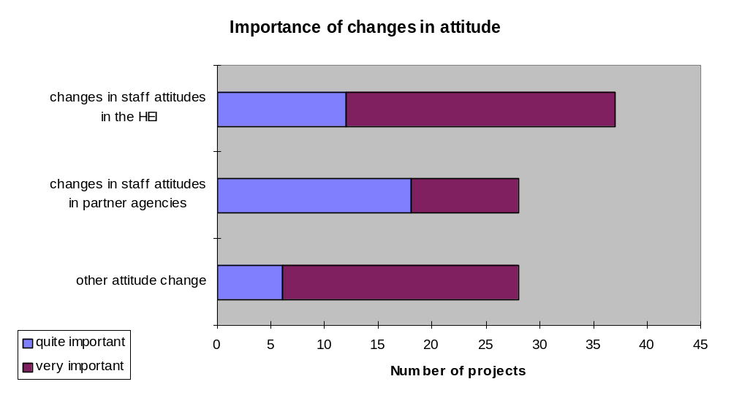
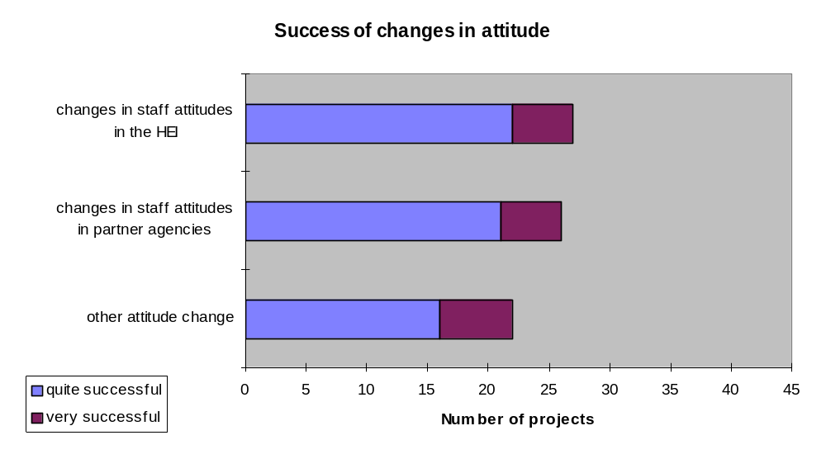Eleven projects reported a change in the attitude of their target group as aspirations and awareness of HE were raised. Four projects noted a change in the attitude of the general public, especially among the family members of learners. Attitude change was also seen in tutors and existing adult guidance providers.
All of the projects saw some form of change in institutional profile and partnerships as important (39 saw it as very important) and 34 of them thought that they had been successful in achieving it (27 very successful). 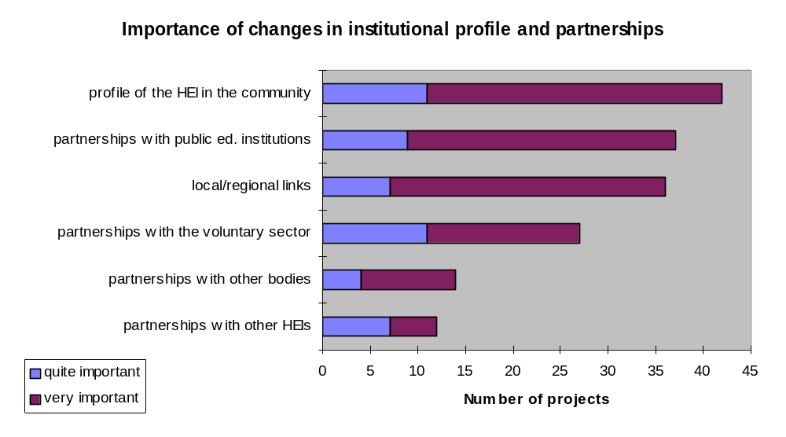
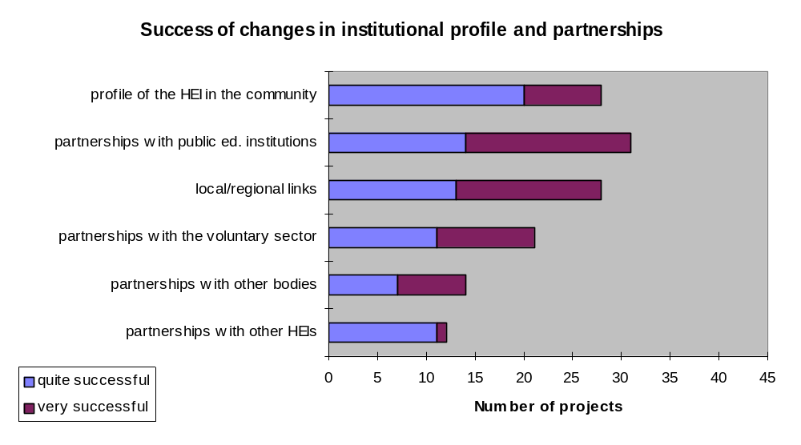Projects established a wide range of other partnerships, including those with local authorities, TECs, health agencies, employment agencies, the Race Equality Council, schools and colleges, libraries, community groups/projects, and companies such as IBM and BT.
Thirty four of the projects saw some form of curriculum change as important (19 saw it as very important) and 23 of them thought that they had been successful in achieving it (nine saw themselves as being very successful).
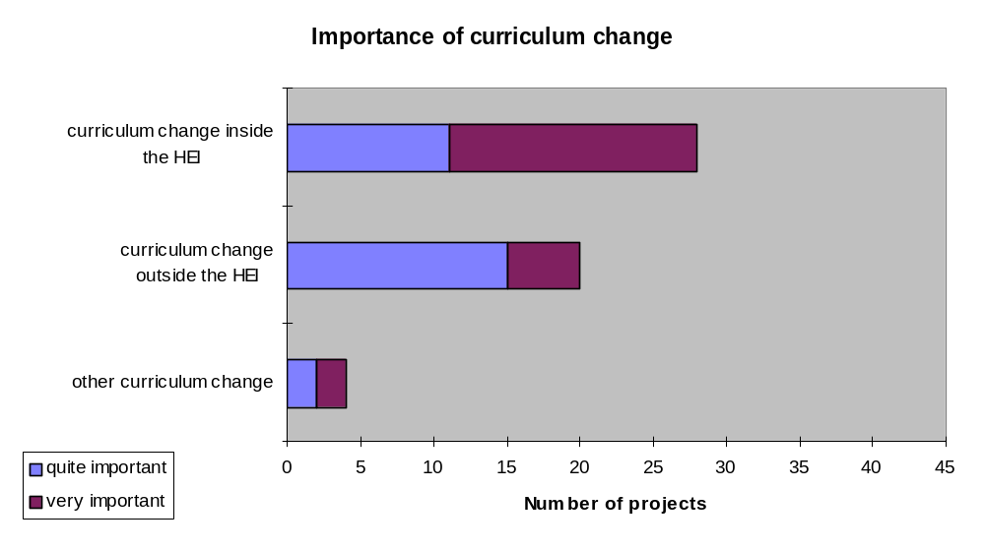
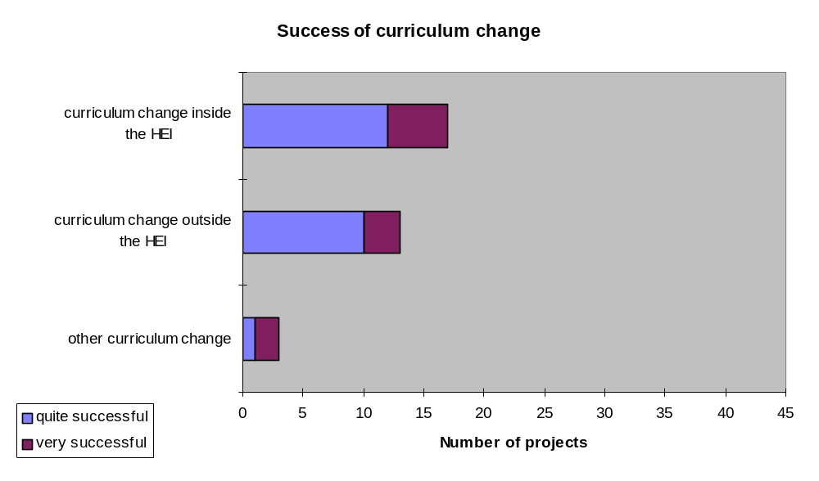Other curriculum change identified included key skills, and the opportunity for learners to negotiate their own curriculum according to their own interests.
All of the projects saw achieving some form of change for the direct benefit of students as important (35 very important) and 36 of them thought that they had been successful in achieving it (17 very successful). 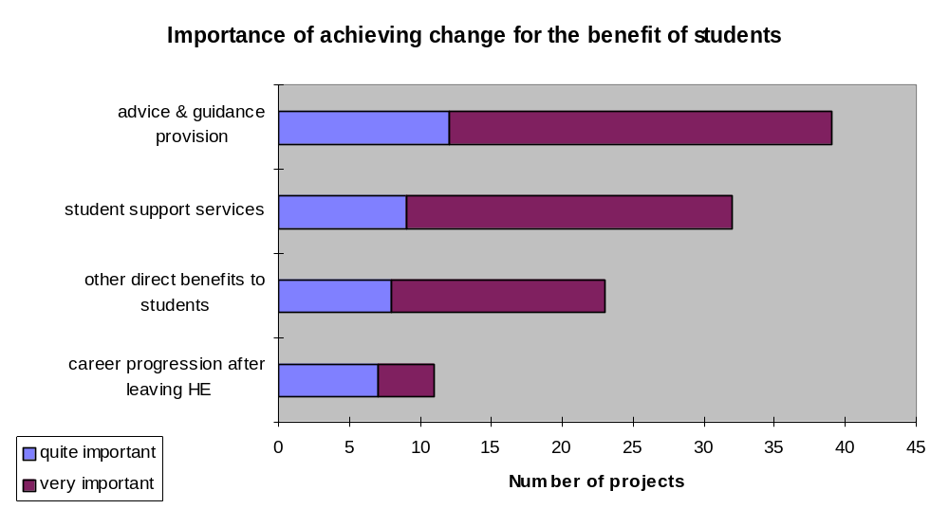
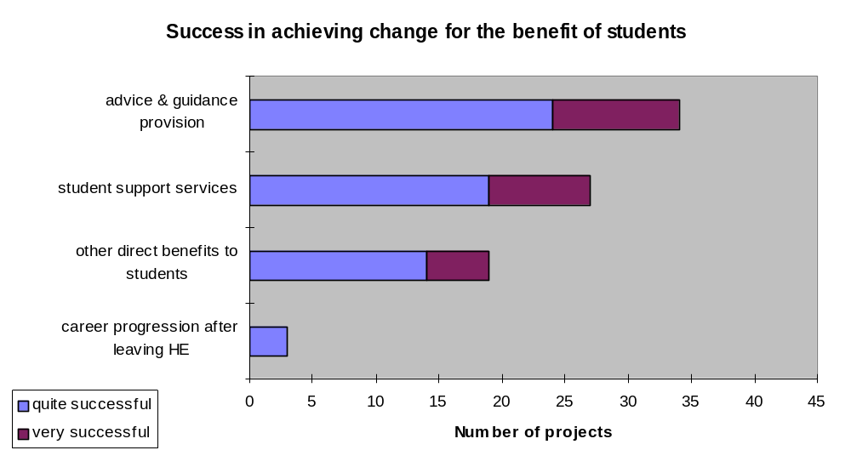
Projects identified many other ways in which students benefited. These included increased confidence (six projects) and motivation (three projects) and increases in self esteem, ambition, personal development and social responsibility. Students also benefited by gaining new and developing existing study skills (four projects). Value added by experience of participation, the provision of mentors/role models and opportunities for progression were each mentioned by two projects.
Thirty-four of the projects saw some form of institutional change as important (21 saw it as very important) and 23 of them thought that they had been successful in achieving it (10 saw themselves as being very successful). 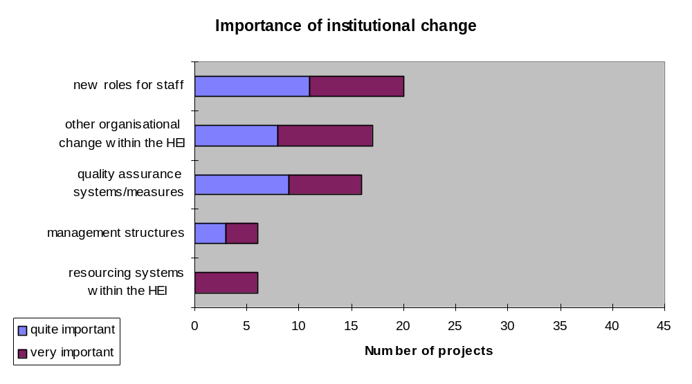
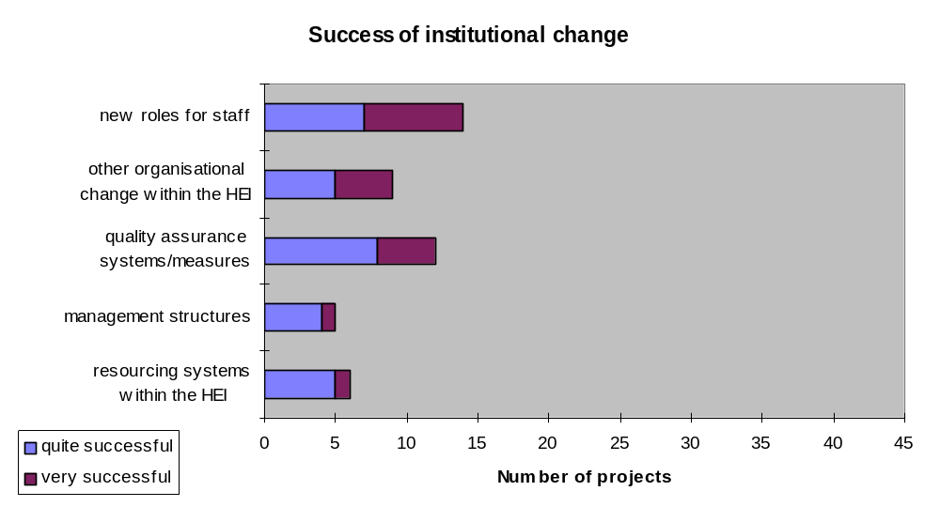
Other institutional changes which occurred included new admissions procedures for target groups and developments in embedding and regulation.

The liberal adult education questionnaire
In September 1998, a questionnaire was sent out to each of the 20 LAE projects.
The aim of the questionnaire was to enable the evaluation team to see how projects fitted into their institutions, to define what is distinctive about liberal adult education, and to identify the rationale for liberal adult education being seen as a distinct kind of HE.
Seventeen questionnaires (85 per cent) were completed and returned. Two institutions did not respond and one refused to complete the questionnaire.

The projects and the institution
Projects were divided between pre- and post-1992 institutions. Predictably the former were more likely to have been engaged in liberal adult education for a longer period of time.
Liberal adult education provision is managed through a separate academic department (adult education, continuing education and so on) in 10 of the institutions; through a central unit in five; and through some departments in another two.
With the funding allocated to the liberal adult education programme, 12 projects continued previous work which could not be mainstreamed, nine developed previous liberal adult education work in the institution and eight undertook new fields of work for the institution.

“Your project”
Projects were asked to identify those features that they considered to be distinctive about their work in terms of client groups; programme objectives; learning and teaching processes; partnerships and entry requirements.
Most projects were working with most of the client groups suggested. People who have not previously participated in HE, learners in the third age and rural learners were the major focus for the greatest number of projects. Other client groups targeted include gay/lesbian groups, prison populations and ex-offenders, voluntary groups and denominational groups within church networks.
Work with particular client groups | Major focus | One of many elements present | Not an element
People who have not previously participated in HE | 6 | 8 | 3
Learners in the third age | 6 | 5 | 6
Rural learners | 4 | 3 | 10
People with low/no formal qualifications | 3 | 10 | 4
Learners over 25 | 2 | 11 | 4
Women | 2 | 10 | 5
Unemployed adults | 1 | 10 | 6
Ethnic minorities | 1 | 9 | 7
Disabled adults | 0 | 11 | 6
Other | 3 | 2
Projects were asked to identify both primary and secondary programme objectives of their work. Here there was very little consensus. Individual empowerment was the only distinctive objective that all programmes accepted as an essential element of their work, although only seven of them saw it as a major focus. “Learning for its own sake”, non-accredited programmes and disseminating the institution’s knowledge to the community were seen as a major focus by more projects, but conversely, there were some projects for whom these were not an element. The least common objectives were developing access routes to mainstream HE, and learning for citizenship. However, even here, some projects considered these to be a major focus.
Distinctive programme objectives | Major focus | One of many elements present | Not an element
“Learning for its own sake” | 9 | 7 | 1
Programmes not accredited | 9 | 7 | 1
Disseminating the University's knowledge to the community | 8 | 5 | 4
Individual empowerment | 7 | 10 | 0
Learners not assessed/accredited | 7 | 8 | 2
“Non-vocational” subject range | 6 | 9 | 2
Redistribution of opportunity | 5 | 9 | 3
Empowering communities | 5 | 7 | 5
Access route to mainstream HE | 2 | 11 | 4
Learning for active citizenship | 2 | 8 | 7
Other | 0 | 1
Projects were asked to identify the distinctive processes by which teaching and learning took place within their project. Each of the processes in the table below were considered to be a major focus by some of the projects, although they did not feature at all in others.
Distinctive learning and teaching processes | Major focus | One of many elements present | Not an element
Stress on group learning | 7 | 6 | 4
Stress on more equal student/tutor relationship | 5 | 8 | 4
Stress on non-linear progression (remaining in learning without necessarily going ‘higher’) | 4 | 10 | 3
Stress on negotiated curriculum | 4 | 8 | 5
Other | 1 | 0
Projects were asked to identify those external agencies with which they had entered into partnerships. Partnerships were mostly made with voluntary and community groups and within local authority adult/community education. Very few projects made links with industrial/commercial employers, with trade unions/professional bodies or with the WEA. Some projects also worked with the University of the Third Age, with art galleries and museums, and with ethnic and multi-cultural community groups.

Partnerships with external agencies | Major focus | One of many elements present | Not an element
Links with voluntary/community groups (Local history societies, tenants associations etc) | 7 | 7 | 3
Links with local authority adult/community education | 4 | 9 | 4
Links with the WEA | 1 | 4 | 12
Links with trade unions/professional bodies | 1 | 4 | 12
Links with further education colleges | 0 | 10 | 7
Links with industrial/commercial employers | 0 | 2 | 15
Other | 1 | 2
When asked to identify any distinctive entry requirements, all projects said that their liberal adult education work was distinctive in that it required no formal entry requirements.

Liberal adult education in your Institution
This section explored how services provided to liberal adult education learners differed from those provided for other learners in the institution.
Most projects said that liberal adult education students receive either the same or a poorer quality of service compared with other students in the institution. This is especially true of access to library/resource centres, with opportunities for progression and with access to accreditation of prior learning.
Relative quality of service | Better | The same | Worse
On-course guidance | 5 | 6 | 6
Access to accreditation of prior learning | 4 | 6 | 7
Pre-entry guidance | 3 | 9 | 5
Opportunities for progression | 2 | 8 | 7
Scrutiny from quality assurance systems | 2 | 12 | 3
Access to library/resources centres | 1 | 7 | 9

By comparison with other staff in the institutions, liberal adult education staff are more likely to be part-time, to be on short-term contracts, to be working practitioners in their fields and to be hourly paid. However, three institutions said that there were not likely to be any differences between liberal adult education and other staff in the institution.
In most institutions fees charged to students on liberal adult education programmes were lower than, or the same as those paid by part-time students on other programmes.
Data on progression from liberal adult education programmes to degree programmes within the institution was routinely collected by nine of the projects. Few institutions collected data on progression to other institutions within HE, FE, local authority providers or the WEA. Oxford and Hull were notable exceptions, collecting information on progression to most sectors.
Projects were asked as to whether they thought that liberal adult education was better provided by an HE institution than by another provider, and if so, why? Three institutions said that they thought that this work could be done by other providers, but that they were unwilling to take on the work. Overwhelmingly projects believed that this work sat best in the HE environment. The benefits claimed for the connection to an HE institution included the following.

Benefits of delivery through an HE institution | Number of projects
Provision of HE level work | 7
Use of HE resources e.g. Buildings, equipment, delivery structure, IT, libraries, networks, learning centres | 7
Staff expertise | 5
Progression | 3

Projects also suggested that engaging in liberal adult education can benefit the HEI by raising awareness of the needs of different groups of students and by improving the profile of the HEI in the community.

Distinctive features of liberal adult education
Distinctive features identified by the largest number of projects as important or essential characteristics of liberal adult education were partnerships with external agencies and distinctive entry requirements. All the identified features were seen as distinctive by most respondents, but this was least likely in relation to work with specific client groups.
 | More important or essential for LAE | Not LAE or not distinctive about LAE
Distinctive or no formal entry requirements | 16 | 0
Partnerships with external agencies | 10 | 3
Distinctive programme objectives | 9 | 2
Distinctive teaching methods | 8 | 3
Work with distinctive client groups | 6 | 5
Projects were asked to identify which features were always liberal adult education (that is, such work rarely or never occurs elsewhere in the institution). The main features that were listed included open entry; non-assessment and non-accreditation; student-centred rather than qualification-centred learning; progression routes which are sideways rather than vertical; and the short time-scales in which courses take place.
All projects rejected the suggestion that liberal adult education is normally work at or below HE level 1.
.

The project steering group
The evaluation project was steered by a small group representing the main interested parties in the work. Its members were:
Cliff Allen (Chair) HEFCE
Professor Richard Taylor UACE
John Storan FACE
Patricia Ambrose CVCP
Alasdair Liddell HEFCE
Derek Hicks HEFCE
Freda Tallantyre HEFCE

References
DfEE (1998) ‘The Learning Age’ Government Green Paper on Lifelong Learning HMSO (Cm 3790)
Fieldhouse, R. Butt F. and Harris P. (1996) ‘Report on the Process and Progress of Accreditation and Mainstreaming of Continuing Education in Pre-1992 English and Welsh Universities’ UACE
Higher Education Funding Council for England (1995a) ‘Funds for Non Award-Bearing Continuing Education’ Bristol, HEFCE (Circular 4/95)
Higher Education Funding Council for England (1995b) ‘Non Award-Bearing Continuing Education Funding: The Outcome’ Bristol, HEFCE (Circular 16/95)
Higher Education Funding Council for England (1997) ‘Interim Report - Non Award-Bearing Continuing Education: Funded Projects 1995-99’ Bristol, HEFCE (Report 2/97)
Higher Education Funding Council for England (1998) ‘Good practice in Non Award-Bearing Continuing Education’ Bristol, HEFCE (HEFCE 98/49)
Sargant N. (1991) ‘Learning and Leisure: A study of adult participation in learning and its policy implications’ Leicester, NIACE
Sargant N. et al (1997) ‘ The Learning Divide’ Leicester, NIACE
Social Exclusion Unit (1998) Bringing People Together: a national strategy for neighbourhood renewal, HMSO
The National Committee of Inquiry into Higher Education (1997) ‘Higher Education in the Learning Society’ (The Dearing Report), NCIHE
Woodrow M. et al (1998) 'From Elitism to Inclusion: Good Practice in Widening Access to Higher Education', CVCP

Index

Aids, 21, 71
associate student, 6, 19, 28, 62
University of Bath, 38
University of Birmingham, 28, 32, 40, 43
Black, 16, 21, 43
Bolton Institute of HE, 21, 22, 29
Bournemouth University, 38, 39, 44
University of Bradford, 21, 27, 33, 34
University of Brighton, 20, 31, 39, 40
Brunel University, 40
City University, 25, 27
University of Coventry, 21, 28, 69
credit, 2, 4, 7, 9, 10, 13, 20, 27, 29, 30, 32, 36, 37, 38, 39, 40, 42, 46, 49, 50, 51, 54, 55, 63, 65, 80, 81, 82, 84
University of Derby, 28, 29
disabilities, 5, 6, 19, 71
disability, 4, 21, 33, 34
University of Durham, 38
University of East Anglia, 28, 29
Edge Hill College, 33
University of Essex, 38
ethnic, 4, 5, 19, 20, 21, 23, 29, 33, 34, 41, 44, 47, 48, 68, 71, 79, 81
University of Exeter, 38
guidance, 5, 16, 17, 20, 23, 24, 26, 27, 33, 34, 48, 49, 50, 62, 71, 72, 74, 81
University of Hertfordshire, 25
University of Hull, 21, 82
University of Kent, 21, 30
Kings College, London, 28
Lancaster University, 21, 28, 32, 33
University of Leeds, 15, 16, 27, 28, 29, 31, 32, 34, 36, 40, 44
Leeds Metropolitan University, 15, 16, 28, 29
University of Leicester, 21
level, 5, 7, 9, 11, 12, 14, 20, 21, 22, 28, 30, 31, 34, 39, 41, 43, 44, 46, 49, 51, 54, 55, 56, 57, 61, 62, 63, 64, 82, 83
location, 20, 26, 31
University of Luton, 25, 26, 27
mentoring, 16, 29, 32, 48, 49, 62, 71
mentors, 6, 29, 77
mission, 5, 6, 8, 12, 13, 14, 25, 30, 33, 38, 45, 47, 50, 58, 61, 62, 72, 78
University of Newcastle, 21, 24, 25, 29
Newman College, 40
University of North London, 22, 24, 27, 29
University of Northumbria, 27, 28, 29, 30, 33
Nottingham Trent University, 27, 34
Nottingham University, 28
Open University, 12
University of Oxford, 39, 40, 82
partnership, 5, 7, 8, 9, 12, 15, 23, 24, 25, 29, 30, 37, 39, 40, 44, 45, 48, 49, 50, 55, 56, 57, 58, 61, 62, 75, 79, 81, 82
part-time, 26
University of Plymouth, 69
quality, 26
Queen Mary and Westfield, 28
research, 16, 32, 41
rural, 5, 16, 20, 21, 23, 48, 51, 56, 68, 71, 79
schools, 7, 14, 15, 16, 25, 26, 28, 29, 39, 41, 46, 47, 48, 49, 57, 75
science, 16, 28, 35, 49, 71
shadowing, 30
Sheffield Hallam University, 16, 17, 25, 27, 41, 43
South Bank University, 21, 28
University of Southampton, 30, 31
staff, 4, 7, 8, 11, 13, 14, 17, 18, 23, 24, 25, 26, 27, 29, 30, 31, 33, 34, 36, 38, 39, 40, 44, 47, 48, 49, 50, 51, 56, 57, 58, 59, 60, 62, 63, 65, 66, 67, 72, 81, 82
Students Union, 16
study skills, 6, 77
summer school, 6, 39, 40, 41, 62
University of Sunderland, 37, 44, 69
University of Sussex, 20, 21, 28, 30, 31, 32, 34
University of Teesside, 27, 28
Thames Valley University, 21, 25, 27
third age, 5, 21, 22, 23, 48, 71, 79
University of Ulster, 32, 41
WEA, 12, 16, 27, 81, 82
University of the West of England, 27
Westminster College, 21, 25
University of Wolverhampton, 21, 23, 24
women, 5, 19, 20, 21, 22, 41, 68, 71, 79

The HEFCE provided funding in academic years 1995-1999, but this evaluation covered only 1995-98.
Major examples include the Professional and Commercial Updating Programme (PICKUP) and its successor Continuing Vocational Education (CVE), and the Enterprise in Higher Education programme.
Widening Participation among young people is the subject of a separate study funded jointly by CVCP, HEFCE and DfEE(Woodrow et al 1998).
Social Exclusion Unit (1998) Bringing Britain together: a national strategy for neighbourhood renewal.
For consistency, this report refers to projects funded directly by the HEFCE as “widening provision” (WP)
Sargant N et al. The Learning Divide.
This distinction should be treated with caution, since it is clear that the definition of higher education in terms of “level” is contested territory, both philosophically and politically, and that work of the kind addressed by the projects provides a particular challenge to this notion.
LAE bids were based on proposed student numbers, whereas widening participation ones did not require this. However, some widening participation projects did finance student participation. There appears to have been some inconsistency in how FTEs were calculated in LAE bids, with a target range for institutions from 6-373, and the resulting range of funding per FTE was very wide.
Fieldhouse R. Butt F. and Harris P. (1996) Report on the Process and Progress of Accreditation and Mainstreaming of Continuing Education in Pre-1992 English and Welsh Universities. UACE
The data on the socio-economic profile of the student body issued to institutions in autumn 1998 by the HEFCE makes this information available for the first time, but it is not yet publicly available, and will probably need further refinement and take time to accumulate longitudinal data before it can answer this kind of question.
Bids were based on FTEs, although there appear to have been significant inconsistencies between institutions in how FTEs were calculated
Broadly, those in retirement or approaching it, who have traditionally formed a major constituency for liberal adult education, in both HE and Local Authority sectors. Fieldhouse et al found 45% of mainstreamed LAE students over 55 in 1995-6 (the numbers in this age group appeared to have been unchanged by the mainstreaming of LAE, though the socio-economic mix may have changed)
Using postcodes linked to neighbourhood types as a proxy for socio-economic group.
All numbers in the following tables refer to numbers of projects; 43 represents 100 per cent of respondents.

