Official Statistics Release
Policy area: | Children’s social care providers and places
Theme: | Education, children’s services and skills
Published on: | 28 July 2011
Coverage: | England
Period covered: | 31 March 2011 - 30 June 2011
Status: | FINAL
Issued by: | Office for Standards in Education, Children’s Services and Skills (Ofsted)  125 Kingsway  London  WC2B 6SE
Responsible director: | John Goldup
Statistician: | Adam King
Public enquiries: | enquiries@ofsted.gov.uk
Press enquiries: | pressenquiries@ofsted.gov.uk
Link to official statistics release web page: | http://www.ofsted.gov.uk/resources/official-statistics-childrens-social-care-providers-and-places
Publication medium: | Ofsted website
Publication frequency: | Quarterly
Next publication date: | 27 October 2011

Introduction

This official statistics release reports on the number of children’s social care providers and places and residential accommodation for children in boarding schools and further education colleges that Ofsted has regulatory or inspection responsibility for, covering the period between 31 March and 30 June 2011. Children’s social care providers include, but are not limited to, children’s homes, secure children’s homes, residential special schools, residential family centres, secure training centres, local authority adoption agencies, private fostering arrangements and independent and local authority fostering services.

These statistics are based on a snapshot as at 30 June 2011. Ofsted will publish these data quarterly and the next release will be on 27 October 2011.

Contents

Key findings ……………………………………………………………………………………………………………………………3

Methodology ……………………………………………………………………………………………………………………………4

Additional information ……………………………………………………………………………………………………….4

Table 1: Children's social care providers and places (national or Government Office Region or local authority) ……………………………………………………………………………………………………………………….…..5

Table 2: Children's social care providers and places (national and Government Office Region and local authority) …………………………………………………………………………………………………………….……………..5

Chart 1: National number of children’s social care providers, by provision type, for current quarter …6

Glossary ……………………………………………………………………………………………………………………………7
Key findings

- There were a total of 3,764 children’s social care providers and providers of residential accommodation for children in boarding schools and further education colleges in England at 30 June 2011. There had been an increase of 30 providers since 31 March 2011 (3,734).

- More than half (55%) of the providers in England at 30 June were children’s homes (2,076 homes). There were a total of 16 secure children’s homes in England.

- Boarding schools accounted for 14% of all providers, with 533 schools, and approximately 8% of all providers were local authority fostering services/private fostering services. Just over 5% of the providers in England were residential special schools but all the other provider types accounted for less than 5% of total providers.

- For the majority of provider types there was very little change in their numbers in the last quarter.

- The largest numerical change was among children’s homes where there were an additional 27 homes at 30 June compared to 31 March 2011 (a 1.3% increase).

- In terms of the number of providers there were large differences between the regions (based on former Government Office Regions). At 30 June 2011, the South East region had the largest number of providers at 689 and the North West had the next largest with 677. The North East had the smallest number of providers at 183. The number of providers in individual local authorities varied from one in Isles of Scilly to 151 in Kent.

- The local authority with the largest number of children’s homes located in its area, at 30 June 2011, was Lancashire with 104 homes. Kent and Shropshire had the next largest number of homes, with 74 homes each.

- There were more children’s homes in the former Government Office Regions in the North than in the other regions, with 798 homes in total. This compares with 660 in the Midlands regions and 618 in the Southern regions. The former North West Government Office Region had the largest number of children’s homes with 511.

- Seven local authorities, five of which were in London, did not have any children’s homes in their area.

- The number of social care places is related to the number of providers: the number of registered places is likely to fall if the number of providers falls, and vice versa. The number of places has not seen much change in the period from 31 March 2011 to 30 June 2011.

- It is not possible to provide a total for the number of places in England as data on places are not available for many of the provider types, for example the various fostering and adoption services providers. Of those providers for which the number of places is provided, there were 93,912 places at 30 June 2011.

- As at 30 June 2011, there were 71,984 registered places in boarding schools in England. This was by far the largest number of places in any one provider type with the next largest being children’s homes with 11,862 places.

- The largest proportion of change in the number of places was in residential family centres where there was a 4% decrease between 31 March and 30 June 2011 (a decrease from 408 places to 392 places). There were also small decreases in the number of places in residential further education colleges (from 4,304 to 4,226) and in boarding schools (from 72,140 to 71,985).

- At the local authority level, most place numbers did not change between 31 March and 30 June 2011. For example, looking at boarding school places which make up the majority of all social care places in England, only two local authorities had any change in the period from 31 March 2011; there was a 7% decrease in the number of places in Cambridgeshire and a 2% decrease in the number of places in East Sussex. For both authorities, the number of providers had remained the same.

- There appeared to be much more movement in the number of places in children’s homes compared with the other provider types, despite there not being much change in the number of children’s homes themselves. For example, there was a 30% decrease in the number of children’s home places in Sunderland (from 122 to 86 places) although the number of homes remained at 14. Sunderland has the largest decrease in places in the quarter.

Methodology

- The data in this publication are taken from Ofsted’s Regulatory Support Application (RSA) database, which holds information about all registered social care providers, and the Inspection Tracking System (ITS) which hold information about secure training centres. Data relate to the position as at the end of each month, up to 30 June 2011.
- Information about the number of places is collected at different intervals for different providers which will affect the changes seen in the number of places when looking at quarterly data.
- For more information on how Ofsted regulates and inspects children’s social care, please go to the Ofsted website: www.ofsted.gov.uk/Ofsted-home/Forms-and-guidance/Browse-all-by/Care-and-local-services/Children-s-social-care

Additional information
Due to a reordering of data on the Ofsted database, the number of voluntary adoption agencies appears to have risen sharply between 31 March and 30 June 2011.
All the tables and charts shown in this release, along with additional analysis by month and at regional and local authority level, are available in Excel format on the Ofsted website in the same location as this document. Underlying data are not yet available in Excel and comma separated values (.csv) formats. The aim is to have them available for future publications.

Please see data tables linked below:

Table 1: Children's social care providers and places (national or Government Office Region or local authority)
[Please see Table 1 in the Excel workbook in the same zip file as this document]

Table 2: Children's social care providers and places (national and Government Office Region and local authority)
[Please see Table 1 in the Excel workbook in the same zip file as this document]

Chart 1: National number of children’s social care providers, by provision type, for current quarter
[See chart 1 below]

Chart 1

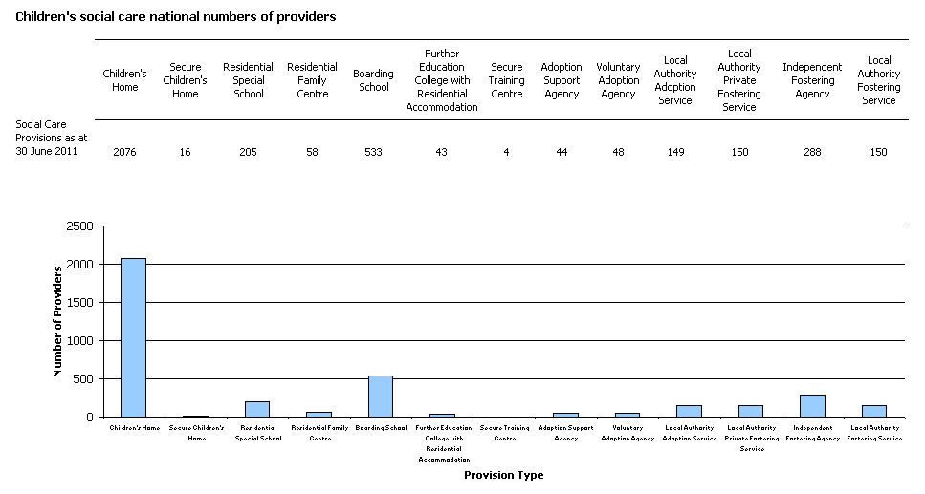

Glossary

Adoption agencies
The focus of all adoption agencies is on placing children successfully into adoptive families who the agency recruits, assesses, prepares and supports, so they will meet the children’s needs and enable them to develop and achieve throughout their lives. The services maintained by local authorities are described in section 3(1) of the Adoption and Children Act 2002. Local authorities place children with adoptive families recruited and approved by themselves, by other local authorities or by voluntary adoption agencies who must register with Ofsted. Adoption agencies may also provide birth records, counselling and intermediary services to adoptees and birth relatives.

Adoption support agencies
Adoption support agencies are defined by section 8 of the Adoption and Children Act 2002 and provide services to anyone touched by adoption and are registered with Ofsted. This includes counselling and help for children and adults to gain information about their adoption or to trace birth relatives. Adoption support agencies can be either organisations or individuals, and may be contracted by a local authority to provide support services.

Boarding Schools
The vast majority of boarding schools are independent and belong to associations which are members of the Independent Schools Council. As education in these schools is inspected by their own inspectorate, Ofsted inspects only the welfare of boarders in these schools. The remainder are maintained boarding schools where both education and the welfare of boarders are the subject of Ofsted inspection.

Children’s homes
A children’s home is defined in section 1 of the Care Standards Act 2000, and is an establishment that provides care and accommodation wholly or mainly for children. Children’s homes vary in size and nature. They fulfil a range of purposes designed to meet the different needs of those children and young people who are assessed as needing a residential care placement. Some homes, for example, provide short breaks which are needed to help support children and their family. Some residential special schools, 34 as at 30 June 2011, are registered as children’s homes because boarders are resident for more than 295 days per year.

Fostering services
Local authority fostering services are defined by section 4 of the Care Standards Act 2000. Local authority fostering services and independent fostering agencies recruit, prepare, assess, train and support foster carers. Independent fostering agencies (IFAs) are private companies or charities, who are registered with Ofsted and provide placements to children and young people with foster carers approved by them. IFAs work closely with Local Authorities to deliver these placements.

Places
The term ‘places’ used in this report refers to the number of places that the social care provider is registered to provide. This number usually will not, therefore, be the same as the actual number of children who are receiving services from the provider. Ofsted holds data relating to places for: children's homes; secure children's homes; residential special schools; residential family centres; boarding schools; and further education colleges. For some of these providers Ofsted does not hold data relating to places. Where this is the case, the number of places has been estimated. For all other provision types, and aggregated provision types, places data are not available.

Providers
Children’s social care providers are those institutions or organisations or agencies that provide services to the relevant children and young people. The providers commented on within this report include children’s homes, secure children’s homes, residential special schools, residential family centres, boarding schools, residential further education colleges, secure training centres, adoption support agencies, voluntary adoption agencies, local authority adoption agencies, private fostering arrangements, independent fostering agencies and local authority fostering agencies.

Residential accommodation in further education colleges
The welfare provision of further education colleges that provide, or arrange, residential accommodation for one or more students under the age of 18 years.

Private fostering services
Private fostering is legally defined by section 67 of the Children Act 1989 as an arrangement that occurs when a child who is under 16 (or 18 for a child with learning difficulties and/or disabilities) is cared for in their own home by someone other than their parent or a close relative for 28 consecutive days or more; or children who stay in boarding schools during the holidays for 14 days or more (Children Act 1989 schedule 8 para 9 (i) as amended by section 112 of the Care Standards Act 2000). A private foster carer may be a friend of the family or the child’s friend’s parents or someone who is not previously known to the family. Children (Private Arrangements for Fostering) Regulations 2005 requires parents and private foster carers to give the local authority advance notice of a private fostering arrangement. It also places specific duties on local authorities with responsibilities for children’s services. It is these duties and responsibilities that Ofsted inspects.

Residential family centres
Residential family centres are defined in section 4(2) of the Care Standards Act 2000 as establishments at which: a) accommodation is provided for children and their parents; b) the parents’ capacity to respond to the children’s needs and to safeguard their welfare is monitored and assessed; and c) the parents are given such advice, guidance and counselling is considered necessary.

Residential special schools
Residential special schools are defined in section 59 of the Safeguarding Vulnerable Groups Act 2006. They vary in size and nature. The sector includes large non-maintained special schools which make provision for very specific needs and take children as full boarders from all over the country, to smaller more local providers catering for children with a range of different special needs and disabilities who may be resident at the school only during the week. Some residential special schools, 34 as at 30 June 2011, are registered as children’s homes because boarders are resident for more than 295 days per year.

Secure children’s homes
Secure children’s homes accommodate children and young people who are remanded or have been sentenced for committing a criminal offence. They also accommodate children and young people who are placed there by a court because their behaviour is deemed to present a significant and immediate threat to their safety or the safety of others, unless they are placed in a secure environment

Secure training centres
Ofsted inspects both the care and educational provision for children in four secure training centres. They accommodate young people between the ages of 12 and 17 who have been remanded or sentenced by the courts. The centres are under contract to the Youth Justice Board, which monitors their compliance with requirements. Ofsted does not regulate secure training centres but has an agreement with the Youth Justice Board to inspect care twice a year and education once a year.

© Crown copyright

You may re-use this information (not including logos) free of charge in any format or medium, under the terms of the Open Government Licence. To view this licence, visit http://www.nationalarchives.gov.uk/doc/open-government-licence/ or write to the Information Policy Team, The National Archives, Kew, London, TW9 4DU or e-mail: psi@nationalarchives.gsi.gov.uk.

