MULTIDIMENSIONAL TREATMENT FOSTER CARE IN ENGLAND (MTFCE)

PROJECT REPORT
JULY 2007

National Implementation Team

CONTENTS |  |  | Page Number
 | Executive Summary |  | 1
1. | The Role of the National Implementation Team  (Fig. 1. Model of consultation to current MTFC-A and MTFC- P sites) |  | 5  6
2.  3. | MTFC-A Site Progress, Success and Challenges  2.1 Round One  2.2 Round Two  2.3 Round Three  2.4 Round Four  MTFC-Prevention Programme (MTFC-P) |  | 6  7  7  8  9  9
4. | Project Plan and Timetable  4.1 MTFC-A Team Development and Support  (Fig. 2. Project Team Development and Time Line)  4.2 Planning for the Future  (Fig. 3. Project Timetable – development of MTFC-A and MTFC-P sites) |  | 9  9  11  12  13
5. | Children in MTFC-A Placements at June 2007  (Fig. 4. Children and Young People in active MTFC-A Placements as at June 2007) |  | 14
6. | MTFC Training Programme  6.1 Induction Day (fig. 5. Numbers attending MTFC and MTFC-P induction )  6.2 Progress, Networking and Update Days  6.3 The MTFC Model (fig. 6. Total numbers of clinical team staff trained)  6.4 Foster Carer Training (fig. 7. Total numbers of Foster Carers trained )  6.5 Other Training |  | 15  16  16  17  17  18
7. | Independent Evaluation |  | 19
8. | Assessment Measures  8.1 Strengths & Difficulties Questionnaire (SDQ) (table 1)  8.1.1 Children’s Global Assessment Scale (C-GAS) (table 2)  8.1.2 Development and Well-Being Assessment (DAWBA) (table 3)  8.1.3 Wechsler Intelligence Scale for Children (WISC) or WASI (table 4)  8.2 Psychiatric Meditation |  | 19  20  20  20  21  22
9. | Audit  9.1 Summary of Initial Audit Data for Young People Admitted to MTFC  9.2 Demographics of the Whole Sample of 101 children  9.2.1 Age and Gender (fig.8)  9.2.2 Ethnicity  9.2.3 Legal Status at Admission  9.2.4 Previous Placements (fig.9,10)  9.2.5 Education (table5 School Placement on entry)  9.2.6 Contact with Birth/Adoptive Family (table 6 Frequency of contact)  9.2.7 Leisure Interests (figs.11,12)  9.3 Summary of Young People’s Difficulties & High Risk Behaviours on Entry  9.3.1 Family context and history of abuse (fig.13) (table 7)  9.3.2 Summary of Young People’s High Risk Behaviours - All entrants  (fig.14) (table 8)  9.4 Outcomes for Children who Have Left MTFC-A  9.4.1 Comparison of Graduates with all Entrants to MTFC-A (tables 9,10,11)  9.4.2 Outcomes for Group of 26 Graduates from MTFC-A  i Discharge Placement (fig.15)  ii Presenting Difficulties on Admission and on Leaving (fig. 16) (table 12)  iii Education Outcomes (fig.17)  9.4.3 Comparisons between graduates, early leavers & late leavers (tables 13,14)  i Leaving the MTFC programme (fig.18) (table 15)  ii Entry and exit comparisons for high risk behaviours (table 16)  iii Contact with clinical team during placement (table 17 |  | 22  22  23  23  23  23  24  25  25  26  27  27  28  29  29  31  31  32  33  34  36  38  39
10. | Calculating the Costs of MTFC-A  10.1 Comparative costs (figs.19,20) (table 18)  10.2 Cost of Multidimensional Treatment Foster Care |  | 39  39  42
11. | Consulting with Oregon Social Learning Center |  | 42
12. | Network Partnership |  | 42
13 | Intensive Fostering |  | 43
14 | The Learning so far  14.1 Learning from the treatment model  14.2 Learning from the implementation progress |  | 43  43  43
15 | Current Challenges and Aims for the New Year  15.1 Finance  15.2 Recruitment and Retention  15.3 Moving on Placements  15.4 Evaluation  15.5 Audit  15.6 Programme Fidelity  15.7 Training and Support |  | 44  44  45  45  45  45  45  45
 | Appendix 1. Project Staffing Requirements  Appendix 2. The Points and Levels System  Appendix 3. MTFC-A Programme Example  Appendix 4. Children’s Global Assessment Scale (CGAS) |  | 46  47  48  49

Executive Summary

The Multidimensional Treatment Foster Care in England (MTFCE) programme, piloted by the Department for Children, Schools and Families (previously DfES) for children with challenging behaviour and complex needs is now in its 4th year and has continued to progress well. There have been a number of exciting initiatives this year including the allocation of further government pump-priming money to set up six new programmes to develop Multidimensional Treatment Foster Care services for 3 to 6 year olds (MTFC-Prevention) which aims to promote permanency either by returning children home to their families or to adoption or long term foster care. This builds on the growing success of the programme for adolescents and has provided local authorities with the opportunity to meet the needs of the younger age group.

Twenty teams have been involved in the project, fourteen teams currently have children in MTFC-A (adolescents) foster care placements, 3 teams have withdrawn and the remaining 3 teams are developing their infrastructure, recruiting staff and foster carers and will be making first placements in September 2007. At 1st June 2007 a total of 111 young people, 58 boys and 53 girls, had been admitted to the programme since the first child was placed in April 2004. There are currently 50 children in MTFC foster care placements in 14 sites across England. To date 61 children and young people have left the programme, 31 of these have successfully graduated and moved to family or foster family placements or independent living. 22 have moved out of MTFC before 3 months (early leavers) and 8 have left later and moved to non-family based placements, such as residential childrens’ home. 22 of the 31 children and young people who successfully graduated moved to long term foster care placements, 7 returned home to family, 1 to supported lodging and 1 to a mother and baby unit to work towards independence.

The National Team and Evaluation Team
The MTFCE programme sites are managed and supported by the national implementation team based at the Maudsley Hospital in London, and Booth Hall Children’s Hospital in Manchester, in collaboration with the programme originators at the Oregon Social Learning Center. This team is an innovative development by the DCSF commissioners intended to ensure coherence of approach and fidelity to the model which has been shown to increase positive outcomes. The programme is in the process of being fully evaluated in a controlled study with a one year follow up by independent evaluators from the Universities of Manchester and York; however results from this research are not likely to be available until late in 2008. In order to provide preliminary information an audit data collection has been conducted.

Characteristics of Young People
All of the children and young people admitted had high levels of complex needs. They were aged 10-16 years and had an average of almost 6 previous placements, some as many as 26, all of which broke down or were not meeting their needs due to their very difficult behaviour. Over three quarters had a history of violence towards others, over one third had self harmed, over half exhibited difficulties with sexual behaviour and were considered a risk to themselves or others, over one fifth had a history of fire setting, over one quarter had criminal convictions, a further third had Police verbal warnings or were associating with offending peers. Two thirds had a history of absconding from previous placements. The majority had a history of neglect, physical, emotional or sexual abuse. Girls were significantly more likely to have a history of sexual abuse than boys, and boys were significantly more likely to have a history of physical abuse than girls. They had much higher rates of psychiatric disorder compared to the whole care population (95% v 45%) and ten times higher than the general population (95% v 10%), higher difficulties scores on the Strengths and Difficulties Questionnaire (SDQ) and lower levels of global functioning as measured by the Children’s Global Assessment Scale (CGAS).

Outcomes for graduates
The National Team audit has also collated data on a group of 26 graduates who had successfully completed the programme after an average of 10 months in MTFCE foster care placements at the end of March 2007. The graduates showed positive outcomes in all the assessed areas of risk compared with the year prior to admission; 65% had a history of violence towards other people at entry and 31% on leaving, 48% had sexual behaviour problems on entry and 32% on leaving, 35% were offending at pre-admission and 4%.on leaving, 58% were absconding on entry and 31% on leaving, substance use was 20% on entry and 12% on exit, similarly alcohol use was 35% on admission and 24% on leaving. 27% had a history of self harm on admission; no instances of self-harm or fire setting occurred during the placements. Placements in mainstream and special schools increased from 83% to 91%, and the number of children receiving statements of special educational need increased by one third. Children and young people attending after school leisure activities increased by over one third during their placements. These early results suggest significant reductions in difficulties in the expected direction and compare favourably with current data on poor outcomes for looked after children with complex needs.

Characteristics of early leavers
The 22 early leavers had slightly higher levels of risk behaviours on entry, particularly violence towards others, offending and absconding. More were boys and they had a higher number of placement disruptions prior to MTFCE and a higher number of problem behaviours in the MTFCE foster placements. Reasons for leaving the programme included, failure to engage with the programme (for example difficulties in trusting adults, pressure from peers or boyfriends/girlfriends), fewer freedoms than were available in residential units and anti-social, aggressive or threatening behaviour (e.g. breach of an ASBO).

A number of children in this early leaver group were admitted to the programme against the advice of the national team as “emergencies” or as a “last resort” or because financial pressures on local authorities dictated the placements. These children and their families of origin were likely to have had less time for assessment, engagement or consent issues to be fully addressed by the MTFC team.

Early leavers also had less contact and were less well engaged with programme staff, specifically the individual therapist and skills trainer and their families (if appropriate) were less well engaged with the family therapist. Their placements were also less likely to be supported by teams with a full clinical staff team in place. The association between not having a full clinical team in place, engagement with programme staff and early placement breakdown warrants further investigation. High risk young people are successfully graduating from the programme and further exploration of the factors differentiating graduates and early leavers will be undertaken as more data is collected. It is hoped this will provide important information about where and why resources should be directed and the team and system issues that contribute to the success of MTFCE.

Building sustainability
All of the first and second round sites and some of the third round, have now secured long term funding, some have successfully integrated the MTFC-A programme into their range of services for children in care, three teams have added the MTFC-P programme for younger children to their authorities’ provision, one team has additionally developed an innovative follow on programme designed to offer training and support to foster carers offering long term placements to children graduating from MTFC. The learning from the MTFC-A programme has influenced local authorities to consider the needs of children in residential establishments for assessments and clear behaviour management strategies and of the need for greater provision of support for mainstream fostering. Some of the 3rd round teams are also developing models of care which will provide a range of services for children along a continuum of need; from increased family support to those on the edge of care, extra support for mainstream fostering and specialist services such as MTFC.

In contrast, 3 other sites face serious questions about programme costs, financial sustainability and cost effectiveness that affect their future viability. Detailed information on the full costs of supporting children and young people in care placements is variable across local authorities. In order to help address this the DCSF has commissioned a further project, led by Loughborough University, to calculate the costs of MTFC-A compared with alternative placement and support for children with complex needs with a selected number of the programme sites. Data collection will begin in the next few months and will be available to teams in advance of, but also contribute to, the results of the independent evaluation.

Conference
The 2nd Annual European MTFC Conference was this year held in London in May 2007, hosted by the DCSF and the national team. The conference was attended by programme developers and key staff from Oregon Social Learning Center, delegates from Europe, including Sweden, Holland, Denmark, Norway and Ireland, the Youth Justice Board Intensive Fostering programmes, and staff from the English teams. Young people and foster carers agreed to be videoed for the conference and one young person volunteered to attend with her carer and speak briefly about her experience. We hope to be able to interview and video more young people and foster carers about their views and experience of MTFC over the next year.

Policy context
The recent publication of the government White Paper, Care Matters: Time for Change, emphasises the crucial role that evidence based programmes, such as Multidimensional Treatment Foster Care, play in improving the lives and long term outcomes for children in care. The lessons learned from implementing the programme for adolescents has led to a number of innovations and developments which it is hoped will transform the landscape for children looked after in mainstream and specialist fostering and those on the edge of care.

Government reforms include support for local authorities to deliver better value for money and to use more evidence-based interventions. Joint Area reviews (JARS) will provide some incentives as inspectors will be asked to judge how services are contributing to improving outcomes for children in care. The proposal that agencies take a longer term view on local budgets and avoid making decisions based on short term funding pressures is much welcomed and may help to influence a longer term approach to developing and sustaining these projects.

Network Partnership
The National Implementation Team have now formally signed an agreement with Treatment Foster Care associates at the Oregon Social Learning Center, to become the UK Network Partner. This will enable us to provide implementation services, training and consultation in the MTFC programmes for new teams wishing to develop the model in the UK outside the DCSF funded programme and for existing MTFC-A teams who wish to contract for further services at the end of the current contract. This is an exciting and important step forward in sustaining and developing the programme over the longer term and developing a UK base for these evidence based programmes.

Contents of this report
This is the 3rd annual project report published by the National Implementation Team. For the new MTFC-P sites beginning this year the theoretical background and information can be found in the 1st and 2nd year reports and is not repeated here. The current report provides an update of project development and activity across the national sites, outlines the progress and developmental plan for the teams, the development of the training programmes for the clinical staff and foster carers and the successes, challenges and learning so far. The ongoing audit data and analysis of the young people admitted to the scheme makes up a substantial part of this year’s report.

Rosemarie Roberts

Project Manager
National Implementation Team
1. The Role of the National Implementation Team

Evidence from a number of trials concludes that treatment fidelity is a major determinant of outcome and that a high level of fidelity and model adherence is associated with positive outcomes. The National Team was commissioned by the DfES (now DCSF) in 2003 to provide this consistency of training and fidelity to the model in order to ensure the best possible outcomes for the children, young people and their families in this innovative national project.

The National Team’s staffing this year includes two staff in Manchester, and three full time equivalent staff members in London, one team administrator based in London and one part time and one full time assistant psychologist based in Manchester and London respectively to manage the audit data.

National Team Staff

Director – Stephen Scott, Professor in Child Health & Behaviour,
Consultant Child & Adolescent Psychiatrist
Project Manager - Rosemarie Roberts, Consultant Systemic Therapist

Site Consultants

North Team- Booth Hall Children’s Hospital, Manchester South Team - Maudsley Hospital, London

Team Leader- Dawn Walker – Consultant Systemic Therapist (f/t) Jan Cox – Senior Systemic Therapist (f/t)
Frances Gulliford – Consultant Clinical Psychologist (p/t) Moira Doolan– Consultant Systemic Therapist (p/t)
Catherine Campbell – Assistant Psychologist (p/t) Nicola Cosgrave – Clinical Psychologist (p/t)
Barrie Brown – Consultant Clinical Psychologist (p/t)
Tom Allen – Assistant Psychologist
Fiona Taylor – Administrator

The Project Director, Professor Stephen Scott, Reader in Child Health at the Institute of Psychiatry, Kings College, and Child and Adolescent Psychiatrist at the Maudsley Hospital, London, is a leader in the field of conduct disorder and parenting in the UK and has many publications of clinical trials in this area. As the Kings lead representative, Professor Scott was recently awarded, along with consortia partners Parenting UK and the Family and Parenting Institute, the highly prestigious £30 million pound government contract to develop the National Academy for Parenting Practitioners to support evidence based approaches to parenting across the country.

The rest of the national team at the Maudsley and Booth Hall Children’s Hospital in Manchester are systemic family therapists and clinical psychologists with a high level of expertise in health, social care, education and offender services, training, consultation and research, and bring a great deal of knowledge, experience and expertise to the programme. The original task of training and ensuring treatment fidelity has developed into a comprehensive consultancy role incorporating management consultancy from the development stage, specific training in the MTFC model (both alongside staff at the Oregon Social Learning Center and separately), plus a programme of additional training for clinical staff.

The model of consultation developed in conjunction with the programme originators at the Oregon Social Learning Center in Eugene, Oregon (OSLC) is a further innovation in the development of MTFC services in Europe. OSLC provide consultancy, training and development materials to the national team who then provide this consultancy to the English programmes as shown below.

Figure 1. Model of consultation to current MTFC-A and MTFC- P sites
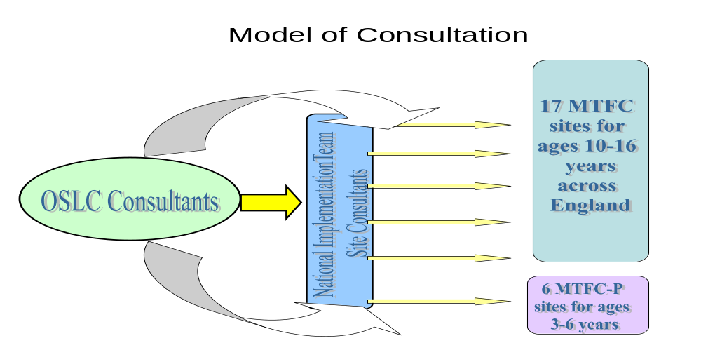

The National Team provides development support on implementation, clinical consultation and support in the treatment model to the clinical teams, support for local and national evaluation and audit, and monitoring and guidance with regard to model adherence. This innovative method of project management includes formal reviews and feedback to the project teams, live and video supervision and written feedback to ensure the teams are given optimum support in taking the programme forward.

2. MTFC-A Site Progress, Successes and Challenges

Over the past 4 years the DCSF has awarded start-up funding to 20 local authorities with their education and health partners to develop MTFC programmes in a series of competitively tendered bids. Two sites decided to withdraw in the very early stages and repay the grants due to difficulties including staff and foster carer recruitment and concerns about sustainability.

In April last year, at the request of our consultants in Oregon the earlier round teams were asked to consider whether or not they wished to work towards certification as an accredited MTFC site. This meant they would be able to continue to use the MTFC name and website facilities and would need to demonstrate their ability and willingness to adhere to the treatment model and continue or re-engage in regular consultation with the national team. Four of the five round one sites and all of the operational round two sites expressed their desire to do so. One of the first round teams based in the Wirral had successfully set up a Treatment Foster Care programme which met local need but had developed differently from the MTFC model. After careful consideration it was agreed as they were no longer running MTFC they would officially withdraw from the national programme in August 2006. They have continued to successfully run their individual programme and are continuing to participate in the independent evaluation.

The remaining teams who were awarded funding between 2003 and 2005 all now have children and young people in placements. The 3 most recent 4th round sites are continuing to develop. There are currently 50 children and young people in MTFC foster care placements in 14 sites across England at the time of writing (July 2007).

2.1 Round One
The first round teams were awarded their start up grants in 2003 and the core training for the clinical teams and foster carers was provided between November 2003 and March 2004, when Oregon Social Learning Center (OSLC) staff came over from the USA to provide training alongside the National Team which had been established in September 2003. One site (Surrey) withdrew from the programme at an early stage due to severe difficulties in recruiting foster carers and concerns regarding sustainability and the Wirral site withdrew last year (see above) leaving four first round teams in operation. The first child to be placed in the programme entered MTFC in April 2004 and graduated from the programme in August 2005.

The first round teams have continued to make steady progress. Three have appointed new Programme Supervisors in the last year who have had to respond quickly to the demands of an established programme whilst at the same time learning the finer details of the treatment model. A further challenge to all has been in sustaining the programmes. One site has successfully maintained the programme despite the withdrawal of 2 out of 3 local authorities who had been part of the original bid albeit with a reduced number of placements. The team now hope to be able to increase their available placements to achieve sufficient numbers for accreditation over the next six months. One team who was struggling last year with lack of carers and placements and insufficient clinical team staff has successfully recruited staff and increased placements. Another team is additionally developing MTFC-P for ages 3 to 6 and has developed an innovatory complementary fostering project designed as a “step-down” from MTFC and has integrated the MTFC programmes into the general provision for looked after children. Finding suitable follow on placements for children who have completed the programme remains an issue for all the teams.

All the first round teams are to be congratulated for their success in securing long term funding; three have been successful in securing mainstream funding, and the fourth in securing funding for the next 3 years. The majority of the first round teams are successfully applying the MTFC model and are now seeing positive outcomes for the children placed.

2.2 Round Two
Four teams were awarded start up funding in autumn 2003 and attended an MTFCE introductory day in December 2003 and a follow up Progress Day in July 2004. Specific training for clinical staff was provided by the national team in March and September 2004. Foster carer training was provided in November 2004, and February, April and June 2005. Some additional foster carer training was provided locally or regionally by the site consultants according to the needs of the teams and the pace of carer recruitment. The first young person was placed in December 2004. All four second round teams now have between 1 and 8 children placed. The sites in this round have developed at vastly different rates. One site experienced significant delays in development due to a complex combination of political and personnel changes at senior level which meant their critical path has been more commensurate with the 3rd and 4th round teams. They have now placed their first child in March this year and are recruiting more foster carers. One site has been highly successful in recruiting foster carers and young people into the programme, but less so in finding follow on placements which is a common problem for many of the programmes across the country. Many of the children have been in placements for over a year which has reduced the team’s ability to take on new placements. The appointment of a new Programme Manager may relieve some of the extra work from the Programme Supervisor and increase capacity to improve this situation.

In the previous year, 3 of the second round sites had temporary Programme Supervisors in post due to maternity cover and staff turnover and were advertising for replacements. Two of the acting Programme Supervisors (PS’s) have now been confirmed in the post and a third team has been successfully covered by the Programme Manager in the PS role and will shortly be interviewing for a permanent staff member.

All of the programmes have been successful in securing continuing funding. One is fully integrated into existing mainstream looked after children services and intends to increase capacity from the current 4 to a more cost effective 6 placements in the next year. One site is considering setting up a second team as the demand for places is high, and another has attracted funding from health enabling health staff in the team to have permanent contracts.

2.3 Round Three
Six teams were awarded start up funding in the autumn of 2004 and attended an MTFCE introductory day in October 2004 and a follow up Progress Day in February 2005. These teams had the advantage of the accumulated knowledge from the other sites and the national team and made good use of this in their planning of protocols, finances and sustainability, the recruitment of staff and carers and choice of young people being admitted to the programme. National training for clinical team staff took place in September 2005 and March 2006 with an extra day of training for Programme Supervisors. Foster carer training took place in November 2005 and in March and September 2006. Additional foster carer training was provided locally or regionally by the site consultants according to the needs of the teams and the pace of carer recruitment. OSLC staff joined the National Team for both of the clinical training dates and the March foster carer training.

All of the 6 teams now have young people in foster placements and have either 3 or 4 placements each. The teams have made good progress; most are working well within the model and beginning to see good results with the young people placed.

The greatest challenge has been financial concerns regarding future funding. Several teams have been faced with considerable pressure to increase placements within a specific time frame, leading to some teams taking children younger than the specified age group, children who were not appropriate MTFC referrals, and emergency placements where assessments and consent issues remain unresolved. The long term future of a number of these teams lies in the balance. Three of the 6 teams only have funding for the next few months or to the end of the financial year and are expected to achieve a specific number of placements by this stage, and/or to demonstrate cost savings in order to receive further funding for the next financial year. Another has received limited funding and is operating with a lower number of placements and reduced staff time. However the two other teams have fared much better; one has secured mainstream funding via a growth bid and is hopeful of securing more from health partners, the other MTFC team budget has been incorporated into the range of services for looked after children. These teams have a number of things in common; both are fully staffed, they have been successful in placing and moving on a number of children with complex needs which has been noted by senior managers and the wider network and have managed to withstand pressures to take children considered unlikely to succeed in the programme.

2.4 Round Four
The fourth round selection was confirmed in the autumn of 2005 and an induction day facilitated by the DCSF and the National Team for the 4 new teams was held in December 2005. Unfortunately, during 2006, one of the sites suffered considerable financial changes in combination with a change in demographics of the looked after children population and severe understaffing in the fostering services which culminated in the decision to withdraw from the programme at the early development stage and repay the grant funding to the DCSF.

The development of the 3 remaining teams is progressing along expected timescales with the focus on arrangements for sustaining the programme, advertising and appointing clinical staff and the recruitment, assessment and approval of foster carers. Training for clinical teams and foster carers is scheduled for September and October 2007 and first placements are expected in October.

[Please see section 4.2 for future plans]

3. MTFC-Prevention Programme (MTFC-P)

This year saw the introduction of a further exciting opportunity for local authorities and partner agencies to tender for pump-priming funding to develop the MTFC programme for 3 to 6 year olds. Six local authorities were granted funding in the autumn of 2006 and attended an induction day organised by the DCSF and the national team with Dr Phil Fisher programme developer from the Oregon Social Learning Center on 4th December. Three of the teams awarded funding for this programme are also running the MTFC programme for adolescents, three are new to MTFC programmes but are benefiting from the existing knowledge of the experienced teams and senior managers. The MTFC-P sites are currently in the developmental stage of setting up systems and protocols, and advertising for staff.

Once appointed the Programme Supervisors will be trained in Oregon at OSLC. Clinical team training for the rest of the staff and training for the foster carers will be scheduled for early in the New Year depending on the progress of recruitment. It is anticipated that first placements will be in early spring.

4. Project Plan and Timetable

4.1 MTFC Team Development and Support
The MTFCE local sites are supported by the National Team to develop in three main phases following their successful application for start up funding. It is anticipated that the new MTFC–P teams will be similarly supported.

Developmental stage
During the developmental stage (see Figure 2) the role of the multi-agency teams is to set up steering groups; develop forward financial plans and work on sustainability issues; recruit clinical staff and foster carers, develop literature and information leaflets for foster carers, children, families and referrers and develop protocols and referral criteria for the programme. This stage takes a minimum of eight months and for some teams much longer, due to the need to negotiate the continuing financing of the posts, and long-term commitment of all agency partners. A named site consultant from the National Team is appointed to each site and will visit the site every three to four weeks, meet with staff as they are appointed into post, attend the steering group meetings and offer additional telephone or email consultation. The site consultant aims to provide developmental advice on setting up a model adherent MTFC programme to steering groups and senior managers. Sample job descriptions for the clinical staff, leaflets and consent forms are provided. Consultants may also be available to make presentations to partner agencies, steering groups and PCT’s (alongside programme sites) and sit on interview panels as appropriate.

The full clinical team needs to be in place and staff and foster carers must complete the specialist MTFC training prior to placing the first child in a MTFC foster care placement. The National Team also provides consultation days or progress update days to enable the sites to meet other programmes at the same stage, and share ideas, problems and solutions.

Intensive Support
Once the clinical team is in place and meeting on a regular basis the site consultant will attend each clinical and foster carer meeting (which are also videoed) and meet with the Programme Supervisor individually, for approximately 3 months, providing weekly direct clinical consultation and support in the treatment model to the clinical teams (see Figure 3). A sample of video recordings will be sent to the programme developers at Oregon Social Learning Center (OSLC) for consultation purposes and to ensure model adherence and fidelity. Recruitment of foster carers continues on a rolling programme. At the end of 3 months the site consultant will conduct a formal review to provide feedback to the team regarding their progress, current strengths, and areas to target for improvement. A rolling programme of ongoing training is also provided to support clinical team staff and train new foster carers following the local team’s assessment and approval process.

Consolidation
After the formal review the site consultant, Programme Supervisor and Programme Manager agree a step-down process during which the site consultant will reduce the number of site visits to two weekly then monthly, then three monthly. Consultation will then be via a regular weekly telephone call to the Programme Supervisor, written feedback notes, video review of the clinical and foster carer meetings plus email and telephone correspondence as appropriate. A site visit will be arranged approximately every three months to the clinical team and foster carer meetings to review the team’s progress and provide face to face consultation and feedback on programme progress. A sample of video recordings will be sent to OSLC for consultation and feedback to the national team on this consultation process.

Sites continue to have access to national training, training for Programme Supervisors and Foster Care Recruiter/Supporters in training the foster carers independently and networking days as required.

Figure 2. Project Team Development and Time Line for MTFC-A and MTFC –P Programmes

Appoint staff required by programme, e.g. BFT, IT, ST, teacher or lead skills trainer

Appoint
Skills
Trainer
OSLC + National team train Clinical staff in MTFCE or MTFC-P model

CLINICAL
Appoint Project
Manager & Foster
Carer Recruiter

TEAM

Appoint Programme Supervisor
Referrals accepted, child/YP seen, consents obtained

Individual programme devised
Set up admin procedures – referral criteria, pathways
Assessment training

Assessments of child/YP, approval & matching
Plan for sustainability
STEERING
Identify accommodation
Goals & Tasks of Team defined
GROUP
Networking & stakeholder presentations on MTFC Programme
Inter-agency structures in place
Agree & sign off JD’s for first posts

First
Placement

Recruitment programme leaflets & posters
Telephone interview & home visits
Assessment plus
“Skills to Foster” Course
Approval by panel
Training of Foster carers by OSLC + National Team in MTFC model
FOSTER
Recruit Foster Carers
CARERS

<4 week time gap
Continue recruitment of Foster Carers

TIME 1 2 3 4 5 6 7 8
Month

4.2 Planning for the Future

The National Team’s contract with the DCSF for consultation, training and support services to the MTFC-A and MTFC-Prevention programmes is currently due to expire at the end of March 2008. While it is anticipated that funding for the National team will be available after April 2008 it is likely that any new contract will be for the continuation of support to the developing 4th round MTFC-A teams and the new MTFC-P sites only.

In preparation for this change the National Team has been working closely with the programme originators at Oregon Social learning Center and has now become the exclusive "Network Partner" for the UK, which will allow us to offer training and consultation, access to WebPDR and the MTFC materials, to existing MTFC-A sites and to new Local Authorities wishing to develop the adolescent programme.

Many of the round 1, 2 and 3 teams have expressed interest in consolidating their programmes by becoming officially certified by OSLC as a Multidimensional Treatment Foster Care provider. There is a growing emphasis in current legislation on local authorities using models which have been shown to work, particularly with the most vulnerable looked after children and young people. One of the benefits of certification is that it demonstrates that the authority uses an evidence based approach to a reliable standard and ensures continued quality of services. There will therefore be a period of 9 months in which the National Team will support these sites in attaining this accreditation via this consultation process in conjunction with OSLC up till 31st March 2008. Sites intending to work towards accreditation who need further development or who do not have sufficient programme graduates will have the option of purchasing consultation and support services from the National team for a further year from April 2008.

Figure 3 below shows the current stage of development of the project sites and the involvement of the National Team site consultant from June 2006 projected until the end of March 2009.

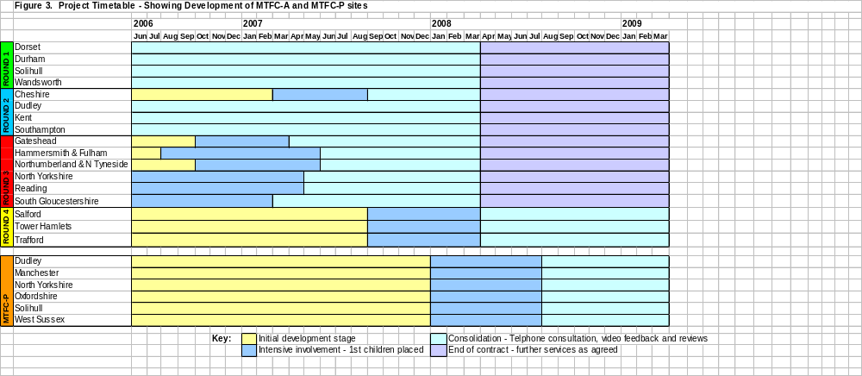

5. Children in MTFC-A Placements at June 2007

The first foster placement took place in April 2004 and 111 children and young people, 58 boys and 53 girls, have been admitted to the programme up to 1st June 2007 (excluding 12 children from the Wirral programme who withdrew from the DfES national programme last year for whom there is little audit data). Of the 50 children currently in MTFC placements, 13 have now been in the programme for over a year, and suitable moving on placements are being sought. 15 children have been in placement for more than 6 months duration, 13 for more than 3 months, and 9 for less than three months (see Figure 4 below).

Figure 4. Children and Young People in active MTFC-A Placements as at June 2007
Site | Child ID | Age Group | Sex | entry date | Days in Programme
Dorset | Dorset 23 | 12-18 | M | 01/09/2006 | 295
 | Dorset 24 | 12-18 | M | 09/03/2007 | 106
 | Dorset 25 | 12-18 | M | 18/04/2007 | 66
Durham | Durham 04 | 12-18 | M | 28/01/2006 | 511
 | Durham 06 | 7-11 | F | 02/11/2006 | 233
 | Durham 07 | 12-18 | F | 21/12/2006 | 184
 | Durham 08 | 12-18 | M | 02/01/2007 | 172
 | Durham 09 | 7-11 | F | 02/02/2007 | 141
Solihull | Solihull 03 | 7-11 | F | 25/02/2005 | 848
 | Solihull 07 | 12-18 | F | 03/05/2006 | 416
 | Solihull 09 | 12-18 | F | 15/11/2006 | 220
 | Solihull 10 | 7-11 | M | 10/01/2007 | 164
Wandsworth | Wandsworth 03 | 12-18 | F | 11/09/2006 | 285
 | Wandsworth 04 | 12-18 | F | 21/09/2005 | 640
 | Wandsworth 06 | 12-18 | M | 06/03/2007 | 109

Site | Child ID | Age Group | Sex | entry date | Days in Programme
Cheshire | Cheshire 01 | 12-18 | M | 27/03/2007 | 88
Dudley | Dudley 05 | 7-11 | M | 25/04/2006 | 424
 | Dudley 06 | 12-18 | F | 09/05/2006 | 410
 | Dudley 08 | 12-18 | M | 20/02/2007 | 123
 | Dudley 09 | 12-18 | F | 03/04/2007 | 81
Kent | Kent 02 | 12-18 | M | 17/02/2005 | 856
 | Kent 05 | 7-11 | M | 19/07/2005 | 704
 | Kent 06 | 12-18 | M | 16/01/2006 | 523
 | Kent 07 | 12-18 | M | 16/01/2006 | 523
 | Kent 10 | 12-18 | F | 12/04/2006 | 437
 | Kent 11 | 12-18 | M | 30/08/2006 | 297
 | Kent 12 | 12-18 | M | 26/10/2006 | 240
 | Kent 14 | 12/18 | F | 23/04/2007 | 61
Southampton | Soton 05 | 12-18 | F | 24/01/2006 | 515
 | Soton 08 | 12-18 | F | 01/11/2006 | 234
 | Soton 09 | 7-11 | M | 13/11/2006 | 222

Site | Child ID | Age Group | Sex | entry date | Days in Programme
Gateshead | Gateshead 02 | 7-11 | F | 06/10/2006 | 260
 | Gateshead 03 | 12-18 | F | 27/11/2006 | 208
 | Gateshead 04 | 12-18 | M | 18/05/2007 | 36
Hammersmith & | H&F 01 | 7-11 | M | 27/08/2006 | 300
Fulham | H&F 03 | 12-18 | F | 02/01/2007 | 172
 | H&F 04 | 12-18 | M | 17/05/2007 | 37
Northumberland | N+NT 06 | 7-11 | M | 08/03/2007 | 107
& N. Tyneside | N+NT 07 | 7-11 | M | 08/03/2007 | 107
 | N+NT 08 | 12-18 | F | 20/04/2007 | 64
North Yorkshire | North Yorks 02 | 12-18 | M | 29/08/2006 | 298
North Yorkshire | North Yorks 03 | 12-18 | F | 29/08/2006 | 298
 | North Yorks 04 | 12-18 | M | 13/10/2006 | 253
 | North Yorks 05 | 12-18 | M | 19/02/2007 | 124
Reading | Reading 03 | 12-18 | F | 15/01/2007 | 159
 | Reading 04 | 12-18 | F | 12/03/2007 | 103
 | Reading 05 | 12-18 | F | 17/04/2007 | 67
 | S.Glos 01 | 7-11 | F | 02/02/2006 | 506
S.Gloucestershire | S.Glos 04 | 12-18 | F | 09/01/2007 | 165
 | S.Glos 05 | 7-11 | M | 21/04/2007 | 63

To date 61 children and young people have left the programme, 31 of these have successfully graduated and moved to family based placements or independent living and 22 have moved out of MTFC before 3 months (early leavers) and 8 have left later but moved to more non-family based placements such as residential or secure units. 22 of the 31 children and young people who graduated moved to mainstream foster care placements, 7 returned home to family, 1 to supported lodging and 1 to a mother and baby unit to work towards independence.

A full description of these different groups, their characteristics and outcomes for children the period of the collation and analysis of the audit data up to 31st March are provided in the audit section of this report (see section 9).

6. MTFCE Training Programmes

In addition to supporting the development and implementation of the model in the sites, the National Team was commissioned to provide training in the MTFC model in order to ensure consistency of approach and fidelity to the treatment programme. In order to achieve this, core training in the MTFC model has been provided for each round of the programme for clinical staff and foster carers prior to young people being placed in treatment foster care.
OSLC staff have regularly been invited to London to train clinical staff and foster carers in conjunction with the national MTFCE team. In addition the National Team has provided training in the assessment requirements of the programme.

The National Team aims to provide the following training programme for all new sites awarded start up funding;

6.1 Induction Day

This provides an overview of the MTFC model, the research evidence from randomised control trials in the USA, the English programme content, the role of the National team and DCSF expectations of the sites (see figure 6.)

Figure 5. Numbers Attending MTFC-A and MTFC-P Induction Day
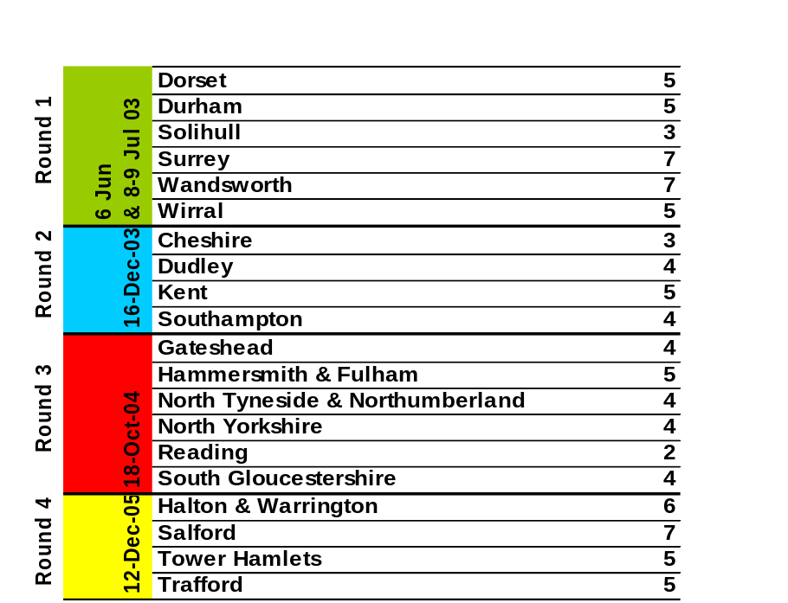
MTFC-P 4-Dec-06 | Dudley | 4
MTFC-P 4-Dec-06 | Manchester | 3
MTFC-P 4-Dec-06 | North Yorkshire | 2
MTFC-P 4-Dec-06 | Oxfordshire | 6
MTFC-P 4-Dec-06 | Solihull | 5
MTFC-P 4-Dec-06 | West Sussex | 5
 | Total to date | 119

6.2 Progress, Networking and Update Days

These provide an opportunity for the lead managers to meet with colleagues from other developing sites to network, exchange information concerning common dilemmas and possible solutions and to gain further information about the model e.g. ideas about successful recruitment of foster carers (see figure 6. below). In the last year the developing Round 4 sites met for an update and networking day in Manchester in September 2006 which was used to update the DCSF on developmental progress, issues and problems arising and to share ideas and successes particularly regarding foster carer recruitment and financial concerns.

An update day for the developing MTFC-P teams has been arranged for early September.

6.3 The MTFC Model

Specific training in the core principles, history, philosophy and practice tools of the MTFC model takes place with the whole clinical team. The training provides the teams with the basic skills and knowledge needed to set up and run the treatment programme for children and young people. The role of each member of the team is differentiated and clearly set out and the operational aspects of the programme outlined. Staff from OSLC have joined the National Team to facilitate each of the initial national trainings for each of the new rounds. Subsequent training for new staff joining teams has continued to run on a rolling programme. Clinical team staff from earlier rounds have also contributed to the training programmes to share their experiences.

This year 5 MTFC-A Clinical Team training courses have been held in; Leeds and London in September 2006, Durham in December 2006, London in February 2007, and South Gloucestershire in May 2007.

Figure 6. Total numbers of clinical team staff trained in the MTFC model since 2003

Round 1 | Dorset |  | 30
Round 1 | Durham |  | 24
Round 1 | Solihull |  | 25
Round 1 | Wandsworth |  | 34
Round 1 | Wirral |  | 12
Round 2 | Cheshire |  | 9
Round 2 | Dudley |  | 24
Round 2 | Kent |  | 14
Round 2 | Southampton |  | 13
Round 3 | Gateshead |  | 10
Round 3 | Hammersmith & Fulham |  | 12
Round 3 | Northumberland & N. Tyneside |  | 8
Round 3 | North Yorkshire |  | 4
Round 3 | Reading |  | 4
Round 3 | South Gloucestershire |  | 16
Round 4 | Salford |  | 1
Round 4 | Tower Hamlets |  | 3
Round 4 | Trafford |  | 3
 | Total to date | 246

  - Foster Carer Training

Foster carer training takes place once the carers have completed the “Skills to Foster” training provided by the local authority, have been formally assessed and then approved by panel. They then receive the additional training in the MTFC model. This provides the basic information needed to understand the principles and practice of operating the programme in the foster carers’ home.

Since last year foster carers from the English project have also joined the training and their presentations were thoroughly enjoyed by the prospective new carers. The two day training course includes a number of case examples, practice exercises and role plays, information about how attachment theory relates to the behavioural programme and examples of dealing with specific behavioural problems in the English legal and cultural context.

Figure 7. Total numbers of Foster Carers trained in MTFC

 | Round 1 | Dorset |  |  |  | 31
 | Round 1 | Durham |  |  |  | 20
 | Round 1 | Solihull |  |  |  | 11
 | Round 1 | Wandsworth |  |  |  | 24
 | Round 1 | Wirral |  |  |  | 12
 |  | Cheshire |  |  |  | 5
 | Round 2 | Dudley |  |  |  | 29
 | Round 2 | Kent |  |  |  | 28
 | Round 2 | Southampton |  |  |  | 16
 |  | Gateshead |  |  |  | 13
 | Round 3 | Hammersmith & Fulham |  |  |  | 8
 | Round 3 | Northumberland & N. Tyneside |  |  |  | 9
 | Round 3 | Reading |  |  |  | 5
 | Round 3 | North Yorkshire |  |  |  | 16
 | Round 3 | South Gloucestershire |  |  |  | 10
 |  | Total to date |  |  |  | 237

The recruitment of foster carers is a continual process and is not consistent across the sites. As a result the National Team have made foster carer training available on a rolling programme in order to train carers at reasonable time intervals following their assessments and approval as foster carers. The aim is to train Programme Supervisors and Foster Carer Recruiters to be able to train their own carers and a number of teams are now proficient in the materials and able to deliver their own courses. All the teams from rounds 1, 2 and 3 will be expected to be able deliver their own training by March 2008. Figure 7 above shows that a total of 237 carers have been trained since the programme began. Included in these figures are; some carers who received separate “top-up” training at their request, plus partners and supporters for example adult children living at home who wished to understand and help with the programme. In the last year 6 MTFC Foster Carer Training courses have been held in; Reading in July 2006, Durham in September 2006, London in November 2006, Cheshire and Kent in January 2007 and London in April 2007.

The next foster carer training courses are scheduled to take place for the MTFC-A Round 4 teams in the autumn of 2007. MTFC-P carers will receive training from the OSLC programme developers early in the New Year.

  - Other Training

In addition a rolling programme of training/consultation and networking days has been provided by the National Team. Smaller training/ consultations have been held to allow individual team members to network, learn from each other and provide ongoing support for their specific roles within the clinical teams. For example the training for skills workers included skills practice and role plays and the education workers day included exploration of the role of the teachers in the MTFCE teams and provided an opportunity to exchange ideas and information and learn from each other.

In the last year 8 Networking Days have been held for; Birth Family Therapists in July and November 2006, Foster Carer Recruiters and Education workers in November 2006, Individual Therapists in December 2006, Programme Supervisors with Programme Managers in November 2006 and March 2007, and Skills Trainers in March 2007.

7. Independent Evaluation

The independent national evaluation team from the universities of Manchester and York was appointed by the DCSF in the autumn of 2004 and has worked closely with the National Team in understanding the structures and systems of the programme sites and determining the practicalities of undertaking a randomised control trial (RCT) alongside a case control study. An information day for the early project sites held in December 2005 was well attended by senior staff from the sites. Issues raised, subsequent site visits and ongoing liaison with steering groups by the evaluation team enabled modifications to the final design of the trial and the specific process for each team.

The Care Placements Evaluation (CaPE) team has worked hard on recruitment of young people into the study as more teams have joined the national programme. The data collection time period has been extended in an attempt to manage some recruitment delays and it is hoped that as the later rounds increase their numbers of placements this will increase the numbers of children available to the RCT.

8. Assessment Measures

The English teams were asked to make full assessments of all children being considered for admission to the MTFC-A programme (see previous annual reports for more details of the assessment protocols). This was an innovation to the original USA programme designed to take account of the specific needs of the looked after population in England and ensuring that there is a comprehensive and detailed assessment of the child’s strengths and needs prior to entering the MTFC programme.

The assessment has two main functions; clinical and evaluative. Firstly to provide detailed and specific information to assess the young person’s current mental, physical, psychological, social and educational functioning which will then inform the planning of the specific treatment goals for each young person coming into the programme, including a detailed risk assessment from which careful contingency plans can be made. Secondly to provide baseline data of the young person’s functioning, strengths and difficulties to enable comparisons to be made across the programme sites.
The baseline measures are as follows; Strengths & Difficulties Questionnaire (SDQ) Children’s Global Assessment Scale (CGAS), Wechsler Intelligence Scale for Children (WISC) or Wechsler Abbreviated Scale of Intelligence (WASI 1999), Wechsler objective reading dimensions test (WORD) and the Development and Well-Being Assessment (DAWBA)

8.1 Strengths & Difficulties Questionnaire (SDQ)

Table 1. Strengths and Difficulties Questionnaires

 | Parent / Carer  Total Difficulties Score at T1 (n=55) | Teacher  Total Difficulties Score at T1 (n=42) | Young Person  Total Difficulties Score at T1 (n=54)
0 – 11 average | 5.5% | 19% | 17%
12 – 15 borderline | 11% | 12% | 18.5%
16 + high | 84% | 69% | 65%

Of the cases for whom we have data, 84% of young people had difficulties in the high range on the SDQ Parent/Carer, 69% had difficulties in the high range according to teacher ratings and of the 54 young people who completed the self rated young persons SDQ, 65% had difficulties in the high range.

8.1.1 Children’s Global Assessment Scale (C-GAS)
The Children’s Global Assessment Scale (CGAS) is a measure developed by Schaffer and colleagues at the Department of Psychiatry, Columbia University to provide a global measure of level of functioning in children and adolescents. The measure provides a single global rating only, on scale of 0-100. In making their rating, the clinician makes use of the glossary details to determine the meaning of the points on the scale.

Table 2. CGAS Scores Whole Group

CGAS | T1 n=54
Mean score | 50.25
Range | 29 - 70

Mean scores at T1 for this group were 50.25 which is on the border between “60-51Variable functioning with sporadic difficulties” and “50-41 Moderate degree of interference in functioning” The range is 29 to 70. (See C-GAS Appendix 4)

8.1.2 Development and Well-Being Assessment (DAWBA)

One specific measure - the Development and Well-Being Assessment (DAWBA) enables comparisons to be made of the mental health status of children in this programme with the large ONS study funded by the Department of Health on the mental health of children looked after compared with a community sample of children living in private households. It was anticipated that the group of children referred to MTFC would have a higher level of complexity of need, including more mental health difficulties than the general looked after population. Professor Robert Goodman who designed the measure has agreed to rate all the DAWBAs and provide formal diagnostic reports to the clinical teams within a short time period.

The data received up to the end of 2006 is summarised in table 3 as follows;

Table 3. Diagnoses according to the clinical rater in MTFC-A cases from 2006 as compared with the ONS survey of looked after children and adolescents in England in 2002, and the ONS survey of children in the British general population in 2004.

ICD Disorder (definite) | MTFC cases in 2006 n=40 | ONS Survey of looked after children | ONS general population sample
Any psychiatric disorder | 95.0% | 44.8% | 9.6%
Multiple psychiatric diagnoses | 40.0% | 13.0% | 2.2%
Any emotional disorder | 37.5% | 11.7% | 3.7%
Separation anxiety | 2.5% | 0.4% | 0.4%
Social phobia | 2.5% | 0.7% | 0.3%
PTSD | 7.5% | 2.1% | 0.2%
Generalised Anxiety | 22.5% | 2.1% | 0.8%
Other Anxiety | 7.5% | 3.9% | 0.9%
Depression | 7.5% | 4.3% | 0.9%
Any Conduct Disorder | 92.5% | 38.9% | 5.8%
ODD | 15.0% | 11.4% | 3.0%
Socialised CD | 20.0% | 14.3% | 1.3%
Unsocialised CD | 50.0% | 5.6% | 0.8%
Other CD | 7.5% | 5.4% | 0.6%
Hyperkinesis | 5.0% | 7.3% | 1.5%
Less common Disorders (tic, eating, autistic) | 2.5% | 3.7% | 1.3%

The table shows that children and young people coming into MTFC were twice as likely to meet the criteria for psychiatric disorders as the population of children in the care system and ten times more likely than the general population. Emotional disorders are 3 times as high and generalised anxiety 10 times greater than the care population. Striking features of the MTFC sample are;
- The high rate of anxiety disorders, particularly generalised anxiety.
- The high proportion of behavioural problems is expected, but the high proportion of unsocialised conduct disorder is striking: the socialised to unsocialised ratio is about 8 times greater than in the ONS sample.
- The low rate of hyperkinesis, which may reflect limitations in the MTFC data collection (for example missing teacher data or carers who did not know the child well)

8.1.3 Wechsler Intelligence Scale for Children (WISC) or WASI

Table 4. IQ scores on entry to MTFC-A n= 34

 | IQ group at T1
 | <70 | 71-80 | 81-100 | >101
No. of Young People | 12% (4) | 29% (10) | 50% (17) | 9% (3)

The table above shows that of the 34 young people for whom there is valid data, half have IQ scores in the 81-100 low average range. Only 9% have scores above 100 and 12% have scores below 70 in the general learning disability range and below the recommended entry criteria for the programme. The mean was 86 and the range 58-127.

8.2 Psychiatric Medication
20 (21%) of the 97 young people for whom data were available were in receipt of medication for a variety of mental health difficulties including ADHD, depression, epilepsy, psychosis, and sleep problems at the time of admission to the programme.

9. Audit

Programme sites have been asked to collect audit data on all children and young people placed in the programme to be collated and analysed by the National Team. The data provides the national programme and individual teams with general information regarding the status of children entering and leaving MTFC-A, including demographic data, numbers of referrals, type and severity of difficulties experienced by the children, their families or previous carers, educational attainment, criminal offences plus information concerning outcomes including some indications of the factors contributing to successful placements and treatment outcomes.

9.1 Summary of Initial Audit Data for Young People Admitted to the MTFC Programme from April 2004 to March 2007.

A total of 101 young people had been admitted to the MTFC-A programme from the first placement in April 2004 up to the point of collating and analysing the current audit data at the end of March 2007. Information on 12 children who were in placement in the Wirral has been excluded as this team withdrew from the programme last year and insufficient audit data is available on the young people.

What follows is a summary of the available data. Information will be presented firstly on the whole sample of 101 children and young people who entered the programme and includes demographics and characteristics, risk behaviours and pre-placement difficulties. Secondly, the characteristics and outcomes for the 26 children who had graduated from the programme at 31st March 2007 and moved to family based placements such as mainstream foster care or extended family, or independent living. The group of early leavers, 22 who left the programme having completed less than 3 months and for whom it is least likely to have had a positive impact and a small sub-group of 8 young people who stayed in the programme for more than 3 months but who cannot be described as graduates as they moved from MTFC to non-family based placements such as residential or secure units.

It is hoped that in exploring this data we will be able to highlight;
- whether the programme is placing the group of young people for whom it was intended
- in what ways the programme appears to contribute to success or change for young people
- whether it is possible to identify those who are most likely and those who are least likely to benefit from the intervention so that resources and placements can most usefully be targeted
- the processes and system issues that may contribute to these outcomes
- what can be learnt about how to use or develop the programme from looking at the comparisons between different groups and outcomes

9.2 Demographics of the whole sample of 101 children and young people

9.2.1 Age and Gender

Figure 8. Age and Gender of Young People on admission to MTFC

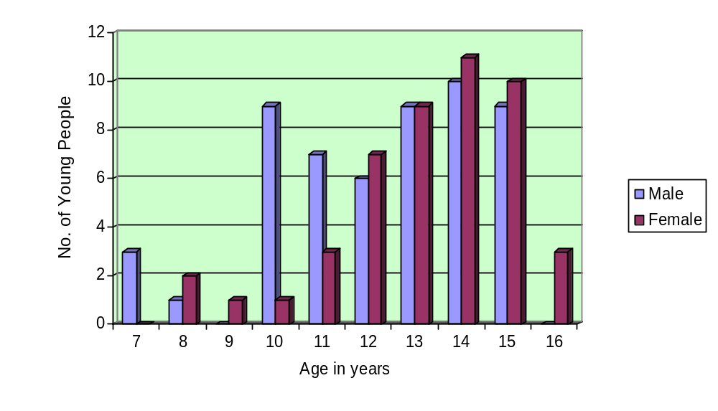
Of the 101 children and young people admitted to the MTFC programme between April 2004 and March 2007, 53% (54) were boys and 47% (47) were girls. The last year of operation has seen 24 boys and 20 girls admitted to the programme. The mean age for all children was 12.68 years, for the boys it was 12.22 years and for the girls slightly older at 13.30 years. The mode for both boys and girls is 14 years but as the table above shows there was a sizable group of 10 year old boys.

Although the programme is designed for older children a small number of younger children (7) have been admitted to MTFC placements. The most common reason for admitting a child into MTFC outside the designated age range was acute concerns about their presenting behavioural difficulties and lack of alternative specialist placements. These children have required adaptations to the adolescent model to ensure developmentally appropriate systems were in place which has posed challenges to the teams and foster carers trained in the original programme. However once established the younger children have responded well to the contingent framework although there have been increased difficulties in securing long term permanent placements for this age group.

9.2.2 Ethnicity
The majority of children who came into the programme were White British (87.5%) although a higher proportion of children from ethnic minorities have been admitted in the last year.

9.2.3. Legal Status at admission
Half of young people (50%) admitted to MTFCE were accommodated by the local authority just under half (46%) had full care orders and 4% interim orders. Slightly higher numbers of boys were on full care orders compared with girls.

9.2.4 Previous Placements

Figure 9. Number of previous placements (n=82)
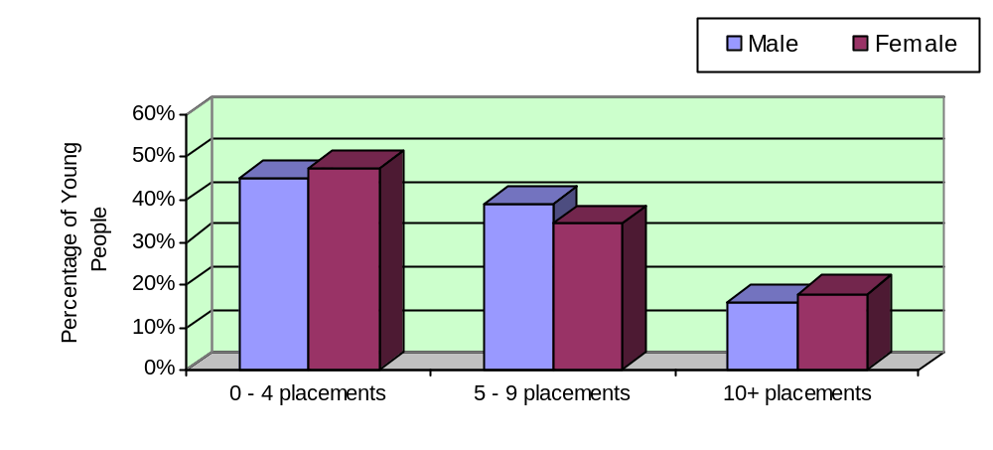
Of the 82 cases for which we had data, 46% (38) of young people had between 0 and 4 placements upon entering MTFC. 37% (30) of young people had between 5 and 9 previous placements and 17% of young people (14) had 10 or more previous placements. The mean number of previous placements was 5.65 and the range was 0 to 26.

Figure 10: Last Placement Prior to MTFCE (n=94)

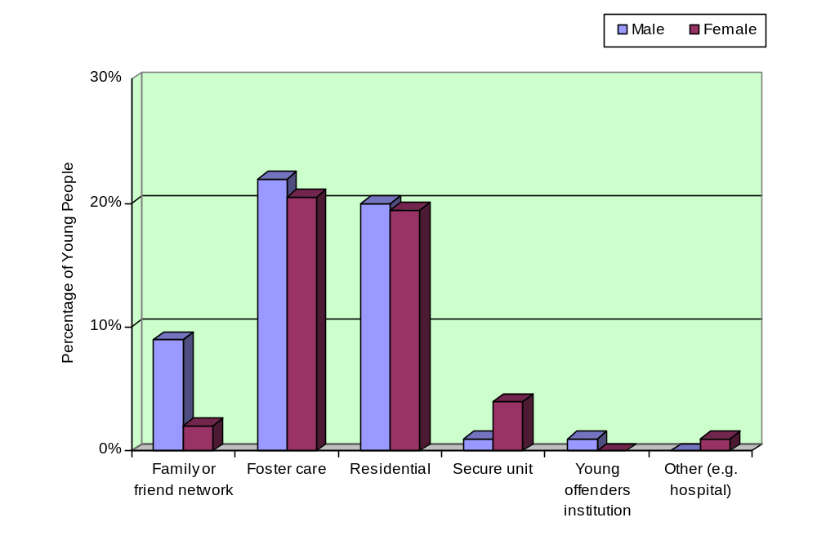 Figure 10 above shows that 40% (37) of the young people admitted to MTFCE came directly from residential care and 42% (40) came from foster care, either local authority or independent provision. The remainder were from a mixture of birth or extended family (11%), secure provision such as Young Offender Institutions or Secure unit (6%) and one case (1%) from hospital.

9.2.5 Education

Table 5. School Placement on entry to MTFCE (n=92)

 | Boys | Girls | Total
Mainstream | 16 (33%) | 18 (41%) | 34 (37%)
Special school | 12 (25%) | 14 (32%) | 26 (28%)
Education other than school | 12 (25%) | 4 (9%) | 16 (17.5%)
Without a school place | 8 (17%) | 8 (18%) | 16 (17.5%)
Total | 48 (100%) | 44 (100%) | 92 (100%)

Of the 92 young people for whom we have data, only 65% (60) had a school place on admission to MTFC either within mainstream or special school. 73% (32) of the girls had a school place compared with 58% (28) of the boys. However gender differences in this table and for all the other educational variables were small and not statistically significant. 35% (32) had no mainstream or special school places, and most were provided with education in a special unit such as a Pupil Referral Unit (PRU). 59% of young people had full time educational provision on entry to MTFC, 34% had part time educational provision and 7% (6) had no educational provision.

Special Educational Needs (n=88)
28% of all children in care have a statement of special educational needs (SEN), compared with 3% of all children. 47% (41) of young people entering MTFC had full statements of special educational needs, 12.5% (11) were on school action plus, and 2% (2) were on school action. In addition a surprisingly high 38.5% (34) had no identified special educational needs despite considerable reported difficulties in school.

Educational Attendance (n=81)
74% (60) of young people were described as mostly attending their educational place, 4% (3) were occasionally attending and 20.5% (18) were frequently not attending.

Behavioural Difficulties in School (n=87)
82% (71) young people had behavioural difficulties identified by teaching staff in the school or education context.

9.2.6 Contact with Birth/Adoptive Family

Table 6. Frequency of contact with birth parents on entry to MTFCE (n=94)

 | Number of young people | Percentage
Weekly | 37 | 40%
Fortnightly | 8 | 8%
Monthly | 7 | 7%
Less than monthly | 25 | 27%
None | 17 | 18%
Total | 94 | 100%

Most of the young people (82%) entering the programme had had some contact with their birth parents in the year prior to admission. 40% (37) of young people had weekly contact, 8% (8) had fortnightly contact, 7% (7) had monthly contact and 27% (25) had contact less frequently than once a month - for example in the school holidays. Only 18% (17) of young people had no contact with birth parents. For 31% (29) of young people contact was supervised, for 44% (41) young people contact was unsupervised and in 5% (5) of cases contact was indirect.

Where young people had siblings, 83% (72) had some form of contact, 29% (25) had weekly contact, 13% (11) had fortnightly contact and 8% (7) had contact at monthly intervals. 16% (14) young people had no sibling contact. Of the 91 young people for whom we have data, 47% (43) had some contact with extended family in the year prior to admission, 26% (24) had contact monthly or more frequently than monthly and 53% (48) had no contact.

9.2.7 Leisure interests

Figure 11. Involvement in After School Leisure Interests on entry to MTFCE (n=90)

21%
8%
71%
No, never
Yes, occasional
Yes, regular
Only 8% (7) of young people regularly took part in after school activities, 21% (19) of young people took part occasionally but the majority (71% n= 64) never took part.

Figure 12. Involvement in Non School Leisure Interests at T1 (n=90)

28%
58%
14%
No, never
Yes, occasional
Yes, regular
Young people’s involvement in non-school leisure activities (n=90) was similar, with 58% (52) young people never taking part in any activities and only 14% (13) taking part regularly
Of the 88 young people for whom we had information on both after school and non school leisure activities, 55% (48) had no involvement with either.

9.3 Summary of Young People’s Difficulties and High Risk Behaviours on entry to MTFC-A

9.3.1 Family context and history of abuse

Table 7. Family Context

 | Boys | Girls | Total
Family Violence (n=25) | 12 (92.5%) | 12 (100%) | 24 (96%)
Family Alcohol Misuse (n=23) | 7 (63%) | 9 (75%) | 16 (70%)
Family Substance Misuse (n=23) | 7 (58.5%) | 5 (45%) | 12 (52%)
Parental Mental Illness (n=23) | 10 (90.5%) | 8 (67%) | 18 (78%)
Parental Physical Health Difficulties (n=24) | 1 (9%) | 4 (31%) | 5 (21%)
Death of Parent (n=27) | 3 (21%) | 2 (15%) | 5 (19%)

Almost all (96%) of the children and young people for who we have data had a family history of violence, 78% had a history of parental mental illness, 70% of parental alcohol misuse, and 52% of substance use. 20% of young people had a family history of parental physical ill health and 19% had suffered the death of a parent.

Figure 13. Abuse history on entry to MTFCE (n=46)
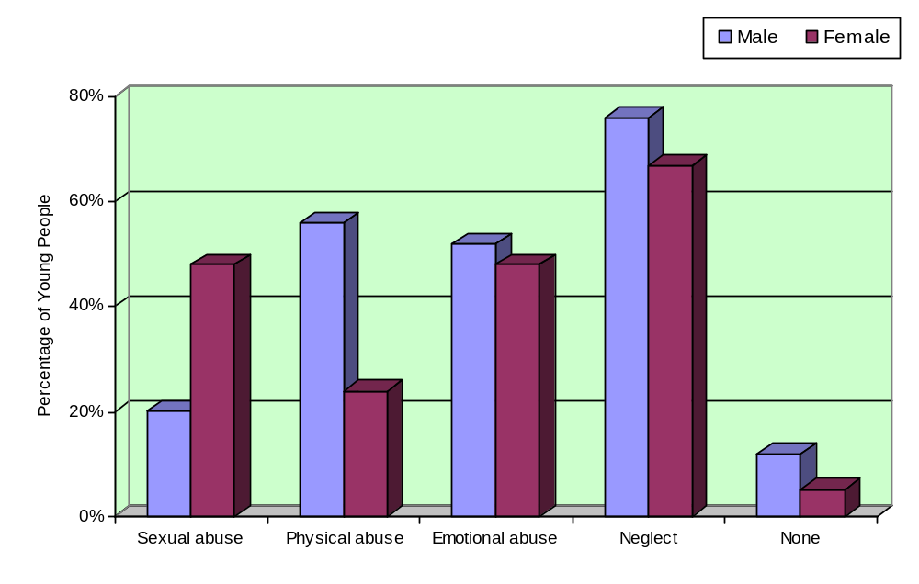
For the 46 young people for whom data are available, 91% (42) had a previous history of some type of abuse. 40% (17) had suffered two or more types of abuse, 26% (11) had suffered three or more types of abuse and 7% (3) children had been subject to all four categories of abuse.

For the 25 boys, 88% (22) had a history of abuse and for the 21 girls a higher 95% (20) of entrants had a history of abuse. There were gender differences in the type of abuse experienced with a much higher percentage of girls being sexually abused and much higher percentage of boys being physically abused. These differences were statistically significant (p<.05).

9.3.2 Summary of Young People’s High Risk Behaviours - All entrants

Figure: 14. High risk behaviours demonstrated by young people on entry by gender.

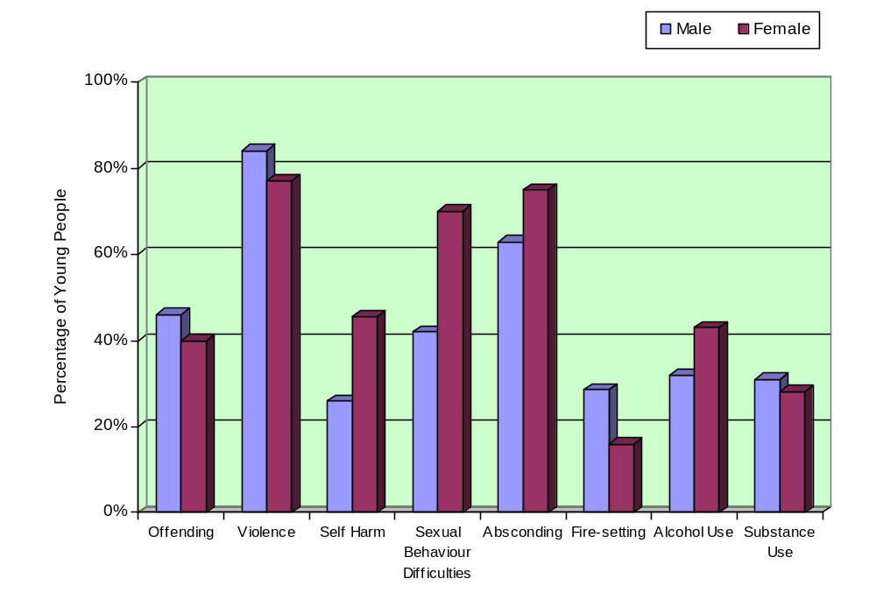

Table: 8. High risk behaviours on entry to MTFCE by gender

Risk factor - significance  Direction of difference | N | Boys | Girls | Totals
Offending not significant  Boys>girls | 93 | 23 (46%) | 17 (40%) | 40 (43%)
Violence not significant  boys>girls | 94 | 42 (84%) | 34 (77%) | 76 (81%)
Self Harm p = <.05  girls>boys | 94 | 13 (26%) | 20 (45.5%) | 33 (35%)
Sexual Behaviour Problems p = <.05  Girls > boys | 92 | 20 (42%) | 31 (70%) | 51 (55%)
Absconding not significant  Girls >boys | 95 | 32 (63%) | 33 (75%) | 65 (68%)
Alcohol Use not significant  Girls >boys | 91 | 15 (32%) | 19 (43%) | 34 (37.5%)
Substance Use not significant  No differences | 91 | 15 (31%) | 12 (28%) | 27 (30%)
Fire-setting not significant  boys>girls | 93 | 14 (28.5%) | 7 (16%) | 21 (22.5%)

The graph and table above show a summary of the high risk behaviours demonstrated by children and young people entering the programme. The table also shows gender differences, direction of difference and statistical significance. Boys showed slightly higher levels of offending, violence and fire setting but none of these as yet reach statistical significance. Girls demonstrated higher levels of absconding and alcohol use and also particularly of self harm and sexual behaviour problems, the latter two reach statistical significance at p = <.05

9.4 OUTCOMES FOR CHILDREN WHO HAVE LEFT MTFC-A

At the 31st March 2007, 56 children had left the programme, 22 left before 3 months (early leavers) and 34 children and young people left after a period of at least 3 months in an MTFC placement; 26 of these were graduates and moved from MTFC after completing the programme, to family, foster family or independent living placements. A small group of 8 children stayed longer than 3 months and moved to non-family based placements such as residential children’s homes (later leavers).

This section explores the characteristics and outcomes for each of these different groups and attempts to answer the following questions;
- What are the characteristics of children who leave early or successfully graduate from the programme – are they different and if so in what way?
- What are the outcomes for these groups?
- Where do they go to when they leave?
- What does this tell us about which children may benefit most from MTFCE?

9.4.1 Comparison of Graduates with all entrants to MTFC-A

On admission the group of 26 successful graduates were similar to the whole group in age and ethnicity. However graduates appear to be different from the whole group in a number of ways as shown in the table below. Graduates were more likely to be female, to have been previously placed in foster care than in residential and to have had fewer previous placements prior to admission to MTFC. Graduates were more likely to be accommodated under S20 than under a Care Order, to have a mainstream school placement, to be in full time education and be attending education more frequently.

Table 9. Demographics on entry to MTFC

 |  | Whole Group  n=101 | Graduates  n=26
Age: | Average  Mode | 12.7 yrs  14 yrs | 12.6 yrs  10 and 15yrs
Gender: | Male  Female | 53%  47% | 42%  58%
Ethnicity: | White British | 87.5% | 85%
Previous Placement Type: | Foster care/family network  Residential/secure/YOI | 54%  47% | 66%  35%
No. of Previous Placements: | 0 – 4  5 – 9  10+ | 46%  37%  17% | 60%  20%  20%
Legal Status: | Accommodated Section 20  Full Care order Section 31  Other (e.g. Interim care order) | 50%  46%  4% | 62%  38%  0%
Education: | Without a school place  No educational provision  In full time education  In mainstream school  Mostly attending educational place | 17.5%  7%  59%  37%  74% | 0%  0%  73%  46%  84%
Contact with birth/adoptive parents | None  Less than monthly  Monthly  Fortnightly  Weekly | 18%  27%  7%  8%  40% | 20%  32%  4%  4%  40%

Table 10. Presenting Difficulties on entry to MTFCE

History of; | Whole Group  n=101 | Graduates  n=26
Offending | 43% | 35%
Violence | 81% | 65%
Self harm | 35% | 27%
Sexual behaviour problems | 55% | 48%
Fire-setting | 22.5% | 24%
Absconding | 68% | 58%
Alcohol use | 38% | 35%
Substance use | 30% | 20%
Abuse:  Neglect  Sexual  Physical  Emotional | 72%  33%  41%  50% | 60%  33%  40%  27%
In terms of risk factors, graduates were also less likely to have a history of offending, violence to others, self harm, sexual behaviour problems, absconding and substance use on admission to MTFCE. They were less likely to have been emotionally abused in the past than the whole sample. The CGAS (see table 11 below) suggests graduates had slightly higher overall functioning on entry. Numbers are currently low, and these differences are small but show a trend in graduates having fewer difficulties on entry than the whole sample.

Table 11. Children’s Global Assessment Scale on entry

CGAS | Whole Group T1  n=54 | Graduates T1  n=13
Mean score | 50.25 | 52.77
Range | 29 - 70 | 35 - 70

9.4.2 Outcomes for group of 26 Graduates from MTFCE

9.4.2 i Discharge placement

The average time in MTFC placement was 10 months, although the range was 4 to 21 months. 73% (19) of the graduates moved to long term foster care placements, 19% (5) went home to family, 1 to semi-supported lodgings to prepare for independence and one girl successfully completed her placement during her pregnancy and moved to a mother and baby unit.

Figure 15. Placement upon discharge - Graduates
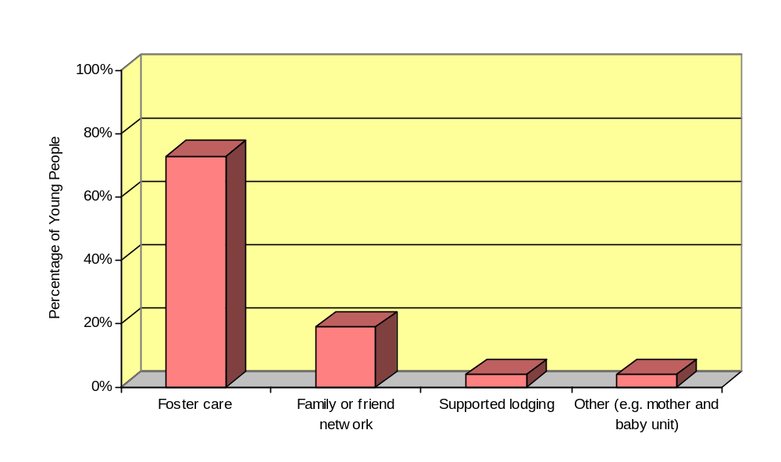

9.4.2 ii Presenting difficulties on admission to MTFC-A (T1) and on leaving (T4)

Children and young people graduating from the MTFC programme show improvements on all the risk behaviours between entering the programme and moving to a new placement. 35% of the group of graduates entered the programme with convictions for criminal offences. On leaving the programme only 1 child had received a further conviction

At admission to the programme 15.5% of graduates had a history of associating with an offending peer group; on discharge this had been reduced to 8.5%. Previous history of violent behaviour towards other people dropped from 65% on admission to 31% on leaving the programme. History of self harming behaviour on entry to MTFC (for example drug overdoses and cutting) was reduced from 27% to 0% during the placement period. Reported concerns regarding young people’s sexual risks to themselves and /or to others reduced during the time in the programme from 48% on entry to 32% on leaving MTFC.

Levels of absconding from placements reduced during the time in the programme from 58% on entry to 31% on leaving MTFC. There were no incidents of fire setting during the placements. Alcohol use reduced from 35% on entry to MTFC to 24% during the placement period. Substance use reduced from 20% on entry to MTFC to 12% during the placement period.

Selected data summarising these outcomes follows;

Figure 16. Summary of High Risk Behaviours at T1 and T4 - Graduates
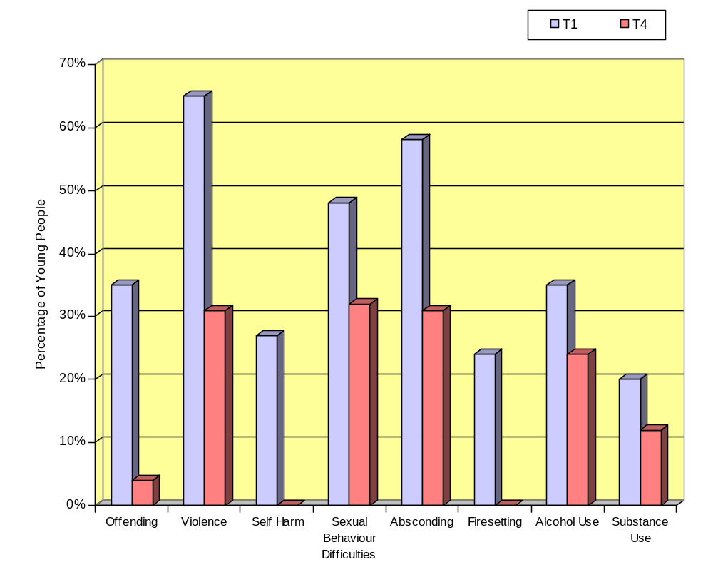
Table 12. Summary of high risk behaviours T1 to T4 changes for graduates

High Risk Behaviours | Graduates  n=26
 | Entry | Exit
Offending | 35% | 4%
Violence towards others | 65% | 31%
Self harming | 27% | 0%
Sexual behaviour problems | 48% | 32%
Absconding | 58% | 31%
Fire-setting | 24% | 0%
Alcohol use | 35% | 24%
Substance use | 20% | 12%

9.4.2 iii Education outcomes

Figure 17. Summary of T1 to T4 changes in education factors for graduates
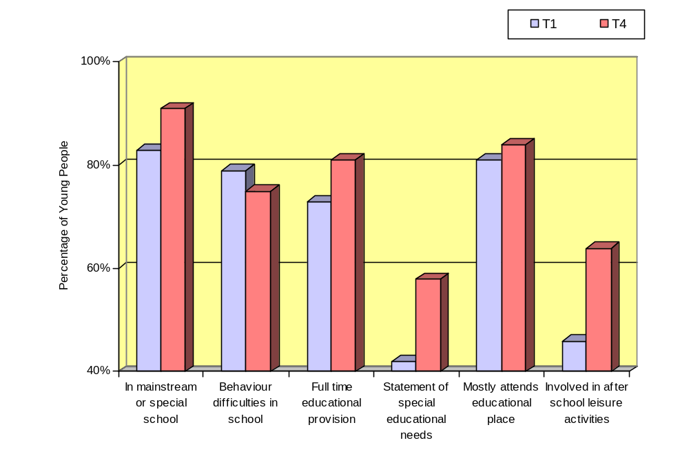
Graduates from the programme also showed improvements on educational factors from admission to discharge. On entry to the programme 52% of graduates had a mainstream school placement. This had reduced slightly to 43% on leaving the programme. 31% of graduates had a placement at a special school on admission to MTFC. This had risen to 48% on leaving. Combined with the figures for mainstream schooling, placements at either mainstream or special school increased from 83% on entry to 91% on discharge from the programme. 79% of the graduates were reported to have behavioural difficulties at school on entry to the programme. This reduced only slightly to 75% on leaving the MTFC programme. The numbers of children receiving Special Educational Needs (SEN) statements increased from 42% to 58% and young people attending after school leisure activities increased from 46% to 64% during their placements.

Initial outcomes indicated by this audit data for the group of 26 graduates from the programme are encouraging, although numbers remain quite small and conclusions must be somewhat cautious. Interestingly the number of negative behaviours shown in the foster care home and recorded on the PDR (Parent Daily Report) completed by the foster carer showed only minor changes and warrants further analysis as the admission and end scores may not reflect the patterns over the progress of the placement.

Children’s Global Assessment Scale (CGAS) functioning scores rose from scores in the impaired range to scores in the range of generally functioning pretty well.

9.4.3 Comparisons between graduates, early leavers and later leavers

There were 22 early leavers up to the end of March 2007 who left the programme having completed less than 3 months (90 days) in an MTFC foster placement. The mean number of days spent in placement for early leavers was 41 days. The mode was 57 days and the range was from 2 to 89 days.

The table below shows that early leavers were slightly older than graduates with a mean age of 13.9 compared with 12.6 years. Over 2/3 (64%) of early leavers were boys compared with 42% of graduates, they were more ethnically diverse and twice as likely as graduates to have been in residential care prior to admission. They were also more likely to have had 5 or more previous placements prior to admission to MTFC. In comparison graduates were more likely to be girls and to have been previously fostered. The most striking difference is in educational provision; only 45% of early leavers had a place at either mainstream or special school compared with 83% of graduates. All of the graduates had some form of educational provision while 24% of early leavers had none. There are no obvious differences in legal status or in the frequency of contact with birth parents.

Table 13. Summary demographics on entry to MTFCE comparing whole group, early leavers, and graduates

 |  | Whole Group  n=101 | Early Leavers  n=22 | Graduates  n=26
Age: | Average  Mode | 12.7 yrs  14 yrs | 13.9 yrs  15 yrs | 12.6 yrs  10 and 15yrs
Gender: | Male  Female | 53%  47% | 64%  36% | 42%  58%
Ethnicity: | White British | 87.5% | 77% | 85%
Previous Placement Type: | Foster care/family network  Residential/secure/YOI | 53%  47% | 28%  72% | 66%  35%
No. of Previous Placements: | 0 – 4  5 – 9  10+ | 46%  37%  17% | 33%  48%  19% | 60%  20%  20%
Legal Status: | Accommodated Section 20  Full Care order Section 31  Other (e.g. Interim care order) | 50%  46%  4% | 55%  41%  4% | 62%  38%  0%
Education: | Without a school place  No educational provision  In full time education  In mainstream school or special school  Mostly attending educational place | 17.5%  7%  59%  65%  74% | 30%  24%  43%  45%  53% | 0%  0%  73%  83%  84%
Contact with birth/ adoptive parents | None  Less than monthly  Monthly  Fortnightly  Weekly | 18%  27%  7%  8%  40% | 23%  23%  4.5%  13.5%  36% | 20%  32%  4%  4%  40%

In addition to the 22 children who left the programme before 3 months in placement, a small group of 8 children, 3 girls and 5 boys, stayed longer than 3 months but did not successfully graduate from the programme and transferred to non-family based placements such as a residential children’s home or secure unit. The mean number of days spent in placement for these late leavers was 319 days (10 months) and the range was 181 to 800 days for the youngest child. The mean age was 12.3 years and the range was 8 – 15 years with modes of 11, 13 and 15 years. They were equally likely to come from either residential or foster care prior to MTFC placement and more likely to be without a school place on entry to the programme.

The table below summarises the high risk behaviours of young people on admission to the programme comparing early leavers, graduates and late leavers. The table indicates that both the early leavers and late leavers groups were more likely to have a history of offending behaviours, violence towards others, absconding, and alcohol and drug use than graduates. Early leavers were more likely to have a history of self harm than either graduates or late leavers. Late leavers were more likely to have sexual behaviour problems than either early leavers or graduates.

Table 14. Summary of High Risk Behaviours for all leavers on entry to MTFCE

 | Whole Group  n=101 | Early Leavers  n=22 | Graduates  n=26 | Late leavers to non-family placements  n=8
History of offending | 43% | 58% | 35% | 50%
History of violence | 81% | 90% | 65% | 83%
History of self harm | 35% | 50% | 27% | 17%
History of sexual behaviour problems | 55% | 45% | 48% | 67%
History of fire-setting | 22.5% | 20% | 24% | 0%
History of absconding | 68% | 85% | 58% | 83%
History alcohol use | 38% | 65% | 35% | 67%
History of substance use | 30% | 65% | 20% | 50%

9.4.3.i Leaving the MTFC programme

Discharge Placements

Figure 18. Placement on Discharge for graduates, early leavers and late leavers

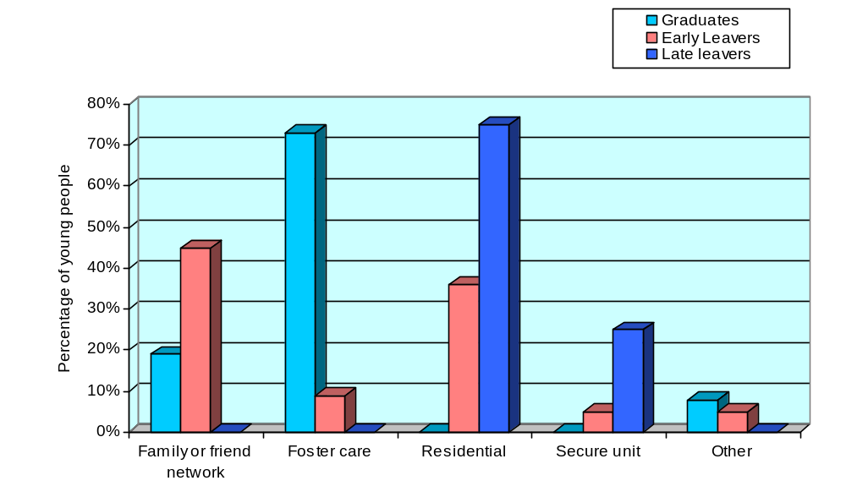
19 (73%) graduates moved to foster care, 1 young person moved to supported lodging and 1 to a mother and baby home and 5 (19%) returned home to live with their families. 6 (75%) of the late leavers went to residential care after leaving MTFCE and 2 (25%) to secure units. One child who was discharged to a residential educational placement had been admitted at the age of 8 years and stayed in the placement for 2 years and 2 months before discharge. He completed the programme and was transferred to the provision that was thought best met his needs. Interestingly, more than half (54%) of early leavers were discharged to family based placements, 45% to home or family network and 9% to foster care. A total of 46% (10) young people left MTFC early to go to residential placements, secure unit or to other non-family based placements. There were some gender differences with twice as many boys going home (57%) than girls (25%). More girls (50%) went to residential units than boys (29%).

Although 63% of early leavers came from residential placements, secure unit or young offenders institution only 46% were discharged back to similar placements and a substantial number went home.

Reasons for leaving MTFCE

Table 15. Early and late leaver’s reasons for leaving

 | Early Leavers  n=22 | Late leavers to non-family placements  n=8
Young person’s wishes | 10 (45%) | 1 (12.5%)
Birth family wishes | 1 (5%) | 0 (0%)
High risk behaviour | 7 (32%) | 3 (37.5%)
Carer wishes | 1 (5%) | 3 (37.5%)
Other (e.g. breached ASBO) | 3 (13%) | 1(12.5%)
Total | 22 (100%) | 8 (100%)

The table above shows the stated reasons for leaving the MTFCE programme for early and late leavers. The most common reason for leaving for early leavers was stated as young persons’ wishes. In some cases this was due to young people withdrawing consent to come into the programme, not wishing to live in foster care or missing the previous freedoms available in residential care. This was often also birth family wish to have the child home. In 2 cases this was positive; for one child the MTFCE assessment and family therapy led to a support plan for family care which allowed the child to be safely managed at home. In the other case the MTFCE team helped the child to obey their curfew, take their medication and attend their schooling.

For both early and late leavers high risk behaviour was also a frequent contribution to placement ending prematurely, particularly violence or threats towards carers and frequent absconding or criminality. This was the case for at least 2 young people who had been admitted as “emergency” placements and where there was insufficient time for assessment including motivation and risk and for consent issues to be fully explored. For late leavers not moving a young person out of MTFCE to a permanent placement after 9 or 10 months in the programme was a contributory factor in placement breakdown for at least 2 cases as the young person and foster carers felt they were no longer achieving anything in the programme.

ii Comparisons between groups on entry and on leaving the programme

The table below shows entry and exit differences in high risk behaviours and education factors for graduates, early leavers and late leavers. As expected the successful graduates demonstrate obvious changes on a variety of risk factors and an increase in school placement and educational attendance as described above Early leavers show some decrease in specific problem behaviours such as offending and fire setting but this is not a like for like comparison as their time in the programme was variable and less than 3 months duration. However it is notable that violence and absconding, both factors which contribute to early placement breakdown, remain high during the placement. As expected there is little change in self-harming or sexual behaviour problems and none in alcohol use. However it is positive that even with a short time in the programme mainstream school placements are slightly increased as is attendance although behavioural difficulties in school increase (perhaps as a result of being in school more often).

Table 16. Entry and exit comparisons between outcome groups

 | Graduates  n=26 |  | Early leavers  n=22 |  | 3+ month leavers  n=8
 | Entry | Exit | Entry | Exit | Entry | Exit
Offending | 35% | 4% | 58% | 21% | 50% | 60%
Violence towards others | 65% | 31% | 90% | 75% | 83% | 100%
Self harming | 27% | 0% | 50% | 40% | 17% | 40%
Sexual behaviour problems | 48% | 32% | 45% | 40% | 67% | 60%
Fire-setting | 24% | 0% | 20% | 5% | 0% | 0%
Absconding | 58% | 31% | 85% | 80% | 83% | 80%
Alcohol use | 35% | 24% | 65% | 65% | 67% | 60%
In mainstream school or special school | 83% | 91% | 45% | 50% | 25% | 25%
Behaviour difficulties in school | 79% | 75% | 81% | 87.5% | 100% | 100%
Frequently not attending educational placement | 13% | 4% | 53% | 37.5% | 33% | 33%

The graduates and later leavers are more comparable as the mean time in placement was similar at around 10 months duration although the late leavers group is small in numbers and conclusions must be very tentative. There were increases in offending, violence and self harm for the late leavers by the end of the placement, and little difference in sexual behaviour problems and alcohol use.

Few of the late leavers had full time school placements on entry to the programme or on leaving and all had behaviour problems in school and poor attendance on entering and on

leaving. There were mid-placement improvements in behaviour difficulties and school attendance for most children and it will be important to track when and why deterioration began, on a case by case basis, to better understand how to intervene differently. There are a number of factors which may be relevant; changes in circumstances for foster carers and young persons family of origin, changes and /or gaps in clinical team staffing, failures in refreshing the programme and keeping model focus after 8 or 9 months, and inability to find follow-on placements so that carers feel “stuck” and young people feel a lack of permanency which need to be further explored.

iii Contact with clinical team during placement

Table 17. Clinical Team contacts during placement for graduates and early leavers

Regular or some involvement with: | Early Leavers n=22 | Graduates n=26
Skills Trainer (ST) | 67% | 95%
Individual Therapist (IT) | 53% | 83%
Education Worker (EW) | 53% | 79%
Family Therapist (FT) | 60% | 84%
Full team in place at time of placement | 57% | 64%

The above table shows the level of involvement of young people with programme staff during placement. Graduates were much more likely to be in regular touch with specific programme staff than early leavers. 67% of early leavers had regular or some contact with the skills trainer during their placement compared with 95% of graduates. 53% of early leavers had regular or some contact with the individual therapist during their placement compared with 83% of graduates.

The picture is similar for contact with other staff; 53% of early leavers had regular or some contact with the education worker during their placement compared with 79% of graduates. 60% of the families of early leavers had regular or some contact with the family therapist during their placement compared with 84% of graduates.

The table also shows that for 64% of graduates a full clinical team was in place at the time of admission while for early leavers 57% were admitted with a full team in place.

The association between level of contacts with programme staff, having a full clinical staff team in place and early placement breakdown or successful graduation warrants further investigation along with other indicators of programme and model fidelity.

10. Calculating the costs of MTFCE

10.1 Comparative Costs
All the children entering the programme have longstanding complex needs, often accompanied by multiple placement breakdown and may be in high cost placements of more than £3000 to £4000 per week or clearly likely to need a high cost placement in the near future. These figures also do not take account of the additional costs of mental health or school support or the costs associated with contacts with the family of origin, travel costs for social workers and so on which may be considerable.

Multidimensional Treatment Foster Care costs substantially less at around £1,800 per week per child based on the recommended minimum of 7 placements and one respite foster carer, depending on local salary, travel and accommodation costs. Costs during the first year when the team is starting up and recruiting foster carers are greater at about £2,000 - £2,300 per week per child, based on a start up team of 4 placements plus one respite foster care placement. A foster carer recruiter/supporter is part of the treatment team and therefore the ongoing costs of assessment and recruitment of foster carers is included (see Appendix 1 for team staffing). The wrap-around nature of the service means that the total costs of 24 hour support to the foster carers, intensive support for the children and young people, in the placement, at school and in social activities as well as work with their families of origin and/or moving on placements are all included within the programme

Reviews of current residential homes and non-specialist residential care for children and young people with complex needs suggest little in the way of effectiveness. The long-term economic costs of these young people into their twenties and thirties have been estimated at between £500,000 and £2 million per person for extra services in the UK. In contrast evidence regarding this programme in the USA found substantial cost savings over a period of time for this vulnerable group and it is anticipated that MTFCE will also prove cost effective over the longer term. Use of a cost calculator to calculate the realistic costs of a looked after young person compared with the MTFCE programme is likely to be a helpful development for teams needing to make a strong financial case for MTFCE provision in the longer term.

Figure 19. Weekly cost of previous placement on entry to MTFCE (n=70)
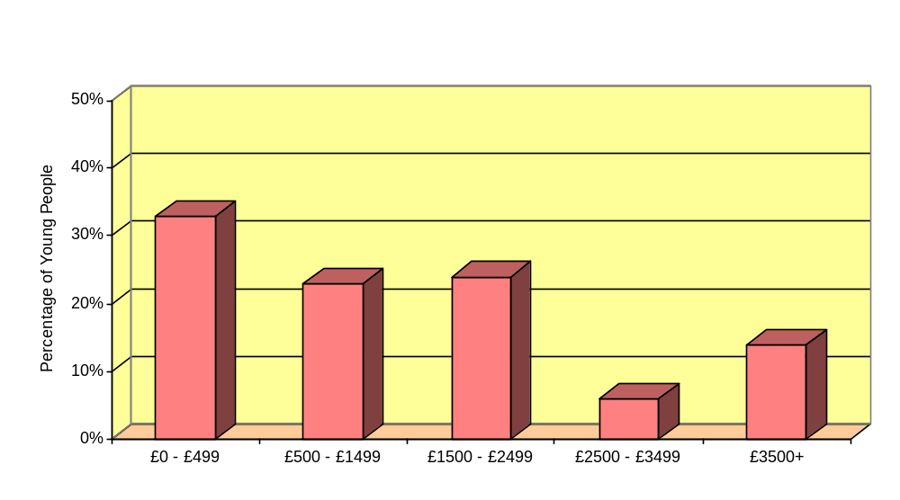
The available information shows that 33% (23) of the previous placements cost up to £500 per week, 23% (16) cost between £500 and £1500 per week, 24% (17) cost between £1500 and £2500 per week, 6% (4) cost between £2500 and £3500 per week and 14% (10) exceeded £3500 a week.
The mean weekly cost of previous placements before MTFCE was £1606. However, at the time of entering MTFCE current placements were often breaking down or considered inappropriate and information was gathered on the costs of the anticipated alternative to MTFCE if a placement had not been available.

Figure 20. Cost of anticipated alternative placement if MTFC had not been available (n=65)
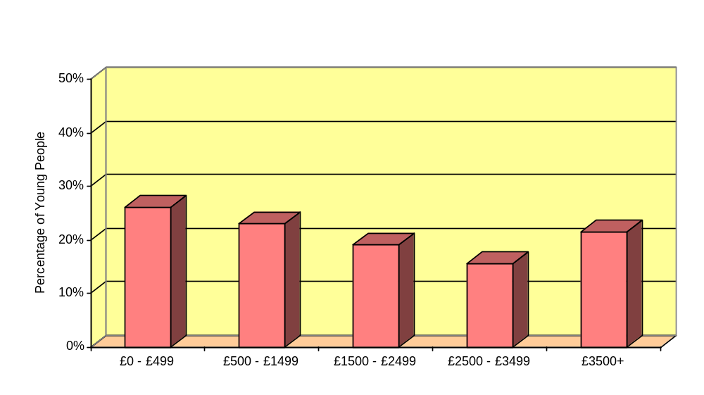
The available information suggested that 21.5% (14) of the alternative placements would have cost up to £499 per week, 23% (15) would have cost between £500 and £1499 per week, 18.5% (12) would have cost between £1500 and £2499 per week, 15.5% (10) would have cost between £2500 and £3499 per week and 21.5% (14) would have exceeded £3500 a week. The mean weekly cost of anticipated alternative placements if MTFC had not been available was £2123.

Based on figures provided by the local MTFC-A teams the predicted costs of the next placement following MTFC was calculated. The table below shows actual weekly costs of the last placement prior to MTFC, the actual costs of the alternative placement if the young person had not come into the programme and the estimated weekly costs of the follow on placement after MTFC for graduates and early leavers.

Table 18.Weekly costs of placements pre and post MTFC

 | Weekly Cost of previous placement prior to MTFC  n= 70 | Weekly cost of alternative placement if MTFC had not been available  n=65 | Weekly Cost of placement post MTFC for Graduates  n=26 | Weekly Cost of placement post MTFC for  Early leavers  n=22
Mean | £1606 | £2123 | £482 | £1662
Range | £0-£6,000 | £0-£6,000 | £0-£2,000 | £0 - £5,280

Table 18 shows that mean costs for graduates reduced from £1606 per week to £482. The costs are slightly increased as one of the graduates went to a mother and baby home to work towards independence and a second young person moved to a small independent living unit, both of which cost more than foster care. This represents a mean saving of £1641 per week compared with the anticipated alternative.

As 10 (45%) of the 22 early leavers returned home the mean costs for this group are reduced to £1662, representing a saving of £461 compared with the anticipated alternative placement. However it is likely in view of their complex needs that some of these children will come back into the care system from their families. Follow up of all these groups for a further year post placement in MTFC-A will be helpful in assessing whether the changes and resultant cost savings have been maintained.

10.2 Cost of Multidimensional Treatment Foster Care
In order to assist local teams in calculating the accurate costs of MTFC placements compared with supporting a similar young person with complex needs in other provision in the care system, the DCSF is further commissioning a costing project to be conducted by Professor Harriet Ward and colleagues at Loughborough University. The aim of the project is to calculate the costs incurred over a specific time period to a range of agencies by children who are experiencing MTFC.

This study will directly link with the wider DCSF funded costing programme being undertaken at the Centre for Child and Family Research at Loughborough and would make it possible to include the unit cost of MTFC in future versions of the Cost Calculator for Children’s Services developed by the team

The costs incurred by the MTFC children will be compared with those incurred by children with similar needs and care histories (but no MTFC placements) for whom the team already hold data collected in the course of earlier costing studies. Data will be collected on the needs, placements, services provided and outcomes of all children in the sample over a time period to include the year prior to placement in MTFC, during MTFC and where appropriate, subsequent placements. Data collection will begin in the next few months and will be available to teams in advance of, but also contribute to, the results of the independent evaluation.

11. Consultation with Oregon Social Learning Center

The National Team have continued to work closely with OSLC and receive weekly clinical telephone consultation with Dr Peter Sprengelmeyer on the operational aspects of the model. OSLC have also regularly joined with the National Team to deliver training in the MTFC model to clinical team staff and new foster carers. Consultation includes video review of tapes provided by the programme sites of clinical and foster carer meetings for the monitoring of fidelity to the programme and consultation on the consultation provided to the sites by the National Team.

12. Network Partnership

The National Implementation Team have now formally signed an agreement to become the UK Network Partner with OSLC which will enable us to provide implementation services, training and consultation in the MTFC programmes for new teams wishing to develop the model in the UK outside the DCSF funded programme, and existing English teams who wish to contract for further services once the existing contract has expired. This is an exciting and important development which will make a considerable contribution to sustaining programmes and rolling out further programmes over the next few years

13. Intensive Fostering

In 2004 the Youth Justice Board decided to use the same model of MTFC with the Intensive Fostering Programme for young offenders serving a community based sentence. Three pilot programmes have successfully been established. DCSF and the National team are working in close collaboration with the YJB senior manager and lead consultant. YJB staff and their site consultant have previously joined the MTFCE clinical staff training and have conducted joint training of new foster carers in conjunction with national team staff.

14. The Learning So Far

14.1 Learning from the treatment model

Over the last 3 years the national MTFCE programme has been developing a sound body of knowledge about what does and doesn’t work and this year’s audit analysis has begun to confirm some of the ideas from the local and national team staff about successful implementation. (Please also see “The Learning So Far” in the two previous annual reports for more details)

The following are a summary of key ideas from site consultants and programme staff about the recipe for a successful programme;

- Operate with a full complement of appropriately skilled and motivated programme staff. There is evidence from the audit data that young people who are in regular contact with the skills trainer and individual therapist and whose families are in regular contact with the birth family therapist, engage better, stay in the programme longer and have better outcomes.
- A positive “can do” approach is an essential requirement for staff and foster carers!
- Ensure model and treatment fidelity – the programme works when used as intended
- Use the tools of the programme to resolve problems
- Model the model with the carers and young people
- Plan ahead continually, short and long terms goals - it is easy to fall into the trap of merely maintaining the status quo once a young person has stabilised.
- Include skills building for young people as well as behavioural change
- Plan for moving on at the very early stage and keep this in the frame
- Keep up the foster carer recruitment. Build up placement capacity as quickly as possible to ensure flexibility, carer support, increased learning and financial viability
- Ensure foster carer contracts are clear and meet the needs of the service and young people as well as support the carers in their task
- Make good assessments of need, risk, motivation and suitability of young people coming into the programme
- Take appropriate referrals of young people who are likely to benefit from the programme
- Maintain positive relationships with the wider system including other agencies
- Ensure at least one champion for the programme in the management system
- Keep data on the young people coming into the programme which can be used to measure change and effectiveness which will support the argument for sustainability

14.2 Learning from the implementation process

In addition to the learning about what works clinically we are increasing our knowledge about what is needed to implement and maintain evidence based programmes and the importance of the implementation process and system structures in creating success. We know that the programme works best when it adds to and complements existing robust provision for looked after children. A number of existing sites have developed tiered fostering services into which MTFC fits as a specialist service. Some sites have developed this further and successfully integrated a number of innovative services for children across a continuum of care. One in particular has developed a complementary “step down” programme for children moving out of MTFC as a means of resolving the ongoing difficulty of finding suitable follow on placements. Some teams are considering the need for regional commissioning and partnership arrangements including the range of specialist services across the spectrum and using unifying approaches across agencies. Having senior managers who have budgetary and managerial responsibilities, are champions for the programme and innovators of service development is clearly the ideal.

It has also become clear that evidence based programmes such as MTFCE are not self sustaining and without continuing support natural model drift would occur with the resulting reduction of model adherence and outcomes. National programmes in particular where coherence of approach and shared learning are important aims, depend on having a system in place for monitoring implementation progress, training and access to ongoing support in the implementation of the main tools of the programme. Long term continuation of MTFC in England will hopefully be sustained through the development of the Network Partnership with Treatment Foster Care associates in Oregon.

15. Current Challenges and Aims for the Next Year

15.1 Finance
Financial constraints have continued to be a limiting factor for the development of this project for a small but significant number of teams. These pressures have created some important repercussions. Key issues have been;
- Pressure to increase placements within a fixed time frame leading to pressure to take unsuitable referrals or those children who are costing the most money
- Pressure to take emergency placements with little or no assessment of need and risk, motivation, suitability or addressing of consent issues leading in some instances to early placement breakdowns.
- Pressure to take referrals outside designated criteria for MTFC e.g. younger children or children with history of indiscriminate violence or very low IQ who struggle to understand or benefit from the programme
- Leaving children in placements too long reducing throughput which would enable more children to benefit and increase cost effectiveness. Considering MTFCE as a long-term fostering programme rather than a short-term therapeutic treatment programme that uses fostering as its mode of treatment may be a factor in this common difficulty.
- Financial cuts to the programme leading to reductions in number of foster care placements therefore reducing cost effectiveness
- Budget cuts reducing staffing or staff capacity
- Consideration of closure affecting staff and carer morale
- Withdrawal of support from health or education partners both financially and in terms of commitment to the programme, staff support and attendance at steering or management group meetings.

The challenge for the next year for sites struggling with budget constraints will be to make the financial case for continuing with the programme and attempt to ameliorate the effects described above. Despite this a significant number of sites have successfully been mainstreamed or have received longer term funding.

15.2 Recruitment and Retention
- Programmes with existing carers will need to continue to recruit foster carers to build up numbers to ensure sustainability and allow for turnover.
- Both developing and established teams should aim to recruit and then retain appropriately skilled and experienced clinical team staff. The small size of the teams means that the programme is vulnerable if any staff members leave or become sick. Teams need to build in mechanisms to train staff to step into new roles as appropriate.

15.3 Moving on Placements
- Programmes must give consideration to only admitting children with a clear follow on plan or at least one that involves parallel planning to avoid children getting “stuck” in MTFCE. Finding suitable moving on placements such as long term less intensive foster care has proven to be a considerable challenge, particularly for areas where fostering services are less well developed. This is a key area of development for the next year.
- Increased through put of young people is needed to ensure programmes are cost effective and are eligible for certification from OSLC.

15.4 Evaluation
- The challenge of ensuring sufficient throughput of potential referrals to support the national evaluation and RCT will continue to be an issue for all the teams over the next year. The National Team will aim to support project teams and the independent evaluators in ensuring the national evaluation proceeds as smoothly as possible.

15.5 Audit
- The collection of audit data by the programme sites and analysis of the characteristics of young people entering the programme, and the small group of graduates has proved to be interesting and informative. Sites will be able to use the data to inform steering groups, PCT’s and members of the progress of the MTFCE programme nationally
- Teams will need to keep up to date with the data collection and will be helped by the assistant psychologist based in the National Team

15.6 Programme Fidelity
- The National Team will need to continue to monitor and support teams to adhere to the MTFCE model in order to secure the best outcomes for children and young people and to support those in preparing and applying for certification from OSLC.

15.7 Training and Support
- The National Team will need to ensure that training, networking and developmental needs of all the teams in the programme are met within an appropriate time period and within current resources up to the end of the current contract in March 2008.
- From April 2008 teams will be given the opportunity to contract with the National Implementation team for a further year in order to achieve certification if appropriate.

Rosemarie Roberts
Project Manager, National MTFCE Team

Appendix 1

MULTIDIMENSIONAL TREATMENT FOSTER CARE in ENGLAND

PROJECT STAFFING

The MTFC programme for adolescents and the MTFC-P programme for 3-6 year olds, developed by the Oregon Social Learning Center in the USA, provides clear guidelines for the staffing of the clinical team which is essential for carrying out the treatment programme in the most effective, consistent and coherent way. This is important in order to ensure fidelity to the model and the greatest chance of positive outcomes for the children and young people admitted to the programme.

The multi-agency MTFC team therefore consists of staff from social services, CAMHS and education to meet these requirements and the requirements of our specific context in England.

MTFC-A Staffing Requirements

Programme Manager
Programme Supervisor
Foster carer recruiter/trainer
Birth Family Therapist
Young Person’s Individual Therapist
Skills Trainer
Education personnel e.g. teacher
Psychiatrist (1-2 sessions)
Clinical Psychologist (if not appointed as PS or IT then 1-2 sessions for assessment)

MTFC-P Staffing Requirements

Programme Manager
Programme Supervisor
Foster carer recruiter/supervisor
Birth Family Therapist
Children’s Group Lead Teacher/Skills Trainer
Skills Trainer

Appendix 2

MTFC for Adolescents

The Points and Levels System
During a young person’s MTFC placement they gradually progress through a three level behaviour management system. This is a structured programme designed to teach pro-social skills, reinforce positive behaviour and attitudes through tangible rewards and offer sanctions for problem behaviour. The young person moves up to the next level by earning sufficient points. Each successive level is characterised by increased autonomy and an increase in privileges. The focus is on being positive, developing a mentoring relationship with foster carers, and helping young people to be successful and develop new skills. The aim is to have a young person functioning well within the context of a family by the end of the placement.

Level 1
The young person spends a minimum of 3 weeks at Level 1 when they first enter the placement and are settling in. At this level they are supervised at all times by their carers, education staff and other MTFC workers. Young people are given immediate reinforcement for appropriate behaviour which may have been ignored in the past. Points are earned easily for routine activities, for example - getting up on time would earn 10 points. Typically, young people earn 100 to 130 points a day. They must accumulate a total of 2100 points to move to Level 2, which most do in about 3 weeks. The points are traded for very basic privileges the following day, for example - watching a TV programme.

Level 2
The treatment team is likely to see the greatest change in the young person’s behaviour during Level 2. Points earned one week are used to buy privileges the next. The young person begins to experience delayed gratification and to develop the capacity to plan ahead. The amount and quality of privileges increases from Level 1 and can continue to increase throughout Level 2 as the young person’s skills improve, offering an opportunity to become increasingly more responsible and confident.

Young people can use points to choose to stay up later, have longer time on the computer, activity time with friends - although the carers and MTFC team will know where a young person is at any time. They can be demoted to Level 1 for a day if they fail to earn the minimum amount of daily points. The therapist works with the young person to propose new privileges that are of interest to her. She is then coached on how to appropriately ask and negotiate for what she wants. Typically youngsters earn 700 to 900 points per week on Level 2, and stay on this level for 12 to 16 weeks.

Level 3
Level 3 can be considered a maintenance phase. During this time, young people are expected to maintain their newly learned skills with less structure. Youngsters have more opportunity to exercise their own judgment and must handle that responsibility reasonably well to stay on this level. The programme supervisor and foster carers use their discretion on this level to customise privileges as well as expected behaviours, being careful to not allow more freedom than the young people can handle, but also being sure they have opportunities to practice appropriate skills and behaviours in more naturalistic settings. To remain at this level a minimum of 120 points must be earned each day.
Basic privileges no longer need to be earned and encouragement is given to take greater responsibility for their own decision-making and actions. However, plans for free time must still be approved in advance. Positive achievements and pro-social interactions are consolidated during Level 3. Plans for any aftercare placement are arranged to fit with these achievements to minimise transition difficulties.

Appendix 3

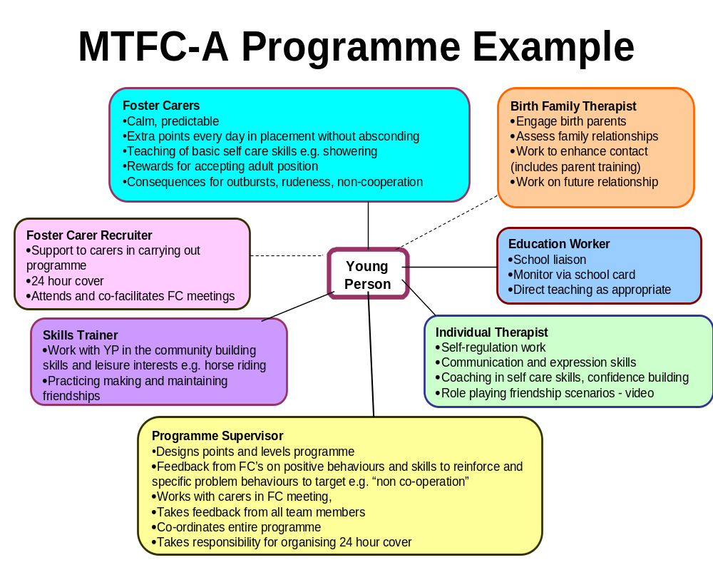
Key: Solid line = directly works with young person as appropriate
Dotted line = indirectly works with young person

The above is an example of the co-ordination of work around a young person who has difficulties in a number of areas including; absconding, outbursts, rudeness, non-cooperation, self care and hygiene, making and keeping friends, confidence and self –esteem. The treatment programme is mediated through the foster carer and is supported by the work of the team in their distinct roles. The Programme Supervisor conducts and directs the clinical team staff in a co-ordinated manner which allows several people to be working on a specific difficulty at one time and in different but complementary ways.

Appendix 4

NSW Department of Health – MH-OAT Project CGAS Information Sheet
Version 1.0 31/05/2002 Page 1 of 2

Children’s Global Assessment Scale (CGAS)
1. Enter a score from 1-100
2. Rate the child/adolescents most impaired level of general functioning during the period rated by selecting the lowest level which describes his/her functioning on a hypothetical continuum of health-illness
3. Use intermediary levels e.g. 35, 94, 68
4. Rate actual functioning regardless of treatment or prognosis, using the descriptions below as a guide

100-91 Superior functioning
90-81 Good functioning
80-71 No more than a slight impairment in functioning
70-61 Some difficulty in a single area, but generally functioning pretty well
60-51 Variable functioning with sporadic difficulties
50-41 Moderate degree of interference in functioning
40-31 Major impairment to functioning in several areas
30-21 Unable to function in almost all areas
20-11 Needs considerable supervision
10-1 Needs constant supervision

Principle reference
Schaffer D, Gould MS, Brasic J, et al. (1983) A children's global assessment scale (CGAS).
Archives of General Psychiatry, 40, 1228-1231.

Description
The Children’s Global Assessment Scale (CGAS) is a measure developed by Schaffer and colleagues at the Department of Psychiatry, Columbia University to provide a global measure of level of functioning in children and adolescents. The measure provides a single global rating only, on scale of 0-100. In making their rating, the clinician makes use of the glossary details to determine the meaning of the points on the scale.

CGAS Glossary
Rate the patient’s most impaired level of general functioning for the specified time period by selecting the lowest level which describes his/her functioning on a hypothetical continuum of health-illness. Use intermediary levels (e.g. 35, 58, 62).

Rate actual functioning regardless of treatment or prognosis. The examples of behaviour provided are only illustrative and are not required for a particular rating.

NSW Department of Health – MH-OAT Project CGAS Information Sheet
Version 1.0 31/05/2002 Page 2 of 2

100-91 Superior functioning in all areas (at home, at school and with peers); involved in a wide range of activities and has many interests (e.g., has hobbies or participates in extracurricular activities or belongs to an organised group such as Scouts, etc); likeable, confident; ‘everyday’ worries never get out of hand; doing well in school; no symptoms.

90-81 Good functioning in all areas; secure in family, school, and with peers; there may be transient difficulties and ‘everyday’ worries that occasionally get out of hand (e.g., mild anxiety associated with an important exam, occasional ‘blowups’ with siblings, parents or peers).

80-71 No more than slight impairments in functioning at home, at school, or with peers; some disturbance of behaviour or emotional distress may be present in response to life stresses (e.g., parental separations, deaths, birth of a sib), but these are brief and interference with functioning is transient; such children are only minimally disturbing to others and are not considered deviant by those who know them.

70-61 Some difficulty in a single area but generally functioning pretty well (e.g., sporadic or isolated antisocial acts, such as occasionally playing hooky or petty theft; consistent minor difficulties with school work; mood changes of brief duration; fears and anxieties which do not lead to gross avoidance behaviour; self-doubts); has some meaningful interpersonal relationships; most people who do not know the child well would not consider him/her deviant but those who do know him/her well might express concern.

60-51 Variable functioning with sporadic difficulties or symptoms in several but not all social areas; disturbance would be apparent to those who encounter the child in a dysfunctional setting or time but not to those who see the child in other settings.

50-41 Moderate degree of interference in functioning in most social areas or severe impairment of functioning in one area, such as might result from, for example, suicidal preoccupations and ruminations, school refusal and other forms of anxiety, obsessive rituals, major conversion symptoms, frequent anxiety attacks, poor to inappropriate social skills, frequent episodes of aggressive or other antisocial behaviour with some preservation of meaningful social relationships.

40-31 Major impairment of functioning in several areas and unable to function in one of these areas (i.e., disturbed at home, at school, with peers, or in society at large, e.g., persistent aggression without clear instigation; markedly withdrawn and isolated behaviour due to either mood or thought disturbance, suicidal attempts with clear lethal intent; such children are likely to require special schooling and/or hospitalisation or withdrawal from school (but this is not a sufficient criterion for inclusion in this category).

30-21 Unable to function in almost all areas e.g., stays at home, in ward, or in bed all day without taking part in social activities or severe impairment in reality testing or serious impairment in communication (e.g., sometimes incoherent or inappropriate).

20-11 Needs considerable supervision to prevent hurting others or self (e.g., frequently violent, repeated suicide attempts) or to maintain personal hygiene or gross impairment in all forms of communication, e.g., severe abnormalities in verbal and gestural communication, marked social aloofness, stupor, etc.

10-1 Needs constant supervision (24-hour care) due to severely aggressive or self-destructive behaviour or gross impairment in reality testing, communication, cognition, affect or personal hygiene.

Koprowska J & Stein M (2000) The Mental Health of ‘Looked-after’ Young People. In P Aggleton, J Hurry & I Warwick (Eds) Young People and Mental Health. London: John Wiley & Sons Ltd.
Henggeler, S. W., Melton, G. B., Brondino, M. J., Scherer, D. G., Hanley, J. H. (1997) Multisystemic Therapy With Violent and Chronic Juvenile Offenders and Their Families: The Role of Treatment Fidelity in Successful Dissemination. Journal of Consulting and Clinical Psychology, 65: 831-833. Scott, S, Carby A, Rendu A (2007) Impact of therapist skill on outcomes of parenting programs for child antisocial behaviour. Submitted
Goodman R (1997) The Strengths and Difficulties Questionnaire: A Research Note. Journal of Child Psychology and Psychiatry, 38, 581-586
Schaffer D, Gould MS, Brasic J, et al. (1983) A children's global assessment scale (CGAS).Archives of General Psychiatry, 40, 1228-1231
Wechsler D. Wechsler Intelligence Scale for Children. 4th edn. Sidcup (UK): Psychological Corporation; 2004
Wechsler D. Wechsler Objective Reading Dimensions Test. Sidcup (UK): Psychological Corporation; 1993.
Goodman, R., Ford, T., Richards, H., Gatward, R. & Meltzer, H. (2000) The Development and Well-Being Assessment: Description and initial validation of an integrated assessment of child and adolescent psychopathology. Journal of Child Psychology and Psychiatry, 41, 645-55)
Statistics in Education, Outcome Indicators for Looked After Children, Twelve months to 30 September 2006, England, Statistical First Release Office of National Statistics (2007).
Scott, S., Knapp. M., et al (2001) Financial cost of social exclusion: a follow up study of anti-social children into adulthood. British Medical Journal.
Aos S, Phipps P, Barnoski R & Lieb R (1999) The comparative costs and benefits of programs to reduce crime: A review of national research findings with implications for Washington state. Olympia, WA: Washington State Institute for Public Policy.

