Harnessing Technology
Pilot study for aligning learner voice with the annual sector survey of FE colleges

Senior supplier: David Kay <david.kay@sero.co.uk>
Project manager and key contact: Giles Pepler <giles.pepler@sero.co.uk>

August 2009

Contents

1 Executive summary
1.1 Introduction and scope
1.2 Recent learner voice research
1.3 Approaches for capturing learner views of technology
1.4 Results
1.4.1 The online survey
1.4.2 Alternative approaches
1.5 Conclusions and recommendations

2 Introduction and scope of this study

3 Review of learner voice research
3.1 UK higher education
3.2 UK further education
3.3 International
3.3.1 New Zealand
3.3.2 Australia
3.3.3 US
3.4 Conclusions

4 The pilot online survey and other approaches
4.1 Scope and objectives of the pilot survey
4.2 Structure and questions
4.3 Composition of sample
4.4 Results
4.4.1 Learner responses to Parts B, C, D and E
4.4.2 Free response comments
4.4.3 Cross-tabulation
4.5 Other approaches and issues
4.5.1 Electronic forum
4.5.2 Focus groups
4.5.3 Blog and interviews
4.5.4 Optivote
4.5.5 Triangulation and implications for future work
4.5.6 College A – an approach to initial assessment

5 Discussion and conclusions
5.1 What value would a survey of learner views of technology add to
existing surveys?
5.2 Scalability and validity of alternative approaches
5.3 Accessibility issues
5.4 Transferability to other education sectors
5.5 Conclusions

6 Recommendations

Appendices
Appendix A – The online survey (A1) and responses (A2)
Appendix B – First draft of an alternative version for lifelong learning in HE
Appendix C: References and bibliography

Executive summary

1.1 Introduction and scope

This report describes a pilot project that investigated effective ways of gathering views about technology from learners in further education (FE) colleges, to complement the Annual Survey of Technology in FE Colleges. The report also reviews recent work on the learner voice in further and higher education and evaluates a number of potential approaches for capturing learner views concerning their experiences of technology.

1.2 Recent learner voice research

It is only in the last few years that the views of learners in higher education (HE) have been formally taken into account in aspects of e-learning across the sector. However, for many years, universities have sought student feedback on courses as part of the overall quality process – but without a prescription for doing this.

May 2005 saw the start of the LEX (Learner EXperiences of e-learning) project within the pedagogy strand of the JISC E-Learning Programme. This research was designed to cover all post-16 sectors, including FE, adult and community learning (ACL) and work-based learning (WBL) plus undergraduate and post-graduate learners. The intention was to produce a series of reports and usable materials for e-learning designers, authors and tutors covering how learners approach e-learning tasks and their strategies in overcoming problems, together with their expectations and experiences of e-learning itself. The approach taken was paradigmatic and, as such, has strongly influenced all future studies. Not restricting it to HE was certainly one factor in its gaining traction in other sectors.

At about the same time, the Higher Education (HE) Academy was starting its programme of benchmarking e-learning, with the key assumption that it would adopt or adapt schemes used for similar purposes elsewhere. Given that the concepts in these schemes had been developed prior to 2005, it is not surprising that, at the top level, they were not strong on learner voice. However, even in the pilot phase of the HE Academy's benchmarking, a number of the institutions carried out student surveys to provide data to inform judgements on criterion scores. By 2007, the project had stabilised on five areas, all or some of which were exercised by institutions:

- student engagement in design
- student understanding of systems
- student help desk
- student experience
- student satisfaction.

But even at the end of the benchmarking phase, there was no standard learner voice questionnaire that was acceptable across HE.

More influential developments for this study came out of the HE Academy Pathfinder programme. One of the institutions involved set up a three-year project to run a Student Experience of E-Learning Laboratory (SEEL), funding the first year out of the HE Academy Pathfinder grant. The resulting survey was generously made available to Sero to draw on for the current learner voice project.

While the HE Academy Pathfinder programme was under way, there was a groundswell of activity in the JISC E-Learning Programme related to student experience. The original single project grew to become an entire programme, spanning two phases over four years, from 2005 to 2009. It comprised a total of nine research projects (two in phase 1 and seven in phase 2), employed mixed-method approaches and had the sustained involvement of more than 200 learners and 3,000 survey respondents.

Finally both strands largely came together (at the community level) with the setting up of ELESIG – the Evaluation of Learners' Experiences of e-learning Special Interest Group – helped by a small pump-priming grant from the HE Academy. Sero staff have been active participants in this.

Thus, at the end of about five years of development, funded by the two main agencies in HE, there is a vibrant community, considerable commonality of research methods and vast experience in running all kinds of surveys and related monitoring mechanisms to tease out the learner voice. While the community is anchored in HE, some of the projects, even early ones, had FE as a focus. At a political level, the learner experience is now firmly embedded in HE policy, although there is little likelihood of reaching a standard survey instrument. There is, however, a continuing level of development that could be a useful resource for the future.

The first relevant FE material comes from early learner voice developments during an NLN project in 2002. Fieldwork carried out between January 2003 and March 2004 generated a total of 527 student responses from eight colleges. Many currently ‘hot’ items were included, eg: 'experience at home or school prior to college', 'ILT for collaborating on projects', 'chat rooms', 'access from home' and 'employable students'. A number of the topics raised (reliability, availability, etc) have a strong benchmarking flavour.

As one would expect from its age, the early benchmarking/maturity system EMFFE, developed by Becta in a similar timeframe to HE developments, has little on learner voice, being again rather provision-focused, though learners are mentioned at many points in the criterion narratives. EMF43, the variant subset of EMFFE developed for the PCDL survey, reflects a slightly later stage of conceptual development in that there are several criteria among the 42 with substantial concentration on aspects of the learner voice.
Although coming from a different development team, the Generator system continues this strand of further embedding learner voice-oriented criteria in the system.

In addition to general systems, certain FE institutions seem to have a record in tackling learner voice. There are only a few of these, however, with two of particular note – Bradford College and Newcastle College – both of which having significant numbers of HE students.

Internationally, we found three useful systems:

- New Zealand: e-Learning Guidelines
- Australia: TAFE (Technical and Further Education)
- US: Flashlight Student Inventory.

For FE in England, a much more realistic approach would be to reflect Generator into a learner voice scheme. Unfortunately the public release of Generator and our team's analysis of it occurred too late in the schedule for our learner voice work for it to have a material effect on our pilot scheme – but it can be looked at again in the future.

It is our contention that the UK contains enough intellectual effort to develop its own autonomous learner voice system. However, if there comes a time when international comparisons are required (as is now happening with benchmarking and which is, of course, routine with PISA, the OECD's Programme for International Student Assessment), such issues may have to be revisited.

The exploratory work produced conclusions on two levels:

- At the top level, it validated the idea that learner voice surveys provide low-level input to benchmarking/maturity schemes and are not embedded in such schemes. Yet to provide 'traction', there must be learner-voice-oriented criteria in such schemes – a situation that is analogous to that for 'staff voice', the principle of which is already accepted. In particular, the learner voice surveys at Chester and Swansea were designed to feed directly into their Pick&Mix benchmarking activities and especially into the learner voice criteria within the top-level scheme.

- At the level of creating criteria, there is no uniformity as yet and no standard model in FE (now) or HE (now or ever), so that the main approach is to draw on a wide range of schemes to find valid wording. This, of course, does not tackle the issue of intersectoral or international compatibility of criteria.

1.3 Approaches for capturing learner views of technology

In this pilot study, learners from four colleges were invited to complete a short online survey. Some also participated in alternative approaches to gathering learner views: focus groups; an electronic forum; a blog within the college virtual learning environment (VLE); a small number of videoed interviews; and a group discussion followed by electronic voting. The topics for these alternative approaches were derived from the online survey questions.

A fifth college took part in the research, but developed a different approach and so did not use the online survey.

This survey – which was designed to take no more than 20 minutes to complete – consisted of an introductory taxonomy section, followed by 24 questions, six on each of four topics. For each question, participants were asked to select the most appropriate response from four options. The final section consisted of two free response questions.

The survey was designed to explore learner views about:

- their expectations of the role of technology in their learning
- the expectations placed on them by the provider
- the facilities and support provided by their institution so that they could use technology in all aspects of their activities within it
- their experience of the ways in which their teachers/lecturers/tutors use technology in their teaching
- the institution’s flexibility of approach to the use of technology in teaching
- changes that the learners would like to see
- what weaknesses and difficulties they have in using and applying technology in learning
- the benefits and drawbacks they have experienced with the use of technology in their learning.

The language in the survey was designed to be accessible to entry- and foundation-level learners, but issues of accessibility for those with physical disabilities and/or learning difficulties were not addressed.

1.4 Results

1.4.1 The online survey

In all, 745 responses were received from the four colleges. Respondents were not wholly representative of the FE learner population: they were very largely white British 16- to 19-year-olds, with no learning difficulties or physical disabilities. Of the total, 43 per cent were female and 57 per cent male, and with two six form colleges included in the pilot, the range of courses was somewhat skewed towards Level 3.

Although the participants did not represent a full cross-section of FE learners, the data extracted from the online survey suggests that a learner voice survey would provide useful triangulation with the full FE surveys of providers and practitioners. For instance, the 2008/09 FE survey showed that many colleges are still wary of allowing learners to use their own devices in college and relatively few permit them to be connected to the college network. The present limited survey paints a rather more optimistic picture:

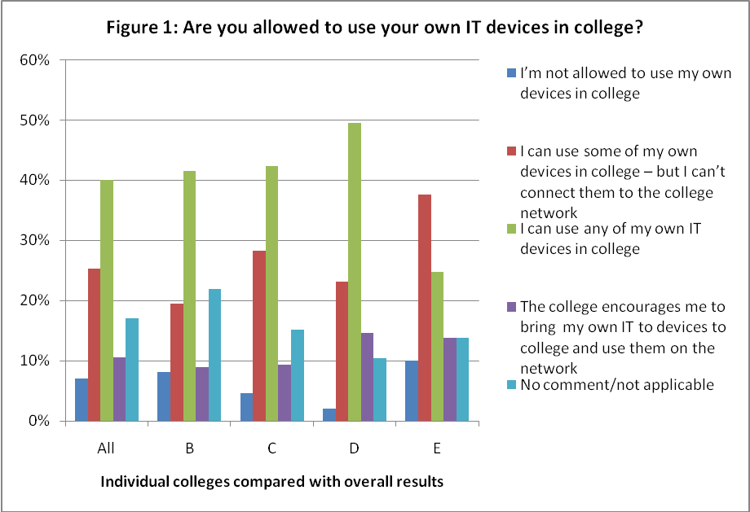

This pilot survey also confirmed that relatively few colleges currently gather learner views on their technology experiences – and interviews with colleges reveal that they would find this valuable:

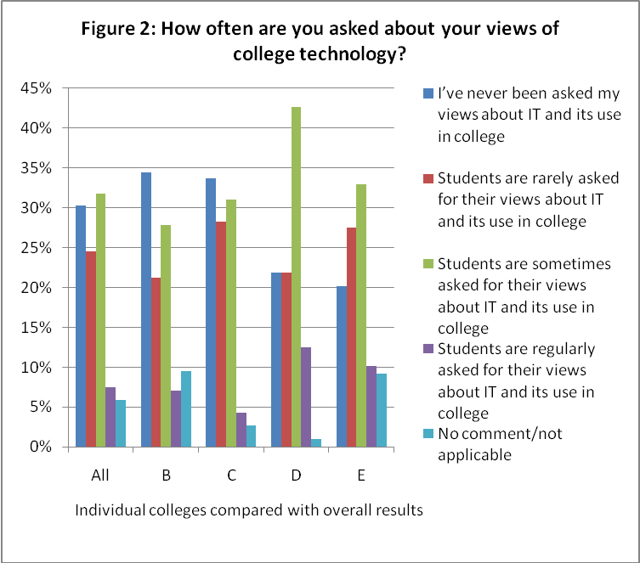

Encouragingly, over two thirds of learners reported that college IT had exceeded their expectations in how it could help them to learn:

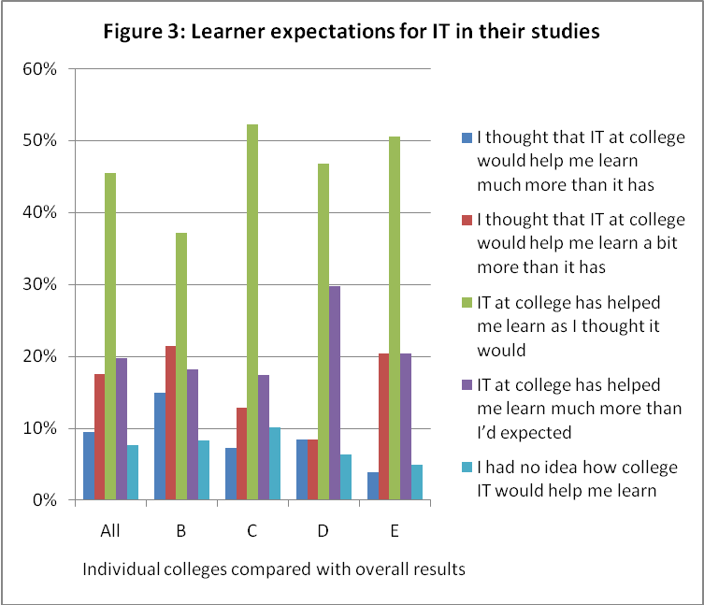

Access to IT and IT support showed a reassuringly close correlation and reinforced the data from colleges and staff:

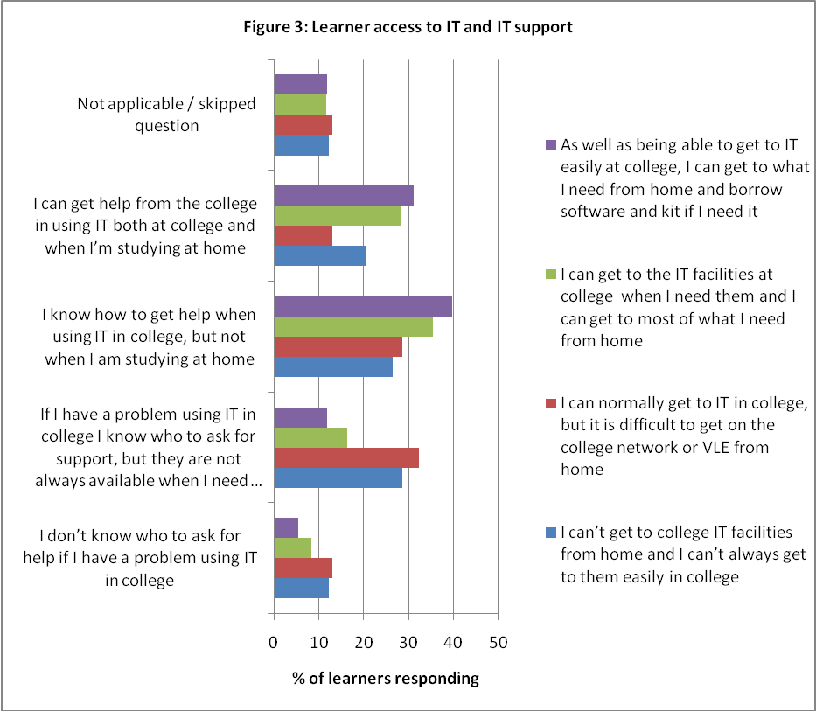

Although most comments to the free response questions were relatively brief, common themes echoed some of the weaknesses identified in the full FE survey. Frequently mentioned topics included:

- the need for a faster network – many learners complained about the slowness of booting up, running software programs and getting internet access
- having laptops rather than PCs
- blocking social networking sites and not trusting students
- the need for wireless networks to be extended
- poor air conditioning, leading to uncomfortable working conditions.

While these were the most common complaints, the twin themes of access to mobile devices and access for learners’ own devices also featured strongly:

'Student gateway through the wireless network. Allowing access on smart phones and other devices. More frequent ghosting of systems, to reduce the slowdown caused my multiple user profiles being stored.'

'… by allowing students to connect personal devices such as internet phone and laptops to the computer network.'

1.4.2 Alternative approaches

None of the alternative approaches added significantly to the data obtained from the online survey, although the videoed interviews were particularly useful for the college where they were conducted. However, none of these other approaches would be cost-effective on a large scale, although they provide a potential toolkit for colleges to use and to validate a national online survey.

1.5 Conclusions and recommendations

This pilot study confirms the initial opinion that an online survey of FE learners’ views of their college technology experiences, linked with the annual FE survey, is practicable, would add value to the annual survey for Becta and would be useful for the colleges themselves.

Further research and development would be required to extend the survey across FE colleges and to broaden it to include other FESR (further education statistical record) sectors. Development work would need to include:

- revisiting the early NLN work from the period 2002–04 to review the learner voice survey material
- a more detailed review of international work – in particular, from New Zealand, Australia and the US
- refining the survey instrument to make sure that it can be clearly linked to the annual Harnessing Technology survey and working with NATSPEC (Association of National Specialist Colleges) to ensure that the instrument is accessible to all learners
- working with Becta and the research teams responsible for other FESR surveys to ensure that the survey content and approach reflect the different learner populations in ACL, WBL and, eventually, the Offender Learning and Skills Service (OLASS)
- liaising with participating providers to ensure that the survey is appropriately marketed to their learners
- creating a ‘toolkit’ of alternative approaches to add value for participating providers.

Drawing on the experiences of this pilot research, we recommend that:

- development work for an online survey of FE college learners should continue, taking account of the discussion and conclusions in Chapter 5 of this report, including revisiting the early NLN work and further review of developments in New Zealand, Australia and the US
- a further larger-scale pilot online survey should be run, linked with the 2009/10 annual FE colleges survey
- further research should be undertaken with other FESR survey contractors and appropriate independent specialist colleges to develop a survey instrument that can be applied across all FESR sectors.

Introduction and scope of this study

The work described in this report complements the Annual Survey of Technology in FE Colleges for 2008/09 conducted by Sero Consulting on behalf of Becta. The annual technology survey has always incorporated responses from both colleges and their staff, but has never included the views of learners on their college technology experiences. This pilot project reviews recent work on giving learners their voice on their experiences of further and higher education, with particular reference to technology, and tests out a number of potential approaches for capturing learner views on their experiences of technology.

Chapter 3 of this report reviews recent learner voice initiatives in UK higher and further education, and includes some international perspectives. Chapter 4 describes the scope of the pilot study, the online survey and field work and presents some of the results. Chapter 5 discusses the outcomes of the research, and Chapter 6 outlines some recommendations.

Review of learner voice research

This chapter outlines recent research into learner voice:

- in UK higher education (HE)
- in UK further education (FE)
- internationally in HE and FE.

Finally it draws some conclusions.

The project would like to thank the various HEIs (higher education institutions) and FECs that supplied their 'learner voice in e-learning' surveys for analysis. Particular thanks are due to: the ELESIG (Evaluation of Learners' Experiences of e-learning Special Interest Group) project; the University of Greenwich; Malcolm Ryan; and Peter Chatterton, ELTI (Embedding Learning Technologies Institutionally) consultant.

3.1 UK higher education

It is only in the last few years that the views of learners in HE have been formally taken into account for aspects of e-learning across the sector. Even the National Student Survey (which has no specific questions on e-learning and only one on IT) dates from just 2005. However, there has for many years been a tradition within universities of seeking student feedback on courses as part of the overall quality process – but no prescription as to how this should be done.

It was in May 2005 that the JISC project LEX (Learner experiences of e-learning) started, within the pedagogy strand of the JISC e-Learning programme (2003–09). The project was run by Glasgow Caledonian University under the direction of Linda Creanor. One can do no better than quote from the project description:

This research study covers all post-16 sectors, including FE, adult and community learning, work-based learning, and undergraduate and postgraduate learners ...

Research methodology will deploy an ‘Interview Plus’ approach, encompassing individual learner interviews and homogeneous focus groups combined with other appropriate instruments such as observations, reflective diaries, tracking data and e-portfolios. A number of online discussions with learners will also be held. The methodology will be flexible in order to respond to the wide variety of learners but will always be bottom up and related to interpretative phenomenology.

The outcome of the project will be a series of reports and usable materials of value to e-learning designers, authors and tutors covering how learners approach e-learning tasks, their strategies to overcome problems, together with their expectations and experiences of e-learning. The project will work closely with the JISC team and build on the earlier scoping study. The project will also work closely with any team appointed by JISC to collect audiovisual materials to feed into e-learner case studies.

In many ways, the approach taken was paradigmatic and, as such, has strongly influenced all future studies. The lack of restriction to HE was certainly one factor in its gaining traction in other sectors.

At about the same time, the Higher Education Academy was starting its programme of benchmarking e-learning. It was a key assumption of this programme that it would not develop a new benchmarking scheme but would adopt (or, at most, adapt) schemes used for similar purposes elsewhere. Since the concepts in these schemes were developed prior to 2005, it is unsurprising that they were not, at the top level, strong on learner voice. For example, the ELTI scheme, popular at the time, had a section with several questions on student ICT skills – and also asked one question on ICT access – but there was no wider questioning of student attitudes or behaviour. The other schemes seemed much the same: although eMM (e-Learning Maturity Model) had 14 process statements which began with the word 'students', most were about provision of services to students, not about student views of these services, and a similar approach was taken in the annual iterations of the OBHE (Observatory on Borderless Higher Education) approach. Worse-seeming still, the 20 core criteria of the Pick&Mix system contained not one criterion about students.

Fortunately, the systems which were taken forward throughout the programme did not ignore learners as starkly. Even in the pilot phase of benchmarking, a number of the institutions carried out student surveys to provide data to inform judgements on criterion scores; one of the most influential early ones was from the University of Chester. In eMM, the use of the management and optimisation dimensions – and, in later years, the lower-level practices – allowed a considerable degree of focus on learner voice. Even before the end of the pilot phase, Pick&Mix, ever-adaptive, had supplementary criteria on learner voice aspects and by 2007 had stabilised on five, all or some of which were exercised by institutions:

- student engagement in design
- student understanding of system
- student help desk
- student experience
- student satisfaction.

But even at the end of the HE Academy-funded benchmarking phase, there was no standard learner voice questionnaire acceptable across HE – institutions seemed keen to 'roll their own', despite in some cases quite strong pressure from their advisers. (It had been hoped by some that ELTI would evolve into such a scheme, but for reasons too detailed to go into here, this never came even near to happening.)

Interestingly the developments that were more influential for our work came out of the HE Academy Pathfinder programme. One of the institutions, the University of Greenwich, decided to focus in Pathfinder on the student experience. It set up a three-year project to run a student experience of e-learning laboratory (SEEL) and funded the first year out of the HE Academy Pathfinder grant. The project was led by Malcolm Ryan and he generously made the survey available to Sero to draw on as input to the current Learner Voice project.

While the HE Academy Pathfinder programme was under way, there was a groundswell of related activity in the JISC E-Learning Programme related to student experience. The original single project grew to a whole programme spanning two phases over four years, from 2005 to 2009, and comprised nine research projects in total (two in phase 1 and seven in phase 2), employed mixed method approaches, with the sustained involvement of over 200 learners and more than 3,000 survey respondents. Five national workshops were run, which disseminated the methods and findings. One of the key players in this was Oxford Brookes University.

Finally, both strands largely came together (at the community level) with the setting up of ELESIG – the Evaluation of Learners' Experiences of e-learning Special Interest Group – helped by a small pump-priming grant from the Higher Education Academy. Sero staff have been active participants in this and Giles Pepler attended the summer workshop this year in Wales.

Thus at the end of about five years of development, funded by the two main agencies in HE, there is a vibrant community, considerable commonality of research methods, and vast experience in running all kinds of surveys and related monitoring mechanisms to tease out the learner voice. While the community is anchored in HE, it is not exclusively HE – and as noted, some of the projects, even early ones, had FE as a focus. At a political level, the learner experience is now firmly embedded in HE policy, as evidenced by the recent report by Paul Ramsden to what was then the Department for Innovation, Universities and Skills (DIUS): Teaching and the Student Experience.

However, and perhaps in line with the vibrancy of the HE sector, there is no standard survey instrument to check on learner voice issues in e-learning in HE – and no real likelihood of getting one.

In addition to maintaining contact at the community level, we have continued to track learner voice work at individual HEIs. The influential surveys at the universities of Chester and Greenwich have already been mentioned, but others came in from, among other places, Swansea and Thames Valley – either derived from Pick&Mix or more general considerations. In several cases - such as Swansea - they arrived too late to influence the design of the 2009 pilot project, but they could be a useful resource for any future round.

An interesting survey was carried out by two MSc students at Lancaster University (Badu and Kanu, 2008). It was completed in the summer term of 2008 and involved 336 students from 23 distinct departments. (Those projects that complain when they find it hard to get hold of many students should consider what two MSc students achieved.) Interestingly Badu and Kanu's work was based on a previous e-learning report by the Centre for the Enhancement of Learning and Teaching (CELT) for teaching staff – this raises the possibility of another route to generate learner voice questions.

The University of Hertfordshire (2008) has carried out an internal survey of its learner views of technology, building on several years of earlier work starting with ELTI. This questionnaire consists of 74 questions, all requiring tick-box answers, and therefore is much quicker to complete than the number of questions might suggest, with a prize draw as an incentive for students to participate. Intended for new students, it focuses on exploring past use of technology, student views on the advantages and disadvantages of common applications, their confidence with and knowledge of these, their expectations about the university’s use of technology and their technology preferences. Although this is not designed to assess student views of technology while they are at the university, the questionnaire could readily be adapted for this purpose.

A whole group of ELTI-related surveys came in from institutions including the University of East London, Bradford College, Nottingham Trent University and the University of Sunderland – all derived one way or the other from the basic ELTI benchmarking scheme. All proved useful for gaining insights, even though the pressures of the project and the front-loading of the literature search work package meant that only minimal scrutiny could be given to each in this phase of the project. Hopefully further analysis can be done in the future.

Queen Mary College of the University of London has undertaken a similar study to Hertfordshire's in its Transitions Project. By comparing home IT to HE IT, this generated very similar results to those shown in Figure 11 in sub-section 4.4.1 below.

Finally, Carol Higgison (2008) at the University of Bradford made a useful posting to Association for Learning Technology (ALT) members on this general topic, which is worth taking excerpts from:

At Bradford I used the Bristol Anorak Survey which now seems to be unavailable although the HEA Economics Subject Centre appears to have developed a shorter, subject specific version available at http://www.economicsnetwork.ac.uk/tips/anorak.htm.

(However a link I found at Leeds suggests they may have moved it into Questionmark Perception http://www.sddu.leeds.ac.uk/online_resources/assessment/intro/quiz.html.)

I also created a survey on the features offered by our VLE, Blackboard in SurveyMonkey (we have a licence through a project) – it is entirely self-reporting and is mainly to make them aware of the features currently available in the VLE – see http://www.surveymonkey.com/s.aspx?sm=YLsWWLypxjc1zLgQT5baUA_3d_3d.

I also use a Word document that asks about aspects of their e-Learning design – attached if the mail list permits, otherwise please email me for a copy. I think I got it from an FTDL funded project called ELT which formed the basis of the SEDA (Staff and Educational Development Association) Learning Technology accredited CPD scheme - http://www.seda.ac.uk/pdf/31%20Embedding%20Learning%20Technologies2.htm.

Colleagues in Bradford’s Learner Development Unit have developed a range of tools for students to identify their development needs. We are now adapting this for staff development.

The SaPRA tool is now embedded in our e-Portfolio tool, PebblePad – you can see it at http://portfolio.pebblepad.co.uk/bradford/viewasset.aspx?oid=60790&type=profileresponse.

3.2 UK further education

As the previous section made it clear that some of the JISC Learner Experience projects did cover FE. It is also worth observing that a few of the HE Academy benchmarking projects were held in FE, in some of the few institutions with substantial HE numbers. However, in this subsection we focus on what came specifically from FE.

The first relevant material comes from an earlier era than most now remember. There were learner voice developments during the NLN (National Learning Network) project at least as early as 2002. Web researches and subsequent conversations with those involved brought to the surface material associated with the NLN Evaluation, carried out by Sheffield Hallam University under contract from the Learning and Skills Development Agency (LSDA). Indeed, a letter signed by Keith Duckitt of the Learning and Skills Council (LSC) was sent to nine colleges on 8 November 2002 informing them of the survey, interviews and focus group plans. Fieldwork was carried out between January 2003 and March 2004. A survey was sent to students at these colleges, and a surprisingly large total of 527 students responded from eight of them. Even the reason for non-response from the remaining college was spookily current: 'Did not take part in survey due to proximity of inspection.' Sadly there was no effort available to track down the actual survey until near the end of this study, given the wealth of other material available. However, the topic sheet for the student focus groups was in files found early on. This listed the following topics:

- What does ILT mean to you?
- What has been your experience/exposure to ILT at home or school prior to college?
- Thinking about ILT at this college, do you have IT support classes? Are they useful/relevant to the way you are learning in this college?
- What types of ILT do you use here? In the classroom/collaborating on projects/for pleasure/homework/information?
- What do you think of the ILT resources here in terms of reliability, availability, access, levels of technical support?
- In the class room, how often is ILT used, is it more fun, learn more, remember more, does it work?
- Would you like to see ILT used more or less in learning/in the classroom? In what way? Why?
- Do you use the Virtual Learning Environment/Intranet?
- What sort of things do you use it for? Access from home, chat room, email, accessing teaching materials, tests, notice board for course information?
- If so, what is better about it?
- Do you think it will lead to better grades, less dropping out, more employable students?

Notice in particular the following items: 'experience at home or school prior to college', 'ILT for collaborating on projects', 'chat room', 'access from home', and 'employable students'. These show that some of the current 'hot' items – home access, social networking and employability – have deeper roots than many realise. If there is a rerun of the learner voice work, we recommend that the NLN files be analysed and the former NLN experts be consulted, as there appears to be a danger that the discontinuity between NLN and later initiatives may have led to a loss of valuable information.

It is interesting also that a number of the topics raised (reliability, availability, etc) have a strong benchmarking flavour – but not surprising when one realises that Kevin Donovan was heavily involved in the NLN evaluation and also in the early CITSCAPES benchmarking system that was, as near as one can judge, the common ancestor of EMFFE, Pick&Mix and ELTI. For more on the history, see Bacsich (2005).

The early benchmarking/maturity system EMFFE, developed by Becta in a similar timeframe to HE developments, has, as one would expect because of its age, little focus on learner voice, being again rather provision-focused, though learners are mentioned at many points in the criterion narratives. The variant subset of EMFFE – EMF43, developed for the PCDL (Personal and Community Development Learning) survey – reflect a slightly later stage of conceptual development in that there are several criteria among the 42, with, in particular, a substantial focus on learner voice aspects:

- S3: Learners can identify and discuss their learning needs throughout their courses.
- S7: Learners can make use of an appropriate range of social and learning networking opportunities.

And at a meta-level:

- L4: Effective use is made of learner satisfaction information.

Although the Generator system comes from a different development team (but informed by EMFFE), it is interesting to note that it continues this strand of further embedding learner-voice-oriented criteria in the system. To keep the analysis manageable, we concentrate only on the 'light' version, which, with its 75 questions, is the closest in 'feel' to EMFFE, ELTI and Pick&Mix. Criteria of note include:

- Equitable Access #5 : Learners understand the information and guidance which is available
- Proactive Support #2: Increased satisfaction with learning amongst our learners
- Tailored Content and Resources #1: Learners understand the types of content available
- Flexible Delivery and Pathways #7: Increased learner satisfaction.

In addition to looking at the general systems, we also checked individual FE institutions which seemed to have a record in tackling learner voice. There were only a few, with two of particular note:

- Bradford College, which has developed a scheme loosely based on the ELTI benchmarking system
- Newcastle College, where questions on learner experience of technology in the college has been embedded within broader internal learner surveys for the past three years.

Perhaps unsurprisingly, both of these colleges have significant numbers of HE students – at Newcastle, the same survey tools are used for both FE and HE learners.

3.3 International

In discussion with sources of international expertise in Becta, in benchmarking circles, in the EU Re.ViCa (Reviewing (traces of) European Virtual Campuses) project and with colleagues in CAPITAL, it became clear that the most likely countries where we would find relevant systems (in HE or FE) would be those Commonwealth countries with a track record in benchmarking and/or centralised quality control in e-learning.

This was convenient as it meant that there was no point in looking at Canada. If the study had been on benchmarking, we would have had to recheck the main EU benchmarking systems (the work in Sweden emerged too late to be of relevance), but by restricting it to learner voice, we found that there are no systems relevant at the European level.

It was also fairly clear by discussion with colleagues with links in Australia and New Zealand that the UK work at a detailed level (not a rhetorical one) on learner voice and the linked topic of the 'Net Generation Learner' was at least a year in advance of even them, let alone any other country. Nevertheless we felt duty bound to check – as sometimes the 'second take' on a topic is much sounder than the first (an issue relevant to Net Generation Learners also).

These assumptions were checked out as far as possible with Becta colleagues active in international circles and with delegates at the Learning and Technology World Forum.

In the event, we found three useful systems:

- New Zealand: e-Learning Guidelines
- Australia: TAFE (Technical and Further Education)
- US: Flashlight Student Inventory.

3.3.1 New Zealand

The New Zealand e-Learning (Quality) Guidelines can be found at http://elg.massey.ac.nz/index.php?title=Main_Page. For the avoidance of doubt, note that these are primarily for the tertiary non-university sector - as is evident from the case studies at http://elg.massey.ac.nz/index.php?title=Case_Study.

The guidelines may not look at all like a learner voice survey, but one of the things that we learned in this project is that, for many benchmarking/maturity/quality schemes, one can derive a 'learner voice' scheme (rather like a slice or a new dimension) by 'reflecting' the scheme in the learner – and so, more or less automatically, generate a learner voice survey. See the Appendix to the Quality Guidelines for a full treatment of this in the case of the e-Learning Guidelines, for which it works particularly well. For example, the following guidelines …

- SO10: Do students get an explanation of any differences to the e-learning course compared to an approach with which they may be more familiar?
- SO11: Do students get training in the use of online information and searching?
- SO12: Do students have access to content support in a timely manner?
- SO13: Do students get appropriate information and communications technology support in a timely manner?

… become learner questions (at a first draft, which in each case may need slightly more nuancing):

- L-SO10: Do you get an explanation of any differences to the e-learning course compared to an approach with which you may be more familiar?
- L-SO11: Do you get training in the use of online information and searching?
- L-SO12: Do you get access to content support in a timely manner?
- L-SO13: Do you get appropriate information and communications technology support in a timely manner?

Stephen Marshall, whose name normally crops up with anything to do with benchmarking in New Zealand, was not involved with the e-Learning Guidelines except for one of the case studies, which is one of the rare ones in HE. He noted to Paul Bacsich (in 2006, before this study):

I am aware of the eLG – I was on the Steering Committee for the research. The intention was not to create benchmarks or performance indicators but rather to provide guidance to individual teachers on using e-learning. The eLG wiki is intended to provide examples and case studies of effective e-learning in a context framed by the guidelines. I think the closest parallel in the UK would be the JISC effective practice guidebook rather than the benchmarking activities …

I see them as running in parallel to the measures included in the eMM and other criteria-based benchmarks and thus useful as a checklist of concerns and issues. They are not designed to support any form of measurement other than self-reflection.

In this project, Paul Bacsich had a quick go at turning Pick&Mix into learner voice questions – ie using a learner virtual slice. However, as Stephen Marshall indicates, benchmark systems are normally at too high a level to make this fruitful, so although it does not work for most of the core criteria (where learners are almost absent), it does work better for some of the more specialised supplementary criteria. This line of reasoning would in the past have led HE experts to consider whether it would be fruitful to look at a learner view of ELTI (the indicators of which are typically much more prolific and specific than the other HE schemes) and to look at the extensions of ELTI as used at Hertfordshire and Nottingham Trent as they must surely have several learner voice questions even though the original ELTI had only a few. And ELTI had a good FE pedigree too, so it might have worked for FE. However, since 2007 ELTI has faded from relevance.

For FE, a much more realistic approach in future would be to reflect Generator into a learner voice scheme. For example, in the 'light' version of Generator, for the Equitable Access area, the following indicators:

- EA 3: No learners are excluded from learning due to technology.
- EA 4: Learners can access all services.
- EA 5: Learners understand the information and guidance which is available.

would become:

- L-EA 3: Do you feel excluded from any learning opportunity due to technology?
- L-EA 4: Do you feel you can access all ICT services?
- L-EA 5: Do you understand all the relevant information and guidance which is available?

Unfortunately the public release of Generator and its analysis by our team occurred too late in the schedule for learner voice work for it to have material effect on our pilot scheme – but the issue can be looked at again in future years.

3.3.2 Australia

The TAFE e-learning indicators were looked at. At first sight, they appeared to add little of interest. However, there was insufficient effort to undertake a full study and it is recommended that they are examined again before any future survey is done. In particular, when writing this report some student survey results were uncovered.

3.3.3 US
The US has no tradition in recent years of benchmarking e-learning, even though one of the earliest schemes was developed in the US – Quality on the Line. However, it is a country where there is a strong tradition of educational evaluation of e-learning institutions and, more importantly, whole programmes of such evaluation. Consequently we looked at the latest state of play with the standard tool, the Flashlight Current Student Inventory, using personal contacts with the director of the TLT Group, Dr Stephen Ehrmann, including a scheduled teleconference with him. The TLT Group has been influential in – and, indeed, involved in – several UK JISC projects and other e-learning projects in evaluation, costing and change management. An early version of the Flashlight Student Inventory was influential on the early ideas for 'programme evaluation' across NLN.

The TLT Group observes:

Version 1.0 of the Flashlight Current Student Inventory (CSI) is an indexed set of almost 500 validated questions for gathering information from current enrolled students about teaching–learning practices, the use of technology to aid those practices (eg, e-mail to help them communicate with faculty), technology support, demographic variables, distance learning, and other related issues.

A version 2.0 is under development. However, the Current Student Inventory is a proprietary tool and to use it would require Becta or the developers to sign a licence agreement with the TLT Group. The group have signalled their willingness to strike such a deal. However, as ours was a fast-moving pilot project on limited resources, it was, not surprisingly, decided not to go down that route this time round.

Certainly it is our contention that the UK contains enough intellectual effort to develop its own autonomous learner voice system – however, if there comes a time when international comparisons are required (as is now happening with benchmarking and is, of course, routine with PISA, the OECD's Programme for International Student Assessment) then such issues may have to be revisited – with US, New Zealand and perhaps Australia.

A little-known fact about the US is that there has been in the last few years a National Survey of Student Engagement (NSSE), similar in some ways to the UK's National Student Survey (NSS). This means that there is more of a common intellectual basis for learner voice work with US agencies than might be realised, even though consultation with US experts has indicated that the phrase 'learner voice' has a somewhat different meaning in US contexts (thus, although there are 113 Google hits for the phrase 'learner voice' in site:edu, many of these are not relevant). Just as in the UK with NSS, NSSE in the US is rather 'distant' from the typical ICT surveys carried out in the US by EDUCAUSE and Green (the Campus Computing Survey).

3.4 Conclusions

The exploratory work done produced conclusions at two levels:

- At the top level, it validated the idea that 'learner voice' surveys are low-level input to benchmarking/maturity schemes, not embedded in such schemes – yet in order to provide 'traction', there must be learner-voice-oriented criteria in such schemes. The situation is analogous to that for 'staff voice' where the principle is already accepted. In particular, the learner voice surveys at Chester and Swansea were designed to feed directly into their Pick&Mix benchmarking activities and especially to the learner voice criteria within the top-level scheme.

- At the level of creating criteria, there is no uniformity as yet and no standard model in FE (now) or HE (now or ever), so that the main approach will be to draw on a wide range of schemes in order to find valid wording. This, of course, does not tackle the issue of any intersectoral or international compatibility of criteria.

The pilot online survey and other approaches

This chapter describes the aims and objectives of this pilot study, discusses the issues involved in compiling the online survey instrument, covers the samples achieved in the study and outlines some of the results, both from the online survey and the alternative approaches adopted in different colleges. A Word transcript of the online survey (and the responses to it) is given in full in Appendix A.

4.1 Scope and objectives of the pilot survey

The first task involved identifying a number of topic areas for the pilot and framing appropriate questions which could be related to Harnessing Technology system outcomes. The scope of the pilot survey was designed to explore what learners (stratified by age, level, course, technology fluency, etc) think about:

- their expectations of the role of technology in their learning
- the expectations placed on them as learners by the provider
- the facilities and support provided by their institution for learners to use technology in all aspects of their engagement with the institution
- their experience of the ways that teachers/lecturers/tutors use technology in their teaching
- the institution’s flexibility of approach to the use of technology in teaching
- changes that they as learners would like to see
- their weaknesses and difficulties in using and applying technology in learning
- the benefits and drawbacks they have experienced while using technology in their learning.

The composition and structure of the survey questionnaire is described in section 4.2 below.

The second task was to identify locations for a number of small-scale pilot projects. Five colleges were agreed to participate:

A: a large GFE (general further education) college in the LSC Yorkshire & The Humber region
B: a medium-sized GFE college also in Yorkshire & The Humber
C and D: two contrasting SFCs (sixth form colleges) in the North West region
E: a medium-sized GFE college in the South East region.

The letters A to E identify each of the five colleges throughout this report.

The original plan was for all five colleges to invite their learners to respond to the online survey and for each college to experiment with an alternative approach to gathering learner views of technology. In the event, this plan was carried out in colleges B, C, D and E, but college A did things differently. These varied approaches are described in section 4.5 below.

4.2 Structure and questions

Three key considerations were taken into account in compiling the online survey:

- covering the topic areas as effectively as possible within a short online survey
- ensuring that the online survey could be completed by learners within 20–25 minutes
- ensuring that the language used was accessible to learners at all levels.

Survey Monkey was employed for the online survey, using an open document format, but with four-digit codes to distinguish between genuine and unsolicited responses. The survey was open from 25 March to 1 May 2009.

Following an introductory screen, the first section of the survey was designed to provide a taxonomy of respondents for potential secondary analysis. Before proceeding to the questions, each respondent was asked to enter a four-digit code: two codes were given to each participating college so that genuine respondents could be identified. The significance of the codes is explained in section 4.3 below.

The taxonomic questions covered: age (question A2); gender (A3); ethnicity (A4); course type and level (A5); study pattern (A6); disability (A7); and learning difficulty (A8). Colleges advised that learners would be familiar with the LSC categories for ethnicity, disability and learning difficulty and these were therefore included in drop-down menus.

The taxonomy section (Part A) was followed by four sections, each containing six questions:

- Part B: About your IT skills and your computer
- Part C: Your opinions of college IT facilities
- Part D: You, the college and IT
- Part E: The effect IT has had on your learning.

In parts C, D and E, the final question was concerned with learner expectations related to the area covered by the section. The final part – 'Part F: My views on making things better' – contained two free response questions on this theme.

4.3 Composition of sample

Four of the five study colleges agreed to publicise the online survey to some or all of their learners. In three of these (B, C and D), the college selected a sample of learners for an additional approach. These colleges were allotted two four-digit codes, one for the sample which received the additional exercise and the other for the wider learner population in the college. The fourth college (E) opened their additional approach to all learners, and the fifth college (A) did not use the online survey. Descriptions of the alternative approaches and their outcomes are given in section 4.5.

In all, 745 responses to the online survey were received and these are summarised by colleges below:

Figure 4: Numbers of responses to online survey by college

College | Responses
B | 251
C | 206
D | 99
E | 121
Other | 68
Total | 745

College B (251 responses) identified three course groups (50 learners) for an additional approach and, through opening the survey up to all learners, generated a further 201 responses.

College C (206 responses) identified a tutor group (26 learners) for an additional approach and generated a further 180 responses from the rest of the student body.

College D (99 responses) identified learners from a range of Level 2 vocational programmes for an additional approach (59 of this cohort responded) and generated a further 40 responses from other learners.

College E (121 responses) did not identify a separate group for its additional approach, but publicised the survey in the same way to all learners.

The final 68 responses included in the analysis recorded a variety of four-digit codes in response to the first question – these were clearly from participating colleges, but could not be reliably allocated to a specific college.

As an incentive for learners to complete the online survey, by typing their email address in Part F of the survey, they were automatically included in a prize draw for an iPod Nano, with one winner drawn out for each college.

Colleges B and C were pleased at the overall response numbers from their colleges, while colleges D and E were disappointed. We identified a number of factors which impacted on response levels:

- the timing of the survey – although the online survey was open for some five weeks, this included the Easter break and came at a time when many of the learners were either out of college on placements, revising for exams, or completing other college surveys

- problems which some colleges experienced in publicising the survey cost-effectively to their learners – using the email addresses provided by learners (or their default college email addresses) and subsequent discussion showed that many learners had not accessed the email addresses they had given during the duration of the survey and so had not seen the latter

- lack of relevance perceived by learners – although iPods were offered as an incentive to participate, comments from learners indicated that, although they were not routinely asked for their views on technology in college, they were generally fairly satisfied and did not have any strong negative views they wished to express.

The sample of learners completing the online survey was not fully representative of FE college learners as a whole. For instance, the age distribution was heavily biased towards 16–19 year olds:

Figure 5: Age distribution of respondents to online survey

Age group | % of responses | Number of responses
14–19 | 92.5% | 679
20–29 | 5.4% | 40
30–39 | 1.0% | 7
40–49 | 0.7% | 5
50 or older | 0.4% | 3
answered question |  | 734
skipped question |  | 11

In terms of gender, 42.9 per cent of those responding (313) were female and 57.1 per cent (416) were male. Of the total, 82.6 per cent (606) identified themselves as White British (LSC code 23) – again, not a fully representative sample of FE learners. Some 89 per cent said they had no disability which affected their learning; 87 per cent reported no learning difficulties; and 96.3 per cent were studying as full-time students.

With two SFCs included, the range of courses studied was skewed towards Level 3:

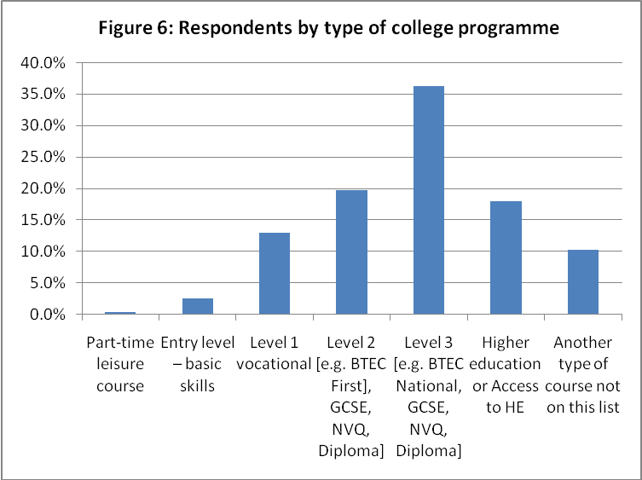

In considering the results (section 4.4), the limitations of the sample need to be borne in mind.

4.4 Results

This section displays some of the results of the survey. As suggested in section 4.3, these should be treated with caution – they are not necessarily representative of FE college learners as a whole, but simply reflect this pilot study. The full set of responses is given in Appendix A2.

4.4.1 Learner responses to Parts B, C, D and E

When asked to assess their own IT skills, most of the learners assessed themselves as ‘fairly good’. In college C, a relatively high proportion of respondents assessed themselves as expert; this was a sixth form college where the sample consisted entirely of highly motivated A-level students.

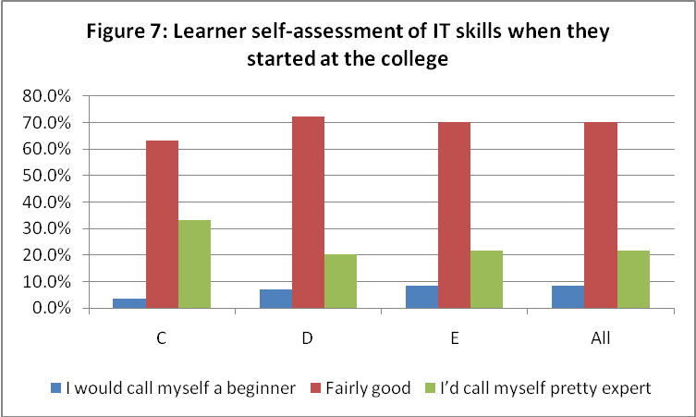

Overall, around 60 per cent of learners asserted that the college had assessed their IT skills when they started their course, with colleges B and C showing figures very close to the overall average, even though the composition of the student population varied considerably between these two. The highest positive score came from college D and the lowest from college E, where the respondents were equally divided between ‘yes’ and ‘no’. College E had earlier participated in the full FE survey, generating a low score in relation to achievement of HT goals, and the range of courses studied by the respondents there was more varied than in the other colleges. In college B, discussions in focus groups with some of the learners who had completed the online survey showed that a few of them had confused the initial online assessment of literacy and numeracy with an IT assessment, but this was only a small minority.

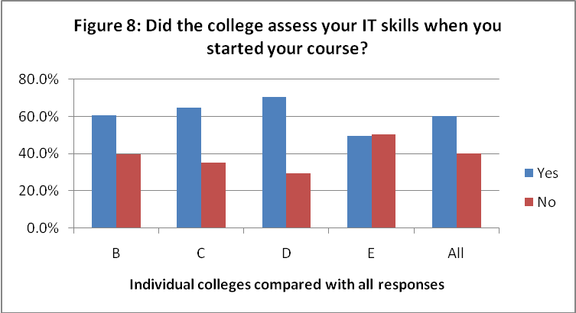

When asked whether their college course had improved their initial IT skills, just over 70 per cent asserted that it had had little or no effect – the exceptions were generally to be found among learners studying for an IT qualification! This finding would require further investigation before it could be called fully valid – eg triangulation with the programme area of the course could yield useful additional information.

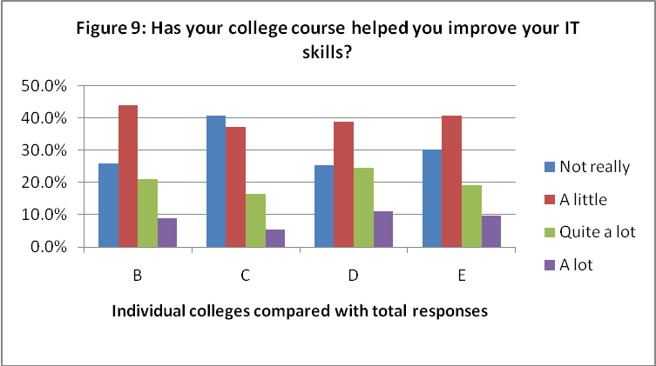

Over 85 per cent of the learners sampled had access at home to a computer with a broadband connection. This is higher than recent estimates of the general population. However, even a small and not necessarily representative sample such as this suggests that there is a continuing ‘digital divide’ related to socio-economic conditions: the scores were less positive for colleges B and D, both of which serve less advantaged catchment areas than colleges C and E.

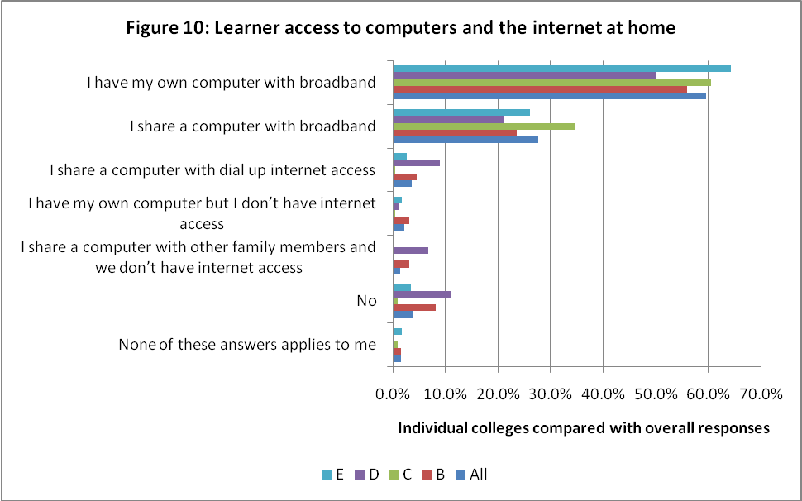

When learners were asked to compare their home IT facilities with what they had found at college, around a third claimed that the college facilities were inferior. This is a very similar percentage to several surveys of HE students, when asked about the comparison between university and home:

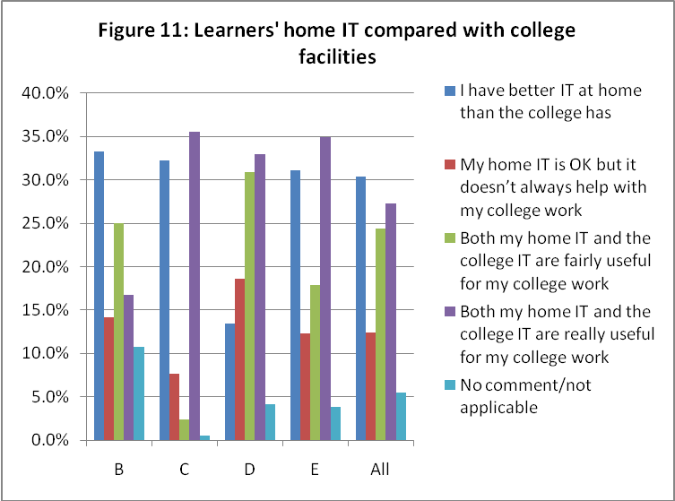

In retrospect, it could have been more useful to have separated this into two questions, with a single yes/no response to the comparison of IT facilities and a separate question on the extent to which both home and college facilities helped with college work, since only a single response was allowed. It was not surprising that College B produced the highest number of respondents who said the question did not apply to them – a significant part of this sample consisted of learners taking a highly practical vocational course in which relatively little use was made of IT.

Most of the learners sampled were relatively recent school leavers and they reported mixed views when comparing college IT to that at their previous school:

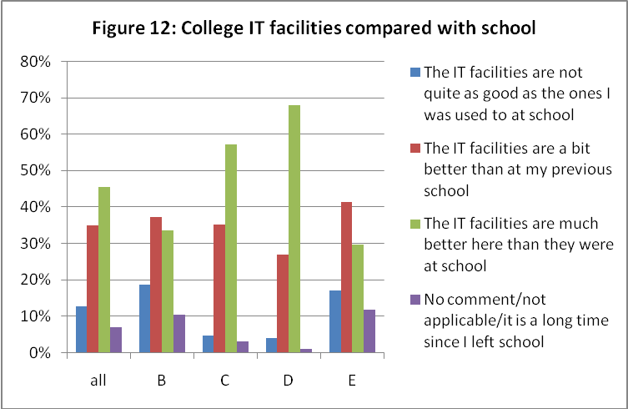

Interestingly, colleges C and D appeared to have much better IT facilities than their partner schools. Both are SFCs, while B and E are GFE colleges. However, not much should be read into this, as the 2008/09 FE survey report demonstrates.

Learners report that they are generally well served by college IT support services:

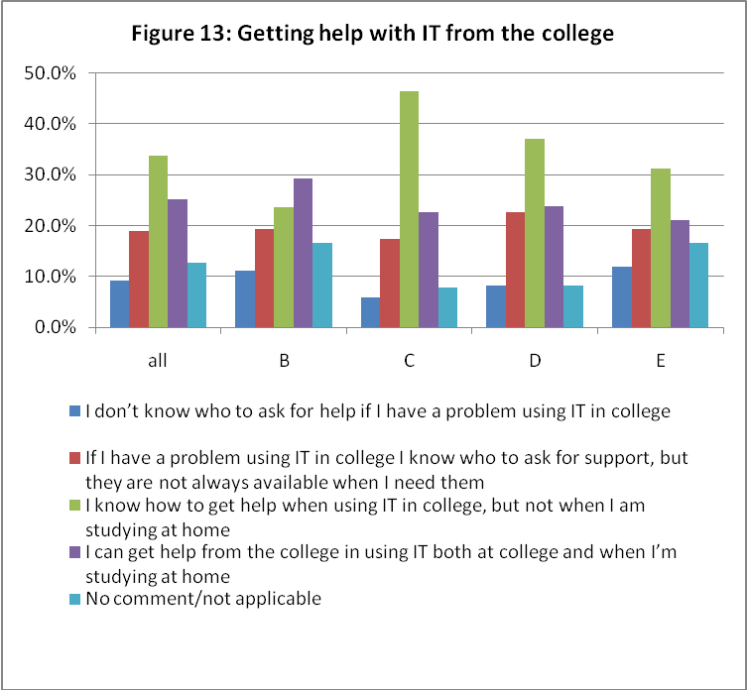

The 2008/09 FE survey showed that many colleges are still wary of allowing learners to use their own devices in college and relatively few allow them to be connected to the college network. This limited survey paints a rather more optimistic picture:

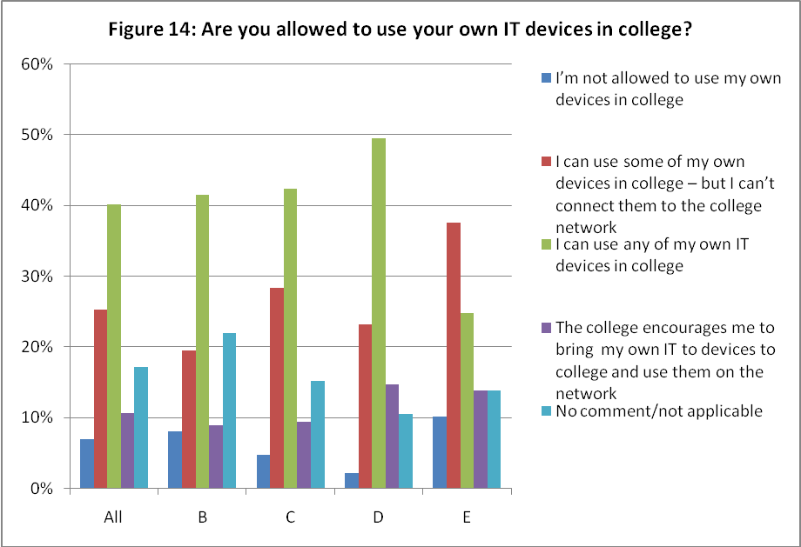

Learners found college IT facilities to be very much as they had expected – though more were pleasantly surprised than disappointed:

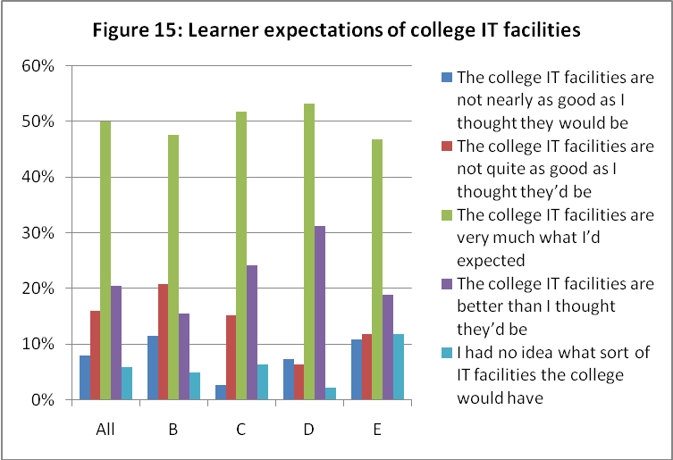

Just over half of the learners responding felt that most or all of their teachers saw IT as important in learning:

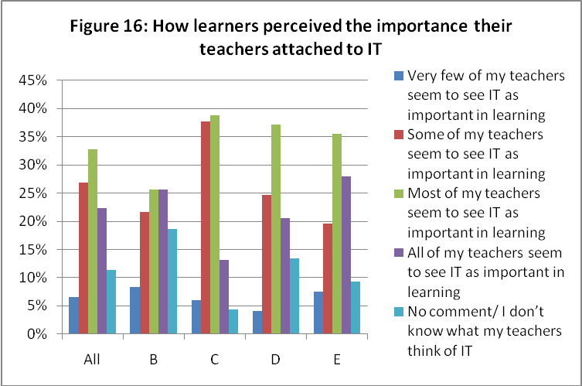

However, relatively few of the learners reported that the college sought their views on their experiences of technology in college. This mirrors the findings of the full FE survey:

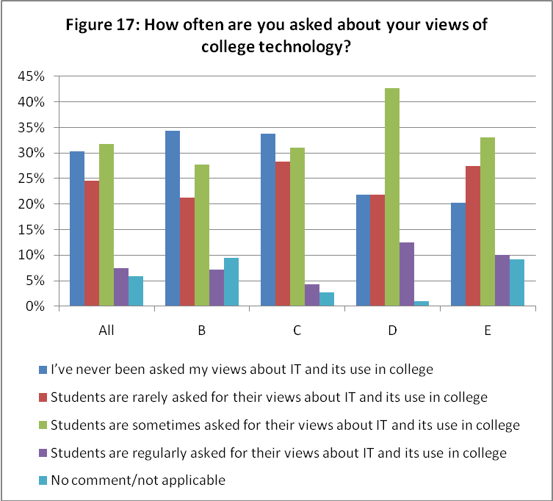

Studying at college had made little or no difference to many learners’ IT skills:

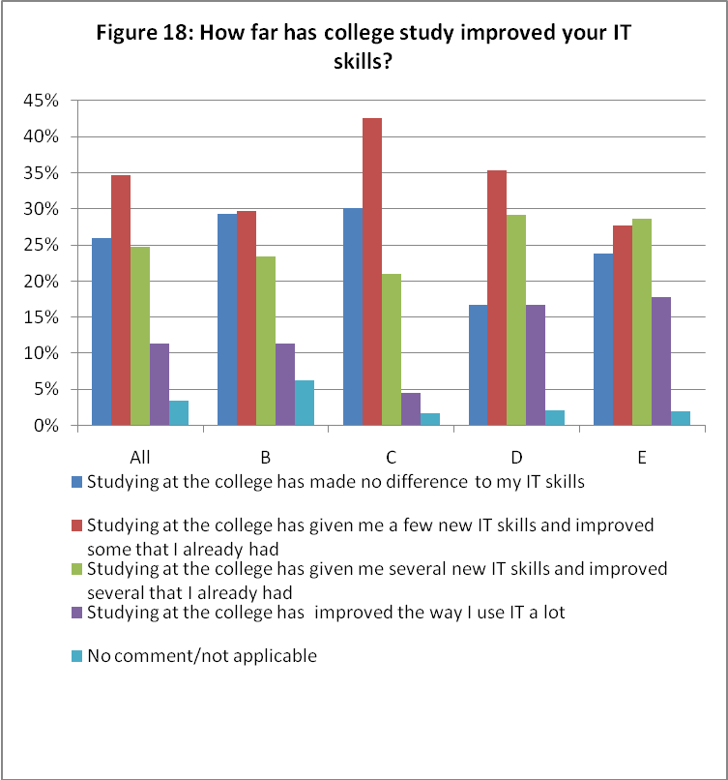

However, a somewhat contrasting picture is painted when learners were asked whether IT had helped them in their college studies – almost half reported that their expectations were met and almost 20 per cent said their expectations had been exceeded:

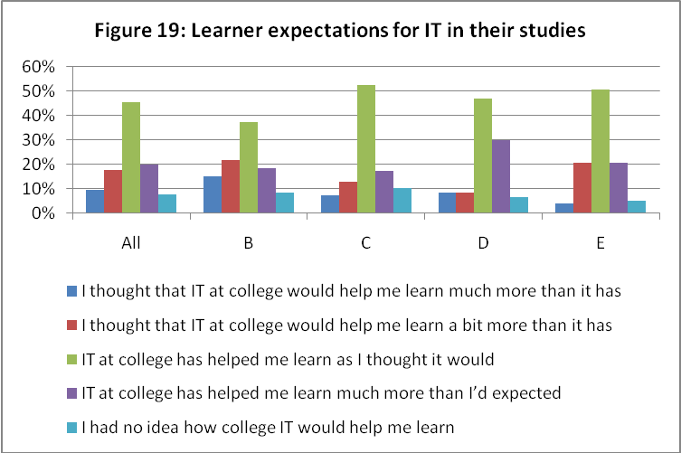

4.4.2 Free response comments

Part F consisted of two fairly similar free response questions. Of the learners, 502 (67%) gave some response to F1: How could college IT facilities best be improved? Few of the comments extended beyond a few words, but frequently mentioned complaints included:

- the need for a faster network – many learners complained about the slowness of booting up, running software programs and getting internet access
- having laptops rather than PCs
- blocking social networking sites and not trusting students
- the need for wireless networks to be extended
- poor air conditioning, leading to uncomfortable working conditions.

While these were the most common complaints, the twin themes of access to mobile devices and access for learners’ own devices also featured strongly:

'Student gateway through the wireless network. Allowing access on smart phones and other devices. More frequent ghosting of systems, to reduce the slowdown caused my multiple user profiles being stored.'

'… by allowing students to connect personal devices such as internet phone and laptops to the computer network.'

'Make the wireless network unlocked so that that students can access the internet on their own devices.'

'Allow easy access to college network by using [our] own laptops/devices.'

'By giving every student a mobile device.'

In one college, where the sample included a number of HE Access students, one of them felt strongly that IT should be an integral part of the Access course:

'Have a recognised qualification in IT as part of the Access to HE course.'

Question F2 asked how the college could use IT better to help students learn. Although the emphasis here was on learning, rather than facilities, it generated many similar responses, but rather fewer learners responded compared to the previous question (410 learners – 55%). Among the brief responses, it was encouraging to find many learners praising their teachers’ use of IT. Overall, however, the question did not add much value in the format in which it was asked.

4.4.3 Cross-tabulation

Responses to a number of questions were cross-tabulated to explore some possible links between areas of the data. Given the small overall size of the sample and the relative homogeneity of the respondents, the data presented below should not necessarily be taken to be fully representative of the FE college learner population. The survey would need to be significantly expanded for more meaningful conclusions to be drawn.

Access to IT and IT support showed a reassuringly close correlation:

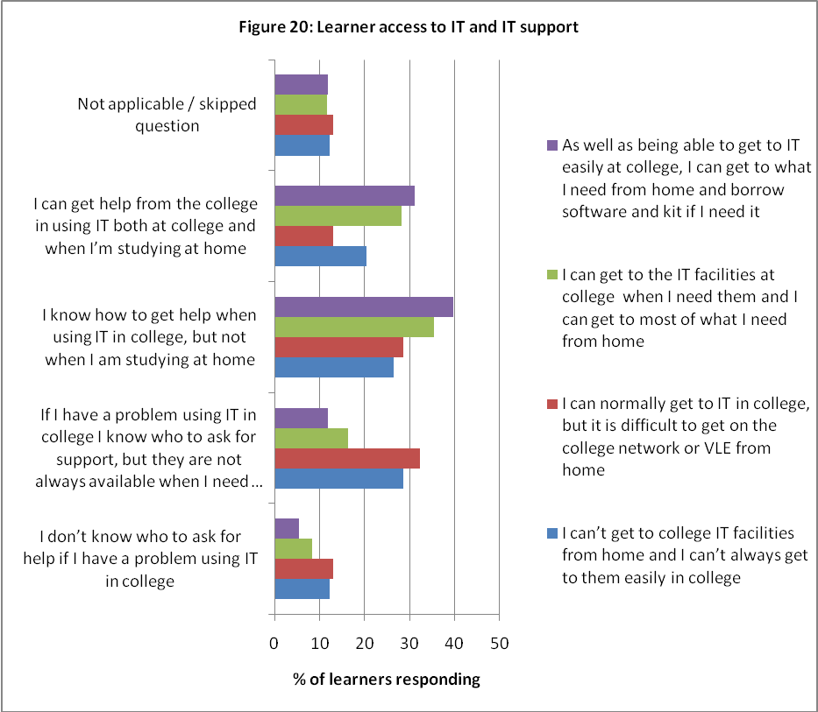

Of learners on Level 1 or 2 vocational programmes (not specialist IT courses), 77 per cent reported that studying at college had made little or no improvement to their IT skills. Level 3 learners showed the best levels of improvement, with 36 per cent asserting that their IT skills had improved:

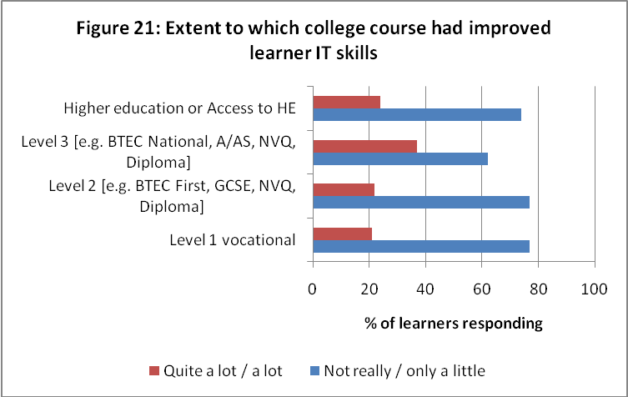

There were some variations in learners’ views about the importance they perceived that their teachers attached to IT and the effectiveness with which the latter used it, but these were not particularly significant:

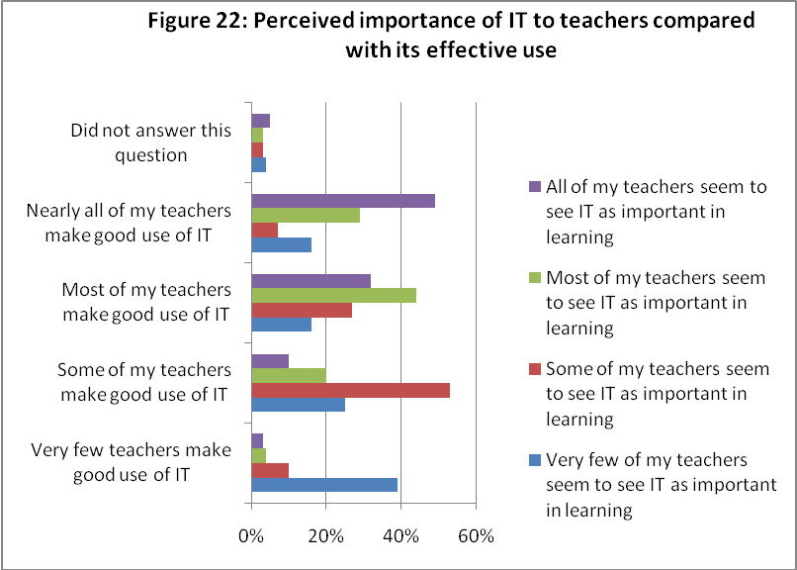

The level and type of course made reassuringly little difference in learners’ views of teacher use of IT:

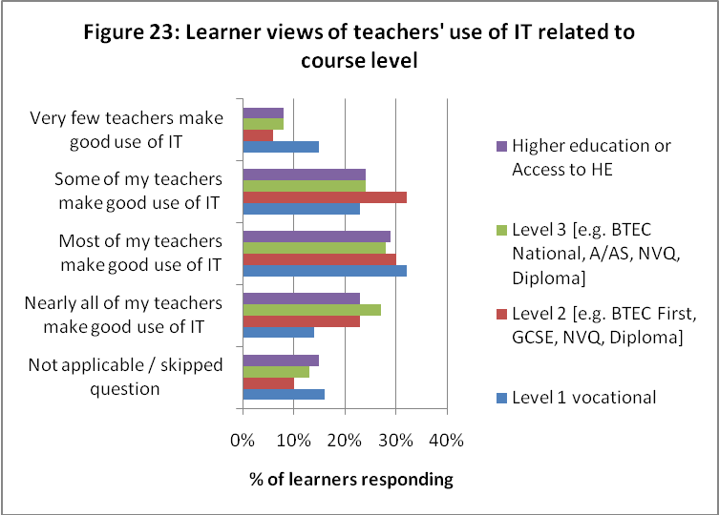

However, when the emphasis of the question was changed, it appeared from this sample that Level 1 vocational learners had a rather less satisfactory IT experience than learners on higher-level programmes:

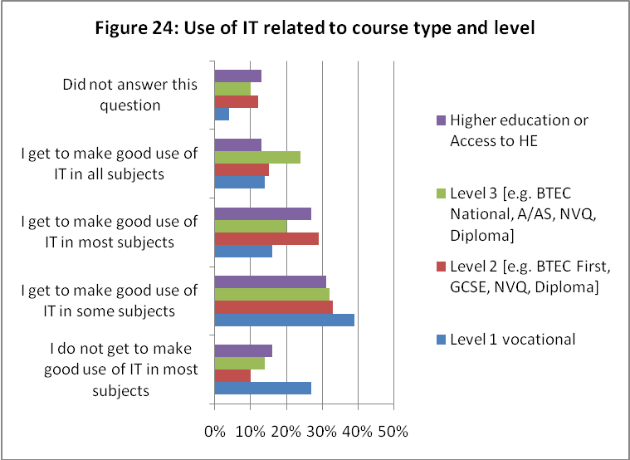

Not too much should be read into the cross-tabulations described above, given the small and not particularly representative nature of the sample. However, with extension of the survey and larger numbers of responses, there are clearly substantial opportunities for triangulation with the annual FE survey.

4.5 Other approaches and issues

In addition to participating in the online survey, colleges B, C, D and E each trialled an alternative approach to gathering learner views about technology. These are described below in sub-sections 4.5.1–4.5.4; sub-section 4.5.5 discusses triangulation between these approaches and the online survey. College A did not participate in the online survey; their alternative approach is described in sub-section 4.5.6.

4.5.1 Electronic forum

College C set up an electronic discussion forum on the college VLE and invited a tutor group to contribute to it. The tutor group had already completed the online survey.

The forum was entitled: 'What are your views about teachers’ use of information technology' and was live for the final week of the spring term. During this period, 11 discussion topics were posted, four started by the teacher and seven by students. Some 106 posts were registered, ranging from 1 ('No problems with current use of IT') to 22 ('Is there a point in Moodle?'). Ten of a possible 26 students contributed.

The college was disappointed with the response and the limited content of the posts that were made. There were three main reasons cited for this:

- The electronic forum was not anonymous (students often used their personal email addresses on Moodle) and it was felt that the lack of anonymity might inhibit students from being completely open and honest.
- Survey overload and the timing of the forum: at around the same time, end-of-year surveys on a range of other issues were in progress.
- The topic was not of great interest to students: they were generally satisfied with their technology experiences at college and there was no additional incentive to participate.

4.5.2 Focus groups

College B identified three tutor groups of learners from the same vocational area for focus group discussions – one each at NVQ levels 1, 2 and 3. The focus groups were conducted by a member of the Sero research team, during normal tutorial time, without the tutor being present; two of the three groups of learners had previously completed the online survey and the third group did so immediately following the focus group discussion.

As with the electronic forum in college C, the focus groups produced no surprises and relatively little was added to the data from the online survey. The learners (who had no choice but to be present) were not strongly engaged with the topics discussed – this applied equally to all three groups, although their online responses indicated that there were differences in the amount of IT used in teaching at different NVQ levels.

Three points of interest emerged:

- A small number of the Level 1 learners had assumed that their initial literacy and numeracy screening was an IT assessment and had responded accordingly to question B5 in the online survey.
- Learners commented that, if their teacher had been present, they would have been inhibited from discussing teacher use of IT. The anonymity guaranteed by an outsider enabled them to do this.
- Two learners with dyslexia commented on accessibility issues with the online survey. The use of text-to-voice software would have made it easier to respond.

4.5.3 Blog and interviews

College E had opened the online survey to all learners. Six of the questions were of particular interest to the college and a blog was established to explore three of them in more detail, using email. A member of the Sero research team then arranged interviews with four learners to explore the other three questions. With the agreement of the learners, these interviews were videoed.

Aware that there were internal communication problems in reaching learners, the college had used tutors, as well as email, to raise learners’ awareness of the online survey and publicise the prize draw. This had resulted in 121 valid completed responses to the survey. In ‘marketing’ the blog, only email was used and the college was disappointed to receive no contributions at all. Three interviewees confirmed that they had not seen the email directing them to the blog; the fourth had seen the email but had been too busy to respond.

The three interviews added significantly to the value of the responses from the online survey. The college felt it learned useful lessons in several areas and plans to use the outputs of the online survey and interviews to drive change in some of its technology policies and practice. In particular, it plans to review and rebrand its IT induction as ‘Digital and learning literacy’, making this a simple script which any member of staff can deliver and provide self-access for learners. This complements the approach being taken by college A – see 4.5.6 below.

4.5.4 Optivote

College D decided to use its voting software as an alternative approach, using a range of questions from the online survey, with voting following group discussions. It had hoped to test this approach with groups of Level 2 vocational students, but timing and timetable issues prevented this happening and only a single small group of students was able to participate in the Optivote session.

Perhaps unsurprisingly, in view of the difficult circumstances, the college felt that the Optivote session added little of value to the online data. As with the other colleges, it was felt that there was little incentive for the students to participate actively and the session was seen as yet another survey at a time of year when students were overloaded with surveys from different areas of the college. However, the college plans to use this approach with a larger group of students in future.

4.5.5 Triangulation and implications for future work

All of the alternative approaches provided reassuring triangulation with the online survey. However, the small size of some of the samples and the difficult timing of the research suggests that further work is necessary to explore other approaches which could best complement and illuminate an online survey. There was, for instance, no opportunity to trial video booth recordings, auditory feedback and a range of other strategies with learners.

The varied approaches did, however, go some way towards establishing some tentative conclusions:

- In-depth interviews are likely to yield the best-quality information but are clearly time-consuming and not necessarily cost-effective.
- Anonymity is important so that learners can be confident that they can express their views honestly. This has implications for the use of focus groups and interviews.
- The timing of survey work and feelings of ‘survey overload’ need to be carefully considered.
- Participating colleges had not previously given much consideration to investigating their learners’ experiences of technology and felt that this was a useful area to survey. However, learners clearly required an incentive to participate and did not generally find the survey either particularly interesting or important to them, despite positive advance publicity from the colleges concerned.

The initial wording of the questionnaire had been reviewed by participating colleges before it was finalised. Comments from learners, both in focus and discussion groups and in interviews, indicated the need for further clarification. In future survey development, it will be essential to trial the instrument with learners in advance of full release – in particular, addressing language and accessibility issues.

4.5.6 College A – an approach to initial assessment

College A decided it was not practicable to offer the online survey to learners in the time available. It was hoped that it would be possible to link the college’s approach to its MoLeNET project, which involved a substantial learner voice component. In particular, it was hoped to explore the extent to which learner views on technology could be reliably obtained from entry- and foundation-level learners and to attempt this through the construction of curriculum materials – an e-book similar to ones which the college had already pioneered.

Unfortunately there was insufficient time to do this. However, following discussions with the college, staff identified a need to review their initial assessment of learners’ IT skills and personal technology. Until now, there has not been universal learner IT assessment on entry and individual courses have not had access to any centrally collected data. Accordingly, the college used the online survey as a basis for developing a simple online questionnaire which is to be embedded in the enrolment process, as part of the college SAC (Student Account Creation). The draft questionnaire contains 44 questions in seven sections: using a computer (9); word processing (8); using the internet (8); using email (9); computer access at home (3); other technologies, including assistive technology (7). All questions are yes/no with tick-box responses.

Although college A’s approach does not fit within the brief of this pilot study, it raised the college’s awareness that they collected insufficient data centrally on learners’ initial IT skills and personal technology. NB: the study has also set college E on the same path (see section 4.5.3).

Discussion and conclusions

This chapter discusses the issues raised by this pilot study of college learner views on their technology experiences. It considers the potential added value of aligning an annual survey of learner views of technology alongside the current Becta annual surveys and other surveys. It discusses the scalability and validity of alternative approaches to such a survey, examines a range of accessibility issues and considers briefly the transferability of the online survey both to other FESR (further education statistical record) sectors and to lifelong learning in HE.

5.1 What value would a survey of learner views of technology add to existing surveys?

Becta has conducted an annual survey of technology adoption and use in FE colleges since 2001. Initially the survey only covered the views of providers, but in the past few years, it has also reported on the views and experiences of staff. However, the third point of the triangle – the views and experiences of learners – has only been reported by proxy, through questions addressed to providers and practitioners.

Clearly learner voice is more than just a flavour of the month. Given the importance which government (and the whole FESR sector) attaches to learner views, it would seem important that the annual technology surveys should include one of learners' views of their technology experiences which can be aligned with the key questions that the full FE survey is designed to address.

The colleges approached for this pilot were enthusiastic about participation and felt that this added value to their own quality improvement strategies. Indeed, two of the five colleges used their participation to review their initial IT assessments of learners, in order to focus their teaching more closely on learner needs and situations. This attitude was also reflected in a number of comments made by interviewees in the full FE survey, and the relatively small number of colleges which had already started to embed technology questions in their internal learner surveys reported significant benefits from this.

If a larger-scale survey were to be linked with the annual college and staff technology survey, it would be important to give colleges feedback on what their learners are saying, while ensuring the anonymity of the learners who commented. The same is true of staff views in the annual survey.

5.2 Scalability and validity of alternative approaches

If a learner voice survey of this nature is to be conducted annually and linked with the full FE survey, it needs to be web-based to generate a sufficiently large number of responses for valid conclusions to be drawn and valuable triangulation to be done.

The alternative approaches trialled in this study did not add much of value to the data obtained from the online survey, with the exception of the videoed interviews at college E. Although only a limited range of alternative approaches was explored, it is unlikely that any alternative to an online survey will be cost-effective in producing a large enough volume of data for analysis or will be capable of appropriate scalability. In addition, several of the approaches were not able to offer anonymity to participants: this is important in eliciting honest responses. The value of alternative approaches, both for individual colleges and for a national organisation such as Becta, is in providing the telling illustrative anecdote, rather than seeking to provide triangulation with online material. However, Chapter 6 includes a recommendation for the use of alternative approaches, based on the limited experiences in this pilot study.

5.3 Accessibility issues

If a learner voice technology survey is to provide useful and valid data across the full range of FESR learners, it is essential that it is equally accessible to all. Accessibility covers two significant sets of issues:

- how an online survey can be accessed and completed by learners at all levels of learning, including learners with learning difficulties and disabilities
- how the survey can be effectively marketed to learners, and perceived by them to be of sufficient relevance and value to encourage participation.

The initial drafts of the online questionnaire were reviewed both by the consultancy team and participating colleges to consider the language levels involved, with the aim of ensuring that it was equally accessible to entry-level and Level 4 learners. Accessibility was not considered in detail for learners requiring assistive technology, but if the project was to be taken further, this would be essential. Discussions took place with the National Star College and JISC Techdis on possible modifications to the online questionnaire and the incorporation of approaches which would enable learners with significant learning difficulties and/or physical disabilities to access the survey and generate valid responses. Their work suggests that putting the survey on a web page which could be readily accessed from a college’s VLE would be a suitable approach.

It is a continuing challenge to secure provider buy-in and participation in the full annual FE survey, and staff participation has often been encouraged through prize draws. A prize draw for learners was used to stimulate learner responses for this pilot study, but even with this, some of the colleges had difficulty communicating with their learners and persuading them to take part. Focus groups and discussion sessions confirmed that learners did not see the subject matter as particularly relevant or interesting to them. Careful marketing appears to be necessary if a larger-scale survey is to generate data representative of the learner population in colleges. If the survey is to be repeated and extended, the best way of ensuring learner involvement would be to ask participating colleges for their most effective methods for communicating with learners and to design a survey instrument that is compatible with the variety of methods that a number of colleges might use.

The constraints of the pilot study meant that the fieldwork was conducted at the end of the college spring term and the first fortnight of the summer term. At this time, most learners are engaged in revision for examinations, or are actually taking them. As a result, accessing learners was not easy, and especially part-time learners, who are scarcely represented in the sample. The timing of a large-scale survey needs careful consideration, particularly if it is designed to blend in with the cycle of the full annual survey. It is likely that the first half of the spring term would be the most appropriate time for such a survey. This would be long enough after the start of courses for learners to be familiar with college technology and how it is being used, but would not, for most learners, run into an examination or holiday period. Running a survey during January/February would also enable the results to be triangulated with the college and staff data and reported on in the same cycle.

5.4 Transferability to other education sectors

This pilot research was confined to a small number of FE colleges, but there is no reason why an online survey should not be extensible to the other FESR sectors, though the Offender Learning and Skills Service (OLASS) would present a particular set of challenges. Although adult and community learning (ACL), work-based learning (WBL) and OLASS all currently use different questionnaires for their annual surveys, the aims and objectives are the same. In addition, sector organisations such as NIACE (National Institute of Adult Continuing Education) are already engaged in a substantial amount of learner voice work. Further work on the survey instrument would be necessary to ensure that it reflected the characteristics of learners in ACL and WBL, and with the vast majority of ACL learners being part-time, marketing and accessibility would require attention.

Learner voice work is more strongly developed through much of HE than it is in FE, though here, as well, there is relatively little which focuses on HE learners’ technology experiences.

5.5 Conclusions

This pilot study confirms the initial view that an online survey of FE learners’ views of their college technology experiences, linked with the annual FE surveys, is practicable and would add value to the annual survey for Becta and for the colleges themselves.

Further research and development would be required, both to extend the survey across FE colleges and to broaden it to include other FESR sectors. Development work would need to include:

- revisiting the early NLN work from the period 2002–04 to review the learner voice survey material
- a more detailed review of international work – in particular, from New Zealand, Australia and the US
- refining the survey instrument to make sure that it can be clearly linked to the annual Harnessing Technology survey and working with NATSPEC (Association of National Specialist Colleges) to ensure that the instrument is accessible to all learners
- working with Becta and the research teams responsible for other FESR surveys to ensure that the survey content and approach reflect the different learner populations in ACL, WBL and, eventually, OLASS
- liaising with participating providers to ensure that the survey is appropriately marketed to their learners
- creating a ‘toolkit’ of alternative approaches to add value for participating providers.

Recommendations

Drawing on the experiences of this pilot research, we recommend that:

- development work for an online survey of FE college learners should continue, taking account of the discussion and conclusions in Chapter 5 of this report, including revisiting the early NLN work and further review of developments in New Zealand, Australia and the US
- a further larger-scale pilot online survey should be run, linked with the 2009/10 annual FE colleges survey
- further research should be undertaken with other FESR survey contractors and appropriate independent specialist colleges to develop a survey instrument that can be applied across all FESR sectors.

Appendices

Appendix A: The online survey (A1) and responses (A2)

A1: YOUR EXPERIENCES WITH TECHNOLOGY IN COLLEGE

Format

After you’ve told us a bit about yourself, the questionnaire has five parts with 28 questions, including two in the final part where there is an opportunity to win an iPod Nano as a ‘thank you’ for taking part. It will typically take 20 minutes to complete the first five parts, as follows:

Part | Estimated  time to answer ALL | Number of questions
A: About you | 4 minutes | 8
B: About your IT skills and your computer | 4 minutes | 6
C: Your opinions of college IT facilities | 4 minutes | 6
D: You, the college and technology | 4 minutes | 6
E: The effect IT has had on your learning | 4 minutes | 6
F: Open questions | Up to you! | 2
Total | 20 minutes | 28

Two pieces of simple advice

- Please try and answer all 26 questions in Parts A–E, but if you don’t understand the question, please leave it unticked or blank and move on.
- Apart from questions that specifically ask about future expectations, please answer every question on the basis of what is happening NOW, even if you think things are going to change soon.

Prize draw

To say ‘thank you’, Sero will enter into a prize draw all students who’ve been asked by their colleges to take part, with one iPod Nano as a prize in each college. To be eligible for this, you’ll need to register your email address in the final section.

Throughout the survey, we’ve used the terms ‘IT’ and ‘technology’ to refer to computers and all other electronic devices that you may have or may use. If you need any help with this survey, a printable version, together with some explanations of the terms used is available at www.sero.co.uk/becta-fe.html.

Please go to the next screen to start the survey
Part A: About you

Please start by entering the four digit code you have been given by your college in this box
A1 Your student number – this may be on your student ID card (please enter in box)

A2 Your age (please tick one box)
- 14–19
- 20–29
- 30–39
- 40–49
- 50 or older

A3 Male or female? (please tick one box)
- Female
- Male

A4 Your ethnicity (please tick one box from the drop-down menu)
- Asian or Asian British – Bangladeshi
- Asian or Asian British – Indian
- Asian or Asian British – Pakistani
- Asian or Asian British – any other Asian background
- Black or Black British - African
- Black or Black British – Caribbean
- Black or Black British – any other Black background
- Chinese
- Mixed - White and Asian
- Mixed - White and Black African
- Mixed - White and Black Caribbean
- Mixed - any other Mixed background
- White – British
- White - Irish
- White – any other White background
- Any other
- Not known/not provided

A5 Your course (please tick one box from the drop-down menu)
- Part-time leisure course
- Entry level – basic skills
- Level 1 vocational
- Level 2 (eg BTEC First), GCSE, NVQ, diploma)
- Level 3 (eg BTEC National, GCSE, NVQ, diploma)
- Higher education or Access to HE
- Another type of course not on this list

A6 The way you’re studying (please tick one box)
- As a full-time student
- As a part-time student
- As a distance learner
- As a work-based student
- Another way which isn’t on this list

A7 Do you have a disability which affects your learning? (please tick all boxes that apply to you)
- 98 no disability
- 01 visual impairment (not just wearing glasses)
- 02 hearing impairment
- 03 disability affecting mobility
- 04 other physical disability
- 05 other medical condition (eg epilepsy, asthma, diabetes)
- 06 emotional/behavioural difficulties
- 07 mental health difficulty
- 08 temporary disability after illness (eg post-viral) or accident
- 09 profound complex disabilities
- 10 Asperger’s syndrome
- 90 multiple disabilities
- 97 other

A8 Do you have a learning difficulty? (please tick all boxes that apply to you)
- 98 no learning difficulty
- 01 moderate learning difficulty
- 02 severe learning difficulty
- 10 dyslexia
- 11 dyscalculia
- 19 other specific learning difficulty (eg dyspraxia, ADD, ADHD)
- 90 multiple learning difficulties
- 97 other

When you’ve completed this screen, please click ‘Done’ to move on to Part B
Part B: About your IT skills and your computer

B1 Your IT skills when you started at college (please tick one box)
- I would call myself a beginner
- Fairly good
- I’d call myself pretty expert

B2 Your confidence in using the internet (please tick one box)
- I’m not confident
- I’m fairly confident
- I’m very confident

B3 Do you have a computer or laptop at home with internet access? (please
tick one box from the drop-down menu)
- No
- I share a computer with other family members and we don’t have internet access
- I have my own computer but I don’t have internet access
- I share a computer with dial-up internet access
- I share a computer with broadband
- I have my own computer with broadband
- None of these answers applies to me

B4 Do you have a mobile phone that you can use to get on to the internet?
(please tick one box)
- Yes
- No

B5 Did the college assess your IT skills when you started your course?
(please tick one box)
- Yes
- No

B6 Has your college course helped you to improve your IT skills? (please tick
one box)
- Not really
- A little
- Quite a lot
- A lot

When you’ve completed this screen, please click ‘Done’ to move on to Part C, or ‘Prev’ to move back to Part A
Part C: Your opinions on college IT facilities

C1 College IT facilities (please tick whichever box best fits)
- The IT facilities are not quite as good as the ones I was used to at school
- The IT facilities are a bit better than at my previous school
- The IT facilities are much better here than they were at school
- No comment/not applicable/it is a long time since I left school

C2 Using IT for college work (please tick whichever box best fits)
- I can’t get to college IT facilities from home and I can’t always get to them easily in college
- I can normally get to IT in college, but it is difficult to get on the college network or VLE from home
- I can get to the IT facilities at college when I need them and I can get to most of what I need from home
- As well as being able to get to IT easily at college, I can get to what I need from home and borrow software and kit if I need it
- No comment/not applicable

C3 Using assistive technology to help me with college work (By ‘assistive
technology’, we mean devices such as tracker balls, switches, alternative/on-screen keyboards, pointing devices, video magnifiers, text-to-speech software, screen magnifiers, Braille displays, hearing loops, predictive word processors, voice recognition systems.) (please tick whichever box best fits)
- I don’t need any assistive technology, so this question doesn’t apply to me
- I need assistive technology to use IT but can’t use it at college
- I can bring in my own assistive technology but the college doesn’t provide any
- The college provides me with the assistive technology I need, but I cannot take it home
- The college provides me with the assistive technology I need and I can take it home as well

C4 Getting support for using technology in college (please tick whichever box
best fits)
- I don’t know who to ask for help if I have a problem using IT in college
- If I have a problem using IT in college I know who to ask for support, but they are not always available when I need them
- I know how to get help when using IT in college, but not when I am studying at home
- I can get help from the college in using IT both at college and when I’m studying at home
- No comment/not applicable

C5 Using my own IT devices in college (By ‘my own devices’, we mean your
own net-book, smart phone, memory stick, laptop, assistive devices, etc.) (please tick whichever box best fits)
- I’m not allowed to use my own devices in college
- I can use some of my own devices in college – but I can’t connect them to the college network
- I can use any of my own IT devices in college
- The college encourages me to bring my own IT devices to college and use them on the network
- No comment/not applicable

C6 My expectations (please tick whichever box best fits)
- The college IT facilities are not nearly as good as I thought they would be
- The college IT facilities are not quite as good as I thought they’d be
- The college IT facilities are very much what I’d expected
- The college IT facilities are better than I thought they’d be
- I had no idea what sort of IT facilities the college would have

When you’ve completed this screen, please click ‘Done’ to move on to Part D, or ‘Prev’ to move back to Part B

Part D: You, the college and technology

D1 College compared with school (please tick whichever box best fits)
- My previous school used IT in learning much better than the college
- My previous school used IT in learning a bit better than the college
- The college uses IT in learning a bit better here than my previous school
- The college uses IT in learning much better here than my previous school
- No comment/not applicable/it is a long time since I left school

D2 College compared with work (please tick whichever box best fits)
- My workplace uses IT in learning much better than the college
- My workplace uses IT in learning a bit better than the college
- The college uses IT in learning a bit better than at my workplace
- The college uses IT in learning much better than my workplace
- No comment/not applicable/I am not in work

D3 College compared with home (please tick whichever box best fits)
- I have better IT at home than the college has
- My home IT is OK but it doesn’t always help with my college work
- Both my home IT and the college IT are fairly useful for my college work
- Both my home IT and the college IT are really useful for my college work
- No comment/not applicable

D4 How my teachers seem to think of IT (please tick whichever box best fits)
- Very few of my teachers seem to see IT as important in learning
- Some of my teachers seem to see IT as important in learning
- Most of my teachers seem to see IT as important in learning
- All of my teachers seem to see IT as important in learning
- No comment/I don’t know what my teachers think of IT

D5 Listening to my views about IT (please tick whichever box best fits)
- I’ve never been asked my views about IT and its use in college
- Students are rarely asked for their views about IT and its use in college
- Students are sometimes asked for their views about IT and its use in college
- Students are regularly asked for their views about IT and its use in college
- No comment/not applicable

D6 My expectations (please tick whichever box best fits)
- I thought the college would use IT much better to help me learn than it does
- I thought that IT would be used a bit better to help me learn than it is
- The college uses IT to help me learn very much as I’d expected
- The college uses IT to help me learn better than I’d expected
- I had no idea how the college would use IT to help me learn

When you’ve completed this screen, please click ‘Done’ to move on to Part E, or ‘Prev’ to move back to Part C
Part E: The effect IT has had on your learning

E1 How my teachers use IT (please tick whichever box best fits)
- Very few of my teachers make good use of IT in teaching
- Some of my teachers make good use of IT in their teaching
- Most of my teachers make good use of IT in their teaching
- Nearly all of my teachers make good use of IT in their teaching
- No comment/not applicable

E2 IT in different subjects (please tick whichever box best fits)
- I do not get to make good use of IT in most subjects
- I get to make good use of IT in some subjects
- I get to make good use of IT in most subjects
- I get to make good use of IT in all subjects
- No comment/not applicable

E3 My IT skills (please tick whichever box best fits)
- Studying at the college has made no difference to my IT skills
- Studying at the college has given me a few new IT skills and improved some that I already had
- Studying at the college has given me several new IT skills and improved several that I already had
- Studying at the college has improved the way I use IT a lot
- No comment/not applicable

E4 How college IT helps my learning (please tick whichever box best fits)
- The college does not use (or let me use) IT to support my learning in useful ways
- The college uses (and lets me use) IT to support my learning in a few useful ways
- The college uses (and lets me use) IT to support my learning in some useful ways
- The college uses (and lets me use) IT to support my learning in many useful ways
- No comment/not applicable

E5 Finding and using information online (please tick whichever box best fits)
- Studying at the college has made no difference to how I find and use online information
- Studying at the college has improved how I find and use online information a bit
- Studying at the college has definitely improved how I find and use online information
- No comment/not applicable

E6 My expectations (please tick whichever box best fits)
- I thought that IT at college would help me learn much more than it has
- I thought that IT at college would help me learn a bit more than it has
- IT at college has helped me learn as I thought it would
- IT at college has helped me learn much more than I’d expected
- I had no idea how college IT would help me learn

When you’ve completed this screen, please click ‘Done’ to move on to Part F, or ‘Prev’ to move back to Part D

Part F: My views on making things better

F1 How could college IT facilities best be improved? (please type as much or
as little as you want)

F2 How could the college use IT better to help students learn? (please type
as much or as little as you want)

My email address for the prize draw

Thank you for completing the survey. We hope you’ll be lucky in the prize draw!

A2: AGGREGATED RESPONSES TO ONLINE SURVEY

FE learner survey (All)
A2 Your age (please tick one box)
Answer options | Response frequency | Response count
14–19 | 92.5% | 679
20–29 | 5.4% | 40
30–39 | 1.0% | 7
40–49 | 0.7% | 5
50 or older | 0.4% | 3
answered questions |  | 734
skipped questions |  | 11
FE learner survey (All)
A3 Male or female? (please tick one box)
Answer options | Response frequency | Response count
Female | 42.9% | 313
Male | 57.1% | 416
answered questions |  | 729
skipped questions |  | 16

FE learner survey (All)
A4 Your ethnicity (please choose one option from the drop-down menu)
Options
Answer options | 11 Asian or Asian British – Bangladeshi | 12 Asian or Asian British – Indian | 13 Asian or Asian British – Pakistani | 14 Asian or Asian British – any other Asian background | 15 Black or Black British - African | 16 Black or Black British – Caribbean | 17 Black or Black British – any other Black background | 18 Chinese | 19 Mixed - White and Asian | 20 Mixed - White and Black African | 21 Mixed - White and Black Caribbean | 22 Mixed - any other Mixed background | 23 White – British | 24 White - Irish | 25 White – any other White background | 98 Any other | 99 Not known/not provided | Response count
Ethnicity | 5 | 14 | 47 | 3 | 8 | 2 | 1 | 5 | 2 | 1 | 3 | 1 | 606 | 9 | 17 | 5 | 5 | 734
 |  |  |  |  |  |  |  |  |  |  |  | Question totals
answered questions |  |  |  |  |  |  |  |  |  |  |  | 734
skipped questions |  |  |  |  |  |  |  |  |  |  |  | 11

 | FE learner survey (All)
 | A5 Your course (please choose one option from the drop-down menu)
 | Options
 | Answer options |  | Part-time leisure course |  | Entry level – basic skills |  |  |  | Level 1 vocational |  | Level 2 (eg BTEC First, GCSE, NVQ, diploma) |  | Level 3 (eg BTEC National, GCSE, NVQ, diploma) |  | Higher education or Access to HE |  |  | Another type of course not on this list |  |  | Response count
 | Course |  | 2 |  | 19 |  |  |  | 94 |  | 144 |  | 263 |  | 131 |  |  | 74 |  |  | 727
 |  |  |  |  |  |  |  |  |  |  |  |  |  |  |  |  |  | Question totals |  |  | Question totals
 | answered questions |  |  |  |  |  |  |  |  |  |  |  |  |  |  |  |  | 727 |  |  | 727
 | skipped questions |  |  |  |  |  |  |  |  |  |  |  |  |  |  |  |  |  |  |  | 18
 | FE learner survey (All)
 | A6 The way you’re studying (please tick one box)
 | Answer options |  |  |  |  |  |  |  |  |  |  | Response frequency |  |  |  |  |  |  | Response count
 | As a full-time student |  |  |  |  |  |  |  |  |  |  | 96.3% |  |  |  |  |  |  | 708
 | As a part-time student |  |  |  |  |  |  |  |  |  |  | 3.1% |  |  |  |  |  |  | 23
 | As a distance learner |  |  |  |  |  |  |  |  |  |  | 0.0% |  |  |  |  |  |  | 0
 | As a work-based student |  |  |  |  |  |  |  |  |  |  | 0.5% |  |  |  |  |  |  | 4
 | Another way which isn’t on this list |  |  |  |  |  |  |  |  |  |  | 0.0% |  |  |  |  |  |  | 0
 | answered questions |  |  |  |  |  |  |  |  |  |  |  |  |  |  |  |  |  | 735
 | skipped questions |  |  |  |  |  |  |  |  |  |  |  |  |  |  |  |  |  | 10
 | FE learner survey (All)
 | A7 Do you have a disability which affects your learning? Please tick all that apply
 | Answer options |  |  |  |  |  |  |  |  |  |  |  |  |  |  | Response frequency |  |  |  |  |  | Response count
 | 98 no disability |  |  |  |  |  |  |  |  |  |  |  |  |  |  | 89.2% |  |  |  |  |  | 617
 | 01 visual impairment (not just wearing glasses) |  |  |  |  |  |  |  |  |  |  |  |  |  |  | 1.3% |  |  |  |  |  | 9
 | 02 hearing impairment |  |  |  |  |  |  |  |  |  |  |  |  |  |  | 1.3% |  |  |  |  |  | 9
 | 03 disability affecting mobility |  |  |  |  |  |  |  |  |  |  |  |  |  |  | 0.4% |  |  |  |  |  | 3
 | 04 other physical disability |  |  |  |  |  |  |  |  |  |  |  |  |  |  | 1.0% |  |  |  |  |  | 7
 | 05 other medical condition (eg epilepsy, asthma, diabetes) |  |  |  |  |  |  |  |  |  |  |  |  |  |  | 3.9% |  |  |  |  |  | 27
 | 06 emotional/behavioural difficulties |  |  |  |  |  |  |  |  |  |  |  |  |  |  | 0.9% |  |  |  |  |  | 6
 | 07 mental health difficulty |  |  |  |  |  |  |  |  |  |  |  |  |  |  | 0.6% |  |  |  |  |  | 4
 | 08 temporary disability after illness (eg post-viral) or accident |  |  |  |  |  |  |  |  |  |  |  |  |  |  | 0.0% |  |  |  |  |  | 0
 | 09 profound complex disabilities |  |  |  |  |  |  |  |  |  |  |  |  |  |  | 0.0% |  |  |  |  |  | 0
 | 10 Asperger’s syndrome |  |  |  |  |  |  |  |  |  |  |  |  |  |  | 1.2% |  |  |  |  |  | 8
 | 90 multiple disabilities |  |  |  |  |  |  |  |  |  |  |  |  |  |  | 0.1% |  |  |  |  |  | 1
 | 97 other |  |  |  |  |  |  |  |  |  |  |  |  |  |  | 3.2% |  |  |  |  |  | 22
 | answered questions |  |  |  |  |  |  |  |  |  |  |  |  |  |  |  |  |  |  |  |  | 692
 | skipped questions |  |  |  |  |  |  |  |  |  |  |  |  |  |  |  |  |  |  |  |  | 53
 | FE learner survey (All)
 | A8 Do you have a learning difficulty? (please tick all that apply)
 | Answer options |  |  |  |  |  |  |  |  |  |  | Response frequency |  |  |  |  |  |  |  | Response count
 | 98 no learning difficulty |  |  |  |  |  |  |  |  |  |  | 87.0% |  |  |  |  |  |  |  | 601
 | 01 moderate learning difficulty |  |  |  |  |  |  |  |  |  |  | 2.0% |  |  |  |  |  |  |  | 14
 | 02 severe learning difficulty |  |  |  |  |  |  |  |  |  |  | 0.3% |  |  |  |  |  |  |  | 2
 | 10 dyslexia |  |  |  |  |  |  |  |  |  |  | 8.1% |  |  |  |  |  |  |  | 56
 | 11 dyscalculia |  |  |  |  |  |  |  |  |  |  | 0.3% |  |  |  |  |  |  |  | 2
 | 19 other specific learning difficulty (eg dyspraxia, ADD, ADHD) |  |  |  |  |  |  |  |  |  |  | 2.5% |  |  |  |  |  |  |  | 17
 | 90 multiple learning difficulties |  |  |  |  |  |  |  |  |  |  | 0.1% |  |  |  |  |  |  |  | 1
 | 97 other |  |  |  |  |  |  |  |  |  |  | 1.4% |  |  |  |  |  |  |  | 10
 | answered questions |  |  |  |  |  |  |  |  |  |  |  |  |  |  |  |  |  |  | 691
 | skipped questions |  |  |  |  |  |  |  |  |  |  |  |  |  |  |  |  |  |  | 54
 | FE learner survey (All)
 | B1 Your IT skills when you started at college (please tick one box)
 | Answer options |  |  |  |  |  |  |  |  |  |  | Response frequency |  |  |  |  |  |  |  | Response count
 | I would call myself a beginner |  |  |  |  |  |  |  |  |  |  | 8.3% |  |  |  |  |  |  |  | 60
 | Fairly good |  |  |  |  |  |  |  |  |  |  | 70.1% |  |  |  |  |  |  |  | 507
 | I’d call myself pretty expert |  |  |  |  |  |  |  |  |  |  | 21.6% |  |  |  |  |  |  |  | 156
 | answered questions |  |  |  |  |  |  |  |  |  |  |  |  |  |  |  |  |  |  | 723
 | skipped questions |  |  |  |  |  |  |  |  |  |  |  |  |  |  |  |  |  |  | 22
 | FE learner survey (All)
 | B2 Your confidence in using the internet (please tick one box)
 | Answer options |  |  |  |  |  |  |  |  |  |  | Response frequency |  |  |  |  |  |  |  | Response count
 | I’m not confident |  |  |  |  |  |  |  |  |  |  | 0.7% |  |  |  |  |  |  |  | 5
 | I’m fairly confident |  |  |  |  |  |  |  |  |  |  | 30.9% |  |  |  |  |  |  |  | 223
 | I’m very confident |  |  |  |  |  |  |  |  |  |  | 68.4% |  |  |  |  |  |  |  | 493
 | answered questions |  |  |  |  |  |  |  |  |  |  |  |  |  |  |  |  |  |  | 721
 | skipped questions |  |  |  |  |  |  |  |  |  |  |  |  |  |  |  |  |  |  | 24
FE learner survey (All)
B3 Do you have a computer or laptop at home with internet access? (please tick one box from the drop-down menu)
Answer options
Answer options |  | No |  | I share a computer with other family members and we don’t have internet access |  |  |  | I have my own computer but I don’t have internet access |  |  |  | I share a computer with dial-up internet access |  | I share a computer with broadband |  |  | I have my own computer with broadband |  |  |  |  | None of these answers applies to me | Response count
Internet access |  | 28 |  | 10 |  |  |  | 16 |  |  |  | 26 |  | 199 |  |  | 428 |  |  |  |  | 11 | 718
 |  |  |  |  |  |  |  |  |  |  |  |  |  |  |  |  |  |  |  |  |  |  | Question totals
answered questions |  |  |  |  |  |  |  |  |  |  |  |  |  |  |  |  |  |  |  |  |  |  | 718
skipped questions |  |  |  |  |  |  |  |  |  |  |  |  |  |  |  |  |  |  |  |  |  |  | 27

FE learner survey (All)
B4 Do you have a mobile phone that you can use to get on to the internet? (please tick one box)
Answer options | Response frequency |  |  |  | Response count
Yes | 64.1% |  |  |  | 463
No | 35.9% |  |  |  | 259
answered questions |  |  |  |  | 722
skipped questions |  |  |  |  | 23
FE learner survey (All)
B5 Did the college assess your IT skills when you started your course? (please tick one box)
Answer options | Response frequency |  |  |  | Response count
Yes | 60.1% |  |  |  | 433
No | 39.9% |  |  |  | 288
answered questions |  |  |  |  | 721
skipped questions |  |  |  |  | 24
FE learner survey (All)
B6 Has your college course helped you to improve your IT skills? (please tick one box)
Answer options | Response frequency |  |  |  | Response count
Not really | 30.3% |  |  |  | 219
A little | 40.8% |  |  |  | 295
Quite a lot | 19.1% |  |  |  | 138
A lot | 9.8% |  |  |  | 71
answered questions |  |  |  |  | 723
skipped questions |  |  |  |  | 22
FE learner survey (All)
C1 College IT facilities (please tick whichever box best fits)
Answer options | Response frequency |  |  |  | Response count
The IT facilities are not quite as good as the ones I was used to at school | 12.6% |  |  |  | 88
The IT facilities are a bit better than at my previous school | 34.9% |  |  |  | 243
The IT facilities are much better here than they were at school | 45.5% |  |  |  | 317
No comment/not applicable/it is a long time since I left school | 6.9% |  |  |  | 48
answered questions |  |  |  |  | 696
skipped questions |  |  |  |  | 49
FE learner survey (All)
C2 Using IT for college work (please tick whichever box best fits)
Answer options | Response frequency |  |  |  | Response count
I can’t get to college IT facilities from home and I can’t always get to them easily in college | 7.1% |  |  |  | 49
I can normally get to IT in college, but it is difficult to get on the college network or VLE from home | 15.6% |  |  |  | 108
I can get to the IT facilities at college when I need them and I can get to most of what I need from home | 54.2% |  |  |  | 375
As well as being able to get to IT easily at college, I can get to what I need from home and borrow software and kit if I need it | 13.4% |  |  |  | 93
No comment/not applicable | 9.7% |  |  |  | 67
answered questions |  |  |  |  | 692
skipped questions |  |  |  |  | 53
FE learner survey (All)
C3 Using assistive technology to help me with college work (By ‘assistive technology’, we mean devices such as tracker balls, switches, alternative/on-screen keyboards, pointing devices, video magnifiers, text-to-speech software, screen magnifiers, Braille displays, hearing loops, predictive word processors, voice recognition systems.) (please tick whichever box best fits)
Answer options | Response frequency |  |  |  | Response count
I don’t need any assistive technology, so this question doesn’t apply to me | 81.5% |  |  |  | 564
I need assistive technology to use IT but can’t use it at college | 2.7% |  |  |  | 19
I can bring in my own assistive technology but the college doesn’t provide any | 2.5% |  |  |  | 17
The college provides me with the assistive technology I need, but I cannot take it home | 8.2% |  |  |  | 57
The college provides me with the assistive technology I need and I can take it home as well | 5.1% |  |  |  | 35
answered questions |  |  |  |  | 692
skipped questions |  |  |  |  | 53
FE learner survey (All)
C4 Getting support for using technology in college (please tick whichever box best fits)
Answer options | Response frequency |  |  |  | Response count
I don’t know who to ask for help if I have a problem using IT in college | 9.2% |  |  |  | 63
If I have a problem using IT in college, I know who to ask for support, but they are not always available when I need them | 19.0% |  |  |  | 130
I know how to get help when using IT in college, but not when I am studying at home | 33.8% |  |  |  | 231
I can get help from the college in using IT both at college and when I’m studying at home | 25.2% |  |  |  | 172
No comment/not applicable | 12.7% |  |  |  | 87
answered questions |  |  |  |  | 683
skipped questions |  |  |  |  | 62
FE learner survey (All)
C5 Using my own IT devices in college (By ‘my own devices’ we mean your own net-book, smart phone, memory stick, laptop, assistive devices, etc.) (please tick whichever box best fits)
Answer options | Response frequency |  |  |  | Response count
I’m not allowed to use my own devices in college | 7.0% |  |  |  | 48
I can use some of my own devices in college, but I can’t connect them to the college network | 25.3% |  |  |  | 174
I can use any of my own IT devices in college | 40.1% |  |  |  | 276
The college encourages me to bring my own IT to devices to college and use them on the network | 10.6% |  |  |  | 73
No comment/not applicable | 17.1% |  |  |  | 118
answered questions |  |  |  |  | 689
skipped questions |  |  |  |  | 56
FE learner survey (All)
C6 My expectations (please tick whichever box best fits)
Answer options | Response frequency |  |  |  | Response count
The college IT facilities are not nearly as good as I thought they would be | 7.9% |  |  |  | 55
The college IT facilities are not quite as good as I thought they’d be | 15.9% |  |  |  | 110
The college IT facilities are very much what I’d expected | 49.9% |  |  |  | 345
The college IT facilities are better than I thought they’d be | 20.4% |  |  |  | 141
I had no idea what sort of IT facilities the college would have | 5.9% |  |  |  | 41
answered questions |  |  |  |  | 692
skipped questions |  |  |  |  | 53
FE learner survey (All)
D1 College compared with school (please tick whichever box best fits)
Answer options | Response frequency |  |  |  |  | Response count
My previous school used IT in learning much better than the college | 9.1% |  |  |  |  | 62
My previous school used IT in learning a bit better than the college | 14.9% |  |  |  |  | 101
The college uses IT in learning a bit better here than my previous school | 37.2% |  |  |  |  | 253
The college uses IT in learning much better here than my previous school | 31.5% |  |  |  |  | 214
No comment/not applicable/it is a long time since I left school | 7.4% |  |  |  |  | 50
answered questions |  |  |  |  |  | 680
skipped questions |  |  |  |  |  | 65
FE learner survey (All)
D2 College compared with work (please tick whichever box best fits)
Answer options | Response frequency |  |  |  |  | Response count
My workplace uses IT in learning much better than the college | 3.5% |  |  |  |  | 24
My workplace uses IT in learning a bit better than the college | 6.2% |  |  |  |  | 42
The college uses IT in learning a bit better than at my workplace | 15.8% |  |  |  |  | 107
The college uses IT in learning much better than my workplace | 16.1% |  |  |  |  | 109
No comment/not applicable/I am not in work | 58.3% |  |  |  |  | 395
answered questions |  |  |  |  |  | 677
skipped questions |  |  |  |  |  | 68
FE learner survey (All)
D3 College compared with home (please tick whichever box best fits)
Answer options |  | Response frequency |  |  |  | Response count
I have better IT at home than the college has |  | 30.4% |  |  |  | 204
My home IT is OK but it doesn’t always help with my college work |  | 12.4% |  |  |  | 83
Both my home IT and the college IT are fairly useful for my college work |  | 24.4% |  |  |  | 164
Both my home IT and the college IT are really useful for my college work |  | 27.3% |  |  |  | 183
No comment/not applicable |  | 5.5% |  |  |  | 37
answered questions |  |  |  |  |  | 671
skipped questions |  |  |  |  |  | 74
FE learner survey (All)
D4 How my teachers seem to think of IT (please tick whichever box best fits)
Answer options |  | Response frequency |  |  |  | Response count
Very few of my teachers seem to see IT as important in learning |  | 6.5% |  |  |  | 44
Some of my teachers seem to see IT as important in learning |  | 26.9% |  |  |  | 181
Most of my teachers seem to see IT as important in learning |  | 32.8% |  |  |  | 221
All of my teachers seem to see IT as important in learning |  | 22.3% |  |  |  | 150
No comment/I don’t know what my teachers think of IT |  | 11.4% |  |  |  | 77
answered questions |  |  |  |  |  | 673
skipped questions |  |  |  |  |  | 72
FE learner survey (All)
D5 Listening to my views about IT (please tick whichever box best fits)
Answer options |  | Response frequency |  |  |  | Response count
I’ve never been asked my views about IT and its use in college |  | 30.3% |  |  |  | 205
Students are rarely asked for their views about IT and its use in college |  | 24.5% |  |  |  | 166
Students are sometimes asked for their views about IT and its use in college |  | 31.8% |  |  |  | 215
Students are regularly asked for their views about IT and its use in college |  | 7.5% |  |  |  | 51
No comment/not applicable |  | 5.9% |  |  |  | 40
answered questions |  |  |  |  |  | 677
skipped questions |  |  |  |  |  | 68
FE learner survey (All)
D6 My expectations (please tick whichever box best fits)
Answer options |  | Response frequency |  |  |  | Response count
I thought the college would use IT much better to help me learn than it does |  | 10.9% |  |  |  | 74
I thought that IT would be used a bit better to help me learn than it is |  | 15.5% |  |  |  | 105
The college uses IT to help me learn very much as I’d expected |  | 47.0% |  |  |  | 319
The college uses IT to help me learn better than I’d expected |  | 18.1% |  |  |  | 123
I had no idea how the college would use IT to help me learn |  | 8.5% |  |  |  | 58
answered questions |  |  |  |  |  | 679
skipped questions |  |  |  |  |  | 66
FE learner survey (All)
E1 How my teachers use IT (please tick whichever box best fits)
Answer options |  | Response frequency |  |  |  | Response count
Very few of my teachers make good use of IT in teaching |  | 8.3% |  |  |  | 55
Some of my teachers make good use of IT in their teaching |  | 28.5% |  |  |  | 188
Most of my teachers make good use of IT in their teaching |  | 33.2% |  |  |  | 219
Nearly all of my teachers make good use of IT in their teaching |  | 26.1% |  |  |  | 172
No comment/not applicable |  | 3.8% |  |  |  | 25
answered questions |  |  |  |  |  | 659
skipped questions |  |  |  |  |  | 86
FE learner survey (All)
E2 IT in different subjects (please tick whichever box best fits)
Answer options |  |  | Response frequency |  |  |  | Response count
I do not get to make good use of IT in most subjects |  |  | 11.0% |  |  |  | 73
I get to make good use of IT in some subjects |  |  | 35.4% |  |  |  | 234
I get to make good use of IT in most subjects |  |  | 26.6% |  |  |  | 176
I get to make good use of IT in all subjects |  |  | 20.1% |  |  |  | 133
No comment/not applicable |  |  | 6.8% |  |  |  | 45
answered questions |  |  |  |  |  |  | 661
skipped questions |  |  |  |  |  |  | 84
FE learner survey (All)
E3 My IT skills (please tick whichever box best fits)
Answer options |  |  | Response frequency |  |  |  | Response count
Studying at the college has made no difference to my IT skills |  |  | 25.9% |  |  |  | 170
Studying at the college has given me a few new IT skills and improved some that I already had |  |  | 34.6% |  |  |  | 227
Studying at the college has given me several new IT skills and improved several that I already had |  |  | 24.7% |  |  |  | 162
Studying at the college has improved the way I use IT a lot |  |  | 11.4% |  |  |  | 75
No comment/not applicable |  |  | 3.4% |  |  |  | 22
answered questions |  |  |  |  |  |  | 656
skipped questions |  |  |  |  |  |  | 89
FE learner survey (All)
E4 How college IT helps my learning (please tick whichever box best fits)
Answer options |  |  |  | Response frequency |  |  |  | Response count
The college does not use (or let me use) IT to support my learning in useful ways |  |  |  | 3.1% |  |  |  | 20
The college uses (and lets me use) IT to support my learning in a few useful ways |  |  |  | 27.3% |  |  |  | 179
The college uses (and lets me use) IT to support my learning in a some useful ways |  |  |  | 34.8% |  |  |  | 228
The college uses (and lets me use) IT to support my learning in many useful ways |  |  |  | 25.8% |  |  |  | 169
No comment/not applicable |  |  |  | 9.0% |  |  |  | 59
answered questions |  |  |  |  |  |  |  | 655
skipped questions |  |  |  |  |  |  |  | 90
FE learner survey (All)
E5 Finding and using information online (please tick whichever box best fits)
Answer options |  | Response frequency |  |  |  | Response count
Studying at the college has made no difference to how I find and use online information |  | 34.8% |  |  |  | 227
Studying at the college has improved how I find and use online information a bit |  | 38.7% |  |  |  | 253
Studying at the college has definitely improved how I find and use online information |  | 22.1% |  |  |  | 144
No comment/not applicable |  | 4.4% |  |  |  | 29
answered questions |  |  |  |  |  | 653
skipped questions |  |  |  |  |  | 92
FE learner survey (All)
E6 My expectations (please tick whichever box best fits)
Answer options |  | Response frequency |  |  |  | Response count
I thought that IT at college would help me learn much more than it has |  | 9.5% |  |  |  | 63
I thought that IT at college would help me learn a bit more than it has |  | 17.5% |  |  |  | 116
IT at college has helped me learn as I thought it would |  | 45.5% |  |  |  | 301
IT at college has helped me learn much more than I’d expected |  | 19.7% |  |  |  | 130
I had no idea how college IT would help me learn |  | 7.7% |  |  |  | 51
answered questions |  |  |  |  |  | 661
skipped questions |  |  |  |  |  | 84

Appendix B – First draft of an alternative version for lifelong learning in HE

YOUR EXPERIENCES WITH INFORMATION TECHNOLOGY IN UNIVERSITY

Format

After you’ve told us a bit about yourself, the questionnaire has five parts with 28 questions, including two free response boxes in the final part. It will typically take 20 minutes to complete the first five parts, as follows:

Part | Estimated  time to answer ALL | Number of questions
A: About you | 4 minutes | 8
B: About your IT skills and your computer | 4 minutes | 6
C: Your opinions of university IT facilities | 4 minutes | 6
D: You, your university and technology | 4 minutes | 6
E: The effect IT has had on your learning | 4 minutes | 6
F: Open questions | Up to you! | 2
Total | 20 minutes | 28

Two pieces of simple advice

- Please try and answer all 26 questions in Parts A–E, but if you don’t understand the question, please leave it unticked or blank and move on
- Apart from questions that specifically ask about future expectations, please answer every question on the basis of what is happening NOW, even if you think things are going to change soon.

Throughout the survey, we’ve used the terms ‘IT’ and ‘technology’ to refer to computers and all other electronic devices that you may have or which may be in use. If you need any help with this survey, a printable version, together with some explanations of the terms used, is available at [to be completed later].

Part A: About you

Please start by entering the institution code you have been given by your institution in this box:

xxxyyy

A1 Your student number – this will be on your student ID card (please enter in
box)

A2 Your age (please tick one box)
- 19 or younger
- 20-29
- 30-39
- 40-49
- 50 or older

A3 Male or female? – please tick one box
- Female
- Male

A4 Your ethnicity (please tick one box from the drop-down menu)
- 11 Asian or Asian British – Bangladeshi
- 12 Asian or Asian British – Indian
- 13 Asian or Asian British – Pakistani
- 14 Asian or Asian British – any other Asian background
- 15 Black or Black British - African
- 16 Black or Black British – Caribbean
- 17 Black or Black British – any other Black background
- 18 Chinese
- 19 Mixed - White and Asian
- 20 Mixed - White and Black African
- 21 Mixed - White and Black Caribbean
- 22 Mixed - any other Mixed background
- 23 White – British
- 24 White - Irish
- 25 White – any other White background
- Any other
- Not known/not provided
A5 Your course (please tick one box from the drop-down menu)
- Part-time leisure course
- Foundation Degree
- Undergraduate
- PGCert
- Masters degree or equivalent
- PhD, DPhil, Taught doctorate etc

A6 The way you’re studying (please tick one box)
- As a full time student on campus
- As a part time student on campus
- As a part time distance learner
- As a part-time work based student
- Another way which isn’t on this list – please itemise……

A7 Do you have a disability which affects your learning? (please tick all boxes
that apply to you from the drop-down menu)
- 98 no disability
- 01 visual impairment (not just wearing glasses)
- 02 hearing impairment
- 03 disability affecting mobility
- 04 other physical disability
- 05 other medical condition (eg epilepsy, asthma, diabetes)
- 06 emotional / behavioural difficulties
- 07 mental health difficulty
- 08 temporary disability after illness (eg post viral) or accident
- 09 profound complex disabilities
- 10 Asperger’s syndrome
- 90 multiple disabilities
- 97 other

A8 Do you have a learning difficulty? (please tick all boxes that apply to you
from the drop-down menu)
- 98 no learning difficulty
- 01 moderate learning difficulty
- 02 severe learning difficulty
- 10 dyslexia
- 11 dyscalculia
- 19 other specific learning difficulty (eg dyspraxia, ADD, ADHD)
- 90 multiple learning difficulties
- 97 other

Part B – About your IT skills and your computer

B1 Your IT skills when you started at this university (please tick one box)
- I would call myself a beginner compared with my peers
- Fairly good
- I would call myself pretty expert

B2 Your confidence in using the internet (please tick one box)
- I’m not confident
- I’m fairly confident
- I’m very confident

Students who live in term time at their home during vacations and all part-time (on campus or distance) students should answer just B3a

B3a Do you have a computer or laptop at home (during vacations) with
internet access? (please tick one box from the drop-down menu)
- No
- I share a computer with other family members and we don’t have internet access
- I have my own computer but I don’t have internet access
- I share a computer with dial up internet access
- I have my own computer with dial up internet access
- I share a computer with broadband
- I have my own computer with broadband
- None of these answers applies to me

Work-based learning students should answer B3b in terms of their work place

B3b Do you have a computer or laptop at where you live in term time with
internet access? (please tick one box from the drop-down menu)
- No
- I share a computer with other people (eg flatmates) and we don’t have internet access
- I have my own computer but I don’t have internet access
- I share a computer with dial up internet access
- I have my own computer with dial up internet access
- I share a computer with broadband
- I have my own computer with broadband
- None of these answers applies to me

B4 Do you have a mobile phone that you can use to get on to the internet?
(please tick one box)
- Yes
- No

B5 Did the university assess your IT skills when you started your course?
(please tick one box)
- Yes
- No

B6a Are your IT skills better now than when you started your programme?
(please tick one box)
- Not really
- A little
- Quite a lot
- A lot

B6b How much has the university helped you with this improvement? (please
tick one box)
- No help
- A little help
- Quite a lot of help
- A lot of help

Part C – Your opinions on university IT facilities

C1 University IT facilities (please tick whichever box best fits)
- The IT facilities are not quite as good as the ones I was used to at my previous institution (school, college or university)
- The IT facilities are a bit better than at my previous institution
- The IT facilities are much better here than they were at my previous institution
- No comment/not applicable/it is at least five years since I left my previous institution

C2a Using IT facilities on campus for university work (please tick whichever
box best fits)
- I can’t get to university IT facilities from home (where I live in term time) – eg because I am a distance learning student not living near campus
- I can normally get to university IT facilities, but it is often not possible to get access to a computer
- I can normally get to university IT facilities, but it is sometimes not possible to get access to a computer
- I can normally get to university IT facilities, and it is easy to get access to a computer
- No comment/not applicable

This question should be answered only by those students with a PC and internet access from their term-time home

C2b Using IT for university work from home (please tick whichever box best fits)
- There are many services I need which are not available via remote access
- There are some services I need which are not available via remote access
- All services I need are in theory available via remote access but I often have problems accessing them
- All services I need are in theory available via remote access but I sometimes have problems accessing them
- All services I need are in theory available via remote access and I do not have problems accessing them
- No comment/not applicable (eg I do not need or want home access)

This question should be answered only by those students with a laptop that they are allowed to bring to campus (assuming that the laptop has wireless access) (see also C5):

C2c Using my laptop for university work from the campus (please tick
whichever box best fits)
- There are many services I need on campus which are not available to access from my laptop
- There are some services I need which are not available to access from my laptop
- All services I need are in theory available to access from my laptop but I often have problems accessing them – eg in parts of the campus I need to access them from
- All services I need are in theory available to access from my laptop but I sometimes have problems accessing them – eg in parts of the campus I need to access them from
- All services I need are in theory available to access from my laptop and I can access them from all parts of the campus I need to access them from
- No comment/not applicable (eg I do not need or want laptop access)

C3 Using assistive technology to help me with university work (By ‘assistive
technology’, we mean devices such as tracker balls, switches, alternative/on-screen keyboards, pointing devices, video magnifiers, text-to-speech software, screen magnifiers, Braille displays, printers/copiers, hearing loops, predictive word processors, voice recognition systems.) (please tick whichever box best fits)
- I don’t need any assistive technology, so this question doesn’t apply to me
- I need assistive technology to use IT but can’t get any at university
- I can bring my own assistive technology in but the university doesn’t provide any
- The university provides me with the assistive technology I need, but I cannot take it home
- The university provides me with the assistive technology I need and I can take and use it at home as well

C4 Getting support for using technology in university (please tick whichever
box best fits)
- If I have a problem using IT in university, I don’t know who to ask for support
- If I have a problem using IT in university, I know who to ask for support, but they are not always available when I need them
- I know how to get support when using IT in university and they are usually available, but not when I am studying at home/my term-time residence
- I can get help from the university in using IT both at university and when I’m studying at home/my residence
- No comment/not applicable

C5 Using my own networkable IT devices in university (By ‘networkable IT
devices’, we mean smart-phone, PDA, net-book or laptop.)
(please tick whichever box best fits)
- I’m not allowed to use any of my own devices in university
- I can use some of my own devices in university but I can’t connect any of them to the university network
- I can use all of my own devices in university but I can’t connect some of them to the university network
- I can use all of my own devices in university and I can connect all of them to the university network
- The university actively encourages me to bring my own IT devices to university and use them on the university network
- No comment/not applicable

C6 My expectations (please tick whichever box best fits)
- The university IT facilities are not nearly as good as I thought they would be
- The university IT facilities are not quite as good as I thought they would be
- The university IT facilities are very much what I expected
- The university IT facilities are better than I expected they would be
- I had no idea what sort of IT facilities the university would have

Part D – You, the university and IT

D1a University compared with school (please tick whichever box best fits)
- IT is used in learning much less well here than it was at school
- IT is used in learning a bit less well here than it was at school
- IT is used in learning a bit better here than it was at school
- IT is used in learning much better here than it was at school
- No comment/not applicable/it is more than five years since I left school

D1b University compared with college (please tick whichever box best fits)
- IT is used in learning much less well here than it was at college
- IT is used in learning a bit less well here than it was at college
- IT is used in learning a bit better here than it was at college
- IT is used in learning much better here than it was at college
- No comment/not applicable/it is more than five years since I left college/I was never at a college

This question is oriented towards postgraduate students but is not applicable only to them

D1c University compared with previous university (please tick whichever box
best fits)
- IT is used in learning much less well here than at my previous university
- IT is used in learning a bit less well here than at my previous university
- IT is used in learning a bit better here than at my previous university
- IT is used in learning much better here than at my previous university
- No comment/not applicable/it is more than five years since I left my previous university/I was never at another university

D2 University compared with full-time (current) workplace (please tick
whichever box best fits)
- IT is used in learning much less well at university than at my workplace
- IT is used in learning a bit less well at university than at my workplace
- IT is used in learning a bit better at university than at my workplace
- IT is used in learning much better at university than at my workplace
- No comment/not applicable/I am not currently in full-time work

This question is oriented towards full-time students living at home during vacation time and part-time students who usually live at home

D3 University compared with home (please tick whichever box best fits)
- I have better IT facilities at home than at the university
- My home IT facilities are OK but they don’t always help with my university work
- Both my home IT and the university IT are fairly useful for my university work
- Both my home IT and the university IT are really useful for my university work
- No comment/not applicable

D4 What my lecturers seem to think of IT (please tick whichever box best fits)
- Very few of my lecturers seem to see IT as important in learning
- Some of my lecturers seem to see IT as important in learning
- Most of my lecturers seem to see IT as important in learning
- All of my lecturers seem to see IT as important in learning
- No comment/I don’t know what my lecturers think of IT

D5 Listening to my views about IT (please tick whichever box best fits)
- I’ve never been asked for my views about IT and its use in the university
- Students are rarely asked for their views about IT and its use in the university
- Students are sometimes asked for their views about IT and its use in the university
- Students are regularly asked for their views about IT and its use in the university
- No comment/not applicable

D6 My expectations (please tick whichever box best fits)
- I thought the university would use IT much better to help me learn than it does
- I thought that the university would use IT a bit better to help me learn than it does
- The university uses IT to help me learn very much as I’d expected
- The university uses IT to help me learn a bit better than I’d expected
- The university uses IT to help me learn much better than I’d expected
- I had no idea how the university would use IT to help me learn

Part E – The effect IT has had on my learning

E1 How my lecturers use IT (please tick whichever box best fits)
- Very few of my lecturers make good use of IT in their teaching
- Some of my lecturers make good use of IT in their teaching
- Most of my lecturers make good use of IT in their teaching
- Nearly all of my lecturers make good use of IT in their teaching
- No comment/not applicable

E2 IT in different subjects (please tick whichever box best fits)
- We do not get to make good use of IT in most subjects
- We get to make good use of IT in some subjects
- We get to make good use of IT in most subjects
- We get to make good use of IT in all subjects
- No comment/not applicable

E3 My IT skills (please tick whichever box best fits)
- Studying at or with the university has made no difference to my IT skills
- Studying at or with the university has given me a few new IT skills and improved some that I already had
- Studying at or with the university has given me several new IT skills and improved several that I already had
- Studying at or with the university has improved the way I use IT a lot
- No comment/not applicable

E4 IT in my wider learning (please tick whichever box best fits)
- This university does not offer IT to support my wider learning in useful ways
- This university offers IT to support my wider learning in a few useful ways
- This university offers IT to support my wider learning in some useful ways
- This university offers IT to support my wider learning in many useful ways
- No comment/not applicable/all my learning needs are covered in courses

E5 Finding and using information online (please tick whichever box best fits)
- Studying at or with the university has made no difference to how I find and use online information
- Studying at or with the university has improved how I find and use online information a bit
- Studying at or with the university has improved how I find and use online information by a reasonable amount
- Studying at or with the university has improved how I find and use online information a lot
- No comment/not applicable

E6 My expectations (please tick whichever box best fits)
- I thought that IT at university would help me learn to a much greater extent than it has
- I thought that IT at university would help me learn to a bit greater extent than it has
- IT at university has helped me learn to a bit less extent than I thought it would
- IT at university has helped me learn to a much less extent than I thought it would
- I had no idea how much or how little university IT would help me to learn

Part F – My views on making things better

F1 How could university IT facilities be improved? (please type as much
or as little as you want)

F2 How could the university use IT better to help students learn? (please
type as much or as little as you want)

Appendix C: References and bibliography

Atkinson, M, Jump, L and Jameson, J (2007), Student Experience Literature Review – SEEL Project Work Package 1, University of Greenwich, available at
http://www.gre.ac.uk/__data/assets/pdf_file/0020/153704/WP1_Student_Exper_Lit_Review_LJ_MA_JJ_Oct_2007.pdf

Bacsich, P (2005), Theory of Benchmarking for e-Learning: A top-level literature review, Matic Media Ltd, available at http://www.matic-media.co.uk/benchmarking/Bacsich-benchmarking-2005-04.doc.
This is the best resource on the early history of benchmarking in FE.

Bacsich, P (2009), 'Benchmarking e-learning in UK universities – the methodologies', in Mayes, T (ed.), Book of Benchmarking and Pathfinder, HE Academy (forthcoming).

Badu, R and Kanu, O (2008), Lancaster University Students E-Learning Survey Report 2008, Centre for the Enhancement of Learning and Teaching, Lancaster University, available at http://www.lancs.ac.uk/celt/celtweb/files/Students_E-Learning_Survey_Report_2008.doc.

Bradford College (2007), Student Survey for Benchmarking E-Learning, supplied to the project.

ELESIG (2009), ELESIG ‘Impact’ Symposium: Impact of learner experience research – using evidence to influence policy, 29 January 2009, London Knowledge Lab, 23–29 Emerald Street, London. WC1N 3QS, programme available at http://www.lkl.ac.uk/cms.

Higgison, C (2008), (ALT) e-Learning – summary of self-audit/reporting tools, available by email from ALT-MEMBERS@JISCMAIL.AC.UK.

Learner Involvement Steering Team (LIST), Learner Involvement, South-West Learning for Living and Work, supplied to the project.

McCaig, C, Mistry, V et al (2004), The Developing Impact of ILT: Survey and case study associated materials, Sheffield Hallam University, available at http://www.shu.ac.uk/research/cre/Survey_and_case_study_materials_dec04_BM.pdf.

National Student Survey (2008), National Student Survey 2008 questionnaire, supplied to the project.

NLN (2004), The Developing Impact of ILT: Learner's questionnaire, available at http://www.lsneducation.org.uk/elearning/files/students_questionnaire_dec04_BM.pdf.

Nottingham Trent University (2008), Benchmarking of e-Learning at Nottingham Trent University, November 2006–April 2007, available at http://elearning.heacademy.ac.uk/weblogs/benchmarking/wp-content/uploads/NTU%20eLearning%20benchmarking%20report%20%20Final%20Version.pdf. The student survey is in Appendix 3.

Ryan, M et al (2008), The Student Experience of E-learning Laboratory (SEEL) Pathfinder Project Journey, University of Greenwich, available at http://www.gre.ac.uk/__data/assets/pdf_file/0010/155854/Pathfinder1_Outward_SEEL.pdf.

Sero Consulting Ltd (2009), 'Annual Survey of Technology Adoption and Use in FE Colleges', unpublished report for Becta, made available to the project.

SPIRE (2008), Web 2.0 student capability (questionnaire), available at http://www.surveymonkey.com/s.aspx?sm=aTcW4Lp_2bmdHuY9pDJITuVw_3d_3d.

Thames Valley University (2007), Student Questionnaire on e-learning at TVU, supplied to the project.

University of Chester (2006), University of Chester Student Consultation on e-learning, formerly public, supplied to the project.

University of East London (2006a), Student Survey for Benchmarking E-Learning, supplied to the project.

University of East London (2006b), Benchmarking of E-Learning: Status report 2, available at http://uelbenchmarking.files.wordpress.com/2007/01/uel-benchmarking-elearning-status-report_2.pdf

University of Greenwich (2008), Student Experience of E-Learning (SEEL) Survey 2008 at the University of Greenwich, supplied to the project.

University of Hertfordshire (2008), Survey on Students’ Use of Technology, supplied to the project.

University of London Queen Mary College (2008), Transitions Project, supplied to the project.

University of Sunderland (2007), Student Survey for Benchmarking E-Learning, supplied to the project.

University of Swansea (2008), Learner Survey, supplied to the project.

See the National Student Survey <www.thestudentsurvey.com>.
See LEX: Learner experiences of e-learning <www.jisc.ac.uk/elp_lex.html>.
See JISC e-Learning programme <www.jisc.ac.uk/whatwedo/themes/elearning/programmeelearning.aspx>.
See Higher Education Academy: Benchmarking <www.heacademy.ac.uk/ourwork/learning/elt/benchmarking>.
See Embedding Learning Technologies Institutionally <www.jisc.ac.uk/whatwedo/programmes/programme_jos/project_elti.aspx>.
See e-Learning Maturity Model <www.utdc.vuw.ac.nz/research/emm/>.
A tabulation of the four iterations of OBHE criteria was supplied to the project by the Re.ViCa project <http://revica.europace.org/>.
See Pick&Mix BenchmarkWiki <http://elearning.heacademy.ac.uk/wiki/index.php/Pick%26Mix>.
See Higher Education Academy: Pathfinder <www.heacademy.ac.uk/ourwork/learning/elt/pathfinder>.
See The Student Experience of E-Learning Laboratory (SEEL) Pathfinder Project Journey <www.gre.ac.uk/__data/assets/pdf_file/0010/155854/Pathfinder1_Outward_SEEL.pdf> (140 KB pdf).
See ELESIG <http://elesig.ning.com>.
See http://www.dius.gov.uk/higher_education/shape_and_structure/he_debate/~/media/publications/S/Summary-TeachingStudentExperience-Ramsden.
For access to these reports, see http://www.lsneducation.org.uk/research/centres/RCFTechEnhanceLearn/innovation.
This was finally found at http://www.lsneducation.org.uk/elearning/files/students_questionnaire_dec04_BM.pdf.
See http://www.citscapes.ac.uk.
See http://www.sero.co.uk/assets/pcdl/Introductory%20Handbook%20051007%20v2.doc (112 KB Word document).
See http://www.generatorfeandskills.com.
See http://www.hsv.se/download/18.8f0e4c9119e2b4a60c800028057/0811R.pdf.
See http://elg.massey.ac.nz/index.php?title=Victoria_University_Wellington.
See http://e-learningindicators.flexiblelearning.net.au.
See, for example, http://e-learningindicators.flexiblelearning.net.au/docs/06state_results/2006Survey_Student_Results_State_Territory_Provider_Type.pdf.
See http://www2.nea.org/he/abouthe/images/Quality.pdf.
See http://www.tltgroup.org/Flashlight/CSI/CSI.htm.
See, for example, http://www.jisc.ac.uk/publications/documents/rtflfinalreport.aspx.
It would not be the first time that UK entities have signed such agreements – JISC have done so in the past, and currently Staffordshire and Strathclyde universities, both noted for e-learning, are subscribers to the TLT Group.
See http://nsse.iub.edu.
See http://www.educause.edu/About+EDUCAUSE/PressReleases/TopTenITIssuesinHigherEducatio/176667 and http://www.campuscomputing.net.
Size categories are those described in the full FE Survey for 2008/09.
This college has recently led research into accessibility issues and authored a useful study: Learner Involvement (South-West Learning for Living and Work, Learner Involvement Steering Team [LIST]).
JISC Techdis produces a memory stick containing free and open-source software for providing appropriate assistive technology for learners with learning difficulties and disabilities.

