Connexions Service Funding Consultation

A report on partners’ views on the consultation paper

 JUNE 2001

Contents

Introduction………………………………………………………………………page 2
Summary of the proposals…………………………………………………….page 2
Who was consulted…………………………………………………………… page 3
Analysis of organisations who responded to the paper…………………page 4

Analysis of responses to each question…………………………………. pages 5 to 48
Developing a funding formula (Question 1)………………………………page 5

The size of the 13-19 year old population (Questions 2-3)……………..page 7

Weightings for young people with additional needs (Questions 4-5)….page 9

Geographical factors (Questions 6-7)……………………………………. page 14

Proxies for young people’s needs (Questions 8-10)…………………….page 16

Method for securing local resources (Question 11)…………………..…page 23

Resources for 13-16 year olds and schools (Questions 12-14)……..…page 25

Resources for post-16 learning routes (Question 15)…………………...page 31

Sub-contracting (Question 16)……………………………………………..page 33

Capital and administration expenditure (Question 17)…………………..page 35

Performance incentives (Questions 18-19)……………………………....page 37

Innovation fund (Questions 20-21)………………………………………...page 41

Beacon status (Question 22)……………………………………………....page 45

Any other comments..…………………………………………………….. page 47

Annex 1: Statistical summary of responses to all questions by type of
organisation……………………………………………………………………...pages 49 to 58
Annex 2: Bar charts showing the responses to each question by type
of organisation………………………………………………………………… pages 59 to 67

Introduction
The Connexions Service will provide a radical new approach to guiding and supporting young people throughout their teenage years, and in the transition to adulthood. It is a universal service, providing advice, guidance and support to all young people according to their needs and is being introduced progressively from April 2001.
The Government set out its vision for the Connexions Service in Connexions: The best start in life for every young person (February 2000). Further details of how the service will operate were set out in The Connexions Service: Prospectus and Specification (May 2000) and the Connexions Service Business Planning Guidance (October 2000).
The introduction of the new service provides an ideal opportunity to review current funding arrangements and develop a new approach that is simple, transparent, objective and better reflects the new policy goals. As a result, we, the Connexions Service National Unit (CSNU), published a consultation document in January 2001 entitled Connexions Service Funding: A Consultation Paper.
This paper explains who we consulted on our proposals and how. It also reports on what consultees said formally, through the Consultation Questionnaire Response Form, or informally, at regional presentations. It does not respond to any of the comments made. CSNU will publish details of the future funding arrangements in due course, and explain what consideration was given to partners’ views.

Summary of the proposals for consultation
The consultation document set out our initial thinking on the type of funding arrangements that the service would need in 2002-03 and beyond, and invited comments by 6 April 2001.
The key principles of the new funding arrangements are that they:
- enable a universal service to be delivered to all young people according to their individual needs, which promotes equality of opportunity;
- encourage partners to contribute appropriate levels of their resources to the partnership;
- reward excellence and encourage innovation;
- maximise European Social Fund money;
- build upon existing good practice and provision;
- are objective and transparent, based on high quality, reliable information which is available to all parties;
- are as simple as possible;
- are compatible with funding mechanisms for related initiatives such as Excellence in Cities and Youth Offending Teams; and
- enable the use of information technology to deliver a more modern and effective system.
The proposals in the document were consistent with the methodology developed for other key initiatives, including the Learning and Skills Council, which flowed from the Learning to Succeed White Paper in 1999. They aimed to bring all the benefits that training providers and others have welcomed in consultation on the Learning and Skills Council system.
The key features of the new funding arrangements proposed in the document were that:
- funds would be allocated to Connexions Partnerships using a funding formula. Views were sought on two options for the structure of the formula:
Option 1 – a formula with a “core” element, based on the size of the 13-19 year old population in each area; and a “targeted” element based on the needs of young people;
Option 2 – a formula with a tripartite structure based on the numbers of, and differential costs of helping, young people in the following three priority groups in each partnership area:
- those with multiple problems who require intensive sustained support (group 1);
- those who are at risk of disengaging who may require in-depth guidance (group 2); and
- those who are progressing well who need information and advice with minimum levels of intervention (group 3);
- there would be significant targeting of funds towards areas with the most young people with additional needs, in view of the extra help that they would need from the service. In Option 1, for example, it was suggested that 30%-50% of the budget might be allocated in respect of the number of young people in each area, and 50%-70% using simple indicators or “proxies” for their needs;
- two or three proxies would be used in the formula to represent the needs of young people in each area. The document sought views on three main proxies:
GCSE results – this would reflect the key aim to improve educational attainment. Whilst capturing the needs of the pre-16 age group, GCSE results would also be a very good indicator of post-16 attainment;
the number of 16-17 year olds not in education or training –some 16 and 17 year olds do well at GCSE, but do not continue in further education or training. This would be important to capture within the funding system; and
unemployment rates – this would capture the needs of young people who come from the most deprived areas. In particular, it would acknowledge the needs of those who do well at GCSE, but face difficulties in entering the labour market;
- views were also sought on whether any additional proxies should be included, in particular:
the number of young people in public care; or
the number of young offenders;
- Connexions Partnerships and the CSNU would agree what resources were available locally to deliver the service, e.g. from the youth service, and this would be an integral part of the grant agreement;
- views were sought on the arrangements for allocating resources to work with 13-16 year olds and work with young people in post-16 learning;
- CSNU would seek to ensure that Connexions Partnerships that started to deliver the service in 2001-02 did not suffer a cash reduction in their budget for at least the first two years as a result of moving to a new funding system;
- an Innovation Fund would be established to encourage new approaches; and
- views were sought on whether the funding formula should reward Connexions Partnerships that performed well, and what form the incentives should take.
Who we consulted after publishing our proposals and how.
We sent out some 3,900 copies of the consultation paper and received 189 responses. The document went to a wide range of organisations including Connexions Partnerships, the voluntary sector, careers service companies, local authority youth services, Youth Offending Teams, Local Education Authorities, social services departments, further education (FE) colleges, probation services, Trades Unions, training providers, local Learning and Skills Councils and health services. It was also made available on the Internet at www.connexions.gov.uk. The document asked 22 key questions about our proposals and partners were able to return completed questionnaires either by e-mail or post.
As well as seeking partners’ written views through the consultation paper, we convened a series of regional events that attracted youth advice, guidance and support practitioners from the wide range of organisations that will, collectively, deliver the new service. The events covered the key principles and features in the consultation document and stressed the need for partners to report their views through the questionnaire, if they wished to influence future funding arrangements. The presentations took place as follows:
Region | Location | Date (2001) | Estimated attendance
North East | Newcastle | 12 February | 120
East of England | Cambridge | 15 February | 90
East Midlands | Nottingham | 19 February | 60
West Midlands | Birmingham | 21 February | 80
London | London | 23 February | 200
Yorkshire & Humber | Leeds | 28 February | 50
South East | Epsom | 8 March | 50
North West | Wigan | 13 March | 100
Total |  |  | 750
NB: The event in the South West was cancelled because of MAFF’s concerns over the spread of ‘foot and mouth’ disease.

Analysis of the organisations who responded to the consultation

To help with the analysis of the responses, as well as indicating their views on the 22 questions, partners were asked to give some information about their background. The number of responses received by type of organisation, including their representative bodies, was:
Type of Organisation
Connexions Service organisations | 37
Careers service companies | 32
Local Education Authorities | 23
Other Local Authority departments | 21
Voluntary sector | 19
FE colleges | 15
Youth service | 13
Other (listed at Annex 1, page 58) | 29
Total | 189
Detailed analyses of responses by type of organisation are at Annexes 1 and 2.
Question 1: Which of the structures for the funding formula would you support?
 | Option 1 | Option 2 | None/No response or clear view
Numbers | 141 | 29 | 19
Percentage | 75% | 15% | 10%
% excluding None/No response or clear view | 83% | 17%
The vast majority of respondents supported Option 1.
There was some misunderstanding of the two options, although this worked both ways and was not significant enough to affect the outcome of consultation. In particular, it was not clear that all respondents understood that the structure of the national funding formula would not determine the amount of money that could be spent locally to support different client groups.

Key issues
- Many respondents felt that Option 1 better reflected the need to provide a universal service to all young people in each area. The clear link with population size acknowledged the core costs and overheads that each Connexions Partnerships would incur. Such core costs were not directly associated with the needs of any of the three Connexions priority groups;
- Option 1 was generally seen as being simpler to administer and more transparent, although some people thought it might be too simplistic;
- Many respondents thought that it would be difficult – if not impossible – to define the three priority groups within the funding formula in a simple yet meaningful way. In reality, young people did not fall neatly into three broad groups and their needs would change over time. Some were concerned that young people might be “labelled” inappropriately if Option 2 was adopted;
- Of those that supported Option 2, a significant number commented that it should help to ensure that local needs were met, including the needs of young people with multiple problems;
- Some people supported Option 2 because they thought that it would be based upon local data, including the Connexions Partnership’s own estimates of young people’s needs;
- At least three respondents suggested an alternative structure for the funding formula. Two proposed a formula that had been developed by their own Connexions Partnership to allocate funds between Local Management Committee areas.

Geographical and sectoral variations
Option 1 emerged as the clear preference in all sectors, although support for Option 2 was slightly higher amongst voluntary organisations and youth services. There were no clear regional variations in the responses to Question 1.

Selected responses
“We are concerned that the three broad groupings for the tripartite structure would be so fluid and would be difficult to provide any sort of meaning for categorisation with regard to a funding formula.” (Local Authority)
“We do not believe Option 2 can be costed efficiently. It would be based on data that may not be robust enough at this stage, and it is unlikely that there would be a common agreed definition of the three groups across the partnership.” (Connexions Partnership)
“Connexions as a universal service must start from the basis of resourcing the needs of all young people. There must be a core of services to which all young people have a clear entitlement.” (Connexions Local Management Committee)
“Option 2 represents a greater degree of sophistication and transparency. It would offer the opportunity to increase flexibility and would enable Connexions to adapt its responses to meet local and area needs.” (voluntary organisation)
Regional events
All regional events expressed a preference for using Option 1, with the exception of the North East, where there was no clear preference for either option. Most participants felt that it would be impossible to define the three priority groups clearly enough to use within a funding formula. They also thought that this approach could lead to inappropriate categorisation of young people, and would not acknowledge that their needs would vary over time.

Question 2: What data do you think should be used to estimate the size of the 13-19 year old population? Question 3: Would you support a combination of school census data and population estimates?
See footnote | School census data only | Population estimates only | Combination of both | Other data | No response or clear view
Numbers | 10 | 7 | 135 | 19 | 18
Percentage | 5% | 4% | 71% | 10% | 10%
% excluding no response or clear view | 6% | 4% | 79% | 11%
The clear majority of respondents supported the use of school census data to identify the number of 13 -15 year olds and the resident population estimates to identify the number of 16 – 19 year olds.

Key Issues
- There was very significant support for using a combination of school census data and annual population estimates. Most people acknowledged that these were the best sources of data available;
- It would be important to make sure that the population figures included pupils in independent/special schools, City Technology Colleges, residential units, Pupil Referral Units, Young Offender Institutions and others excluded from school for whatever reason;
- Some were concerned that population estimates became out of date quickly, and might not take sufficient account of factors such as geographical mobility, refugees or homelessness. Some people thought that they might also underestimate ethnic and certain age groups, particularly young males. Despite these reservations, most respondents acknowledged that there was unlikely to be a more robust source of data available to identify the number of 16 – 19 year olds, at least until the outcome of the 2001 census was known;
- Some respondents preferred to use local data collected by Partnerships because they thought that it would be more accurate than national statistics;
- Some argued that 18 and 19 year olds should be excluded from the population estimates as the numbers moving into higher education (HE) could seriously favour inner city areas to the detriment of rural areas. The figures might also be distorted by individuals who travelled to school or college outside their home area, or those who were resident in an institution such as a specialist school in another area;
- It would be important for the same data to be used everywhere and to be validated by Connexions Partnerships to ensure it was assigned to the correct Partnership. In the longer term, the Connexions Service should maintain a comprehensive database for the 13-19 year old population;
  - A small percentage of respondents suggested alternative data sources, including: Home Office data; GP registrations; data on benefit or Child Benefit claimants; registration of births; college data based on Individual Student Records; projections of historical data on Year 11 pupils; Connexions Partnership mapping data and information from the Learning and Skills Council or Learning Partnerships.

Geographical and sectoral variations
A high proportion of organisations in all sectors supported combining school census data with population estimates. Those who preferred to use school census data only tended to be careers services or Connexions Partnerships, while Local Authorities, voluntary organisations and youth services were more likely to advocate using population estimates alone. Suggestions for other data sources came mostly from careers services, Connexions Services and Local Authorities. Concerns about geographical mobility were mainly raised by organisations in London and the South East.

Selected responses
“We support a combination of these two estimates. We do however think that if it is genuinely to be a universal service the figures need to incorporate numbers from the independent sector’s school rolls.” (several careers service companies)
“A mix of data sources could provide a more accurate picture although population estimates get out of date quickly.” (Careers Service National Association (CSNA), supported by others)
“Although the borough is a net importer of pupils, we also have a responsibility for those pupils placed out-borough. The latter is a higher proportion for London Authorities than those elsewhere. In addition the formula needs to recognise that there is significant pupil mobility in London.” (Local Authority, supported by others)
“Although the population estimates lose accuracy as the time from the last census increases, I cannot see any other alternative that could be used to estimate post 16 population.” (Local Authority)
“The accuracy of the data is of critical importance. We assess that there are greatest difficulties in areas of the country with shifting populations. We do however accept that there are unlikely to be more robust sources than those proposed.” (several careers service companies)
“If this is to estimate core costs, then the relevant population is the 13-25 year old population because of the extended duties and powers towards students with learning difficulties and/or disabilities.” (more than one response)
“There is too strong an emphasis on institutions and the data which they hold which might not take sufficient account of those outside formal learning. The school census data must be supplemented by information on young people who are not in school if it is to be used at all.” (more than one response)
“We are concerned about the indication of using term time basis addresses since the presence of HE students could seriously distort these figures. This would advantage inner city areas to the detriment of rural areas.” (Local Authority)
Regional events
The majority of regions supported a combination of school census data and population estimates but with some reservations about coverage and accuracy of the data. Concerns were expressed about distortions caused by movement of population between areas, particularly HE students where areas with large numbers of students would be rewarded despite them needing a low level of help. There were also concerns that data did not cover those not on school registers, refugees, ethnic groups and the homeless and that population estimates in particular were out of date and tended to underestimate the real situation at local level. One region argued that inclusion of young people in independent schools was unfair to areas with no independent schools as pupils needed little support.
Question 4: If option 1 is adopted, what would be the appropriate balance between funding allocated on the number of young people, and funding allocated using proxies for their needs (as discussed in chapter 2)?

Number of young people: Proxies for their needs
 | 75:25 | 70:30 | 65:35 | 60:40 | 55:45 | 50:50 | 40-50:  50-60 | 40:60
Numbers | 1 | 8 | 1 | 8 | 2 | 65 | 4 | 13
Percentage | 1% | 4% | 1% | 4% | 1% | 34% | 2% | 7%
% excluding no response or clear view | 1% | 6% | 1% | 6% | 1% | 47% | 3% | 9%

 | 35:65 | 30-50:  50-70 | 30-35:  65-70 | 30:70 | 25:75 | No response or clear view
Numbers | 1 | 10 | 1 | 24 | 1 | 50
Percentage | 1% | 5% | 1% | 12% | 1% | 26%
% excluding no response or clear view | 1% | 7% | 1% | 17% | 1%
Almost three-quarters of respondents expressed a clear view on the balance in Option 1 between funding allocated according to the number of young people and funding allocated using proxies for their needs. Almost half of those who expressed a view favoured a 50:50 split, 17% a 30:70 split, and 9% favoured a 40:60 spilt.
Altogether, 85 respondents (61% of those expressing a view; 45% of all respondents) wanted to allocate at least 50% on the basis of the numbers of young people. 99 respondents (71% of those expressing a view; 52% of all respondents) either wanted to allocate at least 50% on the basis of the numbers of young people or would be prepared to support a 50:50 split. 54 respondents (39% of those expressing a view; 29% of all respondents) supported allocating 60% or more on the basis of proxies of need. Only 36 respondents (26% of those expressing a view; 19% of all respondents) supported allocating as much as 70% on the basis of proxies of need.
Of the respondents who did not express a clear view, most made no response at all. Some indicated that there was insufficient information on which to provide a response, that there were differing views within their organisations, or that they did not support Option 1.
It was not clear that all respondents understood that the balance between the number of young people and proxies of need in the national formula would not determine how much individual partnerships could spend on “mainstream” and “targeted” services locally. Some of the responses on the level of targeting may reflect this misunderstanding.

Key issues
- There was strong concern that allocating less than 50% of the funding on the basis of the number of young people would underestimate the core costs that each Partnership would need to meet. Some thought that this would produce funding allocations that would not enable Partnerships in more affluent areas to provide a high quality service to all young people. It was thought that allocating 50% or more on the number of young people would underline the Government’s commitment to the universal service;
- Many respondents who wanted at least 50% allocated on cohort numbers pointed out that significant resources were already being targeted on young people at risk through other initiatives such as Excellence in Cities and the Standards Fund, and that Connexions Partnerships would be able to draw in other resources such as the European Social Fund to support the most needy young people. This should be taken into account when deciding the balance between the “core” and “targeted” elements;
- Several respondents from rural areas argued that if there were no rural weighting in the formula, this could be compensated for by allocating 50% or more of funds on the basis of the number of young people, as this would counterbalance the effect of proxies of need which would target funds towards urban areas;
- Those who wanted a high proportion of funds allocated on a targeted basis argued that this was necessary to focus funding on areas with the highest concentration of needy young people. Many of these respondents pointed to high levels of deprivation and concentrations of priority groups within their own areas;
- Some respondents who wanted a high level of targeting thought that initiatives such as Connexions Direct would ensure that all young people would have access to information and advice.

Geographical and sectoral variations
Not surprisingly, respondents from rural areas, outer London boroughs and the suburbs of other metropolitan areas tended to favour at least 50% of the funds being allocated on the basis of numbers of young people, while respondents from inner city areas, especially in London and the North, tended to favour a higher level of targeting. There were one or two surprising exceptions to this trend: one shire careers service in the South East supported 60% targeting, while an urban careers service in the North East favoured a 50:50 split.
Overall the responses from different sectors tended to reflect the national pattern. There were some slight variations. Careers services and FE colleges tended to favour allocating 50% or more on the basis of numbers, while voluntary organisations and youth services tended to favour higher levels of targeting. However, these sectoral variations were not significant, and geographical location was a far more important factor. Responses from local authorities and Connexions Partnerships almost always reflected their locations.

Selected responses
“We think it is vital not to underestimate the costs of the universal service and would favour at least 50% being allocated on the basis of cohort numbers. Feedback from partners suggests that the credibility of the service would be higher if this figure was greater”. (several careers service companies)
“We would recommend as high a proportion as possible being allocated on the number of young people. We do not accept a case for limiting this to a maximum of 50%. This would be confirmation of the Connexions Service National Unit’s commitment to a universal service. Urban areas are already favoured by a variety of schemes e.g. Excellence in Cities, Standards Fund. The allocation of Connexions funding should not exacerbate this discrepancy.” (several FE colleges and a careers service company)
“We believe that a minimum of 70% of the funding available should be distributed according to the number of 13-19 year olds, this is because 100% of the cohort will need access to universal provision. Anything less would reduce the level of service young people currently enjoy from services in some areas.” (careers service company)
“As the Connexions Service is to be supplemented by Connexions Direct, the Connexions Card website and other information services, as well as improvements in institutional careers education, there should be heavy weighting towards areas with the most disadvantaged young people. Local Pilot experience suggests that young people with greatest needs take up the huge majority of Personal Adviser time.” (careers service company)
“60%/40% in favour of the general population, in order to ensure high quality universal provision is in place…Get the core right, then build upon that firm base, thus ensuring the service is seen by all young people as relevant and not simply a service for the needy only.” (Local Authority)
“Allocation based on a 40:60 split would recognise the universality of Connexions and the needs of targeted groups where, proportionally, demands on resources will be greatest.” (Connexions Partnership)
“30:70%. It is important to ensure adequate funding for those with special needs. It will take far more resources to support each person with special needs.” (voluntary organisation)
Regional events
There was no clear overall view on the level of targeting. There were those, mainly from careers services, who supported 50% or even more for the core element based on the population. They thought this would be a way of demonstrating the importance of the universal service. Those who supported significant targeting of funds to areas with most young people at risk tended to be those from partner organisations working with disadvantaged young people.
Question 5: If option 2 is adopted, what funding differentials would most effectively capture the needs of the three priority groups?
Most respondents did not give a specific reply to this question. About half said they were not giving a specific response because they favoured Option 1 or because they believed that it was not possible to quantify the funding differentials for work with the three priority groups. About a third made no response at all. Many respondents were reluctant to endorse an approach that could be perceived as assigning young people to one of three broad groups and using this categorisation to determine the level of help they should receive. (Option 2 would not be intended to define the actual level of support to young people with different levels of need, but a number of respondents thought that it could be perceived as such.)
Twenty-one respondents offered a specific view on the proportion of the budget that should be available under each “tier” of Option 2. Their responses varied widely from allocating 60% of the budget to reflect the size/needs of priority group 1 (young people needing intensive, sustained support), 20% to group 2 (young people needing in-depth guidance) and 20% to group 3 (young people needing information or advice from time to time), to 20% for group 1, 20% for group 2 and 60% for group 3, with many variations in between. The most common proposals were for a 30:40:30 split, supported by 4 respondents, and a 40:35:25 split, supported by 3 respondents. The average split was 35:33:32. However, it was not always clear that respondents were referring to the three levels of need in the order that they appeared in the document.

Key issues
- There were four major concerns about a funding formula based on the differential needs of the three Connexions priority groups: it is complicated; it is not possible to quantify the size of the three priority groups or the relative costs of helping them; young people should be not categorised in this way as their needs will vary; and it may not provide sufficient resources for the universal service;
- Among those who offered views there was no consensus on the most appropriate funding differentials. Responses tended to reflect the respondents’ views on which young people the Connexions Service should be concentrating its efforts, rather than the actual differential costs. Those who thought that a high proportion of the budget would be needed to support young people who were generally progressing well (group 3) tended also to favour more resources for the core element of Option 1, while those who thought that a high proportion would be needed to help young people with multiple problems (group 1) tended to favour greater targeting within Option 1. A small number of respondents wanted to focus funding on the middle group (group 2) to prevent the “at risk” group from becoming socially excluded;
- A handful of respondents provided views based on their estimates of the numbers of young people in each of the priority groups, the relative costs of helping them and caseloads from the pilots and other initiatives. However, there was considerable variation, and the evidence provided was too limited to reach sound conclusions on differential costs.

Geographical and sectoral variations
The majority of respondents from all sectors and regions were unable to provide a specific response for the reasons given above. Of those that did respond, organisations working with the hardest to help young people and from metropolitan areas tended to think a higher share of the funding should be allocated on the size/needs of group 1, and those providing mainstream services or from rural areas tended to favour a higher share to reflect the size/needs of group 3.
Selected responses
“This is extremely difficult to respond to. The amount of support required by individuals within each of the 3 groups could vary significantly. The middle group is very vague. It is not safe to assume that young people who are progressing well need minimum intervention.” (several FE colleges, similar views expressed by respondents from other sectors)
“We would favour Option 1. Option 2 is a more sophisticated model but any judgement on differential funding will be crude at the present time.” (careers service companies, similar views expressed by several other respondents)
“60%, 20%, 20%. These differentials will provide the much needed resources for early intervention.” (local Learning and Skills Council)
“25%, 25%, 50% according to your list. The 50% which supports the third group, will in fact also support the other two groups, as this makes the core or universal provision.” (Local Authority)
“As much weighting as possible to priority groups 1 and 2. 100% extra to 1 and 5% extra to 2.” (Local Authority)
“1) 30%; 2) 40%; 3) 30%.” (Local Education Authority)
“I believe Option 2 to be a complete non-starter because young people do not slot into these three mythical groups.” (FE college)
“It’s already getting complicated which is exactly why I would not want this option!” (voluntary organisation)
“The Partnership does not have sufficient evidence at this stage on which to base suggestions for funding differentials for each of the three priority groups.” (Connexions Partnership)
“We would favour a funding differential that was weighted in favour of the second priority group…on the basis that positive outcomes with this group should reduce the need for later interventions… We would also note that young people with multiple problems [priority group 1] are more likely to attract funding from other sources.” (voluntary organisation)
“No comment – I think this is too difficult to work out!” (voluntary organisation)
Regional Events
Funding differentials were not discussed at the regional events.
Question 6: Do you agree that Partnerships working in high cost areas should be compensated through the funding system?
 | Yes | No | No response or clear view
Numbers | 154 | 9 | 26
Percentage | 81% | 5% | 14%
% excluding no response or clear view | 94% | 6%
The vast majority of respondents agreed that Partnerships working in high cost areas should be compensated through the funding system.
Question 7: Should the area cost weighting apply to any areas besides London?
 | Yes | No | No response or clear view
Numbers | 127 | 29 | 33
Percentage | 67% | 15% | 17%
% excluding no response or clear view | 81% | 19%
A clear majority of respondents thought that the area cost weighting should be applied to areas besides London. Of those who made a case for a cost weighting in other areas, the majority argued that rural areas should benefit (42%). Others thought there should be a cost weighting in the South East (23%) or other conurbations (5%).

Key issues
- General acknowledgement, regardless of the respondent’s area, that costs in London were higher and should therefore be reflected in the funding formula. Particular emphasis was placed on the cost of recruiting and retaining staff, and on the cost of premises;
- The majority who answered yes to question 7 supported a case for rural weighting to cover higher costs of delivery. Reasons given included: rural transport costs; access costs; 'dead staff time' lost in travel; paucity of provision; population sparsity; recruitment difficulties; diseconomies of scale;
- A case for higher costs was also made by many areas in the South East. These areas argued that they experienced costs that were similar to those in central London and that this should be recognised within the funding formula;
- Many felt that for the purpose of calculating a cost weighting within the funding formula, the London boundaries should be extended to include the surrounding area;
- A number of metropolitan boroughs claimed to experience higher costs and made a case for a specific cost weighting in their area;
- Some responses (5%) advocated a higher cost weighting for London to the exclusion of all other areas. They thought there was no clear evidence to support a cost weighting in areas other than London;
- There were mixed views on whether the Area Cost Adjustment in the DETR's Standard Spending Assessment formula (for calculating funds for local authorities) should be used. Some areas advocated this - others thought that it was unfair and moved too much money into the South East.

Geographical and sectoral variations
The regional variations were clear and predictable. Those based in rural areas put forward a strong case for a rural weighting; those from the South East wanted to secure extra funding to cover higher staff and accommodation costs, and a number of urban conurbations put forward a case for a city weighting. There were no significant sectoral variations in the responses to Questions 6 and 7.

Selected responses
“There should be a sliding scale of weightings that apply to areas or locations outside London that have high cost infrastructure development needs.” (Community Health)
“London should be treated differently BUT not excessively so.” (Local Authority)
“Where services are delivered in, for example, cities and large towns, then costs for premises are always high. One stop shops need to be central and be attractive to young people and the costs of maintenance will be high.” (Local Education Authority)
“It might also be worth pointing out that if London's boundaries were to be fixed today they would surely not be where they were fixed in 1965: any objective analysis would confirm that the area of high cost extends well beyond the Greater London boundary.” (New Start)
“Rurality and scarcity greatly increase costs of service delivery especially where service delivery is based on reaching out to the hardest to help and providing in depth services.” (Connexions Partnership)
“Any weighting used should reflect both the higher costs of direct service delivery e.g. transport, premises, as well as the need to attract staff to areas with higher than average living costs, particularly relating to house prices. These factors apply not only in London.” (Local Education Authority)
“Experience from other education sectors - such as schools and further education - provides little or no evidence to support an area cost weighting factor outside the London area.” (FE college)
“Although the strongest case can be made for London where higher costs add on average 10% to salaries and perhaps significantly more to premises costs, similar pressures are found in certain areas outside of London too, in particular those areas ‘in the shadow of London’.” (Connexions Partnership)
“The acknowledged high cost of living in many parts of the South East of England make cost weighting important in ensuring sufficient recruitment and retention of staff in this area.” (Local Authority)
Regional events
Rather predictably, many regions argued for an additional weighting that would benefit their own particular geographical area. However, there was broad agreement on the need for a London weighting and, to a slightly lesser extent, a rural weighting. Some felt that Partnerships in London delivered 10% less service than other counties because of wages that had to be paid in London – they wanted this to be taken into account in determining the size of the London weighting. Others thought that the service could cost twice as much to deliver in rural areas. However, it was noted that at Connexions Partnership level, costs could balance out since most Partnerships covered a relatively large geographical area, which would include a mix of rural and urban areas. Some delegates believed that the Further Education Funding Council approach to area costs was too crude – this simply acknowledged higher costs in a 25-mile radius around London.
Question 8: Do you agree that GCSE results, the number of 16-17 year olds who are not in education and training and unemployment rates should be the key proxies of need within the funding formula?
 | Yes | No | No response or clear view
Numbers | 132 | 27 | 30
Percentage | 70% | 14% | 16%
% excluding no response or clear view | 83% | 17%
A clear majority of respondents agreed that these should be the key proxies of need within the funding formula.

Key issues
- The data on GCSE results would need to reflect the increasing number of pathways open to 14-16 year olds, e.g. it would also need to include GNVQ results;
- A few respondents thought that unemployment rates should be used with care – these would reflect economic factors and the availability of suitable training provision, and would not include carers and others who were not actively seeking work;
- Some respondents argued that other proxies were more important or that others should be included – for example the DETR indices of deprivation (11 respondents) and Key Stage 2 / Key Stage 3 results (7 respondents);
- Some were concerned about the difficulty of establishing common definitions and measurement of young people who were not in education or training.

Geographical and sectoral variations
There were some sectoral variations. The strongest support for the three key proxies was amongst Local Authorities (86%) and FE colleges (80%). The lowest was amongst youth services (54%) and the voluntary sector (53%), although this is because a higher proportion of voluntary organisations (37%) did not express any clear view. There were no discernable differences between responses from different geographical areas.

Selected responses
“Connexions is about staying in learning, increasing achievement and making a successful transition to adult working life. The proxies should reflect these objectives.” (careers service company)
“GCSEs are the best protection against unemployment.” (voluntary organisation)
“There is a link between school achievement, continuing participation and employment outcomes – this applies to socially excluded young people as well as those excluded as a consequence of disability.” (voluntary organisation)
“Such indicators would be consistent with the thrust of “Bridging the Gap” and we generally support their adoption. However, we do not believe that the long-term adult unemployment rate is directly relevant. We also wonder whether a focus on basic skills deficiencies might provide more focus than GCSE results alone.” (Local Government Association, National Youth Agency)
“The DETR index should be used to recognise barriers to learning are often socio-economic…Test results at key stages 2 and 3 would be a more useful indicator for 13-16 year olds and numbers not in education, training or employment for 16-19 year olds.” (Local Authority)
“other factors, such as English as an additional language, refugees, free school meals etc may be more helpful in assessing resource need.” (careers service company)
“Possession or otherwise of GCSEs at whatever grades does not necessarily equate with the need for advice and guidance about careers. I think that using this as a measure is very dangerous.” (FE college)
Regional events
Overall there was significant support for using participation and attainment data as key proxies within the funding formula. A point was made about the need to include GNVQ data as young people are turning to these in increasing numbers. A number of people also suggested using Key Stage 3 results as this represented the baseline for the Connexions cohort. There was support for using unemployment data, although a significant number preferred the DETR indices of deprivation instead. Where unemployment data was supported there was a preference for the adult long-term rate. This was felt to be a better indicator of structural unemployment and economic disadvantage, and would not penalise areas that had large numbers of young people in low paid/low skilled jobs.
Question 9: If yes, what data on GCSE results do you think the funding formula should include: (a) the number of 15 year olds who do not achieve any GCSEs (including those who are not entered) or (b) the number of 15 year olds who achieve between 1 and 5 GCSEs grades A* - G or (c) both?
 | (a) no GCSEs | (b) 1 – 5 GCSEs grades A* - G | (c) both | None/No response or clear view
Numbers | 16 | 17 | 98 | 58
Percentage | 8% | 9% | 52% | 31%
% excluding None/No response or clear view | 12% | 13% | 75%
The majority of respondents thought that both the number of 15 year olds who do not achieve any GCSEs, and the number who achieve between 1 and 5 GCSEs grades A* - G, should be included in the funding formula. Excluding those who did not express any clear view, three-quarters of respondents favoured this approach.

Key issues
- There was general agreement that option (c) would be more inclusive and therefore a better measure of need. The number of young people who do not achieve any GCSEs at all would be too narrow – there is little difference between the needs of a young person with no GCSEs and a young person with one GCSE at grade G. The number of young people who do not achieve any GCSEs is also small and falling;
- However, some respondents preferred (a) because they thought it would target funds towards those young people with multiple problems. They argued that (b) and (c) would identify too broad a group of young people;
- One or two respondents preferred (b) only because of the strong correlation between the number of young people who do not achieve any GCSEs at all and unemployment rates;
- Some respondents suggested alternative options, for example GCSE points scores; results in core subjects; achievement at grades A - D and a banded approach.

Geographical and sectoral variations
There was some variation by sector. The strongest support for option (c) – as a percentage of total responses from each sector - came from local authorities and the FE colleges. The weakest was from careers service companies (31%). 47% of voluntary organisations, and 46% of the youth service respondents, did not respond or express a clear view in favour of any of the options. There were no discernable differences between responses from different geographical areas.

Selected responses
“Adoption of too narrow a measure of need would send signals to Connexions Partnerships that only the most obviously deprived groups merit priority.” (FE college)
“Both are good indicators of a) a lack of basic skills and b) likely careers that will include periods, at least, of social exclusion.” (Association of Teachers)
“The numbers involved if only option a) is used will be too small to provide a meaningful weighting.” (Local Authority, Connexions Partnership)
“The number of 15 year olds not achieving any GCSEs grades A* - C gives a better proxy for the level of employability and future support needs of the client group.” (careers service company)
“The difference between no GCSEs and 1 (or even 2) is negligible.” (careers service company)
“Using 1 – 5 GCSEs at grades A* - G would be effective as there is a high correlation between those achieving no GCSEs and those who are unemployed at 19.” (Local Authority)
“Not achieving any GCSEs seems a more specific indication of need – option b) is too broad.” (careers service company)
Regional events
On GCSE data the issue was where to draw the line. Many people argued that there was little difference in need between the young person with no GCSEs and the young person with 1 or 2 grade Gs. Therefore some people advocated including those achieving less than 4 or 5 good GCSEs.
Question 10: Do you think that any of the following should also be included in the funding formula: (a) the number of young people in public care; (b) the number of young offenders; (c) any alternative indicators?
 | a) only | b) only | c) only | a) + b) | a) + c) | b) + c) | All three | None | No response or clear view
Numbers | 7 | 7 | 46 | 15 | 6 | 6 | 33 | 33 | 36
Percentage | 4% | 4% | 24% | 8% | 3% | 3% | 17% | 17% | 19%
% excluding no response or clear view | 5% | 5% | 30% | 10% | 4% | 4% | 21% | 21%
The majority of respondents thought that at least one additional proxy should be included in the funding formula (120 responded positively to either a), b) or c), whereas 69 thought that no additional proxies should be included or expressed no clear view). In total, support for each of the three options was as follows:
 | Option a) – young people in public care | Option b) – number of young offenders | Option c) – an alternative proxy
Yes | 61 | 61 | 91
No / Prefer other option | 92 | 92 | 62
No response or clear view | 36 | 36 | 36
Of those who supported the inclusion of further proxies, opinion was divided as to what they should be. There was strongest – although not majority – support for the number of young offenders (61respondents) and the number of young people in public care (61 respondents). There was also significant support for a proxy to capture rural needs (24 respondents), and proxy to identify deprivation such as the DETR indices (21 respondents). In total, at least 23 potential proxies were suggested (see the chart at Annex 2, page 62).

Key issues
- Some respondents thought that young people in care should be included as a proxy because they would be a key client group for the service. On the other hand, others argued that the numbers were small and some young people were accommodated out of the Local Authority area. Numbers might also vary according to Local Authority policy, and using this as a proxy would cut across their targets to reduce the number of young people in care;
- Some thought that the number of young offenders should be included because they would also need significant help from the service. On the other hand, others thought that the data might not be reliable and that there was potential for overlap with other proxies within the funding formula;
- A significant number wanted to keep the funding formula simple – they thought that there would be a strong risk of duplication if further proxies were included;
- Others thought that it would be essential to include further proxies – and that without this, the allocation of funds would not be fair;
- A number of respondents thought that the service would cost more to deliver in rural areas, and that “hidden” rural deprivation should be acknowledged;
- Some questioned why the DETR indices of deprivation were not proposed as a proxy. The indices already existed, were widely recognised and included a broad range of social and economic indicators;
- Several respondents, particularly from Connexions Partnerships, thought that it would be important for the funding formula to recognise the extra cost of providing support to young people in Young Offender Institutions. They argued that the need for such support would not be captured by other proxies in the funding formula, since the location of institutions did not correlate with the wider social and economic position of each area. About the same number of respondents thought that it would not be appropriate to recognise this specifically within the funding formula, as it would skew allocations towards areas with a large number of places in Young Offender Institutions. They argued that these young people would also require a significant amount of support when they returned to their home area.

Geographical and sectoral variations
There were some differences by sector. For example, 73% of Connexions Partnerships and 77% of Local Authorities supported the inclusion of additional proxies, compared to 47% of careers service companies and only 40% of FE colleges. Not surprisingly, respondents tended to favour proxies that would reflect issues or problems in their own area. For example, the majority of those who were concerned about rural issues were based in rural areas. Respondents in London tended to favour a broader range of proxies than respondents from other areas - for example asylum seekers, English as an additional language and homelessness.

Selected responses
“Young people in public care are one of the most disadvantaged groups in terms of achievement and life experiences. Young offenders have by definition become disenfranchised from society.” (Local Authority)
“Young people in care – we don’t support this indicator because it places too great an emphasis on a very small number of the disengaged and disaffected cohort and there is a suspicion that the numbers in care … will be influenced as much by local Social Services policy and resources as standard need.” (careers service company)
“Significant funding for these groups already comes via other routes.” (career service company, FE colleges)
“we most strongly urge the inclusion of Youth Offending Institutions in the funding formula. There is considerable work attached to the servicing of the YOI” (Local Authority)
“We agree with the general principle of keeping the proxy of need element of the formula as simple and transparent as possible.” (Local Authority)
“We must guard against opting for a short list of indicators which may unfairly disadvantage some areas.” (Local Government Association, National Youth Agency)
“The Government have invested a lot of resources to identify multiple deprivation, we are surprised therefore that the DETR index of deprivation is not being utilised.” (Local Authority)
“Some key partners do believe data is available on young offenders, free school meals, English as an additional language, refugees and asylum seekers, exclusion data, travellers and possibly mobility, and that to disregard this information is to disregard the needs of these young people.” (Connexions Partnership)
Regional events
Overall, most people thought that 3 or 4 proxies would be about right, although a wide range of additional suggestions were made. A significant number of people at the London event were concerned that the formula would not be fair unless it included a much larger number of proxies. There was broad support for a proxy that reflected the wider deprivation of an area, in particular the DETR indices of deprivation. There was little support for using places in Young Offender Institutions as a proxy because it did not reflect the intensive support the young people needed when they returned to their home area. There was some support for using other youth offending data but there was recognition that these might have a high correlation with the attainment and participation data. Concerns were also expressed about the robustness of the youth offending data. Few people at the regional events thought that data on young people in public care should be used. The numbers were small and influenced by the local policy of social services.

Question 11: Do you agree that the level of local resources should be agreed through the grant negotiation process, rather than a system of financial incentives?
 | Yes | No | No response or clear view
Numbers | 152 | 5 | 32
Percentage | 80% | 3% | 17%
% excluding no response or clear view | 97% | 3%
The vast majority of respondents supported the view that the level of local resources should be agreed through the grant negotiation process, rather than a system of financial incentives.

Key issues
- Many respondents commented that it would be difficult to determine the level of resources that should be available locally to deliver the service without further explicit guidelines. They did not understand which resources should be treated as “contributing” to delivery of the Connexions Service, and where the boundaries should be drawn. There was also a widespread (but mistaken) view that partners were being asked to re-direct resources to the Connexions Service at the expense of their existing activities;
- Grant negotiation was generally seen to be simplest and most transparent method for agreeing the level of resources that would be available to deliver the Connexions Service. There was a widespread view that financial incentives or a system of “match funding” could skew local priorities and influence the decision-making process of elected local authorities;
- Many people thought that financial incentives would reward those areas that had traditionally spent more on their youth services. These areas may not be in greatest need of extra money. Young people who lived in low-spending areas could be penalised as a result of this;
- Those who supported a system of financial incentives tended to argue that grant negotiations alone would not have enough “teeth”. They thought that there must be some financial penalty or reward to ensure that the right level of resource was available to deliver the Connexions Service, and that Connexions Partnerships were able to co-ordinate these resources effectively at local level.

Geographical and sectoral variations
There were no significant geographical or sectoral variations, although no responses at all from Local Education Authorities, careers service companies or voluntary organisations supported a system of financial incentives.

Selected responses
“The grant negotiation process appears to be the approach that least compromises the principles of local accountability in the allocation of local resources.“ (Local Authority)
“[If financial incentives are introduced there is a] Danger of penalising young people twice in areas of current low provision of local services.” (careers service company)
“Incentives over and above the grant negotiation process will be divisive, and may reward areas where the problems are not as acute and where, therefore, achievement- or over achievement is relatively easy.” (Connexions Partnership)
“Matched funding is too blunt an instrument that could divert resources that are being appropriately spent on local priorities. We would therefore support the proposal that grant negotiation is the better process that will take best account of local priorities and circumstances.” (schools)
“It is too early to devise financial incentives on a service yet to be delivered. Ask this question in 3 years’ time after the 1st phase has been evaluated.” (Youth service)
Regional events
There was a strong preference for agreeing the level of local resources through the grant negotiation process rather than a system of financial incentives. However, there was seen to be a lack of clarity regarding the contributions that were expected from partners at local level. A number of participants throughout the country misunderstood the requirement to identify local resources that would support delivery of the Connexions Service, and were concerned that they were being asked to do more activity without any extra money. Others mistakenly thought that their staff and budgets would need to transfer to the Connexions Partnership, or that they would need to provide a contribution to the Connexions Partnership in cash. They requested further guidance on how partner organisations would be expected to support local delivery of the Connexions Service. In London, there was a concern that local authorities would reduce their funding for youth services and expect Connexions to bridge the gap. Some delegates pointed to areas in which this was beginning to happen already.
Question 12: Do you agree that Connexions Partnerships should be asked to spend at least 35-40% of their grant funding on work with the 13-16 age group?
 | Yes | No | No response or clear view
Numbers | 147 | 16 | 26
Percentage | 78% | 8% | 14%
% excluding no response or clear view | 90% | 10%
The vast majority of respondents agreed that Partnerships should spend at least 35-40% of their grant funding on work with the 13-16 age group.
Key issues
- The majority of respondents who agreed with the proposal thought that a substantial portion of the grant should be spent on this age group to ensure the delivery of a universal service. The general feeling was that at least this level of resource was needed to prevent problems emerging and to encourage participation in post-16 and in Lifelong Learning;
- The proposal would ensure that schools would not receive less from Connexions Partnerships than they did from careers service budgets;
- Clear guidelines would be needed on the support that should be provided to young people at Key Stages 3 and 4. This should be communicated in terms of services and personal adviser support rather than money so that there would be no temptation to substitute funding within schools;
- This age group represents about half of the Connexions 13-19 cohort and therefore some thought that the minimum level of total support should be higher;
- There was some concern that specifying a minimum proportion of grant for work with this age group would create an “artificial” divide at age 16 between those in statutory education and others in further education or vocational training;
- Those who disagreed with the proposal tended to argue that Partnerships should have the flexibility to allocate resources according to identified local need;
- Some respondents sought confirmation that ‘resources’ for work with 13-16 year olds in school was intended to mean Personal Adviser time and other forms of non-financial support.

Geographical and sectoral variations
There were some differences by sector. For example, 93% of the responses from FE colleges and 91% of those from Local Education Authorities agreed that at least 35-40% of grant funding should be spent on work with 13-16 year olds. This compared to 63% of responses from the voluntary sector and 68% from Connexions Partnerships and Local Management Committees.
Selected responses
“Having a minimum acknowledges the importance of pre-16 preventative work.” (careers service company)
“Yes. In fact we believe that a minimum of 50% would be more appropriate as prevention is better than cure.” (careers service company)
“The exact proportions should be based on evidence based practise in terms of the level of resource currently committed from services and the extent to which this is currently meeting needs.” (career service company, Connexions Partnership, Local Education Authority)
“This would run directly counter to an assertion in the funding paper that partnership are to be seen as the key influencing and decision-making body.” (Connexions Partnership)
“No. We are concerned that there should not be a differentiation on the basis of age and compulsory/post compulsory education. It will be important to avoid a focus on institutions, with those institutions having overall control of resources. Ideally funding should follow the individual, with support funded whether that individual is in formal learning or otherwise.” (Local Authority)
“The Connexions Partnerships should be required to give a rationale for the allocation of resources to the various groups of young people in their business plans. These should then be carefully assessed by CSNU/Government Offices. There should be no need for rigid national requirements which may not fit local need.” (Connexions Partnership)
Regional events
There was a mixed reaction to minimum allocations for work with the pre-16 age group. Some thought this essential in order to ensure the universal service whilst others thought it had been unhelpful and had become a maximum. Those who supported it tended to support ring fencing at least 15-20% of the grant for work in post-16 learning as they saw this as logical. Those who rejected a pre-16 minimum wanted total flexibility across the complete age range.
Question 13: Should there be (a) local flexibility in allocating resources to schools or (b) national arrangements, such as a national formula or criteria?
 | (a) | (b) | No response or clear view
Numbers | 131 | 19 | 39
Percentage | 69% | 10% | 21%
% excluding no response or clear view | 87% | 13%
A clear majority of respondents agreed that there should be local flexibility in allocating resources to schools.
Key issues
- The general feeling amongst those respondents who preferred flexibility was that this would allow funds to be allocated according to varying local need, taking into account the support already being made available through other initiatives. Some felt that it would be unlikely that national criteria could be easily developed to be sensitive to local needs;
- Respondents that favoured national arrangements generally did so because this would make the allocation of funds transparent;
- Some respondents favoured a national formula with the scope to have some local flexibility. Many more thought that there should be local flexibility within a broad framework set out in national guidance.
Geographical and sectoral variations
There were some sectoral variations. The strongest support for local flexibility was amongst Local Education Authorities (83%), Local Authorities (76%) and FE colleges (73%). The lowest support came from the voluntary sector (42%), due in part to the high proportion (47%) that expressed no clear view or did not respond to the question.
Selected responses
“By having local flexibility, negotiations between schools and Connexions will determine the correct level of support for each planning year. A national formula would be a mistake – one size does not fit all.” (careers service company)
“Local Management Committees are more in a position to identify need than basing allocation on a national formula.” (careers service company)
“Local partnerships should be allowed to allocate resources according to need. This is an opportunity for flexibility. However, there could be nationally defined minimum to guarantee a level of universal service.” (careers service company)
“Local flexibility would enable Partnerships to allocate resources on the basis of rapidly changing circumstances.” (careers service company)
“Local flexibility is also preferable as it allows Local Management Committees to take account of what support is already being made available to schools through other initiatives such as Education Action Zones, Neighbourhood Renewal Strategy.” (Connexions Partnership, Local Authority, Local Education Authority)
“… supports (b), particularly a national formula. This makes the allocation of funding transparent and enables comparison between schools, by Heads, Governors and parents.” (careers service company)
“We believe the most transparent and simple method would be to agree a national formula or set of criteria, to be used at local level. A small element could be reserved for local issues…” (careers service company, Connexions Partnership, Local Education Authority)
“Resources should be allocated flexibly in order to take into account individual differences between areas and providers.” (FE college)
“We are not convinced that national formulae are a good idea in a field where there are such wide differences in school requirements even in the same town.” (local Learning and Skills Council)
Regional events
There was broad support for locally developed criteria in allocating resources to schools. A national system would be too rigid and not allow local factors to be taken into account.
Question 14: What are the key factors which should influence the allocation of resources to schools?
 | Commented | No comment
Numbers | 164 | 25
Percentage | 87% | 13%
Most respondents offered suggestions on which key factors should influence the allocation of resources to schools. Most of the respondents agreed with the factors listed in the consultation paper.
Key issues
- The majority of respondents agreed that the factors highlighted in the consultation paper should be taken into account, namely: the number of pupils within the school; the number of pupils achieving less than 5 GCSEs at grades A-C and the number achieving no GCSEs; the incidence of underachieving groups; and other relevant local factors;
- A wide range of other factors were suggested. For example: the numbers of black and ethnic minority young people; excluded pupils; young people whose second language is English; young people with learning difficulties or disabilities; young people in care; pupils receiving free school meals; poor attendees; the ‘staying in learning’ rate; levels of deprivation; drug abuse and offending behaviour;
- There was some support for national guidelines to ensure that local actions meet policy priorities.
Selected responses
“The allocation of resources to individual schools should be a reflection of the model used to allocate grant funding to the Connexions Partnerships i.e. cohorts, non-achievement at GCSE and non-progression of young people into learning and employment opportunities.” (careers service company)
“We would propose allocations based on a combination of universal and targeted resource, we are not convinced that GCSE results alone are necessarily a good indicator of the level of need in a school.” (careers service company)
“The essential criteria must be the numbers of young people identified as being at risk of under achieving or dropping out of learning and ensuring that adequate provision is available for our high achievers. Funding must be provided to enable the necessary disapplication of the national curriculum where other learning routes and qualifications would be more appropriate.” (Connexions Partnership)
“Again we think it is important that it is recognised that an overall allocation is needed whatever the size and nature of the school to enable proper attention to the partnership agreement, support for the development of the infrastructure of the personal, social and health education curriculum etc. This should then receive additional weighting on the basis of the number and make up of the student population taking into account such factors as numbers of special needs students, numbers for whom the curriculum is disapplied etc..” (careers service companies, Connexions Partnerships and Local Management Committee)
“Allocation to schools should provide additional personal adviser support that complements, not substitutes school/lea funded provision.” (careers service company, Connexions Partnership)
“We would agree with the factors detailed in paragraph 77 in the consultation paper, but feel there should be scope for schools with particular needs, to make bids for additional funding to address such need.” (Local Authority)
“The key factors listed in para, 77 of the consultation document are fine with the emphasis on incidence of under-achievement and relevant local factors as the priorities.” (voluntary organisation)

Regional events
There was broad support for locally developed criteria in allocating resources to schools.
Question 15: Do you think that Connexions Partnerships should spend a minimum proportion of their budget on the post-16 routes? If yes, what proportion would you suggest?
 | Yes | No | No response or clear view
Numbers | 133 | 30 | 26
Percentage | 70% | 16% | 14%
% excluding no response or clear view | 82% | 18%

At least | 10% | 15% | 20% | 25% | 30% | 35% | 40% | 45% | 50%
Numbers | 27 | 39 | 15 | 4 | 4 | 4 | 4 | 1 | 4
Percentage | 26% | 38% | 15% | 4% | 4% | 4% | 4% | 1% | 4%
A clear majority of respondents agreed that Partnerships should spend a minimum proportion of their grant on work with young people in post-16 learning (school sixth forms; further education colleges and work-based learning), and that this should be at least 15%. Most respondents provided rationales for their proposed level of support. However, many of those who suggested proportions of over 25% did not explain the basis for those levels. Some appear to have interpreted the question in terms of the support that should be available to all 16-19 year olds, rather than those in learning.
Key issues
- General agreement that Partnerships should spend a minimum proportion of their grant to help young people to navigate the increasing number of post-16 routes successfully. This would ensure that the right level of support and guidance was available for the 16-19 age group to minimise drop out rates;
- Important that there are national guidelines on the minimum proportion of the grant to support students post-16 to ensure that adequate support structures are put in place for young people in this crucial transition period; and
- Some of those who did not support the proposal thought that there should be local flexibility to respond to identified needs and local priorities. Others thought that the funding allocation system needed to be flexible enough to cater for the many young people who, after 16, moved between routes, with spells outside learning or employment altogether.
Geographical and sectoral variations
There were some sectoral variations. The strongest support for the proposal was amongst FE colleges (100%) and Local Education Authorities (87%). The lowest support came from Connexions Partnerships and Local Management Committees (54%).
Selected responses
“… we think it important that there are national guidelines on the minimum proportion of budget to support students post-16….We would suggest 15%.” (careers service company)
“>20% as there is a considerable drop out from education as far as this group is concerned. Early intervention through proper resourcing could prevent this.” (careers service company)
“The indicative percentage should not underestimate the complexity of post-16 routes through 6th form, Work Based Training and college. We would suggest 15% in order to achieve improvements on 16-19 subsequent HE drop out rates.” (careers service company)
“Recommended as follows: 45% post-16 (not in education) 15% post-16 (education).” (Connexions Partnership)
“35 – 40%.” (Connexions Partnership)
“Yes, this will ensure a universal service and recognises the needs of the post 16 age group, and would recognise the complexity of post 16 vocational and educational pathways. 15% was recommended.” (Connexions Partnership)
“A minimum of 15% - 20% might be advisable in recognition of the particular needs of more vulnerable 16-19 year olds making the transition from home to independence, school to work or training.” (Connexions Partnership, Local Authority)
“40%.” (FE college)
“Post-16 learning routes have been affected most by the Careers Service focusing agenda. A minimum of 15% would be important in restoring confidence.” (FE college, careers service company)
“By establishing a minimum % allocation for work pre 16 the implication is that the balance will go to work in the post 16 sector across both those in learning and those outside learning. We feel that creating a distinction in the post 16 provision is not helpful.” (careers service company)
Regional events
Views were mixed, but there was a general feeling that if there was to be a minimum for the 13-16 age group, it would be logical to ask Partnerships to spend a minimum of at least 15-20% on work with young people in post-16 learning.
Question 16: Do you agree that Connexions Partnerships should be able to make awards of up to £30,000 in the circumstances described in paragraphs 91-95, subject to a 5% limit on the proportion of their budget which can be allocated in this way?
 | Yes | No | No response or clear view
Numbers | 147 | 7 | 35
Percentage | 78% | 4% | 19%
% excluding no response or clear view | 95% | 5%
The vast majority of respondents welcomed the flexibility to award grants to small community groups, including those with no independent legal status.

Key issues
- This facility was widely welcomed. A number of respondents thought that it would be a key method for engaging very small organisations within the community and voluntary sectors, and that Partnerships would appreciate this extra flexibility;
- A number of respondents made the point that adequate quality assurance arrangements would be required – as for any other provision - and that there should be clear guidelines on the type of organisations and activities that could benefit;
- Some thought that a 5% limit would be too restrictive and suggested allowing a larger proportion of the grant to be allocated in this way. Others who disagreed with the proposal argued that Connexions Partnerships should be able to fund any organisation by way of grant;
- One or two organisations within the voluntary sector were concerned that this facility might be seen by Connexions Partnerships as the only way to engage with voluntary and community organisations. They were concerned that their involvement in Connexions might be limited to accessing up to 5% of the funds through a discrete grant scheme operated by the Partnership, rather than as key strategic players.

Geographical and Sectoral Variations
There were no clear regional variations in the responses to Question 16. There were few sectoral differences, although interestingly, the lowest level of support (as a percentage of all responses from the sector) came from the voluntary sector, where 58% were in favour of the awards. No careers service companies, Connexions Services or youth services disagreed with the proposal.

Selected responses
“The contribution that small voluntary and community organisations can make is important. For example, a Foyer that is not only providing accommodation support to young people in the target age range but is well placed to provide individual support, delivery of life skills and assist / empower young people towards independent living. “ (Local Education Authority)
“This offers the best way of securing valuable contributions without changing the nature of the contributions from this sector. It will be crucial however that Partnerships are clear about what they are buying and assiduous in the evaluation.” (careers service company)
“We presume Connexions Partnerships will value this form of flexibility but would hope that there are robust criteria supplied to ensure the Connexions Services are not bought into disrepute through any charges of conflict of interest or inadequate quality assurance arrangements for supplier organisations.” (Connexions Partnership)
“We are concerned that such an arrangement could be detrimental to the wider voluntary sector. There could be a risk that partnerships would see these awards as constituting their involvement with [the] larger non-statutory sector and fail to engage with larger voluntary organisations.” (voluntary organisation)
“We generally support the proposal for a fund which can be used to support small community groups through grants, although in some areas a 5% limit may unduly restrict responsiveness.” (Youth service)
“We support the spirit of this as a means of involving small, voluntary or community groups. The National Unit's model grant agreement should take account of issues of liability, if it is encouraging partnerships to work with unincorporated bodies.” (FE college)
“Would assist in developing initiatives that may not fit into traditional approaches. Also develop creative ways of engaging younger people. Important to have systems in place to monitor effective use of resources. Formal reporting arrangements need to be in place so that development is shared.” (Community Health)
Regional events
The ability to award grants rather than contracts was generally welcomed, although some did not think it would be a key factor in engaging small voluntary and community groups. Continuity of funding and payment in arrears were more significant issues. Strong messages were also needed about involving the voluntary sector. The sector did not want to be “swallowed up” by Connexions. At the same time, voluntary organisations wanted to be recognised as important players and to be involved in strategic planning.
Question 17: Do you agree that there should not be separate budgets for capital and administration expenditure, but that such expenditure should be separately identified in business plans and monitored by the National Unit?
 | Yes | No | No response or clear view
Numbers | 139 | 14 | 36
Percentage | 74% | 7% | 19%
% excluding no response or clear view | 91% | 9%
The vast majority of respondents agreed that there should not be separate budgets but that the National Unit should separately monitor expenditure on capital and administration.

Key issues
- Most people thought that since Connexions Partnerships would inherit very different situations, and since local needs would vary, it would be difficult to agree a single limit for capital or administration that would be appropriate to all Partnerships;
- Others thought that Partnerships should have maximum flexibility to respond to identified local needs. Providing that their spending proposals were clearly identified and justified in their business plans, they should be able to spend whatever was appropriate on capital and administration;
- Those who did not agree with the proposal were concerned that Partnerships might be tempted to spend more on administration if there was no specific limit, or that they might spend large sums on expensive premises and equipment that were not strictly necessary;
- A few respondents thought that it would be helpful to have a separate budget for capital expenditure because this would enable better planning of capital spend, and greater flexibility to allocate large sums to Connexions Partnerships at times of need.

Geographical and sectoral variations
There were no significant geographical variations. The strongest support for the proposal came from Local Education Authorities (96%) and the weakest (58%) from the voluntary sector.

Selected responses
“We believe that this would offer the most flexibility to Connexions Partnerships, particularly in light of the additional resources that partners will contribute to the overall Connexions Service budget. Partners will differ in terms of the type of resources that they can contribute, be it capital, revenue or 'in-kind' such as premises.” (Local Authority)
“I believe in maximising local partnership flexibilities to meet local needs.” (careers service company)
“The Partnership generally agree that there should be no separate budget - but expenditure should be appropriately documented/recorded. Some form of benchmarking would be helpful in demonstrating that the Service is offering best value.” (Connexions Partnership)
“I would keep both halves separate, then there is no temptation to take funds from the delivery of the service to make some 'marble halls'.” (voluntary organisation)
“A Partnership needs to be given the flexibility to respond to local needs within agreed guidelines and identified in business plans. Monitoring by the National Unit will ensure the effective use of resources over an agreed period of time.” (Youth service)
“Agree that there should not be separate budgets for capital and administration expenditure. It might be wise for the National Unit to have the capacity to respond to particular capital requirements, additional to the normal grant procedure.” (FE college)
Question 18: Do you think that funding should be linked to performance?
 | Yes | No | No response or clear view
Numbers | 75 | 78 | 36
Percentage | 40% | 41% | 19%
% excluding no response or clear view | 49% | 51%
Views on this question were evenly divided.

Key issues
- Some respondents thought that it would be essential to link funding to performance, to bring rigour to planning, monitoring and outcomes;
- There was a widespread view that the principle was right, but that there were dangers or difficulties in implementation. Some thought these difficulties could be overcome, whereas others did not;
- Any proposals would need to be considered very carefully in consultation with partners. Financial incentives, if not sensibly applied, might lead Partnerships to focus on achieving “hard” performance targets at the expense of softer, qualitative outcomes, or to concentrate on young people who needed less help to achieve outcomes at the expense of those with multiple problems;
- Financial incentives should not be introduced immediately. In the early years, some Partnerships would have a distinct advantage because they started to deliver the service earlier than others. The new service would need time to “settle down” and overcome initial problems, and it would also take time to establish the right performance measures. There must be clarity about what Connexions Partnerships were expected to achieve;
- A common concern was that taking funds away from areas that performed poorly could make their task more difficult and penalise young people in those areas. Some respondents felt that deprived areas in particular could lose out, because it would take more time for them to achieve results. It was suggested that any move to link funding with performance should be in addition to core funding allocations, and not be a penalty;
- Those who did not support linking funding to performance thought that other mechanisms were sufficient to secure good performance – including the business planning process; business monitoring; quality standards; best value and inspection. Linking funding to performance would be bureaucratic – and may not achieve the desired results;
- There was concern that Partnerships could be penalised for factors beyond their control, for example Partnerships would be jointly responsible with a number of other organisations for the achievement of headline targets. Some respondents thought that areas where the careers service performed badly could be rewarded for these inadequacies because they would have to meet lower targets than previously successful areas.

Geographical and sectoral variations
There were some sectoral variations. A small majority of FE colleges and careers service companies were in favour of linking funding to performance, whilst a small majority of Local Education Authorities were against it. However, more than three quarters of respondents from youth services did not support linking of funding to performance.

Selected responses
“Performance quality is essential. Financial incentives are powerful motivators.” (Youth service)
“We think the principle is a valuable one but there are dangers in operation and implementation. All organisations need to work within the framework of clear contract specification and overt quality standards. There is value in rewarding excellence but dangers if this saps resources from struggling areas. There should at least be some phased approach to any introduction.” (several Connexions Partnerships and careers service companies)
“We are apprehensive about the impact of too much top slicing of budgets. The final choice of any performance measures should be the subject of detailed research and further consultation.” (careers service company and several FE colleges)
“A system will need to be carefully crafted to avoid discriminating against areas with a high level of need.” (Local Authority)
“We do not support the idea of funding being linked to performance. There are many factors outside the influence of local agencies.” (Local Authority)
“We agree with the principle but care is needed in the determination of the measures used. Develop over time and allow the Connexions Service to bed in first. Client satisfaction should be a key factor in this and how it is measured will require careful identification of evidence.” (Local Authority)
“No …withholding funding will only further deprive young people of support.” (Local Authority)
“Such funding tends to push organisations to work with those from whom it is easiest to obtain outcomes in order to secure funding…I would hate to see that sort of approach undermining the whole purpose of Connexions.” (voluntary organisation)
“We are not convinced of the benefits of linking funding to performance. We believe it is better to have a robust Quality Assurance system by which to ensure continuous improvement. There is a danger of performance incentives skewing delivery processes and not achieving the desired or anticipated outcome(s).” (Connexions Partnership)
Regional events
There was little support for linking funding to performance at the regional events. Although some people thought it would be unfair if the formula penalised a Partnership for being successful, they did not think this was a big enough problem to warrant performance incentives. Overall there was a feeling that linking funding to performance could demoralise and distort behaviour.
Those who saw merit in such a system did not think it could be developed until CSNU were clear about how success was to be determined, and all the measurement systems were in place. There was very strong support for putting resource into effective dissemination of good practice as the way to bring about improvements in performance.
Question 19: If so, which approach, or combination of approaches, do you support and why?
 | Link funding to targets or outcomes | Link funding to combination of performance measures | Other | None/No response or clear view
Numbers | 15 | 40 | 19 | 115
Percentage | 8% | 21% | 10% | 61%
% excluding None/No response or clear view | 20% | 54% | 26%
Less than half of all respondents answered this question. Those who did not support linking funding to performance, and those who thought further work was needed, tended not to express a view on the most appropriate mechanism.

Key issues
- Of those who expressed a view, a slim majority thought that funding should be linked to achievement of a combination of performance measures because this would take account of Partnerships’ all-round performance;
- Some respondents preferred to link funding to the achievement of targets or outcomes, as this would be the ultimate measure of success. Other factors such as quality of business planning and customer satisfaction would contribute to the achievement of targets and outcomes;
- Others felt that it would not be appropriate to link funding solely to the achievement of targets, as most targets would be a shared responsibility;
- Any performance measures would need to account for softer outcomes or the “distance travelled” by young people. Otherwise, there was a risk that financial rewards would apply only to outcomes that were easy to measure and skew the performance of the service;
- Many welcomed the idea of linking funding to customer satisfaction – but cautioned that this should not be the sole measure of performance. Feedback may show that the service is popular, but this would not necessarily mean that it had achieved the best outcomes for young people. Any measure of young people’s views must also include feedback from the hardest to help;
- An alternative would be to link financial rewards to the achievement of beacon status, or access to the Innovation Fund, rather than adjust Partnerships’ core allocations. Non-financial rewards were also suggested, for example increased flexibility for Partnerships that performed best;
- Very few respondents commented on how funding should be linked to performance. One suggested that Partnerships should have to make a case to Government Office Business Managers, and another suggested that up to 10% of funding should be related to performance;
- Several alternative performance measures were suggested, including: measuring processes rather than outcomes in the short term; the EFQM excellence model; feedback from business peers and parents; area-wide inspection results and connecting with the hardest to reach young people.

Geographical and sectoral variations
There were no noticeable geographical or sectoral variations.

Selected responses
“A combined approach, taking account of all-round performance targets, is best.” (careers service company, several FE colleges)
“We feel that measures based on customer satisfaction are not robust enough….a service may be popular but ineffective.” (careers service company)
“If the aim is to ensure achievement and positive destinations, then distance travelled will also need to be accounted for.” (local Learning and Skills Council)
“In time it may be right to develop a system of incentives but it will need to be sophisticated enough to match the complex circumstances, needs and behaviour of young people. The key concern is that, if any incentives are introduced, they should ensure that not only is a universal service available but that the service is broadly-based to encompass provision to meet all needs. A simplistic system based, for example, on the number of Personal Adviser interviews, would be wholly inappropriate.” (Local Government Association, National Youth Agency)
“The main incentive must be to reward the achievement of targets.” (Local Authority)
“One of the options you are considering is customer feedback. We welcome this, but urge caution with the hardest to help: we don’t know enough yet about the best way to approach getting their feedback, or interpreting it.” (New Start network)
“Performance needs to be defined by a “balanced score card” that includes both what is measurable and soft indicators such as client satisfaction.” (voluntary organisation)
“Rewarding partnerships for robust business plans and their delivery, and positive client feedback are sound ideas. How that reward should be given is more difficult. Perhaps partnerships could be given additional funding from the Innovation Fund linked to further developmental / pilot work.” (FE college)
Regional events
There was little support for linking funding to performance at the regional events (see question 18), and virtually no discussion of the form that any financial incentives might take.
Question 20: Do you support the development of an Innovation Fund?
 | Yes | No | No response or clear view
Numbers | 138 | 29 | 22
Percentage | 73% | 15% | 12%
% excluding no response or clear view | 83% | 17%
A clear majority of respondents supported the development of an Innovation Fund.

Key issues
- Most people thought that a dedicated fund would be a valuable tool to support innovation. Some Partnerships might be reluctant to take risks or develop new approaches if they had to fund this from their core allocations. Development work could also be given low priority due to the day to day pressures of service delivery;
- However, some argued that all Connexions Partnerships should be innovative as a matter of course, and that creating a separate fund for innovation would send the wrong signals. They thought that it would be more helpful to require partnerships to be innovative and ask them to spend a certain amount of their core allocation on innovative projects;
- Some questioned whether an Innovation Fund would support genuinely new approaches. They were concerned that proposals might be assessed in ways that missed the point of the innovative practice, or that national criteria would be too prescriptive. Requiring partnerships to bid might also be bureaucratic and time-consuming, and good bid-writers could secure the funding rather than the best projects;
- Some people supported an Innovation Fund only if new money was available – but not if it involved top slicing the national Connexions budget, which would mean less money to deliver the core service;
- One or two alternative approaches were suggested, such as innovation awards or recognising innovation in retrospect.

Geographical and sectoral variations
There were some sectoral variations. All youth service respondents and 81% of Local Education Authority respondents supported the development of an Innovation Fund. Support was less strong amongst Connexions Partnerships, voluntary organisations and FE colleges – although the majority of responses from these sectors did support an Innovation Fund.

Selected responses
“The ability to try new things out, take risks and learn from other good practice will be vital in helping to shape the potential of Connexions to respond holistically to the needs of young people.” (Local Authority)
“I think it may help to create new ideas and approaches which can be shared, the service is new and everyone will be on a learning curve.” (Youth service)
“There is a danger that unless there is a separate fund for research, development and innovation the local partnership will, in due course, find service pressures all consuming and local developmental activity will become small scale or non-existent.” (careers service company)
“Yes, provided that clear criteria are developed for the award of such funds and that they are focused on real and identified needs requiring transferable solutions. There is a balance required here. We would not like to see too much funding creamed off to support the fund to the detriment of core funding.” (Connexions Partnership)
“All Connexions Services will need to be innovative and to “take risks”. A proportion, say 5%, of the funding of each Partnership should be linked to innovation.” (careers service company)
“If this involves top slicing the national Connexions budget then it would seem self-defeating. Allocating all possible resources to partnerships and making them responsible for innovation would be supportable.” (careers service company)
“[there is a] risk that proposals will be assessed in ways which may miss the point of the innovative practice suggested. Equally there is a cost to partnerships of developing proposals in bidding rounds and it may be that some partnerships consider the cost involved and the risk of being unsuccessful mean that they do not participate in any innovation at all, whilst other good bid-writers get the funding without delivering the goods.” (careers service company)
“The innovation funding should be included in the local grant, giving local innovative solutions to local issues.” (Local Authority)
Regional events
There was broad support for an Innovation Fund but most participants thought that it should not just benefit a few Partnerships. All Partnerships must get some funding. There was concern about a bidding system, and some suggested that Partnerships should be allowed to use a proportion of their own budget to fund innovative projects. Although most people were reasonably content with central criteria, these must not be too prescriptive or prevent the development of new approaches to very local problems. Dissemination of the outcome of innovation work would be essential.
Question 21: Are the priorities suggested the right ones?
 | Yes | No | No response or clear view
Numbers | 106 | 33 | 50
Percentage | 56% | 17% | 26%
% excluding no response or clear view | 76% | 24%
The clear majority of respondents agreed with the priorities proposed in the consultation paper, which were:
- identifying and re-engaging those lost to the service;
- achieving equality of outcome for black and minority ethnic young people and young people with additional needs;
- getting feedback from young people with additional needs; and
- involving young people in the development of the service.

Key issues
- Most people thought that the priorities proposed were sensible – although some thought that they were too narrow and a large number of additional priorities were suggested. These included: support to gifted and talented young people; organisational development and multi-disciplinary management of Personal Advisers; work with education and work-based learning; involving the voluntary and community sectors; innovative information and communications technology solutions; attracting staff from minority groups; ways of delivering the service in rural areas; work with key target groups such as teenage parents, drug users and homeless young people; pan-London activities; delivery of the universal service; gender and service access; community mentoring and benchmarking performance;
- Many people argued that there should be local flexibility, or an element of local flexibility, in determining the priorities. The priorities would also need to be kept under review as the service developed;
- Few people disagreed with the proposed priorities, although one or two thought that it would be more important to focus on identifying and disseminating good practice in the early years.

Geographical and sectoral variations
There were some sectoral variations. In particular, the majority of responses from careers service companies disagreed with the proposed priorities, although most responses from other sectors tended to support them. A number of the responses from London expressed interest in pan-London research and development.

Selected responses
“These may be a starting point but they need to be reviewed on a regular basis.” (Regional Development Authority)
“The proposed priorities are fine as far as they go. However, we believe that Connexions Partnerships should be able to bid for Innovation Funds to support new developments based on local priorities.” (careers service company)
“There are a number of other areas of innovation which relate to individual and organisational development that we think should be included in the priority list.” (several careers service companies, Connexions Partnerships)
“By definition, innovation cannot be over-prescriptive. Some broad national priorities are helpful but it is highly probable that local partnerships will be best placed to identify the innovation that is necessary.” (Connexions Partnership)
Regional events
There was little or no discussion about the priorities for an Innovation Fund.
Question 22: Do you support the idea of “Beacon” status?
 | Yes | No | None/No response or clear view
Numbers | 85 | 61 | 43
Percentage | 45% | 32% | 23%
% excluding None/No response or clear view | 58% | 42%
Opinion on this question was divided, although the majority of those who expressed a view were in favour of Beacon status.

Key issues
- Beacon status could provide a further incentive to strive for continuous improvement. Some thought it would be the most appropriate way of rewarding innovation and excellence because it would require consistently high performance over a period of time. It would also provide a good mechanism to share good practice and provide appropriate support to other Connexions Partnerships;
- Nevertheless, a good number of respondents did not think that it would be a priority in the first few years of operation and should be considered again when there was a clear track record for Connexions Partnerships;
- Some were concerned that Beacon status would be divisive and demoralising when applied to only 47 Connexions Partnerships, and less meaningful than when applied to schools and colleges;
- There was concern that Beacon status could simply add another layer of bureaucracy, or lead to confusion due to the growing number of Beacon organisations. There would have to be clarity about how a Beacon Connexions Partnership would relate to a Beacon Local Authority or school, for example.

Geographical and sectoral variations
There were no significant geographical variations. FE colleges were most likely to support Beacon status, whereas the majority of responses from youth services were not in favour.

Selected responses
“Encourages striving for excellence. Ensures best value, best practice.” (Local Authority)
“Can be linked to preferred supplier status to create stability and confidence.” (Connexions Partnership)
“This does not seem to be a strong priority in the first few years of operation. The key challenge initially is to highlight and disseminate pockets of good and effective practice across all services. We think there should be scope within a well organised Innovation Fund to encourage a sound approach to rewarding excellence and innovation, without the difficulties of a whole scale Beacon scheme.” (several organisations in the South East, including Connexions Partnerships and careers service companies)
“To introduce implicit competition between different Connexions teams from the beginning would be counter-productive. Let them share good practice as part of their normal professional ethos.” (representative body)
“Many felt that this might not necessarily mean anything, and could add a layer of bureaucracy in an already complex and centralised system.” (Connexions Partnership)

Regional Events
There was some support for Beacon status. However, many people felt that it was too early to consider and that this should be looked at again when all partnerships had some experience of operating and all the measures of performance were in place, including the evaluation, quality assurance and inspection systems.

Any Other Comments?

 | Made further comments | No further comments
Numbers | 81 | 108
Percentage | 43% | 57%
Although further comments were made by 81 respondents, many re-emphasised points that they had made elsewhere in their response. These issues have not been reflected in the comments below.
Key Issues
Local Management Committees - 19 respondents wanted to see Local Management Committees (LMCs) given greater responsibilities so that decisions would be taken at the point closest to delivery. Most wanted LMCs to have the power to issue contracts. Some wanted them to be legal entities, employ their own staff and have independent budgets.
Grant funding – 9 respondents raised concerns about a grant funding system. They thought it would work against strategic planning, long-term investment, lead to cashflow problems and problems meeting start-up costs. Some thought that grant funding - in combination with the fact that Connexions Partnerships would not be able to carry forward funds from one financial year to the next automatically - would lead to underspends or inappropriate end year budget management.

Other financial issues - Comments were received on a range of financial matters which were each mentioned by only two or three respondents. These included: Concern that there would not be sufficient funds to deliver the Connexions Service; the need for firm guarantees that none of the Connexions Partnerships that started to deliver the service in 2001-02 would get less money in future years as a result of moving to a new funding formula, and the need to tell Partnerships their annual budgets early in the year to aid planning.

Geographical and Sectoral Variations

On the role of LMCs, 8 responses came from within London and 6 from areas close to London. 7 of the responses were from local authorities with the remainder evenly spread between careers services, Connexions Partnerships and LMCs.
5 of the 9 responses on grant funding came from the West Midlands region of which 3 were from further education colleges.

Selected responses
“Boroughs and Unitary authorities ….wish to see decisions taken at the closest possible point to service delivery.” (careers service company)
“Local organisations are far more likely to contribute to a service that is genuinely locally managed.” (Connexions Partnership)
“If LMCs have no contracting power, it is likely they will be seen by local stakeholders as talking shops…” (Connexions Partnership)
“To ensure that chief officers and decision makers….are represented on, and commit to the LMC, the National Unit needs to review…the LMC role and responsibilities.” (Local Authority)
“The grant funding system will favour short term planning rather than long term strategic planning.” (Connexions Partnership)
“While some of the reasoning behind it [grant funding] may be valid, there are other ways of ensuring reserves are not built up.” (careers service company)
“It discourages responsible management and pursuit of planned priorities, in favour of purchases that are easy.” (career service company)

Regional Events

A recurring theme that ran through most of the events was that the voluntary sector felt they were not being involved as much as they should be in local developments. This was particularly true at the strategic level. There was also a feeling amongst some that they were being “swallowed up” by Connexions and could lose their independent identity.

In some areas there was strong support for Local Management Committees but only if they were given more teeth. This was a particular concern in London, and was also raised in the South East and Yorkshire and Humberside. Some delegates thought that Partnerships could become large bureaucratic, contracting quangos - LMCs were better positioned to determine local needs and should let and manage contracts with their own delegated budgets. Under the current proposals, some delegates thought that LMCs would have responsibility without power and as such would not attract the involvement of the right people.

Summary of responses to all questions by organisation |  |  |  |  |  |  |  |  |  |  |  |  |  |  |  |  |  |  |  |  |  |  | Annex 1
Fig. 1: Statistical summary of responses to all questions
 | (It is not possible to provide a statistical breakdown to questions 4, 5, 14 and 19 because these were open questions and
 | a wide range of responses were received. A summary breakdown of the responses to question 2 is on page 7)
Q | Option 1 | Of Total |  | Option 2 | Of Total |  | Yes | Of Total |  | No | Of Total |  | (a) | Of Total |  | (b) | Of Total |  | (c) | Of Total |  | None/No response or clear view | Of Total | Total
1 | 141 | 75% |  | 29 | 15% |  |  |  |  |  |  |  |  |  |  |  |  |  |  |  |  | 19 | 10% | 189
3 |  |  |  |  |  |  | 135 | 71% |  | 26 | 14% |  |  |  |  |  |  |  |  |  |  | 28 | 15% | 189
6 |  |  |  |  |  |  | 154 | 81% |  | 9 | 5% |  |  |  |  |  |  |  |  |  |  | 26 | 14% | 189
7 |  |  |  |  |  |  | 127 | 67% |  | 29 | 15% |  |  |  |  |  |  |  |  |  |  | 33 | 17% | 189
8 |  |  |  |  |  |  | 132 | 70% |  | 27 | 14% |  |  |  |  |  |  |  |  |  |  | 30 | 16% | 189
9 |  |  |  |  |  |  |  |  |  |  |  |  | 16 | 8% |  | 17 | 9% |  | 98 | 52% |  | 58 | 31% | 189
10 |  |  |  |  |  |  |  |  |  |  |  |  | 61 |  |  | 61 |  |  | 91 |  |  | 69
11 |  |  |  |  |  |  | 152 | 80% |  | 5 | 3% |  |  |  |  |  |  |  |  |  |  | 32 | 17% | 189
12 |  |  |  |  |  |  | 147 | 78% |  | 16 | 8% |  |  |  |  |  |  |  |  |  |  | 26 | 14% | 189
13 |  |  |  |  |  |  |  |  |  |  |  |  | 131 | 69% |  | 19 | 10% |  |  |  |  | 39 | 21% | 189
15 |  |  |  |  |  |  | 133 | 70% |  | 30 | 16% |  |  |  |  |  |  |  |  |  |  | 26 | 14% | 189
16 |  |  |  |  |  |  | 147 | 78% |  | 7 | 4% |  |  |  |  |  |  |  |  |  |  | 35 | 19% | 189
17 |  |  |  |  |  |  | 139 | 74% |  | 14 | 7% |  |  |  |  |  |  |  |  |  |  | 36 | 19% | 189
18 |  |  |  |  |  |  | 75 | 40% |  | 78 | 41% |  |  |  |  |  |  |  |  |  |  | 36 | 19% | 189
20 |  |  |  |  |  |  | 138 | 73% |  | 29 | 15% |  |  |  |  |  |  |  |  |  |  | 22 | 12% | 189
21 |  |  |  |  |  |  | 106 | 56% |  | 33 | 17% |  |  |  |  |  |  |  |  |  |  | 50 | 26% | 189
22 |  |  |  |  |  |  | 85 | 45% |  | 61 | 32% |  |  |  |  |  |  |  |  |  |  | 43 | 23% | 189

Fig. 2: Summary of responses from the Connexions Service organisations

Q | Option 1 | Of Total |  | Option 2 | Of Total |  | Yes | Of Total |  | No | Of Total |  | (a) | Of Total |  | (b) | Of Total |  | (c) | Of Total |  |  | None/No response or clear view | Of Total | Total
1 | 29 | 78% |  | 4 | 11% |  |  |  |  |  |  |  |  |  |  |  |  |  |  |  |  |  | 4 | 11% | 37
3 |  |  |  |  |  |  | 28 | 76% |  | 2 | 5% |  |  |  |  |  |  |  |  |  |  |  | 7 | 19% | 37
6 |  |  |  |  |  |  | 28 | 76% |  | 4 | 11% |  |  |  |  |  |  |  |  |  |  |  | 5 | 14% | 37
7 |  |  |  |  |  |  | 21 | 57% |  | 8 | 22% |  |  |  |  |  |  |  |  |  |  |  | 8 | 22% | 37
8 |  |  |  |  |  |  | 23 | 62% |  | 5 | 14% |  |  |  |  |  |  |  |  |  |  |  | 9 | 24% | 37
9 |  |  |  |  |  |  |  |  |  |  |  |  | 1 | 3% |  | 4 | 11% |  | 20 | 54% |  |  | 12 | 32% | 37
10 |  |  |  |  |  |  |  |  |  |  |  |  | 9 |  |  | 14 |  |  | 17 |  |  |  | 10
11 |  |  |  |  |  |  | 28 | 76% |  | 2 | 5% |  |  |  |  |  |  |  |  |  |  |  | 7 | 19% | 37
12 |  |  |  |  |  |  | 25 | 68% |  | 4 | 11% |  |  |  |  |  |  |  |  |  |  |  | 8 | 22% | 37
13 |  |  |  |  |  |  |  |  |  |  |  |  | 25 | 68% |  | 4 | 11% |  |  |  |  |  | 8 | 22% | 37
15 |  |  |  |  |  |  | 20 | 54% |  | 9 | 24% |  |  |  |  |  |  |  |  |  |  |  | 8 | 22% | 37
16 |  |  |  |  |  |  | 28 | 76% |  |  | 0% |  |  |  |  |  |  |  |  |  |  |  | 9 | 24% | 37
17 |  |  |  |  |  |  | 24 | 65% |  | 4 | 11% |  |  |  |  |  |  |  |  |  |  |  | 9 | 24% | 37
18 |  |  |  |  |  |  | 15 | 41% |  | 16 | 43% |  |  |  |  |  |  |  |  |  |  |  | 6 | 16% | 37
20 |  |  |  |  |  |  | 24 | 65% |  | 11 | 30% |  |  |  |  |  |  |  |  |  |  |  | 2 | 5% | 37
21 |  |  |  |  |  |  | 18 | 49% |  | 9 | 24% |  |  |  |  |  |  |  |  |  |  |  | 10 | 27% | 37
22 |  |  |  |  |  |  | 16 | 43% |  | 14 | 38% |  |  |  |  |  |  |  |  |  |  |  | 7 | 19% | 37

Fig. 3: Summary of responses from careers service companies

Q | Option 1 | Of Total |  | Option 2 | Of Total |  | Yes | Of Total |  | No | Of Total |  | (a) | Of Total |  | (b) | Of Total |  | (c) | Of Total |  | None/No response or clear view | Of Total | Total
1 | 25 | 78% |  | 4 | 13% |  |  |  |  |  |  |  |  |  |  |  |  |  |  |  |  | 3 | 9% | 32
3 |  |  |  |  |  |  | 22 | 69% |  | 5 | 16% |  |  |  |  |  |  |  |  |  |  | 5 | 16% | 32
6 |  |  |  |  |  |  | 26 | 81% |  | 1 | 3% |  |  |  |  |  |  |  |  |  |  | 5 | 16% | 32
7 |  |  |  |  |  |  | 21 | 66% |  | 5 | 16% |  |  |  |  |  |  |  |  |  |  | 6 | 19% | 32
8 |  |  |  |  |  |  | 22 | 69% |  | 5 | 16% |  |  |  |  |  |  |  |  |  |  | 5 | 16% | 32
9 |  |  |  |  |  |  |  |  |  |  |  |  | 4 | 13% |  | 5 | 16% |  | 10 | 31% |  | 13 | 41% | 32
10 |  |  |  |  |  |  |  |  |  |  |  |  | 7 |  |  | 7 |  |  | 14 |  |  | 17
11 |  |  |  |  |  |  | 27 | 84% |  |  | 0% |  |  |  |  |  |  |  |  |  |  | 5 | 16% | 32
12 |  |  |  |  |  |  | 27 | 84% |  |  | 0% |  |  |  |  |  |  |  |  |  |  | 5 | 16% | 32
13 |  |  |  |  |  |  |  |  |  |  |  |  | 23 | 72% |  | 3 | 9% |  |  |  |  | 6 | 19% | 32
15 |  |  |  |  |  |  | 25 | 78% |  | 4 | 13% |  |  |  |  |  |  |  |  |  |  | 3 | 9% | 32
16 |  |  |  |  |  |  | 26 | 81% |  |  | 0% |  |  |  |  |  |  |  |  |  |  | 6 | 19% | 32
17 |  |  |  |  |  |  | 25 | 78% |  |  | 0% |  |  |  |  |  |  |  |  |  |  | 7 | 22% | 32
18 |  |  |  |  |  |  | 17 | 53% |  | 9 | 28% |  |  |  |  |  |  |  |  |  |  | 6 | 19% | 32
20 |  |  |  |  |  |  | 23 | 72% |  | 5 | 16% |  |  |  |  |  |  |  |  |  |  | 4 | 13% | 32
21 |  |  |  |  |  |  | 10 | 31% |  | 15 | 47% |  |  |  |  |  |  |  |  |  |  | 7 | 22% | 32
22 |  |  |  |  |  |  | 15 | 47% |  | 12 | 38% |  |  |  |  |  |  |  |  |  |  | 5 | 16% | 32

Fig. 4: Summary of responses from Local Education Authorities (LEAs)
Q | Option 1 | Of Total |  | Option 2 | Of Total |  | Yes | Of Total |  | No | Of Total |  | (a) | Of Total |  | (b) | Of Total |  | (c) | Of Total |  | None/No response or clear view | Of Total | Total
1 | 20 | 87% |  | 3 | 13% |  |  |  |  |  |  |  |  |  |  |  |  |  |  |  |  |  | 0% | 23
3 |  |  |  |  |  |  | 17 | 74% |  | 6 | 26% |  |  |  |  |  |  |  |  |  |  |  | 0% | 23
6 |  |  |  |  |  |  | 21 | 91% |  | 1 | 4% |  |  |  |  |  |  |  |  |  |  | 1 | 4% | 23
7 |  |  |  |  |  |  | 18 | 78% |  | 4 | 17% |  |  |  |  |  |  |  |  |  |  | 1 | 4% | 23
8 |  |  |  |  |  |  | 18 | 78% |  | 4 | 17% |  |  |  |  |  |  |  |  |  |  | 1 | 4% | 23
9 |  |  |  |  |  |  |  |  |  |  |  |  | 3 | 13% |  | 3 | 13% |  | 13 | 57% |  | 4 | 17% | 23
10 |  |  |  |  |  |  |  |  |  |  |  |  | 9 |  |  | 9 |  |  | 16 |  |  | 5
11 |  |  |  |  |  |  | 23 | 100% |  |  | 0% |  |  |  |  |  |  |  |  |  |  |  | 0% | 23
12 |  |  |  |  |  |  | 21 | 91% |  | 2 | 9% |  |  |  |  |  |  |  |  |  |  |  | 0% | 23
13 |  |  |  |  |  |  |  |  |  |  |  |  | 19 | 83% |  | 1 | 4% |  |  |  |  | 3 | 13% | 23
15 |  |  |  |  |  |  | 20 | 87% |  | 3 | 13% |  |  |  |  |  |  |  |  |  |  |  | 0% | 23
16 |  |  |  |  |  |  | 19 | 83% |  | 2 | 9% |  |  |  |  |  |  |  |  |  |  | 2 | 9% | 23
17 |  |  |  |  |  |  | 22 | 96% |  | 1 | 4% |  |  |  |  |  |  |  |  |  |  |  | 0% | 23
18 |  |  |  |  |  |  | 9 | 39% |  | 12 | 52% |  |  |  |  |  |  |  |  |  |  | 2 | 9% | 23
20 |  |  |  |  |  |  | 19 | 83% |  | 3 | 13% |  |  |  |  |  |  |  |  |  |  | 1 | 4% | 23
21 |  |  |  |  |  |  | 19 | 83% |  | 2 | 9% |  |  |  |  |  |  |  |  |  |  | 2 | 9% | 23
22 |  |  |  |  |  |  | 11 | 48% |  | 8 | 35% |  |  |  |  |  |  |  |  |  |  | 4 | 17% | 23

Fig. 5: Summary of responses from Local Authorities (other than LEAs)
Q | Option 1 | Of Total |  | Option 2 | Of Total |  | Yes | Of Total |  | No | Of Total |  | (a) | Of Total |  | (b) | Of Total |  | (c) | Of Total |  | None/No response or clear view | Of Total | Total
1 | 17 | 81% |  | 1 | 5% |  |  |  |  |  |  |  |  |  |  |  |  |  |  |  |  | 3 | 14% | 21
3 |  |  |  |  |  |  | 17 | 81% |  | 3 | 14% |  |  |  |  |  |  |  |  |  |  | 1 | 5% | 21
6 |  |  |  |  |  |  | 19 | 90% |  |  | 0% |  |  |  |  |  |  |  |  |  |  | 2 | 10% | 21
7 |  |  |  |  |  |  | 16 | 76% |  | 3 | 14% |  |  |  |  |  |  |  |  |  |  | 2 | 10% | 21
8 |  |  |  |  |  |  | 18 | 86% |  |  | 0% |  |  |  |  |  |  |  |  |  |  | 3 | 14% | 21
9 |  |  |  |  |  |  |  |  |  |  |  |  |  | 0% |  | 2 | 10% |  | 16 | 76% |  | 3 | 14% | 21
10 |  |  |  |  |  |  |  |  |  |  |  |  | 8 |  |  | 7 |  |  | 13 |  |  | 5
11 |  |  |  |  |  |  | 18 | 86% |  | 1 | 5% |  |  |  |  |  |  |  |  |  |  | 2 | 10% | 21
12 |  |  |  |  |  |  | 17 | 81% |  | 2 | 10% |  |  |  |  |  |  |  |  |  |  | 2 | 10% | 21
13 |  |  |  |  |  |  |  |  |  |  |  |  | 16 | 76% |  |  | 0% |  |  |  |  | 5 | 24% | 21
15 |  |  |  |  |  |  | 14 | 67% |  | 5 | 24% |  |  |  |  |  |  |  |  |  |  | 2 | 10% | 21
16 |  |  |  |  |  |  | 19 | 90% |  | 1 | 5% |  |  |  |  |  |  |  |  |  |  | 1 | 5% | 21
17 |  |  |  |  |  |  | 17 | 81% |  | 2 | 10% |  |  |  |  |  |  |  |  |  |  | 2 | 10% | 21
18 |  |  |  |  |  |  | 9 | 43% |  | 9 | 43% |  |  |  |  |  |  |  |  |  |  | 3 | 14% | 21
20 |  |  |  |  |  |  | 17 | 81% |  | 3 | 14% |  |  |  |  |  |  |  |  |  |  | 1 | 5% | 21
21 |  |  |  |  |  |  | 14 | 67% |  | 2 | 10% |  |  |  |  |  |  |  |  |  |  | 5 | 24% | 21
22 |  |  |  |  |  |  | 10 | 48% |  | 8 | 38% |  |  |  |  |  |  |  |  |  |  | 3 | 14% | 21

Fig. 6: Summary of responses from the voluntary sector
Q | Option 1 | Of Total |  | Option 2 | Of Total |  | Yes | Of Total |  | No | Of Total |  | (a) | Of Total |  | (b) | Of Total |  | (c) | Of Total |  | None/No response or clear view | Of Total | Total
1 | 10 | 53% |  | 5 | 26% |  |  |  |  |  |  |  |  |  |  |  |  |  |  |  |  | 4 | 21% | 19
3 |  |  |  |  |  |  | 10 | 53% |  | 3 | 16% |  |  |  |  |  |  |  |  |  |  | 6 | 32% | 19
6 |  |  |  |  |  |  | 13 | 68% |  |  | 0% |  |  |  |  |  |  |  |  |  |  | 6 | 32% | 19
7 |  |  |  |  |  |  | 12 | 63% |  | 1 | 5% |  |  |  |  |  |  |  |  |  |  | 6 | 32% | 19
8 |  |  |  |  |  |  | 10 | 53% |  | 2 | 11% |  |  |  |  |  |  |  |  |  |  | 7 | 37% | 19
9 |  |  |  |  |  |  |  |  |  |  |  |  | 4 | 21% |  |  | 0% |  | 6 | 32% |  | 9 | 47% | 19
10 |  |  |  |  |  |  |  |  |  |  |  |  | 7 |  |  | 6 |  |  | 10 |  |  | 7
11 |  |  |  |  |  |  | 13 | 68% |  |  | 0% |  |  |  |  |  |  |  |  |  |  | 6 | 32% | 19
12 |  |  |  |  |  |  | 12 | 63% |  | 2 | 11% |  |  |  |  |  |  |  |  |  |  | 5 | 26% | 19
13 |  |  |  |  |  |  |  |  |  |  |  |  | 8 | 42% |  | 2 | 11% |  |  |  |  | 9 | 47% | 19
15 |  |  |  |  |  |  | 12 | 63% |  | 2 | 11% |  |  |  |  |  |  |  |  |  |  | 5 | 26% | 19
16 |  |  |  |  |  |  | 11 | 58% |  | 3 | 16% |  |  |  |  |  |  |  |  |  |  | 5 | 26% | 19
17 |  |  |  |  |  |  | 11 | 58% |  | 1 | 5% |  |  |  |  |  |  |  |  |  |  | 7 | 37% | 19
18 |  |  |  |  |  |  | 6 | 32% |  | 6 | 32% |  |  |  |  |  |  |  |  |  |  | 7 | 37% | 19
20 |  |  |  |  |  |  | 11 | 58% |  | 4 | 21% |  |  |  |  |  |  |  |  |  |  | 4 | 21% | 19
21 |  |  |  |  |  |  | 9 | 47% |  | 1 | 5% |  |  |  |  |  |  |  |  |  |  | 9 | 47% | 19
22 |  |  |  |  |  |  | 5 | 26% |  | 4 | 21% |  |  |  |  |  |  |  |  |  |  | 10 | 53% | 19

Fig. 7: Summary of responses from further education colleges
Q | Option 1 | Of Total |  | Option 2 | Of Total |  | Yes | Of Total |  | No | Of Total |  | (a) | Of Total |  | (b) | Of Total |  | (c) | Of Total |  | None/No response or clear view | Of Total | Total
1 | 12 | 80% |  | 3 | 20% |  |  |  |  |  |  |  |  |  |  |  |  |  |  |  |  |  | 0% | 15
3 |  |  |  |  |  |  | 13 | 87% |  | 1 | 7% |  |  |  |  |  |  |  |  |  |  | 1 | 7% | 15
6 |  |  |  |  |  |  | 13 | 87% |  | 1 | 7% |  |  |  |  |  |  |  |  |  |  | 1 | 7% | 15
7 |  |  |  |  |  |  | 9 | 60% |  | 4 | 27% |  |  |  |  |  |  |  |  |  |  | 2 | 13% | 15
8 |  |  |  |  |  |  | 12 | 80% |  | 2 | 13% |  |  |  |  |  |  |  |  |  |  | 1 | 7% | 15
9 |  |  |  |  |  |  |  |  |  |  |  |  | 3 | 20% |  | 1 | 7% |  | 9 | 60% |  | 2 | 13% | 15
10 |  |  |  |  |  |  |  |  |  |  |  |  | 5 |  |  | 5 |  |  | 2 |  |  | 9
11 |  |  |  |  |  |  | 13 | 87% |  | 1 | 7% |  |  |  |  |  |  |  |  |  |  | 1 | 7% | 15
12 |  |  |  |  |  |  | 14 | 93% |  |  | 0% |  |  |  |  |  |  |  |  |  |  | 1 | 7% | 15
13 |  |  |  |  |  |  |  |  |  |  |  |  | 11 | 73% |  | 3 | 20% |  |  |  |  | 1 | 7% | 15
15 |  |  |  |  |  |  | 15 | 100% |  |  | 0% |  |  |  |  |  |  |  |  |  |  |  | 0% | 15
16 |  |  |  |  |  |  | 12 | 80% |  | 1 | 7% |  |  |  |  |  |  |  |  |  |  | 2 | 13% | 15
17 |  |  |  |  |  |  | 12 | 80% |  | 1 | 7% |  |  |  |  |  |  |  |  |  |  | 2 | 13% | 15
18 |  |  |  |  |  |  | 7 | 47% |  | 5 | 33% |  |  |  |  |  |  |  |  |  |  | 3 | 20% | 15
20 |  |  |  |  |  |  | 10 | 67% |  | 2 | 13% |  |  |  |  |  |  |  |  |  |  | 3 | 20% | 15
21 |  |  |  |  |  |  | 10 | 67% |  | 3 | 20% |  |  |  |  |  |  |  |  |  |  | 2 | 13% | 15
22 |  |  |  |  |  |  | 10 | 67% |  | 1 | 7% |  |  |  |  |  |  |  |  |  |  | 4 | 27% | 15

Fig. 8: Summary of responses from the Youth Service
Q | Option 1 | Of Total |  | Option 2 | Of Total |  | Yes | Of Total |  | No | Of Total |  | (a) | Of Total |  | (b) | Of Total |  | (c) | Of Total |  | None/No response or clear view | Of Total | Total
1 | 9 | 69% |  | 3 | 23% |  |  |  |  |  |  |  |  |  |  |  |  |  |  |  |  | 1 | 8% | 13
3 |  |  |  |  |  |  | 9 | 69% |  | 3 | 23% |  |  |  |  |  |  |  |  |  |  | 1 | 8% | 13
6 |  |  |  |  |  |  | 13 | 100% |  |  | 0% |  |  |  |  |  |  |  |  |  |  |  | 0% | 13
7 |  |  |  |  |  |  | 11 | 85% |  | 1 | 8% |  |  |  |  |  |  |  |  |  |  | 1 | 8% | 13
8 |  |  |  |  |  |  | 7 | 54% |  | 5 | 38% |  |  |  |  |  |  |  |  |  |  | 1 | 8% | 13
9 |  |  |  |  |  |  |  |  |  |  |  |  |  | 0% |  |  | 0% |  | 7 | 54% |  | 6 | 46% | 13
10 |  |  |  |  |  |  |  |  |  |  |  |  | 8 |  |  | 8 |  |  | 11
11 |  |  |  |  |  |  | 10 | 77% |  | 1 | 8% |  |  |  |  |  |  |  |  |  |  | 2 | 15% | 13
12 |  |  |  |  |  |  | 10 | 77% |  | 3 | 23% |  |  |  |  |  |  |  |  |  |  |  | 0% | 13
13 |  |  |  |  |  |  |  |  |  |  |  |  | 8 | 62% |  | 4 | 31% |  |  |  |  | 1 | 8% | 13
15 |  |  |  |  |  |  | 9 | 69% |  | 3 | 23% |  |  |  |  |  |  |  |  |  |  | 1 | 8% | 13
16 |  |  |  |  |  |  | 11 | 85% |  |  | 0% |  |  |  |  |  |  |  |  |  |  | 2 | 15% | 13
17 |  |  |  |  |  |  | 10 | 77% |  | 3 | 23% |  |  |  |  |  |  |  |  |  |  |  | 0% | 13
18 |  |  |  |  |  |  | 3 | 23% |  | 10 | 77% |  |  |  |  |  |  |  |  |  |  |  | 0% | 13
20 |  |  |  |  |  |  | 13 | 100% |  |  | 0% |  |  |  |  |  |  |  |  |  |  |  | 0% | 13
21 |  |  |  |  |  |  | 10 | 77% |  |  | 0% |  |  |  |  |  |  |  |  |  |  | 3 | 23% | 13
22 |  |  |  |  |  |  | 4 | 31% |  | 7 | 54% |  |  |  |  |  |  |  |  |  |  | 2 | 15% | 13

Fig. 9: Summary of responses from other organisations
Q | Option 1 | Of Total |  | Option 2 | Of Total |  | Yes | Of Total |  | No | Of Total |  | (a) | Of Total |  | (b) | Of Total |  | (c) | Of Total |  | None/No response or clear view | Of Total | Total
1 | 19 | 66% |  | 6 | 21% |  |  |  |  |  |  |  |  |  |  |  |  |  |  |  |  | 4 | 14% | 29
3 |  |  |  |  |  |  | 19 | 66% |  | 3 | 10% |  |  |  |  |  |  |  |  |  |  | 7 | 24% | 29
6 |  |  |  |  |  |  | 21 | 72% |  | 2 | 7% |  |  |  |  |  |  |  |  |  |  | 6 | 21% | 29
7 |  |  |  |  |  |  | 19 | 66% |  | 3 | 10% |  |  |  |  |  |  |  |  |  |  | 7 | 24% | 29
8 |  |  |  |  |  |  | 22 | 76% |  | 4 | 14% |  |  |  |  |  |  |  |  |  |  | 3 | 10% | 29
9 |  |  |  |  |  |  |  |  |  |  |  |  | 1 | 3% |  | 2 | 7% |  | 17 | 59% |  | 9 | 31% | 29
10 |  |  |  |  |  |  |  |  |  |  |  |  | 8 |  |  | 5 |  |  | 8 |  |  | 16
11 |  |  |  |  |  |  | 20 | 69% |  |  | 0% |  |  |  |  |  |  |  |  |  |  | 9 | 31% | 29
12 |  |  |  |  |  |  | 21 | 72% |  | 3 | 10% |  |  |  |  |  |  |  |  |  |  | 5 | 17% | 29
13 |  |  |  |  |  |  |  |  |  |  |  |  | 21 | 72% |  | 2 | 7% |  |  |  |  | 6 | 21% | 29
15 |  |  |  |  |  |  | 18 | 62% |  | 4 | 14% |  |  |  |  |  |  |  |  |  |  | 7 | 24% | 29
16 |  |  |  |  |  |  | 21 | 72% |  |  | 0% |  |  |  |  |  |  |  |  |  |  | 8 | 28% | 29
17 |  |  |  |  |  |  | 18 | 62% |  | 2 | 7% |  |  |  |  |  |  |  |  |  |  | 9 | 31% | 29
18 |  |  |  |  |  |  | 9 | 31% |  | 11 | 38% |  |  |  |  |  |  |  |  |  |  | 9 | 31% | 29
20 |  |  |  |  |  |  | 21 | 72% |  | 1 | 3% |  |  |  |  |  |  |  |  |  |  | 7 | 24% | 29
21 |  |  |  |  |  |  | 16 | 55% |  | 1 | 3% |  |  |  |  |  |  |  |  |  |  | 12 | 41% | 29
22 |  |  |  |  |  |  | 14 | 48% |  | 7 | 24% |  |  |  |  |  |  |  |  |  |  | 8 | 28% | 29

Fig 9 (cont.): Analysis of other organisations

Organisation |  |  |  |  |  |  |  | Nº |  |  | Organisation |  |  |  |  |  |  |  |  |  |  |  | Nº
Trades Union |  |  |  |  |  |  |  | 4 |  |  | Regeneration Partnership |  |  |  |  |  |  |  |  |  |  |  | 1
School |  |  |  |  |  |  |  | 2 |  |  | Engineering Employers' Federation |  |  |  |  |  |  |  |  |  |  |  | 1
Training provider |  |  |  |  |  |  |  | 1 |  |  | National Association for Managers of Student Services |  |  |  |  |  |  |  |  |  |  |  | 1
Learning and Skills Development Agency |  |  |  |  |  |  |  | 1 |  |  | Institute of Directors |  |  |  |  |  |  |  |  |  |  |  | 1
Learning and Skills Council |  |  |  |  |  |  |  | 3 |  |  | Catholic Education |  |  |  |  |  |  |  |  |  |  |  | 1
Youth Offending Teams |  |  |  |  |  |  |  | 2 |  |  | Government |  |  |  |  |  |  |  |  |  |  |  | 3
Health Service |  |  |  |  |  |  |  | 1 |  |  | Regional Development Agency |  |  |  |  |  |  |  |  |  |  |  | 1
New Start Network |  |  |  |  |  |  |  | 1 |  |  | Pupil Referral Unit |  |  |  |  |  |  |  |  |  |  |  | 1
Equal Opportunities Commission |  |  |  |  |  |  |  | 1 |  |  | Local Race Equality Council |  |  |  |  |  |  |  |  |  |  |  | 1
West Mercia Constabulary |  |  |  |  |  |  |  | 1 |  |  | Learning Partnership |  |  |  |  |  |  |  |  |  |  |  | 1

Annex 2 – Bar charts showing the responses to each question by type of organisation

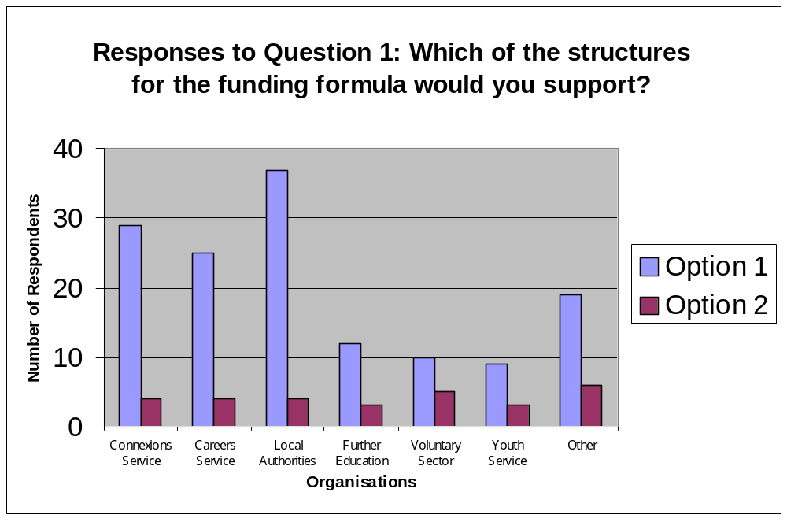
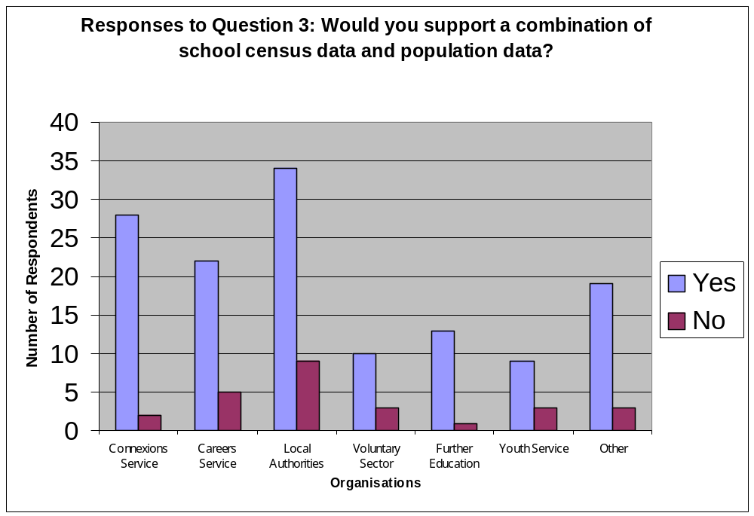

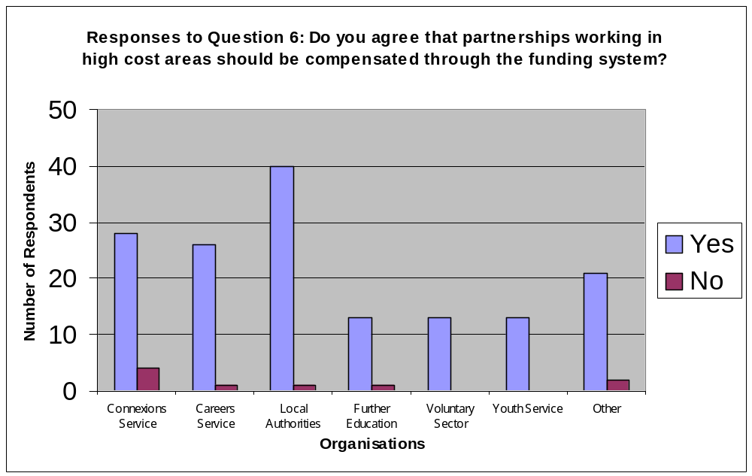

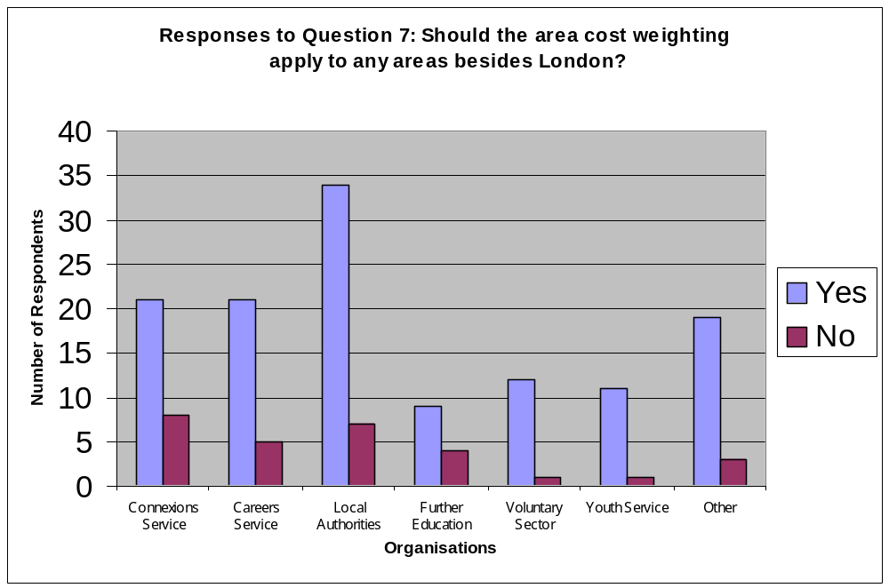

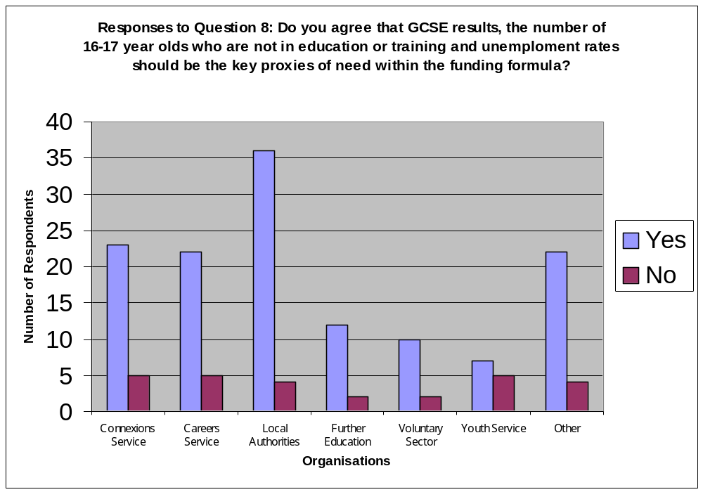

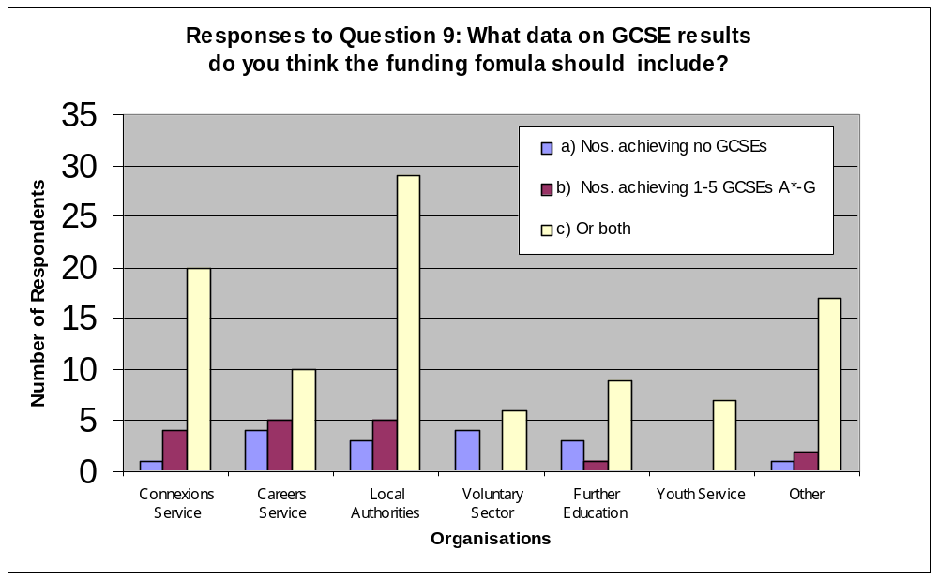

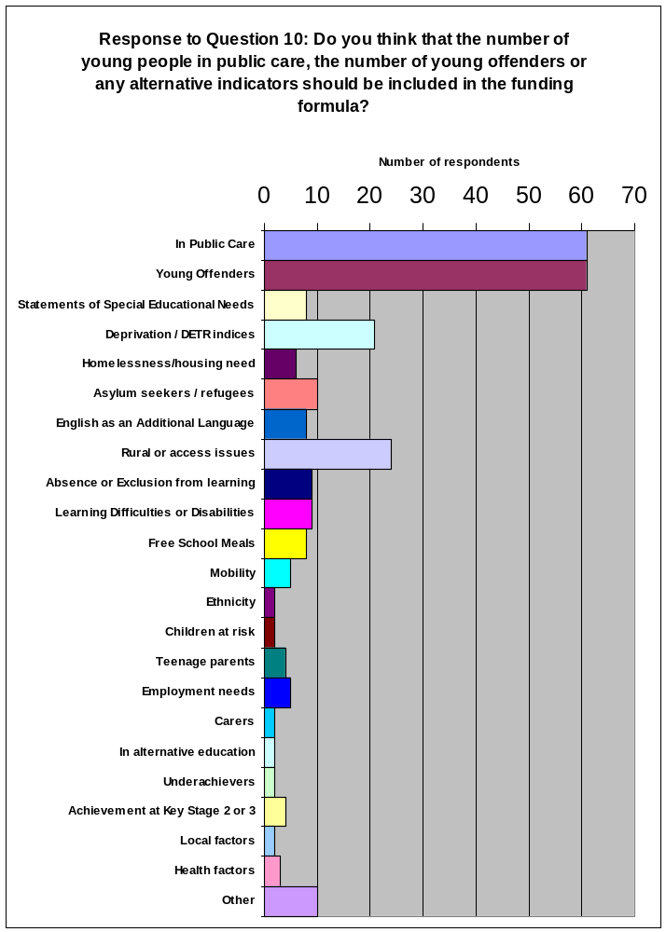

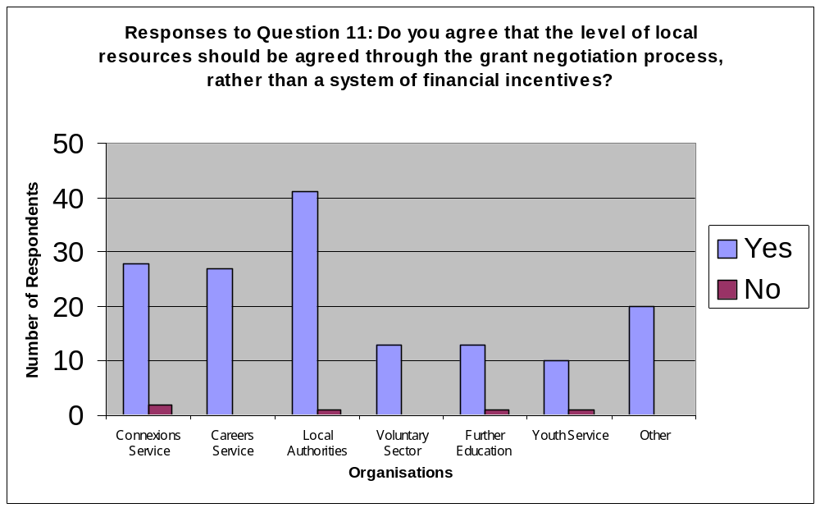
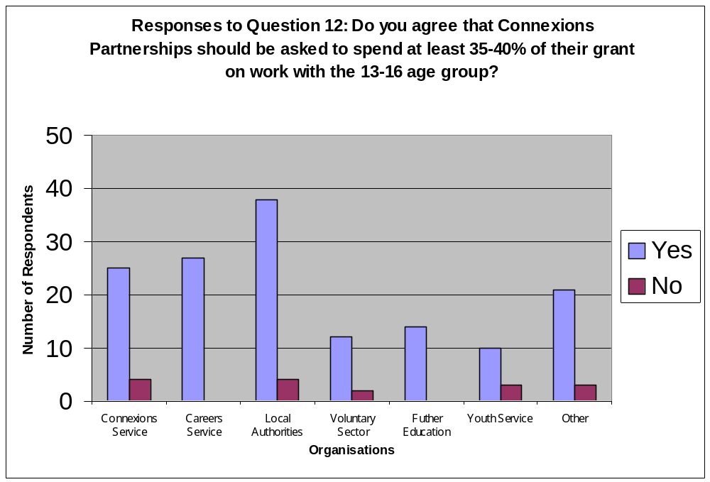

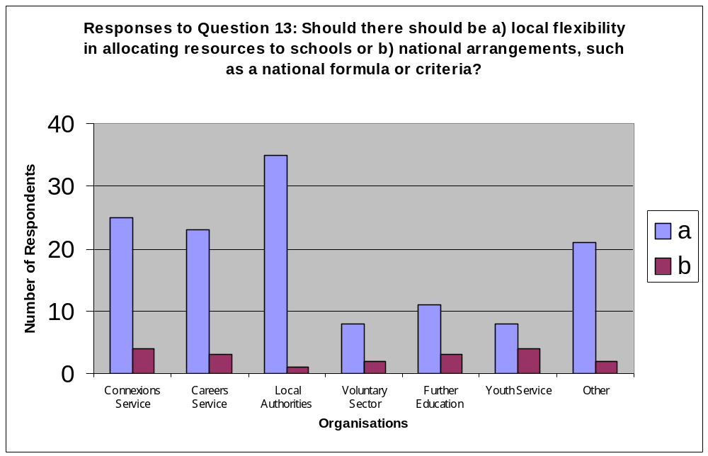

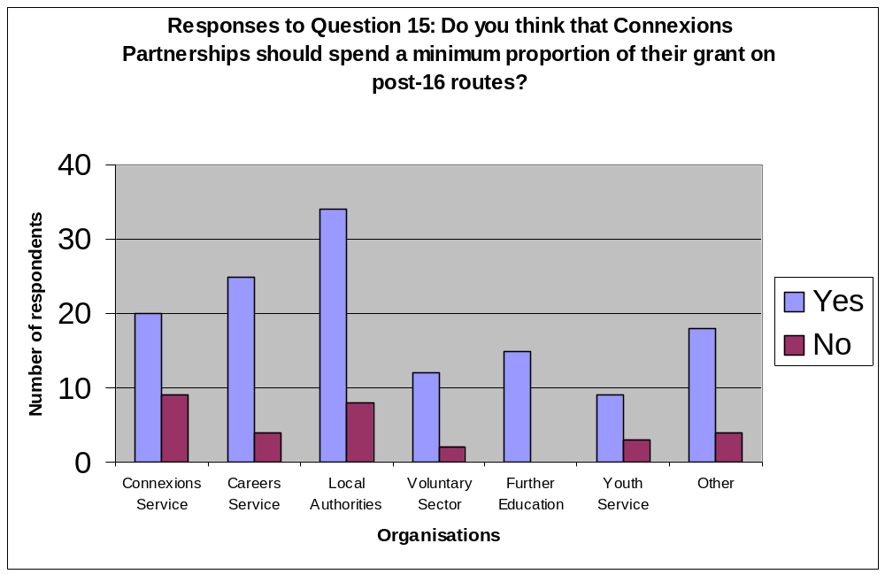

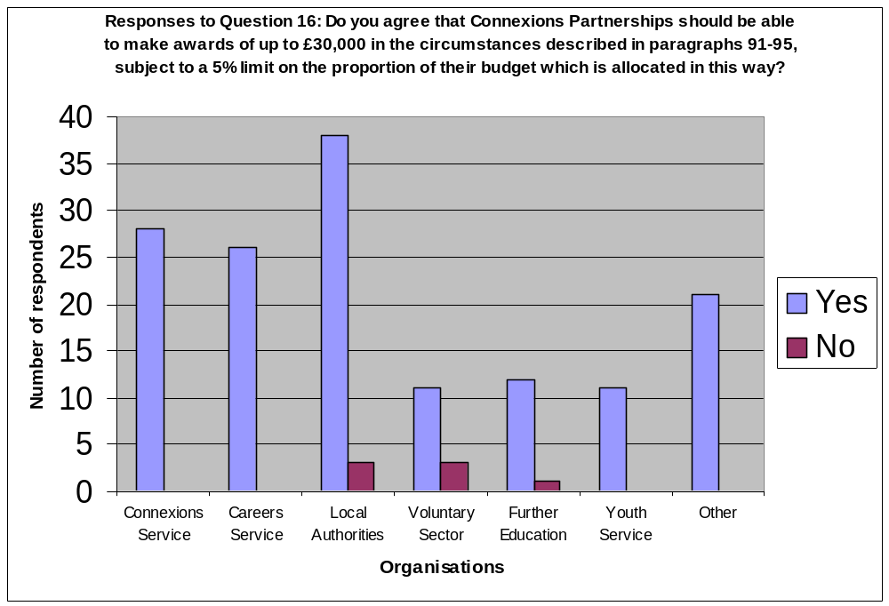

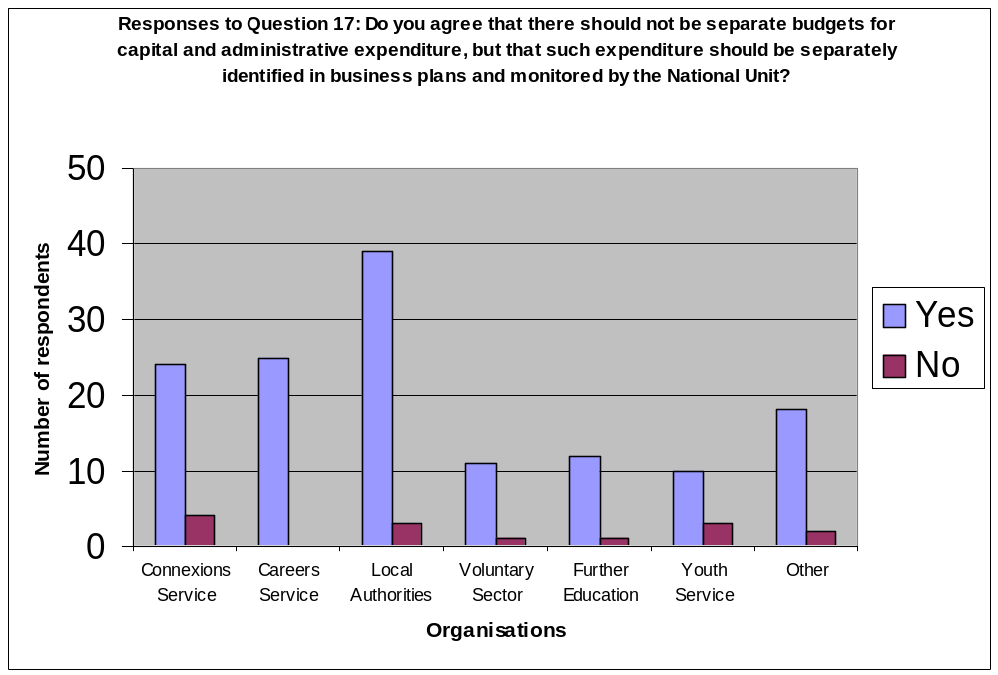

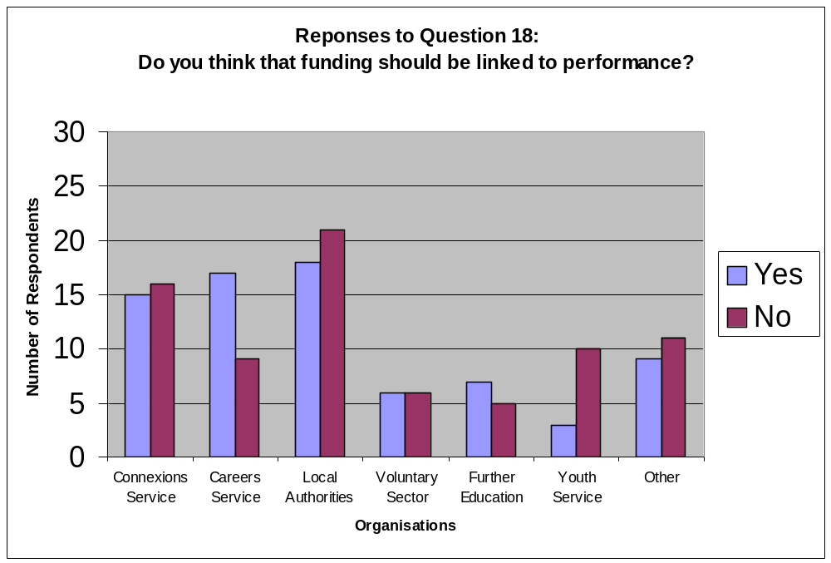
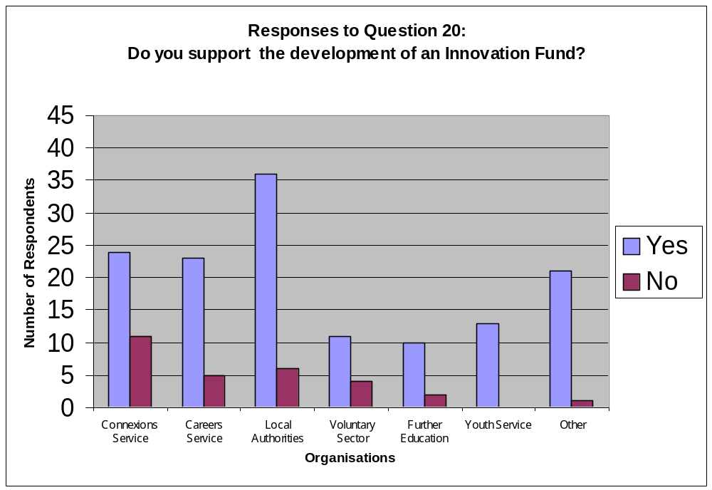

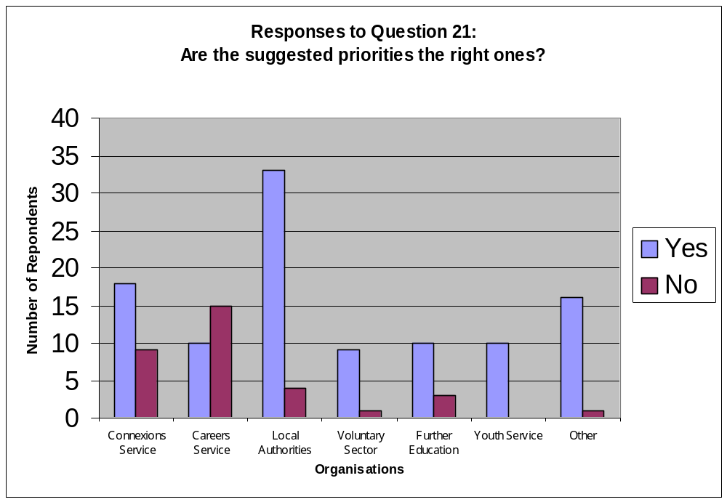
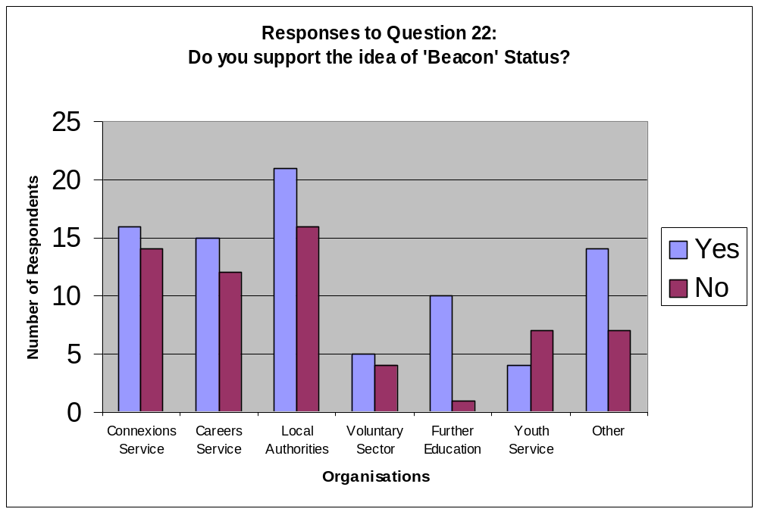

For example, a small minority thought that the two elements of Option 1 would represent the funding that they would be able to spend on a “universal” and a “targeted” service. A few respondents also thought that the three “tiers” in Option 2 would determine how much money could be spent on work with young people with different levels of need. In fact, the funding formula is intended to ensure that each Partnership receives a fair share of the available funding, based on the needs of young people in its area. Once each Partnership receives its allocation, it will determine how to spend it locally, to provide a service that meets the needs of each individual young person.
In fact, both options would be based on nationally available data that is collected on a consistent basis.
This table gives a detailed analysis of the comments received in response to Question 2 . The figures in Annex 1 for Question 3 relate only to the number of respondents who answered Yes or No to Question 3. The figures are different because some respondents who proposed a specific source of data for Question 2 also said they would be prepared to support the combination in question 3.
This figure includes those who wanted to allocate 50% or more on this basis. It therefore includes the 18 respondents who wanted at least 60% of the funding allocated on numbers of young people.
This figure includes the 85 respondents who want at least 50% allocated on this basis, plus the 14 who supported a range of either 40-50 or 30-50 being allocated on this basis.
This figure includes those who supported 60% or more, or who supported a range which included 60%.
This figure includes those who supported 70% or more, or who supported a range which included 70%.
Rather, partners are being asked to identify the existing resources that are devoted to youth support and guidance activities at local level, and to say which of these resources will also help to achieve the goals of the Connexions Service. For example, a youth worker employed by a Local Authority may already be performing all or part of the Personal Adviser role. In this case, it may be appropriate for the youth worker to undertake the appropriate training and be called a Connexions Personal Adviser, working as part of the Connexions Service locally. The youth worker could still be employed by the Local Authority.
The consultation paper stated that Connexions Partnerships would contract directly with delivery organisations. As a result, funding from the National Unit would not pass directly to LMCs, although the consultation paper did not preclude LMCs from being given a notional budget allocation or taking the lead in decisions about the provision that should be available in their area.

