|  |  |
| --- | --- |
| **Official Statistics Release** | |
| Policy area: | Children’s homes inspections and outcomes |
| Theme: | Education, children’s services and skills |
| Published on: | 27 June 2013 |
| Coverage: | England |
| Period covered: | 1 January 2013 to 31 March 2013 |
| Status: | **PROVISIONAL** |
| Issued by: | Office for Standards in Education, Children’s Services and Skills (Ofsted) Aviation House 125 Kingsway  London WC2B 6SE |
|
|
|
| Responsible director: | Richard Brooks |
| Statistician: | Adam King |
| Public enquiries: | [enquiries@ofsted.gov.uk](mailto:enquiries@ofsted.gov.uk) |
| Press enquiries: | [pressenquiries@ofsted.gov.uk](mailto:pressenquiries@ofsted.gov.uk) |
| Link to official statistics release web page: | [www.ofsted.gov.uk/resources/official-statistics-childrens-social-care-inspections-and-outcomes](http://www.ofsted.gov.uk/resources/official-statistics-childrens-social-care-inspections-and-outcomes) |
| Publication medium: | Ofsted website |
| Publication frequency: | Quarterly |
| Next publication date: | Autumn 2013 |

Contents

Introduction………………………………………………………………………………………………………………………….4

Key findings………………………………………………………………………………………………………………………….4

Methodology…………………………………………………………………………………………………………………………7

Chart 1: Overall effectiveness of children’s homes inspected between 1 April 2007 and 31 March 2013, by financial year (provisional)……………….………………………………………….……………………………9

Chart 2: Overall effectiveness of children’s homes inspected between 1 April 2007 and 31 March 2013, by quarter (provisional)……………………………………………………….....………………………………….10

# Chart 3: Overall effectiveness of local authority run children's homes inspected between 1 April 2011 and 31 March 2013, by quarter (provisional)…….……………………………………………………………11

# Chart 4: Overall effectiveness of private and voluntary run children's homes inspected between 1 April 2011 and 31 March 2013, by quarter (provisional)..…………………………………………………………11

Chart 5: Progress judgement of all children's homes at interim inspection between 1 April 2011 and 31 March 2013, by quarter (provisional)…………………………………………………………………………………12

Table 1: Number of children’s homes inspections carried out between 1 January 2013 and 31 March 2013, by inspection type (provisional).……………....………………………………………………………………...13

Table 2: Overall effectiveness of children’s homes at full inspections between 1 January 2013 and 31 March 2013 (provisional)……..………………………………………………………..…………….....................14

Table 3a: Full inspection outcomes of children's homes (excluding secure children’s homes and residential special schools caring for pupils for more than 295 days per year) inspected between 1 January 2013 and 31 March 2013 (provisional)……..…………………………………………..…………………..15

Table 3b: Full inspection outcomes of secure children’s homes inspected between 1 January 2013 and 31 March 2013 (provisional)…….……………………………………………………………………………..........16

Table 3c: Full inspection outcomes of residential special schools caring for pupils for more than 295 days per year inspected between 1 January 2013 and 31 March 2013 (provisional)…….……..……..17

Table 3d: Interim inspection outcomes of all children’s homes inspected between 1 January 2013 and 31 March 2013 provisional)……..………………………………………………………………………...............18

Map 1: Children's homes receiving a good or better overall effectiveness grade at full inspection, by Region, since 1 April 2012 (provisional)…………………………………….…………………….……………..……..19

Map 2: Children's homes receiving an adequate or lower overall effectiveness grade at full inspection, by Region, since 1 April 2012 (provisional)……………………………………...…………..….…...20

Map 3: Local authority-run children's homes receiving a good or better overall effectiveness grade at full inspection, by Region, since 1 April 2012 (provisional).………………………………………………....21

Map 4: Private and voluntary -run children's homes receiving a good or better overall effectiveness grade at full inspection, by Region, since 1 April 2012 (provisional)……………………………...………….21

Map 5: Local authority-run children's homes receiving an adequate or lower overall effectiveness grade at full inspection, by Region, since 1 April 2012 (provisional)……………………………………..…..22

Map 6: Private and voluntary-run children's homes receiving an adequate or lower overall effectiveness grade at full inspection, by Region, since 1 April 2012 (provisional)……………..……….22

Glossary ....…………………………………………….…………………………………………………………………………..23

Introduction

This official statistics release reports on children’s homes inspections that occurred between 1 January 2013 and 31 March 2013 under the Care Standards Act 2000. These statistics are based on provisional data and are subject to change.

**Key findings**

**Inspections and outcomes of children’s homes** **full inspections**

* The period 1 January 2013 and 31 March 2013 is the fourth quarter since the introduction of the revised Ofsted framework for inspection of children’s homes.[1] Provisional statistics indicate there were 50 full inspections of children’s homes during this period. (Table 1)
* Of the 50 homes inspected, 2 (4%) were outstanding for their *Overall effectiveness*; 29 (58%) were good, 15 (30%) were adequate and 4 (8%) were inadequate. Fifty inspections is a relatively small number of inspections and as such no strong inference should be drawn to the quality of children’s homes as a whole, based on this quarter’s data alone. (Table 2)
* The percentage of homes receiving a good or better *Overall effectiveness* judgement in the quarter was lower than in previous quarters, which is a similar pattern to last year. Like last year, this might in part, be due to the fact that a significant number of homes (almost one third) were receiving their first full inspection since registering.
* Between the introduction of the revised children’s homes inspection framework on 1 April 2012 and 31 March 2013 (2012-13), 16% of homes received an outstanding *Overall effectiveness* grade. This compares to 26% in the first year after the introduction of the children’s homes inspection framework in April 2011 (2011-12).[2] (Chart 2)
* Five per cent of homes have received an inadequate *Overall effectiveness* grade in 2012-13. This is an increase of three percentage points, from 2% in 2011-12. (Chart 2)

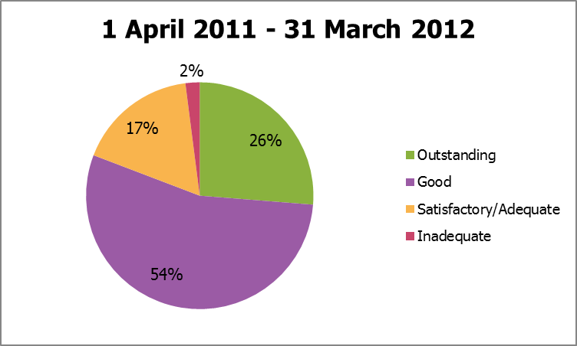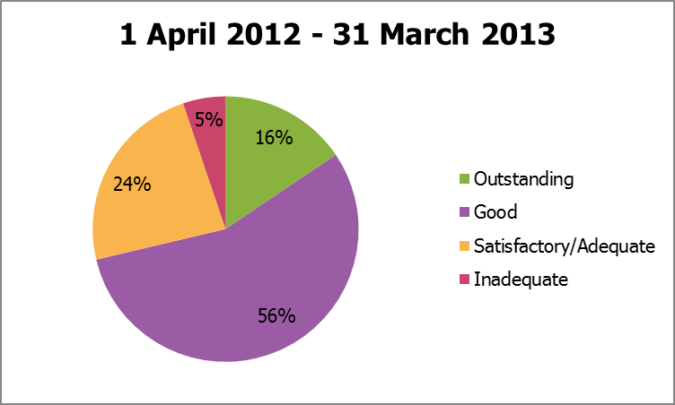

* In 2012-13, there were 48 homes that were judged inadequate for *Overall effectiveness*  that were judged good or better at their previous full inspection. Forty three of these declined from good and five from outstanding. There were six homes that improved from inadequate at their previous full inspection to good at their latest full inspection in 2012-13.
* The regions with the highest percentage of good or better *Overall effectiveness* grades were the South East (77%) and West Midlands (75%). In contrast, in London, 57% received an *Overall effectiveness* grade of good or better. The national percentage of good or better homes is 71%. (Map 1)
* In 2012-13, in local authorities where at least five homes have been inspected; the authorities with the lowest proportion of good or better *Overall effectiveness* inspection grades each had 25% or less of homes receive a good or better grade. These authorities were Haringey (14%), Sandwell (18%), Bracknell Forest (20%), Luton (20%) and Bournemouth (25%). These are inspections of all homes, not just those run by the local authority. (Table 4)

**Sector data**

* In England, 74% of children’s homes are run by private or voluntary providers and 26% are run by local authorities. A slightly larger proportion of local authority-run homes than private and voluntary-run homes received a good or better *Overall effectiveness* grade (74% compared to 70%), in 2012-13.[3] (Maps 3 + 4)
* In 2012-13, 17% of local authority-run homes received an outstanding grade for *Overall effectiveness*, which is a decrease from 28% in 2011-12. In the same period, 4% were given an inadequate grade, an increase from 2% in 2011-12. (Chart 3)
* A similar change occurred for private and voluntary homes; 15% were given an outstanding grade for *Overall effectiveness* in 2012-13, a decrease from 25% in 2011-12. In the same period 6% were given an inadequate grade, an increase from 2% in 2011-12. (Chart 4)
* In individual local authority areas, where at least five local authority run-homes have been inspected in 2012-13, there were wide variations in the number who received good or better *Overall effectiveness* grades. In 13 authorities (Bradford, Devon, Durham, East Sussex, Leicester City, Lincolnshire, North Yorkshire, Sheffield, Stoke-on-Trent, Walsall, Warrington, West Sussex and Worcestershire), all local authority-run homes inspected were good or better. The authorities with the lowest proportion of good or better inspection grades each had one third or less of their homes receive a good or better grade. These authorities were Essex (17%), Sunderland (17%), Derby City (29%), Cumbria (33%) and Somerset (33%). (Table 4)
* The sectorial picture, when grouped by regions, varies widely across the country. In two regions, in 2012-13, the proportion of homes receiving a good or better *Overall effectiveness* grade was 19 percentage points higher among local authority-run homes than private and voluntary sector-run homes: North East (78% and 59%, respectively) and London (71% and 52%, respectively). In contrast, there are two regions where the proportion of private and voluntary-run homes receiving good or better grades is approximately 10 percentage points higher than local authority-run homes: East of England (73% and 62% respectively) and South West (69% and 59% respectively). (Maps 3 + 4)

**Interim inspections**

* There were more interim inspections carried out on all types of children’s homes between January and March 2013 (1,161) compared to the previous quarter (410). Of these 1,161 interim inspections, 735 (63%) made good progress and 305 (26%) made satisfactory progress. However, 101 (9%) made inadequate progress. Twenty (2%) did not receive an inspection outcome as children were not accommodated in the children’s home at the time of inspection. (Table 3d)
* In 2012-13 there were 1,729 interim inspections. Of These 1,729 interim inspections, 1,009 (58%) made good progress and 495 (29%) made satisfactory progress. However, 163 (9%) made inadequate progress. Sixty two (4%) did not receive an inspection outcome as children were not accommodated in the children’s home at the time of inspection.
* In 2012-13 there were 1,561 homes that received an interim inspection after their full inspection earlier in the year. Of the 236 homes that received an outstanding *Overall effectiveness* grade at their full inspection, 80% received a good progress interim inspection judgement and 3% received an inadequate progress judgement. Of the 70 homes that received an inadequate *Overall effectiveness* grade at their full inspection, 43% received a good progress interim inspection judgement, 40% received a satisfactory progress judgement and 17% received an inadequate progress judgement.

**Impact of revisions on key findings of previous release**

* Final data covering the period 1 October 2012 to 31 December 2012 have been released and can be found on the Ofsted website: [www.ofsted.gov.uk/resources/official-statistics-childrens-social-care-inspections-and-outcomes](http://www.ofsted.gov.uk/resources/official-statistics-childrens-social-care-inspections-and-outcomes).
* The revision of statistics relating to the 1 October 2012 to 31 December 2012 quarter from ‘provisional’ to ‘final’ status includes outcomes relating to a further 59 inspections. These consist of an additional 36 full and 23 interim inspections of children’s homes, which took place in this period and have been published since 31 January 2013.

* The main changes to the key findings of the previous release are listed below.
* An additional 23 children’s homes received good or better *Overall effectiveness* grade at their full inspection and an additional 13 received adequate or lower. These additional inspections mean only a very small change to the grade profile presented in the previous provisional data.

# Methodology

The data in the release are from inspections undertaken between 1 January 2013 and 31 March 2013.

Statistics relating to inspections in the most recent quarter are provisional and include inspections in the period where the inspection report was published within one month of the end of the quarter. If an inspection report is published later than one month, and less than four months, after the end of the quarter in which the inspection took place, that inspection will be included in the final release of the statistics.

Inspections and outcomes of provider settings that are not currently active are included in this statistical release and are reflected in the underlying data within the comma separated values (csv) and Excel files as ‘resigned’. Revisions are published in line with Ofsted’s revisions policy for official statistics. For more information about the policy, please visit the Ofsted website or access the policy via the following link: <http://www.ofsted.gov.uk/resources/statistical-notice-ofsted-revisions-policy-for-official-statistics>.

For more information on how Ofsted regulates and inspects children’s social care, please go to the Ofsted website: <http://www.ofsted.gov.uk/children-and-families-services>. In its inspection of social care services, Ofsted must take account of national minimum standards published by government.

This release includes sector data. Sector data are the ownership type for each home (local authority, private, voluntary and health authority). Ofsted’s data are currently grouped into a single private and voluntary category for reporting purposes. Additional information is being collected to enable a more nuanced sectorial split in future releases.

In releases of the data prior to September 2012, Ofsted separated out residential special schools that care for pupils for more than 295 days a year, from the other types of children’s homes in charts 1 and 2. From the September 2012 release onwards all three types of children’s homes have been included in charts 1 and 2. We have also revised the data for 1 April 2011 onwards to include all three types of homes. This means that the data in charts 1 and 2, relating to the period 1 April 2011 onwards, in releases from September 2012 onwards, will not match the data shown in charts 1 and 2 in releases prior to September 2012.

The revised inspection framework for children’s homes which began on 1 April 2012 includes a change of name of one of the grades. The judgement ‘adequate’ has replaced the previous judgement of ‘satisfactory’. Where previously a home could receive outstanding, good, satisfactory or inadequate grades, they can now receive outstanding, good, adequate or inadequate.

**Additional information**

All the tables and charts shown in this release, along with additional analysis at regional and local authority level, are available in Excel format on the Ofsted website in the same location as this document. Underlying data are also available in Excel and csv formats.

# Chart 1: Overall effectiveness of all children's homes inspected between 1 April 2007 and 31 March 2013, by financial year (provisional)1 2

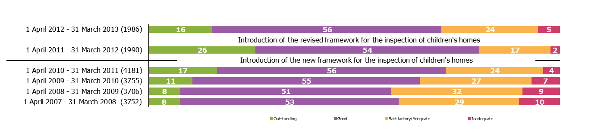

*Source: Ofsted Inspections*

1. Percentages are rounded and may not add to exactly 100.

2. Inspections since the inspection framework change on 1 April 2011 include only full inspections, inspections prior to 1 April 2011 include both interim and full inspection.

Chart 2: Overall effectiveness of all children's homes inspected between 1 April 2007 and 31 March 2013, by quarter (provisional)1 2

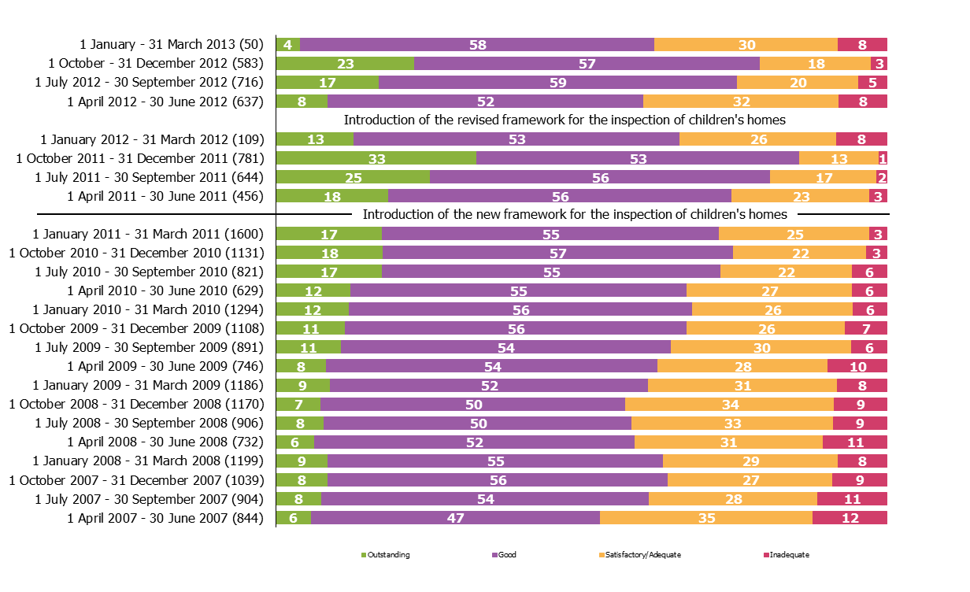

*Source: Ofsted inspections*

1. Percentages are rounded and may not add to exactly 100.

2. Inspections since the inspection framework change on 1 April 2011 include only full inspections, inspections prior to 1 April 2011 include both interim and full inspection.

|  |
| --- |
| **Chart 3: Overall effectiveness of local authority run children's homes inspected between 1 April 2011 and 31 March 2013, by quarter (provisional)1 2** |
|
|

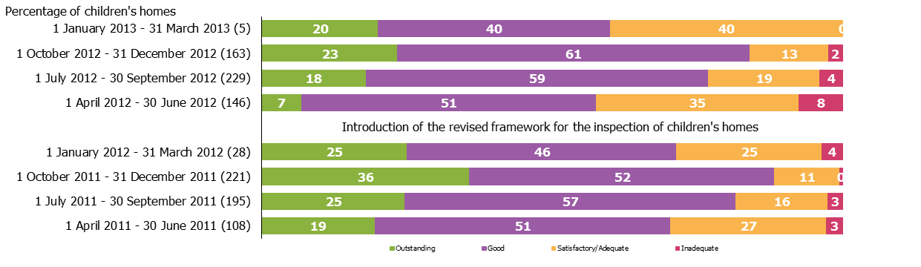

*Source: Ofsted inspections*

1. Percentages are rounded and may not add to exactly 100.

2. Local authority data include a small number of homes run by health authorities.

|  |
| --- |
| **Chart 4: Overall effectiveness of private and voluntary run children's homes inspected between 1 April 2011 and 31 March 2013, by quarter (provisional)1** |
|
|

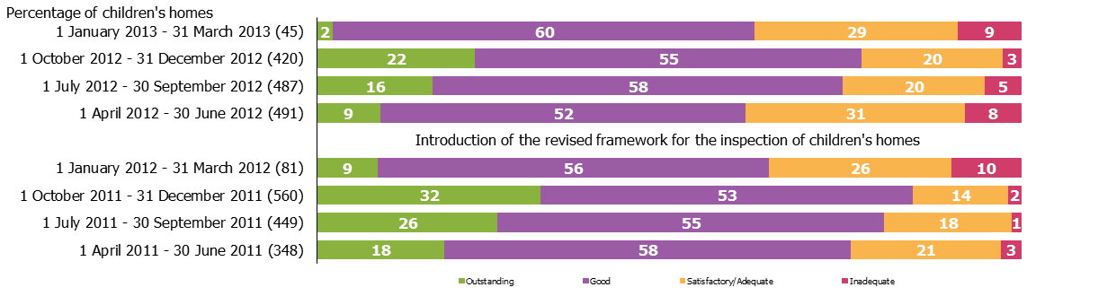

*Source: Ofsted inspections*

1. Percentages are rounded and may not add to exactly 100.

**Chart 5: Progress judgement of all children's homes at interim inspection between 1 April 2011 and 31 March 2013, by quarter (provisional)1**

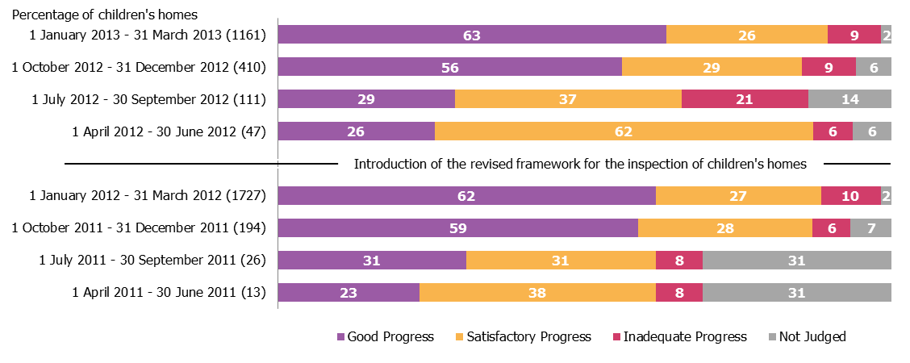

*Source: Ofsted inspections*

1. Percentages are rounded and may not add to exactly 100.

2. At an interim inspection, progress is judged based on requirements and recommendations made following the last full inspection.

**Table 1: Number of children's homes inspections carried out between 1 January - 31 March 2013, by inspection type (provisional)¹ ²**



1. The 'all' figures include all homes, of all ownership type, in the local authority area. Local authority run homes data include a small number of homes run by health authorities.

2. Residential special schools that care for pupils for more than 295 days per year must register as children’s homes.

# Table 2: Overall effectiveness of children's homes at full inspections between 1 January - 31 March 2013 (provisional)¹ ²



# 1. The 'all' figures include all homes, of all ownership type, in the local authority area. Local authority run homes data include a small number of homes run by health authorities.

2. Residential special schools that care for pupils for more than 295 days per year must register as children’s homes.

**Table 3a: Full inspection outcomes of children's homes (excluding secure children's homes and residential special schools caring for pupils for more than 295 days a year) inspected between 1 January - 31 March 2013 (provisional)¹ ² ³**



1. The 'all' figures include all homes, of all ownership type, in the local authority area. Local authority run homes data include a small number of homes run by health authorities.

2. Percentages are rounded and may not add to exactly 100.

3. Residential special schools that care for pupils for more than 295 days per year must register as children’s homes and their inspection outcomes data can be found in table 3c.

# Table 3b: Full inspection outcomes of secure children's homes inspected between 1 January - 31 March 2013 (provisional)1 2 3



1. The 'all' figures include all homes, of all ownership type, in the local authority area. Local authority run homes data include a small number of homes run by health authorities.

2. Percentages are rounded and may not add to exactly 100.

3. Percentages should be treated with caution, where the number of inspections is low.

Table 3c: Full inspection outcomes of residential special schools caring for pupils for more than 295 days per year inspected between **1 January - 31 March 2013** (provisional)¹ ² ³



1. The 'all' figures include all homes, of all ownership type, in the local authority area. Local authority run homes data include a small number of homes run by health authorities.

2. Percentages are rounded and may not add to exactly 100.

3. Residential special schools that care for pupils for more than 295 days per year must register as children’s homes.

# Table 3d: Interim inspection outcomes of all children's homes inspected between 1 January - 31 March 2013 (provisional)¹ ² ³



1. The 'all' figures include all homes, of all ownership type, in the local authority area. Local authority run homes data include a small number of homes run by health authorities.

2. Percentages are rounded and may not add to exactly 100.

3. At an interim inspection, progress is judged based on requirements and recommendations made following the last full inspection.

4. Children’s homes not accommodating children at the time of their interim inspection received no judgement.

5. Residential special schools that care for pupils for more than 295 days per year must register as children’s homes.

**Map 1: Children's homes receiving a good or better overall effectiveness grade at full inspection, by Region, since 1 April 2012 (provisional)**



**Map 2: Children's homes receiving an adequate or lower overall effectiveness grade at full inspection, by Region, since 1 April 2012 (provisional)**



Map 3: Local authority run children's homes receiving a Map 4: Private and voluntary run children's homes receiving a

good or better overall effectiveness grade at full good or better overall effectiveness grade at full inspection,

inspection, by Region, since 1 April 2012 (provisional)1 by Region, since 1 April 2012 (provisional)



1. Local authority data include a small number of homes run by health authorities.

**Map 5**: Local authority run children's homes receiving an Map 6: Private and voluntary run children's homes receiving an

adequate or lower overall effectiveness grade at full adequate or lower overall effectiveness grade at full

inspection, by Region, since 1 April 2012 (provisional)1 inspection, by Region, since 1 April 2012 (provisional)



1. Local authority data include a small number of homes run by health authorities.

Glossary

**Children’s homes**

A children’s home is defined in section 1 of the Care Standards Act 2000, and is an establishment that provides care and accommodation wholly or mainly for children. Children’s homes vary in size and nature. They fulfil a range of purposes designed to meet the different needs of those children and young people who are assessed as needing a residential care placement. Some homes, for example, provide short breaks which are needed to help support children and their family. Some residential special schools are registered as children’s homes because boarders are resident for more than 295 days per year.

**Residential special schools**

Residential special schools are defined in section 59 of the Safeguarding Vulnerable Groups Act 2006. They vary in size and nature. The sector includes large non-maintained special schools which make provision for very specific needs and take children as full boarders from all over the country, to smaller more local providers catering for children with a range of different special needs and disabilities who may be resident at the school only during the week. Some residential special schools are registered as children’s homes because boarders are resident for more than 295 days per year. There are also a small number of independent residential special schools who also tend to cater for children with very specialist needs.

**Sector**

Sector refers to the type of provider that owns the children’s home.

*Local Authority*

These are public bodies responsible for the children’s home.

*Private*

These are for-profit organisations mostly with limited company status. These can also though be individually owned children’s homes and run for profit.

*Voluntary*

These are mostly not-for-profit organisations, mainly with charitable status. These can also be individually owned children’s homes and run on a not-for-profit basis.

*Health Authority*

These are NHS Trust-run.

**Secure children’s homes**

Secure children’s homes are defined by section 25 of the 1989 children act. They accommodate children and young people who are remanded or have been sentenced for committing a criminal offence. They also accommodate children and young people who are placed there by a court because their behaviour is deemed to present a significant and immediate threat to their safety or the safety of others, unless they are placed in a secure environment. Ofsted inspections are conducted in accordance with the Care Standards Act 2000 and judgements in reports are made in relation to the outcomes for children set out in the Children Act 2004. The criteria are the same as those used to inspect non-secure children’s homes.

© Crown copyright

You may re-use this information (not including logos) free of charge in any format or medium, under the terms of the Open Government Licence. To view this licence, visit [http://www.nationalarchives.gov.uk/doc/open-government-licence/](http://www.nationalarchives.gov.uk/doc/open%2Dgovernment%2Dlicence) or write to the Information Policy Team, The National Archives, Kew, London, TW9 4DU or e-mail: [psi@nationalarchives.gsi.gov.uk](mailto:psi@nationalarchives.gsi.gov.uk).

1. An amended inspection framework for children’s homes was introduced in April 2012. Details of the framework can be found at <http://www.ofsted.gov.uk/resources/inspection-of-childrens-homes-for-inspections-1-april-2012>.
2. Ofsted introduced a new inspection framework in April 2011. This was revised in April 2012. Although there were only a small number of changes these were significant and intended to make inspection more challenging. As such any comparisons between the two years need to be viewed in this context.
3. All data for local authority-run homes include those run by health authorities. Please refer to the glossary for more details on the different types of providers.