|  |  |
| --- | --- |
| **Official Statistics Release** | |
| Policy area: | Children’s homes inspections and outcomes |
| Theme: | Education, children’s services and skills |
| Published on: | 23 January 2014 |
| Coverage: | England |
| Period covered: | 1 July 2013 to 30 September 2013 |
| Status: | **PROVISIONAL** |
| Issued by: | Office for Standards in Education, Children’s Services and Skills (Ofsted) Aviation House 125 Kingsway  London WC2B 6SE |
|
|
|
| Statistician: | Adam King |
| Public enquiries: | [enquiries@ofsted.gov.uk](mailto:enquiries@ofsted.gov.uk) |
| Press enquiries: | [pressenquiries@ofsted.gov.uk](mailto:pressenquiries@ofsted.gov.uk) |
| Link to official statistics release web page: | [www.ofsted.gov.uk/resources/official-statistics-childrens-social-care-inspections-and-outcomes](http://www.ofsted.gov.uk/resources/official-statistics-childrens-social-care-inspections-and-outcomes) |
| Publication medium: | Ofsted website |
| Publication frequency: | Quarterly |
| Next publication date: | 27 March 2014 |

Contents

Introduction………………………………………………………………………………………………………………………….4

Key findings………………………………………………………………………………………………………………………….4

Methodology…………………………………………………………………………………………………………………………8

Chart 1: Overall effectiveness of children’s homes inspected between 1 April 2007 and 30 September 2013, by financial year (provisional)..……..………………………………….…………………………10

Chart 2: Overall effectiveness of children’s homes inspected between 1 April 2007 and 30 September 2013, by quarter (provisional)……………………………………….....………………………………….11

# Chart 3: Overall effectiveness of local authority run children's homes inspected between 1 April 2011 and 30 September 2013, by quarter (provisional)..…………………………………………………………12

# Chart 4: Overall effectiveness of private and voluntary run children's homes inspected between 1 April 2011 and 30 September 2013, by quarter (provisional)....…………..……………………………………12

Chart 5: Progress judgement of all children's homes at interim inspection between 1 April 2011 and 30 September 2013, by quarter (provisional)..…..……………………………………………………………………13

Table 1: Number of children’s homes inspections carried out between 1 July 2013 and 30 September 2013, by inspection type (provisional).……………....………………………………………………...14

Table 2: Overall effectiveness of children’s homes at full inspections between 1 July 2013 and 30 September 2013 (provisional)…..………………………………………………………..…………….....................15

Table 3a: Full inspection outcomes of children's homes (excluding secure children’s homes and residential special schools caring for pupils for more than 295 days per year) inspected between 1 July 2013 and 30 September 2013 (provisional)...…….……..………………………………..…………………..16

Table 3b: Full inspection outcomes of secure children’s homes inspected between 1 July 2013 and 30 September 2013 (provisional)….….…………………………………………………………………………..........17

Table 3c: Full inspection outcomes of residential special schools caring for pupils for more than 295 days per year inspected between 1 July 2013 and 30 September 2013 (provisional)……..…..……..18

Table 3d: Interim inspection outcomes of all children’s homes inspected between 1 July 2013 and 30 September 2013 provisional)……………….……………………………………………………………...............19

Map 1: Children's homes receiving a good or better overall effectiveness grade at full inspection, by Region, since 1 April 2013 (provisional)…………………………………….…………………….……………..……..20

Map 2: Children's homes receiving an adequate or lower overall effectiveness grade at full inspection, by Region, since 1 April 2013 (provisional)……………………………………...…………..….…...21

Map 3: Local authority-run children's homes receiving a good or better overall effectiveness grade at full inspection, by Region, since 1 April 2013 (provisional).………………………………………………....22

Map 4: Private and voluntary -run children's homes receiving a good or better overall effectiveness grade at full inspection, by Region, since 1 April 2013 (provisional)……………………………...………….22

Map 5: Local authority-run children's homes receiving an adequate or lower overall effectiveness grade at full inspection, by Region, since 1 April 2013 (provisional)……………………………………..…..23

Map 6: Private and voluntary-run children's homes receiving an adequate or lower overall effectiveness grade at full inspection, by Region, since 1 April 2013 (provisional)……………..……….23

Glossary ....…………………………………………….…………………………………………………………………………..24

Introduction

This official statistics release reports on children’s homes inspections that occurred between 1 July 2013 and 30 September 2013 under the Care Standards Act 2000. These statistics are based on provisional data and are subject to change.

**Key findings**

**Inspections and outcomes of children’s homes** **full inspections**

* Provisional statistics indicate there were 491 full inspections of children’s homes during this period. The 479[1] children’s homes inspected equated to 23% of the 2,063 children’s homes active at 30 June 2013 and accounted for 24% (or approximately 2,775 places) of the total national children’s homes capacity. (Table 1)
* Of the 491 inspections, 56 (11%) were outstanding for their *Overall effectiveness*; 281 (57%) were good, 115 (23%) were adequate and 39 (8%) were inadequate. (Table 2)
* Between 1 April 2013 and 30 September 2013, 66% of homes received a good or better *Overall effectiveness* grade, this was a slight decrease from the same period of the previous year (68%). Also in the period, 7% of homes have received an inadequate *Overall effectiveness* grade which was a slight increase from the same period of the previous year (6%). Ofsted use a proportionate risk approach when scheduling children’s homes inspections, which makes a comparison between the same periods of 2012 and 2013 the best comparator.[2] (Chart 2)

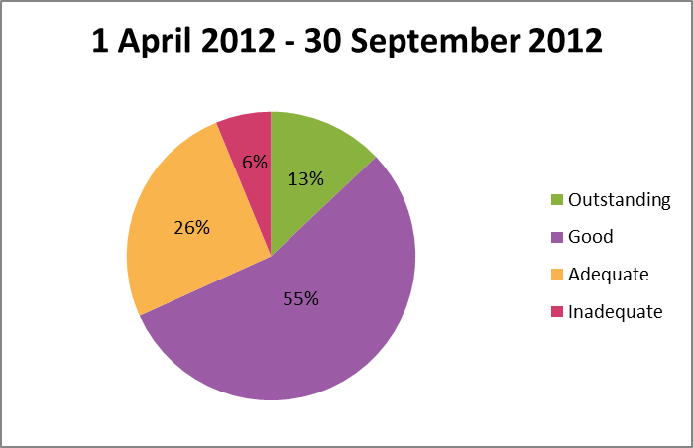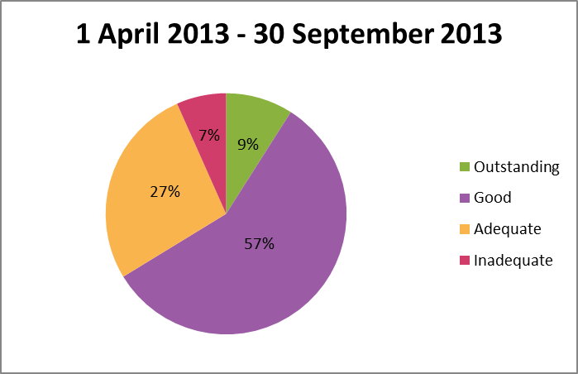

Total number of inspections = 1,353 Total number of insepctions: = 1,109

* When comparing the *Overall effectiveness* inspection grades of the 935 homes who received a full inspection since 1 April 2013, to their previous full inspection grade from 2012-13; 53 (95%) of the 56 previously judged inadequate improved and 148 (54%) of the 275 previously graded adequate improved and 16 (6%) declined. Conversely 49 (51%) of the 96 previously graded outstanding declined in grade and 114 (22%) of the 508 previously graded good declined and 40 (8%) improved. An additional 139 homes were inspected in the period which had not received a full inspection in 2012-13.[3]

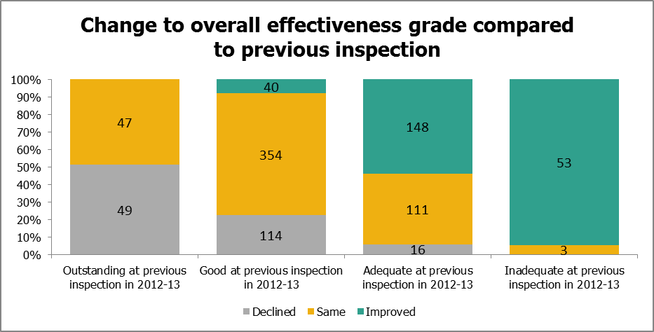

* In the period, there were 17 homes that were judged inadequate for *Overall effectiveness* that had been judged good or better at their previous full inspection. Sixteen of these declined from good. There were 16 homes that improved from inadequate at their previous full inspection to good.
* Of the 604 homes rated good or better in 2012-13 and re-inspected since then, 127 (21%) are now rated adequate or inadequate. The East Midlands, West Midlands and East of England are the areas of the country where this decline is most prominent with comparative rates of 33%, 24%, and 39% respectively. The lowest rates of good or better homes declining to adequate or lower were found in the North East (12%) and London (13%). Looking at this grade change in local authorities, Norfolk has the most homes that declined in this way, 53% (eight out of 15 homes re-inspected), and Hampshire and Stockport have the least with 0% (out of 17 and 12 homes respectively).

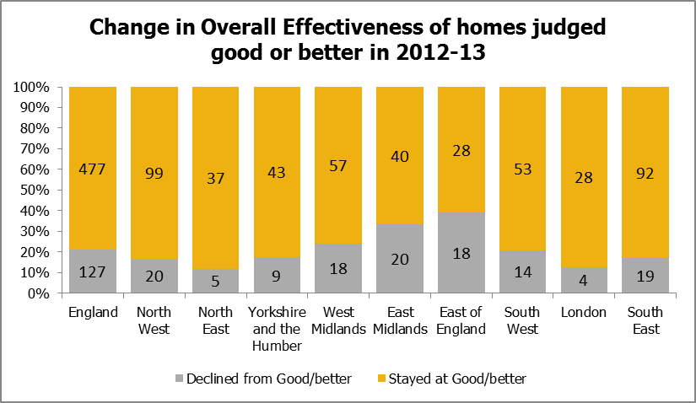

* Conversely, of the 331 homes rated adequate or lower in 2012-13 and re-inspected since then, 164 (50%) are now rated good or better. The North East, North West, and Yorkshire and the Humber showed the most marked improvement with comparative rates of 57%, 58%, and 60% respectively. The lowest rates of improvement were found in the West Midlands and South East (33% and 38 % respectively). Looking at this grade change in local authorities, St Helens had the most homes that improved in this way with 100% (out of seven homes) then Leeds with 90% (nine out of 10 homes). Sandwell had the least with 13% (one out of eight homes).

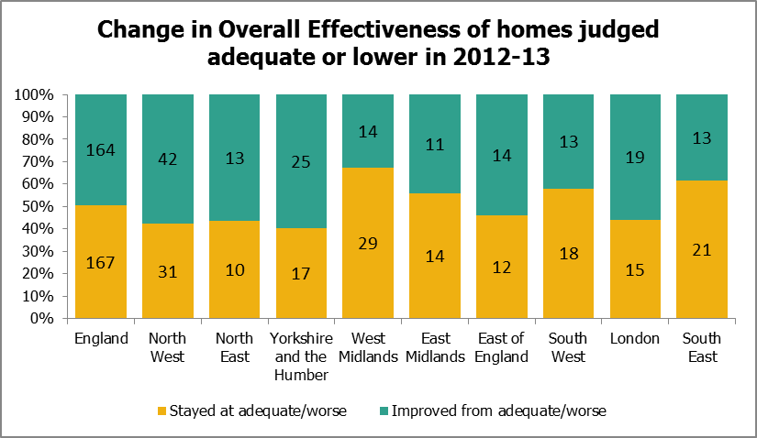

* The regions with the highest percentage of good or better *Overall effectiveness* grades since 1 April 2013 were the North West (73%), North East (72%), South East (71%), and Yorkshire and the Humber (70%). The regions with the lowest percentage were the East Midlands (57%), West Midlands (58%), and East of England (59%). The national figure of good or better homes was 66%. (Map 1)

**Sector data**

* Between 1 April 2013 and 30 September 2013, a slightly smaller proportion of private-run homes than local authority or voluntary-run homes received a good or better *Overall effectiveness* grade (65%, compared to 68% and 69% respectively).[4]
* In the period, local authority-run homes received a higher percentage (11%) of outstanding grades for *Overall effectiveness* than private-run homes (9%) and voluntary-run homes (7%).
* With regards to inadequate *Overall effectiveness* grades, private-run homes received the highest proportion (8%), compared to local authority-run homes (5%) and voluntary-run homes (1%).
* The sectorial picture, when grouped by regions, varies widely across the country. In two regions, between 1 April 2013 and 30 September 2013, the proportion of homes receiving a good or better *Overall effectiveness* grade was 20 percentage points, or more, higher among local authority-run homes than private and voluntary-run homes: East of England (74% and 54%, respectively) and London (85% and 59%, respectively). In contrast, the proportion of private and voluntary-run homes receiving good or better grades is 16 percentage points higher than local authority-run homes in the South West and 19 percentage points higher in the South East. (Maps 3 + 4)

**Interim inspections**

* Between 1 July 2013 and 30 September 2013, there were 55 interim inspections. Of these 55, 15 (27%) made good progress and 12 (22%) made satisfactory progress. However, 15 (27%) made inadequate progress. Thirteen (24%) did not receive an inspection outcome as children were not accommodated in the children’s home at the time of inspection. (Table 3d)

**Impact of revisions on key findings of previous release**

* Final data covering the period 1 April 2013 to 30 June 2013 have been released and can be found on the Ofsted website: [www.ofsted.gov.uk/resources/official-statistics-childrens-social-care-inspections-and-outcomes](http://www.ofsted.gov.uk/resources/official-statistics-childrens-social-care-inspections-and-outcomes).
* The revision of statistics relating to the 1 April 2013 to 30 June 2013 quarter from ‘provisional’ to ‘final’ status includes outcomes relating to a further 200 inspections. These consist of an additional 199 full inspections and one interim inspection of children’s homes, which took place in this period and have been published since 31 July 2013.
* An additional 127 children’s homes received good or better *Overall effectiveness* grade at their full inspection and an additional 72 received adequate or lower. These additional inspections mean only a very small change to the grade profile presented in the previous provisional data.

# 

# Methodology

The data in the release are from inspections undertaken between 1 July 2013 and 30 September 2013.

Statistics relating to inspections in the most recent quarter are provisional and include inspections in the period where the inspection report was published within one month of the end of the quarter. If an inspection report is published later than one month, and less than four months, after the end of the quarter in which the inspection took place, that inspection will be included in the final release of the statistics.

Inspections and outcomes of provider settings that are not currently active are included in this statistical release and are reflected in the underlying data within the comma separated values (csv) and Excel files as ‘resigned’.

Revisions are published in line with Ofsted’s revisions policy for official statistics. For more information about the policy, please visit the Ofsted website or access the policy via the following link: <http://www.ofsted.gov.uk/resources/statistical-notice-ofsted-revisions-policy-for-official-statistics>.

For more information on how Ofsted regulates and inspects children’s social care, please go to the Ofsted website: <http://www.ofsted.gov.uk/children-and-families-services>. In its inspection of social care services, Ofsted must take account of national minimum standards published by government.

This release includes sector data. Sector data are the ownership type for each home (local authority, private, voluntary and health authority). Ofsted’s data are disaggregated into separate private and voluntary categories in the tables.

The revised inspection framework for children’s homes which began on 1 April 2012 includes a change of name of one of the grades. The judgement ‘adequate’ has replaced the previous judgement of ‘satisfactory’. Where previously a home could receive outstanding, good, satisfactory or inadequate grades, they can now receive outstanding, good, adequate or inadequate.

On 10 July 2013 Ofsted re-published the inspection framework and evaluation schedule for children’s homes. The changes implemented were:

* Where a home is judged inadequate for overall effectiveness, the home will not have an interim inspection to check on progress; instead it will have a full inspection within six to eight weeks. If, at the second full inspection, the home is judged inadequate for *Overall effectiveness*, Ofsted will seek to take robust action including action to cancel registration.
* Where there is a failure to have a registered manager for more than 26 weeks, it will lead to an inadequate judgement for leadership and management. That leadership judgement, being a limiting judgement of overall inadequacy.

**Additional information**

All the tables and charts shown in this release, along with additional analysis at regional and local authority level, are available in Excel format on the Ofsted website in the same location as this document. Underlying data are also available in Excel and csv formats.

# Chart 1: Overall effectiveness of all children's homes inspected between 1 April 2007 and 30 September 2013, by financial year (provisional)1 2

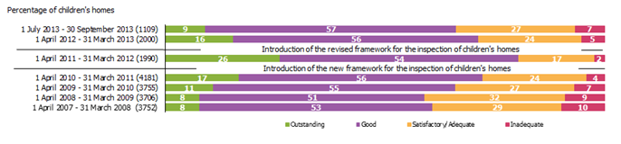

*Source: Ofsted Inspections*

1. Percentages are rounded and may not add to exactly 100.

2. Inspections since the inspection framework change on 1 April 2011 include only full inspections, inspections prior to 1 April 2011 include both interim and full inspection.

Chart 2: Overall effectiveness of all children's homes inspected between 1 April 2007 and 30 September 2013, by quarter (provisional)1 2

*Source: Ofsted inspections*

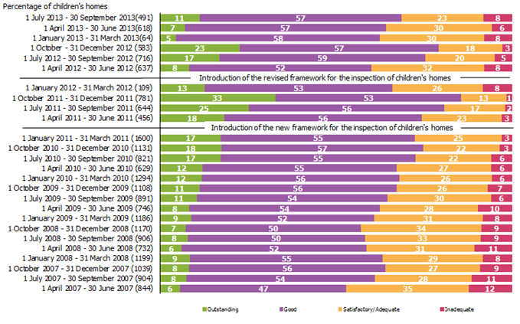

1. Percentages are rounded and may not add to exactly 100.

2. Inspections since the inspection framework change on 1 April 2011 include only full inspections, inspections prior to 1 April 2011 include both interim and full inspection.

|  |
| --- |
| **Chart 3: Overall effectiveness of local authority run children's homes inspected between 1 April 2011 and** 30 September **2013, by quarter (provisional)1 2** |
|
|

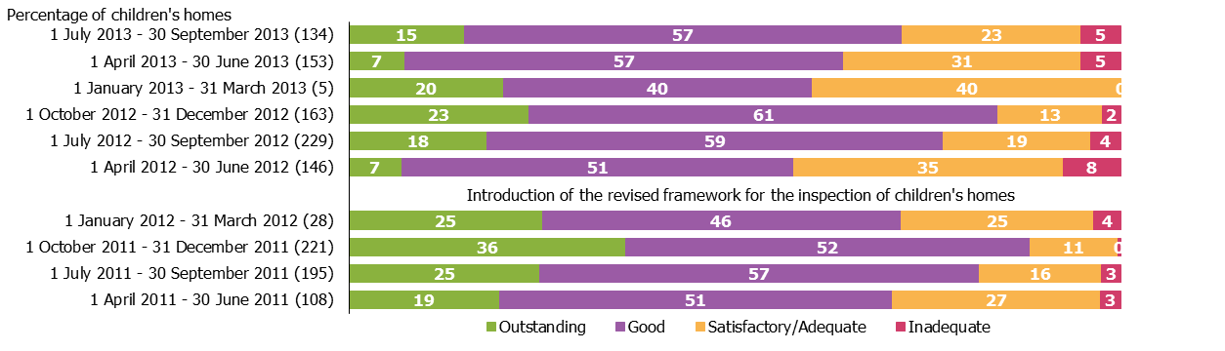

*Source: Ofsted inspections*

1. Percentages are rounded and may not add to exactly 100.

2. Local authority data include a small number of homes run by health authorities.

|  |
| --- |
| **Chart 4: Overall effectiveness of private and voluntary run children's homes inspected between 1 April 2011 and** 30 June **2013, by quarter (provisional)1** |
|
|

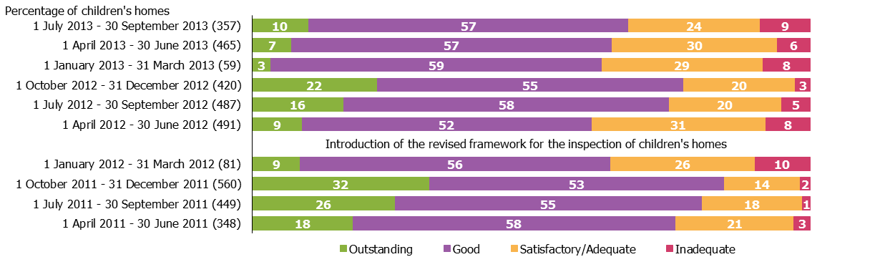

*Source: Ofsted inspections*

1. Percentages are rounded and may not add to exactly 100.

**Chart 5: Progress judgement of all children's homes at interim inspection between 1 April 2011 and** 30 September **2013, by quarter (provisional)1 2**

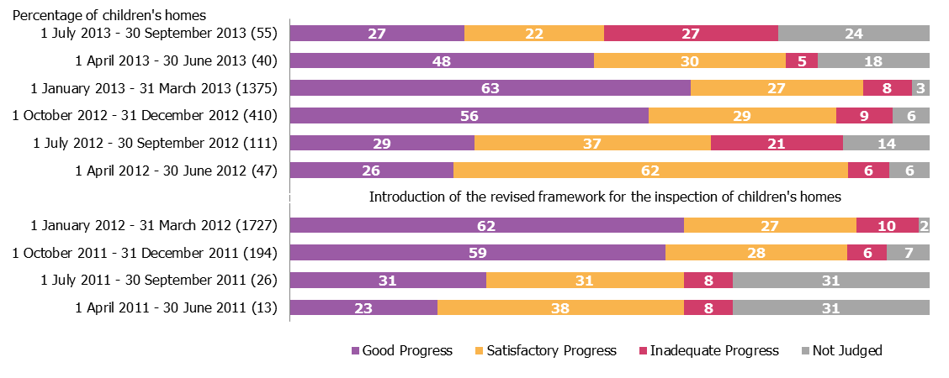

*Source: Ofsted inspections*

1. Percentages are rounded and may not add to exactly 100.

2. At an interim inspection, progress is judged based on requirements and recommendations made following the last full inspection.

3. Homes do not receive a judgement if there are no children being cared for when they are inspected.

**Table 1: Number of children's homes inspections carried out between 1 July – 30 September 2013, by inspection type (provisional)¹ ²**

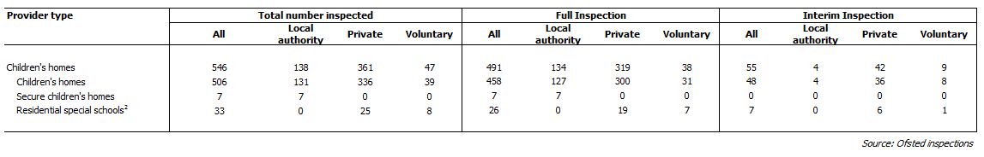

1. The 'all' figures include all homes, of all ownership type, in the local authority area. Local authority run homes data include a small number of homes run by health authorities.

2. Residential special schools that care for pupils for more than 295 days per year must register as children’s homes.

# Table 2: Overall effectiveness of children's homes at full inspections between 1 April – 30 June 2013 (provisional)¹ ²

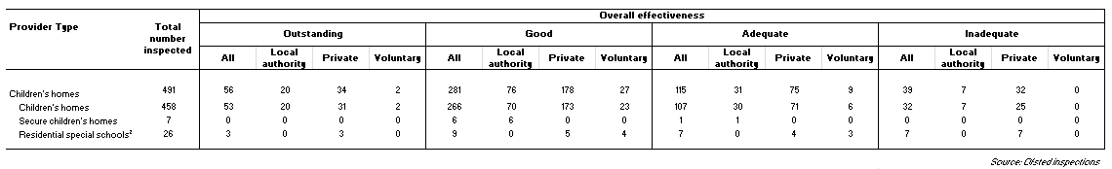

# 1. The 'all' figures include all homes, of all ownership type, in the local authority area. Local authority run homes data include a small number of homes run by health authorities.

2. Residential special schools that care for pupils for more than 295 days per year must register as children’s homes.

**Table 3a: Full inspection outcomes of children's homes (excluding secure children's homes and residential special schools caring for pupils for more than 295 days a year) inspected between 1 July – 30 September 2013 (provisional)¹ ² ³**



1. The 'all' figures include all homes, of all ownership type, in the local authority area. Local authority run homes data include a small number of homes run by health authorities.

2. Percentages are rounded and may not add to exactly 100.

3. Residential special schools that care for pupils for more than 295 days per year must register as children’s homes and their inspection outcomes data can be found in table 3c.

# Table 3b: Full inspection outcomes of secure children's homes inspected between 1 July – 30 September 2013 (provisional)1 2 3



1. The 'all' figures include all homes, of all ownership type, in the local authority area. Local authority run homes data include a small number of homes run by health authorities.

2. Percentages are rounded and may not add to exactly 100.

3. Percentages should be treated with caution, where the number of inspections is low.

4. This sub judgement is only applicable in secure children's homes inspections. Not all secure children's homes inspections reported on this sub judgement.

Table 3c: Full inspection outcomes of residential special schools caring for pupils for more than 295 days per year inspected between **1 July – 30 September 2013** (provisional)¹ ² ³



1. The 'all' figures include all homes, of all ownership type, in the local authority area. Local authority run homes data include a small number of homes run by health authorities.

2. Percentages are rounded and may not add to exactly 100.

3. Residential special schools that care for pupils for more than 295 days per year must register as children’s homes.

# Table 3d: Interim inspection outcomes of all children's homes inspected between 1 July – 30 September 2013 (provisional)¹ ² ³



1. The 'all' figures include all homes, of all ownership type, in the local authority area. Local authority run homes data include a small number of homes run by health authorities.

2. Percentages are rounded and may not add to exactly 100.

3. At an interim inspection, progress is judged based on requirements and recommendations made following the last full inspection.

4. Children’s homes not accommodating children at the time of their interim inspection received no judgement.

5. Residential special schools that care for pupils for more than 295 days per year must register as children’s homes.

**Map 1: Children's homes receiving a good or better overall effectiveness grade at full inspection, by Region, since 1 April 2013 (provisional)**



**Map 2: Children's homes receiving an adequate or lower overall effectiveness grade at full inspection, by Region, since 1 April 2013 (provisional)**



Map 3: Local authority-run children's homes receiving a Map 4: Private and voluntary-run children's homes receiving a

good or better overall effectiveness grade at full good or better overall effectiveness grade at full inspection,

inspection, by Region, since 1 April 2013 (provisional)1 by Region, since 1 April 2013 (provisional)



1. Local authority data include a small number of homes run by health authorities.

**Map 5**: Local authority-run children's homes receiving an Map 6: Private and voluntary-run children's homes receiving an

adequate or lower overall effectiveness grade at full adequate or lower overall effectiveness grade at full

inspection, by Region, since 1 April 2013 (provisional)1 inspection, by Region, since 1 April 2013 (provisional)



1. Local authority data include a small number of homes run by health authorities.

Glossary

**Children’s homes**

A children’s home is defined in section 1 of the Care Standards Act 2000, and is an establishment that provides care and accommodation wholly or mainly for children. Children’s homes vary in size and nature. They fulfil a range of purposes designed to meet the different needs of those children and young people who are assessed as needing a residential care placement. Some homes, for example, provide short breaks which are needed to help support children and their family. Some residential special schools are registered as children’s homes because boarders are resident for more than 295 days per year.

**Residential special schools**

Residential special schools are defined in section 59 of the Safeguarding Vulnerable Groups Act 2006. They vary in size and nature. The sector includes large non-maintained special schools which make provision for very specific needs and take children as full boarders from all over the country, to smaller more local providers catering for children with a range of different special needs and disabilities who may be resident at the school only during the week. Some residential special schools are registered as children’s homes because boarders are resident for more than 295 days per year. There are also a small number of independent residential special schools who also tend to cater for children with very specialist needs.

**Sector**

Sector refers to the type of provider that owns the children’s home.

*Local Authority*

These are public bodies responsible for the children’s home.

*Private*

These are for-profit organisations mostly with limited company status. These can also though be individually owned children’s homes and run for profit.

*Voluntary*

These are mostly not-for-profit organisations, mainly with charitable status. These can also be individually owned children’s homes and run on a not-for-profit basis.

*Health Authority*

These are NHS Trust-run.

**Secure children’s homes**

Secure children’s homes are defined by section 25 of the Children Act 1989. They accommodate children and young people who are remanded or have been sentenced for committing a criminal offence. They also accommodate children and young people who are placed there by a court because their behaviour is deemed to present a significant and immediate threat to their safety or the safety of others, unless they are placed in a secure environment. Ofsted inspections are conducted in accordance with the Care Standards Act 2000 and judgements in reports are made in relation to the outcomes for children set out in the Children Act 2004. The criteria are the same as those used to inspect non-secure children’s homes.

© Crown copyright

You may re-use this information (not including logos) free of charge in any format or medium, under the terms of the Open Government Licence. To view this licence, visit [http://www.nationalarchives.gov.uk/doc/open-government-licence/](http://www.nationalarchives.gov.uk/doc/open%2Dgovernment%2Dlicence) or write to the Information Policy Team, The National Archives, Kew, London, TW9 4DU or e-mail: [psi@nationalarchives.gsi.gov.uk](mailto:psi@nationalarchives.gsi.gov.uk).

1. Some children’s homes were inspected more than once in the quarter due to the re-publishing of the inspection framework and evaluation schedule for children’s homes on 10 July 2013. Please see the methodology section for further details of the changes in the republished framework and schedule.
2. See paragraph 5 in the following document ‘Conducting inspections of children’s homes’ which can be found at <http://www.ofsted.gov.uk/resources/conducting-inspections-of-childrens-homes-for-inspections-1-april-2012>.
3. The majority of these homes are new homes or homes which have re-registered following a change of ownership. Some homes may also only receive interim inspections in years which they are not operational.
4. All data for local authority-run homes include those run by health authorities. Please refer to the glossary for more details on the different types of providers.