Every child matters
Framework for the inspection of children’s services

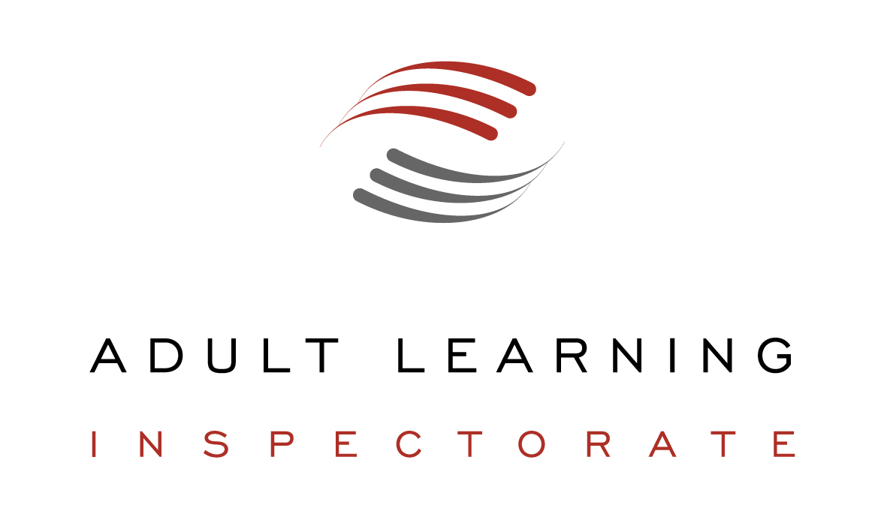
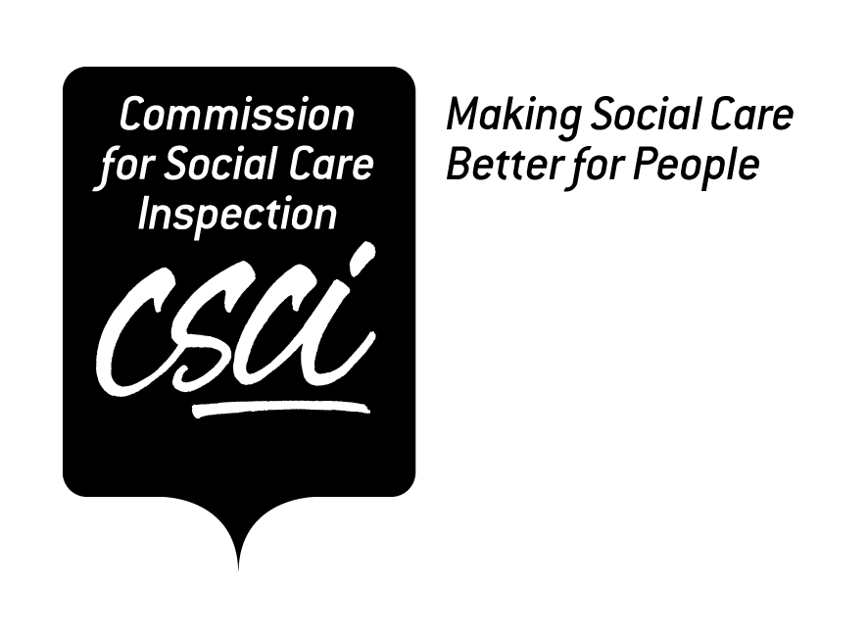



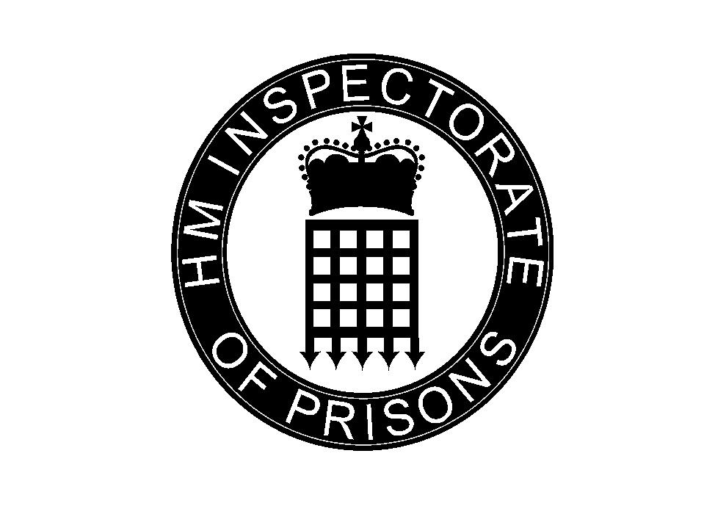

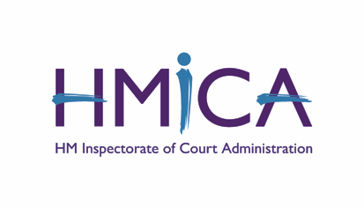
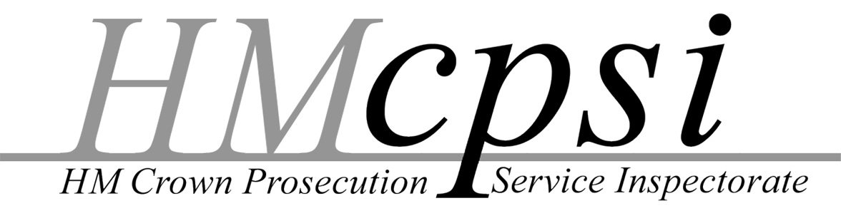

All July 2005 HMI 2433

Contents
Introduction 1
Purpose of the Framework 1
Application of the Framework 2
Principles for the inspection of children’s services 3
Purpose of inspection 3
Coverage of inspection 3
Conduct and reporting of inspection 4
Quality of inspection 6
Contributions to outcomes for children and young people 7
Using the Framework 8

Introduction
- Section 21 of the Children Act 2004 requires Her Majesty’s Chief Inspector of Schools to devise a framework for the inspection of children’s services (‘the Framework’), setting out principles to be applied by any person or body conducting a relevant assessment, inspection, review, investigation or study.

- The Framework applies to relevant inspections carried out by: the Adult Learning Inspectorate; the Audit Commission; the Commission for Social Care Inspection; the Commission for Healthcare Audit and Inspection, known as the Healthcare Commission; HM Inspectorate of Constabulary; HM Inspectorate of Probation; HM Inspectorate of Prisons; HM Crown Prosecution Service Inspectorate; HM Inspectorate of Court Administration; and the Office for Standards in Education.

- Relevant inspections are those of children’s services. Children’s services are defined for inspection purposes by section 23 of the Children Act 2004 and regulations to be made under it. Subject to consultation, regulations will provide that in general they include services for children and young people aged 0–19 inclusive, whether by statutory, voluntary or private providers, which are assessed by any of the inspectorates and commissions listed in paragraph 2. They will also include services for those over 19 who are receiving services as care leavers under sections 23C and 24D of the Children Act 1989, and those over 19 but under 25 with a learning difficulty within the meaning of section 13 of the Learning and Skills Act 2000 and receiving services under that Act. However, for certain services – in secure training centres, prisons and removal centres, and by youth offending teams, local probation boards and police forces – only services for children up to their 18th birthday will be within the definition. New functions introduced by the Children Act 2004, on cooperation to improve well-being, information databases, local safeguarding children boards, children and young people’s plans, and director of and lead member for children’s services, are also within the definition of children’s services for the purposes of assessment.

Purpose of the Framework
- The Children Act 2004 provides that the purpose of the Framework is to ensure that relevant inspections properly evaluate and report on the extent to which children’s services improve the well-being of children and relevant young persons. The Government’s document Every child matters: change for children (December 2004) indicates national and local priorities for children’s services. It sets out an Outcomes Framework, which includes the five outcomes for children and young people given legal force in the Children Act 2004, 25 specific aims for children and young people, and explicitly relates inspection criteria to the five outcomes. Framework for the inspection of children’s services, to which the Secretary of State for Education and Skills has given consent, cements this relationship. In turn, the Every child matters outcomes framework dovetails with the National service framework for children, young people and maternity services.

- The Framework draws on the recommendations, applying to inspection generally, of the July 2003 Office of Public Services Reform report Inspecting for improvement. That report defines inspection as a review, conducted by external bodies, that should: be independent of service providers; provide assurance to ministers and the public about the safe and proper delivery of services; contribute to improvement of services; report in public; and deliver value for money. It sets out 10 principles of inspection and external review which form the basis of the principles in this Framework.

- The 10 inspectorates and commissions to which the Framework applies have participated fully in developing the Framework. Wherever possible – for example in inspecting youth offending teams and in joint area reviews – they will work together, in line with the Government’s intentions to increase joint working and to reduce costs and burdens of inspection.

Application of the Framework
- The principles apply to inspections of front line provision, such as early years settings, children’s homes and schools, whether this provision is made by the public, private or voluntary sectors. They also apply to joint area reviews and to any separate inspections of local authority and other services that support front line provision.

- The principles will apply in different ways in different contexts. The Framework governs the coverage and guides the methods of inspection, but does not replace specialist inspection frameworks. These specialist frameworks will continue to be used in inspections of different types of provision, reflecting the specific statutory requirements under which the commissions and inspectorates work.

Principles for the inspection of children’s services

Purpose of inspection
- Inspection aims to improve outcomes for children and young people.
It seeks to do this by:
- focusing on the experiences and achievements of children and young people
- evaluating the contributions that services make to the well-being of children and young people, including those at risk of achieving poor outcomes because of learning difficulties and/or disabilities disruption of family life or other disadvantage
- encouraging rigorous self-assessment by the services inspected
- evaluating services’ capacity, providing an objective evaluation for staff working in them and building their capacity to improve the provision made
- saying what should be done to improve service contributions to outcomes
- informing action taken to pursue improvement.

Coverage of inspection
- Inspection evaluates and rates service contributions to five key outcomes for children and young people:
- being healthy, so that they are physically healthy; mentally and emotionally healthy; sexually healthy; have healthy lifestyles; choose not to take illegal drugs
- staying safe, so that they are safe from maltreatment, neglect, violence and sexual exploitation; safe from accidental injury and death; safe from bullying and discrimination; safe from crime and anti-social behaviour in and out of school; have security and stability and are cared for
- enjoying and achieving, so that they are ready for school; attend and enjoy school; achieve stretching national educational standards at primary school; achieve personal and social development and enjoy recreation; achieve stretching national educational standards at secondary school
- making a positive contribution, so that they: engage in decision-making and support the community and environment; engage in law-abiding and positive behaviour in and out of school; develop positive relationships and choose not to bully and discriminate; develop self-confidence and successfully deal with significant life changes and challenges; develop enterprising behaviour
- achieving economic well-being, so that they: engage in further education, employment or training on leaving school; are ready for employment; live in decent homes and sustainable communities; have access to transport and material goods; live in households free from low income.

Contributions of services to these outcomes will be assessed against definitions set out on pages 9–11.

- Inspection assesses the quality and management of services for children and young people.
Judgements of the quality and management of services will include the effectiveness of the steps taken to:
- plan for improved outcomes by identifying the needs, views and concerns of children and young people, their parents and carers and establish ways of meeting them
- work cooperatively with partners to share information and provide services
- develop, train and support staff to equip them to deliver services
- eliminate unlawful discrimination and promote equal opportunities
- make sufficient high quality provision that gives value for money
- review the effectiveness of services.

Conduct and reporting of inspection
- Inspection is proportionate to risk and tailored to needs and circumstances.
Inspection will:
- take account of performance data and other existing information
- concentrate inspection where it will have the most impact
- be tailored to need, taking account of statutory cycles and reporting requirements
- use fieldwork only where there is no alternative way of gathering the evidence needed, or where it is needed to validate the picture painted by performance data and other information.

- Inspectors aim to keep disruption to the organisations inspected and their service users to a minimum.
They seek to do this by:
- setting information requirements and other demands at a modest level
- making use as far as possible of the existing documentation and systems of the organisations inspected, including their self-assessments
- bringing together existing data to inform evaluation
- sharing information between inspectors, subject to statutory restrictions and agreed protocols on confidentiality and other requirements
- organising inspection visits and reporting them efficiently.

- Inspectors report openly, clearly and fairly on the basis of secure evidence.
Inspectors aim to secure the cooperation and confidence of those being inspected and contribute actively to the improvement of services. They seek to do this by:
- making the purpose and the process of inspection clear
- using teams with appropriate experience, relevant skills and shared understanding
- making judgements on the basis of consistent use of criteria
- engaging with service managers and other staff and keeping them informed of emerging issues
- gathering evidence systematically and evaluating it impartially
- communicating findings about strengths and weaknesses in a clear, fair and well-argued way
- playing a constructive part in the process of improvement and accountability.

- Inspectors take account of the views of children and young people and of their parents and carers and seek to involve them in inspections in other ways.
Inspectors want to make sure that the views of children and young people, their parents and carers, about the services they receive, or wish to receive, are sought and considered. They will gather the views of children and young people themselves and will assess the extent to which services themselves consult and make use of the findings of consultation.

In gathering the views of children and young people, inspectors will:
- provide them with information about the inspection
- take into account children and young people’s level of understanding and take their differing views equally seriously
- seek to ensure they receive views from a diverse range of children and young people
- use a range of ways of securing children and young people’s views that are appropriate to their age and, where practicable, meet their preferences for ways of communicating their views
- ensure that children and young people feel safe during the process and enable them to raise individual concerns, and respond to or refer these as appropriate
- consider their views in reaching judgements about the availability, quality and impact of provision, setting these views in the context of other evidence
- make sure that their views are reflected in the findings of the inspection and that reports are fed back to children and young people in an appropriate form.

Quality of inspection
- Inspectors evaluate the process and benefits of inspection and seek continually to improve its quality.
Evaluation of the process of inspection will be based on the extent to which:
- the arrangements for the inspection, including the basis for judgements, are clear and encourage productive engagement on the part of those inspected
- the process of the inspection is efficient and does not place undue burdens on those involved
- the views of children and young people, and of their parents and carers, are incorporated in the inspection
- inspectors demonstrate integrity, objectivity and courtesy as they undertake their work
- reports make relevant, well-founded and clear judgements understood by service staff, users and other stakeholders
- complaints about inspections are handled fairly and promptly.

Evaluation of the benefits of inspection will be based on the extent to which it contributes to:
- improvements in services for children and young people, and/or in their cost-effectiveness
- services working together more effectively
- outcomes for children and young people in the area improving overall and in their consistency across different groups, including those groups at risk of achieving poor outcomes
- the development of national policy and action taken to implement it.

Contributions to outcomes for children and young people
- The statements below illustrate what a local network of public services can do, in conjunction with families and other agencies, to promote the well-being of children and young people. The statements link the key aims in the government’s Every child matters: change for children programme with the activities that contribute most directly to them.

- Not all the contributions to outcomes are relevant to each type of service inspected. However, most services make a contribution to more than one of the outcomes. Judgements will be made only in an inspection where it is appropriate and practical to do so. Illustrations of evidence for judgements will be published separately.

Being healthy
Outcomes:
Children and young people are: physically healthy; mentally and emotionally healthy; sexually healthy; have healthy lifestyles; choose not to take illegal drugs.
Key judgements:
- parents and carers receive support to keep their children healthy
- healthy lifestyles are promoted for children and young people
- action is taken to promote children and young people’s physical health
- action is taken to promote children and young people’s mental health
- looked after children’s health needs are addressed
- the health needs of children and young people with learning difficulties and/or disabilities are addressed.

Staying safe
Outcomes:
Children and young people are: safe from maltreatment, neglect, violence and sexual exploitation; safe from accidental injury and death; safe from bullying and discrimination; safe from crime and anti-social behaviour in and out of school; have security and stability and are cared for.
Key judgements:
- children and young people and their carers are informed about key risks to their safety and how to deal with them
- children and young people are provided with a safe environment
- the incidence of child abuse and neglect is minimised
- agencies collaborate to safeguard children according to the requirements of the current government guidance
- services are effective in establishing the identity and whereabouts of all children and young people aged 0–-16
- action is taken to avoid children and young people having to be looked after
- looked after children live in safe environments and are protected from abuse and exploitation
- children and young people with learning difficulties and/or disabilities live in safe environments and are protected from abuse and exploitation.

Enjoying and achieving
Outcomes:
Children and young people are: ready for school; attend and enjoy school; achieve stretching national educational standards at primary school; achieve personal and social development and enjoy recreation; achieve stretching national educational standards at secondary school.
Key judgements:
- parents and carers receive support in helping their children to enjoy and achieve
- early years provision promotes children’s development and well-being and helps them meet early learning goals
- action is taken to ensure that education provision for 5–16 year olds is of good quality
- children and young people are encouraged to attend and enjoy school and enabled to achieve highly
- educational provision is made for children who do not attend school
- all children and young people can access a range of recreational activities, including play and voluntary learning provision
- children and young people who are looked after are helped to enjoy and achieve
- children and young people with learning difficulties and/or disabilities are helped to enjoy and achieve.

Making a positive contribution
Outcomes:
Children and young people engage in decision-making and support the community and environment; engage in law-abiding and positive behaviour in and out of school; develop positive relationships and choose not to bully and discriminate; develop self-confidence and successfully deal with significant life changes and challenges; develop enterprising behaviour.
Key judgements:
- children and young people are supported in developing socially and emotionally
- children and young people, particularly those from vulnerable groups, are supported in managing changes and responding to challenges in their lives
- children and young people are encouraged to participate in decision-making and in supporting the community
- action is taken to reduce anti-social behaviour by children and young people
- action is taken to prevent offending and to reduce re-offending by children and young people
- children and young people who are looked after are helped to make a positive contribution
- children and young people with learning difficulties and/or disabilities are helped to make a positive contribution.

Achieving economic well-being
Outcomes:
Children and young people: engage in further education, employment or training on leaving school; are ready for employment; live in decent homes and sustainable communities; have access to transport and material goods; live in households free from low-income.
Key judgements:
action is taken by partners to support families in maximising their economic well-being
young people aged 11–19 are helped to prepare for working life
action is taken to ensure that 14–19 education and training is planned and delivered in a coordinated way, and to ensure that education and training (for 16–19 year olds) is of good quality
community regeneration initiatives address the needs of children and young people
action is taken to ensure that young people have decent housing
children and young people who are looked after are helped to achieve economic well-being
children and young people with learning difficulties and/or disabilities are helped to achieve economic well-being.

Using the Framework
- To meet the requirements of the Framework, the commissions and inspectorates undertake to:
- fulfil the principles of the Framework in relation to relevant inspections, having regard to the different circumstances in which inspections take place and the different statutory duties and powers on which they are based
- cover service contributions to the five key outcomes in their relevant inspections, where it is appropriate and practical to do so
- adopt, where relevant, common protocols to govern inspection practice
- share information about planned inspections in order to maximise the coherence of coverage and minimise burdens on the organisations inspected
- provide analysis of the findings of inspections in order to inform joint area reviews.

- The Children Act stipulates that the Framework may include principles relating to the organisation of the results of any relevant assessment. In carrying out their separate assessments and inspections, the commissions and inspectorates will use their preferred ways of classifying and communicating judgements to the audiences concerned. In communicating the findings of assessments and inspections for the purpose of compiling information for joint area reviews, they will use a four-point classification scale.

- Her Majesty’s Chief Inspector of Schools will keep the Framework and its application under review to ensure that it is fulfilling the intentions of the Children Act. In doing so, the Chief Inspector will consult with the heads of commissions and inspectorates about the extent to which application of the Framework is proving practical and beneficial and seek their assessment of any changes which may be necessary.

- Her Majesty’s Chief Inspector of Schools may at any time revise the Framework, consulting in accordance with the provisions of the Children Act and seeking the consent of the secretary of state before publishing a revision.

Hereafter, the terms ‘assessment’ and ‘inspection’ are used interchangeably and encompass ‘review’, ‘investigation’ and ‘study’.
The term learning difficulties and/or disabilities is used to refer to individuals or groups of learners who have either a learning difficulty in relation to acquiring new skills or who learn at a different rate to their peers. The term is used to cross the professional boundaries between education, health and social services and to incorporate a common language from 0–19. The Disability Discrimination Act defines that, 'a person has a disability if he or she has a physical or mental impairment that has a substantial and long-term adverse effect on his or her ability to carry out normal day-to-day activities.' Physical or mental impairments can include sensory impairments and learning difficulties. The definition also covers medical conditions when they have long-term and substantial effects on pupils' everyday lives. Those designated with special educational needs (SEN) under current legislation (education) all have learning difficulties and/or disabilities that make it harder for them to learn than most learners of the same age.

