The Future of Initial Teacher Education for the Learning and Skills Sector: An Agenda for Reform

Responses to Consultation

June 2004
The Future of Initial Teacher Education for the Learning and Skills Sector: Agenda for Reform

DfES Standards Unit consultation

Introduction 2

Methodology 3

Findings 4

Pie chart of all responses by group 5

Graphs showing qualitative responses by question 6

Further Education Colleges 17
Higher Education Institutes 31

Consortia 41

Awarding Bodies and Universities Council for Education and Training 47

Unions 59

Adult and Community Learning 66

Minority groups 77

National organisations 103

Regional organisations 129

Individuals 135

Responses from national and regional events 141

Appendices:

Appendix 1 Respondents 146

Appendix 2 Questions asked at events 149

Appendix 3 Stakeholders 151

Appendix 4 Response by question 152

Introduction

On 11 November, the Secretary of State for Education launched a consultation into the future of initial teacher education in the further education/learning and skills sector. The consultation period was for three months, ending on 29 February 2004.

The consultation included the following events and processes:

- Seminar at the launch at the AoC National Conference
- Three national consultations in London, Birmingham and Bolton
- Four regional focus groups in Taunton, Cambridge, Manchester and Newcastle
- An awarding body consultation meeting
- An HEI consultation meeting
- Two stakeholders meeting

In addition to the events, anyone with an interest was invited to respond to the consultation document.

This report is the summative document of the consultation process and aims to:

- Collate the responses to the DfES Standards Unit consultation
- Analyse the responses and make comments where appropriate
- Draw conclusions based on the findings
- Make recommendations for DfES action

The methodology section gives more detail about how this process was carried out.

Methodology

The consultation process spanned the three months from November 2003 until February 2004.

The consultation process included the following:

- Three national events held in London, Birmingham and Bolton – to which 233 people attended
- Four regional events in Cambridge, Taunton, Manchester and Newcastle – which were attended by 66 people
- Awarding body and HEI events
- Stakeholders events
- Written responses from 181 respondents

Delegates to the three national events were given ten questions to consider in round table discussions. These questions were based on the 21 questions in the consultation (see Appendix 2 for the questions). The answers were collected by a scribe for each table and collated by DfES.

Delegates to the four regional focus group events were sent the questions beforehand so they had time to consider their responses. Delegates were experienced ITT professionals, HR managers etc. and were put into groups to discuss the questions. Feedback was collected from all delegates and collated.

The awarding body and HEI events were aimed at identifying the key messages from those who validate/accredit ITT qualifications.

The stakeholders’ events aim to inform and update those with an interest in ITT and identify their key messages and concerns in order to feed these into the process (For a list of stakeholders see Appendix 3).

Once the consultation period was over, all the responses were collated and analysed – more details can be found in the Findings section on page 4. The groupings represent the key areas of involvement in the process of ITT:

- The validating/accrediting organisations - awarding bodies, HEIs – and consortia
- Those who deliver – FE staff and HEI staff – and consortia
- Non-FE providers with an interest – ACL
- Large organisations with a national remit - national organisations
- Organisations with a regional remit – regional organisations
- Organisations with a specific role – unions, minority groups
- Events – from the various events held around the country

Findings

There were responses from 181 respondents which were put into ten groupings:

- Further Education Colleges
- Higher Education Institutes
- Consortia
- Awarding Bodies and Universities Council for Education and Training
- Unions
- Adult and Community Learning
- Minority groups
- National organisations
- Regional organisations
- Individuals

The findings are presented as follows:

- A pie chart showing the break down of responses by grouping
- Graphs of the questions providing quantitative data
- Responses by grouping

Within each of the ten groupings, quantitative data is presented first, followed by a breakdown of questions by each respondent, together with relevant quotes.

In addition to this, Appendix 4 lists the responses of all respondents by question, providing an overview of each question.

Pie chart of responses by group
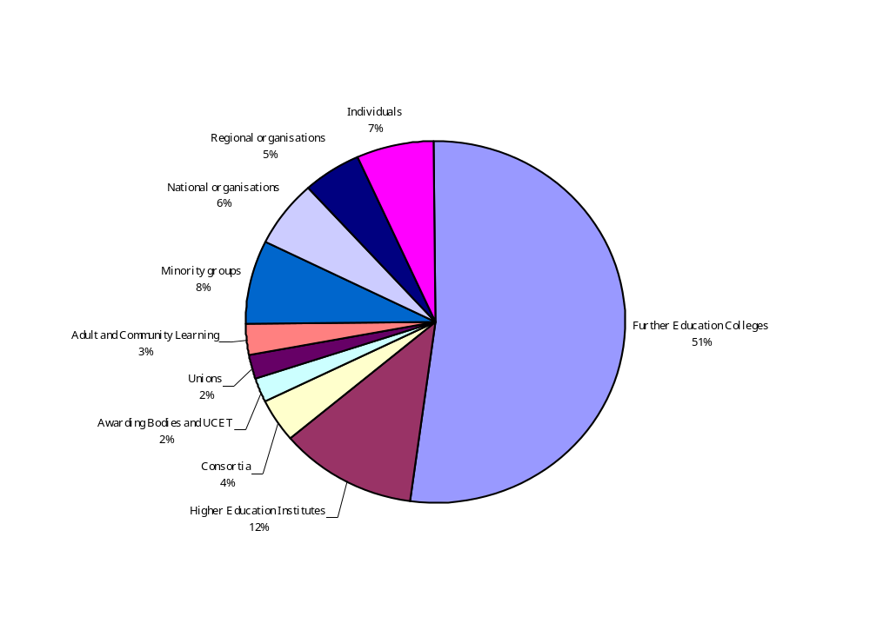

Key:

Total responses - 181

Further Education Colleges - 94
Higher Education Institutes - 21
Consortia - 7
Awarding Bodies and UCET - 4
Unions - 4
Adult and Community Learning - 5
Minority groups - 14
National organisations - 11
Regional organisations - 9
Individuals - 12
Graphs showing quantitative responses by question

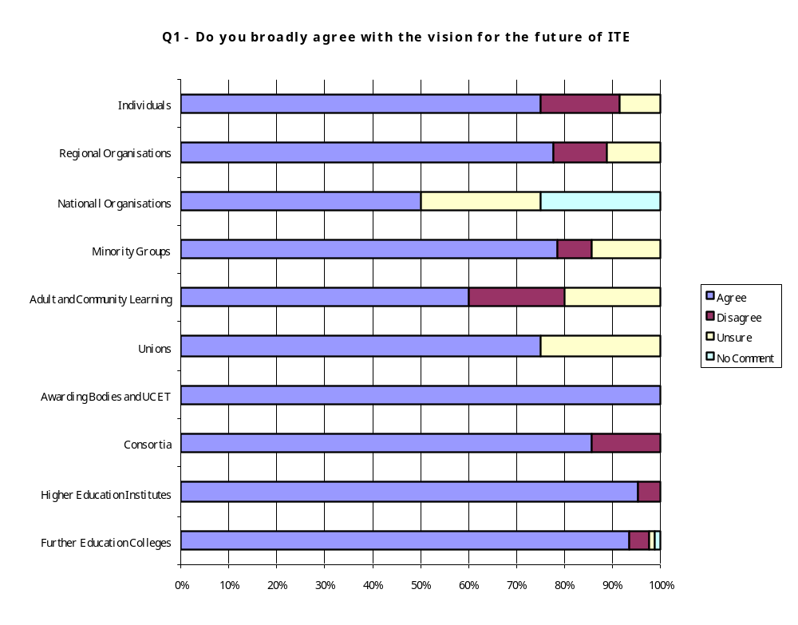

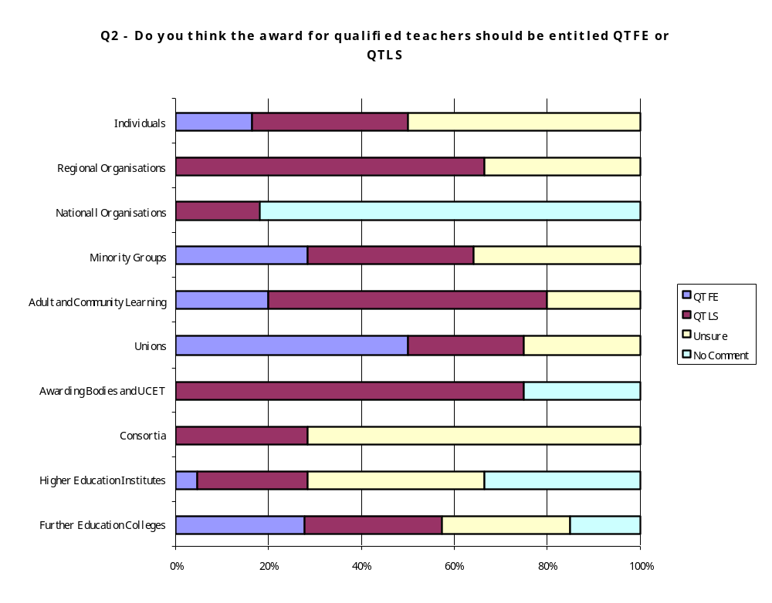

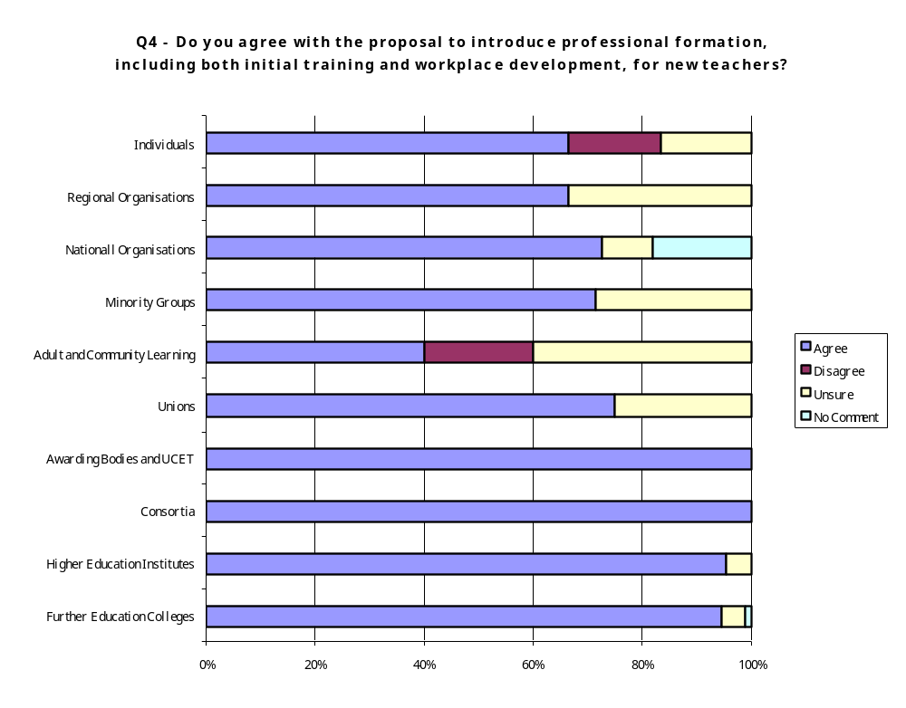

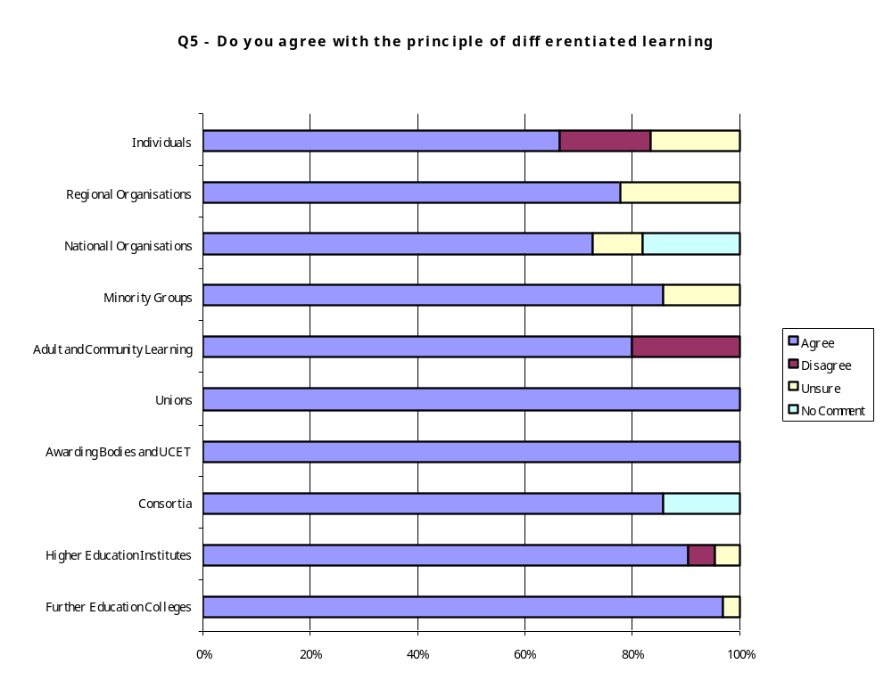

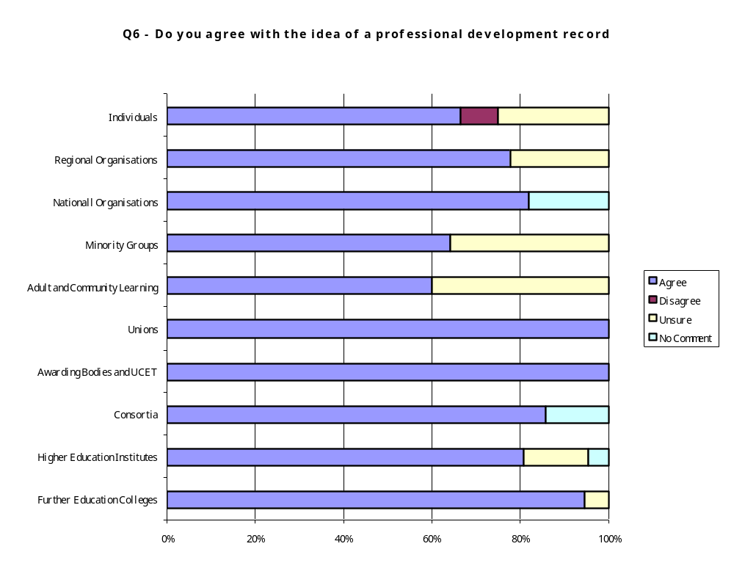

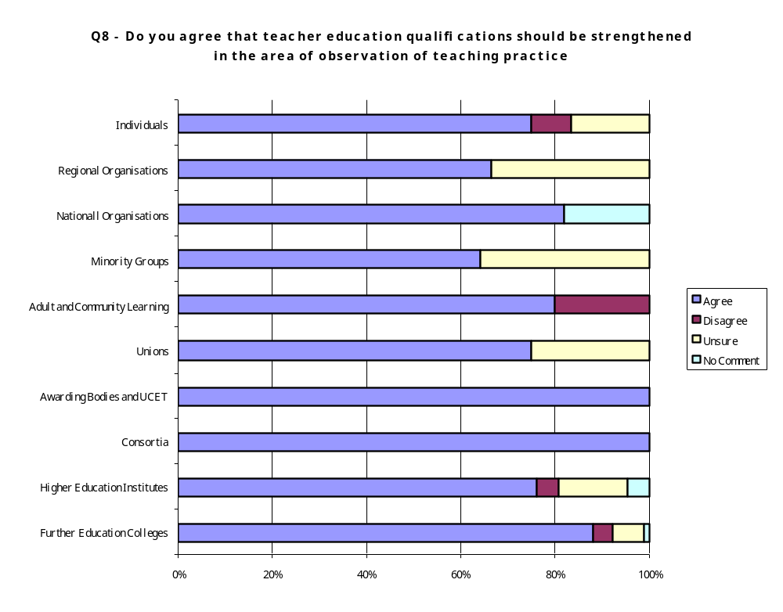

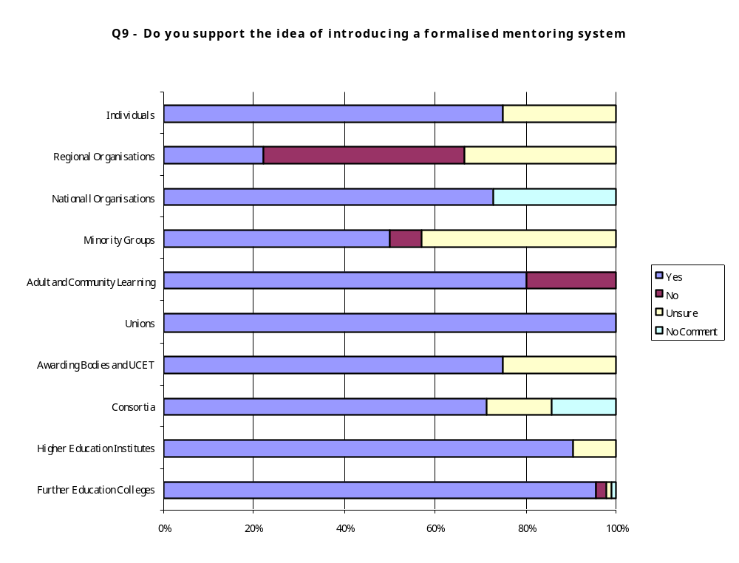

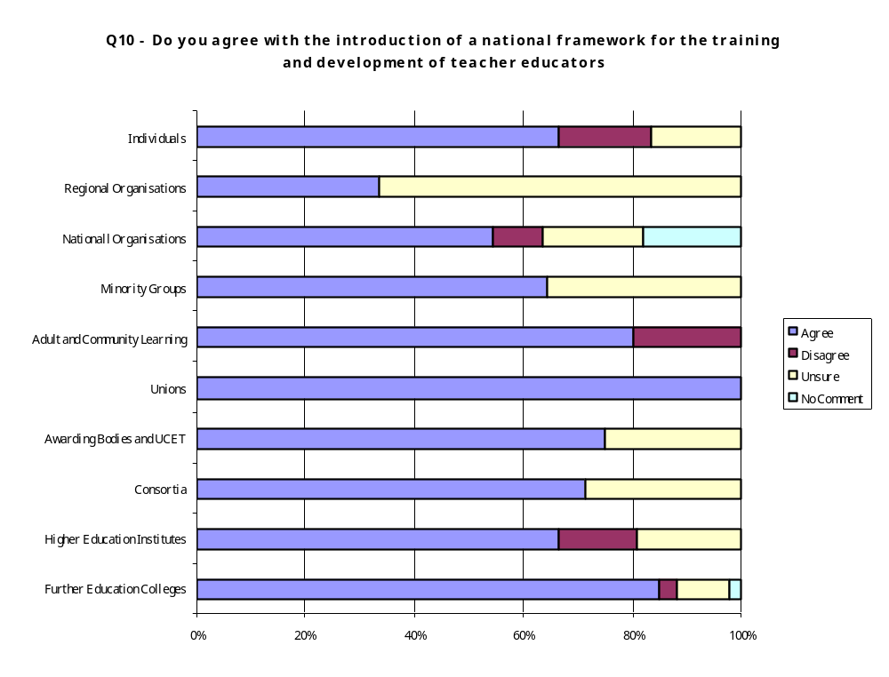

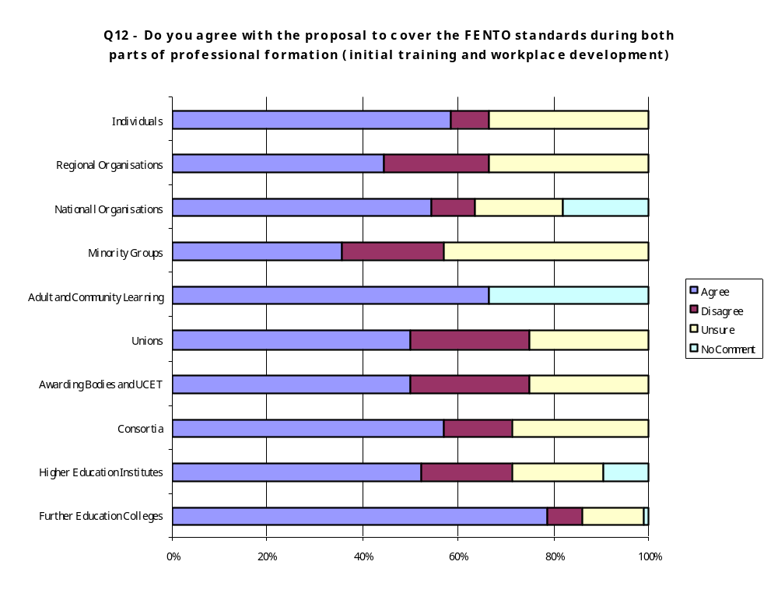

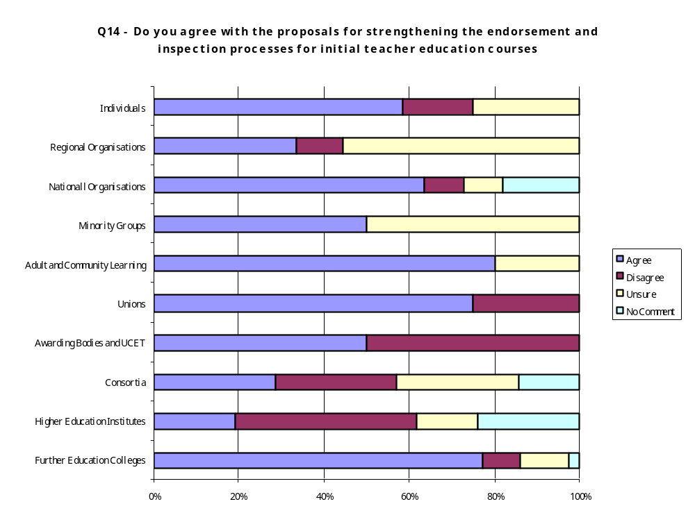

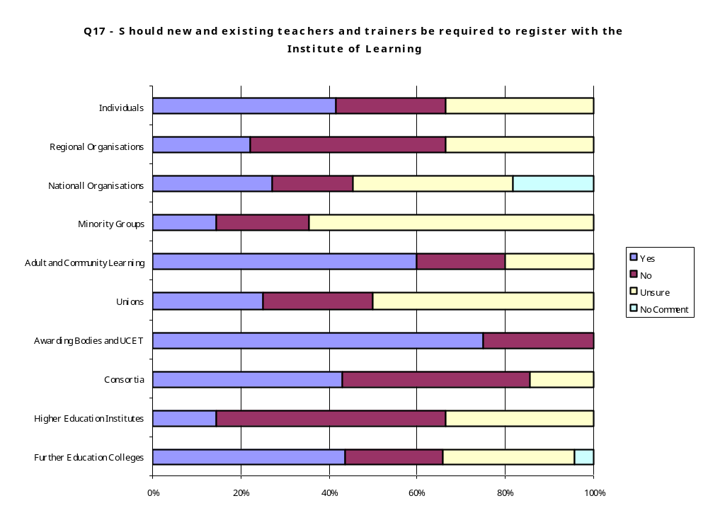

Further Education Colleges

94 colleges responded to the consultation. See Appendix 1 for listings.

Q1. Do you broadly agree with the vision for the future of ITE?

Agree | Disagree | Unsure | No comment
88 | 4 | 1 | 1

The response to this question was an overwhelming number of “agree”s, but all responses were followed by a “but” or proviso which could be grouped under four headings:

- The FE sector – specific viewpoint
- Qualifications
- Resources – funding, people and time
- Areas of concern

The FE sector:

- There was an overwhelming plea for parity with schools and HE as these were seen as having better pay, terms, conditions and status than FE. A range of reasons were cited as evidence for this claim, including lack of investment; the number of organisations “checking up” on FE colleges; the lack of a GTC/TTA; the freedom of HEIs etc.
- The schools model is inappropriate for FE – reasons given included FE diversity; the FE sector is not uniform; the FE sector is more complex than that of schools due to the range of specialist areas, the diversity of FE learners and so on
- FE is interdependent with schools and HE
- The FE sector has a high number of part-time staff in order to ensure current expertise in the range of specialist areas. This therefore makes it harder to provide an equitable framework of qualifications that do not put these sessional staff off teaching in the sector. A pragmatic approach was recommended.

Qualifications:

- There was general agreement that it was a good thing to have basic skills aspirations, but a number of concerns were raised about the speed, quantity and level of such measures to date. There was general consensus that CPD would be a better route to acquire these skills
- There was a frequent reference to the need to use APEL in a less bureaucratic way – this is dealt with in more detail in Question 5.
- A large number of respondents referred to the time issue for current qualifications. It was agreed that trainees needed longer in many cases.

Suggestions were made, including building on to a core of units and not demanding evidence of complete coverage at the start of the qualification. There was also agreement that the length, and breadth and time were too tight and that longer was needed if there was to be differentiation according to need.

Resources:

- Virtually every respondent said that the vision would need funding and time including HR and development support

Concerns:

- One size does not fit all – respondents were concerned that a blanket rule would be applied across the sector, regardless of their needs. It is easier to do this in the schools sector.

“FE is characterised by its diverse entry portals to the sector….. within these groups there are pressures which obviate against the clear view outlined in the paper” (GLOSCAT)

“Is it realistic or appropriate for every trainee to be exposed to every level, every age group and organisational setting before achieving qualified status” (Lewisham College)

“How can one individual be competent in the full range of attributes listed
The unique capability of each individual seems at variance with the huge breadth of competence expected and multiplicity of roles” (Morley College)

Q2. Do you think the award for qualified teachers should be entitled QTFE or QTLS?

QTFE | QTLS | Unsure | No comment
26 | 28 | 26 | 14

QTS was preferred by large proportion despite not being offered as an option.

QTLS – demonstrate that sector recognises providers are across the sector but not as well recognised as QTFE.

Unsures – not happy with options offered:

- Wanted QTET
- QTFHE - further and higher education responsibilities acknowledged

And other contributors included HE, FE, PCE etc. Other views included:

- Wanted to concentrate on the qualification rather than its title – asking about the title is “jumping the gun”
- Actively dislike the given options as prefer QTS – covers status across the schools/FE spectrum (14-16 emphasises links)

“FENTO has sometimes created an unfortunate barrier to professional development for those who would previously be admitted to awards covering a wider post compulsory education and training sector” (Lewisham College)

Q3. Should teacher training in the learning and skill sector be at graduate or equivalent level, as in schools?

Yes | No | Unsure | No comment
47 | 28 | 15 | 4

There was some misunderstanding of the question. However, responses included:

- It was thought that the question referred to subject – specific knowledge and skills - and was not about training as a teacher
- There was confusion about the nature of levels, ie teaching is a level 4 skill – and not about the level of the qualification.
- Vocational teachers are likely to need briefing. Programmes offering support to develop level 4 skills required now by ABs and HEIs (writing skills).

Nature of assessment – there should be:

- Flexibility
- Appropriateness
- Differentiation for vocational staff

There were questions about the meaning of equivalence, and a desire for a flexible definition, not a purist, academic one.

“Parity with QTS” (Lewisham College)

“Should be at level 4 but not necessarily delivered as an academic course” (NESCOT)

“There should be progression routes which make this training accessible for the existing and potential workforce” (Pre-School Learning Alliance)

“Please note the number of part time subject specialists employed because of the scarcity and currency of their experience and the use of agency staffing in many colleges. To what levels should they be trained?” (Boston College)

Q4. Do you agree with the proposal to introduce professional formation, including both initial training and workplace development, for new teachers?

Agree | Disagree | Unsure | No comment
89 |  | 4 | 1

Full agreement for two phase model, but:

- The importance of resources consistently came through – time and funding
- Employers’ responsibility is key to making it work
- ‘Teaching passport’ – initial stage into teaching plus supported training
- CPD common parlance across all professions
- Longer time needed for p/t staff
- Balance needed between being over-bureaucratic and a tick list

“The proposal about breadth is an aspiration. It is unrealistic to expect all FE staff to experience the breadth the report describes……We do have a responsibility to broaden horizons, but we have a responsibility to support new teachers into effectiveness quickly” (Boston College)

Q5. Do you agree with the principle of differentiated learning?

Agree | Disagree | Unsure | No comment
91 |  | 3

The responses were overwhelmingly in agreement, but it is clear that there are many interpretations of the term. Comments included:

- Respondents were happy with the idea of ILPs – their learners have them, so they should too
- Must address dual standards between how students are treated and how own staff, as students, are treated
- Flexibility needed for ILPs
- ILPs – lead to very varied methods of delivery, so therefore require:
  - time
  - delivery
  - assessments
  - methods etc
- ILP – emphasise need for effective initial assessments / diagnostics.
- Happy with informed use of APEL but not at the expense of devaluing the award
- Longer time needed to ensure differentiated learning
- Changes meant changing SI

“Important to recognise the existing skills and knowledge of the new teachers (or those who are unqualified but may have been teaching for some time)” (Great Yarmouth College)

“Why the use of APEL?” (Lewisham College)

“The under-utilisation of IPLs and ITE nationally is inexcusable” (Lewisham College)

“This principle should also apply to assessment” (Stamford College)

“Differentiation …..means allowing for different learning speeds and this is not catered for by the statutory regulations” (NESCOT)

Q6. Do you agree with the idea of a professional development record?

Agree | Disagree | Unsure | No comment
89 |  | 5

Overwhelmingly yes, but with some questions and concerns being highlighted:

- Who takes responsibility – teacher, IfL organisation? Who owns, monitors and has access to the information?
- Concern about links between qualifications and pay
- Integration with HR systems and processes received general approval
- The system/process should be broad
- Simple and non-bureaucratic
- Funding and resource implications
- Sessional staff, p/t staff – how are these addressed in this process?

Q7. If so, what form should the PDR take?

There was general consensus that the PDR should not be burdensome, bureaucratic or demand extra work of staff. Comments included:

- Online / paper based – blend of both – need to meet all needs
- Models offered -eg – school, CIPD, nursing – don’t “re-invent the wheel”
- A desire for simplicity, flexibility, transferability, portability between sector, broader sector and other professions
- Include range of aspects
- Links with HR needed to ensure effectiveness and coherence
- Not over-bureaucratic / not tick box – but demonstrates development
- Staged implementation

“What is important is that a variety of formats should be acceptable, electronic and paper based” (Solihull College)

Q8. Do you agree that teacher education qualifications should be strengthened in the area of observation of teaching practice?

Agree | Disagree | Unsure | No comment
82 | 4 | 6 | 1

The respondents overwhelmingly agreed with this proposal – but agreement was wholly dependent on:

- Adequate resources – funding, time and people
- Developmental culture and approach rather than judgemental
- Standardised locally and nationally (maybe by SU?), and based on common criteria
- In CPD phase – linked with progression
- Linking HR, QA and ITT
- Subject and generic aspects included
- Mentoring support
- Include peer involvement, skills-specific, shadowing

Q9. Do you support the idea of introducing a formalised mentoring system?

Yes | No | Unsure | No comment
90 | 2 | 1 | 1

There was complete agreement with the proposal, but there were the following caveats and comments:

- Virtually 100% said funding was vital as this is an expensive model to implement – funding must be ring-fenced and cover all aspects of provision
- Rewarded – finances, time and professional recognition
- There was consensus on benefits in raising quality of teacher
- Concerns about subject-specific – FE provision varied – may not be practical.
- P/t, sessional and external staff – how are they included? Needs consideration
- Standardisation and guidelines

Q10. Do you agree with the introduction of a national framework for the training and development of teacher educators?

Agree | Disagree | Unsure | No comment
80 | 3 | 9 | 2

There was a general misunderstanding of the question – many respondents thought it referred to teachers rather than teacher trainers. The majority were in agreement, but:

- Support for maintaining teaching practice in other subject areas – practising teachers as well as trainers
- Framework should be just that – a simple, flexible, national framework
- P/t and sessional staff to be treated differently
- Some comments on funding and the cost and time implications
- Vocational/academic issues were raised
- Currency – need widespread recognition and transferability
- No more quangos, but needs to be managed and monitored by single body

“There is a sense in which the words “national” and “framework” will somehow imbue the system with a rightness it does not warrant” (Newcastle College)

Q11. How can we build on the achievements in adult literacy, numeracy and ESOL teaching for the learning and skills sector workforce?

There was some confusion over the question – and many respondents felt that this was a leading question –ie- what achievements? They felt no evidence was offered to support the claim about achievement. Responses included:

- More “no comments” than any other question
- Does this apply to all teachers? And a sense of concern if this was the case
- Core ITT too full already – so make it CPD, allow choice of if and when
- Is it needed? Is it priority?
- Level 4 is too high. Who said this is the case and based on what evidence?
- Not feasible / practical / too expensive / retention of staff would be affected

“Unclear about the achievements meant here” (Great Yarmouth College)

Q12. Do you agree with the proposal to cover the FENTO standards during both parts of professional formation (initial training and workplace development)?

Agree | Disagree | Unsure | No comment
74 | 7 | 12 | 1

There was general agreement, but:

- The FENTO standards were produced as a model of professional capability and could only be reached after time by experienced staff, therefore they can’t all be included in ITT – so there must be induction and CPD
- Separate benefits of standards from the unpopular changes carried out by C&G
- Links between CPD and PDR – ongoing
- Include fewer aspects of the standards in ITT – follow the schools model

- Flexibility needed in-house as trainees require opportunities to demonstrate the capabilities – and time should be allowed to meet the needs of all staff
- Ensure these standards apply across LSC sector
- Common set for HE and FE
- HR procedure links

Q13. What should be included in the wider review of standards?

This question was omitted by a large number of respondents. Respondents did comment and stressed the need for time for this to be carried out and introduced properly to ensure we get it right this time. Other answers included:

- Basic Skills, ICT and e-Learning
- Range of contexts –ie- LDD, prisons, ACL, 14-16 etc
- Parity between all qualifications
- Links to subject
- Common core with options to be covered over time
- One-to-one delivery
- Align with schools
- Make it similar to the national curriculum in schools
- Clear and simple means of assessment
- Inclusive clear pathway from instructor to advanced practitioner status
- Research
- Fewer of them
- Less jargon
- Include equality and diversity
- 14-16/18-19
- Simplify them
- FENTO standards are not a statement of competencies, they are a description of a role so should not be treated as the basis for qualifications or job descriptions
- Standards are not the basis for a teacher training qualification as are they assessment criteria
- FENTO is not the appropriate body, this should be carried out by a professional body
- Must meet all needs, so should cover all age groups and use practical user friendly language
- Core and optional modules
- Flexibility
- Can’t cover all the standards, can’t expect same of part-timers as full-time
- Extend timescales
- Link to Success for All 14-16
- Links with other professional bodies
- Reduce size with broader approach as in schools
- Make it a professional qualification

“Reduction in the number of standards. Simplification of language. Must apply to all areas of the sector” (Great Yarmouth College)

Q14. Do you agree with the proposals for strengthening the endorsement and inspection processes for initial teacher education courses?

Agree | Disagree | Unsure | No comment
68 | 10 | 13 | 3

Although there was general agreement with the principle, there was a sense that this needs to be done with a professional broad approach, over time, through consultation and with a supportive developmental approach. There is an awareness that any changes costs money and must be adequately funded to be done well. Respondents suggested:

- Exercise professional judgement
- Increase in funding needed to achieve this effectively
- Increase in number of observations needed
- Endorsement does not mean anything at present, so should be strengthened but must ensure the OfSTED role is not duplicated
- Ideally we should all deal with one body rather than FENTO, OfSTED, QAA, QCA etc
- Need time to consolidate
- No additional inspection burdens are needed
- Should link with verification
- Should be funded and piloted
- Ensure inspectors have relevant experience
- Need to be aware of impact on staffing in colleges – there are already recruitment and retention problems
- Endorsement has not been proved to be successful in driving up standards
- Why is FE forced down a route which is more rigorous either than schools or HE?
- Ensure standardisation of process
- Who should do it? Confusion over role of FENTO and OfSTED
- Not too prescriptive
- Avoid replication
- Take time to introduce it, don’t rush it
- Use APEL
- No more bureaucracy, already too much
- ILP needed
- Introduce something like the schools have which is less demanding

“Quality is not inspected into anything, it has to be there in the first place” (Croydon College)

Q15. What checks should be included in the endorsement process?

The majority of respondents agreed with what was suggested in paragraph 11.3. Comments included:

- Should be driven by ILP
- Allow time
- Take a more standardised approach
- Include the qualifications of tutors
- Include mentoring
- Moderation of teaching practice
- Standardised observation criteria
- Too much observation at the moment
- Resourcing implications – time, funding and people
- Ensure parity in the way awarding body and HE qualifications are dealt with
- Need one overarching organisation to ensure parity
- Validate providers
- ILP to have national format
- Financial implications
- Capacity implications
- Clarify key skills
- Increase the number of observations
- Endorsement should look at local delivery
- Ensure appropriateness of whatever is introduced
- Look at what QAA does, do not duplicate
- Over-emphasis on subject pedagogy
- Original approach was to support – don’t lose sight of this
- Training implications
- Clearer criteria for determining entry to the profession

“This signifies a major shift from endorsement of courses through awarding institutions and inspection of course provision to include endorsement of providers and inspection of HR practices. There would undoubtedly be difficulties in implementing such proposals.
Such a shift will call into question the suitability of the providers to offer appropriate training for their own staff and to those of other institutions” (Solihull College)

Q16. What arrangements should be made for funding and assuring the quality of initial teacher education in the learning and skills sector?

There was a range of replies including:

- Ensure college financial and external funding arrangements are taken into account and those involved are kept informed
- Level playing field needed
- Establish benchmarks
- It is extensive, so must be adequately funded and resourced
- Funding to follow learner
- Funding should be ring-fenced – this was a very common plea
- Do not take the funding away as you did with the Standards Unit
- Make sure colleges get a fair amount of the funding that is given to HEIs
- Avoid top slicing
- Sufficient funding vital including staff release and cover
- Funding through the LSC
- Reduce the number of organisations involved and devote the money saved to funding; no existing organisation can do this yet
- Proposals are costly, all aspects of delivery must be funded
- Avoid duplication of funding bodies
- Co-ordination and standardisation of funding across the board
- One centralised body
- Adequate funding of ITT and in-service
- Full funding, colleges to bid for additional funding
- Must be fully costed
- Parity of funding between colleges and HE
- Additional funding needed to train subject specialists for mentoring, CPD, observation; reduce teaching load on trainees
- Standardisation of funding
- Funding needed for mentoring and staff cover
- Fully funded, parity across colleges, FE and HE
- One single funding source
- Funding and quality should be responsibility of one organisation
- Need to ensure there is agreement about what constitutes quality
- Adequate funding and clarity about what is funded
- General simplification needed across the board
- Beware of linking funding to quality
- Funding to cover whole range

“Current arrangements for funding ITT programmes through the national load-banded or tariffed formulae are inadequate to meet the demands of ITT courses as they stand and will certainly be insufficient to incorporate the reforms as these proposals are implemented” (Solihull College)

Q17. Should new and existing teachers and trainers be required to register with the Institute of Learning?

Yes | No | Unsure | No comment
41 | 21 | 28 | 4

This was seen by many as a leading question as it was implicit in the phrasing that the IfL would be the one organisation. Responses included:

- Would raise profile of the profession
- Ongoing CPD essential
- Make its function clear
- The organisation needs the same clout as the Law Society or BMA
- In principle yes, but must include all staff
- Yes, but not the IFL
- Many part-time FE teachers have a main career so already belong to a professional body
- Need mutual recognition between professional bodies as teachers may belong to more than one
- Need to promote benefits before making registration compulsory
- Should only be compulsory for new entrants to the profession
- Would assist in professionalising the role
- Yes for new teachers but needs to be phased in
- Must administer CPD
- Integrate with GTC
- Should be free of charge
- Should not be IFL, new body should be created following consultation and then marketed
- Should be choice not compulsory
- It will raise professional standards
- Not IFL, GTC the only real option
- Yes to idea of a professional body, not necessarily IFL, could be GTC or HE Academy
- Sixth form colleges already belong to GTC, separate organisation would be divisive
- No to this style of body but yes to a body which represents members, eg BMA
- Would raise professionalism in the sector
- Need to ensure there are benefits as the GTC is not as successful as hoped
- Support role but needs to be clarified about what it offers and improve communication, it has really low membership
- Need to ensure there are benefits, little uptake unless benefits and improved status are clear
- Need to allow choice
- Must be member led
- Yes, but nothing to do with sector Skills Council, modelled on the GTC
- Should link with HE Academy
- IFL superfluous and expensive
- Professional body a welcome idea but IFL has not attracted people to join, should look to the GTC
- Choice of professional bodies
- Who pays?
- Need clear guidance before anyone should be asked to join (2)

“Clearly the IFL is embryonic and practitioners have not been joining in large numbers “(Lewisham College)

Q18. How can providers improve their integration of initial teacher education and human resource management?

This was a fairly specialist area of knowledge and, as a result, there was a wide range of answers but little evidence of agreement. Responses included:

- Long term organisational strategy coupled with short term training
- Strategies related to Success for All and Skills strategy
- Formalise communication links between the departments
- They should be achieved by training on appointment, funding of mentors, reduced timetable at start
- Need to change funding methodology so ITT is seen as key rather than a drain on resources
- This is a matter for individual institutions
- IIP
- Diversity of individual organisations
- Appraisal, in service training, ILP, induction systems (2)
- Strategic planning
- Determined at local level
- Identify best practice case studies
- Two teams are inextricably linked
- Ensure integration of two teams
- Two teams work together as new staff enter
- How does this work for part-time teachers
- Tracking of staff by both teams
- Problematic as colleges can’t afford to have staff teaching on low timetables
- Set national guidelines
- Interlinked strategies
- Transition team
- Involve the AoC
- Involve the two teams in interviewing new staff
- Ongoing CPD
- Regular feedback between two teams
- Address at strategic corporate level and liaising between HR, QA, ITT, mentors and professional development team
- Most ITT in service so both teams have to work together, should be part of a wider performance management system that incorporates appraisal
- HR departments must be involved in professional development with exchange of information between the two
- Strategic planning and shared approach
- HR often perceived as non-academic and staff development as academic; these should be integrated and all those involved in teacher training should work collaboratively or coherently
- Improve communications between two sections
- Integrate the two sections, coupled with IIP
- Joint selection process, links between annual appraisal and teacher training, funded remission, harmonising admin systems of both teams
- Improve links and communication and a clear strategy
- Integration through workforce development plan and curriculum specific plan and an overarching plan
- Complete integration across the board
- Inspect the working relationship between the two teams
- Integrate into one training and support function across the college and separately funded
- Check it through inspection
- Two teams to take common approach to CPD, share training and IT resources
- Should not be integrated, assessment needs to be objective and failures dealt with by HR
- HR and staff development should create ILP together
- Closer links between the two
- Integrated teacher ed programmes to HR
- All colleges to have a staff development manager

Q19. How should we fund initial teacher education in the future to ensure high quality and value for money?

ITE is a specialist area of knowledge and this question encompasses two areas – quality and funding. However, there was a variety of responses, including:

- Adequate funding – suggested by the majority of respondents
- Ring-fenced funding for teacher training – again a popular response
- Funding of resources
- Incentives such as a bursary
- Funding for all activities relating to this area
- Costs should be borne by providers
- Should have parity with schools teacher training
- Direct funding to where the training is
- Remove anomalies of qualifications and increase funding
- One organisation for funding
- Should be LSC targeted funding
- Funding should follow trainee
- Parity between awarding body and HEI qualifications
- Improve funding structure to include adequate pay for teacher trainees, mentors, adequate teaching hours
- Ring fenced funding
- Accessible funding
- Stop HEFCE top slicing
- Increase funding to colleges
- Single funding body and funding to follow individual
- Adequate funding with single budget for per learner regardless of whether they do the qualification or what it is
- Equality of funding wherever the qualification is taken
- Rationalise funding, ie one single funding body
- Parity of funding between HE and FE
- Remove funding anomalies between FE and HE
- Appropriate level of funding
- Funded at full cost
- Simplify the funding
- Funding incentives for shortage areas
- About 30% increase in funding to accommodate all the implications of the changes

“The question of funding “failure” needs addressing” (GLOSCAT)

“Direct funding to colleges and not through the LSC or HEFCE” (Newcastle College)

Q20. What legislation do you think is needed to implement the proposals for reform

This question caused problems for many respondents as this level of legal detail is not something that impacts on their daily work. Suggestions included:

- To formalise QTS – this was the top answer
- All requirements should be mandatory
- Mandatory registration with professional body should be adequate
- Regulation not legislation
- Underpin entitlement
- Only if there is agreement that the recommendations are adequate and fully funded
- Legislation to include existing staff not just new staff
- Use of QTS, with amnesty for existing staff
- Not necessary to legislate
- Only around funding and professional body
- No further legislation needed
- Minimum
- And for mentoring
- Legislation should be phased in
- Legislation not always helpful
- Needed for those delivering teacher training for qualifications, generic and subject specialists in literacy, numeracy and ESOL
- Yes, but give transition period

“The need for legislation in some areas should not be a barrier to making progress on reforms” (Lewisham College)

“Transition period and flexibility for those in the profession nearing the end of their career and those having to gain qualifications to stay in” (CONEL)

Q21. What regional support would you like from the Standards Unit?

There were concerns that there was no need for additional organisations – either regional or national, and a sense that some respondents felt there were enough networks already. However, there was muted enthusiasm for a regional standards unit set-up:

- Working with others
- College networks for providers of ITT
- Sharing good practice
- Advice and guidance
- Regular visits and support from expert practitioners
- Local partnerships plus funding required
- Consultancy and training
- Assistance through good practice
- Professional development opportunities for teacher trainers
- Regular meetings and supportive visits
- Regional advisers and support
- One size does not fit all
- General support and sharing good practice
- Examples of good practice
- Brokerage
- Research
- No more regional layers needed
- No more networks, we already have plenty
- Trialling and piloting
- Could be co-ordinated by the LSC
- A placement agency
- Produce a video / CD ROM
- Endorsement
- LSDA
- Mentors
- Partnerships
- Standardisation and observation

Higher Education Institutes
21 Higher education institutions (HEIs) responded to the consultation – see Appendix 1. Because HEIs are validating/awarding bodies – there was a noticeably higher level of understanding about the technical aspects of ITE, especially in specialist areas such as endorsement, standards development and qualifications.

HEIs have had a powerful voice in this consultation as they have responded individually by organisation, via UCET and via regional consortia along with their partner colleges.

Q1. Do you broadly agree with the vision for the future of ITE?

Agree | Disagree | Unsure | No comment
20 | 1

There was strong agreement about the vision, but:

- There were doubts about its realism
- There was a sense that funding is key to progress and success

“The word ‘subjects’ in a consultation document would be better replaced by curriculum areas” (University of Central England)

“The vision contains many innovative and supportive statements but implies further moves towards an industrial model of teacher training and employment rather than a professional one” “The IFL has been relatively inactive. Registration with a more substantial body such as GTC/GMC equivalent would raise the standing of the profession”. (Nottingham Trent University)

“If the intention is to make all teachers in the learning and skills sector have equal status to schools and HE, then there should be comparability in terms of the level of the awards” (University of the West of England)

Q2. Do you think the award for qualified teachers should be entitled QTFE or QTLS?

QTFE | QTLS | Unsure | No comment
1 | 5 | 8 | 7

A variety of mixed views were offered, but the overwhelming message was a need for:

- Parity with school’s sector
- QT status to be applied across the sector (longer-term goal)
- QT(ET) and QT(PCET) proposed

“We do not agree with either of the proposed titles. There should be qualified teacher status for teachers in the sector but it should be the same as that given to teachers in schools” (Anglia Polytechnic University)

“We would support a licence to practice qualification that related to the whole sector rather than just FE” (University of the West of England)

“If teachers in FE are to have status comparable to school teachers then they need to be awarded the same QTS award” (University of Exeter)

Q3. Should teacher training in the learning and skill sector be at graduate or equivalent level, as in schools?

Yes | No | Unsure | No comment
13 | 4 | 4

There was confusion about this question: does it mean subject taught or does it relate to the level of teacher training assessment? For example:

- Should start at NQF Level 3 and end within NQF Level 4 range
- Framework should fit within Foundation Degree structure
- Should definitely aspire to HE Level 3 as per schools
- Extra support needed for some staff to access NQF Level 4
- An unrealistic expectation due to pay and conditions

“We believe that DfES should take this opportunity to standardise the credit loads and qualification levels for all ITT programmes… and also provide an opportunity to credit the post ITT work placement year of the proposed professional formation at 60 credits HE level 2” (University of Warwick)

“We believe that level 4 should be seen as a midpoint in teacher education as opposed to the culmination of studies” (University of Leicester)

“The exit point of a professional qualification must be at graduate level “ (Oxford Brookes University)

“Part-time doctors or dentists are not expected to be less qualified than their full time counterparts” (University of Sunderland)

Q4. Do you agree with the proposal to introduce professional formation, including both initial training and workplace development, for new teachers?

Agree | Disagree | Unsure | No comment
20 |  | 1

There was unanimous agreement qualified by:

- Resourcing and funding is essential to make any progress
- Entitlement must have ring-fenced money
- Arrangements for full- and part-time staff must be clear
- Who will monitor this
- Where will the ‘QTS’ boundary be set

“This is an excellent idea but there must be some process whereby employers are “forced” to provide the workplace development” (University of Hertfordshire)

Q5. Do you agree with the principle of differentiated learning?

Agree | Disagree | Unsure | No comment
19 | 1 | 1
.
Similarly, there was overwhelming agreement, but:

- Achievement of this principle is very resource hungry
- Use of AP(E)L varies widely
- New framework on use of AP(E)L and the whole principle needed
- Time constraints on achieving qualification need amendment to comply with the principle

“Considerable resource implications associated with APEL” (University of Central England)

“Varying approaches to APL and APEL across the HE sector may create problems in terms of fairness and consistency” (Anglia Polytechnic University)

Q6. Do you agree with the idea of a professional development record?

Agree | Disagree | Unsure | No comment
17 |  | 3 | 1

The HEIs could offer clear support for this proposal if:

- The document is a professional PDR and not simply a record of achievement
- The value of the process is recognised and supported
- A nationally agreed template is agreed
- A paper version exists for verification by line-managers
- The process is disengaged from appraisal
- ITE should develop the skills for this activity

“A paper based PDR would enhance ownership and reduce feelings of “surveillance” “(University of Central England)

“The sector has experienced the use of a range of student portfolios, including RoAs and progress files. In practice these add little to the learning process, are bureaucratic and are not used by learners” (Nottingham Trent University)

“We see the fledgling institute for Learning as an irrelevance. The GTC should be the professional body representing teachers in all sectors" (Anglia Polytechnic University)

“We believe that trainees should start a PD journal during their initial education but that any regulatory force should only be applied following initial qualification” (University of the West of England)

“The development of the PDR should decide whether it is a journal or a record” (South Bank University)

Q7. If so, what form should the PDR take?

The PDR could/should:

- Be a document that evidences professional engagement with the work not simply a RoA
- Be linked with the ‘licence to practice’ and QTS and have credits attached
- This should in turn to be linked with GTCE(not IfL)
- Be an on-line document with a nationally agreed template

Q8. Do you agree that teacher education qualifications should be strengthened in the area of observation of teaching practice?

Agree | Disagree | Unsure | No comment
16 | 1 | 3 | 1

The strong agreement from HEIs is qualified by:

- How will this resource-hungry exercise be funded?
- There is a need for a nationally-agreed template
- The process should be standardised and observers trained
- Observations should be developmental initially then summative and should not be managerial tools
- How will non-FE settings manage this?
- Mentors could contribute to the process

“The moderation ideas for teaching practice are positive” (Nottingham Trent University)

“Teaching practice observation is a skilled activity that requires the highest quality to undertake it” (University of Exeter)

Q9. Do you support the idea of introducing a formalised mentoring system?

Yes | No | Unsure | No comment
19 |  | 2

There was solid agreement tempered by:

- Funding is critical to its success
- A mentor framework and attendant qualification is essential
- Reward for mentors and time for trainees is essential too
- Subject-specific mentoring is not practical - but cognate areas is more realistic
- Regional networks or LTSN model need
- Development of an on-line mentor community is a practical element

“We recommend that advocacy be incorporated into the range of qualities and functions a mentor might be asked to develop” (University of Wolverhampton)

“The establishment of an online mentoring community would be useful area to consider and develop” (Bath Spa University College)

“We would welcome the development of a formal mentoring system as existed in the past in a very developed form prior to the incorporation of colleges” (University of the West of England)

Q10. Do you agree with the introduction of a national framework for the training and development of teacher educators?

Agree | Disagree | Unsure | No comment
14 | 3 | 4

Although general agreement existed, there was a variety of views and these included:

- Issue not the high priority as suggested in the OfSTED report
- Resource implications were great
- Further consultation needed on this issue
- This is a GTCE issue
- Regional hubs needed to co-ordinate

“A framework of expected qualifications and experience will be of benefit in creating parity of provision and support across all programmes” (Nottingham Trent University)

“Questions of control and ownership of such a framework are crucial. It needs to be independent of other bodies such as DfES and FENTO” (Anglia Polytechnic University)

Q11. How can we build on the achievements in adult literacy, numeracy and ESOL teaching for the learning and skills sector workforce?

This was felt to be a leading question as respondents stated that achievements in this area were difficult to identify and there was no supporting evidence.

However, there was some agreement around the following areas:

- Partial sympathy and agreement expressed for the rationale for the agenda
- The current strategy to force Basic Skills content into ITT programmes is wrong and unworkable
- There should be a moratorium on further FENTO innovations or additions
- Level 2 requirements are suitable entry requirements

“We have developed a basic skills NQF level 2-level 4 qualification pathway for those who work predominantly in the domain of basic skills and for those who require a supplementary basic skills qualification” (University of Warwick)

“We recommend that subject specialist foci be “wrapped around” the existing pattern of generic provision in PCE” (University of Wolverhampton)

“There should be an instant moratorium upon the production of any further FENTO innovations or additions to standards” (University of Greenwich)

Q12. Do you agree with the proposal to cover the FENTO standards during both parts of professional formation (initial training and workplace development)?

Agree | Disagree | Unsure | No comment
11 | 4 | 4 | 2

There was some consensus with the proposal except:

- Many respondents wanted the FENTO standards dropped and new ones developed which should be aligned with TTA standards
- A TTA was needed.
- The standards in their current format should be revised
- Some respondents wanted the standards to stay as they are

“FENTO values are excellent fundamentals for teacher training programmes” (Oxford Brookes)

“Not all standards can be met effectively during training” (University of Central England)

“We would wish to avoid the development of a competence framework for the workplace element” (Nottingham Trent University)

“It is probably an appropriate time to remove the FENTO standards altogether. They are the result of an employer led model underpinned by a technical industrial and training orientated ideology which ill suits the professional development required of teachers” (Anglia Polytechnic University)

“We agree with the proposal to cover all FENTO standards… but are concerned about the interpretation of the word “coverage” (University of the West of England)

“We suggest that FENTO standards are dropped and that professional standards akin to the TTA standards are used as a basis for a way forward (Institute of Education)

Q13. What should be included in the wider review of standards?

There was clear support from respondents on:

- Encouraging linkages/alignment with schools (to aid formation of a TTA/GTC and so QTS) and some extent HE
- Producing standards which facilitate core and options framework of qualifications and which are fewer in number and for the whole sector
- Producing standards which have ICT and basic skills integrated in them

Other more singular views included:

- Retaining and re-focusing on values and skills and attributes
- No NVQs please
- Integrate the NVQ learning and development concepts into revise standards

“What needs urgent review is the number of agencies and institutions involved in the post compulsory education, its funding and quality assurance” (University of Exeter)

Q14. Do you agree with the proposals for strengthening the endorsement and inspection processes for initial teacher education courses?

Agree | Disagree | Unsure | No comment
4 | 9 | 3 | 5

There was consensus around the idea that:

- Endorsement is unnecessary
- The need to abandon endorsement and work/align standards more closely with TTA/GTC
- HEIs have own thorough internal QA procedures and there is too much inspection/monitoring

Alternative, more individual, views included:

- Endorsement is OK
- The process should focus on student experience
- The need to reduce numbers of agencies involved

“The regulatory structures emanating from the consultation document look onerous and could involve HEIs and colleges in a continuous round of validation, endorsement, review and inspection. The relative simplicity of the schools sector is recognised in the consultation document but the recommendations seem to point to an even more complex system for FE than is currently in place. It is essential that the number of agencies involved in these procedures is reduced to a minimum.” (University of Central England)

“We accept the need for inspection which recognises the complexity of the sector and not be driven by the school model” (Anglia Polytechnic University)

Q15. What checks should be included in the endorsement process?

This question is close to the heart of HEIs as they are awarding/validating bodies and have to undergo the endorsement process. There was a wide range of views with consensus on:

- The desire to abandon the process of endorsement
- Some agreement with the need for some sort of process
- The need to wait until after the consultation and review of standards
- Overlap of ‘inspections’ to be avoided

“The requirement for nine observations will cost more than £2,250 per student – where is the money to come from” (Oxford Brookes)

“A GTCFE could adopt a role in conjunction with the TTA to establish professional standards, endorse qualifications and act as a professional body for students and qualified staff” (University of Central England)

Q16. What arrangements should be made for funding and assuring the quality of initial teacher education in the learning and skills sector?

There was a strong plea for:
- Increased funding
- Single TTA-type body to redress inequities
- Money to be ring-fenced

Some acceptance of OfSTED inspections but peer review as per QAA desired
“Given the complexity of the sector, funding should match or exceed that provided for school sector “(University of Central England)

“One body, similar remit to the TTA, to be established to create one focussed funding and QA body” (Nottingham Trent University)

“Funding should follow the trainee”. (University of the West of England)

Q17. Should new and existing teachers and trainers be required to register with the Institute of Learning?

Yes | No | Unsure | No comment
3 | 11 | 7

This was perceived by HEIs as a leading question as many could not see any evidence of the benefits of the IfL compared with other professional bodies. In general:

- Very few HEIs were in favour of IfL
- High proportion want to join with GTCE
- Some preferred ILTHE and felt that, as there was so much HE in FE taking place, this would be a sensible option
- General dislike of the competence model and most expressed a preference for the professional model

“The IFL has been relatively inactive. Registration with a more substantial body such as GTC/GMC equivalent would raise the standing of the profession”. University of Central England)

“A similar system to the GTC model which brought together regulation, registration, police checks and professional status could be of value” (Nottingham Trent University)

“In principle we are in favour of a professional body… however we are not sure that the IFL is the right body for this purpose” (University of the West of England)

Q18. How can providers improve their integration of initial teacher education and human resource management?

There was universal approval of the concept, however:

- Great variations currently exist in colleges which need to be addressed
- Variation could be a stumbling block to progress
- HRM needs regulating to ensure integration happens
- Ring-fenced money for employers to progress this is essential to its success
- How can this be applied to smaller providers as well as colleges?

Q19. How should we fund initial teacher education in the future to ensure high quality and value for money?

There was very strong support for single TTA-type body which:

- Uses ring-fenced money to support ITE
- Offers a system for funding which is transparent

Other comments included:

- The desire for mandatory award and bursaries to remain
- More funding and parity with schools needed
- The importance of recognising the needs of P/T staff in this

“At an equivalent level to the compulsory sector …and be consistent and not dependent upon particular initiatives such as the Standards fund” (University of Central Lancashire)

“The ‘ideal’ ITE model of a continuous learning framework runs counter to the fixed costs/fixed delivery model currently available” (University of Leicester)

“The current funding methodologies are too complex and make a plea that whatever method is adopted should be both simple and transparent” (Anglia Polytechnic University)

“Unless ITT is properly funded there will be an even greater skills shortage in the PCE sector. We recommend that funding be attached to the individual student teacher learner.” (University of Wolverhampton)

“Any assumption that university overheads can be reduced for FE teacher training is mistaken” (University of Leeds)

Q20. What legislation do you think is needed to implement the proposals for reform?

There was no general consensus on this point. Some preferred administrative methods to establish key changes, whilst others suggested legislation would be needed to:

- Establish ‘QTS’ title
- Ring-fencing of funding
- Establish and monitor entitlement

“Legislation will be needed to ensure that some of the entitlements are provided” (University of Central England)

“We are concerned about the impact of sector skills council government on the evolution of the sector and the professional identify of its workforce” (University of Wolverhampton)

Q21. What regional support would you like from the Standards Unit?

A clear response to establish support through SU regional groups was evident.

Suggestions included:

- Mechanisms for sharing good practice
- Support for dissemination of research outcomes in a practical manner
- Co-ordination and brokering of placements, mentoring capacity and partnerships with schools
- Further development of subject/curriculum area networks
- Build on existing networks and include all constituents of the L&S sector

“A regional funding and QA framework, encouraging the development of FE/HE alliances delivering initial teacher education programmes” (University of Leicester)

“Input and dissemination of innovative and exciting delivery methods” (Nottingham Trent University)

“The SU might facilitate brokerage of teacher placement provision and support subject specialist networks” (University of Wolverhampton)

Consortia
7 consortia responded to the consultation – see Appendix 1. Six of the consortia were HEI-led groups comprising a number of FECs and an HEI, and one was a sixth form college consortia.

Q1. Do you broadly agree with the vision for the future of ITE?

Agree | Disagree | Unsure | No comment
6 | 1

There was broad agreement with vision that must be inclusive of the entire post-16 sector and a sense that this should be the case as teaching is a professional activity.

Some felt that ITT is currently good but the institutional climate is poor and some recruits are not strong.

Q2. Do you think the award for qualified teachers should be entitled QTFE or QTLS?

QTFE | QTLS | Unsure | No comment
 | 2 | 5

There was general agreement that QTS was the preferred term, and mixed views on QT(LS), QT(FE), QT(PCET) or QT(ET).

“We would prefer the idea of QTS for everyone whether in the school sector or PCET. We would prefer to align ourselves with the professional sector and away from the industrial criteria and operational standards represented by FENTO and the lifelong learning sector Skills Council” (University of Plymouth Consortium)

Q3. Should teacher training in the learning and skills sector be at graduate or equivalent level, as in schools?

Yes | No | Unsure | No comment
4 | 1 | 1 | 1

As before, there were mixed views but there was some agreement on working towards this level for vocational subject teachers in their subject and/or through ITT

Q4. Do you agree with the proposal to introduce professional formation, including both initial training and workplace development, for new teachers?

Agree | Disagree | Unsure | No comment
7

This was universally welcomed but the consortium members felt:

- Success was dependent on resources for reduced workload
- Funding was needed for better integration of HR with SD and ITT and for
- Mentoring

“The term professional development entitlement would be preferred to professional development record” (NTU)

Q5. Do you agree with the principle of differentiated learning?

Agree | Disagree | Unsure | No comment
6 |  |  | 1

There was strong agreement, but:

- Appropriate funding essential for ILP assessments
- Sophisticated system needed and a true equality of opportunity approach adopted
- Longer time frame needed for staff to achieve goals
- New management approach necessary

Q6. Do you agree with the idea of a professional development record?

Agree | Disagree | Unsure | No comment
6 |  |  | 1

Overwhelming yes but:
- To be tied in with Staff Development
- CPD structures should be clear
- New approach should be taken by managers

Q7. If so, what form should the PDR take?

Answers reflected those of FECs and HEIs, in that:

- The PDR should not take a tick box approach
- There should be evidence of engagement and not be like the record of achievement
- Support for on-line version with reservations (surveillance/security), but should also have a paper version

Q8. Do you agree that teacher education qualifications should be strengthened in the area of observation of teaching practice?

Agree | Disagree | Unsure | No comment
7

Strong agreement, but:

- Funding is crucial
- Training and standardisation of mentors key
- Should be applied to wider L&S sector
- Use peers in the process

Q9. Do you support the idea of introducing a formalised mentoring system?

Yes | No | Unsure | No comment
5 |  | 1 | 1

Strong agreement, but mentoring:

- Must be clearly funded and ring fenced
- Must be valued and rewarded
- The proposal for comprehensive subject specific support not completely realistic

Q10. Do you agree with the introduction of a national framework for the training and development of teacher educators?

Agree | Disagree | Unsure | No comment
5 |  | 2

There was general agreement in principle but:
- There were variable views on its nature
- There was a view that the professional model rather than an industrial one was needed
- There was a need to recognise both the team and the skills mix
- How can this be applied to whole L&S sector which is diverse?

“We are unsure about this ……… if it is to be FENTO then the answer is a definite no” (University of Plymouth Consortium)

Q11. How can we build on the achievements in adult literacy, numeracy and ESOL teaching for the learning and skills sector workforce?

As with the FECs and HEIs, there was a sense of bewilderment about what the achievements were and where the evidence to support this claim could be found.

- No agreement on what has been successful
- Access was needed to programmes at level 3

Q12. Do you agree with the proposal to cover the FENTO standards during both parts of professional formation (initial training and workplace development)?

Agree | Disagree | Unsure | No comment
4 | 1 | 2

There was some agreement in the responses:

- Some want to extend the time period
- Concern over who is included, how the standard will be covered and when this will take place
- Standards are reductionist and not fit-for-purpose/meaningless
- Could be revised to meet OfSTED concerns

“It is not possible to achieve complete coverage of the FENTO standards in their present form. The standards should be achieved over a longer period which should include the follow up to the normal two year in-service training” (NTU)

“In our view FENTO standards have not been a success ……… they represent a reductionist approach to the complex nature of teaching and professional practice” (University of Plymouth Consortium)

Q13. What should be included in the wider review of standards?

There was general agreement they need to be reviewed and:

- Include e-learning, classroom management skills
- Core and options model suggested dependent on age groups and
- Contexts
- Linkages with schools standards proposed

“Consideration of the 14-16 year old in FE along with recognition of the HE delivery within FE” (NTU)

Q14. Do you agree with the proposals for strengthening the endorsement and inspection processes for initial teacher education courses?

Agree | Disagree | Unsure | No comment
2 | 2 | 2 | 1

Broad range of views expressed:

- GTC is best option
- Endorsement should look at teaching practice, mentoring, access issues, CPD and basic skills
- Duplication of inspection activities to be avoided

“Against endorsement becoming a “tick box” approach” (Huddersfield Consortium)

“Professional leadership and judgement is seen as more important than an over-emphasis on ticking technical standards” (University of Worcestershire Partnership)

Q15. What checks should be included in the endorsement process?

General agreement that checks are needed, but:

- The entitlement needs checking too!
- Procedures need standardising
- Endorsement should be abandoned

Q16. What arrangements should be made for funding and assuring the quality of initial teacher education in the learning and skills sector?

- Extra funding is needed
- Funding must be ring-fenced to create parity with schools
- A plea for no TTA-type bidding system
- Vision needs to be shared with college managers

“The TTA …… does not have equivalent expertise and understanding of the diverse needs of the learning and skills sector” (Huddersfield Consortium)

“We feel strongly that funding for formation activity should be ring fenced and be available to the operational manager responsible for ITE and all those responsible for meeting staff development targets” (Sussex FE Consortium)

“We want PCET training to be funded at the same rate as the statutory sector” (University of Plymouth Consortium)

Q17. Should new and existing teachers and trainers be required to register with the Institute of Learning?

Yes | No | Unsure | No comment
3 | 3 | 1

There was some limited support but:

- The IfL would need to have equal strength to the GTC
- Need to link registration with a body to offer a ‘licence to practise’

Q18. How can providers improve their integration of initial teacher education and human resource management?

The concept was valued by respondents:

- SMT should take the lead
- Holistic system needed starting from initial assessment

“We would welcome a clear strategy linking HR and teacher education in each college” (Huddersfield Consortium)

Q19. How should we fund initial teacher education in the future to ensure high quality and value for money?

Although a variety of views was offered, there was consensus around:

- Funding should match schools funding
- Need for a single funding agency and parity of support with schools
- Parity of funding between AB/HEIs
- Funding to be attached to trainee
- L&SC should require specific ITT plan from each college

“Salaries in FE need to be brought into line with schools as FE staff are often teaching the same age group as schoolteachers yet are paid substantially less” (Manchester Metropolitan)

“Our view is that our sector is seriously under-funded in comparison with the school sector …… although mentoring is expensive, it is probably the key to improving in-service provision and full time provision” (University of Plymouth Consortium)

Q20. What legislation do you think is needed to implement the proposals for reform?

Most respondents favoured legislation to:

- Ensure employers comply with entitlement etc.
- To set up GTC, QTS title
- Repeal SI to give staff more time to meet goals

Q21. What regional support would you like from the Standards Unit?

Regional support for SU generally welcomed in the areas of:

- Identifying, disseminating and co-ordinating good practice
- Development of curriculum areas
- Support to do the job

Alternative view proposed that national rather than regional networks are needed.

Awarding Bodies and Universities’ Council for Education and Training (UCET)

4 Awarding Bodies responded to the consultation – see Appendix 1.

The quantitative responses can be found below and the responses from individual organisations, together with quotes, start on page 49.

Q1. Do you broadly agree with the vision for the future of ITE?

Agree | Disagree | Unsure | No comment
4

Q2. Do you think the award for qualified teachers should be entitled QTFE or QTLS?

QTFE | QTLS | Unsure | No comment
 | 3 |  | 1

Q3. Should teacher training in the learning and skill sector be at graduate or equivalent level, as in schools?

Yes | No | Unsure | No comment
3 |  | 1

Q4. Do you agree with the proposal to introduce professional formation, including both initial training and workplace development, for new teachers?

Agree | Disagree | Unsure | No comment
4

Q5. Do you agree with the principle of differentiated learning?

Agree | Disagree | Unsure | No comment
4

Q6. Do you agree with the idea of a professional development record?

Agree | Disagree | Unsure | No comment
4

Q8. Do you agree that teacher education qualifications should be strengthened in the area of observation of teaching practice?

Agree | Disagree | Unsure | No comment
4

Q9. Do you support the idea of introducing a formalised mentoring system?

Yes | No | Unsure | No comment
3 |  | 1

Q10. Do you agree with the introduction of a national framework for the training and development of teacher educators?

Agree | Disagree | Unsure | No comment
3 |  | 1

Q12. Do you agree with the proposal to cover the FENTO standards during both parts of professional formation (initial training and workplace development)?

Agree | Disagree | Unsure | No comment
2 | 1 | 1

Q14. Do you agree with the proposals for strengthening the endorsement and inspection processes for initial teacher education courses?

Agree | Disagree | Unsure | No comment
2 | 2

Q17. Should new and existing teachers and trainers be required to register with the Institute of Learning?

Yes | No | Unsure | No comment
3 | 1

Cambridge ESOL (UCLES)

Question 1:

- Adequate funding and fundamental change are needed
Question 3:

- Yes, but it is unrealistic

Question 4:

- Some standards can only be covered once you are teaching

Question 7:

- Could be electronic, but needs to be verified

Question 9:

- Needs funding
- There are capacity issues
- Guidelines needed

Question 11:

- Focus on subject specific teaching

Question 13:

- Relevance, quantity, fit and overview, core standards

Question 15:

- Feedback from other inspection processes

Question 16:

- Funding should be accessible and should cover course development and training grants
- Funded mentoring and clear guidelines

Question 19:

- Funding specifically targeted
- Bursaries needed

Question 20

- Legislation must not exclude good training provision and good teachers
- Should apply to new teachers not existing ones

Question 21

- Funding
UCET

Question 1

- Ambitious and aspirational for an extremely complex and diverse area of provision
- Fails to acknowledge importance of professional values

Question 2

- QTS to free the sector from competence-based approach
- Align with schools and their professional model

“We are anxious to free our sector from the internal/occupational nexus in which it is presently located, overseen by a plethora of bodies that overlap responsibilities. We wish to emphasise our sector’s strong affinity with the work of tutors in other sectors whose work is governed according to professional rather than internal criteria” (UCET)

Question 3

- Graduate otherwise not in line with other great professions
- To accept it must remain aspirational at present
- Should be reached through CPD

Question 4

- Reduce teaching timetable
- Continuing support
- Apply to full and part time teachers

Question 5

- Is applied to students so must be applied to trainees
- Should take place at all stages from pre-entry to post training
- Should include APL

Question 6

- Recognises professional growth

Question 7

- Should not be just bureaucratic device, should be discursive, analytical and reflective
- Less managerialist, not computer based

Question 8

- Need to demonstrate reliability and validity through moderation, formative and summative
- Frequency should be needs based rather than formulaic

Question 9

- Training of managers, recognising and rewarding work
- Funding

Question 10

- There was little detail about the nature of the framework, should be looked at as a team
- Who owns and regulates framework

“The key issue for us concerns who owns and regulates the framework” (UCET)

Question 11

- Unclear about the meaning of this question, lessons are not generaliseable

“We are unclear about the meaning of this question” (UCET)

Questions 12 and 13

- They applaud the determination to enhance the quality of provision
- It is time for major change not a review
- Remove FENTO standards as they are the product of an employer-led body and reflect the industry model
- Should be put on same professional footing as teachers in other sectors
- Remove work from the jurisdiction of FENTO and place alongside the TTA

“We advocate the removal of the FENTO standards….. we must remove our work from the jurisdiction of FENTO and place it alongside that of teachers in primary and secondary schools under aegis of the TTA” (UCET)

Question 14

- Drastic surgery is needed
- Professional accreditation should subsume validation and endorsement in a single process and should be done by a body like GTC

“There is a similar need for drastic surgery to the so-called endorsement and inspection regime” (UCET)

Question 15

- Should be focus of professional debate
Question 16

- No new quality assurance body is needed, should be done by TTA equivalent and Ofsted

“We see no reason for creating a new body, thus intensifying the bewildering bureaucratic confusion with which our FE and related provision is currently bedevilled. The quality assurance of provision should be overseen nationally by the TTA, the institutions themselves and Ofsted” (UCET)

Question 17

- Cannot see case for IFL
- Should use GTC

Question 18

- This is a matter for the institutions themselves

Question 19

- Seriously under-funded
- Should be integrated with all teaching training and appropriate body is the TTA
- Simpler and more transparent funding model

“Currently our sector is seriously under-funded” (UCET)

“Need to integrate with rest of teacher education and the appropriate funding body should be the TTA” (UCET)

Question 20

- Not in a position to answer

Question 21

- Analysis of trainees’ needs

Edexcel

Question 1

- Need to address complexity of the sector

Question 2
- Not happy with the titles

Question 3
- As an ultimate achievement but start with level 3 and bridge gap

Question 4
- Schools model with mentoring would help

Question 7

- Computer based

Question 8

- Increase peer group informal observations

Question 9

- Should be for both full and part time teachers

Question 10

- Should include all relevant qualifications, equivalent to QTS

Question 11

- What are these achievements?

Question 12

- Standards need to be robust to reflect the diverse nature of the sector

Question 14

- Must be funded

Question 15

- Needs consistency

Question 16

- Funding to be targeted
- Quality assurance

Question 19

- Apply to part time and full time staff

City & Guilds

Question 1

- Need to be aware of teachers from different backgrounds and starting points
- Skills gap in ICT
- Learning and skills sector not a distinct entity
- Need to consider shortage areas
- Subject expertise to be considered
- School teachers in Scotland have to have a specified level of CPD each year

Question 2

- QTLS as it identifies breadth of the sector but mutual recognition needed with QTS

Question 3

- Also needs subject specific expertise and qualification, “survival kit” for part time and occasional staff
- Level 3 stepping stone
- Parity across all sectors
- Roles for level 3 qualified staff
- Should level 4 be defined by academic work?

Question 4

- Initial qualification cannot cover all the standards

Question 5

- Should include different sizes of award
- Core and options
- APL
- Recognise different learning needs and styles

Question 6

- Should include subject updates
- Concerns about practicalities

Question 7

- Introduce as early as possible
- Negotiated with tutor
- Review by line manager
- Flexible format, eg online
- Should recognise evidence in a variety of formats
Question 8

- Should link subject specialism to learning theory
- Should be for assessment and development
- Funding implications

Question 9

- Effective manager essential to the vision
- Time, training and funding implications

Question 10

- Some reservations, must be realistic in terms of timescale and where the sector is at present

Question 11

- At present should have some level of competence but concerned that the implementation has not been thought through
- No adequate capacity building
- Unrealistic lead in time
- Centres having problems delivering the course
- High level of non-achievement, particularly amongst craft lecturers
- Need to distinguish between personal skills and trainees ability to support those in their classes

Question 12

- Yes, but need to review standards to ensure clarity

Question 13

- Nature of the standards, length, number and specificity
- Range of occupational areas
- Core and options
- Commonality and differences
- Level

Question 14

- There has been too much continual change which undermines the credibility of the system
- Centres are subject to too many layers of audit and inspection and bureaucracy is impeding real teaching and learning
- Conflicting responsibilities for awarding bodies

“Those delivering FE ITE and their learners have suffered a period of continual change….this undermines the credibility of the system” (City & Guilds)

Question 15

- Should licence awarding bodies and allocate responsibility

Question 16

- Present system not even-handed, eg awarding body candidates do not have access to the grant and HEFCE funding is more generous than LSC
- TTA equivalent is useful but may be over-simplistic

Question 17

- Agree in principle but need to explore the detail

Question 18

- Potentially problematic and CPD should be used to identify development needs

Question 19

- Parity between AB and HE routes
- Additional funding

Question 20

- Whole sector needs a consistent view about qualifications and legal requirements on FE teachers do not help this
- Existing stage 1 should be revised

Question 21

- Networks for sharing good practice

Unions

4 unions responded to the consultation – three representing the practitioners (NATFHE, NASUWT and ATL) and one representing the employers (ACM).

The answers are grouped together below.

Q1. Do you broadly agree with the vision for the future of ITE?

Agree | Disagree | Unsure | No comment
3 |  | 1

There was broad agreement for the vision qualified by:

- Low confidence in current qualifications framework
- Vision needs better explanation of how it will meet all parts of the sector
- Funding is essential for any success
- HR strategy is key
- Vision is unrealistic and hugely ambitious

“The bulk of the vision is concerned primarily with ITT in FE despite the title of the consultation document” (NATFHE)

Q2. Do you think the award for qualified teachers should be entitled QTFE or QTLS?

QTFE | QTLS | Unsure | No comment
2 | 1 | 1

There were mixed views, depending on the union’s stance. Answers included:

- QTS needed for the sector
- QT(FE) will be better recognised
- ‘QT’ bit is needed for license to practise

Q3. Should teacher training in the learning and skill sector be at graduate or equivalent level, as in schools?

Yes | No | Unsure | No comment
3 |  | 1

Respondents found this a confusing question, but responses included:

- Agreement that it should be graduate level
- Flexible routes into it necessary
- Flexible time scales needed for completion
- Do not discourage people who begin at a lower level
Q4. Do you agree with the proposal to introduce professional formation, including both initial training and workplace development, for new teachers?

Agree | Disagree | Unsure | No comment
3 |  | 1

Clear support was evident amongst respondents, but:

- Must cater for P/T staff too!
- Reduced timetable vital for success
- Funding is vital for success
- AP(E)L needs much development
- HR element will need funding
- Further consultation needed
- National template necessary
- Articulation of management and teaching activity interface needed

Q5. Do you agree with the principle of differentiated learning?

Agree | Disagree | Unsure | No comment
4

This proposal was broadly welcomed. However:

- Different starting points were needed
- AP(E)L to be used wisely and national guidance needed
- Flexible time spans needed for completion
- Links to performance management needed

Q6. Do you agree with the idea of a professional development record?

Agree | Disagree | Unsure | No comment
4

This proposal was strongly endorsed:

- Processes underpinning the exercise are valuable and crucial
- No evidence yet that CEDP in school’s ITT has any beneficial effect
- Research needed and learning from school’s experience
- Time/resources necessary
- Keep system simple and a journal format favoured

“To our knowledge, there is no evidence to suggest that the CEDP contributes to professional formation. It is ATL’s view that the quality of the reviewer/manager/induction tutor/ team leader is of a much greater significance” (ATL)
Q7. If so, what form should the PDR take?

Comments included:

- Need to reflect college processes
- National template needed
- Professional Practice Development is a better title!
- Ownership to be with individual
- Variety of formats needed as a diverse sector
- P/T staff could present difficulties
- Should it link with performance management and progression

Q8. Do you agree that teacher education qualifications should be strengthened in the area of observation of teaching practice?

Agree | Disagree | Unsure | No comment
3 |  | 1

Agreement expressed qualified by:

- Funding implications must be identified
- Observation should be central element in training
- Training for observers to give quality feedback is key

Q9. Do you support the idea of introducing a formalised mentoring system?

Yes | No | Unsure | No comment
4

This proposal was fully supported and respondents felt:

- Mentors need training and national standards developing
- Process will encourage action research
- Regional partnerships and agreements will help here

Q10. Do you agree with the introduction of a national framework for the training and development of teacher educators?

Agree | Disagree | Unsure | No comment
4

General agreement was evident, with:

- Resource implications to be identified and addressed
- Single body to co-ordinate this
- To include all educators with the broader sector
“A framework for the training and development of teacher educators is essential if there is to be consistency in the delivery of initial teacher training in the learning and skills sector” (NATFHE)

Q11. How can we build on the achievements in adult literacy, numeracy and ESOL teaching for the learning and skills sector workforce?

There were no responses from two of the four groups. Responses from the remaining two groups included:

- A warning not to overload ITT
- Recognition of basic skills awareness should be built into ITT along with ICT

Q12. Do you agree with the proposal to cover the FENTO standards during both parts of professional formation (initial training and workplace development)?

Agree | Disagree | Unsure | No comment
2 | 1 | 1

Although there was some agreement here, comments were modified by:

- Some standards are over-demanding even for teachers with 4 years experience
- Standards reaching end of their shelf-life
- It is important to revise them now and not wait for the LLLSSC
- ILPs essential for success here

“We support the review of the FENTO standards as these are nearing the end of their life” (NATFHE)

“ACM considers that the revised FENTO standards should be covered during initial training and workplace development” (ACM)

Q13. What should be included in the wider review of standards?

Wider review to include:

- Amendment of original design
- Improved versatility covering all aspects of L&S sector
- Plain English employed
- Articulation with management standards
- Start now!
- Core and options model
- Cognisance of School standards and TTA work including induction standards

Q14. Do you agree with the proposals for strengthening the endorsement and inspection processes for initial teacher education courses?

Agree | Disagree | Unsure | No comment
3 | 1

General agreement supported by:

- Avoid duplication with OfSTED etc.
- OfSTED welcomed
- Single body preferable
- Endorsement is probably too basic
- Time needed for consolidation
- SSC should not lead this review
- Serious concerns about quality of OfSTED inspectors

“Our members have experienced major problems with this work being contracted out to companies and individuals who have little knowledge and less understanding of the problems being faced by teachers. NASUWT has details of a significant number of unresolved problems caused by inspection staff, particularly with the lack of understanding of issues of equality, diversity and people skills. We urge the DfES to ensure that inspection staff are managed by one accountable body, preferably directly employed by Ofsted.” (NASUWT)

Q15. What checks should be included in the endorsement process?

Support for the detail in the consultation document qualified by:

- Who should carry out this function?
- Some senior staff in institutions are not teachers or were good teachers?

“Checks on trainee teachers should be discreet and not merely absorbed into a “tick box” approach of measuring the minimum observation time” (ATL)

Q16. What arrangements should be made for funding and assuring the quality of initial teacher education in the learning and skills sector?

Comments included:

- Wait for new LLLSSC to decide what should happen
- Link quality of provision with funding as per TTA and use their experience
- No comment without seeing PCW report
- Too many bodies already –single one needed

“We do not need a new body or bodies set up to do this” (ACM)

“The learning and skills sector is already awash with organisations with responsibility for aspects of quality” (ACM)

“Our thought is that the structural infrastructure could be leaner, clearer and more focussed” (ACM)

Q17. Should new and existing teachers and trainers be required to register with the Institute of Learning?

Yes | No | Unsure | No comment
1 | 1 | 2

There was no consensus on this question and responses included:

- IfL not formed /no not yet
- Use GTCE as they have capacity
- Functional link needed with, or to be modelled on, GTCE
- Registration with professional body essential
- L&S sector is much more diverse that schools

“ATL would have preferred the GTCE to become the distinctive voice of the profession for all those teaching 16-19 year olds” (ATL)

Q18. How can providers improve their integration of initial teacher education and human resource management?

This proposal is:

- Tied up with leadership and leadership strategy
- Fully supported and essential for success
- Important but a firewall needs to be established between ITT processes and HR/management/appraisal/progression processes

Q19. How should we fund initial teacher education in the future to ensure high quality and value for money?

Comments included:

- More rational and streamlined
- Ring-fenced
- Bursaries to be maintained
- No PCW report, no comment

“NATFHE does have a concern that the Standards Fund has been incorporated into the core funding for FE colleges ….there will be insufficient resources for ITT and CPD” (NATFHE)

Q20. What legislation do you think is needed to implement the proposals for reform?

Responses included:

- This is not a reasonable question
- QT (whatever) will need legislation
- Against IfL
- Sector not yet ready interim position needed
- Legislation necessary for success

Q21. What regional support would you like from the Standards Unit?

Regional support generally welcomed:

- Must be co-ordinated with existing structures
- Potential for fruitful support in:
- Supporting integration of HR with ITT etc.
- Mentoring and placement issues
- Facilitation of learning from Theme 2 into Theme 3
- What value could it add?
- Need to utilise DRB experience for post-16 sector

Adult and Community Learning
5 bodies responded to the consultation. The quantitative responses are below, and detailed responses, together with quotes, start on page 68.

Q1. Do you broadly agree with the vision for the future of ITE?

Agree | Disagree | Unsure | No comment
3 | 1 | 1

Q2. Do you think the award for qualified teachers should be entitled QTFE or QTLS?

QTFE | QTLS | Unsure | No comment
1 | 3 | 1

Q3. Should teacher training in the learning and skill sector be at graduate or equivalent level, as in schools?

Yes | No | Unsure | No comment
2 | 2 | 1

Q4. Do you agree with the proposal to introduce professional formation, including both initial training and workplace development, for new teachers?

Agree | Disagree | Unsure | No comment
2 | 1 | 2

Q5. Do you agree with the principle of differentiated learning?

Agree | Disagree | Unsure | No comment
4 | 1

Q6. Do you agree with the idea of a professional development record?

Agree | Disagree | Unsure | No comment
3 |  | 2

Q8. Do you agree that teacher education qualifications should be strengthened in the area of observation of teaching practice?

Agree | Disagree | Unsure | No comment
4 | 1

Q9. Do you support the idea of introducing a formalised mentoring system?

Yes | No | Unsure | No comment
4 | 1

Q10. Do you agree with the introduction of a national framework for the training and development of teacher educators?

Agree | Disagree | Unsure | No comment
4 | 1

Q12. Do you agree with the proposal to cover the FENTO standards during both parts of professional formation (initial training and workplace development)?

Agree | Disagree | Unsure | No comment
2 |  | 2 | 1

Q14. Do you agree with the proposals for strengthening the endorsement and inspection processes for initial teacher education courses?

Agree | Disagree | Unsure | No comment
4 |  | 1

Q17. Should new and existing teachers and trainers be required to register with the Institute of Learning?

Yes | No | Unsure | No comment
3 | 1 | 1

The City Lit

Question 1

- Agree, and the proposal might increase access to ACL staff to professional development

“Teachers in ACE historically have had less access to professional development and less recognition of their professionalism” (City Lit)

Question 2

- QTLS recognises diversity of the sector

Question 3

- Should achieve level 4 at the end but unrealistic to start at level 4
- Avoid a two-tier system
- Initial stage should emphasise practical skills over academic achievement and be at level 3

Question 4

- Should be available to part time teachers and teachers in adult and community education

Question 5

- This would help those who have difficulty with their personal literacy and language skills
- Funding is needed
- Fast track models should be available
- Coherent training

Question 6

- Many practical problems to overcome

Question 7

- Online

Question 8

- Financial implications
- LSC funding does not cover cost of observations
- Cannot provide subject specialist observations for the vast range of subject areas taught in ACL

“LSC funding does not fully recognise the cost of observation” (City Lit)

Question 9

- Should be the responsibility of the workplace and partnership arrangements
- Reduce workload and payment
- For part time and full time staff
- Mentors trained
- Adequate funding

Question 10

- Resources

Question 11

- Recognise funding needs

Question 12

- More appropriate in the workplace

Question 13

- Should include all contexts, not just FE
- Should be reduced and made coherent
- Avoid repetition across the stages

Question 14

- Ensure coherence between inspectors, awarding bodies and FENTO

Question 16

- Funded in the same way and at the same level

Question 17

- Should be a variety of membership categories to recognise diversity of the sector

Question 18

- Teacher training judgements should not be used by management to measure an employee’s effectiveness in post

Question 19

- Single funding source and sufficient
Question 20

- Legal requirement to have appropriate qualification and the right to financial support

Question 21

- Network, partnership arrangements and specialist subject support, dissemination of good practice

Reading Adult & Community College

Question 2

- Portable and widely recognised

Question 3

- There are lots of tutors who cannot work at level 4; this training turns them into better essay writers but not necessarily better teachers

Question 4

- There may only be one person teaching a subject
- Capacity
- Collaboration would be needed

Question 5

- Time and funding

Question 9

- Availability a problem

Question 10

- Requirements are too high and current shortages will increase

Question 16

- Funding

The Percival Guildhouse

Question 1

- Vision is great but goals too high and of no help to voluntary and community sector

Question 2

- Does it matter?

Question 3

- As many of the subjects are practical, this is inappropriate

Question 4

- Is it a dance step?

Question 5

- Should be alternative methods of assessment

Question 6

- Will lead to more unnecessary bureaucracy

Question 7

- Paper based systems prone to abuse

Question 9

- Will lead to unnecessary bureaucracy

Question 10

- Advantages unclear

Question 19

- Would need to be fully funded

Question 20

- No legislation

Kent Adult Education Service

Question 2

- Needs a title that reflects the diversity

Question 4

- Needs a link to the whole of the sector

Question 7

- Paper based

Question 16

- One body needed

Question 19

- Individual funding

Community Education Lewisham

Question 1

- Emphasises FE colleges, need to cover whole sector

Question 2

- Title needs to reflect diversity

Question 3

- Should be recognised by improved pay

Question 4

- This would be difficult to manage

Question 5

- APL, support students’ basic skills

Question 6

- Like a CV, as in schools

Question 8

- Should be reflected in the funding

Question 9

- Should be part of staff development

Question 10

- For the whole of the sector

Question 11

- Why is a special need not included with literacy, numeracy and ESOL?

Question 12

- This could work with APL

Question 13

- Should reflect more than APL

Question 14

- Should be more than just FE

Question 15

- Assessment of basic skills throughout generic teaching
- Workplace development

Question 16

- Be simplified, ALI and Ofsted are conflicting
- Single funding source

Question 19

- Adequate funding

Question 21

- Benchmarking with other providers, share resources, good practice and support

Minority Groups

14 groups responded to the consultation. Quantitative responses are below and detailed responses by organisation start on page 79.

Q1. Do you broadly agree with the vision for the future of ITE?

Agree | Disagree | Unsure | No comment
11 | 1 | 2

Q2. Do you think the award for qualified teachers should be entitled QTFE or QTLS?

QTFE | QTLS | Unsure | No comment
4 | 5 | 5

Q3. Should teacher training in the learning and skill sector be at graduate or equivalent level, as in schools?

Yes | No | Unsure | No comment
8 | 3 | 3

Q4. Do you agree with the proposal to introduce professional formation, including both initial training and workplace development, for new teachers?

Agree | Disagree | Unsure | No comment
10 |  | 4

Q5. Do you agree with the principle of differentiated learning?

Agree | Disagree | Unsure | No comment
12 |  | 2

Q6. Do you agree with the idea of a professional development record?

Agree | Disagree | Unsure | No comment
9 |  | 5

Q8. Do you agree that teacher education qualifications should be strengthened in the area of observation of teaching practice?

Agree | Disagree | Unsure | No comment
9 |  | 5

Q9. Do you support the idea of introducing a formalised mentoring system?

Yes | No | Unsure | No comment
7 | 1 | 6

Q10. Do you agree with the introduction of a national framework for the training and development of teacher educators?

Agree | Disagree | Unsure | No comment
9 |  | 5

Q12. Do you agree with the proposal to cover the FENTO standards during both parts of professional formation (initial training and workplace development)?

Agree | Disagree | Unsure | No comment
5 | 3 | 6

Q14. Do you agree with the proposals for strengthening the endorsement and inspection processes for initial teacher education courses?

Agree | Disagree | Unsure | No comment
7 |  | 7

Q17. Should new and existing teachers and trainers be required to register with the Institute of Learning?

Yes | No | Unsure | No comment
2 | 3 | 9

Skillsmart Retail Ltd

This is the Sector Skills Council for the retail industry.

Question 1

- This will improve the economic competitiveness and prosperity of the country

Question 2

- QTFE has more meaning than QTLS

Question 3

- Would have major implications for the supply of teachers
- Would reduce the availability of industry specialists
- Would result in reduction of courses being offered
- Should have appropriate teaching skills but the depth and breadth will vary

Question 4

- Agree as long as it meets variety of needs

Question 5

- One size fits all approach will not work

Question 6

- All teachers should remain current in their field
- Should be a continuous thing, not just ITT

Question 7

- Alternative modules to choose from, eg CIPD

Question 8

- Should continue post-training
Question 9

- Not everyone has the skills to be a mentor
- Concern about capacity
- Good source of mentors in industry

Question 10

- Framework should ensure all teacher trainers reach the same standards
- Should also ensure continuous checks on performance

Question 12

- Complete the review before decisions are made about coverage

Question 14

- Need to see specific details before agreeing

Question 17

- IFL is not the only option, CIPD is well established
- IFL has not established its credibility

NLN Staff Development Working Group

The National Learning Network supports e-learning and funds e-learning strategies and initiatives. Its responses are therefore related to e-learning.

Question 1

- Need to include a statement on e-learning

Question 4

- Failure to incorporate e-learning into teacher training could prove a potential barrier to the success of the strategy

Question 5

- E-learning has the capability to do this

Question 6

- Yes

Question 7

- Electronic system and use of technology but with paper option
- Not sure sector is ready to adopt the system universally
- Hybrid system needed to accommodate diverse nature of the sector

Question 8

- Moderation via e-learning
- Ensure observers are equipped with e-learning skills
Question 9

- Mentoring through e-learning support network
- A balance of personal and electronic communication

Question 10

- Framework to include e-learning situations

Question 12

- ILT standards should be included and there should be e-learning standards for teachers and e-leadership standards for managers

Question 13

- As Q.12
Question 14

- Embed e-learning in ITT

Question 15

- E-learning
- Check providers have used e-learning in the courses

Question 20

- Lack of take up of e-learning in ITT

Question 21

- e-learning to be included in ITT

Forum through Learning Partnership

Question 1

- Needs a driving central agency to take responsibility as the current picture is piecemeal

Question 2

- Title needs to reflect sector

Question 3

- Do not throw the baby out with the bathwater
- Level 4 may be unrealistic, unachievable and too stringent for many in the sector
- Difficulty mapping crafts and skills against Level 4

Question 4

- Cost and resourcing implications are enormous

Question 5

- Need transparent process for APL
- Bite sized units

Question 6

- Online
- Who is it for?

Question 7

- In line with APL process and modular unitisation

Question 8

- Insufficient capacity, cost must be covered
- Flexibility

Question 9

- Analysis of cost vital
- Appoint Ofsted inspectors of post compulsory education as mentors
- Centralised agency
- Not to be linked with pay

Question 10

- Must be long term initiative

Question 11
- Needs a definition of competence

Question 12
- Tiered but staged approach

Question 13
- Current standards are too burdensome and the language remote

Question 14
- Aim should be parity of esteem

Question 16
- Realistic funding levels

Question 17
- Identify the advantages

Question 18
- Challenges due to sessional staff

Question 19
- Increase to core funding

Question 20
- Transferability of qualifications

Question 21
- Rationalisation

National Association for Numeracy and Mathematics

This is a professional organisation for those who teach maths and numeracy in colleges and is based in Richard Huish College – an independent sixth form college in Taunton.

Question 1

- Mathematics and numeracy should be included
- Transferability between schools and FE

Question 2

- QTS

Question 3

- What is Level 4? Should be based on teaching skills and not the ability to write an academic essay

Question 4

- Transferability between sectors

Question 5

- Concern about practicality

Question 6

- Is expensive so perhaps similar system to that used in accountancy and the law

Question 7

- Electronic

Question 8

- Need extra staff to carry out extra observations
- Should be more formative as well as summative
- Large cost attached

Question 9

- Capacity issues, payment issues, additional costs
- Need for regional organisations

Question 10
- Additional costs

Question 11
- Should consider subject specialisms in teacher training

Question 12
- FENTO standards not intended as a syllabus to define the curriculum

Question 13
- There are too many micro standards

Question 14
- Should be less paper based

Question 15
- Consider approaches to training and appropriateness of staff
- Checking teaching practice is a good idea

Question 16
- Appropriate level of funding needed to cover the whole lot

Question 17
- Need to consider purpose

Question 19
- Ensure money is targeted to where it is needed

Question 20
- Want umbrella organisation

Question 21
- Part of the proposed regional centre for excellence in Mathematics

Royal Society of Chemistry

The Royal Society of Chemists has 45,000 members worldwide and has worked with the TTA to develop the Chemistry Enhancement Course.

They “generally agree with the proposals for ITE in the learning and skills sector but caution against a too prescriptive approach in trying to meet the needs of a very diverse but important sector of education provision.”

Question 3
- Stress word “equivalent”

Question 4
- Funding and time

Question 6
- Manageable and constructive

Question 7
- Professional bodies for chartered status

Question 8
- Priority to mentoring of teaching practice

Question 9
- Selection of mentors, adequate funding and time

Question 16
- Funding and time

Question 19
- Ring fenced resources

Centre for Economic and Social Inclusion

The Centre for Economic and Social Inclusion is an independent, not-for-profit organisation dedicated to promoting social justice, social inclusion and tackling disadvantage. They work with the public sector, voluntary organisations, business and trade unions and develop policy and strategy in a variety of fields.

Question 1

- Profile outlined in the document is inappropriate and would discourage potential teachers
- Need to attract experienced practitioners from industry
- Subjects like literacy, numeracy etc should be augmented by specialists brought into the team

Question 2

- The title detracts from the need to ensure professional competence

Question 3

- The sector has a wide range of people for whom this may not be appropriate
- The status of the sector should not rest upon comparisons with the school sector but on teaching professionals being valued for bringing a combination of vocational and occupational experiences to their teaching

Question 4

- Should be practical

Question 5

- Emphasise differentiated outcomes to develop a broad base of teaching
- Should also accommodate those who wish to specialise in a narrower field

Question 6

- Potential problems in implementation
- Issues of ownership
- Not a tick box exercise

Question 7

- Online
- Must be about their teaching and mentoring

Question 8

- Include self assessment and peer assessment and those trained in observation
- Costings

Question 9

- Document emphasises formal role but need to be aware of informal role
- Should also think about helping the whole team

Question 10

- Encourage more advanced practitioners into the sector
- Decentralisation of process

Question 11

- Should build on the idea of diverse teams delivering teaching as the current drive for multi-skilled professionals is misguided and nowhere is this more clearly illustrated than in literacy, numeracy and ESOL
- Include specialists in teams where they can work alongside teachers or trainers

Question 12

- FENTO standards do not necessarily constitute a good guide for the whole of the sector, one size does not fit all

Question 13

- Common core of standards across all sectors, supplemented by options

Question 14

- Should apply across the sector

Question 15

- Checks on mentoring expanded to the whole team

Question 16

- Would increase need for QA systems

Question 17

- Should encourage registration rather than compel

Question 19

- Funding should include all areas of activity and associated costs

Question 20

- No need for legislation

Question 21

- Regional pilots for teacher training
- Regional events to disseminate information

Protocol Professional

Protocol Professional is an agency supplying teachers to FE colleges. They were previously known as ELS. It is part of the Protocol Group – which is a collection of organisations working in the field of education and training.

Question 2
- QTLS reflects the sector

Question 3
- Any changes should be confined to new entrants

Question 4
- Burdensome, will compound staff shortages

Question 6
- Start with new recruits as existing staff are often reluctant

Question 7
- Preferably electronic, user friendly and verified

Question 8
- Supportive but rigorous

Question 9
- Excellent idea but need to assess impact before change is implemented

Question 10
- This would provide a more consistent approach

Question 11
- Difficulties in attracting new recruits
- Need to address needs of the sector

Question 12
- Standards should cover all aspects of the training and relate to progression pathways

Question 13
- All settings, all standards, new initiatives, ICT and tutoring

Question 14
- Will impact general quality

Question 15
- Initial assessment of trainees
- Mentoring and its implementation
- Observation process
- Moderation of teacher training
- Linkage between elements of the course
- Student feedback

Question 16
- Radical review of funding needed
- Extend golden hellos

Question 17
- Help the professional status

Question 18
- Include ITT targets in three year development plans

Question 19
- LEA mandatory awards needed for full and part time

Church of England Archbishops’ Council

The Church of England Archbishops’ Council has an education section which includes Lifelong Learning (FE, Learning and Skills and HE); Schools Strategy (Schools, Colleges); Training and Development (Children, Youth and Young Adults, Lay Discipleship and Shared Ministry).

This organisation has a spiritual brief, and their responses reflect this.

Question 1

- Include spiritual, moral, social and cultural develop of young people

Question 2

- QTFE

Question 3

- Move towards graduate status provided adequate arrangements are in place for APL

Question 5

- Include moral and spiritual developments
- Strengthen initial diagnostic processes
- Flexible delivery

Question 6

- Yes, as long as they are updated

Question 9

- Need to support implementation of the reforms

Question 11

- Literacy, numeracy and ESOL highly specialised areas

Question 13

- Should include the spiritual, moral, social and cultural development of young people

National Association for Teaching English and other Community Languages (NATECLA) – Teacher Training Working Party

NATECLA is a national forum for English and community language teaching issues and is run by and for its members.

Question 1

- Sufficient funding and time

Question 2

- QTS

Question 3

- Long term timescales needed to achieve
- In the short term need to strengthen the integration of theory and practice

Question 4

- Strengthen the pre-service element of ITT
- Continue responsibility for teacher training teams in supporting the workbased element
- Clarify definition of role of mentors

Question 5

- Trainees must be clear about the acceptable standards
- Linking achievement to HE undergraduate levels does not seem helpful

Question 6

- Need feedback from teachers

Question 7

- Simple, clear, free, quick, validated, held by individual teachers

Question 8

- Consider range of models

Question 9

- Clarify mentoring
- Clear set of roles, responsibilities and entitlements
- Mentors to join teacher training teams
- Formalised mentoring of new staff needed

Question 10

- Wide and comprehensive consultation is needed
- Explicit training needed for teacher trainers

Question 11

- Adopt and adapt the specialised traditions of ESOL teacher training, eg integration of theory and practice, moderation of teacher training courses, staged practice of initial pre-service work experience and further training

Question 12

- Integrate theory and practice

Question 13

- Standards developed must include standards which relate to teaching and learning

Question 16

- Want single source of funding and sufficient funding
- Inspection should include all elements

Question 18

- ITT should be better integrated within the institutional structure

Question 19

- Want one funding source
- Fund contact hours not guided learning
- Bring back ring-fenced standards fund
- Improve terms and conditions for teacher trainers

Question 21

- Coherent links between agencies involved in teacher training

Association of Learning Providers (ALP)

ALP is a membership organisation representing work-based trainers.

- If rules which apply to FE now are later applied to the whole learning and skills sector, then there is a threat to workbased providers
- Lack of awareness of whole sector highlighted by use of term “teachers” throughout
- Very concerning is frequent reference to FENTO and its standards – other standards should also be included
- LLLSSC must have a defining role in developing standards
- No legislation
- Adequate funding needed
- What lead time is envisaged
- Primacy of the FE sector is emphasised

“There is a real threat to workplace learning if measures introduced now (which are focused on the needs of the FE colleges sector) are later widened to cover the whole of the learning and skills sector. DfES and others must appreciate that colleges and independent providers in workbased learning do not operate in the same way, although there may be distinct overlaps” (Association of Learning Providers)

AFASIC
AFASIC is the charity representing children and young adults with speech, language and communication impairment and is a recognised training provider

- Wish to remind people that language underlies all learning and how difficult students with speech and/or language impairment find learning

Engineering and Science & Technology Awarding Body Forms (SEMTA)

SEMTA is the Sector Skills Council for science, engineering and manufacturing technologies.
- SEMTA is the Sector Skills Council for Science, Engineering and Manufacturing Technologies
- Teachers need to be expert in their own areas as well as teaching
- Need to meet the needs of the entire sector
- Avoid being too prescriptive
- Need to add value
- Have a core with associated development models
- Consider the needs of part time throughout
- Graduateness is not necessarily appropriate
- Professional formation should be an entitlement but all the costs should be considered
Royal National Institute for the Blind (RNIB)

The RNIB stated that awareness of blind and partially sighted learners should form part of the curriculum and that any planning and development should involve specialist organisations.

Question 1
- Equal status to schools and HE
- Recognise commonality as well as diversity
- ICT

Question 2
- It is not the title but the status that matters
- QTS as in schools and work towards transferability

Question 3
- Desirable but not necessarily practicable as large numbers are part time or work in practical areas

Question 4
- Should include an awareness of the needs of learners with learning difficulties and disabilities
- Reduce timetable

Question 5
- Need adequate support from course tutor and institution

Question 6
- Reflection, supportive

Question 7
- Not burdensome

Question 8
- Adequate funding

Question 9
- Could help develop subject specific teaching skills

Question 10
- Framework should include special qualification for teachers of visually impaired learners

Question 11
- Tension between desirability and possibility, ie decline in numbers of teachers in construction

Question 16
- Endorsement already OK

Question 17
- Would need to demonstrate it has a role

Question 18
- Models of co-operation and a system of APL

Question 19
- Restore ring fencing of funds

Question 20
- Adequate time

Question 21
- Encourage new links including those with specialised colleges

Local Authority Adult Learning Network

Question 1

- 1992 resulted in separation of teacher training and FE and local authority adult learning services; these should be brought together under the LLLSSC
- Little reference to the LEA sector

Question 2

- QTLS as includes wide sector

Question 3

- Equal status to those in schools and HE
- Many part time, should not be required to reach a graduate level
- Need to recognise their APL experience and qualifications

Question 4

- Dependent on the amount of teaching being undertaken
- Single coherent plan

Question 5

- Needs to reflect the varied curriculum setting and level of involvement of all staff
- Many local authorities already have these
- Web based record with copy incorporated into institutions’ records which will accommodate part time working in more than one place

Question 8

- Cost and staffing but it is a vital area

Question 9

- Managing teaching observation with so many part time staff is difficult so to add mentoring is unreasonable, but mentoring important so build on existing structures

Question 10

- Framework must be inclusive and reflect the needs of local authority adult educators

Question 11

- Would question the presumption that these areas have improved in recent years as many tutors feel de-qualified and excluded from the FE sector due to recent improvements, eg excluded from golden hellos.

Question 12

- FENTO standards have narrow focus so want new standards for the whole sector

Question 13

- The whole range of adult learning activity provided by local authorities
- Volunteers
- Health and social care
- Teaching older adults
- Also needs of those who do not teach, eg managers and support staff
- Credit accumulation

Question 14

- This should not be the responsibility of FENTO but the LLLSSC and ALI

Question 15

- Responsibility of LLLSSC

Question 16

- Including local authority staff will require additional funding

Question 17

- Should be considered by the LLLSSC
- Need to be persuaded of benefits
- Must not be bureaucratic
- Must not create professional barriers

Question 18

- Through Ofsted and ALI inspections

Question 19

- The same way as schools

Question 20

- Current legislation applies only to FE, this is unfair – new legislation should include all

Question 21

- LEAFEA would like to work with the standards unit regional networks as it does with other regional partners

Development Education Association

Development Education is an organisation that aims to raise awareness and understanding of how global issues affect the everyday lives of individuals, communities and societies.

Question 1

- Must include global perspectives and sustainability concept as core elements

Question 3

- APL

Question 10

- Set of indicators as used in schools

Question 15

- Should include how local and global events inter-connect

Question 21

- How DEA can work in partnership

National Organisations

11 national organisations responded to the consultation – these are detailed in Appendix 1.

Quantitative responses are below, and detailed responses start on page 105.

Q1. Do you broadly agree with the vision for the future of ITE?

Agree | Disagree | Unsure | No comment
4 |  | 2 | 2

Q2. Do you think the award for qualified teachers should be entitled QTFE or QTLS?

QTFE | QTLS | Unsure | No comment
 | 2 |  | 9

Q3. Should teacher training in the learning and skill sector be at graduate or equivalent level, as in schools?

Yes | No | Unsure | No comment
6 | 1 | 1 | 2

Q4. Do you agree with the proposal to introduce professional formation, including both initial training and workplace development, for new teachers?

Agree | Disagree | Unsure | No comment
8 |  | 1 | 2

Q5. Do you agree with the principle of differentiated learning?

Agree | Disagree | Unsure | No comment
8 |  | 1 | 2

Q6. Do you agree with the idea of a professional development record?

Agree | Disagree | Unsure | No comment
9 |  |  | 2

Q8. Do you agree that teacher education qualifications should be strengthened in the area of observation of teaching practice?

Agree | Disagree | Unsure | No comment
9 |  |  | 2

Q9. Do you support the idea of introducing a formalised mentoring system?

Yes | No | Unsure | No comment
8 |  |  | 3

Q10. Do you agree with the introduction of a national framework for the training and development of teacher educators?

Agree | Disagree | Unsure | No comment
6 | 1 | 2 | 2

Q12. Do you agree with the proposal to cover the FENTO standards during both parts of professional formation (initial training and workplace development)?

Agree | Disagree | Unsure | No comment
6 | 1 | 2 | 2

Q14. Do you agree with the proposals for strengthening the endorsement and inspection processes for initial teacher education courses?

Agree | Disagree | Unsure | No comment
7 | 1 | 1 | 2

Q17. Should new and existing teachers and trainers be required to register with the Institute of Learning?

Yes | No | Unsure | No comment
3 | 2 | 4 | 2

Association of Colleges (AoC)
The AoC is an employer-led membership organisation representing the principals/chief executives and corporations of England’s FE colleges. They also have links with similar organisations in Scotland, Wales and Northern Ireland.

Question 1

- Misunderstanding of role of FENTO standards – total coverage cannot be achieved by all trainees
- ITT should assure minimum compliance in teaching, learning and assessment
- Further attributes, eg literacy/numeracy/ESOL/SLDD should be developed over time

“Concern at the misrepresentation of the FENTO standards in the document – the stages relate to the role, not to the number of hours worked as stated”. (Association of Colleges)

Question 2

- Label less important than status, should be equal status to QTS

Question 3

- Should be available for levels appropriate to trainees depending on role
- It is often the specialist area that is important for the quality of learning rather than graduateness
- If all staff had to be graduates it would have negative effect on the vocational curriculum

Question 4

- Yes, but reliant on adequate funds to pay for mentors, cover and reducing timetable
- AoC estimate costs as £65m in 2006/07 and £66m in 2007/08
- Post qualification experience should extend beyond a year

Question 5

- Implications for length of time different learners will take to complete the training

Question 6

- Yes

Question 7

- Should be unburdensome, available electronically and provided by the IFL

Question 8

- Yes, and provide standards and set of criteria

Question 9

- Yes, but funding is vital

Question 10

- Yes, as it will help consistency
- Must not present a barrier

Question 11

- Questions the assumptions behind the question, many good committed practitioners have been lost through the burden of gaining qualifications
- Over theoretical
- Level 4 is far too high
- C&G 9285 as a requirement is a barrier
- It has taken a deplorable length of time for literacy, numeracy and ESOL qualifications to become available

“Question the assumptions behind this question …….the colleges have also reputedly lost good committed practitioners through the burden of gaining qualifications” (Association of Colleges)

Question 12

- As FENTO standards are about role they cannot be covered at ITT

Question 13

- Should include HE in FE
- Should have a common core of generic standards and sets of standards differentiated according to job role and context

Question 14

- Endorsement should be carried out by the new LLLSSC

Question 15

- Checks should include conforming to standards and liaising between the training and host institutions for the signing off of qualified teachers

Question 16

- Funding should cover delivery of teacher training and release of staff

Question 17

- Should be undertaken by the institutions for learning

Question 18

- Not all colleges currently engage in ITT
- Resource implications if all colleges need to develop expertise
- Integration should be evidenced in the HR strategy included in the LSC development plans
- Data protection issues

Question 19

- Initial teacher training reforms should be fully funded

“Full funding of the ITE reforms will cost £65m in 2006/07 and £66m in 2007/08” (Association of Colleges)

Question 20

- Enabling legislation is needed

Question 21

- Standards Unit should not be involved in operational matters but should support organisations

“It is not appropriate for the Standards Unit to be involved in operational matters” (Association of Colleges)

General Teaching Council (GTC)
The GTC emphasis the fact that it has not been recognised as a formal stakeholder in the consultation and has raised this issue with the department. GTC believes that their lack of involvement has resulted in a partial or inaccurate reference to the GTC’s role in the consultation document.

Question 1

- Yes, supports the vision but should include the trainee teacher’s entitlement and some detail as to what it is. Might wish to consider introduction of a provisional licence to cover those involved in in-service ITT to avoid those who have not completed the licence to practice not being able to teach whilst on work based training

Question 2
- QTFE
- Wish it to remain separate from QTS
- Lack of explicitness on which staff are the focus on proposals, is it FE staff or learning and skills sector

Question 3
- There is no rationale for holding different expectations between schools and FE

“No rationale for holding different expectations with regard to teacher quality across the school and FE sectors, particularly at a time when there is an overlap of learners and curriculum” (GTC)

Question 4
- This combination has worked in schools but there may be problems in FE because of the high proportion of in-service ITT
- Collaboration between institutions involved is vital

Question 5
- Yes, as repetition is demoralising for new entrants
- School ITT is increasingly recognising APL but costs are greater
- Need to widen access to the teaching profession, particularly in FE
- No mention of entry requirements and it is not clear why, given the emphasis in the consultation on the effectiveness of ITT in schools

Question 6
- Yes

Question 7

- Cannot discuss format without clarifying purpose
- If the purpose is for the individual, then the individual should choose the format
- The record should support professional needs

Question 8
- Observation should be accompanied by constructive feedback
- Moderation is important
- ITT in schools is less effective if workplace development is little more than observation
- The Ofsted report identified observation as a weakness but GTC emphasises that the effectiveness of observation depends on other factors

Question 9
- Yes, should be widely available for experienced teachers as well as new entrants
- Consistent with the learning culture
- Research identifies the benefits in terms of teaching quality and retention
- Should be an entitlement to mentoring
- Mentors should be trained

Question 10
- The consultation paper does not make a robust case for the introduction of a framework
- FE teachers do not have an equal need for professional development as this will vary across the role
- Quality of FE ITT should be evaluated through a range of mechanisms

Question 11
- It is important to capture generalised expectations but there should be a framework for specialised teaching

Question 12
- Problems could arise as the trainee will be working and earning whilst training so employers need to be content with this
- Consideration of all the phases should be supported by guidance

Question 13
- Achieving greater coherence between schools and FE

“Achieving greater coherence between professional entry standards for teaching in schools and FE institutions” (GTC)

Question 15
- Appropriate role of the profession
- Credibility with the profession
- Stakeholders

Question 17
- This should be a separate consultation that goes into greater detail about the processes and benefits
- See no reason why the powers and responsibilities given to the school teaching profession should not be extended to colleagues in FE
- Compulsory registration as a precursor to having the power to regulate the profession as voluntary registration cannot be a basis for regulation
- Another pre-requisite is a universal entry standard and in FE this would be QTFE
- The GTC has a statutory remit for schools and would be appropriate for some but not all FE

Question 18
- May be scope to encourage a greater area-wide focus on ITE and CPD

Question 20
- Legislation would be required if compulsory professional legislation was introduced in FE

Question 21
- Reference the TTA’s Regional Consortia
- Do not replicate or cut across existing regional networks

“The Council has not been recognised as a formal stakeholder in this consultation paper ……… perhaps as a result this paper contains some partial or inaccurate references to the GTC’s role” (GTC)

`Sixth Form Colleges’ Forum (SFCF)
The SFCF represents the principals and corporations of sixth form colleges. They did not respond to the questions separately, so their views were as follows:

- Disappointed that so little reference is made to the 6th Form Colleges which are in many respects different to general FE colleges
- SFCs have already met the Success for All targets, ie 90% of full time and 60% of part time staff are qualified teachers
- In the 3 year development plan SFCs are using CPDs
- NQTs can do their full induction in SFCs
- SFCs can recruit from GFEs and schools
- Staff leaving SFCs tend to go to schools which is why they have to maintain the pay structures comparable to schools
- SFCF as a seat on the GTC but membership is voluntary for SFC staff
- SFCF also has a seat on the IFL as this body is differently constituted; if IFL membership was to be compulsory this would raise considerable questions and debate as GTC has more to offer teachers in SFCs because the majority are QTS
- All staff in SFCs are included in a performance management scheme which is transferable with the school teachers’ threshold system
- Qualifications should be at the highest level possible with post-qualification support and development whilst being fit for purpose

Learning & Skills Development Agency (LSDA)
The Learning and Skills Development Agency develops policy and practice in post-16 education and training. It is funded by the DfES via the LSC.

The LSDA believes ITT and CPD should be entitlement for teachers, trainers and tutors but clarity is needed to establish where the distinctions lie.

Question 1

- Because of the diversity in the sector, CPD should be an important aspect of a teacher’s career

Question 2
- QTLS is more inclusive
- Welcomes the incremental approach to extend the entitlement to the Learning & Skills sector

Question 3
- Graduate level entry qualifications should not be required
- ITT qualifications should be awarded at graduate level
- To demand graduate level qualifications for all teachers in vocational areas could present barriers to recruitment

“Graduate level entry qualifications should not be required for all trainee teachers” (LSDA)

“To demand graduate level qualifications for all teachers of vocational work in this sector might present barriers to the recruitment of an appropriate mix of teaching staff” (LSDA)

Question 4
- This should not be the only requirement for a licence to practise and should not be restricted to ITT, so it should have two phases – first for trainees to focus on the management of learning and second, post-qualification to look at context, age range, learner type, policy changes etc
- Should be continuous activity starting with ITT
- Reduce teaching load to support this

Question 5
- Should be seen as individualised learning to accommodate wide variety of developmental needs of trainees

Question 6
- Should be active and available on line

- Should be used in conjunction with colleagues so it becomes a stimulus for social learning, professional debate and critical reflection of practice

Question 7

- Interactive, online
- Need to consider purpose and ensure there are tangible benefits to individuals and organisations

Question 8
- Should have a formative role and this relies on good communication between observers and trainees
- Should have variety of observers to bring a range of perspectives
- Distinction between summative and formative assessment

Question 9
- A structured programme can enhance professional learning experience of trainees
- Has resource implications

Question 10
- This will help the teams be more effective

Question 11
- All ITT trainees should acquire a basic skills qualification at level 4
- Need to have their own skills developed to an appropriate level, eg basic skills at Level 2 with 3 and 4 through CPD

Question 12
- The standards are description of role and were not intended to be all achieved
- Some standards would be more appropriate for the workplace

“It was not envisaged that all standards should be achieved in ITE” (LSDA)

Question 13
- Harmonisation between the sectors and some focus on 14-19

Question 14
- The three year cycle of inspection should monitor the endorsement process

Question 15
- Increase in the number of observations

Question 16
- Funding, policy on remission, Ofsted inspections, strengthened endorsement, external examiners to moderate

Question 17
- Unless the benefits outweigh the costs there is little commitment in the sector

Question 18
- All professional development should be linked to strategic plan
- Need further research

Question 19
- Fully funded

Question 20
- Parity of entitlement with the schools’ sector, eg defined requirements for a qualified teacher, be phased in and register with professional body

Question 21
- Create regional learning communities similar to those establish by the National College for School Leadership

“Creating regional learning communities” (LSDA)

“Both ITE and CPD should be entitlements for teachers, trainers and tutors in the sector. However, clarity needs to be established as to where the distinction lies” (LSDA)

Further Education National Training Organisation (FENTO)
FENTO is an employer-led organisation representing the principals/chief executives and corporations of the UK’s FE colleges. It will soon merge with other NTOs to become the Lifelong Learning Sector Skills Council.

Question 1

- Yes, must recognise breadth and width of the sector

Question 2
- Title must be inclusive

Question 3
- Graduateness should be a desirable long term objective but work to be done to bring coherence across the sector first of all

Question 4
- Establish a good way to prepare new teachers for a variety of experiences which cannot all be fitted into a qualification

Question 5
- Differentiation is about prior experience and additional learning support
- Core plus options

Question 6
- Yes

Question 7

- Interactive, online
- Common framework that support portability

Question 8
- Moderation of assessed observation

Question 9
- Must be fully resourced for which people are selected and developed
- Mechanisms needed to provide mentors in less common subject areas

Question 10
- Need systematic identification, support and development of teacher educators

Question 11
- Needs to be an outcome related to the personal literacy or numeracy skills of trainee teachers that is compatible with the requirements elsewhere, ie NQF2
- Should be an outcome of professional development and not an entry requirement, in order to continue to provide access to non-professional HE participants
- Also include ICT

Question 12
- Should be linked to the professional development record

Question 13
- 14-16/14-19 development
- Boundaries with the HE, workbased and ACL sectors

Question 14
- Three year cycle of inspection by Ofsted to link with endorsement

Question 15
- Observations should span both phases

Question 16
- Trainee teacher’s entitlement should be fully funded

Question 17
- IfL is the appropriate body but others may prefer to opt for the GTC or the HE Academy
- If registration is compulsory, then there must be mutual recognition between the three and the requirement to register with one of them

Question 18
- Consider data protection legislation

Question 19
- Trainee teacher’s entitlement fully funded

“The trainee teachers’ entitlement should be fully funded” (FENTO)

Question 20
- QTS

Question 21
- Enable co-ordination and coherence through regional structures
- Liaising with established networks
- Links to ITT

“Liaising with the established networks should take place before any improvement of the new structures” (FENTO)

Institute for Learning and Teaching in HE (ILTHE)
The ILTHE is the professional body for those who teach and support learning in higher education in the UK.

Question 1

- Needs to recognise commonalities as well as diversity including commonality between FE and HE sectors
- Parity of status across all sectors

Question 2
- Most important is recognition of the award by employers; this is more important than the name

Question 3
- This is problematic, particularly in the case of vocational tutors
- Would facilitate mobility across sectors

Question 4
- Should include initial and workplace development
- Should be informal and formal

Question 5
- Must be inclusive
- Equality of opportunity
- Reflect diversity of full and part time staff

Question 6
- Must not simply be form filling, bureaucratic and burdensome
- Issues of ownership between individual and employer must be addressed
- Ethical considerations related to the purpose

“It is important to recognise that there are complex issues of ownership between individual and employee” (ILTHE)

Question 7

- Encourage use of online

Question 8
- Should be peer-based and assessed to ensure value
- Resource implications in respect of properly trained mentors
- Timing is important

Question 9
- Resource implications
- Should not be formalised unless there are sufficient funds

Question 10
- Develops professional identity for teachers in all sectors
- Must be able to support the concept of differentiated learning needs

Question 11
- Shadowing, co-mentoring and subject orientated networks

Question 12
- Less complex and more user friendly and also alignment between the context for assessment and the content of the standards

Question 13
- Articulation between the sectors, resources and management, minimise administrative burden
- Assess impact of implementation and impact on planning strategies

Question 14
- Unlikely proposals will effectively address concerns raised in the review
- Tighter inspection regime may discourage diversity of provision which is essential for the sector and undermines the capacity of the sector to develop a framework beyond the tick box approach

Question 15
- Should be aware of the resource implications

Question 16
- Increase in expectations must be met with appropriate levels of Resourcing
- Quality assurance

“A tighter inspection regime …… might discourage diversity of provision …….essential for the sector and undermines the capacity of the sector to develop a revised framework that goes beyond a tick box approach to the assessment of standards on a narrowly technical level” (ILTHE)

Question 17
- IfL does not have the capacity to act as a guarantor of standards so the benefits are unclear

Question 18
- HR strategies should be based on information on long term workforce planning
- Need incentives for regional partnership planning

“Create incentives for regional partnership planning” (ILTHE)

Question 19
- Funding across the board

Question 20
- Legislation may inhibit the institutions’ ability to attract teachers into part time teaching but legislation could be used in pay

Basic Skills Agency (BSA)
The BSA is funded by the DfES and the Welsh Assembly.

Question 1

- Need sufficient time

Question 2
- Neither name captures diversity

Question 3
- Appropriate for fully qualified teacher status but there needs to be preparatory course at lower level
- Unit and credit system

Question 4
- Entitlements to CPD for newly qualified teachers
- Professional development centres

Question 7

- Paper and electronic

Question 9
- Mentoring is not enough to address subject specific pedagogy, want more subject specific training in the ITT process

Question 11
- National curriculum framework like schools
- Wants review of literacy and numeracy standards

Question 12
- Should include all learning settings

Question 17
- Should be viewed as an entitlement rather than a requirement

Learndirect
Learndirect is a network of online learning and information services, funded by the government and developed by UfI.
Question 1

- The description of the vision does not fit with the notion of diversity

Question 2
- QTLS

Question 3
- Current teaching qualifications do not meet the needs of learndirect support workers so new framework should be more flexible and modular to support differentiation
- Bear in mind the needs of non-institutionalised workers
- ILPs as a standard approach

Question 7

- Online record system

Question 8
- Mentoring as resource implications so online is an option

Question 9
- May be different for small organisations

Question 10
- Would not be appropriate for learndirect

Question 11
- Ufi is taking all staff through literacy, numeracy or ESOL training

Question 13
- Current FENTO standards do not meet the needs of e-learning providers so differentiated options would be useful

“FENTO standards do not meet the needs of a large number of providers” (UfI)

Question 14
- Would like to see the supply of an e-learning context

Question 16
- Funding of small providers would be welcome

Question 17
- Costs may be prohibitive so levels should be carefully reviewed

Question 18
- Improved standards in leadership and management would help providers to understand the link between business planning and HR

Question 20
- Legislation to be considered after diversity context and specialism issues are resolved

Question 21
- To help smaller providers to promote and share good practice

National Research and Development Centre (NRDC)
The NRDC for Adult Literacy and Numeracy is a consortium of organisations funded by the Department for Education and Skills as part of the Skills for Life strategy. The consortium is managed by the Institute of Education, University of London.

Question 1

- Practical teaching should be central to training and assessment
- Theory and practice should not be separated

Question 2
- QTLS as the more inclusive term

Question 3
- Graduateness should be exit point not entry point
- There is confusion around the language of levels and this needs to be addressed

Question 4
- Must not separate theory and practice

Question 5
- Should not be a substitute for offering a wide variety of courses

Question 6
- Electronic

Question 7

- Electronic

Question 8
- Moderation and standards at national level to ensure consistency

Question 9
- Mentoring is part of the answer, also need subject specificity
- ITT could group curriculum areas in the same ways as the inspectorate do
- Problems with funding mentors

Question 10
- This is necessary for the supply of new teacher trainers
- Should be applied to the team as a whole
- Should cater for the training of different roles within the team

Question 11
- Problems funding programmes which integrate subject specificity and generic aspects

Question 12
- Subject to a fundamental review of the standards as this is not an appropriate tool for judging the final attainment of trainees

Question 13
- Inspection will strengthen endorsement
- National consistency essential

Question 16
- Confusion around separate funding systems, source of difficulty

Question 17
- Separate professional registration

Question 18
- Need information and guidance

Question 19
- Resource implications

Question 21
- Regional co-ordination of supply of ITT and subject specific mentors

National Institute for Adult Continuing Education (NIACE)
NIACE is a membership organisation promoting the needs of adult learners.

Question 1

- Would like less rigid distinction between ITT and CPD
- A range of qualifications in supporting learners

Question 2
- Would like qualifications to work across all parts of the learning and skills sector

Question 3
- Should be equal esteem to the schools sector
- Access should be open to as many as possible
- Should not have set prerequisites for entry

Question 4
- The module suggested is too linear so would like a more closely integrated module of professional development to meet individual need

Question 5
- Through credit accumulation and transfer, APL, exemptions, awareness of extra costs of managing such a flexible programme

Question 6
- Format should be easily accessible, secure and confidential

Question 7

- Electronic, secure access to awarding bodies to record formal recognition

Question 8
- Avoid a single formal approach, must be effective and manageable arrangements
- Potential costs must be addressed

Question 9
- Not sure that the investment in capacity building will be worthwhile due to the many part and short term contracts of employment

“We are not sure that the investment in capacity building to create effective professional mentors will be worthwhile in areas of the learning and skills sector where most staff are on part-time and short term contracts of employment” (NIACE)

Question 10
- Need more details before commenting to ensure that the needs of ACL are included

Question 11
- Cannot identify the achievements but welcome the infrastructure which offers differentiated workforce development opportunities
- Need coherence, clarity and communication

“We have not yet been able to identify the achievements/success of the new qualifications framework for teachers of LLN” (NIACE)

Question 12
- If it is learning and skills sector then the FENTO standards are not fit for this purpose as FE so needs a wholesale review
- Qualifications should not cover all of any standards as CPD should be included

Question 13
- FENTO standards are just one of over twenty sets of standards that are relevant to staff in the sector so any review must cover all of those
- Should include all staff, not just teaching

Question 14
- Endorsement process should be fit for purpose for the whole sector and should include ALI as well as Ofsted

Question 15
- Matter for the LLLSSC

Question 16
- Should consider the needs of part time staff
- Need integrated approach of ITT and CPD
- Adequate funding

Question 17
- IFL is FE only so if this is talking about the learning and skills sector it would not be appropriate

Question 18
- HR should be integrated with all training and development not just ITT

Question 19
- The same as in schools

Question 20
- Current legislation for FE only so is not adequate for the learning and skills sector
- it should not simply extend the FE regulations to the whole of the learning and skills sector
- Thorough review is required

Question 21
- Mixed economy of support through regions

Regional Organisations

9 organisations responded to the consultation – see Appendix 1.

Q1. Do you broadly agree with the vision for the future of ITE?

Agree | Disagree | Unsure | No comment
7 | 1 | 1

There was general agreement with the vision with variable comments including:

- P/T staff rather ignored
- Too heavily based on schools model
- Need GTC/TTA
- LEA’s not catered for in the report

Q2. Do you think the award for qualified teachers should be entitled QTFE or QTLS?

QTFE | QTLS | Unsure | No comment
 | 6 | 3

There were understandably mixed views representing the various viewpoints of the organisations:

- Core and options needed
- Sub-qualifications needed

Q3. Should teacher training in the learning and skill sector be at graduate or equivalent level, as in schools?

Yes | No | Unsure | No comment
3 | 2 | 4

There was general agreement that it should be at graduate level, but:

- Possibly level 4 will be unrealistic and damaging
- Level 4 OK as an end point

Q4. Do you agree with the proposal to introduce professional formation, including both initial training and workplace development, for new teachers?

Agree | Disagree | Unsure | No comment
6 |  | 3
There was general consensus for this but:

- Must retain Level 3
- Funding is crucial for its success
- OK for F/T and fractionals – but what about P/T staff
- Blanket requirements will have an adverse affect

Q5. Do you agree with the principle of differentiated learning?

Agree | Disagree | Unsure | No comment
7 |  | 2

There was total agreement, except:

- Funding is essential
- Learners must build up to Level 4
- Lack of parity between HE/AB qualifications
- AP(E)L issues need clarification
- Need a module school teachers can access to work in FE/Post-16

Q6. Do you agree with the idea of a professional development record?

Agree | Disagree | Unsure | No comment
7 |  | 2

Full support given for PDR:

- Should be web-based
- Paper- based is essential for verification purposes
- Process is important, not product
- Should link to career structures
- Move needed to a professional body model, not competence based
- Should be portable across all parts of L&S sector

Q7. If so, what form should the PDR take?

PDR should / could be:

- Designed by the institution
- Reflect core skills and values
- Influenced by ILP
- Updated annually
- Cover all staff part- and full-time
- Include personal development

Q8. Do you agree that teacher education qualifications should be strengthened in the area of observation of teaching practice?

Agree | Disagree | Unsure | No comment
6 |  | 3

This proposal was welcomed, but;

- Be moderated, QA’d and standardised
- High costs acknowledged
- Developmental initially
- Align criteria with inspection criteria

Q9. Do you support the idea of introducing a formalised mentoring system?

Yes | No | Unsure | No comment
2 | 4 | 3

There were mixed views, with reservations based around:

- Hugely resource intensive
- Costs will be unreasonable
- Subject specific elements not realistic in vocational areas
- Mentors need training and support
- Could be part of CPD/PDR for mentors and also use LTSN as model, or build on TTA mentor packs

Q10. Do you agree with the introduction of a national framework for the training and development of teacher educators?

Agree | Disagree | Unsure | No comment
3 |  | 6

There were mixed responses which included:

- Cert Ed is minimum
- What about LEA staff
- Only agree to this if realistic
- High cost implications
- Not a high priority at present

Q11. How can we build on the achievements in adult literacy, numeracy and ESOL teaching for the learning and skills sector workforce?

Varied views included:

- No thank you – it undermines recruitment
- What has been achieved?
- OK to set minimum personal skills
- Access/bridging programmes needed
- Better use to be made of AP(E)L
- Linked to PDR
- Subject-specific basic skills are a priority

Q12. Do you agree with the proposal to cover the FENTO standards during both parts of professional formation (initial training and workplace development)?

Agree | Disagree | Unsure | No comment
4 | 2 | 3

There was general agreement, but:

- Amend and apply to whole of L&S sector
- Core and options model needed
- Include community development staff in this work
- Professional not competence model needed

Q13. What should be included in the wider review of standards?

Should be:

- More applicable to wider L&S sector
- Linked to carer structures
- Core and options model
- Acknowledge LEA workers
- Clearer guidance needed on levels

Q14. Do you agree with the proposals for strengthening the endorsement and inspection processes for initial teacher education courses?

Agree | Disagree | Unsure | No comment
3 | 1 | 5

Mixed responses:

- 9 hours very expensive
- Not realistic outside FE colleges
- LLLSSC to implement, not FEnto
- ALI to be involved

Q15. What checks should be included in the endorsement process?

Views included:

- Diversity of sector must be better recognised
- Cost of meeting needs of P/T staff in LEA settings prohibitive
- Who will have the skills to asses LEA staff
- Effectiveness of training should be evaluated

Q16. What arrangements should be made for funding and assuring the quality of initial teacher education in the learning and skills sector?

Responses included:
- TTA needed
- Needs/flexibility of P/T staff should be better recognised
- Additional costs involved with P/T staff must be acknowledged
- Insufficient current funding
- Radical reform needed with ring-fenced money
- Consistent funding over the whole sector

Q17. Should new and existing teachers and trainers be required to register with the Institute of Learning?

Yes | No | Unsure | No comment
2 | 4 | 3

Views included:

- Not sure about IfL
- IfL is appropriate body

Q18. How can providers improve their integration of initial teacher education and human resource management?

Comments included:

- Ring-fenced money essential
- Contractual obligations required to meet minimum qualifications
- OfSTED/ALI to check progress
- Huge variations between colleges will be stumbling block
- ITE should influence HR, not the reverse
- HR departments usually have no experience of ITT

Q19. How should we fund initial teacher education in the future to ensure high quality and value for money?

Comments included:

- Must have ring-fenced money
- Use school’s model
- Inspections should check funding arrangements
- Wait for PCW report

Q20. What legislation do you think is needed to implement the proposals for reform?

Views on legislation included:

- Essential for ‘QT’ bit
- Against some of the reforms so against it
- Current focus is unfairly on FE colleges
- Will have major unintended consequences

Q21. What regional support would you like from the Standards Unit?

Positive responses included:

- Do not duplicate existing regional structures
- Regional supported welcomed in curriculum areas
- Alternative views suggested that TTA already provided regional support and SU may impose even more bureaucracy

Individuals

12 individuals responded to the consultation.

Q1. Do you broadly agree with the vision for the future of ITE?

Agree | Disagree | Unsure | No comment
9 | 2 | 1

Comments included:

- Do not move too quickly
- Basic skills agenda not applicable
- Diversity ignored
- Training for staff to be incremental

Q2. Do you think the award for qualified teachers should be entitled QTFE or QTLS?

QTFE | QTLS | Unsure | No comment
2 | 4 | 6

Variable views included:

- FE is preferable in title as it known
- QTS only is satisfactory
- Why not simply QT

Q3. Should teacher training in the learning and skill sector be at graduate or equivalent level, as in schools?

Yes | No | Unsure | No comment
4 | 3 | 5 | -

This question confused some respondents. Comments were:

- Depends on subject background
- Qualification to finish at level 4
- Entry at Level 3 is OK
- Huge resource implications for P/T staff
- Level 4 at ITE but not in subject

Q4. Do you agree with the proposal to introduce professional formation, including both initial training and workplace development, for new teachers?

Agree | Disagree | Unsure | No comment
8 | 2 | 2

General agreement qualified by:

- Substantial new resources needed
- Requires total restructuring of the qualification
- Problems raised by diversity and P/T staff
- Placement problems

Q5. Do you agree with the principle of differentiated learning?

Agree | Disagree | Unsure | No comment
8 | 2 | 2

General agreement tempered by:

- Funding implications are huge
- ICT can offer help in this setting
- Against it if it means different types of teacher with different types of pay/responsibilities
- ILP idea is good
- Time needed to be flexible
- Does DfES agree??
- Do not allow AP(E)L to operate without rigour
.
Q6. Do you agree with the idea of a professional development record?

Agree | Disagree | Unsure | No comment
8 | 1 | 3

Broad agreement mediated by:

- Must be funded appropriately
- An independent institution should do this
- HODs to be involved
- What format will it have/Paper or electronic
- Professional status gained should provide license to practice in any setting

Q7. If so, what form should the PDR take?

Format could be:

- Flexible allowing transfer from other professions
- DfES to decide, and to be managed by providers not individuals
- Centrally held (or by HOD/HR), IT and paper-based
- Not on-line

Q8. Do you agree that teacher education qualifications should be strengthened in the area of observation of teaching practice?

Agree | Disagree | Unsure | No comment
9 | 1 | 2

General agreement included:

- L&S sector staff have to teach outside their specialism
- Should be developmental initially and not performance/QA based
- Quality not quantity
- Resources needed
- Ring-fenced standards fund was good

Q9. Do you support the idea of introducing a formalised mentoring system?

Yes | No | Unsure | No comment
9 |  | 3

Substantial support for this, but:

- Resources needed
- National and regional forums needed
- National model needed
- ICT based support available with a little more development

Q10. Do you agree with the introduction of a national framework for the training and development of teacher educators?

Agree | Disagree | Unsure | No comment
8 | 2 | 2

Strong agreement but various views on its nature included:

- Time commitment may be impractical
- Opposed to ‘refreshment of work experience’
- Teams to be evaluated, not individuals
- Vocational experience important, not academic qualifications
- ITT staff should teach other students too
- Develop what is already there in ITT teams

Q11. How can we build on the achievements in adult literacy, numeracy and ESOL teaching for the learning and skills sector workforce?

Widely differing comments included:

- Free accessible training
- Where this is relevant then OK
- Political ingenuity of practitioners in this area is to be admired
- Why are there differences in requirements between schools and FE?
- All staff should have at least level 2 in literacy
- Too early for this
- Clear need to recognise subject-specific methodologies
- Caution needed, confusion reigns

Q12. Do you agree with the proposal to cover the FENTO standards during both parts of professional formation (initial training and workplace development)?

Agree | Disagree | Unsure | No comment
7 | 1 | 4

General agreement qualified by:

- Disaggregation is fine
- Too many standards
- The standards need to be accessible to a wider audience
- Level 4 as an end point is OK
- They seem like a barrier to development
- Problem when inappropriately used
- Not suited for work place learning

Q13. What should be included in the wider review of standards?

Suggestions focused on:

- Too may agencies involved in their application – e.g. LLLSSC
- Need to improve pay and conditions
- Shorter briefer ones needed, not competence statements
- To be stretched out over a five year period
- Subject –specific learning is important
- Common core needed
- Research capacity needed
- ICT and e-learning to be addressed

Q14. Do you agree with the proposals for strengthening the endorsement and inspection processes for initial teacher education courses?

Agree | Disagree | Unsure | No comment
7 | 2 | 3

General consensus tempered by:

- Avoid duplication
- Process should be developmental
- Concern about time frames
- Do not ditch college provision
- Should be lodged with a single body

Q15. What checks should be included in the endorsement process?

Some agreement on the list provided in the document, amended by:

- Management support to be monitored
- Better linking of theory with practice
- More focused on trainee experience
- Basic skills delivery to be included
- Links between generic and subject-specific to be reviewed
- EV should include these task in their role
- Use of funding
- Clear developmental plans

Q16. What arrangements should be made for funding and assuring the quality of initial teacher education in the learning and skills sector?

Key points emerging were:

- Increased funding needed
- Must cover costs of mentoring
- Must cover costs of increased TP observation
- Must ring-fence money
- Single funding body, like TTA, needed

Q17. Should new and existing teachers and trainers be required to register with the Institute of Learning?

Yes | No | Unsure | No comment
5 | 3 | 4

No consensus – views clustered around:

- What benefits would accrue?
- IfL too young
- GTC is better
- OK – but cut-off point needed for part-time staff
- Funding form IfL to fall on employers/DfES

Q18. How can providers improve their integration of initial teacher education and human resource management?

Suggestions included:

- Better level of awareness needed between HR/SD/ITT
- Inspection needed of college strategies
- Simpler qualifications would help
- Training to be linked to contract
- Not all providers have ITT provisions
- ITT programme are designed to meet needs of range of staff outside FE
- HR coordinators take stronger role
- Variable patterns of co-operation exist in colleges
- This is the number one priority

Q19. How should we fund initial teacher education in the future to ensure high quality and value for money?

Succinct comments included:

- Simply and well
- Properly
- Via ring-fenced money
- Via a TTA
- Avoid discriminatory patterns of funding
- All programmes across L&S sector to be equally funded
- To be load-banded with emphasis on number of hours of input
- L&SC funding too complicated

Q20. What legislation do you think is needed to implement the proposals for reform?

Suggestions included:

- Extend SI to existing staff
- Reform Act needed
- Extend compulsion to all staff in L&S sector
- Ensure existing legislation is implemented
- Too many organisations
- Reforms to be staged over time and properly supported

Q21 What regional support would you like from the Standards Unit?

Support wanted included:

- Focus for sharing good practice
- Developing curriculum networks
- Practical help
- Empathy
- Training on new issues
- Hope it is not just another agency
- Training opportunities for teacher educators
- Advisory visits to ITT teams
- Named regional contact
- Too many regional bodies already

Responses from national and regional events

This section aims to capture some of the common themes and key points from the analysis of the responses from:

- The AoC Conference – seminar (11 November 2003)
- 3 road shows: London (13 January ), Birmingham (20 January), Bolton (22 January)
- 1 stakeholder group (28 January)
- 1 awarding body meeting (15 February)
- 1 UCET meeting 16 December 2003
- 4 focus groups: Cambridge (6 February), Taunton (9 February), Manchester (12 February), Newcastle(23 February)

Q1. Do you broadly agree with the vision for the future of ITE?

Yes – the following points occurred more than once but were not key themes:

- Difficult to disagree with the vision but it needs to be “anchored in the current realties of FE colleges and the need to look at other transformations in FE which are needed to support the professionalisation agenda” London roadshow.
- No quick fix possible: the vision needs to implemented in stages, with deadlines set
- The school model is not necessarily right for FE or L&S sector; some anxiety about development of 2 tier-system with those not “up to” level 4 being doomed to be trainers or assistants
- Apparent emphasis on 14-19 learners in sector is inappropriate
- In L&S sector need to focus on competency to teach rather than subject pedagogy; though latter is recognised as important, need to balance generic and specialist training; the size and complexity of “subjects” in FE militates against inclusion in ITE; “androgyny is the way forward, not subject pedagogy”, (London 13 Jan).
- This document is more concerned with FE than learning and skills sector which is very diverse- what about work-place assessors and ACL?
- CPD needed to ensure coverage of whole learning and skills sector

Q2. Do you think the award for qualified teachers should be entitled QTFE or QTLS?

Very few answers to this question:

- QTLS preferred by most who responded
- Two focus group sessions said QTS for everyone to give parity with school sector; one said QTS (PCET)

Q3. Should teacher training in the learning and skill sector be at graduate or equivalent level, as in schools?

No clear consensus; majority view yes but:

- Important to define “equivalent” closely; should include vocational qualifications and years of experience
- FE teachers also need parity of qualifications and pay with schools
- “Graduate level is not always appropriate”
- Need to balance high status qualification with expectations of learners and the demands of level 4 – some may not meet this level
- Stage one of FE qualification should be at level 3 “to get people in and get them started”
- L&S sector desperately needs those from “skilled trades” to teach – will graduate level qualification put them off?
- Graduate level should not be defined by ability to perform academically

Q4. Do you agree with the proposal to introduce professional formation, including both initial training and workplace development, for new teachers?

Broad agreement with following reservations:

- Resources will be needed to back the entitlement to ITE and workplace development entitlement
- How will it relate to conditions of service and workload?
- Is it legally enforceable?
- Who is responsible for part-timers and agency staff?

Q5. Do you agree with the principle of differentiated learning?

General agreement with the principle of differentiated learning but:

- There are resource issues, costs of ILPs in tutor time need to be recognised, otherwise ILPs impractical
- Assessment leading to ILP essential
- Must avoid bureaucracy

Q6. Do you agree with the idea of a professional development record?

- Strongly supported but reservations regarding complexities of administration/audit

Q7. If so, what form should the PDR take?

- Not many direct answers to this question:
- Electronic recording system to be maintained by the individual
- Based on reflective practice; must facilitate qualitative elements of CPD
- How will PDR relate to appraisal?
- Nursing model has some merits
- Chartered Institute of Management CPD on-line model, useful mode

Q8. Do you agree that teacher education qualifications should be strengthened in the area of observation of teaching practice?

Few answers to this question, those who did answer said yes, more teaching observations needed with associated funding; observations should be about development of the teacher, not collecting data

Q9. Do you support the idea of introducing a formalised mentoring system?

Strong support for mentoring but with following points/reservations:

- Needs adequate resourcing in terms of time and money (school mentors are paid)
- There is a shortage of experienced and trained mentors (good teachers are needed in the classroom)
- Subject specific mentors will be difficult to get especially in some academic/vocational areas; ESOL cited as example
- Peripatetic mentors for part-time skills teachers
- Cultural change in the sector needed to ensure used effectively by staff

Q10. Do you agree with the introduction of a national framework for the training and development of teacher educators?

Supported but with reservation that should not be too complex and will require funding; subsidiary comments:

- HE Cert. Eds are more flexible than awarding body courses
- Has worked before - use existing bodies rather than create new ones
- Requirement for recent teaching experience in learning and skills sector would be an issue for many HEIs offering ITE
- Some who meet the qualifications requirements would not be able to provide the expertise and support needed by trainee teachers

Q11. How can we build on the achievements in adult literacy, numeracy and ESOL teaching for the learning and skills sector workforce?

There were very few answers to this question:

- Basic skills lobby has political support and much funding has been focussed on this area of work
- What achievements?
- Redefine core curriculum, include generic numeracy and literacy

Q12. Do you agree with the proposal to cover the FENTO standards during both parts of professional formation (initial training and workplace development)?

This proposal was generally supported:

- Reservations expressed about FENTO standards which don’t cover 1:1 teaching, can be inflexible/interpreted differently and are not applicable to whole of the varied learning and skills sector.
- Trainees find it hard to connect the standards to their training and work experience
- WBL providers need different set of standards and competencies

Q13. What should be included in the wider review of standards?

- The number of standards; learn lesson of TTA ie not too many competencies (5 TTA standards, hundreds of FENTO standards)
- ICT
- Diversity, differentiated learning

Q14. Do you agree with the proposals for strengthening the endorsement and inspection processes for initial teacher education courses?

- Yes, CIF should include “commitment to ITE and CPD”; inspection should cover delivery of ITE
- Yes, but OfSTED lack understanding of learning and skills sector and needs to be based on developmental/advisory approach rather than inquisitional approach

Q15. What checks should be included in the endorsement process?

- Review of assessment strategy to ensure greater consistency across providers
- Consultation document doesn’t recognise the fact that many teachers in L&S sector are part-time

Q16. What arrangements should be made for funding and assuring the quality of initial teacher education in the learning and skills sector?

- Entitlement model with money attached to the individual learner
- Too many agencies involved in QA; need to balance the need for quality assurance with proliferation of agencies
- Cove/Beacon status for ITE?

Q17. Should new and existing teachers and trainers be required to register with the Institute of Learning?

- Very few answered this question, most of those who did answer said yes; Manchester consensus was no, as benefits not clear and could exclude staff from WBL and ACL

Q18. How can providers improve their integration of initial teacher education and human resource management?

- Not many HR departments can embrace CPD; some said there is need for liaison between HR and ITE rather than integration
- Ring fence CPD funding
- Stoke on Trent and Leeds cited as having good practice in integrating ITT and CPD/HR strategies
- Is OfSTED right in their quoted observation? They need to recognise the difference between ITE and HRM (ITE staff need a teaching/training background, HR staff do not)

Q19. How should we fund initial teacher education in the future to ensure high quality and value for money?

- Very few answers to this question
- Adequate funding essential; regret at ending of Standards fund: without ring-fencing money in colleges is not prioritised for teacher education
- Observations are difficult to fund – this needs resolving
- LSC should fund ITE

Q20. What legislation do you think is needed to implement the proposals for reform?

- Legislation is needed to underpin reforms in the document because colleges are “businesses” with individual approaches to HR and they won’t happen otherwise; administrative methods/funding drivers will not be sufficient.
- A few said minimum qualification and basic skills qualification requirement to teach in L&S sector
- Legislation should cover probationary period, 90% teaching load while training, mentoring.

Q21. What regional support would you like from the Standards Unit?

No common themes emerged; few answered this question at all, several said “no comment”, some said they ran out of time before they got to this question. Minority suggestions include:

- Regional networks of mentors(some suggested subject specific mentors)
- Use supporting networks to harness FE expertise (like LEA model)
- DfES/SU should draw on successful practitioners in FE for advice, not principals and secondees to Standards Unit
- Not through LLSCs who don’t know anything about FE
- Good practice groups
- Don’t want regional DfES/SU offices: use money to support existing networks

Appendix 1 – respondents

Further Education Colleges

Abingdon
Barnet
Barnfield
Barnsley
Bexley
Birmingham
Bishop Auckland
Blackburn
Boston
Bournville
Bradford
Brighton & Hove
Burton
Bury
Carshalton
City & Islington
City College Norwich
CONEL
Cornwall
Coulsdon
Croydon
Darlington
Derby
Doncaster
East Berkshire
East Norfolk 6th Form
East Riding
Eastleigh
GLOSCAT
Grantham
Great Yarmouth
Grimsby
Guildford
Huddersfield
Hull
Josiah Mason
Keighley
Kensington & Chelsea
Leeds
Leicester
Lewisham
Lincoln
Lowestoft
Luton Sixth Form
MANCAT
Milton Keynes
Morley
NESCOT
Newcastle on Tyne
North Devon
North Herts
Northampton
NW London
Orpington
Otley
Peterborough
Port Talbot
Pre-school learning alliance
Queen Elizabeth SFC
Redcar & Cleveland
Royal Forest of Dean
Salford
Sandwell
Shrewsbury
Solihull
South East Essex
South Nottingham
St John Rigby
Stamford
Stephenson
Stockport
Stoke on Trent
Stoke on Trent SFC
Stourbridge
Southampton
Sussex Downs
Sutton
Telford
Totton
Tower Hamlets
Uxbridge
Wakefield
WALCAT
Walsall
Waltham Forest
Warrington
Warwickshire
Westminster
West Cheshire
West Nottingham
Weston
Weymouth
Wigan & Leigh
York

Higher Education Institutes
Anglia Polytechnic University
Bath Spa University College
Birmingham UCE
Central Lancashire University
De Montfort University
Exeter University
Greenwich University
Hertfordshire University
Leeds University (2)
Leicester University
London University IOE
Northumbria University
Nottingham Trent University
Oxford Brookes University (2)
South Bank University
Sunderland University
Warwick University
West of England University
Wolverhampton University

Consortia
Huddersfield University PCET
Sussex 6th Form Colleges
Plymouth University & 7 partner colleges
Worcester University & partner colleges
Central Lancashire University partnership
Nottingham Trent University partnership group of colleges
Manchester Metropolitan University

Awarding Bodies and Universities Council for Education and Training
City & Guilds
Edexcel
UCET
UCLES

Unions
ATL
ACM
NATFHE
NASUWT

Adult and Community Learning
Kent Adult Education Service
Lewisham Community Education
Professional Development & Training – City Lit
Reading Adult Community College
Percival Guildhouse

Minority groups
Afasic
ALP
Centre for Economic and Social Inclusion
Church of England
Forum through Learning Partnership
Institute of Maths and its applications
Nat Association for Numeracy and Maths in Colleges
NATECLA Teacher Training Working Party
NLN Staff Development Working Group
Protocol Professional
RNIB
Royal Society of Chemistry
SEMTA – engineering and science and technology awarding body forums
Skillsmart Retail Ltd

National organisations
AoC
Basic Skills Agency
FENTO
General Teaching Council for England
Institute for Learning and Teaching in HE
Learn Direct
LSDA
National Institute for Adult Continuing Education
NRDC
QCA
Sixth Form Colleges Forum

Regional organisations
Derbyshire County Council
EMFEC
Kent County Council
LEA
Learning South West
NWDA
Yorkshire Forward

Individuals - 12

Appendix 2 - questions

Questions asked at the national events in London, Birmingham, and Bolton.

1. Please comment on the vision for the future of ITE outlined in the consultation document.

2. The consultation document makes some proposals about the Trainee Teacher’s Entitlement. Please comment on the following four areas:

- Mentoring system

- Principle of differentiated learning i.e. individual learning plans for each trainee teacher

- Professional development record

- Introduction of a national framework for teacher educators

3. The consultation document proposes a revision of the FENTO Standards for Teaching and Supporting Learning. Please comment on the following:

- The key areas you think should be included in the wider review

- The proposal to cover the FENTO standards during initial training and professional development of the FE workforce

- Priority areas to be included in the revised endorsement process

- Suggestions for improving the inspection process

4. Please comment on the key issues around the implementation of the vision outlines in the consultation document. Your discussion should include:

- Funding

- Integration of ITE and Human Resource Management

5. Implementation of the proposals will need support. Please discuss possible areas of support – these could be legislative; regional and national support from the Standards Unit or any other ideas you have.

Questions asked at the focus groups in Cambridge, Taunton, Bolton and Newcastle:

Question 1 Do you broadly agree with the vision for the future of initial teacher education (ITE)?

Question 2 Do you think the award for qualified teachers should be entitled QTFE or QTLS?

Question 3 Should teacher training in the learning and skills sector be at graduate or equivalent level as in schools?

Question 5 Do you agree with the principle of differentiated learning?

Question 8 Do you agree that teacher education qualifications should be strengthened in the area of observation of teaching practice?

Question 4 Do you agree with the proposal to introduce professional formation, including both initial training and workplace development, for new teachers?

Question 6 Do you agree with the idea of a professional development record?

Question 7 If so, what form should the professional development record take?

Question 9 Do you support the idea of introducing a formalised mentoring system?

Question 10 Do you agree with the introduction of a national framework for the training and development of teacher educators?

Question 11 How can we build on the achievements in adult literacy, numeracy and ESOL teaching for the rest of the learning and skills sector workforce?

Question 16 What arrangements should be made for funding and assuring the quality of ITE in the learning and skills sector?

Question 17 Should new and existing teachers and trainers be required to register with the Institute for Learning?

Question 18 How can providers improve their integration of ITE and HR management?

Question 19 How should we fund ITE in the future to ensure high quality and value-for-money?

Appendix 3 – list of stakeholders

Geraldine Burns LSC
Catherine Bush City & Guilds
Ros Clow Oxford Brooks University
Laura Cunningham DfES
Sue Dutton AoC
Susan Edge FENTO
Punita Goodfellow DfES
Nick Harris QAA
Ivor Jones AoC
Anthony Jordan DfES Wales
Jonathan Mackey DfES
Randall McMullan QCA
Drew Moores-Grimshaw DfES
Peter Mucklow DfES
Anthony Nasta Ofsted
Jacqueline Nunn TTA
Paddy O’Hagan QCA
Catherine O’Sullivan DfES
Graeme Rosenberg HEFCE
Fiona Sellers DfES
Dan Taubman NATFHE
Appendix 4 - responses by question

A summary of responses from Further Education, Higher Education, Consortia, Awarding Bodies and UCET, National and Regional organisations, Adult & Community Learning and Unions

Q1. Do you broadly agree with the vision for the future of ITE?

- There was an overwhelming plea for parity with schools and HE as these were seen as having better pay, terms, conditions and status than FE. A range of reasons was cited as evidence for this claim, including lack of investment; the number of organisations “checking up” on FE colleges; the lack of a GTC/TTA; the freedom of HEIs etc.
- The schools model is inappropriate for FE – reasons given included FE diversity; the FE sector is not uniform; the FE sector is more complex than that of schools due to the range of specialist areas, the diversity of FE learners and so on
- The FE sector has a high number of part-time staff in order to ensure current expertise in the range of specialist areas. This therefore makes it harder to provide an equitable framework of qualifications that do not put these sessional staff off teaching in the sector. A pragmatic approach was recommended.
- There was general agreement that it was a good thing to have basic skills aspirations, but a number of concerns were raised about the speed, quantity and level of such measures to date. There was general consensus that CPD would be a better route to acquire these skills
- There was a frequent reference to the need to use APEL in a less bureaucratic way – this is dealt with in more detail in Question 5.
- A large number of respondents referred to the time issue for current qualifications. It was agreed that trainees needed longer in many cases – especially for part-time staff. Suggestions were made, including building on to core of units and not demanding evidence of complete coverage at the start of the qualification. There was also agreement that the length, and breadth and time were too tight and that longer was needed if there was to differentiation according to need.
- Virtually every respondent said that the vision would need funding and time including HR and Development support
- One size does not fit all – and there was a sense that respondents were concerned that a blanket rule would be applied across the sector, regardless of their needs. It is easier to do this in the schools sector.
- Broad agreement with vision that must be inclusive of all the post-16 sector
- ITT is currently good but institutional climate is poor and some recruits are not strong

- Yes, supports the vision but should include the trainee teacher’s entitlement and some detail as to what it is. Might wish to consider introduction of a provisional licence to cover those involved in in-service ITT to avoid those who have not completed the licence to practice not being able to teach whilst on work based training
- Adequate funding and fundamental change
- Ambitious and aspirational for an extremely complex and diverse area of provision
- Fails to acknowledge importance of professional values
- Need to address complexity of the sector
- Need to be aware of teachers from different backgrounds and starting points
- Skills gap in ICT
- Learning and skills sector not a distinct entity
- Need to consider shortage areas
- Subject expertise to be considered
- School teachers in Scotland have to have a specified level of CPD each year
- Broad agreement for the vision qualified by:
- Low confidence in current qualifications framework
- Vision needs better explanation of how it will meet all parts of the sector
- HR strategy is key
- Vision is unrealistic and hugely ambitious
- Agree, and might increase access to ACL staff to professional development
- Vision is great but goals too high and of no help to voluntary and community sector
- Misunderstanding of role of FENTO standards – total coverage cannot be achieved by all trainees
- ITT should assure minimum compliance in teaching, learning and assessment
- Further attributes, eg literacy/numeracy/ESOL/SLDD should be developed over time
- Because of the diversity in the sector, CPD should be an important aspect of a teacher’s career
- Needs to recognise commonalities as well as diversity including commonality between FE and HE sectors
- Practical teaching should be central to training and assessment
- Theory and practice should not be separated
- Would like less rigid distinction between ITT and CPD
- P/T staff rather ignored
- Need GTC/TTA
- LEA’s not catered for in the report

Q2. Do you think the award for qualified teachers should be entitled QTFE or QTLS?

- Wanted QTET
- QTFITE – further and higher
- Wanted to concentrate on the qualification rather than its title
- Actively dislike as want QTS – covers status across the schools/FE spectrum (14-16 emphasises links)
- QT status to be applied across the sector (longer-term goal)
- QT(ET) and QT(PCET) proposed
- General agreement on need for QTS
- Mixed views on QT(LS), QT(FE)
- QTS to free the sector from competence based approach
- Align with schools and their professional model
- Not happy with the titles
- QTLS as identifies breadth of the sector but mutual recognition needed with QTS
- QT(FE) will be better recognised
- ‘QT’ bit is needed for license to practise
- Does it matter?
- Title needs to reflect diversity
- Label less important than status, should be equal status to QTS
- Wish it to remain separate from QTS
- Lack of explicitness on which staff are the focus on proposals, is it FE staff or learning and skills sector
- Welcomes the incremental approach to extend the entitlement to the Learning & Skills sector
- Most important is recognition of the award by employers; this is more important than the name
- Core and options needed
- Sub-qualifications needed

Q3. Should teacher training in the learning and skill sector be at graduate or equivalent level, as in schools?

- Question refers to subject – specific knowledge and skills and not training as a teacher – assumed couldn’t teacher train
- Nature of levels, ie teaching level 4 skills – not that qualification. Had to be assessed at level 4 course.
- Vocational teachers likely to need briefing. Programmes offering support to develop level 4 skills required now by ABs and HEIs (writing skills).
- What is equivalence? Flexible definition, not purist, academic.
- Should start at NQF Level 3 and end within NQF Level 4 range
- Framework should fit within Foundation Degree structure
- Should definitely aspire to HE Level 3 as per schools
- Extra support needed for some staff to access NQF Level 4
- An unrealistic expectation due to pay and conditions
- Mixed views but some agreement on working towards it for vocational subject teachers in their subject and/or through ITT
- Should be reached through CPD
- As an ultimate achievement but start with level 3 and bridge gap
- Also needs subject specific expertise and qualification, “survival kit” for part time and occasional staff
- Parity across all sectors
- Roles for level 3 qualified staff
- Should level 4 be defined by academic work
- Agreement that it should be graduate level
- Flexible routes into it necessary
- Flexible time scales needed for completion
- Do not discourage people who begin at a lower level
- Should achieve level 4 at the end but unrealistic to start at level 4
- Avoid a two tier system
- Initial stage should emphasise practical skills over academic achievement and be at level 3
- There are lots of tutors who cannot work at level 4; this training turns them into better essay writers but not necessarily better teachers
- Should be recognised by improved pay
- Should be available for levels appropriate to trainees depending on role
- If all staff had to be graduates it would have negative effect on the vocational curriculum
- There is no rationale for holding different expectations between schools and FE
- Graduate level entry qualifications should not be required
- ITT qualifications should be awarded at graduate level
- To demand graduate level qualifications for all teachers in vocational areas could present barriers to recruitment
- Graduateness should be a desirable long term objective but work to be done to bring coherence across the sector first of all
- Would facilitate mobility across sectors
- Unit and credit system
- Current teaching qualifications do not meet the needs of learndirect support workers so new framework should be more flexible and modular to support differentiation
- Bear in mind the needs of non-institutionalised workers
- ILPs as a standard approach
- There is confusion around the language of levels and this needs to be addressed
- Should be equal esteem to the schools sector

Q4. Do you agree with the proposal to introduce professional formation, including both initial training and workplace development, for new teachers?

Full agreement for two phase model, but:

- Employers’ responsibility key to making it work
- ‘Teaching passport’ – initial stage into teaching plus supported training
- ITFE not popular – CPD common parlance across all professions
- Balance needed between being over-bureaucratic and tick list
- Resourcing and funding is essential to make any progress
- Entitlement must have ring-fenced money
- Arrangements for full- and part-time staff must be clear
- Who will monitor this
- Where will the ‘QTS’ boundary be set
- Funding needed for better integration of HR with SD and ITT and for mentoring
- Some standards can only be covered once you are teaching
- Schools model with mentoring would help
- Initial qualification cannot cover all the standards
- Reduced timetable vital for success
- AP(E)L needs much development
- HR element will need funding
- Further consultation needed
- National template necessary
- Articulation of management and teaching activity interface needed
- Should be available to part time teachers and teachers in adult and community education
- There may only be one person teaching a subject
- Is it a dance step?
- Needs a link to the whole of the sector
- Yes, but reliant on adequate funds to pay for mentors, cover and reducing timetable
- AoC estimate costs as £65m in 2006/07 and £66m in 2007/08
- Post qualification experience should extend beyond a year
- This combination has worked in schools but there may be problems in FE because of the high proportion of in-service ITT
- Collaboration between institutions involved is vital
- This should not be the only requirement for a licence to practise and should not be restricted to ITT, so it should have two phases – first for trainees to focus on the management of learning and second, post-qualification to look at context, age range, learner type, policy changes etc
- Establish a good way to prepare new teachers for a variety of experiences which cannot all be fitted into a qualification
- Should be informal and formal
- Entitlements to CPD for newly qualified teachers
- Professional development centres
- Must not separate theory and practice
- The module suggested is too linear so would like a more closely integrated module of professional development to meet individual need
- Must retain Level 3
- Blanket requirements will have an adverse affect

Q5. Do you agree with the principle of differentiated learning?

- Overwhelmingly yes, but clear there are many interpretations of term
- Happy with ILPs
- Happy with APEL – informed use of, but not at expense of devaluing award.
- Longer time needed to ensure differentiated learning
- Changing SI
- ILPs – lead to very varied methods of delivery: time, delivery, assessments, methods etc
- ILP – emphasise need for effective initial assessments / diagnostics.
- Must address dual standards between how students are treated and own staff.
- Achievement of this principle is very resource hungry
- Use of AP(E)L varies widely
- New framework on use of AP(E)L and the whole principle needed
- Time constraints on achieving qualification need amendment to comply with the principle
- Appropriate funding essential for ILP assessments
- Sophisticated system needed and a true equal opportunities approach adopted
- Longer time frame needed for staff to achieve goals
- New management approach necessary
- Is applied to students so must be applied to trainees
- Should take place at all stages from pre-entry to post training
- Should include APL
- Should include different sizes of award
- Core and options
- APL
- Different starting points needed
- AP(E)L to be used wisely and national guidance needed
- Flexible time spans needed for completion
- Links to performance management needed
- This would help those who have difficulty with their personal literacy and language skills
- Fast track models should be available
- Should be alternative methods of assessment
- APL, support students’ basic skills
- Yes, as repetition is demoralising for new entrants
- School ITT is increasingly recognising APL but costs are greater
- Need to widen access to the teaching profession, particularly in FE
- No mention of entry requirements and it is not clear why, given the emphasis in the consultation on the effectiveness of ITT in schools
- Should be seen as individualised learning to accommodate wide variety of developmental needs of trainees
- Differentiation is about prior experience and additional learning support
- Equality of opportunity
- Reflect diversity of full and part time staff
- Should not be a substitute for offering a wide variety of courses
- Through credit accumulation and transfer, APL, exemptions, awareness of extra costs of managing such a flexible programme
- Lack of parity between HE/AB qualifications
- Need a module school teachers can access to work in FE/Post-16

Q6. Do you agree with the idea of a professional development record?

- Who takes responsibility – teacher, IfL teachers’ organisation? Who owns, monitors, has access
- Links to qualifications and pay
- Integrate with HR systems and processes, approval
- Simple and non-bureaucratic
- Funding and resource complications
- Sessional staff, p/t staff
- The document is a professional PDR and not simply a record of achievement
- The value of the process is recognised and supported
- A nationally agreed template is needed
- A paper version exists for verification by line-managers
- The process is disengaged from appraisal
- ITE should develop the skills for this activity
- To be tied in with Staff Development
- CPD structures
- Recognises professional growth
- Should include subject updates
- Processes underpinning the exercise are valuable and crucial
- No evidence yet that CEDP in school’s ITT has any beneficial effect
- Research needed and learning form school’s experience
- Keep system simple and a journal format favoured
- Many practical problems to overcome
- Like a CV, as in schools
- Should be used in conjunction with colleagues so it becomes a stimulus for social learning, professional debate and critical reflection of practice
- Must not simply be form filling, bureaucratic and burdensome
- Issues of ownership between individual and employer must be addressed
- Ethical considerations related to the purpose
- Electronic
- Format should be easily accessible, secure and confidential
- Should be web-based
- Should link to career structures
- Move needed to a professional body model, not competence based
- Should be portable across all parts of L&S sector

Q7. If so, what form should the PDR take?

- Online / paper based – blend of both – need to meet all needs
- Models – school, CIPD, nurses
- Simplicity, flexibility, transferability, portability between sector, broader sector and other professions
- Links with HR
- Not over-bureaucratic / not tick box – but demonstrates development
- Staged implementation
- Be a document that evidences professional engagement with the work not simply a RoA
- Linked with the ‘license to practice’ and QTS and credits attached
- This should in turn to be linked with GTCE (not IfL)
- Be an on-line document with a nationally agreed template
- Should evidence engagement and not be RoA
- Support for on-line with reservations (surveillance/security), but
- Should also have a paper version
- Should not be just bureaucratic device, should be discursive, analytical and reflective
- Less manageralist, not computer based
- Computer based
- Introduce as early as possible
- Negotiated with tutor
- Review by line manager
- Should recognise evidence in a variety of formats
- Need to reflect college processes
- Professional Practice Development is a better title!
- Ownership to be with individual
- Variety of formats needed as a diverse sector
- P/T staff could present difficulties
- Should it link with performance management and progression
- Paper based systems prone to abuse
- Paper based
- Should be unburdensome, available electronically and provided by the IFL
- Cannot discuss format without clarifying purpose
- If the purpose is for the individual, then the individual should choose the format
- Need to consider purpose and ensure there are tangible benefits to individuals and organisations
- Common framework that support portability
- Electronic, secure access to awarding bodies to record formal recognition
- PDR should/could be:
- Designed by the institution
- Reflect core skills and values
- Influenced by ILP
- Up-dated annually
- Cover all staff part- and full-time
- Include personal development

Q8. Do you agree that teacher education qualifications should be strengthened in the area of observation of teaching practice?

- Resources – funding, time and being there
- Developmental rather than judgemental
- Standardised nationally (maybe SU), locally, nationally moderated/standardised common criteria
- In CPD phase – linked with progression
- Linking HR, QA and ITT
- Mentoring support
- Subject, generic, peer, skills-specific, shadowing
- How will this resource hungry exercise be funded
- Need for a nationally agreed template
- The process to be standardised and observers to be trained
- Observations should be developmental initially then summative and non-managerial tools
- How will non-FE settings manage this
- Training and standardisation of mentors key
- Should be applied to wider L&S sector
- Need to demonstrate reliability and validity through moderation, formative and summative
- Frequency should be needs based rather than formulaic
- Increase peer group informal observations
- Should link subject specialism to learning theory
- Should be for assessment and development
- Funding implications must be identified
- Observation should be central element in training
- Financial implications
- LSC funding does not cover cost of observations
- Cannot provide subject specialist observations for the vast range of subject areas taught in ACL
- Observation should be accompanied by constructive feedback
- ITT in schools is less effective if workplace development is little more than observation
- The Ofsted report identified observation as a weakness but GTC emphasises that the effectiveness of observation depends on other factors
- Should have a formative role and this relies on good communication between observers and trainees
- Should be peer-based and assessed to ensure value
- Mentoring as resource implications so online is an option
- Moderation and standards at national level to ensure consistency
- Avoid a single formal approach, must be effective and manageable arrangements
- Align criteria with inspection criteria

Q9 Do you support the idea of introducing a formalised mentoring system?

- Virtually 100% said funding was vital as this is an expensive model to implement – ring-fenced and to cover all aspects
- Rewarded – finances, time and professional recognition
- Consensus on benefits in raising quality of teacher
- Concerns about subject-specific – FE provision varied – may not be practical.
- P/t, sessional and external staff – how are they included
- Standardisation and guidelines
- A mentor framework and attendant qualification is essential
- Subject-specific mentoring not practical - but cognate areas is more realistic
- Regional networks or LTSN model need
- Development of an on-line mentor community is a practical element
- Mentoring must be clearly funded and ring fenced
- Comprehensive subject specific support not completely realistic
- Capacity issues
- Training of managers, recognising and rewarding work
- Should be for both full and part time teachers
- Effective manager essential to the vision
- Time, training and funding implications
- Process will encourage action research
- Should be the responsibility of the workplace and partnership arrangements
- For part time and full time staff
- Will lead to unnecessary bureaucracy
- Should be part of staff development
- Yes, should be widely available for experienced teachers as well as new entrants
- Consistence of learning culture
- Research identifies the benefits in terms of teaching quality and retention
- Should be an entitlement to mentoring
- Mentors should be trained
- A structured programme can enhance professional learning experience of trainees

- Mechanisms needed to provide mentors in less common subject areas
- Should not be formalised unless there are sufficient funds
- Mentoring is not enough to address subject specific pedagogy, want more subject specific training in the ITT process
- May be different for small organisations
- Mentoring is part of the answer, also need subject specificity
- ITT could group curriculum areas in the same ways as the inspectorate do
- Not sure that the investment in capacity building will be worthwhile due to the many part and short term contracts of employment
- Could be part of CPD/PDR for mentors and also use LTSN as model, or build on TTA mentor packs

Q10. Do you agree with the introduction of a national framework for the training and development of teacher educators?

- Support for maintaining teaching practice in other subject areas – practising teachers as well as trainers
- Framework should be just that – a simple, flexible, national framework
- P/t and sessional staff to be treated differently
- Vocational/academic issues again
- Currency
- No more quangos, but needs to be managed and monitored
- Issue not a high priority give OfSTED report
- Resource implications were great
- Further consultation needed on this issue
- This is a GTCE issue
- Regional hubs needed to co-ordinate
- Professional model not an industrial one needed
- Recognises teams and skill mix
- How can this apply to whole L&S sector which is diverse
- Who owns and regulates framework
- Should include all relevant qualifications, equivalent to QTS
- Resource implications to be identified and addressed
- Single body to co-ordinate this
- To include all educators with the broader sector
- Requirements are too high and current shortages will increase
- The consultation paper does not make a robust case for the introduction of a framework
- FE teachers do not have an equal need for professional development as this will vary across the role
- Quality of FE ITT should be evaluated through a range of mechanisms
- Need systematic identification, support and development of teacher educators
- Develops professional identity for teachers in all sectors
- Must be able to support the concept of differentiated learning needs
- This is necessary for the supply of new teacher trainers
- Should cater for the training of different roles within the team
- Need more details before commenting to ensure that the needs of ACL are included
- Cert ed is minimum
- What about LEA staff
- Not a high priority at present

Q11. How can we build on the achievements in adult literacy, numeracy and ESOL teaching for the learning and skills sector workforce?

Confusion over the question – say that it is a leading question, ie what achievements? No evidence to support sense of achievement assumptions.

- More “no comments” than any other question
- Is it all teachers?
- Core ITT too full already – so make it CPD
- Level 4 too high. Who said? Based on?
- Not feasible / practical / expensive / relation of staff
- Partial sympathy and agreement expressed for the rationale for the agenda
- Current strategy to force Basic Skills content into ITT programmes is wrong and unworkable
- Moratorium of further FENTO innovations or additions should occur
- Level 2 requirements are suitable entry requirements
- Access programmes at level 3
- Focus on subject specific teaching
- Unclear about the meaning of this question, lessons are not generalisable
- At present should have some level of competence but concerned that the implementation has not been thought through
- No adequate capacity building
- Unrealistic lead in time
- Centres having problems delivering the course
- High level of non-achievement, particularly amongst craft lecturers
- Need to distinguish between personal skills and trainees ability to support those in their classes
- Recognition of basic skills awareness should be built into ITT along with ICT
- Why is a special need not included with literacy, numeracy and ESOL?
- Questions the assumptions behind the question, many good committed practitioners have been lost through the burden of gaining qualifications
- Over theoretical
- Level 4 is far too high
- C&G 9285 as a requirement is a barrier

- It has taken a deplorable length of time for literacy, numeracy and ESOL qualifications to become available
- It is important to capture generalised expectations but there should be a framework for specialised teaching
- All ITT trainees should acquire a basic skills qualification at level 4
- Need to have their own skills developed to an appropriate level, eg basic skills at Level 2 with 3 and 4 through CPD
- Needs to be an outcome related to the personal literacy or numeracy skills of trainee teachers that is compatible with the requirements elsewhere, ie NQF2
- Should be an outcome of professional development and not an entry requirement, in order to continue to provide access to non-professional HE participants
- Also include ICT
- Shadowing, co-mentoring and subject orientated networks
- National curriculum framework like schools
- Wants review of literacy and numeracy standards
- Would not be appropriate for learndirect
- UfI is taking all staff through literacy, numeracy or ESOL training
- Problems funding programmes which integrate subject specificity and generic aspects
- Cannot identify the achievements but welcome the infrastructure which offers differentiated workforce development opportunities
- No thank you – it undermines recruitment
- Access/bridging programmes needed
- Better use to be made of AP(E)L

Q12. Do you agree with the proposal to cover the FENTO standards during both parts of professional formation (initial training and workplace development)?

- Standards were model of professional capability and reached after time by experienced staff, therefore can’t all be included in ITT – and needs induction and CPD
- Separate benefits of standards from change done by C&G
- Links between CPD and PDR – ongoing
- Fewer in ITT – as schools model
- Flexibility in house as need opportunities to demonstrate – time
- Ensure they apply across LSC
- Common set for HE and FE
- HR procedure links
- Many respondents wanted FENTO standards dropped and new ones developed aligned with TTA standards
- A TTA was needed
- Others wanted a revision of the standards in their current format
- A few wanted to retain them and FENTO to remain as they are
- Standards are reductionist and not fit-for-purpose/meaningless
- Could be revised to meet OfSTED concerns
- It is time for major change not a review
- Remove FENTO standards as they are the produced of an employer led body and reflect the industry model
- Should be put on same professional footing as teachers in other sectors
- Standards need to be robust to reflect the diverse nature of the sector
- Some standards are over-demanding even for teachers with 4 years experience
- ILPs essential for success here
- This could work with APL
- As FENTO standards are about role they cannot be covered at ITT
- Problems could arise as the trainee will be working and earning whilst training so employers need to be content with this
- The standards are description of role and were not intended to be all achieved
- Some standards would be more appropriate for the workplace
- Should be linked to the professional development record
- Less complex and more user friendly and also alignment between the context for assessment and the content of the standards
- Subject to a fundamental review of the standards as this is not an appropriate tool for judging the final attainment of trainees
- If it is learning and skills sector then the FENTO standards are not fit for this purpose as FE so needs a wholesale review
- Amend and apply to whole of L&S sector
- Core and options model needed
- Include community development staff in this work
- Professional not competence model needed

Q13. What should be included in the wider review of standards?

- Basic Skills, ICT and e-Learning (5)
- Range of contexts (6)
- Parity between all qualifications
- Links to subject
- One to one delivery
- Align with schools
- Clear means of assessment
- Inclusive clear pathway from instructor to advanced practitioner status (2)
- Research
- Fewer of them
- Less jargon
- Include equal opportunities
- Simplify them
- FENTO standards are not a statement of competencies, they are a description of a role so should not be treated as the basis for the job description
- Standards are not the basis for a teacher training qualification neither are they assessment criteria (2)
- FENTO is not the appropriate body, should be carried out by a professional body
- Must meet all needs, so should cover all age groups and use practical user friendly language
- Can’t cover all the standards, can’t expect same of part-timers as full-time
- Link to Success for All 14-16
- Links with other professional bodies
- Reduce size with broader approach as in schools
- Make it a professional qualification
- Encouraging linkages/alignment with schools (to aid formation of a TTA/GTC and so QTS) and some extent HE
- Produce standards which facilitate core and options framework of qualifications and which are fewer in number and for the whole sector
- Standards which have ICT and basic skills integrated in them
- Retaining and re-focusing on values and skills and attributes
- No NVQs please
- Integrate the NVQ learning and development concepts into revise standards
- Include e-learning, classroom management skills
- Core and options model suggested dependent on age groups and contexts
- Linkages with schools standards proposed
- Range of occupational areas
- Wider review to include:
- Amendment of original design
- Improved versatility covering all aspects of L&S sector
- Plain English employed
- Articulation with management standards
- Start now!
- Cognisance of School standards and TTA work including induction standards
- Should reflect more than APL
- Should include HE in FE
- Should have a common core of generic standards and sets of standards differentiated according to job role and context
- 14-16/14-19 development
- Boundaries with the HE, workbased and ACL sectors
- Articulation between the sectors, resources and management, minimise administrative burden
- Assess impact of implementation and impact on planning strategies
- Current FENTO standards do not meet the needs of e-learning providers so differentiated options would be useful
- FENTO standards are just one of over twenty sets of standards that are relevant to staff in the sector so any review must cover all of those
- Should include all staff, not just teaching
- More applicable to wider L&S sector
- Linked to career structures
- Acknowledge LEA workers

Q14. Do you agree with the proposals for strengthening the endorsement and inspection processes for initial teacher education courses?

- Increase in funding needed to achieve in this way (2)
- Increase in number of observations needed
- Ideally deal with one body rather than FENTO, OfSTED, QAA, QCA, awarding body, universities etc (2)
- Should be extended to all providers of ITEE
- Need time to consolidate
- No additional inspection burdens are needed (2)
- Should link with verification
- Should be funded and piloted
- Ensure inspectors have relevant experience
- Need to be aware of impact on staffing in colleges
- Endorsement has not been successful in driving up standards
- Why is FE forced down a route which is more rigorous either than schools or HE
- Ensure standardisation of process
- Use APEL
- ILP needed
- Introduce something like the schools have which is less demanding
- Abandon endorsement and work/align standards more closely with TTA/GTC
- HEIs have own thorough internal QA procedures and there is too much inspection/monitoring
- Endorsement is OK
- Process should focus on student experience
- GTC is best option
- Endorsement should look at TP, mentoring, access issues, CPD and basic skills
- Duplication of inspection activities to be avoided
- Drastic surgery is needed
- Professional accreditation should subsume validation and endorsement in a single process and should be done by a body like GTC
- There has been too much continual change which undermines the credibility of the system
- Centres are subject to too many layers of audit and inspection and bureaucracy is impeding real teaching and learning
- Conflicting responsibilities for awarding bodies
- Avoid duplication with OfSTED etc.
- OfSTED welcomed
- Endorsement is probably too basic
- SSC should not lead this review
- Serious concerns about quality of OfSTED inspectors
- Ensure coherence between inspectors, awarding bodies and FENTO
- Endorsement should be carried out by the new LLLSSC
- The three year cycle of inspection should monitor the endorsement process
- Unlikely proposals will effectively address concerns raised in the review
- Tighter inspection regime may discourage diversity of provision which is essential for the sector and undermines the capacity of the sector to develop a framework beyond the tick box approach
- Would like to see the supply of an e-learning context
- 9 hours very expensive
- Not realistic outside FE colleges

Q15. What checks should be included in the endorsement process?

- Driven by ILP
- More standardised approach
- Qualifications of tutors (3)
- Mentoring (3)
- Moderation of teaching practice
- Standardised observation criteria (3)
- Too much observation at the moment
- Resourcing implications (3)
- Ensure parity between awarding body and HE
- Need one overarching organisation to ensure parity
- ILP to have national format
- Financial implications
- Capacity implications
- Clarify key skills
- Endorsement should look at local delivery
- Look at what QAA does, do not duplicate
- Over-emphasis on subject pedagogy
- Original approach to support
- Training implications
- Clearer criteria for determining entry to the profession
- Abandoning endorsement
- Contentment with endorsement
- Wait till after the consultation and review of standards
- Overlap of ‘inspections’ to be avoided
- Be ring fenced to create parity with schools
- No TTA bidding system
- Vision needs to be shared with college managers
- Feedback from other inspection processes
- Should be focus of professional debate
- Should licence awarding bodies and allocate responsibility
- Assessment of basic skills throughout generic teaching
- Workplace development
- Checks should include conforming to standards and liaising between the training and host institutions for the signing off of qualified teachers
- Funding should cover delivery of teacher training and release of staff
- Stakeholders
- Observations should span both phases
- Matter for the LLLSSC
- Diversity of sector must be better recognised
- Cost of meeting needs of P/T staff in LEA settings prohibitive
- Who will have the skills to assess LEA staff

Q16. What arrangements should be made for funding and assuring the quality of initial teacher education in the learning and skills sector?

- Ensure college financial and external funding arrangements are taken into account and those involved are kept informed
- Level playing field
- Establish benchmarks
- Funding should be ring-fenced (11)
- Do not take it away as you did with the Standards Unit
- Make sure colleges get a fair amount of the funding that is given to HEIs
- Avoid top slicing
- Sufficient funding vital including staff release and cover (3)
- Funding through the LSC
- Reduce the number of organisations involved and devote the money saved to funding; no existing organisation can do this yet
- Proposals are costly, all aspects of delivery must be funded
- Avoid duplication of funding bodies
- Co-ordination and standardisation of funding across the board
- Adequate funding of ITT and in-service (3)
- Full funding, colleges to bid for additional funding
- Parity of funding between colleges and HE
- Additional funding needed to train subject specialists for mentoring, CPD, observation; reduce teaching load on trainees (3)
- One single funding source, do not use the schools TTA as it stands
- Funding and quality should be responsibility of one organisation
- Need to ensure there is agreement about what constitutes quality
- Beware of linking funding to quality
- Single TTA type body to redress inequities
- Money to be ring-fenced
- Funding should be accessible and should cover course development and training grants
- Funded mentoring and clear guidelines
- No new quality assurance body is needed, should be done by TTA equivalent and Ofsted
- Funding to be targeted
- Quality assurance
- Present system not even-handed, eg awarding body candidates do not have access to the grant and HEFCE funding is more generous than LSC
- TTA equivalent is useful but may be over-simplistic
- Wait for new SSC to decide
- Link quality of provision with funding as per TTA and use their experience
- No comment without PCW report
- Too many bodies already –single on needed
- Be simplified, ALI and Ofsted are conflicting
- Funding, policy on remission, Ofsted inspections, strengthened endorsement, external examiners to moderate
- Trainee teacher’s entitlement should be fully funded
- Funding of small providers would be welcome
- Need integrated approach of ITT and CPD
- Needs/flexibility of P/T staff should be better recognised
- Additional costs involved with P/T staff must be acknowledged
- Radical reform needed with ring-fenced money

Q17. Should new and existing teachers and trainers be required to register with the Institute of Learning?

- Would raise profile of the profession
- The organisation needs the same clout as the Law Society or BMA
- In principle yes, but must include all staff
- Many part-time FE teachers have a main career so already belong to a professional body
- Need mutual recognition between professional bodies as teachers may belong to more than one
- Need to promote benefits before making registration compulsory
- Should only be compulsory for new entrants to the profession
- Yes for new teachers but needs to be phased in
- Must administer CPD
- Integrate with GTC (2)
- Should be free of charge
- Should not be IFL, new body should be created following consultation and then marketed
- Should be choice not compulsory
- Yes to idea of a professional body, not necessarily IFL, could be GTC or HE Academy
- Sixth form colleges already belong to GTC, separate organisation would be divisive
- No to this style of body but yes to a body which represents members, eg BMA
- Support role but needs to be clarified about what it offers and improve communication, it has really low membership
- Need to allow choice
- Must be member led
- Yes, but nothing to do with sector Skills Council, modelled on the GTC
- Should link with HE Academy
- IFL superfluous and expensive
- Professional body a welcome idea but IFL has not attracted people to join, should look to the GTC (2)
- Choice of professional bodies
- Who pays?
- Very few in favour of IfL
- High proportion want to join with GTCE
- Some prefer ILTHE
- General dislike of the competence model and most prefer the professional model
- Equal strength of view to join with GTC
- Need to link registration with a body to offer a ‘license to practise’
- Functional link needed with or to be modelled on GTCE
- Registration with professional body essential
- Should be a variety of membership categories to recognise diversity of the sector
- This should be a separate consultation that goes into greater detail about the processes and benefits
- Sees no reason why the powers and responsibilities given to the school teaching profession should not be extended to colleagues in FE
- Compulsory registration as a precursor to having the power to regulate the profession as voluntary registration cannot be a basis for regulation
- Another pre-requisite is a universal entry standard and in FE this would be QTFE
- The GTC has a statutory remit for schools and would be appropriate for some but not all FE
- Unless the benefits outweigh the costs there is little commitment in the sector
- IfL is the appropriate body but others may prefer to opt for the GTC or the HE Academy
- If registration is compulsory, then there must be mutual recognition between the three and the requirement to register with one of them
- IfL does not have the capacity to act as a guarantor of standards so the benefits are unclear
- Costs may be prohibitive so levels should be carefully reviewed
- Separate professional registration

Q18. How can providers improve their integration of initial teacher education and human resource management?

- Long term organisational strategy coupled with short term training
- Strategies related to Success for All and Skills strategy
- Formalise communication links between the departments (3)

- They should be achieved by training on appointment, funding of mentors, reduced timetable at start
- Need to change funding methodology so ITT is seen as key rather than a drain on resources
- This is a matter for individual institutions
- IIP
- Appraisal, in service training, ILP, induction systems (2)
- Identify best practice case studies
- Two teams are inextricably linked
- Ensure integration of two teams (2)
- How does this work for part-time teachers
- Tracking of staff by both teams
- Problematic as colleges can’t afford to have staff teaching on low timetables
- Set national guidelines
- Transition team
- Involve the AoC
- Ongoing CPD
- Regular feedback between two teams
- Address at strategic corporate level and liaising between HR, QA, ITT, mentors and professional development team
- Most ITT in service so both teams have to work together, should be part of a wider performance management system that incorporates appraisal
- Strategic planning and shared approach
- HR often perceived as non-academic and staff development as academic; these should be integrated and all those involved in teacher training should work collaboratively or coherently
- Joint selection process, links between annual appraisal and teacher training, funded remission, harmonising admin systems of both teams
- Improve links and communication and a clear strategy
- Integration through workforce development plan and curriculum specific plan and an overarching plan
- Inspect the working relationship between the two teams
- Integrate into one training and support function across the college and separately funded
- Check it through inspection
- Should not be integrated, assessment needs to be objective and failures dealt with by HR
- Integrated teacher ed programmes to HR
- All colleges to have a staff development manager
- HRM needs regulating to ensure integration happens
- Ring-fenced money for employers to progress this is essential to its success
- How can this apply to small providers other than colleges
- SMT should take the lead
- Potentially problematic and CPD should be used to identify development needs
- Tied up with leadership and leadership strategy
- Fully supported and essential for success
- Important but a firewall needs to be established between ITT processes and HR/management/appraisal/progression processes
- Teacher training judgements should not be used by management to measure an employee’s effectiveness in post
- Not all colleges currently engage in ITT
- Integration should be evidenced in the HR strategy included in the LSC development plans
- May be scope to encourage a greater area-wide focus on ITE and CPD
- Consider data protection legislation
- HR strategies should be based on information on long term workforce planning
- Need incentives for regional partnership planning
- Improved standards in leadership and management would help providers to understand the link between business planning and HR
- Contractual obligations required to meet minimum qualifications
- OfSTED/ALI to check progress
- Huge variations between colleges will be stumbling block
- ITE should influence HR, not the reverse

Q19. How should we fund initial teacher education in the future to ensure high quality and value for money?
- Ensure high quality and value for money
- Ring fenced for teacher training (9)
- Funding of resources
- Incentives such as a bursary (3)
- Funding for all activities relating to this area
- Costs should be borne by providers
- Should have parity with schools teacher training
- Direct funding to where the training is
- Remove anomalies of qualifications and increase funding
- Should be LSC targeted funding
- Parity between awarding body and HEI qualifications
- Improve funding structure to include adequate pay for teacher trainees, mentors, adequate teaching hours
- Stop HEFCE top slicing (2)
- Single funding body and funding to follow individual
- Adequate funding with single budget for per learner regardless of whether they do the qualification or what it is
- Equality of funding wherever the qualification is taken
- Remove funding anomalies between FE and HE
- Funding incentives for shortage areas
- About 30% increase in funding to accommodate all the implications of the changes
- Strong support for single TTA type body
- System for funding to be transparent
- Mandatory award and bursaries to remain
- Acknowledge needs of P/T staff in this
- Need for a single funding agency and parity of support with schools
- Parity of funding between AB/HEIs
- Funding to be attached to trainee
- L&SC should require specific ITT plan from each college
- Funding specifically targeted
- Should be integrated with all teaching training and appropriate body is the TTA
- Simpler and more transparent funding model
- Apply to part time and full time staff
- Parity between AB and HE roots
- Inspections should check funding arrangements
- Wait for PCW report

Q20. What legislation do you think is needed to implement the proposals for reform?
- To formalise QTS (13)
- All requirements should be mandatory
- Mandatory registration with professional body should be adequate
- Regulation not legislation (3)
- Only if there is agreement that the recommendations are adequate and fully funded
- Legislation to include existing staff not just new staff
- Use of QTS, with amnesty for existing staff
- Only around funding and professional body (2)
- No further legislation needed
- And for mentoring
- Legislation should be phased in
- Needed for those delivering teacher training for qualifications, generic and subject specialists in literacy, numeracy and ESOL
- Yes, but give transition period
- Establish ‘QTS’ title
- Ring-fencing of funding
- Ensure employers comply with entitlement etc.
- Set up GTC, QTS title
- Repeal SI to give staff more time to meet goals
- Legislation must not exclude good training provision and good teachers
- Should apply to new teachers not existing ones
- Whole sector needs a consistent view about qualifications and legal requirements on FE teachers do not help this
- Existing stage 1 should be revised
- QT (whatever) will need legislation
- Against IfL
- Sector not yet ready interim position needed
- Legislation necessary for success

- Legal requirement to have appropriate qualification and the right to financial support
- Legislation would be required if compulsory professional registration was introduced in FE
- Parity of entitlement with the schools’ sector, eg defined requirements for a qualified teacher, be phased in and register with professional body
- QTS
- Legislation may inhibit the institutions’ ability to attract teachers into part time teaching but legislation could be used in pay
- Legislation to be considered after diversity context and specialism issues are resolved
- Current legislation for FE only so is not adequate for the learning and skills sector
- Against some of the reforms so against it
- Current focus is unfairly on FE colleges
- Will have major unintended consequences

Q21. What regional support would you like from the Standards Unit?

- Working with others
- College networks for providers of ITT
- Sharing good practice (6)
- Advice and guidance (3)
- Regular visits and support from expert practitioners
- Local partnerships plus funding required
- Consultancy and training
- Professional development opportunities for teacher trainers
- Regional advisers and support (2)
- One size does not fit all
- Brokerage
- Research
- No more regional layers needed
- No more networks, we already have plenty
- Trialling and piloting (4)
- Could be co-ordinated by the LSC
- A placement agency
- Produce a video / CDrom
- Endorsement
- LSDA
- Mentors
- Partnerships
- Standardisation and observation
- Support for dissemination of research outcomes in a practical manner
- Co-ordination and brokering of placements, mentoring capacity and partnerships with schools
- Further development of subject/curriculum area networks

- Build on existing networks and include all constituents of the L&S sector
- Regional support for SU generally welcomed especially to: -
- Identifying, disseminating and co-ordinating good practice
- Development of curriculum areas
- Support to do the job
- Alternative view proposed that a national not regional network needed
- Trainee needs analysis
- Relevance, quantity, fit and overview, core standards
- Potential for fruitful support in:
- Supporting integration of HR with ITT etc.
- Facilitation of learning from Theme 2 into Theme 3
- What value could it add?
- Need to utilise DRB experience for post-16 sector
- Network, partnership arrangements and specialist subject support, dissemination of good practice
- Standards Unit should not be involved in operational matters but should support organisations
- Reference the TTA’s Regional Consortia
- Do not replicate or cut across existing regional networks
- Create regional learning communities similar to those establish by the National College for School Leadership
- Links to ITT
- To help smaller providers to promote and share good practice
- Regional co-ordination of supply of ITT and subject specific mentors
- Moderation of assessed observation
- Mixed economy of support through regions
- Regional support welcomed in curriculum areas
- Alternative views suggested that TTA already provided regional support and SU may impose even more bureaucracy

about present assessment methodologies based on working skills etc.
about present assessment methodologies based on working skills etc.

