PUBLICATION OF SCHOOL AND COLLEGE PERFORMANCE TABLES IN 2002

CONSULTATION

Introduction
1. Comparative performance tables of achievements in 2002 in individual schools and FE sector colleges will be published towards the end of the year:
- each local education authority will publish primary school performance tables of the results in National Curriculum Key Stage 2 tests for schools in their area;
- the DfES will publish:
- pilot tables testing the calculation and presentation of a Key Stage 1 to Key Stage 2 value added measure;
- secondary school performance tables of achievements in Key Stage 3 results and in GCSE examinations and vocational qualifications; and
- school and college performance tables of achievements in A/AS examinations and vocational qualifications.
2. This consultation paper sets out the Secretary of State’s proposals for the information to be published, and invites your views:
Annex A discusses the arrangements for the publication of information on pupils eligible for Key Stage 2 assessment in primary school tables;
Annex B discusses the issues surrounding the publication of information on pupils with special educational needs in the primary and secondary tables;
Annex C discusses the publication of information in the secondary school tables, including value added measures for Key Stage 2 to Key Stage 3 and for Key Stage 3 to GCSE/GNVQ;
Annex D discusses the publication of information on students aged 16-18 in schools and FE sector colleges;
Annex E discusses developments for future years’ performance tables;
Annex F illustrates our proposals for the content of the 2002 tables; and
Annex G is a questionnaire for you to use to submit your comments.
3. Your views are needed by no later than Friday 24 May if they are to inform the Secretary of State’s final decisions.
4. Please send your comments, by the above date, using the proforma at Annex G of this document to:
Sheena Vinod
Department for Education and Skills
Room 2AL
Sanctuary Buildings
Great Smith Street
London SW1P 3BT
5. Alternatively, you can send your comments electronically by accessing the document and questionnaire online at
http://www.dfes.gov.uk/performancetables
ANNEX A
PUBLICATION OF DATA ON PUPILS IN PRIMARY SCHOOLS
Summary
1. The primary school tables will continue to cover the performance of pupils at the end of Key Stage 2 in all maintained mainstream and special schools in each local education authority area, and are expected to be published in December.
2. Given the significant change proposed for 2003 with the introduction of Key Stage 1 to Key Stage 2 value added, the Secretary of State intends to make no change to the content and format of the primary school tables in 2002.
Valued Added Pilot
3. The next step in our progressive introduction to the tables of value added measures will see a pilot programme in 2002 testing the calculation and publication of a Key Stage 1 to Key Stage 2 value added measure, prior to national publication for all schools in 2003. The pilot will work with a sample of volunteer schools and will be conducted in the same fashion as the 2001 secondary value added pilot. The pilot will also be used to test developments in electronic communications with primary schools.
4. The results of the value added pilot will be published by the Department at the end of the year at the same time as local education authorities publish the main primary school performance tables. Then, subject to a successful evaluation, Ministers propose that a value added measure for all primary schools should be published in the 2003 tables.
Coverage of the tables
5. Ministers propose no change to the requirement that local education authorities must publish information in the tables about all maintained schools (including maintained special schools) with pupils eligible for assessment at the end of Key Stage 2.
Performance of pupils in Key Stage 2 tests
6. The performance information to be published will cover:
- the number of pupils eligible for assessment at the end of Key Stage 2 in 2002;
- the number and percentage of eligible pupils with special educational needs – both with and without statements i.e. those on School Action, School Action Plus or with a statement of SEN as set out in the Special Educational Needs Code of Practice;
- the percentage of eligible pupils who achieve Level 4 or above in each of the three core subjects of English, mathematics and science;
- the percentage of eligible pupils who are absent or disapplied from the tests in each of the core subjects;
- an average point score (see Appendix 1); and
- a school improvement measure, showing a sum of the percentages of eligible pupils achieving Level 4 or above in tests across the three core subjects for each of the years 1999, 2000, 2001 and 2002.
7. Ministers have decided not to change the policy of basing the percentage of pupils achieving Level 4 or above on the results of all pupils in a school who are eligible for Key Stage 2 assessment, including those who are absent or disapplied from the tests. Our reasons for continuing to include information on pupils with special educational needs are explained in full in Annex B.
8. Similarly, Ministers have decided to continue to publish an average point score which disregards pupils absent or disapplied from the tests. This adds balance to the tables by providing qualitative information alongside the quantitative percentages, and by better reflecting the achievements of pupils at either end of the attainment spectrum.
9. Ministers have decided to retain the concession in relation to overseas pupils for whom English is not their first language, the criteria will remain the same. That is, to have pupils excluded from the tables, schools must demonstrate that:
- they were admitted for the first time to an English school on, or after, the start of the 2000/01 school year;
- they arrived in England from overseas; and
- their first language is not English.
10. Dialects of English such as Jamaican Patois, Creole and Krio will not be accepted as a language other than English for the purposes of this performance tables policy because pupils who have moved from an education system based on the English language are not as disadvantaged as those who have moved from a non-English based education system.
Your views
Q1. Do you agree that no change should be made to the performance information published in the primary school tables?
Rates of pupil absence from school
11. We propose to continue to publish:
- the number of day pupils of compulsory school age; and
- the percentage of half days missed by such pupils due to:
- authorised absence and
- unauthorised absence.
Your views
Q2. Do you agree that rates of pupil absence (authorised and unauthorised) should continue to be reported in the primary school tables?
Contextual Data
12. Contextual information will continue to be provided on the school’s name, address and telephone number; school type; age range; numbers of pupils on roll; whether the school has been awarded a Charter Mark; and on pupils with special educational needs.
Your views
Q3. Do you agree that no change should be made to the contextual information provided in the primary school tables?
Q4. Are there any other issues relating to the primary school tables that you would like to raise?

Appendix 1
Average point score
1. The average point score will be an amalgamation of the results of all eligible pupils in all three Key Stage 2 tests. It will be published as a single figure.
2. The score is calculated by allocating points to each pupil’s results in each test using the equivalences shown in the table below:

Key Stage 2 Test Level | All subjects
6 | 39
5 | 33
4 | 27
3 | 21
Compensatory 2 | 15
N (not awarded a test level) | 15
B (Working below the level of the test) | 15
Disapplied | Disregarded from calculation
Absent | Disregarded from calculation
Not eligible for the test | Disregarded from calculation
Lost script | Disregarded from calculation
Missing | 0

3. The formula used to calculate the average point score is:
Total points for English + maths + science = APS (rounded to one decimal place)
Eligible pupils in English + maths +science

ANNEX B

Performance and contextual data on pupils with special educational needs

1. The Secretary of State proposes to make no change to the policy of including pupils with special educational needs in mainstream schools in the performance tables. She does, however, recognise that there is an issue for those mainstream schools which have been very welcoming of children with particular forms of special educational need, in relation to the effect this sometimes has on their reported performance.
2. We know that many schools have serious concerns about the inclusion in the performance tables of pupils with special educational needs, and of those disapplied from National Curriculum assessment arrangements, given the effect this can have on their results.
3. Ministers have consistently resisted arguments for excluding pupils with special educational needs from the performance tables, whether wholly or selectively, for the following main reasons:
- they are strongly committed in principle to an inclusive approach to the education of pupils with special educational needs. This principle should apply as much to the publication of their achievements as to any other aspect of their education; and
- pupils with special educational needs cover the whole range of academic ability. Many schools catering for diverse groups of pupils achieve high standards. There is therefore no case for a blanket exclusion from the tables of such pupils.
4. Any approach which aimed to exclude specific groups of pupils with special educational needs would raise the following problems:
- it would fall foul of the inclusive principle referred to above;
- it would give rise to difficulties in terms of defining which groups of pupils should be excluded and why. Assuming that agreed definitions could be arrived at, collecting the necessary data and enforcing the definitions could prove enormously burdensome and time-consuming. In practice it would not be possible to verify that all exclusions from the tables were justified which would, in time, undermine confidence in the integrity of the reported results;
- if exclusion from the tables were based on administrative practices (such as statementing or disapplication from the National Curriculum), or on organisational arrangements (such as the establishment of units for pupils with special educational needs), this might merely reflect the differing policies of individual schools and local education authorities rather than any underlying reality. This in turn could seriously undermine the comparability and consistency of the performance tables;
- exclusion based on administrative practices or organisational arrangements could generate perverse incentives within the educational system.
5. For all these reasons, Ministers have attempted to address the genuine concerns of schools by improving the contextual data on special educational needs which are published in the tables and by extending the range of performance data which are reported.
Contextual data
6. The performance tables already include contextual data on:
- the percentage of pupils who were disapplied from National Curriculum assessment in each of the core subjects (combined with the percentage who were absent from the test);
- the number and percentage of pupils on roll with special educational needs, with and without statements; and
- the number and percentage of pupils in the test or examination cohort with special educational needs – both with and without statements.
7. We have not published in the tables an identifier for schools with units for pupils with special educational needs. We believe that such an identifier could be misleading as readers might think that a school with a unit must have a significantly higher proportion of pupils with special educational needs than other schools, whereas this is not necessarily the case. We consider that the publication of contextual information about the percentage of pupils on roll and in the test or examination cohort with special educational needs should be sufficient on its own, although we shall continue to keep this conclusion under review.
8. Contextual information helps readers understand the extent to which a school’s results might have been affected by higher proportions of pupils with special educational needs on roll. We do recognise that this can only be a partial solution, because contextual data is rarely reported in the “league tables” published in the national and local press, which for many parents are still a key source of information about local schools. We will continue to draw attention as often as we can to the importance for parents of placing headline figures about school performance in a wider context and of forming as complete and rounded a picture as possible of a school, including reading its prospectus and, most important of all, by visiting it.
Performance data
9. Last year saw an extension of the primary school tables to include the reporting of achievements in the Key Stage2 tests of pupils in special schools; and the inclusion for all schools of an average point score, which allowed for a wider range of performance (including that of some pupils with special educational needs) to be reported.
10. And, significantly, this year the introduction of value added measures in the secondary tables will better reflect the achievements of pupils at either end of the attainment spectrum. We will also be testing the publication of a Key Stage 1 to Key Stage 2 value added measure with a sample of schools prior to the reporting of a value added measure for all schools in next year’s primary school tables.
11. The Qualifications and Curriculum Authority are currently working on establishing equivalencies between GCSE/GNVQs and other qualifications, including Entry Level qualifications, with a view to including these other qualifications in the value added measure from 2003.
P Scales
12. P Scales were introduced on a voluntary basis in 1999 to assist with the target setting process. Schools are able to use P Scales to provide best fit judgments for pupils functioning below Level 1 and below Level 2 of the National Curriculum. In 2001 a revised version was published taking into account feedback from consultation during 2000 (Supporting the Target Setting Progress: Guidance for effective target setting for pupils with special educational needs, available from DfES Publications on 0845 602 2260). The consultation strongly supported the need for statutory target setting which covered all pupils, and this became a requirement in December 2001.
13. It is not the intention at the moment to make the P Scales themselves statutory. We believe it will be more helpful for as many schools and LEAs as possible to use them voluntarily and feedback both the issues and the progress that they make. However, we recognise that a common system for measuring the progress of pupils, for whom the early levels of the National Curriculum are not appropriate, is essential if we are to make further progress on benchmarking and moderation. This is a prerequisite before the P Scales could be included in the Performance Tables.
14. To support this process we are considering setting up a national data collection exercise, building on that currently carried out for QCA by Durham University. This will use the P Scales information provided by participating schools and LEAs to generate national data that might be used for benchmarking purposes in the OFSTED PANDAS and the Department’s Autumn Package of data sent to schools. It will also support the development of value added measures for pupils not achieving at the usual age related Key Stage or GCSE levels.
Your views
Q5. Do you agree that no further changes should be made to the way the tables deal with pupils with special educational needs, beyond those that have been introduced so far?
Q6. Do you agree that plans for the future will sufficiently address problems in reporting on pupils with special educational needs?
Q7. Do you agree that P Scale type data should be collected and, subject to the development of a satisfactory system of moderation, be used in Departmental publications?

ANNEX C
PUBLICATION OF DATA ON PUPILS IN SECONDARY SCHOOLS
Summary
1. The Secretary of State proposes to extend the secondary school tables in 2002 to include, for the first time for all schools:
- the results of pupils at the end of Key Stage 3;
- a Key Stage 2 to Key Stage 3 value added measure; and
- a Key Stage 3 to GCSE/GNVQ value added measure
Further information about these proposals is set out below.
PUBLICATION OF INFORMATION ON PUPILS AT THE END OF KEY STAGE 3
2. As announced in the White Paper Schools achieving success, the Secretary of State intends to publish for all schools their results in the National Curriculum Key Stage 3 tests. This is timely now that we can also set those results in context with the publication of a value added measure and will help to ensure that schools give priority to pupils’ progress in the early years of secondary education.
Presentation
3. Ministers intend to include the Key Stage 3 test results as additional data columns within the secondary school tables. The vast majority of schools will have both Key Stage 3 and GCSE/GNVQ results and will want a full picture of their achievements shown in a single publication. We do not propose, therefore, to publish Key Stage 3 results in a separate publication. An illustration of how the secondary tables might look like this year is shown at Annex F.
Coverage
4. Ministers propose to report the achievements of all pupils at the end of Key Stage 3 in all maintained schools (including special schools). We also intend to report the results achieved by those independent schools whose pupils follow the National Curriculum and whose tests are submitted for external marking.
Performance of pupils in the Key Stage 3 tests
5. Ministers propose to publish schools’ results following the well established format at Key Stage 2. The tables will show:
- the number of pupils eligible for assessment at the end of Key Stage 3 and on the school roll at the time of the 2002 tests;
- the number and percentage of eligible pupils with special educational needs – both with and without statements i.e. those on School Action, School Action Plus or with a statement of SEN as set out in the Special Educational Needs Code of Practice;
- the percentage of eligible pupils achieving Level 5 or above in the tests in each of the core subjects of English, mathematics and science;
- the percentage of eligible pupils who are absent or disapplied from the tests in each of the core subjects;
- an average point score (see paragraphs 8 - 11 below); and
- a value added measure showing the progress made by pupils from Key Stage 2 to Key Stage 3 (see paragraphs 14-16 below).
Percentage of pupils achieving Level 5 or above
6. The percentage of pupils achieving Level 5 or above in the tests will be based on the results of all pupils in a school who are eligible for Key Stage 3, including those who are absent or disapplied from the tests. Our reasons for continuing to include information on pupils with special educational needs are explained in full at Annex B.
7. The average point score will, however, disregard pupils absent or disapplied from the tests which will add balance to the tables by providing qualitative information alongside the quantitative percentages, and by better reflecting the achievements of pupils at either end of the attainment spectrum.
Average point score
8. The average point score for each school will be an amalgamation of the results of all eligible pupils in all three Key Stage 3 tests. This will be published as a single figure, the calculation of which is explained in Appendix 1.
9. The average point score will be an amalgamation of the results of all eligible pupils in all three Key Stage 3 tests. It will be published as a single figure.
10. The score is calculated by allocating points to each pupil’s results in each test using the equivalences shown in the table in Appendix 1.
11. The formula used to calculate the average point score is:
Total points for English + maths + science = APS (rounded to one decimal place)
Eligible pupils in English + maths +science

Pupils from Overseas
12. Ministers have decided to retain the concession in relation to overseas pupils for whom English is not their first language, the criteria for which will remain the same. That is, to have pupils excluded from the tables, schools must demonstrate that:
- they were admitted for the first time to an English school on, or after, the start of the 2000/01 school year;
- they arrived in England from overseas; and
- their first language is not English
13. Dialects of English such as Jamaican Patois, Creole and Krio will not be accepted as a language other than English for the purposes of this performance tables policy because pupils who have moved from an education system based on the English language are not as disadvantaged as those who have moved from a non-English based education system.
Your views
Q8. Do you agree that Key Stage 3 results should be published as additional data columns within the secondary tables rather than as a separate publication?
Q9. Do you agree that pupils’ achievements in Key Stage 3 tests should be published for all maintained schools?
Q10. Do you agree that pupils’ achievements in Key Stage 3 tests should be published for those independent schools that participate in the National Curriculum process?
Q11. Do you agree that performance indicators showing the percentage of pupils achieving Level 5 or above at Key Stage 3 should be published in the proposed format?
Key Stage 2 to Key Stage 3 value added measure
14. The Secretary of State’s proposals in respect of value added as outlined below are based on responses to last year’s consultation on the calculation and presentation of value added measures in performance tables. Her proposals also reflect the findings from our evaluation of the subsequent programme of work with some 200 volunteer schools in the publication of the 2001 value added pilot tables to test our intentions for this year.
15. Ministers propose that the value added measure for Key Stage 2 to Key Stage 3 should be based on the results achieved by all eligible pupils (as defined at paragraph 5 above) and for whom there is a match to prior attainment in the Key Stage 2 tests.
Method of calculating value added
16. The proposed methodology is explained in detail at Appendix 1. Key issues are:
a. the calculation of each pupil’s value added measure will be based on a median line approach;
b. an average point score based on the National Curriculum level achieved by each pupil in each test will be used as the ‘input’ and ‘output’ measures;
c. pupils for whom all results are disregarded at Key Stage 2 or at Key Stage 3 will be excluded from the value added calculations;
d. where one or two of a pupil’s results are disregarded at either Key Stage, then the input or output measure will be calculated as the average of the remaining one or two results;
e. each school’s value added score will be published as a measure centred around 100 – e.g. a score of 0.2 will be published as 100.2; and a score of –1.2 will be published as 98.8;
f. Paragraph 36 below discusses additional information which will add some context to the value added measures.
Your views
Q12. Do you agree with the proposed methodology for calculating the Key Stage 2 to Key Stage 3 value added measure?
PUBLICATION OF INFORMATION ON PUPILS AT THE END OF COMPULSORY SCHOOLING
17. The Secretary of State proposes no change to the performance indicators showing the achievements of pupils at the end of compulsory schooling, except for:
- the introduction of a value added score measuring the progress made by pupils from Key Stage 3 to GCSE/GNVQ;
- a consequential change in the calculation of the average point score published in the tables.
Coverage
18. The tables will continue to report the achievements of all maintained and independent schools with pupils on roll in their final year of compulsory schooling.
Performance of pupils in GCSE/GNVQs
19. For each school with pupils in their final year of compulsory schooling on roll at the time of the Annual Schools’ Census, the tables will show:
- the number of 15 year olds;
- the percentage of such pupils who achieve:
- 5 or more GCSE/GNVQ grades A*-C; and
- 5 or more grades A*-G;
- the percentage of such pupils who obtain no GCSE/GNVQ passes;
- a “capped” GCSE/GNVQ point score per pupil (see paragraphs 27-32]) below;
- a school improvement measure showing for each of the years 1999, 2000, 2001 and 2002:
- the percentage of 15 year olds achieving 5 or more grades A*-C; and
- the percentage of 15 year olds obtaining no passes;
- the number of pupils in Year 11, regardless of their age; and
- the percentage of such pupils who achieve 5 or more grades A*-C.
Pupils with special educational needs
20. Issues surrounding the publication of information on pupils with special educational needs, are discussed in Annex B.
Pupils from Overseas
21. Ministers have decided to retain the concession in relation to overseas pupils for whom English is not their first language, the criteria for which will remain the same. That is, to have pupils excluded from the tables, schools must demonstrate that:
- they were admitted for the first time to an English school on, or after, the start of the 2000/01 school year;
- they arrived in England from overseas; and
- their first language is not English.
22. Dialects of English such as Jamaican Patois, Creole and Krio will not be accepted as a language other than English for the purposes of this performance tables policy because pupils who have moved from an education system based on the English language are not as disadvantaged as those who have moved from a non-English based education system.
Excluded pupils
23. Ministers have decided to retain the concession that schools who admit pupils that have been permanently excluded from other maintained schools in the four terms preceding the January Annual Schools’ Census should continue to be able to reduce the number of 15 year olds on roll to remove any such pupils for the purposes of the performance tables.
Your views
Q13. Do you agree that there should be no change to the percentage based indicators published on GCSE/GNVQ achievements?
Q14. Do you agree that the concession to maintained schools that admit pupils permanently excluded from other maintained schools should be retained?
Key Stage 3 to GCSE/GNVQ value added measure
24. The Secretary of State’s proposals in respect of value added as outlined below are based on responses to last year’s consultation on the calculation and presentation of value added measures in performance tables. Her proposals also reflect the findings from our evaluation of the subsequent programme of work with some 200 volunteer schools in the publication of the 2001 value added pilot tables to test our intentions for this year.
25. Ministers propose that the value added measure for Key Stage 3 to GCSE/GNVQ should be based on the results of 15 year olds (as defined at paragraph 19 above) and for whom there is a match to prior attainment in Key Stage 3 tests.
26. The proposed methodology is explained in detail at Appendix 1. Key issues are:
a. the calculation of each pupil’s value added measure will be based on a median line approach;
b. an average point score based on the National Curriculum level achieved by each pupil in each Key Stage 3 test will be used as the ‘input’ measure;
c. pupils for whom all results are disregarded at Key Stage 3 will be excluded from the value added calculations;
d. where one or two of a pupil’s results are disregarded at Key Stage 3, then the input measure will be calculated as the average of the remaining one or two results;
e. each school’s value added score will be published as a measure centred around 100 – e.g. a score of 0.2 will be published as 100.2; and a score of –1.2 will be published as 98.8.
Output measure (GCSE/GNVQ)
27. Respondents to last year’s consultation were fairly evenly split between proponents of a total point score per pupil as the output measure at GCSE/GNVQ, and those who favoured a ‘capped’ point score, that is, one which counted only the pupil’s best GCSE/GNVQ results up to a certain limit. In last year’s value added pilot we used a total point score approach, because this reflected the views of a slight majority in the consultation and because there was no consensus of opinion as to where to set any cap. Our evaluation of the value added pilot continued to show a fairly even divide in opinion.
28. Those in favour of a total point score argue that:
a. schools behave professionally in their decisions on the number of examinations appropriate for each pupil, reflecting a desirable breadth and balance of educational experience, and would not be influenced by performance tables;
b. it gives credit for all of a pupil’s GCSE/GNVQ achievements; and
c. it is consistent with the point score already published in the tables, in the Autumn Package and in Ofsted’s PANDAs.
29. The perceived disadvantages of the total point score are that:
a. those schools which limit their pupils’ exam entries more than other schools with comparably able pupils would show relatively lower value added; and
b. some schools might feel under pressure to maximise exam entries even when this was not in the best interests of individual pupils.
30. Those in favour of a capped total point score (i.e. a score for the “best X” results or for a defined list of subjects, e.g. English and maths and the next “best Y” results) argue that:
a. it limits the risk of putting undue pressure on schools to maximise exam entries at the expense of quality of outcomes and (possibly) against the best interests of the individual pupil; and
b. it is in keeping with the diversity of experience encouraged by the recently published 14-19 Green Paper in that it does not provide a disincentive to schools to consider learning options other than those assessed through conventional examination routes.
31. The perceived disadvantages of a capped total point score are that:
a. it will not reflect the full progress made by some pupils;
b. it could imply a Government standard for the number of GCSE/GNVQs for which pupils should be entered; and
c. if set too high or too low, it could encourage schools to enter individual pupils for an inappropriate number of examinations.
d. it would create an upper ceiling of achievement, e.g., if set at 10, the maximum GCSE/GNVQ point score that could be achieved is 80 points (10 grade A*s). Since the median capped GCSE/GNVQ point score for pupils with the highest levels of prior attainment is likely to be very near or at this limit, pupils would show little or no value added if they met this standard. Once the upper end of the median line reached 80 points, there would be no possibility for pupils to achieve positive value added scores.
32. In keeping with the broad thrust of the 14-19 Green Paper, the Secretary of State has concluded that the balance of argument has moved in favour of placing a cap on the number of GCSEs and equivalents that would be counted as a measure of pupil and school performance. The Secretary of State proposes, therefore, to use a capped total point score as the output measure in the Key Stage 3 to GCSE/GNVQ value added measure.
Your views
Q15. Do you agree that a Key Stage 3 to GCSE/GNVQ measure should be published in the performance tables?
Q16. Do you agree with the proposed methodology?
Q17. Do you agree that the value added measure should be presented as a numerical figure centred around 100?
Q18. Do you agree that the total point score should be capped?
33. Amongst those who favour capping, there is no consensus of opinion on where a cap should be set, with views ranging from setting a cap at five (in keeping with the 5+A*-C GCSE and other targets) to setting a cap at twelve. An analysis of last year’s examination results (please see the tables at Appendix 2) show that a considerable proportion of pupils in both the maintained and the independent sectors and in CTCs are entered for nine or ten GCSE/GNVQs. To set the cap at eight would, for example, top slice the achievements of 73% of pupils. The Secretary of State proposes, therefore to set the cap at ten GCSE/GNVQs, at least in the early years before the changes in study patterns proposed in the 14-19 Green Paper begin to take effect.
Your views
Q19. Do you agree that the cap should be set at ten GCSEs or the GNVQ equivalent, at least in the initial years?
Q20. If not, at what level do you think the cap should be set?
34. Ministers also believe that a capped total point score which includes the core subjects of English and mathematics would be in keeping with the new Government targets announced for 2004. This will not be possible in 2002, however, because decisions will need to be made about which of the many syllabuses available to schools should be used. Ministers therefore propose that the capped point score should include English and mathematics as mandatory subjects from 2003.
Your views
Q21. Do you agree that the capped total point score should include English and mathematics as mandatory subjects from 2003?
Average point score per pupil
35. If the Key Stage 3 to GCSE/GNVQ value added measure published in the tables is to be based on a capped point score, then it would seem sensible to cap the “stand alone” point score published in the tables. The Secretary of State therefore proposes that the stand alone point score should be based on the same approach as that used in the output score for the Key Stage 3 to GCSE/GNVQ value added measure – that is, a total point score capped at ten GCSEs or the GNVQ equivalent.
Your views
Q22. Do you agree that the ‘stand alone’ average point score should be capped in line with the output score proposed for the Key Stage 3 to GCSE/GNVQ value added measure?
FURTHER INFORMATION TO BE PUBLISHED ALONGSIDE VALUE ADDED MEASURES
36. Ministers propose to:
a. publish a coverage indicator for both the Key Stage 2 to Key Stage 3 and the Key Stage 3 to GCSE/GNVQ value added measures to show the percentage of pupils that were included in the calculation. Furthermore, Ministers intend to suppress a school’s value added measure where the coverage is less than 50% of the cohort;
b. publish a stability measure for the Key Stage 3 to GCSE/GNVQ value added measure to show the percentage of pupils included in the value added calculation that took both their Key Stage 3 tests and their GCSE/GNVQs at the same school; and
c. publish a column showing the average number of GCSE/GNVQs taken by pupils included in the Key Stage 3 to GCSE/GNVQ value added measure.
Banding of VA measures
37. Evaluation of the 2001 value added pilot revealed some desire on the part of schools for the value added scores to be “banded”, so that schools with broadly similar scores were grouped together. Schools were anxious to avoid a “league tabling” approach to the numerical value added scores, which would make distinctions between schools even when the difference between their scores was statistically insignificant. We have a great deal of sympathy with this concern. However, we also know from previous consultation exercises that there is a significant body of protest against the publication of banded value added measures (such as A to C or A to E) because of concerns about fairness. The Secretary of State is, therefore, minded to consider the possibility of publishing a ‘band’ alongside the numeric score and would welcome views on whether to do so from next year.
Your views
Q23. Do you agree that the value added measures should be suppressed in cases where coverage is less than 50% of the cohort?
Q24. Do you agree that a stability measure should be published for the Key Stage 3 to GCSE/GNVQ value added measure?
Q25. Do you agree that an additional column should be published showing a value added ‘band’ in the 2003 tables? If so, do you have views on how those bands should be defined?
Performance of pupils in other vocational qualifications
38. the Secretary of State proposes to continue to publish information on:
- the number of 15 year olds studying for units of GNVQs, full awards or units of NVQs, the City and Guilds Diploma of Vocational Education, RSA Initial Awards and the IT Key Skill at Levels 1 and 2; and
- the percentage of such pupils achieving all the qualifications or units attempted.
Your views
Q26. Do you agree that we should continue to publish information on the performance of pupils in other vocational qualifications?
Rates of pupil absence from school
39. We propose to continue to publish:
- the number of day pupils of compulsory school age; and
- the percentage of half days missed by such pupils due to:
- authorised absence; and
- unauthorised absence.
Your views
Q27. Do you agree that we should continue to publish rates of pupils absence from school?
Contextual data
40. Contextual data will continue to be provided on the school’s name, address and telephone number; the school’s type; whether the school is a specialist school; admissions policy; gender of intake; age range; number of pupils on roll; whether the school has been awarded a Charter Mark; and on pupils with special educational needs.
Your views
Q28. Are there any other issues relating to the secondary school tables that you would like to raise?
Appendix 1
VALUE ADDED METHODOLOGY
1. This appendix explains how value added will be calculated for each eligible pupil and then aggregated to give a score for the school. We will use a median line approach whereby the value added score for each pupil is the difference between their own ‘output’ point score and the median – or middle – output point score achieved by pupils with the same starting point, or ‘input’ point score. In this way an individual pupil’s progress is compared with the progress made by other pupils with the same prior achievement.
Key Stage 2 to Key Stage 3 Value Added Measure
2. The ‘input’ and ‘output’ measures for the value added calculation are based on the points awarded to pupils’ results. The following tables show how points are allocated to pupils’ Key Stage 2 and Key Stage 3 test results:
Key Stage 2
Test outcome (Level) | All subjects
6 | 39
5 | 33
4 | 27
3 | 21
Compensatory 2 | 15
N (not awarded a test level) | 15
B (working below the level of the test) | 15
Disapplied | Disregarded
Absent | Disregarded
Not eligible for the test | Disregarded
Lost Script | Disregarded

Key Stage 3
Test outcome (Level) | English | Maths and Science
E (exceptional performance) | 57 | 57
8 | 51 | 51
7 | 45 | 45
6 | 39 | 39
5 | 33 | 33
4 | 27 | 27
3 | 21 | 21
Compensatory 2 | - | 15
N (not awarded a test level) | 21 | 15
B (working below the level of the test) | 21 | 15
Disapplied | Disregarded | Disregarded
Absent | Disregarded | Disregarded
Mixed tier (maths and science only) | Disregarded | Disregarded
Not eligible | Disregarded | Disregarded
Lost Script | Disregarded | Disregarded

3. Pupils for whom all results are disregarded at Key Stage 2 or Key Stage 3 will be excluded from the value added calculation. Except for those pupils with at least one disregarded result which is disapplied at Key Stage 2 and at least one Key Stage 3 result which is not disregarded – in such cases the pupil will be included in the calculation with an input score of zero.
Input measure (Key Stage 2 test results)
4. The input measure for each pupil will be calculated as the average point score achieved in the English, mathematics and science Key Stage 2 test results. For example, the average point score for a pupil achieving test levels 4, 4 and 5 in subject respectively would be:

27 + 27 + 33 = 29
3

Output measure (Key Stage 3 test results)
5. The output measure for each pupil will be calculated as the average point score achieved in the English, mathematics and science Key Stage 3 test results. For example, the average point score for a pupil achieving test Levels 5, 6 and 4 in each subject respectively would be:

33 + 39 + 27 = 33
3

6. Where any Key Stage 2 or Key Stage 3 results for a pupil have been disregarded, the relevant measure will be calculated as the average of the remaining one or two results.
Calculation of a pupil’s value added score
7. A pupil’s value added score will be based on comparing their Key Stage 3 performance with the median Key Stage 3 performance of other pupils with the same or similar prior attainment at Key Stage 2. The median value is the middle value - with half of the pupils having an average Key Stage 3 average point score at or below the median, and half at or above the median.
8. The graphs below give an illustration of the median Key Stage 3 point scores across the range of Key Stage 2 point scores nationally – joining the medians gives the ‘national median line’. There are two graphs: one shows median scores for pupils in mainstream schools and the other shows median scores for pupils in special schools only. The lines shown below are examples based on 2001 data: in the 2002 exercise, corresponding lines will be derived from the national 2002 data.

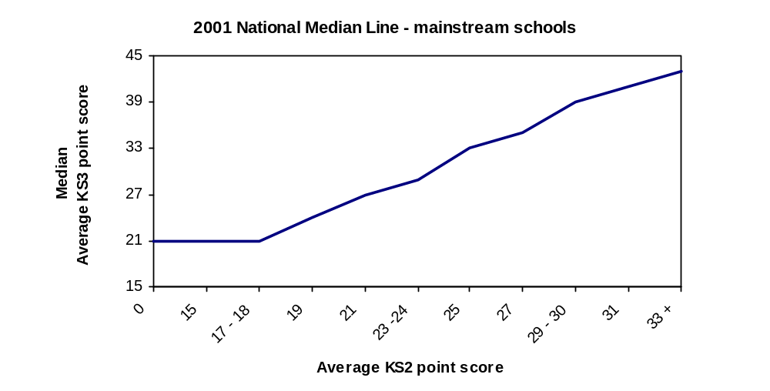
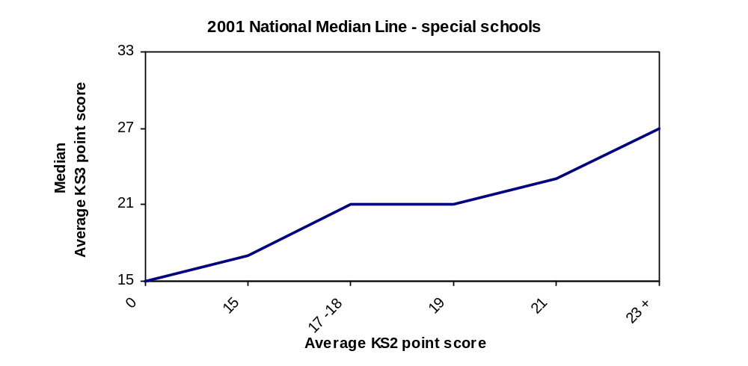

Calculation and presentation of a school’s value added measure (Key Stage 2 to Key Stage 3)
9. In the following illustrative example, school A has 4 pupils eligible for inclusion in the value added measure with Key Stage 2 and Key Stage 3 average point scores as shown. The median average point scores have been allocated according to the national median line for mainstream schools shown above and a value added score calculated for each pupil.
10. A school’s value added score is a simple average (arithmetic mean) of the value added measures for all pupils in the school. For a mainstream school, and using the median values shown in the graph above:

Pupil | Pupil’s KS2 average  point score | Pupil’s KS3 average  point score | Median KS3 average  point score for their  KS2 average | Pupil’s VA  Score
A | 25 | 36 | 33 | +3
B | 25 | 29 | 33 | -4
C | 27 | 35 | 35 | 0
D | 27 | 37 | 35 | +2

Total of all pupils’ value added scores = +1
Average value added score per pupil = +1 divided by 4 (the number of pupils) Schools value added score = +0.25 (presented as 100.3)
The score is rounded to one decimal place using normal rounding conventions and centred around 100.
Key Stage 3 to GCSE/GNVQ Value Added Measure
11. The ‘input’ and ‘output’ measures for the value added calculations are again based on the points awarded to pupils’ results. The points allocated to Key Stage 3 results are shown in the tables at paragraph 2 above.
Input measure (Key Stage 3 test results)
12. The input measure for each pupil will be calculated as the average point score achieved in the English, mathematics and science Key Stage 3 test results. For example, the average point score for a pupil achieving test Levels 4, 4 and 5 in each subject respectively would be:

27 + 27 + 33 = 29
3

13. If any Key Stage 3 results for a pupil are disregarded, the output measure will be calculated as the average of the remaining one or two results.

14. The following tables show how points are allocated to pupils’ GCSE/GNVQ results.

GCSE grade | GCSE points | GCSE (Short Course) points
A* | 8 | 4
A | 7 | 3.5
B | 6 | 3
C | 5 | 2.5
D | 4 | 2
E | 3 | 1.5
F | 2 | 1
G | 1 | 0.5

GNVQ grade | Full GNVQ | Part One GNVQ | GNVQ Language Unit
Intermediate Distinction | 30 | 15 | -
Intermediate Merit | 24 | 12 | -
Intermediate Pass | 20 | 10 | 3.5
Foundation Distinction | 16 | 8 | -
Foundation Merit | 12 | 6 | -
Foundation Pass | 6 | 3 | 2

15. Pupils for whom all results were disregarded at Key Stage 3 will be excluded from the value added calculations. Except for those pupils with at least one disregarded result which is disapplied at Key Stage 3 and at least one GCSE/GNVQ result – in such cases the pupil will be included in the calculation with an input score of zero.
Output measure (GCSE/GNVQ results)
16. We propose that the output measure for each pupil will be the total point score at GCSE/GNVQ, ‘capped’ at 10. That is, the sum of all points attained by a pupil in their best 10 GCSE (or equivalent) results. For example, a pupil who achieved, 3 Ds, 4 Cs, 3 Bs and 2 As at GCSE would have a point score of 56, i.e. the results in the 11th and 12th GCSEs at grade D have been disregarded. A full GNVQ is equivalent to 4 GCSEs, a GNVQ Part One is equivalent to 2 GCSEs and a GNVQ Language Unit is equivalent to 0.5 GCSEs.
Calculation of a pupil’s value added score
17. A pupil’s value added score will be based on comparing their GCSE/GNVQ performance with the median GCSE/GNVQ performance of other pupils with the same or similar prior attainment at Key Stage 3. The median value is the middle value - with half of the pupils having a ‘capped’ total GCSE/GNVQ point score at or below the median and half at or above the median.
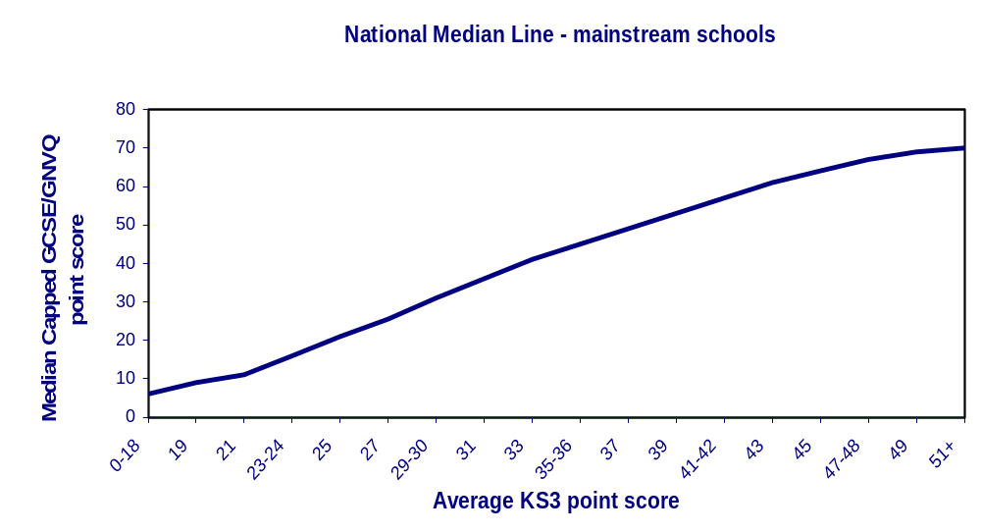
18. The graphs below give an illustration of the pattern of median ‘capped’ total GCSE/GNVQ point scores across the range of Key Stage 3 point scores nationally - joining the medians gives the ‘national median line’. There are two graphs: one shows median scores for pupils in maintained schools and the other shows median scores for pupils in special schools only. The lines shown below are examples based on 2001 data: in the 2002 exercise, corresponding lines will be derived from the national 2002 data.

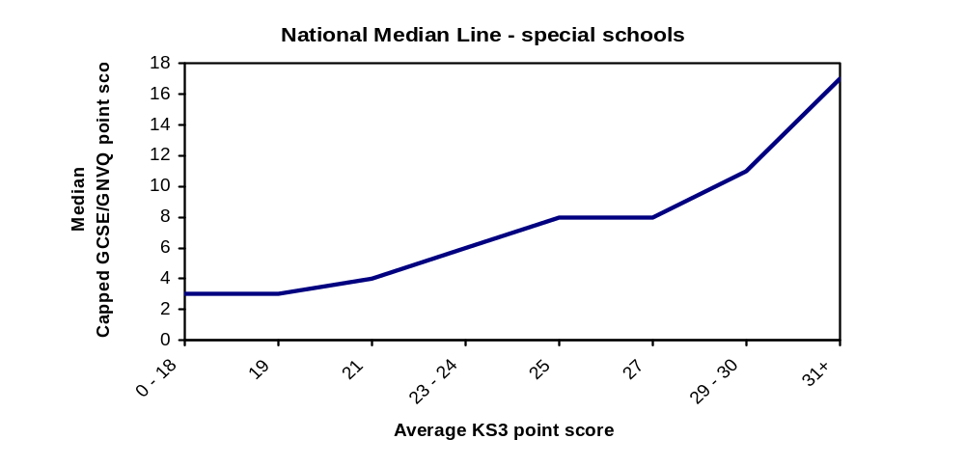
Calculation and presentation of a school’s value added measure (Key Stage 3 to GCSE/GNVQ)
19. In the following illustrative example, school B has 4 pupils eligible for inclusion in the value added measure with Key Stage 3 and GCSE/GNVQ average point scores as shown. The median average point scores have been allocated according to the national median line for mainstream schools shown above and a value added score calculated for each pupil.
20. A school’s value added score is a simple average (arithmetic mean) of the value added measures for all the pupils in the school. For a mainstream school, and using the illustrative median values shown in the graph above:
Pupil | Pupil’s KS3 average  point score | Pupil’s ‘capped’ GCSE/GNVQ  point score | Median ‘capped’ GCSE/GNVQ  point score for their  KS3 average | Pupil’s VA  Score
A | 29 | 32 | 31 | 1
B | 33 | 41 | 41 | 0
C | 33 | 38 | 41 | -3
D | 43 | 65 | 61 | 4

Total of all pupils’ value added scores = 2
Average value added score per pupil = 2 divided by 4 (the number of pupils)
School’s value added score = 0.5 (presented as 100.5)
The score is rounded to one decimal place using normal rounding conventions and centred around 100.
How the stability indicator is calculated
21. This will show, as a percentage, the proportion of pupils that have remained in a school between Key Stage 3 and GCSE/GNVQ and will be calculated by dividing the number of pupils who took both their Key Stage 3 and GCSE/GNVQ tests/examinations in the school by the total number of pupils included in the VA calculation. For example, if a school had 10 pupils in the value added calculation and only 7 took both their Key Stage 3 and GCSE/GNVQ tests and examinations in the same school then the stability indicator would be 70%.
Appendix 2
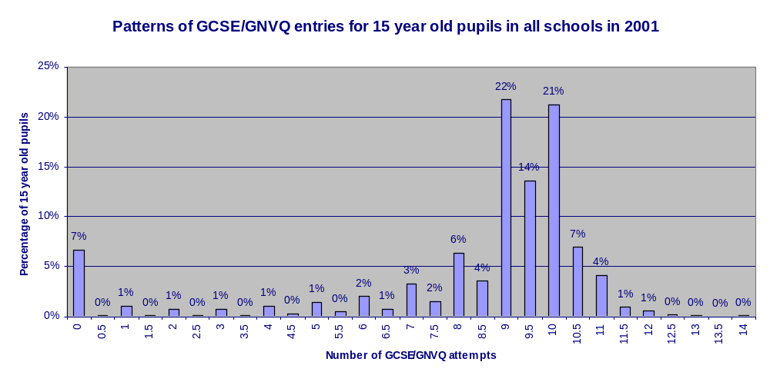
The graph above shows the percentage of 15 year old pupils in all schools attempting various numbers of GCSE/GNVQs. For example, 22 per cent of 15 year old pupils attempt 9 GCSEs or equivalent.

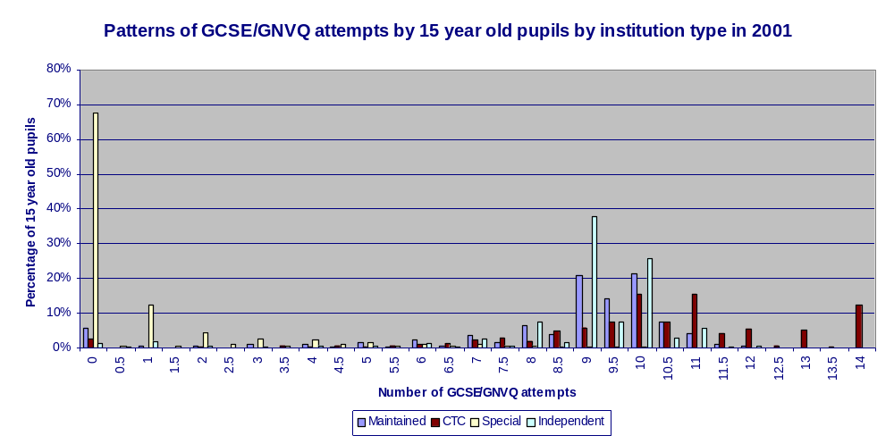

The graph above shows the patterns of GCSE/GNVQ attempts for 15 year old pupils by institution type. This identifies differing patterns of GCSE/GNVQ study between different institution types. For example, 21 per cent of 15 year old pupils in maintained schools attempt 10 GCSE or equivalent.

ANNEX D

PUBLICATION OF DATA ON STUDENTS AGED 16-18 IN
SCHOOLS AND FURTHER EDUCATION SECTOR COLLEGES

Summary
1. The Secretary of State proposes that the post-16 tables should continue to report the sum achievements of students at the end of two years of advanced study, but include 16 year olds who complete their studies early as well as 17 and 18 year olds.

2. This will mean that the 2002 tables will report the sum achievements over two years of 16-18 year olds in new general and vocational A level and Advanced Subsidiary qualifications, including new vocational A level double awards. Results in general and vocational A/AS will not be shown separately, but together in combined indicators only.
Your views
Q29. Do you agree that the tables should report the summative achievement of 16-18 year olds after two years of advanced study?
Performance of students in 2002 in general and vocational A/AS
3. We propose to publish the:
- number of 16-18 year olds on roll;
- average point score of 16-18 year olds entered for GCE and VCE A/AS over 2000/01 and 2001/02; and
- average point score per GCE and VCE A/AS entry.
4. As last year, results will not be divided between those entered for fewer than two A levels, and those entered for more than two A levels. Results in other specified advanced and intermediate vocational qualifications, and in the International Baccalaureate Diploma, will continue to be reported separately. Any students completing an Advanced GNVQ in 2001/2002 will have started before September 2000 and will not, therefore, be counted in the tables.
Your views
Q30. Do you agree that general and vocational A/AS should be reported together in combined indicators?
New UCAS tariff
5. As the new UCAS tariff will replace the old A level scoring system from Autumn 2002, the Secretary of State proposes that the GCE and VCE A/AS average points scores in the tables should be calculated using the new tariff from 2002.
Your views
Q31. Do you agree that the new UCAS tariff should be used in the calculation of the average A/AS point scores in 2002?
6. Points will be awarded to grades as follows:
GCE/VCE AS | GCE/VCE A level | VCE A level double award | Score
 |  | AA | 240
 |  | AB | 220
 |  | BB | 200
 |  | BC | 180
 |  | CC | 160
 |  | CD | 140
 | A | DD | 120
 | B | DE | 100
 | C | EE | 80
A | D |  | 60
B |  |  | 50
C | E |  | 40
D |  |  | 30
E |  |  | 20

Discounting
7. Where a student has gained a GCE AS and a GCE A level in the same subject over the two years being reported on, only the A level entry and result will count, unless the student fails to obtain a pass grade for the A level in which case the AS pass grade will be reported. Similarly, a VCE A level pass grade will discount a VCE AS in the same subject, while a VCE A level double award will discount a VCE A level in the same subject. There will be no discounting between GCE and VCE A/AS in similar subject areas.

8. Results will be reported in the tables on the basis students were eligible to claim at the time results are forwarded by the Awarding Bodies to the Department’s contractor in August.

BTEC National Diploma

9. BTEC National Diplomas are not yet scored under the new UCAS tariff and will, therefore, have to be reported separately from general and vocational A/AS for the time being.
10. Last year some schools and colleges reported that, where a student was studying an A level or AS with a BTEC National Diploma, it had the effect of deflating their average A/AS score per student. Ministers have decided therefore that this year, where students are studying general or vocational A/AS alongside a BTEC National Diploma, schools and colleges will be allowed to delete the student from their published A/AS results.
Part-time students
11. As last year, part-time students in colleges studying, for example, a general or vocational A level or AS in the evening or on day release should not be included. Colleges will be allowed to delete any such students from their results.
Advanced Extension Awards and key skills
12. The Secretary of State proposes to defer inclusion of Advanced Extension Awards and key skills taken post-16 from the tables until 2003. Advanced Extension Awards are not yet scored under the new UCAS tariff and cannot, therefore, be reported on a comparable basis with general and vocational A/AS this year. More flexible use of the key skills qualifications was introduced in Summer 2001 to enable greater tailoring to individual students’ needs. This points to deferring their inclusion until 2003 so that data on the full range of provision can be captured.
Combined booklets
13. The Secretary of State proposes, if possible, to combine the secondary and post-16 performance tables into a single publication this year reflecting the 14-19 phase of education. If technical difficulties prove insurmountable this year, then we would certainly wish to move to a single 14-19 publication in 2003.
Your views
Q32. Do you agree that the secondary and post-16 booklets should be combined into a single publication?
Q33. Do you have any other comments you would like to make about the post-16 tables?

ANNEX E

FUTURE CHANGES TO THE TABLES

1. In the recently launched Green Paper, Extending Opportunities, Raising Standards, the Secretary of State announced a number of proposals for future change to the performance tables to support our vision for the delivery of education to 14-19 year olds. Proposals include counting more vocational qualifications in the tables, recognising differing rates of progress and developing new post-16 indicators that show achievement of level 2 and level 3 by age 19 and provide a direct link with attainment of national targets.
2. These changes would be in addition to ongoing work to develop measures of value added across the tables and present considerable challenges. The Qualifications and Curriculum Authority have already started working with Ofsted and the Learning and Skills Council to place a value on a wide range of vocational qualifications on a scale equivalent to GCSE and A/AS, and are due to make their first report later in the year. In addition to the changes for 2002 already discussed elsewhere in this document, the mid-term plan for change is:
2003
Primary tables

- revise Key Stage 2 performance indicators to reflect 2004 targets
- introduce a measure of value added between Key Stage 1 and Key Stage 2
Secondary and post-16 tables
- count a wider range of vocational qualifications towards level 2 attainment at age 16
- revise level 2 performance indicators to reflect 2004 targets
- pilot a measure of value added between Key Stage 2 and level 2 attainment at age 16
2004
Secondary and post-16

- introduce a measure of value added between Key Stage 2 and level 2 attainment at age 16
- count a wider range of vocational qualifications towards attainment post-16
- introduce new post-16 performance indicators showing percentages attaining level 2 and level 3 at age 19
- pilot a measure of value added between level 2 attainment at 16 and level 3 attainment at 19.
If you have any comments on these developments or the timetable, you should write to the address at the front of this consultation document.
- The Green Paper Extending Opportunities, Raising Standards can be viewed on the Department’s website at http://www.dfes.gov.uk/14-19greenpaper. If you have any comments on the broader agenda discussed in the paper, you can reply on line or write to:
Jane Fox
DfES 14-19 Green Paper Consultation
Response Unit
Area 1B, Castle View House
East Lane
Runcorn WA7 2GJ

ANNEX G
SCHOOLS AND COLLEGE PERFORMANCE TABLES IN 2002
CONSULTATION
Please let us have your views on the proposals outlined in this consultation document by completing this questionnaire. You can add any additional comments in the space provided.

Please return your completed form by Friday 24th May to:

Sheena Vinod
Department for Education and Skills
Room 2AL
Sanctuary Buildings
Great Smith Street
London
SW1P 3BT

Tel : 020 7925 6782 Fax: 020 7925 5179

This document is available on the Internet at:
http://www.dfes.gov.uk/performancetables

Completed forms can be sent to the Department by clicking the ‘Submit’ button at the end of the online questionnaire.

Under the Code of Practice on open Government, your responses will be made available to the public on request, unless you indicate that you wish it to remain confidential.

Do you wish your comments to remain confidential?

Yes No

Thank you very much for taking the time to complete this questionnaire.
So that we can acknowledge receipt of your comments please fill in your details below.

Name:
Mr/Mrs/Miss/Ms/other
Organisation or representative group:
Address:

Postcode:
Email Address:

PUBLICATION OF DATA ON PUPILS IN PRIMARY SCHOOLS -
ANNEX A

Performance on pupils in Key Stage 2 tests

YOUR VIEWS

Please use the space below each question for any additional comments.

Q1. Do you agree that no change should be made to the performance information published in the primary school tables?
Agree Disagree

Q2. Do you agree that rates of pupil absence (authorised and unauthorised) should continue to be used in the primary school tables?

Agree Disagree

Q3. Do you agree that no change should be made to the contextual information provided in the primary school tables?

Agree Disagree

Q4. Are there any other issues relating to the primary school tables that you would like to raise?

Yes No

PERFORMANCE AND CONTEXTUAL DATA ON PUPILS WITH SPECIAL EDUCATIONAL NEEDS -
ANNEX B

Q5. Do you agree that no further changes should be made to the way the tables deal with pupils with special educational needs, beyond those that have been introduced so far?

Agree Disagree

Q6. Do you agree that plans for the future will sufficiently address problems in reporting on pupils with special educational needs?

Agree Disagree

Q7. Do you agree that P Scale type data should be collected and, subject to development of a satisfactory system of moderation, be used in Departmental publications?

Agree Disagree

PUBLICATION OF DATA ON PUPILS IN SECONDARY SCHOOLS - ANNEX C

Q8. Do you agree that Key Stage 3 results should be published as additional data columns within the secondary tables rather than as a separate publication?

Agree Disagree

Q9. Do you agree that pupils’ achievements in Key Stage 3 tests should be published for all maintained schools?

Agree Disagree

Q10. Do you agree that pupils’ achievements in Key Stage 3 tests should be published for those independent schools that participate in the National Curriculum process?

Agree Disagree

Q11. Do you agree that performance indicators showing the percentage of pupils achieving Level 5 or above at Key Stage 3 should be published in the proposed format?

Agree Disagree

Q12. Do you agree with the proposed methodology for calculating the Key Stage 2 to Key Stage 3 value added measure?

Agree Disagree

Q13. Do you agree that there should be no change to the percentage based indicators published on GCSE/GNVQ achievements?

Agree Disagree

Q14. Do you agree that the concession to maintained schools that admit pupils permanently excluded from other maintained schools should be retained?

Agree Disagree

Q15. Do you agree that a Key Stage 3 to GCSE/GNVQ measure should be published in the performance tables?

Agree Disagree

Q16. Do you agree with the proposed methodology?
Agree Disagree

Q17. Do you agree that the value added measure should be presented as a numerical figure centred around 100?

Agree Disagree

Q18. Do you agree that the total point score should be capped?
Agree Disagree

Q19. Do you agree that the cap should be set at ten GCSEs or the GNVQ equivalent, at least in the initial years? Agree Disagree

Q20. If not, at what level do you think the cap should be set?

Q21. Do you agree that the capped total point score should include English and mathematics as mandatory subjects from 2003?

Agree Disagree

Q22. Do you agree that the ‘stand alone’ average point score should be capped in line with the output score proposed for the Key Stage 3 to GCSE/GNVQ value added measure?

Agree Disagree

Q23. Do you agree that the value added measures should be suppressed in cases where coverage is less than 50% of the cohort?

Agree Disagree

Q24. Do you agree that a stability measure should be published for the Key Stage 3 to GCSE/GNVQ value added measure?

Agree Disagree

Q25. Do you agree that an additional column should be published showing a value added ‘band’ in the 2003 tables? If so, do you have views on how those bands should be defined?

Agree Disagree

Q26. Do you agree that we should continue to publish information on the performance of pupils in other vocational qualifications?
Agree Disagree

Q27. Do you agree that we should continue to publish rates of pupils absence from school?

Agree Disagree

Q28. Are there any other issues relating to the secondary school tables that you would like to raise?

Yes No

PUBLICATION OF DATA ON STUDENTS AGED 16-18 IN SCHOOLS AND FURTHER EDUCATION SECTOR COLLEGES - ANNEX D

Q29. Do you agree that the tables should report the summative achievement of 16-18 year olds after two years of advanced study?
Agree Disagree

Q30. Do you agree that general and vocational A/AS should be reported together in combined indicators?

Agree Disagree

Q31. Do you agree that the new UCAS tariff should be used in the calculation of the average A/AS point scores in 2002?

Agree Disagree

Q32. Do you agree that the secondary and post-16 booklets should be combined into a single publication?

Agree Disagree

Q33. Do you have any other comments you would like to make about the post 16 tables?

Yes No

Local education authorities are required to publish core performance and contextual data, provided by the DfES after verification with schools. They may also publish additional performance or contextual data to provide parents with further information on the performance of their schools and to set the core data in a local context.
The number of pupils eligible for assessment will include those who are absent from the tests or disapplied from National Curriculum assessment arrangements.
An improvement measure will not be published for special schools.
The number of pupils eligible for assessment will include those who are absent from the tests or disapplied from National Curriculum assessment arrangements.
Referred to in this and other performance tables documents as “15 year olds” (age immediately before the start of their final year of compulsory schooling).
Full Foundation and Intermediate GNVQs, Part One GNVQs and GNVQ Language Units are merged with GCSE results on the basis of equivalents between the two sets of qualifications set out in Appendix 1.
A pupil who achieves the minimum of one GCSE (Short Course) or one GNVQ Language Unit will continue to count as achieving at least 1 GCSE/GNVQ.
16, 17 and 18 on 31 August 2001.
On 17 January 2002 in schools, at the start of the Spring term 2001 in colleges.
Each AS counts as half an entry and each VCE A level double award as two entries for this purpose.
BTEC National Diploma or C&G Diploma of Vocational Education at national level.
BTEC First Diploma or C&G Diploma of Vocational Education at intermediate level.

