Wellington House
133-155 Waterloo Road
London
SE1 8UG

Tel: 02 07 972 2000
Direct Line: 02 07 972 4237/4346


1 October 2003

DRAFT REGULATIONS AND GUIDANCE FOR CONSULTATION: GET IT SORTED: PROVIDING EFFECTIVE ADVOCACY SERVICES FOR CHILDREN AND YOUNG PEOPLE MAKING A COMPLAINT UNDER THE CHILDREN ACT 1989

Dear Colleague,

Please find enclosed a copy of the consultation draft Regulations and guidance for advocacy for children and young people making or intending to make a complaint. The draft Regulations and guidance when finalised will implement the new duty under the Adoption and Children Act 2002 on local authorities to make arrangements for the provision of advocacy to children and young people making or intending to make a complaint under the Children Act 1989.

We are sending five copies of this document to local authorities. Please forward copies to your children’s complaints officer, listening to children officer, children’s rights officer (or equivalent) and Head of Children’s Services. We are also sending copies direct to a number of stakeholders.

Although the Regulations and guidance will not be finalised until February 2004, local authorities should begin to prepare for implementation now. The finalised Regulations and guidance will come into effect in April 2004. A children and young people’s booklet explaining the changes will be issued at the same time.

This guidance is specifically about the provision of advocacy services. It is not about other changes to the complaints procedure.

You may be aware that the Adoption and Children Act 2002 made other changes to the Children Act 1989, which:

- enable time limits to be set for the making of representations including complaints;
- enable an “informal” initial resolution stage, without involving an independent person, to be introduced for complaints involving looked-after children and children in need;
- enable the scope of the Children Act 1989 complaints procedure to be extended to certain functions under part 4 (care and supervision) and part 5 (protection of children) of the Act; and;
- enable the local authority functions under the Adoption and Children Act 2002 about which a complaint may be made under the Children Act complaints procedure to be specified in regulations.

These changes will be dealt with in separate Regulations and guidance and will also be subject to consultation.

How to respond
(see also How to Use this Consultation Document at the front of the guidance)

The consultation runs from 1st October to 31st December 2003. Comments must reach the Department by 31st December.

Extra copies of the draft Regulations and guidance and the response questionnaire can be downloaded from www.dfes.gov.uk/consultations or alternatively, hard copies can be requested from Prolog by quoting reference number DfES/0492/2003:

Prolog
DfES Publications
PO Box 5050
Sherwood Park
Annesley
Nottingham NG15 0DJ

Tel: 0845 6022260
Fax: 0845 6033360
Email: dfes@prolog.uk.com

Please use the enclosed consultation response questionnaire. Completed questionnaires with any other comments should be returned to the address below by 31st December 2003.

Barbara Herts
Children’s Participation section
Room 114
Wellington House
133-155 Waterloo Road
London SE1 8UG

Responses and general queries can also be sent via email to: advocacyconsultation@doh.gsi.gov.uk

For any general queries about the document, please contact Barbara Herts, Tel: 02 07 972 4237 or Bill Jobson Tel: 0207 972 4346.

Regional Events

We will be running a series of regional events over the next few months to help local authorities prepare for the coming into force of the Regulations and guidance.

Yours sincerely,
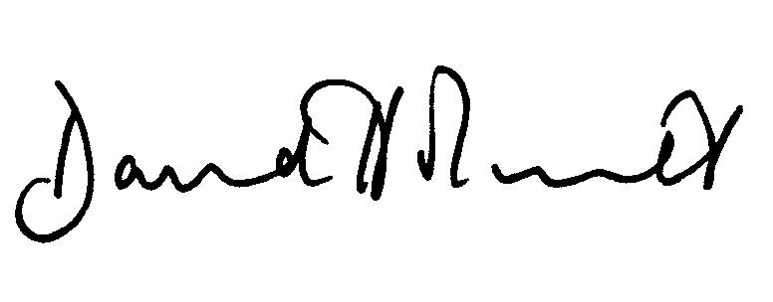
David Holmes
Divisional Manager
Placement, Permanence and Child Protection
Department for Education and Skills

