Children’s use of mobile phone text messaging and its impact on literacy development in primary school.

Clare Wood, Emma Jackson, Beverly Plester & Lucy Wilde
Coventry University

Background
The fastest growing market of mobile phone users has been reported to be pre-teen children and the Ofcom Media Literacy Audit (2006) of over 1500 UK children reported that 49% of 8-11 year olds had their own mobile phone. However, whilst the expanding availability of this technology is apparent, its effects upon its users are not as clear. Questions have been raised about the effect of text messaging on standard literacy, and answered largely through speculation and anecdote. Detailed, objective answers to this question have important implications for the education of school age users of mobile technologies.

There has been much media speculation regarding the effect that texting may have upon children’s literacy (see Crystal, 2008). Many have reported unintentional intrusions of abbreviations used in texting (so-called ‘textisms’) in inappropriate contexts, an issue particularly cited in relation to children’s school work (BBC, 2005). Thurlow (2006) has reported a critical discourse analysis of over 100 media articles focused on texting, drawing out several themes of high profile concern to the journalists. The flavour of these was decidedly negative and often exaggerated, published with little regard to the actual uses of text messaging. This gives cause for concern, as influential media articles could be used to inform educational policy decisions in the absence of empirical evidence.

We argue that texting allows children to experiment with language in an informal and playful manner. Indeed, Crystal (2006) describes this light hearted use of language as ludic, language play freed from the heavy constraints of standard language. Experimentation may enhance the development of key skills involved in the acquisition of literacy. Texting sees children explicitly demonstrating an understanding of how words can be manipulated, segmented and blended to allow for succinct and successful communication. Indeed, many of the abbreviations that children use when texting are phonological reductions, such as ‘wot’ and ‘nite’. This form of abbreviation suggests the role that phonological awareness – awareness of the sound structures in spoken language - may play in mastering text language. Phonological awareness is consistently associated with success in literacy development (Adams, 1990). Arguably, the word play that children have in texting offers a rudimentary and informal learning platform from which they can develop sensitivity, confidence and flexibility with phonology and orthography, which may in turn benefit developing literacy skills.

A further factor with bearing on literacy attainment is that text messaging, in whatever form, provides children with additional exposure to the written word. Cipielewski and Stanovich (1992) demonstrated that children’s reading ability at around the age of 10-11 years was predicted by a measure of text exposure after earlier reading ability and orthographic decoding skill were accounted for (also see Stainthorp, 1997). It is possible that text messaging provides young children with an important increase in exposure to text, and also improves their motivation to engage with written communication without the constraints of school expectations.

In terms of spelling, although textisms may be orthographically unconventional in one sense, they do demonstrate an awareness of alternative legitimate orthographic spellings within English (e.g. ‘ite’ is pronounced the same as ‘ight’). Moreover, it is important to acknowledge that exposure to misspellings does not necessarily have a negative effect on the subsequent learning of correct spellings in children (Ehri, Gibbs & Underwood, 1988; Dixon & Kaminska, 2007). Although textisms are ‘misspellings’ in a conventional sense, they are phonologically and orthographically ‘acceptable’ forms of written English, and for children there is no evidence that knowledge or use of them would cause interference with their learning of conventional written English.

Previous research by the applicants (Plester, Wood & Bell, 2008; Plester, Wood & Joshi, 2009) has shown positive associations between children’s knowledge of text abbreviations and their performance on standard measures of academic achievement and literacy. Initially, we believed that this may be attributable to the mediating variable of phonological awareness. That is, good readers are known to have good phonological awareness, and this skill appears to underpin many of the textisms commonly used. However, Plester et al. (in press) found that even when we control for children’s phonological awareness, their knowledge of text abbreviations is explaining new variance in their literacy scores.

The work by Plester and Wood is unique in exploring the educational impact of text messaging on children’s literacy. However, a weakness in the existing studies is that they do not access cause and effect directly and the measure of ‘textism knowledge’ used is only a proxy for the textisms actually used by the children when they use their mobile phones. This study overcomes both these limitations by directly assessing the effects of giving young children mobile phones.

Research Question
How does text messaging impact on primary school children’s reading and spelling development?

Methodology
This study conducted a pre-post test analysis of the impact of text messaging on a group of children who have not had access to a mobile phone before. Sixty-one 9-10 year-old-children who did not own a mobile phone were recruited to the study. All children were initially assessed on IQ, reading, spelling and phonological awareness using standard measures (Wechsler Abbreviated Intelligence Test, British Ability Scales and Phonological Assessment Battery).

Half the children in each school were randomly allocated to a ‘mobile phone’ group and the remaining children to a comparison group (Table 1 summarises the characteristics of the children in the two groups). This method of random allocation from within a school was used to control for the possible confounding effects of tuition methods (i.e. some teachers / schools teach differently to others, and this could contribute to the results obtained).

The ‘mobile phone’ children were given a phone every Friday afternoon to take home and use to send text messages. Each Monday morning, the phones were collected back in and their text messages collated. Each Friday, the reading and spelling of both groups of children was assessed. At the end of the school term the children’s reading, spelling and phonological awareness was reassessed (post-test). Children in the control group had exactly the same experience of participating in the study (e.g. weekly testing and one-to-one contact with the researcher), except that they did not receive a mobile phone over the weekend. This was intended to reduce as far as possible the contribution of any Hawthorne effects to the results (i.e. being placed under close scrutiny can result in improved performance). All the children in the control group were allowed access to the mobile phones after post-testing, so that they could also have the experience of using them.

At the conclusion of the study two children were not available for post testing, leaving a final sample of 59 children: 29 in the mobile phone group and 30 in the control group.

Results
Based on the completed data from the 59 children assessed during the project, we have completed a simple analysis to whether there is any evidence of improved literacy skills in the mobile phone group compared to the control group. Descriptive data on the two groups of children at pre-test is presented in Table 1 below. It can be seen that overall the groups are quite similar, with average IQ towards the lower end of the normal range and with somewhat more variation in ability (and slightly lower ability on average) in the mobile phone group than in the control group.

Table 1: Descriptive Statistics on Pre-Test Measures by Group
(SD in parentheses).

Assessment | Control Group (N=31) | Mobile Phone Group (N=30)
Age in months | 116.1 (5.6) | 115.3 (5.2)
IQ | 90.9 (12.2) | 90.6 (13.1)
Reading | 147.4 (19.5) | 134.9 (24.1)
Spelling | 114.1 (18.3) | 107.1 (23.4)
Rhyme Detection | 18.4 (2.8) | 17.4 (4.5)
Spoonerisms | 21.0 (6.1) | 18.1 (6.3)
Nonword Reading | 16.3 (3.6) | 14.7 (4.5)
Rapid Picture Naming | 98.1 secs (20.2) | 100.6 secs (20.9)
Alliteration Fluency | 12.3 (3.1) | 11.2 (3.4)
Rhyme Fluency | 11.9 (3.0) | 9.5 (3.2)
Semantic Fluency | 22.7 (4.9) | 19.4 (4.8)

To obtain a measure of improvement in literacy skills, we subtracted the children’s pre-test scores from their post-test scores and used this as a rough indicator of how far they had progressed on each skill during the academic term. We then compared the children in the ‘mobile phone’ group to the control children on each measure, with the prediction that for each variable there would be significantly greater improvement for the children in the mobile phone group compared to the control group.

The overall pattern of results is pleasing: on every measure the children who were given mobile phones were found to outperform the children who were in the control condition, although it should be noted that because of the limited sample in the present study, not all these differences reached the statistically significant level of p=.05.

Figure 1 shows the experimental group having slightly higher mean growth in reading than the children in the control group, although this was not statistically significant (p=.225).

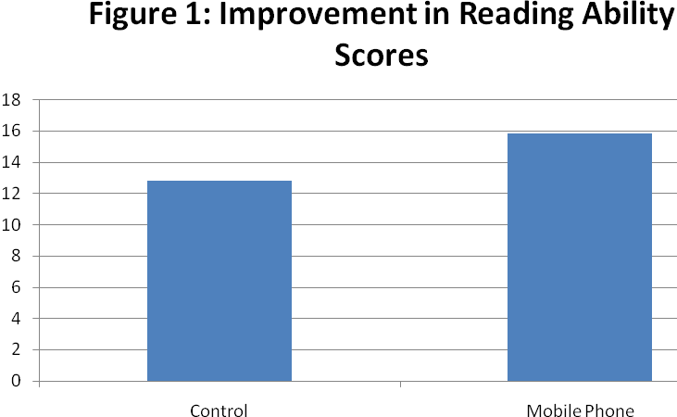

Figure 2 shows an advantage for the control group with respect to amount of growth in spelling performance, but this different also failed to reach statistical significance (p=.069).

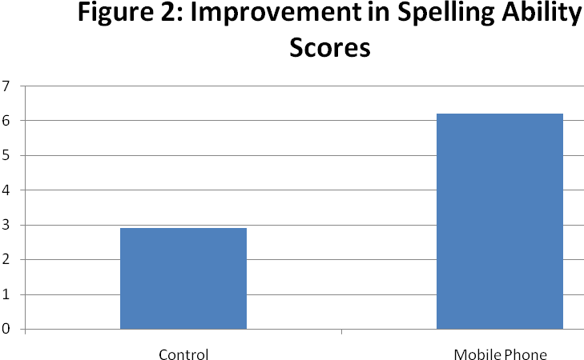

Figure 3 shows that for rhyme detection, the mobile phone group showed a small overall improvement over the course of the year, whereas the control group showed a small decline, but again this different failed to reach statistical significance (p=.099). These scores may be somewhat limited by some of the children showing extremely good performance on the measure.

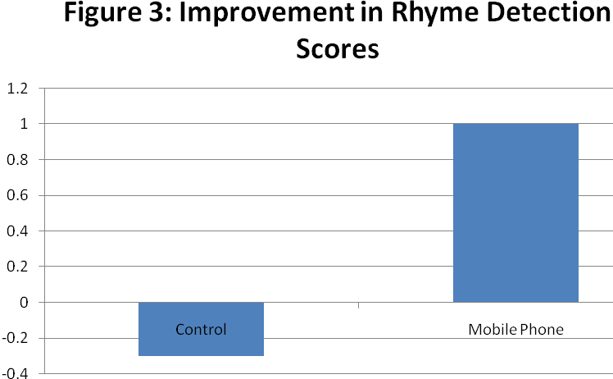

Figure 4 shows the results with respect to spoonerism performance – a complex test of phonological awareness, which we have previously found to be strongly associated with texting performance and use of text abbreviations in particular. Here we can see that children in the mobile phone group were showing significantly greater improvement in the ability to produce spoonerisms compared to the control group (p=.045).

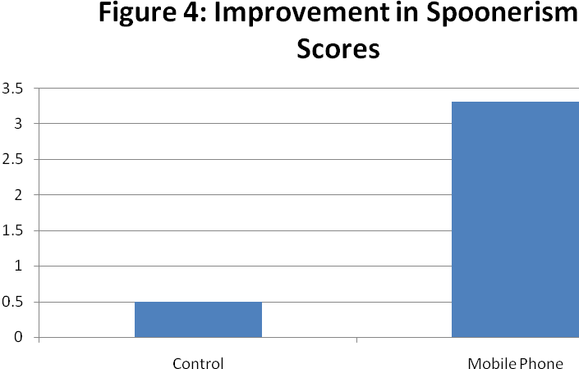

Figure 5 shows the children’s improvement on non-word reading: a skill that requires them to apply a purely ‘phonic’ approach to decoding text. On this measure we see a small improvement for both groups with a slight advantage for the mobile phone group, although this difference was not statistically significant (p=.093).

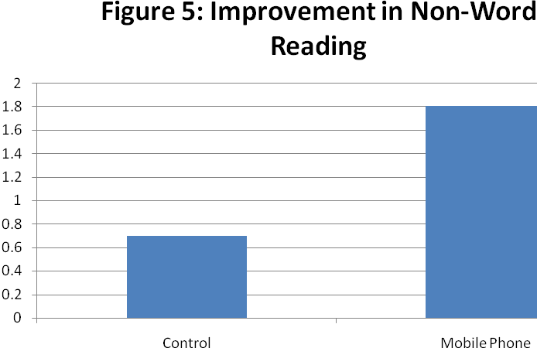

Figure 6 shows the amount of improvement in rapid picture naming (phonological retrieval and articulation) during the academic term. The graph shows slower naming speeds as negative values, and faster naming speeds as positive values, to enable comparison with the other figures in this report. The mobile phone group showed a slight improvement on this measure whereas the control group on average maintained their level of performance (showed by a zero gain), but the difference was not statistically significant (p=.235).

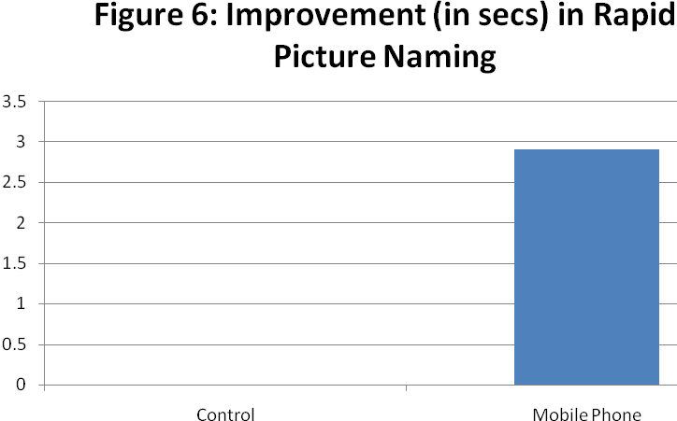

Figure 7 shows improvement in performance on the three fluency subtests of the Phonological Assessment Battery: alliteration fluency, rhyme fluency and semantic fluency. These tasks require the children to generate as many words as they can think of that are either phonologically related to a target word (e.g. the might be asked to think of words that rhyme or start with the same sound) or that are semantically related to a target word. It can be seen that the amount of improvement is slightly better for the mobile phone group than for the control group on all three measures. Statistical analyses reveals that the improvement in rhyme fluency (p=.024) and semantic fluency (p=.015) are statistically significant, although the difference for alteration fluency was not (p=123).

Figure 7: Improvement in Fluency Scores

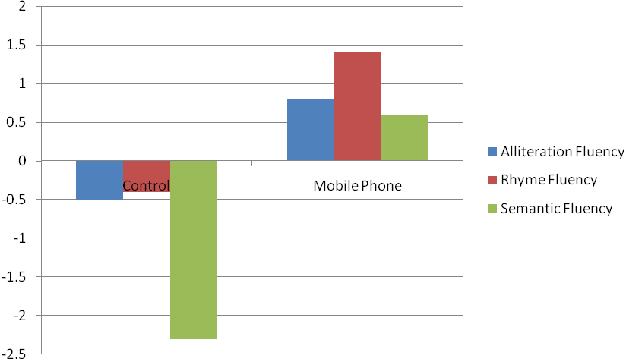

Each week we collected data on the number of text messages the children sent and received, and we were interested in the extent to which there may be associations between these two variables and the amount of improvement the children showed from pre to post test on each measure. Table 2 below summarises this analysis which focussed on the messages sent and received at the beginning, middle and end of the study. This was done because it was noted that there was an initial peak of use at the onset of the study, steady use in the middle but the phones were used less frequency at the end of the study.

The correlations show that the number of messages sent and received appears to be most closely associated with improvement in reading and spelling ability, rather than in phonological awareness.

Table 2: Spearman Correlation Coefficients showing the strength of association between literacy improvement and numbers of text messages sent and received at the beginning, middle and end of the study (* = p<.05).

 | Week 1  Sent | Week 1  Rec’d | Week 5 Sent | Week 5 Rec’d | Week 9 Sent | Week 9 Rec’d
Reading | .339* | .170 | .548* | .416* | .120 | .132
Spelling | .302 | .398* | .442* | .371* | .395* | .273
Rhyme | -.172 | -.124 | -.086 | -.227 | .267 | -.038
Spoonerisms | .220 | .154 | -.132 | -.070 | .266 | .173
NW Reading | .015 | -.103 | .091 | .187 | -.275 | -.344
Rapid Naming | -.168 | .015 | .233 | .147 | -.315 | -.155
Alliteration Fluency | .176 | .065 | .023 | .042 | .291 | .322
Rhyme Fluency | .194 | .350* | -.071 | -.154 | -.033 | -.133
Semantic Fluency | .124 | .021 | -.230 | -.264 | .127 | .272

Practical Issues
The first batch of data (Summer Term of 2008) acted as a pilot to identify a range of issues associated with this type of work. The first of these related to recruitment of children. Most schools that we approached were interested but unable to take part because of a ‘no phones on campus’ policy which meant that even the limited handing out and receiving phones on school premises was not possible. Other schools were reluctant to participate because of the nature of the study itself (i.e. the ‘promotion’ of texting). This meant that we were only able to recruit 21 children during that term. However, we have since been able to engage the schools in dialogue about the research, and in the cohort of children tested in Autumn 2008 there were 40 children, making a total sample of 61. Some schools are now approaching us to participate in the study, so we are going to continue the study for a further term in order to expand the sample. This will enable us to conduct more conservative and thorough statistical analyses of the data. We will provide a copy of the final report for Becta’s website as soon as this is available.

Conclusion
Overall the results would suggest that text messaging on mobile phones, albeit in a limited way (i.e. for ten weekends only) does appear to impact on children’s literacy skills. In particular, the strongest effects were observed in terms of the children’s phonological awareness development and ability to generate semantically associated words. This would suggest, as we have previously suggested, that text messaging (though the use of textisms) would appear to be a mechanism through which phonological skills can be developed. The gains in reading and spelling ability observed appear to be most closely associated with exposure to print (i.e. the volume of messages sent and received).

The important message to take away from this research is that children’s texting behaviour should not necessarily be a cause for concern. Texting presents children with self and peer-initiated opportunities to engage with print, practice conventional spellings and create alternative spellings and explore their own phonological understanding in a non-judgemental context. Parents and teachers can capitalise on the children’s enjoyment of such language play through designing and contributing to such activity.

References
Adams, M..J. (1990). Beginning to Read: Thinking and Learning about Print. Cambridge, Mass.: MIT Press.
Cipielewski, J and Stanovich, K. E. (1992) Predicting growth in reading ability from children's exposure to print. Journal of Experimental Child Psychology, 54, 74-89.
Crystal, D. (2008). Txtng: The Gr8 Db8. Cambridge: Cambridge University Press.
Crystal, D. (2006). Language and the Internet (2nd Ed.). Cambridge: Cambridge University Press.

Dixon, M. and Kaminska, Z. (2007). Does exposure to orthography affect children's spelling accuracy? Journal of Research in Reading 30, 184–197.
Ehri, L. C., Gibbs, A. L. and Underwood, T. L. (1988). Influence of Errors on Learning the Spellings of English Words. Contemporary Educational Psychology, 13, 236-253.
Ofcom (2006). Media Literacy Audit: Report on media literacy amongst children. http://www.ofcom.org.uk/advice/media_literacy/medlitpub/medlitpubrss/children/ Last accessed 2 January 2008.
Plester, B. Wood, C., & Bell, V. (2008). Txt msg n school literacy: does texting and knowledge of text abbreviations adversely affect children’s literacy attainment? Literacy, 42, 137-144.
Plester, B., Wood, C. & Joshi, P. (2009). Exploring the relationship between children’s knowledge of text message abbreviations and school literacy outcomes. British Journal of Developmental Psychology, 27,145-161..
Stainthorp, R. (1997) A Children's Author Recognition Test: a useful tool in reading research. Journal of Research in Reading, 20 (2), 148-158..
Thurlow, C. (2006). From statistical panic to moral panic: The metadiscursive construction and popular exaggeration of new media language in the print media. Journal of Computer-Mediated Communication, 11(3), article 1. http://jcmc.indiana.edu/vol11/issue3/thurlow.html Last Accessed 16 April 2007

