0`
Contents

DELIVERING
SUCCESS THROUGH EXCELLENCE

An Analysis of the Performance of DEL Programmes and Provision

(The 4th Annual Report)

Prepared by: Analytical Services, Department for Employment and Learning

October 2008

Executive Summary 4

Chapter 1: Introduction 25

Chapter 2: Context for Analysis 28

Chapter 3: Assessing Performance 33

The Skills Agenda 33
Trends in Key Skills Indicators 40
The Employment Agenda 41
Trends in Key Employment Agenda Indicators 45
The Innovation Agenda 46
Chapter 4: Higher Education 50
Qualifications 51
Enrolments 55
Non-continuation 61
Trends in Key Higher Education Indicators 65

Chapter 5: Higher Education in Further Education Colleges 67

Qualifications 67
Enrolments 70
Retention / Achievement 74
Trends in Key Higher Education in Further Education Indicators 77
Chapter 6: Further Education 79

Qualifications 81
Enrolments 83
Retention / Achievement 87
Trends in Key Mainstream Further Education Indicators 94
Chapter 7: Training for Success / Programme-Led Apprenticeships 96

Chapter 8: ApprenticeshipsNI 104

Chapter 9: Bridge to Employment 111

Trends in Bridge to Employment 112
Chapter 10: Essential Skills 113

Qualifications 113
Enrolments 116
Retention / Achievement 119
Trends in Key Essential Skills Indicators 122
Chapter 11: Moving People Into Employment 123

Performance in Moving People into Work 124
Steps to Work 125
Economic Inactivity 127
Trends in Key Employment Indicators 129
Chapter 12: Innovation and Knowledge Transfer 131

Higher Education Business and Community Interaction Survey 133
The Connected Programme 135
Trends in Key Innovation indicators 138
Summary 139

Annex 1: DEL Quality and Performance Action Plan 141

Annex 2: What Factors Contribute to Successful Student Outcomes from Further Education – An Econometric Analysis 142

Executive Summary

- The Department’s skills, employment and innovation programmes are key drivers of sustainable economic growth and shared prosperity – as recognised in the Northern Ireland Economic Strategy. The programmes are delivered through a diverse network of providers ranging from colleges and universities to the Employment Service, training organisations and community and voluntary groups.

- The Department is committed to ensuring that the provision it funds is of a high quality, and that those who provide these services on its behalf commit to high performance standards.

- This report, the fourth in the ‘Delivering Success through Excellence’ series, provides a detailed (quantitative) analysis of the Department’s performance across its programmes and provision. It is underpinned by the principle that measuring and benchmarking performance is an essential step towards improving quality. The report’s central reference point is the Department’s Programme for Government 2011-2015 commitments (outlined in Chapter 1) and its key strategic goals for skills, employment and innovation / R&D. It examines performance against those high level commitments drilling down into programme areas. The report includes national and international benchmarking, where possible. The Department is keen to develop this aspect of its performance analysis and has taken steps to support the development of benchmarking in future reports.

- The report is based on the latest available data at the time of the report’s production. In the context of skills programmes this will, in most cases, relate to 2011/12 academic year data. When reporting on long term trends the report seeks to use ten years but this is not possible or relevant in all cases, for example, where a programme of activity did not exist or the relevant baseline is more recent (e.g., Programme for Government). The report is complemented by an Action Plan which seeks to respond to the specific issues raised here and to enhance further the performance and, ultimately the quality of the Department’s sponsored programmes (See Annex A).

Key Findings

- In terms of the external environment, the downturn continues to have a significant impact on the economic, demographic and social backdrop for the Department’s provision. While there are some signs of tentative recovery in a number of sectors, particularly those that are export focused, the underlying economic picture in Northern Ireland remains challenging. Overall, Northern Ireland can expect limited growth through 2013, according to independent forecasts. The depressed labour market presents significant challenges for the Northern Ireland Employment Service in particular. The numbers of people claiming Jobseeker’s Allowance has risen from a pre-recession low of around 23,000 (September 2007) to over 65,000 (December 2012) – a rise of over 40,000. However, more recently the claimant count has decreased by almost 3,000 since the start of 2013. This is the most sustained fall in unemployment claimants since August 2007. Nevertheless, the latest claimant count rate is higher than the UK rate of 4.2% and is the highest of the UK regions.

- While the Northern Ireland skills profile has improved steadily over the last decade, gaps remain when compared to the best performing regions and nations. This reflects a legacy of historical educational underachievement and of outward migration of those who are more highly skilled as they seek to capitalise on economic opportunities elsewhere. The Department’s Skills Strategy – ‘Success through Skills – Transforming Futures’ recognises that transformational change is required if Northern Ireland is to become internationally competitive. ‘Transforming Futures’ sets out four long term (up to 2020) strategic goals that underpin the Department’s skills policy and complement its Programme for Government commitments. While significant work remains to be done to deliver both the ‘Transforming Futures’ skills goals and a number of the Department’s new Programme for Government commitments, particularly around Science, Technology, Engineering and Mathematics (STEM), this report shows that a positive start has been made in a number of areas (see table E1 for summary details).

Table E1: Trends in Key Skills Indicators
Indicator | Recent Change | Long-Term Trend
Percentage of those people in employment with Level 2 skills and above* | Between Q1 2012 and Q1 2013, it is estimated that the percentage of people in employment with level 2 skills and above has decreased by 1.1 percentage points, and now stands at 74.2%. (Goal: to attain at least 84% by 2020) | Since the baseline in 2008, it is estimated the percentage of those people in employment with Level 2 skills and above has increased by 2.5 percentage points to 74.2% in Q1 2013. (Goal: to attain at least 84% by 2020)
Percentage of those people in employment with Level 3 skills and above* | Between Q1 2012 and Q1 2013, it is estimated that the percentage of people in employment with level 3 skills and above has decreased by 1.8 percentage points, and now stands at 57.3%.(Goal: to attain at least 68% by 2020) | Since the baseline in 2008, it is estimated the percentage of those people in employment with Level 3 skills and above has increased by 2.1 percentage points to 57.3% in Q1 2013. (Goal: to attain at least 68% by 2020)
Percentage of those people in employment with Level 4-8 skills and above* | Between Q1 2012 and Q1 2013, it is estimated that the percentage of people in employment with level 4-8 skills and above has increased by 1.8 percentage points, and now stands at 36.2%.(Goal: to attain at least 44% by 2020) | Since the baseline in 2008, it is estimated the percentage of those people in employment with Level 4-8 skills and above has increased by 3.2 percentage points to 36.2% in Q1 2013. (Goal: to attain at least 44% by 2020)
Percentage of those qualifying from NI HEIs in graduate and post graduate level courses in STEM subjects | Between 2010/11 and 2011/12 the percentage of those qualifying from NI HEIs in graduate and post graduate level courses in STEM subjects remained broadly unchanged, increasingly marginally from 18.1% to 18.5%.(HE Strategy Target: to attain at least 22% by 2020) | Between 2008/09 and 2011/12 the percentage of those qualifying from NI HEIs in graduate and post graduate level courses in STEM subjects remained broadly unchanged, increasing marginally from 18.0% to 18.5%. (HE Strategy Target: to attain at least 22% by 2020)
Deliver over 200,000 qualifications at Level 2 and above | In 2011/12 academic year there were 73,247 Level 2 and above full qualifications gained across mainstream FE, Essential Skills, funded Departmental Training programmes, and HE, including HE in FE. This is growth of 11% from the qualifications gained in 2010/11. | Almost 140,000 qualifications at Level 2 and above have been delivered in the first two academic years of this PfG commitment (2010/11 and 2011/12) – well in excess of the target of 105,000 for the two years. This suggests good progress is being made towards achievement of the overall target.

* The three skills of people in employment indicators set out above are based on Labour Force Survey (LFS) data. The LFS is a sample survey which is subject to considerable volatility; caution should be applied in reading too much into its short term movements.

- Employment remains a key issue for the Northern Ireland economy and society. Northern Ireland’s employment rate lags considerably below the UK average and most, if not all, UK regions. The desire to increase employment is central to the Northern Ireland Economic Strategy which sets a longer term strategic goal of increasing the employment rate here so that, by 2030, it exceeds the average for the UK regions. In moving towards that goal, the current PfG sets out commitments in relation to job creation and to help people into employment. Of particular relevance to DEL is the continued focus on encouraging those currently out of work to move towards and into employment where that is appropriate. Again an encouraging start has been made towards delivering the PfG target of moving 114,000 benefit claimants into employment (further details are set out below)

- Economic success is increasingly dependent on innovation - through research and development and knowledge transfer - to drive productivity and competitiveness. The higher education and further education sectors have the potential to significantly affect the level of innovative capacity through their role as knowledge-generators. Higher Education Research and Development (HERD) in Northern Ireland is broadly on a par with the UK average. However, while the UK HERD is also close to average EU spend, it is far from being a world leader.
Higher Education (Chapter 4)

- There has been good performance in relation to qualifications achieved at the NI HEIs and, looking to the future, the long-term increase in enrolments coupled with a decrease in HE non-continuation rates bodes well. NI continues to perform better on widening access indicators than the UK as a whole. Nevertheless work remains to be done on increasing the proportion of enrolments in STEM areas at HE, and variability remains across subject areas in terms of non-continuation rates. The Department plans to monitor these issues closely particularly as it considers the potential impact of fee differentials that exist across the UK and beyond

Table E 2: Trends in key Northern Ireland Higher Education Institution Indicators

Indicator | Recent Change | Long-Term Trend
Qualifications | The number of student qualifiers at NI HEIs has increased over the year to 2011/12 by 8%, from 14,960 in 2010/11 to 16,100 in 2011/12. | The number of student qualifiers at NI HEIs has increased by almost one-quarter (+23%) between 2001/02 and 2011/12.
‘Narrow’ STEM Qualifications | The number of ‘narrow’ STEM qualifications gained at Northern Ireland Higher Education Institutions over the last year has increased by 10% to 2,975 in 2011/12. ‘Narrow’ STEM represents 18.5% of overall qualifications compared to a Skills Strategy goal of at least 22% by 2020. | The number of ‘narrow’ STEM qualifications gained at Northern Ireland Higher Education Institutions has increased by 9% between 2001/02 and 2011/12.
Overall Enrolments | Enrolments at NI HEIs remained at a similar level in 2011/12 compared to 2010/11 – around 52,000. | Enrolments at NI HEIs grew by 10% between 2001/02 and 2011/12.
Widening Access | The proportion of young full-time first  degree entrants to NI HEIs by National Statistics Socio-Economic Classification (NS-SEC) 4,5,6 & 7 in 2011/12 was 39.1%, the same as the position of 39.1 % in 2010/11. | Between 2002/03 and 2011/12 the proportion of young full-time first degree entrants to NI HEIs by (NS-SEC) Classes 4,5,6 & 7 has decreased from 41.3% to 39.1%.
‘Narrow’ STEM Enrolments | ‘Narrow’ STEM enrolments at NI HEIs decreased by 2% over the year to 10,930 in 2011/12. | ‘Narrow’ STEM enrolments at NI HEIs have increased by 4% between 2001/02 and 2011/12.
Non-continuation | The proportion of all full-time first degree entrants to NI HEIs in 2010/11 who were no longer in HE in 2011/12 was 6.0%, this compares favourably with a rate of 8.3% in the previous year. | There has been an improvement in the proportion of all full-time first degree entrants to NI HEIs who were no longer in HE one year later over the ten year period between 2001/02 (8.0%) and 2011/12 (6.0%).

Higher Education in Further Education (Chapter 5)

- There has been robust performance in relation to HE in FE qualifications in recent years, including the key ‘narrow’ STEM areas. Encouragingly, ‘narrow’ STEM enrolments are up 16% and retention and achievement have increased over the last year. In addition, over recent years HE in FE has increased its percentage share of enrolments and qualifications from the more deprived areas in Northern Ireland

Table E 3: Trends in key Northern Ireland Higher Education in Further Education Indicators

Indicator | Recent Change |  | Long-Term Trend
Qualifications | The number of full qualifications achieved from HE in FE provision has increased over the year to 2011/12 by 10%, from 4,061 in 2010/11 to 4,466 in 2011/12. |  | The number of full qualifications achieved from HE in FE provision has increased by 46% between 2003/04 and 2011/12.
‘Narrow’ STEM Qualifications | The number of ‘narrow’ STEM full qualifications achieved from HE in FE over the last year has increased by almost one-third (+31.7%) to 1,080 in 2011/12. |  | The number of ‘narrow’ STEM full qualifications achieved from HE in FE provision has more than doubled (+121%) between 2003/04 and 2011/12.
Overall Enrolments | Enrolments in HE in FE experienced a 3% increase between 2010/11 (11,004) to 2011/12 (11,316). |  | Enrolments at HE in FE fell by 15% between 2003/04 and 2011/12.
Widening Access | In 2011/12 20% of HE in FE enrolments were from the 20% most deprived areas in NI - the same proportion as in 2010/11. |  | Since 2001/02 there has been a 4 percentage point increase in drawing in those from the 20% most deprived areas to HE in FE, compared to 2010/11.
‘Narrow’ STEM Enrolments | ‘Narrow’ STEM enrolments in HE in FE increased by 16% over the year to 2011/12. |  | ‘Narrow’ STEM enrolments in HE in FE have increased by 3% between 2003/04 and 2011/12.
Retention on HE in FE Courses |  | The retention rate on HE in FE courses has increased marginally by 1 percentage point to stand at 95% in 2011/12. | The retention rate on HE in FE courses at 95% in 2011/12 is at the same level as in 2001/02.  .
Achievement on HE in FE Courses |  | The achievement rate on HE in FE courses has increased from 88% in 2010/11 to 93% in 2011/12. | The achievement rate on HE in FE courses has increased from 78% in 2001/02 to 93% in 2011/12.

Further Education (Chapter 6)

- The focus of Chapter 6 is on mainstream FE provision at Level 2 and above. Other aspects of FE provision are assessed elsewhere in the report. The focus on Level 2 and above reflects the emphasis that has been placed on this level of provision in the Programme for Government and Northern Ireland Economic Strategy. While FE mainstream provision experienced a decline in overall qualifications at level 2 and above in the last year (-3%), it delivered growth in ‘narrow’ STEM qualifications (+4%). There has been a drop in the volume of overall enrolments at level 2 and above (-6%) with a marginal decline in ‘narrow’ STEM enrolments (-1%). It should be noted that Essential Skills Level 2 enrolments have increased by 6% in the last year and this is acting to offset reductions in enrolments in mainstream FE. A longer term decline in ‘narrow’ STEM enrolments in FE Mainstream is an issue the Department is seeking to address, and is reflected in its Quality and Performance Action Plan (Annex 1). FE mainstream provision continues to engage successfully with individuals from some of the most deprived areas in Northern Ireland, whilst retention and achievement rates have shown positive increases from 2010/11 to 2011/12.

Table E 4: Trends in Key Mainstream Further Education Indicators (at qualification level 2 and above)
Indicator | Recent Change | Long-Term Trend
Qualifications in mainstream FE | The number of qualifications in mainstream FE has decreased by 3% from 24,628 in 2010/11 to 23,973 in 2011/12. | N/A
‘Narrow’ STEM Qualifications | The number of ‘narrow’ STEM full qualifications achieved from mainstream FE over the last year has increased by 4% to 4,244 in 2011/12. | N/A
Enrolments on mainstream FE courses | The number of enrolments on mainstream FE courses has decreased by 6% from 47,284 in 2010/11 to 44,505 in 2011/12. | Enrolments on mainstream FE courses have decreased by 7.5%, from 48,090 in 2007/08 to 44,505 in 2011/12.
Widening Access | In 2011/12 21.5% of mainstream FE enrolments were from the 20% most deprived areas in NI – the same proportion as in 2010/11. | In 2011/12 21.5% of mainstream FE enrolments were from the 20% most deprived areas in NI, showing a 1 percentage point increase since 2007/08.
‘Narrow’ STEM Enrolments | ‘Narrow’ STEM enrolments within mainstream FE decreased by 1% over the year to 2011/12. | ‘Narrow’ STEM enrolments within mainstream FE have decreased by one-fifth (20%) between 2007/08 and 2011/12.
Retention on mainstream FE Courses | The retention rate for mainstream FE enrolments has held fairly constant over the last year increasing by 1 percentage point to stand at 92% in 2011/12. | The retention rate for mainstream FE enrolments was 91% in 2007/08.
Achievement on mainstream FE Courses | The achievement rate for mainstream FE courses enrolments has increased from 80% in 2010/11 to 83% in 2011/12. | N/A

Training for Success / Programme-led Apprenticeships (Chapter 7)

- At 31 October 2012, 7,768 individuals were benefitting from the Training for Success Programme (including Programme-led Apprenticeships). Overall occupancy on Training for Success has decreased during the year from October 2011 to October 2012, by 6%, however ‘narrow’ STEM occupancy has increased by 5% over the same period, and has almost doubled (+92%) in the last three years.

Table E5: Trends in Training for Success / Programme-led Apprenticeships
Indicator | Recent Change | Long-Term Trend
Overall occupancy on the DEL Training for Success / PLA programme. | Figures for 31 October 2012 indicate a 6% decrease in occupancy on Training for Success (inc. PLA) compared to the same period a year earlier, bringing the total occupancy number to 7,768. | Occupancy has grown by 59% between 2008 and 2012.
PLA participants on ‘narrow’ STEM frameworks | Occupancy on ‘narrow’ STEM frameworks within PLA has increased by 5% between October 2011 and October 2012. | Occupancy on ‘narrow’ STEM frameworks within PLA has almost doubled (92%) between October 2009 and October 2012.
TfS/PLA participants by MDM quintiles | The proportion of TfS participants from the most deprived areas decreased from 42% to 41% between October 2011 and October 2012.  The proportion of PLA participants from the most deprived areas increased from 31% to 32% between October 2011 and October 2012. | The proportion of TfS participants from the most deprived areas has increased from 40% to 41% over the last four years. The proportion of PLA participants from the most deprived areas has decreased from 35% to 32% over the last three years.
Numbers of TfS and PLA leavers obtaining qualifications | Numbers of Level 2 and above qualifications obtained by leavers from TfS/PLA increased substantially from 418 to 1,346 between 2010/11 and 2011/12. | Figures for numbers of qualifications obtained by leavers from TfS/PLA for the early years of these programmes are not comparable with later years, as it takes considerable time for trainees to pass through the system and for qualifications to be obtained.

ApprenticeshipsNI (Chapter 8)

- At 31 October 2012, 11,207 individuals were benefitting from the ApprenticeshipsNI programme. This represents a decrease in occupancy since October 2011 of just over 8%. However, the long term trend in occupancy remains upwards with strong growth in numbers over the last four years (+77%). This includes growth in ’narrow’ STEM frameworks (+20%), albeit these decreased in the latest year. The number of Level 2 and Level 3 qualifications obtained continues to grow strongly with around 7,000 qualifications obtained since 2007/08.
Table E 6: Trends in ApprenticeshipsNI
Indicator | Recent Change | Long-Term Trend
Overall occupancy on the DEL ApprenticeshipsNI programme. | Between October 2011 and October 2012, there was an 8% decrease in occupancy on the ApprenticeshipsNI programme, bringing the total occupancy number to 11,207. | Occupancy on ApprenticeshipsNI has increased by 77% between 2008 and 2012.
ApprenticeshipsNI participants on ‘narrow’ STEM frameworks | Occupancy on ‘narrow’ STEM frameworks within ApprenticeshipsNI has decreased by 15% between October 2011 and October 2012. | Occupancy on ‘narrow’ STEM frameworks within ApprenticeshipsNI increased by 20% between October 2008 and October 2012.
ApprenticeshipsNI participants by MDM quintiles | The proportion of ApprenticeshipsNI participants from the most deprived areas has increased by 1 percentage point between October 2011 and October 2012, to 25%. | The proportion of ApprenticeshipsNI participants from the most deprived areas increased between October 2008 and October 2012, from 20% to 25%.
Number of Level 2 qualifications obtained by leavers from the DEL ApprenticeshipsNI programme. | Between 2010/11 and 2011/12, there was an increase of 7% in the number of NVQ Level 2 qualifications obtained by leavers from the Apprenticeship NI programme. Full frameworks obtained by leavers at Level 2 increased by 1%. | Between 2007/08 and 2011/12, the number of NVQ Level 2 qualifications obtained by Apprenticeship leavers increased from 66 to 4,324. Over the same period, the number of Level 2 leavers obtaining a Full Framework at Level 2 increased from 46 to 3,482.
Number of Level 3 qualifications obtained by leavers from the DEL ApprenticeshipsNI programme. | Between 2010/11 and 2011/12, there was an increase of 76% in the number of NVQ Level 3 qualifications obtained by participants leaving ApprenticeshipsNI. Over the same period, the number of these leavers who obtained a Full Framework at Level 3 increased by 88%. | Between 2007/08 and 2011/12, the number of NVQ Level 3 qualifications obtained by participants leaving ApprenticeshipsNI increased from 1 to 2,416. Over the same period, the number of these leavers who obtained a Full Framework at Level 3 increased from a zero base to 2,270.

Bridge to Employment (Chapter 9)

- The Department’s Bridge to Employment programme has worked with a number of companies to provide bespoke recruitment and pre-employment training for some 160 individuals in the last year (2012/13), 128 of who secured employment. There were 321 successful trainees in 2011/12, 288 of whom secured an offer of employment with the participating company. The training completion rate on Bridge to Employment has decreased in the last year to 2012/13 but remains high at 80%.

Table E 7: Trends in Bridge to Employment
Indicator | Recent Change | Long-Term Trend
Successful completion of training on Bridge to Employment programmes  (i.e. achieving employment following training) | The training completion rate on Bridge to Employment has decreased over the last year from 90% in 2011/12 to 80% in 2012/13, but still remains at a high level. | The training completion rate has decreased from 99% in 2008/09 to 80% in 2012/13, but still remains at a high level.

Essential Skills (Chapter 10)

- The focus of Chapter 10 is at Level 2 – the highest level of achievement in Essential Skills. The focus on Level 2 (and above) reflects the emphasis that has been placed on this level of provision in the Programme for Government and Northern Ireland Economic Strategy. Strong performance has been recorded in relation to qualifications achieved at Level 2 in Essential Skills with all three subject areas (Literacy, Numeracy and ICT) experiencing increases of around one quarter. Looking to the future, the increase in enrolments at Level 2 (albeit ICT enrolments have remained fairly static over the last year) coupled with a slight increase in retention and a 99 per cent achievement rate bodes well. It has also shown that the Essential Skills Strategy has been particularly successful in attracting those from the most deprived areas of Northern Ireland.

Table E 8: Trends in Key Essential Skills Indicators – Level 2 Provision

Indicator | Recent Change | Long-Term Trend
Level 2 Qualifications in Essential Skills | The number of Level 2 qualifications in Essential skills has increased by 26% from 16,307 in 2010/11 to 20,584 in 2011/12. | Level 2 qualifications in Essential Skills have increased from 291 in 2003/04 to 20,584 in 2011/12.
Level 2 Enrolments on Essential Skills courses | The number of Level 2 enrolments on Essential skills courses has increased by 7% from 21,766 in 2010/11 to 23,211 in 2011/12. | Level 2 enrolments on Essential Skills course has increased from 759 in 2003/04 to 23,211 in 2011/12.
Retention on Level 2 Essential Skills Courses | The retention rate on Level 2 Essential skills courses has held constant at 90% in 2011/12. | The retention rate on Level 2 Essential skills courses has increased from 89% in 2003/04 to 90% in 2011/12.
Achievement on Level 2 Essential Skills Courses | The achievement rate on Level 2 Essential skills courses has increased from 84% in 2010/11 to 99% in 2011/12. | The achievement rate on Level 2 Essential skills courses has increased from 43% in 2003/04 to 99% in 2011/12.

Moving People into Employment (Chapter 11)

- Despite very challenging economic and labour market conditions, the Employment Service has achieved strong performance in terms of its key objective of helping people off benefits and into employment; and in terms of its key programme, Steps to Work, in assisting people into sustained employment. This emphasis will need to be maintained in the light of challenging labour market conditions and this will involve a continued refocusing of the frontline service offered by Employment Service staff and a development of a new employment programme to increase the number people that are helped into sustained jobs.

Table E 9: Trends in key Employment Indicators
Indicator | Recent Change | Long-Term Trend
Moving Benefit clients into Employment | In 2012/13 there were 38,871 benefit claimants supported into employment (compared to a target of 30,000). This represents an increase of 2.4% (900 claimants) from 2011/12, (29.6% above target) and has been achieved against a backdrop of rising unemployment. | Numbers have increased somewhat despite the recession putting downward pressure on vacancies. In the first two years of the PfG the Department has supported almost 77,000 (76,841) benefit claimants into employment. The commitment is to support 114,000 into employment by 2015.
Steps to Work | This year’s data have been enhanced by adding information from DSD and HMRC. These have improved the estimates of those moving to employment. The figure for 2011/12 was 37% of leavers moving to unsubsidised employment which is unchanged from the previous year (2010/11) | Since the Steps to Work programme was introduced in September 2008 the percentage of leavers moving to unsubsidised employment has increased year on year from 26% in 2008/09, 33% in 2009/10 to 37% in both 2010/11 and 2011/12.
Economic Inactivity* | Inactivity Strategy to be developed and likely to result in refined indicators. The working age inactivity rate stands at 27.3% (May – July 2013). This rate increased by 0.3 percentage points over the quarter and by 0.4 percentage points over the year. However, the Northern Ireland rate remained significantly higher than the UK average rate (22.3%) and was the highest rate among the twelve UK regions. | The working age economic inactivity rate has mostly stayed within a fairly narrow band between 25% and 30% over a period of around three decades.

* The Economic Inactivity rate is based on Labour Force Survey (LFS) data. The LFS is a sample survey which is subject to considerable volatility; caution should be applied in reading too much into its short term movements.
Innovation Agenda (Chapter 12)

- Northern Ireland has been shown to outperform the rest of the UK in a number of key Higher Education / Further Education Research and Development and innovation indicators including the number of spin-off companies and the extent of research collaboration. The proportion of full cost recovery professional and technical provision at FE colleges has also increased over the last year. The number of STEM PhD enrolments has fallen over the last year, mirroring an overall fall in PhD enrolments at NI HEIs. However, the number of economically-focussed PhD enrolments has increased by around 50% over the decade.

Table E 10: Trends in Key Innovation Indicators
Indicator | Recent change | Long-Term Trend
STEM PhD enrolments at NI HEIs | Between 2010/11 and 2011/12 STEM enrolments in PhDs at NI HEIs have decreased by 7.5%. | Between 2001/02 and 2011/12 STEM enrolments at NI HEIs have increased by 47%
Income from Collaborative Research at NI HEIs | Between 2010/11 and 2011/12 income from Collaborative Research has decreased by 11%. However, In relative terms, the performance of local HEIs in gaining income from collaborative research remains strong at £35.4 million in 2011/12, representing 3.6% of the UK total (where the Northern Ireland economy represents 2.2% of UK Output) | Income from Collaborative Research has increased by 28% between 2002/03 and 2011/12.
Number of Spin-off Companies originating from NI HEIs | Between 2010/11 and 2011/12 the number of spin-off companies decreased by 1 (from 39 companies to 38). However, in relative terms, this represented almost 5% of the UK total in 2011/12, indicating that local HEIs are outperforming their UK counterparts. | Between 2002/03 and 2011/12 the number of spin-off companies has increased by 23% (from 31 companies in 2002/03).
FE Cost Recovery Provision | Between 2010/11 and 2011/12, cost recovery professional & technical provision in FE (which provides an indicator of FE interaction with business and the community) increased by 1.8%. | Between 2002/03 and 2011/12, the cost recovery professional & technical provision in FE has increased by around 50%, on aggregate.

Key Findings: Summary

- Overall, the report points to continuing challenges from the environment the Department operates within; it refers to increases in unemployment and to weak prospects for economic growth over the medium term. Nevertheless, it demonstrates that a good start is being made against both Programme for Government commitments and key strategic goals. However much more remains to be achieved in the years ahead. Across the higher education (HE) and further education (FE) sectors, the report points to an improving picture on retention of students on courses and, particularly in FE, on achievement of qualifications. It shows that qualifications at level 2 or above fell (in the year to 2011/12) in FE Mainstream provision (-3%) but increased in HE (+8%), HE in FE (+10%), Essential Skills (+26%) and Training Programmes (+32%). This bodes well for continued attainment against the Department’s overall Programme for Government qualifications target.

- Across a broad front, DEL skills provision continues to be successful at engaging with those from the more deprived areas and, where comparable data exist, the Northern Ireland performance on this measure tends to be significantly ahead of other parts of the UK. The report does however point towards challenges in the Science, Technology, Engineering and Mathematics (STEM) agenda with more to be done to achieve the Success through Skills strategic goal of increasing the proportion in Higher Education qualifying with STEM qualifications. In addition, while ameliorated somewhat by improving retention and achievement performance, STEM enrolments at level 2 and above in mainstream FE have declined in recent years. Strong growth in Essential Skills ICT and numeracy enrolments at level 2 should also be set against that picture.

- The Department has published, alongside this report, an action plan to respond to the specific issues raised here and to enhance further the quality and performance of its sponsored programmes. (See Annex A)

Chapter 1: Introduction

  - Within the Executive’s Programme for Government (PfG) ‘Growing a Sustainable Economy and Investing in the Future’ along with ‘Creating Opportunities and Tackling Disadvantage’ are identified as two of its highest priority areas for the period to 2015. The aim of the Department for Employment and Learning (DEL) – “to promote learning and skills, to prepare people for work and to support the economy” – is right at the heart of these priorities.

  - In pursuing its aim the Department also contributes to many of the Executive’s other key priorities – in helping to create a shared future, ensuring sustainable development, promoting equitable access to services across the rural and urban population, promoting a fairer society and delivering well governed high quality services. The Department’s economic and social footprint is reflected in its Programme for Government commitments, to;

  - “increase uptake in economically relevant Science, Technology, Engineering and Mathematics (STEM) places”;

  - “upskill the working age population by delivering over 200,000 qualifications by 2014/15”;

  - “develop and implement a Strategy to reduce economic inactivity through skills, training, incentives and job creation” (a joint DEL and DETI commitment) ;

  - “support people (with an emphasis on young people) into employment by providing skills and training”; and

  - “ensure there are no increases in student fees beyond the rate of inflation for Northern Ireland students studying here”.

  - The Department’s skills, employment and innovation programmes will support delivery against these commitments, and are central to rebuilding and rebalancing the economy, for social inclusion and for addressing deprivation. The programmes are delivered through a diverse network of providers ranging from colleges and universities to the Employment Service, training organisations and community and voluntary groups.

  - The Department is committed to ensuring that the employment, education, training and skills provision it funds is of a high quality, and that those who provide these services on its behalf commit to suitably high performance standards. The Department’s quality improvement strategy, ‘Success through Excellence’, underscores its commitment to raising standards.

  - Measuring and benchmarking performance is an essential step towards improving quality. This report is the fourth in a series of detailed quantitative analyses of DEL’s programmes and provision. It adds to the evidence presented in the previous DEL ‘Delivering Success through Excellence’ reports published in each of the last three years. The report has been completed by the Department’s Analytical Services group and forms an important part of the Department’s assessment of the quality and performance of its programmes and sponsored provision. It adds and gives context to the work of the DEL Quality Improvement Advisor and independent assessments of quality, such as those conducted by the Education and Training Inspectorate (ETI) and the Quality Assurance Agency (QAA).

  - The report provides an update on performance right across the Department’s key programmes and provision – developing national and international benchmarking analysis and, reflecting on that analysis, identifies further challenges. It is structured around quality and performance in the key areas of skills, innovation and employment/employability that are central to the Department’s strategic focus, and Northern Ireland’s economic and social prosperity. These issues are recognised in the Executive’s Programme for Government and in its Economic Strategy. The Department’s key commitments - around skills, employment and innovation – and the provision it funds to deliver them, form the spine of this report.

  - An Action Plan has been developed to respond to the specific issues raised in this report and to enhance further the quality and performance of DEL sponsored programmes. It is attached at Annex A.

Box 1.1: Benchmarking Performance

- The Northern Ireland economy is becoming increasingly integrated into the global economy and is competing internationally for business and inward investment. Northern Ireland must therefore look beyond its own record on key areas such as skills, employment and innovation by assessing its performance in a national and international context.

- For this reason the Department has sought to report upon its performance in a wider context, where possible. These benchmarks – both national and international – are presented in yellow boxes throughout the report.

- To build further on this approach, the Department has commissioned, as part of its Research Agenda, a scoping study to identify best practice in international skills benchmarking. The scoping study will benchmark Northern Ireland’s performance against other regions and assess the Department’s performance and its associated impact on productivity and employment against other small, open, developed, knowledge based, and export focused economies. The research will be published late 2013 / early 2014.

- The OECD published recently the results of its International Survey of Adult Skills (ISAS). The results show that adult literacy levels in N. Ireland have improved over the last decade and a half and the region has closed the skills gap with the OECD average. N. Ireland’s improvement has been driven by improving literacy standards for those adults performing at the lower competency levels. This is in keeping with the Department’s strategic focus via delivery of the Essential Skills programme.

- Whatever international source is used, the evidence suggests that there is still much to be done if N. Ireland is to further close the gap with the leading countries.

Chapter 2: Context for Analysis

  - The downturn continues to have a significant impact on the economic, demographic and social backdrop for the Department’s provision. While there are some signs of tentative recovery in a number of sectors, particularly those that are export focused, the underlying economic picture in Northern Ireland remains challenging. Overall, Northern Ireland can expect limited growth to continue for some time, according to independent forecasts.

  - Moreover, the future prospects for the Northern Ireland economy, in the short term to medium term at least, are likely to be influenced strongly by external factors. The eurozone crisis continues to weigh down on global economic confidence. Local economic confidence is also being influenced by continued public sector spending constraint, deflated property prices and subdued earnings growth.

  - The global downturn has compounded a number of Northern Ireland’s existing economic weaknesses including productivity levels that are too low and high economic inactivity (the highest in the UK). While the rate of decline in the Northern Ireland labour market has eased recently, levels of unemployment, particularly long term unemployment and youth unemployment remain a concern. It will be important for Northern Ireland’s future growth prospects that people do not become detached from the labour market and that is a key focus for the Department. The depressed labour market presents significant challenges for the Northern Ireland Employment Service. The numbers of people claiming Jobseeker’s Allowance has risen from a pre-recession low of around 23,000 to over 65,000 – a rise of over 40,000 (Dec 2012). Employee jobs figures from NISRA’s Quarterly Employment Survey similarly show a fall of around 40,000 jobs since the pre-recession peak. However, more recently the claimant count has decreased by almost 3,000 since the start of 2013.

  - Looking at Northern Ireland’s employee jobs figures in more detail reveals two key trends in terms of gender and working pattern. Namely, full-time employment and male employees have borne the brunt of the job losses so far. Males have accounted for over two thirds (68%) of the net decrease in employee jobs between March 2008 and March 2013. This is due to the concentration of job losses in male dominated industries such as manufacturing and construction. Over the last 5 years the number of male employee jobs has fallen by 27,060 jobs (7.6%), which compares with 12,520 (3.3%) for females. However, the number of male employees in full-time employment has fallen by almost 10% over the same period, double the decline experienced by females. Interestingly, the number of male part-time jobs has increased by 2.3% (+1,450) over the last 5 years. Female part-time employment in March 2013 was less than 2% below the corresponding figure in March 2008. As a result, Northern Ireland’s overall part-time employment has fallen by less than 1% (1,910) over the last 5 years. Meanwhile full-time employment has fallen by a hefty 7.8% or 37,670 jobs, over the same period.

  - Private sector jobs have recovered in the UK as a whole to a level above their pre-recession peak, over the same period they have fallen by 7% in NI.

  - Demographic factors are also expected to play a part. Northern Ireland has a young population (0-14yrs); younger than the UK average and second only to the Republic of Ireland within the European Union. This represents a potential economic strength for the future, if harnessed fully. These younger cohorts are likely to be better qualified than any of their predecessors. However, challenges remain in ensuring they have skills in areas that will match closely with future demand and that they do not become detached from a labour market which remains weak.

  - Despite having proportionately more young people, the demographic in this age range is in transition. The population of 16 and 17 year olds in Northern Ireland has fallen from just under 52,000 in 2007 to an estimated 49,000 in 2012, a fall of 5%. The fall in the number of young people is expected to continue until about 2018 when it is expected to bottom out at around 45,000. After that it is expected to rise again and recover to 50,000 by the end of the next decade (around 2030) reflecting recent rises in fertility. This group represents a key cohort for DEL as it is made up of those people that are about to enter the labour market for the first time. The continued decline means that Northern Ireland may have to look more to the up-skilling of the existing workforce to meet future skill needs. This is an issue that is picked up in the Northern Ireland Skills Strategy “Success through Skills – Transforming Futures”.

  - Population projections also indicate a marked increase in the size of the population at older ages. The number of people aged 65 and over is projected to increase by around 42% in the next fifteen years (2010-2025). Moreover, the number of people aged 65 and over will continue to rise after 2025, and there are projected to be twice as many people aged 65 and over in 2047 than there are today. Figure 2.1 demonstrates how, over time, the age distribution is projected to change.

Figure 2.1: Projected age distribution of NI population, 2010-35 (percentages)
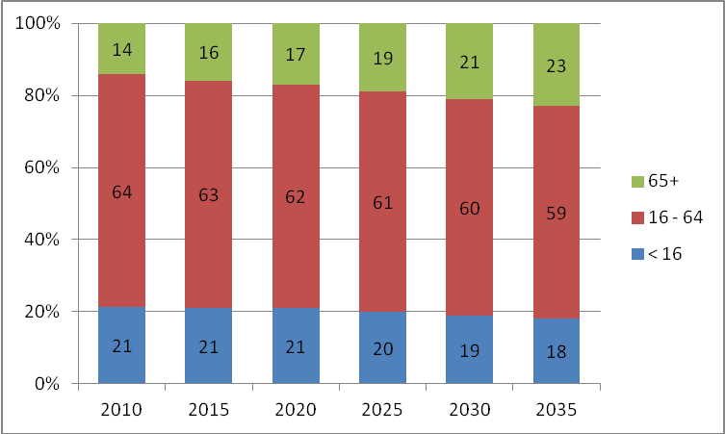
(Source: NISRA)

  - The planned increases to the state pension age will change the composition of the working age population further with more people working longer. That will have implications for employers and for the Department as they seek to ensure that skill sets remain relevant throughout extended working lives.

Chapter 3: Assessing Performance – The Skills, Employment and Innovation Agenda

  - The importance of investing in skills, employment and innovation is well established. They are key drivers of productivity, economic growth and shared prosperity and are at the core of the Executive’s vision for Northern Ireland. Moreover, developing the skills base and the employability of our people must be a vital component of any potential corporate tax reduction in Northern Ireland. ‘Preparing for a Lower Corporation Tax Environment’ (DEL, 2012) highlights in particular the importance of strong skills in Science, Technology, Engineering and Mathematics (STEM); management and leadership; and literacy, numeracy and employability skills if Northern Ireland is to capture the full benefits of a lower Corporation Tax.

  - The Department’s Business Plan highlights the importance of continued investment in the areas of skills, employment/employability and innovation.

The Skills Agenda

  - While the Northern Ireland skills profile has improved steadily over the last decade, gaps remain when compared to the best performing regions and nations. Figure 3.1 illustrates in a UK context that Northern Ireland continues to have proportionately more people with low or no qualifications and fewer with high level qualifications (NQF Levels 4-8). Figure 3.2 illustrates that internationally, despite improvements in the skill base, the skills profile of the Northern Ireland workforce remains behind many OECD and EU countries – particularly in terms of the high proportions here with low or no qualifications. This picture reflects a legacy of historical educational underachievement and of outward migration of those who are more highly skilled as they seek to capitalise on economic opportunities elsewhere.

Figure 3.1: National Skills Profile: Qualifications of those in Employment by UK Region (2013 (Q1))
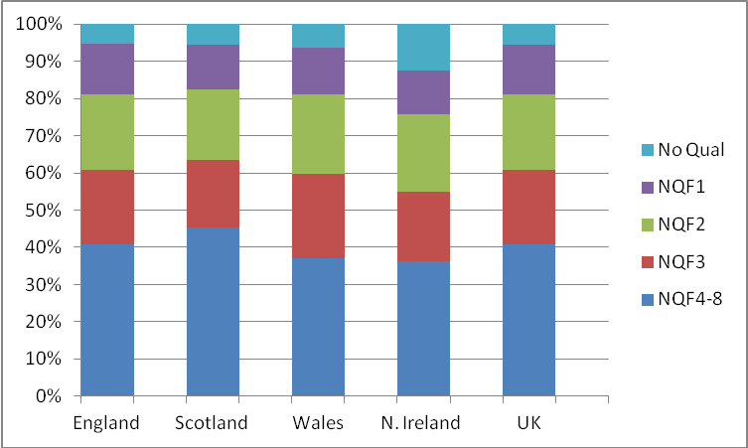
(Source: NI LFS)

Figure 3.2: International Skills Profile: Highest Qualification Attained (25-64 year olds)
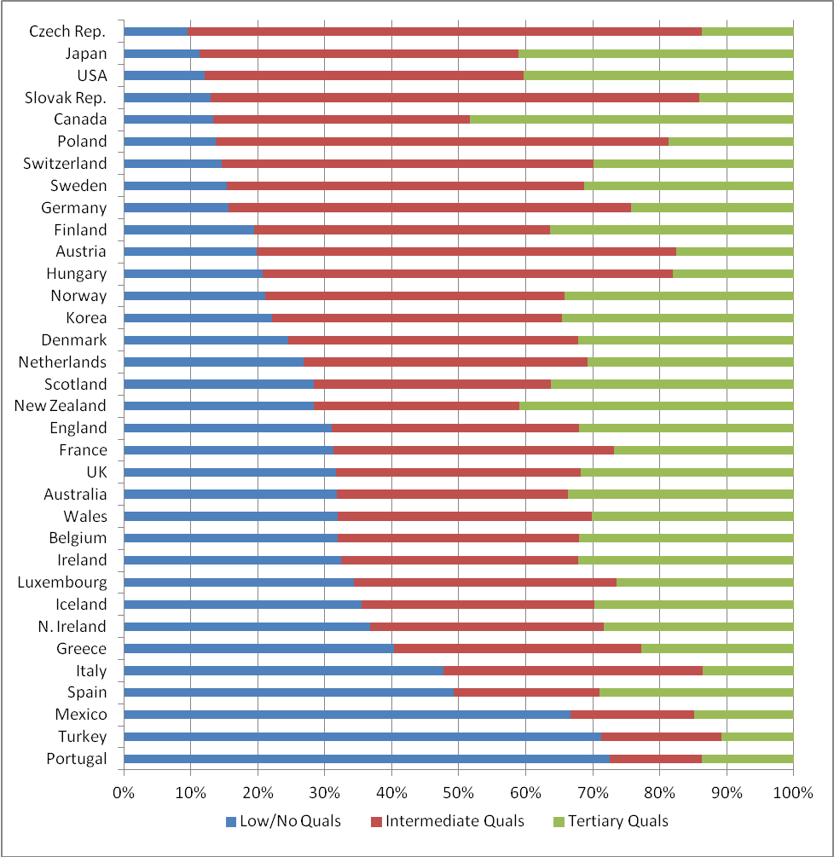
(Source: Eurostat, UKCES 2010)

  - The Department’s Skills Strategy (‘Success through Skills – Transforming Futures’) recognises that, in order to achieve the skills profile required to close the productivity gap with the UK and to compete globally, transformational change is required. The vision for ‘skills’ is to; “support the Executive’s economic aspiration by ensuring that excellent leadership is provided from well qualified managers supported by a highly skilled workforce”. It is supported by a range of complementary strategies including: Graduating to Success, the Higher Education Strategy; Access to Success, the HE Widening Participation Strategy; FE Means Business, the Further Education Strategy; Leading to Success, the Management and Leadership Strategy; Pathways to Success, the strategy targeted at those who are Not in Employment Education and Training (NEETs); Essential Skills for Living, the Essential Skills Strategy; and Preparing for Success, the Careers Strategy.

  - Success through Skills and these underpinning strategies have been designed to focus on those who: are entering the labour force for the first time; are already in the workforce; and are currently excluded from the labour force, by providing them with the skills to compete for jobs, retain jobs and progress up the skills ladder. The ‘Structured to Deliver Success’ document sets out in more detail how this strategic framework works in a complementary manner to develop the skills that are required for sustained economic growth and prosperity.

  - The Department’s vision for skills is reflected in the four ‘Transforming Futures’ long-term (up to 2020) strategic goals. The goals seek to increase the proportion of those in employment with skills at Level 2 and above, Level 3 and above and those with Level 4-8 skills. In addition, the Skills Strategy includes a goal of increasing the proportion of those qualifying from NI Higher Education Institutions (HEIs) at Graduate and post Graduate level in STEM subjects (in particular physical and biological sciences, mathematical and computer science, engineering and technology related subjects).

Success through Skills – Transforming Futures (Strategic Goals)
Strategic goal 1:
Increase the proportion of those people in employment with Level 2 skills and above to 84-90% by 2020, from a baseline of 71.2 in 2008.

Strategic goal 2:
Increase the proportion of those people in employment with Level 3 skills and above to 68-76% by 2020, from a baseline of 55.6% in 2008.

Strategic goal 3:
Increase the proportion of those people in employment with Level 4-8 skills and above to 44-52% by 2020, from a baseline of 32.3% in 2008.

Strategic goal 4:
To increase the proportion of those qualifying from Northern Ireland Higher Education Institutions with graduate and post graduate level courses in STEM subjects (with an emphasis on physical and biological sciences, mathematical and computer science, engineering and technology) by 25-30% in 2020 from a baseline of 18% in 2008.

  - The Department has committed, via the Northern Ireland PfG, to ‘Deliver over 200,000 qualifications at Level 2 and above across Further Education (FE), Essential Skills, DEL training programmes and Higher Education (HE)’. The target covers qualifications gained during the academic years ending in 2011, 2012, 2013 and 2014.

  - The latest data show that during the 2011/12 academic year 73,247 full qualifications were gained at Level 2 and above across mainstream FE, Essential Skills, funded DEL Training Programmes, and HE (including HE in FE). These data represent the second tranche of qualifications that will contribute to the delivery of the four year PfG target, with monitoring beginning with 2010/11 data. The data indicate that good progress is being made towards achievement of the overall target and the qualification outputs for 2010/11 and 2011/12 of almost 140,000 are well in excess of the target of 105,000 for those two years. The 2011/12 qualifications targets are 11% up on the 2010/11 levels. The qualifications gained by type of provision in 2010/11 and 2011/12 can be broken down as follows:

PfG Qualifications Target: Full Qualifications Gained – Level 2 and above
 | 2010/11 | 2011/12 | % change
HE in FE (FE Colleges) | 4,061 | 4,466 | +10%
HE (NI HEIs) | 14,960 | 16,100 | +8%
Mainstream FE | 24,628 | 23,973 | -3%
Training Programmes | 6,167 | 8,124 | +32%
Essential Skills | 16,307 | 20,584 | +26%
Total | 66,123 | 73,247 | +11%

  - High level analysis of the Department’s performance in terms of delivering qualifications and enrolments shows that:

of the 140,000 qualifications achieved at Level 2 and above in the first two years of the Department’s PfG commitment, 53% have been at level 2, 19% at level 3 and 28% at level 4+;
- The largest increase in qualifications achieved between 2010/11 and 2011/12 has been at level 2 driven largely by growth in Essential Skills (+14%), followed by level 4+ (+8%) and level 3 (+5%);
- 30% of all qualifications achieved (at level 2 and above) have been in the economically relevant ‘narrow’ STEM areas. The proportion of ‘narrow’ STEM qualifications attained has increased by around one-fifth (22%) between 2010/11 and 2011/12;
- Within ‘narrow’ STEM, the number of ICT qualifications delivered (at level 2 and above) has increased by 15% between 2010/11 and 2011/12;
- Around one-fifth of all enrolments (at level 2 and above) in 2011/12 were from the most deprived areas in N. Ireland, broadly unchanged from the previous year and demonstrating continued strong engagement with those that are from the most deprived areas

  - In order to provide context, recent and longer term trends against both the PfG qualifications target and the established Transforming Futures goals are set out below. This analysis shows that while significant work remains to be done to deliver both the Transforming Futures skills goals and a number of the PfG commitments, a positive start has been made.

  - Strong performance in the ‘Transforming Futures’ goals – increasing the skills profile of those people in employment – is likely to reflect, in some part, employers seeking to retain skilled staff through the downturn so that they are in as strong a position as possible to take advantage of the upturn once it takes root.

Table 3.1: Trends in Key Skills Indicators

Indicator | Recent Change | Long-Term Trend
Percentage of those people in employment with Level 2 skills and above* | Between Q1 2012 and Q1 2013, it is estimated that the percentage of people in employment with level 2 skills and above has decreased by 1.1 percentage points, and now stands at 74.2%. (Goal: to attain at least 84% by 2020) | Since the baseline in 2008, it is estimated the percentage of those people in employment with Level 2 skills and above has increased by 2.5 percentage points to 74.2% in Q1 2013. (Goal: to attain at least 84% by 2020).
Percentage of those people in employment with Level 3 skills and above* | Between Q1 2012 and Q1 2013, it is estimated that the percentage of people in employment with level 3 skills and above has decreased by 1.8 percentage points, and now stands at 57.3%.(Goal: to attain at least 68% by 2020) | Since the baseline in 2008, it is estimated the percentage of those people in employment with Level 3 skills and above has increased by 2.1 percentage points to 57.3% in Q1 2013. (Goal: to attain at least 68% by 2020)
Percentage of those people in employment with Level 4-8 skills and above* | Between Q1 2012 and Q1 2013, it is estimated that the percentage of people in employment with level 4-8 skills and above has increased by 1.8 percentage points, and now stands at 36.2%.(Goal: to attain at least 44% by 2020) | Since the baseline in 2008, it is estimated the percentage of those people in employment with Level 4-8 skills and above has increased by 3.2 percentage points to 36.2% in Q1 2013. (Goal: to attain at least 44% by 2020)
Percentage of those qualifying from NI HEIs in graduate and post graduate level courses in STEM subjects | Between 2010/11 and 2011/12 the percentage of those qualifying from NI HEIs in graduate and post graduate level courses in STEM subjects remained broadly unchanged, increasingly marginally from 18.1% to 18.5%.(HE Strategy Target: to attain at least 22% by 2020) | Between 2008/09 and 2011/12 the percentage of those qualifying from NI HEIs in graduate and post graduate level courses in STEM subjects remained broadly unchanged, increasing marginally from 18.0% to 18.5%. (HE Strategy Target: to attain at least 22% by 2020)
Deliver over 200,000 qualifications at Level 2 and above | In 2011/12 academic year there were 73,247 Level 2 and above full qualifications gained across mainstream FE, Essential Skills, funded Departmental Training programmes, and HE, including HE in FE. This is growth of 11% from the qualifications gained in 2010/11. | Almost 140,000 qualifications at Level 2 and above have been delivered in the first two academic years of this PfG commitment (2010/11 and 2011/12) – well in excess of the target of 105,000 for the two years. This suggests good progress is being made towards achievement of the overall target.

* The three skills of people in employment indicators set out above are based on Labour Force Survey (LFS) data. The LFS is a sample survey which is subject to considerable volatility; caution should be applied in reading too much into its short term movements.

Employment Agenda

  - Increasing employment was at the heart of the Executive’s PfG 2008-2011, with a key goal being to increase the employment rate over the period to 2020. The desire to increase employment remains central to the Northern Ireland Economic Strategy which sets a longer term strategic goal of increasing the employment rate here so that, by 2030, it exceeds the average for the UK regions. In moving towards that goal, the current PfG sets out commitments in relation to job creation and to help people into employment. Of particular relevance to DEL is the continued focus on encouraging those currently unemployed to move towards and into employment where that is appropriate. This agenda is shared with the rest of the UK, although the approaches developed in Northern Ireland differ from those elsewhere and are tailored to the local environment and needs.

  - The desire to increase employment reflects, in part, Northern Ireland’s long history of being a region of low employment and high unemployment. Although employment levels (and labour market participation) rose until the downturn, and unemployment fell to historically very low levels, employment levels still remained low by UK standards (Figure 3.3). In 2005 the working age employment rate in NI was around 67%, still some 5 or 6 percentage points behind the UK rate and the lowest of any UK country or region.
Figure 3.3: UK Regional Employment Rate (2002-2012)
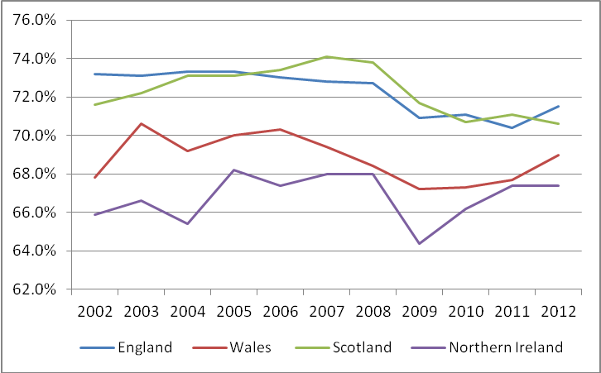
(Source: ONS)

  - In general, employment rose steadily until late 2007 when the rise levelled off at an employment rate of around 68%. Since mid-2008, however, the impact of the current recession is clear. There has been a loss of around 40,000 employee jobs – mostly in the private sector but more recently in the public sector as expenditure constraints begin to have an impact. The particularly worrying aspect of the loss in private sector employment is when the Northern Ireland position is juxtaposed with the UK as a whole where all of the private sector jobs that were lost have been recovered, although some of these jobs may not be as high quality as the ones that existed previously.
  - Northern Ireland’s employment rate is low in a UK context, although internationally, compared to national rates for other OECD countries; it does not fare just as badly. It is below the rate in countries such as the Netherlands for example, but well above others such as Italy and Spain. Figure 3.4 shows the Northern Ireland rate and selected other rates – it can be seen that although it is below the UK rate it is broadly on a par with the USA and somewhat above the rates for the EU and OECD countries and also of Ireland, whose rate has dropped considerably since the downturn.

Figure 3.4: OECD Employment Rate (2006-2012)
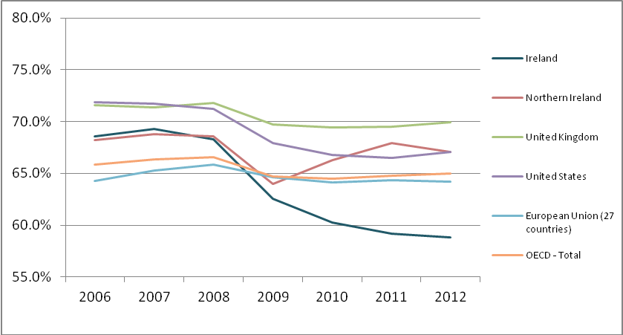
(Source: OECD)

  - The Executive has also turned its attention to the problem of economic inactivity. Inactivity levels for working age people in Northern Ireland have, for decades, been high, largely varying between 25% and 30%. Northern Ireland repeatedly reports the highest level of inactivity of any country or region of the UK, and rates are usually some four or five percentage points higher than the UK average. The rate currently (May - July 2013) stands at 27.3%, five percentage points above the UK rate (22.3%) and the highest of any UK region.
  - For this reason the Programme for Government contains a commitment to develop and implement a strategy to reduce economic inactivity in Northern Ireland. The Economic Inactivity Strategy is being led by DEL and DETI and will develop interventions on the demand side (through incentives and job creation) and on the supply side (through training and skills development).

  - As a first step the Department has published a baseline study (available here: http://www.delni.gov.uk/economic-inactivity-strategy-baseline-study.pdf) which provides a detailed analysis of factors contributing to the high rate of inactivity in Northern Ireland, a set of regional and international comparisons and an assessment of current and previous policy initiatives. The recommendations of the baseline study will underpin the draft inactivity strategy that will be presented to the Executive for agreement during 2013.

Table 3.2: Trends in Key Employment Agenda Indicators
Indicator | Recent Change | Long-Term Trend
Employment Rate* | The employment rate decreased by 0.9 percentage points between 2012 (Q1) and 2013 (Q1) to 66.6%. This compares to a UK rate of 71.4% in 2013 (Q1). | The employment rate has fallen since the onset of the recession, although there was a gradual recovery up to early 2012, this has not continued through 2012 with the rate falling back to under 67% in early 2013.
Inactivity Rate* | The working age inactivity rate stands at 27.3% (May – July 2013). This rate increased by 0.3 percentage points over the quarter and by 0.4 percentage points over the year. The Northern Ireland rate remained significantly higher than the UK average rate (22.3%) and was the highest rate among the twelve UK regions. | The working age economic inactivity rate has mostly stayed within a fairly narrow band - between 25% and 30% over a period of around three decades.
Moving Benefit clients into Employment | In 2012/13 there were 38,871 benefit claimants supported into employment (compared to a target of 30,000). This represents an increase of 2.4% (900 claimants) from 2011/12 (30% above target), and has been achieved against a backdrop of rising unemployment. | Numbers have increased somewhat despite the recession putting downward pressure on vacancies. In the first two years of the  PfG the Department has supported around 77,000 (76,841) benefit claimants into employment. The commitment is to support 114,000 into employment by 2015.

* The Employment rate and the Economic Inactivity rate are based on Labour Force Survey (LFS) data. The LFS is a sample survey which is subject to considerable volatility; caution should be applied in reading too much into its short term movements.

Innovation Agenda

  - It is now widely accepted that the wealth of a country or region is directly linked to levels of research and development and innovation. For example, the Organisation for Economic Co-operation and Development (OECD) argues that innovative efforts and Research and Development in particular, are the major factor behind technical change and long-term economic performance. The higher education and further education sectors have the potential to affect significantly the level of Research and Development in a region and subsequently regional economic development through their role as knowledge-generators.

  - In general, universities perform the primary research function of producing basic research which industry can turn to marketable uses. The HE and FE sectors are also focussed on economic development and work closely with business to address internal skills gaps, to develop new products, improve processes and develop/enter new markets. Collaboration between universities, colleges and business is critical to the innovation agenda; the evidence shows overwhelmingly that companies need access to the competence of the HE sector through its R&D capabilities, combined with the experience of the FE sector in skills transfer to help them get the best results from knowledge transfer. The Department is committed to working with universities and colleges to extend the range and depth of their collaboration with the business sector, with a primary focus on meeting the needs of business innovation.

  - While total Research and Development spend in Northern Ireland is now close to the UK average (1.85% of GDP), the UK and Northern Ireland continue to lag behind spending levels amongst the international pace setters (Figure 3.5).

Figure 3.5: Gross Domestic Expenditure on R&D (2011) as a % of GDP
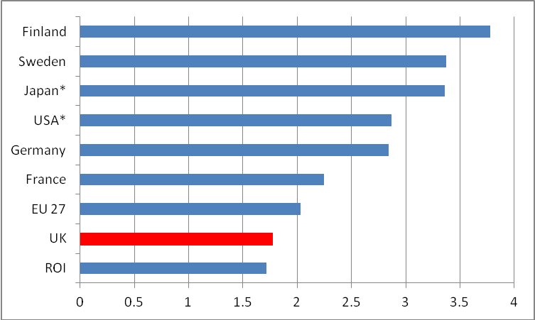
Source: Eurostat/OECD
(* 2010 figures as only forecasts available for 2011)

  - Similarly, Figure 3.6 illustrates that Higher Education Research and Development (HERD) in Northern Ireland is slightly below the UK average. However, while the UK HERD is also close to average EU spend, it is far from being a world leader. Northern Ireland HERD expenditure falls below several other small open economies such as Ireland (albeit marginally) and Estonia.

Figure 3.6: HERD as a % of GDP (2011)
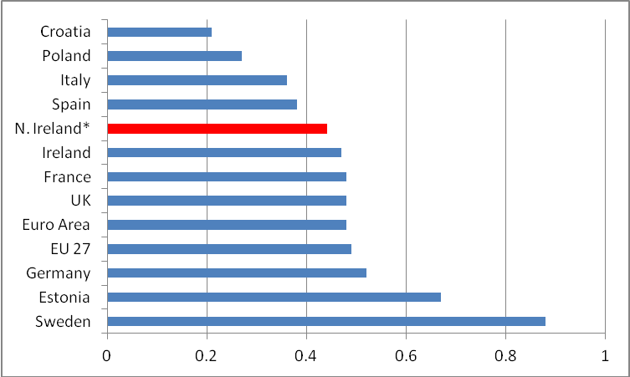
(Source: Eurostat)

  - Innovation is a key element of the Executive’s Economic Strategy, it recognises that Northern Ireland’s economy is demanding a higher level of relevant skills, and that economic success is increasingly dependent on research and development and knowledge transfer to drive productivity and competitiveness.

  - The Department’s Higher Education Strategy – ‘Graduating to Success’ – will support innovation in the university sector through the pursuit of research and development excellence, overseas institutional research partnerships, knowledge transfer and university-business collaboration. The Higher Education strategy sets out the Department’s detailed proposals to support the ‘Innovation, R&D and Creativity’ pillar of the economic strategy, these include commitments to:

- support internationally excellent and world-leading research and development; and
- build upon and increase sustainable knowledge transfer activities.

  - A more detailed assessment of performance in each of the strategically important areas of skills, employment and innovation is set out in the remainder of the report. The analysis focuses on key performance data, including; enrolment/occupancy, retention and achievement data on skills and training programmes. It also identifies and considers key issues (and challenges) that will affect the Department’s ability to deliver upon its commitments.

Chapter 4: HIGHER EDUCATION

  - Higher Education (HE) has a key part to play in the Executive’s plans for economic growth, investment and social inclusion. Higher Education Institutions (HEIs) have an important role in terms of addressing the skill needs of the workforce and fostering innovation through research and development, knowledge transfer and university-business collaboration. The Higher Education Strategy – “Graduating to Success” – recognises this contribution and sets out the direction for higher education policy in Northern Ireland for the period up to 2020. The Strategy’s four guiding principles are responsiveness, quality, accessibility and flexibility. The Executive’s decision to freeze tuition fees for NI students at NI institutions reflects its commitment to ensure that the opportunity to participate in higher education is available to all who can benefit from it. This part of the report looks specifically at the teaching and learning aspects of Higher Education. The R&D aspects of HE are considered later in the report within the Innovation section.

  - Furthermore, this element of the report looks at performance indicators for Northern Ireland’s local HEIs. Section 5 considers HE that is delivered via the FE Colleges in Northern Ireland.

NORTHERN IRELAND HEIs

Qualifications
  - The introduction to this report set out performance against a key Departmental PfG commitment – namely “upskilling the working age population by delivering over 200,000 qualifications by 2014/15. Qualifications gained by students from Northern Ireland HEIs will contribute towards the delivery of this commitment. The following section considers performance in this regard.

  - In 2011/12, there were 16,100 qualifiers across all levels of study from the NI HEIs – increasing (+8%) from 14,960 in 2010/11. The longer term trend is set out in Figure 4.1 below.

Figure 4.1: Qualifiers from NI HEIs
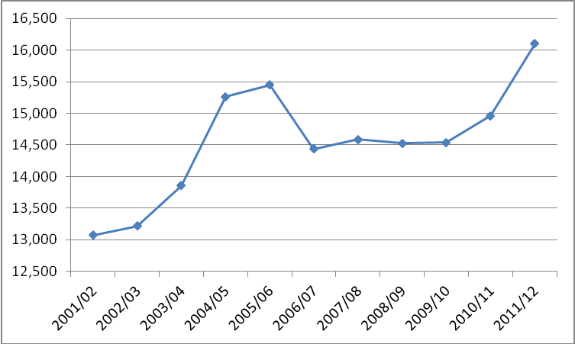
(Source: Higher Education Statistics Agency)

Box 4.1: Overall qualifications
Over the last ten years, qualifiers from NI HEIs have grown by 23%. While this is strong performance, it represents less than half the rate of growth experienced at the UK HEIs (51%). More recently, qualifiers have grown by 8% from 2010/11 to 2011/12 at the NI HEIs, which is above the UK average of 3%. The stronger growth in HE qualifications in the UK as a whole may reflect, in part, the former UK Government’s desire to raise participation of young people in HE to over 50%. HE participation in Northern Ireland has historically been well ahead of the UK and that remains the position (see Box 4.4 below).

  - STEM qualifications are considered to be of particular strategic significance to the Northern Ireland economy. Within HEIs there has been growth in ‘narrow’ STEM qualifications in the last year. Qualifications in those areas grew by 10% up to 2011/12, marginally above the average growth across the NI HEI sector (8%). In terms of individual subjects, ‘Physical Sciences’ has experienced a substantial decline (18%), whilst ‘Biological Sciences’ and ‘Computer Science’ have increased considerably (32% and 26% respectively) over the year.

Table 4.1: Qualifiers from NI HEIs by Subject Area
Subject Area | 2001/02 | 2010/11 | 2011/12 | Decade Change | 2010/11 - 2011/12 Change
Medicine & dentistry | 310 | 460 | 485 | 56% | 5%
Subjects allied to medicine | 2,610 | 2,660 | 2,495 | -4% | -6%
Agriculture & related subjects | 150 | 165 | 155 | 3% | -6%
Biological sciences | 580 | 730 | 960 | 66% | 32%
Physical sciences* | 465 | 485 | 400 | -14% | -18%
Mathematical sciences | 115 | 75 | 80 | -30% | 7%
Computer science | 965 | 570 | 720 | -25% | 26%
Engineering & technology | 595 | 840 | 815 | 37% | -3%
Arch., building & planning | 395 | 695 | 840 | 113% | 21%
Social studies* | 1,010 | 1,455 | 1,555 | 54% | 7%
Law | 320 | 730 | 815 | 155% | 12%
Business & admin | 1,860 | 2,750 | 3,120 | 68% | 13%
Mass communications | 280 | 310 | 385 | 38% | 24%
Languages | 490 | 615 | 580 | 18% | -6%
History and philosophy | 260 | 425 | 425 | 63% | 0%
Creative arts & design | 505 | 560 | 655 | 30% | 17%
Education | 1,265 | 1,415 | 1,585 | 25% | 12%
Combined | 910 | 20 | 35 | -96% | 75%
Total | 13,075 | 14,960 | 16,100 | 23% | 8%
Total 'narrow' STEM | 2,720 | 2,705 | 2,975 | 9% | 10%
‘narrow' STEM share (%) | 20.8 | 18.1 | 18.5

* Around half of the decline in Physical Science qualifiers can be explained by a recoding of ‘Geography’ into 50% ‘Physical Geography’ and 50% ‘Human Geography’ at one of Northern Ireland’s HEIs. This contributes partially to the increase in ‘Social Studies’ qualifiers in 2011/12.

Box 4.2: STEM
‘Narrow’ STEM made up 18.5% of total qualifiers from the NI HEIs in 2011/12. This is lower than the overall UK picture (22%). However, the proportion for all STEM subjects at the NI HEIs in 2011/12 was 43%, which is above the UK average of 39%.

  - In terms of qualifications by level of study at the NI HEIs the year on year analysis shows that there were increases across all levels of study from 2010/11 to 2011/12, most significantly in First degree (10%); followed by ‘Other undergraduate’ (8%) and Postgraduate (4%). (Fig. 4.2)
Figure 4.2: Qualifiers from NI HEIs by level of study
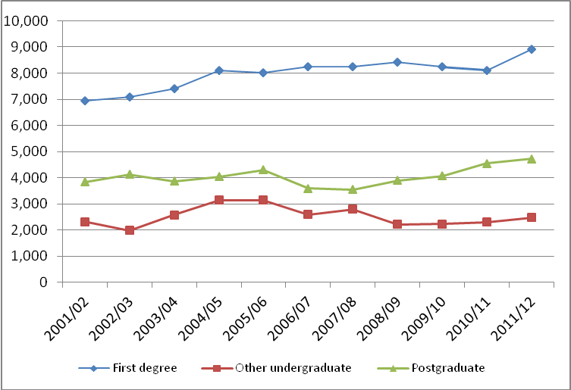
(Source: Higher Education Statistics Agency)

Box 4.3: Level of Study
Unlike the NI picture whereby ’Other undergraduate’ qualifiers have increased from 2010/11 to 2011/12 by 8%, there has been a decrease (7%) at the UK level. Postgraduate level percentage increases were similar across both the UK and NI; however the growth in First degree qualifiers at the NI level (10%) was higher than that experienced in the UK (6%).

Enrolments

  - Looking to the future delivery of the PfG qualifications target, it is important to also monitor enrolment levels and the extent to which those that do enrol complete their course. Tomorrow’s qualifications will be dependant on the numbers now enrolling and the propensity for those that do enrol to complete their course successfully. The following two sections consider these two important aspects in the context of Northern Ireland HEIs.

  - Following a period of steady increase in overall student enrolments at Northern Ireland HEIs over recent years these levelled off in 2011/12 compared to 2010/11. More recent accepted applicant data from the University and Colleges Admissions Service (UCAS), which provides information on a narrower range of students (ie accepted applicants to full-time first degrees courses) would indicate that there has been a 5% increase between 2011/12 and 2012/13 at NI institutions – the highest in the UK. There was a 2% decrease at Scottish institutions, whilst there were decreases at English and Welsh institutions (6% and 8% respectively).

  - Each year a cohort of students from Northern Ireland migrate to Great Britain (GB) for their HE experience. For instance in the 2011/12 academic year approximately one third of Northern Ireland domiciled full-time first year undergraduates left the region to study at a HEI in GB. However, research has indicated that, in the main, those who opt for a university place in Great Britain as their first choice do so for reasons which are positive rather than leaving reluctantly. The most important reason cited was that the student considered a particular institution as being the best place to undertake their chosen course. Issues of reputation and location were also important to the respondents. In that respect, these students are ‘determined leavers’.

Box 4.4: Participation Rates
In the academic year 2010/11, Northern Ireland’s higher education age participation index (API) was 48.0%, which is higher than the Scotland API (44.3% in 2009/10), and also the more-wide ranging Higher Education Initial Participation Rate (HEIPR) used in England (47.0% in 2010/11).

Internationally, while it is difficult to develop comparisons that are fully consistent, the UN Educational, Scientific and Cultural Organisation (UNESCO) has sought to calculate a Higher Education Enrolment rate for a wide range of countries. Calculating a Northern Ireland figure using the UNESCO approach would place Northern Ireland 23rd out of 140 countries and ahead of the UK, Ireland, France, Israel and Switzerland. However NI’s HE enrolment rate is calculated to be lower than those in Korea, the US, Australia, New Zealand and many of the Scandinavian countries.

  - Mirroring the pattern for qualifications set out above, Northern Ireland has a marginally lower concentration of ‘narrow’ STEM enrolments (21% of total enrolments) compared to UK HEIs (24%). Over the last year the total number of students enrolled on ‘narrow’ STEM related courses at NI HEIs decreased by 205 (a fall of 2%). However there were positive increases in the ‘Mathematical Sciences’, ‘Computer Science’ and ‘Biological sciences’ subject areas – 7%, 5% and 4% respectively. The largest decrease in enrolments in ‘narrow’ STEM subjects was in ‘Physical Sciences’ (14%) followed by ‘Engineering & technology’ (7%).

Table 4.2: Enrolments at NI HEIs by Subject Area
Subject Area | 2001/02 | 2010/11 | 2011/12 | Decade Change | 2010/11 - 2011/12 Change
Medicine & dentistry | 1,360 | 1,995 | 1,955 | 44% | -2%
Subjects allied to medicine | 7,470 | 7,925 | 7,915 | 6% | 0%
Agriculture & related subjects | 405 | 460 | 425 | 5% | -8%
Biological sciences | 2,275 | 3,010 | 3,120 | 37% | 4%
Physical sciences | 1,490 | 1,760 | 1,510 | 1% | -14%
Mathematical sciences | 365 | 350 | 375 | 3% | 7%
Computer science | 3,890 | 2,655 | 2,790 | -28% | 5%
Engineering & technology | 2,495 | 3,360 | 3,135 | 26% | -7%
Arch., building & planning | 1,440 | 2,410 | 2,070 | 44% | -14%
Social studies | 3,385 | 4,460 | 4,520 | 34% | 1%
Law | 1,030 | 2,285 | 2,155 | 109% | -6%
Business & admin | 6,090 | 8,375 | 8,895 | 46% | 6%
Mass communications | 690 | 1,105 | 1,085 | 57% | -2%
Languages | 2,905 | 2,090 | 1,920 | -34% | -8%
History and philosophy | 1,585 | 1,465 | 1,360 | -14% | -7%
Creative arts & design | 1,770 | 2,175 | 2,125 | 20% | -2%
Education | 3,955 | 6,045 | 6,025 | 52% | 0%
Combined | 4,555 | 75 | 530 | -88% | 607%
Total | 47,155 | 52,000 | 51,905 | 10% | 0%
Total 'narrow' STEM | 10,515 | 11,135 | 10,930 | 4% | -2%
‘narrow' STEM share (%) | 22.3 | 21.4 | 21.1
(Source: Higher Education Statistics Agency)

Box 4.5: STEM
‘Narrow’ STEM made up 21% of enrolments at the NI HEIs in 2011/12 – which is slightly lower than the overall UK picture (24%). Over the decade ‘narrow’ STEM enrolments have increased by 4% at the NI HEIs which is substantially smaller than the 37% increase experienced all UK HEIs.
However, ‘Broad’ STEM enrolments accounted for 45% of total enrolments at the NI HEIs in 2011/12, which sits above the UK average of 42%. While it is difficult to compare countries on an exact like-for-like basis, placing Northern Ireland performance on this measure in an international context using OECD data would also suggest that Northern Ireland performs better than the UK and OECD country average for ‘Broad’ STEM enrolments. That said Northern Ireland is some way behind the world leaders, Finland and Germany where well over 50% of HE enrolments are in broad STEM areas.

  - The number of undergraduate enrolments at the NI HEIs stood at 40,675 in 2011/12 – showing no change from 2010/11. Within that, the ‘other undergraduate’ category experienced a 12% decrease in enrolments between 2010/11 and 2011/12. These make up 15% of all undergraduate enrolments (6,280), compared to 34,395 ‘First Degree’ enrolments, which showed a 2% increase over the year. There was a small decrease in Postgraduate enrolments of 1% at the NI HEIs between 2010/11 and 2011/12.

Figure 4.3: Enrolments at NI HEIs by Level of Study
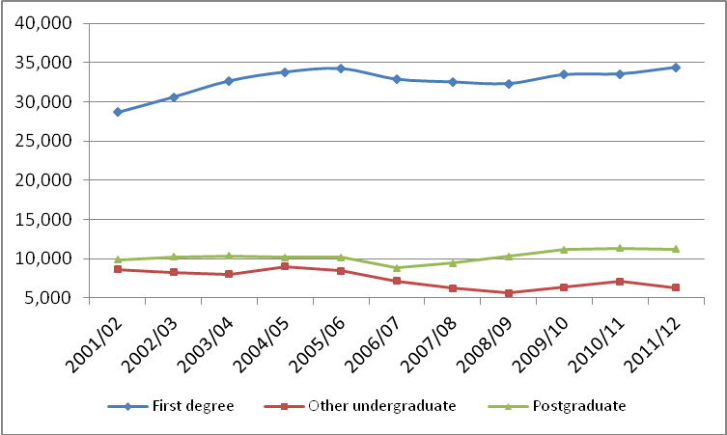
(Source: Higher Education Statistics Agency)

Box 4.6: Level of study
There were decreases at both the NI and UK HEIs in postgraduate enrolments between 2010/11 and 2011/12 - but at a higher rate across the UK – decreases of 1% and 3% respectively. However growth was higher at the UK HEIs over the decade (21% increase compared to 14% increase at the NI HEIs). Whilst undergraduate enrolments remained fairly constant from 2010/11 to 2011/12 at the NI HEIs, there was a small 1% increase at the UK HEIs.

  - Northern Ireland HEIs continue to recruit a high proportion of students from lower social backgrounds in comparison to the UK with a marginal proportionate increase for the latest year (see Table 4.3). Although NI’s HEIs outperform HE institutions in the UK based upon this performance indicator, it is documented in the Department’s Widening Participation Strategy ‘Access to Success’ that there are still stubborn pockets of underrepresentation of certain groups within higher education including persons in SEC Groups 5 – 7; students from low participation/high deprivation neighbourhoods; young Protestant males from areas of high deprivation; and adult learners, particularly work-based learners.

Table 4.3: Young Full-time First Degree entrants at SEC Level 4, 5, 6 & 7 at NI and UK HEIs

 | Entrants at NI HEIs |  |  | Entrants at UK HEIs
 | 2002/03 | 2010/11 | 2011/12 | 2002/03 | 2010/11 | 2011/12
% drawn from SEC Level 4-7 | 41.3% | 39.4% | 39.1% | 28.4% | 30.6% | 30.7%
Total SEC Level 4-7 | 2,355 | 2,310 | 2,310 | 50,930 | 71,760 | 78,410
(Source: Higher Education Statistics Agency)

Box 4.7: Entrants by Socio-Economic Class
In terms of social class, 39.1% of young full-time first degree entrants to NI HEIs in 2011/12 were from the National Statistics Socio-Economic Classification (NS-SEC) 4, 5, 6, & 7, which is similar to the proportion in 2010/11. This also remains well above the UK average of 30.7%.

Non-continuation
  - The latest data show that Northern Ireland HEI non-continuation rates have improved over the year, decreasing by 2.3 percentage points whereby, of all full-time first degree entrants to NI HEIs in 2010/11, 6.0% were no longer in HE in 2011/12 .

  - HESA produces a set of performance indicators, which seek to offer an objective measure of how a HEI is performing. Non-continuation forms one of those indicators and Figure 4.4 sets that information out for the NI HEIs. This shows that QUB, UU and Stranmillis were performing better than their benchmarks however not at a level which could be described as statistically significant, while St. Mary’s was performing worse than its benchmark, but again not significantly so. This shows an improvement for QUB, UU and Stranmillis compared to 2010/11, whilst St. Mary’s was broadly on par with its rate in 2010/11.

Figure 4.4: Percentage of all full-time first degree entrants failing to continue in HE in 2011/12 following entry in 2010/11
(Source: Higher Education Statistics Agency)

  - Non-continuation rates also vary by subject area studied (see Figure 4.5). ‘Architecture, building & planning’ and ‘Creative arts & design’ have the highest rates, both just over 10%, followed by ‘Engineering & technology’ (8.7%) and ‘Computer science’ (8.6%). ‘Medicine & Dentistry’ and ‘Education’ related subjects had the lowest rates - 0% and 1.1% respectively.

Figure 4.5: Percentage of full-time first degree entrants to NI HEIs failing to continue in HE in 2011/12 following entry in 2010/11 by subject area
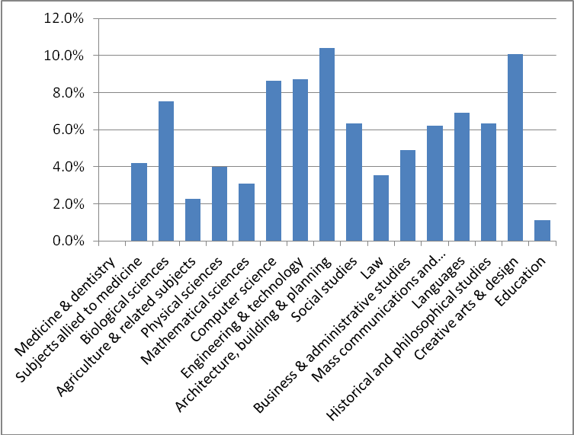
(Source: Higher Education Statistics Agency)

Box 4.8: Non-continuation
Of all full-time first degree entrants to NI HEIs in 2010/11, 6.0% were no longer in HE in 2011/12, showing better performance than the UK average of 7.4%.

Summary
  - In summary this section has shown that there has been good performance in relation to qualifications achieved at the NI HEIs and, looking to the future, the long-term increase in enrolments coupled with a decrease in HE non-continuation rates bodes well. NI continues to perform better on widening access indicators than the UK as a whole. Nevertheless work remains to be done on increasing the proportion of enrolments in STEM areas at HE and variability remains across subject areas in terms of non-continuation rates. The Department plans to monitor these issues closely particularly as it considers the potential impact of fee differentials that exist across the UK and beyond. These issues are reflected within the Department’s Quality and Performance Action Plan (Annex 1), which sets out the measures the Department is taking in response.

Table 4.4: Trends in Key NI HEI Indicators
Indicator | Recent Change | Long-Term Trend
Qualifications | The number of student qualifiers at NI HEIs has increased over the year to 2011/12 by 8%, from 14,960 in 2010/11 to 16,100 in 2011/12. | The number of student qualifiers at NI HEIs has increased by almost one-quarter (+23%) between 2001/02 and 2011/12.
‘Narrow’ STEM Qualifications | The number of ‘narrow’ STEM qualifications gained at Northern Ireland Higher Education Institutions over the last year has increased by 10% to 2,975 in 2011/12. ‘Narrow’ STEM represents 18.5% of overall qualifications compared to a Skills Strategy goal of at least 22% by 2020. | The number of ‘narrow’ STEM qualifications gained at Northern Ireland Higher Education Institutions has increased by 9% between 2001/02 and 2011/12.
Overall Enrolments | Enrolments at NI HEIs remained at a similar level in 2011/12 compared to 2010/11 – around 52,000. | Enrolments at NI HEIs grew by 10% between 2001/02 and 2011/12
Widening Access | The proportion of young full-time first  degree entrants to NI HEIs by National Statistics Socio-Economic Classification (NS-SEC) 4,5,6 & 7 in 2011/12 was 39.1%, the same as the position of 39.1 % in 2010/11. | Between 2002/03 and 2011/12 the proportion of young full-time first degree entrants to NI HEIs by (NS-SEC) Classes 4,5,6 & 7 has decreased from 41.3% to 39.1%.
‘Narrow’ STEM Enrolments | ‘Narrow’ STEM enrolments at NI HEIs decreased by 2% over the year to 10,930 2011/12. | ‘Narrow’ STEM enrolments at NI HEIs have increased by 4% between 2001/02 and 2011/12.
Non-continuation | The proportion of all full-time first degree entrants to NI HEIs in 2010/11 who were no longer in HE in 2011/12 was 6.0%, this compares favourably with a rate of 8.3% in the previous year. | There has been an improvement in the proportion of all full-time first degree entrants to NI HEIs who were no longer in HE one year later over the ten year period between 2001/02 (8.0%) and 2011/12 (6.0%).

Chapter 5: HIGHER EDUCATION IN FURTHER EDUCATION COLLEGES

Qualifications
  - In 2011/12, there were 4,466 full achievements across HE in FE from the NI FE Colleges – increasing from 4,061 in 2010/11 (a 10% increase over the year). The longer term trend is also upward and is set out in Figure 5.1 below.

Figure 5.1: HE in FE full achievements at NI FE Colleges
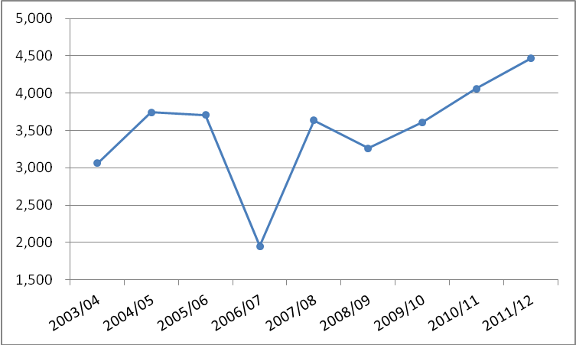
(Source: Further Education Levers Survey (FELS))
Note: FELS Dataset is incomplete for 2006/07 due to lecturer strike that year.

  - There has been strong growth in ‘narrow’ STEM HE in FE full qualifications in the last year, whereby qualifications rose by almost one-third (31.7%) up to 2011/12 (see Table 5.1). In terms of individual subjects, although ‘Biological Sciences’ has experienced a significant increase this is from a very small base. ‘Physical Sciences’ has remained broadly constant in terms of full achievements over the period, though again the numbers are very small. There has been a longer term decline in ‘Mathematics and Computing Science’ qualifications, with a drop of 6% in the most recent year. This is recognised in the Department’s Quality and Performance Action Plan. More encouragingly, ‘Engineering & Technology’ has experienced a substantial positive increase in HE in FE full qualifications - 55% over the last year.

Table 5.1: HE in FE full achievements at NI FE Colleges by Subject Area
Subject Area | 2003/04 | 2010/11 | 2011/12 | 2003/04 – 2011/12 change | 2010/11 – 2011/12 change
Allied to Medicine | 253 | 124 | 84 | -66.8% | -32.3%
Agriculture & Related | 20 | 23 | 17 | -15.0% | -26.1%
Biological Sciences | - | 20 | 34 | N/A | 70.0%
Physical Sciences | 14 | 11 | 14 | 0.0% | 27.3%
Mathematics & Computing Science | 339 | 311 | 292 | -13.9% | -6.1%
Engineering & Technology | 136 | 478 | 740 | 444.1% | 54.8%
Architecture, Building & Planning | 67 | 245 | 290 | 332.8% | 18.4%
Social Studies | 420 | 829 | 950 | 126.2% | 14.6%
Business & Administration Studies | 1,165 | 1,129 | 1,165 | 0.0% | 3.2%
Mass Communications & Documentation | 47 | 132 | 87 | 85.1% | -34.1%
Languages | 18 | 45 | 42 | 133.3% | -6.7%
Creative Arts & Design | 183 | 302 | 410 | 124.0% | 35.8%
Education | 209 | 341 | 268 | 28.2% | -21.4%
Combined & General | 190 | 71 | 73 | -61.6% | 2.8%
Total | 3,061 | 4,061 | 4,466 | 45.9% | 10.0%
Total 'Narrow' STEM | 489 | 820 | 1,080 | 120.9% | 31.7%
‘Narrow' STEM share | 16% | 20% | 24.2%

(Source: Further Education Levers Survey (FELS))

  - In terms of social background, the qualifications achieved in HE in FE were broadly representative of the population in 2011/12 – 18% of qualifications achieved were from the 20% most deprived areas in Northern Ireland (see Figure 5.2). However, this represents a slight decrease of 1 percentage point from 2010/11.

Figure 5.2: HE in FE full achievements at NI FE Colleges by Deprivation Quintiles
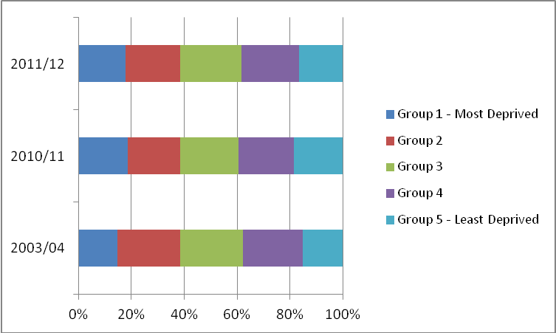
(Source: Further Education Levers Survey (FELS)

Enrolments
  - There has been an increase in HE in FE enrolments at the NI FE Colleges between 2010/11 and 2011/12 from 11,004 to 11,316 - a rise of 3 per cent. The longer term trend (see Figure 5.3) shows that although there has been a decline from 2000/01 to 2007/08, enrolments have been increasing gradually in more recent years.

Figure 5.3: HE in FE enrolments at NI FE Colleges

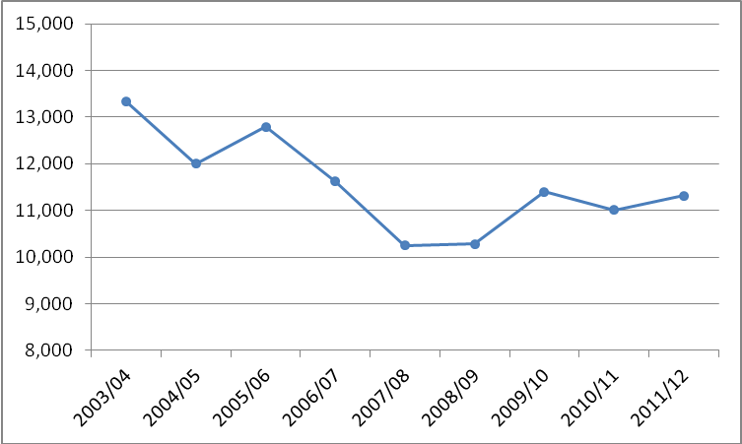

(Source: Further Education Statistical Record (FESR)

  - HE in FE enrolments in ‘narrow’ STEM subjects increased by 16% between 2010/11 and 2011/12 – a total increase of 368 enrolments, as shown in Table 5.2. Enrolments in ‘Mathematics & Computing Science’ increased over the year – by 9%, but this masks a much larger drop in enrolments over the longer term. Encouragingly, enrolments in ‘Engineering & Technology’ increased by over one-fifth (22%) across HE in FE in the last year. Enrolments in ‘Physical Sciences’ and ‘Biological Sciences’ are low in comparison to the other ‘narrow’ STEM subjects (61 and 113 respectively).

Table 5.2: HE in FE enrolments at NI FE Colleges by Subject Area
Subject Area | 2003/04 | 2010/11 | 2011/12 | 2003/04 to 2011/12 change | 2010/11 to 2011/12 change
Medicine & Dentistry | 13 | 0 | 0 | -100.0% | -
Allied to Medicine | 457 | 282 | 238 | -47.9% | -15.6%
Agriculture & Related | 71 | 64 | 56 | -21.1% | -12.5%
Biological Sciences | 12 | 84 | 113 | 841.7% | 34.5%
Physical Sciences | 89 | 69 | 61 | -31.5% | -11.6%
Mathematics & Computing Science | 1,462 | 902 | 985 | -32.6% | 9.2%
Engineering & Technology | 998 | 1,209 | 1,473 | 47.6% | 21.8%
Architecture, Building & Planning | 632 | 789 | 695 | 10.0% | -11.9%
Social Studies | 2,213 | 2,308 | 2,425 | 9.6% | 5.1%
Business & Administration Studies | 5,036 | 3,153 | 3,202 | -36.4% | 1.6%
Mass Communications & Documentation | 188 | 251 | 199 | 5.9% | -20.7%
Languages etc. | 27 | 95 | 74 | 174.1% | -22.1%
Creative Arts & Design | 909 | 997 | 1,035 | 13.9% | 3.8%
Education | 606 | 645 | 650 | 7.3% | 0.8%
Combined & General | 617 | 156 | 110 | -82.2% | -29.5%
Total | 13,330 | 11,004 | 11,316 | -15.1% | 2.8%
Total 'Narrow' STEM | 2,561 | 2,264 | 2,632 | 2.8% | 16.3%
‘Narrow' STEM share | 19.2 | 20.6 | 23.3

(Source: Further Education Statistical Record (FESR))

  - In 2011/12 those from the least deprived 20% areas in Northern Ireland were less likely to be enrolled in a HE in FE course compared to those from the most deprived 20% of areas – 17% and 20% respectively (see Figure 5.4). The position has not changed from 2010/11, however since 2001/02 there has been a significant shift in balance towards enrolments from more deprived areas – this translates into a 4 percentage point increase in the proportion of enrolments drawn from the 20% most deprived areas.

  - The number of HE in FE full qualifications gained has increased significantly since 2003 and is on a steady upward trend since 2008. At the same time the number of HE in FE enrolments has been falling steadily over the same period (-15%). This pattern can be explained by two important factors: Firstly, much of the decline reflects falling numbers in part-time HE in FE – in other words qualifications are being achieved over a shorter period of time. Secondly, it is a function of an increasing achievement rate - of those that complete their course, the proportion that achieve the qualification they were aiming for – which has increased from 79% in 2003 to 93% in 2012.

Figure 5.4: HE in FE enrolments at NI FE Colleges by Deprivation Quintile
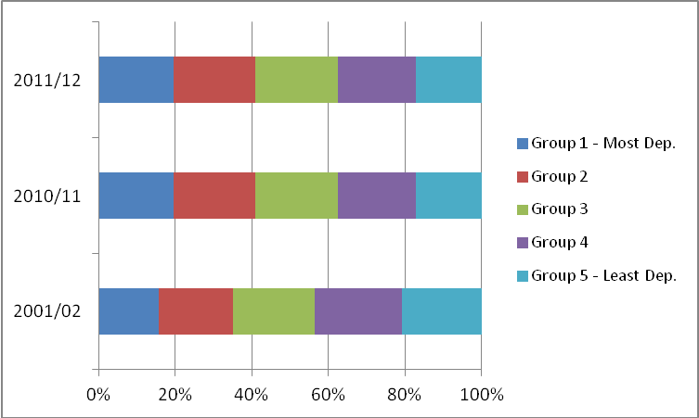
(Source: Further Education Statistical Record (FESR))

Retention/achievement

  - Retention and achievement rates for HE in FE were 95% and 93% respectively in 2011/12. This shows an increase in retention of 1 percentage point since 2010/11 (Figure 5.5), whilst achievement rates have increased from 88% in 2010/11.

Figure 5.5: HE in FE retention and achievement at NI FE Colleges
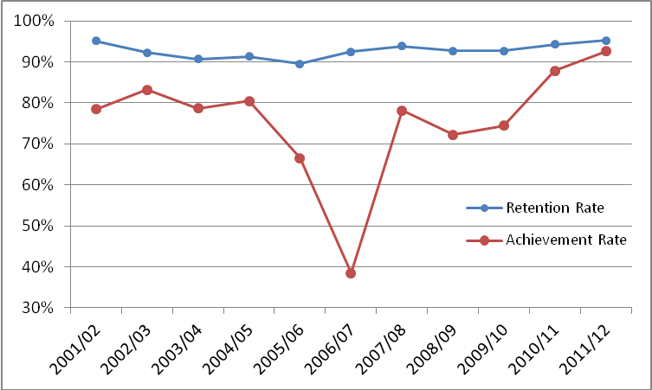
(Source: Further Education Levers Survey (FELS))
Note: FELS Dataset is incomplete for 2006/07 due to lecturer strike that year.

  - Figure 5.6 shows that retention and achievement varies by subject area across HE in FE provision. Retention rates across all subject areas were at least 90% in 2011/12, with the exception of subjects allied to medicine (88%). There was greater variation in relation to achievement rates by subject area. Achievement rates across all subject areas were at least 85% in 2011/12 (except languages, although there were a small number of enrolments in this subject category). Achievement rates on ‘narrow’ STEM subjects combined were 3 percentage points higher than on non ‘narrow’ STEM subjects combined.

Figure 5.6: HE in FE retention and achievement at NI FE Colleges by subject (2011/12)
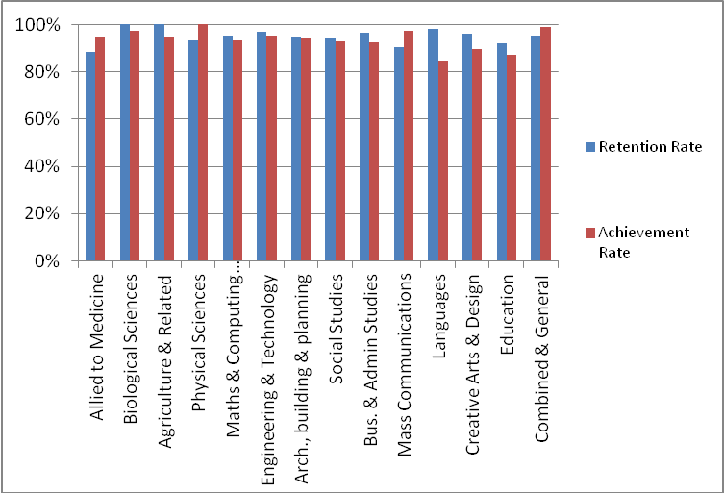
(Source: Further Education Levers Survey (FELS))

  - While the variance in retention rates is relatively small across HE in FE students from different deprivation backgrounds, in 2011/12 it was lowest for those from the fifth most deprived areas in NI (93%) with retention rates sitting at 95-97% for all other groups (see Figure 5.7). The achievement rate was lowest for those from the fifth least deprived areas in NI (91%), whilst these were 92-93% for all other groups. .
Figure 5.7: HE in FE retention and achievement at NI FE Colleges by Deprivation Quintile (2011/12)
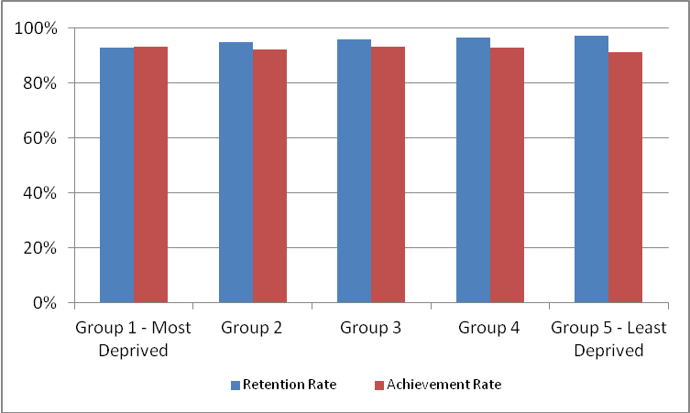
(Source: Further Education Levers Survey (FELS))

Factors that impact on the successful completion of Further Education courses
The Department recognises the wide variance in retention and achievement rates amongst different types of student within the FE sector and has developed an in-depth statistical model to understand these differences in more detail. A summary of outputs from this model are presented in the FE section and that analysis includes the HE in FE data.

Summary
  - In summary, this section has shown that there has been robust performance in relation to HE in FE qualifications in recent years, including the key ‘narrow’ STEM areas. However, overall enrolments (including some STEM subjects) appear to be on a longer-term downward trend, particularly ‘Mathematics and Computing Science’, which is something the Department will seek to monitor closely and address through its Quality and Performance Action Plan – the more recent trend however is more positive. Encouragingly, retention and achievement have increased over the last year. In addition, over recent years HE in FE has increased its percentage share of enrolments and qualifications from the more deprived areas in Northern Ireland.

Table 5.3: Trends in Key NI HE in FE Indicators
Indicator | Recent Change |  | Long-Term Trend
Qualifications | The number of full qualifications achieved from HE in FE provision has increased over the year to 2011/12 by 10%, from 4,061 in 2010/11 to 4,466 in 2011/12. |  | The number of full qualifications achieved from HE in FE provision has increased by 46% between 2003/04 and 2011/12.
‘Narrow’ STEM Qualifications | The number of ‘narrow’ STEM full qualifications achieved from HE in FE over the last year has increased by almost one-third (+31.7%) to 1,080 in 2011/12. |  | The number of ‘narrow’ STEM full qualifications achieved from HE in FE provision has more than doubled (+121%) between 2003/04 and 2011/12.
Overall Enrolments | Enrolments in HE in FE experienced a 3% increase between 2010/11 (11,004) to 2011/12 (11,316). |  | Enrolments at HE in FE fell by 15% between 2003/04 and 2011/12.
Widening Access | In 2011/12 20% of HE in FE enrolments were from the 20% most deprived areas in NI - the same proportion as in 2010/11. |  | Since 2001/02 there has been a 4 percentage point increase in drawing in those from the 20% most deprived areas to HE in FE, compared to 2010/11.
‘Narrow’ STEM Enrolments | ‘Narrow’ STEM enrolments in HE in FE increased by 16% over the year to 2011/12. |  | ‘Narrow’ STEM enrolments in HE in FE have increased by 3% between 2003/04 and 2011/12.
Retention on HE in FE Courses |  | The retention rate on HE in FE courses has increased marginally by 1 percentage point to stand at 95% in 2011/12. | The retention rate on HE in FE courses at 95% in 2011/12 is at the same level as in 2001/12.  .
Achievement on HE in FE Courses |  | The achievement rate on HE in FE courses has increased from 88% in 2010/11 to 93% in 2011/12. | The achievement rate on HE in FE courses has increased from 78% in 2001/02 to 93% in 2011/12.

Chapter 6: FURTHER EDUCATION

  - Further Education (FE) is the main provider of professional and technical education and training in Northern Ireland. The sector plays an important role in raising skill levels in the region. The range of courses provided by the FE sector spans essential skills, professional, technical and academic programmes including HE and FE. The majority of FE enrolments are funded through the Department’s Funded Learning Unit (FLU) mechanism, however the FE sector also provides training and education provision which is funded by other sources such as training programmes and employers/individuals.

  - Overall enrolments within the FE sector from 2010/11 to 2011/12 have decreased by 2%. However, the long term trend shows significant growth with enrolment numbers having grown by a quarter over the past decade and enrolments remain 8% higher than when the current FE infrastructure was created in 2007/08 with the formation of the 6 regional colleges. In terms of the wider picture, enrolments at Level 2 and HE in FE have both increased by 4% and 3% respectively over the year to 2011/12, while Level 1 and entry and Level 3 enrolments witnessed falls of 17%, and 5% respectively. Level 2 represents the majority of enrolments accounting for 47% of total provision in 2011/12 and that level has seen the biggest growth over the decade (+60%). Current retention rates (i.e. the extent to which those enrolled stay on their course) have stayed constant over the last year from 2010/11 to 2011/12 at 88%, whilst achievement rates (the extent to which those who complete their course gain a qualification) have increased over the last year to stand at 84% (4 percentage points higher than the year before).

  - There were 92,685 professional and technical qualifications achieved by students at NI FE Colleges in 2011/12. This has grown by 7% from the previous year. Forty-nine percent of these qualifications were at Level 2; 25% at Entry and Level 1; 20% at Level 3; and the remainder were from HE in FE.

  - Provision at Level 2 and above across mainstream FE, Essential Skills, funded DEL Training programmes, and HE, including HE in FE are counted towards the Department’s key PfG commitment i.e. to upskill the working age population by delivering over 200,000 qualifications by 2014/15. It is in the remainder of this section of the report that mainstream Level 2 and above FE provision is considered using data from the Department’s Funded Learning Unit (FLU) return. That is the same source that is used to monitor the mainstream FE aspect of the PfG qualifications commitment. Entry level and Level 1 FE mainstream provision is therefore excluded from the remainder of this analysis. In 2011/12 it made up 21% (12,059) of overall FE mainstream provision.

  - Other areas of FE provision are assessed in different sections of this report. HE in FE has been set out previously. Essential Skills and Training Programmes are discussed later – both of which include provision delivered in the NI FE Colleges. Full cost recovery enrolments are detailed in the innovation section.

Qualifications

  - In 2011/12, there were 23,973 Level 2 and above full achievements in mainstream FE, decreasing from 24,628 in 2010/11 – a 3% decrease. The decrease is larger for Level 2 provision (4%) compared to Level 3 provision (1%) over the year. Figure 6.1 sets out the qualifications achieved by level of study over the two year period, whereby Level 3 makes up around 46% of mainstream FE qualifications. It should be noted that the FLU return did not capture achievement data until 2009/10 and therefore further trend analysis is not available prior to that year.

Figure 6.1: Mainstream FE qualifications by Level of Study
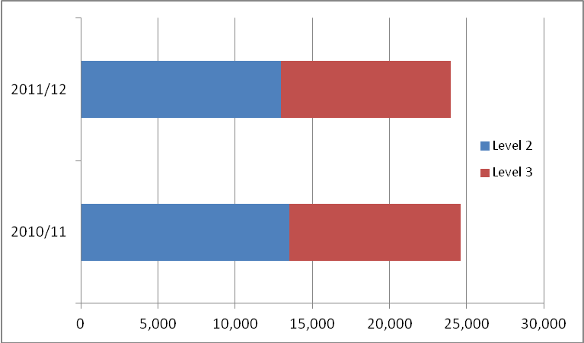

(Source: Funded Learning Unit)

  - In the last year there has been modest growth in full qualifications at level 2 and above, within mainstream FE ‘narrow’ STEM subjects whereby these qualifications rose by 4% up to 2011/12 (see Table 6.1). In terms of individual subjects, ‘Biological Sciences’ and ‘Mathematics and Computing Science’ experienced decreases (4.4% and 1.6%, respectively) whilst ‘Physical Sciences’, and Engineering and Technology’ experienced increases, of 11.2%and 15% respectively.

Table 6.1: Mainstream Level 2 and above FE qualifications by subject
Subject Area | 2010/11 | 2011/12 | % change
Allied to Medicine | 658 | 829 | 26.0
Agriculture & Related | 689 | 648 | -6.0
Biological Sciences | 293 | 280 | -4.4
Physical Sciences | 454 | 505 | 11.2
Mathematics & Computing Science | 2,168 | 2,133 | -1.6
Engineering & Technology | 1,153 | 1,326 | 15.0
Architecture, Building & Planning | 555 | 458 | -17.5
Social Studies | 3,211 | 3,018 | -6.0
Business & Administration Studies | 4,688 | 4,248 | -9.4
Mass Communications & Documentation | 295 | 387 | 31.2
Languages | 1,549 | 1,246 | -19.6
Humanities | 389 | 360 | -7.5
Creative Arts & Design | 5,491 | 5,494 | 0.1
Education | 1,939 | 2,115 | 9.1
Combined & General | 1,096 | 926 | -15.5
Total | 24,628 | 23,973 | -2.7
Total 'Narrow' STEM | 4,068 | 4,244 | 4.3
‘Narrow' STEM share | 17% | 18%

(Source: Funded Learning Unit)

  - In terms of social background, the full qualifications achieved at Level 2 and above in mainstream FE were broadly representative of the population in 2011/12 – 20% of full qualifications achieved were from the 20% most deprived areas in Northern Ireland (see Figure 6.2). This represents a marginal increase - less than 1 percentage point - from 2010/11.

Figure 6.2: Mainstream Level 2 and above FE qualifications by Deprivation Quintiles
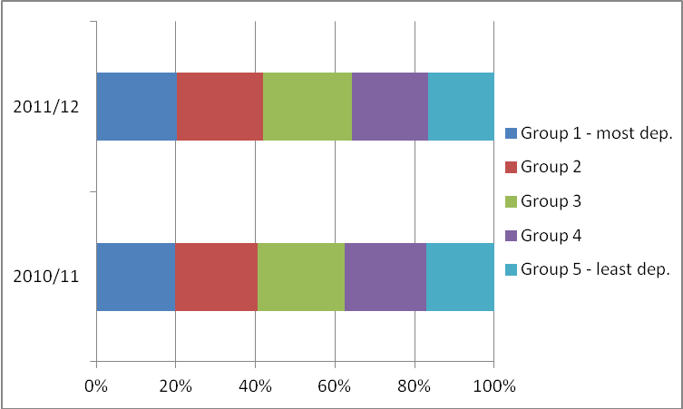

(Source: Funded Learning Unit)

Enrolments

  - There has been a decline in mainstream Level 2 and above FE enrolments at the NI FE Colleges between 2010/11 and 2011/12 from 47,284 to 44,505 - a drop of six per cent. The longer term trend (see Figure 6.3) shows that enrolments have fallen by around 7.5% between 2007/08 to 2011/12. The ‘spike’ in enrolments in 2009/10 may have been driven, at least in part, by the recession whereby people tend to turn to up-skilling during periods of weakness in the labour market.

Figure 6.3: Mainstream Level 2 and above FE enrolments
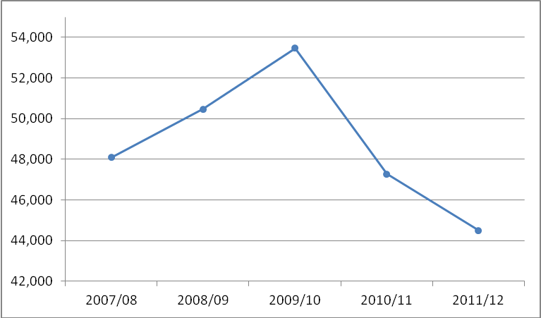
(Source: Funded Learning Unit)

  - In 2011/12 Level 2 enrolments made up just over half (51%) of all mainstream FE provision. Over the four year period set out in Figure 6.4 below the share of Level 2 and Level 3 enrolments has remained broadly unchanged.

Figure 6.4: Mainstream FE enrolments by Level of study
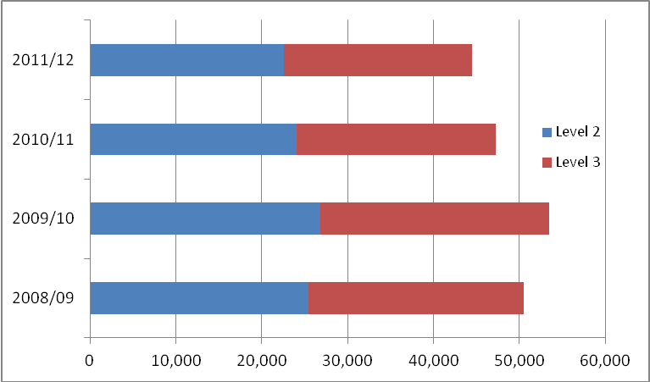
(Source: Funded Learning Unit)

  - While qualifications in 'narrow’ STEM subjects in mainstream Level 2 and above FE have grown over the year to 2011/12 (see above sub-section), enrolments in these subject areas have decreased marginally (-1%) over the same period – a total fall of less than 100 enrolments, as shown in Table 6.2. Over the year, enrolments in ‘narrow’ STEM subjects decreased, apart from ‘Engineering and Technology’ which experienced a 5% increase. Over the longer term ‘narrow’ STEM enrolments have grown strongly with the notable exception of ‘Mathematics and Computer Science’, which has experienced a sharp decline (-38%) since 2007/08. It appears that there has been a shift from mainstream ICT enrolments in FE at level 2 towards level 2 provision in ICT via the Essential Skills programme which is discussed further at Section 10 of the report. The increase in Essential Skills ICT enrolments more than makes up for the fall in FE Mainstream ICT enrolments.

Table 6.2: Mainstream Level 2 and above FE enrolments by subject
Subject Area | 2007/08 | 2010/11 | 2011/12 | 07/08 - 11/12 % change | 10/11 - 11/12 % change
Allied to Medicine | 1,671 | 1,530 | 1,538 | -8.0% | 0.5%
Agriculture & Related | 1,087 | 1,110 | 1,008 | -7.3% | -9.2%
Biological Sciences | 439 | 613 | 541 | 23.2% | -11.7%
Physical Sciences | 700 | 1,013 | 984 | 40.6% | -2.9%
Mathematics & Computing Science | 7,004 | 4,469 | 4,349 | -37.9% | -2.7%
Engineering & Technology | 2,447 | 2,473 | 2,597 | 6.1% | 5.0%
Architecture, Building & Planning | 1,475 | 1,163 | 1,101 | -25.4% | -5.3%
Social Studies | 5,139 | 5,397 | 5,214 | 1.5% | -3.4%
Business & Administration Studies | 7,586 | 8,709 | 7,798 | 2.8% | -10.5%
Mass Communications & Documentation | 942 | 774 | 827 | -12.2% | 6.8%
Languages | 3,467 | 2,980 | 2,286 | -34.1% | -23.3%
Humanities | 449 | 707 | 560 | 24.7% | -20.8%
Creative Arts & Design | 8,348 | 10,254 | 9,710 | 16.3% | -5.3%
Education | 2,410 | 3,629 | 3,705 | 53.7% | 2.1%
Combined & General | 4,926 | 2,463 | 2,287 | -53.6% | -7.1%
Total | 48,090 | 47,284 | 44,505 | -7.5% | -5.9%
Total 'Narrow'[1] STEM | 10,590 | 8,568 | 8,471 | -20.0% | -1.1%
‘Narrow' STEM share | 22% | 18% | 19%
(Source: Funded Learning Unit)

  - In 2011/12 those from the most deprived 20% of areas in Northern Ireland were more likely to be enrolled in FE Level 2 and above mainstream provision compared to those from the least deprived 20% of areas, 21% and 16% respectively (see Figure 6.5). This position has not changed measurably over the last four years.

Figure 6.5: Mainstream Level 2 and above FE enrolments by Deprivation Quintile
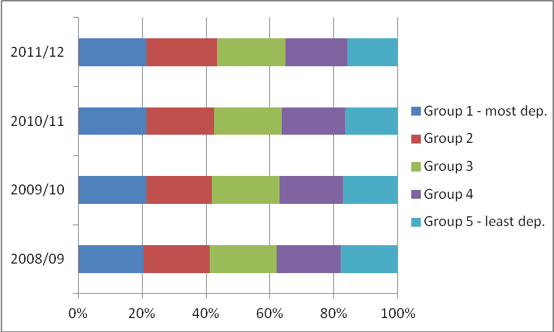
(Source: Funded Learning Unit)

Retention/achievement

  - Retention and achievement rates for mainstream Level 2 and above FE were 92% and 83% respectively in 2011/12. This represents an increase in retention of 1 percentage point since 2010/11 (Figure 6.6), whilst achievement rates have increased from 80% in 2010/11. The increasing quality of FE datasets (with improved recording of achievement data) is likely to be contributing to an element of this observed increase.

Figure 6.6: Mainstream Level 2 and above FE retention and achievement
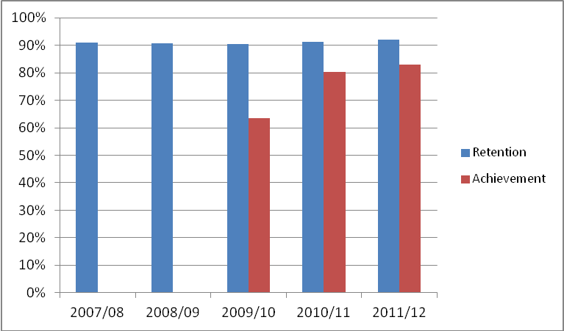
(Source: Funded Learning Unit)

  - There has been an improvement of three percentage points in the achievement rate in Level 2 provision between 2010/11 and 2011/12. The retention rate moved from 91% to 92% over the year. Level 3 retention and achievement rates also improved over the year (see Figure 6.7).

Figure 6.7: Mainstream FE retention and achievement by Level of study
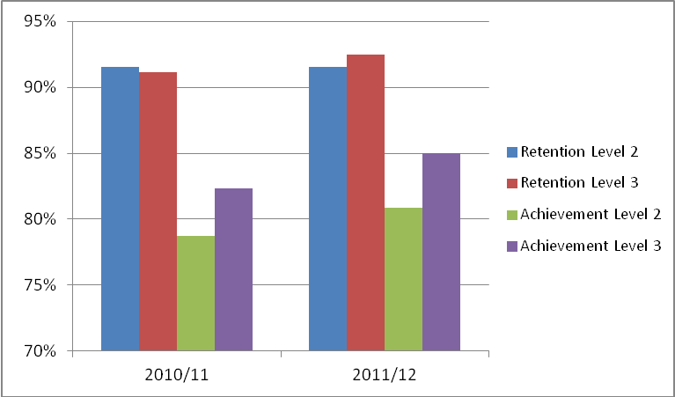

(Source: Funded Learning Unit)

  - Retention and achievement rates vary by subject area across mainstream Level 2 and above FE provision as shown in Figure 6.8. Retention rates across all subject areas varied between 89% (‘Mathematics and Computing’) to 98% (‘Agriculture & related’) in 2011/12. There was greater variation in relation to achievement rates by subject area. ‘Biological Sciences’ had the lowest achievement rate of 60% whilst ‘Education’, ‘Creative Arts and Design’ and ‘Mass Communication & documentation’ had the highest achievement rates at 90% or over.

Figure 6.8: Mainstream Level 2 and above FE retention and achievement rates by subject (2011/12)
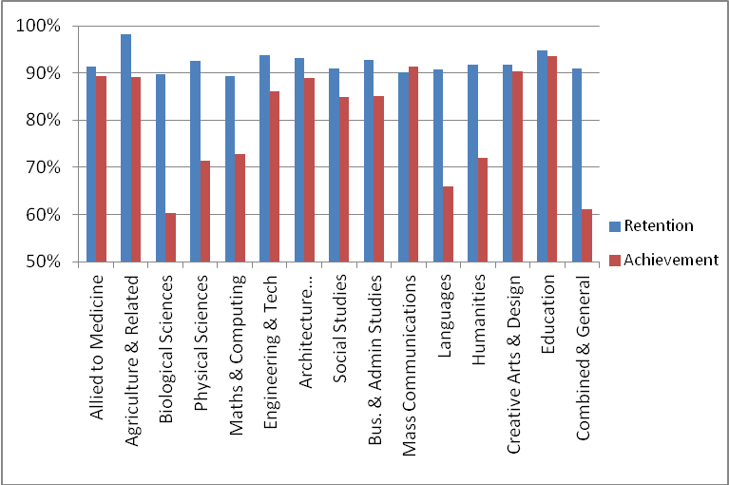
(Source: Funded Learning Unit)

  - Retention and achievement rates for mainstream Level 2 and above FE in 2011/12 were lowest for those from the fifth most deprived areas in NI – 89% and 80% respectively, as set out in Figure 6.9. Retention rates were 91-94% for all other groups, whilst achievement ranged from 81-85%, with the middle quintile showing the highest rate.
Figure 6.9: Mainstream Level 2 and above FE retention and achievement rates by Deprivation Quintile (2011/12)

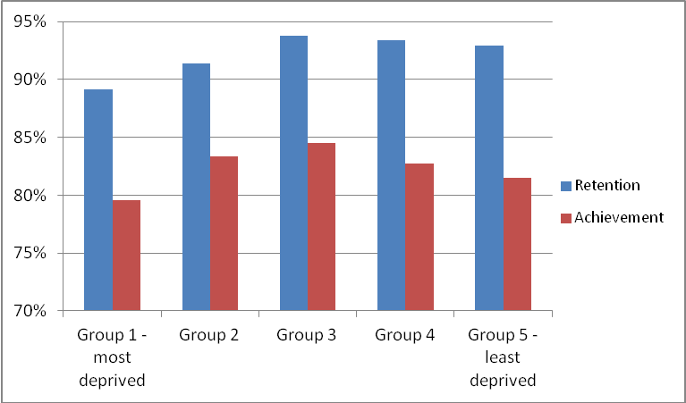

(Source: Funded Learning Unit)

Box 6.1: Factors that impact on the successful completion of Further Education courses
The Department recognises the wide variance in retention and achievement rates amongst different types of student within the FE sector and has developed an in-depth statistical model to understand these differences in more detail.

The objective of the research is to provide the Department, the FE Sector and relevant stakeholders with a quantitative insight into how a range of characteristics (e.g., gender, social background, college attended etc) impact on the chance of a student successfully gaining a (professional and technical) qualification through the Further Education sector. The statistical technique used enables comparison of college retention and achievement performance on a more “like for like” basis; by quantifying the effect individual characteristics have on the probability of successfully attaining the intended qualification. For example it addresses questions such as:

- How does subject studied affect an individual’s likelihood of success, after accounting for other potential influences (including college, gender, level of study, social background, employment status etc.)?

‘What Factors Contribute to Successful Student Outcomes from FE’ (see Annex B) sets out the context, methodology and results in detail. Amongst other things the analysis shows that while an element of the performance gap between colleges can be explained by differences in the types of students they recruit or the types of courses they deliver, a significant performance gap remains after adjusting for those factors. That would suggest that some colleges are better at delivering successful outcomes for “like for like” students.

It is intended that the analysis will assist colleges to: shape curriculum plans; identify and address weaknesses and “risk areas”; shape student support and pastoral care; and identify/learn from best practice across the sector. Further, the paper will contribute to the Department’s evidence base, while sitting alongside and providing context (and focus) to other internal and external mechanisms in place to assess quality and performance, including the Department’s Quality Improvement Branch and the Education and Training Inspectorate.

Summary

  - Whilst FE mainstream provision experienced a decline in overall qualifications at level 2 and above in the last year (-3%), it delivered growth in ‘narrow’ STEM qualifications (+4%). There has been a drop in the volume of overall enrolments at level 2 and above with a marginal decline in ‘narrow’ STEM enrolments. A longer term decline in ‘Mathematics and Computing’ enrolments has been presented although the analysis recognises that this decline has been more than offset by increases in ICT and numeracy Essential Skills enrolments at Level 2. FE mainstream provision continues to engage successfully with individuals from some of the most deprived areas in Northern Ireland, whilst retention and achievement rates have shown positive increases from 2010/11 to 2011/12.

Table 6.3: Trends in Key mainstream Further Education Indicators (at qualification level 2 and above)
Indicator | Recent Change | Long-Term Trend
Qualifications in mainstream FE | The number of qualifications in mainstream FE has decreased by 3% from 24,628 in 2010/11 to 23,973 in 2011/12. | N/A
‘Narrow’ STEM Qualifications | The number of ‘narrow’ STEM full qualifications achieved from mainstream FE over the last year has increased by 4% to 4,244 in 2011/12. | N/A
Enrolments on mainstream FE courses | The number of enrolments on mainstream FE courses has decreased by 6% from 47,284 in 2010/11 to 44,505 in 2011/12. | Enrolments on mainstream FE courses have decreased by 7.5%, from 48,090 in 2007/08 to 44,505 in 2011/12.
Widening Access | In 2011/12 21.5% of mainstream FE enrolments were from the 20% most deprived areas in NI – the same proportion as in 2010/11. | In 2011/12 21.5% of mainstream FE enrolments were from the 20% most deprived areas in NI, showing a 1 percentage point increase since 2007/08.
‘Narrow’ STEM Enrolments | ‘Narrow’ STEM enrolments within mainstream FE decreased by 1% over the year to 2011/12. | ‘Narrow’ STEM enrolments within mainstream FE have decreased by one-fifth (20%) between 2007/08 and 2011/12.
Retention on mainstream FE Courses | The retention rate for mainstream FE enrolments has held fairly constant over the last year increasing by 1 percentage point to stand at 92% in 2011/12. | The retention rate for mainstream FE enrolments was 91% in 2007/08.
Achievement on mainstream FE Courses | The achievement rate for mainstream FE courses enrolments has increased from 80% in 2010/11 to 83% in 2011/12. | N/A

Chapter 7: Training for Success and Programme-Led Apprenticeships

  - Training for Success is designed to enable participants to progress to higher level training, further education, or employment by providing training to address personal and social development needs, develop occupational and employability skills and, when necessary, Essential Skills training. The main options are Skills for Your Life, designed to address the personal and development needs of young people who have disengaged from learning and/or have significant obstacles, and Skills for Work which helps young people gain skills and a Vocationally Related Qualification, to be able to gain employment, or to progress to Apprenticeship provision or Further Education.

  - In addition, Programme-Led Apprenticeships (PLA) were introduced in 2009 as an intervention measure to respond to the economic downturn, and replaced the Pre-Apprenticeships option within TfS. Following the introduction of the new Training for Success provision, PLA has been closed to new starts from June 2013.

  - In addition to producing overall statistical bulletins, the Department collates and analyses the data provided by individual suppliers for the purposes of quality and performance monitoring. The Department shares the data with the Education and Training Inspectorate for use in inspections and to inform the evaluation of each supplier’s self-evaluation report and quality improvement plan.

  - At 31 October 2012, 7,768 individuals were benefitting from the Training for Success Programme. Overall occupancy on Training for Success decreased during the year from October 2011 to October 2012, by 6%.

  - The long term trend of increasing occupancy in Training for Success is strongly upwards, having increased by 59% from October 2008 to October 2012. Within particular strands of TfS, occupancy on Skills for Your Life has remained steady both in the short and longer-term, whereas occupancy on Skills for Work has increased by 33% over the past four years. Occupancy on Programme-Led Apprenticeships has also increased, by 82% in the last three years (see Table 7.1)

Table 7.1: Occupancy on TfS/PLA by Option/Level
 | TfS - Skills for your Life | TfS - Skills for Work | PLA (1) | Other TfS (2) | Total
Oct-08 | 451 | 1,542 | 0 | 2,899 | 4,892
Oct-09 | 736 | 1,705 | 2,863 | 1,411 | 6,715
Oct-10 | 492 | 2,025 | 5,080 | 212 | 7,809
Oct-11 | 522 | 2,089 | 5,562 | 68 | 8,241
Oct-12 | 451 | 2,050 | 5,219 | 48 | 7,768
(1) All participants on PLA are at Level 2. Options within TfS are up to Level 1.
(2) Includes Pre-Apprenticeships, clients where an option was not assigned and clients
still on pre-TfS 2008 options
Source: DEL Client Management System

  - The information available indicates that occupancy on ‘narrow’ STEM courses within Programme-Led Apprenticeships has almost doubled (+92%) between October 2009 and October 2012 (see Table 7.2). In the shorter term, occupancy on STEM courses has increased, by 5% between October 2011 and October 2012. ‘narrow’ STEM occupancy now represents thirty percent (29.2%) of overall occupancy on Programme-Led Apprenticeships (Table 7.2).

Table 7.2: Occupancy on STEM Frameworks, PLA ⁽¹⁾
Framework | Oct-09 | Oct-10 | Oct-11 | Oct-12 | 2009 - 2012 % change | 2011 - 2012 % change
Agriculture Industry | 42 | 69 | 68 | 77 | 83.3% | 13.2%
Construction | 926 | 1,492 | 1,327 | 1,081 | 16.7% | -18.5%
Engineering and Technology | 725 | 1,153 | 1,261 | 1,313 | 81.1% | 4.1%
Manufacturing | 0 | 5 | 5 | 12 | N/A | 140.0%
IT | 69 | 149 | 183 | 200 | 189.9% | 9.3%
Total 'broad' STEM | 1,762 | 2,868 | 2,844 | 2,683 | 52.3% | -5.7%
Total 'narrow' STEM | 794 | 1,307 | 1,449 | 1,525 | 92.1% | 5.2%
Overall occupancy | 2,863 | 5,080 | 5,562 | 5,219 | 82.3% | -6.2%
‘narrow' STEM as a % of overall occupancy, PLA | 27.7% | 25.7% | 26.1% | 29.2%

Source: DEL Client Management System

Framework is not recorded for participants on Training for Success

  - Figures 7.1(i) and 7.1(ii) detail the proportion of participants on TfS and Programme-Led Apprenticeships by NIMDM quintiles. Those from the most deprived backgrounds in NI are well represented in both TfS and PLA programmes with the percentage of those on TfS from the most deprived areas increasing slightly over the last four years, from 40% to 41%, while there has been a decrease for participants on PLA, from 35% to 32% over the last three years (PLAs were introduced in September 2009).
Figure 7.1(i): TfS Occupancy by Deprivation Quintile

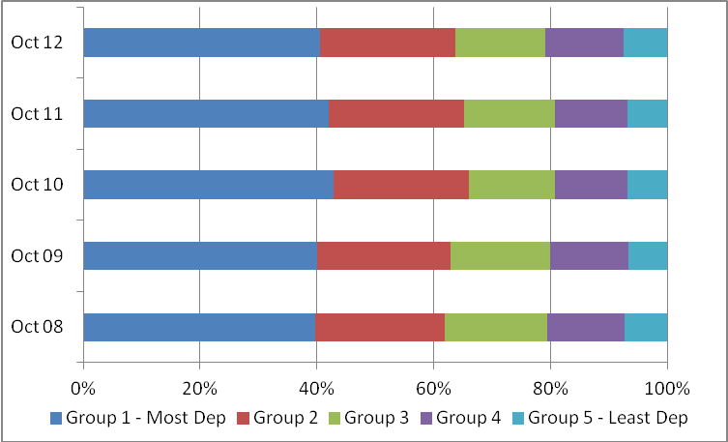
Source: DEL Client Management System
Figure 7.1(ii): PLA Occupancy by Deprivation Quintile
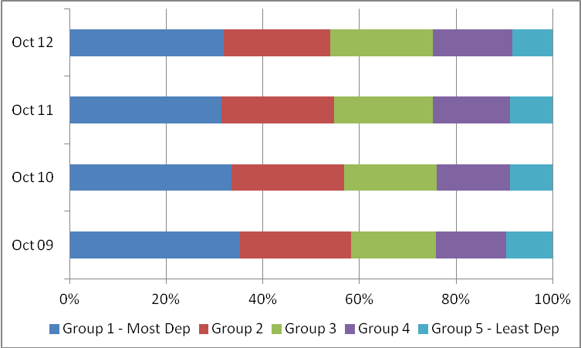
Source: DEL Client Management System
]
  - Tables 7.3 and 7.4 below detail the qualifications achieved by participants leaving the different strands of TfS between 2008/09 and 2011/12. Numbers of leavers from Skills for Your Life who achieved a qualification increased steadily from 2008/09 to 2010/11 but decreased between 2010/11 and 2011/12. Numbers of leavers from Skills for Work who achieved a qualification increased steadily from 2008/09 to 2011/12. It should be noted that only those qualifications at Level 2 and above (in the case of Table 7.4, only the Level 2 Tech Cert, which are highlighted) count towards DEL’s overall Programme for Government target.

Table 7.3: Qualifications obtained by participants leaving TfS Option Skills for Your Life
 | Number of Leavers Achieving
Academic year | ES Entry Level | ES Level 1 | ES Level 2 | Entry Level VRQ
2008/09 | 30 | 36 | 9 | 29
2009/10 | 184 | 158 | 24 | 198
2010/11 | 275 | 204 | 56 | 302
2011/12 | 230 | 167 | 34 | 248

Source: DEL Client Management System

Table 7.4: Qualifications obtained by participants leaving TfS Option Skills for Work
 | Number of Leavers Achieving
Academic year | ES Entry Level | ES Level 1 | ES Level 2 | Level 1 VRQ | Level 2 Tech Cert
2008/09 | 97 | 48 | 11 | 62 | 10
2009/10 | 599 | 694 | 190 | 826 | 169
2010/11 | 542 | 620 | 204 | 729 | 101
2011/12 | 681 | 725 | 315 | 866 | 181

Source: DEL Client Management System

  - Tables 7.5 and 7.6 below detail the qualifications achieved by participants leaving Programme-Led Apprenticeships (PLA) between 2009/10 and 2011/12. PLA participants undertake Essential Skills training as necessary to meet the requirements of the training frameworks in question. Section 10 of this report sets out the total number of Essential Skills qualifications that were obtained in Northern Ireland and how that number has changed over the last number of years. The number of Essential Skills qualifications gained by participants on Programme-Led Apprenticeships are also set out below to demonstrate the particular impact that programme has on developing participants’ literacy, numeracy and ICT skills. These tables show that the number of leavers who achieved a qualification has increased steadily from 2009/10 onwards. Only NVQ Level 2 qualifications count towards the Department’s Programme for Government qualifications target (highlighted).

  - It should be noted that figures in Tables 7.3 through 7.6 refer to the numbers of qualifications achieved rather than the numbers of individuals achieving a qualification. Also, numbers of qualifications achieved in the early years of a programme will of necessity be lower than in later years, as it takes time for participants to move through the programme and achieve.

Table 7.5: Qualifications obtained by participants leaving Programme-Led Apprenticeships
 | Numbers of Leavers Achieving
Academic Year | NVQ Level 2 | Full Framework Level 2
2009/10 | 14 | 7
2010/11 | 317 | 235
2011/12 | 1,165 | 938

Source: DEL Client Management System

Table 7.6: Essential Skills Qualifications obtained by participants leaving Programme-Led Apprenticeships
 | Numbers of Leavers Achieving
Academic Year | Essential Skills Level 1 | Essential Skills Level 2
2009/10 | 99 | 86
2010/11 | 697 | 599
2011/12 | 1,508 | 1,337

Source: DEL Client Management System

  - A revised training provision has been introduced from June 2013 and further details will be incorporated into the next edition of this annual report.

Table 7.7: Trends in Training for Success / PLAs

Indicator | Recent Change | Long-Term Trend
Overall occupancy on the DEL Training for Success / PLA programme. | Figures for 31 October 2012 indicate a 6% decrease in occupancy on Training for Success compared to the same period a year earlier, bringing the total occupancy number to 7,768. | Occupancy has grown by 59% between 2008 and 2012.
PLA participants on ‘narrow’ STEM frameworks | Occupancy on ‘narrow’ STEM frameworks within PLA has increased by 5% between October 2011 and October 2012. | Occupancy on ‘narrow’ STEM frameworks within PLA has almost doubled (92%) between October 2009 and October 2012.
TfS/PLA participants by MDM quintiles | The proportion of TfS participants from the most deprived areas decreased from 42% to 41% between October 2011 and October 2012.  The proportion of PLA participants from the most deprived areas increased from 31% to 32% between October 2011 and October 2012. | The proportion of TfS participants from the most deprived areas has increased from 40% to 41% over the last four years  The proportion of PLA participants from the most deprived areas has decreased from 35% to 32% over the last three years.
Numbers of TfS and PLA leavers obtaining qualifications | Numbers of Level 2 and above qualifications obtained by leavers from TfS/PLA increased from 418 to 1,346 between 2010/11 and 2011/12. | Figures for numbers of qualifications obtained by leavers from TfS/PLA for the early years of these programmes are not comparable with later years, as it takes considerable time for trainees to pass through the system and for qualifications to be obtained.

Chapter 8: ApprenticeshipsNI

  - The ApprenticeshipsNI Programme aims to provide participants with the opportunity, through paid employment, to gain a Level 2/Level 3 Apprenticeship Framework, and to provide opportunities for progression to further and higher education and training.

  - In addition to producing overall statistical bulletins, the Department collates and analyses the data provided by individual suppliers for the purposes of quality and performance monitoring. The Department shares the data with the Education and Training Inspectorate for use in inspections and to inform the evaluation of each supplier’s self-evaluation report and quality improvement plan.

  - At 31 October 2012, 11,207 individuals were benefitting from the ApprenticeshipsNI programme. This represents a decrease in occupancy since 31 October 2011 of just over 8%. Females represent just under 50% of all apprentices, rising to 60% of those in the age 25 and over group. Compared to last year, female occupancy has decreased by 8%. The long-term trend for female occupancy had been upwards, with an increase of almost 110% between 2008 and 2012; so too has the long-term trend for overall occupancy (+77% from 2008 - 2012) – see Table 8.2.

Table 8.1: Occupancy on ApprenticeshipsNI by Level
 | Level 2 | Level 2/3 | Level 3 Progression | Level not Assigned | Total
Oct-08 | 4,567 | 1,144 | 516 | 113 | 6,340
Oct-09 | 6,563 | 1,673 | 1,233 | 41 | 9,510
Oct-10 | 6,413 | 1,560 | 2,208 | 26 | 10,207
Oct-11 | 7,094 | 1,818 | 3,237 | 47 | 12,196
Oct-12 | 6,511 | 1,084 | 3,592 | 20 | 11,207

Source: DEL Client Management System

  - The increases in both the proportion of females and those aged 25 and over reflected changes in provision, as a result of the introduction, in September 2008, of All Age Apprenticeships [25+] along with provision for those working Reduced Contracted Hours. Subsequent changes that will impact on uptake are outlined in paragraph 8.8 below.
  - The information available indicates that occupancy on ‘narrow’ STEM training within ApprenticeshipsNI has been falling in recent years, from 27% of overall occupancy in 2008 to 18% in 2012. (See table 8.2)
Table 8.2: Occupancy on STEM Frameworks, Apprenticeships only
Framework | Oct-09 | Oct-10 | Oct-11 | Oct-12 | 2009 - 2012 % change | 2011 - 2012 % change
Agriculture Industry | 42 | 69 | 68 | 77 | 83.3% | 13.2%
Construction | 926 | 1,492 | 1,327 | 1,081 | 16.7% | -18.5%
Engineering and Technology | 725 | 1,153 | 1,261 | 1,313 | 81.1% | 4.1%
Manufacturing | 0 | 5 | 5 | 12 | N/A | 140.0%
IT | 69 | 149 | 183 | 200 | 189.9% | 9.3%
Total 'broad' STEM | 1,762 | 2,868 | 2,844 | 2,683 | 52.3% | -5.7%
Total 'narrow' STEM | 794 | 1,307 | 1,449 | 1,525 | 92.1% | 5.2%
Overall occupancy | 2,863 | 5,080 | 5,562 | 5,219 | 82.3% | -6.2%
narrow' STEM as a % of overall occupancy | 27.7% | 25.7% | 26.1% | 29.2%

Source: DEL Client Management System

  - Figure 8.1 details the proportion of participants in ApprenticeshipsNI by NIMDM quintiles. The proportion of those on ApprenticeshipsNI from the most deprived areas has increased over the last four years, from 20% to 25%.

Figure 8.1: ApprenticeshipsNI Occupancy by Deprivation Quintile
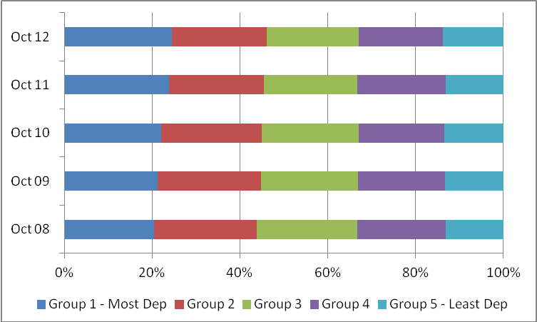
Source: DEL Client Management System

  - Tables 8.3 and 8.4 detail the qualifications achieved by leavers from Level 2, Level 2/3 and Level 3 Progression Apprenticeships between 2007/08 and 2011/12. Highlighted figures indicate those which count towards the Programme for Government target as detailed in Section 3 (p.39) of this report.
  - Numbers of qualifications gained in the early years of ApprenticeshipsNI are lower than in later years as it takes time for trainees to move through the programme and achieve.

Table 8.3: Qualifications obtained by participants leaving Level 2 Apprenticeships
 | Numbers of Leavers Achieving
Academic Year | NVQ Level 2 | Full Framework Level 2
2007/08 | 60 | 46
2008/09 | 1,041 | 895
2009/10 | 3,393 | 2,887
2010/11 | 3,838 | 3,402
2011/12 | 3,917 | 3,461

Source: DEL Client Management System

Table 8.4: Qualifications obtained by participants leaving Level 2/3 and Level 3 Progression Apprenticeships
 | Numbers of Leavers Achieving
Academic Year | NVQ Level 2 | NVQ Level 3 | Full Framework Level 2 | Full Framework Level 3
2007/08 | 6 | 1 | 0 | 0
2008/09 | 85 | 86 | 10 | 69
2009/10 | 188 | 577 | 40 | 474
2010/11 | 214 | 1,372 | 30 | 1,209
2011/12 | 425 | 2,416 | 21 | 2,270

Source: DEL Client Management System

  - In September 2011, with a view to re-balancing the economy, the Minister initiated a review of adult training, including Apprenticeships. This was to ensure that resources were targeted more effectively on the priority skills needs of the local economy and the specific needs of adults and, from August 2012 a revised funding policy for adult apprentices (aged 25+) has been introduced. Recruitment to Apprenticeships is expected to contract somewhat in light of this sharper focus on priority areas. Further analysis of impact will be incorporated into the next edition of this report.

Box 8.1: WorldSkills 2013
Over the last number of years Northern Ireland's performance in skills competitions at UK and world level has progressed significantly. Below is a breakdown of Northern Ireland's performance at WorldSkills competitions (held every 2 years) and at UK competitions (held every year).
There were 20 NI competitors on the UK Squad competing for a place on Team UK at WorldSkills Leipzig in July 2013. This was the highest representation of all the UK regions.
Team UK selection was announced in March 2013 and nine NI competitors were chosen to represent the UK on the world stage. This was the highest representation of all the UK regions.

WorldSkills Competition
Year Team Members Medals
2005 2 Gold (1), Medallion for Excellence (1)
2007 1 Bronze (1)
2009 1 Bronze (1)
2011 7 Gold (1), Silver (1), Bronze (1), Medallion (2)
2013 9 Bronze (1), Medallion for Excellence (6)

UK Competition
Year Medals
2010 Gold (4) Silver (6), Bronze (12), Highly Commended (1)
2011 Gold (10) Silver (1), Bronze (2)
2012 Gold (9) Silver (9), Bronze (8)
2013 (Event to be held 14-16 November 2013)

Table 8.4: Trends in Apprenticeships NI
Indicator | Recent Change | Long-Term Trend
Overall occupancy on the DEL ApprenticeshipsNI programme. | Between October 2011 and October 2012, there was an 8% decrease in occupancy on the ApprenticeshipsNI programme, bringing the total occupancy number to 11,207. | Occupancy on ApprenticeshipsNI has increased by 77% between 2008 and 2012.
ApprenticeshipsNI participants on ‘narrow’ STEM frameworks | Occupancy on ‘narrow’ STEM frameworks within ApprenticeshipsNI has decreased by 15% between October 2011 and October 2012. | Occupancy on ‘narrow’ STEM frameworks within ApprenticeshipsNI increased by 20% between October 2008 and October 2012.
ApprenticeshipsNI participants by MDM quintiles | The proportion of ApprenticeshipsNI participants from the most deprived areas has increased by 1 percentage point between October 2011 and October 2012, to 25%. | The proportion of ApprenticeshipsNI participants from the most deprived areas increased between October 2008 and October 2012, from 20% to 25%.
Number of Level 2 qualifications obtained by leavers from the DEL ApprenticeshipsNI programme. | Between 2010/11 and 2011/12, there was an increase of 7% in the number of NVQ Level 2 qualifications obtained by leavers from the Apprenticeship NI programme. Full frameworks obtained by leavers at Level 2 increased by 1%. | Between 2007/08 and 2011/12, the number of NVQ Level 2 qualifications obtained by Apprenticeship leavers increased from 66 to 4,342. Over the same period, the number of Level 2 leavers obtaining a Full Framework at Level 2 increased from 46 to 3,482.
Number of Level 3 qualifications obtained by leavers from the DEL ApprenticeshipsNI programme. | Between 2010/11 and 2011/12, there was an increase of 76% in the number of NVQ Level 3 qualifications obtained by participants leaving ApprenticeshipsNI. Over the same period, the number of these leavers who obtained a Full Framework at Level 3 increased by 88%. | Between 2007/08 and 2011/12, the number of NVQ Level 3 qualifications obtained by participants leaving ApprenticeshipsNI increased from 1 to 2,416. Over the same period, the number of these leavers who obtained a Full Framework at Level 3 increased from a zero base to 2,270.

Chapter 9: Bridge to Employment

  - The Bridge to Employment (BTE) programme aims to provide assistance to inward investment and local companies who are recruiting people who are currently unemployed.

  - The programme includes bespoke training courses which are developed in conjunction with the participating company and training provider to enable trainees to acquire the skills needed to meet the recruitment profile of the business. Up to 2012/13 the proportion of trainees’ successfully completing training and achieving employment has remained high. In 2012/13 some 160 people successfully completed Bridge to Employment training. Some 128 of the 160 trainees were offered employment by the participating company. This represents 80% of those who completed the training.

Table 9.1: Trends in Bridge to Employment
Indicator | Recent Change | Long-Term Trend
Successful completion of training on Bridge to Employment programmes  (i.e. achieving employment following training) | The training completion rate on Bridge to Employment has decreased over the last year from 90% in 2011/12 to 80% in 2012/13, but still remains at a high level. | The training completion rate has decreased from 99% in 2008/09 to 80% in 2012/13, but still remains at a high level.

Chapter 10: Essential Skills

  - The Department for Employment and Learning launched the Essential Skills for Living Strategy and action plan eleven years ago in April 2002. Essential Skills for Living aims to improve adult literacy and numeracy (including Information & Communication Technology (ICT)) in Northern Ireland. Essential Skills provision is provided across five levels for literacy and numeracy and two levels for ICT. The Department’s PfG qualifications target includes only those qualifiers at Level 2 in Essential Skills and therefore the main focus of this subsequent analysis is at that level, however information across all levels is also included in this section to ensure a complete picture is painted.

Qualifications

  - In 2011/12, there were 20,584 qualifiers at Level 2 in Essential Skills increasing from 16,307 in 2010/11 – a 26% increase. This increase is considered as being attributable to the Department working closely with all of the FE Colleges to provide them with data on their performance in relation to enrolments, retention and achievement rates. Each college was required to prepare an Essential Skills Action Plan with DEL setting individual targets to ensure that the Department’s ‘then’ PSA target on Essential Skills for the year ending in March 2011 would be achieved. The FE sector responded very positively to the increased targets set by DEL. The targets were challenging and ensured that there was a greater focus on delivery to older learners, more emphasis on delivering within the workplace and community settings and a strong focus on driving up achievement rates, this resulting in a positive increase in qualifications achieved. There have also been positive increases each year since the start of the Strategy in Level 2 Essential Skills qualifications as shown in Figure 10.1.

Figure 10.1: Level 2 Essential Skills qualifications
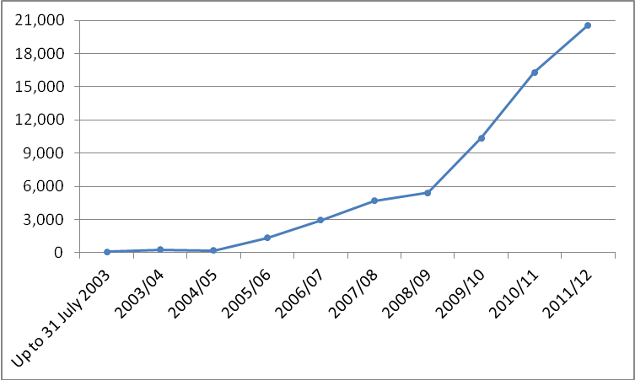
(Source: Essential Skills Awarding Bodies)

  - Level 2 qualifications represented 51% of total Essential Skills qualifications in 2011/12. Qualifications across all levels of study in Essential Skills have increased by 13% in 2011/12. The data show that the biggest increase since the start of the Strategy was at Level 2.

  - There has been growth across all subject areas in Level 2 Essential Skills qualifications from 2010/11 to 2011/12; Literacy (+29%), ICT (+28%) and Numeracy (23%).

Figure 10.2: Level 2 Essential Skills qualifications by subject
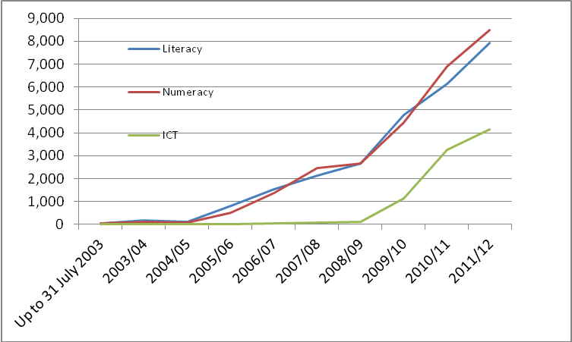
(Source: Essential Skills Awarding Bodies)

  - Across all levels of study, the increase in qualifications from 2010/11 to 2011/12 is most marked in Numeracy whereby qualifications gained increased from around 14,300 to just over 16,350.

Box 10.1: International Survey of Adult Skills
The International Survey of Adult Skills is a product of the Programme for the International Assessment of Adult Competencies (PIAAC) led by the Organisation for Economic Co-operation and Development (OECD). It assessed the proficiency of adults, aged 16-65, in three information processing skills, which the OECD regards as essential for full participation in the knowledge-based economies and societies of the 21st century. The three areas of proficiency assessed were ‘Literacy’; ‘Numeracy’ and ‘Problem solving in technology-rich environments’ (PSTRE). Northern Ireland, Ireland and England participated in the study alongside 21 other participating countries and sub-national regions.

The Survey in Northern Ireland was carried out by the National Foundation for Educational Research (NFER) in partnership with the Northern Ireland Statistics and Research Agency (NISRA). The results of the survey were published by the OECD in October 2013 with a separate but related Northern Ireland report.
The results demonstrate that Northern Ireland's literacy performance has improved over the last decade and a half and that the gap between Northern Ireland and the OECD average has reduced. It shows that fewer Northern Ireland adults are performing at the lowest literacy levels. The results show that literacy, numeracy and problem solving skills are well rewarded in the Northern Ireland labour market with those individuals who have the highest skills earning the most. Nevertheless, despite these improvements, working age adult competencies have some way to go to match the best performing countries in literacy, numeracy and problem solving.

Enrolments

  - In line with the increases in Level 2 Essential Skills qualifications, enrolments have also been increasing and continue to do so. These are up from 21,766 in 2010/11 to 23,211 in 2011/12 or by 7%. Level 2 enrolments made up 39% of overall enrolments in 2011/12 (Level 1 represented the majority). Figure 10.3 sets out the longer term trend of Level 2 enrolments since the beginning of the Strategy.

Figure 10.3: Level 2 Essential Skills enrolments
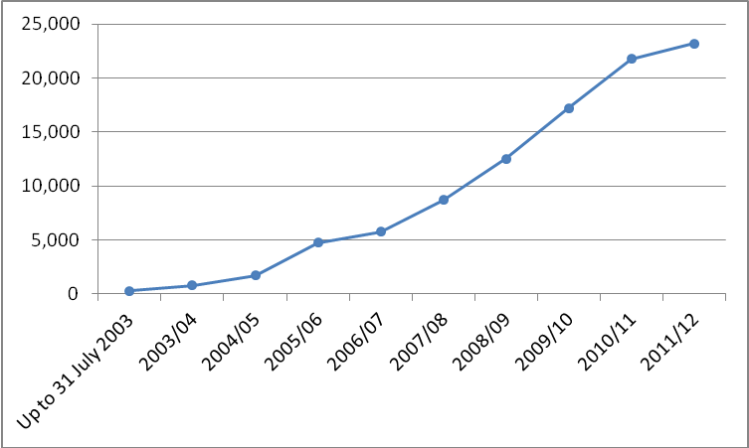
(Source: Essential Skills Enrolment Return)

  - At the overall level, there has been a very significant increase in enrolments on Essential Skills courses since the introduction of the strategy. Despite the continued growth at Level 2, recent data show that overall the enrolment levels have begun to level off, decreasing slightly by 2% in the year to 2011/12, with a total of 60,597 enrolments.

  - Analysis of enrolments at Level 2 by subject shows increases across ICT (21%) and Numeracy (6%) between 2010/11 and 2011/12 – Literacy enrolments at Level 2 had a 1% increase (see Figure 10.4). In 2011/12 ICT represented almost one quarter of all Level 2 enrolments (23%); and 39% for Literacy and 37% for Numeracy.

Figure 10.4: Level 2 Essential Skills enrolments by subject
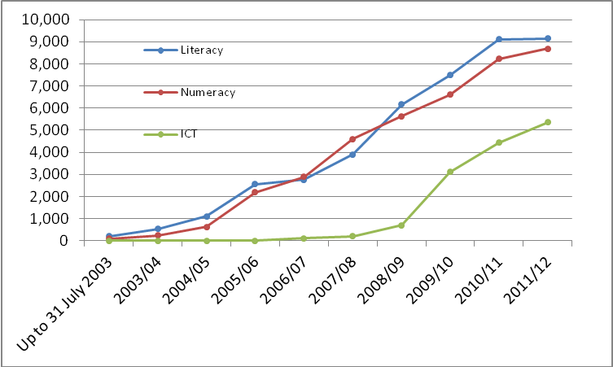
(Source: Essential Skills Enrolment Return)

  - Across all levels of study, in 2011/12 there were 38% and 37% of enrolments in Literacy and Numeracy, respectively, with ICT representing 25% of total enrolments. Over the academic year to 2011/12, growth was experienced in ICT at 3% from 2010/11. For both Literacy and Numeracy there was a slight decrease, with 4% and 2% respectively, over the same period.

  - The Essential Skills programme has been successful in engaging those from the most deprived areas of Northern Ireland. In 2011/12, 24% of Level 2 enrolments in Essential Skills were from the 20% most deprived areas in Northern Ireland. Since the start of the Strategy 25% of all level 2 enrolments have been drawn from such areas.

  - This is even more pronounced across all levels of study where Essential Skills providers have been successful in attracting a disproportionately large number of enrolments from the more deprived areas of Northern Ireland (30% since the start of the Strategy and 29% in 2011/12). This is positive given that the evidence available indicates that the need for development of essential skills is concentrated (although not exclusive to) more deprived areas.

Box 10.2: Assessing Literacy and Numeracy levels at a Sub Regional Level

The Department has recently initiated a piece of research to examine the possibility of providing estimates of self reported ‘Literacy’ ability at small geographical areas, such as Super Output Areas (SOAs). This work will benefit policy makers by building up a clearer picture of Essential Skills needs at a local level in Northern Ireland. The first phase of this research has scoped the feasibility of using Omnibus Survey data in conjunction with Census information to develop a spatial micro simulation model. Phase two of the project now involves developing a model to provide estimates of self reported ‘Literacy’ ability within small geographical areas.

Retention/Achievement

  - Retention and achievement rates at Level 2 in Essential Skills provision were at their highest levels in 2011/12 since the Essential Skills Strategy was introduced – 90% and 99% respectively (Figure 10.5). Over the course of the Strategy retention and achievement rates at Level 2 have been 88% and 74% respectively.
Figure 10.5: Level 2 Essential Skills retention and achievement
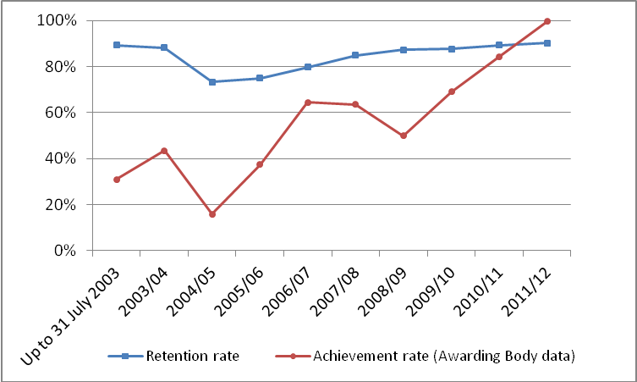
(Source: Essential Skills Awarding Bodies)

  - Across all levels of study, the data indicate that retention and achievement rates have been 88% and 61% respectively, over the period since the introduction of the Essential Skills strategy. Rates have been improving and were again higher in 2011/12 with the retention rate for that year recorded at 90%, while the achievement rate was 99%.

  - This pattern was similar across all levels of study, whereby retention rates were highest for literacy and numeracy at 92% each in 2011/12, with ICT showing a rate of 85%. In terms of achievement rates, numeracy was highest (80%), followed by Literacy (73%) and ICT (67%).

Box 10.3: Factors that impact on the successful completion of Essential Skills courses
Similar to the FE econometrics work detailed earlier on Further Education, the Department plans to conduct a detailed statistical analysis of outcomes in Essential Skills to consider why there appears to be significant variance in retention and completion rates across different types of students and providers. That work will be undertaken during 2013.

Summary
  - This section has demonstrated strong performance in relation to qualifications achieved at Level 2 in Essential Skills with all three subject areas (Literacy, Numeracy and ICT) experiencing increases of around one quarter. Looking to the future, the increase in enrolments at Level 2 (albeit ICT enrolments have remained fairly static over the last year) coupled with a slight increase in retention and a 99 per cent achievement rate in 11/12 bodes well. It has also shown that Essential Skills provision has been particularly successful in attracting those from the most deprived areas of Northern Ireland.
Table 10.1: Trends in Key Essential Skills Indicators - Level 2 provision
Indicator | Recent Change | Long-Term Trend
Level 2 Qualifications in Essential Skills | The number of Level 2 qualifications in Essential skills has increased by 26% from 16,307 in 2010/11 to 20,584 in 2011/12. | Level 2 qualifications in Essential Skills have increased from 291 in 2003/04 to 20,584 in 2011/12.
Level 2 Enrolments on Essential Skills courses | The number of Level 2 enrolments on Essential skills courses has increased by 7% from 21,766 in 2010/11 to 23,211 in 2011/12. | Level 2 enrolments on Essential Skills course has increased from 759 in 2003/04 to 23,211 in 2011/12.
Retention on Level 2 Essential Skills Courses | The retention rate on Level 2 Essential skills courses has held constant at 90% in 2011/12. | The retention rate on Level 2 Essential skills courses has increased from 89% in 2003/04 to 90% in 2011/12.
Achievement on Level 2 Essential Skills Courses | The achievement rate on Level 2 Essential skills courses has increased from 84% in 2010/11 to 99% in 2011/12. | The achievement rate on Level 2 Essential skills courses has increased from 43% in 2003/04 to 99% in 2011/12.

Chapter 11: Moving People Into Employment

  - The aim of the Employment Service is to help people find jobs (and also to help employers find suitable employees). Within this, there is a special emphasis on assisting those currently unemployed to move closer to the labour market with the ultimate objective of helping them find – and sustain – work. This is summarised in a key PfG commitment which seeks to help at least 114,000 off benefit and into work over the lifetime of the Programme for Government.

  - The Employment Service seeks to do this in a number of ways. The main interventions are through the Service’s frontline staff based in Jobs & Benefits Offices and in JobCentres; and through the Steps to Work programme. Frontline staffare supported by systems such as Jobcentre Online (where people looking for work can explore vacancies) and Employers Online (allowing employers to post vacancies). Steps to Work operates in a more intensive way with those on benefit (although non-benefit claimants can access the service) to help equip people to find and keep employment. The emphasis within Steps to Work is on people sustaining employment, not just finding it. ‘Steps to Work’ is discussed in more detail below.

  - Over the period of the current PfG, the social security context is likely to change with the replacement of a number of existing benefits by a new system of Universal Credit. Universal Credit has a number of objectives, but key amongst them is to realign the system so that it better supports people on unemployment benefits to take a job. This will require a change in the offering that the Employment Service has for benefit recipients. During 2011/12 the Department used research and evaluation evidence to rescope its main offering to benefit recipients (currently Steps to Work); 2012/13 will see that new provision (Steps to Success) being firmed up following consultation with a view to it being introduced later in the PfG period. Similarly the Employment Service’s frontline delivery is being reviewed so that it is best placed to support clients under a Universal Credit regime and to ensure it aligns with the new Steps to Success employment programme. These new services will, in all likelihood, result in new indicators for monitoring towards the end of the PfG period.

Performance in Moving People into Work

  - As mentioned in Chapter 3 and above, the Employment Service has a commitment under the Programme for Government to assist at least 114,000 individuals into employment over the period of the Programme for Government. In the first year of the PfG (2011-12), the Department supported 37,970 individuals into employment compared to a target of 35,000. In year two (2012-13) 38,871 individuals were supported into employment, against a target of 30,000 – In the 2 year period the Employment Service exceeded its target by 11,841 or 18.2%.

  - The PfG also contains a commitment to help young people in particular to move into employment (considered to be those aged between 18 and 24). In 2011-12 the Department supported 12,385 young people into employment, in 2012-13 it helped a further 13,048 young people into employment. The general trend is upwards, although to a certain extent this reflects the fact that more young people are unemployed thus increasing the number who need help. In July 2012 the Minister for Employment and Learning launched the Youth Employment Scheme. The scheme involves a series of measures to help young people aged 16 to 18 not in employment, education or training (NEETs) and unemployed young people aged 18-24 find and secure employment.

Steps to Work

  - Steps to Work is the Department’s main adult return to work programme. Its aim is to assist people who are unemployed or economically inactive to find and sustain employment. Participation is mandatory for all those on Jobseeker’s Allowance (JSA) aged between 18 and 24 who have been claiming JSA for 6 months or longer and those aged 25 and over claiming JSA for 18 months or more. Steps to Work also offers access to provision for voluntary participants aged 18 or over (16 or over for lone parents) for those on Incapacity Benefit, Employment and Support Allowance, Income Support, other benefits, and those economically inactive not in receipt of benefits.

  - From September 2008 to March 2013, 114,650 participants started Steps to Work. The majority of participants who started were mandatory, accounting for 74% (85,160 participants) of all starts.

  - As the programme’s aim indicates, the focus is on helping people to find work and in this respect the Department has set two key targets:

  - 25% of leavers to find employment (within 13 weeks of leaving) and to sustain that employment for a full 13 weeks; and
  - 85% of those who have sustained employment for a continuous period of 13 weeks to retain that employment for a further additional 13 week period i.e. total duration of 26 weeks sustained employment

  - These targets and statistics published prior to June 2012 were developed using only data held by DEL and derived from information stored in the Department’s Client Management System (CMS). In order to improve the quality and accuracy of Steps to Work destination statistics, the Department embarked on a significant programme of work to enhance existing data by adding benefit data held by the Department for Social Development (DSD); and employment data from Her Majesty’s Revenue and Customs (HMRC). The merging of these data sources has led to an increase of six percentage points (from 22% to 28%) in the estimate of the proportion of participants recorded as moving into unsubsidised employment sustained for 13 weeks.

  - Between September 2008 and September 2012 Steps to Work assisted a total of 32,280 participants to find employment with 29,315 entering unsubsidised employment over the period – 35% of all leavers. Approximately 82% of participants who moved into unsubsidised employment sustained that employment for 13 weeks or more. This represents 29% of all leavers from the programme in that period. From the period September 2008 to June 2012, 86% of those who sustained employment for 13 weeks, remained in employment for a further 13 weeks, i.e. at least 26 weeks in total. Further information is available in the following statistical bulletin – http://www.delni.gov.uk/stw-stats-sept08-mar13.htm

Economic Inactivity

  - The Executive is also focussed on the problem of economic inactivity. Inactivity levels for working age people in Northern Ireland have, for decades, been high, largely varying between 25% and 30%. Northern Ireland has repeatedly reported the highest level of inactivity of any country or region of the UK, and rates are usually some four or five percentage points higher than the UK average. The rate currently (Mar – May 2013) stands at 27.5%, five percentage points above the UK rate (22.5%) and the highest rate amongst the twelve UK regions.

  - For this reason the Programme for Government contains a commitment to develop and implement a strategy to reduce economic inactivity in Northern Ireland. The Economic Inactivity Strategy is being led by DEL and DETI and will develop interventions on the demand side (through incentives and job creation) and on the supply side (through training and skills development). As a first step the Department has published a baseline study (available here: http://www.delni.gov.uk/economic-inactivity-strategy-baseline-study.pdf) which provides a detailed analysis of factors contributing to the high rate of inactivity in Northern Ireland, a set of regional and international comparisons and an assessment of current and previous policy initiatives. The recommendations of the baseline study will underpin the draft strategy that will be presented to the Executive for agreement later during 2013.

  - As the Strategy is firmed up, targets and indicators will be further developed.

Summary

  - This section has demonstrated that, despite very challenging economic and labour market conditions, the Employment Service has achieved strong performance in terms of its key objective of helping people off benefits and into work; and in terms of its key programme, Steps to Work, in assisting people into sustained employment. This emphasis will need to be maintained in the light of continuing poor labour market conditions and this will involve a continuing refocusing of the frontline service offered by Employment Service staff and a development of a new employment programme to increase the number people helped into sustained jobs.
Table 11.1: Trends in Key Employment Indicators
Indicator | Recent Change | Long-Term Trend
Moving Benefit clients into Employment | In 2012/13 there were 38,871 benefit claimants supported into employment (compared to a target of 30,000). This represents an increase of 2.4% (900 claimants) from 2011/12 (29.6% above target), and has been achieved against a backdrop of rising unemployment. | Numbers have increased somewhat despite the recession putting downward pressure on vacancies. In the first two years of the PfG the Department has supported almost 77,000 (76,841) benefit claimants into employment. The commitment is to support 114,000 into employment by 2015.
Steps to Work | This year’s data have been enhanced by adding information from DSD and HMRC. These have improved the estimates of those moving to employment. The figure for 2011/12 was 37% of leavers moving to unsubsidised employment which is unchanged from the previous year (2010/11) | Since the Steps to Work programme was introduced in September 2008 the percentage of leavers moving to unsubsidised employment has increased year on year from 26% in 2008/09, 33% in 2009/10 to 37% in both 2010/11 and 2011/12.
Economic Inactivity* | Inactivity Strategy to be developed and likely to result in refined indicators. The working age inactivity rate stands at 27.3% (May – July 2013). This rate increased by 0.3 percentage points over the quarter and by 0.4 percentage points over the year. However, the Northern Ireland rate remained significantly higher than the UK average rate (22.3%) and was the highest rate among the twelve UK regions. | The working age economic inactivity rate has mostly stayed within a fairly narrow band between 25% and 30% over a period of around three decades.

* The Economic Inactivity rate is based on Labour Force Survey (LFS) data. The LFS is a sample survey which is subject to considerable volatility; caution should be applied in reading too much into its short term movements.

Chapter 12: Innovation and Knowledge Transfer

  - Encouraging research and development, creativity and innovation in the Northern Ireland economy is one of the Department’s key areas of activity. The Department seeks to enhance innovation capacity by supporting the local universities’ research capabilities and research quality; exploiting fully the contribution that the local universities and further education colleges can make to the economy and, in particular, increase their responsiveness to the needs of business and the community. This support is reflected in the Department’s commitments within the NI Economic Strategy Comprehensive Action Plan (Theme A).

  - The Department’s Higher Education strategy sets out detailed proposals to support the ‘innovation, R&D and Creativity’ pillar of the economic strategy, these include commitments to:
- support internationally excellent and world-leading research and development; and
- build upon and increase sustainable knowledge transfer activities.

  - Graduate skills, with an emphasis on STEM and other economically-relevant skills, will drive the innovation agenda. The Department achieved its previous PfG target of increasing by 300 the number of PhD research students at local universities. Over the last year overall PhD enrolments have decreased by 5% and PhD enrolments in ‘narrow’ STEM subjects have decreased by 7.5%. A contributory factor is the gap between the run-out of the Department's original allocation of 300 additional PhD places (commencing in AY 08/09) and the start of the 350 additional places commencing AY 13/14 (funded mainly under "Graduating to Success" and the Executive's Economy and Jobs Initiative). This gap resulted in no new enrolments, over the baseline, occurring in each of AY 11/12 and AY 12/13

  - Between 2001/02 and 2011/12 the number of PhD enrolments at NI HEIs has grown by 9.5% (from 1,945 to 2,130). Over the same period, the number of ‘narrow’ STEM PhD enrolments increased by 47% (to 985) (Figure 12.1). The Department’s active intervention in this area has been a contributory factor in the growth in economically-focussed ‘narrow’ STEM PhD enrolments.

Figure 12.1: PhD enrolments in Northern Ireland over time
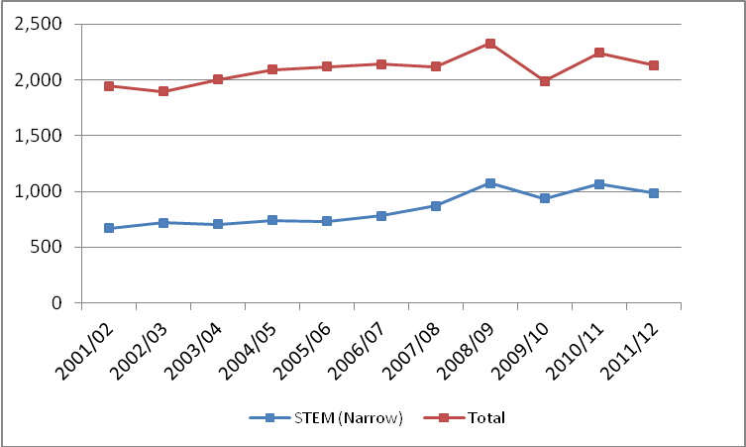
(Source: Higher Education Statistics Agency)

  - The four UK higher education funding bodies, which includes the Department, periodically undertakes a peer review-based benchmarking exercise (called the Research Assessment Exercise (RAE)) to assess the quality and volume of research activity carried out by our higher education institutions. The last RAE was in 2008. Research graded at the highest level by RAE has been increasing across both Queen’s University Belfast (QUB) and University of Ulster (UU) and both universities have improved their overall position in the wider UK HEI context. In addition, forty per cent of research activity submitted by Stranmillis University College was adjudged to be internationally recognised or higher.

  - From 2014, the RAE will be replaced by a new framework for the assessment and funding of research, known as the Research Excellence Framework (REF) which will, for the first time, introduce a measure of research impact.

Higher Education Business and Community Interaction Survey (HEBCI)

  - The annual HE-BCI survey focuses exclusively on output data covering a range of activities, from the commercialisation of new knowledge, through the delivery of professional training, consultancy and services, to activities intended to have direct social benefits. The Department publishes Northern Ireland summary reports of the key findings.

  - Northern Ireland compares favourably with the rest of the UK in key measures from the 2013 HE-BCI Survey – relating to the 2011/12 academic year. The latest HE-BCI data show a decline in the income Northern Ireland HEIs received from business and community interaction in 2011/12, by around 14%, reflecting the continued difficult economic climate. However, this follows very strong performance in three previous HE-BCI surveys culminating in 2010-11 when universities income exceeded £100 million, for the first time. It is also worth noting that local HEIs continue to outperform their UK counterparts across many key HE-BCI metrics (on a UK GVA share basis), including collaborative income and spin-off companies, for example.

  - One key indicator of HEI / business and community interaction is the extent to which local HEIs generate income from collaborative research. This includes research that is taken forward jointly by a HEI, a public funder and a third party. Data for the latest year (2011/12) show that income from this source had decreased by 11% to £35.4m in 2011/12, however this should be considered against an impressive longer term rising trend – HEI income increased by over one-quarter (+28%) between 2002/03 and 2011/12.

Box 12.1: Collaborative Research
With a share of about 2.2% of UK Output in Northern Ireland, NI HEIs income from collaborative research represents 3.6% of the UK total.

  - In terms of commercialisation activities, the number of spin-off companies originating from a Northern Ireland HEI (with some HEI ownership and still active after 3 years) has decreased marginally from 39 companies in 2010/11 to 38 companies in 2011/12. There has been an overall increase of 23% since 2002/03.
Box 12.2: Spin-off Companies
The number of spin-off companies originating from a Northern Ireland HEI represented 4.6% of the UK total in 2011/12. Again higher than the Northern Ireland share of UK output (2.2%).

  - Consultancy contracts are a more direct form of knowledge exchange between Higher Education and the economy. Income from this source has increased by 4% to £7.1 million in 2011/12.

Box 12.3: Consultancy Contracts
Income from consultancy contracts grew by 4% to £7.1 million in 2011/12, up from £6.9 million in 2010/11. Income from consultancy has more than trebled since 2002/03. Income from consultancy of £7.1 million in Northern Ireland represented 1.8% of the UK total in 2011/12.

Box 12.4: Global Competitive Report 2012-13
It is worth noting the outcomes of the World Economic Forum’s ‘Global Competitive Report 2012-13. It indicates that, in a global context, the United Kingdom is regarded as extremely competitive on a number of innovative measures and ranks 2nd out of 144 countries in terms of the extent of University-industry collaboration in R&D. Within this context it is encouraging to note that the evidence presented in the HEBCI survey (set out above) would suggest that the level of university – industry collaboration in Northern Ireland compares favourably with the UK as a whole.

Department for Employment and Learning’s Higher and Further Education Collaboration fund – The Connected Programme

  - Funded by the Department’s Higher and Further Education Collaboration Fund, the Connected Programme is an initiative of Queen’s University Belfast, the University of Ulster and Colleges NI, with additional links to the Agri-Food and Bioscience Institute (AFBI) and the College of Agriculture, Food and Rural Enterprise (CAFRE).

  - The objective of the Connected Programme is to facilitate Northern Ireland’s two universities to extend the range and depth of their collaboration with the Further Education sector with a primary focus on meeting the innovation needs of business. The aim of the Programme is; “to enable the HE and FE sectors to identify and meet the Knowledge Transfer needs of business and the wider community in a coordinated and holistic fashion”.

  - Connected effectively acts as a one stop shop for companies wishing to access the technology and knowledge capital within the local research base, taking them right through the whole process from problem definition through to solution identification and implementation.

  - Latest data would indicate that the programme has already exceeded the target in the NI Economic Strategy to undertake 155 knowledge transfer projects on behalf of local businesses, having delivered some 120 projects in 2011/12 alone and a further 118 in 2012/13. These projects have leveraged an associated investment from local companies of over £350k.

  - Looking specifically at the Further Education sector, the latest data show that there was a 1.8% rise in the proportion of full cost recovery professional and technical provision at Further Education colleges in Northern Ireland (an indicator of community and business interaction) over the last year (2011/12). Looking at this picture over the longer term (from 2002/03) full cost recovery professional and technical provision in Further Education has increased by almost 50%.

Summary

  - In summary while recognising that the economic context is presenting challenges for FE/HE’s engagement with business this section has shown that Northern Ireland regularly outperforms the rest of the UK in a number of HE / FE R&D and innovation indicators including the number of spin-off companies and the extent of research collaboration. The proportion of full cost recovery professional and technical provision at Further Education colleges has also increased over the last year despite the difficult economic conditions.

Table 12.1: Trends in Key Innovation indicators
Indicator | Recent change | Long-Term Trend
STEM PhD enrolments at NI HEIs | Between 2010/11 and 2011/12 STEM enrolments in PhDs at NI HEIs have decreased by 7.5%. | Between 2001/02 and 2011/12 STEM enrolments at NI HEIs have increased by 47%
Income from Collaborative Research at NI HEIs | Between 2010/11 and 2011/12 income from Collaborative Research has decreased by 11%. However, In relative terms, the performance of local HEIs in gaining income from collaborative research remains strong at £35.4 million in 2011/12, representing 3.6% of the UK total (where the Northern Ireland economy represents 2.2% of UK Output) | Income from Collaborative Research has increased by 28% between 2002/03 and 2011/12.
Number of Spin-off Companies originating from NI HEIs | Between 2010/11 and 2011/12 the number of spin-off companies decreased by 1 (from 39 companies to 38). However, in relative terms, this represented almost 5% of the UK total in 2011/12, indicating that local HEIs are outperforming their UK counterparts. | Between 2002/03 and 2011/12 the number of spin-off companies has increased by 23% (from 31 companies in 2002/03).
FE Cost Recovery Provision | Between 2010/11 and 2011/12, cost recovery professional & technical provision in FE (which provides an indicator of FE interaction with business and the community) increased by 1.8%. | Between 2002/03 and 2011/12, the cost recovery professional & technical provision in FE has increased by around 50%, on aggregate.

Summary

  - Overall, this report points to continuing challenges from the environment the Department operates within; it refers to high levels of unemployment and to difficult conditions for economic growth over the medium term. Nevertheless, it demonstrates that a good start is being made against both Programme for Government commitments and key strategic goals. Across the higher education (HE) and further education (FE) sectors, the report points to an improving picture on retention of students on courses and, particularly in FE, on achievement of qualifications. It shows that while enrolments at level 2 or above fell (in the year to 2011/12) in FE Mainstream provision (-6%) they increased in HE in FE provision (3%). These two areas account for about 40% of the qualifications that contribute to the Department’s overall Programme for Government qualifications target. Essential Skills (Level 2) enrolments have continued to expand, by 7% whilst enrolments at Northern Ireland HEIs remained static in the year to 2011/12. Meanwhile, occupancy on DEL Training Programmes fell (in the year to end October 2012); Training for Success (-6%), ApprenticeshipsNI (-8%).

  - Across a broad front, DEL skills provision continues to be successful at engaging with those from the more deprived areas and, where comparable data exist, the Northern Ireland performance on this measure tends to be significantly ahead of other parts of the UK. The report does however point towards challenges in the Science, Technology, Engineering and Mathematics (STEM) agenda with more to be done to achieve the Success through Skills strategic goal of increasing the proportion in Higher Education qualifying with STEM qualifications.

  - The Department has published an action plan (Annex A) to respond to the specific issues raised in this report and to enhance further the quality and performance of its sponsored programmes.

Annex A

DEL Quality and Performance Action Plan

[Attached separately – See DEL Website]

Annex B

What Factors Contribute to Successful Student Outcomes from FE – An Econometric Analysis

[Attached separately – See DEL website]

http://www.northernireland.gov.uk/ni-economic-strategy-revised-130312.pdf
The seasonally adjusted number of people claiming unemployment related benefits in NI stood at 62,200 (6.9% of the workforce) in August 2013.
http://www.delni.gov.uk/success-through-skills-transforming-futures.pdf
With an emphasis on physical and biological sciences, mathematical and computer science, engineering and technology
Defined as Biological sciences, Physical sciences, Mathematical sciences, Computer science & Engineering & technology
Source: HESA. (Figures are rounded to the nearest 5).
2002/03 is the first year NS-SEC was available.
Defined as Biological sciences, Physical sciences, Mathematics & Computing science and Engineering & technology.
2003/04 is used as the base year for HE in FE qualifications and enrolments as this is the first year the current NICIS Management Information System became operational within the colleges
Defined as Biological sciences, Physical sciences, Mathematics & Computing science and Engineering & technology.
Defined as Biological sciences, Physical sciences, Mathematics & Computing science and Engineering & technology.
The increasing quality of FE datasets (with improved recording of achievement data) is likely to be contributing to an element of this observed increase.
Mainstream FE in this instance refers to accredited Further Education provision funded from the Department’s FE Recurrent Block Grant, i.e., Funded Learning Unit (FLU), and excludes any Essential Skills or Higher Education provision funded through that mechanism.
Defined as Subject Areas: Biological sciences, Physical sciences, Mathematics & Computing science and Engineering & technology.
2007/08 is used as the long term baseline since this was the first year FLU data was collected.
The FLU return did not capture achievement data until 2009/10 and therefore further trend analysis is not available prior to that.
Defined as Subject Areas: Biological sciences, Physical sciences, Mathematics & Computing science and Engineering & technology.
Defined as subject areas; Engineering & Technology, Manufacturing and Information Technology.
Defined as subject areas; Engineering & Technology, Manufacturing and Information Technology.
Defined as subject areas; Engineering & Technology, Manufacturing and Information Technology.
Qualifications are correct as at 31 March2013. Enrolments are correct as at 1 February 2013.
Qualifications in Essential Skills are calculated on the information returned by Awarding Organisations.
The inability to match individuals with Essential Skills qualifications issued by Awarding Organisations to the enrolment data from the providers of Essential skills reduces the robustness of achievement rate analysis by academic year.
This is explained further in Section 12 (12.3).
Position at June 2013.
Relates to those spin out companies with some HEI ownership and still active after 3 years.
Success Through Excellence – A Quality Improvement Strategy for the Further Education and Training System in Northern Ireland January 2007
Previous editions of the Departments ‘Delivering Success through Excellence’ Performance reports can be found at: http://www.delni.gov.uk/qualityperformanceanalysis
http://www.delni.gov.uk/international-survey-adult-skills-2012.pdf
The seasonally adjusted number of people claiming unemployment related benefits in NI stood at 63,000 (7.0% of the workforce) in June 2013.
http://www.delni.gov.uk/lower-corporation-tax-environment.pdf
http://www.delni.gov.uk/corporate-and-business-plan-2013-2015-reduced.pdf
http://www.delni.gov.uk/success-through-skills-transforming-futures.pdf
http://www.delni.gov.uk/success-through-skills-structured-to-deliver-success.pdf
52,500 in 2010/11 (academic year); 52,500 in 2011/12; 53,000 in 2012/13; and 53,000 in 2013/14. A total of 211,000 full qualifications. Historically, almost 207,000 full qualifications were gained over the four-year period 2006-07 to 2009-10 at Level 2 and above across FE, Essential Skills, DEL training and HE.
Full qualifications do not for instance include units achieved.
This refers to all HE in FE full achievements. The figures the Department reports for its PfG commitment relate to HE in FE qualifications funded by DEL only. The Department funded 3,605 full HE in FE qualifications in 2010/11 and a further 3,965 qualifications in 2011/12.
It should be noted that these figures include NVQ Level 2 and NVQ Level 3 qualifications (325 in 2010/11 and 20 in 2011/12) which have been obtained under the Jobskills/Modern Apprenticeships programme. These programmes are not extant but participants are still obtaining qualifications.
With an emphasis on physical and biological sciences, mathematical and computer science, engineering and technology
All rates here are measured using Labour Force Survey (LFS) data. These will be subject to sampling error and also will fluctuate seasonally within any one year. The definition of working age has been changed to 16-64 for both males and females. The former PfG Goal was set prior to the change in definition and the target thus relates to a working age population of 16-59 (female); 16-64 (male). All figures here have been corrected to the new definition of the employment rate
‘A Strategy to Tackle Economic Inactivity in Northern Ireland: Baseline Study (2013)
Dominique Guellec and Bruno van Pottelsberghe de la Potterie, ‘R&D and Productivity Growth: Panel Data Analysis of 16 OECD Countries’ (OECD Economic Studies No. 33, 2001/II)
NI GDP figures based on UK GVA/GDP Ratio. HERD figures for US, Japan and, Israel who are among global leaders are not available for 2011
http://www.delni.gov.uk/graduating-to-success-he-strategy-for-ni.pdf
Based upon data from the Higher Education Statistics Agency (HESA) and the University and Colleges Admissions Service (UCAS).
This relates to data for Queen’s University Belfast, University of Ulster and St. Mary’s and Stranmillis University Colleges. The Open University (OU) is excluded from the analysis as HESA define OU as a GB institution for the purpose of reporting.
Defined as Biological sciences, Physical sciences, Mathematical sciences, Computer science & Engineering & technology.
The Higher Education Statistics Agency introduced the Joint Academic Coding System in 2002/03 to replace the two different classifications systems. This resulted in a significant reclassification of the ‘Combined’ subject area.
Defined as Biological sciences, Physical sciences, Mathematical sciences, Computer science & Engineering & technology.
…which also includes Medicine & Dentistry, Subjects Allied to medicine, Construction and Agriculture.
Other undergraduate includes qualification aims equivalent to and below first degree level.
Osborne, R. D. (2006), ‘Access to and Participation in Higher Education in Northern Ireland’ Higher Education Quarterly, 60: 333–348.
The Age Participation Index (API) is a measure used to demonstrate changes in participation of young people in Higher Education over time. More precisely it is defined as the number of NI domiciled young entrants (aged under 21) to full‐time undergraduate Higher Education (in the UK or Republic of Ireland) as a percentage of the 18 year‐old population of Northern Ireland.
Note - methodologies used are slightly different.
Wales does not currently calculate a specific age participation rate and therefore its measure of participation is not at all comparable to NI.
UNESCO Tertiary Education Enrolment rate statistics can be found at: http://www.uis.unesco.org/Pages/default.aspx
Defined as Biological sciences, Physical sciences, Mathematical sciences, Computer science & Engineering & technology
The Higher Education Statistics Agency introduced the Joint Academic Coding System in 2002/03 to replace the two different classifications systems. This resulted in a significant reclassification of the ‘Combined’ subject area.
Defined as Biological sciences, Physical sciences, Mathematical sciences, Computer science & Engineering & technology.
‘narrow’ STEM plus Medicine & Dentistry, Subjects Allied to medicine, Construction and Agriculture.
The major part of this reduction was due to fewer numbers enrolled on the part time Advanced Certificate in Credit Union Practice at one of Northern Ireland’s HEI’s.
http://www.delni.gov.uk/index/publications/pubs-higher-education/access-to-success.htm
These take into account differences between institutions, such as subject mix or the qualifications on entry, so a more like-for-like accurate comparison can be made between individual NI institutions and the wider UK sector.
If an institution’s indicator is very different, i.e. significant, from its benchmark we can say that there is some factor other than subject, entry qualification or age leading to this difference.
Defined as Biological sciences, Physical sciences, Mathematical sciences, Computer science & Engineering & technology
Source: HESA. (Figures are rounded to the nearest 5).
2002/03 is the first year NS-SEC was available
In addition, there were 685 qualifications achieved in 2011/12 which were not full qualifications. This includes achievement of units at level 4 and above.
The longer term trend analysis begins in 2003/04 as prior to that it is not possible to identify full qualifications only as data were collected in a different format.
Defined as Biological sciences, Physical sciences, Mathematics & Computing science and Engineering & technology.
This refers to all HE in FE full achievements. The figures the Department reports for its PfG commitment relate to HE in FE qualifications funded by DEL only. The Department funded 3,605 full HE in FE qualifications in 2010/11 and a further 3,965 qualifications in 2011/12.
This analysis uses the 2010 Northern Ireland Multiple Deprivation Measures (NIMDM), which uses statistical techniques to merge a range of indicators of deprivation and rank 890 small regions (Super Output Areas) of NI in terms of deprivation. This analysis is based on areas within NI in terms of deprivation quintiles: that is, it divides the areas of NI into five groups, from the lowest 20% (most deprived) of super-output areas up to the highest 20% (least deprived) of super-output areas.
Defined as Biological sciences, Physical sciences, Mathematics & Computing science and Engineering & technology.
Retention is defined as the proportion of FYEs (Final Year Enrolments) that do not withdraw from their programme of study, therefore becoming Final Year Completers (FYCs).
Achievement relates to the percentage of FYCs who obtain full or partial Achievement. Note that achievement rates are based upon both full and partial qualifications in line with those published on the DEL web-site and that this differs to the qualifications set out above which is on the basis of the measurement of the PfG target including full qualifications only.
Defined as Biological sciences, Physical sciences, Mathematics & Computing science and Engineering & technology.
Defined as Biological sciences, Physical sciences, Mathematics & Computing science and Engineering & technology.
2003/04 is used as the base year for HE in FE qualifications and enrolments as this is the first year the current NICIS Management Information System became operational within the colleges.
Defined as Biological sciences, Physical sciences, Mathematics & Computing science and Engineering & technology.
Defined as Biological sciences, Physical sciences, Mathematics & Computing science and Engineering & technology.
The increasing quality of FE datasets (with improved recording of achievement data) is likely to be contributing to an element of this observed increase.
It is important to note that mainstream FE in this instance refers to accredited Further Education provision funded from the Department’s FE Recurrent Block Grant, i.e. FLU, and excludes any Essential Skills or Higher Education provision funded through that mechanism. .
Please note that there were a further 3,999 partial achievements within 2011/12.
Defined as Subject Areas: Biological sciences, Physical sciences, Mathematics & Computing science and Engineering & Technology.
This analysis uses the 2010 Northern Ireland Multiple Deprivation Measures (NIMDM), which uses statistical techniques to merge a range of indicators of deprivation and rank 890 small regions (Super Output Areas) of NI in terms of deprivation. This analysis is based on areas within NI in terms of deprivation quintiles: that is, it divides the areas of NI into five groups, from the lowest 20% (most deprived) of super-output areas up to the highest 20% (least deprived) of super-output areas.
It should be noted that the FLU return was introduced for the 2007/08 academic year and therefore data are not available prior to that.
Defined as Subject Areas: Biological sciences, Physical sciences, Mathematics & Computing science and Engineering & Technology.
Retention rate is calculated by dividing the number of non-withdrawals by the number of enrolments.
Achievement rate is calculated by dividing the number of achievements by the number of non-withdrawals and in this instance includes both full and partial achievements, unlike the PfG qualifications target which only includes full achievements.
It should be noted that the FLU return did not capture achievement data until 2009/10 and therefore further trend analysis is not available prior to that.
Defined as Subject Areas: Biological sciences, Physical sciences, Mathematics & Computing science and Engineering & technology.
2007/08 is used as the long term baseline since this was the first year FLU data was captured.
The FLU return did not capture achievement data until 2009/10 and therefore further trend analysis is not available prior to that.
Defined as Subject Areas: Biological sciences, Physical sciences, Mathematics & Computing science and Engineering & technology
Defined as Subject Areas: Biological sciences, Physical sciences, Mathematics & Computing science and Engineering & technology.
Defined as subject areas; Engineering & Technology, Manufacturing and Information Technology
Defined as subject areas; Engineering & Technology, Manufacturing and Information Technology.
Defined as subject areas; Engineering & Technology, Manufacturing and Information Technology.
Defined as subject areas; Engineering & Technology, Manufacturing and Information Technology.
Entry Level 1; Entry Level 2; Entry Level 3; Level 1; and Level 2 for literacy and numeracy while levels 1 and 2 for ICT.
International Survey of Adult Skills | Department for Employment and Learning
Retention rate = Number of non-withdrawals/ Number of enrolments
Achievement rate = Number of achievements/ Number of non-withdrawals
However, it should be noted that the inability to match individuals with Essential Skills qualifications issued by Awarding Organisations to the enrolment data from the providers of Essential Skills courses reduces the robustness of achievement rate analysis by individual academic years.
Qualifications are correct as at 31st March 2013. Enrolments are correct as at 1st February 2013.
Qualifications in Essential Skills are calculated on the information returned by Awarding Organisations.
The inability to match individuals with Essential Skills qualifications issued by Awarding Organisations to the enrolment data from the providers of Essential skills reduces the robustness of achievement rate analysis by academic year.
‘A Strategy to Tackle Economic Inactivity in Northern Ireland: Baseline Study (2013)
‘Graduating to Success’ (DEL 2012): http://www.delni.gov.uk/graduating-to-success-he-strategy-for-ni.pdf
‘Narrow’ STEM includes Biological Sciences, Physical Sciences, Mathematical sciences, Computer Science and Engineering & technology.
The other UK funding bodies are the Higher Education Funding Council for England (HEFCE), the Scottish Funding Council (SFC) and the Higher Education Funding Council for Wales (HEFCW).
Higher Education – Business and Community Interaction Survey Northern Ireland Analysis | Department for Employment and Learning.
Position as at June 2013
Relates to those spin out companies with some HEI ownership and still active after 3 years.

