

Cheshire and Warrington Learning and Skills Council:

EMPLOYERS SURVEY 2001-02

CHESHIRE AND WARRINGTON LEARNING AND SKILLS COUNCIL
EMPLOYERS SURVEY 2001-02

CONTENTS

 |  | Page
1. | Introduction and summary of key findings | 1
2. | Organisation background | 3
3. | Sales | 3
4. | Employment | 7
5. | Vacancies | 13
6. | Qualifications | 18
7. | Skill Gaps in the current workforce | 22
8. | Future Skills Needs | 31
9. | Basic Skills | 33
10. | Off the job training | 34
11. | Planning Issues | 43
 | Annex One – Survey Sample Breakdown | 45
 | Annex Two – Summary of NVQ levels | 46
CHESHIRE AND WARRINGTON LEARNING AND SKILLS COUNCIL
EMPLOYERS SURVEY 2001-02

1. Introduction and summary of key findings

A telephone survey was conducted with 2,028 employers in the Cheshire and Warrington area between November 2001 and January 2002. The sample was stratified by size of employer, District and business sector. The detailed sample frame is shown in Annex 1.

Employers were asked a series of questions regarding:

• Background establishment information (product, size, ownership, performance)
• Employment trends, staff turnover
• Recruitment difficulties/ hard to fill vacancies
• Skills gaps and shortages and their economic impact
• Training activity and plans
• Barriers to learning
• IiP
• Existing and future workforce training and development needs
• Skills levels of the employed workforce
• Employers’ financial investment in training and development
• Employer feedback on quality and effectiveness of education and training
• Basic skills.

This information will be used by the Council and its partners to develop further their plans and strategies to meet the needs of Cheshire and Warrington leaners and employers. Key findings from the Survey are summarised in the remainder of this section.

The local economy of Cheshire and Warrington was reasonably buoyant at the turn of the year with only one in ten companies having experienced a drop in sales in the previous 12 months, despite the impact of September 11th. This was reflected in the employment pattern with only 10 per cent of employers reducing staff numbers and the majority of these were in the smallest (1-4 employee) sizeband. Confidence in the future appeared fairly robust too, with only 3 per cent of employers expecting to have to reduce employment in the coming 12 months.

Given the relatively low proportion of unemployment in the area and the high levels of staff retention, it might be expected that filling vacancies would be a problem but only six per cent of employers said they currently had vacancies. Even of those, only 46 per cent said that they had at least one vacancy which was hard to to fill. Sales was the area providing most difficulty but even in this occupation they were generally being filled within a month. Very few employers had vacancies which were caused by what they perceived as genuine skill shortages within the labour market. Basic skills, for instance, was not identified as a problem among applicants.

Although employers do not always have an entirely accurate view of the qualifications held by their staff, the estimate that 22 per cent of employees do not have any qualifications is consistent with the Labour Force Survey and TEC surveys. There are particularly high concentrations of unqualified staff in the wholesale/retail and Transport and Communications sectors. Indeed, among all sales staff, over two thirds have no qualifications that help them with their current job.

Despite the lack of qualifications in some areas, generally employers are happy that staff at all levels are proficient in their current job. The biggest area of concern was personal service employees where nine per cent of employers did not believe these staff were proficient. The main issue in terms of lack of proficiency for occupations with lower skill requirements is related to staff turnover and therefore having new people in post. Some employers did cite inability to keep up with change and reluctance to take up training opportunities as causing some deficiencies among senior occupations. Lack of customer handling skills was the most widely shared deficiency and affected Sales in particular.

However, the response from the employers to this survey suggests that there are no particular problems being caused by skill gaps, even among those employers that acknowledge that some gaps exist. Where a need to address a gap is perceived, the main response is to provide further training.

A majority of employers also do not believe that there are any barriers to developing or maintaining a fully proficient team of employees. Those that do perceive some barriers cited lack of funding for training, lack of time for training and lack of cover for training.

Again, a majority of employers did not think that their workforce’s skills needs had changed. Of those which did, the most popular reason given was that improved skills were needed to cope with the introduction of new technology. Other new skills which were required included adapting to new working practices and the development of new products or services. IT skills, both basic and advanced, were expected to be the main skills areas which would become more important over the next two to three years. Around half of all employers did not expect any skills development would be required during this period.

Almost no employers identified any basic skills issues for their staff. Even for the few that did acknowledge some difficulties, a third said they did not think it affected the ability to do their job.

Forty four per cent of employers had funded off the job training within the previous 12 months. In the main, this training was specifically related to the needs of the job. Seventy per cent used outside suppliers for their off the job training. Those which had used colleges or private training providers were generally very satisfied with their level of responsiveness.

Fifty four per cent of employers did not have any form of business or training plan and only 12 per cent had a specific budget for training. This finding provides a useful context for many of the others. There is a relationship between employers which have identified skills deficiencies and the ownership of formal written plans which suggests that if other establishments were to adopt similar practices, they might identify “latent” or unrecognised skill gaps within the organisation.

The following report presents these findings in more detail. Further analysis is available on request.

2. Company Background

Over a quarter of employers (26%) were based at more than one location. Not surprisingly this was related directly to number of employees with 83 per cent of those with less than five employees being based at one location compared with only 23 per cent of those with over 250 employees. Public administration and hotels and caterers were most likely to have multiple employment sites.

Just over a third (37%) of employers were part of a larger organisation and 63 per cent of these had their head office outside North West England.

Only two per cent had been established within the previous 12 months, although in Ellesmere Port and Neston this applied to six per cent.

3. Sales

Trading conditions appear to have been reasonably good over the previous 12 months with a third of employers enjoying increased sales. Only 11 per cent suffered a reduction in sales. Crewe and Nantwich employers were the most successful with 42 per cent increasing sales while only 24 per cent increased sales in Warrington. (Table 3.1 and Chart 3.1)

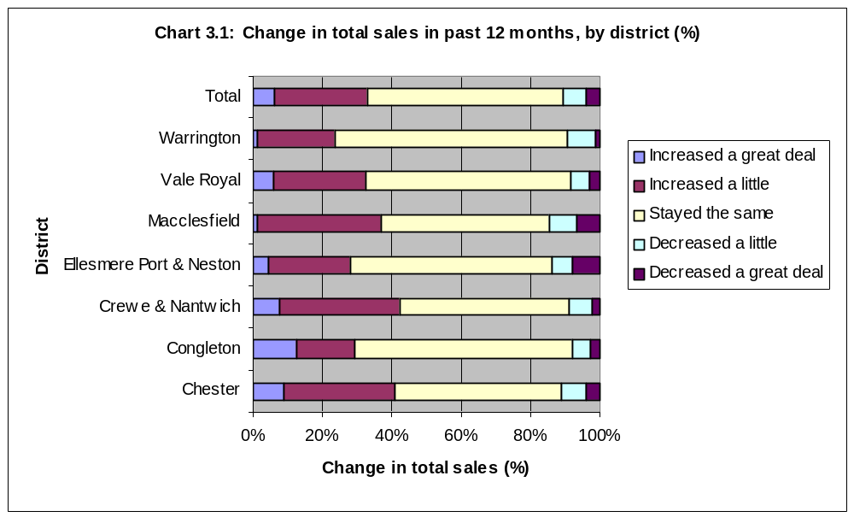

Larger employers were most likely to increase sales. Fifty nine per cent of 250+ employers increased sales but only 26 per cent of companies with less than five employees managed this. (Table 3.2)

By sector, the Primary sector has been most successful although this is based on a small sample. Otherwise Wholesale and Retail has been most successful, with over half of employers increasing sales while the Business services sector has tended to maintain rather than grow sales. (Table 3.3)
Table 3.1: Change in total sales in past 12 months, by District (per cent)

 | Chester | Congleton | Crewe & Nantwich | Ellesmere Port & Neston | Macclesfield | Vale Royal | Warrington | TOTAL
Increased a great deal | 9.1 | 12.4 | 7.6 | 4.4 | 1.2 | 5.9 | 1.3 | 6.1
Increased a little | 32.0 | 17.1 | 34.6 | 23.4 | 35.5 | 26.4 | 22.4 | 27.0
Stayed the same | 47.8 | 62.6 | 49.2 | 58.6 | 48.6 | 59.4 | 67.1 | 56.4
Decreased a little | 7.1 | 5.0 | 6.5 | 5.5 | 7.9 | 5.2 | 7.9 | 6.6
Decreased a great deal | 4.0 | 2.8 | 2.2 | 8.1 | 6.8 | 3.1 | 1.4 | 3.9

Table 3.2: Change in total sales in past 12 months, by number of employees (per cent)

 | 1-4 | 5-9 | 10-24 | 25-49 | 50-99 | 100-249 | 250+ | TOTAL
Increased a great deal | 4.1 | 8.8 | 8.4 | 13.9 | 13.7 | 14.8 | 21.0 | 6.1
Increased a little | 22.1 | 35.8 | 36.5 | 34.9 | 38.6 | 39.2 | 37.6 | 27.0
Stayed the same | 62.3 | 46.1 | 47.6 | 42.3 | 40.9 | 35.4 | 34.1 | 56.4
Decreased a little | 6.4 | 7.9 | 5.1 | 8.6 | 5.7 | 8.7 | 4.8 | 6.6
Decreased a great deal | 5.1 | 1.3 | 2.4 | 0.3 | 1.1 | 1.9 | 2.5 | 3.9

Table 3.3: Change in total sales in past 12 months, by sector (per cent)

 | Primary | Manufacturing | Construction | Wholesale/ Retail | Hotels/ catering | Transport/ Comms | Finance | Business Services | Education | Health | Public admin/ govt | Other | TOTAL
Increased a great deal | 0.0 | 2.8 | 3.3 | 18.5 | 2.2 | 6.0 | 11.2 | 0.4 | 3.1 | 10.6 | 4.9 | 1.4 | 6.1
Increased a little | 70.9 | 30.5 | 25.2 | 35.1 | 29.9 | 31.1 | 35.5 | 17.9 | 35.9 | 31.6 | 28.5 | 23.4 | 27.0
Stayed the same | 23.0 | 43.1 | 62.6 | 35.5 | 53.9 | 44.8 | 42.8 | 74.6 | 53.8 | 54.3 | 62.1 | 66.9 | 56.4
Decreased a little | 3.1 | 14.1 | 6.5 | 5.2 | 12.6 | 15.6 | 9.5 | 4.3 | 6.3 | 3.6 | 0.0 | 3.3 | 6.6
Decreased a great deal | 3.0 | 9.5 | 2.4 | 5.6 | 1.5 | 2.5 | 1.1 | 2.8 | 1.0 | 0.0 | 4.6 | 5.0 | 3.9

4. Employment

Staff levels have been broadly in balance over the previous 12 months, with 12 per cent increasing staff numbers, 10 per cent decreasing and the remainder staying the same. Congleton has had the highest proportion of employers increasing staffing levels (16%) while 14 per cent of employers in Crewe and Nantwich have reduced staff numbers (Table 4.1).

The larger companies were the most likely to change their employment levels and the majority of these were increasing staff numbers. Indeed, it was only employers with less than five employees already which had a higher proportion reducing staff numbers (Table 4.2).

The sectors which had the highest proportion of companies increasing employment were Education, Finance and Health. The highest proportions of companies with falling employment were Manufacturing, Public administration and Transport and Communications. (Table 4.3). Chart 4.1 shows this graphically by calculating the “percentage balance”, taking the proportion of employers decreasing employment away from the proportion increasing.

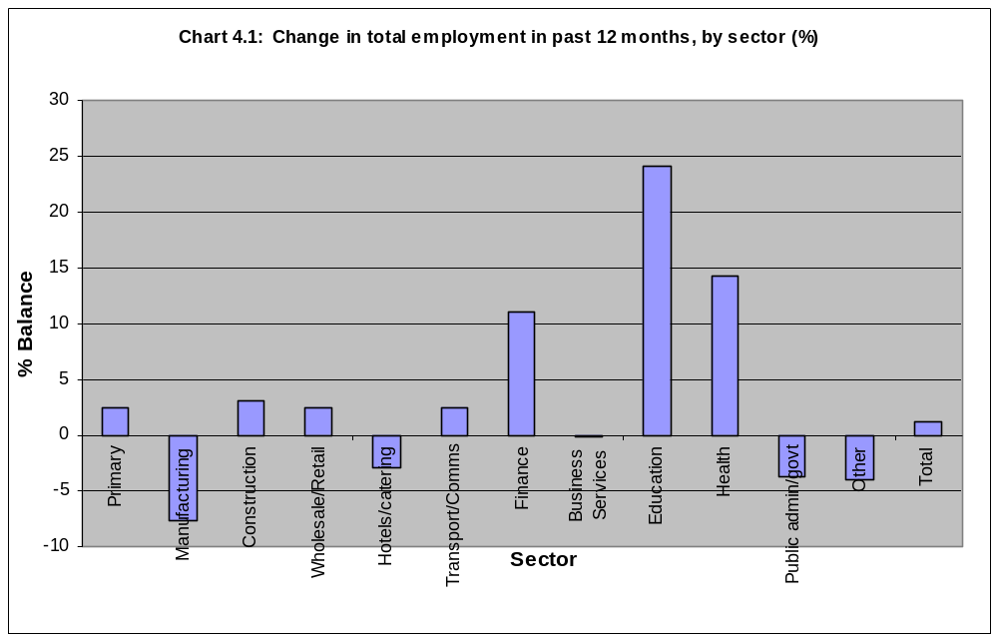

Table 4.1: Change in total employment in past 12 months, by District (per cent)

 | Chester | Congleton | Crewe & Nantwich | Ellesmere Port & Neston | Macclesfield | Vale Royal | Warrington | TOTAL
Increased | 12.5 | 16.2 | 13.0 | 11.2 | 6.8 | 12.4 | 9.2 | 11.6
Stayed the same | 73.9 | 75.2 | 72.9 | 81.0 | 82.1 | 83.3 | 78.8 | 78.1
Decreased | 13.7 | 8.6 | 14.2 | 7.7 | 11.1 | 4.3 | 12.0 | 10.4

Table 4.2: Change in total employment in past 12 months, by number of employees (per cent)

 | 1-4 | 5-9 | 10-24 | 25-49 | 50-99 | 100-249 | 250+ | TOTAL
Increased | 4.2 | 19.3 | 25.9 | 32.1 | 35.8 | 39.3 | 46.0 | 11.6
Stayed the same | 86.1 | 67.5 | 64.4 | 55.6 | 56.8 | 48.5 | 40.2 | 78.1
Decreased | 9.7 | 13.1 | 9.6 | 12.2 | 7.4 | 12.2 | 13.9 | 10.4

Table 4.3: Change in total employment in past 12 months, by sector (per cent)

 | Primary | Manufacturing | Construction | Wholesale/ Retail | Hotels/ catering | Transport/ Comms | Finance | Business Services | Education | Health | Public admin/ govt | Other | TOTAL
Increased | 5.6 | 12.6 | 10.5 | 12.5 | 10.0 | 17.5 | 22.0 | 7.9 | 28.7 | 19.1 | 14.4 | 8.9 | 11.6
Stayed the same | 91.3 | 67.2 | 82.1 | 77.5 | 77.0 | 67.5 | 67.1 | 84.0 | 66.7 | 76.1 | 67.5 | 78.3 | 78.1
Decreased | 3.1 | 20.2 | 7.4 | 10.0 | 13.0 | 15.0 | 10.9 | 8.0 | 4.6 | 4.9 | 18.1 | 12.8 | 10.4

The most common reason (64%) for increasing employment was because of increased turnover or budgets although one in five said that there was no specific reason (Table 4.4).

Table 4.4: Reasons for increasing employment

 | Per cent
Increase in turnover/budget | 63.9
Increase in profit | 4.9
Move into new business areas | 5.2
Company restructuring | 3.8
Introduction of new working practices | 0.6
Introduction of new technology | 0.6
Company takeover or merger | 0.4
No specific reason | 19.9

Similar reasons were cited for decreasing employment, although in 11 per cent of cases this was due to company restructuring (Table 4.5).

Table 4.5: Reasons for decreasing employment

 | Per cent
Decrease in turnover/budget | 26.7
Decrease in profit | 9.4
Withdrawal from business areas | 2.6
Company restructuring | 11.2
Introduction of new working practices | 6.2
Introduction of new technology | 0.0
Company takeover or merger | 3.0
No specific reason | 35.0

Most of the changes in staff numbers have been small. Ninety eight per cent took on less than 15 employees in the twelve month period and the same proportion lost less than 15 employees (Table 4.6).

Table 4.6: Changes in employment

 | Increase | Decrease
None | 69.6 | 68.6
1-2 | 16.7 | 17.4
3-4 | 5.9 | 5.8
5-9 | 3.6 | 4.5
10-14 | 2.2 | 2.0
15-19 | 0.5 | 0.4
20-29 | 0.7 | 0.8
30-49 | 0.2 | 0.3
50-99 | 0.3 | 0.3
100-199 | 0.2 | 0.1
200-499 | 0.0 | 0.0
500+ | 0.0 | 0.0

Hotels and Catering is the sector which has lost the largest numbers of staff. Thirteen per cent of businesses in the sector lost 10 or more employees in the year compared with just two per cent in the Financial Services sector.

The expectation is that employment will broadly stay the same over the coming 12 months, with 88 per cent forecasting that staff numbers will remain stable. Nine per cent are expecting to increase employment and only three per cent to reduce staff numbers. Crewe and Nantwich is the least optimistic area where seven per cent of businesses are expecting to reduce staffing levels (Table 4.7).

Employment change is most likely among the larger businesses. A quarter of those with 250 employees or more expect to be increasing employment with 10 per cent forecasting a decrease, albeit small (Table 4.8).

Transport and Communications is the sector most likely to see increased employment, although Business Services is the most likely to see employment increase a great deal. Over 10 per cent of Public Administration organisations, however, expect employment to fall, with six per cent forecasting significant falls in employee numbers (Table 4.9). Chart 4.2 represents this graphically through a percentage balance, where the decrease has been taken away from the increase proportion. A factor of 3 has been used to weight the “great deal” responses. This shows that Health is the sector which is likely to have the largest net increase.

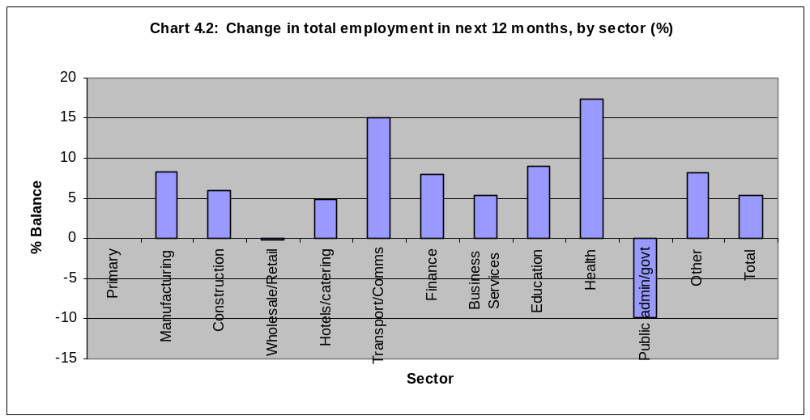

Table 4.7: Change in total employment in next 12 months, by District (per cent)

 | Chester | Congleton | Crewe & Nantwich | Ellesmere Port & Neston | Macclesfield | Vale Royal | Warrington | TOTAL
Increase a great deal | 1.8 | 0.4 | 0.1 | 0.3 | 0.3 | 3.7 | 1.1 | 1.0
Increase a little | 9.0 | 7.3 | 8.8 | 8.9 | 6.6 | 6.8 | 6.8 | 7.7
Stay the same | 87.1 | 88.1 | 83.9 | 87.6 | 88.5 | 88.3 | 91.0 | 87.7
Decrease a little | 1.7 | 4.2 | 3.6 | 2.9 | 3.4 | 0.7 | 0.8 | 2.7
Decrease a great deal | 0.4 | 0.0 | 3.6 | 0.3 | 1.1 | 0.4 | 0.2 | 0.9

Table 4.8: Change in total employment in next 12 months, by number of employees (per cent)

 | 1-4 | 5-9 | 10-24 | 25-49 | 50-99 | 100-249 | 250+ | TOTAL
Increase a great deal | 1.0 | 0.9 | 0.5 | 1.6 | 4.0 | 1.4 | 4.1 | 1.0
Increase a little | 4.2 | 12.5 | 14.6 | 17.0 | 17.9 | 18.4 | 21.1 | 7.7
Stay the same | 91.2 | 83.0 | 81.4 | 78.8 | 74.5 | 77.7 | 64.6 | 87.7
Decrease a little | 2.6 | 2.6 | 3.1 | 2.6 | 3.6 | 1.7 | 10.2 | 2.7
Decrease a great deal | 1.0 | 1.1 | 0.4 | 0.0 | 0.0 | 0.7 | 0.0 | 0.9

Table 4.9: Change in total employment in next 12 months, by sector (per cent)

 | Primary | Manufacturing | Construction | Wholesale/ Retail | Hotels/ catering | Transport/ Comms | Finance | Business Services | Education | Health | Public admin/ govt | Other | TOTAL
Increase a great deal | 0.0 | 0.4 | 1.2 | 0.7 | 0.0 | 1.4 | 0.4 | 1.6 | 0.0 | 1.0 | 0.0 | 1.6 | 1.0
Increase a little | 0.0 | 10.2 | 8.9 | 9.4 | 6.5 | 16.1 | 7.6 | 3.6 | 10.9 | 15.4 | 12.3 | 5.3 | 7.7
Stay the same | 100.0 | 86.4 | 87.1 | 83.6 | 91.8 | 77.2 | 91.3 | 92.2 | 87.6 | 82.5 | 76.5 | 91.1 | 87.7
Decrease a little | 0.0 | 3.0 | 0.8 | 3.6 | 1.7 | 5.3 | 0.8 | 2.7 | 1.9 | 1.1 | 5.7 | 2.0 | 2.7
Decrease a great deal | 0.0 | 0.0 | 1.9 | 2.7 | 0.0 | 0.0 | 0.0 | 0.1 | 0.0 | 0.0 | 5.5 | 0.0 | 0.9

5. Vacancies

Only six per cent of employers had any vacancies at the time of the survey and the majority of these were for one or two members of staff. The largest proportion of employers with vacancies were in Ellesmere Port and Neston (Table 5.2) where 11 per cent were seeking staff. This compares with the national Employers Skill Survey which showed that 14 per cent of establishments had a vacancy.

The sectors with the highest proportion of vacancies were Health, Hotels and Catering, Education, Transport and Communications and Public administration (Table 5.3) although this is influenced by the above average proportion of large employers within some of these sectors.

Employers were asked if any of the vacancies were proving hard to fill. Overall, 46 per cent of employers who had a vacancy had at least one which was hard to fill. Table 5.1 and Chart 5.1 shows that the occupation most hard to fill was Sales. Other difficult areas were Elementary, Associate Professional and Personal Service.

Table 5.1: Vacancies proving hard to fill, by occupation (% of respondents with any vacancies)

 | Per cent
Managers | 3.0
Professional | 9.6
Associate Professional | 16.2
Administrative | 1.7
Skilled | 5.6
Personal Service | 12.5
Sales | 31.6
Process | 6.6
Elementary | 19.0

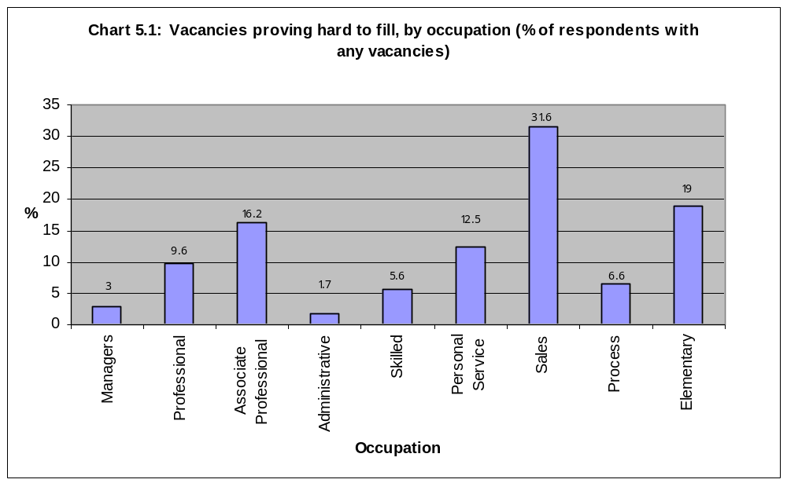

Table 5.2: Number of vacancies, by District (per cent)

 | Chester | Congleton | Crewe & Nantwich | Ellesmere Port & Neston | Macclesfield | Vale Royal | Warrington | TOTAL
0 | 90.5 | 96.4 | 94.6 | 89.0 | 92.8 | 94.6 | 94.2 | 93.6
1-2 | 6.9 | 3.3 | 4.8 | 8.9 | 6.6 | 5.1 | 3.5 | 5.3
3-4 | 1.9 | 0.1 | 0.3 | 0.7 | 0.4 | 0.2 | 1.5 | 0.6
5-9 | 0.4 | 0.1 | 0.3 | 0.8 | 0.1 | 0.1 | 0.6 | 0.3
10+ | 0.3 | 0.0 | 0.0 | 0.6 | 0.2 | 0.1 | 0.2 | 0.1

Table 5.3: Number of vacancies, by sector (per cent)

 | Primary | Manufacturing | Construction | Wholesale/ Retail | Hotels/ catering | Transport/ Comms | Finance | Business Services | Education | Health | Public admin/ govt | Other | TOTAL
0 | 95.5 | 97.7 | 95.8 | 94.6 | 84.9 | 89.4 | 94.9 | 97.5 | 88.1 | 80.5 | 89.1 | 89.0 | 93.6
1-2 | 4.5 | 2.1 | 3.6 | 5.0 | 12.5 | 8.8 | 4.3 | 2.0 | 9.6 | 15.5 | 7.9 | 8.6 | 5.3
3-4 | 0.0 | 0.0 | 0.3 | 0.2 | 1.8 | 0.4 | 0.8 | 0.2 | 2.3 | 2.2 | 0.8 | 1.9 | 0.6
5-9 | 0.0 | 0.2 | 0.3 | 0.1 | 0.8 | 1.2 | 0.0 | 0.2 | 0.0. | 0.9 | 0.8 | 0.3 | 0.3
10+ | 0.0 | 0.0 | 0.0 | 0.2 | 0.0 | 0.2 | 0.0 | 0.1 | 0.0 | 0.9 | 1.6 | 0.2 | 0.1

Table 5.4 examines the length of time taken to fill these vacancies. The most common period of time for the most difficult to fill vacancies was as follows:

- Sales – 2 weeks to one month
- Elementary – 2 weeks to one month
- Associate Professional – 1-2 months
- Personal Service – over 6 months.

The main reasons which were cited for having these hard to fill vacancies were:

- Sales – Low number of applicants with required attitude, poor terms and conditions
- Elementary – Not enough people interested, low number of applicants, poor terms and conditions
- Associate Professional – Low number of applicants
- Personal Service – Low number of applicants.

Very few employers had vacancies which were caused by what they perceived as genuine skill shortages within the labour market. Although questioned on the issue specifically, Basic Skills were not identified as being a problem among applicants for current vacancies.

Table 5.4 – How long to fill a hard to fill vacancy, by occupation (per cent)

 | Managers | Professionals | Associate Professional | Administrative | Skilled | Personal Service | Sales | Process and machine operatives | Elementary
<2 wks | 0.0 | 0.0 | 0.0 | 25.5 | 0.0 | 3.3 | 1.5 | 20.4 | 7.0
2 wks –1 mth | 13.6 | 5.6 | 13.9 | 24.7 | 6.1 | 20.2 | 74.2 | 5.6 | 45.0
1-2 mths | 69.6 | 83.2 | 41.0 | 34.5 | 48.6 | 21.2 | 18.0 | 44.6 | 26.3
2-3 mths | 0.0 | 0.0 | 5.4 | 0.0 | 9.5 | 7.4 | 2.2 | 0.0 | 3.5
3-6 mths | 6.8 | 11.3 | 8.5 | 0.0 | 8.2 | 14.2 | 2.8 | 0.0 | 5.3
>6 mths | 9.8 | 0.0 | 31.3 | 15.3 | 27.6 | 33.7 | 1.3 | 29.4 | 12.9

6. Qualifications

A quarter of employees in Cheshire and Warrington are qualified to NVQ level 4 or above with professional and associate professional employees being the most highly qualified staff, with 78 per cent of professionals having an NVQ level 4 or higher qualification (Table 6.1 and Chart 6.1). There is, however, almost as many employees without any qualifications at 22 per cent of staff. This applies to 60 per cent of process and machine operatives, 51 per cent of sales staff and 43 per cent of those in elementary occupations. Indeed, 21 per cent of managers had no qualifications.

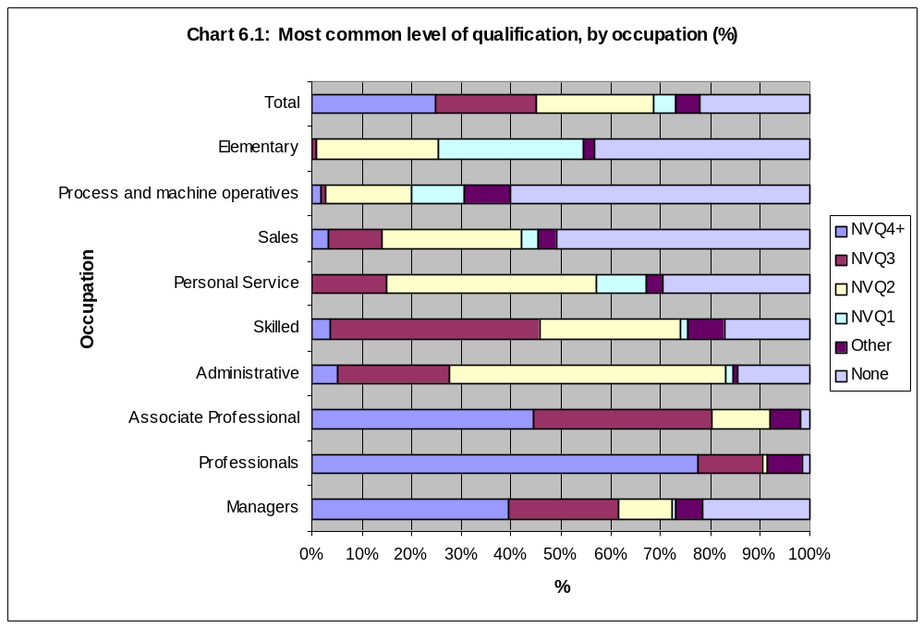
Table 6.2 breaks down managerial qualifications by sector and shows that Wholesale and Retail and Transport and Communications are the main sectors in which managers work without qualifications: this applied to almost half the employers in these two sectors. The best qualified managers are in Public administration, Education and Business services.

Table 6.1: Most common level of qualification, by occupation (per cent)

 | Managers | Professionals | Associate Professional | Administrative | Skilled | Personal Service | Sales | Process and machine operatives | Elementary | TOTAL
NVQ4+ | 39.6 | 77.8 | 44.9 | 5.1 | 3.7 | 0.0 | 3.4 | 1.9 | 0.1 | 24.7
NVQ3 | 22.3 | 12.9 | 36.2 | 22.6 | 42.1 | 15.2 | 10.7 | 0.8 | 0.9 | 20.3
NVQ2 | 10.7 | 1.2 | 11.8 | 55.9 | 28.2 | 41.9 | 27.9 | 17.2 | 24.5 | 23.7
NVQ1 | 0.7 | 0.0 | 0.0 | 1.4 | 1.7 | 10.2 | 3.5 | 10.8 | 29.3 | 4.3
Other | 5.6 | 7.0 | 6.3 | 1.0 | 7.5 | 3.4 | 3.6 | 9.2 | 1.9 | 4.7
None | 21.4 | 1.5 | 1.8 | 14.4 | 17.1 | 29.6 | 51.1 | 60.3 | 43.4 | 22.2

Table 6.2: Most common level of qualification of managers, by sector (per cent)

 | Primary | Manufacturing | Construction | Wholesale/ Retail | Hotels/ catering | Transport/ Comms | Finance | Business Services | Education | Health | Public admin/ govt | Other | TOTAL
NVQ4+ | 26.6 | 37.5 | 24.4 | 17.2 | 6.0 | 8.3 | 53.1 | 69.7 | 69.8 | 58.6 | 87.7 | 21.0 | 39.6
NVQ3 | 0.0 | 28.9 | 35.2 | 18.4 | 29.0 | 15.2 | 12.5 | 21.4 | 19.0 | 23.8 | 2.9 | 27.8 | 22.3
NVQ2 | 6.7 | 7.9 | 9.8 | 9.7 | 22.8 | 28.9 | 9.2 | 6.6 | 1.4 | 2.4 | 2.9 | 22.4 | 10.7
NVQ1 | 0.0 | 0.5 | 1.7 | 0.1 | 1.1 | 3.0 | 0.0 | 0.0 | 0.0 | 0.0 | 0.0 | 3.8 | 0.7
Other | 49.6 | 1.7 | 9.2 | 7.1 | 14.2 | 2.9 | 19.6 | 8.3 | 8.3 | 3.1 | 0.0 | 2.5 | 5.6
None | 17.0 | 23.6 | 19.8 | 47.5 | 26.9 | 41.7 | 5.6 | 1.4 | 1.4 | 12.6 | 6.5 | 25.2 | 21.4

Administrators are most commonly qualified to NVQ level 2 or equivalent (Table 6.3). Again, however, a large proportion of those employed in Wholesale and Retail, Transport and Communications and also Hotels and Catering, are unqualified. The highest qualified administrators tend to work in Business Services and Education.

Skilled staff are mainly employed in Manufacturing and Construction. The breakdown of qualifications is similar between the two sectors with around 40 per cent qualified to NVQ level 3. A quarter of Skilled employees in these sectors are unqualified.

Personal service employees are particularly important in the Hotels and Catering sector. Although 41 per cent of businesses reported that their most common qualification was NVQ level 2, for 44 per cent it was most common that they were unqualified. Similarly, 68 per cent of Wholesale and Retail employers said that their sales staff were most likely to be unqualified.

Process staff were most likely to be employed in Manufacturing or Transport and Communications. In Manufacturing 51% of employers say they are qualified to NVQ level 2 or above but 38 per cent said their process staff were unqualified. In Transport and Communications 68% of employers said their process staff were unqualified.

Employers were then asked how many of the staff in these categories had qualifications which actually refer to or help them to carry out their current job competently (Table 6.4). For all occupations, this increases the proportion of staff with no qualifications for the job held. Over two thirds of sales staff, for example, were in this category.

Table 6.3: Most common level of qualification of administrative staff, by sector (per cent)

 | Primary | Manufacturing | Construction | Wholesale/ Retail | Hotels/ catering | Transport/ Comms | Finance | Business Services | Education | Health | Public admin/ govt | Other | TOTAL
NVQ4+ | 0.0 | 9.4 | 2.6 | 1.2 | 8.3 | 0.5 | 0.0 | 6.1 | 1.7 | 6.6 | 4.2 | 7.0 | 5.1
NVQ3 | 9.4 | 15.2 | 9.5 | 13.7 | 7.5 | 17.7 | 17.0 | 29.5 | 31.2 | 26.8 | 27.0 | 19.6 | 22.6
NVQ2 | 90.6 | 47.1 | 62.8 | 34.9 | 40.0 | 40.8 | 80.3 | 63.8 | 60.4 | 50.1 | 58.0 | 59.7 | 55.9
NVQ1 | 0.0 | 4.8 | 5.3 | 1.2 | 0.0 | 2.4 | 2.7 | 0.2 | 0.0 | 0.7 | 0.0 | 1.5 | 1.4
Other | 0.0 | 0.0 | 0.0 | 1.2 | 1.3 | 2.8 | 0.0 | 0.5 | 1.7 | 5.2 | 0.0 | 0.0 | 1.0
None | 0.0 | 23.9 | 19.7 | 47.7 | 44.3 | 35.9 | 0.0 | 0.3 | 5.1 | 10.6 | 10.9 | 12.3 | 14.4

Table 6.4: Percent of employees with qualifications that help their current job, by occupation (per cent)

Per cent | Managers | Professionals | Associate Professional | Administrative | Skilled | Personal Service | Sales | Process and machine operatives | Elementary
1-10 | 0.1 | 0.1 | 0.0 | 0.3 | 0.2 | 0.0 | 0.2 | 0.1 | 0.6
11-20 | 0.2 | 0.1 | 0.0 | 0.2 | 0.2 | 1.2 | 0.0 | 0.6 | 0.4
21-30 | 0.1 | 0.2 | 0.0 | 0.4 | 0.0 | 1.0 | 0.2 | 0.5 | 0.5
31-40 | 0.2 | 0.3 | 0.1 | 0.2 | 0.2 | 0.5 | 0.1 | 0.0 | 0.4
41-50 | 1.3 | 1.3 | 2.2 | 3.9 | 5.9 | 6.0 | 3.5 | 4.0 | 2.6
51-60 | 0.1 | 0.0 | 0.5 | 0.1 | 0.3 | 0.2 | 0.1 | 0.4 | 0.3
61-70 | 0.2 | 0.2 | 0.3 | 0.5 | 0.7 | 3.1 | 0.1 | 6.0 | 0.1
71-80 | 0.2 | 0.6 | 0.2 | 0.4 | 1.2 | 1.5 | 0.3 | 0.7 | 0.1
81-90 | 0.0 | 0.1 | 0.0 | 0.2 | 0.1 | 0.2 | 0.0 | 0.2 | 0.0
91-100 | 70.9 | 92.2 | 84.5 | 64.7 | 66.7 | 58.9 | 28.4 | 24.9 | 16.0
None | 26.7 | 5.0 | 12.2 | 29.2 | 24.7 | 27.4 | 68.1 | 62.5 | 79.2

7. Skill Gaps in the current workforce

Generally employers were satisfied that their staff at all levels were proficient in their current job. Table 7.1 and Chart 7.1 shows the proportion of employers who had identified gaps in proficiency in different occupations. Very few employers saw any deficiencies in their senior managers but nine per cent were concerned about Personal Service staff. Other areas of concern were Sales, Associate Professional, Process and Elementary occupations.

Table 7.1: Proportion of employers with staff who are not proficient at their current job, by occupation (per cent)

 | Per cent
Managers | 0.8
Professional | 2.5
Associate Professional | 8.1
Administrative | 3.6
Skilled | 4.8
Personal Service | 9.1
Sales | 8.4
Process | 7.8
Elementary | 7.3

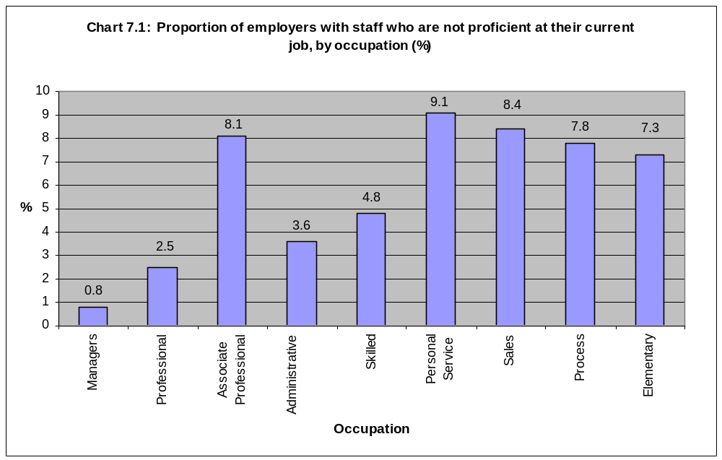
Table 7.2 shows the reasons why employers believed their staff were not fully proficient in these areas. The most popular was because the staff were new into the post. High staff turnover was an issue among the occupations with lower skill requirements while inability to keep up with change and reluctance to take up training opportunities were cited as reasons for deficiencies in the most senior occupations.

The skill deficiencies varied by occupation (Table 7.3). Basic computer literacy was only an issue for some administrative staff but advanced IT skills were lacking in some senior occupations. Technical and practical skills were lacking in some skilled and process job staff. Lack of customer handling skills was the most widely shared deficiency and affected Sales in particular. Lack of management skills was only seen as significant among senior occupations.

Table 7.2: Reasons for different occupations not being fully proficient at their current job (per cent)

 | Managers | Professionals | Associate Professional | Administrative | Skilled | Personal Service | Sales | Process and machine operatives | Elementary
Failure to train and develop staff | 22.7 | 0.0 | 4.5 | 2.9 | 0.0 | 2.5 | 0.7 | 2.4 | 0.0
Recruitment problems | 5.9 | 0.0 | 0.0 | 6.5 | 0.0 | 0.0 | 1.3 | 15.1 | 0.0
High staff turnover | 0.0 | 6.5 | 2.6 | 2.4 | 0.9 | 15.0 | 13.2 | 9.3 | 26.6
Only in job short time | 22.3 | 60.4 | 69.7 | 70.7 | 20.9 | 47.5 | 65.1 | 61.7 | 44.8
Reluctant to take up training opportunities | 19.8 | 18.5 | 3.5 | 4.9 | 0.6 | 2.8 | 2.5 | 7.0 | 11.6
Inability to keep up with change | 24.1 | 17.5 | 0.0 | 7.6 | 2.7 | 1.5 | 3.1 | 9.5 | 6.0
Other | 22.1 | 7.1 | 21.5 | 15.7 | 80.4 | 47.0 | 15.9 | 28.5 | 30.3

Table 7.3: Skills/qualities which are missing among different occupations (per cent)

 | Managers | Professionals | Associate Professional | Administrative | Skilled | Personal Service | Sales | Process and machine operatives | Elementary
Basic computer literacy | 0.0 | 0.0 | 1.0 | 10.8 | 0.0 | 0.0 | 0.0 | 0.0 | 0.0
Advanced IT, software | 17.2 | 16.7 | 23.4 | 36.2 | 0.7 | 0.0 | 0.8 | 4.2 | 2.6
Other technical and practical | 0.0 | 6.5 | 24.8 | 13.7 | 92.0 | 11.7 | 0.9 | 54.3 | 18.3
Customer handling | 13.8 | 27.7 | 19.8 | 36.5 | 0.9 | 27.2 | 76.7 | 11.4 | 27.4
Team working | 5.6 | 5.8 | 1.8 | 2.6 | 1.2 | 2.9 | 21.1 | 15.9 | 6.8
Foreign languages | 0.0 | 6.5 | 0.0 | 0.0 | 0.0 | 0.0 | 0.0 | 7.1 | 0.0
Problem solving | 0.0 | 0.0 | 0.0 | 0.0 | 0.0 | 0.0 | 0.0 | 7.1 | 2.6
Management | 34.2 | 24.9 | 6.8 | 2.6 | 1.2 | 2.5 | 2.2 | 16.5 | 0.0
Other | 17.9 | 32.7 | 41.1 | 34.2 | 2.5 | 58.5 | 15.5 | 25.1 | 29.9
None | 30.8 | 13.0 | 22.3 | 16.8 | 3.5 | 19.3 | 11.8 | 12.1 | 33.6

Respondents were asked about the impact of skill gaps on their businesses and the responses are summarised in Table 7.4. The overwhelming conclusion is that no particular problems are being caused by skill gaps, even among those employers who acknowledge that some gaps exist. It was only in the case of those with gaps in managers, professionals, process or elementary staff that more than one in ten employers cited a problem. The main examples were:

- Managers – Loss of orders to competitors
- Professionals – Loss of orders to competitors
- Process – Increased operating costs, difficulties in introducing new working practices
- Elementary – Difficulties in meeting customer service objectives.

Table 7.4: Impact on the employer of different occupations not being fully proficient at their current job (per cent of those with deficiencies in each occupation)

 | Managers | Professionals | Associate Professional | Administrative | Skilled | Personal Service | Sales | Process and machine operatives | Elementary
Loss of orders to competitors | 12.3 | 14.5 | 0.0 | 0.0 | 0.0 | 0.0 | 0.0 | 9.9 | 1.1
Delayed development of new products/services | 6.3 | 0.0 | 0.0 | 2.9 | 1.9 | 0.0 | 1.1 | 7.9 | 0.0
Withdrawal from certain products and markets altogether | 0.0 | 0.0 | 0.0 | 0.0 | 0.0 | 0.0 | 0.0 | 8.3 | 0.0
Difficulties in meeting customer service objectives | 6.9 | 7.8 | 1.4 | 0.0 | 0.0 | 7.8 | 5.3 | 10.9 | 23.6
Difficulties in meeting quality standards | 0.0 | 0.0 | 5.1 | 0.0 | 0.0 | 4.7 | 3.7 | 16.2 | 9.0
Increased operating costs | 0.0 | 6.7 | 3.7 | 0.0 | 1.2 | 0.0 | 0.8 | 23.1 | 0.0
Difficulties in introducing technological change | 4.7 | 0.0 | 0.0 | 2.2 | 0.0 | 0.0 | 0.0 | 13.7 | 1.8
Difficulties in introducing new working practices | 0.0 | 0.0 | 2.7 | 0.0 | 0.0 | 0.0 | 0.7 | 18.5 | 1.8
No particular problems | 76.8 | 78.8 | 92.2 | 94.9 | 96.9 | 92.2 | 92.4 | 71.8 | 67.7

Employers were then asked how they had responded to these skill gaps (Table 7.5). A substantial majority had taken action and for all occupations, the main response was to provide further training. Other actions which had been taken included:

- Managers – Changing working practices
- Professionals – Increasing trainee programmes
- Process – Increasing trainee programmes
- Elementary – Increased recruitment.

Table 7.5: Action being taken to overcome skills shortcomings with different occupations (per cent of those with deficiencies in each occupation)

 | Managers | Professionals | Associate Professional | Administrative | Skilled | Personal Service | Sales | Process and machine operatives | Elementary
Increased recruitment | 0.0 | 5.8 | 0.0 | 0.0 | 1.9 | 1.4 | 1.2 | 0.0 | 12.4
Providing further training | 78.2 | 71.3 | 96.3 | 95.2 | 97.6 | 81.7 | 96.4 | 68.5 | 72.5
Changing working practices | 12.0 | 12.6 | 2.2 | 0.0 | 0.0 | 4.5 | 1.7 | 5.0 | 0.0
Relocating work within company | 0.0 | 0.0 | 0.0 | 0.0 | 0.0 | 0.0 | 0.0 | 0.0 | 0.0
Expanding recruitment channels | 0.0 | 0.0 | 0.0 | 0.0 | 1.1 | 0.0 | 1.2 | 4.3 | 2.2
Increasing trainee programmes | 0.0 | 17.7 | 0.0 | 2.6 | 1.2 | 2.3 | 2.5 | 12.3 | 4.5
Other | 2.6 | 2.7 | 1.0 | 1.1 | 0.0 | 10.3 | 35.7 | 9.4 | 11.0
No particular action taken | 24.8 | 26.1 | 4.9 | 3.7 | 2.4 | 10.0 | 0.7 | 14.4 | 8.8

All employers were asked to consider what barriers existed to developing or maintaining a fully proficient team of employees at each occupational level (Table 7.6). A clear majority did not believe that there were any barriers. However, a number of barriers were identified. Lack of funding for training was cited for all occupations with 18 per cent of employers raising this with regard to Skilled employees. Lack of time for training was also important, especially for more senior occupations (17 per cent of employers said it was a barrier to developing Professionals) while lack of cover for training was also an issue for a number of employers, particularly those in the 1-4 employee category.

Employers were then asked if they thought that skill needs for each occupation had changed for any of a number of specified reasons. At least a half did not think any of them applied to any of the occupations (Table 7.7). Of those which did believe that skill needs had changed, new skills needed to cope with the introduction of new technology was the most popular reason given. This applied to 38 per cent of employers who had associate professional staff, for example. Over a quarter of employers said that sales and administrative staff were affected by this too. New skills needed to cope with new working practices also affected 26 per cent of employers with associate professionals. Other occupations for which this was significant included skilled, professionals and personal service. New skills needed in order to develop new products or services had impacted on 16 per cent of employers with sales staff.
Table 7.6: Barriers which exist to developing a proficient team, for different occupations (per cent)

 | Managers | Professionals | Associate Professional | Administrative | Skilled | Personal Service | Sales | Process and machine operatives | Elementary
Lack of funding for training | 9.4 | 13.6 | 13.4 | 11.0 | 18.1 | 8.4 | 9.4 | 7.3 | 4.8
Lack of suitable, relevant courses | 3.1 | 1.5 | 1.0 | 0.7 | 1.7 | 0.5 | 1.3 | 0.5 | 0.8
Lack of courses in area/locality | 1.6 | 3.1 | 4.3 | 4.5 | 2.6 | 1.9 | 4.4 | 0.4 | 0.5
Staff unwilling to do training | 0.2 | 0.7 | 0.5 | 0.3 | 0.4 | 0.2 | 2.9 | 1.5 | 1.0
High labour turnover | 0.2 | 0.4 | 0.8 | 0.3 | 0.3 | 0.8 | 3.7 | 0.8 | 1.0
Lack of time for training | 13.1 | 17.4 | 13.1 | 10.6 | 15.2 | 12.1 | 6.2 | 7.4 | 5.7
Lack of cover for training | 7.6 | 12.4 | 8.8 | 6.2 | 6.7 | 4.9 | 1.0 | 4.2 | 3.1
Other | 1.8 | 0.6 | 0.8 | 0.2 | 2.1 | 1.6 | 1.9 | 2.0 | 1.7
Don’t know | 1.0 | 0.8 | 0.9 | 0.4 | 0.2 | 0.3 | 0.3 | 0.5 | 0.6
No barriers | 79.3 | 71.0 | 74.5 | 81.2 | 66.8 | 80.1 | 78.9 | 85.5 | 87.5

Table 7.7: Changes in skill needs, for different occupations (per cent)

 | Managers | Professionals | Associate Professional | Administrative | Skilled | Personal Service | Sales | Process and machine operatives | Elementary
New skills needed to develop new products/services | 8.4 | 4.4 | 7.0 | 4.4 | 15.6 | 6.1 | 9.8 | 3.1 | 2.5
New skills needed to cope with new working practices | 12.6 | 17.2 | 25.8 | 7.4 | 18.9 | 16.0 | 11.4 | 11.1 | 8.3
New skills needed to cope with new technology | 21.4 | 22.5 | 38.3 | 25.3 | 22.8 | 4.6 | 28.4 | 16.6 | 6.9
Increased competition | 4.7 | 2.4 | 1.9 | 3.7 | 5.7 | 0.5 | 4.3 | 1.7 | 1.3
Other | 1.3 | 0.8 | 1.7 | 0.2 | 1.1 | 0.3 | 1.0 | 0.1 | 0.0
Don’t Know | 1.2 | 0.4 | 0.7 | 0.7 | 0.2 | 1.1 | 6.6 | 1.2 | 0.9
None of the above | 66.0 | 64.3 | 47.6 | 69.2 | 59.5 | 73.9 | 55.0 | 71.6 | 83.8

8. Future Skills Needs

Employers were asked which skills they thought would become more important to their staff over the next two to three years. Table 8.1 illustrates that around half of all employers did not expect any of the skills specified to become more important.

IT skills, both basic and advanced are perceived as the main areas which will be more demanding over this period. Advanced IT was an issue for 30 per cent of employers of associate professionals and 20 per cent of employers of administrators. IT skills were expected to become more demanding for only a minority of personal service, process and elementary occupations.

Some skills reflected their occupational area. Technical and practical skills were expected to become more important for skilled and process staff. Similarly, Customer handling is increasing in importance for sales, elementary and personal service occupations. To a lesser degree, team working is also increasingly important in these jobs.
Table 8.1: Skills which are expected to become more important over the next 2-3 years, for different occupations (per cent)

 | Managers | Professionals | Associate Professional | Administrative | Skilled | Personal Service | Sales | Process and machine operatives | Elementary
Basic computer literacy | 8.0 | 15.0 | 10.1 | 16.8 | 13.8 | 3.2 | 12.2 | 4.3 | 4.5
Advanced IT, software | 16.3 | 17.1 | 29.9 | 20.4 | 8.6 | 1.6 | 9.7 | 3.7 | 0.6
Other technical and practical | 6.3 | 8.5 | 7.3 | 0.9 | 24.8 | 4.6 | 3.2 | 12.0 | 2.0
Customer handling | 10.3 | 7.1 | 8.2 | 7.1 | 6.7 | 19.4 | 28.1 | 2.5 | 27.6
Team working | 1.6 | 0.9 | 2.5 | 1.3 | 1.2 | 4.2 | 4.4 | 2.0 | 3.7
Foreign Langauages | 0.2 | 0.0 | 0.0 | 0.5 | 0.0 | 0.0 | 0.8 | 0.0 | 0.4
Problem solving | 0.0 | 0.0 | 0.0 | 0.0 | 0.0 | 0.0 | 0.0 | 0.0 | 0.0
Management | 5.0 | 3.0 | 1.1 | 0.9 | 0.4 | 1.0 | 3.3 | 0.5 | 0.8
Basic numeracy | 0.2 | 0.0 | 0.9 | 0.0 | 0.0 | 0.0 | 0.4 | 0.1 | 0.0
Basic literacy | 0.1 | 0.0 | 0.5 | 0.0 | 0.0 | 0.0 | 0.1 | 0.4 | 0.1
Basic communication | 1.2 | 1.6 | 0.9 | 1.4 | 4.0 | 1.6 | 4.1 | 0.7 | 1.1
Other | 6.8 | 4.0 | 6.5 | 3.9 | 2.9 | 10.1 | 7.7 | 6.8 | 4.7
None | 55.9 | 51.7 | 45.6 | 56.3 | 52.4 | 60.2 | 45.9 | 71.0 | 61.1

9. Basic Skills

Table 8.1 shows that neither basic literacy nor numeracy was expected to become more important over the next two to three years but some employers did agree that basic communication skills would need to improve.

Only nine per cent of employers say that they test for Basic Skills aptitudes when recruiting craft and unskilled staff. The Public Administration sector is the most likely to test for this with over a quarter of employers applying tests (Table 9.1). Sixty nine per cent of those testing use numeracy tests and 62 per cent literacy tests. Just over half ask verbal questions to test communications skills.

Table 9.1: Testing for Basic Skills aptitudes, by sector

 | Per cent
Primary | 1.9
Manufacturing | 10.5
Construction | 2.5
Wholesale and Retail | 14.7
Hotels and Catering | 2.7
Transport and Communications | 17.8
Finance | 0.0
Business Services | 5.6
Education | 6.9
Health | 7.3
Public administration | 28.7
Other | 9.4

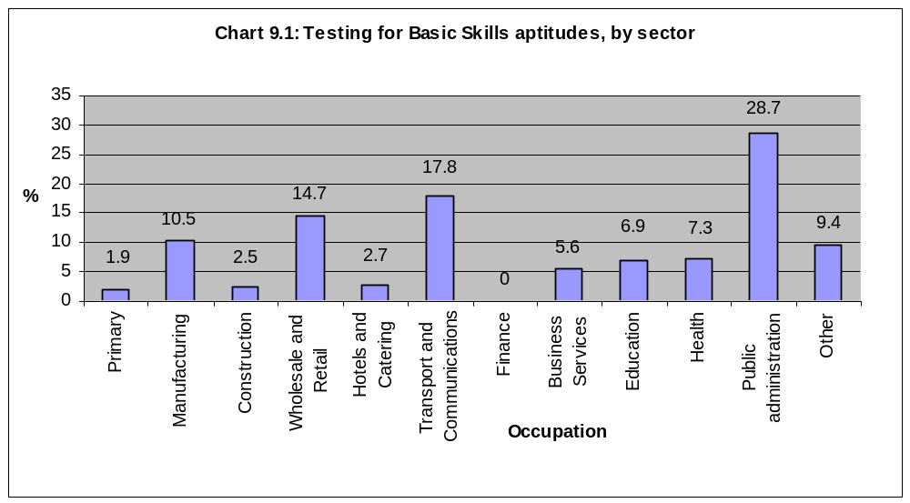

When employers were asked about skills deficiencies in their staff, almost none identified problems with Basic Skills. For the few that did, communication skills rather than Literacy or Numeracy were most likely to be referred to. Even of those which did acknowledge some Basic Skills issues, 32 per cent said they did not think that it affected their competence to do the job.

10. Off the job training

Forty four per cent of organisations had funded off the job training for any of their employees in the previous 12 months. This compares with only a third of employers nationally. Not surprisingly, there was a strong relationship to the size of the organisation. Thirty four per cent of 1-4 employee organisations had funded off the job training but this rose to 93 per cent of those with 250+ employees.

Chart 10.1 shows that only just over a third of organisations had funded off the job training in Congleton and Vale Royal but 59 per cent had in Warrington.

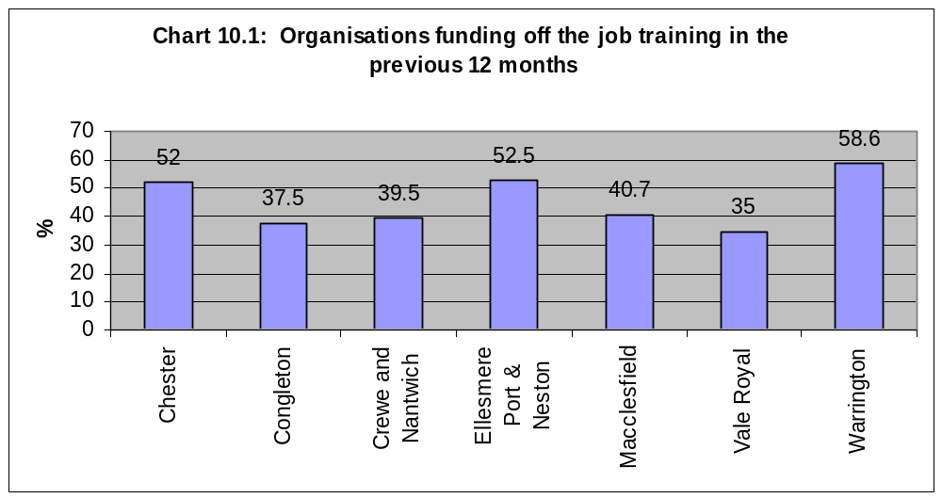

Chart 10.2 shows the main differences by sector. Education had the highest proportion of employers paying for off the job training for staff at 83 per cent. Around two thirds of employers in the Public administration, Health and Financial services sectors also paid for off the job training. Those sectors which had the smallest proportion of employers paying for off the job training were Manufacturing, Primary and Construction.

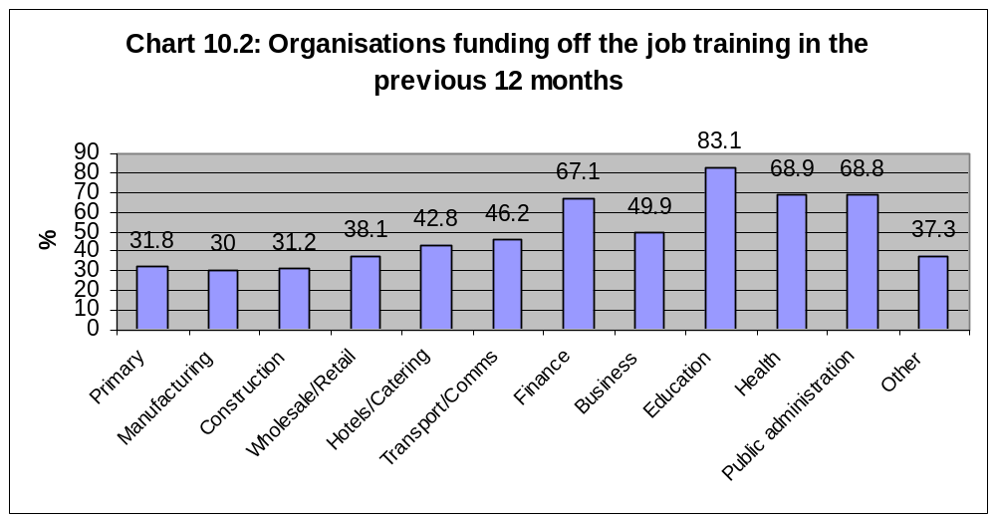

By occupation, there is a concentration on managers when off the job training is being offered. Only six per cent of employers of process and machine operatives had paid for any off the job training for them (Chart 10.3).
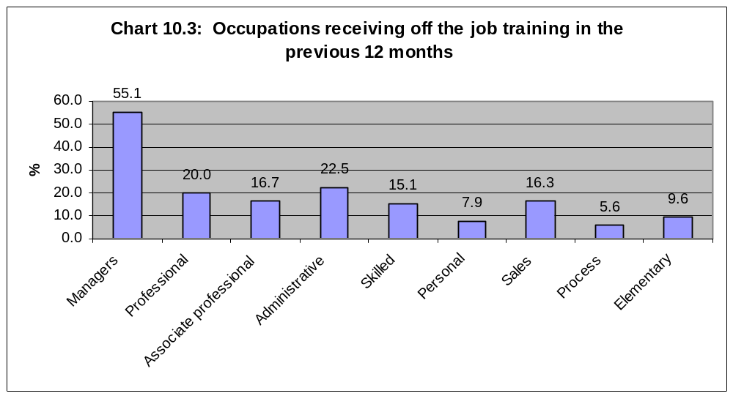

Employers were asked about the type of training which different groups of occupations had received (Table 10.1). Mainly the training was specific to the job but new technology featured for both managers and professionals and administrative, personal and sales. Health and Safety was also a strong area for skilled, process and elementary and administrative, personal and sales.

Table 10.1: Training received by different occupational groups (per cent of those training these occupations)

 | Managers, professionals or associate professionals | Administrative, personal or sales | Skilled, process or elementary
Job specific | 81.6 | 66.2 | 69.4
Supervisory | 5.8 | 7.1 | 0.4
Management | 19.1 | * | *
New technology | 31.3 | 36.2 | 5.2
Foreign Languages | 0.6 | 0.1 | 2.6
Personal development | 6.8 | * | *
Induction | * | 15.4 | 19.4
Health & Safety | * | 24.0 | 33.7
None of these | 2.8 | 3.4 | 7.1

* Employers were not asked about these catagories for these occupations.

Seventy per cent of employers used an outside supplier for their off the job training. This differed by sector with, for example, over 90 per cent of Manufacturing organisations using outside suppliers but less than 30 per cent of Hotel and Catering companies using them.

Employers were asked about the responsiveness of the colleges in Cheshire and Warrington to their training needs. Only a third of employers had had contact with the colleges but those that had were generally satisfied with the response they had received. There seemed to have been more contact in Chester than elsewhere (Table 10.2).

Table 10.3 shows that larger employers are more likely to have had contact with colleges. Almost half of all 250+ employee organisations say they have found local colleges very responsive to their needs.

Table 10.2: Responsiveness of Colleges, by District (per cent)

 | Chester | Congleton | Crewe & Nantwich | Ellesmere Port & Neston | Macclesfield | Vale Royal | Warrington | TOTAL
Very responsive | 23.4 | 13.0 | 16.1 | 19.7 | 25.4 | 14.1 | 15.6 | 18.3
Quite responsive | 24.0 | 16.3 | 11.1 | 8.7 | 8.1 | 7.4 | 5.2 | 11.4
Not very responsive | 0.8 | 1.8 | 0.4 | 0.6 | 0.2 | 7.4 | 0.2 | 1.7
Not at all responsive | 0.1 | 0.9 | 1.5 | 0.7 | 0.1 | 0.0 | 0.2 | 0.5
No contact | 48.7 | 66.3 | 69.5 | 68.9 | 65.7 | 70.2 | 78.5 | 66.9
Varies too much to say | 0.5 | 0.1 | 1.3 | 0.2 | 0.1 | 0.2 | 0.4 | 0.4
Don’t know | 2.5 | 1.4 | 0.3 | 1.2 | 0.5 | 0.7 | 0.2 | 0.9

Table 10.3: Responsiveness of Colleges, by number of employees (per cent)

 | 1-4 | 5-9 | 10-24 | 25-49 | 50-99 | 100-249 | 250+ | TOTAL
Very responsive | 14.3 | 23.8 | 24.1 | 34.3 | 28.9 | 21.2 | 46.6 | 18.3
Quite responsive | 10.5 | 12.9 | 11.2 | 11.1 | 17.0 | 33.2 | 12.8 | 11.4
Not very responsive | 1.7 | 1.7 | 1.4 | 1.0 | 1.7 | 0.0 | 2.3 | 1.7
Not at all responsive | 0.4 | 1.2 | 0.5 | 0.2 | 0.0 | 0.0 | 0.0 | 0.5
No contact | 72.3 | 59.5 | 59.5 | 51.0 | 47.0 | 40.5 | 36.0 | 66.9
Varies too much to say | 0.3 | 0.2 | 1.0 | 0.6 | 0.6 | 0.0 | 0.0 | 0.4
Don’t know | 0.5 | 0.6 | 2.2 | 1.8 | 4.8 | 5.2 | 2.4 | 0.9

By sector (Table 10.4), there are major differences with 80 per cent of Transport and communications employers having had no contact with colleges, compared with only 37 per cent of health related organisations.

Comments from those who said they had found colleges unresponsive to their needs included:

- “Difficult to contact, lack of guidance and tutorial advice”
- “Cancelled course in electronics”
- “Only offered day courses – we prefer night courses or more intensive”
- “Courses are good but flexibility is poor”
- “Courses are not always suitable”
- “Courses tend to be too basic”
- “Difficult to get hold of”
- “Do not respond to queries”
- “Lack of help with costs”
- “Fully booked”
- “High staff turnover”
- “Too expensive”
- “Lack of communication”
- “Lack of courses at available times and at suitable cost”
- “No courses were really relevant”
- “No level 2 on sewing”
- “No suitable courses for funeral directors”
- “Not all courses are good or relevant”
- “Don’t deliver what is promised”
- “Not good at feedback”
- “Don’t offer the right courses and don’t understand the needs of business”
- Not targeted at the needs of the people who go there”
- One course was oversubscribed and they received no support whilst studying at home as a result”
- “Not flexible enough”
- “Not relevant to us”
- “Syllabus not what we expected and large class numbers”
- “They do not offer courses on bulk bag making and sewing machine courses therefore all training is inhouse”
- “Not relevant”
- “Too general, learn more on the job”
- “Too much paperwork”
- “Total People are much better. Staff at college are negative”
- “Lack of funding prevents us using them”
- “Wirral Met very good, West Cheshire not good, not seeing students as customers, losing certificates”
- “Would like more part time course availability”

Table 10.4: Responsiveness of Colleges, by sector (per cent)

 | Primary | Manufacturing | Construction | Wholesale/ Retail | Hotels/ catering | Transport/ Comms | Finance | Business Services | Education | Health | Public admin/ govt | Other | TOTAL
Very responsive | 28.5 | 23.6 | 13.2 | 19.4 | 13.4 | 4.6 | 22.3 | 16.8 | 46.0 | 33.2 | 20.3 | 15.4 | 18.3
Quite responsive | 0.0 | 10.3 | 16.7 | 17.3 | 4.6 | 11.3 | 0.0 | 5.0 | 10.5 | 22.4 | 6.0 | 16.3 | 11.4
Not very responsive | 0.0 | 3.3 | 0.8 | 0.8 | 0.0 | 1.4 | 0.0 | 2.8 | 1.5 | 4.4 | 0.0 | 0.6 | 1.7
Not at all responsive | 0.0 | 2.9 | 1.0 | 0.6 | 1.3 | 0.0 | 0.0 | 0.0 | 0.0 | 0.2 | 0.0 | 0.0 | 0.5
No contact | 70.0 | 53.7 | 68.1 | 61.8 | 79.5 | 80.0 | 77.7 | 75.0 | 38.7 | 37.0 | 69.4 | 66.0 | 66.9
Varies too much to say | 0.0 | 0.0 | 0.0 | 0.0 | 0.2 | 0.0 | 0.0 | 0.3 | 1.1 | 2.6 | 0.0 | 1.6 | 0.4
Don’t know | 1.5 | 6.2 | 0.2 | 0.1 | 1.0 | 2.8 | 0.0 | 0.1 | 2.1 | 1.5 | 4.4 | 0.1 | 0.9

While 72 per cent of employers said they had had no contact with private training providers (Table 10.5), those which had were very satisfied with less than one per cent of all employers saying that private training providers had been unresponsive. Again, the larger employers were more likely to have had contact with private training providers (Table 10.6). The main sectors which had had contact were Finance, Education, Health and Public administration (Table 10.7).

Comments from those who said they had found private training providers unresponsive to their needs included:

- “Very difficult to find Corgi registration courses”
- “Too basic – needed to start at a higher level”
- “No relevant training”
- “Needs to be more job specific”
- “Haven’t provided right calibre of people”
- “Not delivering all they promised”
- “Not had much to offer”
- “Do not meet our requirements”
- “Not flexible enough”
Table 10.5: Responsiveness of private training providers, by District (per cent)

 | Chester | Congleton | Crewe & Nantwich | Ellesmere Port & Neston | Macclesfield | Vale Royal | Warrington | TOTAL
Very responsive | 28.2 | 8.9 | 15.7 | 26.6 | 13.9 | 20.3 | 30.0 | 19.4
Quite responsive | 9.8 | 8.5 | 5.3 | 15.0 | 3.3 | 6.2 | 4.9 | 7.0
Not very responsive | 0.1 | 0.0 | 0.6 | 0.0 | 2.2 | 0.6 | 0.0 | 0.8
Not at all responsive | 0.0 | 0.3 | 0.0 | 0.0 | 0.0 | 0.1 | 0.2 | 0.1
No contact | 59.4 | 80.3 | 77.8 | 57.2 | 80.4 | 71.4 | 64.4 | 71.7
Varies too much to say | 0.7 | 0.1 | 0.0 | 0.0 | 0.2 | 0.3 | 0.0 | 0.2
Don’t know | 1.9 | 1.9 | 0.6 | 1.2 | 0.1 | 1.1 | 0.6 | 1.0

Table 10.6: Responsiveness of private training providers, by number of employees (per cent)

 | 1-4 | 5-9 | 10-24 | 25-49 | 50-99 | 100-249 | 250+ | TOTAL
Very responsive | 16.8 | 19.4 | 25.2 | 31.5 | 32.6 | 33.4 | 45.6 | 19.4
Quite responsive | 4.5 | 10.5 | 10.0 | 13.0 | 15.9 | 26.6 | 13.1 | 7.0
Not very responsive | 0.7 | 1.4 | 0.3 | 1.1 | 0.0 | 0.0 | 0.0 | 0.8
Not at all responsive | 0.1 | 0.0 | 0.1 | 0.3 | 0.6 | 0.0 | 0.0 | 0.1
No contact | 77.6 | 67.6 | 61.4 | 50.8 | 42.1 | 30.7 | 35.9 | 71.7
Varies too much to say | 0.0 | 0.0 | 0.7 | 0.2 | 2.4 | 1.5 | 1.1 | 0.2
Don’t know | 0.3 | 1.2 | 2.2 | 3.1 | 6.6 | 7.8 | 4.3 | 1.0

Table 10.7: Responsiveness of private training providers, by sector (per cent)

 | Primary | Manufacturing | Construction | Wholesale/ Retail | Hotels/ catering | Transport/ Comms | Finance | Business Services | Education | Health | Public admin/ govt | Other | TOTAL
Very responsive | 25.0 | 14.6 | 13.5 | 12.2 | 7.5 | 4.3 | 49.3 | 29.6 | 36.3 | 31.1 | 31.2 | 13.1 | 19.4
Quite responsive | 0.0 | 9.1 | 7.9 | 9.7 | 1.0 | 14.5 | 1.2 | 1.4 | 10.6 | 13.3 | 9.6 | 13.1 | 7.0
Not very responsive | 0.0 | 0.0 | 0.2 | 0.6 | 0.0 | 1.1 | 0.0 | 1.3 | 0.8 | 2.6 | 0.0 | 0.2 | 0.8
Not at all responsive | 0.0 | 0.0 | 0.9 | 0.0 | 0.2 | 0.2 | 0.0 | 0.0 | 0.0 | 0.0 | 0.0 | 0.0 | 0.1
No contact | 72.6 | 69.9 | 76.2 | 77.2 | 90.0 | 78.5 | 48.7 | 67.6 | 49.5 | 49.5 | 51.6 | 73.4 | 71.7
Varies too much to say | 0.0 | 0.2 | 0.0 | 0.0 | 0.0 | 0.0 | 0.8 | 0.1 | 0.8 | 1.2 | 5.0 | 0.0 | 0.2
Don’t know | 2.3 | 6.2 | 1.4 | 0.4 | 1.4 | 1.5 | 0.0 | 0.1 | 2.1 | 2.4 | 2.6 | 0.2 | 1.0

11. Planning Issues

Fifty four per cent of employers did not have any form of business or training plan and only 12 per cent had a budget for training (Table 11.1). For employers with less than five employees, two thirds had no form of plan and only 4 per cent had a training budget (Table 11.2).

Eighty per cent of Construction businesses had no form of plan while public sector organisations were most likely to have business and training plans and budgets for training (Chart 11.1).

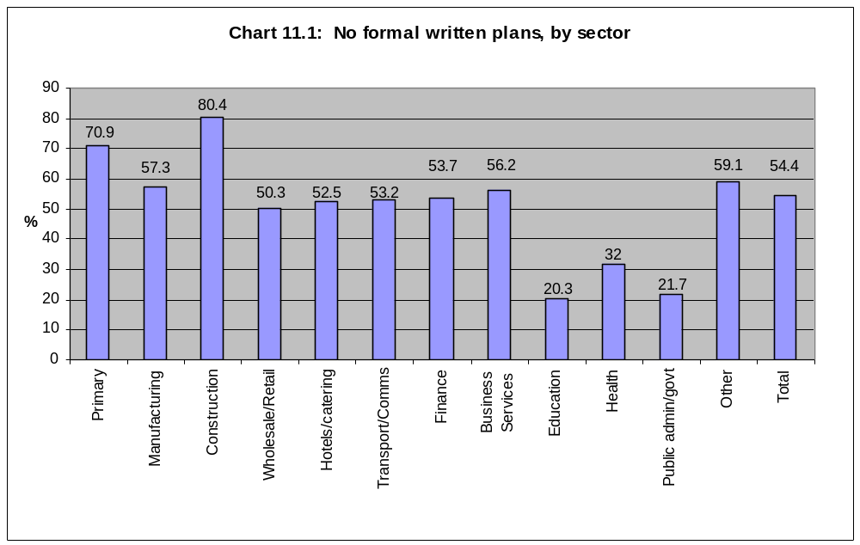

Table 11.1: Formal written plans, by number of employees (per cent)

 | 1-4 | 5-9 | 10-24 | 25-49 | 50-99 | 100-249 | 250+ | TOTAL
Business Plan | 28.9 | 43.1 | 61.2 | 68.4 | 75.3 | 77.1 | 88.2 | 38.0
Human Resources Plan that forecasts the number and types of staff that will be needed in the year ahead | 3.5 | 13.4 | 29.4 | 43.4 | 52.2 | 57.3 | 78.3 | 11.5
Training Plan that specifies in advance the level and type of training employees will need. | 6.5 | 20.2 | 38.2 | 52.1 | 59.4 | 58.8 | 82.5 | 15.9
Budget for training expenditure | 4.0 | 15.6 | 29.3 | 47.3 | 51.7 | 52.9 | 78.7 | 12.2
None of the above | 66.3 | 44.4 | 26.0 | 16.1 | 13.0 | 6.6 | 4.4 | 54.4
Don’t know | 3.3 | 8.8 | 6.9 | 7.6 | 6.1 | 11.3 | 9.6 | 4.9

Table 11.2: Formal written plans, by sector (per cent)

 | Primary | Manufacturing | Construction | Wholesale/ Retail | Hotels/ catering | Transport/ Comms | Finance | Business Services | Education | Health | Public admin/ govt | Other | TOTAL
Business Plan | 27.7 | 34.4 | 16.2 | 40.6 | 39.7 | 36.4 | 36.8 | 39.8 | 59.1 | 57.6 | 60.3 | 29.5 | 38.0
Human Resources Plan | 3.1 | 12.7 | 5.0 | 12.2 | 11.4 | 13.6 | 12.9 | 7.5 | 37.7 | 23.7 | 45.1 | 9.6 | 11.5
Training Plan | 4.5 | 14.6 | 6.2 | 18.1 | 19.7 | 15.8 | 16.4 | 11.0 | 48.6 | 37.1 | 46.6 | 11.9 | 15.9
Budget for training | 10.8 | 14.8 | 4.5 | 12.0 | 11.9 | 9.4 | 25.3 | 8.0 | 39.3 | 34.3 | 48.9 | 9.0 | 12.2
None of the above | 70.9 | 57.3 | 80.4 | 50.3 | 52.5 | 53.2 | 53.7 | 56.2 | 20.3 | 32.0 | 21.7 | 59.1 | 54.4
Don’t know | 1.5 | 6.0 | 3.0 | 4.7 | 6.5 | 8.6 | 3.0 | 2.0 | 4.6 | 8.1 | 17.9 | 11.0 | 4.9

Annex One – Survey Sample Breakdown

SIC |  | Chester | Congleton | Crewe and Nantwich | Ellesmere Port | Macclesfield | Vale  Royal | Warrington | Cheshire & Warrington
A, B, C, E, F | Primary/ Construction | 32 | 32 | 32 | 33 | 26 | 30 | 35 | 220
D | Manufacturing | 21 | 30 | 30 | 28 | 24 | 32 | 37 | 202
G | Wholesale/ Retail | 27 | 26 | 32 | 26 | 29 | 24 | 34 | 198
H | Hotels/ Catering | 32 | 26 | 33 | 26 | 23 | 29 | 27 | 196
I | Transport/ Communications | 19 | 30 | 25 | 29 | 22 | 27 | 38 | 190
J | Financial Services | 37 | 16 | 24 | 15 | 29 | 18 | 24 | 163
K | Business Services | 32 | 32 | 27 | 24 | 42 | 34 | 58 | 249
L | Public Sector | 24 | 5 | 10 | 6 | 4 | 7 | 12 | 68
M | Education | 20 | 19 | 27 | 28 | 17 | 18 | 24 | 153
N | Health etc | 34 | 22 | 26 | 24 | 24 | 28 | 32 | 190
O | Other Services | 27 | 25 | 27 | 26 | 35 | 30 | 29 | 199
 | TOTAL | 305 | 263 | 293 | 265 | 275 | 277 | 350 | 2028

Annex 2 - Summary of NVQ levels

NVQs are allocated to one of 5 levels, which range from competent performance at a very basic skill to competent performance at a senior management level.
- Level 1: The most basic, GCSE grade D-G / Foundation GNVQ. The candidate would be competent in a range of work activities, which are routine; the candidate would require supervision.
- Level 2: Broadly equates to GCSE grade A*-C / Intermediate GNVQ. The candidate would be competent in a significant range of work activities some of which are not predictable or routine. A degree of autonomy is given; the candidate would not require supervision.
- Level 3: Broadly equates to 2 A Levels / Advanced GNVQ. The candidate would be competent in quite a broad range of activities, which would cover a variety of contexts. The work would be complex; the candidate would be supervising other staff.
- Level 4: Broadly equates to higher professional graduate and postgraduate level. The candidate would be competent in a broad range of work activities, which are technical and require significant responsibility; the candidate would be managing other staff.
- Level 5: Broadly equates to higher professional graduate and postgraduate level. The candidate would be competent in a significant range of complex techniques across a wide range of unpredictable contexts; the candidate would be managing or co-managing an organisation.

