Greater Merseyside Learning and Skills Council

DRAFT

A Strategy for Learning and Skills in Greater Merseyside

2002 – 2005



CONTENTS

CHAIR’S FOREWORD 3
NATIONAL PLANNING CONTEXT – THE LSC’S OBJECTIVES AND TARGETS 4
LOCAL PLANNING CONTEXT 5
NEEDS ANALYSIS 7
OUR AMBITION AND TARGETS 16
STRATEGIC OBJECTIVE 1: INCREASING THE PARTICIPATION AND ACHIEVEMENT OF YOUNG PEOPLE 19
STRATEGIC OBJECTIVE 2: INCREASING THE PARTICIPATION AND ACHIEVEMENT OF ADULTS 25
STRATEGIC OBJECTIVE 3: MEETING THE WORKFORCE DEVELOPMENT AND SKILLS NEEDS OF EMPLOYERS 30
STRATEGIC OBJECTIVE 4: IMPROVING THE QUALITY, RELEVANCE AND COHERENCE OF LEARNING PROVISION 36
GMLSC - ORGANISATION 42
CONSULTATION ARRANGEMENTS 43
OUTLINE EVALUATION ARRANGEMENTS 45

CHAIR’S FOREWORD

I am delighted, as Chair of Greater Merseyside Learning and Skills Council, to present to you the Strategy for Learning and Skills in Greater Merseyside.

The Learning and Skills Council has been set up with a clear remit to raise levels of skills and knowledge for all adults and young people to world class standards. This is to be done against a backdrop of an increasingly knowledge based, service sector economy, in which too many people are prevented from achieving their potential by a lack of basic skills, outdated knowledge, or simply a mistrust and dislike of ‘the learning system’ – a learning system that too often is inflexible and unresponsive to learners’ needs.

Our task is to ensure that the people of Greater Merseyside are equipped, through learning, with the necessary skills to participate fully, both in the economy and as citizens. We need to develop a culture where lifelong learning is an integral part of people’s lives and is seen as a way of expanding life chances and creating better futures for themselves, their families and their communities.

Whilst the LSC’s key objectives are common across England, we must ensure that our local plans reflect local needs. We need to understand where Greater Merseyside differs from other parts of the country and to develop appropriate responses. Local challenges include:

- Low levels of participation in learning and below average levels of achievement amongst both young people and adults;

- A higher than average number of people who lack the basic skills of literacy and numeracy;

- A concentration of lack of access to learning and work amongst particular communities of people – both by geography and characteristics (e.g. ethnicity, gender, disability) - compounded by high levels of economic and social deprivation;

- The general absence of a learning culture across Greater Merseyside, within both communities and the employer base;

- A higher than average incidence of people in low skill jobs in industries vulnerable to economic change.

We know that we cannot meet this challenge alone. We need to secure your involvement – as partners, deliverers of learning, employers, communities, young people and adults – in delivering this strategy. As a first step in securing this involvement, we conducted an extensive consultation exercise, the outcomes of which have been key in shaping this strategy. We believe that by working together to identify the key challenges we face and agreeing how best we can face them, we have developed a strategy that can provide a framework for everyone to more effectively align their resources and better meet local needs.

We look forward to continuing to work with you deliver the stretching and challenging strategy set out in this document.

Jim Michie

Chair, Greater Merseyside Learning and Skills Council

NATIONAL PLANNING CONTEXT – THE LSC’S OBJECTIVES AND TARGETS

The Learning and Skills Council (LSC) came into existence at the end of March 2001, with a remit to integrate the planning and funding of all post compulsory learning outside of Higher Education. Since April 2001, the LSC has been responsible for further education, work-based learning, workforce development and adult and community learning. Responsibility for funding school sixth form provision will pass to the LSC from April 2002. The LSC published its Corporate Plan in July 2001, setting out the organisation’s strategic framework to 2004. This strategic framework also provides the framework for the development of this local Strategic Plan. The Corporate Plan sets out our national mission and vision, and our key objectives and targets for 2004.
Our mission is to raise participation and attainment through high quality education and training which puts learners first.

Our vision is that, by 2010, young people and adults in England will have knowledge and productive skills matching the best in the world.

Nationally, our key objectives are:
- To extend participation in education, learning and training
- To increase the engagement of employers in workforce development
- To raise the achievement of young people
- To raise the achievement of adults
- To raise the quality of education and training and user satisfaction

Each of these objectives has associated outcome targets: these are national targets but their achievement is made up of the sum of local progress towards the targets. These targets are set out below. Our local objectives, targets and actions, as set out in this Plan, have been developed within this national framework, and relate back to these national key objectives. This Plan therefore needs to be considered both in the context of this national planning framework, and the local planning environment, as described below.

Key Objectives | Targets for 2004
- Extend participation in education, learning and training | 80% of 16-18 year olds in structured learning (2000: 75%)
 | Baseline and targets for adults to be set in next year’s Plan
- Increase engagement of employers in workforce development | Develop measure of employer engagement in next year’s Plan
- Raise achievement of young people | 85% at Level 2 by age 19 (2000: 75%)
- Raise achievement of young people | 55% at Level 3 by age 19 (2000: 51%)
- Raise achievement of adults | Raise literacy and numeracy skills of 750,000 adults
- Raise achievement of adults | % of adults at Level 2: target to be set in next year’s Plan
 | 52% of adults at level 3 (2000: 47%)
- Raise quality of education and training and user satisfaction | Baselines and targets to be set in next year’s Plan

LOCAL PLANNING CONTEXT

The local strategic environment

In developing this Plan we are seeking to produce a framework for all our partners involved in the planning and delivery of learning and skills in Greater Merseyside, not just a Strategic Plan for Greater Merseyside Learning and Skills Council (GMLSC). We would like our partners to contribute to and sign up to this learning and skills agenda, and as a starting point, we have sought to align our strategic objectives to those of our key regional and sub-regional partners – the North West Development Agency (NWDA), The Mersey Partnership (TMP), Greater Merseyside Connexions (GM Connexions), the Employment Service (ES), the Objective 1 Partnership and Greater Merseyside Enterprise (GME).

The NWDA has set out a vision for a learning region and offered a framework for achieving this vision. The Regional Learning and Skills Action Plan embraces four strategic objectives which align closely with those for the Greater Merseyside area. These objectives are:
- To raise the demand of employers for skilled people, to increase their skills investment and to improve their workforce development capacity;
- To raise individual demand for skills;
- To invest in equality of opportunity for learning leading to increased social inclusion; and
- To invest in improvements to the regional labour and learning market.

Table 1 sets out where we see the linkages between our strategic objectives and the strategies of the NWDA and our other key strategic partners.

Table 1
GMLSC OBJECTIVES | NWDA | Connexions | Objective 1 | Employment Service | TMP | GME
1. Increasing the participation and achievement of young people |  |  |  |  | 
2. Increasing the participation and achievement of adults |  |  |  |  | 
3. Meeting the workforce development and skills needs of employers |  |  |  |  |  | 
4. Improving the quality, relevance and coherence of local learning provision |  |  |  |  | 

We are developing this plan within a landscape of local strategic change. TMP has recently taken on a strategic role on behalf of local partners and has just published its draft Action Plan for Merseyside. We have a new Connexions service for Greater Merseyside, with a role to provide coherent support and guidance for young people. The Employment Service too is refocusing the way that it operates, in particular broadening its focus to support all people of working age that are in receipt of benefits. The Objective 1 programme, running from 2000 to 2006, is being managed more strategically with an emphasis on commissioning activity that meets the needs of Merseyside. GME are responsible for providing business support to SMEs across the area and are key partners in delivering the workforce development agenda. The NWDA has been given the role of developing, in collaboration with GMLSC, ES, GONW, and Local Authorities, a Framework for Regional Employment and Skills Action, ensuring a coherent approach to employment, skills and economic development.

All of these organisations (together with many at district level) have an important role to play in responding to the skills and learning needs of Greater Merseyside. We will make most progress by agreeing what the local skills and learning priorities are and working together to deliver this strategy.

Working in partnership

It is essential that GMLSC works in partnership to achieve the objectives set out in this strategy. Whilst the LSC is a young organisation with a new remit, we have the benefit here in Greater Merseyside of working in an area with a long history of partnership working. We will seek to be a positive influence and establish a reputation for collaboration and partnership. In addition to our key strategic partners set out above, our partners include:

- Learning providers
- Local Education Authorities (LEAs)
- Local Learning Partnerships
- Local Strategic Partnerships (LSPs)
- Voluntary sector, community groups and agencies
- Local authorities
- Education Business Links
- Employers

Maximising our contribution to economic development

Learning plays an important role in the economic development and regeneration of an area, and our activities form a key element of local regeneration plans. We have focussed on developing a shared agenda with sub-regional, district and neighbourhood level partnerships through our participation on many of our local strategic partnerships and through sitting on the boards of many local regeneration partnerships.

We also play an active role on Objective 1 partnerships, at both a strategic and operational level, to ensure the effective alignment of Objective 1 funding with our own. The Objective 1 Partnership, as set out in their Corporate Plan, have undertaken to use this Strategy as ‘a shared strategic framework against which GMLSC and partner investment in learning and skills can be planned’.

We also sit on the Board of TMP, and have signed up to their recently produced ‘Action Plan for the City Region’. This Action Plan will be used by the NWDA to inform their investment decisions in Merseyside, and provides a vehicle for co-ordinating the economic development activities of partners. We worked closely with TMP to develop the learning and skills dimension of the action plan, and have reflected within this strategy the economic development priorities identified for the sub-region and the role that learning can play in achieving these priorities.

To support us in focussing our resources on local economic development and regeneration priorities, we have set targets for participation in those wards in Greater Merseyside that are within the 10% most deprived wards in the country. This will enable us to align our resources to those procured by LSPs through the Neighbourhood Renewal Fund and to other regeneration funding such as SRB and Objective 1.

NEEDS ANALYSIS

In developing this strategy, we have considered:
- the skills needed to support the local and regional economy;
- the needs of learners if they are to achieve their potential;
- the extent to which our learning infrastructure meets these needs.

In the pages that follow, we set out a summary of the analysis used to inform our identification of local challenges, describes within the main body of the strategy. It is these challenges that we must address if we are to achieve our ambition.

Background – the Local Socio-Economic Context

Greater Merseyside remains an area facing enormous challenges to upskill its current and future workforce. It is one of England’s most densely populated urban areas with 1.5 million people living in the six districts of Halton, Knowsley, Liverpool, Sefton, St Helens and Wirral. The resident labour force is around 916,000 of whom around 600,000 are in employment, 50,000 are self-employed and around 320,000 are not employed. Of those not in employment around 40,000 are claiming benefit and 264,000 are economically inactive, a proportion far higher than for England overall.

Employment has been growing over the past five years and now 553,000 people are employed in Greater Merseyside businesses, with growing sectors in finance, retail and tourism. The area has a large public sector, representing a much higher proportion of employment than that of England, with nearly 4 in 10 employees working in this sector. A lower proportion of the workforce is employed in manufacturing than elsewhere, but this still represents around 80,000 people.

Greater Merseyside has 26,000 businesses registered for VAT, with a registration rate below that for the UK. Compared to the national average, the area has fewer small firms and a higher proportion of large firms. By most measures the Greater Merseyside economy performs poorly when compared to the rest of the country. For example, GDP per head stands at 70% of that for the UK (1998).

Within an overall population decline forecast for the Greater Merseyside area the population in the 19 year old cohort is expected to rise from 19,800 in 2000 to 20,900 in 2004. Similarly the cohort aged 16-18 is anticipated to increase from 60,200 to 62,800.

Out of 139 wards in the Greater Merseyside area, 74 are within the top 10% of the most deprived in England as defined by DTLR’s Index of Deprivation. In total, these wards contain around 50% of the working age population.

Despite continuing to fall, unemployment rates in Greater Merseyside remain higher than for England overall. Claimant unemployment remains twice the England average. Chart 1 clearly demonstrates the disparities between Greater Merseyside and the rest of the country.

There remains significant unemployment amongst 16 – 19 year olds in Greater Merseyside. The International Labour Organisation (ILO) annual estimate for 2000 suggests that around 11,000 young people (10%) are unemployed at any one time. (Local Labour Force Survey, 2000) In areas of high unemployment, employees who do not develop the necessary skills are most at risk of becoming unemployed and have difficulty in becoming re-employed.

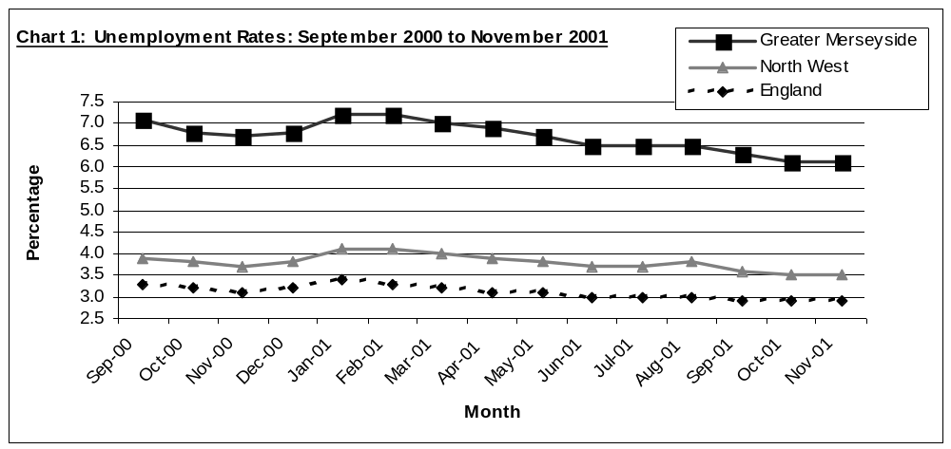

The Demand for Skills

Working with employers to understand their skills needs is paramount in meeting the LSCs agenda. Our first step in developing this understanding has been an extensive survey of employer skills needs, the results of which are described here.

Skill gaps within the existing workforce

In 28% of establishments in Greater Merseyside, the employer believed that not all their staff are fully proficient to do their job; in other words, they thought their organisation had a ‘skills gap’. The incidence of skills gaps is highest in the construction sector at 35% and lowest in other personal service industries at 17%. Within those organisations with skill gaps, the key gaps identified tended to be generic skills such as customer handling skills (26%), verbal communication skills (23%), written communication skills (20%), problem solving skills (18%) and team working skills (17%).

In almost two thirds of these cases, the cause of the skill gap was identified as new staff who had only been in the job for a short while. However, the next two most frequently cited reasons – that employees are reluctant to accept/make the most of training opportunities (23%) and that the employer themselves had failed to train and develop staff (23%) – are clearly problems to be tackled if we are to fill these skills gaps.

These skill gaps have a direct impact on employers. The key impacts identified by employers were difficulties in meeting the required quality standards (28%), difficulties in meeting customer service objectives (27%) and increased operating costs (25%).

Whilst many employers have taken action to overcome skills gaps – providing further training (58%), increase/expand trainee programmes (27%) – a significant minority (35%) had not used training as a way of dealing with gaps in their employees skills. Over a fifth of these employers said that there was no particular reason why they hadn’t provided training. Of those that could identify a reason, the most frequent responses were that they could not afford to have people taken out of the workplace (9%), there was no/not much training available (9%), and that employees weren’t motivated to train and wouldn’t take up if offered (5%).

Skills shortages within the labour pool

Greater Merseyside organisations indicated fewer skills shortages than nationally, but the indications are that these are a higher proportion than would be expected given the unemployment levels in the area. At the time of the survey, 12% of businesses had vacancies, 6% of organisations had ‘hard-to-fill’ vacancies, and 3% of organisations had ’skill-shortage’ vacancies. We estimate that some 1,300 employers across Greater Merseyside are facing skill shortages.

The greatest number of vacancies in Greater Merseyside are in sales and customer service occupations, skilled trade occupations, administrative and secretarial occupations and associate professional and technical occupations. More employers in construction, transport and other personal services had vacancies than in other sectors.

Employers identified the key causes of skill shortage vacancies to be a low number of applicants with the required skills, a low number of applicants with the required attitude, motivation or personality and a lack of the qualifications the company demands. The skills characteristics of the skill shortage vacancies were identified as technical and practical skills, customer handling skills, oral and verbal communication skills, personal attributes and problem solving skills.

As with skill gaps, skill shortages impact directly on companies. The impact of vacancies caused by a skills shortage includes a loss of business or orders to competitors, difficulties in meeting customer service objectives and delays in developing new products or services. To try and attract applicants with the right skills, employers have increased the salaries to make the jobs more attractive, increased advertising or recruitment spend and expanded the recruitment channels.

Future skills needs:

Companies were asked to identify the type of skills their staff were likely to need in future, considering the broad occupational areas within their companies. These are set out in Table 2.

Table 2: Future skill needs by broad occupational areas
Occupational area | Skill need
Managers/Professional and Associate Professional and Technical staff | Advanced IT or software skills (16%)
 | Customer handling skills (9%)
 | Management skills (9%)
Administrative and secretarial staff | Advanced IT or software skills (23%)
Administrative and secretarial staff | Basic computer literacy skills (14%)
Administrative and secretarial staff | Customer handling skills (6%)
Personal service occupations | Customer handling skills (12%)
Personal service occupations | Other technical and practical skills (8%)
Personal service occupations | Team working skills (5%)
Sales and service staff | Customer handling skills (27%)
Sales and service staff | Advanced IT or software skills (10%)
Sales and service staff | Oral or verbal communication skills (7%)
Skilled trade, operations and elementary staff | Other technical and practical skills (13%)
Skilled trade, operations and elementary staff | Customer handling skills (7%)
Skilled trade, operations and elementary staff | Basic computer literacy skills (7%)

Participation and achievement

Participation by young people

Overall, 82% of young people in Greater Merseyside continued in some form of learning at the end of their compulsory education. This varies from 61% in Knowsley to 92% in Sefton. At least 3% of young people leave school at 16 and go into employment without any training. These young people are less likely to have achieved a Level 2 by the end of their compulsory learning. Figures from DfES show that participation in learning by young people is not significantly behind the national average. However, this still means that more than 3,000 young people stop participating in learning when they leave school at 16.

We estimate current participation in learning of 16-18 year olds to be 46,500. 48% of these are in further education, 25% in school sixth forms and 17% in work based learning.

Particular groups of young people are less likely to participate in learning. National research suggests that young people with disabilities are twice as likely to not participate in post-16 learning. Teenage mothers are less likely to participate in learning, and local evidence suggests that in parts of Greater Merseyside there are higher rates of teenage pregnancy than in the country as a whole.

Achievement of young people

Level 2 achievement rates at the end of compulsory learning are lower in Greater Merseyside (43%) than the England average (50%). Table 3 indicates that achievement varies substantially across the districts.

Table 3: GCSE achievement at age 16
 | % achieving 5+ A*-C grade GCSEs
Halton | 40
Knowsley | 27
Liverpool | 37
Sefton | 53
St Helens | 46
Wirral | 51
Greater Merseyside | 43
North West | 46
England | 50
Source: DfES, 2001

In recent years, the gap between local and national performance has reduced, with the performance of all six LEAs at 5+ A*-C grade GCSEs increasing at a faster rate than the England average.

A sizeable minority of young people who leave education at 16 have failed to achieve the equivalent of a Level 1 qualification (7% across Greater Merseyside compared to an England average of less than 6%). Across the six LEAs the proportion of pupils who failed to achieve any GCSE passes in 2001 ranged from 4% to 11%.

Female pupils have higher levels of achievement than males. 48% of female 16 year olds achieved 5 A*-Cs at GCSE compared to 39% of males. 6% of young women failed to achieve any passes at GCSE compared to 9% of young men.

Achievement of Level 2 at 19 is slightly below the national average. We estimate the percentage of 19 year olds with a Level 2 qualification to be 73%, compared to 75% for England as a whole. However, the challenge is enormous if we compare our current achievement to that for the national target for 2004 of 85%.

Some young people are failing to achieve because they do not reach the end of their course. Retention rates vary across all providers: for example, retention in the FE sector in Greater Merseyside ranges from 75% - 93%. In the two recent area inspection reports, poor retention rates were identified as a key weakness in the work based learning programme.

Participation of adults

Nationally, it is estimated that around 26% of the working age population have not undertaken any form of learning in the last 3 years. Locally, indications are that around 224,000 aged 16 to retirement age have not undertaken any learning in the past 3 years, a higher proportion than nationally.

Chart 2 Proportion of adult learners (aged 16 – 69)
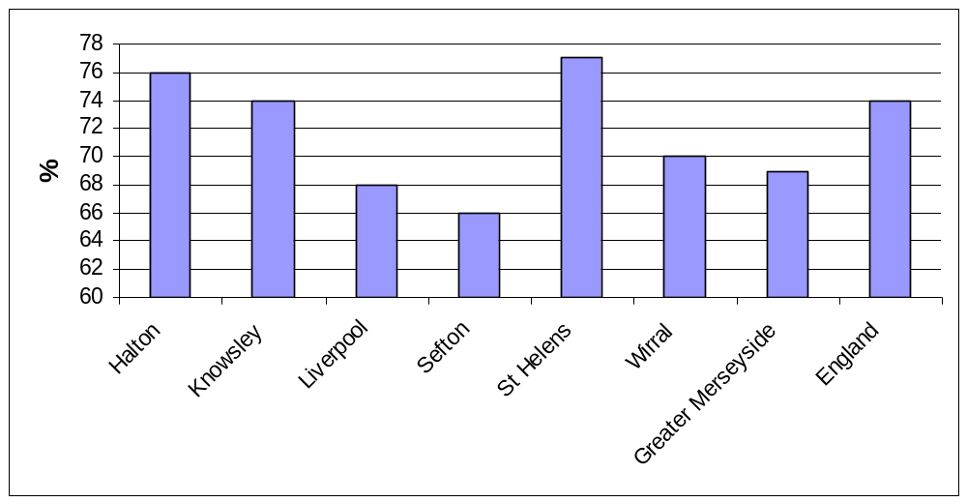
Source: Local Labour Force Survey, 2000

There are significant obstacles to increasing the demand for learning. Almost a third of female respondents to the DfES’s 1997 Adult Learning Survey did not have time for learning because of family commitments, whilst more than a fifth of adults cited the cost of learning as a barrier. The reasons why non-learners don’t participate are wide ranging and are set out in Chart 3.

Some groups are less likely to participate than others. Nationally the participation rate for adult learning is 77% for men compared to 71% for women. Women’s lower participation in the labour market probably explains this, given the role of the workplace in driving learning. Additionally, women are significantly under-represented in learning at NVQ Level 3. Participation in learning is also influenced by age. The participation rate for 18 – 24 year olds is 86%. As retirement approaches the rate drops to 66% (55 – 59 year olds). There is a marked decrease in participation rates after the age of 60 which is again probably largely due to the decreased participation of the older groups in the labour market. People over the age of 50 represent less than 10% of people in training, although they represent 30% of the working age population. However, people are living longer, and working longer: approximately 16,000 Greater Merseyside residents are over retirement age and still in employment.
Chart 3: Reasons why adult non-learners don’t participate in learning
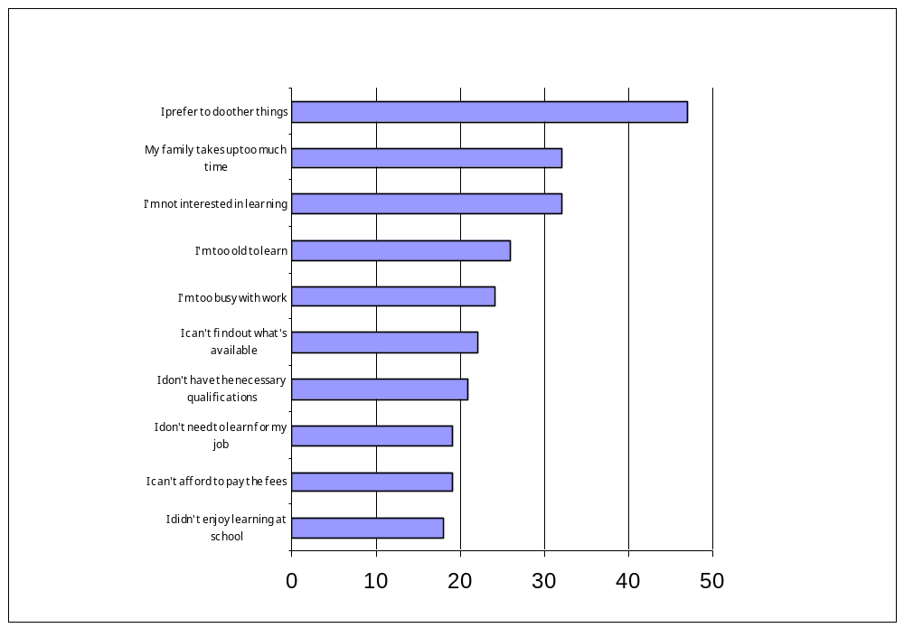

Source: National Adult Learning Survey, 1997

Achievement of adults

The Labour Force Survey indicates that 44% of economically active people aged between 18 and retirement have achieved a Level 3 qualification (46% in England overall). Across Greater Merseyside, the proportion of adults with a Level 3 or higher qualification varies from 36% to 47%.

In Greater Merseyside, 22% of people of working age have no qualifications (16% across England), compared to 14% of those who are economically active.

Table 4: Adult qualification achievement
Economically active persons of working age | Greater Merseyside | England
No qualifications | 14 | 12
Level 1 or above | 86 | 88
Level 2 or above | 63 | 63
Level 3 or above | 44 | 46
Level 4 or above | 24 | 27
Source: Local Labour Force Survey, 2000

There are a significant number of adults in Greater Merseyside who lack the necessary basic skills. Almost 29% of working age adults (259,000 people) have poor numeracy skills, and more than 27% have poor literacy skills (245,000 people). Adults with poor basic skills are more likely to be on lower incomes, be unemployed, have low self-confidence and low motivation and have children that struggle at school.

Nationally, figures suggest that some ethnic groups have lower levels of achievement. For example, less than 25% of African-Caribbean boys achieve 5 GCSEs (A*-C) compared to nearly 50% of all white pupils. Amongst youth trainees, young people from minority ethnic groups are less likely to obtain qualifications and jobs. Post-16 educational achievement also varies, with 74% of white students in colleges achieving a Level 3 qualification, compared to 69% for Indian students (the next best performing ethnic group) and 59% for Black Caribbean students (the lowest performing ethnic group).

Nationally, disabled people are twice as likely to have no qualifications as non-disabled people. The Local Labour Force Survey 2000 suggests that Greater Merseyside has the greatest proportion of people with disabilities who did not have a qualification (40% compared to an England average of 30%).

Greater Merseyside’s Learning Infrastructure

Colleges

There are 16 organisations in Greater Merseyside delivering further education (FE) funded by GMLSC, of which there are 11 colleges, 2 LEAs, 1 HEI and 2 institutions. Of the colleges, 7 are general FE colleges and 4 are sixth form colleges.

In 1999-2000, 136,671 students were funded through these institutions. Table 5 below shows the breakdown of these students by age and full/part-time status. In recent years, we have seen an expansion in FE, with growth in numbers of 28% over the last 4 years.

Table 5: Students in FE 1999/2000
16-18 Full-time
Female | 7640
Male | 7248
Total | 14,888
16-18 Part-time
Female | 3735
Male | 3974
Total | 7,709
19+ Full-time
Female | 5548
Male | 4936
Total | 10,484
19+ Part-time
Female | 62095
Male | 41495
Total | 103,590
Total all 16-18 students | 22,597
Total 19+ students | 114,074
Total all students | 136,671

A wide range of different subjects are available within the FE sector, with at least 70 subjects (sub-programme level) offered. Retention and achievement rates, although generally at or above average, do vary. For full time courses, retention varies from 79% - 95%. Achievement across all courses varies from 67% - 91%.

Within the sub-region, we have 2 beacon colleges, Knowsley Community College and Carmel Sixth Form College. In general, this sector is meeting and exceeding quality standards, with satisfactory or better inspection grades across the board.

Schools

There are 148 secondary schools in Greater Merseyside, including 39 special schools. Of the 109 mainstream schools, 72 have their own sixthh forms. There are 33 faith schools providing 16-18 education. There are also 17 special schools, offering provision for 16-18 year old young people with learning and/or physical disabilities. Approximately 11,570 16-18 year olds were studying in schools across the sub-region in 2001. Table 6 shows the breakdown of pupils in schools.

The size of school sixth forms varies across Greater Merseyside. Excluding special schools, sixth form sizes range from 15 – 440 pupils. 32 schools have sixth forms with less than 150 pupils. There does appear to be a correlation between the size of a sixth form and the performance of its pupils, as set out in Chart 4. However, we need to ensure that any assessment of provision takes into account the value added a school gives to its students.

Table 6: LEA School Participation data
 | Halton | Knowsley | Liverpool | St Helens | Sefton | Wirral | GMLSC
11-16 schools | 3 | 8 | 3 | 6 | 10 | 6 | 36
Pupils | 3113 | 6835 | 1455 | 4311 | 7014 | 5339 | 28067
11-18 schools | 4 | 3 | 30 | 6 | 12 | 17 | 72
11-15 pupils | 5008 | 3082 | 27854 | 6798 | 11545 | 15662 | 69949
16-18 pupils | 466 | 323 | 4161 | 1050 | 2117 | 3171 | 11288
Special 11-16 schools | 2 | 4 | 8 | 3 | 2 | 3 | 22
Pupils | 145 | 256 | 397 | 240 | 159 | 202 | 1399
Special 11-18 schools | 2 | 2 | 5 | 1 | 4 | 3 | 17
11-15 pupils | 47 | 59 | 256 | 39 | 94 | 330 | 825
16-18 pupils | 29 | 36 | 85 | 15 | 39 | 74 | 278
Total all schools | 8808 | 10591 | 34208 | 12453 | 20968 | 24778 | 111806
Source: Form 7 2001

Most school sixth forms offer A/AS level qualifications, with many also making AVCEs available. One school only offers vocational qualifications in its sixth form. Achievement at GCE A/AS level varies across schools, from an average point per pupil score of 4.3 to 26.1. Issues about the range of subject areas and qualification types and levels available to young people in school sixth forms have been raised in both Area Inspection Reports produced to date.

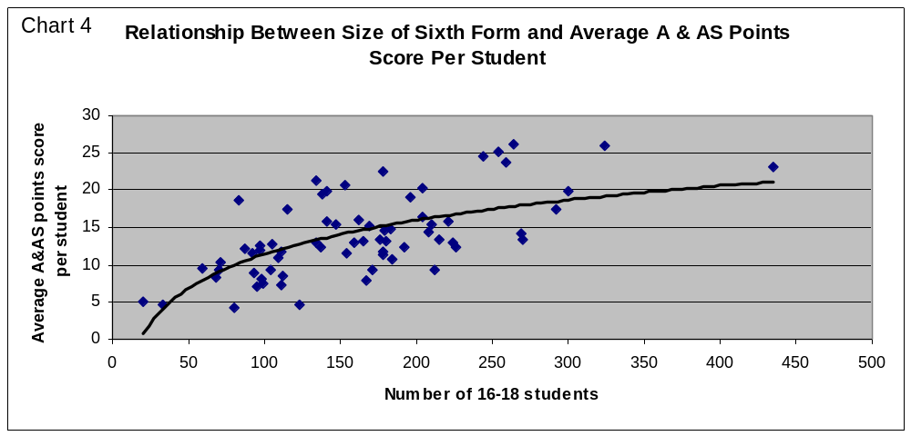
Work based learning provision

Within Greater Merseyside, a higher proportion of school leavers enter work based learning than nationally (13% in Greater Merseyside compared to 9% in England). More than 12,000 people are currently in training and we expect this figure to be higher by the end of 2001-2. More than 80% of trainees are Advanced or Foundation Modern Apprentices. In addition, 300 young people who need further support before moving into vocational training are currently accessing Life Skills or Preparatory Training provision.

A breakdown of trainees by age and employment status in each area are set out in Table 7.

Work based learning is supported by many of the sub-regions employers, with 73% of trainees employed. The programme offers training in all major occupational areas and at all levels. The biggest take up of training is in retailing and customer service (18%), followed by business administration (16%), construction (14%) and health care (14%).

The work based learning programme is currently delivered by some 102 providers, 7 of which are colleges. The size of providers varies widely in terms of number of trainees, with the smallest having 7 GMLSC funded trainees and the largest 1,100.

Table 7: Work based learning trainees 2001
Area | 16 - 18 | 19+ | Employed
Halton | 70% | 30% | 70%
Knowsley | 66% | 34% | 70%
Liverpool | 66% | 34% | 66%
Sefton | 60% | 40% | 77%
St Helens | 72% | 28% | 65%
Wirral | 66% | 34% | 74%
Out of Area | 58% | 42% | 87%
TOTAL | 64% | 36% | 73%

Although there is some excellent work based learning provision, there are also some poorly performing providers. Based on an analysis of Inspections carried out to October 2001 (covering 75% of the provider base), over half of providers were awarded an unsatisfactory grade within one or more areas of inspection.

LEA secured Adult and Community Learning (ACL)

ACL provision is a key tool for facilitating access to learning for those traditionally difficult to engage, by delivering learning in community locations, using delivery methods that will engage traditional non-learners. The adult education curriculum is generally focussed on non-vocational, leisure and recreational activities, and community and voluntary organisations are often engaged in its delivery. Historically, there is very little information about the take up of the provision available through this route, although in future years LEAs will be required to provide more detailed information on learners and their outcomes.

The data we do have refers to total number of learning opportunities, but does not take into account repeat participants. In 1999/2000, more than 22,000 ACL opportunities were delivered. Of these, 1,300 were basic skill training. Almost three quarters of these opportunities were taken up by females, and almost a quarter by people over 60 years old.

OUR AMBITION AND TARGETS

Our ambition for Greater Merseyside

Our ambition for Greater Merseyside reflects the local challenges we face and the scale of change that we believe is necessary to enable us to address the barriers to learning faced by the people and employers of Greater Merseyside.

“To create a learning culture in Greater Merseyside in which everyone is encouraged and enabled to reach their potential, where high quality provision is available to meet the needs and desires of learners, and people are equipped with the skills needed to enable the development of a prosperous local economy”

Achieving this ambition will take time, and is probably beyond the lifetime of this Plan. Below we set out our local strategic targets for 2004 which represent our first step towards achieving that ambition.

Our key objectives and targets for 2004

Table 8: Strategic Plan Targets 2002 – 2004
STRATEGIC
Strategic Objective (SO) | Indicator(s) | Baseline | Target 2004
SO1  Increasing the Participation and Achievement of Young People | 16-18 participation in learning | 46,468 | + 5,974
 | 19 yr olds achieving level 2 | 14,600 | + 1,401
 | 19 yr olds achieving level 3 | 7,892 | + 1,152
 | Basic Skills Achievements | N/a | 23,336
 | 16-18 year olds participating from wards in the 10% most deprived in England | Tba | Tba
SO2  Increasing the Participation and Achievement of Adults | Adult participation in learning | 453,000 | Target tba
SO2  Increasing the Participation and Achievement of Adults | Adults achieving level 23 | 413,000 | Target tba
SO2  Increasing the Participation and Achievement of Adults | Adults achieving level 3 | 283,000 | + 52,493
SO2  Increasing the Participation and Achievement of Adults | Basic Skills Volumes | N/a | 23,336
SO2  Increasing the Participation and Achievement of Adults | Adults participating from wards in the 10% most deprived in England | Tba | Tba
SO3  Meeting the Workforce Development and Skills Needs of Employers | Basic Skills volumes | N/a | 23,336
 | Indicator for employer engagement | Indicator tba | Target tba
SO4  Improving the Quality, Relevance and Coherence of Local Learning Provision | Reduction in curriculum and generic areas receiving a ‘poor’ grade | Baseline tba | Target tba
 | Learner satisfaction | Indicator tba | Target tba

As part of our local planning process, we will need to set local targets which will contribute to the achievement of the LSC’s national targets. It is important that we are able to make the link between what we do and our progress towards our targets. For that reason, our strategy is structured in a way that enables us to clearly demonstrate our impact against those national targets:
- Increasing the participation and achievement of young people
- Increasing the participation and achievement of adults
- Meeting the workforce development and skills needs of employers
- Improving the quality of local learning provision

We have set out below, in summary, these key strategic objectives and the impact targets we have set to measure the progress that GMLSC and our partners make towards them.

From these strategic objectives, we have developed a planning framework that links our strategic impacts to our operational outputs and results. This framework is set out below. A more detailed table at Annex 2 sets out for each strand of the strategy the key operational objectives and targets that we must deliver against if we are to achieve our impact targets.

Strategic Objective 1: Increasing the Participation and Achievement of Young People
Operational Objective 1.1: Bring back into learning those young people who are currently disengaged
Operational Objective 1.2: Improve the retention, progression and achievement of young people
Strategic Objective 2: Increasing the Participation and Achievement of Adults
Operational Objective 2.1: Drive up the demand for learning amongst adults
Operational Objective 2.2: Enable adults to progress through learning and increase achievement
Strategic Objective 3: Meeting the Workforce Development and Skills Needs of Employers
Operational Objective 3.1: Stimulate the workforce development activity of employers
Operational Objective 3.2: Ensure that learning provision meets employer needs
Operational Objective 3.3: Stimulate employment growth
Strategic Objective 4: Improving the quality, relevance and coherence of provision
Operational Objective 4.1: Raise provider quality and standards
Operational Objective 4.2: Develop a coherent and responsive learning infrastructure

GMLSC and our partners believe there is great value in setting targets at district level, both to reflect the differences between areas and to increase their relevance to local partners. Once Greater Merseyside targets have been agreed, we will work with Learning Partnerships to disaggregate the strategic targets set in Table 8.

Equality of Opportunity and Social Exclusion

Underpinning all that we do is a strong commitment to equality of opportunity and social inclusion. In implementing our plans, we will strive to give everyone the chance, through education, training and work, to realise their full potential and thus help to build an inclusive and fair society and a competitive economy.

We have mainstreamed equality of opportunity and social inclusion throughout this strategy, addressing inequalities of race, gender and disability, together with inclusion of those disadvantaged by age or multiple deprivation. We will measure and track progress towards our local targets for all such groups, and have produced a detailed Equal Opportunities and Social Inclusion Delivery Plan, which sets out our operational priorities for 2002-2003, with delivery targets to reflect our commitment to equalising opportunities in learning and increasing social inclusion throughout Greater Merseyside.

STRATEGIC OBJECTIVE 1: INCREASING THE PARTICIPATION AND ACHIEVEMENT OF YOUNG PEOPLE

The analysis of local needs is set out in greater detail in the section on participation and achievement earlier. In summary, key local challenges are:-

- To re-engage those young people who drop out of learning. Around 3,500 young people stop participating in learning in Greater Merseyside when they leave school at 16 (estimated 18% of cohort), rising to 5,500 by the age of 17 (estimated 27% of cohort).
- To reduce the number of young people that currently drop out of learning at 16, and critically, at 17. Retention rates vary across all providers: for example, retention in the FE sector in Greater Merseyside ranges from 75% to 93%.
- To differentiate the delivery of the strategy across the Greater Merseyside area to reflect the different needs each district. For example, there is significant variation in the percentage of young people not continuing in learning at the end of compulsory education across the Greater Merseyside area – from 39% in Knowsley to 8% in Sefton.
- To work with LEAs to ensure that young people are given the best opportunity of achieving level 2 qualifications by the age of 16. Whilst our best performing district has a 5 or more GCSE A*-C achievement rate of 53% at 16 (compared to a national average of 50%), in our poorest performing district this is only 27%.
- To provide a range of learning opportunities post-16 that reflect pre-16 achievement. A sizeable minority of the young people who leave education at 16 have failed to achieve the equivalent of a Level 1 qualification. Groups particularly affected include care leavers, teenage mothers, disabled young people and certain ethnic minorities.
- To continue to increase the achievement of Level 2 at 19 which is currently broadly similar to the national average. We estimate the percentage of 19 year olds with a Level 2 qualification to be 73% in Greater Merseyside, compared to 75% in England as a whole.
- To improve achievement of Level 3 qualifications where Greater Merseyside currently lags a long way behind the national average. Only 40% of 19 year olds are currently qualified to Level 3 in the sub-region, compared to the national rate of 51%.

This analysis suggests that the Strategic Objective to ‘Improve the Participation and Achievement of Young People’ can be secured by pursuing two key Operational Objectives:-

- To bring back into learning those young people who are currently disengaged; and
- To improve the retention, progression and achievement of young people.

The strategy outlined below will rely heavily on effective close working relationships with Greater Merseyside Connexions and our providers for its delivery. We have also reflected within this section of the strategy the government’s emergent 14-19 agenda and have, where appropriate, set out action we will take in relation to 14-16 year olds. We recognise however that it is important to have in place strategies for interventions for young people before the age of 14, and will seek to ensure that 14-19 strategies align effectively with those of agencies supporting young people of all ages.

Operational Objective 1.1: To bring back into learning those young people who have disengaged

This Operational Objective targets those young people who are disengaged from and/or disaffected with learning. The analysis above suggests three categories of tactical response:-

- An appropriate and accessible curriculum;
- Developing and sustaining support mechanisms; and
- Marketing and promotion.

Appropriate and Accessible Curriculum

GMLSC will fund a range of education and training opportunities that relate to the needs of disengaged young people. A key element of this will be ensuring that there is sufficient, appropriate Entry Level and Level 1 provision, including basic skills, to enable those young people who have not achieved this standard by the age of 16, and for whom it is an appropriate ‘first step’, to enter learning. We also need to ensure that we use appropriate delivery methods (e.g. evening access, remote learning, community based provision) that respond to the barriers faced by some young people.

Life Skills – helping to bring young people back into learning

The Life Skills programme is designed to help those young people who require intensive support to progress into mainstream training, education or employment. Typically, the programme supports those young people who have been excluded from school or have been long-term non-attendees, young offenders or those who, by particular circumstance or attitude, need intensive additional support to engage in learning.
Life Skills offers a wide range of support and provision, tailored to meet exactly an individual’s needs. Some of the areas that could be included on a training plan are vocational tasters, confidence building, self-awareness raising, youth arts, sport and leisure, job seeking skills and money management. Given the diverse needs of this client group, providers offer the type of support required to meet the preferred learning style of the individual and deliver the support in a variety of settings e.g. community and youth centres.
Some 27 providers across Greater Merseyside are currently offering Life Skills provision to more than 200 young people who are most disengaged from learning.

We will continue to develop, with our delivery partners, new pathways for learning that will encourage young people to view learning as a continuous process from 14 to 19 and beyond. In particular, GMLSC will fund vocational learning opportunities for 14-16 year olds for whom the school environment is not working and who are at risk of disaffection from the learning process.

Ensuring equality of opportunity in learning is a key responsibility for the LSC. We will work with our providers to remove barriers to learning – in relation to e.g. access, learning materials - in terms of race, gender, disability, age, marital status, religion, sexual orientation or that experienced by those suffering social exclusion. Our Equal Opportunities and Social Inclusion Delivery Plan for 2002/3 sets out in detail some of the activities planned in relation to provision for young people.

Learner Support

For young people outside learning to be able to access information, advice and guidance we need, with GM Connexions, to ensure local, community based access. Such support may need to be delivered through community venues or linked into other support mechanisms accessed by young people.

For some young people – those with particular social or learning needs who are not engaged in learning - we will need to respond directly to the needs of those individuals. We will work with Connexions to identify and implement targeted strategies for engaging disengaged young people through integrated multi-agency provision.

We need to help young people to overcome the barriers they may face to engaging in learning by offering appropriate support. This could be financial support (e.g. LEA administered Educational Maintenance Allowance), learner support (e.g. dealing with dyslexia) or pastoral support (e.g. supporting those with substance misuse problems or homelessness).

Marketing and promotion

For some young people in Greater Merseyside there is little value attached to learning. High levels of deprivation and social exclusion in some areas have eroded any link between learning and employment. As part of any marketing strategy for young people, we will need to work with our partners to demonstrate the benefits of learning – for employment, income, social interaction and pleasure - and the consequences of not learning. We will work closely with GM Connexions and providers to ensure that both young people and their families/carers understand the opportunities available to them.

We need to ensure that young people currently employed without training, and their employers, are aware of their rights and responsibilities in relation to paid time off for study. We will work with Greater Merseyside Connexions, who have lead responsibility for this, to develop appropriate promotional, support and evaluation strategies.

Operational Objective 1.2: To improve the retention, progression and achievement of young people.

This Operational Objective targets those young people who are already engaged with learning to ensure that they achieve their potential. The earlier analysis suggests three categories of tactical response:-

- An appropriate and accessible curriculum;
- Better support for learners; and
- Marketing and promotion

Appropriate and Accessible Curriculum

GMLSC will fund a comprehensive range of education and training opportunities that relate to the aspirations and needs of young people, and where appropriate, employers, ensuring that the volume, level and range of opportunities funded strike a balance between these.

We will ensure that provision is planned collaboratively with our providers. We will agree realistic and challenging targets with providers and ensure that the funding allocation process reflects our local targets and the ability of providers to deliver. We are working with providers to undertake a Greater Merseyside wide-strategic review of provision, which will be supported by district level reviews and area inspection reports, to determine how best to shape provision over the coming years to meet the needs of young people. Additionally, we will develop arrangements with GM Connexions to ensure that the needs of young people they identify are effectively fed into the planning cycle.

To support the progression of young people we will work with partners to create clear and stimulating pathways up to and beyond 19, including Foundation Degrees, which reflect both vocational and academic preferences. We will work with a wide range of partners, including HEIs, to raise young people’s learning aspirations and ensure that young people are equipped to effectively make the transition between different levels of learning through to HE. This will help to contribute to the government’s target of increased participation in HE.

Knowsley 14-19 Collegiate – a new approach to learning

Knowsley is one of the poorest performing districts in the country in terms of its achievement levels at 16 and 19. In direct response to a recent Area Inspection report, all local partners – the LEA, schools, Knowsley Community College, GM Connexions, work based learning providers and GMLSC – are working together through the Learning Partnership to develop a ground breaking model for 14-19 learning in Knowsley which will dramatically improve levels of achievement.
This approach places individual learners at the centre of the system, rather than the institution by enabling learners to have access to the best learning opportunities available across the area rather than in any one provider. It seeks to tackle the institutional and systematic barriers to a 14-19 phase of learning through proposals for greater collaboration between schools, colleges and other providers in providing learning for 14-19 year olds. It also recognises that achievement in both academic and vocational routes has a parity of esteem, and will develop vocational options for all students, which are linked to individual potential and employability.
The Knowsley Collegiate approach consists of 4 main strands:
- The development of an enhanced learner-focussed curriculum, which is planned across the Borough, drawing on the expertise, specialisms and resources of all partners.
- A coherent delivery mechanism that can be accessed across insititutions, supported by a comprehensive ICT network. There will be a robust management structure for the collegiate approach which represents the needs and philosophies of each institution
- The development of innovative vocational and learning centres, linked to industry. Such centres will focus in individuals vocational aptitudes and accessible to the full ability range. The first stage of this, a Vocational Learning Centre for the 14-19 phase at Knowsley College, is currently under development
- The creation of a virtual learning environment that is accessible in all learning centres and supports an ‘any place, any time’ approach to learning.
It is intended that the first phase of this innovative approach to 14-19 learning be available to learners in Knowsley from September 2002.

We need to ensure that education and training for young people is delivered in a high quality learning environment. We will work with providers to provide young people with appropriate, up to date equipment, including ICT access, and support proposals for capital developments that facilitate the participation and achievement of young people.

Appropriate learning opportunities need to be made available for young people with learning difficulties and/or disabilities to enable them to go on from compulsory education and achieve their potential. We will secure appropriate provision for these young people in accordance with section 13 of the Learning and Skills Act 2000.

We will encourage young people to improve their understanding of the world of work by developing and promoting links between schools, post-16 providers and employers, working with the Greater Merseyside Education Business Link Organisation and its constituent organisations.

We will work with providers and Connexions to ensure that young people are recruited onto appropriate courses – in terms of both level and type of learning – that will best enable them to fulfil their potential.

Learner Support

Key to attracting young people into learning and retaining them once there is providing high quality, impartial information, advice and guidance. Recent Area Inspections of Knowsley and Liverpool identified sometimes inappropriate pre-16 guidance as a significant factor in poor participation and achievement rates in these areas. Greater Merseyside Connexions have been charged with the lead on this and GMLSC will work closely with them in their work with schools, colleges and work based learning providers. We will ensure that the Connexions Service has access to information on learning opportunities, the achievement of young people and how this relates to the local labour market.

GMLSC will work with providers to ensure that all young people for whom poor literacy or numeracy skills might be a barrier to achievement have access to high quality basic skills support and that this is delivered in a way that will break down taboos about basic skills education/training. Detail of proposed actions are set out in GMLSC’s draft Basic Skills Action Plan, which will be implemented from April 2002.

We will work with providers to develop support mechanisms to improve retention and retain young people at risk of leaving their programme or course early. Some of the ways in which this issue will be addressed include the development of mentors for work-based learners, financial incentives for learners to complete and the provision of pastoral support to help young people deal with problems outside learning.

We will secure high quality work experience and education business link activity including mentoring, industry days and development programmes. We will also provide professional development opportunities for teachers so that they are better able to prepare their pupils for the world of work.

Marketing and promotion

We need to ensure that young people are aware of the different routes and opportunities available to them to enable them to progress and develop. Whilst individual providers will be responsible for marketing their programmes and courses, organisations such as GM Connexions and ourselves will deliver effective PR and marketing campaigns to young people which promote greater understanding of the value of learning and the landscape of choice in relation to post-16 learning.

Strategic and Operational Targets

The strategic and operational targets for Strategic Objective 1 are set out in Table 9 below. The Operational Targets will be central in informing business planning and contracting priorities in the next planning cycle. Operational targets have been chosen as stepping-stones to achieve the overall Strategic Targets. In establishing and setting operational targets, care has been taken to ensure that perverse outcomes are not generated (e.g. through unanticipated changes to provider behaviour).

The first two targets for Operational Objective 1.1 – Participation in Learning at 16 and Participation in Learning at 17 are shared with the Greater Merseyside Connexions Service and, as such, will be secured through the effective operational integration of activities supported by both Connexions and GMLSC.

Figure 1 illustrates how funding mechanisms link our strategic and operational objectives. Set out are GMLSC and partner funding streams for young people, both core and discretionary, that can be marshalled to support the achievement of our operational objectives and hence our strategic impact targets.
Table 9: Strategic Plan Targets 2002 - 2004: Strategic Objective 1
STRATEGIC
 | Indicator(s) | Baseline | Targets
SO1  Increasing the Participation and Achievement of Young People | 16-18 participation in learning | 46,468 | + 5,974
 | 19 yr olds achieving level 2 | 14,600 | + 1,401
 | 19 yr olds achieving level 3 | 7,892 | + 1,152
 | Basic Skills Volumes | N/a | 23,336
 | 16-18 year olds participating from wards in the 10% most deprived in England
OPERATIONAL
 | Indicator(s) | Baseline | Targets
Operational Objective 1.1  Bring back into learning those young people who are currently disengaged | Participation in learning at 16 | 16,270
 | Participation in learning at 17 | 14,391
 | Numbers in structured learning | 36,700
Operational Objective 1.2  Improve the retention, progression and achievement of Young People | FE Retention rate | 83.3%
 | 6th Form Retention rate | Baseline tba
 | WBL Retention rate | Baseline tba
 | Numbers achieving level 1 | Baseline tba
 | Numbers achieving level 2 | Baseline tba
 | Numbers achieving level 3 | Baseline tba
 | Basic Skills Volumes | Baseline tba

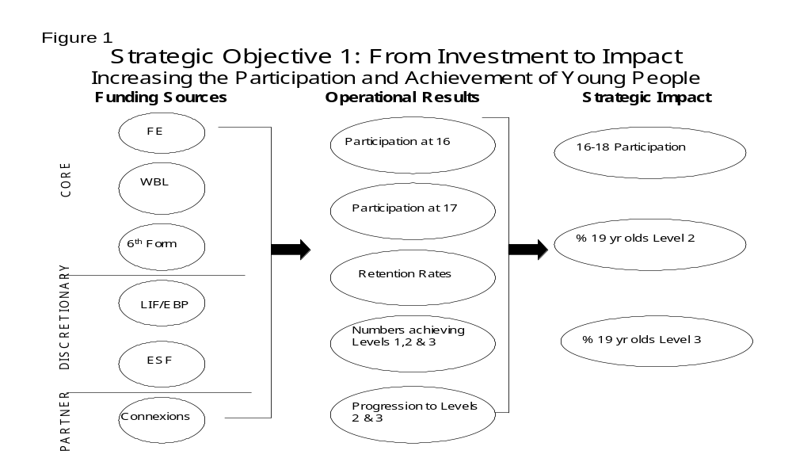

STRATEGIC OBJECTIVE 2: INCREASING THE PARTICIPATION AND ACHIEVEMENT OF ADULTS

The analysis of local needs is set out in greater detail in the section on participation and achievement earlier. In summary, key local challenges are:-

- To narrow the gap between adult participation in Greater Merseyside (currently 65%) and England as a whole (currently 77%).
- To use learning as a tool to increase economic activity (Greater Merseyside has the lowest economic activity rate in England) and to better enable people to access employment (Greater Merseyside has the highest unemployment rate). For many adults in Greater Merseyside, the first challenge will be to tackle poor basic skills. Almost 29% of working age adults have poor numeracy skills and more than 27% have poor literacy skills.
- To help adults overcome the barriers to learning. A great deal of research has been carried out nationally to identify the barriers to learning faced by adults. The cost of learning, family and caring commitments, a lack of confidence and poor prior experience of education or training are all significant in preventing adults from accessing learning.
- To target those groups least likely to access learning, including ex-offenders/prison populations, people suffering from high levels of deprivation, specific cultural/ethnic groups, disabled people, those with social, domestic or caring responsibilities and people aged 50 +.
- To improve achievement rates amongst adults and reduce the gap between Greater Merseyside and England. Currently 41.5% of adults have achieved a level 3 qualification (compared to 46% nationally), and 22.1% have achieved a level 4 qualification (nationally this figure stands at 26.5%).

This analysis suggests that the Strategic Objective to ‘Increase participation and achievement by adults’ can be achieved by pursuing two key Operational Objectives:

- To drive up the demand for learning amongst adults; and
- To enable adults to progress through learning and increase achievement

Operational Objective 2.1: Drive up the demand for learning amongst adults

This objective focuses on how we can encourage adults to return to learning. The analysis above suggests three areas of response:

- Improving our promotion and marketing of learning;
- An appropriate and accessible curriculum; and
- Providing better support mechanisms

Promotion and Marketing

We will work with our partners, including IAG partnerships, Learning Partnerships and LEAs, to develop promotional materials that demonstrate the benefits learning brings in terms of employment prospects, family benefits and personal satisfaction.

We will utilise national campaigns and our in-house marketing and PR expertise to ensure that local PR and marketing builds on national LSC and government campaigns, adding a local perspective where this adds relevance and impact. We will work with our providers to develop ways to draw into learning those people who have not engaged in any structured learning in the previous three years, building on existing practice of University for Industry (UfI), Adult Learners’ Week and other initiatives.

We will target the promotion of learning at the hardest to reach non-learners through other agencies working with these groups, such as social services, probation services, employers, trade unions and health services and through the development of an ‘outreach’ approach.

Addressing the needs of deprived communities - Working with partners to add value
A key forum for local partners to work together in Greater Merseyside is the emerging Local Strategic Partnerships (LSPs). LSPs have been asked by the Government to develop local community strategies that set out how the partners will work together to achieve improvements in service delivery to their communities. These community strategies will also set out how the local partnership intends to use allocation from the Neighbourhood Renewal Fund to tackle deprivation in the most deprived neighbourhoods.
As the key partner in post-16 learning in each of our districts, we want to ensure that we use our mainstream programmes, as well as discretionary funding, to target those areas of deprivation identified as within the 10% most deprived in the country, in line with the methodology used for the Neighbourhood Renewal Fund. We have therefore included targets for increased participation in those wards identified as most deprived. The wards we will target are:
Halton: Castlefields, Riverside, Kingsway, Murdishaw, Palace Field, Grange, Brookvale, Halton Brook, Norton and Mersey
Knowsley: Princess, Longview, Cherryfield, Kirkby Central, Northwood, Cantril Farm, Tower Hill, Knowsley Park, St. Michaels, St. Gabriels, Halewood South, Whitefield, Page Moss, Park, Halewood West, Prescot East, Whiston South, Whiston North
Liverpool: Speke, Everton, Vauxhall, Granby, Pirrie, Breckfield, Melrose, Clubmoor, Smithdown, Dovecot, Netherley, Kensington, St. Mary's, Valley, Abercromby, County, Dingle, Tuebrook, Fazakerley, Anfield, Broadgreen, Picton, Old Swan, Gillmoss, Warbreck
Sefton: Linacre, Orrell, Derby, Netherton, Ford, Litherland, St. Oswald, Church
St Helens: Parr and Hardshaw, Broad Oak, West Sutton, Marshalls Cross, Queen's Park, Thatto Heath, Grange Park
Wirral: Bidston, Birkenhead, Tranmere, Seacombe, Leasowe, Egerton

Appropriate and Accessible Curriculum

Local access to learning is important to encourage participation by those who have not recently participated in learning. GMLSC, with its providers and other partners will develop better local access to learning, including basic skills. A key element of this will be support for LEAs in the provision of more family learning programmes. We will also work with learning providers and other agencies to develop a network of facilities to bring learning opportunities to communities. Local companies will also be encouraged to open up their learning facilities to communities in evenings and at weekends. We also need to ensure that we make available learning opportunities that are flexible enough to attract employed people.

Improving the basic skills of adults is a key element of our strategy, and reflects the substantial proportion of adults in Greater Merseyside who have problems with basic literacy and/or numeracy. Our Basic Skills Action Plan (which runs from April 2002) sets out ways in which, working with partners and through the providers we fund, we can contribute to the National Strategy for Basic Skills and achieve our challenging basic skills targets. In working towards this target, we will work closely with Employment Service to ensure that appropriate linkages are made with their Work Skills programme. We will use development funding to encourage innovative basic skills provision and ensure that basic skills learning materials are relevant to adults and their daily lives. If we are to met out targets for basic skills we will need to increase the number of basic skills tutors, and in particular seek to encourage more tutors from disadvantaged backgrounds to act as role models.

We will encourage and promote the use of new technologies as a way of enabling adults to access learning in their communities and homes, as well as with their employer, working with learndirect to ensure that appropriate courses and support are available to new learners.

We will ensure that specialist provision is available to meet the needs of those adults disadvantaged in the learning market. For example, we will provide appropriate learning opportunities for minority ethnic groups, including English for Speakers of Other Languages, so that adults have the opportunity to reach their potential. We will also support access to inclusive and specialist learning opportunities for disabled people and those with learning difficulties

With our partners, we will ensure that we have a wide range of ‘first step’ or ‘taster‘ opportunities to encourage participation in learning.

Learner Support

We will work with GM Connexions and local Information, Advice and Guidance (IAG) Partnerships to ensure that high quality adult information, advice and guidance services are available to people in appropriate locations, at the right times and in a range of formats (e.g. face to face, on-line, Braille, printed); and that appropriate linkages to learndirect are in place.

We will help to overcome financial barriers to learning by promoting Career Development Loans and working with LEAs and colleges to devise imaginative fee admission schemes in order to make provision for adults more accessible and easy to understand. The LSC has been tasked, working with DfES to develop a successor to ILAs to support individual learners.

We will work with partners to overcome other barriers to learning faced by adults. In particular, we will work with Early Years Development and Childcare Partnerships (EYDCPs) and learning providers to improve access to learning for those with childcare or other caring responsibilities. We will also work with EYDCPs to promote working in childcare settings and provide funding to support their training strategies.

Operational Objective 2.2: Enable adults to progress through learning and increase achievement

This operational objective is focussed on adults who have accessed learning to ensure that they are able to achieve their full potential. The analysis above suggests the following responses:

- An appropriate and accessible curriculum; and
- Improved support for learners

Appropriate and accessible curriculum

We will provide a range of high quality learning opportunities for adults that meet their needs. For young adults, we will continue to offer work based learning opportunities through the Modern Apprenticeship programme. Vocational and academic learning opportunities will be available to adults through the Further Education sector, and we will work with providers to ensure that there is sufficient flexibility to enable employed adults to access education and training. More informal learning will be available through a network of Adult and Community Learning centres across Greater Merseyside. Given the comparatively low level of adult achievement in Greater Merseyside, we will ensure that sufficient entry level basic skills and ICT learning opportunities are available and that these are presented in imaginative and attractive ways.

If we are to begin to develop a culture of lifelong learning, we need to ensure that there are clear progression routes between different types and levels of learning. There is a particular need for us to work with providers to develop routes to enable people to move from informal and basic skills provision into formal learning. We will work to develop a flexible and responsive programme of learning opportunities that will support such progression and promote greater collaboration between providers. We will also work with providers and HEIs to continue and develop routes for adults to access HE.

We recognise the potential of ICT to transform access to learning, enabling adults to learn at work, at home, or within their community, at a time and pace that meets their needs. We will work with our partners to develop an e-learning strategy for Greater Merseyside which brings together the existing range of activity currently being funded by government (such as UK on-line) and those funded locally through the Objective 1 programme and other regeneration funds.

We need to ensure equality of access and of success for adults. Further details of our approach are in our Equal Opportunities and Social Inclusion Action Plan, but will include for example the development of learning materials that take into account the different characteristics of learners from different cultural and social backgrounds

Providing appropriate support

We will work with the Adult IAG Network to improve the availability of information and advice on progression to other learning to keep adults in learning and encourage a culture of lifelong learning. In addition, we will provide up to date analysis of the labour market to support adults in making learning choices and career progression.

We will work with providers to ensure that appropriate financial, pastoral and learning support mechanisms are in place to enable adults to complete their course and achieve. Our partners have told us that it is important to celebrate the achievement of adult learners, and we will work with them to develop recognition schemes.

We will provide support for adult learners who have learning difficulties and/or disabilities and ensure that disadvantaged groups of learners have access to the additional support they need to achieve their learning goals.

Strategic and Operational Targets

The strategic and operational targets for Strategic Objective 2 are set out in Table 10. The operational targets will be key in developing our business planning and contracting priorities for 2001/2. Figure 2 illustrates how we can utilise different funding streams, both core and discretionary, to support the achievement of our operational objectives for adults, and hence our strategic objectives.

Table 10: Strategic Plan Targets 2002 - 2004: Strategic Objective 2
STRATEGIC
 | Indicator(s) | Baseline | Targets
SO2  Increasing the Participation and Achievement of Adults | Adult participation in learning | 453,000
SO2  Increasing the Participation and Achievement of Adults | Adults achieving level 2 | 413,000
SO2  Increasing the Participation and Achievement of Adults | Adults achieving level 3 | 283,000 | + 52,493
SO2  Increasing the Participation and Achievement of Adults | Basic Skills Volumes | N/a | 23,336
SO2  Increasing the Participation and Achievement of Adults | Adults participating from wards in the 10% most deprived in England | Baseline tba
OPERATIONAL
 | Indicator(s) | Baseline | Targets
Operational Objective 2.1  Drive up the demand for learning amongst adults | Numbers in LSC supported provision | 89,689
 | Information and advice sessions | 12,689
Operational Objective 2.2  Enable adults to progress through learning and increase achievement | FE retention rate (adults) | 82.8%
 | WBL 19+ retention rate | Baseline tba
 | Level 2 achievement (adult numbers) in LSC-supported provision | Baseline tba
 | Level 3 achievement (adult numbers) in LSC-supported provision | Baseline tba
 | Basic Skills Volumes | N/a

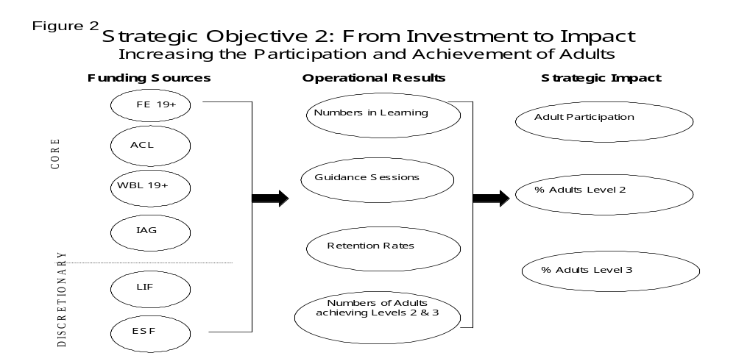

STRATEGIC OBJECTIVE 3: MEETING THE WORKFORCE DEVELOPMENT AND SKILLS NEEDS OF EMPLOYERS

The analysis of local needs is set out in greater detail in the section on skills needs earlier. In summary, key local challenges are:-

- To increase the proportion of Greater Merseyside workforce receiving job related training, currently 11% compared to a figure of 13% for Britain. Part of the explanation for this is that Greater Merseyside has a higher proportion (than the national figure) of employees in lower skill occupations and a smaller proportion of the workforce qualified to NVQ 3 or above.
- To tackle basic skills in the work place. Greater Merseyside is behind the national average in terms of both literacy and numeracy, with the problem being most severe in Halton, Knowsley and Liverpool, and less pronounced in Sefton and Wirral. Further analysis shows particular wards in Halton, Knowsley and Liverpool having approximately four in ten adults lacking these basic literacy and numeracy skills.
- To ensure that the local population has the skills necessary to meet existing skills shortages and to take advantage of anticipated employment growth (0.5% p.a. in the North West).
- To overcome barriers to employers training their staff. Such barriers include a fear of staff being poached, a failure to recognise the benefits of training, financial constraints, loss of working time, appropriateness of courses/qualifications and resistance from employees.
- To ensure that the workforce is equipped with the generic employability and key skills required by all employers, irrespective of sector and technical skill requirements.
- To ensure that planners, providers and users of workforce development support are able to access comprehensive shared information in skill needs.

- To maximise employment opportunities in the sub-region, providing support for existing employers to grow their workforces and for new employers to locate in Greater Merseyside.
In responding to these issues, we have identified three Operational Objectives where we believe we need to take action if we are to ensure that the workforce of Greater Merseyside is equipped with the right skills to improve the area’s competitiveness and to promote economic growth:

- Driving up the demand for workforce development from employers;
- Developing a learning infrastructure that responds to local employers’ needs; and
- Stimulating employment growth

In developing this element of the strategy, we have considered the conclusions of both ‘Skills for Productivity and Employability’, a report commissioned from the CBI and TUC by the Chancellor of the Exchequer, and ‘In Demand: Adult Skills for the 21st Century’, published by the Cabinet Office’s Performance and Innovation Unit. The Government has asked the PIU to continue to work with DfES, Dti and the Treasury to take their work forward to develop the government’s workforce development policy and implementation plan. This will be published in the summer of 2002.

We also, in response to our analysis of the challenge facing us, propose to adopt – in line with national policy on the role of Sector Skills Councils and key local strategies - a sectoral approach to skills development. In doing so, GMLSC will work with all sectors that are important to the local economy. This sectoral approach will underpin our activities in relation to workforce development, and indeed inform our approach to securing appropriate vocational learning opportunities for adults and young people. However, we recognise that many companies straddle more than one sector, and that all sectors of our economy need to be supported to engage more in workforce development.

In its recently published Action Plan for Greater Merseyside, TMP has identified the following sectors as being critical to the future prosperity of the sub-region:-

- Biotechnology/life sciences
- Port and related activities
- Construction
- Health
- Tourism
- ICT and new media

These sectors will be the focus of NWDA investment in Greater Merseyside in the period 2002-2004. These will also, therefore, be included in the sectors with which GMLSC proposes to proactively engage in the period of this Strategic Plan

Operational Objective 3.1: To stimulate the workforce development activity of employers

This Operational Objective seeks to stimulate a culture change in Greater Merseyside’s employers through promoting the benefits of workforce development and through providing advice, guidance and support in adopting best practice. The analysis above suggests three categories of tactical response:-

- Improving the promotion and marketing of workforce development to employers
- Improving the advice and guidance available to employers
- Identifying and disseminating best practice

Promotion and Marketing

Together with our key strategic partners, we will seek to develop persuasive messages aimed at employers and individuals highlighting the benefits of learning at all levels (including basic skills), and for all sectors of the workforce in terms of impact on business and individual performance.
We will also promote collaborative activity for providers targeting their marketing with particular sectors or geographies to reduce employer confusion. We will also seek to establish data sharing protocols between GMLSC, GME and providers to support the development of a more coherent and customer-focussed service.

Advice and Guidance

Employers tell us that it is not clear how they access the right support for workforce development, and we need to rationalise the number of agencies contacting businesses. We will work with partners to reduce employer confusion about workforce development services and learning opportunities available to them and their staff, and seek to establish a single agreed point of access for employers to access up to date information and advice.
We will also collaborate closely with GME and Objective 1 partners to ensure that workforce development is integral to the diagnostic business support service offered to SMEs in Greater Merseyside. This will be supported through the use core LSC budgets and ESF from Objectives 1 and 3.

Best Practice

We will utilise existing networks (e.g. excellence-net) to promote best practice sharing and enable employers to overcome the barriers to workforce development. In collaboration with partners, we will develop sectoral clustering and networking to support the sharing of excellent workforce development practices and ideas in key local sectors. Sectors we intend to proactively work with will include biotechnology/life sciences, port and related activities, construction, health, tourism, ICT and new media.

We will continue to support companies to take up Investors in People. Both GMLSC and GME (who deliver IiP support to SMEs) will support the development of practices that underpin the standard.

Operational Objective 3.2: To ensure that learning provision meets employers needs

This Operational Objective seeks to affect a step-change in the ability of the provider infrastructure to respond to employer needs. The analysis above suggests that a dual focus is required to both respond to the immediate needs of employers and their employees and to plan for the longer-term skill needs of the local economy. This approach suggests the need for three categories of tactical response:-

- Responding to the current skill needs of employers
- Responding to the skill needs of employees
- Planning and provision to meet the future needs of the local economy

Responding to the current skill needs of employers

GMLSC will deliver the workforce development elements of the demand-led company development programme that will be mediated by GME’s (ERDF) diagnostic Action Planning process. GMLSC will deploy core budgets (WBL, FE, WfD) alongside co-financed ESF (Objectives 1 and 3) to deliver bespoke services to companies that will encompass the development of company and individual learning plans, basic, technical, functional and management training.
We will work with employers to provide basic skills learning to their employees, through e.g. the introduction of the National Basic Skills Brokerage Scheme; working with the TUC Learning Services to develop the skills and knowledge of Learning Representatives in the workplace to support those with identified basic skill needs.
We will make available appropriate learning provision to enable local employers and their staff to maximise their use of new technologies in the work place. In addition, we will promote the use of on-line learning in the workplace to improve access to learning, working closely with UfI to ensure that learning materials are developed that meet the needs of SMEs.
We will procure a comprehensive range of work based learning opportunities for young people that meets both the needs of employers and individuals. GMLSC is commissioning a major review of the WBL route in Greater Merseyside to ensure that the scope and quality of provision and providers is sufficient to meet the needs of the local economy.

We will support HEIs to improve the employment and retention of graduates in local business and promote links between HEIs and industry.

Responding to the skill needs of employees

Together with partners, GMLSC will foster and develop employee development programmes and promote new and innovative approaches including on-line learning in the workplace. This will include collaboration with relevant organisations such as learndirect and the UfI to ensure that learning materials are developed that are appropriate to the needs of SMEs. Much of the provision development activity outlined under strategic objective 2, ‘Improving the participation and achievement of adults’ will contribute to this operational objective.
We will work with initiatives such as the TUC’s Bargaining for Skills to promote the development of work-based mechanisms to support and extend learning in the workplace, for example, through the creation of work-based learning champions.

We will work with GMLSC’s provider network to ensure that appropriate community-based opportunities are offered to those employees unlikely to receive training from their employer. We will target those in low skill occupations and those with low levels of qualification, and promote delivery at a time and location convenient to these individuals.

Meet the future needs of the local economy

We will work with partners to improve the quality and availability of sectoral labour market and skills information, and to develop a shared understanding of Greater Merseyside’s future skill needs and skill gaps. This analysis will be used by the LSC and its partners to procure and provide appropriate learning provision.
We will ensure that workforce development support and training provision responds to sectoral skill needs, working closely with the new Sector Skills Councils.
The Greater Merseyside Skills Research Forum is convened and chaired by GMLSC and involves a wide range of stakeholders who commission or undertake research and evaluation of labour market and skills issues in the sub-region. The Forum will ensure that research into employer needs is coherent and that findings are shared and understood

Operational Objective 3.3: To stimulate employment growth

This Operational Objective seeks to affect a step-change in the ability of the provider infrastructure to respond to growing and Inward Investing employers. A dual focus is required to both respond to the immediate needs of these employers and to plan for the longer-term skill needs of growth sectors in the local economy. This approach suggests the need for two categories of tactical response:-

- Responding to current skill needs; and
- Responding to future skill needs

Responding to current skill needs

GMLSC will work with local agencies, including TMP, GME and Objective 1 (Objective 3 in Halton) to ensure that local resources are galvanised to present relevant packages of workforce development support to potential inward investors. It is our intention that this ‘offer’ to inward investors be integrated with the site, premises, infrastructure and business support ‘offers’. Inward investors should be offered an holistic service through a single point of contact (such as an Account Manager). GMLSC will actively support the development of such a customer-focused and demand-led approach.
GMLSC will deploy core budgets (WBL, FE, WfD) alongside co-financed ESF (Objectives 1 and 3) to deliver bespoke services to growth companies that will encompass the development of company and individual learning plans, basic, technical, functional and management training.

Future skills needs

GMLSC will source appropriate research, analysis and intelligence (including drawing on the work of partners such as NWDA and TMP) to enable us to respond to the needs of identified growth sectors for Greater Merseyside in our procurement processes to ensure that we are continuously developing an appropriately pool of local skills.
We will develop a cultural change programme based on successful models used locally to support large employers where industrial and economic change is prevalent.

Strategic and Operational Targets

The strategic and operational targets for Strategic Objective 3 are set out below. The operational targets will be central in informing business planning and contracting priorities in the next planning cycle. Operational targets have been chosen as stepping-stones to achieve the overall Strategic Targets. In establishing and setting operational targets, care has been taken to ensure that perverse outcomes are not generated (e.g. through unanticipated changes to provider behaviour).

The targets for companies undergoing diagnostics, companies assisted, and employees assisted are shared with GME (our local SBS franchise) through the Priority 1 funded workforce development programme and, as such, will be secured through the effective operational integration of activities supported by both GME and GMLSC.

Table 11: Strategic Plan Targets 2002 - 2004: Strategic Objective 3
STRATEGIC
 | Indicator(s) | Baseline | Targets
SO3  Meeting the Workforce Development and Skills Needs of Employers | Basic Skills volumes | N/a | 23,336
 | Indicator for employer engagement | Indicator tba
OPERATIONAL
 | Indicator(s) | Baseline | Targets
Operational Objective 3.1  Stimulate the workforce development activity of employers | IiP Commitments | Baseline tba
 | Companies undergoing diagnostics | N/a
Operational Objective 3.2  Ensure that learning provision meets employers’ needs | IiP Recognitions | Baseline tba
 | Companies Assisted | N/a
 | Basic Skills Volumes | N/a
 | Employer satisfaction rate | N/a
Operational Objective 3.3  Stimulate employment growth | Companies Assisted | N/a
Operational Objective 3.3  Stimulate employment growth | Employees Assisted | N/a
Operational Objective 3.3  Stimulate employment growth | Gross no. of new jobs linked to support | N/a

Figure 3 below illustrates how funding mechanisms link our strategic and operational objectives. Set out are GMLSC and partner funding streams to support workforce development, both core and discretionary, that need to be brought together to enable us to achieve our operational objectives and hence our strategic impact targets.

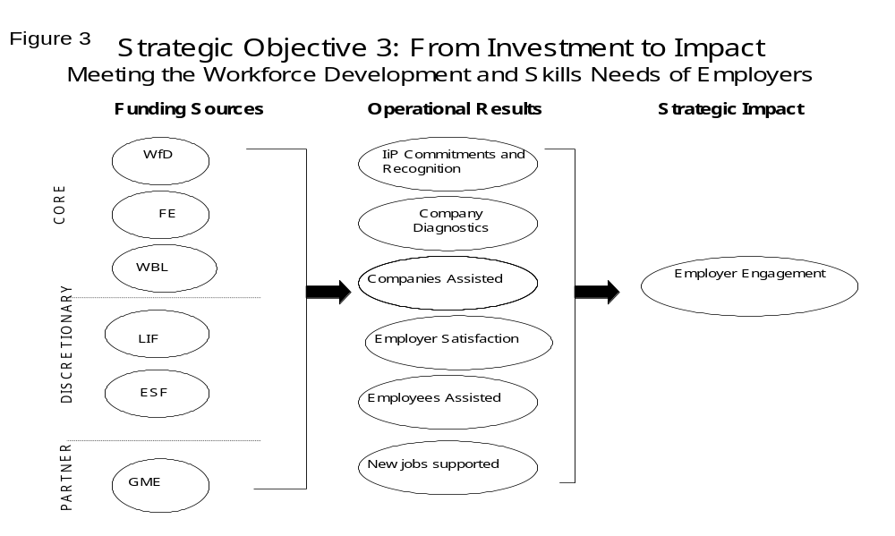

STRATEGIC OBJECTIVE 4: IMPROVING THE QUALITY, RELEVANCE AND COHERENCE OF LEARNING PROVISION

A description of Greater Merseyside’s learning infrastructure is set out in the section on the learning infrastructure earlier. The key challenges in developing a high quality, relevant learning infrastructure are:

- To improve collaboration between providers in the planning and delivery of learning. In assessing the quality of provision in Knowsley and Liverpool during Area Inspection, OfSTED Inspectors identified the need for better collaboration across providers and within sectors.
- To enable voluntary and community sector providers to meet the LSC’s resource and quality requirements. Given the levels of deprivation in Greater Merseyside and the success of this type of provider in accessing the hard-to-reach, we need to develop and maintain the capacity of the voluntary and community sectors to meet the needs of learners.
- To develop management information systems and data that enable GMLSC, its partners and providers to better assess, manage and plan provision.
- To improve the quality of our providers, as evidenced by inspection, achievement and learner satisfaction data.
- To ensure that learners have access to a wide range of provision, in terms of type, level and subject of learning, irrespective of where they live.
- To effectively manage the use of regeneration funding to add value to mainstream funding of learning activities.
- To capture learner feedback to ensure that account is taken of their views in the planning of provision.

To deliver the high quality provision envisaged in our ambition statement, we will need to develop and implement a detailed quality improvement strategy. This will be done within the framework of the national quality improvement strategy and place the experience of learners at its heart. By doing so, we believe we will develop a network of providers to support the increase in participation and achievement we require in Greater Merseyside. Within this strategic plan, we set out the framework for our quality improvement strategy, based on the analysis above. This analysis suggests that we can break down the strategic objective of ‘Improving the Quality, Relevance and Coherence of Learning Provision’ into two Operational Objectives:

- Raise provider quality and standards; and
- Develop a coherent and responsive learning infrastructure

Many of the activities detailed here will form part of a broad supplier development programme that will be designed by the GMLSC, working with local providers and national agencies.

Operational Objective 4.1: To raise provider quality and standards

This operational objective focuses on improving quality of learning delivered by individual providers. The analysis above suggests three areas in which we need to respond:

- Better teaching and learning;
- More effective and efficient systems; and
- A learner-centred focus
Teaching and Learning

At the heart of a learner’s experience is the quality of the teaching and training they receive. We will encourage and support teachers and trainers to take-up professional teaching and training qualifications and require all providers to demonstrate their commitment to investing in their people.

We will encourage the concept of provider excellence in subject areas relevant to the needs of the Greater Merseyside economy. In particular, we will actively support our Further Education Colleges in developing their plans for becoming Centres of Vocational Excellence (CoVEs), and work with those that are successful within the lifespan of this plan to enhance the quality, flexibility and responsiveness of their specialist provision.

Centres of Vocational Excellence
In July 2001, the Government set out its prospectus for Centres of Vocational Excellence (CoVEs). CoVEs are intended to develop new, and enhance existing, excellent vocational provision that will be focussed on meeting the skills needs of employers, locally, regionally, nationally and sectorally. The Government wants half of all general FE colleges to have at least one CoVE by 2003/4.
CoVEs will be characterised by close links between colleges, other providers, business partners, other employment interests and communities. They aim to produce appropriately qualified and skilled workers with excellent employment and career prospects which meet the needs of the economy. To do this they will work closely with business and industry to develop:
- a shared understanding of skill needs;
- learning opportunities that meet employer and learner needs interns of delivery method and content; and
- excellent quality provision and teaching staff with up to date knowledge and skills
The first round of initial proposals for CoVE status closed in December 2001. Within Greater Merseyside, initial proposals have been put forward in the vocational areas of media and journalism, health and care, business and information technology and vocational business and management training. Final decisions of on the first CoVEs in Greater Merseyside will be made in March 2002, with proposals then dealt with on a quarterly basis. Once CoVE proposals have been formally approved, colleges join the CoVE programme and receive support to develop their specialist area with the aim of obtaining formal recognition within 12 months

Effective and Efficient Systems
We will support the Inspectorates in the inspection process through the provision of information, advice and data analysis and will develop and foster links with OfSTED and ALI inspectors assigned to work with GMLSC. We will support providers in producing post-inspection action plans and utilise Standards Funding where appropriate to support their implementation.
We will support continuous quality improvements by supporting providers in undertaking a rigorous annual self-assessment against the Common Inspection Framework and preparing and submitting their self-assessment report and development plan. In particular we will provide support for raising standards in adult and community learning where previous inspection arrangements have been weak
The regular review of provider performance is a key element in our quality improvement strategy. As a result of the Provider Performance Review, we will make decisions on interventions, rewards and sanctions. Where concerns arise, we will agree an action plan with the provider and provide support during implementation.
We will, working with the national office, seek to improve the collection, analysis and use of data by both the LSC and providers to promote better planning and delivery. A key issue to be addressed in the short to medium term is the use of value added as a tool for measuring individual and provider achievement, particularly for informal learning, and we will work with the national office to build on good practice being developed locally.
We want to ensure that our providers are not subjected to unnecessary bureaucracy, particularly where they are also contracting with ES. We will work with ES to develop a joined up approach to inspection and quality development.
We will place health and safety at the forefront of all contractual and partnership arrangements and use best endeavour to ensure that learners in Greater Merseyside can learn within a safe working environment. Whilst responsibility for health and safety rests with providers, GMLSC will act as a support mechanism and catalyst for continuous improvement through the sharing of good practice and dissemination of information.

Learner focus

We will work with providers to remove inequalities in learning programmes – in relation to e.g. access, learning materials, outcomes - in terms of race, gender, disability, age, marital status, religion, sexual orientation or that experienced by those suffering social exclusion. As part of our capacity development programme, we will address the need for continuing professional development (CPD), systems development and other aspects of learning.
We will work with GM Connexions, Learning Partnerships and providers to ensure that learners influence the development of provision. GM Connexions have recently set up a ‘Youth Consultative Forum’ which will have a direct impact on the way in which Connexions operates and delivers its services to young people. We will develop arrangements with GM Connexions to enable feedback from young people developed in this way to influence the provision we fund. Learning Partnerships have already carried out work to access adult learner views on local learning provision, and we will work with them to develop approaches that will enable adults to influence their provision. Additionally, providers should themselves be gathering regular and comprehensive learner feedback, and we will seek to improve the coherence of their approaches.

Operational Objective 4.2: To develop a coherent and responsive learning infrastructure

This objective focuses on the quality of the learning infrastructure as a whole, in terms of the appropriateness, relevance and accessibility of the education and training on offer. The analysis above suggests that there are three areas for action:

- Needs led planning
- Joining up funding
- Developing capacity and sharing good practice

Needs led planning

We are currently undertaking a Strategic Review of Education and Training provision across Greater Merseyside, which will provide us with a detailed picture of our current provision for adults and young people and a clear view of current and future demand. We will use the outcomes to inform the development of our learning infrastructure through the development and implementation of an asset management plan.

We will also use this review to support us in expanding provision that meets the needs of individuals, communities and employers – whether that is delivered by school sixth forms, FE colleges or work based learning providers – and rationalise that which does not. This will be taken forward though our business planning and funding allocation processes.

We will make use of available resources to deliver innovative projects to enhance the range of learning provision and encourage new types of provision to meet identified needs. We intend where appropriate to develop relationships with new providers who can offer high quality learning that meets identified need and complements our existing provision. Such providers will be supported to develop any necessary systems for them to access LSC funding. Where appropriate, we will work together with ES to bring in new provision.

We need to work with our local partners, in particular Merseytravel and our Local Authorities, to ensure that the transport infrastructure facilitates access to learning opportunities.

Post-16 Area Inspections are an important tool in developing a learning infrastructure that responds to the needs of learners. We will continue to work with partners take forward the area inspection action plans in Knowsley and Liverpool. We expect the other four districts of Greater Merseyside to be inspected during 2002 and will work with the Inspectorates in this process. We will lead partners in developing area inspection action plans and funding bids, working closely with the Learning Partnerships. As one of the earliest LSCs to complete area inspection action plans, we will also work with the national office to develop good practice in action planning.

Joined up funding

The government has initiated a number of partnership led initiatives to drive up standards and increase participation and achievement, such as Excellence Challenge and Excellence in Cities. GMLSC will seek to participate fully in any such partnerships to ensure effective alignment of post-16 funds with partners to support such initiatives.

There is significant additional resource available for learning in Greater Merseyside, thanks to the European Objective 1 and 3 programmes and we will seek to bring coherence to the deployment of European funding. Co-financing for ESF will be key to ensuring this coherence whilst promoting flexibility and minimising bureaucracy for providers. The alignment of our strategy to Objective 1 ESF is set out in Annex 7.

We will play an active role on local partnerships e.g. Local Strategic Partnerships, Pathways, Strategic Investment Areas to ensure that any additional funding to be spent on learning adds value to existing LSC budgets.

Developing capacity and sharing good practice

Provider collaboration – working together to improve learning
A key issue identified during the area inspection of Liverpool was the lack of collaboration between work based learning providers, which has hindered them in improving the quality of work based learning programmes available to young people in Liverpool. During the action planning in response to the area inspection report, Liverpool’s work based learning providers came together to decide how best they could together tackle some of the weaknesses identified within the programme and share best practice that already existed.
Following agreement by DfES of the Liverpool Post Area Inspection Action Plan, the Liverpool work based learning providers set up collaborative working groups to take forward the 4 key issues of initial assessment, retention, working with employers and learner review. These groups are making real progress in developing shared approaches to various aspects of the programme. As a result of the work of the initial assessment-working group, for example, providers have developed and agreed an initial assessment model that providers will follow when conducting this most important aspect of learning. All the working groups are now finalising their proposals and in early 2002 the task groups will report back and make recommendations to the Liverpool provider group and GMLSC. The Liverpool providers are now starting to work with providers from other areas through a rejuvenated Greater Merseyside Training Federation to share the good practice developed by the working groups.
The Merseyside Training Federation has a critical role to play in supporting providers in collaborative quality improvement activities, and from 2002 GMLSC will provide resources to support the Federation in co-ordinating provider activities.
We are keen to promote provider collaboration as a key tool for quality improvement. Significant strides have been made in improving collaboration between work based learning providers in Knowsley and Liverpool as a result of the area inspections and we will actively support the development of further collaborative arrangements across the Greater Merseyside area, utilising the Greater Merseyside Training Federation. We will continue to utilise learning partnerships as the most appropriate vehicles to promote self managed provider collaboration and quality improvement work.

We will encourage and support our providers to improve their capacity to deliver our objectives and respond flexibly to emerging skill needs and policy developments.

We will, as part of our supplier capacity development programme provide a range of quality support initiatives, which identify and promote good practice and stimulate the sharing of information and resources across post 16 sectors.

We recognise the importance of the community and voluntary sector in providing provision for those hardest to engage, and also the difficulties this group of providers face in developing and maintaining the systems and resources required by the LSC. We will seek to identify appropriate ways of building this capacity within the community and voluntary sector to enable them to bid for and deliver LSC funded programmes to appropriate quality standards.

Improving the Quality, Relevance and Coherence of Learning Provision

The strategic and operational targets for Strategic Objective 4 are set out below, and will inform our business planning and contracting as we move through the planning cycle.

Table 12: Strategic Plan Targets 2002 - 2004: Strategic Objective 4
STRATEGIC
 | Indicator(s) | Baseline | Targets
SO4  Improving the Quality, Relevance and Coherence of Learning Provision | Reduction in curriculum and generic areas receiving a ‘poor’ grade | Baseline tba
 | Indicator tba
OPERATIONAL
 | Indicator(s) | Baseline | Targets
Operational Objective 4.1  Raise provider quality and standards | Learner satisfaction rate | N/a
 | Employer satisfaction rate | N/a
Operational Objective 4.2  Develop a coherent and responsive learning infrastructure | £m co-financed pa | £0
 | Providers supported to develop capacity | N/a

Figure 4 illustrates how funding mechanisms link our strategic and operational objectives. Set out are the funding streams available to support the development of the learning infrastructure, both core and discretionary. These funding streams are brought together to enable us to deliver the operational targets outlined above, and hence achieve the strategic impact targets.

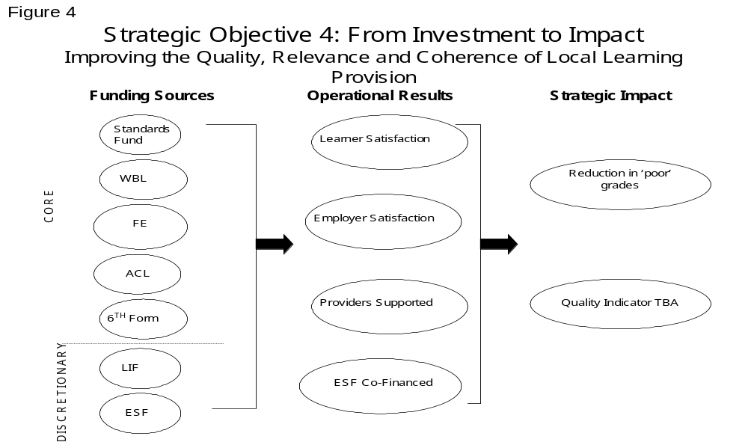

GMLSC - ORGANISATION

The LSC is a national organisation which combines the advantages of national programmes and resourcing with local flexibility and initiative. Each of the 47 local delivery arms of the LSC has a Council made up of non-executive representatives of the LSC’s major partners in the planning and delivery of post-16 learning. The local Council is responsible for ensuring that funding is deployed locally to meet the needs of local individuals, employers and communities. Membership of GMLSC’s Council is set out in Annex 3.

To support the Council in its leadership and steering role, there are three advisory committees. These committees provide advice on learning for young people, learning for adults, including workforce development, and equal opportunities and social inclusion. In addition, there is an audit committee.

The local office for Greater Merseyside, based in Liverpool, is headed by Paul Holme, Executive Director. The organisation is structured into six areas. The diagram below describes this structure and includes a summary of the key responsibilities of each directorate.

Figure 5 – Organisation Structure

GMLSC Council - Chairman: Jim Michie
Executive Director: Paul Holme
Corporate  & Finance  Director:  Rob Burn |  |  | Strategy &  Europe  Director:  David Brennan |  |  | Development  Director:  Richard Merritt |  |  | Service  Delivery  Director:  Elaine Bowker |  |  | Organisational Development  Head:  Susan Wood |  |  | Special Projects  Head:  Jim Mulvaney
Functions:  Financial  Assurance  Facilities  Management  Finance and  Resources  IT Services |  |  | Functions:  Strategic Planning  Business planning  Skills analysis  Research  Information provision  Evaluation  European Funding  Area Inspections |  |  | Functions:  Equal Opportunities  Basic Skills  Marketing and Publicity  Local Initiative Fund  Education Business Links  Adult & Community Learning  Adult information, Advice & Guidance  Local Partnerships |  |  | Functions:  Work Based Learning  FE Colleges  FE Institutions  Sixth Form Colleges  Workforce Development |  |  | Functions:  Secretariat  Human Resources  Quality and Standards  Training & Development |  |  | Functions:  Special Projects-  Internal and External

CONSULTATION ARRANGEMENTS

Our Approach

Early in the development of this Strategy, the Council decided that this Strategy should provide a framework for all planners and deliverers of learning and skills in Greater Merseyside, not just a strategy for GMLSC. Given this, it became even more important that we take an approach to consultation that was as open and wide-ranging as possible. In addition, it was important that we secured the buy in of our key strategic partners to this approach. These regional and sub-regional organisations - TMP, the Objective One Partnership, GM Connexions, GME, the NWDA and ES – have been consulted regularly as we have developed our emerging strategy, with a view to them providing a formal sign up to the completed strategy.

Process

The consultation on the strategy has taken place in two phases: an informal consultation on our challenges and priorities during autumn 2001, and a formal consultation on the strategy early in 2002. Below we set out the process for each phase.

Phase 1: Informal Consultation

Over 600 organisations, agencies, partnerships, stakeholders etc. were identified and written to enclosing copies of the consultation document, and inviting feedback and comment. A full list of those with whom we have consulted is detailed in annex 4.

Two provider workshops, attended by more than 80 provider representatives, were held during the last two weeks of November to enable more detailed discussion of some of the key issues to be addressed within the strategy, namely: retention and achievement, employer engagement, quality, and participation.

In addition, a series of ‘Inquiry Panels’ were held that adopted a parliamentary inquiry method of operation and that allowed partners and others to present their views through a series of researched presentations. Each panel consisted of a series of 15minute presentations of evidence followed by 15-30 minutes of questioning by the panel to clarify points being made. Panel members included members of GMLSC’s Council, Senior GMLSC staff and representatives from a number of our strategic partners. Four separately themed panels were held in Southport, Liverpool, Widnes and Wirral on the themes of quality, participation achievement of adults, the engagement of employers in workforce development, and participation and achievement of young people.

In parallel to this consultation on the Strategic Plan, we held a number of workshops with the voluntary and community sector and other agencies involved in the issues of gender and age, disability, ethnicity, and social inclusion. The feedback from these workshops has been used to inform both the development of our Equal Opportunities and Social Inclusion Action Plan. Attendance at these workshops was dominated by the voluntary and community sector, and other agencies with interest in these themes.

We have also sought to get feedback from employers. Members of the Executive visited some of our largest employers to obtain their views on skills and learning. In addition, we have utilised existing employer links through Liverpool Chamber and GME to encourage employers to contribute to the development of the plan.

Phase 2: Formal Consultation

During this phase of the consultation, partners and stakeholders are asked to contribute with written feedback, prior to finalisation of the Strategy.

Additionally, there are workshops each district, organised with the support of local Learning Partnerships, to get local endorsement of key changes in the strategy and a local perspective on the key priorities.

Outcomes

The feedback from the consultation has been invaluable in shaping this strategy, and we are grateful to our partners for the considerable time and effort that they have put into responding to the consultation. A report detailing all elements of the feedback that we have received is available on request and will also be posted on the national website: www.lsc.gov.uk.

OUTLINE EVALUATION ARRANGEMENTS

GMLSC and its partners are firmly committed to evidence-based planning. Central to this is the development of a robust and coherent evaluation framework. Underpinning the framework is the quantification of the anticipated results and impacts of the Strategy. This approach ensures that there is a clear and transparent linkage between all levels of planning from the strategic to individual provider contracts. This relationship can be visualised from the top down or from the bottom up:-

from the top down:

- all provision is planned in a specific context relative to our ambition for Greater Merseyside.
- This underpins the strategy and gives rise to four strategic objectives. The strategic objectives are directly quantified by our over-arching targets (impacts)
- Each specific strategic objective is, in turn, implemented through Operational Objectives. Each Operational Objective can be measured by the results it generates.

from the bottom up:

- Operational Objectives are implemented through contracts, funding agreements or partnership working using various (financial, human, technical or organisational) means or resources (inputs).
- expenditure and associated contracts give rise to a series of physical outputs (for example number of training places provided, advice and guidance sessions etc.).
- Results are the (medium-term) effects of the activity supported (e.g. number of qualifications, institutional retention rates etc.).
- These results directly contribute to achieving our over-arching targets (impacts).

Figure 6 below illustrates this.

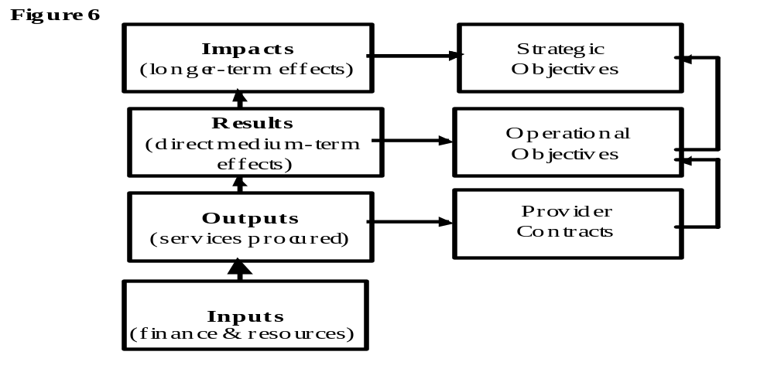

Our approach to evaluation addresses relevance, efficiency, effectiveness and utility:-

Evaluation issues
- Relevance: To what extent are the strategy’s objectives relevant in relation to the evolving needs and priorities of Greater Merseyside?
- Efficiency: How were the resources (inputs) turned into outputs or results?
- Effectiveness: How far has the strategy contributed to achieving its objectives (impacts)?
- Utility: Did the strategy have an impact on the target groups or populations in relation to their needs?

The evaluation of the Strategic Plan for Learning and Skills in Greater Merseyside will be in three phases, namely, prior, formative, and summative.

The prior evaluation of this Strategy involves testing:

- The relevance of the agreed output, result, and impact indicators; and
- The linkage and consistency between the strategic plan, business plan and contracting process.

In practice, there will be three phases to the prior evaluation of the Strategy :-

- Phase 1 – Testing the relevance and appropriateness of the indicators and targets through a wide-ranging process of consultation with key stakeholders in Greater Merseyside. This document forms the basis of that consultation;
- Phase 2 – Establishing consistency between GMLSC’s Business Plan and the Strategic Plan; and
- Phase 3 – Establishing consistency between contracting activity and the Business Plan

The formative evaluation of the Strategy will examine the degree of effectiveness achieved on the basis of the indicators collected. It will also assess the quality and relevance of these indicators. Formative evaluation, as its name suggests, is used to inform improvements in programmes and suppliers. The detailed content and approach to be adopted will be developed and agreed by the Greater Merseyside Labour Market and Skills Research and Evaluation Forum. Membership of the Forum can be found on the national LSC website (www.lsc.gov.uk).

Finally, the summative evaluation will compare the expected impacts of the strategy with those actually achieved. The approach adopted will be developed and agreed by the Greater Merseyside Labour Market and Skills Research and Evaluation Forum.

Annex 1

LEVEL | GENERAL QUALIFICATIONS | VOCATIONALLY RELATED QUALIFICATIONS | OCCUPATIONAL QUALIFICATIONS
Level 4 | Higher-level qualifications |  | NVQ Level 5
Level 3 | AS/A Levels  AEAs | Vocational A level  (Advanced GNVQ) | NVQ Level 3
Level 2 | GCSE  Grades A*-C | Intermediate GNVQ | NVQ Level 2
Level 1 | GCSE  Grades D-G | Foundation GNVQ | NVQ Level 1
Entry Level | Certificate of achievement
National Qualifications Framework
Annex 2
Planning Framework and Associated Operational Targets

Operational Objectives | Indicator(s) | Baseline | Targets
Strategic Objective 1: Increasing the Participation and Achievement of Young People
Operational Objective 1.1  Bring back into learning those young people who are currently disengaged | Participation in learning at 16 | 16,270
 | Participation in learning at 17 | 14,391
 | Numbers in structured learning | 36,700
Operational Objective 1.2  Improve the retention, progression and achievement of young people | FE Retention Rate | 83.3%
 | 6th Form Retention rate | Baseline tba
 | WBL Retention rate | Baseline tba
 | Numbers achieving level 1 | Baseline tba
 | Numbers achieving level 2 | Baseline tba
 | Numbers achieving level 3 | Baseline tba
Strategic Objective 2: Increasing the Participation and Achievement of Adults
Operational Objective 2.1  Drive up the demand for learning amongst adults | Numbers in LSC supported provision | 89,023
 | Information and advice sessions | 12,689
Operational Objective 2.2  Enable adults to progress through learning and increase achievement | FE retention rate (adults) | 82.8%
 | WBL 19+ retention rate | Baseline tba
 | Level 2 achievement (adult numbers) in LSC-supported provision | Baseline tba
 | Level 3 achievement (adult numbers) in LSC-supported provision | Baseline tba
 | Basic Skills Volumes | N/a
Strategic Objective 3: Meeting the Workforce Development and Skills Needs of Employers
Operational Objective 3.1  Stimulate the workforce development activity of employers | IiP Commitments | Baseline tba
 | Companies undergoing diagnostics | N/a
Operational Objective 3.2  Ensure that learning provision meets employer needs | IiP Recognitions | Baseline tba
 | Companies Assisted | N/a
 | Basic Skills Volumes | N/a
 | Employer satisfaction rate | N/a
Operational Objective 3.3  Stimulate employment growth | Companies Assisted | N/a
Operational Objective 3.3  Stimulate employment growth | Employees Assisted | N/a
Operational Objective 3.3  Stimulate employment growth | Gross no. of new jobs linked to support | N/a
Strategic Objective 4: Increase the quality, relevance and coherence of provision
Operational Objective 3.4  Raise provider quality and standards | Learner satisfaction rate | Measure tba
 | Employer satisfaction rate | Measure tba
Operational Objective 3.5  Develop a coherent and responsive learning infrastructure | £m co-financed pa | £0
 | Providers supported to develop capacity (volumes) | N/a
Annex 3

Greater Merseyside LSC Council Members

Jim Michie - Chairman  Non Executive Director:  Passport and Records Agency  Manchester 2002 Ltd  Cheshire Building Society | Paul Holme,  Executive Director  Greater Merseyside Learning and Skills Council | David Atkin  Headteacher  Rainhill High School
Gordon Burns  Personnel Director  Stoves Plc | Dr Martin Carey  Executive Dean  Liverpool Hope  University College | Sue Carmichael  Principal  Constructive Futures
Claire Dove  Chief Executive  Women’s Technology & Education Centre and Blackburne House | Mike Doyle  Deputy Chair  North West Development Agency | John Firr  Chief Executive  Partnership for Learning
Veronica Laird  Managing Director  Newbreed Freight Ltd | Richard Marbrow  Councillor  Liverpool City Council | Geoffrey Piper  Chief Executive  North West Business  Leadership Team
Kath Boullen  Chief Executive  St Helens Chamber of  Commerce and Industry | Brian Davies  Regional Union officer  AEEU | Heather Hardcastle  Human Resources and Training Contract Manager  Local Solutions
Sir George Sweeney
Principal
Knowsley Community College
Annex 4

CONSULTED ORGANISATIONS

ACME
Age Concern
Arch-diocese of Liverpool
Arden College
Barnardos
Birkenhead 6th Form college
Business Dynamics
Carmel 6th Form College
CDS Housing
Churches Action for Racial Equality
Commission for Racial Equality
Construction Industry Training Board
Diocese of Chester
Diocese of Liverpool
Disability Rights Commission
Dyslexia Association Wirral
Edge Hill College
Employers
Employment Opportunities for People with Disabilities
Employment Service
Equal Opportunities Commission
Equality North West
Expanding Horizons
Early Years Childcare and Development Partnerships
Fairbridge in Merseyside
Forum Housing
Greater Merseyside Connexions
Greater Merseyside Enterprise
Greater Merseyside IAG Partnership
Greenbank Project
Halton Association of Secondary Headteachers
Halton Borough Council
Halton Business Forum
Halton College
Halton LEA
Halton Learning Partnership
Halton Voluntary Action
Higher Education Institutions
HM Prisons
Hugh Baird College
King George V 6th Form College
Knowsley Association of Secondary Headteachers
Knowsley Chamber of Industry and Commerce
Knowsley Community College
Knowsley CVS
Knowsley LEA
Knowsley Learning Partnership
Knowsley MBC
Learning and Skills Development Agency
Liverpool Archdiocesan Education Department
Liverpool Association of Secondary Headteachers
Liverpool Black Sisters
Liverpool Chamber of Commerce and Industry
Liverpool City Council
Liverpool City of Learning
Liverpool Community College
Liverpool Compact
Liverpool CVS
Liverpool Hope University College
Liverpool Housing Trust
Liverpool John Moores University
Liverpool LEA
Liverpool Learning Partnership
Liverpool Muslim Society Mosque and Cultural Centre
Liverpool Somali Association
Liverpool Women's Technology Centre
Local Strategic Partnerships
Merseyside Association of Colleges
Merseyside Bangladesh Association
Merseyside Caribbean Council
Merseyside CVS
Merseyside Disability Federation
Merseyside Employers Network on Disability
Merseyside Probation Service
Merseyside Skills Training
Merseyside Society for Deaf People
Merseytravel
MPs
National Housing Federation - Merseyside
North West Aerospace Alliance
North West Development Agency
Objective One Partnership
Other Voluntary and Community Sector organisations and agencies
Pakistan Centre
Partnership for Learning
Pathways Partnerships
PSS
Refugee Action
Riverside Housing Association
Royal National Institute for the Blind
Secondary Schools
Sefton Association of Secondary Headteachers
Sefton Chamber of Commerce and Industry
Sefton EBP
Sefton LEA
Sefton Learning Partnership
Sefton MBC
SETPOINT
Shrewsbury Diocesan Schools' Commission
Southport College
SRB Partnerships
SSDA Partnerships
St Helens Association of Secondary Headteachers
St Helens Chamber of Commerce and Industry
St Helens College
St Helens District CVS
St Helens EBP
St Helens LEA
St Helens Learning Partnership
St Helens MBC
The Big Issue
The Dark Horse Venture
The Knowsley Compact
The Mersey Partnership
The Nugent Care Society
The Pagoda Chinese Community Centre
The Probation Service
Trades Union Congress
Trident Trust
University of Liverpool
Venture Housing Association
Weston Spirit
Widnes & Runcorn 6th Form College
Wirral Action
Wirral Association for Disability
Wirral Association of Secondary Headteachers
Wirral Chamber of Commerce and Industry
Wirral CVS
Wirral Drugs Services
Wirral LEA
Wirral Learning Partnership
Wirral MBC
Wirral Metropolitan College
Wirral Society for the Blind and Partially Sighted
WITCH
Women's Technology and Education Centre
Work based learning providers
Workers Educational Association
Young Enterprise
Young Persons Advisory Service

Annex x
Glossary
ACL | Adult Community Learning
A LEVEL | Advanced Level Qualification
ALI | Adult Learning Inspectorate
AS LEVEL | Advanced Subsidiary Level Qualification
AVCE | Advanced Vocational Certificate of Education
CBI | Confederation of British Industry
CoVES | Centres of Vocational Excellence
CPD | Continuing Professional Development
DfES | Department for Education and Skills
DTI | Department of Trade and Industry
DTLR | Department for Transport, Local Government and the Regions
EBP | Education Business Partnership
ERDF | European Regional Development Fund
ES | Employment Service
ESF | European Social Fund
FE | Further Education
GCSE | General Certificate of Secondary Education
GDP | Gross Domestic Product
GM CONNEXIONS | Greater Merseyside Connexions
GME | Greater Merseyside Enterprise
GMLSC | Greater Merseyside Learning and Skills council
GNVQ | General National Vocational Qualification
GONW | Government Office for the North West
HEI | Higher Education Institutions
IAG | Individual Advice and Guidance
ICT | Information Communications Technology
IiP | Investors in People
ILAs | Individual Learning Accounts
ILO | International Labour Organisation
LEAs | Local Education Authorities
LIF | Local Inititative Fund
LSC | Learning and Skills Council
LSPs | Local Strategic Partnerships
NVQ | National Vocational Qualification
NWDA | North West Development Agency
O1 | Objective 1
OfSTED | Office for Standards in Education
PIU | Performance and Innovation Unit
SBS | Small Business Service
SMEs | Small/Medium sized Enterprises
SRB | Single Regeneration Budget
TMP | The Mersey Partnership
TUC | Trade Union Congress
UfI | University for Industry
WfD | Workforce Development

Annex 6

Bibliography

ADULT LITERACY AND NUMERACY DELIVERY PLAN - LSC’s response to DfES ‘Skills for Life, Learning and Skills Council (2001)

AN ACTION PLAN FOR THE CITY REGION 2002 – 2005, The Mersey Partnership (2001)

A NEW COMMITMENT TO NEIGHBOURHOOD RENEWAL: National Action Plan, Social Inclusion Unit (2001)

A SKILLS ASSESSMENT OF GREATER MERSEYSIDE (draft), Greater Merseyside Learning and Skills Council (2002)

CONNEXIONS BUSINESS PLAN 2002 – 2005 (draft), Greater Merseyside Connexions (2001)

INDEX OF DEPRIVATION, Department of Transport, Local Government and the Regions (2001)

KNOWSLEY AREA WIDE INSPECTION, Office for Standards in Education (2001)

LIVERPOOL AREA WIDE INSPECTION, Office for Standards in Education (2001)

LSC GRANT LETTER 2002 – 03, Department for Education and Skills (December 2001)

MAINSTREAMING EQUAL OPPORTUNITIES, Department for Education and Skills (2001)

OBJECTIVE 1 CORPORATE PLAN, Government Office for the North West (2001)

MEETING SECTOR NEEDS: SOME EMERGING LSC APPROACHES - An LSC corporate plan discussion paper, Learning and Skills Council (June 2001)

RAISING STANDARDS: THE LSC’s QUALITY IMPROVEMENT STRATEGY - An Occasional LSC discussion paper Learning and Skills Council (Aug 2001)

SKILLS FOR LIFE – National strategy for improving adult literacy and numeracy, Department for Education and Skills (2001)

STRATEGIC FRAMEWORK TO 2004, CORPORATE PLAN, Learning and Skills Council (2001)

THE LEARNING AND SKILLS ACT 2000, H.M.S.O. (2000)

THE RIGHT ANGLE ON SKILLS, North West Development Agency (2000)

WORKFORCE DEVELOPMENT POLICY, Cabinet Office Performance and Innovation Unit (Summer 2002)

Annex 7
Mapping of Objective 1 ESF against the Strategic Plan for Learning and Skills in Greater Merseyside

Operational Objectives/ ESF Measures | Measure 4 Training for SMEs | Measure 12 Training for specific sectors | Measure 13 Action for employment | Measure 14 Promoting social inclusion for access to labour market | Measure 15 Lifelong learning | Measure 17 Positive action for women | Measure 25 Action for employment in Pathways Areas | Measure 26 Promoting social inclusion in Pathways Areas | Measure 27 Lifelong learning in Pathways Areas
Strategic Objective 1: Participation and Achievement of Young People
Operational Objective 1  Bring back into learning disengaged Young People |  |  | ✔ | ✔ | ✔ | ✔ | ✔ | ✔ | ✔
Operational Objective 2  Promote the achievement of Young People |  |  |  |  | ✔ |  |  |  | ✔
Strategic Objective 2: Participation and Achievement of Adults
Operational Objective 3  Stimulate demand for learning | ✔ | ✔ |  | ✔ | ✔ | ✔ |  | ✔ | ✔
Operational Objective 4  Support the achievement of adults | ✔ | ✔ |  | ✔ | ✔ | ✔ |  | ✔ | ✔
Strategic Objective 3: Meeting Skills Needs
Operational Objective 5  Stimulate the workforce development activity of employers | ✔ | ✔
Operational Objective 6  Ensure provision meets employer requirements | ✔ | ✔
Operational Objective 7  Stimulate employment growth | ✔ | ✔
Strategic Objective 4: Increase the quality, relevance and coherence of provision
Operational Objective 8  Raise providers quality | ✔ | ✔ |  | ✔ | ✔ | ✔ |  | ✔ | ✔
Operational Objective 9  Develop a coherent and responsive learning infrastructure | ✔ | ✔ |  | ✔ | ✔ |  |  | ✔ | ✔

See Annex 1 for explanation of qualification levels
Includes 14 19 year olds
Indicative targets. Targets will be finalised by the Council in February.
The basic skills target will be achieved through 3 of the strategic objectives and is therefore repeated in each
Baseline includes FE 16-18 and WBL 16-18
Population 16+
Economically active population only
Based on FE 19+ and WBL 19+ data
Achievement of these targets is predicated on the ability of GMLSC to access the resources required to fund the levels of additional participation and achievement indicated and having the capacity within the learning infrastructure to deliver. Actions to develop such capacity are set out under Strategic Objective 4.
Operational targets to be agreed
This comprises Greater Merseyside residents in FE, Greater Merseyside residents with GMLSC contracted WBL providers and all 16-18 year olds in Greater Merseyside schools.
This comprises Greater Merseyside residents in FE, and with GMLSC contracted WBL providers
Contracted delivery for 2001/02

