
Evaluation of the Skills Account Trials

Skills Account Holder Telephone Survey

Telephone Surveys Conducted in June and September 2009

December 2009

Of interest to everyone involved in Skills Accounts in England

Further information
For further information please contact the appropriate Learning and Skills Council office. Contact details for each office can be found on the LSC website: www.lsc.gov.uk
Learning and Skills Council
National Office
Cheylesmore House
Quinton Road
Coventry CV1 2WT
T 0845 019 4170
F 024 7682 3675
www.lsc.gov.uk

RCU is a specialist educational market research company working with clients all over the UK. Its mission is to develop practical and relevant research and consultancy solutions for clients through innovation, professionalism and market expertise.

RCU provides customised market research, consultancy, publications and seminars for a wide range of public and private sector clients and has been serving the learning and skills sector since 1987.

To find out more about the work of RCU,
telephone 01772 885999,
e-mail enquiries@rcu.co.uk or visit www.rcu.co.uk.

The responsibility for the contents of the report rests with the authors

CONTENTS
Executive Summary 1
Background and objectives 1
Findings from the June Telephone Survey 2
Findings from the September Telephone Survey 4
Overall Conclusions 6
Recommendations 8
1. Introduction 10
2. The Skills Account Database 12
2.1 Introduction 12
2.2 Skills Account Holder Characteristics 13
3. Findings from the June Telephone Survey 23
3.1 Introduction and Methodology 23
3.2 Characteristics of Respondents 24
3.3 Skills Account Awareness and Initial Information 31
3.4 Advantages of Skills Accounts 36
3.5 Activating and Accessing the Skills Account Website 39
3.6 Course Finder Tool 43
3.7 Skills and Interest Tool 44
3.8 Jobs Profile Tool 45
3.9 Qualifications Calculator 47
3.10 Skills Vouchers 48
3.11 Overall Views on Skills Accounts 50
3.12 Multivariate analysis 58
4. Findings from the September Telephone Survey 64
4.1 Introduction and Methodology 64
4.2 Characteristics of Respondents 65
4.3 Skills Account Awareness and Initial Information 73
4.4 Advantages of Skills Accounts 78
4.5 Activating and Accessing the Skills Account Website 81
4.6 Course Finder Tool 86
4.7 Skills and Interest Tool 88
4.8 Jobs Profile Tool 89
4.9 Qualification Calculator 91
4.10 Skills Vouchers 92
4.11 Learning Record 94
4.12 Funding Indicator 96
4.13 Overall Views on Skills Accounts 97
4.14 Multivariate analysis 107
5. Conclusions 112

Executive Summary

Background and objectives
- A Skills Account is a personal resource provided by the Government to help individuals to access training. A Skills Account aims to help individuals take control of their learning and working life.
- This report presents the findings from the first two telephone surveys of Skills Account holders, conducted in June and September 2009. Each survey involved interviews with 450 individuals, predominately in the initial trial regions of the South East, East Midlands and West Midlands.
- The interview questions explored a range of issues including initial information about Skills Accounts, the online activation process, usability of the website, perceptions relating to the individual features and tools and views on the overall concept of Skills Accounts.
- The contact details for the telephone survey were obtained from the Skills Account database, containing the details of all individuals that had registered for a Skills Account. The first survey in June was based on registered Skills Account holders up to 18th May (a total population of 15,211) and the second survey in September was based on Skills Account holders who registered between 18th May and 19th August 2009 (a total population of 8,335).
- In the early part of the year Skills Account registrations were most likely to have been via Strategic Learning Providers in the South East and East Midlands and the Careers Advice Service and targeted at adults enrolling on college courses starting in January and February. In the summer period, however, new Skills Account registrations were more likely to have come from the Integrated Employment and Skills (IES) trials and nextstep centres (very few college courses are taking place at this time).The current data recording systems do not allow us to specifically identify individuals who registered via nextstep or IES providers, although evidence relating to this can be inferred from survey responses.
- At the time of the interviews Skills Accounts were in the early stages of development, having been launched in December 2008. In 2009/10 and beyond the Skills Account website will undergo considerable development and the trials will be extended from the three initial regions to all nine regions in the country. In addition, Skills Accounts will be tested in a number of different contexts and with specific audiences.
- The research findings presented in this report are part of a much wider range of evaluation activities taking place between 2008/09 and 2009/10. Telephone surveys in 2009/10 will include control groups and follow up interviews with previous respondents. An increase in the sample size and improvements in management information stored within the Skills Account database will also allow more extensive analysis, such as by previous qualification level or by initial entry route. In addition to telephone surveys, the evaluation team are carrying out face-to-face interviews, focus groups and data analysis. Future reports will review the findings from all of these research sources and present detailed conclusions on the Skills Account trials.
- The first two telephone surveys, however, provide an early indication of customer reaction to the concept of Skills Accounts, establishing a baseline for future evaluation activities. It is important to recognise that changes in perception over time and by audience type will be as important as absolute numbers.

Findings from the June Telephone Survey
- The first survey took place at the beginning of June 2009 and involved a total of 450 telephone interviews. Just under half of the survey respondents were currently unemployed and available for work and 56% of respondents were currently taking a course or were planning to do so in the near future.
- Just under a quarter of survey respondents said that access to a wider range of courses was, in their view, the most important advantage of having a Skills Account (the most common response of those who named an advantage). The second most frequently cited advantage was extra funding to pay for learning, despite the fact that Skills Accounts do not in practice offer additional funding. Almost a third of respondents, however, could not name an advantage or did not feel that Skills Accounts offered any perceived benefits.
- Almost 40% of respondents had told someone else about Skills Accounts and individuals who were most satisfied with the Skills Account service were the most likely to have done this. This suggests that once the service is fully developed widespread usage could spread quite quickly via word of mouth and recommendations from existing users.
- Whilst all respondents recalled registering for a Skills Account, only 78% could recall activating the account online. Nine out of ten of these individuals said they had found it very easy or quite easy to activate. The majority of problems experienced by respondents were associated with choosing and entering passwords. Over 80% of individuals found the website itself very easy or quite easy to use but a small number thought that the usability could be improved. Most respondents said that the website tools were useful, with the Course Finder tool being the most commonly used.
- Two-thirds of those who had visited the website said they were aware of the Skills Voucher feature but only around a quarter of these had generated a voucher. Just under three-quarters thought the Skills Voucher would be fairly useful or very useful although some respondents said they had experienced problems when they had taken the voucher to a learning provider.
- Over two-thirds of respondents were either very satisfied or fairly satisfied with the overall Skills Account service and just 9% of respondents expressed dissatisfaction. Over 90% of those aged under 25 said they were fairly satisfied or very satisfied compared to less than 50% of the over 45s.

Findings from the September Telephone Survey
- The second telephone survey took place in September 2009 and a further 450 interviews were planned and achieved. The questions were identical to those asked in the first survey, apart from two additional questions on the Learner Record and Funding Indicator tools. The survey targeted individuals who had registered for a Skills Account between 18th May and 19th August 2009. Individuals who registered for a Skills Account between these dates were less likely to have accessed the service via a Strategic Learning Provider and the Careers Advice Service and more likely to have accessed the service via nextstep and the IES trials.
- Almost 40% of respondents could not state any advantage of having a Skills Account, a higher percentage than in the first survey. The percentage was highest among respondents from the West Midlands, which suggest some correlation between this response and individuals on the IES trails. Individuals in this trial are likely to have a lower level of prior attainment and so may have found it difficult to articulate advantages to a telephone interviewer.
- The most frequently cited advantage of having a Skills Account was more regular access to information and guidance about careers and learning. Extra funding to pay for learning was the next most frequently cited advantage.
- More respondents in the September survey said that they received help to activate their account than in the June survey, confirming that a higher proportion of Skills Account holders activated their account via an ESP provider and nextstep.
- More respondents from the September survey remembered activating their Skills Account (85%) than from the June survey (78%). The vast majority of those who could recall using their Skills Account said they found it very easy or quite easy to activate.
- In general the perceptions of Skills Accounts in the September survey were similar to the perceptions in the June survey, despite the differences in the samples. Virtually identical percentages of respondents, for example, found the website easy to use and similar numbers thought that Skills Accounts were a good idea.
- The percentage of respondents who were dissatisfied with the Skills Account service was slightly lower in the September survey than in the June survey. This was possibly because a higher proportion of respondents in the September survey had help in activating their account. Only 9% of respondents disagreed or strongly disagreed that having a Skills Account would encourage them to take part in learning in the future. In the first survey this figure was 15%.
- Just under half of those who had visited the website said they were aware of the Skills Voucher feature but less than a third of these had generated a voucher. The level of awareness of the Skills Voucher was lower in the September survey than in the June survey. Just under three-quarters thought the Skills Voucher would be fairly useful or very useful. However, there appeared to be confusion over what the Skills Voucher provides.

Overall Conclusions
- In general, the reaction to Skills Accounts has been extremely positive and the findings demonstrate that the service has enormous potential. In particular the surveys found that:
- The vast majority of respondents thought that Skills Accounts were a good idea. In the first survey, for example, 94% of respondents thought that Skills Accounts were a good idea and this was virtually identical in the second survey, where 93% thought that they were a good idea.
- Most respondents thought that Skills Accounts will encourage them to take part in future learning. In both surveys almost 80% of respondents agreed with this statement.
- The majority of respondents thought that Skills Accounts were easy to activate and use. Less than 6% of respondents in each survey said that Skills Accounts were quite difficult or very difficult to use.
- These findings were consistent across the two surveys and did not appear to be dependent on the initial entry route into the service (e.g. via Strategic Learning Provider, nextstep, ESP provider etc.).
- The surveys have also highlighted a number of issues that the development team, providers and stakeholders may wish to review. The key identified issues are:
- A high proportion of respondents did not return to the Skills Account website after their first visit.
- The most significant factor affecting satisfaction with the Skills Account service appears to be the age of the respondent.
- Ease of use is a key factor determining satisfaction with the service and whilst the majority of respondents did not think the website was difficult to use, there is still scope for improvement, as less than half of respondents said that it was very easy to use.
- Many respondents were unsure about the advantages of Skills Accounts and their practical benefits.
- Tools related to funding entitlement (i.e. Skills Voucher, Funding Indicator) were in general felt to be useful but there was some confusion about their use and concern about whether Skills Vouchers would be accepted by providers.
- The surveys suggest that where Skills Accounts are opened with dedicated face-face support the percentage of users who are dissatisfied with the service decreases.

Recommendations
- The Skills Account team should ensure that the development of the Skills Account website is specifically informed by the needs of all age groups. In particular, the development team should take into account the likelihood that younger people may be more familiar with the use of online tools and have greater access to IT services. This issue could be partially addressed, for example, by pre-release testing with users of different ages and consideration of the appropriate use of language, imagery, content and usability. In addition providers and service deliverers should ensure that the needs of all age groups are taken into account when providing information about Skills Accounts, including the design of promotional materials, the availability of support systems for registration/activation and the provision of on-going Skills Account advice and help.
- The Skills Account development team should investigate the development of website tools and activities that encourage frequent use of Skills Accounts. This might include, for example, discussion forums, information about study skills and updated news items. This would help users become familiar with the site and increase the likelihood that other tools are accessed.
- The Skills Account team should identify, further develop and promote the ways in which Skills Accounts provide clear and distinctive added value over and above alternative face to face and paper based information sources. For example, Skills Accounts could link course information with quality ratings, user feedback and potential earnings, providing a distinctive online service supporting clients in their decision making. The Skills Account website could also be heavily customised to the needs of individual users, allowing them to save and link the results of different course and job related searches.
- The Skills Account development team should seek to improve the clarity of the funding aspects of the website. Whilst survey respondents were in general positive about the concept of Skills Vouchers, the implementation of them was felt to be misleading and confusing. They were often not accepted by providers and gave the impression that individuals will get ‘money off’ the cost of the course when in reality vouchers just gave information to the user.
- Strategic Learning Providers should consider offering additional support to help individuals activate their Skills Accounts. Data returns suggest that a large number of individuals who are registered for Skills Accounts do not in practice activate them. Providers may wish to ensure, for example, that individual support for Skills Account creation is available at the time of enrolment or induction (in a number of Strategic Learning Providers this process is already happening and is integrated into existing processes in order to avoid additional costs).

- Introduction
- A Skills Account is a personal resource provided by the Government to help individuals to access training. The Skills Account aims to help individuals take control of their learning and working life and provides:
- Advice about sources of support to help with learning
- Course information, to help understand the options available when deciding about skills and careers
- A Skills Voucher, which shows what funding may be available for chosen courses
- This report presents the findings from the first two telephone surveys of Skills Account holders, conducted in June and September 2009. Each survey involved interviews with 450 individuals, predominately in the initial trial regions of the South East, East Midlands and West Midlands. The interview questions explored a range of issues including initial information about Skills Accounts, the online activation process, usability of the website, perceptions relating to the individual features and tools and views on the overall concept of Skills Accounts.
- The contact details for the telephone survey were obtained from the Skills Account database which contains the details of all individuals that had registered for a Skills Account. The first survey was based on registered Skills Account holders up to 18th May 2009 (a total population of 15,211) and the second survey was based on Skills Account holders who registered between 18th May and 19th August 2009 (a total population of 8,335).
- Section 2 of this report looks in detail at the Skills Account database and provides an analysis of the characteristics of Skills Account holders.

- Section 3 of the report provides a detailed analysis of the results from the June telephone survey. The section also includes multivariate analysis, in order to identify key factors which influence an individual’s satisfaction with the Skills Account service.
- Section 4 of the report provides a similar analysis of the results from the September telephone survey and highlights any variations between the two surveys.
- The final section (Section 5) presents overall conclusions from the two surveys and provides a summary of key messages for different stakeholder groups. The telephone surveys are the first in a series of interviews that are planned to take place over the next two years and will include a longitudinal study and a control group. At the time of the initial surveys the development of Skills Accounts was in its infancy, having been launched in December 2008.

- The Skills Account Database
  - Introduction
- The Skills Account database contains details of all users that have registered for a Skills Account. The registration process captures personal information such as name, gender, date of birth, address and telephone number and all users are allocated a unique Skills Account Number. There are a number of different ways in which this registration process can take place. The key entry points into the Skills Account service were through the following routes:
- Strategic Learning Providers (SLP)
There were 20 Strategic Learning Providers in the South East and East Midlands in the first year of the trials (18 general further education colleges and 2 independent learning providers). SLPs asked prospective adult learners whether they would be interested in receiving a Skills Account and if so uploaded details of these individuals to the Skills Account database on a monthly basis (the trials in the East Midlands and the South East were a universal trial targeted at all adults). Individuals were sent a welcome pack which gaves further details about Skills Accounts and explained how the account could be activated. The activation process is carried out by the individual themselves via the Skills Account homepage http://skillsaccounts.direct.gov.uk .

- Nextstep Advisors
Nextstep is a free service that offers face-to-face help and support about training, learning and the world of work. Nextstep advisors in the trial regions introduce the Skills Account service to clients during the careers interview and if clients are interested in registering, advisors activate the online account by directly accessing the Skills Account homepage.
- Careers Advice Service
The Careers Advice Service is a free national telephone helpline which provides callers with structured advice about skills, careers and learning. Careers advisors introduce Skills Accounts to all callers in the trial regions and if the caller is interested in registering for a Skills Account upload their details to the Skills Account database. These callers are then sent a welcome pack explaining how they can activate their online account.

- Integrated Employment and Skills (IES) Trials (West Midlands)
In addition to the universal trials Skills Accounts were also specifically targeted at individuals taking part in the IES trials in the West Midlands and South East. The IES trials focus on supporting people who are unemployed to progress into sustainable employment with training. Skills Accounts were offered to individuals taking part in the Employability Skills Programme (ESP) via the IES and registration took place by ESP providers, directly through the Skills Account homepage.

- Self Directed Route
In addition to the above registration processes individuals can self-register by directly accessing the Skills Account homepage themselves.
  - Skills Account Holder Characteristics
- The contact details for the telephone surveys described in this report were extracted from the Skills Account database up to 18th May and 19th August 2009 respectively. As of 19th August there were a total of 23,546 Skills Account holders. The table below shows a breakdown of Skills Account holders by region (based on home postcode of the Skills Account holder). Unsurprisingly, the majority of Skills Account holders were from the South East, East Midlands and West Midlands Regions (45.2%, 36.2% and 8.3% respectively) where the initial trials were held. The vast majority of the remainder are likely to live near the border with the East Midlands and South East and were informed about Skills Accounts via a provider or support service located in the trial region.

Skills Account Holders by Region (19th August 2009)
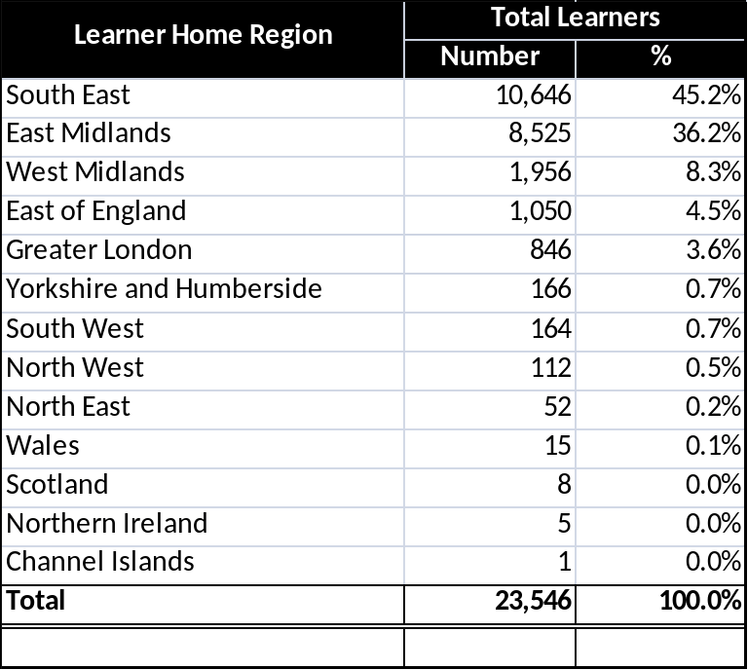
- The table below and the map on the following page show the number of Skills Account holders by local authority district. The highest concentration of Skills Account holders at this time were from Leicester (6% of all users), followed by Isle of Wight, Nottingham and Northampton.
- The wide variation in the take up of Skills Accounts by local authority district is probably due to the different ways in which providers have promoted Skills Accounts during the trials rather than to any underlying socio-economic factors.

Skills Account Holders by Local Authority District (19th August 2009)
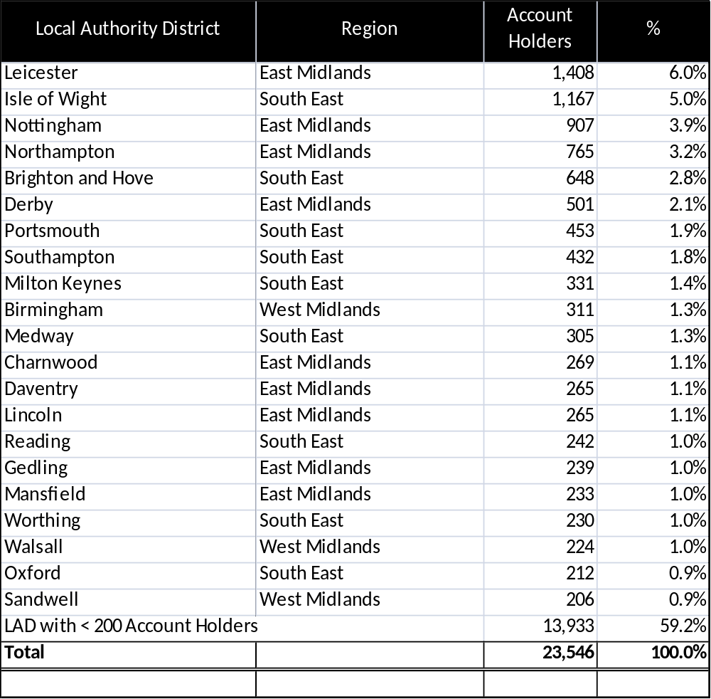

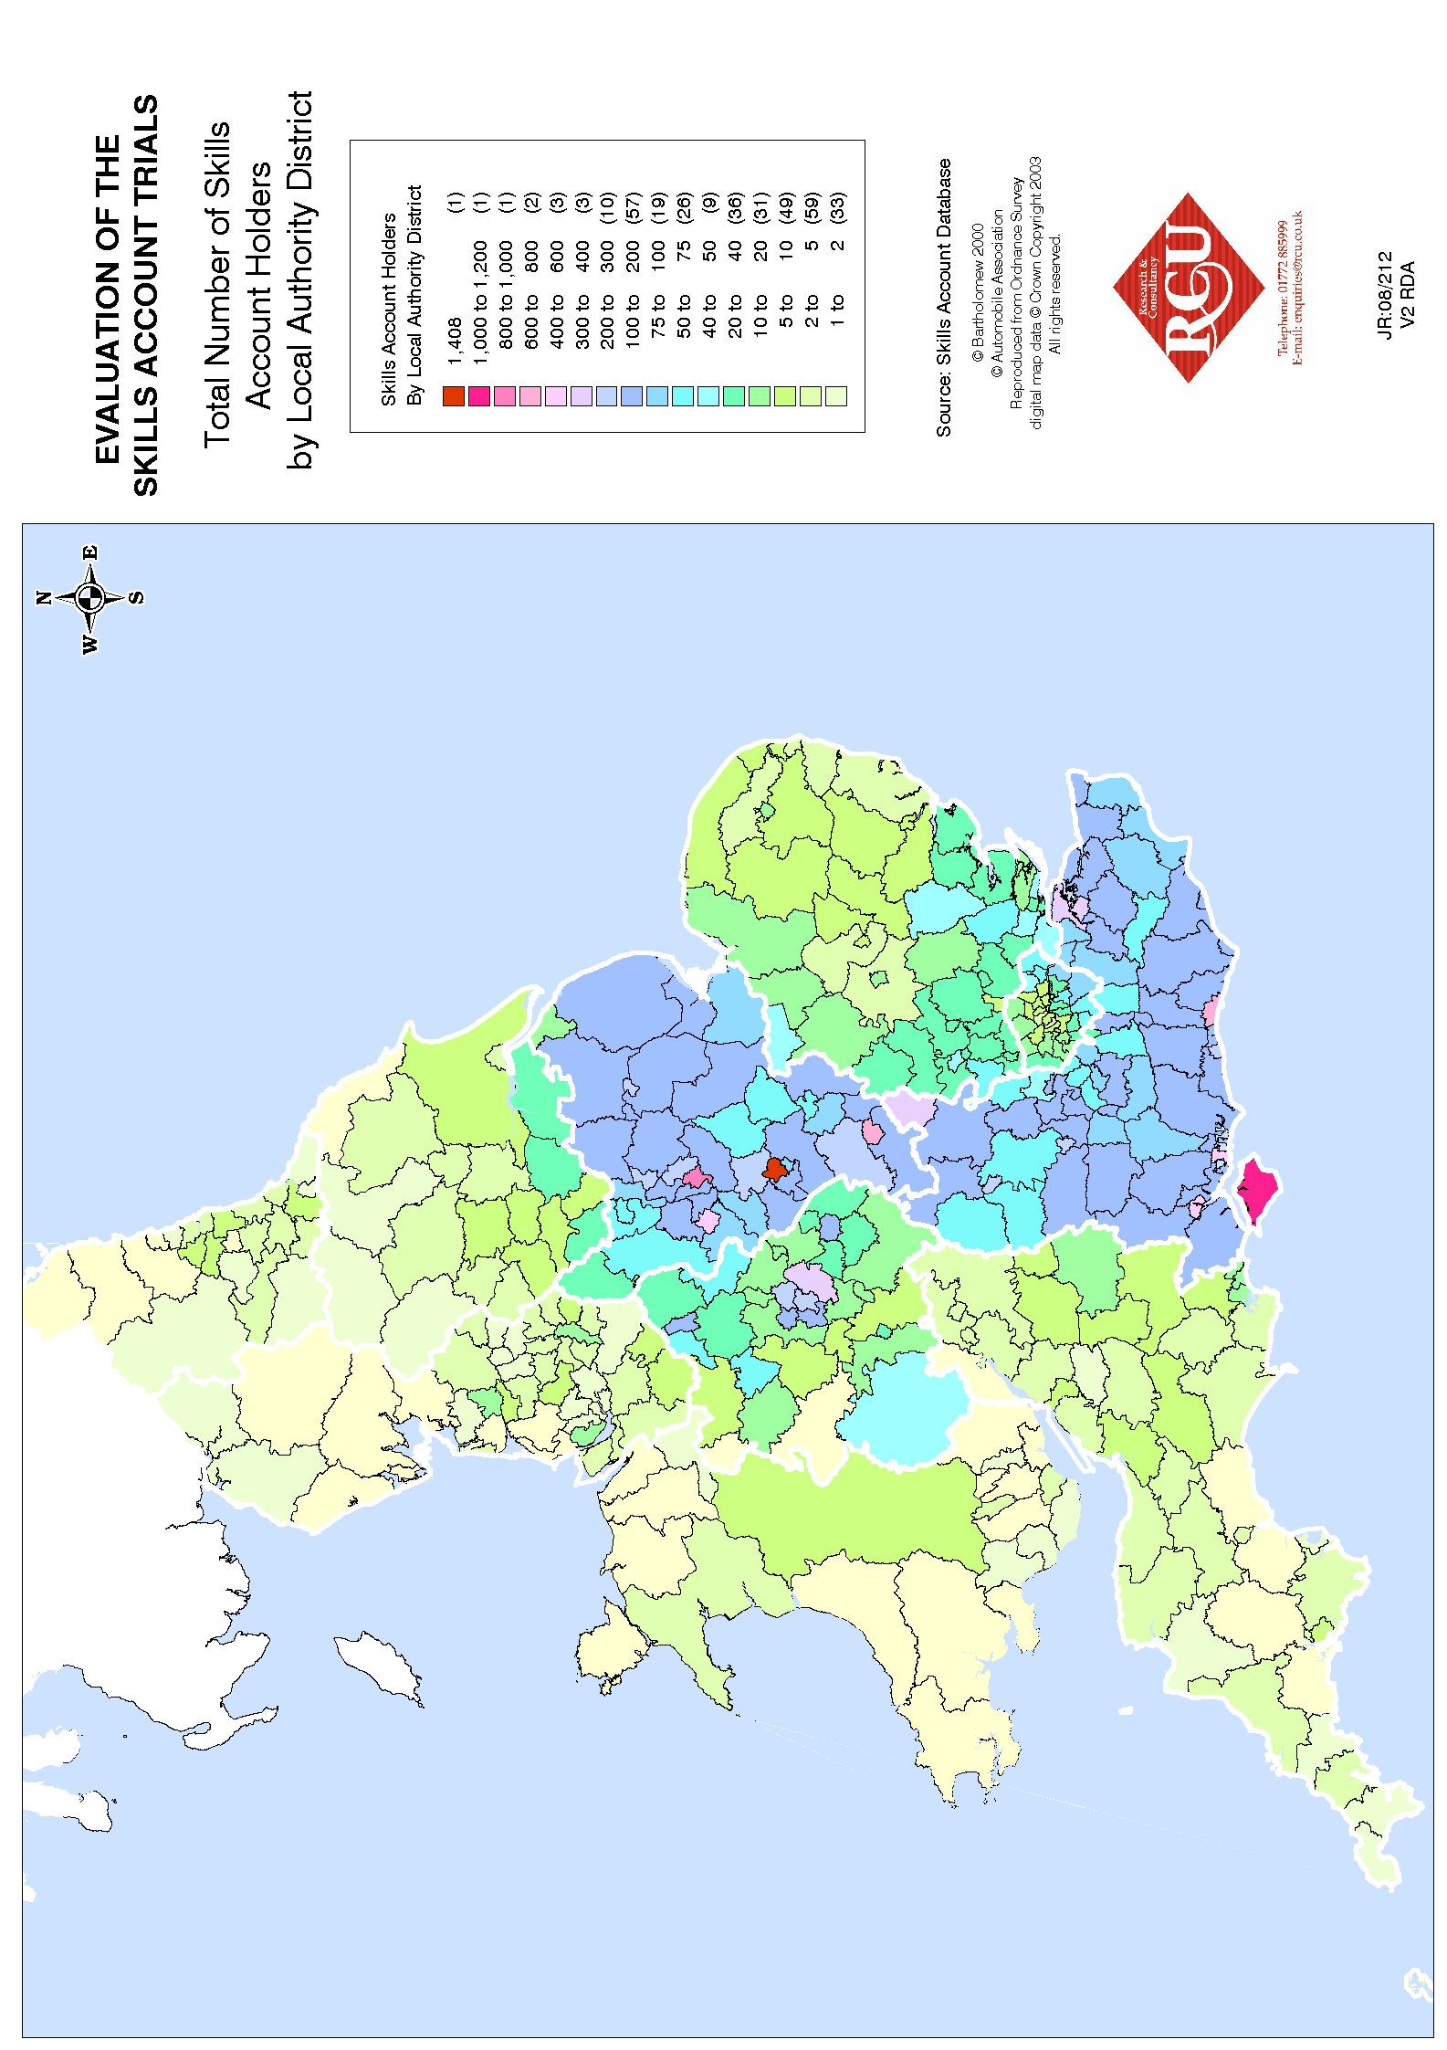
The database also holds details on Skills Account registration dates. The chart below shows the number of Skills Accounts registered per month since the Skills Account Website was launched in December 2008.

Skills Account Registrations by Date (up to end of July 2009)
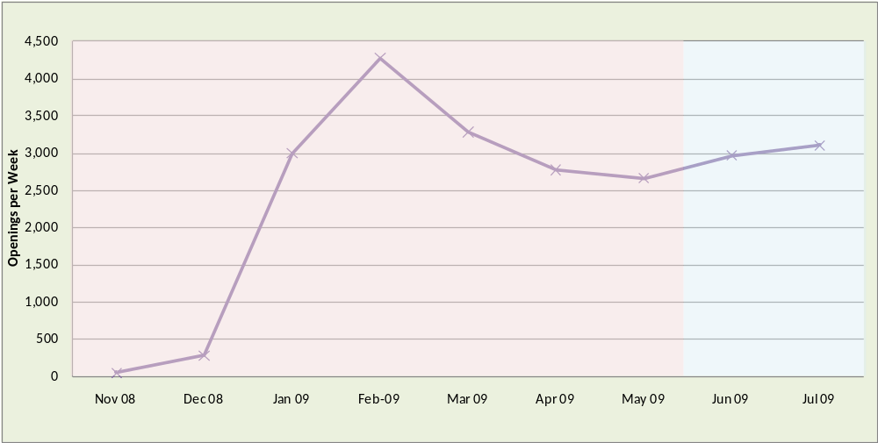
- The highest number of registrations per month took place in February 2009 and gradually reduced during the spring. Skills Account registrations increased again during June and July. This pattern of Skills Account registrations is predominately due to the way in which the Skills Account trials were rolled out and the recruitment pattern of partners involved in the trials.
- In the early part of the year Skills Account registrations were most likely to have been via SLPs and targeted at adults enrolling on college courses starting in January and February. In the summer period, however, new Skills Account registrations were more likely to have come from the IES trials and nextstep centres (very few college courses are taking place at this time).
- The two telephone surveys (based on database records between December and May and between May and August respectively) therefore have a different client mix. The first survey has a higher proportion who registered through the SLPs and the second survey has a higher proportion who registered via nextstep and ESPs.
- The following table shows the breakdown of registered Skills Accounts by SLPs. The table also shows the number of registered Skills Accounts from the Careers Advice Service and the number through other routes.
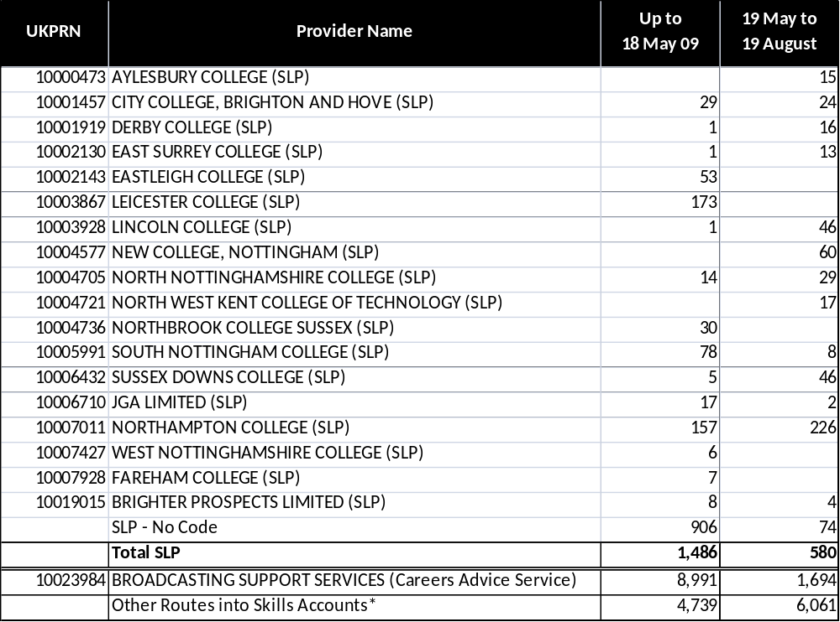*This includes ESP providers, nextstep, self directed route and other routes where no provider is specified.
- As the chart on the following page shows there is a significant difference between the two cuts of data as predicted from the timeline graph. The first shows a relatively high proportion of registered Skills Accounts coming from the Careers Advice Service (this route was operational well in advance of other routes so was offering Skills Accounts over a longer period), whilst the second shows a much higher level of Skills Accounts coming from other routes (particularly ESP providers and nextstep).
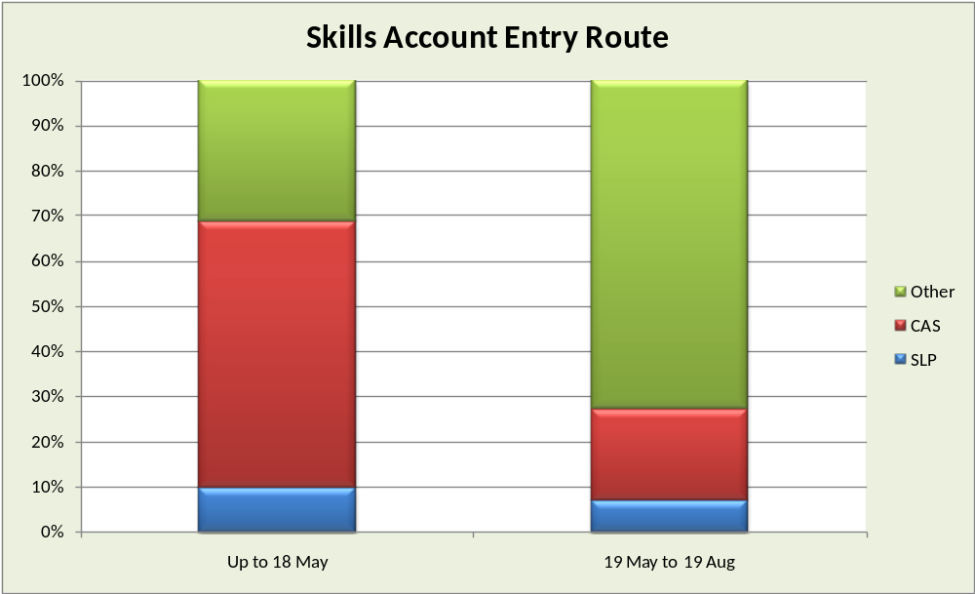
- At the time of the analysis is was not possible to breakdown the category other, in order to distinguish between Skills Accounts created through ESP providers, nextstep and the self directed route. However, in future surveys the combination of larger sample sizes and enhancements to the Skills Account database will allow analysis of findings by entry routes.
- At the 19th August 2009, 53.7% of Skills Account holders were female (12,651) and 46.3% were male (10,895). These percentages are similar to the proportions of male and females in the overall further education population and suggest no particular gender bias in the uptake of Skills Accounts at this stage. The proportions of males and females did not change significantly between May and August.
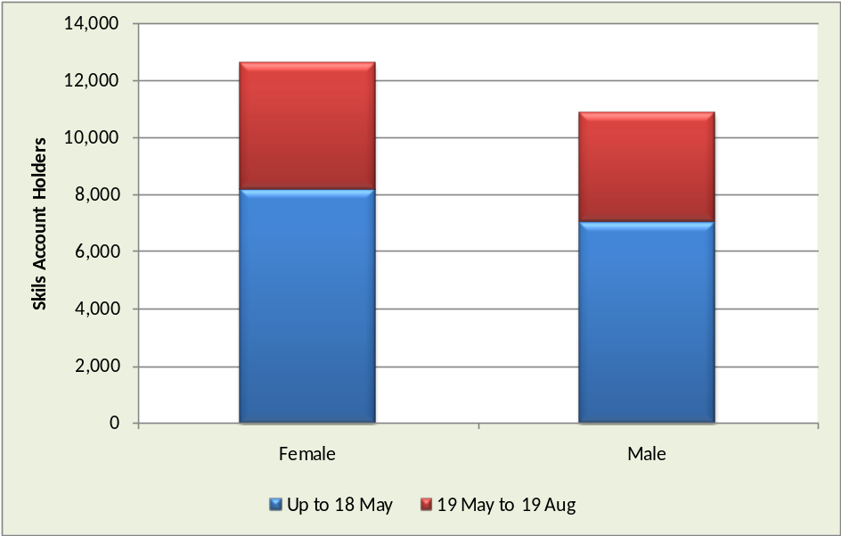

- Of the 23,546 Skills Account holders just under a third fell within the 25-34 age band (7,424) and approximately a quarter were within the 35-44 age band (5,881). The over 65 group had only 95 account holders.
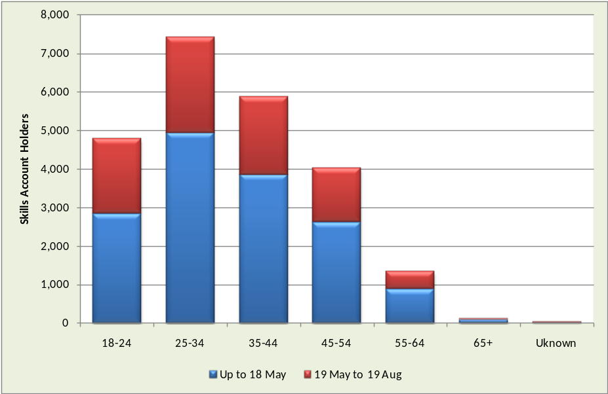
- The detailed table on the next page shows the characteristics of Skills Account holders by the different groups used within this report. The groups are:
- Total number of Skills Account holders up to 18th May 2009.
- Skills Account holders up to 18th May 2009 who had a valid telephone number and made up the sample for the first telephone survey.
- Total number of Skills Account holders between 19th May and 19th August 2009.
- Skills Account holders between 19th May and 19th August 2009 who had a valid telephone number and made up the sample for the second telephone survey.
- All Skills Account holders as recorded on the database up to 19th August 2009.
- These are the core datasets used for the telephone surveys discussed in sections 3 and 4 of this report.

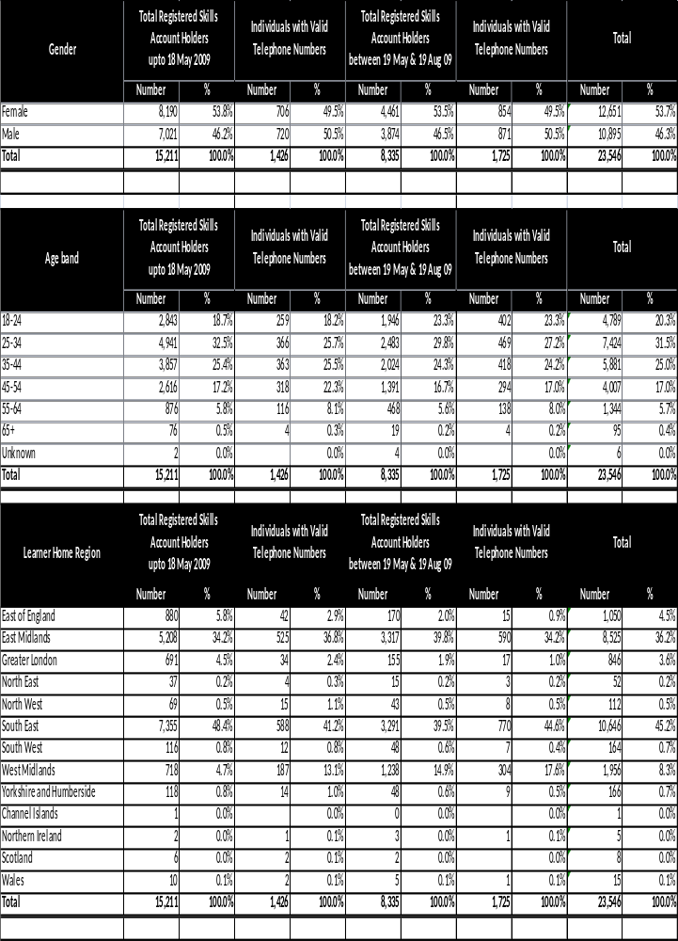

- Findings from the June Telephone Survey
  - Introduction and Methodology
- As of 18th May 2009, 15,211 individuals were recorded on the Skills Account database, but only 1,426 of these had provided a valid telephone number. This was the target population for the telephone survey.
- The telephone survey took place at the beginning of June 2009 and was carried out using a script based CATI system. In order to maximise the response rate the interviews lasted approximately 10 to 12 minutes. A target number of 450 interviews were planned and this target was met within 2 weeks of the interview process starting. The questions were agreed with the LSC and were pre-tested prior to the interviews with Skills Account holders. The questions explored a range of issues including initial information about Skills Accounts, the online activation process, usability of the website, perceptions relating to the individual features and tools, and views on the overall concept of Skills Accounts. Appendix 2 includes a copy of the telephone survey questionnaire.
- The telephone survey was the first in a series of interviews that are planned to take place over the next two years and will include a longitudinal study and a control group. At the time of the initial survey the development of Skills Accounts was in its infancy, having been launched in December 2008. Most Skills Account users will have accessed software release 1.2, with more extensive functionality such as the Learner Record and Learner Statement not appearing until later in the year. The results from this initial survey therefore provide a baseline for subsequent telephone surveys.
- It is important to note that because only 10% of account holders gave telephone numbers, there will be some inevitable skewing of the sample. For example, older account holders were more likely to give a telephone number. Therefore, the analysis includes breakdowns by age, gender, current work status, home LSC Region and other characteristics in addition to the overall results where this is appropriate. The first part of this section gives a detailed breakdown of survey respondent characteristics and, where relevant information exists, these are compared to the full database of Skills Account holders as of 18th May 2009.
  - Characteristics of Respondents
- The contact list for the survey was drawn from the Skills Account database of registered users. At the start of the survey respondents were asked if they could remember registering for a Skills Account. Only those who could recall registering for an account were invited to take part in the survey and a total 450 telephone interviews were completed for the June survey. 53% of those interviewed were female, similar to the proportion in the overall Skills Account database at this time. The chart below shows the age breakdown of respondents.

Age Band of June Respondents (450 Base)
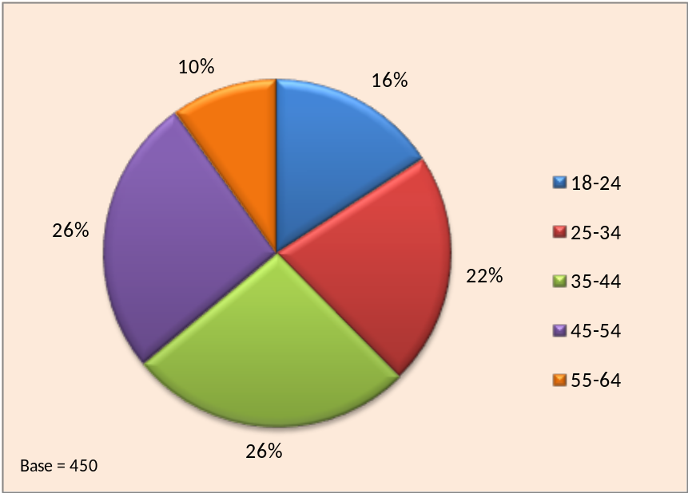

- The age profile of Skills Account holders within the sample differs from that within the overall database since the younger age groups tend to be under-represented and the older groups over-represented. The proportion of under-35s in the sample was just under 40% compared to around 50% for the overall database. Conversely, over-45’s represented around 35% of the sample but only 25% of the overall database. The proportion of the 35-44 age band was about the same within the sample and the overall database.
- There were two factors influencing the skewing of the sample by age group. Firstly, older Skills Account holders were more likely to have given contact telephone numbers when submitting their personal details on sign-up. Secondly, as in all surveys of this type, older respondents tend to be more easily contacted and more willing to be interviewed. There was no opportunity to counter these skewing factors in the first survey, since a sample of 450 Skills Account holders was required from a total list of telephone numbers of less than 1,500 (which inevitably included erroneous or out-of-date contact details).
- Skills Account holders of all ages were represented in the sample although females had a slightly younger age profile, as the chart below illustrates.

Age and Gender Profile
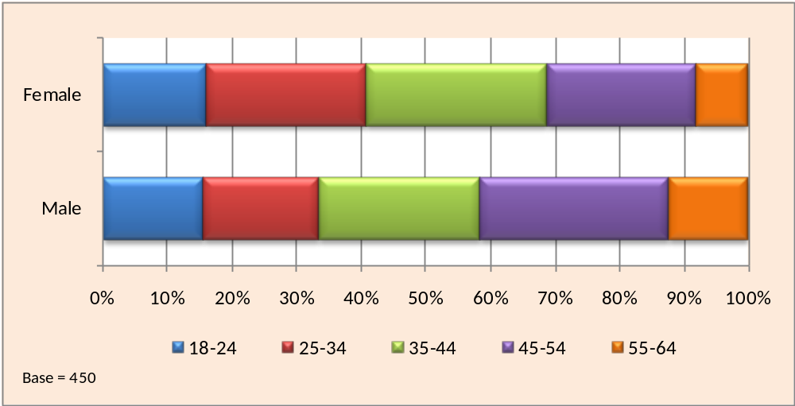

- The chart below shows the broad ethnic group of respondents which was gathered from the survey questionnaire. The details that Skills Account holders volunteer when they sign up does not include their ethnic background so it was not possible to cross-check the profile of the sample against the full Skills Account database.

Ethnicity Breakdown
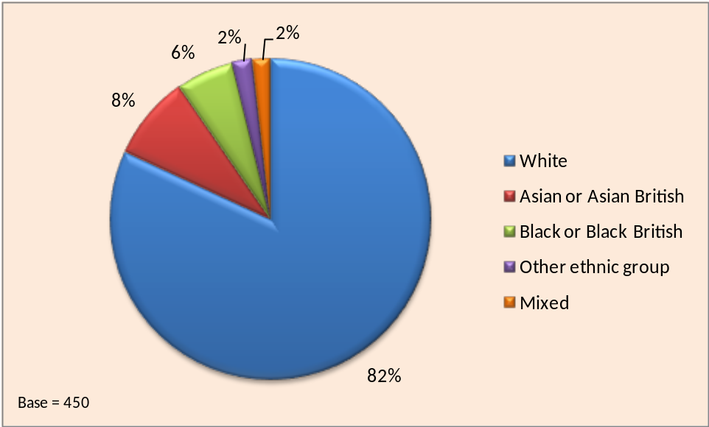

- The respondents were asked if they had taken part in education or training courses in the last three years. The chart below shows the results.

Have you taken any course or training in the last three years?
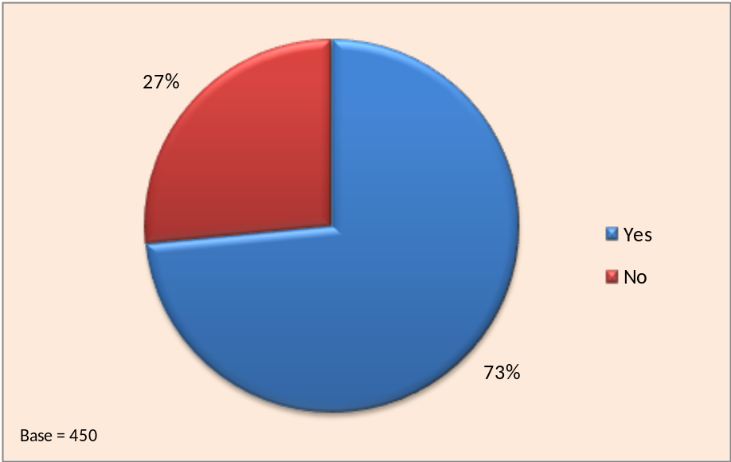

- Almost three-quarters of respondents had recently been involved in some kind of formal learning. There were some differences to the response to this question depending on age and gender. The most likely age group to have taken a course were the 18-24 year olds (80%) and the least likely were those aged 25-34 and 35-44, at just under 70% for both groups. Females (77%) were also more likely than males (68%) to have taken a course within the last three years.
- There were also differences according to the current status of respondents. Excluding those currently in full-time education or training, those in full-time or part-time employment were the most likely to have taken a course within the last three years. The least likely were the self-employed and those not currently in education or training, including the unemployed and those with full-time family/caring responsibilities.
- Most of the Skills Account holders were currently taking a course or were planning to do so in the near future, as the chart below illustrates. The percentage of Skills Account holders who said that they were currently taking a course (44%) was much higher than the percentage of the Skills Account database records that could be matched with ILR records (12%). This could be due to Skills Account holders taking non-LSC funded courses and/or ILR records not being sufficiently up to date to reflect courses that were being taken (i.e. learners had started their course within the past few months and the F02 ILR is based on records submitted in February 2009).

Currently taking a Course or in Training
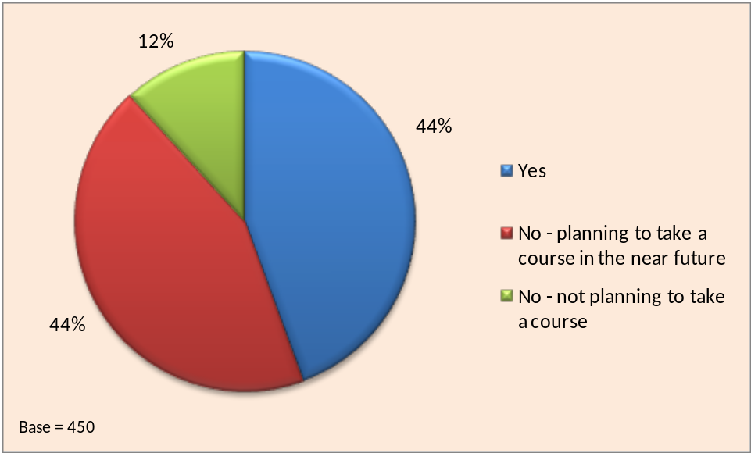

- Around one in eight were not planning to take a course despite having signed up to a Skills Account, although this proportion rose to one in six among those aged 45 and over. Females (51%) were more likely than males (38%) to be taking a course at the time of the survey. 14% of males were not currently engaged in education or training and had no plans to do so in the near future.

- In terms of current work status, it was the self-employed or those in full-time employment that were the most likely not to be taking a course or planning to do so in the near future. However, around one in eight of those who described themselves as unemployed were not intending to take a course.
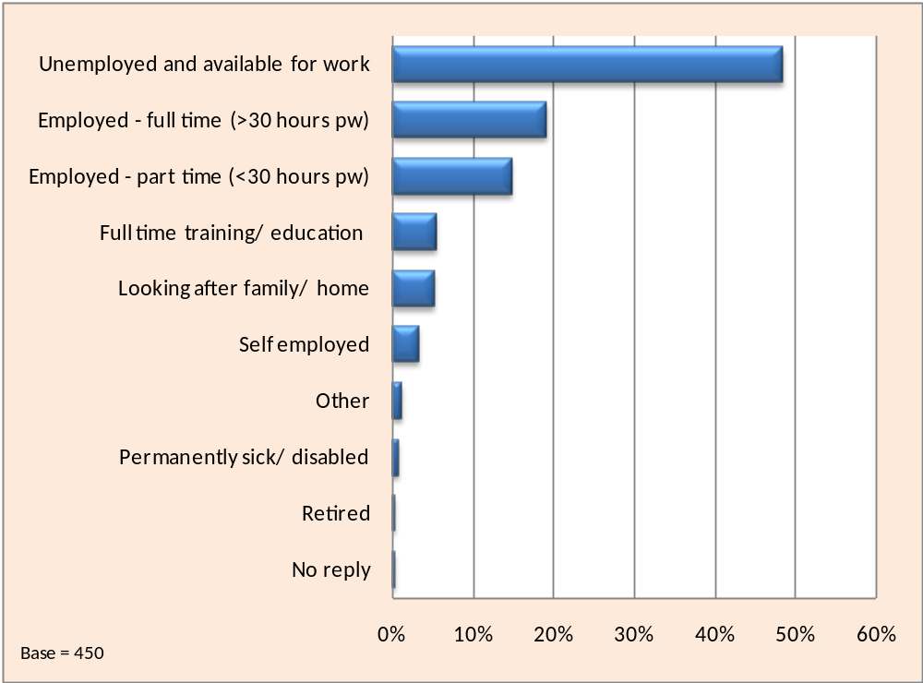
- The chart below shows how respondents described their current work status.

Current Status
- Just under half of the survey respondents were currently unemployed and available for work. This figure rose to 70% among those who had first heard about Skills Accounts through Jobcentre Plus.
- There was a marked difference in the current status of respondents according to gender. 63% of males were unemployed compared to just 35% of females. There was little difference in the proportion of females and males in full-time employment, although females were much more likely than males to be in part-time employment, 22% compared to 8%.
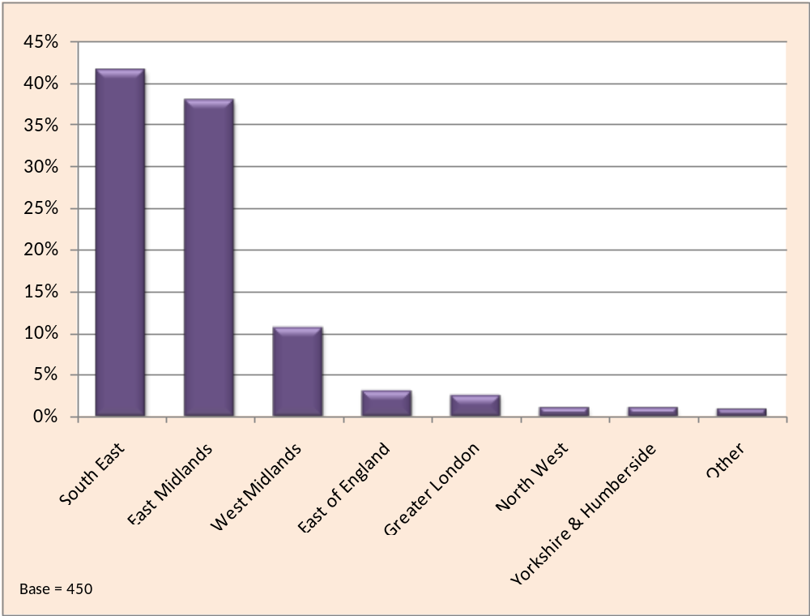
- The contact details supplied by Skills Account holders when they signed up included their home postcode. This information from the database supplied by the LSC was matched to respondents so that the LSC Region in which they lived could be identified. The chart below shows the distribution of respondents by LSC Region.

Home Location of Respondents (LSC Region)

- Respondents were mostly from the two main Skills Account trial LSC Regions, the South East and the East Midlands, matching the profile of the overall Skills Account database. Just over 10% were from the West Midlands where Skills Accounts were trialled with Jobcentre Plus clients only as part of the IES trials.
  - Skills Account Awareness and Initial Information
- The chart below shows how respondents first became aware of Skills Accounts. A third said that they had been introduced to Skills Accounts through a learning/training provider and for a fifth the first contact had been via the Internet itself.

How did you first become aware of Skills Accounts?
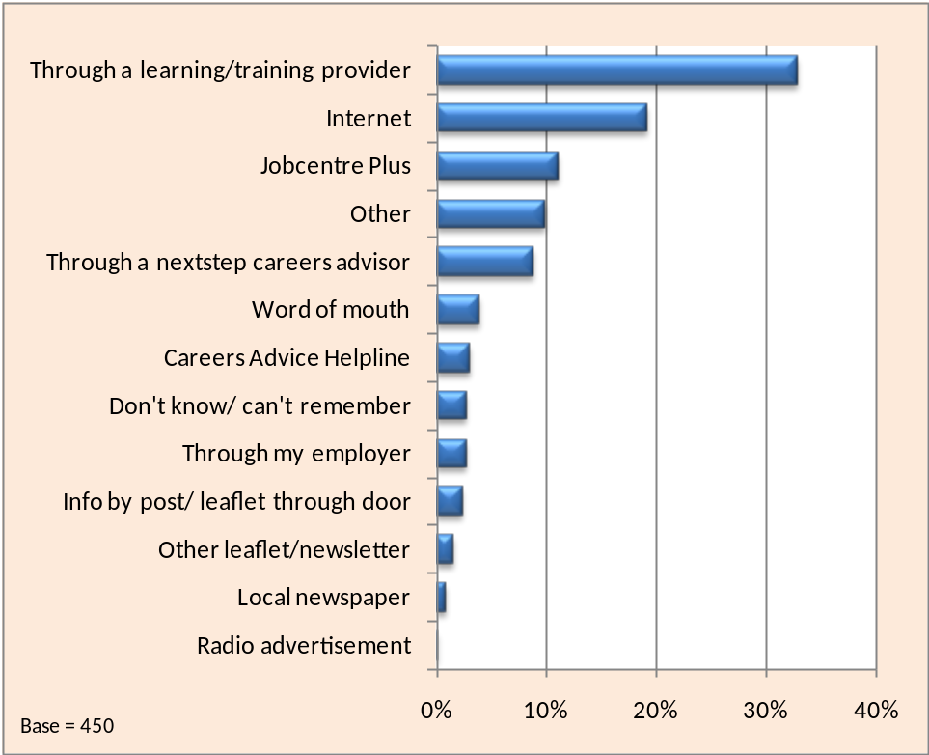

- Just under half of 18-24 year olds had first learnt about Skills Accounts through a learning/training provider. Older respondents were less likely to have first heard this way, particularly those aged 45-54, with only a fifth saying that a learning/training provider was their initial source of information. However, this group was the most likely to have first become aware of Skills Accounts through the Internet (27%). Those most likely to have been introduced to Skills Accounts through Jobcentre Plus were in the 35-44 age group (16%), with the least likely being the under 25s (7%).
- The South East and East Midlands LSC Regions had very similar response patterns to this question but in the third of the main trial regions, the West Midlands, a higher percentage (46%) had first learnt about Skills Accounts though a learning/training provider (most likely to have been the provider delivering the Employability Skills Programme, following a referral from Jobcentre Plus).
- Respondents were asked to name all their sources of information about Skills Accounts. The sources were read out in turn by the interviewer (not in the order shown in the chart) and respondents were asked to identify the ones from which they had received information. The red bars represent the percentage of respondents that named each of those listed as a source of information and the green bars show the percentage that identified each as their single main source of information.

Sources of Information about Skills Account
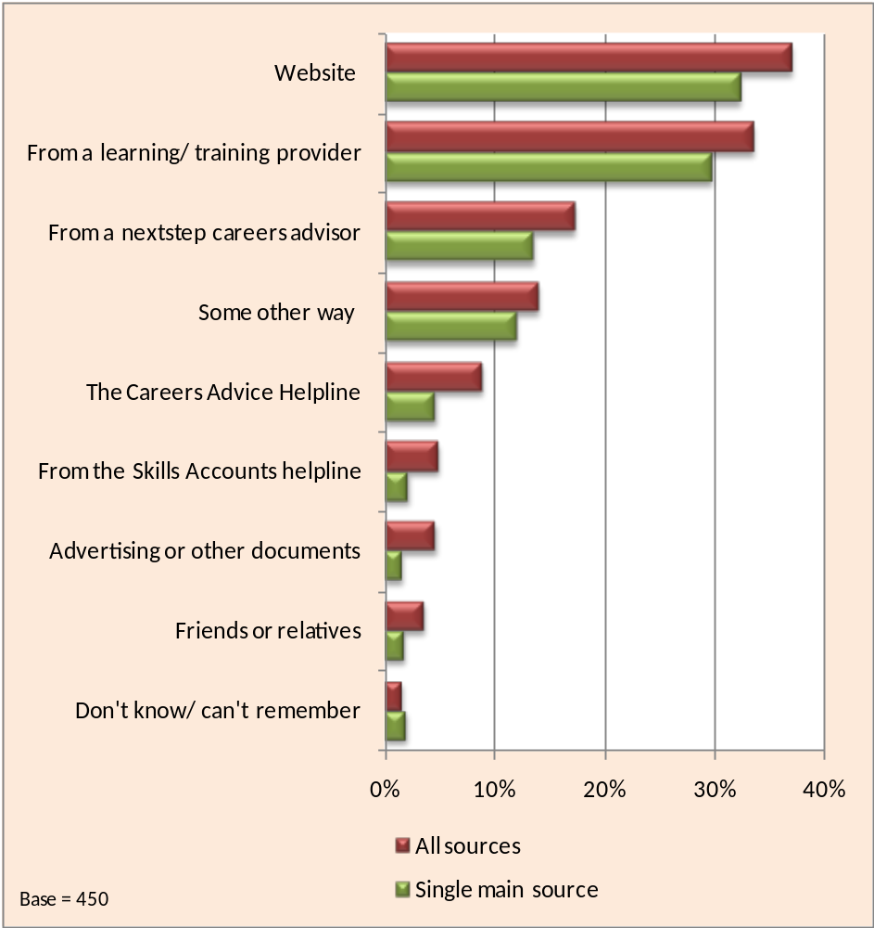

- Over 70% of respondents had received information from the Skills Account website or from a learning/training provider. The third most frequently cited was through a nextstep careers advisor. The other sources most often identified by respondents (included in the “some other way” category) were: Job Centre (3%), my employer and learndirect.
- Less than one in six of respondents had seen any advertising or written information about Skills Accounts before signing up, as the pie chart below illustrates.

Did you see advertising or other documents about Skills Accounts before signing up?
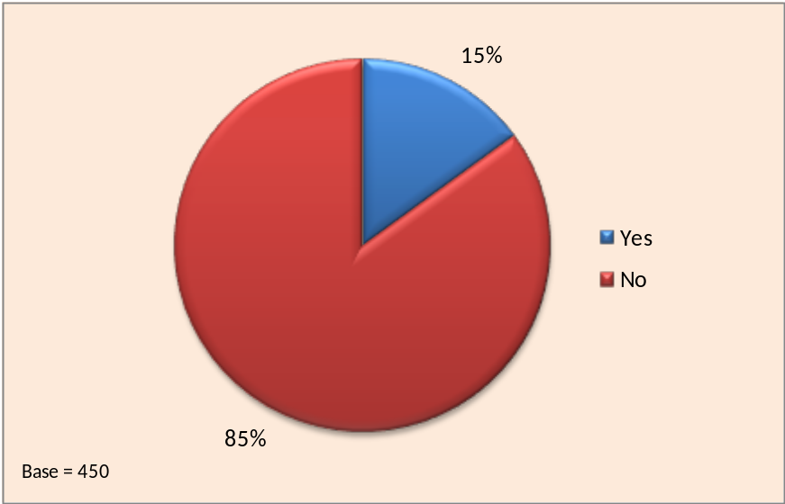

- Most of the respondents who had seen advertising or written information were generally positive about what they had seen or heard. Comments included:
“The leaflets are short, informative and to the point”
“I was given a leaflet by nextstep explaining about it and it was quite good”
“It was on the television, but I didn't take much notice of it. However, now that I am unemployed it has become useful”
- Respondents aged 55 and over were the most likely to have seen advertising and/or other written information whereas the youngest age group, the under 25s, were the least likely. However, females, despite having a younger age profile, were also more likely to have seen such information. People in full-time employment were more likely to have seen information on Skills Accounts than people who were unemployed, self-employed or working part time.
- It is interesting to note that both the telephone survey and the Skills Account registration database record some individuals as saying that they heard about Skills Accounts through television advertising. However, in practice Skills Accounts have not actually been promoted via this route. It is possible that some people are remembering general messages about training from the “It’s in our hands” campaign, have an indistinct memory of detailed messages and are associating common references (such as direct.gov) with Skills Accounts.
  - Advantages of Skills Accounts
- The chart below shows the results when the 352 respondents that had activated their account online were asked to identify, unprompted, the most important advantages of having a Skills Account. Respondents could give more than one answer if they wished, so the bars in the chart add up to more than 100%.

Most important advantage of having a Skills Account
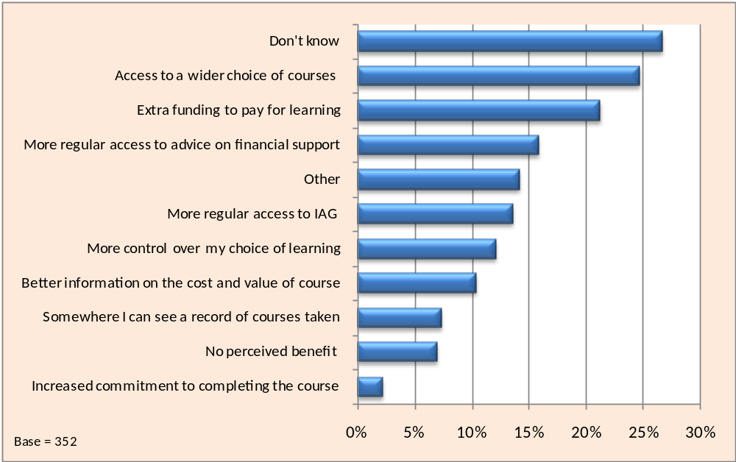
- Well over a quarter of respondents said they did not know what were the most important advantages of having a Skills Account. Many of these respondents did not feel they were sufficiently knowledgeable about all that Skills Accounts offered to express an informed opinion. Around 7% of respondents said they could not think of any perceived benefits of having a Skills Account. This group were much more likely to have used the tools and features on the website and therefore were more able to express an opinion, but having used the tools did not feel that they provided them with any particular benefits.
- Almost a quarter of respondents said access to a wider range of courses was, in their view, the most important advantage of having a Skills Account.
- Among those respondents who gave other reasons were the following comments:
“Future employers will be able to find candidates for work through Skills Accounts”
“It is very convenient for me as I don’t have to go trawling anywhere else”
“Helps you choose an employment suitable to you”
“It helps students on a lower income to study further”
- The second most frequently cited advantage was the perception that Skills Accounts provided extra funding to pay for learning, although this varied by LSC region. Whilst Skills Accounts do not in practice provide additional money this cited advantage may reflect a perception that the account provides information on pre-existing sources of funding that individuals were unaware of or may reflect some confusion over the operation of the Skills Voucher. 28% of those in the South East saw this as one of the most important advantages and was the top answer among respondents in this region. However in both the East and West Midlands, only 17% identified this as one of the most important advantages.
- The next question aimed to gather evidence on whether the Skills Account website was forgettable or newsworthy. Respondents were asked if they had told anyone else about Skills Accounts and the results are shown in the figure below.

Have you told anyone else about Skills Account?
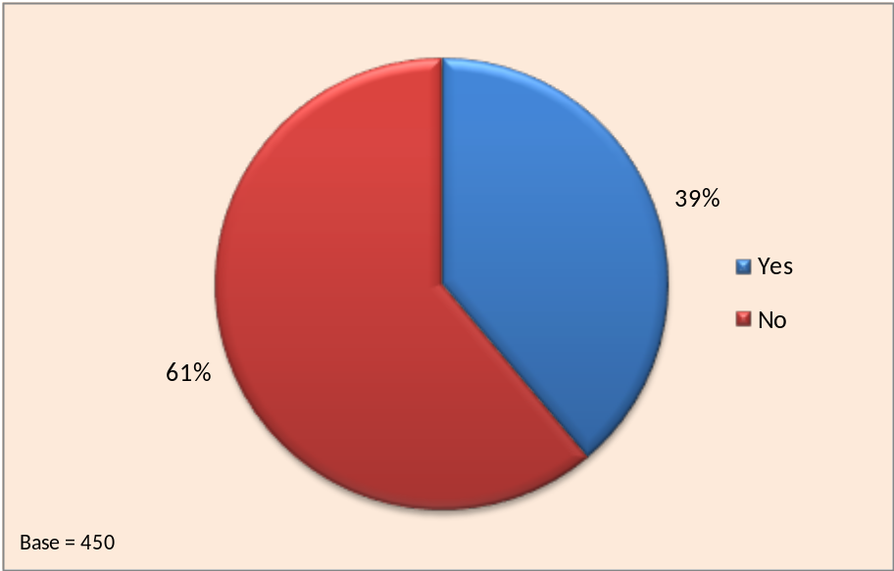

- Overall, almost 40% of respondents had told someone else, although females (43%) were more likely than males (34%) to have done so. Those aged in their 20s and 30s were also more likely than those in their 40s and 50s to have shared their experience of Skills Accounts with others.
- In terms of current status, those in full or part-time employment or full-time education or training were the most likely to tell someone else about Skills Accounts. Those that were least likely to have spread the word were those potentially in more isolated situations, including the self-employed, the unemployed and those at home with family/ caring responsibilities.
- Multivariate analysis of the results, covered in detail later in this report, revealed that those most satisfied with the overall Skills Account service were the ones most likely to tell someone else about them.
- The results from this question are potentially quite significant for the LSC as it suggests that once the service is fully developed widespread usage could spread quite quickly through word of mouth and recommendations from existing users within the home or the workplace.
  - Activating and Accessing the Skills Account Website
- The chart below shows the proportion of respondents that could remember activating their Skills Account online.

Do you remember activating your Skills Account online?
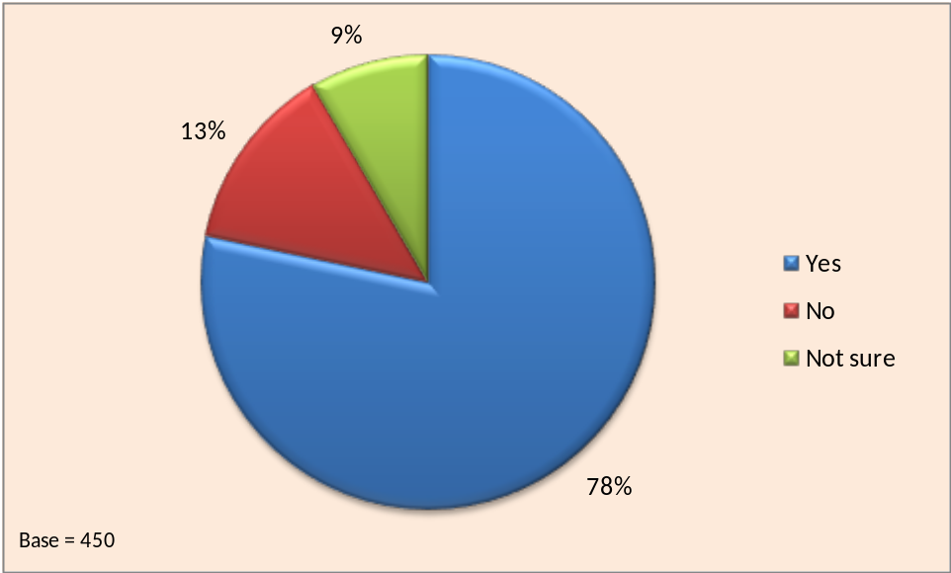

- The yes total includes respondents who were initially not sure but could remember using the Skills Account website and therefore must have activated their account to do so. The ones that answered no had no recollection of activating their account or using the website. Respondents in the not sure category also had no recollection, but thought it was quite possible they had done so.
- The 78% of respondents (352 in total) that could recall using the Skills Account website were asked a series of questions about their usage of the site. Those who could recall using the Skills Account website were asked how easy it was to activate their account.

How easy was it to activate your Skills Account?
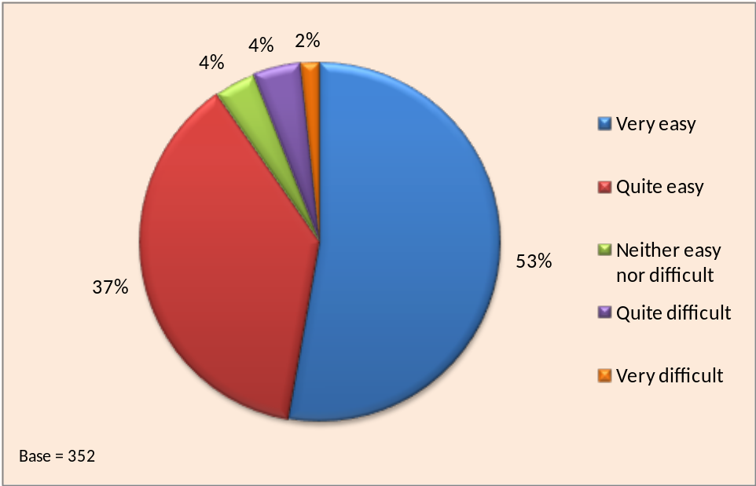

- Nine out of ten said they had found it very easy or quite easy. This rose to 99% among those respondents aged under 30, but fell to just over 80% among those aged 30 and over.
- The majority of problems experienced by respondents were associated with choosing and entering passwords, although general unfamiliarity with computers was also a contributory factor in some cases.
- Just over half said it was very easy to activate their Skills Account online although there was some variation with age. Over two-third of the under-35s had found it very easy compared to half of those age 35-44 and around 40% of those aged 45 and over.
- Of the 352 respondents that answered the questions on website usage, 23% (80) said they had received help in activating their account online. The figure below shows who had provided the help.

Who helped you activate your Skills Account?
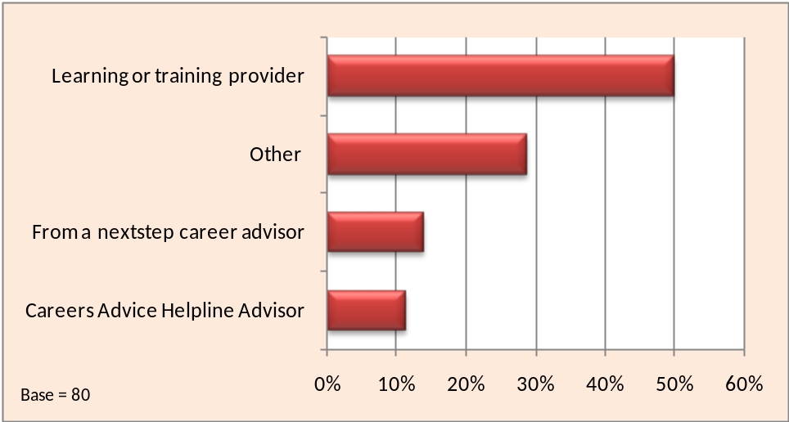

- Half the respondents said they had received help from a learning or training provider although over a quarter mentioned other sources of assistance. In most cases this was a friend/family member or an advisor or support worker in the place where they had signed up.
- Respondents aged under 45 were most likely to cite a learning/training provider as the source of the help they had received, whereas older respondents were more likely to identify other sources of help.
- The next question aimed to gather evidence on respondents’ own perception of their level of usage of the Skills Account website. It asked how often they had accessed their account since signing up. The chart below shows the results.

How often have you accessed your online account since signing up?
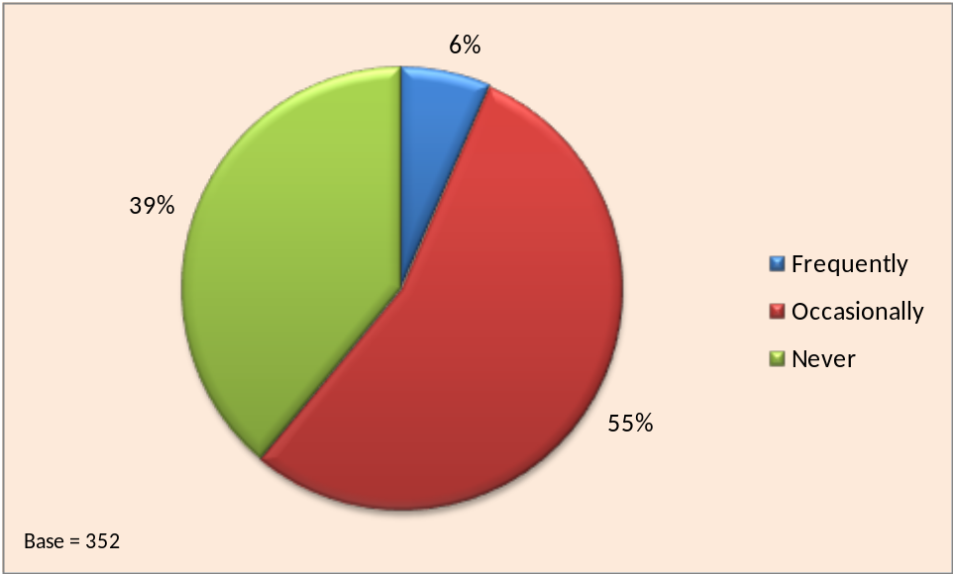

- The majority of respondents said that they were occasional users of the website although a sizeable minority had not re-visited the website since first signing up. The age group most likely to have visited the website since signing up were the under 25s and the least likely were the over 45s. This is likely to reflect the younger generation’s familiarity and confidence with computers and accessing websites.
- Multivariate CHAID analysis of the results, covered in detail later in this report, revealed a close association between how frequently respondents had accessed their online accounts and how easy they found the Skills Account website to use.
  - Course Finder Tool
- The Course Finder Tool on the Skills Account website allows users to search a database of courses and find out which providers are offering courses that they might be interested in. 44% of respondents who remembered visiting the Skills Account website said they had used the Course Finder Tool, which was the highest percentage for all of the tools available. Their views on how useful they had found the Tool are shown in the figure below. 78% of respondents said that they found the Tool very useful or fairly useful.

How useful was the Course Finder Tool?
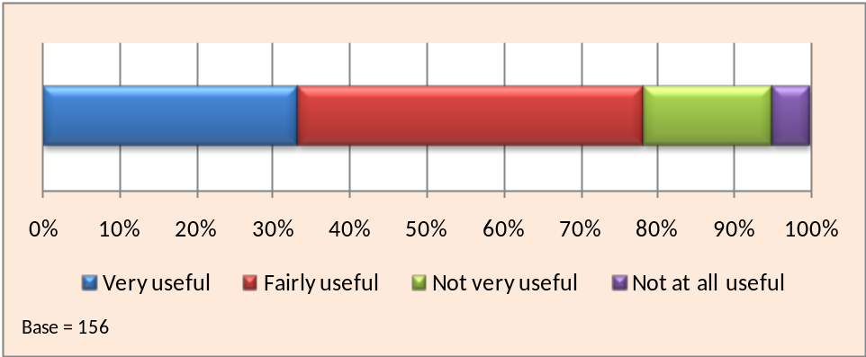

- Some of the positive comments about the Tool included:
“You just type the in the course and it will tell you the nearest college that provides that course”
“It was handy to have all the information in one place”
“It was simple and easy to use”
“I was looking for an IT course and the website found it straight away”

“My husband is now going to use it”
“It gives a lot of information and you can limit it down to what you are looking for and you don't have to go through everything. It is very good.”
- When individuals did give less positive comments this tended to be related to general usability issues. For example:
“There was nothing suitable for me. I typed in SAGE and had difficulty with it”
“I was looking for part-time evening courses but it was hard to get the information from the drop down boxes”
  - Skills and Interest Tool
- The Skills and Interest Tool assesses user’s current skills and interests using a series of multiple choice questions and suggests possible career options. 95 (27%) of the website visitors had used the Skills and Interests Tool on the website. The figure below shows how useful they found it. More than 86% said that the tool was very useful or fairly useful whilst only 3% said that it was not at all useful.

How useful was the Skills and Interest Tool?
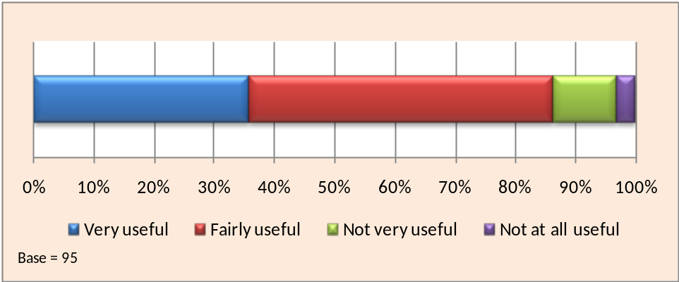

- Positive comments about the Tool included:
“It suggested the sort of career path I wanted to take and also suggested other ideas I hadn't really thought about”
“It helps you to find your own goal and to find which course is required”
“Once again it was well laid out and easy to use”
- However, some respondents felt that whilst the Tool was useful the outputs were often fairly general or not specific enough for their current circumstances. For examples two respondents said:
“It was too broad-brush for me”
“I did it on two different days and it gave me two different answers, and I lost confidence in it. One said I should be suitable as an advisor and the other that I would be suitable as a manager”
  - Jobs Profile Tool
- The Jobs Profile Tool provides detailed information about different careers. The following chart shows how useful respondents found the Jobs Profile Tool. 84% of respondents who had used the Jobs Profile Tool said it was very useful or fairly useful, whilst 6% said the Tool was not at all useful.

How useful was the Jobs Profile Tool?
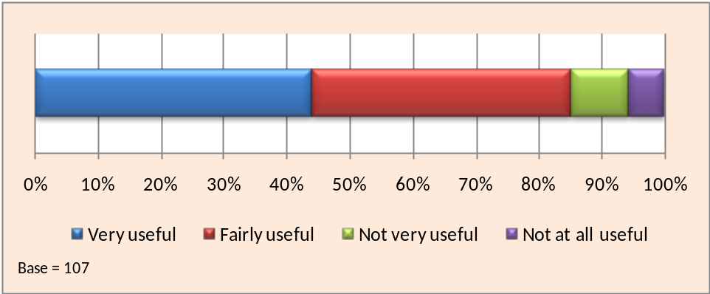

- Respondents felt the Tool was generally easy to use and informative. Comments included:
“It gave more information than I expected”
“It was helpful to me as I am looking at Social Work/Prison Service. It was interesting reading”
“It gave me new ideas about jobs that I had not even considered”
- Some of the less positive comments related to individuals who were looking to find specific jobs rather than information on careers. For example two respondents said:
“Basically, I don't want to re-train I just want another job”
“I needed to find someone to take me on for a few weeks to see, and prove, that I could do that job”

  - Qualifications Calculator
- 143 (41%) of the respondents who had visited the Skills Account website remembered using the Qualifications Calculator. The figure below shows how useful they found it. Whilst 70% found it very useful or fairly useful, 11% found it not at all useful.

How useful was the Qualifications Calculator
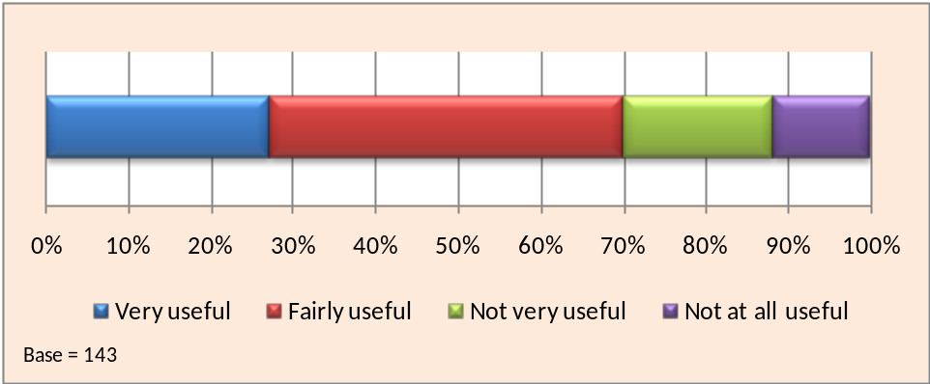

- For some individuals the Qualifications Calculator wasn’t that applicable because they had only recently achieved their qualifications and were well aware of the level. Respondents who were positive about this and found it easy to use and helpful said:
“I am 59 years old and it worked out that I was more qualified than I thought I was”
“I wasn't aware of what level of education I was so it helped me identify what level of education I am”
“It was very useful in finding out my equivalent qualification because I am from Jamaica”
  - Skills Vouchers
- 220 respondents, representing just under two-thirds of those who had visited the website, said they were aware of the Skills Voucher feature but only around a quarter of these had generated a voucher to take to a provider. The 52 respondents who had generated a Skills Vouchers were asked what they thought the Skills Voucher provides and how useful they thought it was. The responses to these questions are listed in Appendix 4.
- All respondents understood that a Skills Voucher was related to funding and most believed that it provided a subsidy on the cost of the course. Some individuals said that it told you whether you were entitled to money from the Government, and others believed that you could use the voucher to buy things with (e.g. books and accommodation).
- The figure below shows the results to the question on how useful they thought the Skills Voucher was.
How useful was the Skills Voucher?
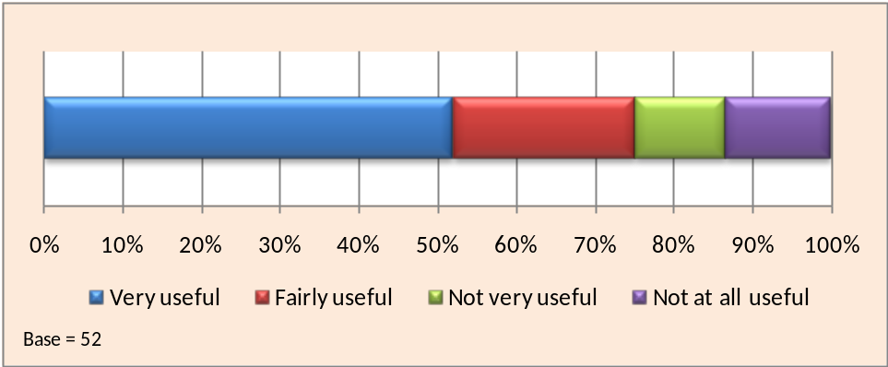

- Just under three-quarters thought the Skills Voucher would be very useful or fairly useful. Typical comments included:
“It is a brilliant idea. I have printed it off and am now going to take it somewhere and see what happens”
“Very encouraging for studying, especially if you are thinking of going back into education as it provides a good incentive”
“It's useful because it gives you information in advance prior to starting the course”
- Some respondents, however, said they had experienced problems when they had taken the voucher to a learning provider;
“None of the colleges or training providers in this area will accept the voucher and only courses at Level 1/2 will qualify. Have to be on benefit or tax credits.”
“I think it gives out the wrong impression using the term voucher. When I took it to the college I found I wasn't eligible for funds which was disappointing as the site said I would be.”
“I took it to the college but they were not interested and did not know much about it.”
“It is misleading and cannot be spent with colleges.”
- In general, therefore, whilst survey respondents were positive about the concept of Skills Vouchers, the implementation of them was felt to be misleading and confusing. Vouchers were often not accepted by providers and individuals often thought that vouchers would give ‘money off’ the cost of the course, when in reality they just gave information to the user.
  - Overall Views on Skills Accounts
- All the respondents that had used the Skills Account website were asked how easy it was to use. The figure below shows the results.

How easy is it to use the Skills Account website?
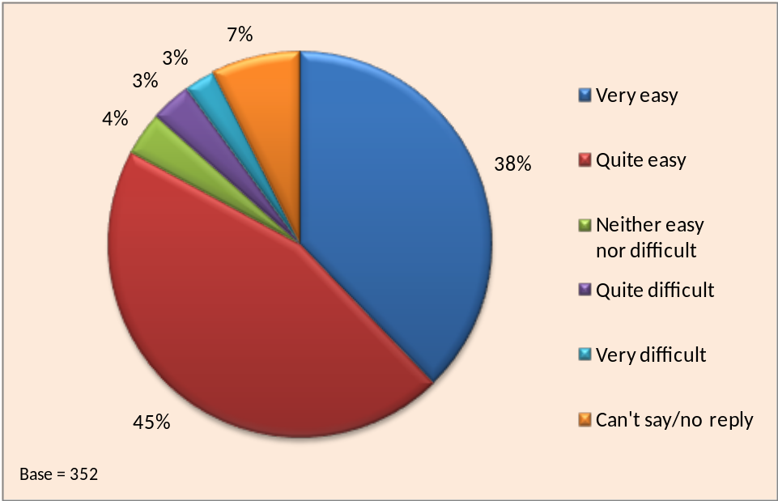

- Most respondents found the website easy to use with well over 80% saying it was very easy or quite easy. Very few of those aged under 25 had experienced difficulties, although around 10% of the over 45s had done so.
- Around two-thirds of those who said they frequently accessed their Skills Account online also said they found the website very easy to use. This compares with just under half of those who accessed their account occasionally and a quarter of those who had never accessed their Skills Account again after first signing up. Comments on ease of use included the following:

- Very easy/quite easy
“Because there are tabs to click on and it guides you to where you want to go”
“Rather intuitive to use, clear instructions and several tools to find what you want”
“It was self explanatory and easy to move through”
Very difficult/quite difficult
“It’s just not well laid out and is not clear”
“Had difficulty when asked to put in a value which was not recognised”
- The chart below shows the results from when all respondents were asked about their overall satisfaction with the Skills Account service. The chart is based on the 352 respondents that remembered activating their account. 11% said it was too soon to say or that they had insufficient knowledge and experience of Skills Accounts to comment.

Overall Satisfaction with Skills Account Service
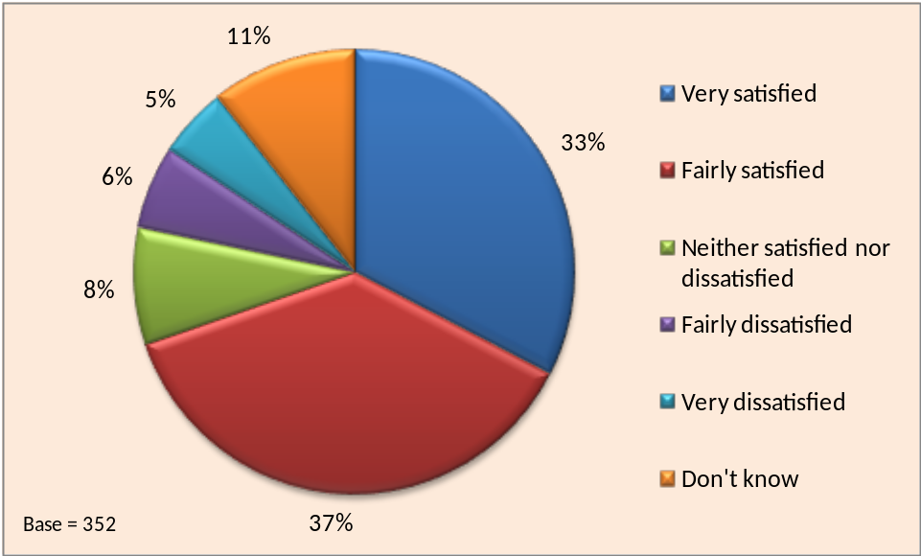

- Just 9% of respondents expressed dissatisfaction with the Skills Account service. Some expressed dissatisfaction that they had not been able to use the Skills Vouchers and others had not been able to find a suitable course. Some said they did not understand Skills Accounts or could not see the purpose of them.
- There was also significant variation in the response according to the age of respondents with younger age groups expressing higher satisfaction. Over 90% of those aged under 25 said they were fairly satisfied or very satisfied compared to less than 50% of the over 45s. However, older respondents were also more likely to say they didn’t know, perhaps reflecting lower use of the Skills Account website compared to younger respondents.
- Respondents were asked if they thought Skills Accounts were a good idea. The chart below shows the results broken down by age, gender and current status. The base number of respondents for each group is shown in brackets. Some of the groups within the current status categories are small and therefore the results should be viewed with some caution. Note that the scale runs from 50% to 100% to better illustrate the differences between groups.

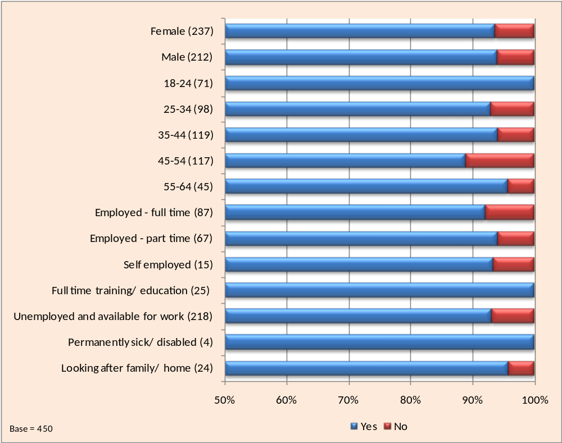
Are Skills Accounts a good idea?
- Overall the response is very positive with 94% of respondents believing that Skills Accounts are a good idea although the chart illustrates some differences among respondent groups. The main variation within groups was related to age. All the respondents aged under 25 thought that Skills Accounts are a good idea compared to just under 90% of those in the 45 to 55 age group. Even so there is still a very positive endorsement of Skills Accounts from over 45s in general.
- It is interesting to compare the finding that 94% of respondents thought that Skills Accounts are a good idea with the finding that over a quarter could not name a specific advantage of having a Skills Account (Section 3.4). This suggests that for some individuals the overall concept of an online account looking at skills and learning was welcomed but that they struggled to identify practical benefits of the service to themselves as individuals at that particular point in time.
- Comments from respondents were mainly positive about Skills Accounts although some respondents were less sure of their worth. The comments below are typical of both points of view.
- Positive Comments
“It is good for you if you are unaware of qualifications or how to go about starting in a career”
“Provides information on courses and funding available in the local area”
“Anything that helps people back into work has to be beneficial”
“Can give directions that you might not have thought of”
“Very impressed, so many people looking for jobs and its good that it provides information that people require”
“Gives opportunity to people to re-train and give them funding”
“I think people use the internet more and more these days and they need lots of options to look at to find out about things. It will be especially useful for young people starting out”
“It is for people like me who are without a job and I think it is a very good”
“Gives more insight into what you can accomplish”
“For me personally I find it difficult to search but if all the information is on a site and is altogether this makes it easier for me to find”
“Gives people the luxury of choosing jobs and training in the privacy of their own home”
“It will encourage people to continue in learning”
- Negative Comments
“I think it is much better for someone to go college and be told what they can do”
“I don't understand anything about it. We were told to sign up by the college I was attending but they gave us no further details about it”
“I think it’s dreadful that you have to provide personal details. I think you should just be able to access details of careers information without having to give personal details”

- Respondents had previously been asked if they had used the Skills Account website features and what they thought of them. The responses were therefore based on individual experiences of the tools available (and many individuals had not used some of them). The chart below shows the views of all respondents on how useful a range of possible online tools and features might be as the website develops in the future. This allowed all respondents to comment, whether or not they had used the existing features on the website.

Views on possible future online tools and features
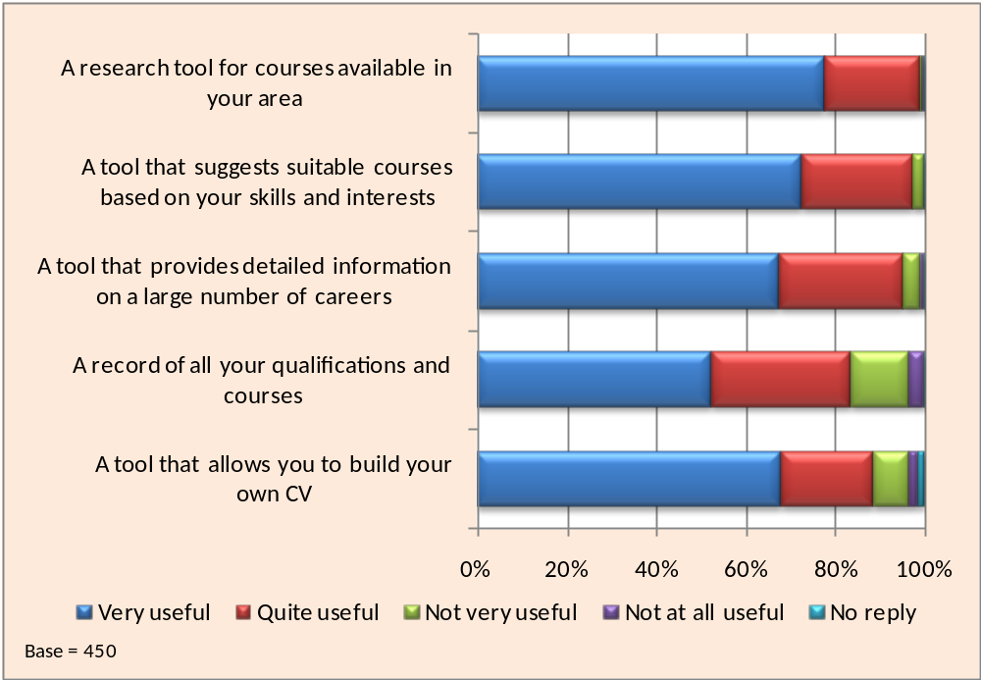

- Most respondents felt all the tools and features listed would be useful. The most popular feature was a research tool for finding locally available courses. Almost all respondents thought that this would be very useful or quite useful. However, in response to an earlier question, less than 80% of respondents who had used the existing Course Finder Tool had found it useful.

- The least popular feature was a record of qualifications and courses, although well over 80% thought this would be useful. Those most likely to disagree were in the 45 to 54 age group (27%) possibly because they only had a small number of qualifications. In contrast, only 6% of 18 to 24 year old thought this feature would not be useful.
- The chart below shows the response to a question about Skills Accounts and respondents’ future learning.
Will a Skills Account encourage you to take part in more learning in the future?
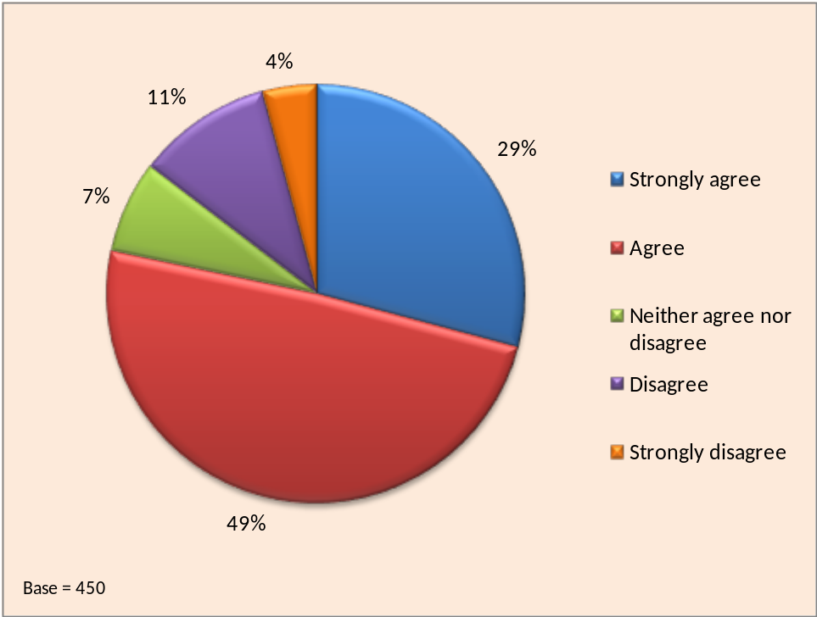

- Almost four out of five respondents said that having a Skills Account will encourage them to take part in more learning in future. Those aged under 35 were the most likely to be in agreement with the statement although a quarter the 45-54 age group disagreed or strongly disagreed.
- There was also some variation in the response according to how respondents were first introduced to Skills Accounts. 92% of those who had first learnt about them from a learning/training provider said they would be encouraged to take part in learning in future through having a Skills Account compared to 80% of those who had been introduced to them by nextstep.
  - Multivariate analysis
- The analysis thus far in this report has been based on bivariate methods of analysing the data by examining the behaviour of a single variable when set against one or more other variables. This section looks at the results of multivariate analyses carried out on the data using two research software tools, SPSS CHAID and MLwiN. Multivariate techniques allow the analysis of multiple variables simultaneously upon which statistical models can be built. From these models the effect can be measured for single variables in isolation when the impact of all the other variables in the model are neutralised.
- Firstly, the survey data was analysed using MLwiN software to isolate the impact of each of a range of Skills Account holder characteristics and responses to questions (such as age, gender and whether or not they had accessed their Skills Account since signing up). The analysis was based on the dependent variable Q20: Overall, how satisfied are you with the Skills Account Service? and the likelihood that they were very satisfied or fairly satisfied. If the program found that a factor made no difference to the probability of a satisfied response it assigned it an outcome of 1. If a factor appeared to increase the likelihood of a satisfied response, other things being equal, it gave it a value above 1. Finally, if a factor appeared to reduce the likelihood of a satisfied response it gave it a value below 1. It also tested the extent to which the outcome could be relied on by calculating the confidence limits (margin for error). If the neutral value of 1 falls anywhere within these confidence limits this means it is possible that the factor has no net effect on the likelihood of a very satisfied or fairly satisfied response (e.g. the 25-34 age group in the chart below).

Satisfaction with Skills Accounts Odds Ratios - Age Group
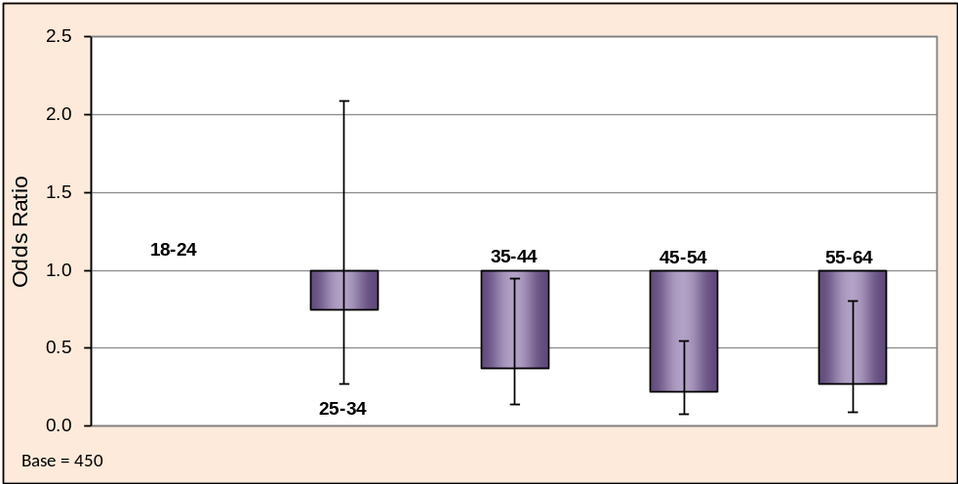

- The above chart shows that age is a key characteristic in respondents’ overall satisfaction when the impact of all other variables in the model are neutralised. This re-enforces the findings from the bivariate analysis which showed that under 25s tended to give the highest satisfaction ratings.
- The second factor within the MLwiN model that had statistical significance was that of frequency of use of the Skills Account website. In the chart below, the category occasionally was chosen as the base against which the others are compared.

Satisfaction with Skills Account Odds Ratios - How often have you accessed your account since you signed up?
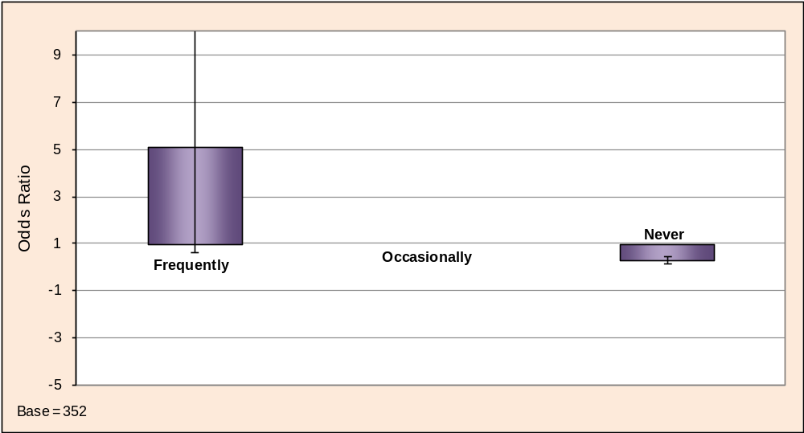
- The chart appears to confirm that respondents who accessed their Skills Account frequently were more likely to express their satisfaction with the service. However the base number of respondents who accessed their account frequently (23) was relatively small compared to the other categories so the findings for this category are less robust. This is emphasised by the very wide error bar which crosses the base value of 1.
- The only other factor within the MLwiN model that had statistical significance was Q6: Have you told anyone else about Skills Accounts? In the chart below, the response category no was chosen as the base.

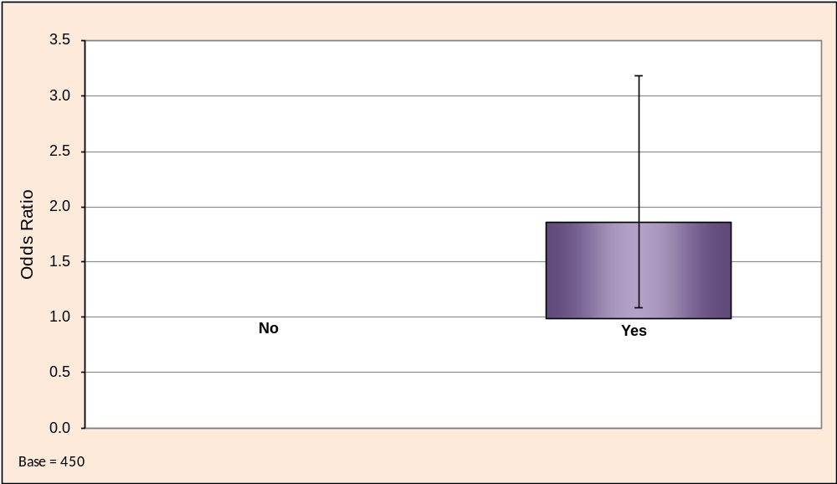
Satisfaction with Skills Account Odds Ratios Odds Ratios - Have you told anyone else about Skills Accounts?

- The chart confirms that those respondents who have told other people about Skills Accounts tend to be the ones who are more satisfied with the service. This is a very positive finding as it suggests that messages about Skills Accounts being carried by word of mouth are more likely to be spoken by those with good experiences of the service.
- The second multivariate analysis tool used was CHAID, which is an abbreviation of Chi-squared Automated Interaction Detector. This program searches large bodies of data to identify combinations of variables that cause maximum variation in a given outcome (i.e. response to the dependent variable). The dependent variable used in the CHAID diagram below is Q11: How often have you used your online account since signing up? CHAID analysis produces a family tree ranking of variables in terms of their relative importance as an explanation of the response to the dependent variable. The chart below shows the full tree produced by CHAID.

- The key variable to which influenced the level of use of the website was how easy respondents had found it use. The analysis confirms that those who found the site very easy or quite easy to use were more likely to be frequent or occasional users.
- Having found the factor with the greatest significance, CHAID then looked for the next factor that would have most impact on each of the diagram’s branches or “nodes.” The third level of the tree shows that for the largest node in term of number of respondents (Node 2), the quite easy category was split by a further variable Q6: Have you told anyone else about Skills Accounts? Those that answered yes were more likely to be frequent users of the website, which reinforces the finding from the MLwiN analysis.
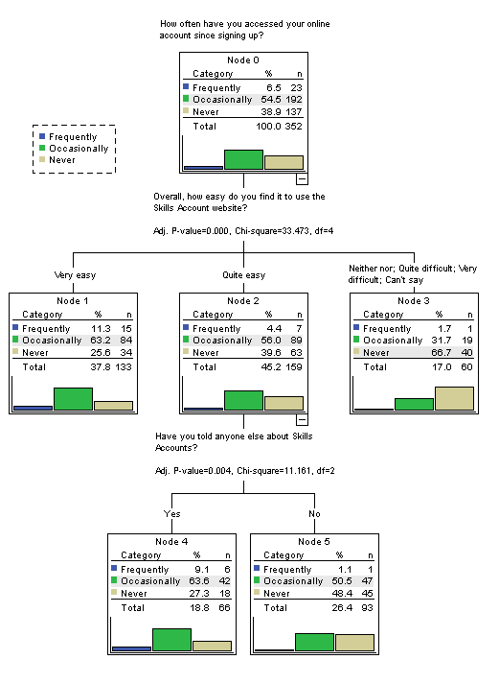
- Findings from the September Telephone Survey
  - Introduction and Methodology
- The second telephone survey took place in September 2009 and, as with the first survey, was carried out using a script based CATI system. The interviews lasted around 12 minutes, which was slightly longer than the first survey because a couple of additional questions were added. A target number of 450 interviews were again planned and this target was met within 2 weeks of the interview process starting. The questions were identical to those asked in the first survey, apart from two additional questions on the Learner Record and Funding Indicator Tools. Appendix 2 includes a copy of the telephone based questionnaire.
- The survey targeted individuals who had registered for a Skills Account between 18th May and 19th August 2009. The Skills Account database included 8,335 individuals in this category, of which 1,725 had valid telephone numbers (around 20% of the dataset). This was double the rate for the first survey (where only 10% had telephone numbers) and the second sample is therefore potentially more robust.
- As discussed in section 2 of the report, individuals who registered for a Skills Account between 18th May and 19th August 2009 were less likely to have accessed the service via a Strategic Learning Provider and the Careers Advice Service and more likely to have accessed the service via nextstep, and the IES trials.
  - Characteristics of Respondents
- A total of 450 Skills Account holders completed telephone interviews for the second survey. Only those who could recall registering for an account were invited to take part. The sample contained almost equal numbers of males (223) and females (227). The chart below shows the age breakdown of respondents.

Age band of respondents
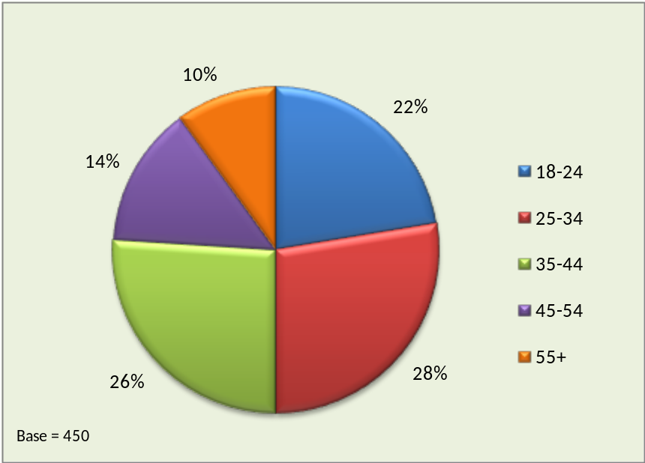

- The age profile of survey respondents was broadly similar to the total population of Skills Account holders registered between 18th May and 19th July 2009. In the first survey the research team noted that there was a sampling bias towards older learners and in the second survey this was corrected for, using pre-defined age quotas.

- Compared to the first survey conducted in June, respondents were more likely to be in the younger age bands (18-24 and 25-35) than in the older age bands. This was predominately due to more accurate sampling rather than any underlying age difference between Skills Account holders before and after May 18th.
- Skills Account holders of all ages were represented in the sample although females had a slightly younger age profile, as the chart below illustrates.

Age and Gender Profile
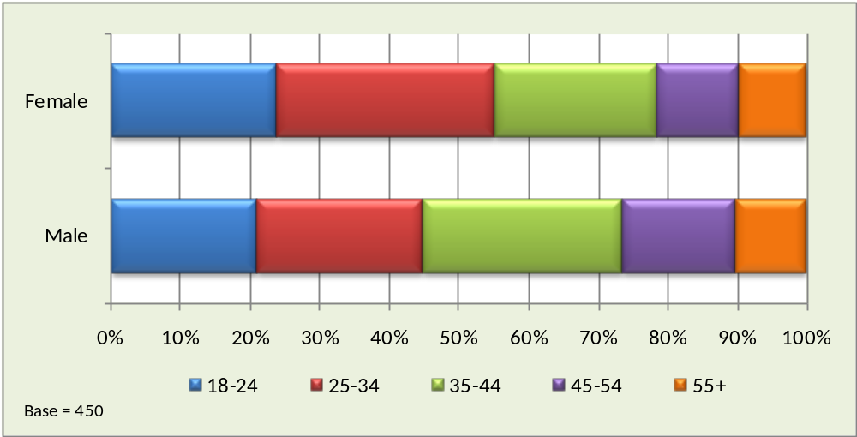

- The chart below shows the broad ethnic group of respondents which was gathered from the survey questionnaire.

Ethnicity Breakdown
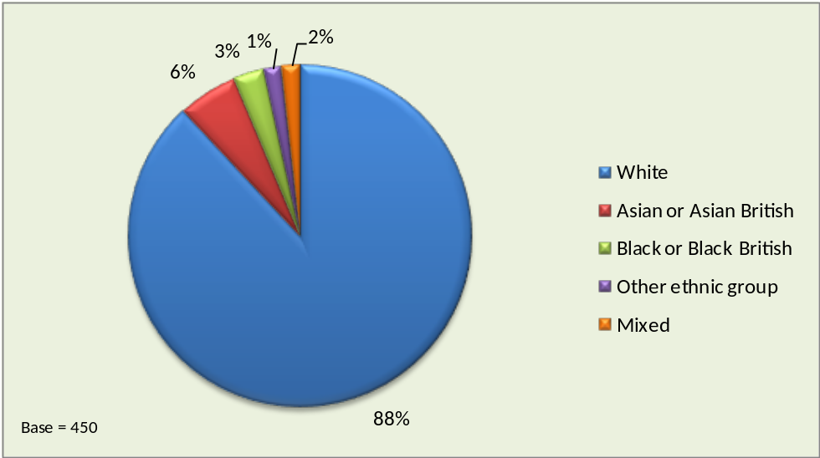

- The respondents were asked if they had taken part in education or training courses in the last three years. The chart below shows the results.

Have you taken any course or training in the last three years?
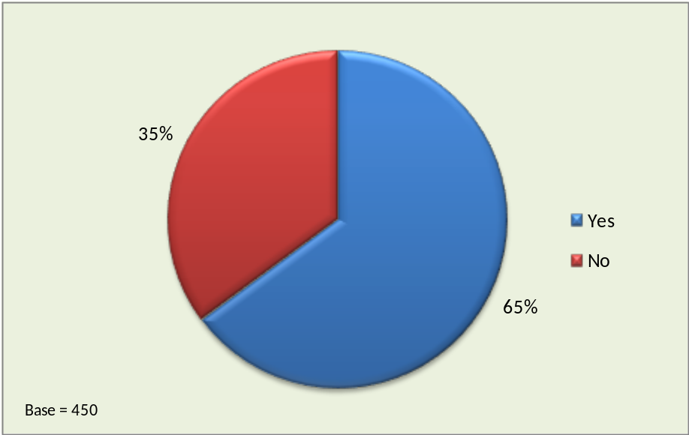

- Compared to the first survey a slightly lower percentage of respondents had been involved in formal learning in the last three years (65% as opposed to 71%). This is possibly because fewer Skills Account holders in the second survey were registered via Strategic Learning Providers (and a significant proportion of college learners may well be repeat learners).
- The responses by age, gender and employment status were similar to the first survey. Individuals who were most likely to have taken a course in the last three years were in the 18-24 age group, were female, and in full time employment. Males in the 45 to 54 age group were the least likely, only just over half having taken a course or training in the last three years.
- 85% of Skills Account holders were currently taking a course or were planning to do so in the near future, as the chart below illustrates. This is a very similar result to the first survey.

Currently taking a Course or in Training
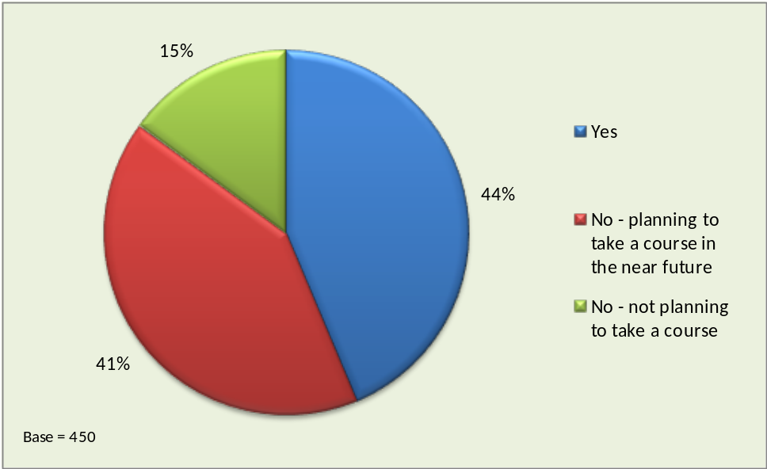

- The proportion of respondents not planning to take a course was highest among those aged 55 and over, rising to 30% of males in this age group. Overall, 20% of males were not currently taking a course or planning to do so in the near future. The equivalent figure for females was just 10%.
- Unemployed respondents were the least likely to be taking a course at the current time (33%) but the most likely to be planning to take one in the near future (51%). Well over a quarter of those in full-time employment or self employment were not taking part in education or training currently nor had any plans to do so. Only one of the 26 respondents who were looking after the family/home was not currently in learning or planning to be in the near future.
- The chart below shows how respondents described their current work status.

Current Status
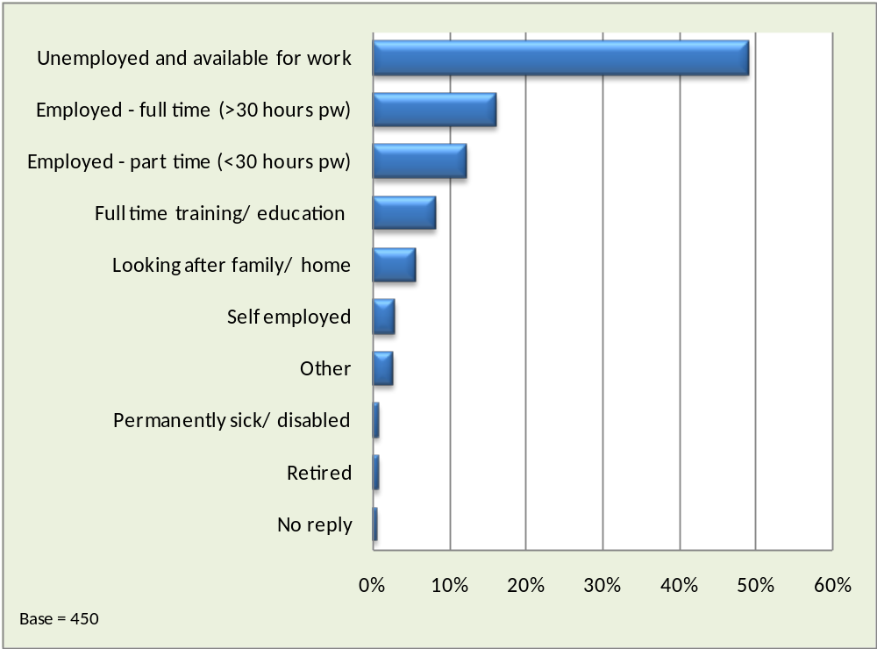
- Overall, just under half of survey respondents were currently unemployed and available for work. Two-thirds of males were unemployed compared to just one-third of females. Just under a third of respondents were in some form of employment.
- In terms of age, unemployment was highest among those in the 35 to 44 and 45 to 54 age groups at almost 60%. Those aged 55 and over were the most likely to be in employment and those aged 45 to 54 the least likely.

- The responses were in general very similar to the first survey. This is interesting given that individuals who registered for a Skills Account between 18th May and 19th August 2009 (the second survey period) were less likely to have accessed the service via a Strategic Learning Provider and more likely to have accessed the service via nextstep and the IES trials.
- The chart below shows the distribution of respondents by LSC Region.

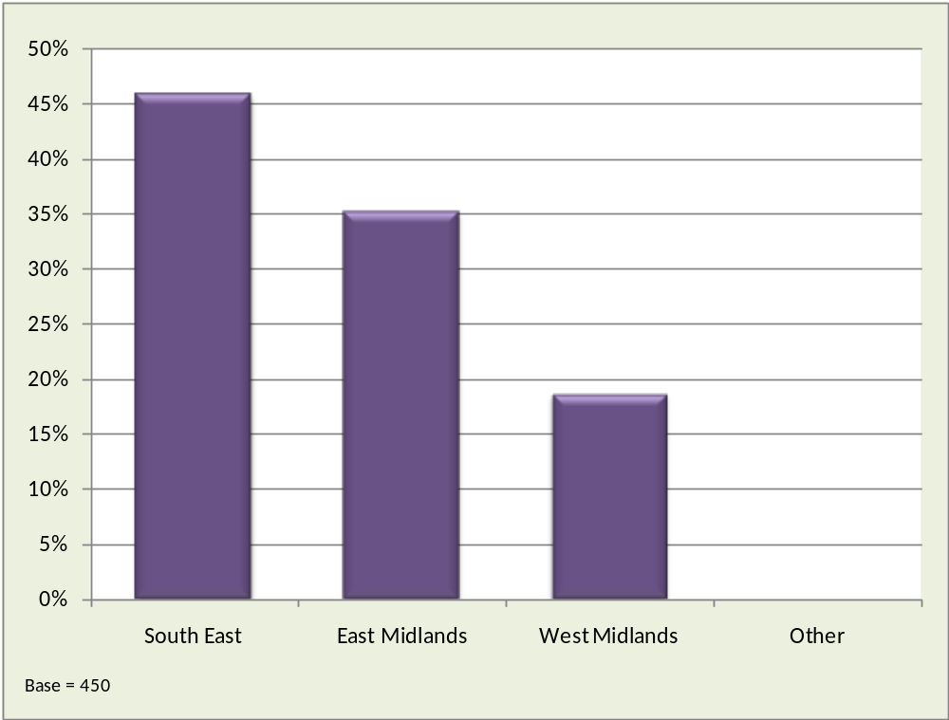
Home Location of Respondents (LSC Region)

- The Skills Account holders surveyed were mostly from the two main trial LSC Regions, the South East and the East Midlands which accounted for over 80% of respondents. Just under a fifth were from the West Midlands where Skills Accounts have been trialled with Jobcentre Plus clients only. The numbers of Skills Account holders registered between 19th May and 19th August in the South East and the East Midlands were very similar, with each region accounting for around 40% of all registrations. However, almost a quarter of account holders from the South East supplied a contact telephone number compared to just 18% of those from the East Midlands.
- Compared to the first survey the percentage of respondents from the West Midlands and the South East had increased and the percentage of respondents from the East Midlands had gone down. This is because the West Midlands and South East are IES trial regions, offering Skills Accounts through the ESP programme. This was a major route for Skills Account registration during the second survey period.

  - Skills Account Awareness and Initial Information
- The chart below shows how respondents to the September survey first became aware of Skills Accounts. Almost 40% had been introduced to Skills Accounts through a learning/training provider and for a quarter the first contact had been through Jobcentre Plus. In addition to SLPs in the South East and East Midlands, learning/training providers included the ESP providers in the West Midlands and the South East, who were providing specific basic skills and employability skills training programmes for Jobcentre Plus clients as part of the IES trials.

How did you first become aware of Skills Accounts?
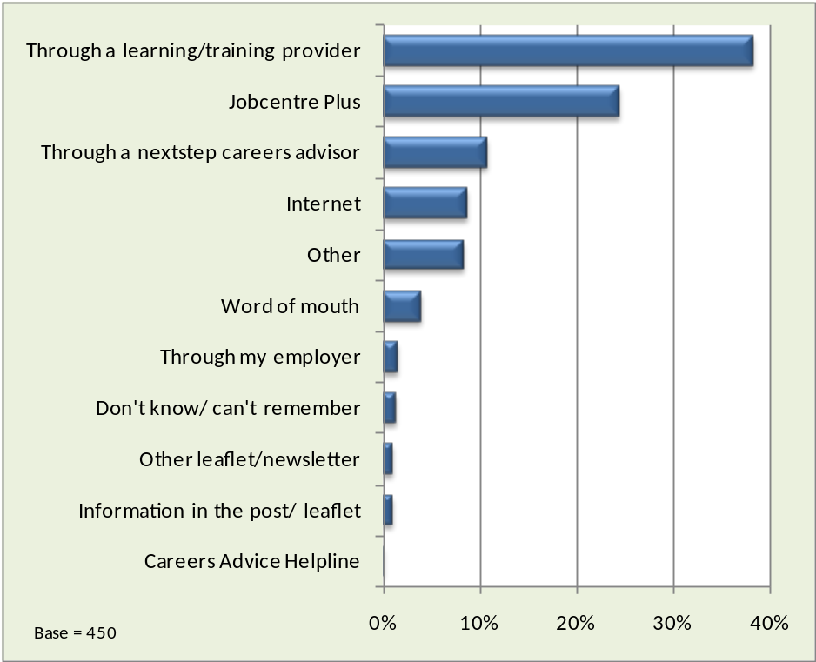

- 55% of 18-24 year olds had first learnt about Skills Accounts through a learning/training provider compared to around a third of those falling into older age groups. Males (46%) were also more likely than females (31%) to have cited learning/training providers as providing their initial introduction to Skills Accounts. Almost a half of respondents from the East Midlands had been introduced to Skills Accounts this way compared to just over a third those from the South East.
- Almost a quarter of respondents had first heard of Skills Accounts through Jobcentre Plus. This proportion rose to around a third among those aged 45 to 54 and 55+ but only one in eight of the 18 to 24 year olds said Jobcentre Plus was where they first heard about Skills Accounts. Males (35%) were more than twice as likely as females (16%) to cite Jobcentre Plus as their first contact. Respondents for the West Midlands were the most likely to have heard about Skills Accounts through Jobcentre Plus (43%).
- 11% of respondents had heard about Skills Accounts from a nextstep careers advisor. Respondents from the East Midlands were the least likely to have heard this way (7%) and those from the West Midlands were the most likely (17%). Only 1% of West Midlands’ respondents cited the Internet as first raising their awareness of Skills Accounts (these individuals almost exclusively accessed Skills Accounts through the IES trials).
- Respondents were asked to name all their sources of information about Skills Accounts. The sources were read out in turn by the interviewer (not in the order shown in the chart) and respondents were asked to identify the ones from which they had received information. The red bars represent the percentage of respondents that named each of those listed as a source of information and the green bars show the percentage that identified each as their single main source of information.

Sources of Information about Skills Account
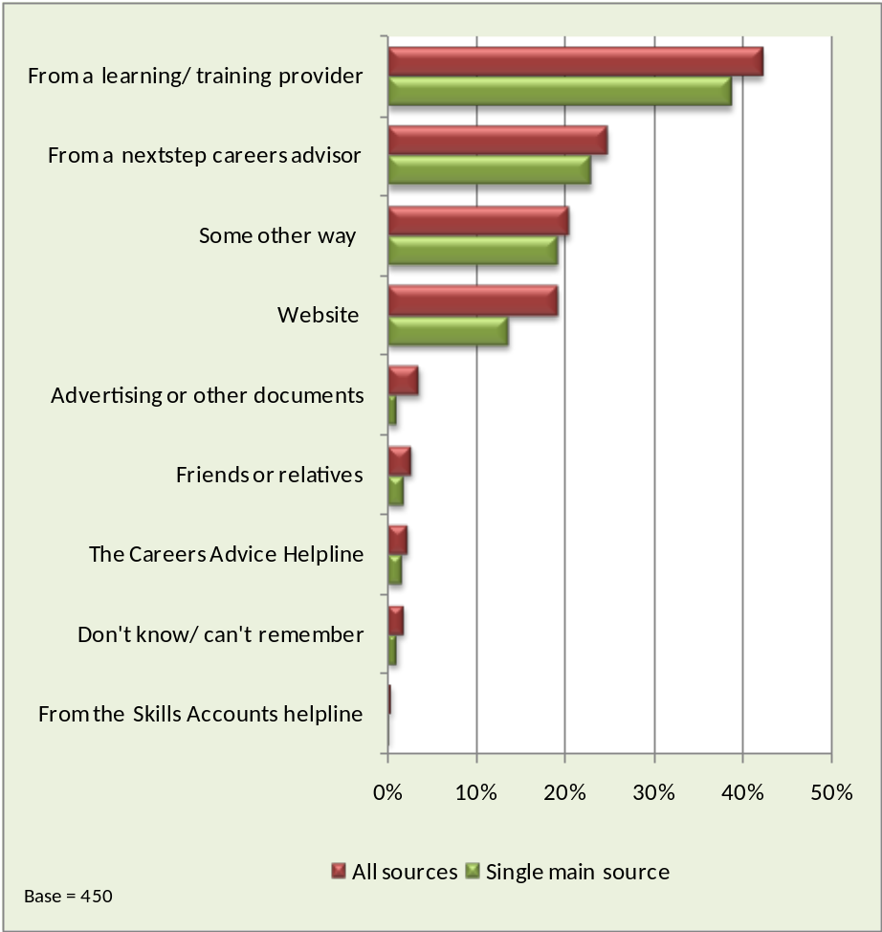

- Almost 40% respondents cited a learning/training provider as their single main source of information about Skills Accounts. This figure rose to 58% among 18 to 24 year olds.
- Almost half of those who said they had sourced their information about Skills Accounts some other way mentioned Jobcentre Plus. Other sources identified included PeopleServe, work/employer and Probation Officer.
- Only around one in eight respondents had seen any advertising or written information about Skills Accounts before signing up, as the pie chart below illustrates (a similar percentage to the first survey in June).

Did you see advertising or other documents about Skills Accounts before signing up?
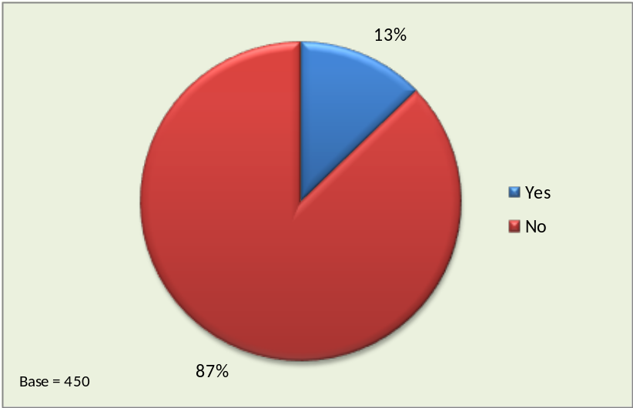

- Those respondents who had seen any advertising or written information were mainly positive about what they had seen or heard. Comments included:
“It was informative and explained what was on offer”
“The leaflets are fine; they have plenty of information about the site”
“It gave me the wrong impression as it led me to believe it was to access local jobs rather than information about training”
- Females (19%) were three times as likely as males (6%) to say they had seen any advertising about Skills Accounts. Those in the 25 to 34 age group were the least likely to have seen advertising (8%) and in terms of Region, those from the West Midlands were the least likely (also 8%).

  - Advantages of Skills Accounts
- The chart below shows the results when the 382 respondents that had activated their account online were asked to identify, unprompted, the most important advantages of having a Skills Account. Respondents could give more than one answer if they wished so the bars in the chart add up to more that 100%.

Most important advantage of having a Skills Account
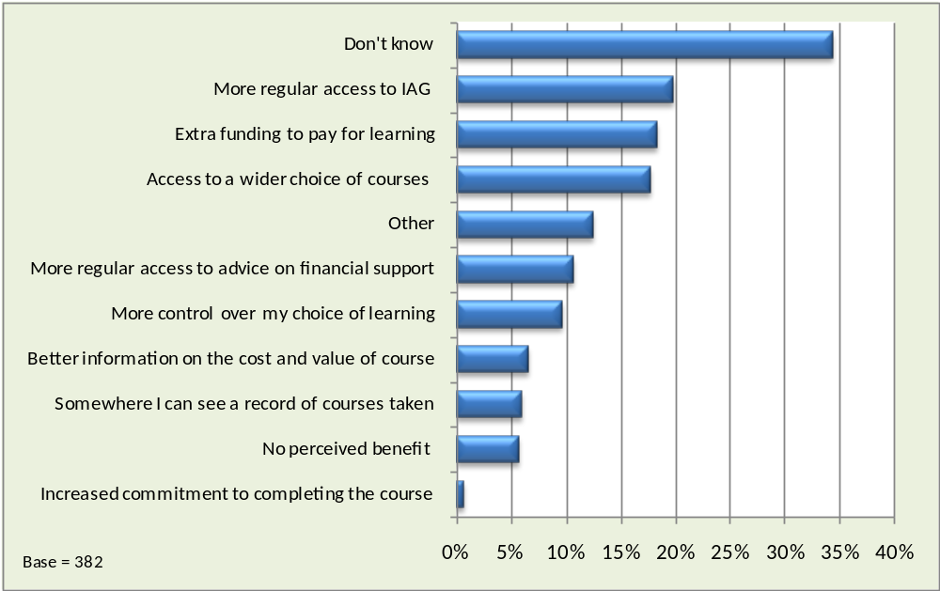
- Almost 35% of respondents did not know what the advantages of having a Skills Account were. These respondents tended not to have used most of the skills and features on the website and therefore felt unable to offer an informed view. The percentage was highest among respondents from the West Midlands at 39%, which suggests some correlation between this response and individuals on the IES trials. The proportion of those respondents who were looking after the family/home answering don’t know to this question was particularly high at almost two-thirds, although the base number of respondents falling into this group (22) was relatively low.
- These results suggest that the benefits of Skills Accounts may be less immediately clear to IES clients who require basic skills or employability skills support in order to gain sustainable employment. Many of these individuals may have been unemployed for a considerable period of time. Other research conducted by the research team indicates that these individuals’ primary focus is often on short term goals (such as getting a job to pay off debts) rather than longer term planning for learning and a career.
- The most frequently cited advantage of having a Skills Account was more regular access to Information and Guidance about careers and learning at 21%. This percentage was highest among respondents aged 35 to 44; and those who had first learnt about Skills Accounts through a nextstep Careers Advisor.
- 18% of respondents believed that having a Skills Account would give them access to a wider range of courses than they would have had otherwise. This percentage was lowest among those age 25 to 34 and highest among those aged 55 and over (33%).
- Extra funding to pay for learning was the third most frequently cited advantage of having a Skills Account, although this was considerably lower than in the first survey in June. This was possibly because a higher proportion of respondents in the second survey did not have to pay course fees for their current course because they were part of the IES trials. This hypothesis is supported by the considerable regional variation in the proportion of individuals who cited extra funding to pay for learning as an advantage of having a Skills Account. Almost a quarter of respondents from the East Midlands mentioned this compared to 16% of respondents from the South East and just 4% from the West Midlands.
- Among those respondents who gave other reasons were the following comments:
“Build my own CV”
“Guides you in the right direction, gives you hope and confidence for the future. I am more motivated”
“Opens your eyes as to what is available to you.”
- The next question aimed to gather evidence on whether the Skills Account website was newsworthy or forgettable. Respondents were asked if they had told anyone else about Skills Accounts and the results are shown in the figure below.

Have you told anyone else about Skills Account?
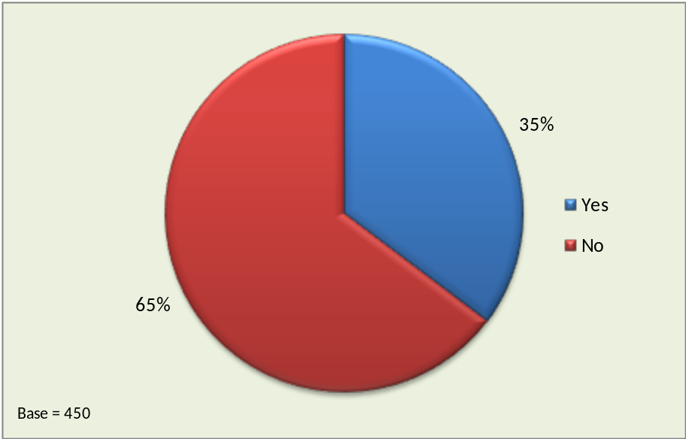

- Overall, almost 40% of respondents had told someone else, although females (40%) were more likely than males (30%) to have done so. Respondents from the South East and East Midlands were also more likely than those from West Midlands to have shared their experience of Skills Accounts with others. The percentage of respondents who had told someone else about Skills Accounts was slightly lower in the September survey (35%) than in the June survey (39%).
- In terms of current status, those in full or part-time employment or full-time education or training were the most likely to tell someone else about Skills Accounts. Those that were least likely to have spread the word were those potentially in more isolated situations, including the self-employed, the unemployed and those at home with family/caring responsibilities.
  - Activating and Accessing the Skills Account Website
- The chart below shows the proportion of respondents that could remember activating their Skills Account online.

Do you remember activating your Skills Account online?
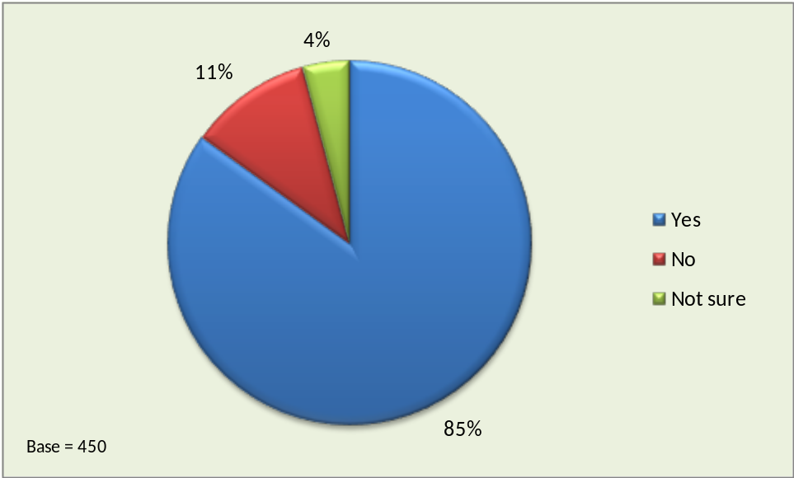

- The yes total includes respondents who were initially not sure but could remember using the Skills Account website and therefore must have activated their account to do so. The ones that answered no had no recollection of activating their account or using the website. Respondents in the not sure category also had no recollection but thought it was quite possible they had done so.
- More respondents from the September survey remembered activating their Skills Account (85%) than from the June survey (78%). This is possibly because more September respondents activated their account with support from a nextstep advisor or as part of a structured training session within the IES trials.
- The 85% of respondents (382 in total) that could recall using the Skills Account website were then asked a series of questions about their usage of the site.

- Those who could recall using the Skills Account website were asked how easy it was to activate their account.

How easy was it to activate your Skills Account?
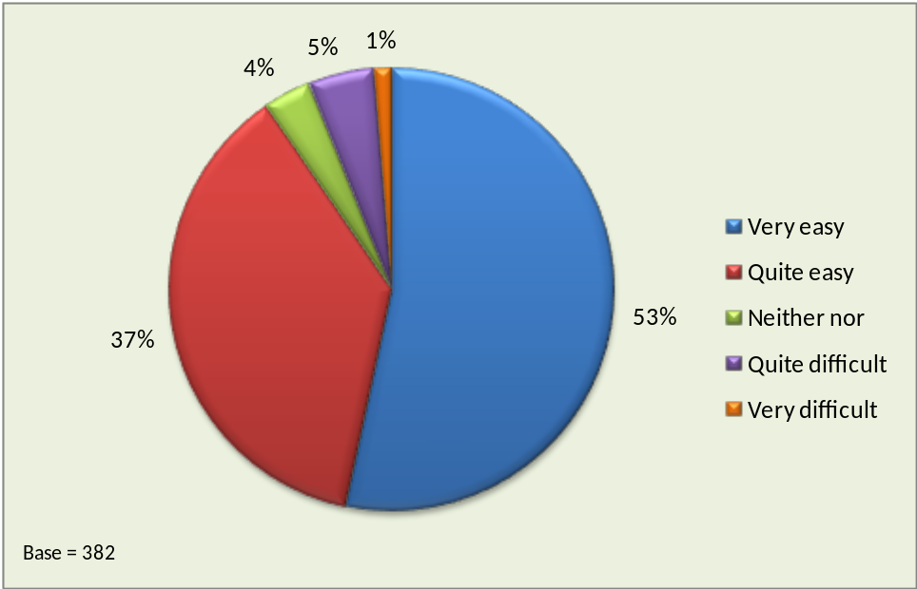

- Just under 90% of respondents said they had found it very easy or quite easy although this response varied by region. Those from the East Midlands and the South East were much more likely than those from the West Midlands to say it had been very easy to activate their account.
- The total percentage of respondents who found it very easy or quite easy to activate their Skills Account was identical in the June and September surveys (both 53%) even though the characteristics of the samples were slightly different.

- Of the 382 respondents that answered the questions on website usage, 35% (132) said they had received help in activating their account online. This is much higher than in the June survey (23%) confirming that a higher proportion of Skills Account holders between May and August activated their account through an ESP provider within the IES trials or during a face-face interview with a nextstep advisor. The figure below shows who had provided the help.

Who helped you activate your Skills Account?
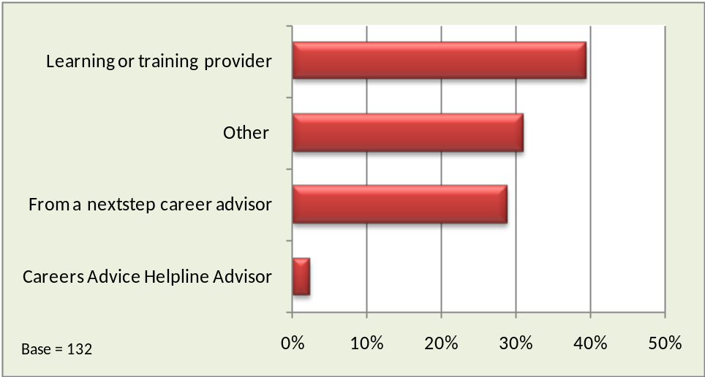

- Just under 40% the respondents said they had received help from a learning or training provider although almost a third mentioned other sources of assistance. The most frequently mentioned other sources were: Jobcentre Staff, Skills Advisor and family/friends.

- The next question aimed to gather evidence on respondents’ own perception of their level of usage of the Skills Account website. It asked how often they had accessed their account since signing up. The chart below shows the results.

How often have you accessed your online account since signing up?
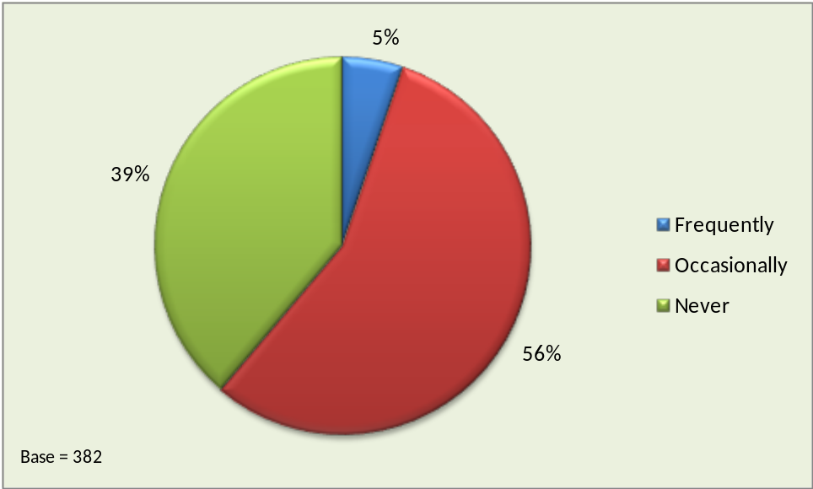

- The majority of respondents said that they were occasional users of the website although almost 40% had not re-visited the website since first signing up.
- These findings are virtually identical to the findings from the June survey, suggesting that frequent usage of the website usage is not dependent on the initial access route into Skills Accounts.
- Those aged 55 and over were the least likely to have revisited the Skills Account website since they first activated their account. Over half of this group had not visited the website again.
  - Course Finder Tool
- The Course Finder Tool on the Skills Account website allows users to search a database of courses and find out which providers are offering courses that they might be interested in. 34% of the respondents who remembered visiting the Skills Account website said they had used the Course Finder Tool, which was the highest percentage for all of the tools available, but lower than in the June survey. Their views on how useful they had found the Tool are shown in the figure below. Just over 80% of respondents said that they found the Tool very useful or fairly useful (similar to the percentage from the June survey).

How useful was the Course Finder Tool?
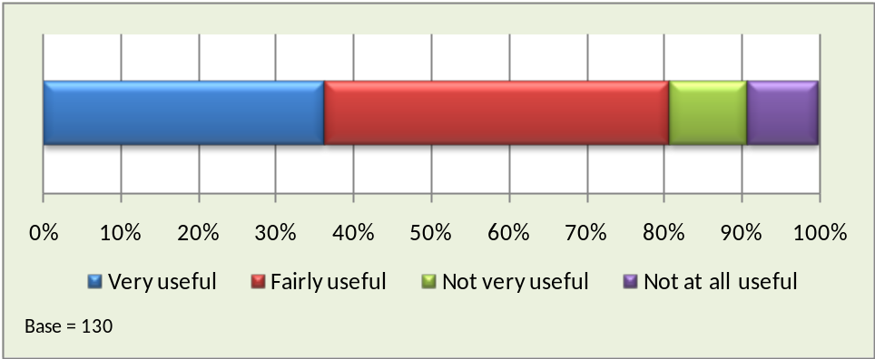

- Some of the positive comments about the Tool included:
“It gave me an idea of what courses were available”
“It advised me on which colleges did the course I was looking for”
“Shows what courses are available in different areas”
“Gave me options and choices I hadn't considered before”
- Where individuals gave less positive comments this was often because the information was not specific enough for their individual circumstances. For example:
“It didn’t have a lot of courses in the area I live in”
“I have a specialised skill set, and the results were too general for me.”
  - Skills and Interest Tool
- The Skills and Interest Tool assesses user’s current skills and interests using a series of multiple choice questions and suggests possible career options. 27% of the website visitors had used the Skills and Interests Tool on the website. The figure below shows how useful they found it. More than 88% said that the Tool was very useful or fairly useful whilst only 3% said that it was not at all useful.

How useful was the Skills and Interest Tool?
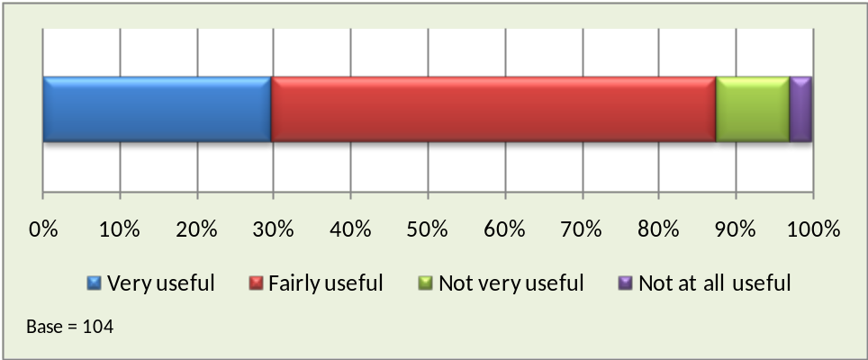

- Positive comments about the Tool included:
“It gave me an idea of things that could interest me. It’s another line of research for finding a new career path”
“It brings out your strengths and weaknesses which you can add to your CV”
“It has shown me that I could actually go for a job that suits my personality”
“It made me aware of jobs I would never have considered. It opened my eyes”
- Again, some respondents commented that outputs were often fairly general or not specific enough for their current circumstances.
“It did not come out with anything that was relevant.”
“It might be a bit broad.”
- The findings from the June and September surveys were virtually identical, with similar percentages of respondents having used the Tool and similar percentages having found it very useful or fairly useful.
  - Jobs Profile Tool
- The Jobs Profile Tool provides detailed information about different careers. The following chart shows how useful respondents found the Jobs Profile Tool. 84% of respondents said that this Tool was very useful or fairly useful, whilst 6% said the Tool was not at all useful.

How useful was the Jobs Profile Tool?
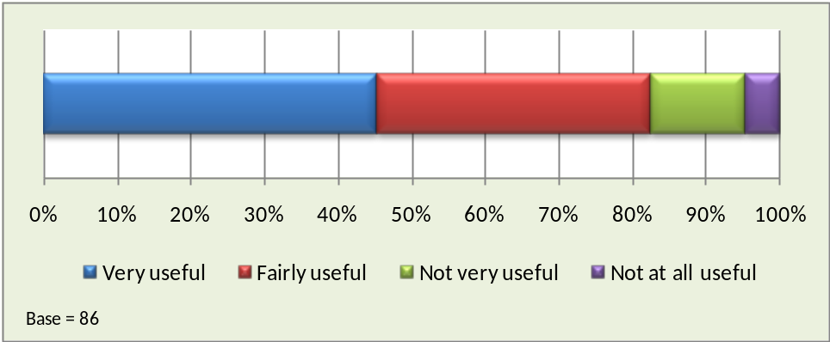

- Respondents felt the Tool was generally easy to use and informative. Comments included:
“Broadened my awareness of the different jobs that are out there”
“It gave me descriptions of different jobs”
“It’s really hard to get an honest countdown about the different jobs out there”
“It let me know how to get into different fields of work, so I could plan my training.”
- Some of the less positive comments related to its scope and usability for example:
“I found it was very limited”
“It's OK but it is not that easy to follow, most students don't understand it and have difficulty”
“There are quite few jobs on there to look at but there were not a lot for my age group”
- There was little significant variation in responses to this question between the two surveys, with a slightly higher percentage of respondents having found the tool very useful or fairly useful in the September survey.

  - Qualification Calculator
- 124 (32%) of the respondents who had visited the Skills Account website remembered using the Qualifications Calculator Tool. This was a lower percentage than in the June survey, possibly because the number of individuals with no or few qualifications was higher in the second survey so the Tool was less relevant. The figure below shows how useful they found it. Whilst 70% found it very useful or fairly useful, 11% found it not at all useful (identical to the response from the first survey in June).

How useful was the Qualifications Calculator
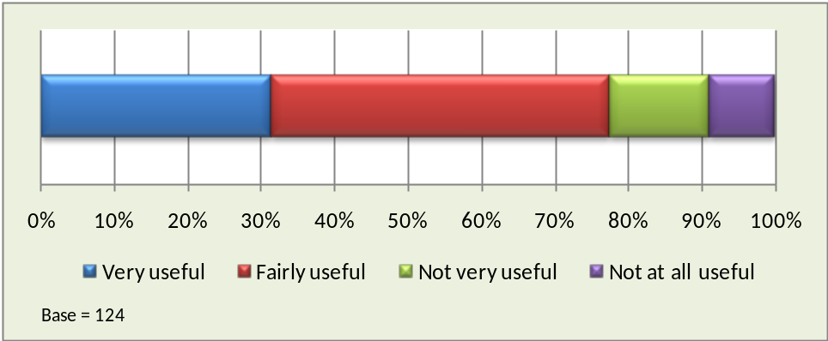

- Respondents who were positive about the Tool found it easy to use and helpful. For example three respondents said:
“I didn't know what my qualification level was and it worked it all out for me”
“I have a number of different qualifications and it is helpful to know what level they are”
“Was not aware that different qualifications were allocated different levels and wanted to find out what level my degree was”
- Some respondents had experienced difficulties using the calculator as in the following two comments.
“I couldn't find any of my qualifications”
“I found it very confusing and I'm quite aware of the different qualifications. I think a potential learner would be put off by that”
  - Skills Vouchers
- 178 respondents, representing just under half of those who had visited the website, said they were aware of the Skills Voucher feature but less than a third of these had generated a voucher. The percentage of respondents who were aware of the Skills Voucher was much lower in the September survey than in the June survey. This was possibly because this facility was not signposted by some nextstep advisors and staff delivering the ESP programme.
- The 56 respondents who had generated a Skills Vouchers were asked what they thought the Skills Voucher provides and how useful they thought it was. The responses to these questions are listed in Appendix 4 and are similar to those from the June survey. The figure below shows the results to the question on how useful they thought the Skills Voucher was.

How Useful was the Skills Vouchers?
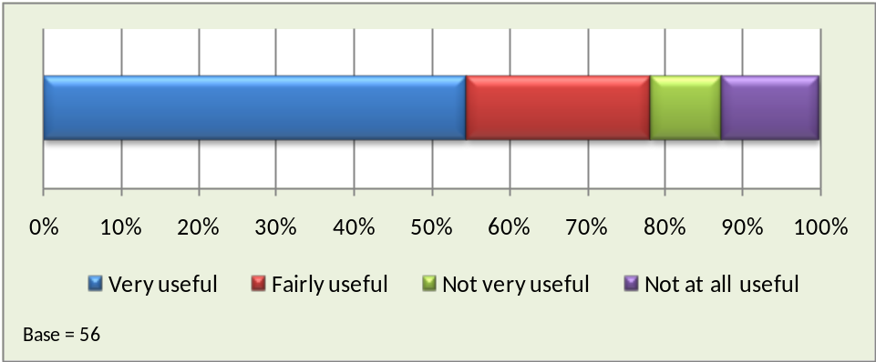

- In general, the usefulness ratings and the comments about Skills Vouchers did not vary significantly between the June and September surveys. Just over three-quarters thought the Skills Voucher would be fairly useful or very useful and there were many positive comments as shown by the following example:
“Helped me to have confidence when meeting my tutor as I felt it confirmed that I would be able to meet course expenses”
- However there appeared to be confusion over what the Skills Voucher provides as illustrated by the comments below. As in the June survey vouchers were often not accepted by providers and individuals often thought that vouchers would give ‘money off’ the cost of the course, when in reality they just gave information to the user.
“It says that I may qualify for the funding but it isn't clear so I have had to go through college anyway. I had no clue what to do through the instructions on the website”
“I think it is excellent if it works but it is confusing to me. I took it to the college and they said I was not entitled to anything, although the voucher said I was entitled to £3590”
  - Learning Record
- The Learning Record Contains details of learners’ past achievements and qualifications to date, verified by their learning provider. It also includes a section where learners can add their prior learning achievements and any courses they are taking. The Learning Record was introduced into the Skills Account website in July and questions about the Learning Record were only asked in the September survey.
- The following chart shows how useful respondents found the Learning Record.

How useful was the Learning Record

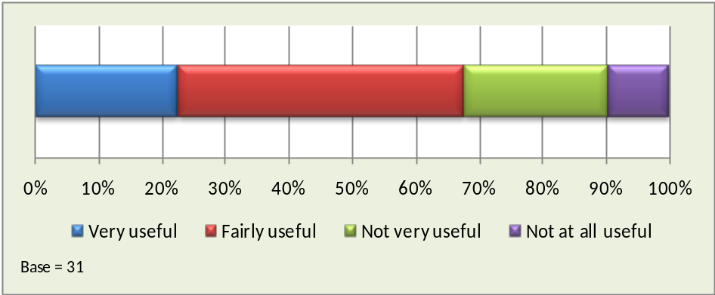

- Only 31 respondents had used the Learning Record and around two-thirds had found it to be fairly useful or very useful.
- Comments on the Learning Record feature were mixed. Some respondents explained why they had found the feature useful for example:
“It was good to see what qualifications I had all in one place, I realised I had more than I thought and remembered some that I had actually forgotten about”
“This was very useful because it sorts it out and it has your newest qualification first to the oldest in order so you always know where you are up to and it is easy to find”
- However, other respondents were not convinced about the benefits of such a function:
“It is just a record, it doesn't really help me”
“I have my achievements and qualifications on paper in front of me so I don’t need this tool”

  - Funding Indicator
- The Funding Indicator Tool can be used to identify the funding that the Government may have contributed towards learning and, where appropriate, is set against a learner’s own contributions. Like the Learning Record, the Funding Indicator Tool was introduced into the Skills Account website in July and questions about the Funding Indicator Tool were only asked in the September survey. The following chart shows how useful respondents found it.

How useful was the Funding Indicator Tool?
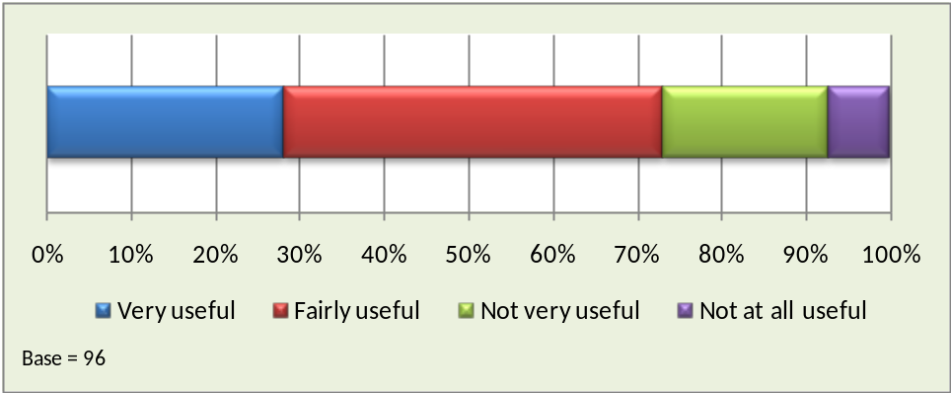

- 96 respondents had used the Funding Indicator Tool and just under three-quarters had found it to be fairly useful or very useful.
- The following comments are typical examples from respondents who had found the Funding Indicator useful.
“It gave me a perspective on how much it was going to cost for me to go on the course I want”
“I found out what I was entitled to, and therefore what courses I could get help with”
“This tool was mainly the reason why I was using the account, everything was easily laid out”
- However, some respondents said they found the tool awkward to use and other said they did not see the point of it, as illustrated by the following comments
“I used it ok but I don’t really know what it was about, it didn't explain itself properly”
“This was very misleading. You see a figure of money and you think this is what has been allocated or may be allocated but this is not the case. You never see any money at all”
- Telephone interviewers also reported that in some cases respondents were confused between the Funding Indicator Tool and the Skills Voucher feature and found it difficult to distinguish between the operation and purposes of these two different features.
  - Overall Views on Skills Accounts
- All the respondents that had used the Skills Account website were asked how easy it was to use. The figure below shows the results.

How easy is it to use the Skills Account website?
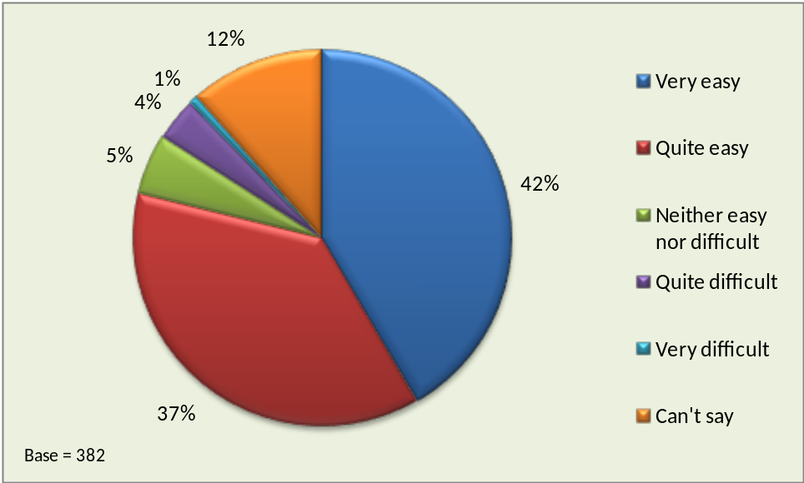

- Most respondents found the website easy to use with almost 80% saying it was very easy or quite easy (mirroring the results from the June survey). Most of those who answered can’t say had not revisited the Skills Account website since first signing up. The younger the respondents were, the more likely they were to say the website was very easy to use. Half of 18-24 year olds gave this response compared to a quarter of those aged 55 and over.
- All of the respondents who said they frequently accessed their Skills Account online also said they found the website very easy or quite easy to use. Reasons given for particular responses to this question included:
- Very easy/quite easy
“I'm fairly competent and I found it one of the most pleasurable sites to use”
“Easy to use, easy instructions to follow”
“Very straightforward and user friendly”
- Very difficult/quite difficult
“I found it difficult to find my way around to get information”
“I've had quite a few problems, couldn’t log in, asked for help and was told I should make a new account”

- The chart below shows the results when all respondents were asked about their overall satisfaction with the Skills Account service. The chart is based on the 382 respondents that remembered activating their account. 14% did not feel they had sufficient knowledge about Skills Accounts to offer a view.

Overall Satisfaction with the Skills Account Service
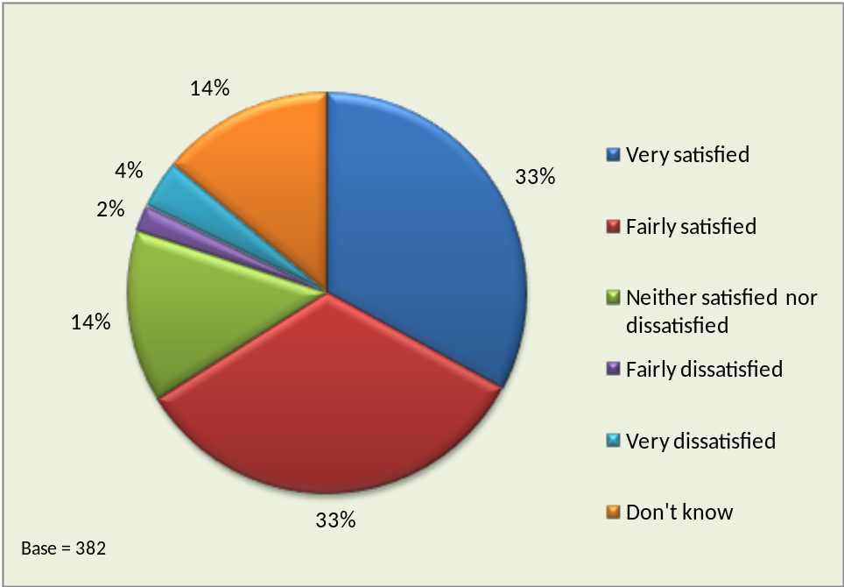

- Only 6% of respondents expressed any dissatisfaction with the Skills Account service while two-thirds said they were fairly satisfied or very satisfied. The satisfaction rate (those who were fairly satisfied or very satisfied) was highest among those in the 18 to 24 age group at 71%.
- The response to this question was closely correlated with respondents’ views on the ease of use of the website. Half of those who thought the website was very easy to use also said they were very satisfied with the Skills Account service compared to a quarter of those who found it quite easy to use. 15% of those who found the website neither easy nor difficult, 7% of those who found it quite difficult and none of those who found it very difficult said they were very satisfied with the Skills Account service.
- The percentage of respondents who were dissatisfied with the Skills Account service was lower in the September survey than in the June survey. This was possibly because a higher proportion of respondents in the September survey had help in activating and using their account (via a nextstep advisor or ESP provider) and any problems were therefore quickly sorted out.
- Respondents were asked if they thought Skills Accounts were a good idea. The chart below shows the results broken down by age, gender and current status. The base number of respondents for each group is shown in brackets. Some of the groups within the current status categories are small and therefore the results should be viewed with some caution. Note that the scale runs from 50% to 100% to better illustrate the differences between groups.

Skills Accounts a good idea?
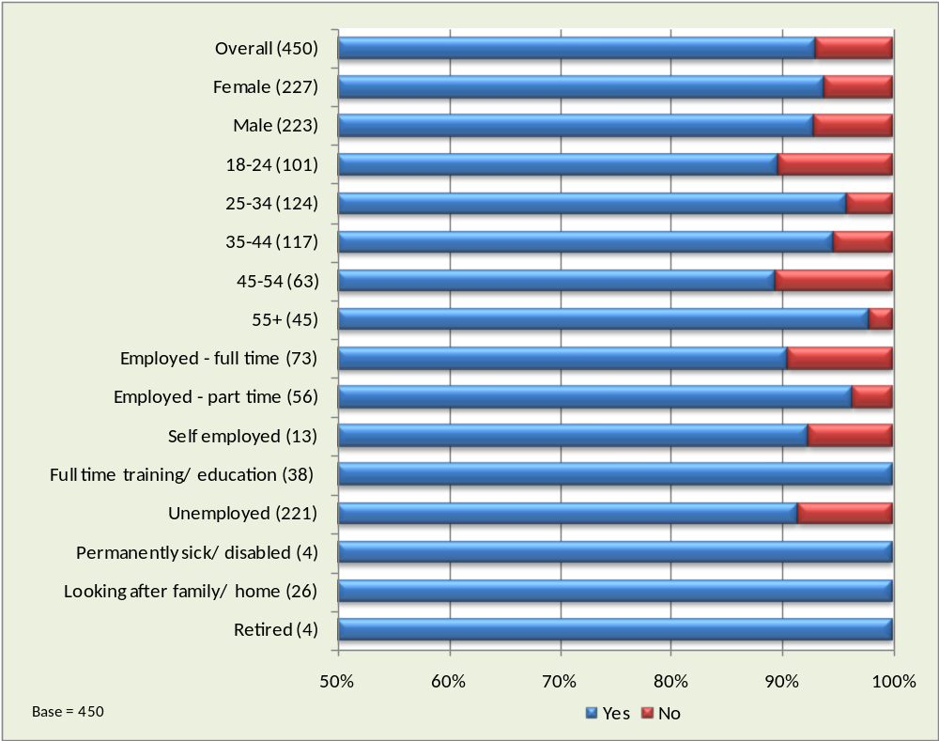
- Overall the response is very positive with 93% of respondents believing that Skills Accounts are a good idea although the chart illustrates some differences among respondent groups. In terms of current status the least likely to think that Skills Accounts were a good idea were those in full-time employment.
- The results in general are similar to those from the June survey. However, whilst 89% of 18-24 year olds thought that Skills Accounts were a good idea in the September survey, 100% thought that they were a good idea in the June survey. This variation may be due to the greater number of Jobcentre Plus clients in the second survey who might prefer a face-to-face rather than an online service.
- Comments from respondents were mainly positive about Skills Accounts although some respondents were less sure of their worth. The comments below are typical of both points of view.
- Positive Comments
“It helps people to get jobs etc. especially older people”
“For those who can’t afford to pay for the course - It’s good for them”
“It appears to help people look for jobs and what qualifications they will need”
“There are a lot of features that are very helpful like finding funding and courses”
“Makes sense to have everything in one place”
“If it helps people to find jobs etc. its a good idea”
“I used the website to produce my C.V. A lot of the other websites charge for a this service whereas I received help and it was free”
“It gives you an opportunity to learn which may not have been otherwise available”
“They can help people who can’t afford to do things on their own”
“Opens your horizons for what you could possibly do”
“I imagine they could help a lot of people especially with the funding that may be available”
“It seems to help people to look for jobs and careers and also what qualifications you will need”
“I think they are a great idea that is why I had a look, I'd love to get better qualifications. It was so confusing it put me off though”
- Negative Comments
“Well my opinion is that I could go to other places and get the same information e.g. Connections, Colleges, Direct.Gov website etc.”
“What’s the use of a Skills Account when you don’t know what it’s about and how to use it”
“I just think its time consuming with very little benefit”
“I think these services are just going round in circles, each one is giving the same things that we've had before. It is always better to deal with people on a face to face basis”
“I do not think it helps you in any way to get back into work”
- Respondents had previously been asked if they had used the Skills Account website features and what they thought of them. The responses were therefore based on individual experiences of the tools available (and many individuals had not used some of them). The chart below shows the views of all respondents on how useful a range of possible online tools and features might be as the website developed in the future. This allowed all respondents to comment, whether or not they had used the existing items on the website.

Views on possible future online tools and features
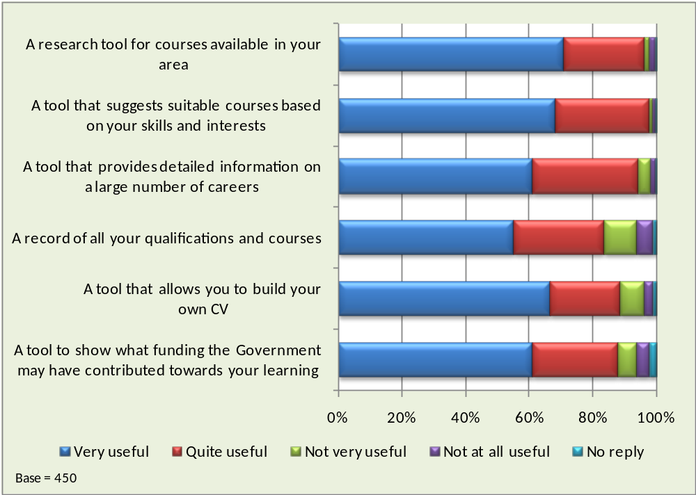
- According to respondents, the most popular tools on a future Skills Account website would be those that helped people find courses. 96% thought a tool to find courses available in their area would be very useful or quite useful and 98% thought that a tool that suggests suitable courses based on their skills and interests would be very useful or quite useful.
- The least popular feature was a record of qualifications and courses, although well over 80% thought this would be useful.
- The findings from this question were very similar in both the September and June surveys. The September survey also asked respondents how useful they thought a tool would be that showed how much the Government contributed towards their learning. 61% thought that this would be very useful and a further 26% thought it would be quite useful.
- The chart below shows the response to a question about Skills Accounts and respondents’ future learning.

Will a Skills Account encourage you to take part in more learning in the future?
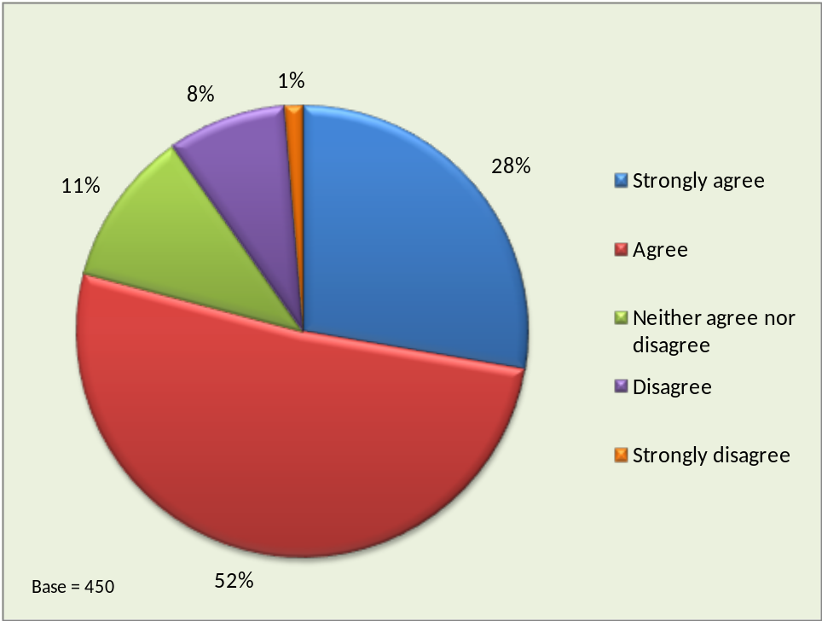

- 80% of respondents strongly agree or agreed that having a Skills Account will encourage them to take part in more learning in future although this figure rose to 93% among those who said they were very satisfied with the Skills Account Service and 85% among those who were fairly satisfied. Around half of those who were dissatisfied with the service did not think having a Skills Account would encourage them to take part in more learning in the future.
- However one in five respondents in the 45 to 54 age group disagreed. In terms of work status, disagreement was highest among those in full-time employment or self-employment at 15%.
- Only 9% of respondents disagreed or strongly disagreed that Skills Accounts would encourage them to take part in more learning in the future. In the first survey in June 15% disagreed or strongly disagreed with this statement.

  - Multivariate analysis
- This section looks at the results of multivariate analyses carried out on the data using two research software tools, SPSS CHAID and MLwiN. Multivariate techniques allow the analysis of multiple variables simultaneously upon which statistical models can be built. From these models the effect can be measured for single variables in isolation when the impact of all the other variables in the model are neutralised.
- Firstly, the survey data was analysed using MLwiN software to isolate the impact of each of a range of Skills Account holder characteristics and responses to questions (such as age, gender and whether or not they had accessed their Skills Account since signing up). The analysis was based on the dependent variable Q20: Overall, how satisfied are you with the Skills Account Service? and the likelihood that they were very satisfied or fairly satisfied. If the program found that a factor made no difference to the probability of a satisfied response it assigned it an outcome of 1. If a factor appeared to increase the likelihood of a satisfied response, other things being equal, it gave it a value above 1. Finally, if a factor appeared to reduce the likelihood of a satisfied response it gave it a value below 1. It also tested the extent to which the outcome could be relied on by calculating the confidence limits (margin for error). If the neutral value of 1 falls anywhere within these confidence limits this means it is possible that the factor has no net effect on the likelihood of a very satisfied or fairly satisfied response (e.g. the 25-34 age group in the chart below).

Satisfaction with Skills Account Odds Ratios - Age Group
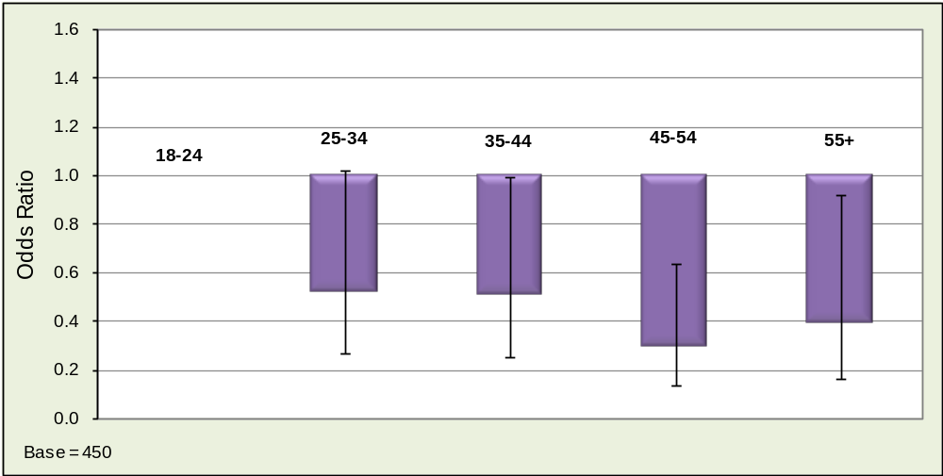

- The above chart shows that age is a key characteristic in respondents’ overall satisfaction when the impact of all other variables in the model are neutralised. This re-enforces the findings from the bivariate analysis which showed that under-25s tended to give the highest satisfaction ratings. The results show a similar pattern to the June survey with higher satisfaction levels among younger respondents although those aged 55+ tended to be more positive than those aged 45 to 54.
- The second factor within the MLwiN model that had statistical significance was that of frequency of use of the Skills Account website. In the chart below, the category occasionally was chosen as the base against which the others are compared.

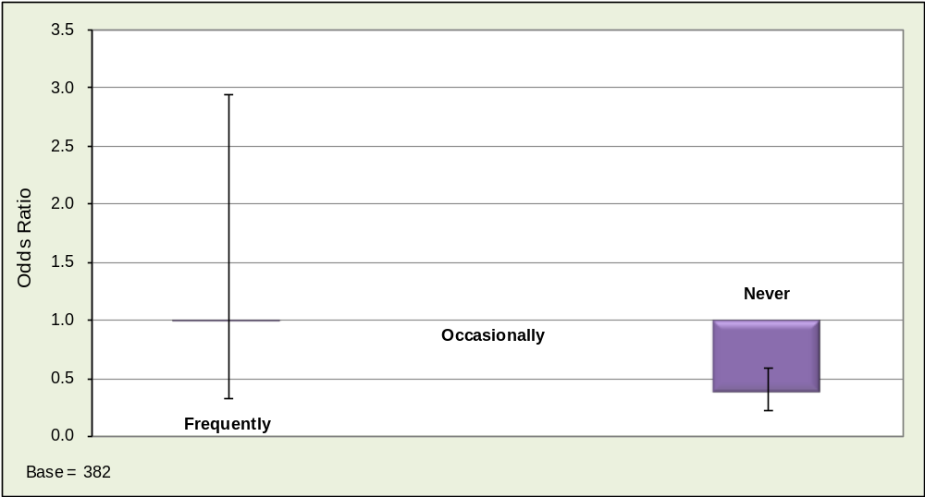
Satisfaction with Skills Account Odds Ratios - How often have you accessed your account since you signed up?

- The chart confirms that respondents who never accessed their Skills Accounts were more likely to express their dissatisfaction with the service. The base number of respondents who accessed their account frequently (20) was relatively small compared to the other categories so the findings for this category are less robust. This is emphasised by the very wide error bar which crosses the base value of 1.
- The only other factor within the MLwiN model that had statistical significance was Q6: Have you told anyone else about Skills Accounts? In the chart below, the response category no was chosen as the base.
Satisfaction with Skills Account Odds Ratios - Have you told anyone

else about Skills Accounts?
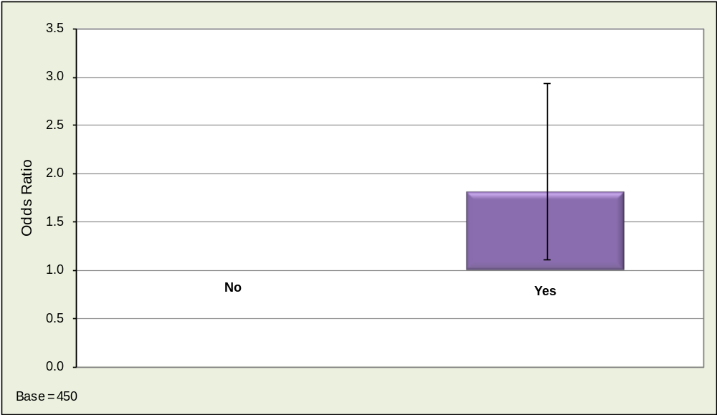

- The chart confirms that those respondents who have told other people about Skills Accounts tend to be the ones who are more satisfied with the service. This is a very similar result to the first survey and reinforces the findings.
- The second multivariate analysis tool used was CHAID, which is an abbreviation of Chi-squared Automated Interaction Detector. This program searches large bodies of data to identify combinations of variables that cause maximum variation in a given outcome (i.e. response to the dependent variable). The dependent variable used in the CHAID diagram below is Q11: How often have you used your online account since signing up? CHAID analysis produces a family tree ranking of variables in terms of their relative importance as an explanation of the response to the dependent variable. The chart on the following page shows the full tree produced by CHAID.
- As with the first survey, CHAID revealed the key variable which influenced the level of use of the website was how easy respondents had found it use. The analysis confirms that those who found the site very easy to use were more likely to be frequent or occasional users.
- Having found the factor with the greatest significance, CHAID then looked for the next factor that would have most impact on each of the diagram’s branches or “nodes.” The third level of the tree shows that for the largest node in term of number of respondents (Node 2), the quite easy, neither nor, quite difficult category was split by a further variable Q6: Have you told anyone else about Skills Accounts? Those that answered yes were more likely to be frequent users of the website which reinforces the finding from the MLwiN analysis.

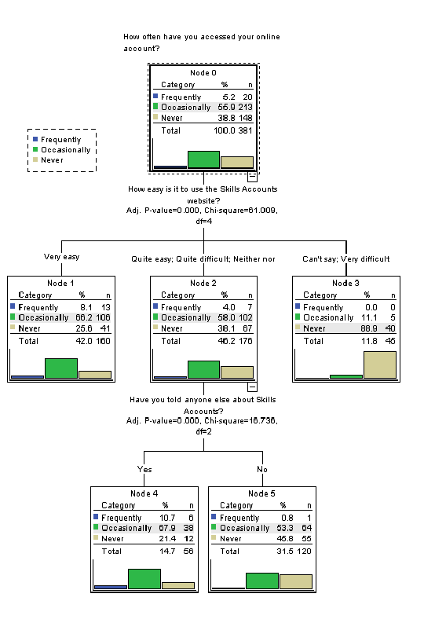
- Conclusions
- The telephone surveys discussed in this report provide initial client feedback on the Skills Account service. As of 19th August 2009 over 23,000 Skills Accounts had been registered and a total of 900 of these Skills Account holders took part in the telephone surveys.
- At the time of the interviews Skills Accounts were in the early stages of development, having been launched in December 2008. In 2009/10 and beyond the Skills Account website will undergo considerable development and the trials will be extended from the three initial regions to all nine regions in the country. In addition, Skills Accounts will be tested in a number of different contexts and with specific audiences.
- Telephone surveys in 2009/10 will include control groups and follow up interviews with previous respondents. An increase in the sample size and improvements in management information stored within the Skills Account database will also allow more extensive analysis, such as by previous qualification level or by initial entry route. In addition to telephone surveys, the evaluation team are carrying out face-to-face interviews, focus groups and data analysis and future reports will review the findings from all of these research sources and present detailed conclusions on the Skills Account trials.
- The first two telephone surveys, however, provide an early indication of customer reaction to the concept of Skills Accounts, establishing a baseline for future evaluation activities. It is important to recognise that changes in perception over time and by audience type will be as important as absolute numbers.
- In general, the reaction to Skills Accounts has been extremely positive and the findings demonstrate that the service has enormous potential. In particular the surveys found that:
- The vast majority of respondents thought that Skills Accounts were a good idea. In the first survey, for example, 94% of respondents thought that Skills Accounts were a good idea and this was virtually identical in the second survey, where 93% thought that they were a good idea.
- Most respondents thought that Skills Accounts will encourage them to take part in future learning. In both surveys almost 80% of respondents agreed with this statement.
- The majority of respondents thought that Skills Accounts were easy to activate and use. Less than 6% of respondents in each survey said that Skills Accounts were quite difficult or very difficult to use.
- These findings were consistent across the two surveys and did not appear to be dependent on the initial entry route into the service (e.g. via Strategic Learning Provider, nextstep, ESP provider etc.).
- However, the surveys have also highlighted a number of potential issues and the most important of these are listed below:
- A high number of respondents do not return to the Skills Account website after the first visit. In both surveys 39% of respondents said that they never accessed the website again after they had first activated their account. This suggests that whilst many individuals thought that Skills Accounts were a good idea and easy to use, they were not sufficiently beneficial to them as individuals at that particular time to attract them back again. This is not necessarily a problem, since a large number of individuals may only wish to access their Skills Account once or twice a year (for example when they have passed a course or are looking to develop new skills). However, there is a potential danger that the long period of time between the need for accessing Skills Account information will inhibit the widespread use of the service (individuals may forget passwords for example or lack familiarity with the site).
- The most significant factor affecting satisfaction with the Skills Account service appears to be the age of the respondent. Multivariate analysis on the survey findings highlighted age as a key factor and this is probably because younger people have greater day to day familiarity with the Internet and web based services.
- Ease of use is an important factor determining satisfaction with the service. Multivariate analysis of the survey findings showed a strong relationship between ease of use and overall satisfaction. Whilst this is not an unexpected conclusion, it emphasises that extensive user testing is important in order to maximise the potential benefits of Skills Accounts and that this should be an on-going process throughout the trials. As previously stated the majority of respondents found the Skills Account website easy to use. However, in both surveys less than half of the respondents found it very easy to use, so there is still scope for improvement (there was a 4% increase in this rating from the first to the second survey, possibly reflecting improvements to the website design in the July software release).
- Some respondents were unsure about the practical benefits of Skills Accounts in comparison to existing services. This appeared to be a more significant issue in the second survey, possibly because the number of individuals accessing basic skills and employability skills programmes had increased.
- Tools related to funding entitlement (i.e. Skills Voucher, Funding Indicator) were in general felt to be useful but there was some confusion about their use and concern about whether Skills Vouchers would be accepted by providers.
- The surveys suggest that where Skills Accounts are opened and activated with dedicated face-to-face support, the percentage of users who are dissatisfied with the service decreases.

Recommendations
1. The Skills Account team should ensure that the development of the Skills Account website is specifically informed by the needs of all age groups. In particular, the development team should take into account the likelihood that younger people may be more familiar with the use of online tools and have greater access to IT services. This issue could be partially addressed, for example, by pre-release testing with users of different ages and consideration of the appropriate use of language, imagery, content and usability. In addition providers and service deliverers should ensure that the needs of all age groups are taken into account when providing information about Skills Accounts, including the design of promotional materials, the availability of support systems for registration/activation and the provision of on-going Skills Account advice and help.
2. The Skills Account development team should investigate the development of website tools and activities that encourage frequent use of Skills Accounts. This might include, for example, discussion forums, information about study skills and updated news items. This would help users become familiar with the site and increase the likelihood that other tools are accessed.
3. The Skills Account team should identify, further develop and promote the ways in which Skills Accounts provide clear and distinctive added value over and above alternative face to face and paper based information sources. For example, Skills Accounts could link course information with quality ratings, user feedback and potential earnings, providing a distinctive online service supporting clients in their decision making. The Skills Account website could also be heavily customised to the needs of individual users, allowing them to save and link the results of different course and job related searches.
4. The Skills Account Development Team should seek to improve the clarity of the funding aspects of the website. Whilst survey respondents were in general positive about the concept of Skills Vouchers, the implementation of them was felt to be misleading. They were often not accepted by providers and gave the impression that individuals will get ‘money off’ the cost of the course when in reality vouchers just gave information to the user.
5. Strategic Learning Providers should consider offering additional support to help individuals activate their Skills Accounts. Data returns suggest that a large number of individuals who are registered for Skills Accounts do not in practice activate them. Providers may wish to ensure, for example, that individual support for Skills Account creation is available at the time of enrolment or induction (in a number of Strategic Learning Providers this process is already happening and is integrated into existing processes in order to avoid additional costs).
Appendix 1: Technical Summary of Research Methodology
Governing Research Principles
All RCU’s research and consultancy work is governed by a rigorous quality assurance system that is accredited under the market research industry kitemark ISO 20252, the policies and guidelines of the Market Research Society and relevant Data Protection Legislation. For more details of ISO 20252 and the Market Research Society codes of conduct see www.mrs.org.uk.

Project Team

RCU Staff
Richard Boniface - Project Manager
Gareth Wilson – Deputy Project Manager
Graham Whalley: Senior Systems Analyst – Database analysis and ILR matching
Nonihal Kandola – Systems Analyst – Database analysis and ILR matching Mohammad Naeem Kazi - E-Services Manger - CATI survey design, setup and implementation
Colette Dunn - Survey Processing Manager - survey processing and validation
David Carter - Statistical Analyst - survey data analysis and statistical modelling
Peter Byram - Director of Quantitative Research - survey design, analysis and reporting
Stacy McMullen – Project Administrator
PH Research (Sub-contractor)
A team of 6 telephone interviewers carried out 450 telephone interviews In June and September. PH Research hold the ISO 20252 quality standard which covers all aspect of the survey work carried out. All the interviewers attended a special training session on Skills Accounts run by RCU.

Key Quantitative Research Elements
- Description: The telephone surveys took place in June 2009 and September 2009. They were carried out using a script based CATI system. Interviews lasted approximately 10 to 12 minutes. The questions were agreed with the LSC and were pre-tested prior to the interviews with Skills Account holders. The questions explored a range of issues including initial information about Skills Account, the online activation process, usability of the website, perceptions relating to the individual features and tools, and views on the overall concept of Skills Account.
- Target Population: The research was intended to produce an accurate reflection of the views of respondents who had recently signed up for a Skills Account. For the first survey, the database of Skills Account holders supplied by the LSC included telephone contact details of just over 1400 individuals and for the second, just under 1700. These were targeted for the survey.
- Sampling: A target number of 450 interviews with Skills Account holders were planned for both the June and September surveys.
- Sampling Results: For both surveys, the target sample of 450 interviews was met within 2 weeks of the interview process starting.
- Sampling Effectiveness: For the June survey only 10% of account holders gave telephone numbers, although this figure rose to 20% for the September survey. Therefore, there will be some inevitable skewing of the sample compared to the overall population of Skills Account holders. For example, older account holders were more likely to give a telephone number although for the second survey, quotas were set for younger account holders to compensate for this. No corrective weighting have been applied to account for skew but the analysis in this report includes breakdowns by age, gender, current work status, home LSC Region and other characteristics in addition to the overall results where this is appropriate.

- Data Entry and Verification: Response data was collected by PH Research using a computer aided telephone interview CATI system designed in SNAP survey software system. Response data was subject to 100% verification and validation checking by RCU. Responses to open questions were reported in full unless otherwise stated and analysis.
- Weighting of Survey Results: All figures in the report are based on unweighted results. Where potential distortion could arise from differential response rates by key sub-samples, the results are reported within the sub-samples rather than being aggregated.
- Estimates: All quoted figures are actual survey responses and no use of estimated or imputed data has been made.
- Bases and Data Sources: The base figures and data sources for each table and chart are separately identified within the report text. In keeping with public sector data protocols, cell values have been suppressed if they occur at a level of 5 or below.
- Storage of Raw Data: As part of our quality assurance arrangements we will keep evidence of individual survey responses for at least 18 months after the closure of the project.
Reporting
The report contains a combination of absolute figures and relative figures, such as percentages or variations from national averages or benchmarks. Tables and references contained in the report are labelled in such a way as to make their nature clear. Where sub-sets of the data or weightings have been used this is clearly identified.
The report includes a combination of direct reporting of survey outcomes and the interpretations/recommendations of RCU staff. The latter approach is clearly identifiable from the report context and/or section headings.

Learning and Skills Council
National Office
Cheylesmore House
Quinton Road
Coventry CV1 2WT
T 0845 019 4170
F 024 7682 3675
www.lsc.gov.uk
© LSC September 2009
Published by the Learning and Skills Council

Extracts from this publication may be reproduced for non-commercial educational or training purposes on condition that the source is acknowledged and the findings are not misrepresented.

This publication is available in electronic form on the Learning and Skills Council website: www.lsc.gov.uk

If you require this publication in an alternative format or language, please contact the LSC Help Desk: 0870 900 6800

Publication reference: LSC-P-NAT-090179

All 450 individuals in the sample recalled registering for a Skills Account but only 352 of these recalled actually activating the online account (see 3.5). The findings from the question on the most important advantages of having a Skills Account are based on those who activated the account.
All 450 individuals in the sample recalled registering for a Skills Account but only 382 of these recalled actually activating the online account (see 4.5). The findings from the question on the most important advantages of having a Skills Account are based on those who activated the account.

