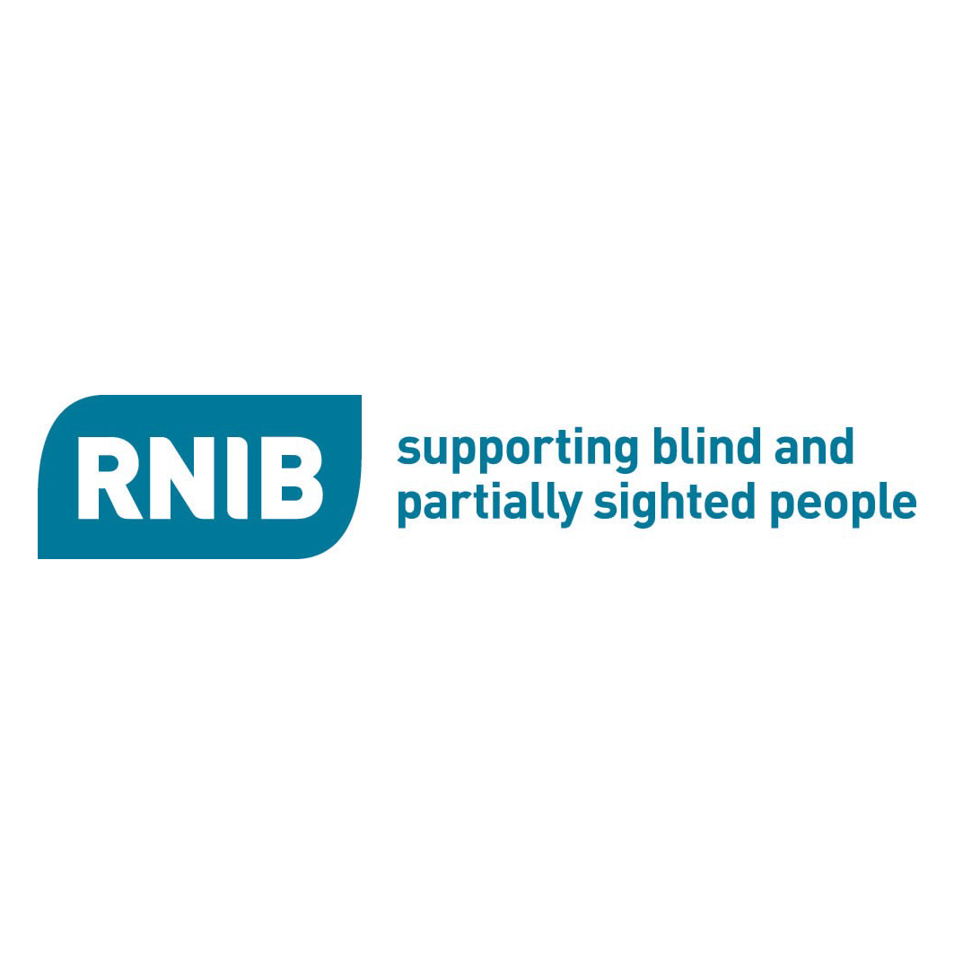


RNIB College learners

get smart with their

mobile phones

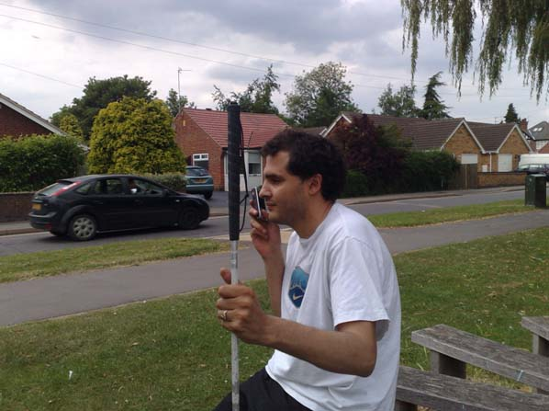

Becta Mobile Phone Project 2009

Provider profile:

Name and brief description of the organisation, including provider type:

RNIB College is a specialist college for people who are blind, partially sighted and/or have other disabilities

Location and region:

Loughborough

Name and contact details of authors:

Dr Margaret Uffendell, ICT & Resources Manager
Mike Hefferan, Learning Resources Development Officer (mhefferan@rnibcollege.ac.uk)
Mick Finnigan, Project Assistant

Approximate number of staff and programme areas involved:

7 staff covering LSC, Adult and supported learners at the mainstream college next to us.

Approximate number of learners involved:

55

Summary.

Can mobile phones be used to improve communication between staff and disabled learners? Can disabled learners learn to use the features on the new smart mobile phones effectively? The project identified key areas of value to learners: Using GPS to aid mobility, receiving college information via SMS texts and learning to use two particularly relevant applications available for mobiles: playing e-books and scanning text to speech.

The report below contains the following headings:
- Introduction
- Action Plan Aims
- Review ownership, use and areas for improvement
- Research, purchase, install and test appropriate mobile phone and software
- Assess learner skills, identify areas for improvement and offer training
- Review current methods of teaching mobility
- Review current communication for general college information
- Key areas where mobile phones could add to the learners' experience
  - Using GPS
  - PC to text
  - Mobile Daisy Player
  - kReader Scanner software

- Future Key Areas
- Conclusions
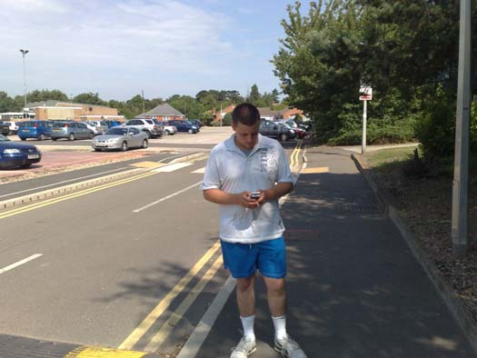

Introduction.

There has been a massive increase in the last few years in the choice of communication methods. If you want to watch television, do you use your TV set, laptop, or mobile phone? How about last night's programme that you were unable to see. You could have recorded it on your DVD or perhaps you will watch the missed programme on your laptop using BBC I player or Demand 5? You may even link your laptop to your TV screen. Perhaps you want to send your learners a text – do you text them from your mobile phone, or do you use a PC to text service, or do you send them an email and ask them to use their mobile phone to pick up their email. Are you going to take photographs? Do you pick up your camera, camcorder or mobile phone? What about listening to music?

Mobile phones have become part of everyday life. This is due to a large part in the increases in their technical sophistication. Memory, battery life, screen clarity, storage cards, operating systems and access to the Internet have all hugely improved. Being able to communicate while on the move has many benefits. For the young, communicating on their own device away from parents or teachers is very appealing.

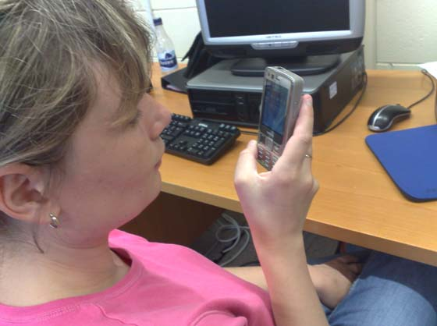

At the same time as these technical advances have marched onwards, other trends also had their effect. Mobile phones have become fashion statements and they are now necessities not luxuries. Young people in particular quickly adopted them. Even in 2002, the Learning and Skills Development Agency reported that 90% of people aged 15 to 19 used a mobile phone and 81% of people aged 20 to 24 used one, (Anderson & Blackwood, 2004).

Educational establishments have also taken on more learners with a wider range of experiences, expectations and disabilities. There is a greater emphasis on individual learning, on line courses, accessible materials and an always-on availability of resources.

All these factors have encouraged the use of mobile devices and in particular the mobile phone.

Smart phones now are a mixture of phone, personal assistant and computer. They have operating systems, can download software, use GPS navigation and allow speech software to be installed.

In mainstream colleges mobile phones are used for a wide variety of purposes to communicate between parents, staff and learners. However, there are question marks when it comes to disabled learners. Are they also part of this technical growth? Do they use mobile phones in a similar way to their peers? Are there other benefits or costs for this particular group? Are there barriers to using this technology such as poor accessibility or high costs?

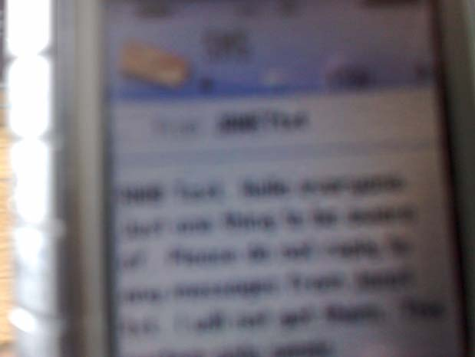
Action plan aims:

- Review ownership and use of mobile phones by learners.

- Research, purchase and test appropriate mobile phone and software

- Assess learner skills, identify areas for improvement and offer training

- Review current methods of teaching mobility

- Review current communication for general college information

- Identify key areas where mobile phones could add to the learners' experience

- Support learners and staff in these key areas and assess the impact

- Look to the future

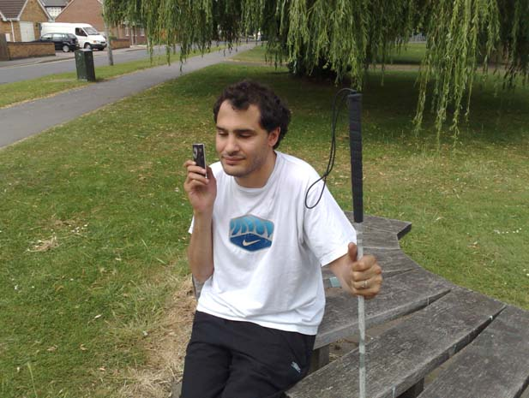

All learners were invited to participate in the mobile phone survey. There were 55 responses, 53 of whom currently possess a mobile. Far more learners used a mobile phone than originally envisaged. Information was collected on the current phone, features used, service provider and type of contract. Three-quarters of the respondents were visually impaired, although only 43% used any enabling technology and 55% had another disability.

Everybody used the mobile for calls and 76% used them for texts. Few used their mobile to watch TV and no one used it for editing documents. The most popular features after calls were: SMS texts, photos, listening to personal music, movies, radio and downloading music. Smaller percentages of learners used the phone for tasks such as Internet access, diary, email and watching TV.

The youngest age group (17 to 21) were the keenest to use the most popular features.

Although a high percentage of learners used texts, the percentage was higher for sighted learners (not VI) than visually impaired (VI) learners, (92% versus 70%).

Males tended to use slightly more features than females although the differences were small. The one exception was in taking photos where 74% of makes used photos compared to 46% of females.

Nearly 75% of respondents were on Pay-as-you-go contracts and Vodafone was the provider for a third. This may have been because they provide the Talks speech software for free and 30% of respondents were Jaws users, (Jaws being the speech software used in college to provide learners who have little useful sight with access to a PC).

More able visually impaired learners who studied at the mainstream college did make greater use of the more advanced features such as accessing the Internet and backing up to PC.

No learner had previously used GPS features.

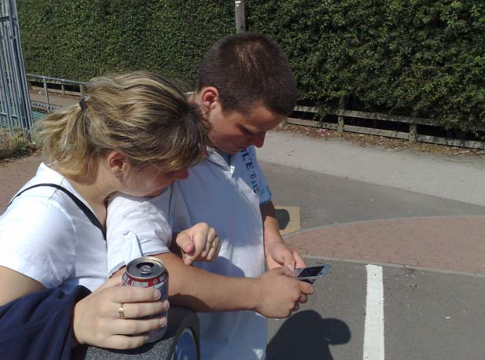
Research, purchase and test appropriate mobile phone and software.

Development of mobile phones is ongoing making a lifetime for the average phone two to three years. The cost of additional software, along with the difficulty and further costs to upgrade, can make people fearful of making a wrong choice.

Blind and partially sighted users are at a disadvantage to sighted people as they generally have to buy enlargement or speech software to access a phone. This software limits the choice of mobile phone. If you then take in to account the limited choice of phones capable of running GPS software the list to choose from is very small. All but one of the phones we could choose from are no longer in production, although still available. New phones are constantly being introduced. However the delay time to allow enabling software to be produced is considerable.

Software costs can be prohibitive to allow universal use:

  - Talks/Mobile Speak (speech software) £150
  - KNFB Reader (scanner software) £675
  - Mobile Daisy Reader (Plays e-books) £110
  - Wayfinder Access (GPS for VI users) £299

Vodafone offer a free Talks package to users but choice of phones is limited and the version provided has less functionality than the premium version which is sold.

Phone choice for the project was determined by the software we hoped to run. To avoid extra time to learn and set up the phones it was decided to have one phone type that could undertake all tasks. The Nokia n95 was the only phone that had all the necessary requirements:
Inbuilt GPS; wireless LAN; large screen; Talks compatible; and Wayfinder Access compatible.

An N95-8GB was also purchased to run KNFB reader software.

Assess learner skills, identify areas for improvement and offer training.

Learners were given the option to test the phones and software and 65% joined the testing group.

Investigating further from the survey results, those learners with greater learning disabilities were less confident at exploring features on their phones and visually impaired learners found certain tasks more difficult than sighted learners. These were tasks such as writing texts, adding contacts to their address book, navigating menus, making folders and configuring the Talks speech.

A blind consultant was commissioned to write a manual for the mobile phones for non-sighted learners using the Talks speech software.

Workshops in the general use of mobile phones were run for the adult learners and support given for the younger learners and one to one tuition provided where relevant for all learners – sighted and non-sighted.

Training sessions for tutors and support staff were undertaken based on using a smart phone. Basic functionality of the different software programmes provided an overview of the most popular features.

Two visually impaired expert mobile phone users who run their own businesses were invited to College at separate times to demonstrate to learners their use of mobile phones in their jobs and daily lives.

All learners reported greater confidence at using mobile phones and their features at the end of the project.

Review current methods of teaching mobility.

There are two issues here, obstacle avoidance and route guidance. From a physical point of view, blind people generally are able to move and walk around as any sighted person. Mobility training is given to allow them to move safely through their environment. Routes are learnt and memorised. Traditional mobility aids such as a white cane or guide dog are solutions to obstacle avoidance. Route guidance relies on memory.

Blind people are taught routes and have to build a mental map of surroundings and routes. This is time consuming and relies on professional help being available when the person requires it, which is not always possible. GPS systems potentially offer blind people and mobility trainers greater freedom to learn more routes, but at a pace that suits. GPS also offers more information such as how far off a junction is or where the local bank is situated. This starts to offer other elements as part of mobility training.

All learners are assessed for their personal level of independent mobility and travel skills during their pre admission assessment period.

Learners set mobility targets to work towards achieving some of the standards in the Mobility Skills Curriculum. The 3 Curriculum levels encompass the following:
Level M – Making my way around (college and immediate campus)
Level O – On my own (Wider campus and local community, town centre etc)
Level B – Branching out (Wider community, nearby towns, using public transport)

Location and length of mobility sessions varies but generally last no longer than 45 minutes. Independent mobility and travel skills are also embedded in all other areas of the curriculum. Some learners complete a module in transport and travel.

Mobility can therefore cover specific mobility training in using a cane and moving around the environment but it also includes wider skills in travelling around the community. Using technology such as GPS could therefore be an appropriate addition to learners' skills.

Review current communication for general college information.

Staff currently use:

- Focus groups: these are the most effective in eliciting responses and discussion but opinions can be skewed to a minority if only one or two learners from each of the various groups attend.
- Surveys: responses can be very low.
- Talking notice board: This was initially created because non-sighted learners cannot see a notice board full of posters. Talking notice board was a weekly verbal announcement of information and events. It used to be held during meal times but learners did not like the interruption to their meals. Now it is repeated with relevant groups in their flats in the halls of residences.
- Email: Several of the less able learners do not use their email regularly or find it difficult.
- Tutorials: Case load tutors meet their learners frequently but have to concentrate on work and personal issues for the learner and do not have the time to communicate everything other staff may wish to get across to learners as a whole.

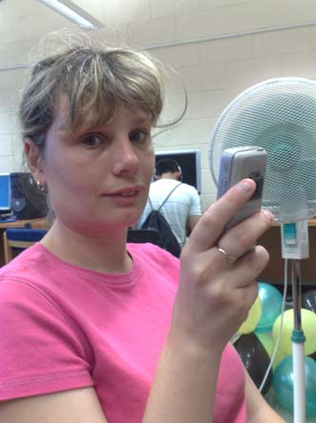
Key areas where mobile phones could add to the learners' experience.

Once basic skills and confidence had increased, four key areas were identified for further testing with learners. These were: using GPS, receiving information via texts, and looking at two new applications that could be downloaded to the phones and that would potentially be of benefit to disabled users. These are reported below.

1. Using GPS.

Implementation
- Test GPS features within project team.
- Train one of the mobility staff to use the GPS with speech.
- Train selected learners.
- Collect feedback.

Successes and challenges
The GPS system was tested with the speech and the staff within the project team piloted the phones. GPS Training was given to the mobility officers who cascaded this down to other support staff. Learners were then trained to use the software without compromising personal safety.

A GPS Workshop was held with an experienced external user. Tom, a local self employed piano tuner gave his personal experiences of using a dedicated system for route finding to enable him to run his own business travelling around the country, as well as talking about his off road use, planning trips around the countryside, setting waypoints and navigating between them. Learners had a hands-on demonstration with a device called Trekker and the various components that make up the system: GPS receiver, PDA, speaker and a harness to hold everything.

Opinions expressed at the workshop by learners were that the system was very expensive at £1300 and you were very noticeable, possibly exposed to mugging by wearing expensive technology, "cyborg like" was another comment. The other opinion was that of course if you were sighted you would possibly be purchasing a car for travelling to work which is far more expensive.

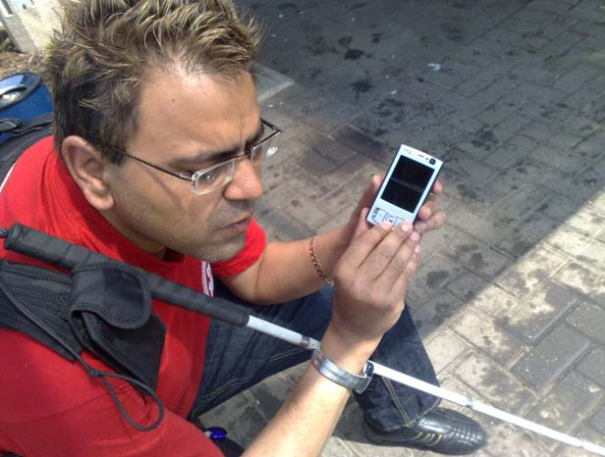
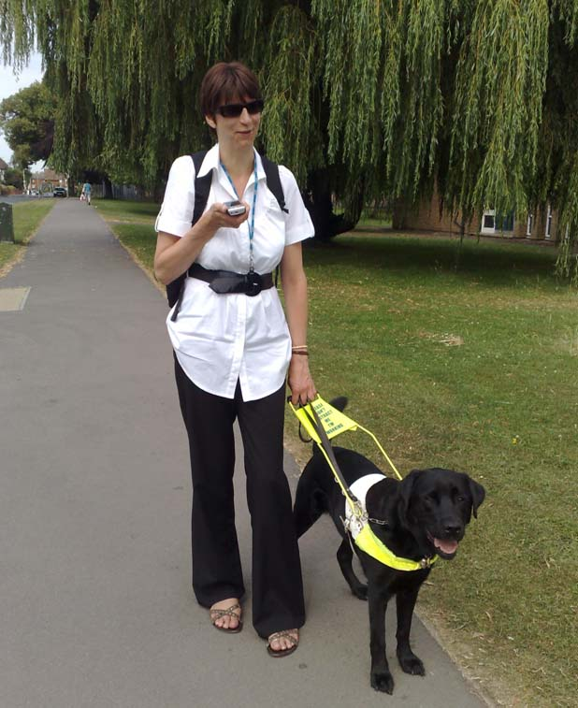

The mobility officer then tested out the smart phones purchased for the project while out with various learners between the college and the halls of residence as well as in the local area.

Effective use of GPS software was made difficult by the complex nature of the interface and the inexperience of users. After several days use most users reported being happier to use the software but that the GPS location was less accurate than they had hoped. 40% percent thought of the software as a route finder, while 60% believe it to be both a route finder and a mobility aid.

The first attempts frustrated some users because of occasional loss of GPS signal or connection to the mapping database, " The phone failed to connect to the navigation function at the Halls, and outside on route to Sainsbury’s".

Also users reported too much feedback from the phones' speech system, " SU found that the talking function was annoying and over informative. I found that the speech function was too quick and ‘robotic’."

This was looked at and reconfigured to cut out repetition and non-essential speech.
- Set the option "Read function keys" to: "by request". The original setting interfered by reading out what ‘key one’ and ‘key two’ functions are set to each time you changed something in the GPS system. The new setting would only read out this information when requested.
- Set the "Read list index" to "never". The - original setting interfered by reading out how many icons were in each list every time.
- Set Verbose descriptions to "no". This should have reduced some of the verbosity or over informative speech.
- Set "Mute on keylock" - this stopped the continuous feedback from the phone when in a pocket, battery low announcements still work in this setting
One learner said they would not purchase the GPS software due to the 10-metre tolerance in accuracy, stating they hoped for 1 metre tolerance giving them a chance at finding a door or ATM.

Impact and Outcomes
Two issues arose that caused much debate – one on the problems of listening to GPS information while trying to concentrate on mobility and the other, not entirely separate was how well the GPS information worked when using a long cane.

GPS Audio interfering with mobility?

There was a debate as to whether the learner should use an earpiece or speaker, which is safer and the problems of listening to route instructions while also concentrating on obstacle avoidance. "The visually impaired person pedestrian relies heavily on information contained within the ambient sound environment; for location and orientation information, navigation information, and importantly, safety information..…. such as the approach of a vehicle or other pedestrians", (Gustafson-Pearce, Billett & Cecelja, 2007).

GPS use in conjunction with established long cane skills.

The navigational function on the phone fails to give accurate proximity of location and was usually out by 6-12 feet. This could confuse the learner as they would pick up contrary information from their cane. For example, the phone may state that the learner needs to turn right after a 15 feet, however the learner may realise, (due to their cane skills), that they have missed the crossing by a few feet.

It may also take a while for a learner to listen to both the environmental noise and what is being said by the phone. Overwhelming instruction by the phone may also confuse/ agitate the learner.

Long Cane Skills involve the learner to take in information from the environment and make decisions as to how they will go about making the rest of their journey. Therefore such conventional skills rely on reasoning and, to a degree, empower the learner. On the contrary the Nokia N95 tells the learner what to do and may hinder reasoning and personal development.

One mobility officer felt, "The phone does well to cater for the technically minded learner as it comprises of various functions. I also feel that a learner may be able to work with the navigational element better if they were taught to use the phone as a mobility aid, before learning Long Cane skills. This is because the learner would be able to comprehend the inaccuracies of the device and make up for the short fall with long cane skills, Cane skills entail traditional methods which may hinder the use of such a device".

Another mobility officer felt that perhaps learners need to learn mobility (as in learning to avoiding obstacles and move around) first and then use GPS later as a route aid.

The most popular feature? Generally the “where am I feature” was considered the most interesting aspect of the software. Users could look up from a wide selection of points of interest ranging from ATMs, restaurants to swimming pools and navigate to them or just explore their surroundings and fill gaps in the mental mapping of routes.

Only 60% of learners reported that they navigated independently to places they had never been to before, using friends and taxis manage their travel. Results from using the GPS system were rather mixed. 40% did respond that they would feel more confident about exploring their local town with GPS on their phone, while 40 % responded "maybe". Comments were that it could be improved first. However, a larger percentage, 60%, said they would be more confident with GPS on their phone to navigate to a place they had never been to. Perhaps users more easily tolerate the difficulties in using GPS when in a completely new environment.

Difficulties are often very practical when using a device that is still rather unfriendly. One learner commented, "I found it difficult to operate while working my guide dog, he got frustrated at me stopping to input things on the phone".

However, independence and confidence were improved for some learners. All learners reported that they enjoyed using the GPS technology even though at times it was frustrating and difficult to use. The results point to learning the two aspects of mobility and route finding separately and then putting them together. GPS is still difficult to use on the phones and not as accurate as it needs to be and usability needs to improve before it can benefit all users. The GPS instructions providing route aid may only be of benefit to more able learners, but the ability to supply points of interest about the local area would be the main feature to concentrate on when teaching all learners.

Martin's Story
Martin is an adult learner on a Work Preparation scheme at RNIB College Loughborough.

"I had possession of a Nokia mobile phone, which had a GPS navigation system within it for evaluation of the usability of the system for someone who has sight problems like myself.

After a familiarisation session with a trainer where I was shown the operation of the phone and how to access the GPS programme in the phone, I was given the phone for four days to use the system in my own time in different locations for myself. Setting up of finding a location was something I found to be quite straightforward once this was completed and I had ensured that I had a satellite connection, which was not always as easy as other times, as the advice to find an open area to get a signal was not always a guaranteed method of getting a signal once I was using the phone in it’s navigation mode I found that the instructions were fairly slow in delivering information, something that I found to be something unnerving and caused doubt in it’s operation, as I was quite familiar with the routes that I was using and the fact that I have some eyesight in daylight conditions this was not much of a problem, but if my eyesight was worse, or I was in a strange location this could be more of a concern to me. As a result I tried deliberately to lose the signal by walking under canopies and close to high walls, this test proved that the signal was not reliable enough to be trusted in these conditions.

Overall the system proved to be nearly good, but it had it’s flaws which means it is not reliable enough for my use, the operation of the phone itself was not a issue even though I have little knowledge of different phones and no experience of any GPS systems at all, price would not be an issue to me, I understand that there could be a more accurate system on the way so I would be inclined to wait for this.

I had no problems with using the phone in public as a lot of people these days have earpieces and phones to their ear, the only concern that I had was that in busy areas I needed to listen harder to hear instructions which meant that did not be able to concentrate on my own environment and possible safety, this would be a technique that I would need to master with any type of audible navigation system that is used.

The ability to use different preset menus for local services like ATM’s and railway stations is very useful and I used often also I tried some of the favourites that had been stored by previous students as well as adding to the list myself".
End of Martin's Story.

Next Steps
The Wayfinder Access relies on connection to a database to plan routes and download routes. It is also possible to save positions as favourites that can be shared with other users. This could then be passed on to future learners.

We have marked several routes around Loughborough college campus in an attempt to build a college campus map. Unfortunately unmarked roads are not recognised and even when favourites are set along a path, the software seems unable to follow them, instead referring the user to the nearest marked path.

2. PC to text system.

Implementation
- Research PC to text systems.
- Install an example of a system.
- Ask for a volunteer group of learners who wish to receive college information by text.
- Train staff to send texts.
- Pilot PC to text system and collect feedback.

Of the features available on a mobile phone, using SMS text messages was identified as one which would be one of the easiest for learners to use and available on virtually all learners' mobile phones. Sending information to learners in a medium that is accessible, convenient and well known to them is viewed as a good example of supporting the Government's personalised learning agenda.

A service where college information can be sent from a PC to mobile phone would enable staff to easily send out texts to groups of learners. Staff do not need to use their personal phone and so there is no loss of privacy for staff or costs to them involved.

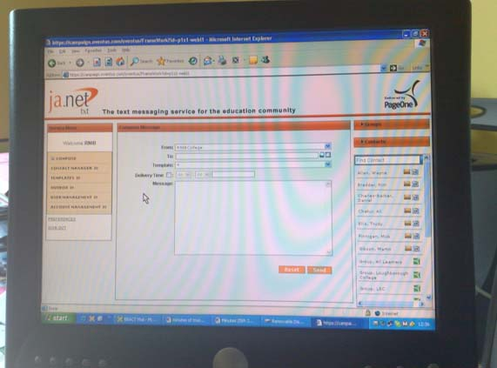

A recent survey of FE colleges showed that colleges used SMS messages for administration, improving attendance and sending out news and announcements of events and activities.

We therefore decided to send out texts of general college information that was also sent in global emails and newsletters. The information included items such as the college lunch menu, announcements of college events and activities, technical news of importance to learners, local events in the town and announcements form the college training office.

The system chosen for the pilot used was JANET txt supplied by PageOne. JANET txt is a comprehensive suite of secure one and two-way text messaging services, provided by PageOne on behalf of JANET(UK) and specifically tailored to meet the requirements of the UK Education Community
. We chose this initially since we are already on the JANET network for our Internet access and it was quick and easy to set up. It is run from a website which meant that no software needed to be installed. Once the necessary forms had been completed the service was immediately available the same day.

A group of learners were identified who were willing to take part in the pilot. They were chosen from all 3 groups of learners in the college: those on LSC programmes, those on adult programmes and those supported at the mainstream college next door

Learners and their mobile phone numbers were entered as individuals in to our contacts list and four groups were also created, one for each group of learners and one for all learners. This meant texts could be sent in one step to a group of learners.

Two demonstrations of the service were held for teaching and residential staff to explain how it works.

There were two aspects to investigate. One was the accessibility of the web site so that a blind member of staff could send out texts. The second was to evaluate how well the learners managed and what their views were on the service.

Accessibility of the PageOne website, successes and challenges.
This visually impaired member of staff, (Mick), used Jaws version 8 speech software to access the website. As a blind user he cannot use a mouse and has to use keyboard commands.

The login page was accessible although it would be useful if, after entering the password, the user could just press Enter to login rather than having to press TAB to go the login button and then pressing Enter. Getting to the initial compose message screen was fine. The problems came when Mick was in the "To" edit box to enter the name that the SMS message was going to. First we tried to simply start typing the name to see if it would appear from the contacts list as you begin to type the letters. This is a feature sometimes found, for example when sending a hotmail email. However, this feature was not available.

To choose a group name Mick had to navigate to the Groups button. Jaws has a command that lets the user list the buttons found on the webpage but it was not possible to identify the Groups button in this way. His quickest method was to arrow down very quickly through a large number of objects until he heard the phrase "Group Clickable Mouse Over", and then to continue to arrow down. Although not visible on the screen, Jaws would read out the list of groups and Mick could press Enter on the one he wanted. It is confusing for anyone sighted who is helping because they do not see any list of groups. You have to click the mouse button for the list to become visible to a sighted user, but Jaws strangely does read them.

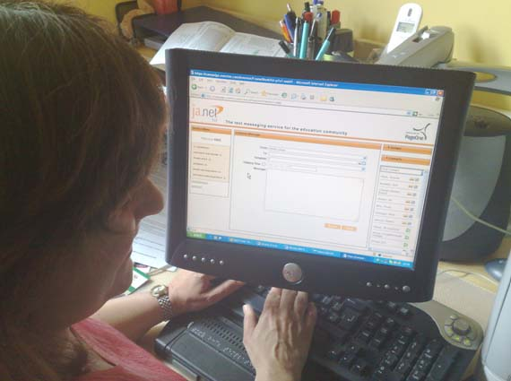

The only other way to speed up finding the button is to use the Jaws find command to search for the word Groups and then arrow down. However, Mick has become used to simply arrowing down as quickly as possible until he hears the word "Clickable Mouse Over".

Although these methods work they would be difficult for a novice user of Jaws, whereas a novice sighted user would be able to use the screen with few problems.

We learnt from PageOne, after a visit from them, that we could enter the group names in to the ordinary contacts list as if it was the name of a person. Every group created has a name and a phone number, just as individual has. The contacts list however was still difficult for Mick to navigate to. The steps he would have to take are as follows. The contacts list is in a separate frame on the screen and Jaws can list frames in a menu to allow the user to arrow down and choose the frame to go to. Mick can do this and then he would have to arrow down the contacts list to find the group name. All Groups were given a name with the word "Group" in them to make them appear together in the list. However it can still take a while to find the group you want.

There is also a search box above the contacts list. Mick can get Jaws to list all form fields on the screen, arrow down to the search edit box and select it in order to move to the search box. Then he can enter the word Group in the search box so the contacts list only shows names that start with the word Group. Then he would have to arrow down to choose the group he wants. This is still a reasonably long process.

After choosing a name of an individual or a group name, there is no quick way to return to the message. There is no "Ok" button, for example, to say you have finished choosing people from the contacts list and want to return to the message.

So Mick has to then carry out a set of steps, using Jaws commands, to return to the message box. He has to use the Jaws command to list form fields on the page, arrow down to Message: edit, (or press M), choose that field from the list and then press Enter to move to the message box.

Most of the information Mick was sending came to him in a Word file so he devised another method that he could use at times. We worked out what he needed to key in on the To row to show the name and phone number for any of the groups. He kept a copy of the names and numbers of the groups in a template Word file. Then when he wanted to send a message he copied the group name and number from Word and pasted it in to the To edit box on the web page and continued from there. Perhaps not ideal, but this was another possible method.

All methods require a confident Jaws user.

Another part of the web page that was not accessible was the part where you can choose a future delivery time and date when you want the message to be delivered. The fields where you enter the times were accessible but there was no method to pick a date without using a mouse. There was also another screen which showed sent messages and coloured circles to show if messages are pending, failed, or have been sent. Neither text nor circles appears to be accessible and Mick did not use this page.

However once a name has been added to the To row, Mick could then go on to key in a message and send without any problems.

PageOne also visited our college to look at how Jaws is used to access a website and they are looking to learn more about Jaws and alter their website to be more accessible. They hope to get hold of a copy of Jaws or come to the college to work. They have been advised if all else fails to at least ensure the website meets W3C standards and can be used without a mouse. These steps can solve a majority of problems.

Evaluating Learners' skills and views, successes and challenges.
The content to be sent to learners was adapted for the mobile phones. The speech software on the phones is not as sophisticated as Jaws. If it came across a price as in the lunch menu, such as £2.00p, then it would pause after the full stop as if it was at the end of the sentence and then read out the figures for the pence, which could sound odd. Jaws on a PC recognises full stops when they are part of a price and reads the price in the correct manner. Prices were written therefore with a hyphen instead of a full stop, for example, £2-00p.

Blank lines between paragraphs sometimes would cause a blank screen to appear on the mobile phone between the paragraphs which could cause the user to think the SMS text had finished, so blank lines were deleted.

If a text was long it could arrive in more than one part with headings such as: linked 1/2, followed by a text with the heading: linked 2/2. This was avoided where possible by shortening the information that was to be sent by text.

Sometimes the language of global emails that went to all learners could be difficult for some of them. Since we were looking at length of the content it was easy to also simplify the language if necessary at the same time before sending the information as text.

The pilot was carried out for approximately one term.

Impact and outcomes.
90% of learners preferred SMS texts to email. "Getting information by text is more convenient as you do not need to be at your PC". One learner said it depended on the information. Very long information would always be better to send via email, as it would not get split. Also if you did delete an email, as long as you act immediately you can get it back from your deleted messages folder, but this is not possible with SMS texts.

Preference for SMS texts was because it was immediate and easy to use. " I might have to wait until the next day for email" one learner quoted. He felt SMS text was convenient because he nearly always had his mobile. Another learner said she felt emails were difficult, "I feel that maybe half of learners from our group do not read emails".

Information such as the College lunch menu and events in the local area were favourites. There was no information sent that they said they did not want. One learner said it did not matter as they could easily delete if he thought a text was not important.

Information that they would like to have in future by SMS text was:
News of University events, the weekly newsletter from Suzanne Poole (this would have to be edited to keep it short), and lists of the weekly and weekend activities for learners in the Halls.

Only one learner reported that there were too many texts. The majority of learners did not mind how many they received, which was surprising. One learner quotes: "I did not mind the amount of texts that were sent as it is an easy operation to delete any text that I did not require".

One learner said that often information sent to learners by email was too long to understand. Shorter SMS texts were easier to understand as well as easier to access.

100% of the learners were in favour of the name for the sender of SMS texts being RNIB College rather than janet txt. They felt learners would not understand the words Janet txt and may delete the message by mistake.

"I preferred the texts to read RNIB College as I did not really know what janetxt meant", and
"I knew what Janet txt meant but the name RNIB College made it more personal".

One learner asked if it was possible to reply to the system as they would like to reply to any questions or surveys using SMS texts rather then emails.

The visually impaired member of staff who sent out the SMS texts found it a good way to communicate and using a website meant it was very flexible to use. He even continued to send out the lunch menu while on holiday in Canada which must be extreme dedication the job or an addiction to the PageOne web site.

It opens up new ways for staff to reach learners. "Brilliant! I sent a text to one learner I had not seen for a while and got a reply within 20 mins. Usually I would have to wait day or even up to a week when contacting them using email".

Next steps
Future possibilities could be:

- Look at parent involvement in receiving news and information via SMS text
- Further uses for SMS text: attendance queries, invite to focus groups, timetable reminders
- Press for improvements in usability of phones and the speech software
- Continue to work with PageOne to improve accessibility of their web site
- Extend system to receive replies from learners
- Compare JANET txt with another system to investigate if there are other relevant features or advantages

3. Mobile Daisy Player

The software used was Code Factory's Mobile Daisy Player. It works on Symbian mobile phones such as Nokia.

A Daisy player is software that plays books in Daisy format. Daisy format has several types, but one type is a format that is audio and synchronised text. In other words, as you listen to the text, you can also see the text on the screen. It is useful for learners with a wide range of disabilities, including dyslexics and the visually impaired.

DAISY format allows navigational features and accessibility that were not possible with analogue audio tapes. Daisy player software is used at the College to play the Daisy teaching materials that teach IT and this format has now replaced all our analogue tapes. The text is still useful even with totally blind learners as the tutor can see on the screen the part of the book that the learner is listening to. They can also see the headings that the learner has recently completed and those that they are going on to next. The learners can also bookmark favourite places or search the text or jump to another heading or go back to a previous heading, all of which was impossible with analogue audio tapes. Currently the software in college is run on the learners' computers. There are also hardware Daisy Players that are separate devices the learner can also use to play Daisy books.

The Mobile DAISY Player software includes the standard features of Daisy players such as changeable audio and text playback speed; ability to play audio only, text-only, and mixed-mode books; configurable colours and size for the text to help partially-sighted users; and bookmark support, with the ability to create voice annotations.

Using Daisy Player software on a mobile allows the user to copy books to their mobile phones and to listen at their convenience.

Implementation
A trial version was first piloted and then a full version purchased. Mini workshops were run with two groups of learners to demonstrate the features and then let them practice on their own for a few days at a time. Then the learners came together as a group to discuss their findings.

Successes & Challenges
All learners who tried it responded that it was very good. They could fast forward, rewind and make bookmarks. They felt that it was not suitable for books that taught IT as they need to use the PC to do that and they felt that switching between listening to the book on the mobile phone and listening to the speech on the PC as they use Microsoft Office was too difficult. (When they use Daisy software on their PC during lessons they use a foot pedal to control the Daisy audio while they keep their hands on the keyboard to control Microsoft Office and this works very well).

The group felt that the mobile phone version was best for books that the user is simply listening to – not trying to use a computer at the same time. Suitable materials would be fiction, revision material, anything they just need to listen to. Shorter pieces of texts, such as notes or prompts, would be better as simple mp3 audio files since they would not be worth converting to daisy. Daisy files are more important where something is lengthy enough that the user may wish to search the text or make bookmarks.

The most rated feature was the portability. With this software, users do not need to carry mobile phone and separate Daisy Player with them while travelling. Many disabled learners have to use public transport rather than a car and portability is important. If, for example, they were using a separate Daisy Player and were on a train listening to a book using headphones, then it would be easy to miss the phone ringing or the text alert. Even if they did hear it, they would have to stop the Daisy Player, search for their mobile phone and press a key to take the call or read the text. However, when using a mobile phone as a Daisy Player, two users noted how easy it was to simply pause the player, take the call, and then continue reading from the point they left off.

During the project a software upgrade was made available to the Talks speech software which added a free of charge daisy player, called Daisy 2 Go, to the phone system. This is not as sophisticated as Mobile Daisy but is another choice.

Impact & Outcomes
The impact is when they are on the move or going on holiday, for example. Instead of carrying around huge Braille books which often were posted in advance since they are so big, or carrying tapes or a separate hardware player, one device lets them carry their reading material and their phone in one unit. This has benefits for leisure or work where users need to travel to see clients or meetings.

Next Steps
These could be to include regular demonstrations of the software for new learners each term as part of regular awareness sessions on current technology.

A further utility giving the ability to purchase and download e-books from Audible has also become available. Books from Audible are MP3 based. Training material was commissioned to teach learners to use this feature successfully and further workshops could be arranged to use the e-books. Other small dedicated players are available that have more functionality so it is personal preference as to which option suits a user's needs.

4. kReader Scanner software

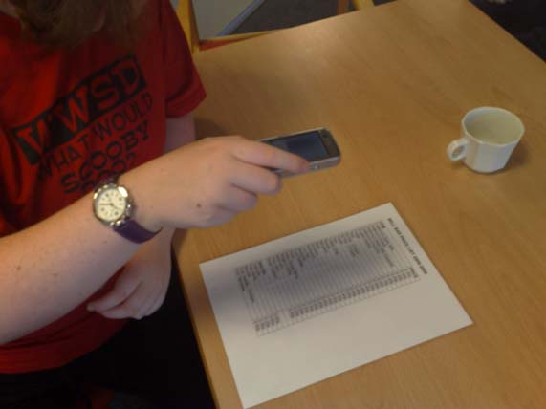

The software used was the kReader Mobile from knfb Reading Technology and is essentially an OCR scanner for reading text and converting it to speech. It allows access to print for visually impaired readers or those struggling with reading or those learning a second language. It runs on a mobile phone. The user can take a picture of a text document such as their mail, receipts, handouts, memos and many other documents. The document analysis technology then recognises the words and reads them aloud to the user. The user can read other languages besides English and they can translate between languages.

The speech can be synchronised with the text and each word can be highlighted as it is read out. Navigation can be by word, character or sentence and the speed and voice can be altered according to user preference. Text can also be imported. The most important feature for a visually impaired user is that it does not matter which way up the text is when you hold the phone over it to scan the text. The software will recognise if the text is upside down and compensate.

Implementation
Mini workshops were run with two groups of learners to demonstrate the features and then let them practice on their own for a few days at a time. Then the learners came together as a group to discuss their findings.

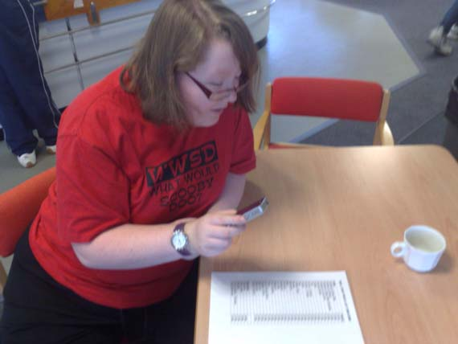

Success and Challenges

Initially several users reported that they could not use the software. The software came with a polarizing filter that had to be fitted to the camera lens on the phone. This was to aid scanning in situations where there is bright light. It was found that the filter had been moved while one of the users had carried the phone in their pocket. This had caused the glue from the backing paper, that is removed before sticking the filter over the cameral lens, to become smeared on to the lens preventing the pictures from being taken properly.

Users felt that it took time to get used to taking a scan. The problem initially was getting the phone at the best height and position over the text. An impressive feature is that software does recognise when text is cut off and tells the user which side is missing. One technique used was to tell the user to put their elbow on the text with their arm upright in the air. If they then held the camera over their fingertips they would then be at about the right height and centred over the paper. They could then withdraw their arm and take the picture. All users reported that they could manage to take a scan after 3 or 4 practice attempts.

All users reported the accuracy of the text to speech as excellent. The favourite uses for it were for menus, pamphlets, reading the post and reading goods in shops. It could not be used for handwriting in the office, but was good for forms and memos.

Impact & Outcomes
In the past scanning has meant using a relatively large piece of hardware attached to a PC. Originally accuracy was quite poor and it was still faster for a touch typist to key in the text rather than scan it. Scanning software has now greatly improved. This software was found to be extremely accurate and portable. Only one device is needed – the phone. Users can of course still use all the other features of the phone and the scanner can be started by pressing one button.

Again portability was the key feature. " This is great! I can take the phone to the front door, pick up an envelope from the post, scan it, and if blank I know the envelope is the wrong way round. Another scan on the other side tells me if the post is mine or for my husband or one of the children. I can quickly sort the post and open mine".

Another user attempted to read packaging in the supermarket. Although it cannot read text on a curved surface such as a tin of food, flat surfaces such as boxes of food could be read.

Next Steps
A longer pilot of the software and further practice will allow greater uses for the software. It would be especially suitable for trials in the College Office, (a training office to simulate a work environment), and trials at work experience placements.

Improvements in the design of the filter should be suggested to the suppliers. The filter could be attached more rigidly to the phone and a small lever used to move it in a similar way to how lens covers are often fitted to cameras. This would allow the filter to be flipped up for taking normal photographs or flipped down over the lens for scanning text.

Final views on the whole project
80% of learners felt that the project has positively affected which mobile phone they would consider buying in the future. The main reason given by any learners who felt they would not consider upgrading to a "smarter" phone was the cost. 80% of learners felt that being part of the project had made them more aware of the useful software available and they would consider purchasing such software for themselves. All felt their confidence had increased. It brings to mind a quote from Go Mobile!, a booklet on mobile learning and its benefits for those with learning difficulties and disabilities, "If appropriate tools are selected, confidence and independence can be increased,… and even something that was previously a challenge made achievable", (Jisc TechDis & LSN, 2008).

One learner's final comment was, "I like finding pubs, restaurants and McDonalds in the local area as easily as everyone else".

Future Key Areas

Using phones as digital recorders,
Downloading podcasts,
Playing videos as lesson reminders.
Visual prompts for remembering points during a journey or a day's schedule

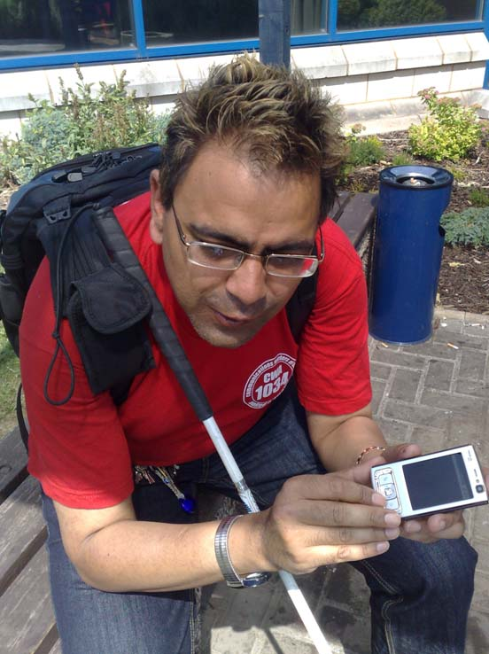
Conclusions
Mobile phones were found to be part of disabled learners' lives as much as non-disabled learners. Speech access is now simple to acquire and phones are more affordable. Some disabled learners may however lack confidence and the skills initially to use features beyond making calls and receiving texts. This is a shame as they could be missing out on good deal of useful support.

Receiving texts was accessible and an inclusive way of receiving College information. New features and applications for mobiles were found to be surprisingly sophisticated and potentially of enormous value to learners.

GPS can add confidence and information for learners finding their way round a new area. Results suggest it is better to learn route finding and obstacle avoidance separately. GPS is still difficult to use on the phones, not as accurate as it needs to be for pedestrians and usability needs to improve before it can benefit all users. The route aid may be of most use to more able learners but information on points of interest in the local area could be used by everybody.

Applications such as the Daisy Player and Scanner could be of great value to a learner's independence and skills, either for leisure purposes or in the work environment.

Teaching mobile phone features to disabled learners in Colleges could be part of the independent living and not doing so could mean learners miss valuable opportunities.

Key words
Mobile Phone, SMS texts, Janet txt, PageOne, GPS, Global Positioning System, Sat Nav, Daisy Mobile, kReader, scanning, communication, disability, visually impaired, Jaws, RNIB College, FE, Specialist College.

Acknowledgements
We would like to thank the tutors, support staff and learners in the College for participating, Jill Peters for data analysis, Nick Smith from PageOne for support, Sight and Sound Technology for providing an initial loan copy of the kReader software, and Tom Maley and Ashif Sindhi for agreeing to come and talk to the learners.
The project was supported by a Becta Grant for 2008 to 2009.

References
Anderson, P. & Blackwood, A. (2004) Mobile and PDA technologies and their future use in education. Jisc Technology and Standards Watch.

Gustafson-Pearce, O. Billett, E. & Cecelja, F. (2007) Comparison between audio and tactile systems for delivering simple navigational information to visually impaired pedestrians. British Journal of Visual Impairment.

Jisc TechDis & LSN, (2008). Go Mobile! Learning and Skills Network.

Royal National Institute of Blind People (RNIB), Registered Charity Number 226227

