|  |  |
| --- | --- |
| **Official Statistics Release** | |
| Policy area: | Children’s homes inspections and outcomes |
| Theme: | Education, children’s services and skills |
| Published on: | 18 December 2012 |
| Coverage: | England |
| Period covered: | 1 July 2012 to 30 September 2012 |
| Status: | **PROVISIONAL** |
| Issued by: | Office for Standards in Education, Children’s Services and Skills (Ofsted) Aviation House 125 Kingsway  London WC2B 6SE |
|
|
|
| Responsible director: | John Goldup |
| Statistician: | Adam King |
| Public enquiries: | [enquiries@ofsted.gov.uk](mailto:enquiries@ofsted.gov.uk) |
| Press enquiries: | [pressenquiries@ofsted.gov.uk](mailto:pressenquiries@ofsted.gov.uk) |
| Link to official statistics release web page: | [www.ofsted.gov.uk/resources/official-statistics-childrens-social-care-inspections-and-outcomes](http://www.ofsted.gov.uk/resources/official-statistics-childrens-social-care-inspections-and-outcomes) |
| Publication medium: | Ofsted website |
| Publication frequency: | Quarterly |
| Next publication date: | 27 March 2013 |

Contents

Introduction………………………………………………………………………………………………………………………….4

Key findings………………………………………………………………………………………………………………………….4

Methodology…………………………………………………………………………………………………………………………7

Chart 1: Overall effectiveness of children’s homes inspected between 1 April 2007 and 30 September 2012, by financial year (provisional)………………………………………….……………………………8

Chart 2: Overall effectiveness of children’s homes inspected between 1 April 2007 and 30 September 2012, by quarter (provisional)……………………………………….....…………………………………..9

# Chart 3: Overall effectiveness of local authority run children's homes inspected between 1 April 2011 and 30 September 2012, by quarter (provisional)……………………………………………………………10

# Chart 4: Overall effectiveness of private and voluntary run children's homes inspected between 1 April 2011 and 30 June 2012, by quarter (provisional………………………………………………………………10

Table 1: Number of children’s homes inspections carried out between 1 April 2012 and 30 September 2012, by inspection type (provisional)..………………………………………………………………...11

Table 2: Overall effectiveness of children’s homes at full inspections between 1 April 2012 and 30 September 2012 (provisional)..…………………………………………………………..…………….....................12

Table 3a: Full inspection outcomes of children's homes (excluding secure children’s homes and residential special schools caring for pupils for more than 295 days per year) inspected between 1 April 2012 and 30 September 2012 (provisional)………………………………………………..…………………..13

Table 3b: Full inspection outcomes of secure children’s homes inspected between 1 April 2012 and 30 September 2012 (provisional)…………………………………………………………………………………..........14

Table 3c: Full inspection outcomes of residential special schools caring for pupils for more than 295 days per year inspected between 1 April 2012 and 30 September 2012 (provisional)..………..……..15

Table 3d: Interim inspection outcomes of all children’s homes inspected between 1 April 2012 and 30 September 2012 provisional)..……………………………………………………………………………...............16

Map 1: Children's homes receiving a good or better overall effectiveness grade at full inspection, by former Government Office Region, since 1 April 2012 (provisional)…………………….……………..……..17

Map 2: Children's homes receiving a satisfactory or lower overall effectiveness grade at full inspection, by former Government Office Region, since 1 April 2012 (provisional)..…………..….…...18

Map 3: Local authority-run children's homes receiving a good or better overall effectiveness grade at full inspection, by former Government Office Region, since 1 April 2012 (provisional)…………....19

Map 4: Private, voluntary and health authority-run children's homes receiving a good or better overall effectiveness grade at full inspection, by former Government Office Region, since 1 April 2012 (provisional)……….……………………………………………………………………………………………………….19

Map 5: Local authority-run children's homes receiving an adequate or lower overall effectiveness grade at full inspection, by former Government Office Region, since 1 April 2012 (provisional).…..20

Map 6: Private, voluntary and health authority-run children's homes receiving an adequate or lower overall effectiveness grade at full inspection, by former Government Office Region, since 1 April 2012 (provisional)……….……………………………………………………………………………………..……………….20

Glossary ....…………………………………………….…………………………………………………………………………..21

Introduction

This official statistics release reports on children’s homes inspections that occurred between 1 July 2012 and 30 September 2012 under the Care Standards Act 2000. These statistics are based on provisional data and are subject to change.

**Key findings**

**Inspections and outcomes of children’s homes** **full inspections**

* The period 1 July 2012 to 30 September 2012 is the second quarter since the introduction of the revised Ofsted framework for inspection of children’s homes.[1] Provisional statistics indicate there were 685 full inspections of children’s homes during this period. (Table 1)
* Of the 685 homes inspected, 119 (17%) were outstanding for their *Overall effectiveness*. 399 (58%) were good, 136 (20%) were adequate and 31 (5%) were inadequate. (Table 2)
* Between the introduction of the revised children’s homes inspection framework on 1 April 2012 and 30 September 2012, 13% of homes received an outstanding *Overall effectiveness* grade. This compares to 22% in the first six months after the introduction of the children’s homes inspection framework in April 2011. Six per cent of homes have received an inadequate *Overall effectiveness* grade between the introduction of the revised framework on 1 April 2012 and 30 September 2012. This is an increase from 2% in the first six months after the introduction of the children’s homes inspection framework in April 2011. (Table 2 + Chart 2)

* The former Government Office Regions with the highest percentage of good or better *Overall effectiveness* grades were the South East (77%) and East Midlands (73%). In contrast, around half the homes in London (51%) received an *Overall effectiveness* grade of good or better. (Map 1)
* There are marked variations, at a local level, in inspection outcomes since 1 April 2012, albeit with only around two thirds of full inspections completed. In local authorities where at least 10 homes have been inspected; a good or better *Overall effectiveness* grade was received by more than 90% of the homes inspected in Stoke-on-Trent (100%), East Sussex (93%) and Durham (91%). The authorities with the lowest proportion of good or better inspection grades each had less than 50% of homes receive a good or better grade. These authorities were Derby City (30%), Northumberland (36%), Cornwall (41%), Sunderland (42%) and Leeds (47%). These are inspections of all homes, not just those run by a local authority. (Table 4)

**Sector data**

* A very similar proportion of local authority and private and voluntary-run homes received a good or better *Overall effectiveness* grade (69% and 68% respectively), between the introduction of the revised inspection framework on 1 April 2012 and 30 September 2012.[2] (Maps 3 + 4)
* Fourteen per cent of local authority-run homes received an outstanding grade for *Overall effectiveness* between the introduction of the revised inspection framework on 1 April 2012 and 30 September 2012, which is a decrease from 23% in the first six months after the introduction of the inspection framework in April 2011. In the same period, 5% were given an inadequate grade, an increase from 3% in the first six months after the introduction of the inspection framework in April 2011. (Chart 3)
* A similar change occurred for private and voluntary homes; 13% were given an outstanding grade for *Overall effectiveness* between the introduction of the revised inspection framework on 1 April 2012 and 30 September 2012, a decrease from 22% in the first six months after the introduction of the inspection framework in April 2011. In the same period 6% were given an inadequate grade, an increase from 2% in the first six months after the introduction of the inspection framework in April 2011. (Chart 4)
* In individual local authority areas, where at least six local authority run-homes have been inspected in the first six months since the introduction of the revised inspection framework, there were wide variations in the number who received good or better *Overall effectiveness* grades. In Durham, Stoke-on-Trent and North Yorkshire all local authority-run homes inspected so far were good or better. The authorities with the lowest proportion of good or better inspection grades each had one third or less of their homes receive a good or better grade so far. These authorities were Derby City (17%), Somerset (17%) and Kingston upon Hull (33%). (Table 4)
* The sectorial picture, when grouped by former Government Office Regions, varies widely across the country. In two regions, since the introduction of the revised inspection framework, the proportion of homes receiving a good or better *Overall effectiveness* grade is more than 10 percentage points higher among private and voluntary sector-run homes than local authority-run homes: East of England (70% and 54%, respectively) and South West (67% and 53%, respectively). In contrast, there are two regions where the proportion of local authority-run homes receiving good or better grades is more than 10 percentage points higher than in private and voluntary homes: North East (76% and 59% respectively) and London (65% and 47% respectively). (Maps 3 + 4)

**Interim inspections**

* There were more interim inspections carried out on all types of children’s homes between July and September (110) compared to the previous quarter (45). Of these 110 interim inspections, 32 (29%) made good progress and 41 (37%) made satisfactory progress. However, 23 (21%) made inadequate progress. Fourteen (13%) did not receive an inspection outcome as children were not accommodated in the children’s home at the time of inspection. (Table 3d)

**Impact of revisions on key findings of previous release**

* Final data covering the period 1 April 2012 to 30 June 2012 have been released and can be found on the Ofsted website: [www.ofsted.gov.uk/resources/official-statistics-children%E2%80%99s-social-care-inspections-and-outcomes](http://www.ofsted.gov.uk/resources/official-statistics-children%E2%80%99s-social-care-inspections-and-outcomes).
* The revision of statistics relating to the 1 April 2012 to 30 June 2012 quarter from ‘provisional’ to ‘final’ status includes outcomes relating to a further 93 inspections. These consist of an additional 91 full and two interim inspections of children’s homes, including residential special schools registered as children’s homes, which took place in this period and have been published since 30 July 2012.

* The main changes to the key findings of the previous release are listed below.
* An additional 52 children’s homes received good or better *Overall effectiveness* grade at their full inspection and an additional 39 received adequate or lower. These additional inspections mean only very small changes to the grade profile presented in the previous provisional data.

# Methodology

The data in the release are from inspections undertaken between 1 July 2012 and 30 September 2012.

Statistics relating to inspections in the most recent quarter are provisional and include inspections in the period where the inspection report was published within one month of the end of the quarter. If an inspection report is published later than one month, and less than four months, after the end of the quarter in which the inspection took place, that inspection will be included in the final release of the statistics.

Inspections and outcomes of provider settings that are not currently active are included in this statistical release and are reflected in the underlying data within the comma separated values (csv) and Excel files as ‘resigned’. Revisions are published in line with Ofsted’s revisions policy for official statistics. For more information about the policy, please visit the Ofsted website or access the policy via the following link: <http://www.ofsted.gov.uk/resources/statistical-notice-ofsted-revisions-policy-for-official-statistics>.

For more information on how Ofsted regulates and inspects children’s social care, please go to the Ofsted website: [www.ofsted.gov.uk/Ofsted-home/Forms-and-guidance/Browse-all-by/Care-and-local-services/Children-s-social-care](http://www.ofsted.gov.uk/Ofsted-home/Forms-and-guidance/Browse-all-by/Care-and-local-services/Children-s-social-care). In its inspection of social care services, Ofsted must take account of national minimum standards published by government.

This release includes sector data. Sector data are the ownership type for each home (local authority, private, voluntary and health authority). Ofsted’s data are currently grouped into a single private and voluntary category for reporting purposes. Additional information is being collected to enable a more nuanced sectorial split in future releases.

In releases of the data prior to September 2012, Ofsted have separated out residential special schools that care for pupils for more than 295 days a year, from the other types of children’s homes in charts 1 and 2. From the September 2012 release onwards all three types of children’s homes have been included in charts 1 and 2. We have also revised the data for 1 April 2011 onwards to include all three types of homes. This means that the data in charts 1 and 2, relating to the period 1 April 2011 onwards, in releases from September 2012 onwards, will not match the data shown in charts 1 and 2 in releases prior to September 2012.

The revised inspection framework for children’s homes which began on 1 April 2012 includes a change of name of one of the grades. The judgement ‘adequate’ has replaced the previous judgement of ‘satisfactory’. Where previously a home could receive outstanding, good, satisfactory or inadequate grades, they can now receive outstanding, good, adequate or inadequate.

**Additional information**

All the tables and charts shown in this release, along with additional analysis by month and at regional and local authority level, are available in Excel format on the Ofsted website in the same location as this document. Underlying data are also available in Excel and csv formats.

# Chart 1: Overall effectiveness of children’s homes inspected from 1 April 2007 to 30 September 2012, by financial year (provisional)1, 2

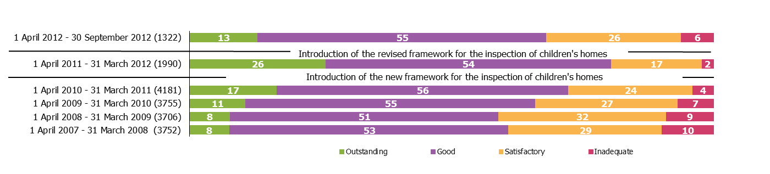

*Source: Ofsted inspections*

1. Percentages are rounded and may not add to exactly 100.

2. Inspections since the inspection framework change on 1 April 2011 include only full inspections, inspections prior to 1 April 2011 include both interim and full inspection.

# Chart 2: Overall effectiveness of children’s homes inspected between 1 April 2007 and 30 September 2012 by quarter (provisional)1,2

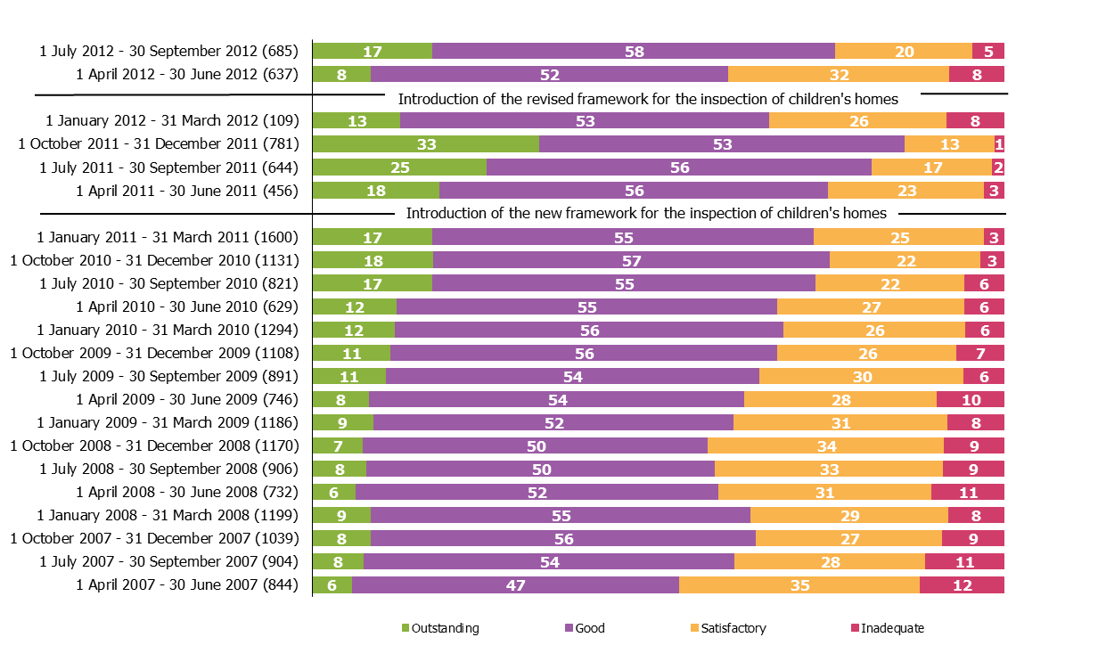

*Source: Ofsted inspections*

1. Percentages are rounded and may not add to exactly 100.

2. Inspections since the inspection framework change on 1 April 2011 include only full inspections, inspections prior to 1 April 2011 include both interim and full inspection.**Chart 3: Overall effectiveness of local authority run children's homes inspected between 1 April 2011 and 30 September 2012, by quarter (provisional)1, 2**

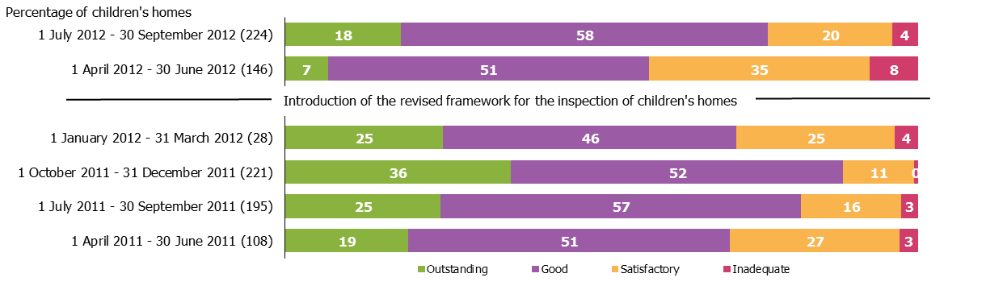

*Source: Ofsted inspections*

1. Percentages are rounded and may not add to exactly 100.

2. Local authority data include a small number of homes run by health authorities.

**Chart 4: Overall effectiveness of private and voluntary run children's homes inspected between 1 April 2011 and 30 September 2012, by quarter (provisional)1**

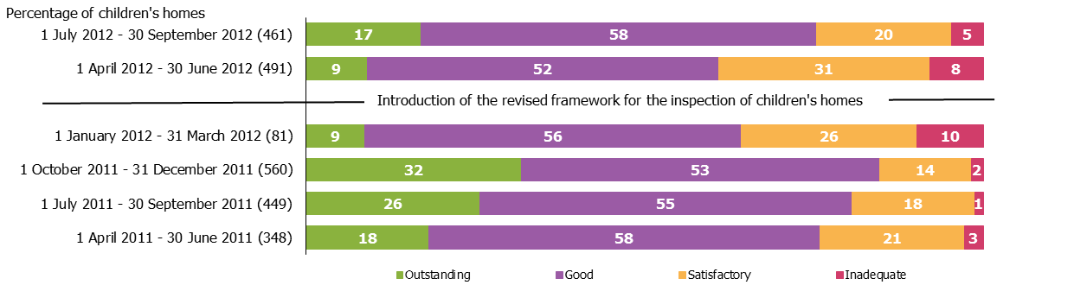

*Source: Ofsted inspections*

1. Percentages are rounded and may not add to exactly 100.

Table 1: Number of children’s homes inspections carried out between 1 July 2012 and 30 **September** 2012, by inspection type (provisional)1, 2, 3



1. The 'all' figures include all homes, of all ownership type, in the local authority area. Local authority run homes data include a small number of homes run by health authorities.

2. Percentages are rounded and may not add to exactly 100.

3. Residential special schools that care for pupils for more than 295 days per year must register as children’s homes.

Table 2: Overall effectiveness of children’s homes at full inspections between 1 July 2012 and 30 September 2012 (provisional)1, 2, 3



1. The 'all' figures include all homes, of all ownership type, in the local authority area. Local authority run homes data include a small number of homes run by health authorities.

2. Percentages are rounded and may not add to exactly 100.

3. Residential special schools that care for pupils for more than 295 days per year must register as children’s homes.

Table 3a: Full inspection outcomes of children's homes (excluding secure children’s homes and residential special schools caring for pupils for more than 295 days per year) inspected between **1 July 2012 and 30 September 2012** (provisional)**1, 2, 3**



1. The 'all' figures include all homes, of all ownership type, in the local authority area. Local authority run homes data include a small number of homes run by health authorities.

2. Percentages are rounded and may not add to exactly 100.

3. Residential special schools that care for pupils for more than 295 days per year must register as children’s homes and their inspection outcomes data can be found in table 3c.

# Table 3b: Full inspection outcomes of secure children’s homes inspected between 1 July 2012 and 30 September 2012 (provisional)1, 2



1. The 'all' figures include all homes, of all ownership type, in the local authority area. Local authority run homes data include a small number of homes run by health authorities.

2. Percentages are rounded and may not add to exactly 100.

Table 3c: Full inspection outcomes of residential special schools caring for pupils for more than 295 days per year inspected between **1 July 2012 and 30 September 2012** (provisional)1,2, 3



1. The 'all' figures include all homes, of all ownership type, in the local authority area. Local authority run homes data include a small number of homes run by health authorities.

2. Percentages are rounded and may not add to exactly 100.

3. Residential special schools that care for pupils for more than 295 days per year must register as children’s homes.

# Table 3d: Interim inspection outcomes of children’s homes inspected between 1 July 2012 and 30 September (provisional)1, 2, 3



1. The 'all' figures include all homes, of all ownership type, in the local authority area. Local authority run homes data include a small number of homes run by health authorities.

2. Percentages are rounded and may not add to exactly 100.

3. At an interim inspection, progress is judged based on requirements and recommendations made following the last full inspection.

4. Children’s homes not accommodating children at the time of their interim inspection received no judgement.

5. Residential special schools that care for pupils for more than 295 days per year must register as children’s homes.

# Map 1: Children's homes receiving a good or better overall effectiveness grade at full inspection, by former Government Office Region, since 1 April 2012



# Map 2: Children's homes receiving an adequate or lower overall effectiveness grade at full inspection, by former Government Office Region, since 1 April 2012



Map 3: Local authority run children's homes receiving a Map 4: Private and voluntary run children's homes receiving a

good or better overall effectiveness grade at full good or better overall effectiveness grade at full inspection,

inspection, by former Government Office Region, since by former Government Office Region, since 1 April 2012

1 April 2012 (provisional)1 (provisional)

 

1. Local authority data include a small number of homes run by health authorities.

**Map 5**: Local authority run children's homes receiving an Map 6: Private and voluntary run children's homes receiving an

adequate or lower overall effectiveness grade at full adequate or lower overall effectiveness grade at full

inspection, by former Government Office Region, since 1 inspection, by former Government Office Region, since 1 April

April 2012 (provisional)1 2012 (provisional)

 

1. Local authority data include a small number of homes run by health authorities.

Glossary

**Children’s homes**

A children’s home is defined in section 1 of the Care Standards Act 2000, and is an establishment that provides care and accommodation wholly or mainly for children. Children’s homes vary in size and nature. They fulfil a range of purposes designed to meet the different needs of those children and young people who are assessed as needing a residential care placement. Some homes, for example, provide short breaks which are needed to help support children and their family. Some residential special schools are registered as children’s homes because boarders are resident for more than 295 days per year.

**Residential special schools**

Residential special schools are defined in section 59 of the Safeguarding Vulnerable Groups Act 2006. They vary in size and nature. The sector includes large non-maintained special schools which make provision for very specific needs and take children as full boarders from all over the country, to smaller more local providers catering for children with a range of different special needs and disabilities who may be resident at the school only during the week. Some residential special schools are registered as children’s homes because boarders are resident for more than 295 days per year. There are also a small number of independent residential special schools who also tend to cater for children with very specialist needs.

**Sector**

Sector refers to the type of provider that owns the children’s home.

*Local Authority*

These are public bodies responsible for the children’s home.

*Private*

These are for-profit organisations mostly with limited company status. These can also though be individually owned children’s homes and run for profit.

*Voluntary*

These are mostly not-for-profit organisations, mainly with charitable status. These can also be individually owned children’s homes and run on a not-for-profit basis.

*Health Authority*

These are NHS Trust-run.

**Secure children’s homes**

Secure children’s homes are defined by section 25 of the 1989 children act. They accommodate children and young people who are remanded or have been sentenced for committing a criminal offence. They also accommodate children and young people who are placed there by a court because their behaviour is deemed to present a significant and immediate threat to their safety or the safety of others, unless they are placed in a secure environment. Ofsted inspections are conducted in accordance with the Care Standards Act 2000 and judgements in reports are made in relation to the outcomes for children set out in the Children Act 2004. The criteria are the same as those used to inspect non-secure children’s homes.

© Crown copyright

You may re-use this information (not including logos) free of charge in any format or medium, under the terms of the Open Government Licence. To view this licence, visit [http://www.nationalarchives.gov.uk/doc/open-government-licence/](http://www.nationalarchives.gov.uk/doc/open%2Dgovernment%2Dlicence) or write to the Information Policy Team, The National Archives, Kew, London, TW9 4DU or e-mail: [psi@nationalarchives.gsi.gov.uk](mailto:psi@nationalarchives.gsi.gov.uk).

1. An amended inspection framework for children’s homes was introduced in April 2012. Details of the framework can be found at <http://www.ofsted.gov.uk/resources/inspection-of-childrens-homes-for-inspections-1-april-2012>.
2. All data for local authority-run homes include those run by health authorities. Please refer to the glossary for more details on the different types of providers.