Official Statistics Release
Policy area: | Local authority children’s services inspections and outcomes: Inspections of local authority arrangements for the protection of children
Theme: | Education, children’s Services and skills
Published on: | 24 January 2013
Coverage: | England
Period covered: | 1 June 2012 – 31 December 2012
Status: | FINAL
Issued by: | Office for Standards in Education, Children’s Services and Skills (Ofsted)  125 Kingsway  London  WC2B 6SE
Responsible director: | John Goldup
Statistician: | Adam King
Public enquiries: | enquiries@ofsted.gov.uk
Press enquiries: | pressenquiries@ofsted.gov.uk
Link to official statistics release web page: | http://www.ofsted.gov.uk/resources/official-statistics-local-authority-childrens-services-inspections-and-outcomes
Publication medium: | Ofsted website
Publication frequency: | Six-monthly
Next publication date: | July 2013

Contents

Intoduction ………………………………………………………………………………………………………………………. | 3
Key findings ……………………………………………………………………………………………………………………… | 3
Table 1: Inspection judgements for inspections of the arrangements to protect children taking place up to 31 December 2012 …………………………………………………………………………………………… | 4
Chart 1: Inspection judgements for inspections of the arrangements to protect children taking place up to 31 December 2012 …………………………………………………………………………………………… | 4
Table 2: Inspection judgements for inspections of the arrangements to protect children taking place up to 31 December 2012, by local authority ………………………………………………………………… | 5
Methodology …………………………………………………………………………………………………………………….. | 6
Additional information ……………………………………………………………………………………………………….. | 6
Glossary …………………………………………………………………………………………………………………………… | 6

Introduction

This official statistics release reports on the outcomes of local authority children’s services inspections that have taken place under the Children Act 2004 and which have subsequently been published.

In May 2012 a new framework of unannounced local authority inspections of the arrangements for the protection of children was introduced by Ofsted. These inspections are referred to in this release as child protection inspections (CPI). These inspections evaluate how effectively children are helped and protected, the quality of front line practice, and the effectiveness of leadership and governance. They consider how effectively the local authority leads partnership working, and how effectively local services contribute to the protection of children and young people.

Inspections under this new framework take place on a one year cycle, running from June 2012 to May 2013. The first inspections under this new framework took place in June 2012 and, by 31 December 2012, there had been 23 inspections completed.

The report does not follow the usual quarterly periods because it introduces the new framework and includes all the inspections that have taken place up to the end of December 2012 and that had been published by 21 January 2013.

Key findings

The authorities inspected are not a representative sample of local authorities in England. The local authorities that were inspected at the beginning of the inspection cycle were those that had been inadequate or adequate with significant weaknesses in their previous safeguarding inspection. Of the 23 CPI inspections that had taken place by 31 December 2012, eight local authorities were judged inadequate for Overall effectiveness, 12 were adequate and three were good.

The outcomes between these inspections and the safeguarding inspections undertaken between 2009 and 2012 are not directly comparable. The new inspection framework has raised the bar. With that caveat, the inspections of child protection arrangements to date have found that eleven local authorities received the same judgement for Overall effectiveness of child protection arrangements that they had for Overall effectiveness of safeguarding. Nine of these were adequate for both inspections and two were inadequate for both inspections.

Six local authorities that had been adequate for Overall effectiveness of safeguarding were found to be inadequate for Overall effectiveness of child protection arrangements. However, three local authorities that had been adequate in their safeguarding inspection were good in their CPI and three that had been inadequate for Overall effectiveness of safeguarding were adequate in their CPI.

One of the three local authorities found to be good for Overall effectiveness, Redbridge, was also good for Effectiveness of help, Quality of practice and Leadership and governance. The other two authorities, Greenwich and Derby City, were found to be adequate for Quality of practice.
Of those local authorities found to be inadequate for Overall effectiveness, five were also inadequate for Effectiveness of help, Quality of Practice and Leadership and Governance. These were Blackpool, Birmingham, Doncaster, Herefordshire and Isle of Wight. All twelve authorities that were adequate for Overall effectiveness were adequate for the other three outcomes

Table 1: Inspection judgements for inspections of the arrangements to protect children taking place up to 31 December 2012¹
 | Overall Effectiveness | Effectiveness of help | Quality of Practice | Leadership & Governance
Outstanding | 0 | 0 | 0 | 0
Good | 3 | 3 | 1 | 3
Adequate | 12 | 14 | 15 | 14
Inadequate | 8 | 6 | 7 | 6
Total | 23 | 23 | 23 | 23
 |  |  | Source: Ofsted inspections
1. Inspections taking place up to 31 December 2012 and published by 21 January 2013.

Chart 1: Inspection judgements (number) for inspections of the arrangements to protect children carried out by 31 December 2012

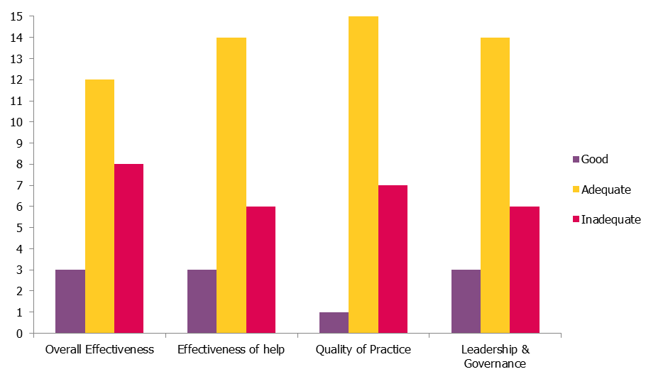

Table 2: Inspection judgements¹ for inspections of the arrangements to protect children taking place up to 31 December 2012², by local authority
Local Authority | Publication date | Overall Effectiveness | Effectiveness of help |  | Quality of Practice |  | Leadership & Governance
Blackpool | 13/07/2012 | 4 |  | 4 | 4 |  | 4
Rotherham | 10/08/2012 | 3 |  | 3 | 3 |  | 3
Bromley | 17/08/2012 | 3 |  | 3 | 3 |  | 3
Birmingham | 19/10/2012 | 4 |  | 4 | 4 |  | 4
Herefordshire | 19/10/2012 | 4 |  | 4 | 4 |  | 4
Cambridgeshire | 19/10/2012 | 4 |  | 4 | 4 |  | 3
Surrey | 19/10/2012 | 3 |  | 3 | 3 |  | 3
North Yorkshire | 09/11/2012 | 3 |  | 3 | 3 |  | 3
Cheshire West and Chester | 09/11/2012 | 3 |  | 3 | 3 |  | 3
Doncaster | 16/11/2012 | 4 |  | 4 | 4 |  | 4
Redbridge | 12/11/2012 | 2 |  | 2 | 2 |  | 2
Salford | 12/11/2012 | 3 |  | 3 | 3 |  | 3
Brent | 30/11/2012 | 3 |  | 3 | 3 |  | 3
Staffordshire | 14/12/2012 | 3 |  | 3 | 3 |  | 3
Wakefield | 07/12/2012 | 3 |  | 3 | 3 |  | 3
Rochdale | 21/12/2012 | 4 |  | 3 | 3 |  | 4
Wokingham | 21/12/2012 | 3 |  | 3 | 3 |  | 3
Shropshire | 08/01/2013 | 3 |  | 3 | 3 |  | 3
Isle of Wight | 15/01/2013 | 4 |  | 4 | 4 |  | 4
Kent | 15/01/2013 | 3 |  | 3 | 3 |  | 3
Derby City | 21/01/2013 | 2 |  | 2 | 3 |  | 2
Calderdale | 21/01/2013 | 4 |  | 3 | 4 |  | 3
Greenwich | 21/01/2013 | 2 |  | 2 | 3 |  | 2
 |  |  |  | Source: Ofsted inspections
1. Local authorities were given the following grades for the judgements shown: 1 Outstanding, 2 Good, 3 Adequate and 4 Inadequate.
2. Inspections taking place up to 31 December 2012 and published by 21 January 2013.

Methodology

- The inspections of local arrangements for the protection will run from May 2012 to June 2013. Not all local authorities, therefore, will be inspected under the current framework, as reported in this release, as it will be replaced with a multi-inspectorate inspection of child protection services from June 2013. This will be a joint inspection between Ofsted, Care Quality Commission, HMI Constabulary, HMI Probation, HMI Prison Service and HMI Crown Prosecution Service.

- The change to the framework will be reflected in future releases of these official statistics.

- For more information on how Ofsted regulates and inspects children’s social care, please go to the Ofsted website: www.ofsted.gov.uk/Ofsted-home/Forms-and-guidance/Browse-all-by/Care-and-local-services/Children-s-social-care

Additional information
All the tables and charts shown in this release, along with additional data at regional and local authority level, are available in Excel format on the Ofsted website in the same location as this document. Underlying data are also available in Excel and comma separated values (.csv) formats.
The selected tables and charts included above are numbered according to the accompanying Excel workbook.

Glossary

Overall effectiveness judgement:

This judgement relates to the extent to which the local authority and its partners are protecting children effectively, including providing effective help that leads to improved outcomes; ensuring that practice is child-centred and focused on identifying and protecting children and young people at risk of harm; demonstrating strategic leadership and governance that improves the help and protection offered to children and young people; and, how they are continuously learning, including learning from feedback from children, young people, families and carers, and practitioners.

The effectiveness of the help and protection provided to children, young people, and their families and carers judgement:

This judgement relates to the extent to which children and young people are protected, risks are managed and that the help provided reduces harm. It includes, for example, the extent to which children, young people and their families feel that they have been effectively helped, and understand the intentions of the help and protection they receive, as well as how the help and protection provided is responsive to ethnicity, culture, religion, language or disability. It also looks at whether there is an early help offer that reflects the needs of the population and whether the help given is proportionate to risk i.e. children and families are not subjected unnecessarily to formal child protection processes.

Quality of practice judgement:

This judgement relates to the first line management of services. It includes, for example, the extent to which: children and young people are seen by a social worker who builds an effective relationship with them; children and young people are listened to and heard, and practice is focused on their experiences; universal services, including those providing early help, make appropriate referrals to social care; management oversight of social work practice includes supervision that is effective, robust, systematic, challenging, and recorded; thresholds for access to services are clear, understood and implemented locally by all professionals working with children, young people and families; assessments, including common assessments, are timely, effective and result in a direct offer of help or appropriate protection where appropriate; and, information sharing between agencies and professionals is timely, specific and effective.

Leadership and governance judgement:

This judgement encompasses leadership and governance within the local authority, through both elected members and officers, and at both corporate and departmental levels, and through the Local Safeguarding Children Board (LSCB). It evaluates how effectively the local authority leads partnership working in relation to early help and child protection, and the effectiveness and capacity of leadership in achieving and sustaining improvement.

© Crown copyright

You may re-use this information (not including logos) free of charge in any format or medium, under the terms of the Open Government Licence. To view this licence, visit http://www.nationalarchives.gov.uk/doc/open-government-licence/ or write to the Information Policy Team, The National Archives, Kew, London, TW9 4DU or e-mail: psi@nationalarchives.gsi.gov.uk.

