18 January 2013

National Strategy for Access and Student Success
Interim report to the Department for Business, Innovation and Skills by the
Higher Education Funding Council for England and the Office for Fair Access

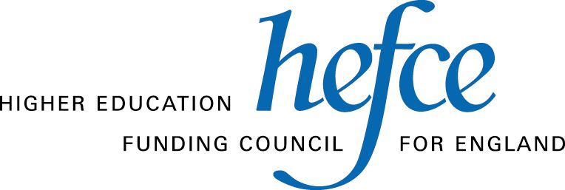
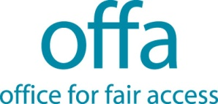
Contents

Executive summary 3
Introduction 3
Section 1: Creating a culture of widening participation 3
Section 2: How the investment in WP delivered change 3
Section 3: Outcomes of the investment 38
Section 4: The challenges to continued progress in WP 35
Section 5: Evidence of what should continue to be supported to widen participation 35
Section 6: Building the strategy 31
Conclusion 37
List of abbreviations 78
Annex A Bibliography 79
Annex B Key issues and actions 82

National strategy for access and student success: Interim report to the Department for Business, Innovation and Skills by HEFCE and the Office for Fair Access

Executive summary
- This is an interim report to Ministers on the development of a national strategy for promoting access and student success in higher education. It is jointly authored by the Higher Education Funding Council for England (HEFCE) and the Office for Fair Access (OFFA). The report:
  - brings together our current knowledge of what works to widen participation in higher education (HE)
  - presents an early assessment of how the investment currently made in widening participation (WP) is meeting, and might better meet, the Government’s aims and objectives and further facilitate the HE sector’s contribution to social mobility
  - looks at how HEFCE’s and OFFA’s processes can be brought together more closely, to avoid duplication and reduce burden on the HE sector.
- The report reviews the evidence to date of what works to widen participation, gathered through the research and evaluation of activity. This initial work forms part of the broader development of the strategy over the next eight months, which will seek to provide a comprehensive, far reaching meta-analysis of the existing evidence, so that funds can be best targeted going forward.
- This report also draws on research that has been specifically commissioned for the development of the national strategy. This includes case studies of institutional activity, and findings from research into the use and impact of the HEFCE WP allocation. It also reports on early discussions that have been held with key stakeholders and sector representatives regarding the priorities for and shape of the strategy.

Key outcomes from the report
- The evidence which we have gathered and present in this report has enabled us to draw some tentative conclusions about where it might be necessary to focus some of the investment in WP in the future
- In particular, our synopsis of research and evaluation studies enables us to conclude the following.
- Outreach is most effective when delivered as a progressive, sustained programme of activity and engagement over time.
- Outreach programmes need to be directed towards young people at different stages of their educational career and begin at primary level.
- The effective delivery of outreach programmes requires the full, adequately resourced involvement and engagement of HEIs, FECs and schools.
- The collaborative provision of outreach delivers benefits in terms of scale, engagement, coordination and impartiality.
- Progression pathways for learners with non-traditional or vocational qualifications need to be clearly articulated.
- Outreach to mature learners depends on good links with FE colleges, employers and the community.
- Retention and success depends on fostering a sense of belonging.
- The academic sphere is key to establishing belonging, so issues of curriculum design, pedagogy, learning and teaching environments and student engagement and support are crucial.
- The report highlights the challenges to the provision of high-quality, relevant advice and guidance to young people in schools and to adults in further education (FE) colleges, employment and the community. Responding to these challenges, the report argues, requires a national response across Government, but it also requires the HE system to critically appraise its existing approaches to outreach and assess where there are greater contributions that could be made. The evidence to date suggests that building on the collaborative arrangements already in place in HE to enable the delivery of sustainable and comprehensive outreach to young and mature students should be a key priority.
- It also requires a greater focus on evaluation of widening participation activity, to measure its effectiveness, For example, while evaluation of discrete widening participation activities is common, there is a need for more institutions to carry out more holistic evaluations of longer-term impact to develop a coherent understanding of what works and why.
- The report also highlights the importance of maintaining and if possible enhancing a focus on equality and diversity. HEFCE has already supported considerable activity to address the differences in degree attainment for students from different ethnic minority backgrounds and it continues to deliver specific funding to provide for and support disabled students. However, the report also highlights the continuing disparity in entry rates between men and women in HE and showed how these mirror the differences men and women in the A-level population before HE entry. The report highlights how using evidence of attendance at Aimhigher summer schools improved the numbers of boys taking part, and how it influenced the behaviours of partnerships so that they considered how best to engage boys while ensuring that they did not neglect disadvantaged girls. All of these issues will be considered further as the evidence develops.

Section 1: Creating a culture of widening participation
- Long-term, sustained investment in widening participation in higher education, in particular the mix of different types of investment, has facilitated the creation of a culture of widening participation which, we argue, has been crucial in effecting positive change.
- Evidence presented in this report strongly indicates that to make significant progress in WP requires a targeted focus on individual learners over a number of years. When working with young people, interventions are most effective when they start early, and are then delivered consistently throughout time at school and college. This requires a high level of commitment from HE providers, supported by the senior team and head of institution. Consequently, recognition of the costs involved of successfully delivering widening participation and student success, a stable infrastructure and reliable investment models have all been vitally important in securing the necessary commitment and facilitating national progress in WP.
- Widening participation initiatives, projects and programmes have created forums within which professionals from HE, FE and schools have been able to come together strategically and collaboratively to create, develop and refine approaches to access and student success. Furthermore, commitment to and investment in widening participation by successive governments has meant that we have witnessed significant improvements in the participation rates of students from the most disadvantaged backgrounds. The Coalition Government has recognised this and is concerned to inject more pace and rigour into the next phase of widening participation.

Section 2: How the investment in WP delivered change
- This report highlights how institutions and the national WP programmes have used the investment made by Government, HEFCE and HE providers to effect change. It uses evidence from research into the use and impact of HEFCE funding for widening participation, evidence derived from monitoring returns – both HEFCE’s widening participation strategic assessments (WPSAs) and OFFA access agreements – and monitoring and evaluation evidence from national programmes to provide an overview of the range and volume of approaches and activity that institutions and collaborative partnerships have been able to deliver.
- For example, recent research into the use and impact of the HEFCE funding for widening participation found that there is significant evidence that since the introduction of WP funding in 1999-2000, there has been a shift in organisational culture and attitudes towards WP across the sector, and that the funding has helped WP to become formalised and embedded in institutional strategies.
- In addition to the consistent levels of investment through the HEFCE allocation, the introduction of access agreements from 2006-07 brought a significant new source of funding to support widening participation and fair access. In 2010-11, universities and colleges spent £424 million on access measures(24.4 per cent of higher fee income), including £378 million (21.7 per cent of higher fee income) on bursaries and a valuable additional funding stream of around £46 million (2.7 per cent of higher fee income) – controlled by institutions themselves – for institutional outreach activities and infrastructure. The evolution of fee income being used for outreach as well as bursary provision reflects a gradual extension of the purposes for which OFFA indicates additional fee income may be used to help build social mobility.
- Many of the case studies included in this report describe interventions that have been in place for, and demonstrate progress over, a number of years, reflecting the long-term nature of the progress that has been made. They set out the types and levels of activity institutions undertake to widen participation, and demonstrate how access agreements and HEFCE funding work together to secure progress.
- In addition, the investment in national programmes provided a solid infrastructure for the creation of collaborative partnerships across the educational sectors. These partnerships worked to raise aspirations and attainment and to create clearly articulated progression pathways for students from differing backgrounds with a broad range of entry qualifications. They also created efficiencies of scale, enabling many more people to benefit than if institutions had been working individually.

Section 3: Outcomes of the investment
- The national strategy we deliver in autumn 2013 will build on the evidence provided in this report, by casting an even wider net in the pool of existing research and drawing on evidence from research commissioned specifically for the strategy. This will include evidence from international comparisons where different approaches may have been adopted. This broad, comprehensive appraisal of evidence should provide a strong base for assessing the impact of the investment on outcomes.
- However, tentative links can begin to be made here on the basis of evidence already held. Analysis conducted by HEFCE in 2010 showed the following:
- The likelihood of those from the lowest participation areas participating in HE had increased by 30 per cent over the last five years and by 50 per cent over the last 15 years.
- Between 1994-95 and 2003-04 the participation rate for the lowest participation areas rose by only one percentage point from 13 per cent to 14 per cent. However, between 2003-04 and 2009-10, the rate had risen rapidly and significantly from 14 per cent to 19 per cent.
- The gap in participation rates between the most and least disadvantaged was still significant despite the progress that had been made: the participation rate of the most advantaged was 57 per cent compared with a participation rate of 19 per cent for the least advantaged.
- The gap in the participation rates between men and women was still large, with women at 40 per cent and men at 32 per cent. However, the last four years included in the analysis did show an improvement in the participation rates for men, which before had remained relatively flat at 29 per cent, and a stabilising, if not yet narrowing, of the gap, even in the most disadvantaged areas where it has been widest.
- Further analysis undertaken by OFFA (OFFA 2010/03) showed that while participation among the least advantaged 40 per cent of young people had significantly and steadily increased across the sector as a whole since the mid-1990s, it had remained almost flat at the most selective third of institutions.
- Over the time that the increases in participation rates occurred (2004-05 to 2009-10), the integrated Aimhigher programme was running and HEFCE investment in WP grew significantly with the introduction of the improving retention element of the allocation in 2003-04. Furthermore, from 2006-07, institutions’ own investment through access agreements added further funding to support WP. Our conclusion is that the sustained and large investment in WP has contributed to the sustained and significant increases in the proportion of young people from our most disadvantaged groups entering HE.
- Analysis of Aimhigher summer schools also supports the case for investment in WP interventions. It found that attending a summer school is associated with elevated rates of entry to higher education, with participants on average being twice as likely to apply, and be accepted, as non-participants. Qualitative research has also supported these findings, providing strong evidence that the kind of outreach delivered through Aimhigher was successful in raising learner aspirations and encouraging applications to HE, as well as playing an important role in generating a culture of achievement in a school or college, or in the wider community.
- In keeping with the student lifecycle approach, investment in WP has also ensured that as the student body has grown in volume and become increasingly diverse, the proportion of students withdrawing early from HE has remained relatively static and low (8.4 per cent of full-time first-degree HE entrants did not continue to their second year in 2009-10, down from 9.1 per cent of entrants in 2002-03).

Section 4: The challenges to continued progress in WP
- There have been significant changes across all of the educational sectors that may impact on widening participation into the future. These include the reforms within HE itself affecting student number controls, higher tuition fees (albeit with a progressive loan and repayment system) and a much more diverse and competitive sector.
- It will be important to continue to monitor issues relating to accessibility, equality and the diversity of the student population. Emerging evidence suggests that there are not significant detrimental effects on applications from the lowest participation neighbourhoods in 2012-13, with entry rates among English 18-year-olds being the highest on record. This continues the longer-term trend in the strong proportional increases of students from these backgrounds since the mid-2000s. However, the full effects on widening participation may take some time to emerge, and it is likely that a range of factors may impact on potential students from disadvantaged backgrounds in the coming years.
- Analysis of UCAS data in terms of gender and ethnicity, coupled with research into degree attainment and a continuing concern to ensure that disabled students are fully supported to participate in HE, shows that a clear focus on issues of equality and diversity is fundamental to the development of a national strategy for widening participation and student success.
- Those applying to and entering HE in 2012-13 may already have been set on a trajectory for higher-level study, having perhaps benefited in previous years from national outreach and progression programmes such as Aimhigher. Institutions may be unable to deliver a similar scale of outreach activity now and in future.
- While institutions are already doing a great deal to reach out to potential HE students from under-represented groups, there is the potential to do more. However, the increasingly competitive nature of the HE system and the emphasis on progress against institutional targets may lead to many institutions disengaging from collaborative outreach arrangements.
- Changes in the school system may also impact on the work to widen participation to HE, as might the replacement of the Educational Maintenance Allowance with the 16-19 bursary, and the changes made to the tuition fee arrangements in FE. We are not yet able to assess how the changes to tuition fees and loans in the FE and HE sectors will impact on the propensity of mature learners to progress to HE. In light of such concerns, we anticipate that the final report may recommend that a greater governmental focus on issues of advice and guidance within schools and colleges will be important in order to maximise the investment in widening participation to HE. The strategy will also explore how HE can most effectively engage in supporting good information and particularly advice and guidance concerning HE in schools and colleges in the new environment.
- There is an argument that such fundamental changes across educational sectors demand a co-ordinated, national response. Individual institutions, however committed, will be unable to meet the myriad of challenges these cross-sector reforms present.
- There is a clear need for schools, colleges and HE institutions to work together strategically to best meet the current and future needs of all their learners. This requires commitment from the Department for Education, BIS) and across Government to a common set of aims and objectives, and to providing challenge, support and incentives for institutions in all sectors to contribute to their realisation.
- The evidence we have to date suggests that well coordinated, structured outreach programmes in which schools, colleges, HE providers and, where appropriate, employers and third sector agencies are equal partners and which deliver clear benefits to learners in terms of engagement, attainment and aspiration are particularly effective in increasing participation in higher education. In light of this the development of the strategy will consider how the HE sector can better focus its investment in WP to encourage a more sustainable and comprehensive approach to outreach arrangements.
- Work will also continue with BIS to develop and enhance the National Scholarship Programme. Changes have been made to enhance the targeting of the funding through alignment with the institutional distribution of students who meet the national eligibility criteria.

Section 5: Evidence of what should continue to be supported to widen participation
- Understanding what works to widen participation is complex. However, robust evidence should be able to provide sufficient confidence in the results to enable us to determine a relationship between an intervention or approach and the outcome which, in turn, would allow us to form a judgement about the effectiveness of the activity.
- The evidence suggests that as approaches to collaborative outreach are developed, particular focus might be given to arrangements that seek to increase the progression rates of mature learners and learners with vocational Level 3 qualifications.
- The evidence further suggests that institutions should continue to invest in and develop their provision of inclusive learning, teaching and student support practices and environments.
- The evidence presented in the report delivers the following key messages:
- Outreach activity should start early in the educational career and should be progressive in nature.
- Delivering outreach to mature learners presents challenges, not least in terms of a lack of easily identifiable target institutions outside FE colleges.
- The progression rates for learners with vocational or non A-level qualifications are significantly lower than those for learners with A-levels.
- Evidence points to a continuing need for structured, co-ordinated approaches to outreach.
- The academic sphere is crucial in fostering a sense of belonging to aid student retention and success.
- Evidence points to the need for investment in inclusive learning, teaching and student support practices and environments.
- Institutions still need to do more to evaluate the impact of their widening participation activity.

Section 6: Building the strategy
- As we undertake the work to develop the strategy for delivery by autumn 2013, we have adopted three core organising themes through which we will address the identified strategic priorities. The three organising themes are:
- maximising the impact of the investment in WP
- growing the evidence base
- integrating HEFCE and OFFA systems.
- In addition to the work being done to develop and deliver the strategy, HEFCE and OFFA have already taken steps to encourage institutions to ensure that the investment currently made in WP through HEFCE grant and institutional funds is used most effectively. HEFCE has sought to do this through its development of the student opportunity allocation, and OFFA through its greater focus on the outcomes of outreach and other access activities.
- Considerable progress has already been made to prepare for the development of the strategy and its delivery by the autumn 2013. The annex detailing key issues and actions that was attached to our response to Ministers in October 2012 has been updated and is attached to this report at Annex B.

Introduction
- This is an interim report to Ministers on the development of a national strategy for promoting fair access and student success in higher education. It is jointly authored by the Higher Education Funding Council for England (HEFCE) and the Office for Fair Access (OFFA). The report:
  - brings together our current knowledge of what works to widen participation in higher education (HE)
  - presents an early assessment of how the investment currently made in widening participation (WP) is meeting, and might better meet, its aims and objectives and further facilitate the HE sector’s contribution to social mobility
  - looks at how HEFCE’s and OFFA’s processes can be brought together more closely to avoid duplication, and reduce burden on the HE sector.
- On 22 May 2012, the Secretary of State for Business, Innovation and Skills, and the Minister for Universities and Science, wrote to HEFCE and OFFA asking us to develop a shared strategy to promote access to higher education and to maximise the impact of the spending by Government, HEFCE and institutions on widening participation in higher education. The Ministers stressed that the strategy should be based on the best available evidence from the UK and other countries, and should harness the public funding being provided to widen participation in a way that drives systemic improvements across the HE system.
- On 22 October 2012 OFFA and HEFCE welcomed this request and outlined the approach we would take to the development of this national strategy. We advised Ministers that in developing the strategy both organisations would draw on a broad mix of activity, including: in-house and commissioned research; consultation with leading experts and stakeholders; and the alignment and integration of key HEFCE and OFFA processes. We further advised that the strategy would:
- build on the progress made to date in the sector to widen participation in higher education
- draw on the considerable store of knowledge and experience already within institutions about what constitutes effective approaches and practice
- address participation throughout the student lifecycle: from pre-entry through to progression into further study or employment
- reflect the rich diversity of both students and higher education providers.
- Ministers accepted the approach we outlined, and asked that the strategy document be delivered by autumn 2013. The strategy will then be reviewed and renewed by HEFCE and OFFA as the evidence base grows and improves. In advance of the strategy document, Ministers requested this interim report.

Section 1: Creating a culture of widening participation
- For both HEFCE and OFFA, widening participation in higher education has been a core priority since the two organisations were established, in 1992 and 2004 respectively.
- OFFA and HEFCE have complementary but distinct roles in widening participation, which have ensured progress has been delivered and secured both nationally and in individual, institutional commitment by individual institutions to WP and fair access.
- HEFCE situates its commitment to widening participation within its broader, strategic role in the HE sector. Its primary focus has been to work at the national level to develop a culture of widening participation in higher education as a whole, and to enable the development of the infrastructures necessary for its delivery. The evidence presented in this report suggests that HEFCE’s long-term investment in WP and its delivery and support for national programmes for outreach and progression (Aimhigher and Lifelong Learning Networks), have both supported institutions to develop and embed WP strategies and activity, and provided nationally supported infrastructure and activity. This has led to the prioritisation of WP across the sector; a shift in the culture, language and approaches within institutions; and demonstrable positive effects on participation.
- OFFA was established in 2004 as an independent non-departmental public body, to help promote and safeguard fair access to higher education and to ensure that students were not deterred from applying on financial grounds following the introduction of variable tuition fees. OFFA does this by requiring each institution that wishes to charge fees above the basic level to have an access agreement, approved by OFFA, in which it sets out how it will sustain or improve access and student retention. Access agreements also include stretching targets which set out the desired outcomes of the work described in the access agreement.
- OFFA’s role is more focused than HEFCE’s: its remit is to ensure increased investment in access and student success measures (beyond that provided through HEFCE allocations) at only those institutions choosing to charge fees above the basic level – though this now covers all higher education institutions (HEIs) and a significant minority of further education colleges (FECs). From its inception as a regulator, OFFA has had a crucial role to play in working with and challenging institutions to achieve real progress in widening participation and fair access and, since 2012, in improving retention. While there is no doubt that institutions are committed to WP, the level of public accountability provided by access agreements and monitoring of progress has resulted in additional impetus and investment. OFFA’s access Agreements build on HEFCE’s broader national and institutional investment in WP, to ensure that it remains a key priority both locally and nationally.
- HEFCE and OFFA recognise that a ‘one size fits all’ approach to widening participation is neither desirable nor practical. ‘WP students’ are not homogenous: while we frequently refer to students from ‘disadvantaged backgrounds’ or ‘under-represented groups’, this is shorthand terminology. Students come from a variety of backgrounds and have multiple characteristics and learner identities that defy categorisation.
- Universities and colleges are also diverse. They vary in size, structure, provision, mission and engagement (local, national and international) and have different aims and objectives in regard to WP, depending on a range of factors. So, although governments and national agencies and bodies may set national priorities and aims, these must be flexible enough to allow institutions to achieve them, as they see fit, without compromising their autonomy, and to allow them to respond to particular regional, demographic or employment challenges.
- HEFCE and OFFA accommodate this need for institutional autonomy within their respective frameworks. HEFCE’s funding for widening participation has traditionally been provided as part of institutions’ block teaching grant rather than as a ring-fenced allocation. From 2009 however HEFCE requires each institution to submit a strategic assessment or statement about its WP activity as a condition of the continued receipt of the WP allocation. OFFA requires the submission of plans and information on investment, but how these are executed is for the individual institution to decide. This approach encourages institutional ownership, buy-in and accountability.
- This recognition of institutional diversity is at the heart of HEFCE’s and OFFA’s approach to widening participation, and explains why investment in widening participation has been structured to allow institutions to be flexible and responsive.
- The long-term nature of investment in and support for widening participation has been vital to the creation of a culture of widening participation within higher education. Evidence, including that presented in this report, strongly indicates that to make significant progress in WP requires a targeted focus on individual learners over a number of years. When working with young people, interventions are most effective when they start early, and are then delivered consistently throughout their time at school and college. This requires a high level of commitment from institutions that, to be effective, must be supported by the senior team and head of institution. Consequently, recognition of the costs involved of successfully delivering widening participation and student success, a stable infrastructure and reliable investment models have all been vitally important in securing the necessary commitment and facilitating national progress in WP.
- Table 1 shows the significant investment made in activity to widen participation in higher education by Government, HEFCE and institutions by listing key investments since 1995. After the publication of the ‘Dearing Report’ in 1997, WP became a national priority and there was a step-change in approach and culture within the HE sector, but this does not represent the start of public support for this important activity. HEFCE’s predecessor body, the University Grants Council, provided earmarked funding for access activity and provision for students from disadvantaged backgrounds, and many Access to HE courses were supported from universities’ continuing education funds.

Table 1: Timeline of investment in widening participation
Year | Funding stream | Level (£M) | Purpose
1995-96 to 1998-99 | Non award-bearing education programme | 18.4 over lifetime of programme | Support of non award-bearing provision for liberal adult education and widening access programmes
1997-98 to 2000-01 | Disability strand projects | 7.3 over lifetime of programme | Special funding initiative to develop and embed good practice in provision and support for disabled students
1998-99 | Widening participation programme | 1.5 over lifetime of programme | Programme to build partnerships and help lay the foundations for effective institutional strategies
1999-2000 to present | Widening participation formula funding allocation | 20 in 1999-2000 rising to 60 in 2012-13 | HEFCE’s first recurrent formula funding for WP based on fulltime students from disadvantaged backgrounds
2000-01 to present | WP allocation plus further formula for part-time students | 24 in 2000-01 rising to 67 in 2012-13 | Recurrent formula funding for WP based on part-time students from disadvantaged backgrounds
2000-01 to present | Mainstream disability allocation | 7 in 2000-01 rising to 13 in 2012-13 | Recurrent formula funding for provision and support for disabled students
2002-03 | Additional funding for WP | 20 (Jointly funded by HEFCE and Learning and Skills Council) | Funding for the development and delivery in 2003-04 of Partnerships for Progression
2003-04 to present | Improving retention allocation | 217 in 2003-04 rising to 224 in 2012-13 | Recurrent formula funding to recognise costs of supporting students at greater risk of withdrawal
2004-05 to 2010-11 | Aimhigher | 84 per year on average (HEFCE, BIS and Learning and Skills Council / Skills Funding Agency main funders) | National outreach programme developed from the integration of the Excellence Challenge initiative and Partnerships for Progression
2004-05 to 2011-12 | Lifelong Learning Networks | 100 over lifetime of programme | Partnerships between HE institutions and FECs to support the progression into HE of learners with vocational Level 3 qualifications
2006-07 to present | Institutional funds delivered to access measures through access agreement commitments | 424 in 2010-11  Rising to 672 in steady state under the new arrangements | OFFA was created in 2004 to ensure that higher fees introduced in 2006-07 did not deter people from entering HE for financial reasons and that institutions were explicitly committed to widening participation
2012-13 onwards | National Scholarship Programme | 50 in 2012-13 rising to 150 by 2014-15 | Provision of individual financial benefit for students with a residual household income of £25,000 or less, who meet individual institutional criteria and are selected for an award

- HEFCE also funded a widening participation co-ordination team, Action on Access, from 2000 until the end of 2011, and a co-ordination team for disability, the National Disability Team, from 2000 to 2005. The purpose of these teams was to build capacity, and to help shape the sector’s response to WP and to the provision and support for disabled students within higher education. They provided forums for practitioners to develop and share practice, helped HEFCE to formulate its guidance to institutions, and informed the development of HEFCE’s policy on and approach to widening participation.
- As well as illustrating the scale of key initiatives, programmes and investment over nearly 20 years, Table 1 illustrates the commitment of successive governments to WP as part of the now broad consensus to make progress on social mobility. This investment has increased over time in line with the increased commitment of Government to support progress, and shows the mix of different types of investment:
  - funding for relatively small-scale projects aimed at improving, embedding and sharing practice
  - mainstream funding allocations to enable the development of institutional strategic approaches to widening participation and student success
  - national programmes aimed at delivering consistent, coherent and comprehensive activity in partnership across educational sectors.
All have made significant contributions to the development and adoption of WP as a core priority across institutions and sectors.

Encouraging and supporting change
- In communicating its funding decisions and its guidance on institutional WP statements and strategies, HEFCE has worked to ensure an approach that supports national as well as local priorities, and that signals its expectations without being overly prescriptive.
- For example, when HEFCE provided £1.5 million in 1998-99 for a WP programme bids had to demonstrate that they would: meet a regional need; promote longer-term commitment to WP; and develop synergy with other funding sources and partnerships.
- Already, the following core themes for HEFCE’s approach to WP were emerging:
- the need for commitment from each institution
- the need for mainstreaming and embedding WP
- the need to work in partnership to meet differing regional needs
- a recognition that different needs, areas, partnerships and institutions would require different approaches.
- A key point in HEFCE’s support was the introduction of a funding supplement for WP from 1999-2000, calculated according to the numbers of full-time undergraduate students from disadvantaged groups within institutions in the teaching funding method. This was the first formula funding stream for WP. The key principles underlying HEFCE’s approach to funding, which have continued to underpin HEFCE’s subsequent WP policy and funding, are set out below:
- Access to achievement – We should encourage institutions not only to increase the participation of students from under-represented groups but also to help such students to succeed.
- Increased collaboration – Priority should be given to collaboration between HEIs and partners from other education sectors to improve progression routes to HE for under-represented groups.
- Recognising diversity – We should avoid prescription in our funding and allow for differences in institutional approach, adopting different funding approaches to recognise the diversity of missions and strategies in the sector.
- Targeting certain groups – Emphasis should be placed on improving the representation of particular disadvantaged groups.
- HEFCE’s funding objectives have been to:
- reward proven success and encourage all institutions to improve their record in WP
- recognise the additional costs of providing access for under-represented groups
- increase the representation in HE of particular disadvantaged groups – for example, disabled students, young people from disadvantaged backgrounds, and those who missed out on opportunities the first time round
- build partnerships between HEIs, schools and especially the further education (FE) sector to improve the progression rates to HE of previously disadvantaged students
- promote and disseminate good practice in strategies to widen participation
- support activity designed to retain students
- encourage collaboration between HEIs to promote the above objectives.
- The receipt of institutional funding was conditional upon the submission of initial WP statements in 1999-2000, followed by full, three-year WP strategies in 2000-01. Through its guidance to institutions on the development of these strategies, HEFCE sought to influence the way in which institutional approaches to WP were realised, and to encourage the adoption and embedding of the lifecycle approach to WP.
- HEFCE’s funding of national programmes (Partnerships for Progression, Aimhigher and Lifelong Learning Networks) encouraged the development of cross-sector partnerships with schools, colleges and universities working towards shared aims and objectives at a strategic and practical level.
- These national programmes also enabled HEFCE to influence practice directly, through provision of evidence. For example, HEFCE’s analysis of the Aimhigher summer schools programme was not only able to establish that there is a relationship between participation on a summer school and progression to HE, but also to demonstrate how good research could affect practice. The initial report, published in 2009, analysed provision and participation in Aimhigher summer schools between 2004 and 2008. It revealed that for every boy participating in these summer schools there were two girls. After this finding was presented to Aimhigher partnerships there was a marked increase in the number of boys participating in summer schools and other interventions, as practitioners within partnerships made changes to their offer and practice to encourage more boys to take part.
- The establishment of OFFA in 2004 and the subsequent introduction of higher fees in 2006-07 ensured that institutions wishing to charge above the basic tuition fee level had to be explicit in regard to their commitment to WP, and deliver a proportion of their own higher fee income to support it. A minimum bursary for students entitled to full state maintenance grant was required of all institutions, but more was expected of those institutions that did not already have a diverse student body. The design of institutions’ investment in access agreements, beyond the minimum bursary, or from 2012-13 National Scholarship Programme (NSP) commitments, was (and remains) for individual institutions to determine. Many institutions were expected to do more than offer the minimum bursary (and now NSP), but precise levels of investment were not set out in legislation, nor explicit in OFFA guidance, though broad guidelines were set out for the new arrangements from 2012-13. OFFA’s specific intention was to give individual universities and colleges the freedom to decide – within the broad guidance – what was an appropriate investment to deliver their plans and ambitions.
- OFFA’s broad expectation under the post-2006 system was that institutions with an already representative student body might spend around 10 per cent of their higher fee income on access measures, and that institutions with further to go in securing a diverse student body would spend a minimum of 20 per cent on access measures, This was in order to encourage progress on widening participation and fair access across the sector. In fact, institutional investment has been much more generous than this: on average institutions spent a quarter of their higher fee income on access agreement commitments in each year between 2006-07 and 2010-11, and many spent much more than this.
- In 2010-11, spending under access agreements comprised around £424 million (24.4 per cent of higher fee income). Of this, £378 million (21.7 per cent of higher fee income) was spent on financial support for students and a further £46 million (2.7 per cent of higher fee income) on additional outreach or other WP activities. This spending is set to increase further from 2012, to a total of £672 million by 2016-17 (excluding the Government’s contribution to the NSP). These figures demonstrate a significant commitment from institutions to widen participation and fair access, and a level of additional investment that has exceeded both Government and OFFA expectations. The new arrangements put in place from 2006-07, and revised in 2012-13, have created a dependable source of income for institutions, and provided some additional confidence and stability to the longer-term planning of access measures within institutions.

Figure 1: Expenditure on OFFA-countable financial support, outreach and retention, 2006-07 to 2016-17: HEIs and FECs
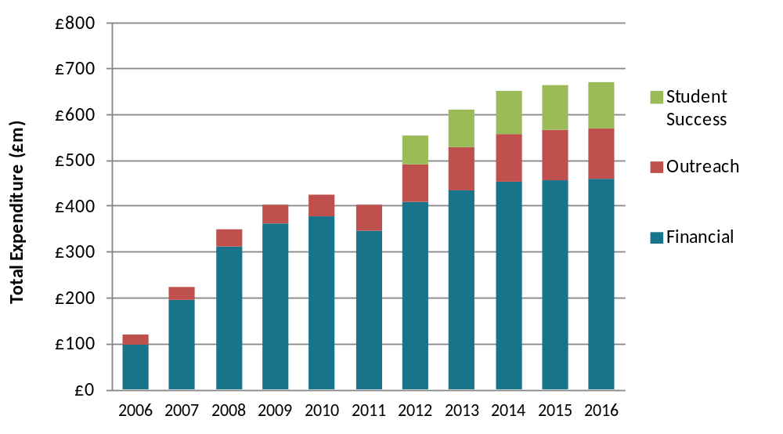
Notes to Figure 1
1 Expenditure for 2006-07 to 2010-11 is based on figures from access agreement monitoring returns; expenditure for 2011-12 to 2016-17 is projected, based on institutions’ financial predictions.
2 ‘Financial’ includes access agreement spending on bursaries, fee waivers and other institutional discounts. Figures from 2012-13 onwards exclude the Government’s NSP allocation.
3 ‘Outreach’ includes access agreement spending committed to outreach activities.
4 ‘Student success’ includes access agreement spending on retention and student success which was introduced in access agreements from 2012-13.
- HEFCE’s and OFFA’s approaches to WP have enabled institutions to develop their strategic responses autonomously, in the ways most appropriate to their prospective and current students. The national programmes set up by HEFCE and commitments by individual institutions have combined to facilitate relationships with schools and colleges that go beyond teacher training partnerships and recruitment fairs. Widening participation initiatives, projects and programmes have created forums within which professionals from HE, FE and schools have been able to come together strategically and collaboratively to create, develop and refine approaches to access and student success. Furthermore, provision of guidance to institutions on which groups should be targeted for WP enabled a consistency of approach to targeting that was sufficiently flexible to work in individual institutional contexts.

Section 2: How the investment in WP delivered change
- Creating a culture of WP and student success within universities and colleges was essential for progress in increasing the participation of students from disadvantaged and under-represented groups. As discussed in Section 1, long-term, stable investment over many years has enabled such a culture to emerge. It created the infrastructure for WP activity which allowed institutions to work individually and collaboratively to make real, sustained progress to increase the participation rates for such students.
- The key investment streams for building and maintaining this infrastructure up until 2012-13 were:
- HEFCE’s allocations for WP, supporting disabled students and improving retention
- institutions’ investment in access measures through their agreements with OFFA
- national programmes such as the Aimhigher programme and the Lifelong Learning Networks
- This section looks in more detail at the impact of these investment streams in securing change.

HEFCE’s widening participation allocation
- HEFCE has traditionally provided its funding for WP as part of institutions’ block grant (the total amount of funding provided by the Council to an institution for teaching and research) which has meant that until relatively recently, institutions were not required to report separately to HEFCE on how they used their WP allocation. Since 2009, institutions have been required to submit widening participation strategic assessments (WPSAs) and latterly widening participation strategic statements (WPSSs) in which they have provided an overview of their approaches, activity and spending on WP.
- To supplement the information delivered through WPSAs and WPSSs, HEFCE very recently commissioned research to investigate the use and impact of its funding for WP. The study reported that:
- There is significant evidence that since the introduction of WP funding in 1999-2000, there has been a shift in organisational culture and attitudes towards WP across the sector.
- There is widespread agreement that the HEFCE funding has helped WP to become formalised and embedded within institutional strategies, including those for recruitment and engagement, teaching and learning and student support. Some institutions have developed a dedicated WP strategy, while others have integrated WP into other institutional policies and strategies.
- Initially, the relatively small amount of funding allocated helped to test out and support specific activities aimed at WP, particularly widening access for under-represented groups.
- Current funding supports a range of standalone as well as mainstream activities, including infrastructure developments, staff appointments, outreach activities, curriculum development and student support. The extent and nature of these activities varies according to the specific challenges faced and the associated priorities set by the individual institutions in terms of their key priority groups.
- Different types of institution face different challenges and as a result have different priorities for WP:
  - ‘Inclusive’ institutions typically attract a high proportion of students from disadvantaged backgrounds and so tend to be more focused on improving retention and reducing the gap in completion rates between WP and non-WP students.
  - ‘Small’ institutions (including many FECs) typically attract a high proportion of students from disadvantaged backgrounds but receive only limited funding because of their size. They are consequently more likely to prioritise activities to support retention and success than other institutions.
  - Widening access is a key challenge for ‘selective’ and ‘specialist’ institutions because, once recruited, students from disadvantaged backgrounds are almost as likely as students from more advantaged backgrounds to be retained and to succeed. Specialist institutions are also concerned about addressing under-representation in specific career areas, for example, the proportion of men in arts programmes.
- Individual institutions target a wide range of under-represented groups, including those living in low participation neighbourhoods, those from lower socio-economic groups, and those from families with a low household income, along with mature entrants, care leavers, first-generation HE entrants, entrants from black and minority ethnic (BME) groups and disabled entrants in some cases.
- WP activities tend to be focused on under-represented groups living in the areas in close proximity to where the institution is based. The characteristics of that locality and population can, therefore, influence the extent and nature of the impact of WP initiatives.
- Although HEFCE provides guidance regarding the targeting of WP activity, it has not sought to prescribe which groups or activities should be classified as ‘WP’. Institutions have been encouraged to mainstream WP and have not been required to directly account for the way in which their WP allocation is spent. Partly as a result, expenditure is difficult to track in many cases. This, coupled with the wide range of other factors that can influence access, retention and success in HE, also means that providing evidence of impact and return on investment presents a challenge.
- Many institutions implemented systems designed to track and monitor their WP activities in response to the introduction of the WPSA in 2009. However, there is limited evidence that impact is being systematically evaluated. Feedback from beneficiaries on discrete activities is common, but with a few notable exceptions, the majority of institutions do not appear to be carrying out more holistic evaluations of longer-term impact to develop a coherent understanding of what works and why. However, all institutions perceive that their activities are making a positive contribution towards WP objectives, most commonly assessed by reference to Higher Education Statistics Agency WP performance indicators, and in a number of cases this is reflected in improved performance against WP benchmarks.
- The HEFCE WP allocation as a proportion of the total budget for WP within institutions varies considerably, and in the event that the WP allocation was reduced, the effect would be felt disproportionately across the sector. Some institutions that are heavily reliant on the WP allocation (even if the total allocation is relatively modest in financial terms) report that a significant amount of WP activity would be reduced or cease altogether without the HEFCE funding, or that other activities would be negatively impacted because resources would be diverted to sustain WP activities. In those institutions where the HEFCE WP allocation represents only a small proportion of the total WP spending, a reduction would have less dramatic consequences. Where institutions have been able to embed WP measures successfully into mainstream activities, a reduction in funding would be less likely to cause WP activity to cease. However, in those institutions a reduction or withdrawal of HEFCE WP funding could have a significant impact on the quality or level of provision in areas not directly related to WP.
- Institutions of all types reported that any reduction in HEFCE funding would trigger a debate at a strategic level to reassess priorities. Early indications suggest that services for disabled students would be largely unaffected (not least because of the statutory duties imposed on institutions) and that institutions would be most likely to re-focus their activities on recruitment and retention (which results in a more tangible return on the investment for the individual institutions). The area of expenditure likely to be hit hardest would be outreach work designed to raise aspirations and awareness of the benefits of HE generally (which currently benefits the whole sector, and contributes towards the achievement of wider WP and social mobility objectives).

How institutions use HEFCE funding for WP
- The research cited in paragraph 73 has provided a very broad analysis of the type of activity and support structures the funding has enabled institutions to deliver. It found that the allocation supports activities ranging from the development of infrastructure and staff appointments, through outreach activities to curriculum development and student support.

Funds for widening access
- The study found that institutions engage in a wide range of activities with schools and colleges, community groups and employers in order to reach target groups and support WP. Figure 1 shows that widening access activities are most frequently designed to raise awareness, knowledge and aspirations for HE study and/or provide a taste of university life. This supports the findings of the 2008 National Council for Educational Excellence (NCEE) study, which showed that the HE sector was ‘involved in numerous initiatives and partnerships working with schools and colleges, raising aspiration and attainment, talent spotting and nurturing potential, giving truly national coverage’

Figure 1: Number of institutions delivering listed interventions using HEFCE widening access funding with schools and colleges (base = 98)
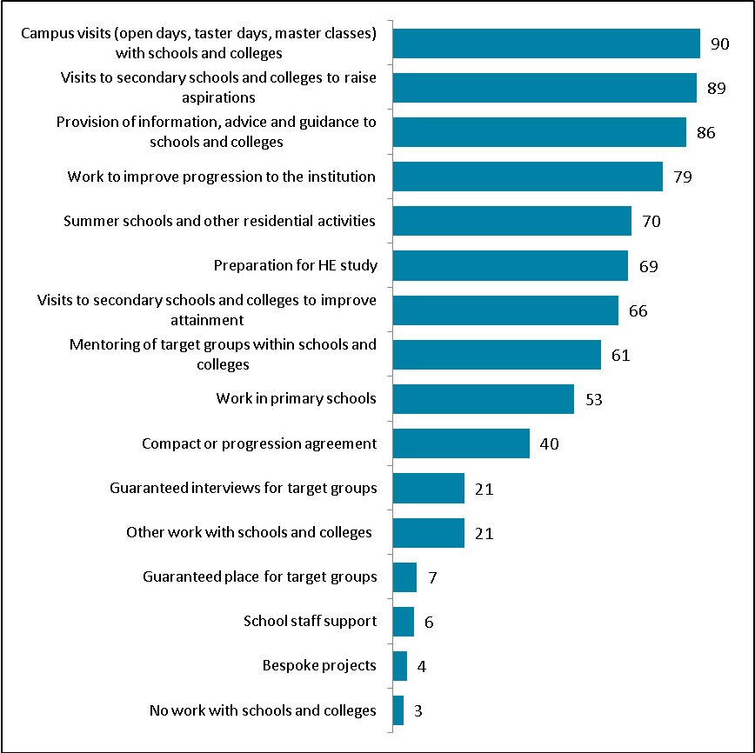

The study found that a substantial minority of institutions seek to reach key target groups, and adults in particular through engagement with voluntary, community and faith groups, and with employers (see Figures 2 and 3).

Figure 2: Number of institutions delivering listed interventions using HEFCE widening access funding with voluntary, community and faith groups (base = 97)
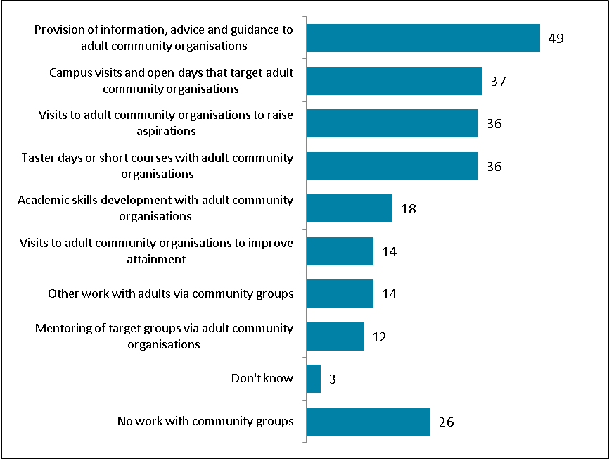

Figure 3: Number of institutions delivering listed activities using HEFCE widening access funding with employers (base = 97)
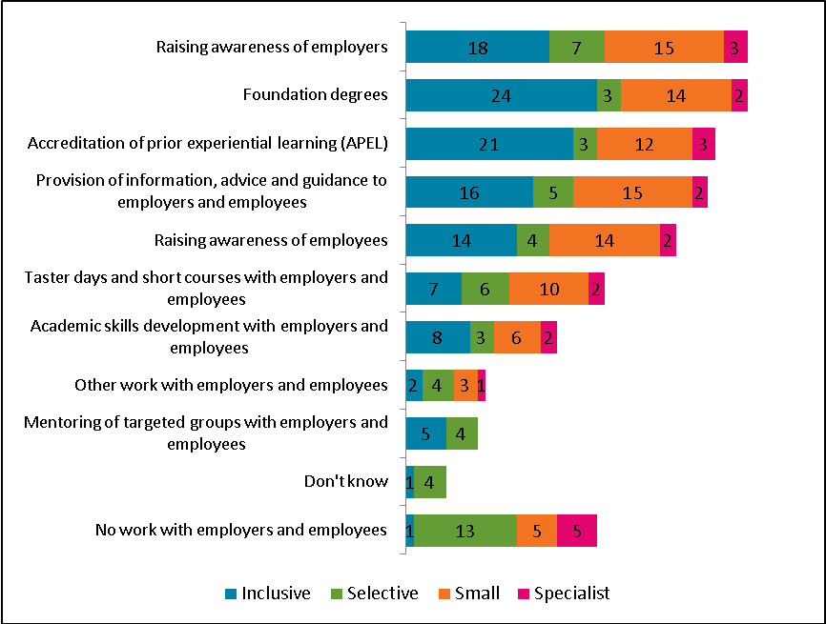

Funds for improving retention and supporting student success
- The study also looked at how institutions use the funding provided to improve retention and found that the vast majority of institutions use the funding to support the provision of additional learning, teaching and assessment support and enhanced pastoral support. Over half also offer support with academic development, have undertaken curriculum organisation and design work and offer career development. Figure 4 provides more detail on the numbers of institutions engaged in the different types of activities.

Figure 4: Number of institutions delivering listed activities using HEFCE improving retention funding (base = 89)
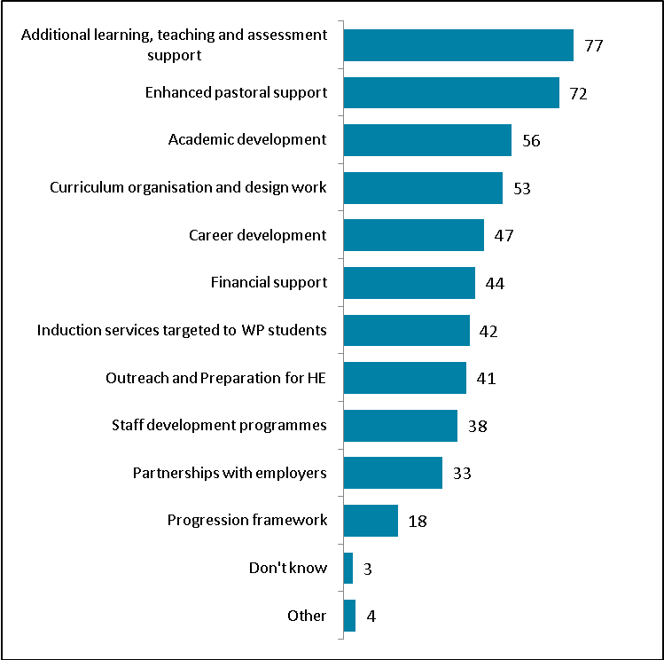

Funds for support of disabled students
- HEFCE’s mainstream disability allocation supports a wide range of activities in the majority of institutions. Institutions have a legal duty under the Disability Discrimination Act 2005 and the Disability Equality Duty to promote equality of opportunity for disabled people and to make anticipatory adjustments to meet the entitlements of disabled students. Over three fifths of the survey respondents reported that they provide additional support for examinations and assessments, staff development, dedicated disability support units, additional admissions support, non-medical helpers, shared specialist IT equipment, additional pastoral support and the provision of modified or additional learning tools. Figure 5 provides more detail.

Figure 5: Number of institutions delivering listed activities using the HEFCE mainstream disability allocation (base = 89).
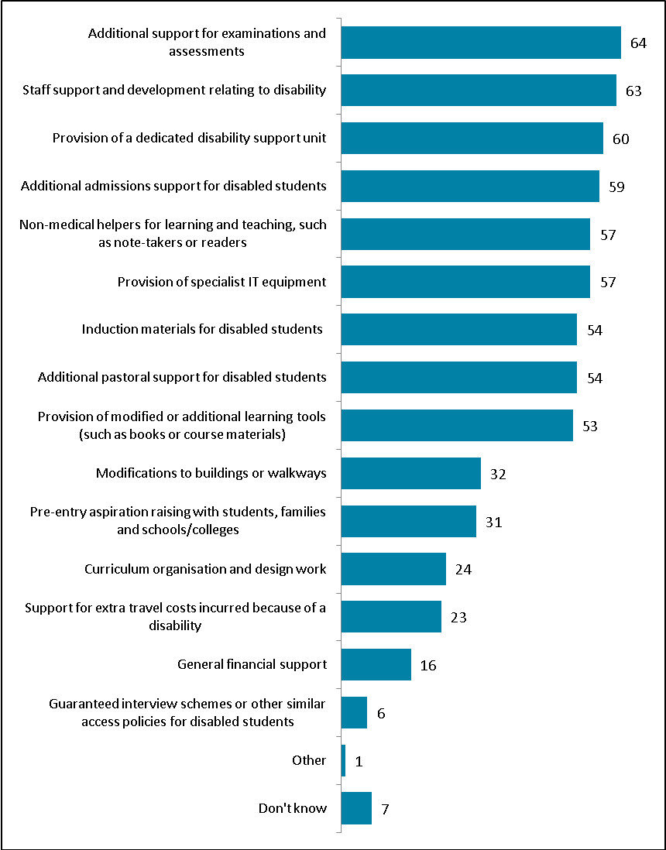
- As well as this research into the WP allocation, HEFCE has monitored how institutions are fulfilling their commitments to WP through their WPSAs. In 2010-11 institutions reported expenditure on WP activity across the student lifecycle – from pre-entry outreach to support for progression from higher education – but varied widely in where they chose to focus their expenditure.
- Table 2 shows the percentage of overall sector spending on WP report reported for 2010-11 against six pre-determined categories. Across the sector almost two-thirds of expenditure is reported as being focused on current students.
- It should be noted, however, that expenditure on this category varied widely among institutions, and most reported spending a lower proportion than the 63 per cent sector-wide figure (around 54 per cent of institutions reported that less than 40 per cent of their WP expenditure was in this category).
- The 63 per cent sector-wide figure may be affected by a number of factors, for instance:
- some institutions have difficulty in disaggregating WP expenditure because they take an inclusive approach to the support of all students
- a larger part of HEFCE funding in 2010-11 was delivered to institutions under the improving retention stream than under the widening access stream
- HEFCE funding for widening access is calculated so that more funding is delivered to those institutions with more students from disadvantaged backgrounds.
- It would therefore seem likely and appropriate that those institutions with strong access records may be spending greater proportions of their WP funding on supporting such students once they have arrived at the institution.

Table 2: Total WP expenditure by category, as a percentage of total sector WP expenditure
Reported category | Percentage of total sector WP expenditure
Outreach work with schools and/or young people | 12%
Outreach work with communities/adults | 5%
Support for current students (academic and pastoral) | 63%
Support for progression from higher education (into employment or postgraduate study) | 2%
Support for disabled students | 6%
WP staffing and administration | 11%
Note: Figures may not add up to 100 per cent due to rounding
- The relatively low proportion of overall sector WP expenditure devoted to outreach work may be a result of the economies of scale achieved in this area through the collaborative work of the Aimhigher programme. It is possible that from 2011-12 we will see the proportion of funding spent on outreach increase, as institutions divert more of their resources into this area.
- In terms of expenditure on outreach, work with schools and young people figured highly in 2009-10 and 2010-11. For example, in 2009-10 all of the WPSAs made reference to links with schools and academies, overwhelmingly in the context of outreach work. Most of the relationships were with local schools, even when institutions had a national profile. The purposes of links were identified as:
- recruitment
- raising aspirations
- preparing students for entering HE
- providing information about finance
- developing community relations
- contributing to social and economic regeneration.
- Outreach work with further education colleges is another key WP activity, with nearly 80 per cent of HEIs’ WPSAs returned in 2009-10 referring to work with FECs to improve progression from FE (for level 3 learners) to HE and to deliver collaborative provision.
- Also in 2009, HEFCE and the Higher Education Funding Council for Wales (HEFCW) published research to underpin review of their policies relating to disabled students, which found that the climate of thinking about disability in HE had been transformed over the last 10 to 15 years. Disability issues are now acknowledged regularly within support work, site planning, admissions, learning and teaching, and assessment.
- The report found that disability was firmly on the agenda and that inputs from official bodies including HEFCE and HEFCW had helped to achieve this change. It found that HEFCE’s mainstream disability funding allocation was being used primarily to provide general dedicated disability services, technical assistance and equipment, or improvements to campus accessibility. There was a spread of activities, however, across most identified expenditure areas. The report concluded that HEFCE’s mainstream disability funding could act to stimulate the finding of more resources.
- HEFCE funding to support disabled students was also considered important in terms of stimulating further investment within institutions. When a sample of institutions were asked to estimate approximately how much of their total budget for disabled students was covered by HEFCE’s mainstream disability funding allocation, forty institutions out of the 64 institutions that responded said it accounted for less than 50 per cent of their budget.
- A later question on the impact that fluctuations in funding had on planning seemed to confirm the value of this money for institutions, with 25 of the 64 who responded selecting ‘some effect’ (and five noting a ‘substantial effect’). The research concluded:
‘The ongoing positive impact of HEFCE and HEFCW became evident in our investigation, and the significance of supportive intervention should be fully understood in future planning. Catalyst effects from funding or specific initiatives and projects are hard to quantify, but it is not certain that HEI and FEC management or teaching staff can be relied upon to prioritise disability simply on the basis of central government advice. It seems probable that a key benefit of having ongoing direct HEFCE or HEFCW involvement and targeted funding is that the effects might be crucially important with senior staff, as well as in the more visible field of innovative projects close to the teaching “coal face”. Although changes and innovations in funding and programmes can be of great value, there are also merits in having a clear sense of continuities from an HEI perspective, in available levels and flows of dedicated funds.’
- In 2010-11, £13 million (3.5 per cent of the total 2010-11 HEFCE targeted allocations for WP and improving retention) was delivered by HEFCE as specific funding for students with disabilities. However, sector spending on support for disabled students, as reported through HEFCE’s monitoring of WPSAs, was 6 per cent of the total spending on WP, supporting the findings of the 2009 research that institutions are putting more money into this important area than HEFCE allocates for the purpose.

How institutions use their additional investment in WP through access agreements
- In addition to the consistent levels of investment outlined above, the introduction of access agreements from 2006-07 brought a significant new source of funding to support widening participation and fair access. Following its establishment in 2004, OFFA’s initial task was to work in collaboration with institutions to ensure the emergence of as generous a set of student support arrangements as was reasonably possible. . OFFA’s annual monitoring of access agreements demonstrated that the introduction of access agreements has generated an enhanced institutional commitment to widening access .In 2010-11, universities and colleges spent £424 million on access measures (24.4 per cent of higher fee income), including £378 million (21.7 per cent of higher fee income) on bursaries and a valuable additional funding stream of around £46 million (2.7 per cent of higher fee income) – controlled by institutions themselves – for institutional outreach activities and infrastructure.
- However, as well as securing additional investment in widening participation, OFFA has consistently focussed on the need to ensure this investment is well spent.
- For example, OFFA has always placed a strong emphasis on the use of evidence to inform the development of access agreements, and has consistently worked with institutions to deliver this.
- In the early years of access agreements, this emphasis was on the level of bursary spending by household income. As it became clear that there had not been a collapse in demand from students just above or below the partial state maintenance grant threshold, OFFA increasingly encouraged institutions to target a greater proportion of their support at students from the lowest income backgrounds where participation was lowest. As a result of this, institutions have increasingly refocused their spending on those students entitled to full maintenance grants. By 2010-11, around four-fifths of bursary and scholarship money went to the very poorest students, helping more than 320,000 students in receipt of a full state maintenance grant.
- In addition, statistical research that OFFA published in September 2010 showed that although bursary awards were on average significantly higher in the most selective institutions, disadvantaged young people had not been influenced by the size of bursary on offer when making their university choices. OFFA concluded that while bursaries had succeeded in their main objective – ensuring that students were not deterred from going to university on financial grounds – the larger bursaries generally offered by the most selective institutions had not changed students’ decision-making when applying and choosing between offers. It suggested that there was mounting evidence that targeted outreach to boost achievement and aspiration among disadvantaged young people at a much earlier stage was a more effective way of widening access to those universities, and encouraged institutions to focus significantly more of their access agreement spending on outreach activities.
- More recently, additional outreach and retention expenditure has allowed institutions to target and respond to the needs of specific groups of students in a more innovative and creative way. Targets are most often defined in relation to retention and students from low participation neighbourhoods; however, some institutions have developed targets which relate to students with disabilities and care leavers. For example, the University of Chichester engages through a pan-Sussex care leaver group with the University of Brighton, the University of Sussex and local authority agencies to improve regional outreach provision for students progressing to FE and HE from a care background.

Combining HEFCE’s WP allocation and additional fee income
- We also have evidence of the ways institutions use their funding for WP from both HEFCE grant and their additional fee income from case studies submitted to OFFA in December 2012, following the Ministers’ request for this interim report. Around 75 institutions contributed over 90 case study examples, many of them relating to projects which have been in place for, and demonstrate progress over, a number of years, reflecting the long-term progress that has been made. They set out the type and level of activity institutions undertake to widen participation, and demonstrate how access agreements and HEFCE funding work together to secure progress. Examples from these case studies are included throughout the interim report. These case studies will feed into the final strategy document and OFFA’s good practice activity.

Case study: The University of Sheffield
The University of Sheffield’s Outreach and Access to Medicine Scheme (SOAMS) provides support and guidance to local pupils in Years 9 to 13 from disadvantaged backgrounds with an interest in medicine or science. SOAMS was established in 2001, specifically to attract under-represented groups to broaden access to medical education for able students who may not otherwise enter the profession.
Students involved in SOAMS must be the first generation to enter higher education. The aim is that this will encourage diversity so that the profession begins to reflect broadly the society it serves in terms of social, cultural and ethnic background.
Each year, up to 100 Year 9 students from registered schools are selected to participate in SOAMS. They continue on the scheme until the end of Year 11 when up to 30 are selected to progress to the second phase in Years 12 and 13. (Additional opportunities are also provided each year for up to 20 Year 12 participants to join this second phase directly.)
During each year of their involvement in SOAMS, participants take part in at least four activities which build knowledge and experience incrementally. Students who complete the scheme and have at least four AS Levels at BBCC (including Chemistry and another science or Maths) are guaranteed an interview for an offer of a place to study Medicine at the University of Sheffield. Students who pass their interview may also benefit from an adjusted offer.
Activities on the programme include lab workshops, a visit to a medical museum in Leeds, AS and A Level study skills sessions, a four-day residential summer school, and one-to-one e-mentoring from current medical students.
The university conducts telephone surveys of SOAMS students at the age of 18 in order to establish whether they have progressed to HE; whether they are studying at the University of Sheffield or another institution; and what subject they are studying. Analysis of these surveys between 2008 and 2011 shows that between two-thirds and three-quarters of SOAMS participants have progressed to HE each year; many of these have progressed to University of Sheffield; and that a growing proportion of these are studying medicine.
More information about SOAMS, including detailed case studies from participants, can be found at www.shef.ac.uk/schools/outreach-programmes/soams

Building the infrastructure for effective WP: national programmes
- Consistent funding to institutions for widening participation and retention activity has been essential in creating a culture which values the development of new and successful approaches.
- Equally as important as the institutional funding was the investment made in national programmes to provide a solid infrastructure for the creation of collaborative partnerships across educational sectors. These partnerships worked to raise aspirations and attainment, and to create clearly articulated progression pathways for students from differing backgrounds with a broad range of entry qualifications. They also created efficiencies of scale, enabling many more people to benefit than if institutions had been working individually.
- For example, monitoring returns submitted by the 42 Aimhigher area partnerships in the final year of the programme (2010-11) show that a total of more than 1.34 million learners participated in Aimhigher programmes and activity, 57 per cent of whom were in school Years 7 to 11. A third of all learners were estimated to have taken part in more intensive activities (as opposed to less intensive, occasional activities) as part of a progression framework.
- Furthermore, 18,750 learners from over 750 schools, colleges and academies had contact with an ‘Aimhigher Associate’ (undergraduate mentor) in 2010-11 and there were over 3,000 students employed as Associates on the scheme from over 120 HEIs.
- The scale of the programme was extensive: on an annual basis during the 2007-08 to 2010-11 funding period of the programme, around 108 higher education institutions, 368 further education colleges, 2,700 schools (including 188 academies and 413 primary schools), and 114 local authorities took part in Aimhigher activities.
- In addition to Aimhigher, between 2004 and 2012HEFCE funded Lifelong Learning Networks (LLNs). These networks of FE and HE partners worked to increase the progression rates of learners with vocational qualifications through the development of clearly articulated pathways from FE to HE, often in the form of progression agreements. By the end of the funding period over 10,000 progression agreements were in place and an estimated 55,000 learners per year had the potential to benefit from these agreements.
- The percentage of the first-year undergraduate population entering HE with vocational qualifications increased from 20 per cent to 24 per cent between 2002-03 and 2008-09, and while the direct contribution of the LLNs to this increase in terms of absolute numbers is modest (due to the limited pot of additional numbers allocated to LLNs) the contribution to wider growth through culture change and amended admissions procedures should not be underestimated.

Case study: Aimhigher West Midlands
Launched in October 2011, Aimhigher West Midlands is a collaborative widening participation partnership led by four HEIs based in Birmingham (Aston University, Birmingham City University, University College Birmingham and the University of Birmingham).
The four partner institutions have committed equal funding and resources to build on work established under the national Aimhigher initiative, which was discontinued in July 2011. This joint commitment includes collaboratively agreed targets for the delivery and impact of outreach activities designed to widen participation both at sector level and within each HEI’s individual access agreement.
In 2011-12, the partnership worked with 44 schools and colleges, who collectively contributed an additional £100,000 of funding to enable over 750 young people to access mentoring, summer schools, and a specialised healthcare strand. The partnership also operates a brokerage service to facilitate the partner HEIs’ engagement with schools and colleges in their wider outreach work.
Results so far indicate increased aspiration to post-16 and HE study for Aimhigher West Midlands participants. Figure 7 below illustrates that, from a sample of 893 learners, those engaged in Aimhigher were more likely to enter level 3 study than their peers who did not participate in the programme. They were also less likely than non-Aimhigher learners to become persons not in education, employment or training (1.8 per cent compared with overall rates of 7.4 per cent in Birmingham and 5.4 per cent in Solihull). The graph also illustrates that the programme’s effectiveness at building aspiration increases with the number of interventions.

Figure 7: Actual post-16 destinations by level of engagement 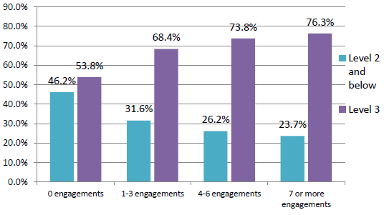
Under the new funding arrangements from 2012-13 onwards, the West Midlands partners have pledged continued support for the collaboration in their access agreements, with each HEI committing £35,000 in addition to significant pro bono delivery capacity. The partners’ access agreements describe how the programme ‘will sharpen its focus on learners in years 9 to 11, and seek to consolidate established links with 20 schools to deliver activities in an intensive and coherent programme in line with the Learner Progression Framework’.

Section 3: Outcomes of the investment
- Section 5 of this report will demonstrate the level of evidence already available for what works to widen participation and maximise success in HE for students from a range of diverse backgrounds. In the national strategy to be published in the autumn, we will build on the evidence presented in this report by casting an even wider net in the pool of existing research. This will not only cover research into WP activity as it is commonly understood, but will also seek to draw on broader work on equality and diversity, and its findings on issues of learning, teaching and student engagement as part of the WP agenda. It will also report on further research that has been specifically commissioned for the development of the strategy. This broad, comprehensive appraisal of evidence should provide a strong base for an assessment of the impact of the investment on outcomes.
- However, tentative links can begin to be made here based on evidence already held.

National progress on WP
- In 2005 HEFCE published the Young Participation in higher education report which showed that between 1995 and 2004 there had been no significant increases in the participation rates of students from the most disadvantaged backgrounds. The trend was flat and the analysis concluded that the problem of the very low HE participation rates for people from such backgrounds was intractable.
- A more recent analysis presents a very different picture. The latest results of the young participation analysis suggests that sustained, long-term educational investment and policy interventions across sectors led to increased attainment at GCSE and a corresponding increasing participation rate in HE for the most disadvantaged groups.
- The key headlines of the research were as follows:
- The overall young participation rate had increased from 30 per cent in 1994-95 to 36 per cent in 2008-09.
- The overall rate only increased by one or two percentage points until 2003-04, after which the rate of increase was much steeper.
- The likelihood of those from the lowest participation areas participating in HE had increased by 30 per cent over the last five years and by 50 per cent over the last 15 years.
- Between 1994-95 and 2003-04 the participation rate for the lowest participation areas rose by only one percentage point from 13 per cent to 14 per cent. However, between 2003-04 and 2009-10, the rate had risen rapidly and significantly from 14 per cent to 19 per cent.
- The increased participation rate matched the increased attainment at GCSE and was consistent with the increased expenditure in schools.
- The increase in the participation rates for those from the most disadvantaged areas had not been achieved at the expense of those from the least disadvantaged areas.
- The gap in participation rates between the most and least disadvantaged was still significant despite the progress that had been made: the participation rate of the most advantaged was 57 per cent compared with a participation rate of 19 per cent for the least advantaged.
- The gap in the participation rates between men and women was still large, with women at 40 per cent and men at 32 per cent. However, the last four years included in the analysis did show an improvement in the participation rates for men, which before had remained relatively flat at 29 per cent, and a stabilising, if not yet narrowing, of the gap, even in the most disadvantaged areas where it has been widest.
- ‘Trends in young participation in higher education: core results for England’ (HEFCE 2010/03) showed that there had been a proportionately larger increase in participation from disadvantaged students compared with advantaged students in recent years. Further analysis undertaken by OFFA (OFFA 2010/03) showed that while participation among the least advantaged 40 per cent of young people had significantly and steadily increased across the sector as a whole since the mid-1990s, it had remained almost flat at the most selective third of institutions.
- The key points of this OFFA analysis were as follows:
- There are much greater participation differences by background for the most selective third of institutions than there are for HE as a whole.
- The participation of disadvantaged young people in the most selective (‘higher entry tariff’) institutions is low and has not increased since the mid-1990s (see Figure 8 below).
- The most advantaged 20 per cent of young people are seven times more likely to enter the most selective institutions than the most disadvantaged 40 per cent.
- This ratio has risen from six times more likely in the mid-1990s but has not increased further since the mid-2000s.
- The participation of disadvantaged young people in the less selective two-thirds of institutions has increased, especially in recent years.
- Young people from all backgrounds now have broadly equal participation rates in the least selective third of institutions.

Figure 8: Participation rates of the most disadvantaged 40 per cent of young people in entry tariff institution groups
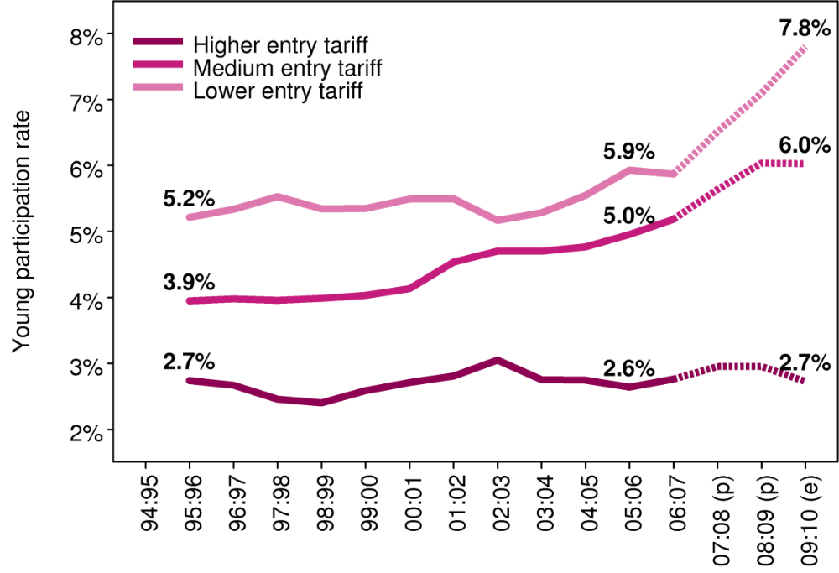
- In summary, there have been significant increases in the participation rates of the most disadvantaged young people (though not in all parts of the sector) which, due to funded growth in the sector, were not achieved at the expense of the participation rates of more advantaged groups.

Impact of the investment
- Over the same period during which these increases in HE participation rates occurred, the integrated Aimhigher programme was running and the improving retention element of the allocation was added to the HEFCE investment in WP, increasing it significantly. Institutions’ financial commitments to widening access through access agreements from 2006-07 added further investment. Therefore, it is reasonable to conclude that the progress seen over the period from 2004-05 to 2009-10 was a result of sustained investment across the educational sectors, and that the funding delivered to widening participation within the HE system was a key element in delivering these successful outcomes.
- Evaluations of both Aimhigher and LLN activity further bolster the link between investment and results. As already discussed, Aimhigher was a key policy intervention which supported partnerships between schools, colleges and HEIs with the objective of raising the HE participation rates of young people from disadvantaged backgrounds. The Aimhigher programme offered a suite of information, advice and guidance activities to targeted learners which were designed to sit alongside the school curriculum.
- Summer schools were one such activity, and between 2003-04 and 2008-09 over 51,000 young people attended an Aimhigher summer school. The target group for the summer schools consisted of those from disadvantaged backgrounds who were most likely to participate in HE. Recent analysis shows that attending a summer school is associated with elevated rates of entry to higher education, with participants being on average twice as likely to apply and be accepted as non-participants. Although on average summer school participants achieve higher levels of attainment than non-participants, the increased likelihood of progression to HE persists when this and various measures of disadvantage are taken into account.
- This analysis has only been carried out for the Aimhigher summer schools but given that many institutions run their own summer schools, the results are encouraging for this type of intervention as a whole.
- Qualitative research has also supported these findings, providing strong evidence that the kind of outreach delivered through Aimhigher was successful in raising learner aspirations and encouraging applications to HE, as well as playing an important role in generating a culture of achievement in a school or college, or in the wider community. Aimhigher had become an important part of institutions’ widening participation activities, and the strong partnership infrastructure and co-ordinated approach to activities were widely viewed as key components of the success of the programme.
- Another important development was the publication by HEFCE in 2007 of its guidance on targeting. The document set out to provide guidance on targeting outreach activity to people from communities under-represented in higher education. Its purpose was to:
- refine the definition of the target group for partnerships and institutions
- provide a methodology to make targeting more effective
- set out a process for measuring the effectiveness of targeting.
- The guidance identified two factors that were deemed critical to the success of targeting:
- the quality of the relationships between all those involved – WP practitioners, teachers, local authorities and so forth
- the quality of the data collected about learners.
- It was hoped that the approach adopted within Aimhigher for the delivery of co-ordinated outreach activity would provide a legacy to the sector which would continue beyond the life of the programme itself. The reality is that some partnerships have continued in a reduced form and some new partnership arrangements have evolved (see the case study below), but the coverage of this type of collaborative activity across the country is patchy and the partnerships themselves can be quite fragile. We have particular concerns about the future coverage and depth of outreach to the more difficult-to-reach mature and rural communities. However, we are aware of some strong post-Aimhigher collaborative partnerships and there are real opportunities to support and build on these. This is likely to form a significant strand of the national strategy.

Case study: The University of York
The University of York is the lead partner in Green Apples: a successful, innovative partnership involving all York FE and HE providers as well as the local authority, North Yorkshire Business Education Partnership, Higher York (the local LLN), all local secondary schools and 10 primary schools. It has been in operation since 1999.
Green Apples is a progressive programme of interventions which focuses mainly on school Years 9 to 11, but also addresses transition points, such as that from primary to secondary school and secondary school to college, where appropriate.
The purpose of Green Apples is to demystify higher education, raise awareness of the routes to and variety of provision within further and higher education, increase the self-confidence and self-esteem of students, and raise aspirations for lifelong learning.
Students are selected for the programme in consultation with schools, using data from the Local Authority. The annual cohort per year group is approximately 180 pupils.
Impact data
The University has worked with York Youth Support Services to follow the destination progress of Green Apples students after compulsory education.
Over the past five years, a higher proportion of Green Apples participants have progressed to post-16 full-time education than is the case for the York state school cohort as a whole. The proportion has been an average of 7 per cent per cent higher over five years, with a 3 per cent higher progression rate for 2010 leavers.
Of the Year 9 cohort who began the Green Apples programme in 2010, after their first visit 53 per cent were more likely to attend Higher Education; after the residential in Year 10 this number increased to 76 per cent; and after the Year 11 Conference 96 per cent of students who attended were interested in going on to higher education.
Case study of Tanya, a Green Apples student
Tanya, a previous Green Apples student who is now studying at the University of York, shares her thoughts on what she learnt at the Year 10 residential:
‘I learnt about the different aspects of student life. I remember doing a quiz in the evening of the residential and asking someone if this is what you actually do at university? You actually get to do things and be a student.
‘When you are at school you are in a bit of a bubble, where you only interact with your friends. Green Apples showed me that I could get on with other people.’
Before being part of the programme she said she ‘didn’t really talk about higher education and didn’t have a clue about the different options.’ Green Apples helped open up the doors to higher education, and gave her support in making her decisions:
‘You need someone to help show you the different options and Green Apples does this. It shows you that you can stay at home and go to university and the different courses available. It demonstrates that Higher Education is achievable even if you are from a low-income family.’
- Many institutions tell us that they find it difficult to disaggregate the funding they get through the WP allocation from their other income streams. This is particularly the case where WP is embedded throughout the institution. However, they also tell us that without it they would not be able to maintain the level of activity they are currently able to deliver. They are aware that they need to improve accounting for the funding and deliver solid evidence regarding the impact it has. A key theme of the development of the national strategy will be to determine how OFFA and HEFCE can help them do so.
- Investment in WP has also ensured that as the student body has grown in volume and become increasingly diverse, the proportion of students withdrawing early from HE has remained relatively static and low (8.4 per cent of full-time first-degree HE entrants did not continue to their second year in 2009-10, down from 9.1 per cent of entrants in 2002-03). The funding delivered by HEFCE to institutions for improving retention recognises that institutions needed to respond to and support different learners in different ways. The stability of retention rates is testament to the responsiveness and expertise of institutions which allowed them to support their students throughout their courses, and beyond them into further study or employment.
- An important aspect of the impact of investment in WP has been the learning that has occurred within the sector. The provision of resource over a sustained period has enabled the growth of the knowledge and evidence base for WP and supporting student success, so that institutions and partnerships have been able to continually enhance and develop their approaches in increasingly sophisticated and nuanced ways. For example, it is now taken for granted that sustained, progressive outreach programmes delivered over time are the most effective: this knowledge was generated by the delivery, refinement, sharing and evidencing of practice provided by the programmes, structures and people that the investment secured.

Summary of key points
- We can determine that:
- significant and sustained progress has been made to increase the participation rates of those form the most disadvantaged backgrounds
- the investment in WP in HE has contributed to that progress
- there is a demonstrable increase in the likelihood of HE participation for learners engaged with outreach activity
- collaborative, coordinated, well resourced approaches to outreach are particularly effective
- institutions need to account more adequately for the funding they receive for WP and evaluate their activity
- the investment has allowed knowledge and expertise to grow in the sector, and increasingly sophisticated responses to WP to evolve.

Section 4: The challenges to continued progress in WP
- Progress made in widening participation must be set in the appropriate context. The growth in participation rates was won through long-term commitment and investment but also came at a time of growth in the overall HE sector and of large-scale investment across schools, colleges and universities. The environment was a benign one for WP in many respects, with the increased numbers of students from disadvantaged backgrounds adding to overall student numbers.
- Since 2009-10, there have been limits on the numbers of students that institutions can recruit. Those institutions that over-recruit have been subject to holdback of HEFCE grant to compensate for the additional demand on the student support budget. From 2012-13, these student number controls have become more complex with the introduction of the high grades and core and margin policies. The restrictions on student numbers have contributed to increased competition for places and, in some parts of the media and schools sector, criticism over some WP activities. These include the use of contextual information in admissions, whereby institutions take into account such data as the levels of average attainment in an applicant’s school, or indicators of socio-economic disadvantage, to provide context for that applicant’s prior attainment and potential. Such efforts to create equality of opportunity are derided by some as ‘social engineering’.
- The student number controls are one part of an increasingly complex HE system that has seen maximum tuition fees rise from £3,375 per annum for regulated full-time undergraduate programmes in 2011-12 to a maximum of £9,000 per annum for new entrants from 2012-13, alongside changes to state and institutional maintenance support arrangements and to the arrangements for loan repayments. The outcome of this varies at individual and institutional level, based on background income while studying and on future earnings. Alongside the significantly higher loan amounts there is also greater maintenance support, and the increased repayment earning threshold results in larger loans being paid back at lower monthly rates, but usually over a longer time and with higher interest than under the old system.
- It will be important to continue to monitor issues relating to accessibility, equality and the diversity of the student population. Emerging evidence suggests that there are not significant detrimental effects on applications from the lowest participation neighbourhoods in 2012-13, with entry rates among English 18-year-olds being the highest on record. This continues the longer-term trend in the strong proportional increases of students from these backgrounds since the mid-2000s. The full effects on widening participation may take some time to emerge, and it is likely that a range of factors will impact on potential students from disadvantaged backgrounds in the coming years.
- There may be potential longer-term changes in the perception of higher education. A number of recent reports provide emerging evidence that higher fees are acting to deter prospective students: for example, a survey of year pupils in years 10 to 13 found that the cost, including tuition fees, was the most common factor cited by students who said they were unlikely to go to university.
- Those applying to and entering HE in 2012-13 may already have been set on a trajectory for higher level study, having perhaps benefitted in previous years from national outreach and progression programmes such as Aimhigher. As Alan Milburn highlights in his report, ‘University challenge: how HE can advance social mobility’, the risk is that the networks and infrastructure built up through Aimhigher will dissipate, and levels of collaboration will fall. A consequence of this would be that institutions are unable to deliver a similar scale of outreach activity in future. For example, institutions have estimated that their spending on outreach as part of their agreements will increase from £46 million in 2010-11 to around £83 million in 2012-13, rising to £110 million by 2016-17. However, the end of national Aimhigher funding, which totalled around £80 million in 2010-11, means that currently the sector’s annual investment in outreach is set to be significantly lower from 2012-13 than in 2010-11.
- Early analysis of UCAS data raises further equality and diversity issues. The data indicate that 18-year-old women were a third more likely to be accepted for entry to HE in 2012 than 18-year-old men. This means that if the acceptance rate for men was 100 per cent, the resulting entry rate for men would still be below that of women. This follows gender inequality trends identified prior to entry to HE; for example, women represented 56 per cent of the total A-level population in 2011-12. The data show that while acceptances for White applicants decreased by 6.9 per cent between 2010 and 2012, acceptances for all BME groups increased (by between 4.5 per cent and 13.4 per cent).
- There has been a great deal of change within HE that students and their advisers need to understand in order to make properly informed decisions. The policies relating to the student number controls discussed in paragraph 126 are complex, and HE institutions, schools and FE colleges have had difficulty in predicting their impact. HEFCE has received anecdotal reports of HEFCE exemptions list for the high grades policy being used inappropriately and has moved rapidly to improve its communications about its use. Concerns are being expressed that the list itself will influence the way in which people in the school and FE sectors view the entry requirements for higher education.
- Future policies must also take into account the potential impact of the rise in tuition fees on decisions to enter HE. Even accepting that the fee loan and repayment system is progressive, we can see from the emerging evidence cited in paragraph 129 that there is a sense that participating in HE now carries with it a significant cost. Unless the benefits of HE are clearly articulated to prospective students and their families from a very early stage, there is a risk that people, particularly those from backgrounds without a tradition of participation in HE, will turn away from it as a viable option even they could afford it due to considerations of value for money. In the final report we may wish to elaborate on the two concepts of affordability and value for money.
- While institutions are already doing a great deal to reach out to potential HE students from under-represented groups, there is the potential to do more, particularly in terms of collaborative work with other institutions. However, they are operating in an increasingly competitive environment and much emphasis has been placed on individual institutions improving their own progress in widening participation, whether through efforts to diversify their intake further or to deliver more successful outcomes to an already diverse student body. There are a number of successful, long-established partnerships and projects, and new collaborations are beginning to emerge; however, other institutions are concentrating their efforts on securing recruitment to and success within their own provision rather than contributing to national progress.
- We may also see (and in some cases are already seeing) the ways in which institutions engage, for example with schools, changing. They may be more likely to focus their activity at older age ranges (particularly at Key Stage 4 and post-16), rather than undertaking crucial work at earlier stages.
- Increasing numbers of institutions are now sponsoring academies and some have developed university technical colleges which serve the 14-19 age range. This has a number of impacts. Firstly, engaging in these kinds of arrangements requires a high level of strategic input and is resource intensive for the institutions. This level of engagement delivers extensive benefits to the schools involved, but because of its intensity institutions can be limited in the number of schools that they are able to work with more broadly. Secondly, institutions are getting directly involved in the running of schools and, in the case of university technical colleges, are setting up in direct competition with their local schools. This again may impact on their level of engagement with the broader schools provision in their areas.
- The following case study illustrates how institutions are engaging with schools at this deeper, more strategic level.

Case study: The University of Essex
Co-sponsorship of Colchester Academy
The University of Essex is a co-sponsor of Colchester Academy, with partner institution Colchester Institute being the lead sponsor. During the first year of operating, 2010-11, the university and Colchester Institute have provided governance and strategic direction, established support networks, delivered activity and established academic networks between academy staff and sponsor academics, to raise the attainment and the aspiration of the students and the academy.
The academy’s 2011 Year 11 Examination results improved from 2010 as below:
● numbers of pupils achieving five or more A to C grades including English and Maths increased by 15 percentage points from 34 per cent in 2010 to 49 per cent in 2011
● numbers of pupils achieving five A* to C grades increased by 23 percentage points from 46 per cent in 2010 to 69 per cent in2011
● the examination results exceeded the OFSTED forward estimate of 27 per cent
● the academy is now above the national average for all academies (45.7 per cent) and improved at 3 times the national rate
● the academy was identified by Essex County Council as one of the most improved schools in the county.
- As the case study demonstrates, there are undoubted benefits of institutions working in this way with schools; indeed, it is something that HEFCE encouraged through its funding for WP. The risk if this is the only approach is that institutions will work with a smaller pool of learners, rather than engaging in collaborative work to broaden that pool. Supporting and encouraging institutions to adopt broader and deeper approaches to their engagement with schools and colleges will continue to be a focus for both HEFCE and OFFA.
- In order to address some of these concerns, OFFA has significantly increased its emphasis on the importance of working collaboratively with other institutions, and also the importance of working with students at a younger age, such as Key Stages 2, 3 and 4, in its guidance on how to produce access agreements for 2014-15.
- The new guidance highlights the benefits of working collaboratively, such as reducing burden on schools and colleges and avoiding duplication of work. It also aims to reassure institutions that collaborative efforts which help to improve general access to the sector, or to parts of the sector, rather than contributing to a single’s institution’s own recruitment, will always be considered when OFFA is assessing the progress institutions have made. Such work benefits all institutions, including those with the most selective entry requirements and is vital to the long-term success of WP as a whole. There is also an explicit requirement within the guidance for institutions to include detail of their activities with younger age groups.
- Institutions are engaging with schools in ways that we would support: long-term, strategic and operating at the level of governance, curriculum and student support. However, if there are few incentives for institutions to engage with a broader range of schools or few mechanisms by which this can happen, the limitations on their individual capacity may create a risk of significantly less engagement with schools and colleges in some parts of the country. This may result in many schools and colleges in more disadvantaged areas, particularly rural and coastal areas, having no tangible relationship with the HE sector.
- This situation may be exacerbated by the changes that have also been taking place in the schools system. A key area of concern is the changes that came into effect in September 2012 to careers education and guidance. The Education Act 2011 ends the statutory requirements for local authorities to deliver a universal careers service to young people. Schools have instead been placed under a statutory duty to secure careers advice but have not been given any additional funding to do so. The requirement to provide careers education has also been removed. A report by the Work Foundation argues that ‘without careers education, careers guidance is reduced to an abrupt and isolated intervention’. They urge that ‘careers education should be embedded in the curriculum as early as primary schools and expanded on with age’.
- In its evidence to the Education Select Committee in October 2012, the Institute of Careers Guidance said of the guidance offered to young people:
- There is no overall coherence of career guidance provision whatsoever for young people up to 18.
- For young people in schools, provision is a postcode lottery subject to budgets and head-teachers’ commitment to independent, impartial career guidance.
- The service in schools is at best restricted in terms of student coverage and limited to the 30 weeks of term-time provision. In the past, students and parents have always appreciated the opportunity to access independent career guidance during school holidays. Now, at these times, it is not possible to access independent career guidance without payment.
- E-mail correspondence between the Association of South East Colleges and the Skills Funding Agency has highlighted that the National Careers Service web-site excludes a range of courses offered by colleges of further education that are not funded by the Skills Funding Agency.
- Young people between 16 and 18 who are in employment but wish to change direction or develop their career prospects do not have access to any independent face-to-face careers guidance service without payment.

- Furthermore, in its report of 2011, the International Centre for Guidance Studies argued that the situation for schools was challenging as they adapt to the loss of Aimhigher, Business Education Partnerships and the erosion of the Connexions service. The centre argues that ‘the removal of the statutory duty to provide careers education could result in a focus on “activities” rather than on a developmental curriculum’.
- In light of such concerns, we anticipate that the final report may recommend that a greater governmental focus on issues of advice and guidance within schools and colleges will be important in terms of maximising the return on investment in widening participation to HE. The strategy will also explore how HE can most effectively engage in supporting good information, advice and guidance (IAG) concerning HE in schools and colleges in the new environment.

Case study: The University of Warwick
‘Thinking About University?’ Online IAG
In light of changes to the national provision of careers guidance, the University of Warwick’s central outreach team began an analysis of how the university was engaging with young learners who were not able to visit the campus. They focused in particular on providing the information that learners wanted, rather than focusing on messages that the institution wished to convey.
Following a period of research, including focus groups with schoolchildren of various ages, new outreach pages were developed and launched. The pages were designed around a single visual theme, based on bespoke illustrations, with age-appropriate written content. The information is applicable to students aspiring to attend any institution.
The new web-pages were launched in December 2011, and have generated significant extra traffic to the web-site, perhaps demonstrating an increased appetite for IAG from prospective students. Table 3 summaries the average hits per day for the six months preceding the launch of the new site, and the corresponding rates in 2012.
Qualitative feedback from local teachers and colleagues within the Local Education Authorities has been positive, particularly as many of the changes to IAG provision have now been implemented. The web-site is available at http://go.warwick.ac.uk/thinkinguniversity.
Table 3
Month | Average daily hits in 2011 | Average daily hits in 2012 | Percentage increase
June | 62 | 169 | 173%
July | 69 | 176 | 155%
August | 64 | 149 | 133%
September | 100 | 199 | 99%
October | 92 | 211 | 129%
November | 81 | 190 | 135%

- The above case study demonstrates how institutions can respond to changes outside the HE sector. The provision of accessible, accurate and relevant information is crucially important, and developments such as the one illustrated are to be welcomed and encouraged. Equally important, however, is that there is sufficient personalised advice and guidance available to ensure that the information is understood and contextualised to fit individual circumstances.
- Other changes have prompted concern about social mobility. The recent Milburn report, ‘University challenge: how higher education can advance social mobility’ highlights the removal of the Education Maintenance Allowance (which provided funding for people aged 16 to 19 from low-income households to continue their studies), which is widely believed in the sector to have had a regressive impact. The Government has replaced this allowance with a new bursary scheme called the 16-19 Bursary Fund, and it has yet to be seen whether this more targeted allocation will have the desired outcomes.
- We have yet to fully assess how the changes to tuition fees and loans in both the FE and HE sectors will impact the propensity of mature learners to progress to HE. First-time mature students are more likely to come from groups that are under-represented in HE, so the drop in the number of such applicants to full-time HE through the UCAS systems has caused concern. We have gathered intelligence from a small number of institutions that part-time applications from this constituency also look to be significantly down in 2012-13, although as recruitment will continue throughout the remainder of 2012-13 it is too soon to draw firm conclusions on part- time demand.
- There is an argument that such fundamental changes across educational sectors demand a co-ordinated, national response. Individual institutions, however committed, will be unable to meet the myriad of challenges these cross-sector reforms present. The Government has already demonstrated its commitment to social mobility in the HE context. Since taking office in 2010, the Coalition Government has ensured that widening participation in HE and increasing social mobility remain core priorities. The Higher Education White Paper devoted a chapter to HE’s vital contribution to social mobility and the steps it should take to continue its progress. The Government’s commitment has been further demonstrated by:
- its overt and vocal support for institutions that are making greater use of contextual factors in their admissions decision making
- its guidance to OFFA to encourage greater levels of collaborative outreach activity
- its encouragement to HEFCE to continue to prioritise and provide funding for WP
- its request to HEFCE and OFFA to develop a national strategy for access and student success to deliver both faster and sustained growth.
- However, there is a clear need for schools, colleges and HE institutions to work together strategically to meet the current and future needs of all their learners. This requires commitment from the Department for Education, BIS and across Government to a common set of aims and objectives, and to providing challenge, support and incentives for institutions in all sectors to contribute to their realisation.
- The evidence we have to date, some of which is presented in the following sections of this report, suggests that well coordinated, structured outreach programmes in which schools, colleges, HE providers and, where appropriate, employers and third sector agencies are equal partners, and which deliver clear benefits to learners in terms of engagement, attainment and aspiration, are particularly effective in increasing participation in higher education.
- The benefits of collaboration in delivering this type and scale of outreach are well documented and will be explored in Section 5. We are aware that there are collaborative partnerships working across the sector but such arrangements are by no means national, are fragile in their reliance on continued commitment and resourcing from HE institutions, and sometimes struggle to secure the necessary level of engagement from schools and colleges. They are also considerably smaller than previous partnerships, so the scale of the activity that can be delivered is necessarily reduced. It is important that support is put into maintaining this legacy from Aimhigher
- In light of the evidence to date and the feedback we are beginning to receive from stakeholders, we are of the view that the work we undertake over the next eight months to develop the national strategy for access and student success should consider how the HE sector can better focus some of its investment in WP to encourage a more sustainable and comprehensive approach to collaborative outreach arrangements. While recognising that such arrangements should involve schools, we would wish to ensure that they also focused on outreach to different types of learners. So for example, we might want particularly to encourage strong progression partnerships between HE institutions and FE colleges, and to ensure that institutions are working strategically with local employers and communities to enable them more effectively to reach out to adults.

The National Scholarship Programme
- The primary purpose of the NSP is to benefit individual students who come from disadvantaged backgrounds as they enter higher education.
- The Government’s contribution to the programme is £50 million in 2012-13, and will be £100 million in 2013-14 and £150 million in 2014-15.
- Each full-time student in receipt of an award will receive a benefit of not less than £3,000, with a pro rata amount delivered to part-time students studying a minimum of 25 per cent intensity of the full-time equivalent. In 2012-13 and 2013-14 institutions are expected to match the Government’s contribution as follows:
  - Institutions intending to charge above £6,000 per year for any of their full-time fees or above £4,500 for their part-time fees will be expected to match the Government’s contribution in a ratio of at least 1:1.
  - Institutions intending to charge £6,000 or less for their full-time fees and £4,500 or less for their part-time fees will be expected to contribute at least 50 per cent.
- For 2014-15, the way the NSP funding is delivered to institutions will change so that it better reflects the number of students from disadvantaged backgrounds entering individual institutions. Consequently, those institutions that perform particularly well in terms of widening participation will see the proportion of the funding they receive through the NSP increase. Therefore, the matched funding requirements for institutions will change so that:
  - The requirement for financial contributions from institutions will be set at the level previously planned for 2014-15 and included in their existing access agreements. Where this would result in financial contributions at a greater ratio than 1:1, the institution is free to make additional NSP awards, to redirect the excess to other forms of financial support or access and retention activity set out in their access agreement, or both.
  - Institutional financial contributions will only be required from institutions with an access agreement.
- Given the newness of the programme, the evidence of its effectiveness or otherwise is necessarily very limited. The formative evaluation of the programme that has been in train since October 2011 published an interim report on the setup of the programme in May 2012. While it is still very early in the programme’s development and delivery, the evaluation found the following:
- While most institutions surveyed perceive that the NSP will provide additional resources to enhance or broaden existing financial aid for WP students, a small number report that existing WP activities will be reduced or displaced as a result of the requirement to provide matched funding for the NSP. Some institutions believe that the NSP will add limited value because they already provide similar types and levels of financial support.
- Although a wide range of approaches are being implemented, the majority of institutions are using their matched funding to increase the number of awards, rather than their value, to maximise the number of students who receive one. However, international evidence suggests that increasing the value of awards is often the preferred model and could have more impact on recruitment and retention.
- The survey of potential students suggests that awareness of the NSP is limited, and that the possibility of receiving an award is having a limited impact on the decision to enter HE as well as choice of institution and subject.
- UCAS, schools and colleges are currently key sources of information about the NSP. Consideration needs to be given to how the NSP is marketed to those outside education with the potential to progress into HE.
- Designing local eligibility criteria that ensure the NSP allocation is neither under- nor overspent can be a challenge for institutions and adds to their administrative burden, especially when the nature of their student cohort is uncertain or changing.
- Varying eligibility criteria and award packages will result in disparities between and within institutions and cohorts; students with the same household income may or may not receive an award, or may receive a differing amounts
- The small number of awards and uncertainty about which students will qualify for an NSP have led some institutions to adopt a deliberately low-key approach to promoting the programme.
- Some elements of existing NSP packages, such as discounted accommodation, may be less attractive to mature learners. Part-time students (many of whom will also be mature) are only entitled to receive the fee waiver element of the NSP. As the government contribution is delivered in the first year of study only, this may mean that part-time students receive a proportionately lower value award over the course of their studies when compared with full-time students.
- Since receiving these initial findings, changes have been made to enhance the targeting of the funding as discussed in paragraph 157 through a better alignment with the institutional distribution of students who meet the national eligibility criteria. However, a consistent view expressed is that the programme’s inability to offer an entitlement at a national level will limit its potential impact on the decisions people make about entry to HE.
- As the evidence presented in Section 5 will demonstrate, research to date has concluded that additional financial support to students in the form of bursaries (as opposed to the student support provided through the Student Loans Company) has had no impact on decisions to enter HE or on choice of institution. However, the analysis was undertaken before the reforms to the HE system that came into effect in 2012-13. The impact of additional financial support in the new regime is uncertain, as is its impact on retention and student success.

Section 5: Evidence of what should continue to be supported to widen participation
- The previous sections of this report have sought to set the context for the future support of WP and student success. The arguments presented are made on the basis of the evidence we have been able to collect and review for this report. The full report to be delivered in September 2013 will provide a much more comprehensive analysis of the research and evaluation evidence available.
- There is a broad body of research already in existence which addresses the issues, challenges and evaluation of WP activity. For example, in 2006 HEFCE commissioned a meta-analysis of the work that had been done to date on understanding the barriers to higher education, and this produced a bibliography of over 500 reports, articles and publications. This section provides a preliminary and limited analysis of a restricted pool of the existing research (primarily that associated with OFFA and HEFCE), to identify some key findings that have informed the views presented in the preceding sections.
- Understanding what works to widen participation is complex. However, robust evidence should be able to provide sufficient confidence in the results to enable us to determine a relationship between an intervention or approach and the outcome, which would allow us to form a judgement about the effectiveness of the activity. The relationships between interventions and outcomes need to be understood in the context of the range of influences on decisions and behaviour, including understanding the accumulative impact of a co-ordinated series of interventions across a number of years. Caution should therefore be exercised in attributing decision or change solely to a specific intervention or approach.

Effective interventions for young participants
- There have been some key statistical reports that have demonstrated the impact or otherwise of specific interventions. As already discussed in paragraphs 64 and 115, HEFCE’s analysis of the Aimhigher summer schools programme was not only able to establish a relationship between participation in a summer school and progression to HE, but also demonstrated how good research could affect practice.
- Earlier in the Aimhigher programme, the National Foundation for Educational Research undertook an analysis of the impact of Aimhigher: Excellence Challenge (one of the forerunner programmes to Aimhigher) on future progression to HE. This analysis was also able to demonstrate an ‘Aimhigher effect’ by showing that the engagement with the activity delivered increased the chances of a young person entering HE. The analysis found the following.
- Young people from Aimhigher: Excellence Challenge schools with only average levels of attainment at GCSE were more likely than their academic peers from non Aimhigher: Excellence Challenge schools to take up a higher education place.
- Although young people in receipt of free school meals are less likely than their peers to progress to higher education, young people in receipt of free school meals were more likely to have progressed to higher education if they attended an Aimhigher: Excellence Challenge school than if they had attended a non-Aimhigher: Excellence Challenge school. For the 2001-02 cohort, this equated to one additional higher education entrant for every 100 young people eligible for free school meals.
- Other statistical reports enable better understanding of the progression rates to HE of people with different entry qualifications. HEFCE published a series of reports that looked at this issue by analysing the progression rates of those with BTEC qualifications, those from apprenticeship programmes and those from Access to HE courses. Although such reports do not address what works to encourage such learners to enter HE, they provide valuable evidence to influence the way in which their needs are addressed. For example, knowing that learners with vocational Level 3 qualifications were much less likely to choose to progress to HE encouraged HEFCE to set up LLNs, which sought to produce clear progression routes to HE for learners with such qualifications and raised the profile of vocational progression within the sector.
- In addition to the analysis in regard to progression to HE by type of Level 3 qualification held, HEFCE also conducted analysis which looked at the relationship between school type and attainment within HE. This report was a key element in the argument for greater use of contextual data and information in admissions decisions. Although the progression rates to HE for young people from state schools are lower than for those from independent schools, it found that all other things being equal, state school students tended to achieve better outcomes than their independent school peers. This finding has been contested by some and supported by others in the HE sector and was widely challenged by the independent school sector. However, we are confident in the findings and will be re-running the analysis to update them and see if anything has changed.
- OFFA’s analysis of participation by the tariff score of entrants has also been instrumental in informing policy decisions around access to highly selective institutions.
- Some reports say more about what does not appear to work to widen access. OFFA’s report on the impact of bursaries on decisions about HE entry published in 2010 clearly demonstrated that bursaries at that time did not appear to impact either on the decision to enter HE or which institution to apply to. This and its analysis of participation by the tariff score of entrants prompted OFFA to change its guidance to encourage institutions to use more of their fee income to deliver outreach activity rather than financial support to students. OFFA intends to follow up on this research in light of the new fees environment, to establish firstly whether the higher fees might prompt applicants to consider bursary provision more carefully as part of their decision-making process, and secondly whether bursaries have any impact or effect on student retention and success. This demonstrates how important it is to constantly revisit and revise research as situations and environments change.
- There are many organisations and bodies that are concerned to widen participation to HE and increase social mobility. The Sutton Trust has produced numerous reports on its activity to widen the participation of students from disadvantaged backgrounds into what it considers to be the most prestigious universities. Its 2004 report into the ‘missing 3,000’, found that suitably qualified applicants from disadvantaged backgrounds were not entering the 13 institutions that it considered to be the top universities in the country in the numbers expected given their entry qualifications.
- This research had an impact on the way in which the policy discourse on fair access was shaped. Prior to this research, many research-intensive institutions claimed that the issue of access to their provision was purely one of prior attainment and therefore solely for the school system to solve. The Sutton Trust research, while accepting attainment as a key factor overall, suggested that this was not the entire story. The research did not suggest that institutions were discriminating against students from these backgrounds at the application stage – it was not known whether students had even applied to them. However, the findings from this research suggested that these institutions needed to assess whether there was anything in their application process that would inadvertently disadvantage certain groups; if such applicants were not applying to them, what made them unattractive to these young people; and what more they could do to encourage students from such backgrounds to consider applying to them.
- OFFA will look to collaborate with UCAS to understand more about which applicants could but choose not to apply to or attend highly selective institutions and why.

Case study: Realising Opportunity
This programme has been developed through a unique collaboration of 12 leading universities, all with a strong commitment to and track record of widening participation and fair access. While considerable progress has been made within the higher education sector to widen participation, evidence shows that the participation of disadvantaged young people at the most selective institutions remains low. Realising Opportunities is aiming to redress this imbalance through developing a single, national programme to support students, building upon the collective expertise of the partnership.
The Realising Opportunities programme began in 2009, funded over a three-year pilot phase by HEFCE. During the pilot phase over 1,000 students were recruited to the programme. The Partnership has agreed to continue the programme from 2012 to 2016 funded entirely from their own resources, targeting a further 1,500 students and allowing time for more evaluation data to be collected.
The innovative work of the Realising Opportunities partnership clearly highlights not only the ongoing commitment to WP by all 12 universities involved but also the successes that can be achieved through a collaborative effort.
Realising Opportunities targets able students from lower socio-economic groups to create a cohort of students deemed ‘most able, but least likely’ to progress to a selective institution. Recruited in Year 12, the students follow an extensive programme of events and activities, including a national skills-based student conference, summer schools and university visits, all underpinned by structured online mentoring delivered by undergraduate students. Unlike many other schemes, successful completion of Realising Opportunities, which includes a robust academic element, results in students having their achievements recognised when applying through UCAS to any of the 12 universities involved. This recognition and the support that the programme offers sets Realising Opportunities apart from any other WP initiative.
Evaluation
By establishing at the outset robust student targeting criteria and a thorough monitoring and evaluation strategy, the partnership is uniquely placed to conduct a detailed longitudinal impact study. The partnership has established a central database containing key socioeconomic data on all participating students.
In addition to the student-level data, the partnership is also tracking participating students’ applications through the UCAS system, to gain additional research on application patterns and destinations. Early indications are showing that students participating on the programme are more likely to progress to a selective university.
In 2012, 86 per cent of students completing the Realising Opportunities programme applied through UCAS. 78 per cent of these students made an application to one of the 12 Realising Opportunities partner universities.
Case study: Kymrun Dhami
Kymrun joined Realising Opportunities in Year 12 from President Kennedy School in Coventry, and found the chance to visit different universities very useful. Kymrun is now studying at the University of York.
‘The Realising Opportunities programme provided me with so much support for my university application. It helped to relieve a lot of the stress that comes with applying to university by guiding you through the process with an e-mentor who has been through the same thing.
‘It was great to be able to speak to someone who understands exactly what you’re going through and can help you directly rather than relying on just what you have read or been told. I learnt all about university life, from someone who is actually living it.
‘It also opened my eyes to a lot of universities I hadn’t considered before by highlighting the benefits of attending a research-intensive university. I looked at the variety of courses and decided that I should go on different Open Days to see what was on offer. Realising Opportunities gives you the chance to visit universities you may not have considered and I actually discovered the University of York through the programme.’
Kymrun enjoyed the programme so much that she has since become an e-mentor for Realising Opportunities and a Student Ambassador.
‘The scheme had such a huge beneficial impact on my university application that I’ve become an e-mentor for the programme this year. This way I’m able to help to carry on the valuable support that was given to me as a mentee.’
- Issues of attainment for different socio-economic groups were at the forefront of the work undertaken by the National Council for Educational Excellence (NCEE). The NCEE looked at what needed to be done across the educational sectors to address the disparities in attainment between those from advantaged and disadvantaged backgrounds. It drew on research from the Sutton Trust that found that by age three, children from disadvantaged backgrounds were on average up to one year behind more advantaged children (with degree-educated parents) in terms of school readiness assessment. Furthermore, the research found that bright children from disadvantaged backgrounds at age two lost significant ground to initially lower-attaining middle-class children by age five. These inequalities continue to widen in school. The study reported that two-fifths of pupils on free school meals who are among the top fifth of performers at age 11 are not among the top fifth of performers at GCSE, and half do not progress to higher education.
- The NCEE stressed the need for work to start with children much earlier in their educational careers and advocated that HE should work with primary age children as well as all years at secondary stage. The work undertaken by the NCEE validated the work that a number of institutions and Aimhigher partnerships had engaged in for some years with younger school pupils. It also supported the way that outreach practice had developed to ensure that it could deliver progressive, sustained outreach programmes to cohorts of young people over a number of years.
- As WP practice evolved it became increasingly apparent that certain approaches to outreach appeared to be more effective. Both Aimhigher partnerships and the professional bodies for science, technology, engineering and mathematics ran evaluated activity which supported the adoption of a progressive and sustained approach to outreach interventions. This led to the development of the Learner Progression Frameworkby Action on Access (HEFCE’s WP coordination team between 1999-2000 and 2010-11), which used an evidence-based approach to encourage the delivery of progressive programmes of outreach to specific cohorts of students over time rather than large one-off events. The Institute of Physics, The Royal Society of Chemistry and the Royal Academy of Engineering all ran programmes funded by HEFCE that sought to increase and widen participation in their particular subject areas in HE. The evaluations of these programmes further supported the argument for sustained interventions over time.

Effective outreach for mature participants
- A recent report from the National Union of Students and Million + stated that there are more than 429,000 mature undergraduates in UK higher education and that such students represent nearly a third of all first-degree undergraduates. It also found that mature students are more likely than their younger peers to:
- have non-traditional qualifications
- apply to only one university or FE college
- study part-time
- be juggling study and family responsibilities
- be from black and minority ethnic groups
- have know disabilities
- obtain lower degree classifications
- Delivering outreach for mature learners presents particular challenges not least in terms of the lack of easily identifiable and targeted institutions such as schools. This is where HE institutions’ links with employers, community groups and FE colleges are important.

Case study: The University of Leeds
The Aspire Beyond GCSE Programme: Working with FE Level 2 learners raising aspirations and attainment
The Lifelong Learning Centre at the University of Leeds has extensive experience of WP activity with adults from local low participation neighbourhoods. During 2011-12, adult education and aspiration-raising activities were undertaken with 1,481 adults in partnership with community-based organisations. Of these, 863 were undertaking FE Level 2 adult learning provision.
Programme outline
This programme was originally developed in 2004 with Aimhigher funding to address the lack of progression for adults from GCSEs and equivalent Level 2 qualifications. This initiative has been embedded and developed over the years and is now an integral part of the University’s widening participation programme as well as having senior management endorsement from Leeds City College.
The Lifelong Learning Centre works with colleagues from Leeds City College’s Adult and Community Education department at nine centres in low participation neighbourhoods throughout Leeds. The programme consists of multiple activities and interventions including aspiration-raising sessions with adults who are studying GCSE or equivalent vocational qualifications in FE community learning centres; impartial one-to-one information, advice and guidance offered to all participating adults individually and in group sessions; and delivery of a summer school for adults from across Leeds which includes academic input from a range of faculties.
Quantitative impact data for 2011-12
● 320 participants engaged in the programme, for instance attending study days, summer school, IAG, learning champion mentoring
● 215 (66 per cent) indicated an interest in progression to HE
● 47 adults who have been programme participants over the last three years successfully applied during 2011-12 to the University of Leeds (there is likely to be under-reporting on applications to HE as tracking progression is complex and not necessarily linear, and data are incomplete)
● overall a year-on-year increase of adults taking active part with incremental increases in numbers progressing to HE.
Qualitative impact data
Periodic evaluations have concluded the following:
● FE managers and staff involved clearly state that this programme widens the horizons of WP students and supports progression to Level 3 and beyond
● the greater the number of interventions by the programme, the more motivated participants are to progress to HE
● Learning Champions are important in raising aspirations
● There is far greater awareness of progression on the part of FE community-based tutors and frontline staff than prior to project.
FE staff quotes
‘In the last five years many of my students have attended the Maths Study day at the University of Leeds. They are often anxious beforehand because many of them have never been inside a university before and they lack confidence. However, because of the informal structure they soon relax and find the day both useful and enjoyable. It opens up opportunities for them that they thought were out of their reach. They realise that university is not just for 18-year-olds but is just as relevant for mature students as well. It is so useful for them to hear from students from a similar background to them who are now studying at University and enjoying it. With regards to the maths workshops, students from different colleges work together and my students come back feeling more comfortable about their own maths ability.’
Leeds City College Maths Tutor
‘There is a general consensus amongst staff that students are oblivious to what progression to HE is available and are really inspired by the project and the Learning Champions. Some students progress quite quickly whilst others take time for the seed to germinate.’
Leeds City College Centre Manager
‘It really makes a difference having the partnership with the university to students’ aspirations – being told by people at a university rather than the people they know that they could achieve – and it is obvious when they come back from study days that their heads are buzzing… good for tutors as well to think beyond what they are doing in the class.’
Leeds City College Head of Adult and Community Education

Case study: Staffordshire University
Step up to HE programme
This initiative targets a wide range of local participants identified as being mature (over 21) and includes the recently and long-term unemployed, as well as individuals with health needs and disabilities.
The Step up to HE programme is delivered three times each year and comprises two modules (30 credits at level 3) which focus on the development of the self-belief, knowledge and skills required for progression to HE. The focus of learning and teaching during module 1 is on reflection and the development of meta-cognition, with activities including journal writing, group work and critical thinking. Module 2 is based on the application and development of specific study skills, including research skills, essay writing and career planning. Information and guidance is provided throughout in terms of student finance and progression opportunities. A high level of pastoral support is also available during and after the course to assist the transition into HE for all students.
The impact of Step Up to HE is significant for the mature learners involved. Between 2009 and 2012, 255 learners have engaged with the programme. There is evidence of impact across families, and this is a significant source of recruitment. Between 50 and 70 per cent of learners per cohort progress onto courses at either HE or FE level (the latter largely being an Access to HE Diploma). For those learners who progressed on to Staffordshire University, the awards studied are varied and include Sociology, English Literature, Law and Forensic Science. Longitudinal tracking of seven learners who were recruited onto Step up to HE in 2009 also provided sound evidence of impact, with two individuals graduating with first class honours, two with 2.1 and three with 2.2 degrees.
A particular example is one learner who experienced significant health needs (requiring a great deal of support during the first days of Step up to HE), who went on to gain a first class honours degree in Sociology and has since gained employment within a faculty at Staffordshire University.

The effectiveness of collaborative approaches to outreach
- In 2012, the Higher Education Academy commissioned a series of synthesis reports based on the evidence contained in the Widening Access, Student Retention and Success National Programmes Archive. One of these reports addressed collaboration and partnership working, and found that the research reports in the archive presented extensive evidence of the benefits of working in partnership. These include:
- Staff and institutional development, especially increases in cross-sectoral understanding of perspectives and practical issues affecting progression to higher education for disadvantaged groups. In some schools this influenced key changes in school culture and policy.
- Valuable working links between institutions and between sectors, and the development of practical working relationships between individuals.
- The creation of a ‘third space’ outside any of the institutional partners, whose focus was on the agreed objectives of the partnership and there was freedom to share ideas, knowledge and resources, both financial and human, and to develop flexible, innovative approaches to entrenched issues.
- Delivery of impartial information about options and opportunities in higher education for learners and other key stakeholders, including employers.
- Brokerage of delivery of outreach that enabled HEIs to use their resource more cost-effectively
- The research in the archive also recognised the challenges to working in partnership including:
- The risk of loss of focus or diversion from the principal objectives of the partnership as institutional priorities and national policies changed.
- The difficulty of securing sustained engagement from key partner institutions and the need to acknowledge the time and work required for partnerships.
- The report found that for those within the partnerships significant practical benefits were derived from the collaboration, from changing cultures within schools to the sharing and building of expertise within partner institutions. Externally, the independence of the partnership increased its credibility:
‘It was able to provide messages to targeted learners that represented opportunities at all partner institutions, favouring none, and it facilitated the targeting of learners that institutions may otherwise marginalise or ignore. […] It presented a credible message about the full range of options, finances, social life and the chance to explore what higher education was about. […]In the LLNs it was seen by employers as a more reliable source of information than individual institutions and more likely to have the wider interests of the region or sub-region at heart.’

Evidence of retention and student success
- It is vital that disadvantaged students who enter HE have full opportunity to achieve to their potential. Student success in the shape of retention, completion, graduate level employment or further study, is important for all higher education students. Therefore, WP cannot only be concerned with access. Once in HE, students need to be properly supported to stay and achieve successful outcomes. Recently (between 2008 and 2011), HEFCE and the Paul Hamlyn Foundation funded seven projects to generate robust, evidence-based analyses and evaluation of the most effective practices to ensure high continuation and completion rates. The findings of these individual projects were brought together by Action on Access and the Higher Education Academy into a summary report.
- The findings of the seven projects were remarkably consistent and concluded that at the heart of student retention and success was a strong sense of belonging in HE, and that the academic sphere was the most important site for nurturing participation of the type which engenders a sense of belonging.
- The programme concluded that all interventions or activities should aim to nurture a culture of belonging through supportive peer relations, meaningful interaction between staff and students to develop the knowledge, expectations and confidence to be successful HE learners, and providing an HE experience which is relevant to interests and future goals. It further identified a set of principles to inform interventions and approaches to student retention and success:
- Interventions and approaches should as far as possible be embedded in mainstream provision to ensure that all students participate and benefit from them. All too often, students at risk of dropping out or not achieving as highly are the ones who do take advantage of optional activity and support.
- Activities should actively seek to engage students for the reason given above.
- Activities need to be informative, useful and relevant to students’ current academic interests and future aspirations; the potential benefit of engaging in the activity should be explicit.
- Early engagement is essential and information should be delivered using a range of media.
- Activities should encourage collaboration and engagement with fellow students and staff.
- The extent and quality of student engagement should be monitored.
- The findings from the What works? programme resonate with the results of research undertaken during the final phase of the Teaching and Learning Research Programme (TLRP). This was a programme that HEFCE funded through the Economic and Social Research Council which funded projects researching pedagogy across educational sectors. The first two phases of the TLRP primarily funded projects that focused on researching schools. Therefore, when funding the final strand, HEFCE advised that projects should focus on the post-16 sectors. It also provided an additional £2 million pounds to the TLRP for projects that focused on WP issues.
- One of the studies concentrated on the experiences of working-class students in higher education, and its conclusions have some similarities with those found through the What works? programme. The study found that the theme of belonging and fitting in is much more nuanced and complex than had been thought. Whereas the What Works? programme highlights the importance of the academic sphere in nurturing and reinforcing the sense of belonging, the TLRP study maintains that it involves students’ identities both as learners and socially. The report states:
‘Students can succeed without participating in university social life. But the social opportunities provide the opportunity for students to access information from peers, and increase their dispositions to learn and progress in new ways. For middle-class students, the social experience appears to be central to their motivation for going to university. The university experience is more holistic for them than for working-class students. For this group, university is about opening up opportunities; meeting new and different people and developing their identity. […] By contrast, many of the working-class students do not have the time for this, don’t have the opportunity, or don’t perceive the merits.’
- More recently, the work we have supported to investigate the factors that might lie behind the differential attainment rates for students from ethnic minority backgrounds in HE has demonstrated the complexity of the challenges in addressing such differences. This work has involved large-scale data analysis which was able to confirm that the differences in attainment between students from ethnic minority backgrounds and students from White backgrounds could not all be accounted for by other characteristics such as entry qualifications.
- In an effort to understand why this is the case, HEFCE has supported the Higher Education Academy and the Equality Challenge Unit in their work with institutions through an institutional change programme in 2009-10 and a BME degree attainment summit in 2012. The further qualitative research undertaken as part of the summit programme highlighted the complexity and multiplicity of issues relating to BME degree attainment as well as they way they intersect with issues of gender and social class. As with the research into retention and success, key themes emerge that broadly relate to inclusion, engagement, relevance and support.
- One of the most important lessons from this body of research on retention and attainment is the importance of the academic sphere on successful outcomes. In terms of curriculum design and learning, teaching and assessment practice, the research shows that provision needs to be inclusive and relevant to the full diversity of the student body and that institutions need to ensure that their students are fully engaged and active partners in the learning contract.

Case Study: Sheffield Hallam University
Support for care leavers
OFFA has supported the care leavers agenda for a number of years, and wrote to all institutions with access agreements in 2006 to highlight the work of the Frank Buttle Trust (now Buttle UK), and to encourage them to consider how their access agreements addressed the needs of care leavers. Since then, over 70 higher education institutions in England have signed up to the Buttle UK Quality Mark. OFFA continues to promote Buttle UK’s Quality Mark to encourage institutions to support care leavers into higher education; the costs associated with obtaining this can be counted in access agreement expenditure.
In light of OFFA’s encouragement, over a quarter of higher education institutions have included targets relating to care leavers in their latest access agreements, and around a third of institutions are offering financial support specifically targeted at care leavers, in the form of bursaries, scholarships or fee waivers.
An example of increased efforts made by institutions in this area comes from Sheffield Hallam University. Over the past six years, the University has developed a comprehensive strategy to promote and support access and progression for looked after children and care leavers. The strategy involves a programme of activity from Year 9 in schools and colleges through to graduation, and covers raising aspirations, support during pre-entry and transition, on-course advice, and financial support. As well as working in partnership with local authorities, colleges and the University of Sheffield to recruit care leavers, Sheffield Hallam also offers on-course support, including a care leaver focus group to allow students to share their experiences; 'finance and welfare health checks' for enrolling care leavers; and bursary packages of £1,500 per year.
The outcomes of this work have included:
• A total of 67 care leavers have enrolled at Sheffield Hallam University since 2008-09, of which 40% were aged between 19 and 25
• Withdrawals from care leavers have reduced from six in 2008-09 to zero for the past two years
• Increased interest from local authorities looking to join the partnership

Summary of key findings from research to 2011
- The above synopsis of a small number of research and evaluation studies enables us to conclude the following.
- Outreach is most effective when delivered as a progressive, sustained programme of activity and engagement over time.
- Outreach programmes need to be directed towards young people at different stages of their educational career and begin at primary level.
- The effective delivery of outreach programmes requires the full, adequately resourced involvement and engagement of HEIs, FECs and schools.
- The collaborative provision of outreach delivers benefits in terms of scale, engagement, coordination and impartiality.
- Progression pathways for learners with non-traditional or vocational qualifications need to be clearly articulated.
- Outreach to mature learners depends on good links with FE colleges, employers and the community.
- Retention and success depends on fostering a sense of belonging.
- The academic sphere is key to establishing belonging, so issues of curriculum design, pedagogy, learning and teaching environments and student engagement and support are crucial.

Key areas for continued investment
- As noted in Section 4 the evidence drawn upon throughout this report suggests that there is a continuing need for structured, co-ordinated, collaborative approaches to outreach that engage institutions across educational sectors and involve other organisations as appropriate, including employers, third sector organisations and community groups. Such work is vital to the long-term success of WP.
- Some of the case studies demonstrate the ways in which some institutions are continuing to deliver collaborative outreach programmes. Building on these arrangements to create greater national coverage and depth and provide some measure of stability would therefore help meet some of the challenges outlined in Section 4.
- Similarly, the evidence clearly points to the need for institutions to continue to invest in the further development of inclusive learning, teaching and student support practices and environments. The work undertaken on BME degree attainment demonstrates the complexity of the issues that institutions need to address and the need for effective monitoring, evaluation, and the continuous enhancement and review of approaches and curricula.

Areas of uncertainty
- There are some areas of investment for which the evidence is less clear, partial or dated. The analysis that OFFA undertook to assess the impact of bursaries on decisions to enter higher education, referred to in paragraph 169, concluded that bursaries had no impact on such decisions. However, this research was conducted under the old fee regime when tuition fees were significantly lower than current fees. Furthermore, many institutions have subsequently retargeted their financial support with the aim of supporting student retention and success, which OFFA’s initial analysis did not address. As already noted, OFFA intends to revisit this research with a view to addressing some of these issues, including impact on retention. In the interim, it would be unwise to draw any firm conclusions regarding the effectiveness or otherwise of bursaries based on the evidence currently available.
- In the 2012-13 access agreements there was a widespread use of in-kind support: for example, accommodation discounts or voucher systems to enhance the learning experience. Some institutions reported that these schemes improved student retention and degree outcomes under the pre-2012 system of fees and student funding. In the guidance for 2014-15 access agreements, OFFA has encouraged institutions to use any evidence they have on the benefit of bursaries, fee waivers or in-kind support to help inform decisions on what form financial support should take, and to monitor the impact of their financial support from the outset. Institutions are also strongly encouraged to consult their students to ensure that schemes are fit for purpose. Early indications from institutions offering a choice of financial support in 2012-13 are that where a choice is offered, students are overwhelmingly opting for maintenance support (for example, cash, discounted accommodation and other institutional services) over fee discounts.

Case study: Financial support – student choice
OFFA has carried out an initial analysis of 26 institutions that are offering a choice of financial support to their students in the 2012-13 academic year, amounting to £18.7m worth of access agreement expenditure. 22 of the 26 institutions responded to an OFFA questionnaire on the choices that students were making, representing 87% of the total expenditure in this area.
Variations in the choices offered to students mean that detailed comparisons can be difficult. For example, while some institutions offer a choice between cash awards and fee waivers, others are offering a choice between cash and other forms of support such as an institutional credit or equipment that are essentially forms of in-kind support, with no option of a fee waiver.
Where institutions were offering a choice under the National Scholarship Programme, there was an additional consideration in that under the rules of the programme, no individual can receive more than £1,000 as a cash award. In addition, individual circumstances would also have had an impact on students’ choices. For example, students who do not live in university sponsored accommodation cannot by definition benefit from awards that offset their accommodation costs.
With these caveats in mind, the key findings of the questionnaire were as follows:
• Where students were offered an unrestricted choice between maintenance awards (cash or discounted accommodation) and fee waivers, they overwhelmingly chose maintenance awards. All of the institutions that responded to our survey reported that less than 15 per cent of students offered a choice had opted for fee waivers as opposed to cash awards, discounted accommodation or other institutional services, and in some cases this figure was less than five per cent.
• For NSP awards, the proportion of funds allocated to fee waivers at surveyed institutions varied between 20 per cent and 40 per cent. This may reflect the £1,000 limit for cash awards under the NSP.
These initial findings are consistent with recent NUS research which found that 64 per cent of undergraduate students expressed a preference for cash awards, while other forms of support (fee waivers, travel vouchers, childcare) were much less popular.
OFFA will continue to analyse the choices students are making through its annual monitoring of access agreements.
- Similarly, as noted in paragraph 158 of this report, there is very little evidence of the effectiveness of the NSP. We have already seen (paragraph 159) that there are concerns that the lack of national entitlement to the NSP and the consequent lack of certainty for prospective students limit its effect on decisions to enter HE. Some have argued that the funding currently delivered to the NSP would be better directed to outreach activity. However, once again, the evidence is simply not there to support one position over another. We do know that effective outreach is the best way to encourage greater participation, but in the new fees and funding environment for HE it might also be the case that the scholarships delivered through the NSP have a positive impact on access to or success in HE. It is also important to consider the role of the NSP for students attending those institutions that do not have access agreements and may not therefore have the additional income at their disposal to deliver their own institutional bursaries or scholarships.
- These issues will be considered as the strategy is developed, with a view to making further recommendations in the main report delivered in September 2013 as to whether and how the funding delivered through the NSP could be more effectively used.

Section 6: Building the strategy

Organising themes
- As we undertake the work to develop the strategy for delivery by autumn 2013, we have adopted three core organising themes through which we will address the identified strategic priorities. The three organising themes are:
- maximising the impact of the investment in WP
- growing the evidence base
- integrating HEFCE and OFFA systems.
We address each of these below.

Maximising the impact of the investment in WP
- The original letter to OFFA and HEFCE from Ministers was quite clear that it expected the strategy to consider whether the way in which funding for WP was currently configured and targeted was the most effective in terms of achieving the desired social mobility outcomes. As we gather further evidence and address the emerging priorities for the strategy, we will do so with a view to assessing whether funding is currently appropriately targeted towards addressing those priorities and if not, providing advice on how it might be refocused. Crucial to these considerations will be a concern to ensure that in re-directing funding we do not inadvertently undermine the capacity of institutions to continue to deliver against their own strategic commitments, aims and objectives.
- This report has already highlighted some areas that the evidence suggests are most effective but for which investment has declined. As the strategy develops, creating proposals that would re-focus elements of the investment towards these areas will be a priority. HEFCE and OFFA have already begun consulting sector bodies, networks, institutional representatives and other organisations on how collaborative outreach programmes might be better supported and funded, and this work will continue over the first six months of 2013.

Growing the evidence base
- OFFA and HEFCE have been concerned for some time to improve and build the capacity within institutions to produce systematic and robust evidence of the effectiveness and impact of their approaches and activity to widen participation. In its 2014-15 guidance, OFFA has strongly encouraged institutions to ensure their access plans are based on clear, robust evidence. The guidance also asks institutions to ensure that all activities are monitored and evaluated from the outset, and that evidence collected from evaluation is used to inform future plans. HEFCE has asked the same of institutions through its guidance on WPSAs and WPSS and has provided further guidance to institutions on what constitutes effective evaluation.
- Informal discussions with a range of institutional representatives have indicated that many institutions would welcome a much clearer indication of the kind of evidence and indicators that we would wish to see. Therefore a key strand within the strategy development will be work undertaken with the sector to develop an evaluation framework to guide them in their efforts to evidence the impact of their activity. Within this, we intend to test the feasibility of developing some common measures for the gathering of high-level evidence that might be aggregated to provide a national picture. We will also investigate what more can be done by national bodies including ourselves to make better use of national data sets in supporting institutions as they track the impact of their interventions on individual students.
- As part of the development of the strategy, in addition to the provision of data and the analysis that both organisations routinely produce to inform and influence WP policy and practice, HEFCE and OFFA will also grow the evidence base at the national level through the research that they commission (outlined in paragraph 219).

Integration of HEFCE and OFFA systems
- Discussions have already commenced between OFFA and HEFCE to further integrate our systems. Consequently, HEFCE will not be requesting three-year widening participation strategic statements in 2013 as originally planned. Instead, HEFCE has written to institutions advising that they should extend their 2012-13 interim WPSS for a further year, with a view to HEFCE and OFFA requesting a joint return from 2014-15.
- Part of the work to develop the national strategy for access and student success is to align better the HEFCE and OFFA processes. We believe that this also presents an opportunity to provide other benefits to institutions. HEFCE and OFFA are therefore developing guidance for an integrated document which aims to integrate WPSSs and access agreements into one submission that meets the requirements of both organisations (thereby reducing burden for institutions), and will also be useful to institutions in other ways.
- The integrated document will aim to create a single, coherent framework within which institutions are able to set their strategies, commitments and targets for widening access and student success. Within this framework institutions will be able to provide evidence of their work and commitment, and HEFCE and OFFA will be able to effectively monitor and evaluate institutional and sector-wide progress.
- The integrated document will initially cover OFFA requirements for 2015-16 and HEFCE requirements for 2014-17. Beyond this we hope to introduce a flexible process of renewal and review of particular sections of the integrated document.
- We aim to publish guidance for the integrated document in early 2014. The guidance will be developed in parallel with the national strategy. We will work in partnership with institutions and other key sector stakeholders to ensure that the new processes are useful and developmental for institutions. Our aim is to support institutions to develop clearly articulated strategies which provide a basis for robust evaluation and monitoring.
- Furthermore, in delaying the requirement for institutions to submit three-year strategies within a year, we can ensure that they can consider the national priorities for WP which will be identified in the national strategy alongside their own institutional WP aims and objectives.

Changes to the investment in WP from 2013-14
- In addition to the work being done to develop and deliver the strategy, HEFCE and OFFA have already taken steps to encourage institutions to ensure that the investment currently made in WP through HEFCE grant and institutional funds is used most effectively.

HEFCE funding to support WP from 2013-14: the student opportunity allocation
- HEFCE’s consultation on student number controls and teaching funding for 2013-14 and beyond, published in February 2012, sets out how it intends to allocate funding to improve student opportunities in higher education. The allocation will support additional infrastructure costs to make national progress in WP, improving student success and social mobility.
- HEFCE is committed to supporting HE providers to deliver a high-quality experience for all students regardless of their background. Its proposals for the allocation recognise that to do this, all providers within the regulated system should be able to undertake long-term, strategic work across all aspects of the student lifecycle irrespective of the tuition fee they charge. HEFCE was clear in its consultation document that its funding for student opportunity would complement but be distinct from any additional commitment that institutions would make through their access agreement with OFFA. While OFFA also encourages institutions to use their own investment through access agreements to increase longer-term, general and collaborative activity, it requires institutions to set out how they will make progress in the shorter term against their own targets, as well as any collaborative targets they may have. The student opportunity allocation will ensure that there is public investment for institutions to engage in activity which delivers longer-term outcomes which may apply more generally to the sector and students outside the individual institution’s targets.
- For example, the allocation could be used for:
- long-term collaboration and engagement with schools and communities
- specific interventions for mature learners
- development of ways to support part-time students from disadvantaged backgrounds more effectively
- activities to ensure inclusive learning and teaching for all those with protected characteristics under the 2010 Equality Act
- gathering, analysing and evaluating evidence on the impact of WP activities
- tracking and supporting the transition of students from disadvantaged backgrounds into postgraduate study or employment, including into the professions
- collaboration to support the progression into HE for learners with vocational or other alternative qualifications
- a strategic programme of interventions throughout the student lifecycle to improve retention and completion
- additional teaching for students who require greater levels of support.

- The response to this proposal was overwhelmingly positive, so from 2013-14 HEFCE will deliver a student opportunity allocation in place of its current allocations for widening access, improving retention and mainstream disability funding.
- HEFCE has also signalled clearly in its consultation, its guidance for the submission of interim WPSSs and the joint guidance with OFFA on the monitoring requirements for access agreements and WPSAs, the need for more robust and comprehensive evidence of the impact of the activity that the funding supports. Such signalling has helped to ensure that as we work to develop the evaluative framework, institutions are able to appreciate how such a framework will help them deliver greater accountability for the public investment in WP.

Further growth in access agreement investment under the post-2012 system
- The purpose of access agreements is to deliver progress in access, student retention and student success, not to secure a precise amount of money to this end. This reflects Ministers’ guidance to OFFA in 2011, which encouraged us and the higher education sector to focus more sharply on the outcomes of outreach and other access activities rather than the inputs and processes. However, particularly in the first few years of the new arrangements when tentative data about the sector’s progress are only just beginning to emerge, OFFA’s view has been that the amount of money institutions invest in additional access measures is an important indicator of their commitment to achieving this progress.
- As such, OFFA was pleased to see significant increases in the level of investment by institutions to support financial support, outreach and retention in the 2012-13 and 2013-14 access agreements. Excluding the Government’s investment in the National Scholarship Programme (£100 million in 2013-14, increasing to £150 million in 2014-15), institutions predict they will spend around £611 million on OFFA-countable access measures in 2013-14, rising to £672 million in 2016-17. This represents 26.7 per cent of their higher fee income.
- In the 2013-14 access agreements, institutions have forecast that around 75 per cent of expenditure will be spent on financial support for students (Figure 9). Nonetheless, 2013-14 access agreements did maintain a higher level of expenditure on outreach which had begun in 2012-13 agreements.
Figure 9 Estimated access agreement expenditure in 2013-14 (including government NSP allocation) by type of spending – HEIs and FECs
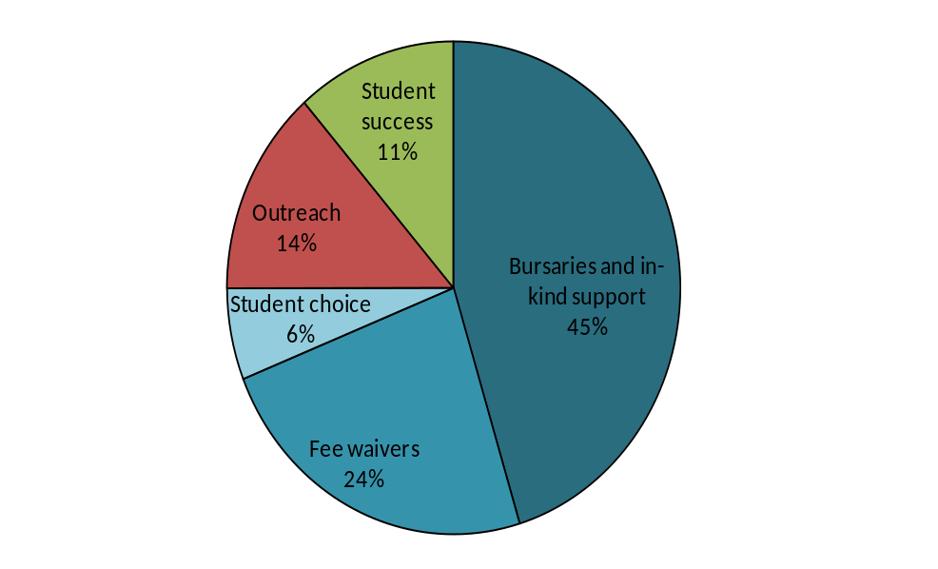
- Under the pre-2012 arrangements, evidence suggests that long-term, co-ordinated outreach has been a more effective use of access funds than financial support for students on entering higher education (OFFA publication 2010/03). Therefore OFFA will continue to strongly encourage institutions to increase outreach work where appropriate, particularly where they have made less progress than anticipated.

Next steps
- Considerable progress has already been made in preparing and developing the strategy for its delivery by the autumn 2013. The annex detailing key issues and actions that was attached to our response to Ministers in October 2012 has been updated and attached to this report at Annex B. Some key points to note are that the research into the use and impact of the WP allocation has already reported and will be published in February 2013, and that the international case studies will be commissioned in early January and will report in May 2013. As this report demonstrates, the collation of the existing evidence has already begun. However, OFFA and HEFCE will commission an overarching review of the evidence base which will form the basis of the literature review for the main report in the autumn.
- HEFCE and OFFA are in the process of setting up a series of thematically organised round table discussions. These will cover:
- collaborative outreach
- monitoring and evaluation
- the role of pedagogic research and development in widening participation
- outreach to and support for mature students
- the equalities and widening participation interface
- access issues for postgraduate study.
- In addition, OFFA and HEFCE have arranged sessions at each of the National Education Opportunities Network’s regional events in the spring, to consult on and discuss the emerging shape and content of the strategy with WP professionals. OFFA is also supporting a seminar series to be delivered by Action on Access which is addressing issues of evaluation and evidence-gathering.

Conclusion
- The evidence we have gathered to date has enabled us to draw some tentative conclusions about where we might need to focus some of the investment in WP in the future.
- The report has highlighted the challenges to the provision of high quality, relevant advice and guidance to young people in schools and adults in employment, the community or FE colleges. Responding to these challenges, the report argues, requires a national response from across Government, but it also requires the HE system to critically appraise its existing approaches to outreach and assess where greater contributions could be made. The evidence to date suggests that a key priority should be building on the collaborative arrangements already in place in HE to enable the delivery of sustainable and comprehensive outreach to young and mature students.
- The report has also highlighted the importance of maintaining and if possible enhancing our focus on equality and diversity. HEFCE has already supported considerable activity to address the differences in degree attainment for students from different ethnic minority backgrounds and it continues to deliver specific funding to provide for and support disabled students. However, the report has also highlighted the continuing disparity in entry rates between men and women in HE and showed how these mirror the differences men women in the A-level population before HE entry. The report has highlighted how using evidence of attendance on Aimhigher summer schools improved the numbers of boys taking part, and how it influenced the behaviours of partnerships so that they considered how best to engage boys while ensuring that they did not neglect disadvantaged girls. All of these issues will be considered further as the strategy develops.
- HEFCE and OFFA are committed to working with the sector to develop and enhance approaches to widening participation and student success that deliver tangible outcomes for the student, the economy and society. We will do this by:
- Building on the work we have presented in this report.
- Developing a framework for evaluation.
- Developing, in consultation with institutions, sector stakeholders, students and Government, a future approach to widening participation which is
- focussed on students and the student interest,
- sensitive to diversity
- responsive to the challenges and opportunities of the current and future HE system.

List of abbreviations
BIS Department for Business, Innovation and Skills
BME Black and minority ethnic
FE Further education
FEC Further education college
HE Higher education
HEFCE Higher Education Funding Council for England
HEFCW Higher Education Funding Council for Wales
HEI Higher education institution
IAG Information, advice and guidance
LLN Lifelong learning network
NCEE National Council for Educational Excellence
NSP National Scholarship Programme
OFFA Office for Fair Access
TLRP Teaching and learning research programme
WP Widening participation
WPSA Widening participation strategic assessment
WPSS Widening participation strategic statement

Annex A

Bibliography
Correspondence between BIS, HEFCE and OFFA relating to the development of the national strategy is available at www.hefce.ac.uk/news/newsarchive/2012/name,76065,en.html, https://www.gov.uk/government/organisations/department-for-business-innovation-skills ,
and www.offa.org.uk/wp-content/uploads/2012/11/Merged-letters-on-joint-strategy-2012.pdf
Centre for Disability Studies and School of Sociology and Social Policy at the University of Leeds: ‘Evaluation of provision and support for disabled students in higher education: a report to HEFCE and HEFCW’ December 2009.
CFE Consulting and Edge Hill University: ‘The uses and impact of HEFCE funding for widening participation’, December 2012. Report awaiting publication in February 2013
Crozier G, Reay D: ‘The socio cultural and learning experiences of working class students in higher education’, ESRC, 2008
Emmerson,C, Frayne, C, McNally, S and Silva, O: ‘Evaluation of Aimhigher: Excellence Challenge. A Policy Evaluation Using the Labour Force Survey’, National Foundation for Educational Research, 2006
Emmerson, C, Frayne, C, McNally, S and Silva, O: ’Evaluation of Aimhigher: Excellence Challenge, the early impact of Aimhigher: Excellence Challenge on pre-16 outcomes: an economic evaluation’. Department for Education and Skills, London, UK, 2005
HEFCE 2003/32: ‘Schooling effects on higher education achievement’, and HEFCE 2005/09: ‘Schooling effects on higher education achievement: further analysis - entry at 19’ February 2009.
HEFCE 2005/03: ‘Young participation in higher education’.
HEFCE guidance 2007/12: ‘Higher education outreach: targeting disadvantaged learners’. Available at: www.hefce.ac.uk/pubs/hefce/2007/07_12/
HEFCE 2009/11: ‘Aimhigher Summer Schools: Analysis of provision and participation 2004 to 2008’.December 2009
HEFCE 2009/17: ‘Pathways to higher education: Apprenticeships’, May 2009, HEFCE 2007/35: ‘Pathways to higher education: BTEC courses’, December 2007 and
HEFCE 2006/16: ‘Pathways to higher education: Access courses’, May 2006. The reports are available at: http://www.hefce.ac.uk/pubs/year/2009
HEFCE 2009/49: ‘Outcomes of HEFCE review of its policy as it relates to disabled students’, December 2009
HEFCE 2010/13: ‘Student ethnicity: Profile and progression of entrants to full-time, first degree study’, May 2010.
HEFCE 2010/32: ‘Aimhigher summer schools: Participation and progression to higher education’, December 2010.
HEFCE 2012/04: ‘Student number controls and teaching funding: Consultation on arrangements for 2013-14 and beyond’, February 2012.
HEFCE: ‘Formative evaluation of the National Scholarship Programme’, May 2012.
Higher Education Academy: ‘Black and minority ethnic student degree retention and attainment’, October 2012
Higher Education Progression Framework: www.aimhigher.ac.uk/practitioner/programme_information/about_aimhigher/progression_model.cfm
International Centre for Guidance Studies, Hooley T, Marriott J, Watts A G, and Coiffait L (2012). ‘Careers 2020: Options for future careers work in English schools’. London: Pearson.
http://derby.openrepository.com/derby/bitstream/10545/251032/1/CAREERS%202020.pdf
Independent Commission on fees: student survey summary 2012:
http://www.independentcommissionfees.org.uk/
National Council for Educational Excellence: recommendations, October 2008
National Foundation for Educational Research: ‘The longer term impact of Aimhigher: Tracking individuals’, October 2009.
National HE STEM project: www.hefce.ac.uk/whatwedo/crosscutting/sivs/stem/
National Inquiry into Higher Education, Report of the National Committee, July 1997
NUS and million+: ‘Never Too Late To Learn: Mature students in higher education’, May 2012.
OFFA report 2010/06: Have bursaries influenced choice between universities? Corver M, September 2010.
Parliamentary publications: ‘Written evidence submitted by the Presidential Team of the Institute of Career Guidance to the Education Select Committee’, October 2012: www.publications.parliament.uk/pa/cm201213/cmselect/cmeduc/writev/632/m58.htm
Paul Hamlyn Foundation: ‘What works? Student Retention & Success: Building student engagement and belonging in Higher Education at a time of change’, July 2012.
‘Review of widening participation research: addressing the barriers to participation in higher education: A report to HEFCE by the University of York, Higher Education Academy and Institute for Access Studies’. July 2006.
Sutton Trust: ‘The missing 3,000 - State Schools Under-Represented at Leading Universities’, August 2004.
Sutton Trust: ‘Increasing higher education participation amongst disadvantaged young people and schools in poor communities’, October 2008.
UCAS, ‘End of cycle report, 2012’, December 2012.
Wiggans J: ‘Collaboration and partnership working in a competitive environment’, Higher Education Academy, 2012.
Work Foundation (2012): ‘Raising Aspirations and smoothing transitions’ by Balaram B and Crowley E, September 2012.

Annex B

Key issues and actions
- We have identified a series of emerging priorities which we believe the new national strategy for access and student success will need to address. Within all these priorities, our focus will be to ensure that we understand how the current funding and investment in widening participation (WP) has been used to address them, how effective it has been to date and how it might be better targeted to deliver the desired outcomes.
- Table 4 provides an outline of our current and planned activity to establish the evidence base and deliver the national strategy. These plans are indicative: our early scoping and feasibility testing may lead to changes being made to them.

Table 4 Indicative plans activity to establish the evidence base and deliver the national strategy
Activity | Status | Output/outcome | Timescale
HEFCE-commissioned research: The use and impact of HEFCE funding for WP. | Final report submitted. Publication process under way. | The research report provides much more comprehensive evidence of how institutions use the funding HEFCE provides. | Commissioned September 2012; delivered in December 2012.
Formative evaluation of the National Scholarship Programme (NSP). | Ongoing: fieldwork and analysis. | First report delivered May 2012; addendum to report delivered October 2012; interim report to be delivered in September 2013; final report to be delivered in September 2015 | Formative evaluation of the NSP running from September 2011 to September 2015.
Review of funding of NSP with the Department for Business, Innovation and Skills (BIS). | Options for a more targeted allocation method for 2013-14, delivered to NSP Steering Group in October 2012. | Changes to the allocation methodology have been agreed by BIS and will be implemented in the 2014-15 NSP. | January 2013 to September 2014
OFFA analysis of the impact of institutional financial support under the new system. | Initial scoping of work. |  | Scoping September 2012 to December 2012.
 | Initial scoping of work. | Substantive research analysis examining the impact of different types and amounts of support on applicant choice and on retention. | Ongoing – we will scope for any early delivery points ahead of the main trend analysis, which needs two to three years of data (delivering in 2014 or 2015).
 | Initial scoping of work. | Research into effects of financial support on retention before and after introduction of variable fees. | Delivery by the end of September 2013.
 | Initial scoping of work. | Early information-gathering of student choice for fee waiver or maintenance support. | This has been completed and will be incorporated into main strategy
 | Initial scoping of work. | Survey of institutions’ own evaluations of institutional financial support. | Ongoing – initial information collection first half of 2013.
OFFA analysis of participation by selectivity of institution and understanding applicant pools. | Initial scoping of ongoing programme of OFFA analysis work. | Research analysis on young participation by selectivity of institution (to update OFFA’s 2010 analysis) | Delivery summer 2013.
 | Initial scoping of ongoing programme of OFFA analysis work. | New analysis to understand more about applicant pools by using the characteristics of successful applicants compared with like qualified applicants elsewhere. Carried out by UCAS in collaboration with OFFA. | Delivery date to be agreed.
Gathering international evidence on what works to widen participation in other countries. | Contract awarded. Currently in 10 day standstill period. Contract to begin 25th January | The research will draw attention to effective WP practice; examine whether the ways in which different educational systems are organised lead to greater or lesser inclusion; and identify any lessons we might learn from them. | January 2013 to May 2013.
Literature review of existing research into WP and related subject matter. | Initial scoping. | The research will evaluate existing material and publications, and identify and synthesise relevant material to provide a robust overview of the findings of existing research. | February 2013 to May 2013.
Mapping research activity across other HE sector bodies to avoid duplication and ensure joined-up activity. | Initial meeting held with BIS, Universities UK, GuildHE, Supporting Professionalism in Admissions (SPA), the Association of Colleges (AoC) and the Sutton Trust. | Commitment to involve all participants in development and advice on research plans. | First meeting held in August 2012. Ongoing throughout 2012 and 2013.
 | Desk-based research to establish research currently in train within other organisations. | Regularly updated register of current research activity in WP. | Ongoing throughout 2012-13.
Ascertain the perceived impact of new approaches to the provision of advice and guidance to young people in schools and people in colleges.  Linked to the above would be work to assess the effectiveness of collaborative approaches to outreach, and to identify where and how such approaches operate. | This work would benefit from a joint approach which sought views from schools and colleges. However, it falls outside the remit of HEFCE and OFFA to conduct any kind of research in schools. Therefore, our work will focus on the perspectives of WP practitioners in HE. | Working through WP practitioner networks to gain an HE perspective of any change in the numbers being reached (especially of target groups) and whether there has been any change of focus from general HE advice and guidance to more institution-specific work. | January 2013 to May 2013.
Hold a series of roundtable discussions with institutional representatives to test proposals, discuss emerging evidence and gather advice as the strategy develops. | To be organised. | Engagement with the broader sector to ensure we draw on broad range of experience and expertise and gain a measure of buy- in on the overall shape and direction of the national strategy. | Meetings to take place from March 2013 up to May 2013.
Commission feasibility study to establish if possible to develop common evaluation measures that all institutions could adopt to assess the targeting and impact of their access and student success work. | Initial scoping. | Report to recommend what, if any measures could be developed and applied by all institutions as part of an evaluation process, with a view to providing evidence that it would be possible to aggregate to deliver a national picture. | Study commissioned early 2013 to report in May 2013.
Linked to feasibility study, establish an evaluation framework for institutions. | To be informed by scope and findings of feasibility study. | The planned outcome would be a framework that would set out the expectations of HEFCE and OFFA in terms of the type and level of evidence institutions should provide to demonstrate the effectiveness and impact of their activity to widen participation and ensure student success, and to ensure that the funding they devote to it is targeted effectively. | As we develop the scope for the feasibility study we will also develop initial proposals for the framework. Both will be tested at the roundtable discussions. This will inform our guidance to institutions on future access agreements and WP strategic statements.
Further alignment/integration of HEFCE/OFFA processes | Joint monitoring process already established for access agreements and WPSAs. Currently developing an integrated process for WP strategic statements and access agreements so that institutions submit one document that meets both HEFCE and OFFA requirements. Institutions were informed on 15 January 2013 of this plan for an integrated document | An integrated WPSS and access agreement process that ensures institutions return information to HEFCE and OFFA in such a way that it meets our requirements; enables us to effectively monitor and assess the effectiveness of institutional activity and government investment; and enables institutions to more effectively organise their approaches to access and student success. | We are planning to deliver the integrated approach in time for the 2014-15 academic year, with guidance to institutions being published in early 2014. This will result in a return from institutions that will articulate their longer-term strategy for 2014 to 2017 and set out their specific access agreement commitments for the 2015-16 academic year.
Widening participation to postgraduate study | This is being taken forward as part of the broader work HEFCE is undertaking to assess the impact of the reforms on postgraduate provision and participation. | Establishing the baseline data for postgraduate participation and determining the optimal WP indicators at postgraduate level. | HEFCE is at the early stages of development in terms of postgraduate study and we will continue to develop this strand of the strategy beyond the end of 2013.
Equalities | OFFA is working with ECU to develop an embedded approach to equalities within access agreements. | An exploration of good practice on participation and retention around protected groups, what evidence and data are available to support OFFA and HEFCE equalities strategies/approach, and where the gaps are. | Ongoing.
Equalities | HEFCE is in the early stages of developing its equality strategy as part of its role to promote and protect the collective student interest. | The HEFCE strategy will build on the work it has undertaken into the provision and support for disabled students, its analysis of HE participation by gender, and the work it has led on black and minority ethnic (BME) degree attainment.
HE delivered in further education colleges (FECs). | This is being taken forward as part of the broader work that HEFCE is undertaking to better understand the particular issues for HE provision delivered by FECs and alternative providers. | HEFCE has already published a report which provides an overview of the trends in FECs with regard to widening access and non-continuation (August 2012/20). The analysis demonstrates the success of FECs in widening access and highlights the need for further focus on student success and completion. | Ongoing.

Use and impact of the HEFCE funding for widening participation’, CFE Consulting and Edge Hill University, December 2012, (to be published in February 2013).
‘Use and impact of the HEFCE funding for widening participation’, CFE Consulting and Edge Hill University, December 2012, (to be published in February 2013).
‘Trends in young participation in higher education: core results for England’ (HEFCE 2010/03) available at http://www.hefce.ac.uk/pubs/year/2010/201003/
‘Aimhigher summer schools: Participation and progression to Higher Education’ (HEFCE 2010/32), available at: www.hefce.ac.uk/pubs/year/2010/201032/
‘End of cycle report, 2012’, UCAS, December 2012.
In this report, the term ‘institution’ should be taken as referring to higher education institutions and those further education colleges which provide higher education. It does not refer to schools.
The 'basic' level is the maximum fee that universities and colleges can charge if they do not have an access agreement approved by OFFA. For students who start courses in 2012-13 the basic annual tuition fee is £6,000 for full-time courses and £4,500 for part-time courses. If a university or college has an access agreement they can charge above the basic fee level, up to a maximum fee level set by government. For students who start courses in the academic year 2012-13, the maximum fee is £9,000 for full-time courses and £6,750 for part-time courses..
The National Committee of Inquiry into Higher Education report is available at: https://bei.leeds.ac.uk/Partners/NCIHE/
‘Aimhigher summer schools: Analysis of provision and participation 2004 to 2008’ (HEFCE 2009/11), available at www.hefce.ac.uk/pubs/year/2009/200911/
A ‘minimum bursary’ (£338 in 2011-12) was guaranteed to all students who entered courses between 2006-07 and 2011-12, provided that they were in receipt of the full state maintenance grant and were paying the maximum fee (£3,375 in 2011-12). Although the requirement to provide a minimum bursary was ended from 2012-13, the establishment of the NSP from 2012-13 means that there are still minimum financial support commitments for all institutions with access agreements.
‘The uses and impact of HEFCE funding for widening participation’, CFE Consulting and Edge Hill University, December 2012. Report awaiting publication in February 2013.
The purpose of WPSAs was to allow institutions to articulate and take full credit for all that they do to widen participation and support student success, and to allow HEFCE to get a further information on how its investment continued to support this core priority. The WPSAs allowed those institutions with access agreements to situate the commitments in those agreements within their broader strategic framework for WP, as well as providing a mechanism through which those institutions without access agreements but in receipt of the HEFCE WP allocation could report on their activity.
This includes funding from a range of sources including HEFCE’ WP allocation, additional fee income, philanthropic funds, etc) but excludes funding for bursaries or other forms of institutional student financial support.
‘Evaluation of provision and support for disabled students in higher education: a report to HEFCE and HEFCW’, Centre for Disability Studies and School of Sociology and Social Policy at the University of Leeds, December 2009.
‘Evaluation of provision and support for disabled students in higher education: a report to HEFCE and HEFCW’, p 150.
‘Young participation in higher education’ (HEFCE 2005/03), available at http://webarchive.nationalarchives.gov.uk/20100202100434/http:/www.hefce.ac.uk/pubs/hefce/2005/05_03/
Trends in young participation in higher education: core results for England’ (HEFCE 2010/03) available at http://www.hefce.ac.uk/pubs/year/2010/201003/
Young participation is defined as that of students entering HE at age 18 or 19.
: ‘Aimhigher summer schools: Participation and progression to Higher Education’ (HEFCE 2010/32), available at: www.hefce.ac.uk/pubs/year/2010/201032/
‘Higher education outreach: targeting disadvantaged learners’ (HEFCE 2007/12), available at: www.hefce.ac.uk/pubs/hefce/2007/07_12/
‘End of cycle report, 2012’, UCAS, December 2012.
Source: www.independentcommissionfees.org.uk/wordpress/wp-content/uploads/2012/08/NFER-student-survey-summaryFINAL.docx
‘End of cycle report, 2012’, UCAS, December 2012.
Report by the Work Foundation: ‘Raising Aspirations and smoothing transitions’ by Brhmie Balaram and Lizzie Crowley,05 September 2012. The report is available at: http://theworkfoundation.com/Reports/320/Raising-Aspirations-and-Smoothing-Transitions
Evidence based on responses from its members and research with 200+ schools across Lincolnshire, Cheshire, Coventry, Warwickshire, Kent, two other shire counties, and a selection of South London boroughs. Available at www.publications.parliament.uk/pa/cm201213/cmselect/cmeduc/writev/632/m58.htm
International Centre for Guidance Studies, Hooley T, Marriott J, Watts A G, and Coiffait L (2012). ‘Careers 2020: Options for future careers work in English schools’. London: Pearson. http://derby.openrepository.com/derby/bitstream/10545/251032/1/CAREERS%202020.pdf
‘Formative evaluation of the National Scholarship Programme’, CFE Consulting and Edge Hill University, May 2012
‘Review of widening participation research: addressing the barriers to participation in higher education: A report to HEFCE by the University of York, Higher Education Academy and Institute for Access Studies’, July 2006, available at: http://webarchive.nationalarchives.gov.uk/20100202100434/http://hefce.ac.uk/pubs/rdreports/2006/rd13_06/
‘The longer-term impact of Aimhigher: Tracking individuals, National Foundation for Educational Research, October 2009
‘Pathways to higher education: Apprenticeships’ (HEFCE 2009/17), ‘Pathways to higher education: BTEC courses’ (HEFCE 2007/35), and ‘Pathways to higher education: Access courses’ (HEFCE 2006/16), available at www.hefce.ac.uk/pubs/
‘Schooling effects on higher education achievement’ (HEFCE 2003/32), and ‘Schooling effects on higher education achievement: further analysis– entry at 19’ (HEFCE 2005/09).
Have bursaries influenced choices between universities?’ (OFFA 2010/06), available at www.offa.org.uk/publications
Sutton Trust report: ‘The missing 3,000 – State Schools Under-Represented at Leading Universities’ 1 August 2004. Available at: www.suttontrust.com/research/the-missing-3000/
s
The University of Birmingham, the University of Bristol, the University of Essex, the University of Exeter, King’s College London, the University of Leeds, the University of Leicester, the University of Liverpool, the University of Manchester, Newcastle University (lead University), the University of Warwick and the University of York.
National Council for Educational Excellence recommendations, October 2008: https://www.education.gov.uk/publications/standard/publicationdetail/page1/DCSF-00803-2008
‘Increasing higher education participation amongst disadvantaged young people and schools in poor communities’, the Sutton Trust, October 2008.
Higher Education Progression Framework: www.aimhigher.ac.uk/practitioner/programme_information/about_aimhigher/progression_model.cfm
National HE STEM project: www.hefce.ac.uk/whatwedo/crosscutting/sivs/stem/
‘Never too late to learn: Mature students in higher education’, NUS and Million +, May 2012.
‘Collaboration and partnership working in a competitive environment’, Jo Wiggans, Higher Education Academy, 2012.
‘What works final research: Building student engagement and belonging in Higher Education at a time of change’, July 2012. Available at: www.phf.org.uk/page.asp?id=1715
‘The socio-cultural and learning experiences of working class students in higher education’, Crozier, G., Reay, D., ESRC, 2008
HEFCE 2010/13: ‘Student ethnicity: Profile and progression of entrants to full-time, first degree study’, May 2010.
‘Black and minority ethnic student degree retention and attainment’, Higher Education Academy, October 2012 http://www.heacademy.ac.uk/resources/detail/retention/bme_summit_report
Student number controls and teaching funding: Consultation on arrangements for 2013-14 and beyond .

