|  |  |
| --- | --- |
| **Official Statistics Release** | |
| Policy area: | Children’s homes inspections and outcomes |
| Theme: | Education, children’s services and skills |
| Published on: | 25 March 2014 |
| Coverage: | England |
| Period covered: | 1 October to 31 December 2013 |
| Status: | **PROVISIONAL** |
| Issued by: | Office for Standards in Education, Children’s Services and Skills (Ofsted) Aviation House 125 Kingsway  London WC2B 6SE |
|
|
|
| Statistician: | Adam King |
| Statistician’s telephone number: | 0300 013 0020 |
| Public enquiries: | [enquiries@ofsted.gov.uk](mailto:enquiries@ofsted.gov.uk) |
| Press enquiries: | [pressenquiries@ofsted.gov.uk](mailto:pressenquiries@ofsted.gov.uk) |
| Link to official statistics release web page: | [www.ofsted.gov.uk/resources/official-statistics-childrens-social-care-inspections-and-outcomes](http://www.ofsted.gov.uk/resources/official-statistics-childrens-social-care-inspections-and-outcomes) |
| Publication medium: | Ofsted website |
| Publication frequency: | Quarterly |
| Next publication date: | 26 June 2014 |

**Key Points**

* Of the 545 children’s homes inspections in the period 1 October to 31 December 2013, 89 (16%) were judged outstanding for their *Overall effectiveness*; 327 (60%) were good, 106 (19%) were adequate and 23 (4%) were inadequate.
* 540 children’s homes were inspected, which equates to 26% of the 2,067 children’s homes active at 30 September 2013; this accounted for 25% (or approximately 2,960 places) of the total national children’s homes capacity in the period. (Table 1)
* Between 1 April 2013 and 31 December 2013, 69% of homes received a good or better *Overall effectiveness* judgement; this was a slight decrease from the same period of the previous year (72%). In the same period, 6% of homes received an inadequate *Overall effectiveness* judgement which was a slight increase from the same period of the previous year (5%).

Introduction

This official statistics release reports on children’s homes inspections that occurred between 1 October 2013 and 31 December 2013 under the Care Standards Act 2000. These statistics are based on provisional data and are subject to change.

**Key findings**

**Inspections and outcomes of children’s homes** **full inspections**

* Provisional statistics indicate there were 545 full inspections of 540 children’s homes during 1 October 2013 to 31 December 2013; five homes that were initially judged inadequate were inspected again in the period. This equates to inspections of 26% of the 2,067 children’s homes active at 30 September 2013. The 540 children’s homes inspected accounted for 25% (or approximately 2,960 places) of the total national children’s homes capacity in the period.[1] (Table 1)
* Of the 545 inspections, 89 (16%) were outstanding for their *Overall effectiveness*; 327 (60%) were good, 106 (19%) were adequate and 23 (4%) were inadequate. (Table 2)
* Between 1 April 2013 and 31 December 2013, 69% of homes received a good or better *Overall effectiveness* judgement; this was a slight decrease from the same period of the previous year (72%). In the period 1 April 2013 – 31 December 2013, 6% of homes received an inadequate *Overall effectiveness* judgement which was a slight increase from the same period of the previous year (5%). Ofsted use a proportionate risk approach when scheduling children’s homes inspections, which makes a comparison between the same periods of 2012 and 2013 the best comparator. However, it should be noted that there were 105 fewer inspections for this period than in the same period in 2012.[2] (See Figure 1 below and Chart 2)

Figure 1[3]

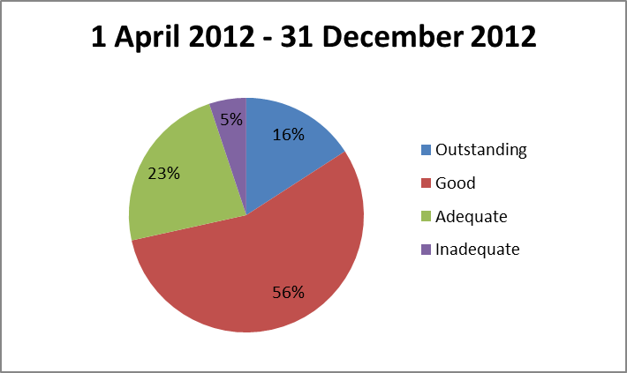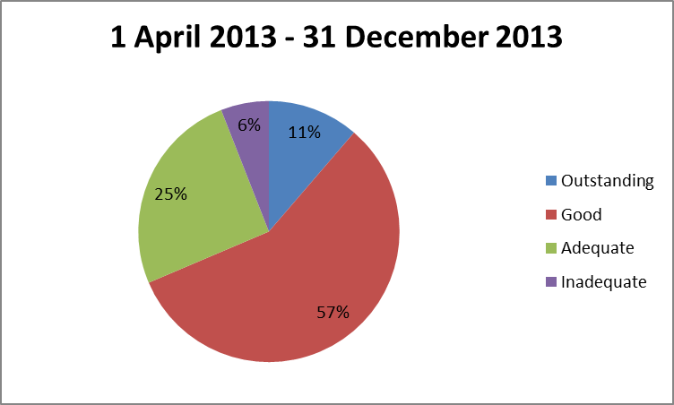

Total number of inspections = 1,936 Total number of inspections: = 1,831

* When comparing the *Overall effectiveness* inspection judgement of the 1,520 homes who received a full inspection since 1 April 2013 to their previous full inspection grade from 2012-13; 56 (95%) of the 59 previously judged inadequate improved, and 202 (55%) of the 365 previously graded adequate improved whilst nine (2%) declined. Conversely 117 (53%) of the 221 previously graded outstanding declined in grade, 181 (21%) of the 875 previously graded good declined, and 84 (10%) improved. An additional 227 homes were inspected in the period which had not received a full inspection in 2012-13.[4] (See Figure 2 below)

Figure 2

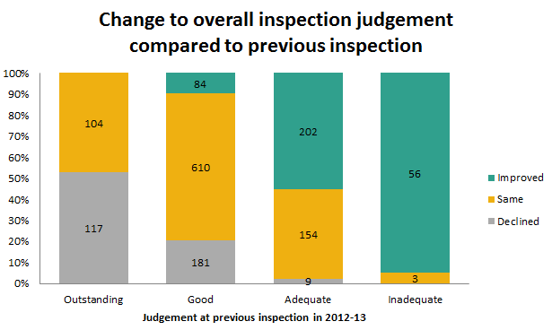

* In the same period, there were 13 homes that were judged inadequate for *Overall effectiveness* that had been judged good or better at their previous full inspection. Three of these declined from outstanding.
* There were 18 homes that improved from inadequate at their previous full inspection to good.

**Regional Data**

* The regions with the highest percentage of homes judged good or better since 1 April 2013 were Yorkshire and The Humber and the North East (both 75%), North West (74%), and the South East (73%). The regions with the lowest percentage of homes judged good or better were the South West (61%), East of England (62%), East Midlands (63%) and West Midlands (64%). The national proportion of good or better homes was 69%. (Map 1)
* Of the 1,096 homes judged good or better in 2012-13 and re-inspected since then, 209 (19%) are now rated adequate or lower. The areas of the country where this decline is most prominent are the East of England, East Midlands and the South West with comparative declines of 28%, 28% and 26% respectively. The lowest proportions of decline were found in the North East (13%) and Yorkshire and The Humber (14%). With regards to specific local authorities, Leicester City saw 67% (four out of six) homes that were judged good or better decline to adequate or lower. Conversely, in Barnsley and Gloucestershire no homes declined on re-inspection (11 homes were re-inspected in each).[5] [See Figure 3 below]

Figure 3

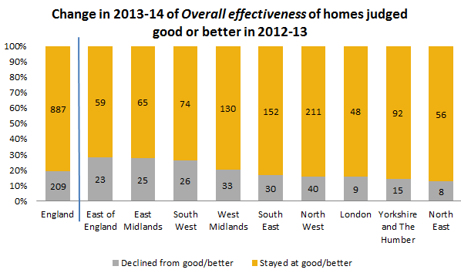

* Of 424 homes judged adequate or lower in 2012-13 and re-inspected since then, 220 (52%) are now judged good or better. The North East and Yorkshire and The Humber showed the most marked improvement with 59% increasing from adequate or lower to good or better. The lowest areas of improvement were in the South West and West Midlands where only 42% of homes located in each area improved. With regards to specific local authorities, in St Helens 100% (out of 12 homes) and in Leeds 90% (nine out of 10 homes) of homes had improved from adequate or lower to good or better. Conversely, areas where fewer homes had improved from adequate or lower included Sandwell with 13% (one out of eight homes), and Somerset with 9% (one out of 11 homes).[6] [See Figure 4 below]

Figure 4

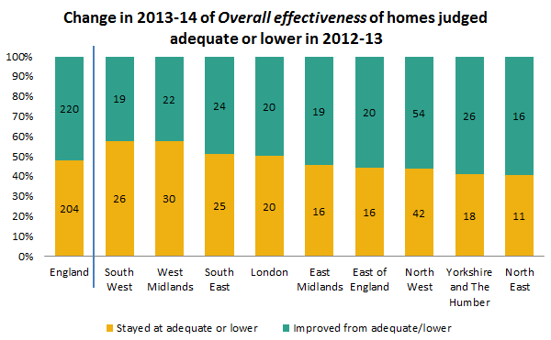

**Sector data**

* In the period 1 October 2013 to 31 December 2013, a smaller proportion of private-run homes (73%) received a good or better *Overall effectiveness* judgement than local authority or voluntary-run homes (82% and 86% respectively). Private-run homes had a slightly higher proportion of homes judged inadequate (5%), than local authority and voluntary-run homes (3% and 0% respectively). Local authority and voluntary-run homes received a higher proportion of outstanding judgements (21% and 19% respectively) than private-run homes (14%). [Charts 3 and 4]
* Between 1 April 2013 and 31 December 2013, a smaller proportion of private-run homes than local authority or voluntary-run homes received a good or better *Overall effectiveness* judgement (67%, compared to 71% and 73% respectively).[7]
* In the period 1 April 2013 to 31 December 2013, local authority-run homes received a higher percentage (14%) of outstanding judgements than private and voluntary-run homes (10% and 11% respectively).
* With regards to inadequate *Overall effectiveness* judgements inspected between 1 April 2013 and 31 December 2013, private-run homes had a slightly higher proportion of inadequate homes than local authority-run homes (7% and 5% respectively). In contrast, two voluntary-run homes received an inadequate inspection grade (1%).
* The sectorial picture, when grouped by regions, varies between the north and south of England. Between 1 April 2013 and 31 December 2013, in the South West and South East regions the proportion of homes receiving a good or better *Overall effectiveness* judgement was nine percentage points higher among private and voluntary-run homes than local authority-run homes. In contrast, across the northern and eastern regions, the proportion of local authority-run homes homes receiving good or better grades is higher than private and voluntary-run homes. The proportion of homes receiving a good or better judgment in the West Midlands is the same across local authority-run homes and private and voluntary. In London, local authority-run homes have a much higher proportion of good or better judgements than private and voluntary-run homes (81% and 59% respectively).

**Interim inspections**

* Between 1 October 2013 and 31 December 2013, there were 198 interim inspections. Of these 198, 81 (41%) made good progress and 52 (26%) made satisfactory progress. However, 46 (23%) made inadequate progress. Nineteen (10%) did not receive an inspection outcome as children were not accommodated in the children’s home at the time of inspection. (Table 3d)

**Impact of revisions on key findings of previous release**

* Final data covering the period 1 July 2013 to 30 September 2013 have been released and can be found on the Ofsted website: [www.ofsted.gov.uk/resources/official-statistics-childrens-social-care-inspections-and-outcomes](http://www.ofsted.gov.uk/resources/official-statistics-childrens-social-care-inspections-and-outcomes).
* The revision of statistics relating to the 1 July 2013 to 30 September 2013 quarter from ‘provisional’ to ‘final’ status includes outcomes relating to a further 200 inspections. These consist of an additional 179 full inspections and 21 interim inspection of children’s homes, which took place in this period and have been published since 31 July 2013.
* Of the additional 179 full inspections, 106 children’s homes received good or better *Overall effectiveness* judgement and 73 received adequate or lower. These additional inspections only slightly changed the grade profile presented in the previous provisional data.

# Methodology

The data in the release are from inspections undertaken between 1 October 2013 and 31 December 2013.

Statistics relating to inspections in the most recent quarter are provisional and include inspections in the period where the inspection report was published within one month of the end of the quarter. If an inspection report is published later than one month, and less than four months, after the end of the quarter in which the inspection took place, that inspection will be included in the final release of the statistics.

Inspections and outcomes of provider settings that are not currently active are included in this statistical release and are reflected in the underlying data within the comma separated values (csv) and Excel files as ‘resigned’.

Revisions are published in line with Ofsted’s revisions policy for official statistics. For more information about the policy, please visit the Ofsted website or access the policy via the following link: <http://www.ofsted.gov.uk/resources/statistical-notice-ofsted-revisions-policy-for-official-statistics>.

For more information on how Ofsted regulates and inspects children’s social care, please go to the Ofsted website: <http://www.ofsted.gov.uk/children-and-families-services>. In its inspection of social care services, Ofsted must take account of national minimum standards published by government.

This release includes sector data. Sector data are the ownership type for each home (local authority, private, voluntary and health authority). Ofsted’s data are disaggregated into separate private and voluntary categories in the tables.

The revised inspection framework for children’s homes which began on 1 April 2012 includes a change of name of one of the grades. The judgement ‘adequate’ has replaced the previous judgement of ‘satisfactory’. Where previously a home could receive outstanding, good, satisfactory or inadequate grades, they can now receive outstanding, good, adequate or inadequate.

**Additional information**

All the tables and charts shown in this release, along with additional analysis at regional and local authority level, are available in Excel format on the Ofsted website in the same location as this document. Underlying data are also available in Excel and csv formats.

List of Charts

Chart 1: *Overall effectiveness* of children’s homes inspected between 1 April 2007 and 31 December 2013, by financial year (provisional)……………………………………………………………………….11

Chart 2: *Overall effectiveness* of children’s homes inspected between 1 April 2007 and 31 December 2013, by quarter (provisional).………………………………………………………………………………12

# Chart 3: *Overall effectiveness* of local authority run children's homes inspected between 1 April 2011 and 31 December 2013, by quarter (provisional)…………………………………………………………….13

# Chart 4: *Overall effectiveness* of private and voluntary run children's homes inspected between 1 April 2011 and 31 December 2013, by quarter (provisional)....…………..……………………………………13

Chart 5: Progress judgement of all children's homes at interim inspection between 1 April 2011 and 31 December 2013, by quarter (provisional)..…..……………………………………………………………………14

**List of Tables**

Table 1: Number of children’s homes inspections carried out between 1 October 2013 and 31 December 2013, by inspection type (provisional)……………………………………………………………………15

Table 2: *Overall effectiveness* of children’s homes at full inspections between 1 October 2013 and 31 December 2013 (provisional)…………………………………………………………………………………………..16

Table 3a: Full inspection outcomes of children's homes (excluding secure children’s homes and residential special schools caring for pupils for more than 295 days per year) inspected between 1 October 2013 and 31 December 2013 (provisional)………………………………………………………………..17

Table 3b: Full inspection outcomes of secure children’s homes inspected between 1 October 2013 and 31 December 2013 (provisional)….….……………………………………………………………………..........18

Table 3c: Full inspection outcomes of residential special schools caring for pupils for more than 295 days per year inspected between 1 October 2013 and 31 December 2013 (provisional)…………….19

Table 3d: Interim inspection outcomes of all children’s homes inspected between 1 October 2013 and 31 December 2013 provisional)………………………………………………………………………………………20

# List of Maps

Map 1: Children’s homes receiving a good or better *Overall effectiveness* judgement at full inspection, by region, since 1 April 2013 (provisional)……………………………………………………………..21

Map 2: Children’s homes receiving an adequate or lower *Overall effectiveness* judgement at full inspection, by region, since 1 April 2013 (provisional)……………………………………………………………..22

Map 3: Local authority-run children’s homes receiving a good or better *Overall effectiveness* judgement at full inspection, by region, since 1 April 2013 (provisional)……………………………………23

Map 4: Private and voluntary-run children’s homes receiving a good or better *Overall effectiveness* judgement at full inspection, by region, since 1 April 2013 (provisional)……………………………………23

Map 5: Local authority-run children’s homes receiving an adequate or lower O*verall effectiveness* judgement at full inspection, by region, since 1 April 2013 (provisional)……………………………………24

Map 6: Private and voluntary-run children’s homes receiving an adequate or lower *Overall effectiveness* judgement at full inspection, by region, since 1 April 2013 (provisional)………………..24

**Glossary**………………….....…………………………………………….………………………………………………………25**Chart 1: Overall effectiveness of all children's homes inspected between 1 April 2007 and 31 December 2013, by financial year (provisional)1 2**



*Source: Ofsted Inspections*

1. Percentages are rounded and may not add to exactly 100.

2. Inspections since the inspection framework change on 1 April 2011 include only full inspections, inspections prior to 1 April 2011 include both interim and full inspections.

Chart 2: *Overall effectiveness* of all children's homes inspected between 1 April 2007 and 31 December 2013, by quarter (provisional)1 2



*Source: Ofsted inspections*

1. Percentages are rounded and may not add to exactly 100.

2. Inspections since the inspection framework change on 1 April 2011 include only full inspections, inspections prior to 1 April 2011 include both interim and full inspections.

|  |
| --- |
| **Chart 3: *Overall effectiveness* of local authority run children's homes inspected between 1 April 2011 and** 31 December **2013, by quarter (provisional)1 2** |
|
|



*Source: Ofsted inspections*

1. Percentages are rounded and may not add to exactly 100.

2. Local authority data include a small number of homes run by health authorities.

|  |
| --- |
| **Chart 4: *Overall effectiveness* of private and voluntary run children's homes inspected between 1 April 2011 and** 31 December **2013, by quarter (provisional)1** |
|
|



*Source: Ofsted inspection*

1. Percentages are rounded and may not add to exactly 100.

**Chart 5: Progress judgement of all children's homes at interim inspection between 1 April 2011 and** 31 December **2013, by quarter (provisional)1 2 3**



*Source: Ofsted inspections*

1. Percentages are rounded and may not add to exactly 100.

2. At an interim inspection, progress is judged based on requirements and recommendations made following the last full inspection.

3. Homes are not judged if there are no children being cared for when they are inspected.

**Table 1: Number of children's homes inspections carried out between 1 October – 31 December 2013, by inspection type (provisional)¹ ²**



1. The 'all' figures include all homes, of all ownership type, in the local authority area. Local authority run homes data include a small number of homes run by health authorities.

2. Residential special schools that care for pupils for more than 295 days per year must register as children’s homes.

# Table 2: Overall effectiveness of children's homes at full inspections between 1 October – 31 December 2013 (provisional)¹ ²



# 1. The 'all' figures include all homes, of all ownership type, in the local authority area. Local authority run homes data include a small number of homes run by health authorities.

2. Residential special schools that care for pupils for more than 295 days per year must register as children’s homes.

**Table 3a: Full inspection outcomes of children's homes (excluding secure children's homes and residential special schools caring for pupils for more than 295 days a year) inspected between 1 October – 31 December 2013 (provisional)¹ ² ³**



1. The 'all' figures include all homes, of all ownership type, in the local authority area. Local authority run homes data include a small number of homes run by health authorities.

2. Percentages are rounded and may not add to exactly 100.

3. Residential special schools that care for pupils for more than 295 days per year must register as children’s homes and their inspection outcomes data can be found in table 3c.

# Table 3b: Full inspection outcomes of secure children's homes inspected between 1 October – 31 December 2013 (provisional)1 2 3



1. The 'all' figures include all homes, of all ownership type, in the local authority area. Local authority run homes data include a small number of homes run by health authorities.

2. Percentages are rounded and may not add to exactly 100.

3. Percentages should be treated with caution, where the number of inspections is low.

4. This sub judgement is only applicable in secure children's homes inspections.

Table 3c: Full inspection outcomes of residential special schools caring for pupils for more than 295 days per year inspected between **1 October – 31 December 2013** (provisional)¹ ² ³



1. The 'all' figures include all homes, of all ownership type, in the local authority area. Local authority run homes data include a small number of homes run by health authorities.

2. Percentages are rounded and may not add to exactly 100.

3. Residential special schools that care for pupils for more than 295 days per year must register as children’s homes.Table 3d: Interim inspection outcomes of all children's homes inspected between **1 October – 31 December 2013** (provisional)¹ ² ³



1. The 'all' figures include all homes, of all ownership type, in the local authority area. Local authority run homes data include a small number of homes run by health authorities.

2. Percentages are rounded and may not add to exactly 100.

3. At an interim inspection, progress is judged based on requirements and recommendations made following the last full inspection.

4. Children’s homes not accommodating children at the time of their interim inspection received no judgement.

5. Residential special schools that care for pupils for more than 295 days per year must register as children’s homes.

**Map 1: Children's homes receiving a good or better overall effectiveness judgement at full inspection, by region, since 1 April 2013 (provisional)**

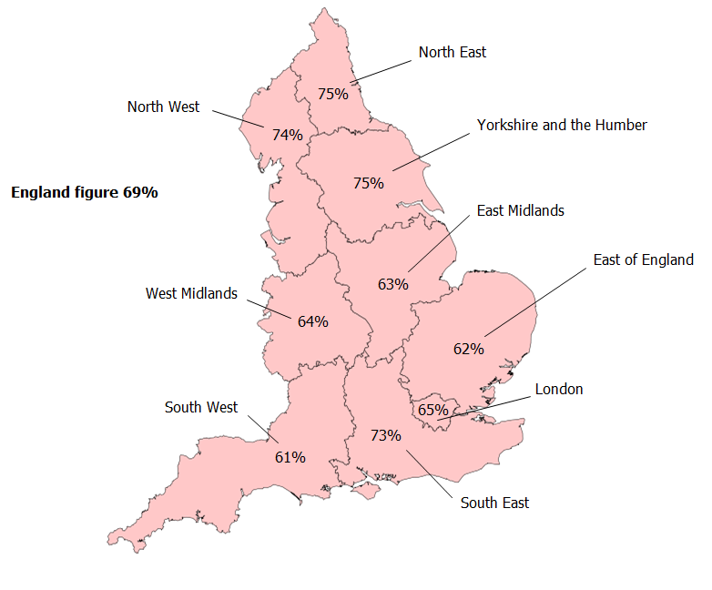

**Map 2: Children's homes receiving an adequate or lower overall effectiveness judgement at full inspection, by region, since 1 April 2013 (provisional)**

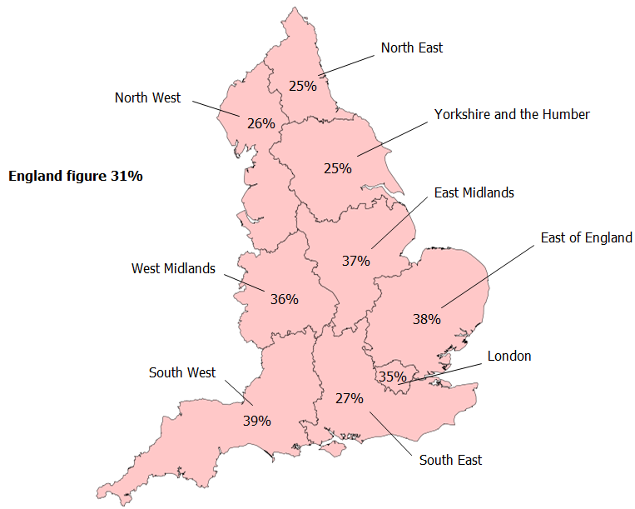

Map 3: Local authority-run children's homes receiving a Map 4: Private and voluntary-run children's homes receiving a

good or better overall effectiveness judgement at full good or better overall effectiveness judgement at full inspection,

inspection, by region, since 1 April 2013 (provisional)1 by region, since 1 April 2013 (provisional)

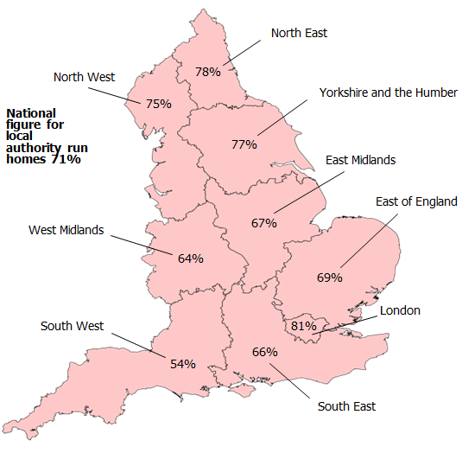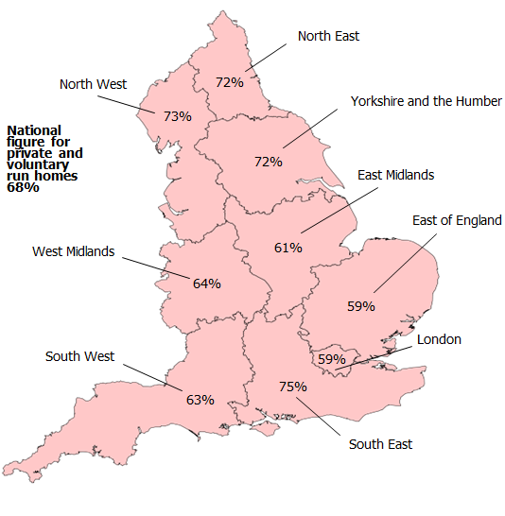

1. Local authority data include a small number of homes run by health authorities.

**Map 5**: Local authority-run children's homes receiving an Map 6: Private and voluntary-run children's homes receiving an

adequate or lower overall effectiveness judgement at full adequate or lower overall effectiveness judgement at full

inspection, by region, since 1 April 2013 (provisional)1 inspection, by region, since 1 April 2013 (provisional)

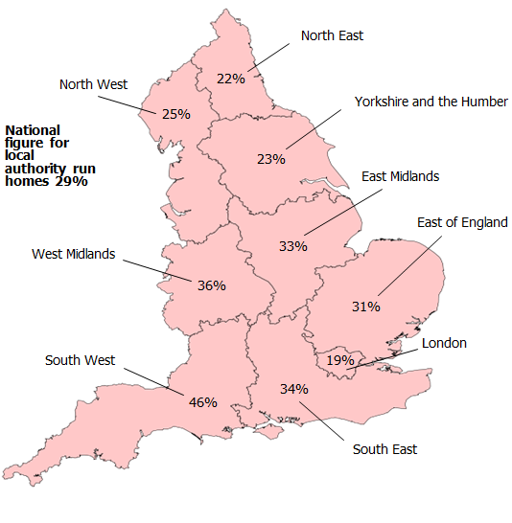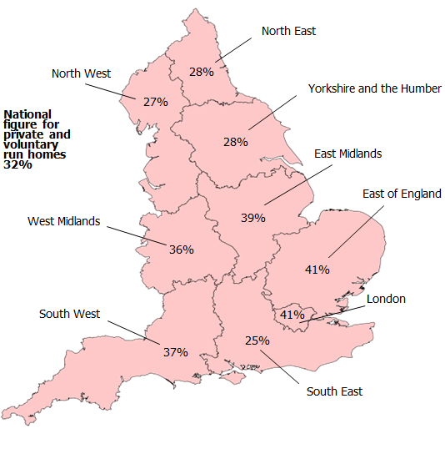

1. Local authority data include a small number of homes run by health authorities.

Glossary

**Children’s homes**

A children’s home is defined in section 1 of the Care Standards Act 2000, and is an establishment that provides care and accommodation wholly or mainly for children. Children’s homes vary in size and nature. They fulfil a range of purposes designed to meet the different needs of those children and young people who are assessed as needing a residential care placement. Some homes, for example, provide short breaks which are needed to help support children and their family. Some residential special schools are registered as children’s homes because boarders are resident for more than 295 days per year.

**Residential special schools**

Residential special schools are defined in section 59 of the Safeguarding Vulnerable Groups Act 2006. They vary in size and nature. The sector includes large non-maintained special schools which make provision for very specific needs and take children as full boarders from all over the country, to smaller more local providers catering for children with a range of different special needs and disabilities who may be resident at the school only during the week. Some residential special schools are registered as children’s homes because boarders are resident for more than 295 days per year. There are also a small number of independent residential special schools who also tend to cater for children with very specialist needs.

**Sector**

Sector refers to the type of provider that owns the children’s home.

*Local Authority*

These are public bodies responsible for the children’s home.

*Private*

These are for-profit organisations mostly with limited company status. These can also though be individually owned children’s homes and run for profit.

*Voluntary*

These are mostly not-for-profit organisations, mainly with charitable status. These can also be individually owned children’s homes and run on a not-for-profit basis.

*Health Authority*

These are NHS Trust-run.

**Secure children’s homes**

Secure children’s homes are defined by section 25 of the Children Act 1989. They accommodate children and young people who are remanded or have been sentenced for committing a criminal offence. They also accommodate children and young people who are placed there by a court because their behaviour is deemed to present a significant and immediate threat to their safety or the safety of others, unless they are placed in a secure environment. Ofsted inspections are conducted in accordance with the Care Standards Act 2000 and judgements in reports are made in relation to the outcomes for children set out in the Children Act 2004. The criteria are the same as those used to inspect non-secure children’s homes.

© Crown copyright

You may re-use this information (not including logos) free of charge in any format or medium, under the terms of the Open Government Licence. To view this licence, visit [http://www.nationalarchives.gov.uk/doc/open-government-licence/](http://www.nationalarchives.gov.uk/doc/open%2Dgovernment%2Dlicence) or write to the Information Policy Team, The National Archives, Kew, London, TW9 4DU or e-mail: [psi@nationalarchives.gsi.gov.uk](mailto:psi@nationalarchives.gsi.gov.uk).

1. The data on the number of children’s homes and places can be found in the children’s social care providers and places statistical first release at the following link: <http://www.ofsted.gov.uk/resources/official-statistics-childrens-social-care-providers-and-places>
2. See paragraph 5 in the following document ‘Conducting inspections of children’s homes’ which can be found at <http://www.ofsted.gov.uk/resources/conducting-inspections-of-childrens-homes-for-inspections-1-april-2012>.
3. Percentages are rounded and may not add to exactly 100.
4. These homes are new homes, homes which have re-registered following a change of ownership, or homes that only received interim inspections in years during which they were not operational.
5. Includes homes that are private and voluntary-run but within the local authority boundary.
6. *Ibid.* 
7. All data for local authority-run homes include those run by health authorities. Please refer to the glossary for more details on the different types of providers.