
Prior Qualifications of Adult Learners in Further Education 2006/7

Research Report prepared for
Learning and Skills Council by
IFF Research Ltd

September 2007
A report on an independent evaluation of the new Learning and Skills Council e-procurement system
September 2007
Of interest to National, Regional and
Local Learning and Skills Colleagues
January 2008
Of interest to National, Regional and
Local Learning and Skills Colleagues
Contents

1.00 Background to the study 1
2.00 Overview of the e-procurement process 2
3.00 Evaluation method 3
3.01 Qualitative research 3
3.02 Quantitative research 3
3.03 Survey response 4
4.00 Five key findings 5
4.01 Key finding 1: LSC procurement aims are strongly supported 5
4.02 Key finding 2: Making such a significant transition was never likely to be easy 6
4.03 Key finding 3: We need to actively manage expectations to avoid misunderstanding 7
4.04 Key finding 4: Communication, communication, communication 8
4.05 Key finding 5: We have a shared interest in quality 8

Background to the study
In early 2007 the Learning and Skills Council introduced a new approach to competitive tendering for the supply of learning and skills provision to employers, employees and individuals not in work, using the Bravo Solutions system (used by a growing number of central government departments and NDPBs).

Competitive tendering for provision was designed to ‘open up’ the learning and skills market by:
- making LSC funds more contestable;
- enabling the best colleges and providers to extend their range of provision and;
- by attracting new providers into the system to increase diversity, improve quality and stimulate innovation in the market.

In this vein, the process is different to many tendering exercises where the object is actually to reduce the number of suppliers.

The procurement design consisted of a two stage process (see next section):
- An initial assessment pre-qualification questionnaire (PQQ) was designed to assess applicants against four criteria:
- Health & Safety;
- Equality & Diversity;
- Financial Health;
- Quality
- Organisations passing the initial assessment were then invited to tender for individual pieces of work. All of the answers in the prequalification stage were carried forward into the tender assessment.

Two core principles underpinned this process:
- that all potential bidders would be subject to the same process and evaluation criteria;
- that organisations known to the tenderers were to be given no additional advantage or disadvantage.

This document summarises key findings from a comprehensive independent evaluation of the process amongst learning providers and a ‘control’ sample of market research agencies (who were participating in a similar tendering exercise at around the same time).

It also includes the Learning and Skills Council’s response to the findings, including actions that have been taken as a direct result of the research.

The research was carried out by a team from Quadrangle.

LSC would like to thank all those who participated in the evaluation for their valuable contribution.

Overview of the e-procurement process

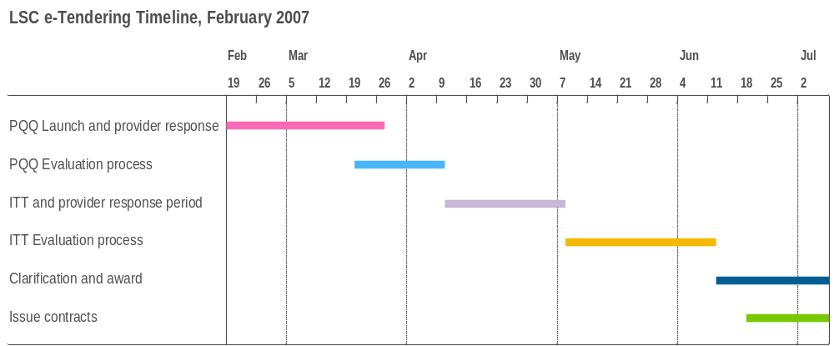

Evaluation method
The research method combined qualitative and quantitative research with a core sample of learning providers drawn from across the market, and a control sample of market research agencies who were undertaking a similar process for the new Framework Agreement.

The focus of the evaluation was on the first round of PQQ and ITT submissions only.

The findings showed that both samples shared a high degree of consistency in their views of the process.

Qualitative research
To inform the design of the survey which formed the basis of the evaluation, Quadrangle conducted consultations in July/ August 2007 with:
- 5 Representative bodies:
- Association of Learning Providers
- Association of Colleges
- NIACE (VCS)
- NIACE (LEAFEA)
- Holex
- 6 learning providers who did not respond to the PQQ
- 5 procurement experts in the public sector, including Central Office of Information and OGC Buying Solutions, the Government’s procurement agency.
- 6 ‘control group’ companies who participated in the Market Research PQQ/ ITT process

In addition, they carried out desk research to identify examples of good practice in procurement – whether in the public or private sector.

Quantitative research
An invitation to participate in an online survey was sent to all 2017 providers who registered on the LSC procurement portal site.

A similar invitation was sent to a ‘control group’ sample of 203 research agencies/consultancies.

The sample was sub-divided into four respondent types:
- Type 1 – registered, started the PQQ but did not complete it;
- Type 2 – registered, completed the PQQ but have not yet submitted a tender;
- Type 3 – registered, completed the PQQ and have submitted a tender;
- Type 4 – registered but didn’t start a PQQ.

Survey response

Quantitative fieldwork was conducted in August 2007. In total, 699 responses were received from the Provider sample (a response rate of 34%), and 45 from the Control group (24%).
The provider sample breakdown was as follows:

Provider sample

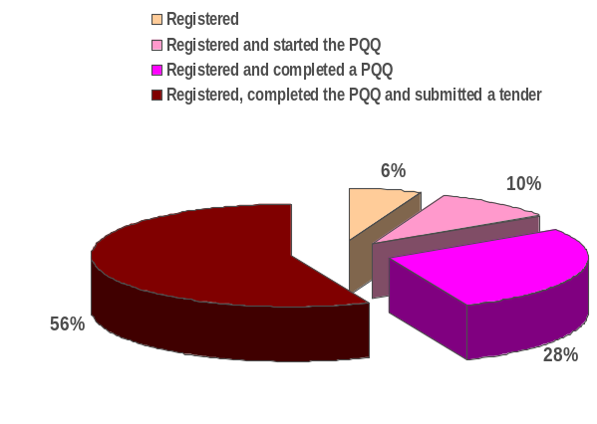

Key findings
This summary focuses on the key findings from the research, and LSC’s response to them (shown in orange text), including the actions we have taken as a result of the feedback.

Key finding 1: LSC procurement aims are strongly supported
Providers were supportive of the ethos underpinning the move to e-procurement.

In particular, they strongly endorsed LSC’s stated aims to:
- open up competition/ increase diversity/ remove barriers;
- raise quality of learning provision;
- be transparent;
- be provider-neutral;
- create a demand-led process.

The table below shows how important (on a scale of 1 – 10, where 10 = Extremely Important) providers feel each of the 9 objectives underpinning the new procurement system is:

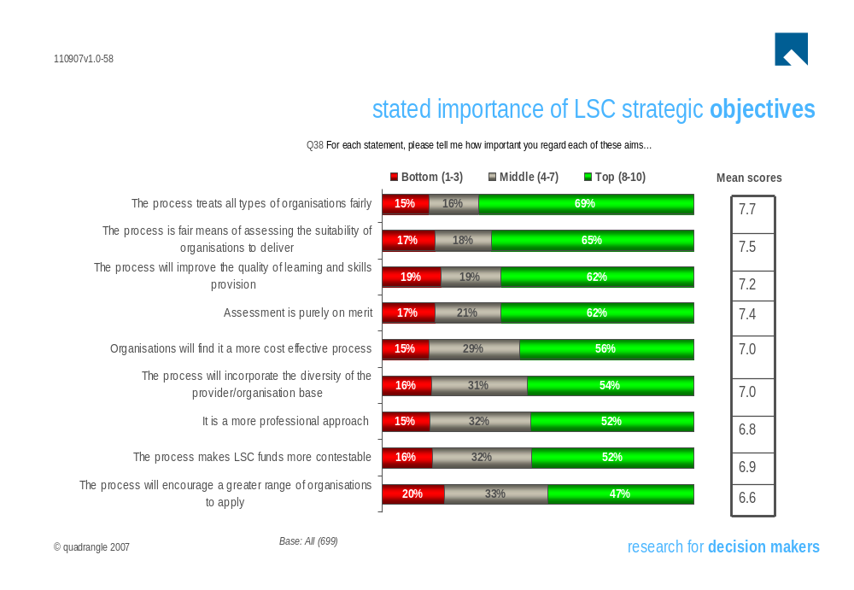

Key finding 2: Making such a significant transition was never likely to be easy

Notwithstanding this strong level of endorsement of LSC’s purpose, the research did find that users had experienced some difficulties in getting to grips with the new system, which catalysed some concerns about the switch – each of which the LSC has reviewed with Bravo Solutions and, where possible/ appropriate, taken action to help improve the user experience in the second round of PQQ submissions – particularly around ensuring clarity in the communications process.

These difficulties are demonstrated by the extent to which providers perceive LSC to have achieved its strategic aims (on a 1 – 10 agreement scale, where 10 = Strongly Agree).

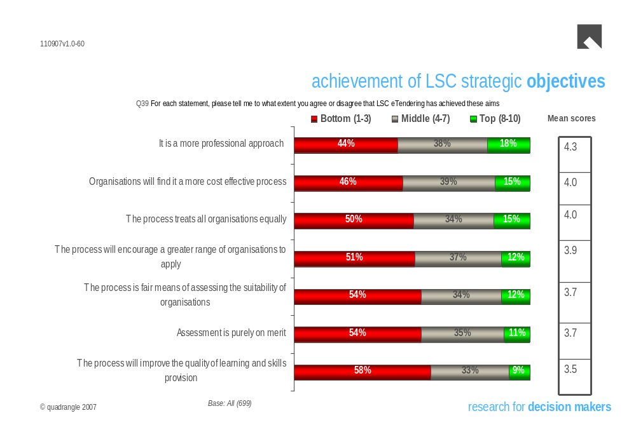

Quadrangle’s analysis showed this to be partly due to a lack of understanding amongst applicants of what is/ isn’t permissible or possible in:
- legal terms;
- a technical sense.

This emphasises the need for LSC to ensure we communicate with applicants more effectively – particularly to help address concerns about protecting the key principles of fairness and open competition (see Key Finding 4).

Groups to whom this issue is especially important include smaller and newer providers, whose resources might be more limited.

The demands eTendering makes on applicants (as opposed to the ‘traditional’ method) was a source of concern across the board, with the majority of providers believing that eTendering takes more time than the previous method, and that insufficient time was allowed to do what was required of them.

As in any change of this scale and nature, there is bound to be a period of transition, as people become familiar with the requirements of the new process.

The number of published PQQs doubled from the first to the second round, which suggests that providers are now becoming more confident in using the Bravo Solutions portal.

LSC response

- LSC gives no preference based on type of applicant, and smaller providers are encouraged to form consortia if they believe this is a more effective way for them to compete;
- A provision has now been made within the system to allow new providers (who are unable to demonstrate a 3 year track record) to attach business plans and other supporting documentation as evidence of financial viability;
- Completion timescales were based on good practice guidelines and on what is required in law by the EU. LSC data shows that many providers left it very near to the deadline to start the process of completing the PQQ, which is likely to have contributed to the pressure they felt to meet the deadline;
- LSC is aware of the pressures on providers - indeed this formed part of the rationale for switching to eTendering through Bravo Solutions in the first place – but the nature of any tendering exercise is that it is intensive. Electronic processes are simpler and faster to use, once users are familiar with the system;
- Feedback from the second round suggests that familiarity is starting to build. Providers are starting to find the Bravo Solutions portal easier to use and are seeing its benefits of the new system, as there is no need to re-submit information once a PQQ has been passed – saving time and resource;
- Another change has seen the number of attachments required in the PQQ reduce dramatically, from 13 down to 1 or 2.

Key finding 3: We need to actively manage expectations to avoid misunderstanding
Some providers expressed concern about the way in which the tendering exercise was communicated, and the level of support that was subsequently made available to applicants.

The main sources of confusion were around:
- eligibility for funding;
- regional vs. national funding;
- the basis for assessing submissions;
- specific criteria for ‘success’.

LSC response

- The LSC took measures to advise potential applicants about the process, in order to make it as open and competitive as possible. These included placing advertisements in national newspapers, and inviting representative bodies to attend briefings in order to encourage them to ‘spread the word’;
- The ‘rules’ regarding eligibility for funding and regional provisions were set out in the ‘Read Me First’ documentation which accompanied the PQQ;
- The LSC complies with the EU regulations on public procurement at both the PQQ and ITT stage of the process and identifies the criteria on which it will judge the offers made by providers. It chooses not to be prescriptive in detailing “success” criteria in order to encourage innovation and focus providers on demonstrating outputs and outcomes to be achieved. It is also mindful that by publishing “success” criteria it would encourage the submission of formulaic bids, and not ones which would be focused on achieving the outputs and outcomes required.
- LSC staff involved in scoring PQQs have received training and are carefully monitored to ensure we achieve our high standards. Staff development will also be a key part of the ITT phase of the programme.

Key finding 4: Communication, communication, communication
This was the issue which probably attracted the most criticism in the evaluation, with both LSC and Bravo Solutions held to be at fault.

Specific concerns included:
- Access to information contained within the Bravo Solutions portal;
- Speed of response to queries;
- Clarity and ease of understanding of PQQ requirements;
- Availability of guidance and support.

LSC response

- LSC acknowledges that this is an area in which improvements can be made, and we have taken a number of steps towards this already;
- However, we believe our efforts need to be in collaboration with those of provider networks. 6% of providers fist heard about the new procurement process from their respective representative body which suggests that this channel can be more effectively used in future;
- We have introduced applicant briefings at both PQQ and ITT stages as a result of the evaluation, which should help to address the concerns expressed in the evaluation;
- We have also extended our internal procurement project team to include a Communications Manager, to help us address this need fully at every stage in the process, and also to ensure that external communications are always public and open.

Key finding 5: We have a shared interest in quality
Providers and LSC alike want to improve the standard of provision to learners, and we both believe that the eTendering system has a role to play in helping to achieve this.

This means making sure that quality providers - in whichever sector - are aware of the procurement process, encouraged to apply and then facilitated to ensure they submit their best possible PQQ.

It is also perceived to be dependent on developing ‘the right’ assessment criteria and ensuring clarity around what providers are required to do.

Providers would like to see quality assessed contemporaneously – i.e. today’s/ and future potential performance taken into account, not just historical track records.

Similarly, they would like to see improvement recognised/ rewarded and providers with shortcomings encouraged and guided to succeed in future.

LSC response

- We share these views expressed in the evaluation research and are committed to working with providers to achieve our common goal.
- This includes a commitment to ongoing evaluation of the effectiveness of the procurement process to ensure continuous improvement.


A report on an independent evaluation of the new Learning and Skills Council
e-procurement system

Research Report prepared for
Learning and Skills Council by
Quadrangle

January 2008

